Belize Water Resources

A Google Earth Engine Dashboard for Assessing Coastal Water Quality in Belize’s Coral Reefs to Identify Sustainable Development Goals for Achieving Sustainable Use of Natural Resources

**Technical Report**

Final Draft – August 8th, 2019

Charlie Devine (Project Co-lead)

Alice Lin (Project Co-lead)

Alana Higgins

Sophia Skoglund

Dr. Christine Lee, NASA Jet Propulsion Laboratory, California Institute of Technology (Science Advisor)

Dr. Juan Torres-Perez, Bay Area Environmental Research Institute, NASA Ames Research Center (Science Advisor)

Dr. Emil Cherrington, The University of Alabama in Huntsville, NASA SERVIR (Science Advisor)

# 1. Abstract

The Belize Barrier Reef is a biodiverse marine ecosystem and the largest coral reef system in the western hemisphere. The reef also provides ecosystem services in the form of fisheries and tourism and is estimated to be responsible for 12 to 15% of the nation’s gross domestic product. Retaining these ecosystem functions requires sustainable coastal management and preservation of water quality, especially in the face of global changes in climate and local anthropogenic impacts. The Belize Water Resources Team at NASA Jet Propulsion Laboratory and NASA Ames Research Center partnered with the Coastal Zone Management Authority and Institute, a Belizean governmental agency, and the Wildlife Conservation Society to evaluate water quality conditions and inform coastal management decisions. Using Google Earth Engine, we developed a tool that outputs a time series of sea surface temperature, turbidity, and chlorophyll-a concentration derived from Landsat 8 Operational Land Imager (OLI) and Sentinel-2 Multispectral Instrument (MSI), Aqua Moderate Resolution Imaging Spectroradiometer (MODIS) and Terra MODIS satellite imagery. With optical data available from 2013 onward, our partners can efficiently identify reef areas threatened by depreciating water quality, designate Marine Protected Areas and no-take zones, and conduct temporal analyses of water quality changes following environmental disturbance events, such as hurricanes. Additionally, this tool will assist in identifying indicators that may be used to measure Belize’s progress towards Sustainable Development Goals regarding marine environments. Using the tool, partners can better monitor changing water quality and make decisions accordingly in regards to sustainable resource use, coral reef conservation practices, and environmental capital.

**Keywords**

water quality, chlorophyll-a, turbidity, Landsat 8 OLI, Sentinel-2 MSI, MODIS, remote sensing, Google Earth Engine

# 2. Introduction

* 1. ***Background Information***

The Belize Barrier Reef is the largest and one of the most pristine reef ecosystems in the Western Hemisphere (Cooper, Burke, & Bood, 2008). Located off the Central American coast, it is home to threatened marine animals, endemic and migratory birds, and a multitude of marine flora and coral species (*Figure 1*). Additionally, the reef serves as a major economic stimulant, contributing to almost one-third of the country’s gross domestic product through tourism, recreation, and fishing operations (Diedrich, 2007). These vital resources require adequate management in order to maintain environmental and economic functionality. Over 21% of territorial waters around Belize are considered Marine Protected Areas (MPAs), which contain no-fishing areas to allow the growth of populations of threatened aquatic species. Despite these current efforts, pollution and damage to coral continue to degrade reef health (Cooper et al., 2008).

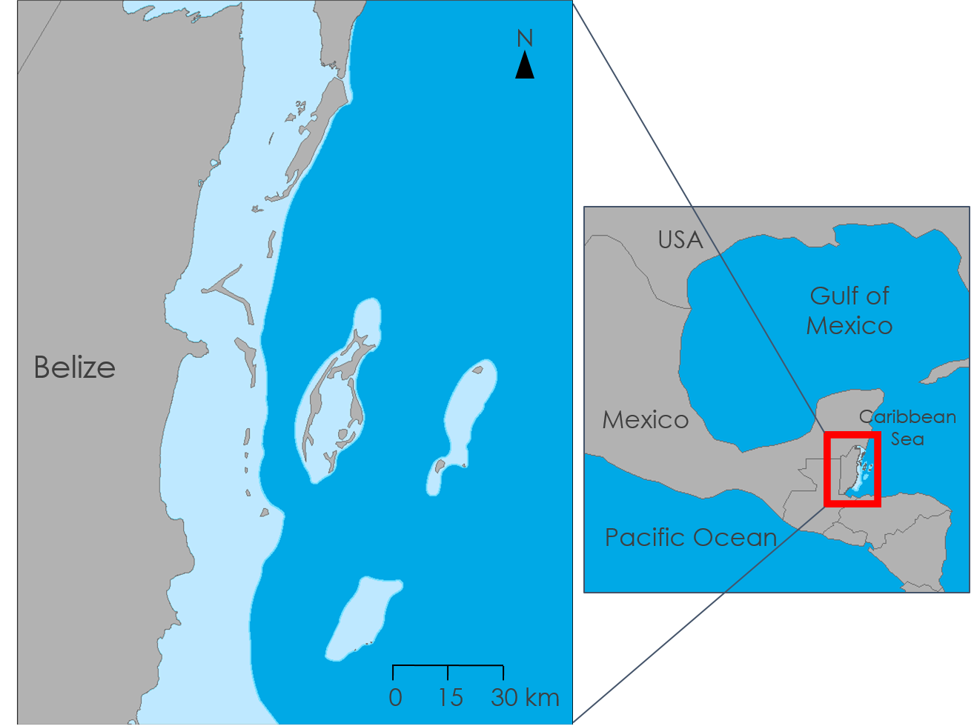

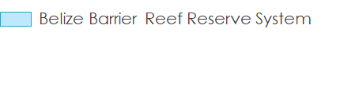

*Figure 1*. The Belize Barrier Reef Reserve System is located off the east coast of the country of Belize in the Caribbean Sea.

Water clarity and color are indicators of reef ecosystem health. Clarity is characterized by the amount of light penetration permitted through the water column. Waters are considered turbid when light is blocked by high concentrations of plankton biomass, dissolved organic matter, and suspended sediment, especially after heavy rainfall events or increased runoff from land. Water color is a result of materials near the sea surface reflecting a visible color. Plants, algae, and plankton contain the pigment chlorophyll-a, which exhibits a green hue due to its reflective photosynthetic properties and accounts for greener waters near coastlines and shores. Chlorophyll-a concentration has been used as a proxy for measuring phytoplankton biomass, increased nutrient runoff, and algal blooms. Because corals usually thrive in clear, shallow water, high levels of turbidity and chlorophyll can hinder reef growth, making them crucial parameters to monitor (McField & Kramer, 2007).

Remote sensing is a viable and efficient way to assess water quality of reef systems. Previous studies have used a variety of algorithms to detect turbidity and chlorophyll-a from high resolution, optical satellite imagery. These studies focused on ocean surface reflectance determined through red and near-infrared (NIR) based algorithms grouped into two, three, and four-band models (Hu, Lee, & Franz, 2012). Additionally, the Normalized Difference Chlorophyll Index (NDCI) draws from the difference between a highly reflecting NIR band and a highly absorbing red band (Mishra, Shraeffer, & Keith, 2014). The relationships between land and coastal waters have also been explored with satellite remote sensing. River plumes can extend offshore to reefs seasonally and particularly following large disturbance events such as hurricanes (Paris & Chérubin, 2008; Soto et al., 2009).

***2.2 Project Partners***

The Belize Water Resources Team partnered with the Wildlife Conservation Society (WCS) and the Coastal Zone Management Authority and Institute (CZMAI) to address Belize Barrier Reef water quality concerns. The CZMAI and WCS Belize are seeking to better understand the linkages between coral reef health and human activities and to improve stewardship of coastal marine ecosystems and connected watersheds. The establishment of the CZMAI was invaluable in ensuring the country’s ability to adopt the United Nations’ Sustainable Development Goals (SDGs), namely Goal 14: Life Below Water (Government of Belize, 2017). One of the country’s major achievements thus far is the creation of the Integrated Coastal Zone Management (ICZM) plan, finalized and endorsed in 2016. The plan provides guidance on permitting coastal zone activities to other government agencies. It is also the basis for the CZMAI’s assessment of proposed projects and the potential land or coastal repercussions. Although the development of the ICZM plan incorporated significant research and a variety of datasets from partners, this approach to gathering information will be hard to repeat when updating the plan every five years (Coastal Zone Management Authority and Institute, 2016). Our partners seek to expand their ecological mapping capacity to identify threatened areas that can be converted into MPAs and no-take zones (WCS Belize, 2019). While familiar with geographic information systems, WCS Belize would like to expand its geospatial analyses to include satellite remote sensing data for monitoring changes in water quality.

***2.3 Objectives***

The primary objective of this project was to support WCS Belize and CZMAI in their efforts to identify areas of poor water quality to improve coastal management surrounding coral reefs. To meet this objective, the Belize Water Resources Team created a user-friendly Google Earth Engine (GEE)-based dashboard to display maps of the Belize Barrier Reef Reserve System and create time series figures of imagery-derived turbidity and chlorophyll-a concentration from January 2013 to May 2019. GEE is a cloud-based platform that hosts a data library containing a vast amount of publicly available satellite imagery and derived products, as well as climate, weather, terrain, and other geophysical data from a variety of sources (Gorelick et al., 2017). In conjunction with *in situ* data collection, the WCS can utilize our GEE application for comparative measures and aid in the identification of high-risk areas. The WCS sees the importance of having this user-friendly tool since it will allow interested stakeholders to easily access and observe water quality conditions. To ensure correct functioning, the team’s GEE visualizations were compared against ACOLITE output images for the corresponding algorithms. This tool will allow partners to better monitor water quality changes over time and will guide the sustainable use of natural resources, coral reef conservation practices, and opportunities for environmental capital.

# 3. Methodology

***3.1 Data Acquisition***

To serve as inputs for our tool, we acquired optical imagery from the GEE data catalog, an online repository of geospatial datasets hosted on Google’s servers. This included Landsat 8 Operational Land Imager (OLI) Level 2 Surface Reflectance, Sentinel-2 Multispectral Instrument (MSI) Level 2A Surface Reflectance, and Aqua and Terra Moderate Resolution Imaging Radiospectrometer (MODIS) products from 2013 to 2019 (Table 1). Our tool also incorporates the National Oceanic and Atmospheric Administration (NOAA) Precipitation Estimation from Remotely Sensed Information Using Artificial Neural Networks-Climate Data Record (PERSIANN-CDR) precipitation dataset, although no analysis involving these data was conducted in this study (Table 1). When loading into GEE, we filtered the imagery by selecting scenes that intersected with our region of interest (coastal Belize). For comparative purposes, we also collected optical imagery to process in ACOLITE for comparison to our GEE tool outputs. Our team chose several Sentinel-2 MSI Level 1 scenes that corresponded in spatial extent and time of acquisition to the data available on GEE (Table 1). When collecting this imagery, we chose scenes that had minimal cloud cover over the coastal water area. In addition to these datasets, we also utilized shapefiles of the Central American coastline, MPAs in Belize, and *in situ* water sample data sourced from various organizations and advisers (Appendix Table A3).

Table 1

*Description of remote sensing data used for tool input and/or for ACOLITE validation*

|  |  |  |  |  |
| --- | --- | --- | --- | --- |
| **Sensor** | **Processing level** | **Resolution** | **Dates** | **Data Provider and Download Source** |
| Landsat 8 OLI | Level 2 Surface Reflectance Tier 1 | 30 m | June 2013 to July 2019 | United States Geological Survey  (USGS) Earth Explorer, acquired in GEE |
| Sentinel-2 MSI | Level 2A Surface Reflectance | 10, 20, 60 m | December 2018 toJuly 2019 | European Space Agency  (ESA Copernicus Open Access Hub), acquired in GEE |
| Level 1C | February 2016 to December 2016 |
| Aqua MODIS | Level 3 Standard Mapped Image | 1 km | July 2002 to 2019 | NASA Ocean Biology Processing Group (OBPG), acquired in GEE |
| Terra MODIS | Level 3 Standard Mapped Image | 1 km | February 2000 to 2019 | NASA Ocean Biology Processing Group (OBPG), acquired in GEE |
| NOAA PERSIANN-CDR | Level 4 | 0.25 arc degrees | January 1983 to 2019 (3-month lag in data release) | National Oceanic and Atmospheric Administration (NOAA), acquired in GEE |

***3.2 Data Processing***

Our main outputs were processed in GEE, and the scenes used for validation were processed through ACOLITE, an optical imagery processor developed by the Royal Belgian Institute of Natural Sciences. This program produces atmospherically corrected imagery before calculating a variety of water quality parameters (Vanhellemont & Ruddick, 2016). Due to the availability of surface reflectance products on GEE, our team chose not to conduct atmospheric corrections within our GEE tool. It is important to note that these atmospheric correction schemes are geared towards terrestrial analysis, rather than ocean color.

In GEE, we performed non-water (i.e. land and cloud) masking using the shortwave infrared (SWIR) band based on a threshold value set by ACOLITE. Specifically, any pixel with a SWIR value above 0.0215 was considered a non-water region and masked in our final analysis. We also used a shapefile to mask the mainland areas, removing terrestrial water bodies from our analyses. For all imagery, we derived turbidity and chlorophyll-a information using algorithms available in ACOLITE (Equations 1 through 3). The algorithms and their corresponding names in ACOLITE are listed in Appendix Table A1.

*3.2.1 Turbidity*

The turbidity function of our tool was developed during a previous effort by Sol Kim, Rafael Grillo Avila, and Xiaowei Wang at University of California (UC), Berkeley under the guidance of Dr. Christine Lee. They produced turbidity raster layers using the algorithm described by Nechad, Ruddick, & Neukermans (2009). The algorithm uses reflectance in the red and near-infrared range of the electromagnetic spectrum, which is highly correlated to turbidity (Nechad et al., 2009). The algorithm outputs turbidity in Formazin Nephelometric units (FNUs) (*Equation 1*).

$\text{Turbidity (FNU) = }\frac{{\text{A}}_{\text{T}}\text{*ρw}}{\text{1-ρw/C}}$ (1)

In this function, AT and C are wavelength-dependent calibration coefficients and $\text{ρw}$ is the water leaving reflectance at a given wavelength. C is calibrated using standard Inherent Optical Property data, while nonlinear least-square regression analysis is used to find AT (Nechad et al., 2009). When comparing the outputs of their GEE algorithm to ACOLITE outputs for the same scene, Kim, Avila, and Wang achieved an R2 value of approximately 0.98, indicating a strong agreement between tools (Table 2).

*3.2.2 Chlorophyll-a*

For Sentinel-2 MSI imagery, we derived NDCI according to Mishra & Mishra (2012) (*Equation 2*). The NDCI approach yields results with upper and lower reflectance bounds of +1 and -1, allowing more remote, isolated areas to be tested without the need for calibration of *in situ* data (Mishra et al., 2014). Due to the lack of a band centered around 708 nm, we did not extract NDCI values for Landsat 8 OLI imagery.

$\text{NDCI = }\frac{{\text{R}}_{\text{rs}}\text{(708) - }{\text{R}}_{\text{rs}}\text{(665)}}{{\text{R}}_{\text{rs}}\text{(708) + }{\text{R}}_{\text{rs}}\text{(665)}}$ (2)

From NDCI, we derived chlorophyll-a concentration according to Mishra & Mishra (2012) (*Equation 3*):

$\text{chlorophyll-a} \left(\text{mg*}{\text{m}}^{\text{-3}}\right)\text{=} {\text{a}}_{\text{0}}\text{+}\left({\text{a}}_{\text{1}}\text{*NDCI}\right)\text{+(}{\text{a}}_{\text{2}}\text{*}{\text{NDCI}}^{\text{2}}\text{)}$ (3)

where a0, a1, and a2 are calibrated model coefficients (14.036, 86.115, and 194.325, respectively) derived from the non-linear fitting of observed chlorophyll-a data with NDCI values.

Chlorophyll-a concentration data are readily available on GEE as one of the MODIS Level-3 products, therefore no further processing was done on our part for Terra and Aqua MODIS imagery.

*3.2.3 Time Series Analysis Following Natural Disturbances*

To expand the analytical capacity of our tool, we added a time series function to the user interface (Appendix B). Upon selection of a time range by the user, a line graph depicting turbidity, chlorophyll-a, sea surface temperature (SST), and precipitation metrics over that time period will be generated. The graph can chart monthly or daily averages of each parameter. These averages will be calculated from every available (unmasked) pixel within a user-specified area.

Due to increased rainfall and runoff following natural disturbances, such as hurricanes, more sediment may be present in ocean waters adjacent to Belize (Soto et al., 2009). To observe environmental changes caused by these events, we created a time series to visualize and quantify the impacts of the major storms specified in Appendix Table A2. Using GEE, we generated average monthly values for turbidity, chlorophyll-a concentration, SST, and precipitation in the coastal zone.

***3.3 Data Analysis***

Although our tool includes a turbidity function, Kim, Avila, and Wang had previously conducted validation tests for Landsat-8 OLI-derived turbidity outputs. Therefore, we focused on comparing our chlorophyll-a outputs from Sentinel-2 MSI imagery to ensure that our dashboard was able to accurately reproduce water quality parameters from ACOLITE. We compared NDCI and chlorophyll-a concentrations derived from Sentinel-2 MSI Level-2A surface reflectance data (S2_SR product in the GEE public data archive) against ACOLITE outputs generated from corresponding Level-1C scenes. This allowed us to assess the feasibility of using the S2_SR product for deriving water quality parameters. The advantage of using this product instead of the Level-1C data is that atmospheric correction has already been applied. Incorporating the Level-1C atmospheric correction scheme in our GEE code would have taken significantly longer and would have required additional calibration/validation steps.

Sentinel-2 MSI Level-1C imagery was downloaded from the ESA Copernicus Open Access Hub and processed in ACOLITE to produce outputs for NDCI and chlorophyll-a concentrations. We conducted accuracy assessments using a GEE script developed by Kim, Avila, and Wang. ‘Predicted’ water quality parameter values were derived in GEE from S2_SR, while ‘actual’ parameter values were generated in GeoTiff format using ACOLITE and imported into GEE. NDCI and chlorophyll-a parameter values from each of these sources were then randomly sampled (n = 5000) to generate a table that allowed for the comparison between pixel values at the same location. This table was processed using the R statistical programming language. Linear regression (R2) and root mean square error (RMSE) statistical metrics were used to determine the agreement between water quality output variables (*Equations 4 and 5*).

${\text{R}}^{\text{2}}\text{=}\frac{\sum{{\left({\text{y}}_{\text{i}}\text{ - }{\overline{\text{y}}}_{\text{i}} \right)}^{\text{2}}}}{\sum{{\left({\text{y}}_{\text{i}}\text{ - }\overline{\text{y}} \right)}^{\text{2}}}}$ (4)

$\text{RMSE =}\sqrt{\frac{\sum_{\text{i=1}}^{\text{N}}{{\left({\text{predicted}}_{\text{i}}\text{ - }{\text{actual}}_{\text{i}}\right)}^{\text{2}}}}{\text{N}}}$ (5)

We repeated this validation process with an atmospherically corrected scene provided by Benjamin Page from the University of Minnesota, Twin Cities (Appendix Table A3). Page has developed a script in GEE that corrects for atmospheric effects based on a scheme tailored towards ocean color analysis. We produced NDCI and chlorophyll-a concentration data from this scene and compared it against corresponding ACOLITE outputs. This additional validation was done to evaluate the differences between imagery produced by different atmospheric correction procedures.

# 4. Results & Discussion

***4.1 Analysis of Results***

We used the output maps from the tool for the spatial analysis of chlorophyll-a and turbidity. In *Figure 2C*, which was generated from Sentinel-2 MSI data and used NDCI derived values in the Mishra equation, areas of high chlorophyll-a concentrations are shown in bright green. In *Figure 2B*, which was generated from Landsat 8 and used the Nechad algorithm, the highest values of turbidity are present bordering the coastlines of the country as well as offshore atolls and islands. There is a visible plume at the mouth of the Belize River, possibly due to sediments being transported from land and accumulating at the river mouth.

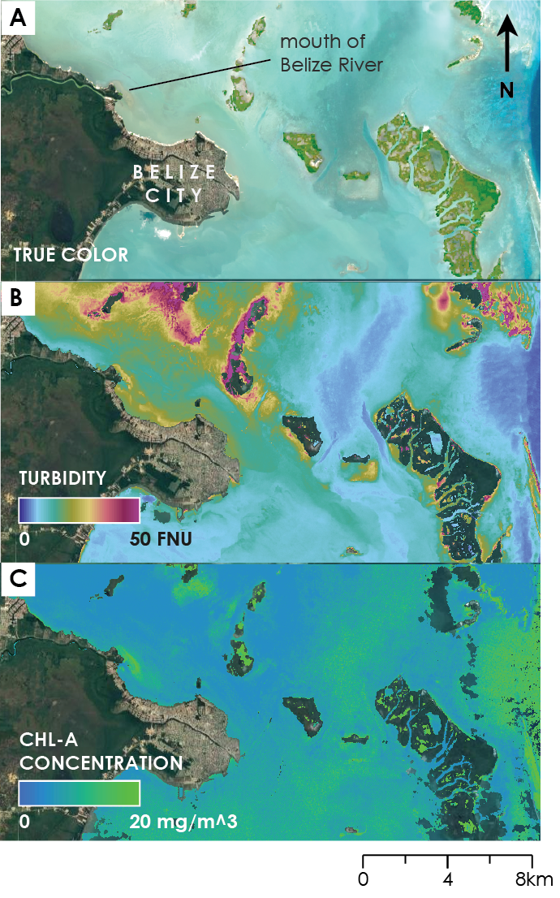

*Figure 2*. GEE tool map outputs for coastal areas around Belize City on July 28th, 2019 (Landsat 8 OLI) and July 30th, 2019 (Sentinel-2 MSI). Layers generated by our tool include A) Landsat 8 OLI true-color image layers, B) Landsat 8 OLI-derived turbidity in FNU, and C) Sentinel-2 chlorophyll-a concentration layers with units in mg/m3.

*4.1.1 Tool Validation*

We reproduced the validation methods used by Kim, Avila, and Wang for turbidity values derived from the Sentinel-2 image tile T16QCE collected on 2019-03-23. Repeating these methods, we validated NDCI and chlorophyll-a values derived from the same image tile collected on 2019-01-02. An R2 value of 0.97 was produced in our turbidity validation, matching closely to the one reported by Kim, Avila, and Wang. This confirmed that the Sentinel-2 Level-2A S2_SR product can accurately reproduce turbidity values generated in ACOLITE. However, validation of NDCI and chlorophyll-a showed much poorer agreement between S2_SR and ACOLITE-generated water quality parameters. R2 values of 0.61 and 0.42 were produced for NDCI and chlorophyll-a, respectively. NDCI values derived from Page’s surface reflectance data appeared to have better agreement with ACOLITE data (R2 = 0.829, RMSE = 0.073), while chlorophyll-a agreement remained poor with respect to relative error (R2 = 0.481) but showed improvement with respect to absolute error (RMSE = 3.205). Table 2 and *Figure 3* display the full set of results from our data validation.

Table 2

*Results of data validation tests; R2 and RMSE values in the red text correspond with data plotted in red within Figure 3*

|  |  |  |  |  |
| --- | --- | --- | --- | --- |
| **Sentinel-2 GEE Tile ID / Collection Date** | **Relationship Tested** | **Water Quality Parameter** | **R2** | **RMSE** |
| T16QCE  2019-01-02 | S2_SR vs.  ACOLITE | NDCI [ ] | 0.611 | 0.228 |
| Chlorophyll-a [mg m-3] | 0.425 | 45.322 |
| Page vs.  ACOLITE | NDCI [ ] | 0.829 | 0.073 |
| Chlorophyll-a [mg m-3] | 0.481 | 3.205 |
| T16QCE  2019-03-23 | S2_SR vs.  ACOLITE | Turbidity [FNU] | 0.977 | 4.281 |

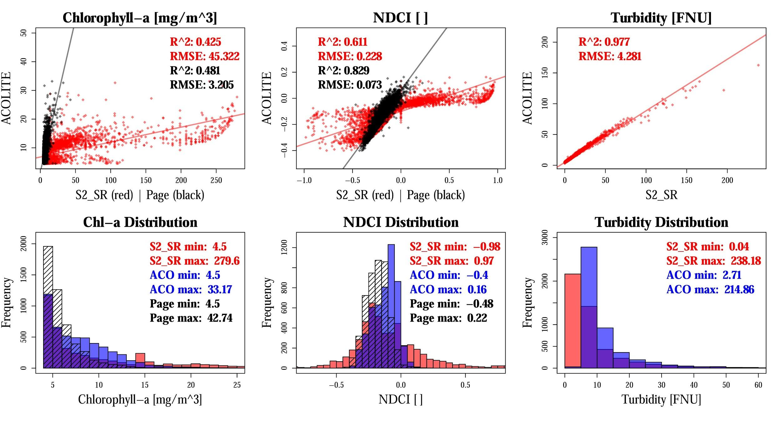

*Figure 3*. These display the results of validation analyses of water quality parameters produced in Google Earth Engine using the Sentinel-2 Level-2A S2_SR product (red) and Sentinel-2 Level-1C data processed by Benjamin Page (black) vs. corresponding outputs from ACOLITE (blue).

Differences between S2_SR and ACOLITE-generated parameters are likely a result of the different atmospheric correction algorithms applied to Sentinel-2 Level-1C data prior to computation of each parameter. When Level-1C data are ingested into ACOLITE, surface reflectance is derived using an atmospheric correction algorithm that has been calibrated specifically for coastal water. The surface reflectance data provided by Page was processed using a similar calibrated atmospheric correction algorithm, which he has translated into the GEE JavaScript application programming interface (API) to process Sentinel-2 Level-1C images available with the GEE data catalog.

Through this validation step, our team determined that it was not feasible to produce NDCI or chlorophyll-a water quality parameters using the Sentinel-2 S2_SR surface reflectance product. In future efforts, the Level-1C atmospheric correction code written by Page in GEE should be incorporated into the tool. Additionally, *in situ* chlorophyll-a observations are needed to re-calibrate the Mishra algorithm based on NDCI values derived from Page surface reflectance data.

*4.1.2 Time Series Analysis Following Natural Disturbances*

We conducted a time series analysis for the coastal region of Belize as well as the coastal area surrounding Belize City (Appendix C). Our time series analysis revealed spatiotemporal changes in water quality parameters following major storm events. When restricting our analysis to the coastal area adjacent to Belize City, we observed an increase in turbidity levels derived from both Landsat 8 OLI and Sentinel-2 MSI imagery following Hurricane Earl in August of 2016 (*Figure 4*). From Sentinel-2 MSI, the average turbidity in the region on July 26th, about a week before the hurricane, was about 14.93 FNU. Following the hurricane, turbidity peaked at 30.53 FNU on August 15. A similar pattern is evident in the Landsat 8 OLI imagery: pre-Earl turbidity is around 10.78 FNU on July 30th before peaking at 24.29 FNU at the end of August.

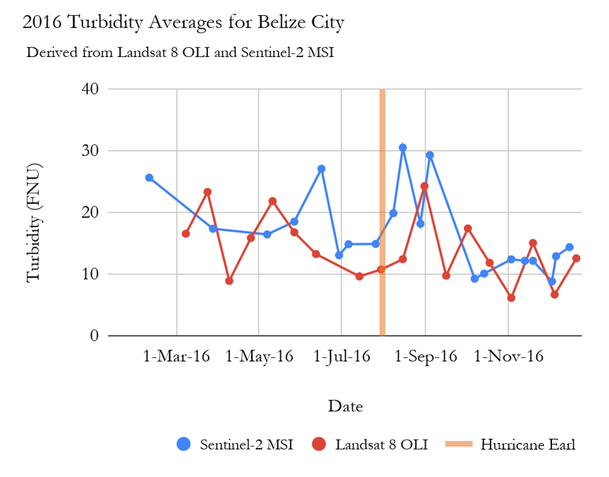

*Figure 4.* 2016 This time series analysis shows Landsat 8 OLI and Sentinel-2 MSI average turbidity values surrounding Belize City per available scene.

We also generated a daily time series comparing the SST and chlorophyll-a concentration Level-3 products from MODIS (*Figure 5*). Due to the coarser resolution of the sensor, we expanded our region of interest to the entire coast of Belize to maximize the number of pixels contributing to our daily averages. Following Hurricane Earl, there is an increase in chlorophyll-a concentration from about 0.77 mg/m3 on August 7th (right at the end of the event) to about 2.45 mg/m3 on August 20th. There is also a response in SST surrounding the disturbance. The average SST of the region experiences a drop from 29.7C on August 2nd (two days before landfall) to 29.1C on August 8th (four days after landfall).

Hurricane Earl

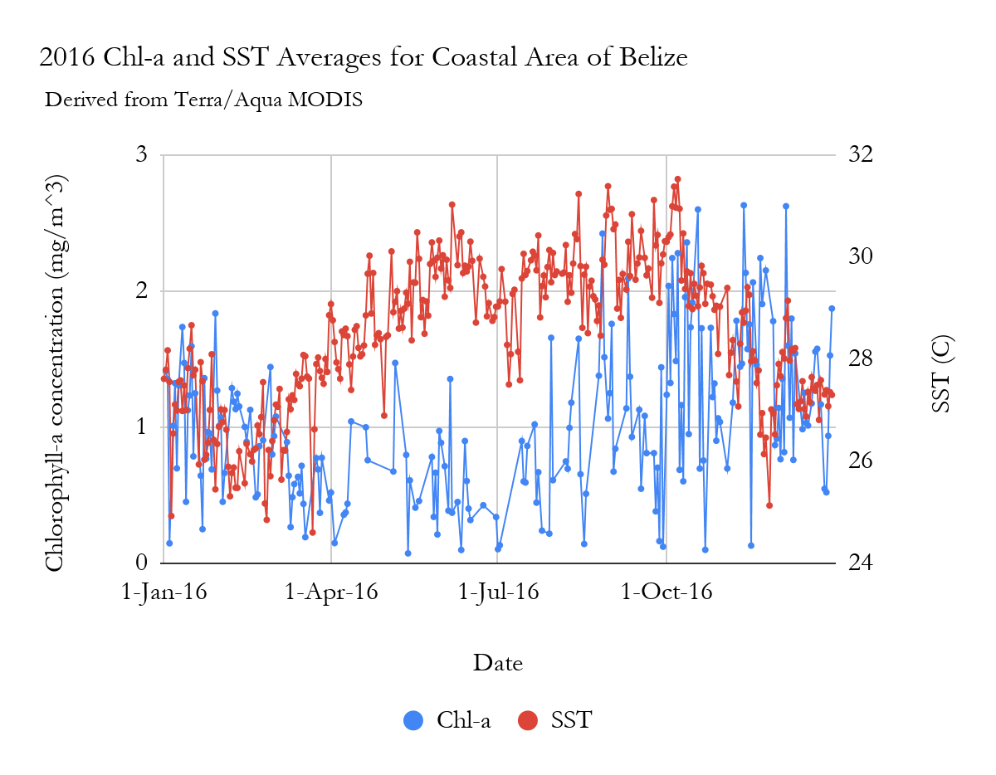

Hurricane Earl

*Figure 5*. 2016 This time series analysis shows Aqua and Terra MODIS daily SST and chlorophyll-a averages for the Belize coastal area.

We also compared differences in chlorophyll-a concentration between two regions to evaluate spatial differences in water quality (*Figure 6*). The two areas we trained our time series analysis on were the entire coastal area of Belize and a small subsection of that region surrounding Belize City and the mouth of the Belize River. There were similar general, temporal trends between the two regions but a significant difference in the chlorophyll-a concentration values. Both the water surrounding Belize City and the whole coast had peak monthly chlorophyll-a concentrations during the winter months, following the end of the rainy season, and lower concentrations between March to May. With the exception of two months (May and July), the chlorophyll-a concentration was higher surrounding Belize City. In some months, the monthly averages are over twice as high as the entire coastal average.

Hurricane Earl

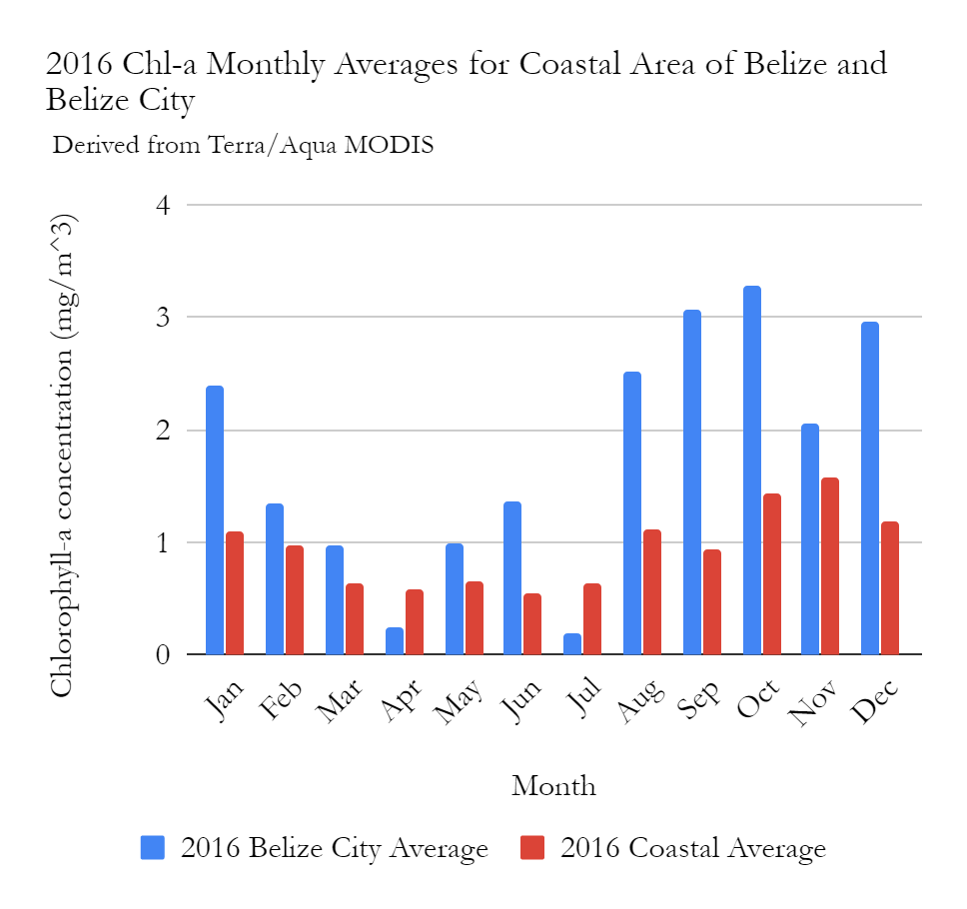

Hurricane Earl

*Figure 6.* This shows 2016 Aqua and Terra MODIS chlorophyll-a monthly averages in Belize City vs. the entire Belize coast.

***4.2 Future Work***

During the second term of this project, the current GEE water quality monitoring application could be improved in several areas. Thus far, comparison with ACOLITE outputs has been the primary method of validating our tool. It would be beneficial to ground-truth the tool against *in situ* water sampling data. However, because remotely sensed observations of water quality only provide information at the water’s surface, future project team members who incorporate *in situ* observations should be mindful of the fact that measurements are often taken at different depths within the water column. Work should be done to make the dashboard more suited to visualize and gather data for nearshore areas. This includes calibrating the Mishra algorithm coefficients or exploring other algorithms that may be a better fit for shallow coastal waters. It will also be important to add an atmospheric correction algorithm into our code, thereby permitting the use of Level 1C Sentinel-2 MSI data instead of the Level 2A surface reflectance data that gave us poor results. Page has a suitable correction algorithm geared towards ocean color analysis and is open to collaboration.

Looking ahead, the Optical Reef and Coastal Area Assessment (ORCAA) tool could be enhanced with the addition of other water quality parameters. Sentinel-3 Ocean and Land Colour Instrument (OLCI) and Sentinel-2 MSI could be used to map color dissolved organic matter (CDOM). Our project partners have also shown interest in incorporating a method to measure Sargassum populations. For this purpose, we recommend exploring the application of Sentinel-1 synthetic aperture radar (SAR) imagery, which is readily available within the GEE public data archive. Using SAR in equatorial regions is advantageous because it is able to penetrate persistent cloud cover, which is a major obstacle for optical sensors (Lang, Kasischke, Prince, & Pittman, 2008). SAR returns high spatial resolution information about surface texture. In theory, the ‘rough’ texture of floating aquatic vegetation would stand in stark contrast to the ‘smooth’ texture of the water surface and would be detectable using SAR. The second term team should consider housing the revised GEE application in a Google Sites website, where tutorial materials and downloadable data could be stored alongside the tool. Having the tool available in Spanish would make it accessible to more end users in Central America. Ultimately, a local analysis of the correlation between water quality parameters and reef cover would be of great value in understanding what makes a reef “healthy.” According to Eric J. Hochberg, a coral reef ecologist with the Bermuda Institute of Ocean Science, evaluating coral reef health is a subjective matter. His global study of the relationship between reef cover and water quality revealed no statistically significant trends (Hochberg, 2019).

# 

# 5. Conclusions

The Belize Water Resources Team successfully built a GEE application that produces maps and time series charts of turbidity, chlorophyll-a, SST, and precipitation. Comparison with ACOLITE outputs provided validation for turbidity and revealed that for chlorophyll-a, better atmospheric correction and an algorithm calibrated to coastal waters are needed. These concerns can be addressed in the second term of this project. The outputs of our tool suggest that there are spatiotemporal effects surrounding large scale disturbances, as seen with Hurricane Earl. The rise in turbidity and chlorophyll-a levels following the hurricane could be attributed to increased runoff, especially from the mouth of the Belize River, located northeast of Belize City (Soto et al., 2009). The observed decrease in SST could be attributed to the cooling effect associated with hurricane-induced vertical mixing of coastal waters, resulting in cooler, deeper waters mixing with surface waters (Gierach & Subrahmanyam, 2008). Our tool also revealed spatial differences in water quality year-round. The higher chlorophyll-a concentrations off the coast of Belize City are likely linked to rapid development in that area. An analysis of land use change over time could offer additional insight.

The spatial and temporal coverage of satellite remote sensing allows for the monitoring of coastal waters across time. The GEE cloud computing platform gave us the ability to quickly process a large amount of data. Additionally, because GEE continues to upload the latest imagery, our water quality analysis tool will be kept up-to-date. There is potential for this tool to adopt a much broader study region, perhaps the coastal waters of other Central and South American countries or of other coral reef systems across the globe.

Our tool will be a great supplement to *in situ* data collection and will help our Belizean partners to efficiently identify areas at risk of water quality degradation. This can result in better-informed decision-making in the creation of environmental policies and regulations and in meeting SDGs. Handing off the tool, tutorial, and other deliverables to our partners also serves to build their capacity in satellite remote sensing. The partners expressed great interest in learning about and using these Earth observation resources that are new to them. Globally, advances in cloud computing and increased availability of remote sensing data will allow for more effective environmental management.

# 6. Acknowledgments

The Belize Water Resources Team would like to thank our partners at CZMAI and WCS for their involvement in our project and for their engagement throughout the development of our GEE tool. Much thanks to our Science Advisors who offered support and insight throughout the term: Dr. Emil Cherrington of The University of Alabama in Huntsville, Dr. Christine Lee of NASA Jet Propulsion Laboratory, Dr. Juan Torres-Pérez of NASA Ames Research Center, and Sean McCartney of NASA Goddard Space Flight Center, as well as NASA DEVELOP Center Leads, Farnaz Bayat and Erika Higa. We would also like to thank Sol Kim, Rafael Grillo Avila, and Xiaowei Wang from UC Berkeley for offering guidance and sharing their GEE outputs of turbidity and Benjamin Page from the University of Minnesota, Twin Cities for guidance on atmospheric correction and validation.

This material contains Moderate-resolution Imaging Spectroradiometer (MODIS) chlorophyll-a and sea surface temperature data, processed by the NASA Goddard Space Flight Center, Ocean Ecology Laboratory, Ocean Biology Processing Group.

This material contains modified Copernicus Sentinel data (2016-2019), processed by ESA.

Any opinions, findings, and conclusions or recommendations expressed in this material are those of the author(s) and do not necessarily reflect the views of the National Aeronautics and Space Administration.

This material is based upon work supported by NASA through contract NNL16AA05C.

# 

# 7. Glossary

**Chlorophyll-a** – Photosynthetic pigment found in chloroplasts of plants, algae, and plankton

**CZMAI** – Coastal Zone Management Authority and Institute, a Belizean government agency

**Earth observations** – Satellites and sensors that collect information about the Earth’s physical, chemical, and biological systems over space and time

**Ecosystem functions** – Ecological processes that are beneficial to humans

**GEE** – Google Earth Engine

**NDCI** – Normalized Difference Chlorophyll Index

**Turbidity** – A measure of water clarity in which high turbidity corresponds to a large presence of suspended matter

**WCS** – Wildlife Conservation Society

# 8. References

Coastal Zone Management Authority and Institute. (2016). *Belize Integrated Coastal Zone*

*Management Plan*. Retrieved from https://www.coastalzonebelize.org/wp-content/uploads/2015

/08/BELIZE-Integrated-Coastal-Zone-Management-Plan.pdf

Cooper, E., Burke, L., & Bood, N. (2008). *Coastal capital: Economic contribution of coral reefs and mangroves to Belize*. Washington DC: World Resources Institute. Retrieved from https://pdf.wri.org/coastal_capital_belize_brochure.pdf

Diedrich, A. (2007). The impacts of tourism on coral reef conservation awareness and support in coastal communities in Belize. *Coral Reefs,* *26*, 985. <https://doi.org/10.1007/s00338-007-0224-z>

Gierach, M. M., & Subrahmanyam, B. (2008), Biophysical responses of the upper ocean to major Gulf of Mexico hurricanes in 2005. *Journal of Geophysical Research*, 113, C04029. doi:10.1029/2007JC004419

Gorelick, N., Hancher, M., Dixon, M., Ilyushchenko, S., Thau, D., & Moore, R. (2017). Google Earth Engine: Planetary-scale geospatial analysis for everyone. *Remote Sensing of Environment*, *202*, 18-27. https://doi.org/10.1016/j.rse.2017.06.031

Government of Belize (2017). *Belize’s voluntary national review for the sustainable development goals.* Retrieved from <https://sustainabledevelopment.un.org/content/documents/16389Belize.pdf>

Hochberg, E. J. (2019, June 24). *The NASA Earth Venture Suborbital-3 Mission: COral Reef Airborne Laboratory (CORAL)*. Lecture presented at a NASA Ames Earth Science Division Seminar in Moffett Field, CA.

Hu, C., Lee, Z., & Franz, B. (2012). Chlorophyll-a algorithms for oligotrophic oceans: A novel approach based on three-band reflectance difference. *Journal of Geophysical Research: Oceans*, *117*, C01011. https://doi.org/10.1029/2011JC007395

Lang, M. W., Kasischke, E. S., Prince, S. D., & Pittman, K. W. (2008). Assessment of C-band synthetic aperture radar data for mapping and monitoring Coastal Plain forested wetlands in the Mid-Atlantic Region, U.S.A. *Remote Sensing of Environment, 112(11)*, 4120-4130. https://doi.org/10.1016/j.rse.2007.08.026

McField, M., & Kramer, P. (2007). *Healthy reefs for healthy people: A guide to indicators of reef health and social well-being in the Mesoamerican Reef Region*. Retrieved from <https://www.researchgate.net/publication/322603385_2018_Mesoamerican_Reef_Report_Card>

Mishra, D., Schaeffer, B., & Keith, D. (2014). Performance evaluation of normalized difference chlorophyll index in northern Gulf of Mexico estuaries using the Hyperspectral Imager for the Coastal Ocean. *GIScience & Remote Sensing*, *51*(2). <https://doi.org/10.1080/15481603.2014.895581>

Mishra, S., & Mishra, D. R. (2012). Normalized difference chlorophyll index: A novel model for remote estimation of chlorophyll-a concentration in turbid productive waters. *Remote Sensing of Environment*, *117*, 394-406. <https://doi.org/10.1016/j.rse.2011.10.016>

NASA Goddard Space Flight Center, Ocean Ecology Laboratory, Ocean Biology Processing Group. (2018). Moderate-resolution Imaging Spectroradiometer (MODIS) Aqua Chlorophyll Data [Dataset]. NASA OB.DAAC, Greenbelt, MD, USA. https://doi.org/10.5067/AQUA/MODIS/L3M/CHL/2018

NASA Goddard Space Flight Center, Ocean Ecology Laboratory, Ocean Biology Processing Group. (2014). Moderate-resolution Imaging Spectroradiometer (MODIS) Aqua SST Data [Dataset]. NASA OB.DAAC, Greenbelt, MD, USA. https://doi.org/10.5067/AQUA/MODIS/L3M/SST/2014

NASA Goddard Space Flight Center, Ocean Ecology Laboratory, Ocean Biology Processing Group. (2018). Moderate-resolution Imaging Spectroradiometer (MODIS) Terra Chlorophyll Data [Dataset]. NASA OB.DAAC, Greenbelt, MD, USA. https://doi.org/10.5067/TERRA/MODIS/L3M/CHL/2018

NASA Goddard Space Flight Center, Ocean Ecology Laboratory, Ocean Biology Processing Group. (2014). Moderate-resolution Imaging Spectroradiometer (MODIS) Terra SST Data [Dataset]. NASA OB.DAAC, Greenbelt, MD, USA. https://doi.org/10.5067/TERRA/MODIS/L3M/SST/2014

Nechad, B., Ruddick, K. G., & Neukermans, G. (2009). Calibration and validation of a generic multisensor algorithm for mapping of turbidity in coastal waters. In C. R. Bostater Jr., S. P. Mertikas, X. Neyt, & M. Velez-Reyes (Eds.), *SPIE Remote Sensing of the Ocean, Sea Ice, and Large Water Regions 2009* (Proceedings Volume 7473, 74730H). https://doi.org/10.1117/12.830700

Paris, C. B., & Chérubin, L. M. (2008). River-reef connectivity in the Meso-American Region. *Coral Reefs, 27*,

773-781. https://doi.org/10.1007/s00338-008-0396-1

Sorooshian, S., Hsu, K., Braithwaite, D. K., Ashouri, H., & NOAA CDR Program. (2014). NOAA Climate Data Record (CDR) of Precipitation Estimation from Remotely Sensed Information using Artificial Neural Networks (PERSIANN-CDR), Version 1 Revision 1 [Dataset]. NOAA National Centers for Environmental Information. https://doi.org/10.7289/V51V5BWQ

Soto, I., Andréfouët, S., Hu, C., Muller-Karger, F. E., Wall, C. C., Sheng, J., & Hatcher, B. G. (2009). Physical connectivity in the Mesoamerican Barrier Reef System inferred from 9 years of ocean color observations. *Coral Reefs, 28*, 415-425. https://doi.org/10.1007/s00338-009-0465-0

US Geological Survey Earth Resources Observation and Science Center. (2014). Landsat 8 OLI/TIRS Level-2 Data Products - Surface Reflectance [Dataset]. https://doi.org/10.5066/F78S4MZJ

Vanhellemont, Q., & Ruddick, K. (2016). Acolite for Sentinel-2: Aquatic Applications of MSI Imagery. The proceedings of the 2016 ESA Living Planet Symposium, Prague, Czech Republic, 9-13 May 2016. *ESA Special Publication, 740.* https://odnature.naturalsciences.be/downloads/publications/ vanhellemontruddick_esa_lps2016_coastalapplications_final_header.pdf

WCS Belize. (2019). *Replenishment Zones Program*. Retrieved June 12, 2019, from <https://belize.wcs.org/Initiatives/Replenishment-Zones-Program.aspx>

# 9. Appendices

**Appendix A.** Supplementary tables of information

Table A1

*Algorithms used in this project and their corresponding ACOLITE names*

|  |  |  |
| --- | --- | --- |
| **Algorithm** | **Parameter** | **ACOLITE Name** |
| Nechad | turbidity | t_nechad |
| NDCI | chlorophyll-a | ndci |
| NDCI-derived chlorophyll-a concentration | chlorophyll-a | chl_re_mishra |

Table A2

*Notable storm events that have impacted Belize since the launch of Landsat 8 in February 2013*

|  |  |
| --- | --- |
| **Name** | **Date** |
| Tropical Storm Barry | June 17th to June 20th, 2013 |
| Hurricane Earl | August 2nd to August 6th, 2016 |
| Tropical Storm Franklin | August 7th to August 10th, 2017 |

Table A3

*Specifications for ancillary data used in GEE tool*

|  |  |  |
| --- | --- | --- |
| **Data Type** | **Specifications** | **Source** |
| US/Central American Coastline; Global Self-Consistent, Hierarchical, High-Resolution Geography Database (GSHHG) | Shapefile | Paul Wessel (University of Hawaii, School of Ocean and Earth Science and Technology)  Walter H.F. Smith (NOAA Geosciences Lab, National Ocean Service) |
| Marine Protected Areas | Shapefile | United Nations Environment World Conservation Monitoring Centre |
| *In Situ* Water Sampling Data | Shapefile | Robert Griffin (Belize Sustainable Development Goals) |
| Atmospherically corrected Sentinel-2 MSI scene  (T16QCE, 2019-01-02) | Raster | Benjamin Page (University of Minnesota, Twin Cities) |

**Appendix B.** The Optical Reef and Coastal Area Assessment (ORCAA) Google Earth Engine dashboard can be used to monitor water quality parameters in proximity to the Belize Barrier Reef System.

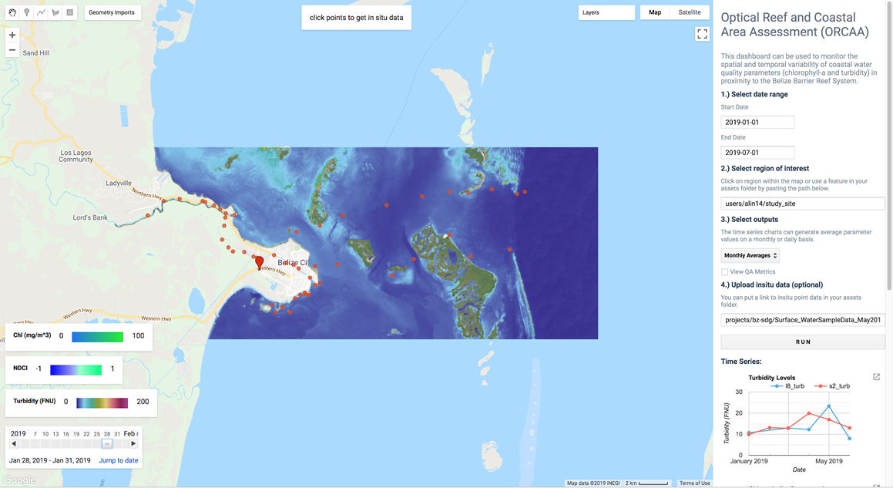

**Appendix C.** This displays the spatial subsets used in time series analyses, where the orange polygon represents the Belize City subset used for *Figures 4 and 6* and the blue polygon represents coastal subsets used in *Figures 5 and 6*.

