Chesapeake Bay Agriculture and Food Security II

Operational Analysis of Winter Cover Crop Environmental Performance throughout the State of Maryland

 **Technical Report**

Final Draft – November 15th, 2018

Logan Kline (Project Lead)

Julio Peredo

Diane Portillo

Benjamin Whong

Dr. W. Dean Hively, USGS Eastern Geographic Science Center (Science Advisor)

Dr. Greg McCarty, USDA-Agricultural Research Service, Hydrology and Remote Sensing Laboratory (Science Advisor)

Dr. Kristofer Lasko, ERDC Geospatial Research Laboratory (Science Advisor)

Previous Contributors:

Dr. Sunita Yadav

John Fitz

Sean McCartney

Perry Oddo

Alison Thieme

# 1. Abstract

Winter cover crops increase the sustainability of agricultural lands and the health of surrounding watersheds through erosion control and nutrient retention. The Maryland Department of Agriculture (MDA) incentivizes the planting of winter cover crops in the Chesapeake Bay area via a cost-sharing program that offers subsidies to enrolled farmers. The success of these cover crops is dependent on several factors, such as crop species, planting date, and termination date. Using imagery from Landsat 5 Thematic Mapper (TM), Landsat 8 Operational Land Imager (OLI), and Sentinel-2 MultiSpectral Instrument (MSI), a previous DEVELOP team constructed methods that evaluated the performance of Maryland cover crops on the basis of biomass. However, the MDA required more streamlined methods and user-friendly tools to implement the products in their day-to-day operations. The current DEVELOP project aimed to simplify the methods established by the previous team through the creation of a graphical user interface (GUI) using Google Earth Engine to optimize end user analysis of cover crop data. The graphical analysis produced by this GUI aids the MDA by granting further insight into cover crop effectiveness, promoting more informed decision making and improved conservation efforts for the Chesapeake Bay.

**Keywords**

Remote sensing, biomass, percent ground cover, Normalized Difference Vegetation Index, graphical user interface, crop performance, Google Earth Engine

# 2. Introduction

* 1. ***Background Information***

The Chesapeake Bay is the largest estuary in the United States, fed by a watershed spanning six states and encompassing 166,000 km2 of diverse terrestrial and marine ecosystems (Phillips & McGee, 2016). Over 3,000 species of bivalves, birds, fish, and other organisms inhabit the watershed, whose coastal wetlands provide nurseries, food, and nesting sites (Chesapeake Bay Foundation). The Chesapeake Bay also generates substantial commercial benefits, hosting a multi-billion dollar boating industry and fisheries capable of generating $2 billion per year (Maryland Department of Natural Resources, 2012). Therefore, the health of the Bay and neighboring watersheds is of great ecological and economic importance to the Mid-Atlantic region. However, soil erosion and nutrient leaching from agricultural lands pose a major threat to the estuary and its local waterways (Dauer, Ranasinghe, & Weisberg, 2000). Sediment loading from farms buries benthic organisms, prevents sunlight from reaching submerged aquatic vegetation and transports nutrients such as nitrogen into vulnerable habitats (Gellis, Banks, Langland, & Martucci, 2004). Excess nitrogen can induce eutrophication and subsequent hypoxia in coastal waters, threatening the prolific fisheries of the Chesapeake Bay (Boesch, Brinsfield, & Magnien, 2001; Malone, Boynton, Horton, & Stevenson, 1993).

To help mitigate these effects, the Maryland Department of Agriculture (MDA) oversees the Maryland Agricultural Water Quality Cost-Share (MACS) Program. This program offers subsidies to Maryland farmers who plant winter cover crops, which have been linked to reduced soil erosion and nitrogen leaching in the Chesapeake Bay region (Hively et al, 2009a; Staver, 2001). Cover crop success varies significantly depending on agronomic factors such as planting date, planting method, and crop species (Hively et. al., 2009a). Studies have linked biomass in particular to increased soil retention, as higher crop biomass correlates with less soil erosion (Prabahakara, Hively, & McCarty, 2015). Therefore, the MDA is interested in methods for analyzing cover crop performance across several variables in order to identify best practices for farms enrolled in its cost-sharing program.

Remote sensing provides powerful satellite imagery tools for monitoring vegetation health, including that of cover crops. Recent research on cover crop efficiency in the Chesapeake Bay region has been conducted largely by a partnership between the United States Geological Survey (USGS) and United States Department of Agriculture’s Agricultural Research Service (USDA-ARS) (Hively et al., 2015; Hively et al., 2009a; Hively, McCarty, & Keppler 2009b). The MDA works in tandem with this partnership and ensures compliance with the MACS Program protocol by performing spot-checks on 20% of enrolled fields (J. Keppler, personal communication, October 1, 2018). Remote sensing technologies offer the opportunity to forego labor-intensive spot-checking and implement publicly available satellite data for evaluating enrollment compliance. Furthermore, spectral vegetation indices can be used to assess winter cover crop performance and enhance MDA recommendations to farmers seeking to improve their conservation strategies (Hively et al., 2015). However, remote sensing research in Chesapeake Bay winter cover crop analysis has not been conducted over large regional scales (Hively, Duiker, McCarty, & Prabahakara, 2015; Prabahakara et al., 2015).

A prior study conducted by the spring 2017 NASA DEVELOP team examined cover crops in four Maryland counties–Talbot, Somerset, Queen Anne’s, and Washington–to aid the MDA in their performance analysis. Data were analyzed for winter (December 15-January 31) and spring (March 1-April 15) from 2006 to 2016. Using the open-source coding platform Google Earth Engine (GEE), the previous team applied remote sensing techniques to MDA field data to analyze crop performance. The team found that the parameter of interest, Normalized Difference Vegetation Index (NDVI), correlated reasonably well with both plant biomass and percent ground cover, two useful metrics for remotely evaluating crop health (Hively et. al., 2009a; Prabhakara et. al., 2015).

The current team continued work in the same study area (Figure 1) and expanded the study period to 2018. Graphical user interface (GUI) production in GEE streamlined methodology used by the previous team, automating the analysis process for the end-user. The GUI provides the MDA the opportunity to analyze the effectiveness of the program on both small and large scales while granting insight into best practices for an updated incentive structure.

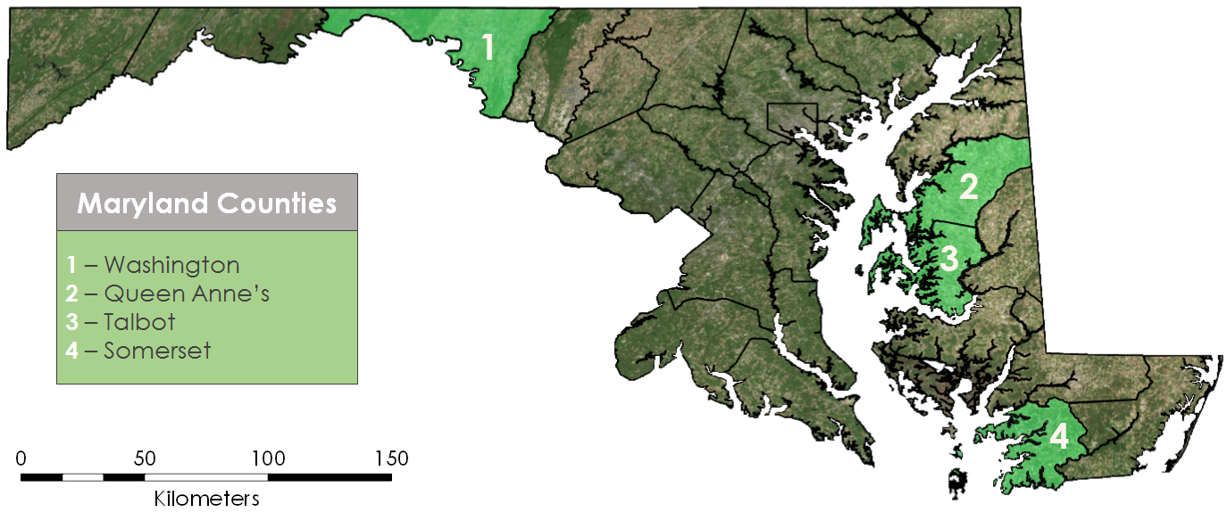

*Figure 1.* Maryland iMAP (2018) detailed county boundaries on ArcGIS Pro World Imagery basemap with study areas highlighted.

* 1. ***Project Partners & Objectives***

Project development was conducted in collaboration with the MDA Office of Resource Conservation (ORC), the USGS Eastern Geographic Science Center (EGSC), the USDA-ARS, and the Environmental Protection Agency (EPA) Chesapeake Bay Program (CBP). Code written by the previous DEVELOP team in GEE, R, and Excel was synthesized to provide the MDA with software that enables enhanced analysis of cover crop biomass and percent ground cover. The GUI automates winter cover crop evaluation, producing both tabular and graphical analysis of performance over time and by county, planting date, and crop type. This software can contribute to more informed decision-making regarding Chesapeake Bay conservation efforts and ensure proper compliance with the Maryland cost-sharing program.

# 3. Methodology

***3.1 Data Acquisition***

The team worked with the same NASA Landsat archival imagery and European Space Agency (ESA) Sentinel-2 imagery that was used during the previous term to continue analysis of winter cover crops. See Table 1 for a complete list of platforms and sensors used for imagery collection. Data were analyzed for winter (December 15-January 31) and spring (March 1-April 15) from December 2006 to April 2018.

**Table 1:** Earth observation platforms, sensors, and image levels used for this project.

|  |  |  |  |
| --- | --- | --- | --- |
| **Platform** | **Sensor** | **Level** | **Google Earth Engine ImageCollection IDs** |
| Landsat 5 | Thematic Mapper (TM) | 1 | LANDSAT/LT05/C01/T1_SR |
| Landsat 8 | Operational Land Imager (OLI) | 1 | LANDSAT/LC08/C01/T1_SR |
| Sentinel-2 | MultiSpectral Imager (MSI) | 1C | COPERNICUS/S2 |

The team also received ground-truth data and cover crop program enrollment shapefiles from the MDA and previous term partners. Data were received for Talbot, Somerset, Queen Anne’s, and Washington counties. Each field contained parameters such as county identification codes, planting method, previous crop type, and current crop type. Calibration data collected by the USGS and USDA were also received for the years 2006 through 2012.

***3.2 Data Processing***

Shapefiles provided by the MDA required reprojection into World Geodetic System 1984 (WKID 4326) via ArcGIS Pro. Following reprojection, shapefiles were uploaded as tabular data into GEE and a 15-meter inner buffer was created in order to reduce edge effects and maintain clear boundaries between agricultural fields. This buffer resulted in some fields losing geometric properties due to their small size; these fields were eliminated prior to conducting the analysis. The CFmask function was then applied to Landsat and Sentinel-2 data to find cloud-free images that would provide the most accurate assessment of enrolled fields. NDVI was calculated for every pixel in a field using the previous team’s GEE script. These values were averaged across each field. The day with the highest average NDVI was selected, and this date and its corresponding NDVI value were extracted for analysis.

***3.3 Data Analysis***

The team utilized the previous term’s R script and partner-gathered calibration data to convert NDVI values into biomass and percent ground cover (Table 2).

**Table 2:** Biomass and percent ground cover equations for winter and spring.

|  |  |  |
| --- | --- | --- |
| **Parameter** | **Winter Equation** | **Spring Equation** |
| ln(Biomass) | 3.2022 + 5.3740*NDVI | 4.7794 + 3.7453*NDVI |
| Percent ground cover | -21.904 + 116.305*NDVI | -10.783 + 107.566*NDVI |

The log value of biomass was then reverted to biomass using the equation (Thieme et. al, 2018):

$\text{Biomass=}{\text{e}}^{\text{ln}\left(\text{Biomass}\right)\text{+}\frac{\text{MSE}}{\text{2}}}$ (1)

where MSE is mean squared error.

***3.4 Data Visualization***

A GEE graphical user interface was created to allow convenient, repeated analysis of data for the MDA. The GUI contains two sections: analysis and filtering. The analysis menu allows users to select a raw dataset, a satellite, and calibration equations to conduct NDVI analysis and produce biomass and percent ground cover values. After these calculations are performed, the analyzed dataset can be exported as a GEE asset or as a shapefile. The new asset can then be imported back into the GUI to undergo filtering. The GUI provides menus for several cover crop parameters (Table 3) and filters the analyzed dataset based on any provided combination of variables.

**Table 3:** Filtering options available through the GUI.

|  |  |
| --- | --- |
| **Parameter** | **Options** |
| County | Allegany, Anne Arundel, Baltimore, Calvert, Caroline, Carroll, Cecil, Charles, Dorchester, Frederick, Garrett, Harford, Howard, Kent, Montgomery, Prince George’s, St. Mary’s, Wicomico, Worcester, Talbot, Washington, Queen Anne’s, Somerset |
| Cover Crop | Wheat, Rye, Barley, Canola, Cereal Grain, Forage Radish, Legume, Oats, Triticale |
| Planting Method | Aerial Air, Broadcast Cultipacker, Broadcast Light Tillage, Broadcast Stalkchop, Vertical Tillage, Conventional, No-till, Aerial Ground |
| Manure | None, Spring, Fall |
| Previous Crop | Corn, Soybeans, Vegetables, Double-crop Soybeans, Sorghum |
| Irrigation | Yes/No |
| Month Planted | August, September, October, November |

The user may then produce a histogram displaying the number of fields by NDVI range for the selected area. Comparing these histograms for various sets of parameters allows the user to analyze patterns for crop performance and better understand the effects of specific growing strategies.

When prompted, the GUI also produces summary tables for a more detailed, comprehensive analysis of specific parameters (see Table 3) and their relative performance in Washington, Queen Anne’s, Somerset, and Talbot counties. These tables were coded to display average NDVI, predicted biomass, and predicted ground cover for the most popular crops and other agronomic factors.

# 4. Results & Discussion

***4.1 Analysis of Results***

The GUI has the capability to produce a collection of tabular and graphical outputs. Figures 2 and 3 display sample histograms produced within the GUI to analyze the health of wheat compared to triticale in Queen Anne’s County.

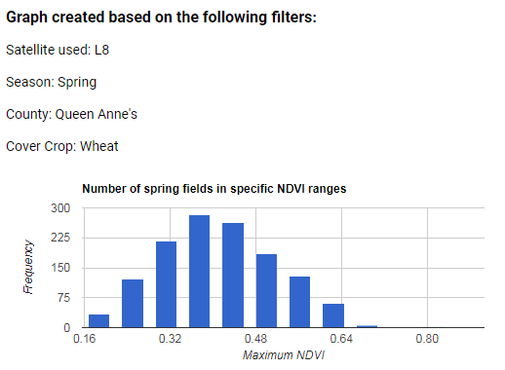

*Figure 2.*Histogram displaying the number of fields versus NDVI for wheat fields in Queen Anne’s County.

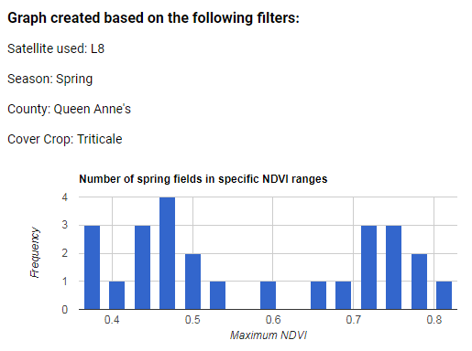

*Figure 3.*Histogram displaying the number of fields versus NDVI for triticale fields in Queen Anne’s County.

In these figures, triticale displays an average NDVI value of 0.56 while wheat displays an average of 0.38, which equates to a 47% difference in NDVI between the two crops. Although the sample size for triticale is comparatively smaller than that for wheat, these results suggest that triticale cover crops may perform better than wheat in Queen Anne’s County. The user may then repeat this analysis in another county, or over the region as a whole, to examine this pattern in further detail.

The GUI can also be used to test scientific hypotheses on cover crop effectiveness. Prior studies have shown that cover crops are more effective if planted in early fall (Hively et. al, 2009a). To verify this, different planting date ranges can be selected in the GUI to examine the performance of cover crops planted in September (Figure 4) compared to those planted in November (Figure 5).

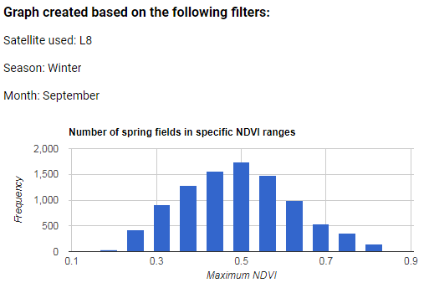

*Figure 4.*Histogram showing number of fields versus maximum NDVI for fields planted in September.

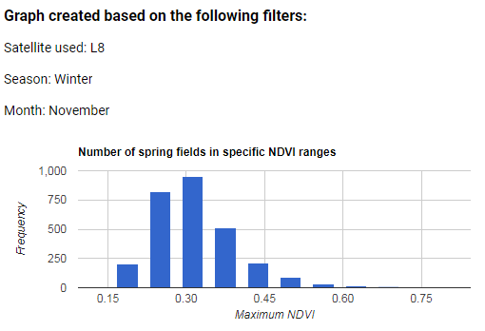

*Figure 5.*Histogram showing number of fields versus maximum NDVI for fields planted in November.

These figures support the hypothesis that early planting, before October 1, yields better cover crop performance: the peak of the November curve is nearly 0.2 NDVI lower than the September curve, corresponding to a difference of 20% ground cover (per the conversion equation in Table 2).

Table 4 displays a portion of the overall summary table produced by the GUI for Queen Anne’s County. See Appendix A for a complete overview of all summary tables and parameters.

**Table 4:** GUI output summary table outlining performance in Queen Anne’s County based on filtering parameters.

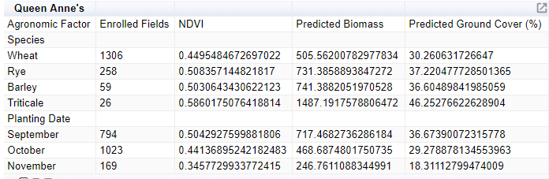

***4.2 Future Work***

A third term would incorporate a spring season time series analysis into previous project work in order to establish the date of springtime termination of cover crops on MACS enrolled winter cover crop fields. This additional analysis would enable the MDA to verify adherence to the cover crop program while eliminating the need for spot-checking, which would reduce workload significantly and increase the effectiveness of cover crop management.

# 5. Conclusions

The Google Earth Engine graphical user interface provides the Maryland Department of Agriculture the ability to utilize NASA Earth observations in evaluating their cover crop program. Analyzed data can be visually represented on an interactive map, filtered for planting characteristics, and displayed as graphical and tabular outputs of average maximum NDVI, predicted biomass, and predicted percent ground cover.

Through GUI construction and use, the team built upon established correlations between NDVI, biomass and ground cover to analyze the effectiveness of a variety of crop planting techniques and parameters. Histograms displaying distributions of NDVI values for a filtered dataset verified that fields planted earlier in the season have higher average NDVI, biomass, and percent ground cover than those planted later in the season. Furthermore, a comparison of performance between crop types indicated that triticale, though planted less frequently, has a higher biomass yield than wheat. Findings such as these give the MDA the opportunity to amend and optimize their cover crop program policies and incentive structure to reward high-performing crops and planting methods.

Providing the MDA with this tool established a means of improving agricultural management techniques throughout Maryland, as the GUI is capable of analyzing fields in all Maryland counties. The GUI supports the MDA’s long-term goals of reducing *in situ* spot-checking of enrolled fields and assessing the productivity of various planting methods. The depth and sophistication of cover crop analysis in Maryland can be improved through future work. However, this partnership has established a novel methodology for cover crop analysis via Google Earth Engine and provided the MDA with a user-friendly tool to help optimize their management of Maryland cover crops, both of which contribute to improved watershed conservation practices and Chesapeake Bay health.

# 6. Acknowledgments

We wish to show our gratitude to our project advisors – Dr. W. Dean Hively, Dr. Greg McCarty, and Dr. Kristofer Lasko – for their participation and guidance during this development process. We also thank our partners on this project: Jason Keppler from the Maryland Department of Agriculture and Rich Batiuk from the Chesapeake Bay Program. Finally, we thank our lead science advisor, Dr. John Bolten, and Center Lead, Victor Lenske, at NASA Goddard Space Flight Center.

This material contains modified Copernicus Sentinel data 2017, processed by ESA.

Any opinions, findings, and conclusions or recommendations expressed in this material are those of the author(s) and do not necessarily reflect the views of the National Aeronautics and Space Administration.

This material is based upon work supported by NASA through contract NNL16AA05C.

# 7. Glossary

**Biomass** – The total mass of a collection of organisms in an area. Used as an indicator of cover crop performance in this study

**Earth observations** – Satellites and sensors that collect information about the Earth’s physical, chemical, and biological systems over space and time

**EPA** –Environmental Protection Agency, an independent government agency

**Graphical User Interface** – A way of visually interacting with a piece of software without requiring edits to the source code

**GSFC** –Goddard Space Flight Center, a NASA Center located in Greenbelt, Maryland

**MACS** – Maryland Agricultural Water Quality Cost-Share Program, a program developed by the Maryland Department of Agriculture that provides subsidies to farmers who grow winter cover crops

**MDA** –Maryland Department of Agriculture, a state agency of Maryland

**NASA** –National Aeronautics and Space Administration, a US government agency

**NDVI** – Normalized difference vegetation index, utilized to highlight vegetation in remotely sensed imagery

**USDA-ARS** –United States Department of Agriculture Agricultural Research Service, a branch of a US government agency

**USGS** –United States Geological Survey, a US government agency

**Winter cover crops** –Crops planted in active agricultural fields during winter months to reduce nutrient leaching and soil erosion into waterways

# 8. References

Boesch, D. F., Brinsfield, R. B., & Magnien, R. E. (2001). Chesapeake Bay eutrophication: Scientific understanding, ecosystem restoration, and challenges for agriculture. *Journal of Environmental Quality, 30*(2), 303-320. doi: 10.2134/jeq2001.302303x

Chesapeake Bay Foundation. (n.d.). Chesapeake wildlife. Retrieved from http://www.cbf.org/about-the-bay/more-than-just-the-bay/chesapeake-wildlife/.

Dauer, D.M., Ranasinghe, J.A., Weisberg, S.B. (2000). Relationships between benthic community condition, water quality, sediment quality, nutrient loads, and land use patterns in Chesapeake Bay. *Estuaries* *23*(1), 80–96. doi:10.2307/1353227

Gellis, A. C., Banks, W. S. L., Langland, M. J., & Martucci, S. K. (2004). Summary of suspended-sediment data for streams draining the Chesapeake Bay watershed, water years 1952-2002 (Report 2004-5056). doi:10.3133/sir20045056

Hively, W. D., Lang, M., McCarty, G. W., Keppler, J., Sadeghi, A., & McConnell, L. L. (2009a). Using satellite remote sensing to estimate winter cover crop nutrient uptake efficiency. *Journal of Soil and Water Conservation*, *64*(5), 303–313. doi:10.2489/jswc.64.5.303

Hively, W. D., McCarty, G. W., Keppler, J. (2009b). Federal-state partnership yields success in remote sensing analysis of conservation practice effectiveness: Results from the Choptank River Conservation Effects Assessment Project. *Journal of Soil and Water Conservation, 64*(5), 154A. doi:10.2489/jswc.64.5.154A

Hively, W. D., Duiker, S., McCarty, G., & Prabahakara, K. (2015). Remote sensing to monitor cover crop adoption in southeastern Pennsylvania. *Journal of Soil and Water Conservation, 70*(6), 340-352. doi:10.2489/jswc.70.6.340

Malone, T. C., Boynton, W., Horton, T., & Stevenson, C. (1993). Nutrient loadings to surface waters: Chesapeake Bay case study. In M. F. Uman (Ed.), *Keeping pace with science and engineering: Case studies in environmental regulation* (pp. 8-38). Washington, DC: National Academy Press.

Maryland Department of Agriculture. (2018). *Build your soil – Maryland’s 2018-2019 cover crop sign-up.* Annapolis, MD: Office of Resource Conservation. Retrieved from https://mda.maryland.gov/resource_conservation/counties/2018CCSignup.pdf.

Maryland Department of Natural Resources. (2012). *Accounting for Maryland’s ecosystem services: Integrating the value of nature into decision making.* Annapolis, MD: Mark Belton.

Maryland iMAP. (2018). *Maryland Physical Boundaries - County Boundaries (Detailed).* Maryland GIS Data Catalog.

Phillips, S. & McGee, B. (2016). Ecosystem service benefits of a cleaner Chesapeake Bay. *Coastal Management, 44*(3), 241-258. doi:10.1080/08920753.2016.1160205

Prabhakara, K., Hively, W. D., & McCarty, G. W. (2015). Evaluating the relationship between biomass, percent groundcover and remote sensing indices across six winter cover crop fields in Maryland, United States. *International Journal of Applied Earth Observation and Geoinformation, 39,* 88-102. doi:10.1016/j.jag.2015.03.002

Staver, K. W. (2001). Increasing N Retention in Coastal Plain Agricultural Watersheds. *The Scientific World Journal*, *1*, 207-215. doi: 10.1100/tsw.2001.375

Thieme, A., Yadav, S., Oddo, P. C., Fitz, J. M., McCartney, S., King, L., … Hively, W. D. (2018). *Using NASA Earth observations and Google Earth Engine to map winter cover crop conservation performance in the Chesapeake Bay watershed.* Unpublished manuscript.

# 9. Appendix A

**Table A.1.** Summary of crop performance in Queen Anne’s County.

|  |  |  |  |  |
| --- | --- | --- | --- | --- |
| **Queen Anne's** |  |  |  |  |
| **Agronomic Factor** | **Enrolled Fields** | **NDVI** | **Predicted Biomass (kg/Ha)** | **Predicted Ground Cover (%)** |
| **Species** |  |  |  |  |
| Wheat | 1306 | 0.442861587 | 1015.199515 | 36.78089874 |
| Rye | 258 | 0.507601578 | 1288.43504 | 43.81767137 |
| Barley | 59 | 0.437538814 | 974.7628984 | 36.2813001 |
| Triticale | 26 | 0.590399161 | 1886.171594 | 52.72387611 |
| **Planting Date** |  |  |  |  |
| September | 794 | 0.444557251 | 1038.255358 | 36.97601955 |
| October | 1023 | 0.455752505 | 1071.179373 | 38.19255264 |
| November | 169 | 0.372999677 | 749.5658639 | 29.33908331 |
| **Planting Method** |  |  |  |  |
| Aerial Air | 796 | 0.415390869 | 909.4077061 | 33.89893422 |
| Aerial Ground | 0 |  |  |  |
| No-till | 0 |  |  |  |
| Broadcast Cultipacker | 0 |  |  |  |
| Broadcast Stalkchop | 17 | 0.433097772 | 941.5146478 | 35.80359497 |
| Broadcast Light Tillage | 237 | 0.480940264 | 1180.633211 | 40.73153855 |
| Conventional | 83 | 0.554184509 | 1590.318134 | 48.82841088 |
| Vertical Tillage | 404 | 0.439617736 | 1000.63893 | 36.38787207 |
| **Previous Crop** |  |  |  |  |
| Corn | 1221 | 0.451995303 | 1065.74598 | 37.79650747 |
| Soybeans | 684 | 0.428250008 | 958.4869573 | 35.2147937 |
| Vegetables | 40 | 0.505772386 | 1310.138675 | 43.62091242 |
| Double-crop Soybeans | 32 | 0.431414362 | 958.4726445 | 35.62251732 |
| Sorghum | 10 | 0.371094696 | 751.3763398 | 29.13417203 |
| **All Fields** | 1987 | 0.444169334 | 1030.433495 | 36.94642843 |

**Table A.2.** Summary of crop performance in Somerset County.

|  |  |  |  |  |
| --- | --- | --- | --- | --- |
| **Somerset** |  |  |  |  |
| **Agronomic Factor** | **Enrolled Fields** | **NDVI** | **Predicted Biomass** | **Predicted Ground Cover (%)** |
| **Species** |  |  |  |  |
| Wheat | 661 | 0.519836647 | 1197.323552 | 39.55053331 |
| Rye | 173 | 0.531777559 | 1345.046019 | 42.78111531 |
| Barley | 9 | 0.534129609 | 1432.192846 | 46.67118553 |
| Triticale | 0 |  |  |  |
| **Planting Date** |  |  |  |  |
| September | 388 | 0.515481235 | 1248.477622 | 40.24118012 |
| October | 525 | 0.523670262 | 1214.47893 | 39.64496996 |
| November | 81 | 0.482822218 | 1068.288561 | 36.66402278 |
| **Planting Method** |  |  |  |  |
| Aerial Air | 318 | 0.49765296 | 1146.758047 | 39.3808378 |
| Aerial Ground | 0 |  |  |  |
| No-till | 0 |  |  |  |
| Broadcast Cultipacker | 7 | 0.571209602 | 1533.859858 | 50.659732 |
| Broadcast Stalkchop | 19 | 0.568561888 | 1430.852859 | 43.93725142 |
| Broadcast Light Tillage | 428 | 0.508283148 | 1198.823233 | 40.95289715 |
| Conventional | 5 | 0.612275381 | 1883.892558 | 55.07701365 |
| Vertical Tillage | 15 | 0.388429969 | 580.1069742 | 17.071572 |
| **Previous Crop** |  |  |  |  |
| Corn | 733 | 0.517164965 | 1218.118791 | 40.59637405 |
| Soybeans | 269 | 0.506460278 | 1211.114035 | 41.06214499 |
| Vegetables | 0 |  |  |  |
| Sorghum | 7 | 0.440297119 | 845.4911401 | 29.81214281 |
| Double-crop Soybeans | 8 |  | 177.8427975 | -10.783 |
| **All Fields** | 1017 | 0.513755373 | 1205.518122 | 40.24118012 |

**Table A.3.** Summary of crop performance in Talbot County.

|  |  |  |  |  |
| --- | --- | --- | --- | --- |
| **Talbot** |  |  |  |  |
| **Agronomic Factor** | **Enrolled Fields** | **NDVI** | **Predicted Biomass** | **Predicted Ground Cover (%)** |
| **Species** |  |  |  |  |
| Wheat | 1894 | 0.438091 | 1006.853405 | 36.3158046 |
| Rye | 63 | 0.51315 | 1309.2288 | 44.41453944 |
| Barley | 76 | 0.499436 | 1240.03065 | 42.93937339 |
| Triticale | 1 | 0.644741 | 1989.516188 | 58.56916156 |
| **Planting Date** |  |  |  |  |
| September | 1035 | 0.430439 | 962.1711986 | 35.47286821 |
| October | 960 | 0.467645 | 1136.820991 | 39.51969727 |
| November | 189 | 0.394337 | 826.5623905 | 31.63425769 |
| **Planting Method** |  |  |  |  |
| Aerial Air | 561 | 0.410764 | 889.1639963 | 33.40124861 |
| Aerial Ground | 75 | 0.41023 | 889.2478634 | 33.34383903 |
| No-till | 0 |  |  |  |
| Broadcast Cultipacker | 0 |  |  |  |
| Broadcast Stalkchop | 12 | 0.43964 | 1091.105731 | 36.50726762 |
| Broadcast Light Tillage | 216 | 0.463709 | 1096.01646 | 39.09637402 |
| Conventional | 12 | 0.573073 | 1802.848891 | 50.86021185 |
| Vertical Tillage | 519 | 0.439671 | 1030.638196 | 36.51068516 |
| **Previous Crop** |  |  |  |  |
| Corn | 1106 | 0.442606 | 1015.152249 | 36.78334642 |
| Soybeans | 976 | 0.450417 | 1063.01576 | 37.66651322 |
| Vegetables | 8 | 0.447571 | 979.7135876 | 37.36037804 |
| Sorghum | 82 | 0.38289 | 792.6080329 | 30.40299461 |
| Double-crop Soybeans | 21 | 0.400645 | 852.217138 | 32.31274904 |
| **All Fields** | 2193 | 0.443466 | 1026.443181 | 36.89712465 |

**Table A.4.** Summary of crop performance in Washington County.

|  |  |  |  |  |
| --- | --- | --- | --- | --- |
| **Washington** |  |  |  |  |
| **Agronomic Factor** | **Enrolled Fields** | **NDVI** | **Predicted Biomass** | **Predicted Ground Cover (%)** |
| **Species** |  |  |  |  |
| Wheat | 95 | 0.453853 | 1068.701498 | 37.00834947 |
| Rye | 279 | 0.481872 | 1234.050564 | 41.05008245 |
| Barley | 87 | 0.496914 | 1287.032818 | 42.66802769 |
| Triticale | 61 | 0.683409 | 2574.449706 | 62.72858266 |
| **Planting Date** |  |  |  |  |
| September | 226 | 0.547729 | 1709.007075 | 48.13396879 |
| October | 312 | 0.47324 | 1200.874216 | 39.7952157 |
| November | 67 | 0.389647 | 797.644623 | 31.12974042 |
| **Planting Method** |  |  |  |  |
| Aerial Air | 8 | 0.495535 | 1178.340091 | 42.51974777 |
| Aerial Ground | 1 | 0.529928 | 1294.190481 | 46.21927343 |
| No-till | 0 |  |  |  |
| Broadcast Cultipacker | 0 |  |  |  |
| Broadcast Stalkchop | 5 | 0.278435 | 509.1456211 | 19.16716604 |
| Broadcast Light Tillage | 7 | 0.570578 | 1621.558368 | 50.59176014 |
| Conventional | 94 | 0.520713 | 1490.932066 | 45.22805688 |
| Vertical Tillage | 7 | 0.533014 | 2034.909524 | 46.55118162 |
| **Previous Crop** |  |  |  |  |
| Corn | 377 | 0.50725 | 1477.148967 | 43.77985088 |
| Soybeans | 144 | 0.437567 | 973.6319863 | 35.63066521 |
| Vegetables | 39 | 0.504948 | 1325.615452 | 43.53223659 |
| Sorghum | 53 | 0.500268 | 1354.815825 | 43.02886781 |
| Double-crop Soybeans | 0 |  |  |  |
| **All Fields** | 613 | 0.490303 | 1338.649931 | 41.78483979 |