**NASA DEVELOP National Program**

****NASA Ames Research Center

**Fall 2016**

**Short Title: Elkhorn Slough Ecological Forecasting II**

**Subtitle:** Utilizing NASA Earth Observations to Understand the Effects of Sea Level Rise and Climatic Variation on Blue Carbon Sequestration, Marshland Extent, and Vegetation Health in California’s Elkhorn Slough

**VPS Title: How Blue is the Slough? Forecasting Sea Level Rise in California’s Elkhorn Slough**

**Project Team & Partners**

**Project Team:**

Melanie Feen, Melanie.L.Feen@nasa.gov

Hannah Friedrich

Stephanie Ly

**Advisors & Mentors:**

Dr. Juan L. Torres-Pérez (Bay Area Environmental Research Institute)

Dr. Sherry L. Palacios (Bay Area Environmental Research Institute)

**Past or Other Contributors:**

Irma Caraballo Álvarez

Abigail Childs

Kirsten Jurich

Martha Sayre

Dr. Ken Johnson (Monterey Bay Aquarium Research Institute)

**Partner Organizations:**

|  |  |  |  |
| --- | --- | --- | --- |
| **Organization** | **POC (Name, Position/Title)** | **Partner Type** | **Boundary Org?** |
| Elkhorn Slough National Estuarine Research Reserve (ESNERR) | Dr. Kerstin Wasson, Research Coordinator; Charlie Endris, GIS Specialist; Andrea Woolfolk, Stewardship Coordinator; Monique Fountain, Tidal Wetland Project Director | End-User | Yes |
| USGS, Western Geographic Science Center | Dr. Kristin Byrd, Research Physical Scientist | Collaborator | No |

**Project Details**

**Applied Sciences National Applications Addressed:** Ecological Forecasting

**Study Area:** Elkhorn Slough, Monterey County, CA

**Study Period:** March 1997 – March 2016; Forecast from 2017 to 2116

**Earth Observations & Parameters:**

Landsat 5, Thematic Mapper (TM) – land cover, vegetation indices

Landsat 8, Operational Land Imager (OLI) – land cover, vegetation indices

Sentinel 2A, Multispectral Instrument (MSI) – mid-resolution land cover, vegetation indices

Airborne Visible and Infrared Imaging Spectrometer (AVIRIS) – high-resolution, hyperspectral land cover

**Ancillary Datasets Utilized:**

* Elkhorn Slough National Estuarine Research Reserve (ESNERR) *in situ* data – suspended sediment concentrations, accretion and subsidence rates, peak biomass, eight transects of Real Time Kinematic (RTK) GPS measurements and Pickleweed Health Index
* Schile et. al (2014) – Transferring MEM results to DEM
* Buffington et. al (2016) – Statistical correction of lidar-derived digital elevation models with multispectral airborne imagery in tidal marshes.
* NOAA Digital Coast – land cover dataset, LiDAR elevation data – model inputs
* NOAA Tides & Currents Historic Data – Monterey, CA Station (9413450)
* Charlie Endris’ Elkhorn Slough 2004 - 2012 Change Detection GIS Dataset using National Agricultural Imagery Program (NAIP) aerial imagery – alternative satellite imagery classification
* 2014 NAIP derived Normalized Difference Vegetation Index (NDVI) from Charlie Endris
* 2010 NAIP Imagery to correct DEM

**Models Utilized:**

* Marsh Equilibrium Model 3.76
* Marsh Equilibrium Model 5.41

**Software Utilized:**

* Google Earth Engine – classification of Landsat and Sentinel images, application of indices to imagery
* Exelis ENVI – land/vegetation classification of Sentinel and AVIRIS images, raster/vector manipulation and analysis, image enhancement
* ESRI ArcGIS – map creation of Landsat, Sentinel, and AVIRIS imagery, Model Builder correction of LiDAR DEM to use in conjunction with MEM output
* Microsoft Excel – multivariate regression analysis of *in situ* data and vegetation health outputs of Sentinel 2/AVIRIS data
* Tableau – visualizations of MEM outputs

**Project Overview**

**80-100 Word Objectives Overview:**

Global climatic variations and sea level rise have the potential to negatively impact marsh health and extent, subsequently leading to the release of greenhouse gases into the atmosphere. To discern past, current, and future marsh health of the Elkhorn Slough, a combination of remote sensing and ecological modelling was used to monitor marsh extent from 1997 onward and to predict the Slough’s ability to adapt to future El NiñoSouthern Oscillation (ENSO) events, rises in sea level, sediment supply levels, and increased ecological threats. The results of this project will inform Elkhorn Slough National Estuarine Research Reserve’s Tidal Wetland Project (TWP) action plan to preserve the slough.

**Abstract:**

Elkhorn Slough is an ecosystem of high biodiversity found in Monterey Bay, California that protects coastline erosion, naturally filters water, provides critical habitat for unique species, and sequesters carbon. However, Elkhorn Slough is experiencing tremendous loss of its marshland extent and stress to vegetation due to threats of rising sea levels and climatic variation. These changes present an opportunity to identify spatial changes and patterns utilizing remotely sensed imagery and forecast the resilience of the slough under different climatic scenarios. This study uses Landsat imagery to detect growth and loss within the slough from 1997 to present, and map the slough’s evolution across time and space following large El NiñoSouthern Oscillation (ENSO) years. In addition, this study integrates Sentinel-2/Airborne Visible and Infrared Imaging Spectrometer (AVIRIS) to compare current day marsh extent and health with *in situ* data provided by Elkhorn Slough National Estuarine Research Reserve (ESNERR). The Marsh Equilibrium Model (MEM) also incorporates inputs from *in situ* data to predict the Elkhorn Slough’s resilience and adaptation to suspended sediment variations and sea level rise scenarios. These comprehensive historical analyses, in conjunction with the present-day assessment of marsh resilience from the model, offer spatial and temporal insights into Elkhorn Slough’s ecological feedbacks. The results from this study will inform ESNERR of Elkhorn Slough’s condition to help future management of this important ecosystem.

**Keywords:**

Ecological Forecasting, Landsat, Sentinel 2, ENSO, Vegetation Indices, Marsh Equilibrium Model (MEM), Suspended Sediment Concentration, Sea Level Rise (SLR)

**Community Concerns:**

* Elkhorn Slough currently faces the threat of sea level rise due to climate change, which has the potential to submerge marsh vegetation and limit the marsh’s ability to adequately migrate to higher elevations.
* Since marshes store large amounts of blue carbon -- that is, carbon sequestered in coastal marine ecosystems -- general decline in marsh health can lead to the release of this carbon to the atmosphere, impacting the global carbon cycle.
* Decline of marsh health and extent is a disturbance to the diverse species that provide important ecosystem services in Elkhorn Slough, demonstrating the necessity to analyze marsh resilience and adaptation within the context of climatic variations.

**Current Management Practices & Policies**:

The Elkhorn Slough National Estuarine Research Reserve (ESNERR) is a California Department of Fish and Wildlife ecological reserve that supports scientific research, education, and outreach initiatives. Currently at ESNERR, over 100 stakeholders are involved in a 5-year plan, the Tidal Wetland Project (TWP), which focuses on adding sediment, reducing eutrophication, and improving research efforts in the Slough to inform policies and restoration actions. ESNERR’s mission, along with the Elkhorn Slough Foundation, prioritizes protecting key habitats and identifying emerging threats, such as sea level rise and climatic variations affecting marsh extent and long-term vegetative health. While scientific research for the preservation of the estuary is actively performed at ESNERR, the Foundation acts as a land trust to continue conservation and protection efforts.

**Decision Support Tools & Benefits:**

|  |  |  |  |  |
| --- | --- | --- | --- | --- |
| **End-Product** | **Earth Observations Used** | **Benefit & Impact** | **Software**  **Release** |  |
| Time Series Analyses of Elkhorn Slough Marshland Extent and Vegetation Health | Landsat 5 TM, Landsat 7 ETM+, Landsat 8 OLI | Detecting historical growth, loss, and persistence trends will provide partners with quantitative estimates of marshland changes and its relationship to ENSO years (El Niño / La Niña). | III |  |
| High-Resolution Map of Elkhorn Slough Marshland Extent and Vegetation Health for Comparison with *in situ* data | Sentinel 2, AVIRIS | By comparing *in situ* data taken during September 2016 with a high resolution map of marsh health, partners can validate areas of restoration need as well as decide how to use high resolution imagery in the future. | III |  |
| Marsh Equilibrium Model (MEM) Outputs, Manual & DEM | CA Coastal Conservancy Lidar or SRTM | Using the MEM will benefit the end-users in assessing the resilience of the Slough to sea level rise as well as large scale climatic variations. Overlaying the results using the Model Builder in ArcGIS created by Schile et al. (2014) onto a DEM corrected as done by Buffington et al. (2016) will enable the users to assess which areas of the marsh are most resilient. The MEM manual will allow the end-users to continue predicting marsh health once the DEVELOP term has ended. | I |  |

**References**

Buffington, K., Dugger, B., Thorne, K., Takekawa, J. 2016. Statistical correction of lidar-derived digital elevation models with multispectral airborne imagery in tidal marshes. Remote Sensing of the Environment. 186: 616-625.

Schile, L. M., Callaway, J. C., Morris, J. T., Stralberg, D., Parker, V. T., & Kelly, M. (2014). Modeling tidal marsh distribution with sea-level rise: Evaluating the role of vegetation, sediment, and upland habitat in marsh resiliency. PloS one, 9(2), e88760.

**Project VPS/Booklet Imagery**

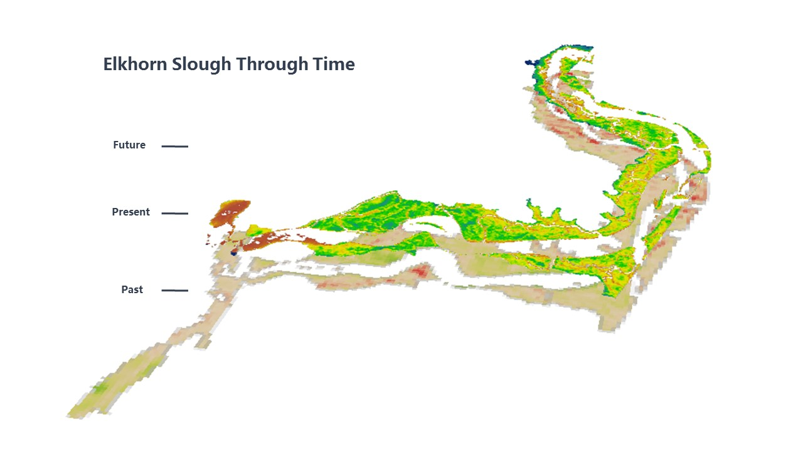

**Caption:** The Elkhorn Slough has experienced a dynamic past and is anticipated to change more in the future as the marsh continues to subside and sea level rises. This image captures the *past* changes in NDVI through Landsat imagery, *present* marsh vegetative health in NDVI through Sentinel 2A imagery and *future* marsh health predicted by the Marsh Equilibrium Model. Image Credit: Elkhorn Slough Ecological Forecasting II Team.

**Image:** 2016Fall_ARC_ElkhornSloughEcoII_VPSDraft.jpg