Midwest Water Resources II

Evaluating Evapotranspiration with NASA Earth Observations and *In Situ* Observations to Understand Water Balance in Midwest Agriculture

 **Technical Report**

Final – March 31st, 2022

Addison Pletcher (Project Lead)

Alec Solberg

Erin Shives

Max Rock

***Advisors:***

Dr. Olivier Prat, NOAA National Centers for Environmental Information, North Carolina Institute for Climate Studies (Science Advisor)

Dr. Brian Nelson, NOAA National Centers for Environmental Information (Science Advisor)

Molly Woloszyn, NOAA National Integrated Drought Information System (Science Advisor)

***Previous Contributors:***

Emma Myrick

Erica Barth-Naftilan

# 1. Abstract

Seasonal water variability in the midwestern United States extensively affects the agricultural community, as it impacts irrigation schedules, growing seasons, and overall ecosystem function. Evapotranspiration (ET) is a critical climatic variable in the water cycle and is used to evaluate spatiotemporal trends in drought and flood conditions. The NASA DEVELOP team partnered with the United States Department of Agriculture (USDA) Midwest Climate Hub, the Minnesota Department of Agriculture, the Illinois State Water Survey, and Michigan State University to compare remotely sensed ET products with *in situ* observations from January 2001 through December 2020. Remotely sensed actual ET (aET) data were sourced from NASA’s Terra Moderate Resolution Imaging Spectroradiometer (MODIS), and reference ET (refET) data were derived from the Gridded Surface Meteorological (gridMET) dataset. For *in situ* comparison, aET data were downloaded from the AmeriFlux database while refET data were collected from the Illinois Climate Network and Michigan State University’s Enviro-weather database. For a holistic assessment of ET, this project generated comparisons between remotely sensed and *in situ* observations, calculated descriptive statistics for validation between refET datasets, and spatially produced statistical validation maps regarding *in situ* sites. The temporal and spatial gaps of AmeriFlux data limited aET analysis. This comparative assessment of ET products across the Midwest can be used by project partners to assess regional water trends and guide future land management decisions.

**Key Terms**

reference evapotranspiration, actual evapotranspiration, MODIS, gridMET, drought

# 2. Introduction

***2.1 Background Information***

The Midwestern region of the United States is among the most intense agricultural production areas in the world, with a 2007 market value of over $76 billion, and it is of interest to consumers, policy makers, and local agencies alike (USDA, 2017). One factor essential to understanding water balance with respect to agriculture is evapotranspiration (ET), the total water vapor flux from Earth's surface to the atmosphere (Zhang et al., 2020). ET is a climatic variable critical to the hydrologic cycle that can be used to evaluate potential drought conditions and is momentous in its ability to link different interactions within the water cycle; as such, it has been referred to as the most important link in hydrological and atmospheric interactions (Hussain et al., 2019; Zhang et al., 2020). Currently, ET is used to inform hydroclimatic assessments, better understand drought propagation, allocate regional water budgets, make agronomic decisions, and assess climate change (Niyogi et al., 2020). ET guides management in water resources for agriculture and is key in understanding hydrologic responses of vegetation dynamics and changes in climate (Huo et al., 2013; Wang et al., 2020).

In the last 50 years, there has been a trend of decreasing ET in northwest China, India, and the United States (Hup et al., 2013; Zhang et al., 2020). We can expect ET patterns to become more variable over time, as a decrease in rainfall and increase in temperature will result in increased ET (Abtew & Melesse, 2013). In Midwest agriculture, the effects of climate change have already been translated to lengthened growing seasons, shifted patterns of precipitation, and increased frequency of extreme weather events easily influenced by even small changes in these categories, agriculture stands to take the brunt of the effects of climate change (USDA, 2017). For this reason, agricultural and water resource managers alike are interested in better understanding the role of ET. This project focused on several Midwestern states: Minnesota, Michigan, Ohio, Wisconsin, Iowa, Indiana, Illinois, Missouri, and Kentucky (Figure 1). The team’s study period spanned 20 years, from January 2001 to December 2021.

Reference ET (refET) is the ability of the atmosphere to remove water from a well-watered area, while actual ET (aET) is the ability of the atmosphere to remove water from the actual water-limited scenario (Niyogi et al., 2020). The aET variable is more difficult to estimate, as it requires accounting for more variables (Fetter, 2001). As a result, aET is primarily measured at *in situ* stations, limiting the availability of aET data across space. There are a variety of in situ methodologies used to measure ET, but none are currently recognized as a best practice for the gathering of ET data (Wang et al., 2020). Research suggests that remotely sensed aET products may allow for estimates across a larger spatial extent. For example, Niyogi et al. (2020) evaluated climatological trends of aET in Indiana, USA using the Moderate Resolution Imaging Spectroradiometer (MODIS) and compared these satellite sensor data with *in situ* measurements. Currently, the combination of *in situ* and remotely sensed data is the most robust scheme for spatiotemporal trend determination and has been used frequently in past years (Szewczak et al., 2020). While technological advances in remote sensing have greatly increased data availability, this is still an area of ongoing research (Niyogi et al., 2020; Zhang et al., 2020). In remotely sensed products, the Penman-Monteith equation is recognized as best for simulating ET values based off other atmospheric data (Wang et al., 2020).

Figure 1. Study area map with the USGS National Land Cover

Database across the study area.

***2.2 Project Partners & Objectives***

Partners involved in this project included: i) the United States Department of Agriculture (USDA) Midwest Climate Hub; ii) the National Oceanic and Atmospheric Administration (NOAA) National Integrated Drought Information System (NIDIS) Midwest Drought Early Warning System; iii) the Minnesota Department of Agriculture, Pesticide and Fertilizer Management Division; iv) the Michigan State University, Department of Geography, Environment, and Spatial Sciences; and v) the Illinois State Water Survey. The partners sought a better understanding of *in situ* versus remotely sensed ET data. The results of this project will aid in agricultural and natural resource managers’ decision making. The partners’ needs were closely considered while setting objectives for the project—a continuation of the NASA DEVELOP Midwest Water Resources I team’s work. Previously, an ET feasibility analysis was conducted using MODIS for aET and the Gridded Surface Meteorological (gridMET) dataset for refET. The team’s efforts allowed for comparison between datasets. Building off this work, project objectives were to: (1) evaluate remotely sensed ET products against *in situ* observations to assess product suitability in the Midwest, (2) analyze and illustrate ET during the 2012 drought throughout the Midwest, and (3) calculate and visualize statistics between *in situ* and remotely sensed products. This continuation allowed for the validation of remotely sensed data with *in situ* data, creating a more holistic and reliable product for end users.

# 3. Methodology

***3.1 Data Acquisition***

Niyogi et al. (2020) found that aET measurements derived from NASA’s Terra MODIS sensor can provide a reasonable estimation of aET. MODIS contains an ET data product, MOD16A2 Version 6, derived from the Penman-Montieth equation (Running et al., 2017). This remotely sensed product’s algorithm combines landcover, albedo, and meteorological inputs to create 500m SIN Grid 8-day composites of ET. MOD16A2 images span a complete temporal range from January 1st, 2001 to December 31st, 2020. This data provided the project’s estimates for remotely sensed aET. The University of Idaho’s gridMET dataset provided gridded meteorological data at a ~4 km spatial resolution and daily temporal resolution. Derived from the combination of high spatial resolution data from the Parameter-elevation Regressions on Independent Slopes Model (PRISM) and high temporal resolution from the National Land Data Assimilation System (NLDAS), gridMET yielded refET observations. This dataset aims to provide high resolution and spatiotemporally comprehensive climate data (Abatzoglou, 2013). The team acquired both MOD16A2 and gridMET observations using the Google Earth Engine (GEE) Python API.

For comparison to remotely sensed aET, the team selected *in situ* data stations from the AmeriFlux database, a network established by the U.S. Department of Energy’s (DOE) Terrestrial Carbon Program, the DOE’s National Institute of Global Environmental Change, NASA, the National Oceanic and Atmospheric Administration, and the U.S. Forest Service (AmeriFlux, 2022). *In situ* data stations provided a latent heat (LE) flux variable in watts per square meter, derived from the eddy covariance technique, measuring the exchange of heat from the Earth’s surface to atmosphere. The team acquired data from four AmeriFlux stations in Michigan (Table A1). Station data provided land cover classification of croplands and grasslands. For comparison to remotely sensed refET, the team collected refET measurements from several *in situ* stations. The Illinois Climate Network’s (ICN) Water and Atmospheric Resources Monitoring Program and Michigan State University’s Enviro-weather database contain archived data of ground-based measurements used to inform the public and policymakers on decision-making (Illinois State Water Survey, 2022; Enviro-weather, 2022; Tables A2 & A3). The stations selected (Figure 2) provided the refET variable estimated by the Penman-Montieth equation, allowing for a direct comparison to gridMET’s refET band (Allen et al., 1998). The *in situ* data selected from AmeriFlux, ICN, and Enviro-weather spanned from January 1st, 1990 to December 31st, 2021.

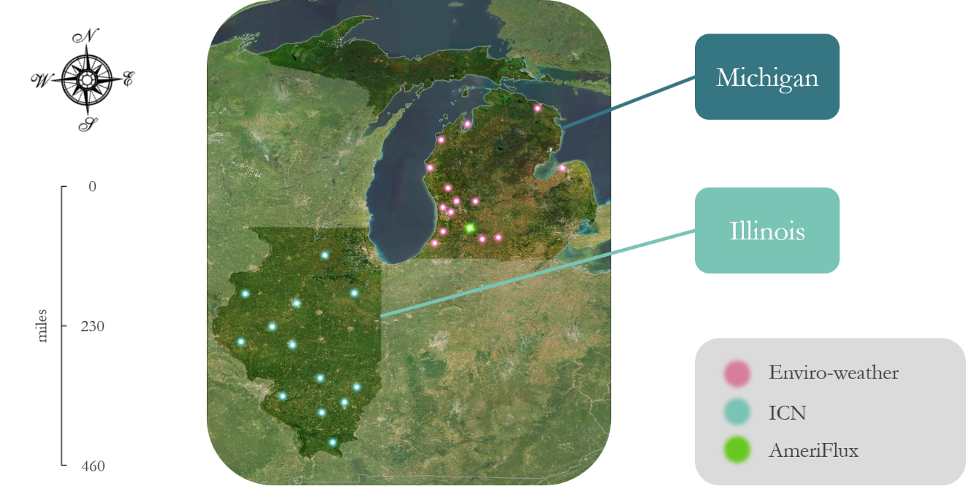

Figure 2. Midwestern locations of in situ data collection by four AmeriFlux stations in close proximity (green), Michigan State University’s Enviro-weather database (pink), and the Illinois Climate Network’s (ICN) Water and Atmospheric Resources Monitoring Program (blue).

***3.2 Data Processing***

As this was a continuation project, the previous term’s processed ET data were used for comparison between *in situ* data and the selected remotely sensed data products. MOD16A2 data were available at a 500m 8-day composite spatial and temporal resolution, while the gridMET dataset was at a ~4000m daily resolution. To enable comparison between datasets, the previous team standardized temporal and spatial resolution by data mining and resampling. Their composites start in January and end in December with only five or six days between composites depending on leap years. This prior data processing, conducted in GEE Python API, provided comparable datasets of gridMET and MOD16A2, which were built upon for this project’s comparison with *in situ* data using a point to pixel methodology.

Site data downloaded from the AmeriFlux database needed significant manipulation and cleaning. The team produced a GEE Python API script to streamline data processing of the *in situ* aET. In the raw AmeriFlux data, missing measurements were reported with a value of –9999. The team removed these values using replacement methodology to accurately visualize latent heat (LE) in watts per square meter (W/m2) over time. Once the site data fulfilled general LE format requirements of the project, with appropriate values and measurement frequency, the team summed the semi-hourly data and then averaged each unit to produce daily LE (W/m2) values. Finally, the team converted AmeriFlux station LE (W/m2) measurements to ET (mm/day) using Equation E1 (Allen et al., 1998; Holland, 2022). The MOD16A2 ET values are aggregated to mm/8-days from summing the ET for each day. The value should be compared to the average of the AmeriFlux data over the same 8 days. The comparison was not performed in this project because of gaps in the AmeriFlux data.

For *In situ* refET, the team collected data from the ICN and Enviro-weather databases. The team downloaded ICN and Enviro-weather data as text files and then converted to CSV files that required additional cleaning. The team produced a GEE Python API script to remove null values and format dates. The refET values in both datasets were given in mm/day, therefore the ICN/Enviro-weather to gridMET comparison can be made directly without unit conversion. Timeseries were plotted to ensure continuity. Figure 3 depicts the methodology followed by the team to meet project objectives.

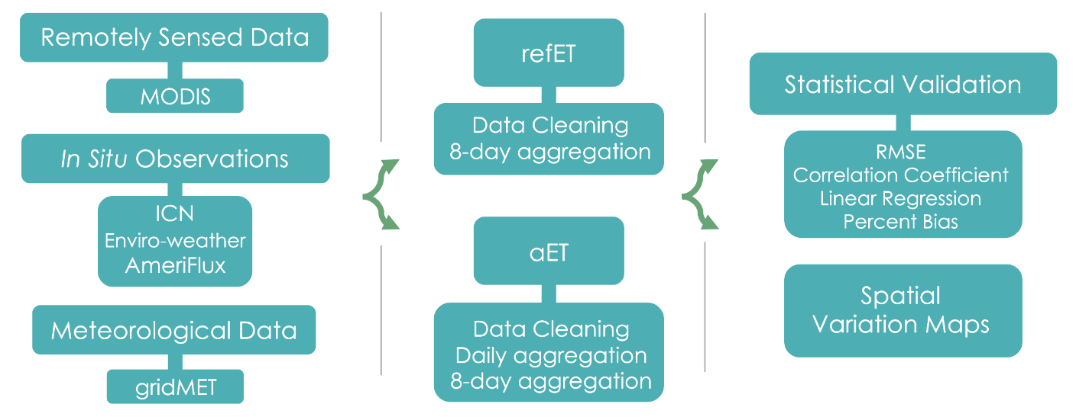

*Figure 3*.Workflow of methodology for comparison between remotely sensed and *in situ* products.

***3.3 Data Analysis***

This project’s first DEVELOP term produced climatology maps and timeseries highlighting comparisons, trends, and anomalies of ET in the Midwest. For this second term, these products were converted to 8-day aggregations using the GEE Python API. The team ran multiple statistical analyses on this term’s additional comparisons between *in situ* station data and remotely sensed ET products. Enviro-weather and ICN observations were compared with refET values from gridMET and aET values from MODIS were also compared with refET values from gridMET in a 2012 drought case study. The team calculated the correlation coefficients, root mean square error (RMSE), percentiles, overall bias, and slope of the linear regression analyses.

# 4. Results & Discussion

***4.1 Overview of Results***

The end products of this project include statistical analyses of comparisons between the remotely sensed products and *in situ* datasets. These consist of standard statistics (i.e., correlation coefficient, RMSE, slope of linear regression, and percent bias) as well as percentile data. The team also created a timeseries analysis of a 2012 drought case study. Additional products include analyses of the 2012 drought, as well as spatial distribution maps of selected statistics for *in situ* sites. The results of the time series display high values of aET and refET in summer of 2012. While there are many indicators of drought such as temperature, streamflow, and snowpack, ET is a significant component to the analysis of drought. High refET and low aET measurements indicate the presence of drought conditions affecting the Midwest region. The analysis of the 2012 case study highlighted the relationship between ET and flash droughts, illustrating the potential impacts of such events on agricultural production.

***4.1.1 Statistical Analysis***

To determine whether *in situ* data validated the accuracy of remotely sensed data, the team calculated statistics including RMSE, percent bias, correlation coefficient, and slope of regression (Appendices B & C). Due to limited data availability with temporal and spatial gaps, the team was unable to perform statistical analyses for AmeriFlux and MODIS comparisons. For consistency between previously obtained remotely sensed dataset calculations from the first term, dates were selected from 2012 to 2021. Both ICN and Enviro-weather data showed strong correlation with gridMET observations (Table C2). The slope of regression shows a consistent increase in both *in situ* refETand the gridMET values (Figure B2). The RMSE is low, further providing evidence to this point (Figure B1). Percent bias is very different between the two *in situ* datasets, ICN and Enviro-weather (Figure B3). High percent bias in ICN data was localized to primarily one site, while Enviro-weather’s distribution throughout the state shows no clear pattern emerging (Figure 4). Overall, percent bias is consistently low, indicating the data is statistically a good fit to the remotely sensed data from gridMET. Between the two *in situ* sources, ICN appears to be in better agreement with gridMET. However, land cover varied greatly between the *in situ* station locations and could explain the observed variability. Uniform fields of crops found in Illinois differ from Michigan's greatly varied landscape and mixed land cover, providing further evidence to this point. Although there appears to be strong correlation between gridMET and *in situ* data, gridMET values are higher than those of the *in situ* stations (Tables C2 & C3).

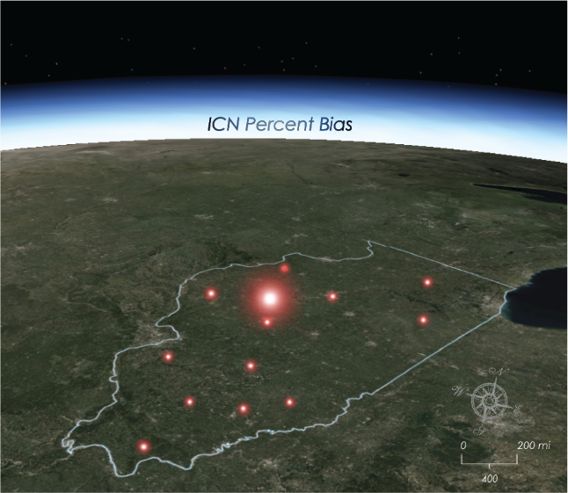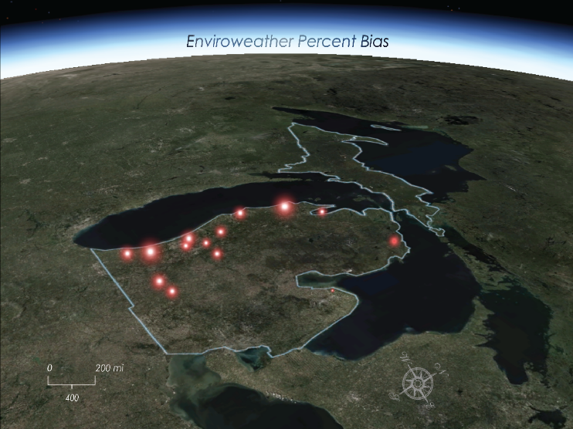

The World Imagery (Firefly) basemap is credited to Esri, Maxar, Earthstar Geographics, and the GIS User Community.

Figure 4. RefET percent bias mapped by in situ data collection site.

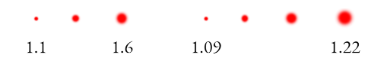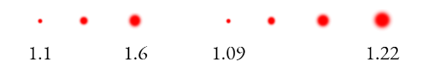

In addition to standard statistics, the team plotted refET by dataset percentile in order to elaborate further on gridMET and *in situ* comparisons (Figures D1-D4). ICN tended to have higher percentile distributions of values than Enviro-weather. Percentile distributions of extracted gridMET values from ICN locations also tended to have higher percentile distributions than the extracted gridMET values from Enviro-weather. These consistencies show that gridMET values are higher than *in situ* values when comparing percentile distributions. *In situ* station and gridMET data were also analyzed by landcover type to examine landcover influences on the distributions of data. The team focused on corn and soybeans because they are major crops of the Midwest. Corn and soybean percentiles show the same distributions as the overall distributions without landcover. Corn percentiles combined with soybean percentiles on a single graph have corn percentile distributions at higher values than soybean (Appendix D). This was due to corn having a higher demand for water resources than soybean because of the crop’s greater release of water (i.e., greater refET values). Landcover and the overall percentiles act as a qualitative comparison for this analysis, which highlights water resource priority in agriculture productivity.

***4.1.2 2012 Case Study***

In the spring of 2012, the Midwest endured a rainfall deficit. The resulting flash drought event, considered a “100-year drought” devastated agricultural productivity and resulted in a loss of 40 billion dollars nationwide (Fetter, 2020). Categorized as an exceptional drought, the low crop yields and forage production led to water shortages and extreme water conservation measures. The onset of this flash drought began in the early summer, leaving the landscape to experience severe water loss during the next two months.

MODIS-derived aET levels were very low, around 21 mm/8-days, for much of the area on the week of April 6th (Figure 5). In contrast, June shows the onset of drought conditions with high aET values reaching a maximum of 77 mm/8-days. As the summer season continued to August, most of the region’s water had already released into the atmosphere, resulting in a decrease of aET rates. Selected dates from the AmeriFlux database were compiled to display the impact of the flash drought during the early summer (Figure E1). The Michigan sites show trends consistent with MODIS’s remotely sensed aET values, producing high measurements of ET during the onset of the drought followed by a gradual decrease over time.

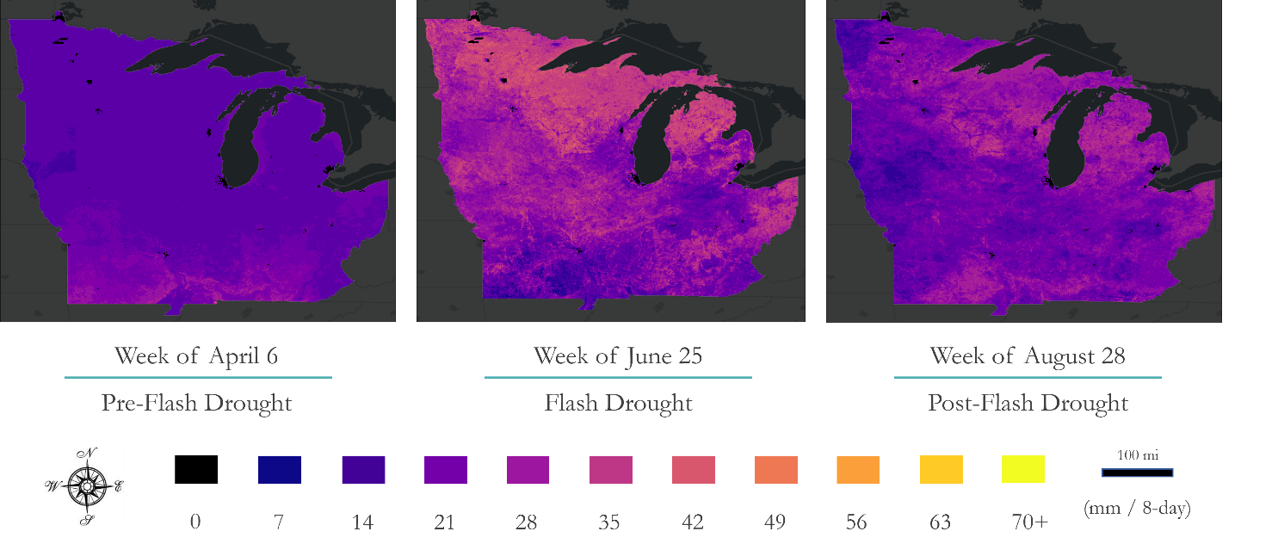

Figure 5. MODIS-derived aET before, during, and after the 2012 flash drought.

The team also compared aET and refET across the case study timeframe (Figure 6). The composite images in comparison display 8-day composites with a start date of June 25th chosen to highlight the higher values of ET during the onset of the drought. The yellow symbology represents values upward of 70 mm/8-day which can be seen abundantly in the Southwest corner of the refET map. Accompanying the composite images, the timeseries displays MODIS aET and gridMET refET values from April through September of 2012. Specifically, this timeseries illustrates the drastic onset of the drought occurring during the early summer months as a result of the region experiencing limited water availability.

***4.2 Discussion***

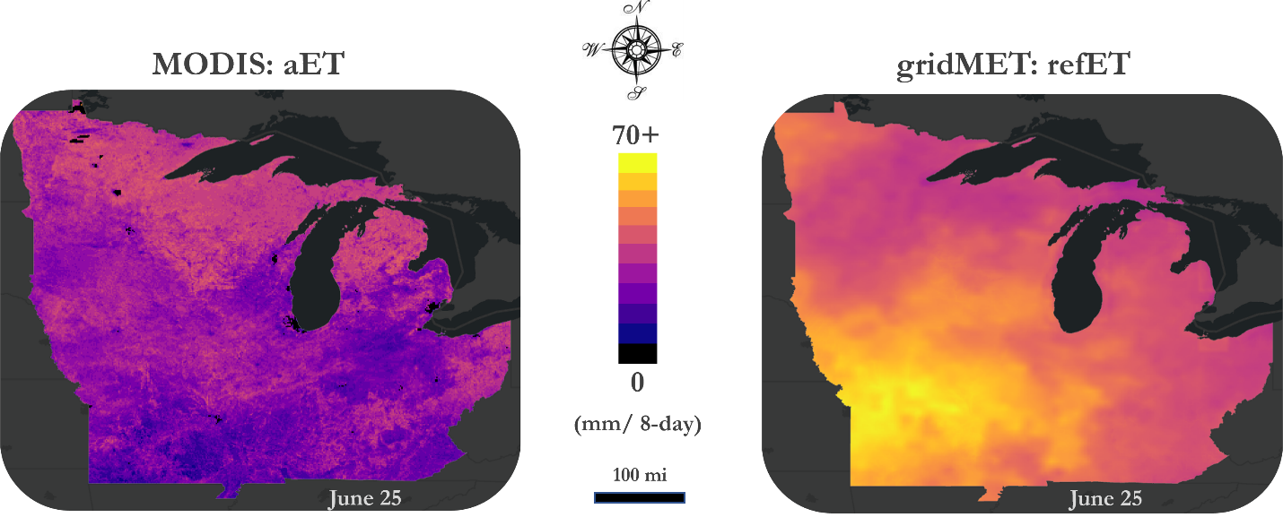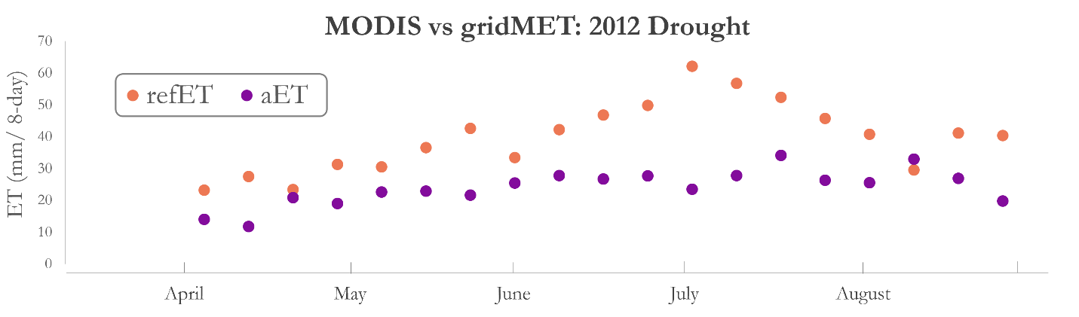

Figure 6. 2012 case study refET and aET comparison and accompanying timeseries.

The Midwest region of the US is surrounded by freshwater bodies, but not all areas have freshwater sources in such proximity. In arid to semi-arid regions where water is even more limited, ET information can help understand the environmental context with a larger goal of improving water use efficiency, by extension impacting food security and local or regional economies that rely on agriculture (Wang et al., 2020). ET also has a part to play in preventing further desertification of arid regions. In such areas, even small changes in temperature and precipitation can have a significant effect on water balance (Huo et al., 2013). ET can also be used to better understand the new environments we face with a warming climate. By tracking ET over space and time, we can understand a region's response to climate change, agricultural practices, or potential mitigation strategies (Zhang et al., 2020).

ICN and Enviro-weather had little to no data gaps of refET, so only a few stations were removed from analysis and the team could perform statistical analyses on these *in situ* refET observations with those derived from gridMET. ICN and Enviro-weather have similar correlation coefficients, around .90, which suggests both datasets are in agreement with gridMET observations. Additionally, ICN and Enviro-weather consistently have positive slopes of regression indicates both *in situ* datasets are positively related with gridMET observations.

ICN and Enviro-weather agree with measurements from gridMET but exhibit slight variation in bias (Table C1). This suggests that landcover may have influenced the variation of bias across both *in situ* station datasets. Although gridMET is strongly correlated to *in situ*, gridMET poorly predicts *in situ* values; the high RMSE suggests the model was not accounting for characteristics unique to each *in situ* datasets. Percentiles for landcover were plotted for ICN, Enviro-weather, and gridMET. Enviro-weather has a lower range of refET values for corn and soybean than ICN. Corn landcover has a higher percentile distribution than soybean which suggests soybeans have a higher demand for resources than corn does.

***4.3 Limitations***

The project was inherently limited by the temporal and spatial resolutions of MODIS and gridMET. Gaps in MODIS data were especially notable during times of high albedo or in areas with limited vegetation cover. This data loss is documented for the MODIS product and associated with missing or flagged data throughout the yearly data collection despite instrumental gap filling algorithms within the product. Although limitations exist, the framework created for data mining and re-sampling allowed for comparison of ET between the two products.

The team endured a complex trial and error process to retrieve accurate AmeriFlux data. Originally, MODIS and AmeriFlux data were to be transformed into comparable aET values for statistical analysis, but AmeriFlux station data gaps were too large for deriving these statistics without bias. In the initial steps, the team downloaded latent heat flux data, provided in watts per square meter in semi-hourly format, from sites within our study area for the full study period between 2012 and 2021. Timestamps were originally in a 9-digit format; these timestamps were manipulated in a Python API and plotted. Once plotted, clear outliers and null data values resulted in most of the data, on a long-term scale, being unusable and limiting the team’s ability to conduct statistical analyses. A new approach was taken, and the team selected temporal ranges that contained fewer missing data. Data from this selection was cleaned and converted from latent heat in watts per square meter to aET in mm per day. If aggregated to mm/8-day, comparison of AmeriFlux with MOD16A2 ET is possible but was not performed in this project due to limited availability of AmeriFlux data.

AmeriFlux data uncertainty arose from the large temporal gaps and outlier values occurring throughout both day and night. These values were corrected for the case study, however, this still resulted in some loss of data. Null values exist within the data for any selected year, day or night within the dataset. This missing data highlighted the importance of identifying temporal ranges containing as few null values as possible. Even a few hours in the middle of one single day is significant to lose, but AmeriFlux has gaps that span over weeks at a time. For instance, in Bondville, 74,253 values are missing from a total of 227,952, resulting in 30.6% of missing values from this site (Figure 7).

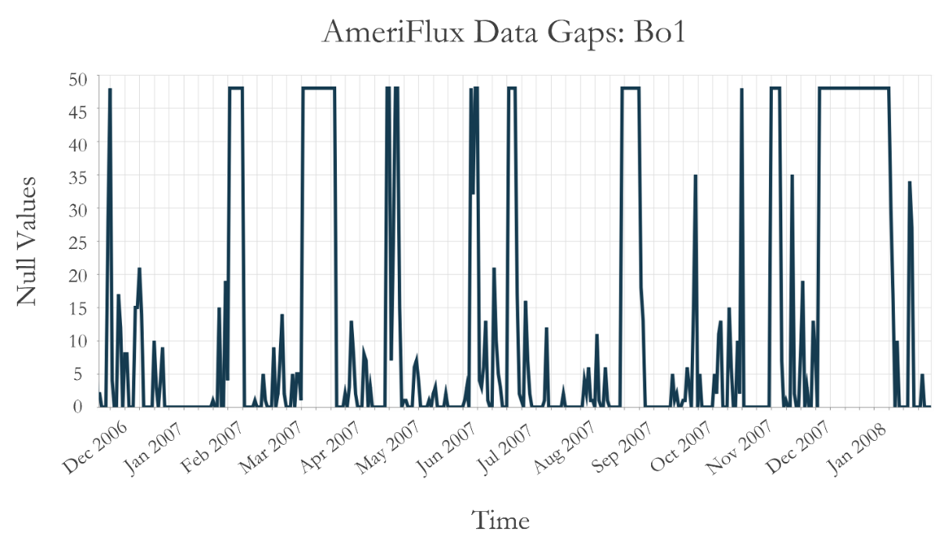

*Figure 7*.Time series of null value quantity from AmeriFlux Bondville (Bo1) site.

***4.4 Future Work***

Measuring aET has gained traction within the past decade and is giving way to new datasets and methodologies. NASA’s Earth-observing Landsat program contains a variety of satellites and bands applicable to quantifying aET. Additionally, the product OpenET provides aET calculations at a monthly timestep. However, with this project’s focus being *in situ* data comparisons, the Landsat and OpenET datasets would have required complex processing and troubleshooting. Currently, OpenET is not available in the Midwest region and only produces monthly data, but there are plans to produce daily data in the near future. Such updates could be utilized in the continuation of this work to quantify aET, calculate spatiotemporal variability, and compare to *in situ* observations.

This research can also be expanded through quantification of ET measurements by crop type and growing cycles. A calculation of seasonal ET variation with respect to crop type would provide insight on the ET response to specific agricultural practices.

# 

# 5. Conclusions

This project’s findings provided a more holistic picture of evaluating ET in the Midwest. With refET, there is a strong statistical correlation between data derived from gridMET and the *in situ* sites of Enviro-weather and ICN. Additionally, percent bias analyses proved the ICN datasets agree more closely than Enviro-weather to gridMET; this could be due to more diverse land cover types at the Enviro-weather stations. In terms of aET, the workflow and application of AmeriFlux data allowed for further understanding of the complexities of using *in situ* observations over a large temporal range. This climatological analysis of ET provides information for our partners to include in monthly climate webinars, drought reports, and recommendations to agricultural and natural resource managers.

Previous studies suggest extreme droughts will continue to occur more frequently in the foreseeable future, emphasizing the importance of using both remotely sensed and *in situ* products as a resource for monitoring ET. NASA Earth observations provide data to conduct this research both qualitatively and quantitatively. This project evaluated satellite and *in situ* ET products that can enhance our understanding of water resources and support future water and food security in local communities.

# 6. Acknowledgments

The Midwest Water Resources II team would like to thank the following individuals for their continued support and guidance throughout this term, each of whom was imperative to the success of the project.

* Katie Lange (NASA DEVELOP National Program)
* Dr. Olivier Prat (NCEI, North Carolina Institute for Climate Studies)
* Dr. Brian Nelson (NCEI, North Carolina Institute for Climate Studies)
* Dr. Dennis Todey (USDA Midwest Climate Hub),
* Molly Woloszyn (NOAA, NIDIS, Midwest Drought Early Warning System)
* Dr. Jeppe Kjaersgaard (Minnesota Department of Agriculture)
* Dr. Jeffery Andresen (Michigan State University, Department of Geography)
* Dr. Trenton Ford (Illinois State Water Survey)
* Dr. Jennie Atkins (Illinois State Water Survey)

Any opinions, findings, and conclusions or recommendations expressed in this material are those of the author(s) and do not necessarily reflect the views of the National Aeronautics and Space Administration.

This material is based upon work supported by NASA through contract NNL16AA05C.

# 7. Glossary

**Earth observations** – Satellites and sensors that collect information about the Earth’s physical, chemical, and biological systems over space and time

**Evaporation** – The process by which water changes from a liquid form to gas vapor; the primary pathway liquid water moves back into the atmosphere in the water cycle

**Evapotranspiration (ET)** – The sum of water lost to the atmosphere by evaporation and transpiration

**aET** – Actual evapotranspiration, defined as the amount of ET that occurs under true field conditions

**refET** – Reference evapotranspiration, defined as the amount of ET from a well-watered grass or crop field surface

**gridMET** – Gridded Surface Meteorological dataset

**MODIS** – Moderate Resolution Imaging Spectroradiometer

**100-year drought** – a severe drought that has a probability of occurring once in every 100 years

**Transpiration** – The evaporation of water from plant stomata

# 8. References

Abatzoglou, J. T. (2011). Development of gridded meteorological data for ecological applications and modeling*. International Journal of Climatology*, *31*(1), 121–131. http://dx.doi.org/10.1002/joc.3413

Abtew, W., & Melesse, A. (2013). Climate Change and Evapotranspiration. *Evaporation and Evapotranspiration*. Springer, Dordrecht. https://doi.org/10.1007/978-94-007-4737-1_13

Allen, R., Pereria, L., Raes, D., & Smith, M. (1998). Crop evapotranspiration – Guidelines for computing crop water requirements. *Food and Agriculture Organization of the United States Irrigation and Drainage Paper 56*. https://www.fao.org/3/X0490E/x0490e00.htm#Contents

Fetter, C. W. (2001). Elements of the Hydrologic Cycle. *Applied Hydrogeology.* Prentice Hall. Upper Saddle River, N.J., (pp. 28-32).

Holland, R. (2022, May 27). *FAQ’s*. Land Data Assimilation System. https://ldas.gsfc.nasa.gov/faq/ldas

Huo, Z., Dai, X., Feng, S., Kang, S., & Huang, G. (2013). Effect of climate change on reference evapotranspiration and aridity index in arid region of China. *Journal of Hydrology*, *492*, 24–34. https://doi.org/10.1016/j.jhydrol.2013.04.011

Hussain, Z. M., Hamilton, S. K., Bhardwaj, A. K., Basso, B., Thelen, K. D., & Robertson, G. P. (2019). Evapotranspiration and water use efficiency of continuous maize and maize and soybean in rotation in the upper Midwest U.S. *Agricultural Water Management*, *221*, 92–98. https://doi.org/10.1016/j.agwat.2019.02.049

Niyogi, D., Jamshidi, S., Smith, D., & Kellner, O. (2020). Evapotranspiration climatology of Indiana using in situ and remotely sensed products. *Journal of Applied Meteorology and Climatology*, *59*(12), 2093–2111.

Running, S., Mu, Q., & Zhao, M. (2017). *MOD16A2 MODIS/Terra Net Evapotranspiration 8-Day L4 Global 500m SIN Grid* (V006) [Data set]. NASA EOSDIS Land Processes DAAC. Accessed 2021-10-06 from https://doi.org/10.5067/MODIS/MOD16A2.006

Szewczak, K., Łoś, H., Pudełko, R., Doroszewski, A., Gluba, Ł., Łukowski, M., Rafalska-Przysucha, A., Słomiński, J., & Usowicz, B. (2020). Agricultural drought monitoring by MODIS potential evapotranspiration remote sensing data application. *Remote Sensing*, *12*(20), Article 3411. http://dx.doi.org/10.3390/rs12203411

United States Department of Agriculture. (2017). *Agriculture in the Midwest.* https://www.climatehubs.usda.gov/hubs/midwest/topic/agriculture-midwest

Wang, H., Li, X., & Tan, J. (2020). Interannual variations of evapotranspiration and water use efficiency over an oasis cropland in arid regions of North-Western China. *Water*, *12*(5), Article 1239. http://dx.doi.org/10.3390/w12051239

Zhang, F., Geng, M., Wu, Q., & Liang, Y. (2020). Study on the spatial-temporal variation in evapotranspiration in China from 1948 to 2018. *Scientific Reports*, *10*(1), Article 17139. https://doi.org/10.1038/s41598-020-74384-3

# Appendix A

*Table A1*.Selected AmeriFlux stations within the state of Michigan.

|  |  |  |  |
| --- | --- | --- | --- |
| **State** | **Site ID** | **Station Name** | **Period of Record** |
| **MI** | US-KL1 | KBS Lux Arbor Reserve Corn | 2009 - 2020 |
| US-KL3 | KBS Lux Arbor Reserve Prairie | 2009 - 2020 |
| US-KM2 | KBS Marshall Farms Prairie | 2009 - 2020 |
| US-KM3 | KBS Marshall Farms Switchgrass | 2009 - 2020 |

*Table A2*. Selected ICN stations within the state of Illinois.

|  |  |  |  |
| --- | --- | --- | --- |
| **State** | **Site ID** | **Station Name** | **Period of Record**  **(start)** |
| **IL** | FRM | Belleville | 11/16/1989 |
| BRW | Brownstown | 8/25/1989 |
| DEK | DeKalb | 1/1/1989 |
| DXS | Dixon Springs | 2/9/1990 |
| FAI | Fairfield | 9/14/1991 |
| MON | Monmouth | 7/21/1989 |
| OLN | Olney | 8/24/1989 |
| ORR | Perry | 7/1/1989 |
| RND | Rend Lake | 3/18/1990 |
| LLC | Springfield | 1/1/1989 |
| STE | Stelle | 1/1/1989 |

*Table A3*. Selected Enviro-weather stations within the state of Michigan.

|  |  |  |  |
| --- | --- | --- | --- |
| **State** | **Site ID** | **Station Name** | **Period of Record** |
| **MI** | SPO | Sparta | 1996 - 2022 |
| HAW | Hawks | 1999 - 2022 |
| ALB | Albion | 2000 - 2022 |
| BEL | Belding | 2000 - 2022 |
| CER | Ceresco | 2000 - 2022 |
| FRM | Fremont | 2000 - 2022 |
| GRJ | Grand Junction | 2000 - 2022 |
| OLD | Old Mission | 2000 - 2022 |
| PIG | Pigeon | 2000 - 2022 |
| BBC | Bainbridge | 2001 - 2022 |
| BNZ | Benzonia | 2001 - 2022 |
| HVL | Hudsonville | 2001 - 2022 |
| WEO | West Olive | 2001 - 2022 |
| LDT | Ludington | 2002 - 2022 |

# Appendix B

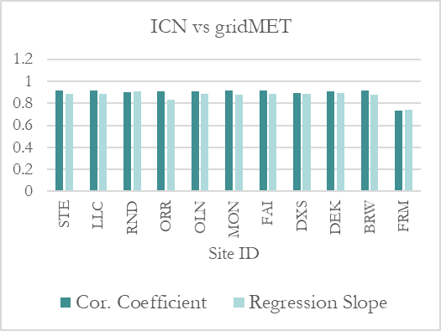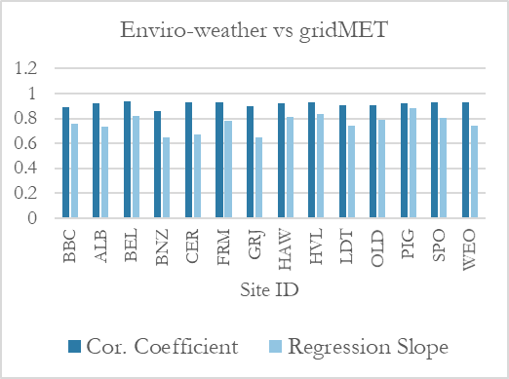

Figure B2. Statistics for selected sites showing correlation and regression between in situ sites versus gridMET.

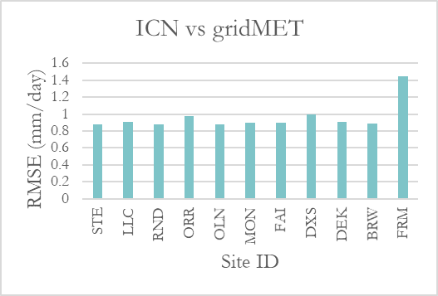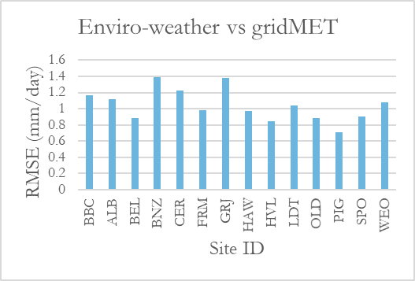

Figure B1. Statistics for selected sites showing root mean square error between in situ sites versus gridMET.

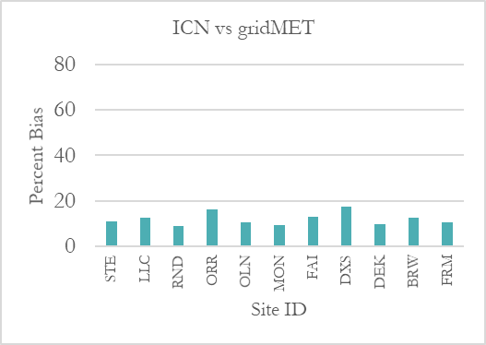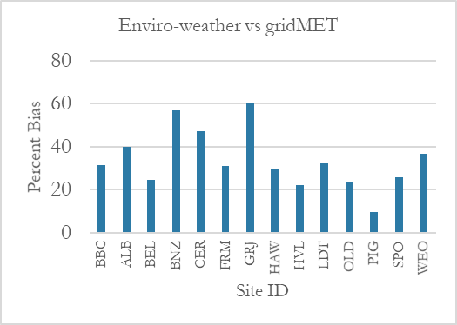

Figure B3. Statistics for selected sites showing percent bias between in situ sites versus gridMET.

# Appendix C

*Table C1*.Statistics for selected *in situ* sites versus gridMET.

|  |  |  |  |  |  |
| --- | --- | --- | --- | --- | --- |
|  | **Site ID** | **Correlation Coeff.** | **RMSE** | **Slope of Regression** | **Percent Bias** |
| ICN vs. gridMET | STE | 0.914 | 0.88 | 0.884 | 1.11 |
| LLC | 0.916 | 0.905 | 0.883 | 1.126 |
| RND | 0.904 | 0.879 | 0.906 | 1.09 |
| ORR | 0.906 | 0.981 | 0.832 | 1.163 |
| OLN | 0.91 | 0.88 | 0.888 | 1.106 |
| MON | 0.913 | 0.895 | 0.882 | 1.093 |
| FAI | 0.915 | 0.896 | 0.887 | 1.129 |
| DXS | 0.893 | 0.993 | 0.884 | 1.176 |
| DEK | 0.908 | 0.906 | 0.894 | 1.097 |
| BRW | 0.914 | 0.889 | 0.877 | 1.125 |
| FRM | 0.736 | 1.452 | 0.74 | 1.107 |
| Enviro-weather vs. gridMET | ALB | 0.922 | 1.115 | 0.731 | 1.399 |
| BEL | 0.935 | 0.882 | 0.817 | 1.246 |
| CER | 0.93 | 1.223 | 0.676 | 1.471 |
| FRM | 0.929 | 0.983 | 0.784 | 1.312 |
| GRJ | 0.895 | 1.383 | 0.65 | 1.599 |
| HAW | 0.919 | 0.974 | 0.811 | 1.294 |
| OLD | 0.907 | 0.879 | 0.789 | 1.232 |
| PIG | 0.924 | 0.71 | 0.884 | 1.096 |
| SPO | 0.931 | 0.906 | 0.801 | 1.258 |
| WEO | 0.93 | 1.077 | 0.738 | 1.365 |

*Table C2*. Statistics for selected *in situ* sites.

|  |  |  |  |  |  |  |  |  |
| --- | --- | --- | --- | --- | --- | --- | --- | --- |
|  | **Site ID** | **Mean** | **Std. Dev.** | **Min.** | **25th Percentile** | **50th Percentile** | **75th Percentile** | **Max.** |
| ICN | STE | 2.727 | 1.955 | 0 | 1.016 | 2.286 | 4.318 | 8.382 |
| LLC | 2.931 | 1.972 | 0 | 1.27 | 2.54 | 4.572 | 7.874 |
| RND | 2.977 | 1.908 | 0 | 1.27 | 2.794 | 4.572 | 8.128 |
| ORR | 2.819 | 1.877 | 0 | 1.27 | 2.54 | 4.318 | 8.128 |
| OLN | 2.932 | 1.914 | 0 | 1.27 | 2.54 | 4.572 | 8.382 |
| MON | 2.828 | 2.009 | 0 | 1.016 | 2.54 | 4.572 | 8.89 |
| FAI | 3.01 | 1.92 | 0 | 1.27 | 2.794 | 4.572 | 8.128 |
| DXS | 2.853 | 1.841 | 0 | 1.27 | 2.54 | 4.318 | 7.62 |
| DEK | 2.682 | 2.008 | 0 | 0.762 | 2.286 | 4.318 | 9.398 |
| BRW | 2.905 | 1.903 | 0 | 1.27 | 2.54 | 4.572 | 8.636 |
| FRM | 3.052 | 1.953 | 0 | 1.27 | 2.794 | 4.572 | 8.382 |
| Enviro-weather | ALB | 2.006 | 1.509 | 0.102 | 0.635 | 1.651 | 3.207 | 6.248 |
| BEL | 2.182 | 1.7 | 0.102 | 0.66 | 1.702 | 3.531 | 7.137 |
| CER | 1.938 | 1.406 | 0.102 | 0.66 | 1.626 | 3.073 | 6.629 |
| FRM | 2.11 | 1.627 | 0.102 | 0.635 | 1.676 | 3.429 | 7.137 |
| GRJ | 1.758 | 1.363 | 0.076 | 0.584 | 1.372 | 2.718 | 7.468 |
| HAW | 2.059 | 1.703 | 0.076 | 0.559 | 1.473 | 3.429 | 6.96 |
| OLD | 1.977 | 1.546 | 0.102 | 0.635 | 1.524 | 3.15 | 6.579 |
| PIG | 2.261 | 1.687 | 0.127 | 0.787 | 1.778 | 3.581 | 8.661 |
| SPO | 2.166 | 1.647 | 0.127 | 0.66 | 1.753 | 3.556 | 6.756 |
| WEO | 2.079 | 1.55 | 0.102 | 0.686 | 1.651 | 3.327 | 7.595 |

*Table C3*.Statistics for gridMET values from selected *in situ* site locations.

|  |  |  |  |  |  |  |  |  |
| --- | --- | --- | --- | --- | --- | --- | --- | --- |
|  | **Site ID** | **Mean** | **Std. Dev.** | **Min.** | **25th Percentile** | **50th Percentile** | **75th Percentile** | **Max.** |
| gridMET | STE | 3.028 | 2.021 | 0.048 | 1.2 | 2.799 | 4.7 | 12.386 |
| LLC | 3.301 | 2.046 | 0.08 | 1.479 | 3.148 | 4.957 | 14.237 |
| RND | 3.244 | 1.904 | 0.084 | 1.5 | 3.124 | 4.8 | 11.045 |
| ORR | 3.278 | 2.044 | 0.067 | 1.495 | 3.1 | 4.9 | 14.83 |
| OLN | 3.243 | 1.962 | 0.043 | 1.5 | 3.124 | 4.88 | 11.464 |
| MON | 3.091 | 2.08 | 0.047 | 1.2 | 2.852 | 4.752 | 14.045 |
| FAI | 3.398 | 1.981 | 0.088 | 1.6 | 3.3 | 5 | 12.256 |
| DXS | 3.355 | 1.859 | 0.1 | 1.684 | 3.3 | 4.934 | 8.792 |
| DEK | 2.943 | 2.041 | 0.043 | 1.1 | 2.642 | 4.54 | 12.411 |
| BRW | 3.27 | 1.984 | 0.055 | 1.5 | 3.1 | 4.871 | 12.934 |
| FRM | 3.377 | 1.942 | 0.1 | 1.6 | 3.3 | 4.928 | 11.487 |
| ALB | 2.806 | 1.905 | 0 | 1.093 | 2.519 | 4.35 | 10.345 |
| BEL | 2.719 | 1.945 | 0.04 | 0.958 | 2.3 | 4.3 | 10.744 |
| CER | 2.851 | 1.936 | 0 | 1.1 | 2.577 | 4.405 | 10.247 |
| FRM | 2.767 | 1.927 | 0.032 | 1 | 2.4 | 4.353 | 9.764 |
| GRJ | 2.811 | 1.877 | 0 | 1.107 | 2.404 | 4.4 | 9.023 |
| HAW | 2.664 | 1.931 | 0 | 0.932 | 2.2 | 4.2 | 8.7 |
| OLD | 2.435 | 1.777 | 0 | 0.878 | 2 | 3.825 | 8.222 |
| PIG | 2.477 | 1.763 | 0 | 0.9 | 2.1 | 3.9 | 9.283 |
| SPO | 2.726 | 1.913 | 0 | 0.984 | 2.4 | 4.3 | 10.562 |
| WEO | 2.838 | 1.953 | 0 | 1.093 | 2.4 | 4.468 | 10.338 |

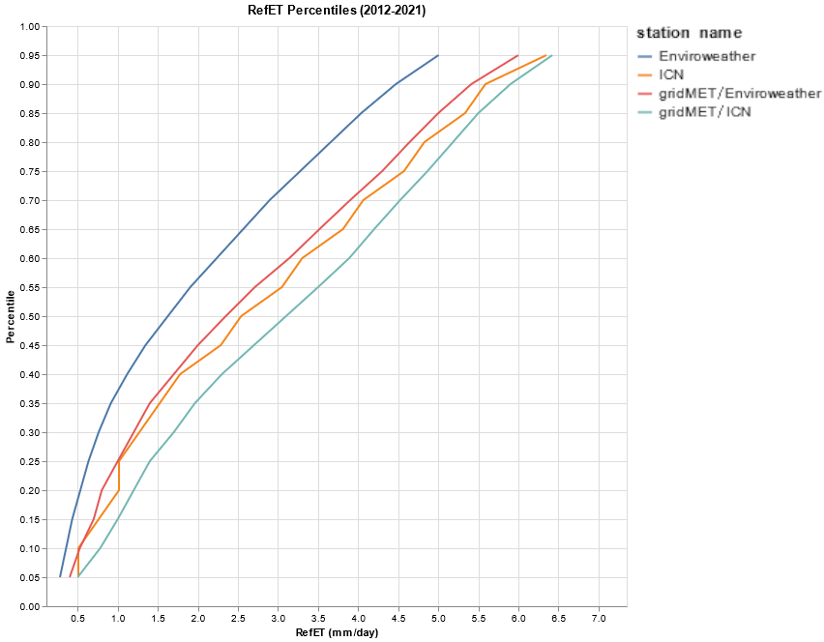**Appendix D**

*Figure D1*.Reference ET percentile graph for all ICN and Enviro-weather stations with all gathered gridMET values from the *in situ* locations.

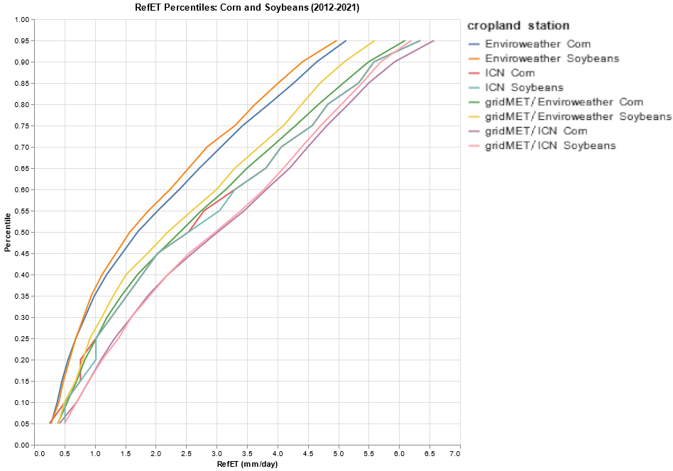

*Figure D2*.Corn and Soybean reference ET percentile graph for ICN and Enviro-weather stations with gathered gridMET values from the *in situ* locations.

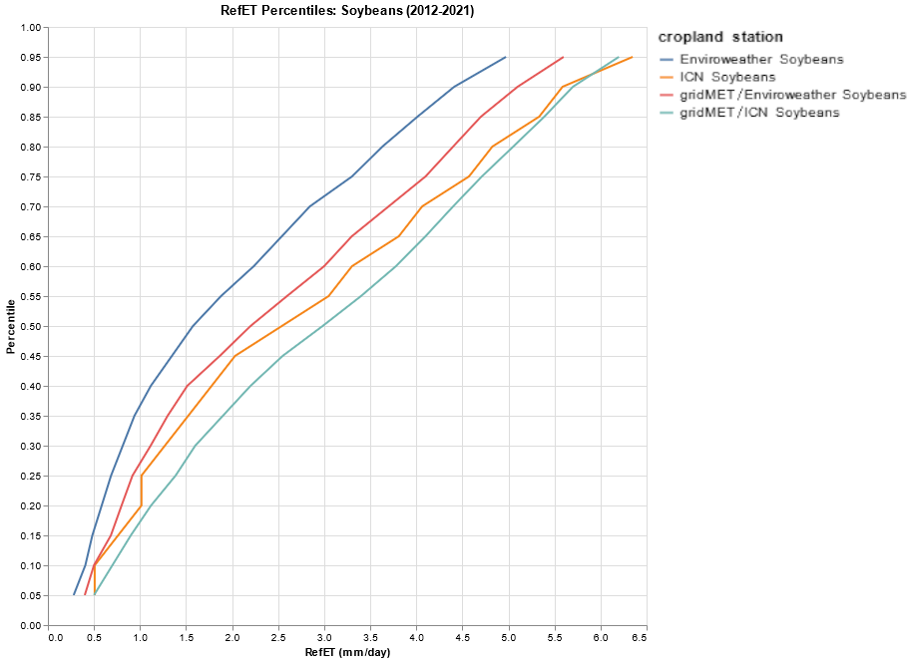

*Figure D3*.Soybean reference ET percentile graph for ICN and Enviro-weather stations with gathered gridMET values from the *in situ* locations.

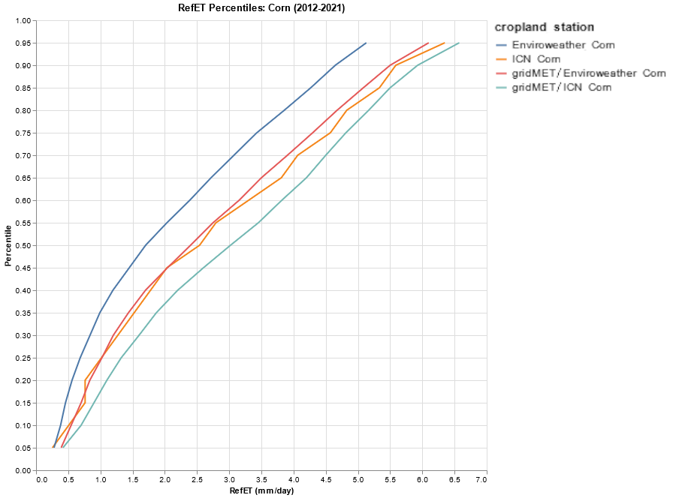

*Figure D4*.Corn reference ET percentile graph for ICN and Enviro-weather stations with gathered gridMET values from the *in situ* locations.

**Appendix E**

The team converted AmeriFlux station LE (W/m2) measurements to ET (mm/day) using Equation E1 (Allen et al., 1998; Holland, 2022).

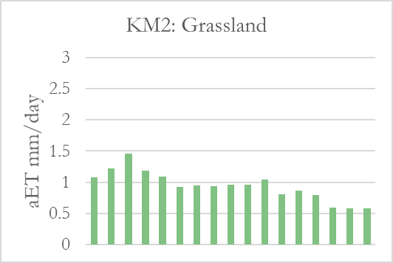

June 25th – July 12th

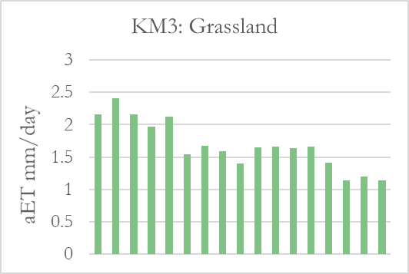

June 25th – July 12th

June 9th – June 30th

June 9th – June 30th

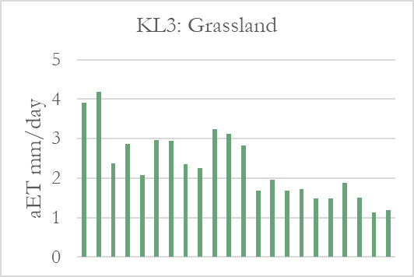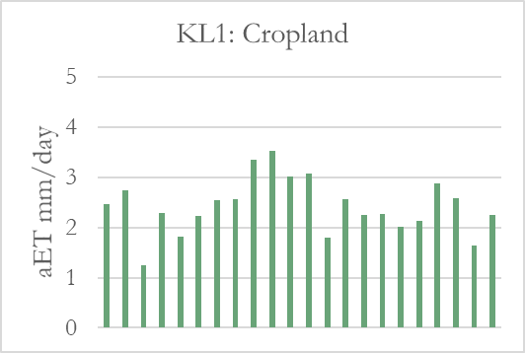

Figure E1. Derived from Michigan AmeriFlux in situ stations, decreasing rates of in situ aET correspond with the 2012 case study flash drought.