**NASA DEVELOP National Program**



University of Georgia

*Spring 2017*

Eastern India Ecological Forecasting II

A Multi-Sensor Approach to Enhance the Prediction of Mangrove Biophysical Characteristics in Chilika Lagoon and Bhitarkanika Wildlife Sanctuary, Odisha, India

**Technical Report**

Final Draft – March 30, 2017

Abhishek Kumar (Project Lead)

Roger Bledsoe

Christopher Cameron

Subash Dahal

María José Rivera Araya

Caren Remillard

Austin Stone

Deepak Mishra, University of Georgia, Department of Geography (Science Advisor)

Previous Contributors:

Jessica Staley

Patricia Stupp

# 1. Abstract

Mangroves, one of the most productive ecosystems on Earth, play a major role in coastal ecosystem processes from mitigating erosion to acting as a barrier against tidal and storm surges associated with tropical cyclones. India has about 5 % of the world’s mangrove vegetation, and over half of which is found along the east coast of the country. Chilika Lagoon and Bhitarkanika Wildlife Sanctuary are Ramsar sites of international wetland importance, situated in the state of Odisha along the east coast of India. Chilika Lagoon holds three small, but distinct mangrove patches, while Bhitarkanika Wildlife Sanctuary has several large, dense patches of mangroves. There is growing concern for the effective management and conservation of these mangrove forests. This study demonstrated the use of a suite of satellite data (Terra, Landsat, and Sentinel-1) for meeting the following objectives: 1. Derive a long-term spatio-temporal phenological maps of the biophysical parameters (chlorophyll, leaf area index, gross primary productivity, and evapotranspiration); 2. Analyze long-term spatio-temporal variability of physical and meteorological parameters; 3. Document decadal changes in mangroves area estimates starting from 1995 to 2017 using Landsat and radar data. The time series developed in this study revealed a phenological pattern for mangrove biophysical characteristics. Historical analysis of land cover maps indicated decrease in dense mangrove area and increase in open mangrove area and fragmentation. The results of this study will be used as an efficient biophysical mapping and monitoring protocol for mangrove forests in restoration decision-making.

**Keywords**

Remote sensing, biophysical parameters, mangrove conservation, mangrove restoration, MODIS, Landsat, Sentinel, Radar

# 2. Introduction

* 1. ***Background Information***

Clustering along tropical coastlines and intertidal zones, mangroves play a unique and crucial role in coastal ecosystem processes including functioning as carbon sinks (Lovelock, Simpson, Duckett, & Feller, 2015). Mangrove forests are one of the most productive and biologically complex ecosystems on earth. Mangroves play important roles in the ecosystem especially in terms of ecological, environmental, biological, medical and economical values. Unlike many other types of vegetation, mangroves can weather extreme environmental conditions such as high salinity, high temperature, extreme tides, high sedimentation, and anaerobic soils (Giri et al*.*, 2010). This is mainly attributed to their complex root system, which not only allows them to live in such harsh environmental settings, but also helps protect coastlines from storm surges and erosion (Kauffman & Donato, 2012). In addition, mangroves provide many other valuable ecological services including acting as an effective carbon sequester and providing habitat and nurseries for many species of animals (Azam, 2011).

Mangroves are especially important for countries, like India, that frequently face tropical cyclones that ravage coastal areas as they mitigate the effects of storm surges (Das & Vincent, 2009). India has approximately 4,461 km2 of mangrove habitat, 57% of which is located along the east coast of the country (Pattanaik, Reddy, Murthy, & Swain, 2008). Chilika Lagoon and Bhitarkanika Wildlife Sanctuary are two notable east coast wetland sites recognized by the Ramsar Convention on Wetlands, which is an international treaty created in 1971 that promotes the conservation and sustainable use of wetlands and their associated resources (The Ramsar Convention Secretariat, 2014). Both Chilika Lagoon and Bhitarkanika Wildlife Sanctuary are situated in the state of Odisha. As the world’s second largest brackish water lagoon (Peetabas & Panda, 2015), Chilika Lagoon holds three small, distinct mangrove patches near the lagoon opening to the Bay of Bengal. Bhitarkanika Wildlife Sanctuary lies north of Chilika Lagoon on a delta formed by the Brahmani and Baitarani rivers and has several large, dense patches of mangroves (Fig. 1). Bhitarkanika’s mangrove forest is recognized as the second largest mangrove ecosystem in India (Chauhan & Ramanathan, 2008).

With 71 species of mangroves and mangrove associates, Chilika Lagoon and Bhitarkanika Wildlife Sanctuary are biodiversity hotspots supporting several populations of crocodiles, lizards, resident and migratory birds, and several rare and endangered mammals (Behera & Nayak, 2013). Residents from at least 36 nearby villages also receive valuable resources and services from the mangroves, including food, raw materials, medicinal and ornamental products and vacation/leisure sites (Hussain & Badola, 2010). Despite their ecological, social, and economic importance, mangroves in this region have been over-exploited or converted to agricultural land (Reddy & Murthy, 2007). Degradation of this ecosystem remains a matter of concern, emphasizing the fact that effective conservation of natural resources is possible only with an understanding of the attitudes and perceptions of local communities (Badola, Barthwal, & Hussain, 2012). Badola and colleagues examined the attitudes and perceptions of local communities towards mangrove forests in the Bhitarkanika Conservation Area. Their study revealed that demographic and socio-economic conditions influenced the attitudes of local communities who valued functions of mangrove forests that were directly linked to their well-being (Badola et al., 2012).

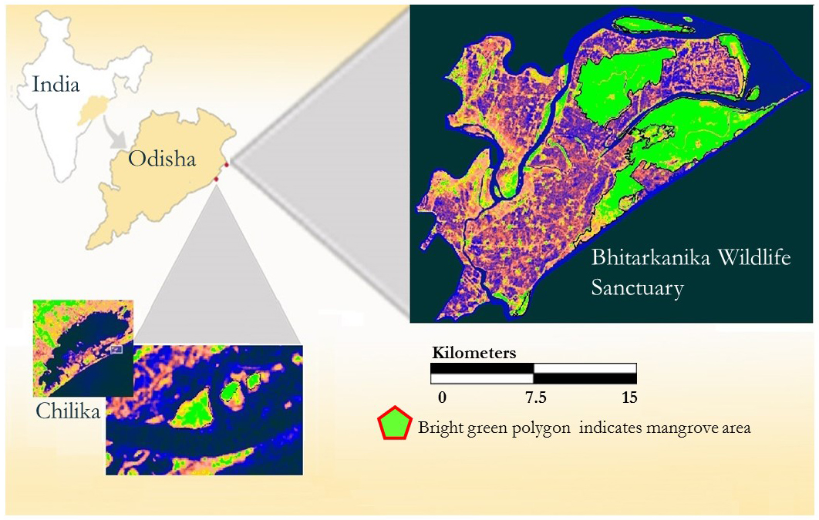

Figure 1. Study area map showing Bhitarkanika Wildlife Sanctuary and Chilika Lagoon. Mangrove patches are highlighted in green.

Remote sensing provides a critical tool to efficiently monitor mangrove forests over time as satellite imagery allows us to examine and frequently monitor mangrove habitat over a large area. Numerous studies have shown the applicability of utilizing multispectral satellite imagery to monitor biophysical characteristics of mangroves, which indicate mangrove health. For instance, a recent study published by Ishtiaque, Soe, & Wang (2016) used MODIS products to analyze degradation in the largest mangrove forest in the world located in Bangladesh and India. They used five ecological parameters including the Percent Tree Cover (PTC), Enhanced Vegetation Index (EVI), Net Primary Productivity (NPP), Leaf Area Index (LAI), and Evapotranspiration (ET). Their pixel-based time-series trend analysis derived from MODIS data showed forest degradation in fragmented parcels within the study area (Ishtiaque et al., 2016). Another recent study by Ibharim, Mustapha, Lihan, & Mazlan (2015) used Landsat and RapidEye data to evaluate changes in land use/land cover and produced change detection maps of mangrove forests to determine threats toward these ecosystems. Continuous monitoring of mangrove forests using remote sensing data will be essential for efficient management of this threatened ecosystem. Findings from recent studies indicate the potential for using moderate resolution satellite data to produce a long-term phenology and identify hotspots for early stages of mangrove degradation.

* 1. ***Project Partners & Objectives***

This project addresses the Ecological Forecasting application area, which promotes the use of Earth observations to analyze and forecast changes in the ecosystems to assist in effective resource management. The primary end user for this project is the Chilika Development Authority (CDA), a government agency in Odisha, India. The CDA was created under the Forest and Environment Department with an objective for conservation and management of these valuable ecosystems. Initially, the first stage of this project utilized satellite data to develop a phenological pattern for mangrove biophyisical parameters corresponding to the different seasons. The objective of this project was to refine and implement a mangrove biophysical characteristics prediction tool for Bhitarkanika Wildlife Sanctuary and Chilika Lagoon by using a suite of satellite data. This tool can derive a long-term phenology (1995-2017) in order to improve management and restoration efforts by the CDA. Project partners received long-term spatio-temporal estimations of mangrove physiological status. The results will increase understanding of long-term changes in mangrove cover and allow them to identify hotspots for early stages of mangrove degradation.

# 3. Methodology

The overall process and data involved in different stages of this study is shown in Fig. 2. Each component is described concisely in the following sections:

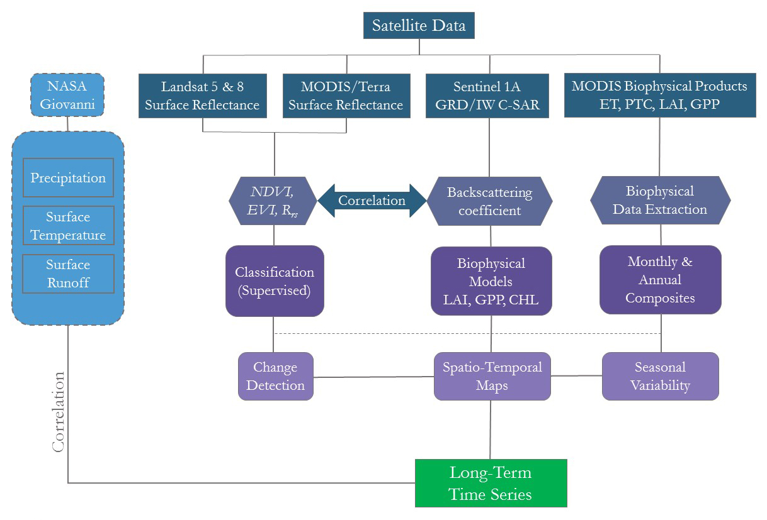

Figure 2. Overall work flow process and various remote sensing data sets utilized in the study.

***3.1 Data Acquisition***

Satellite data from multiple sensors were downloaded from April 1995 to February 2017 (Table 1). Cloud-free Landsat 5 Thematic Mapper (TM) and Landsat 8 Operational Land Imager (OLI) surface reflectance (Rrs) products were downloaded from the United States Geological Survey (USGS) EarthExplorer website for Bhitarkanika. Terra’s Moderate Resolution Imaging Spectroradiometer (MODIS) 250 m Level-2G Rrs daily products (MOD09GQ), corresponding to the closest available dates to the Sentinel 1 data, were downloaded from NASA’s Level 1 and Atmosphere Archive and Distribution System (LAADS) website. Sentinel products were downloaded from the European Space Agency (ESA) Scientific Data Hub website. In addition to single-day products, 8-day and annual products from Terra-MODIS sensor were downloaded from the LAADS website. The monthly evapotranspiration products corresponding to MODIS sensor were downloaded from University of Montana's Numerical Terra dynamic Simulation Group (NTSG) website.

Table 1: Data Acquisition Chart. Cloud-free and nearly cloud-free images were collected from January 1992 to December 2016 for optical sensors. Radar data were acquired from June 2015 to January 2017.

|  |  |  |  |  |  |
| --- | --- | --- | --- | --- | --- |
| **Satellite** | **Sensor** | **Product** | **Temporal Resolution** | **Spatial Resolution (m)** | **Source** |
| Landsat 8 | Observational Land Imager (OLI) | Surface Reflectance | 16-day | 30 | USGS Earth Explorer |
| Landsat 5 | Thematic Mapper (TM) | Surface Reflectance | 16-day | 30 | USGS Earth Explorer |
| Terra | Moderate Resolution Imaging Spectroradiometer (MODIS) | Level-2G Surface Reflectance (MOD09GQ) | 1-day | 250 | NASA's Level 1 and Atmosphere Archive and Distribution System (LAADS) |
| Level-2G Surface Reflectance (MOD09Q1) | 8-day | 500 |
| Leaf Area Index (LAI) | 8-day | 500 |
| Gross Prmary Productivity (GPP) | 8-day | 500 |
| Level-3 Percentage Tree Cover (PTC) (MOD44B) | Annual | 250 |
| Evapotranspiration (ET) (MOD16A2) | Monthly | 1000 | University of Montana's Numerical Terra dynamic Simulation Group (NTSG) |
| Sentinel-1 | Synthetic Aperture Radar (SAR) | High Resolution Ground Range Detected (GRD) Level-1 (IW mode) | 12-day | 10 | ESA Scientific Data hub |

Additionally, we incorporated area averaged physical-meteorological time series (January 2000 – December 2016) data from the NASA’s Giovanni web-based application tool corresponding to Bhitarkanika. These data included monthly averaged precipitation from Tropical Rainfall Measuring Mission (TRMM) products (TRMM_3B43_v7), monthly averaged surface runoff (GLDAS_NOAH025_M v2.1), and surface temperature (GLDAS_NOAH025_M v2.1). All data were first visualized using the NASA Giovanni tool and corresponding ASCII files were downloaded for each parameter for further analysis in Microsoft Excel.

***3.2 Data Processing***

The data processing from multiple-sensor was done parallelly in three parts: (1) land use/land cover (LULC) classification; (2) radar data calibration with MODIS; (3) long-term data extraction using MODIS 8-day and monthly biophysical products (LAI, GPP, and ET). The LULC classification was performed on a 5-year intervals using Landsat 5 & 8 derived Rrs data in near-infrared, red, and green bands. Landsat scenes from similar months (April) were used in classification to avoid impact of seasonality. After stacking 3 bands, a supervised classification was implemented using ERDAS IMAGINE. Google Earth imagery (Landsat, Copernicus, DigitalGlobe, Terrametrics, CNES, and Astrium: year-2016) was used for creating the training data set (total 122 points) corresponding to various classes (dense mangrove, open mangrove, agriculture, bare land, water, sand, mudflat) present inside the study area (Appendix B). The accuracy assessment for classified images was performed by confusion matrices which provided the percentage of correctly classified points in each class and overall accuracy (Appendix G).

To calibrate radar data against MODIS product (MOD09GQ), first pre-processing was performed on these data sets. Pre-processing included radiometric calibration, speckle filtering, ellipsoid correction, re-projection to geographic coordinate system (WGS-1984), and resampling of radar data to 250m spatial resolution to match MODIS pixel resolution. Total three MODIS images (April 12, November 02, and December 08) from 2016 were matched to radar data (within 1 day time gap). Rrs data from MODIS and backscattering coefficients data corresponding to radar sensor were extracted from collocated 60 random pixels (total pixels: 3*60 =180) for calibration. Backscattering coefficients (σ) were extracted for both polarization modes: vertical vertical (VV: σVV) and vertical horizontal (VH: σVH) available in Sentinel 1A-C-SAR data. After extracting the data, linear and non-linear regression analysis was performed between MODIS derived Rrs, vegetation indices (NDVI, EVI) and backscattering coefficients (σVV, σVH). The best-fit relationship was utilized to derive vegetation indices and create spatio-temporal biophysical product maps using calibrated radar data. The spatial maps for biophysical parameters (CHL, LAI, and GPP) were created using previous term biophysical models in SNAP software (Eqs. 1 – 3: details on these models are available in previous term technical report).

$CHL=127*NDVI-46.61 (1)$

$LAI=17.155*EVI-2.574 (2)$ $GPP=0.0983*EVI+0.016$ (3)

Where; NDVI = [Rrs (NIR) - Rrs(Red)]/[Rrs (NIR) + Rrs(Red)]

EVI =2.5*[Rrs(NIR)- Rrs(Red)]/ [(1+Rrs(NIR)+2.4*Rrs(Red)]

The long-term (2000 – 2016) biophysical data extraction from MODIS 8-day GPP, LAI, and monthly ET products, was performed using batch-processing tool in SNAP and ArcMAP model builder tools (Appendix D). First, a fish-net with spatial resolution of 500m *500m was created corresponding to Bhitarkanika (Appendix C). The non-mangrove pixels, and mixed pixels were excluded in data extraction. Extracted data from mangrove pixels were exported to excel sheet for further seasonal and annual analysis.

***3.3 Data Analysis***

The Landsat derived classified spatial maps were first visually analyzed with respect to each class by observing corresponding area in Google Earth image side by side for further improvement. Once the satisfactory level was achieved in classification by comparing visually with published literature (Reddy & Murthy, 2007), quantitative comparison was carried out in terms of area of each class. Each class had a total pixel count that was converted to square kilometers (1 pixel =30m*30m), thus deriving the total area coverage. The trend in each class was analyzed by comparing area coverage with respect to years (1995, 2000, 2005, 2010, and 2014). The accuracy level of classification was measured using confusion matrix table. To validate calibration result between radar data and MODIS, vegetation indices (NDVI and EVI) spatial maps derived from radar data were compared against MODIS derived maps for both backscattering coefficients (σVV, σVH). Further, 1- radar image from beginning of each month (starting March 2016 – February 2017) was used to observe the monthly/seasonal variability in biophysical parameters (CHL, LAI, and GPP) derived from calibrated vegetation indices for both study areas. The long-term biophysical data (2000 – 2016) derived from MODIS 8-day and monthly products were analyzed monthly and annually in Microsoft excel. 8-day data (LAI and GPP) were averaged monthly for each year first, then further averaging of data was carried out for individual months for entire year (2000-2016). Statistics was calculated using excel and exported in table form for further analysis. Similarly, monthly ET data was averaged monthly for entire available years (2000 -2014). Physical-meteorological long-term data (2000 -2016) were also averaged monthly for correlating with biophysical parameters. Data from monsoon season (June, July, August, September) were not included in correlation analysis between biophysical parameters and physical-meteorological variables because of lack of cloud free-quality data for these months. The season classification is provided in Appendix A.

# 4. Results & Discussion

***4.1 Land use – land cover Classification***

The LULC classification results showed a trend of steady decline in dense mangrove and increase in open mangrove area (Fig. 3a). The agriculture was found to be the dominant class in terms of area coverage and therefore, secondary axis was used to show the trend for this class over the years (Fig. 3b). The dense mangrove class displayed an overall decrease, with a slight increase in 2005. However, agricultural land use and open mangrove patches remained consistent for 1995 and 2000, but decreased in 2005 (Fig. 3b). This could be interpreted by a classification error, due to the difference in surface reflectance based on climatological changes, rather than anthropogenic pressure.

Table 3. Estimated area for each class of land use - land cover and confusion matrix accuracy results.

|  |  |  |  |  |  |  |  |  |
| --- | --- | --- | --- | --- | --- | --- | --- | --- |
| Year | Dense Mangrove (km2) | Open Mangrove (km2) | Agriculture (km2) | Mudflat (km2) | Sand (km2) | Water (km2) | Overall Accuracy | Kappa Coefficient |
| 1995 | 138.18 | 33.56 | 387.37 | 19.18 | 22.82 | 113.51 | 0.78 | 0.66 |
| 2000 | 131.88 | 37.96 | 388.13 | 26.58 | 15.27 | 114.80 | 0.80 | 0.66 |
| 2005 | 137.79 | 27.72 | 372.08 | 54.77 | 11.46 | 110.80 | 0.78 | 0.66 |
| 2010 | 113.66 | 45.94 | 390.11 | 44.63 | 5.47 | 114.81 | 0.75 | 0.67 |
| 2014 | 107.49 | 91.95 | 359.46 | 27.15 | 11.06 | 116.89 | 0.75 | 0.67 |

Likewise, in 2014 a rather drastic land cover change was observed where open mangrove patches increased exponentially and agricultural land use and dense mangrove patches decreased. Transition in satellite sensors from Landsat 5 to Landsat 8 might also affected the classification results because of difference in signal to noise ratios of individual sensors. However, trend in major classes of interest (dense and open mangroves) was preserved in the results. Additional classified data from published literature (Reddy & Murthy, 2007) included to further examine the historical trend of mangrove patches in Bhitarkanika also preserved the trend (Appendix E). The new dates included classified data from 1973, two years prior to the establishment of Bhitarkanika National Park, 1988, and 2004. While the dense mangrove pattern remains steady between 1973 and 1988, a noticeable decrease in open mangrove patches was calculated. This could be the effect of the initial drive of agricultural pressures affecting the open ecosystems first, then gradually transitioning deeper into the dense mangrove areas. Accuracy assessment (Appendix G) revealed consistent results for each year analyzed and presented in Table 3.

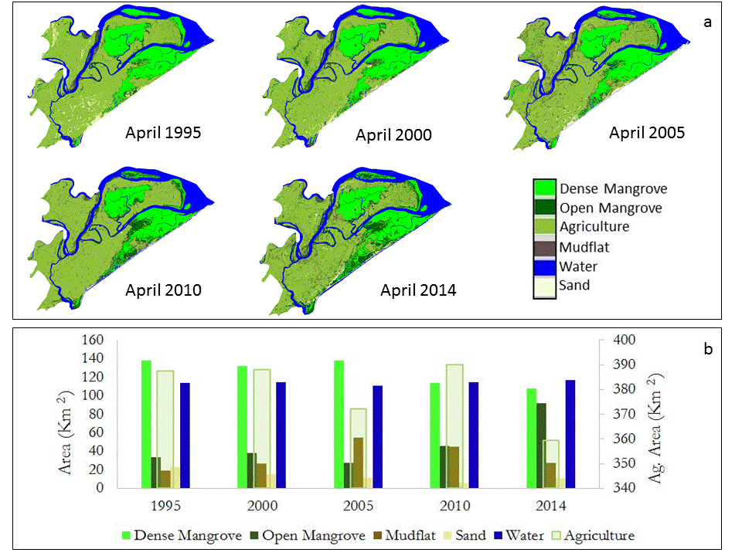

Figure 3. Spatio-temporal variability in land use land cover using Landsat-5 & 8 data for Bhitarkanika Wildlife Sanctuary (a). Estimated area covered by individual classes for different years (b).

***4.2 Calibration of MODIS with Radar Data***

The regression analysis between Rrs data extracted from individual MODIS 250m band and backscattering coefficients (σVV, σVH) derived from radar data are shown in Fig. 4. MODIS NIR band (B2) showed better correlation compared to red band (B1) with respect to both σVV andσVH. However, vegetation indices (NDVI and EVI) which was required to create biophysical products (CHL, LAI, GPP) spatial maps, owed even much better correlation with σVV andσVH compared to individual NIR band. Therefore, best-fit relationship (Eqs. 4-5) was utilized to first produce vegetation indices from radar data and then biophysical models (Eqs. 1-3) were implemented to create spatial biophysical product maps.

$$NDVI=0.3314*\log\left(σvv\right)+1.383 (4)$$

$$EVI2=0.1596*\log\left(σvv\right)+0.7148 (5)$$

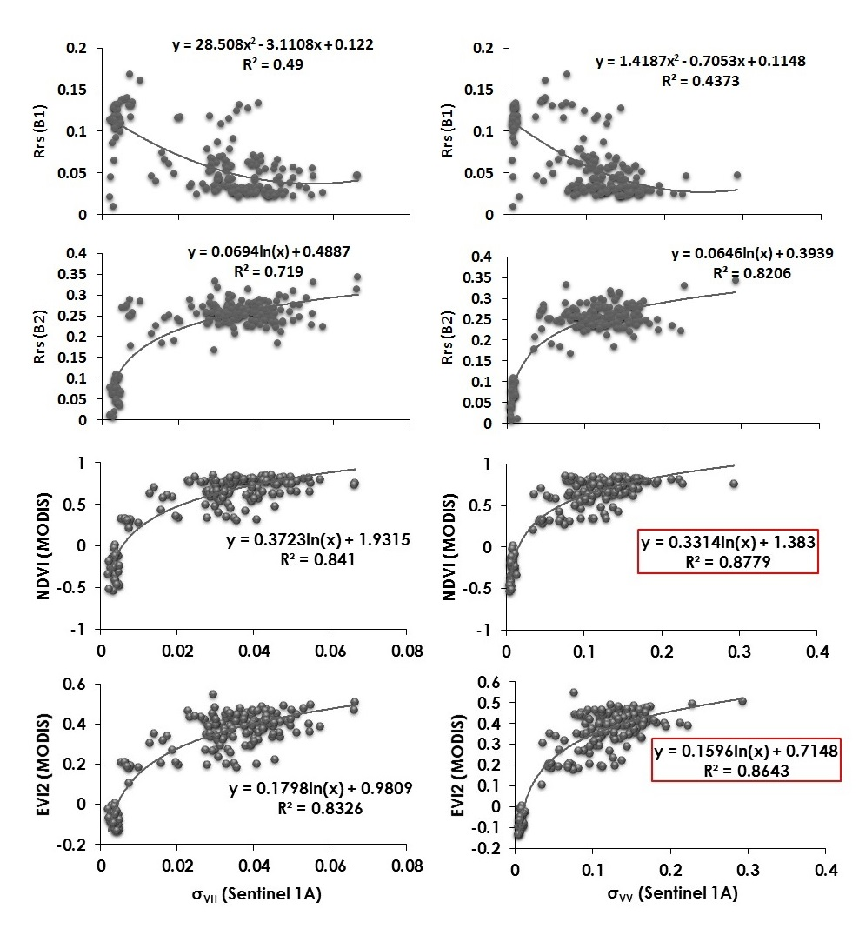

Figure 4. Sentinel 1A derived backscattering coefficients (σVV andσVH) calibrated against MODIS derived Rrs data in individual bands (NIR and red) and vegetation indices. The best-fit correlation results are shown in red boxes.

***4.3 Seasonal Change of Biophysical Parameters***

The seasonal variability in biophysical parameters (CHL, LAI, and GPP) derived from calibrated radar data were found to be consistent with previous term results such as lowest during summer, moderate during winter and spring, and highest during the fall season. The peak month for each season (summer: April; monsoon: August; fall: September; winter: January; Spring: February) were selected to show the spatial variability for all biophysical parameters (Fig. 5). The additional season (monsoon), which was lacking in previous term due to heavy cloud cover was also included because of advantage of radar data. Three seasons (summer, monsoon, and fall) showed the major variability compared to winter and spring and therefore, shown in large size (Fig. 5). Apart from changes in mangrove biophysical parameters, seasonal variability in agriculture area surrounding the Bhitarkanika mangrove was also captured in spatio-temporal maps. In summer, lack of agriculture practices reflected by lowest CHL, LAI, and GPP concentration surrounding Bhitarkanika. During monsoon, these areas become muddy because of heavy precipitation and runoff, and therefore, showed lowest values in biophysical parameters again. However, crops, and agricultural practices are peaks in fall and same observed in spatial maps. These results are important for assessing the impacts of changes in surrounding areas on mangroves health in future such as cyclones which triggers heavy rainfall and surface runoff.

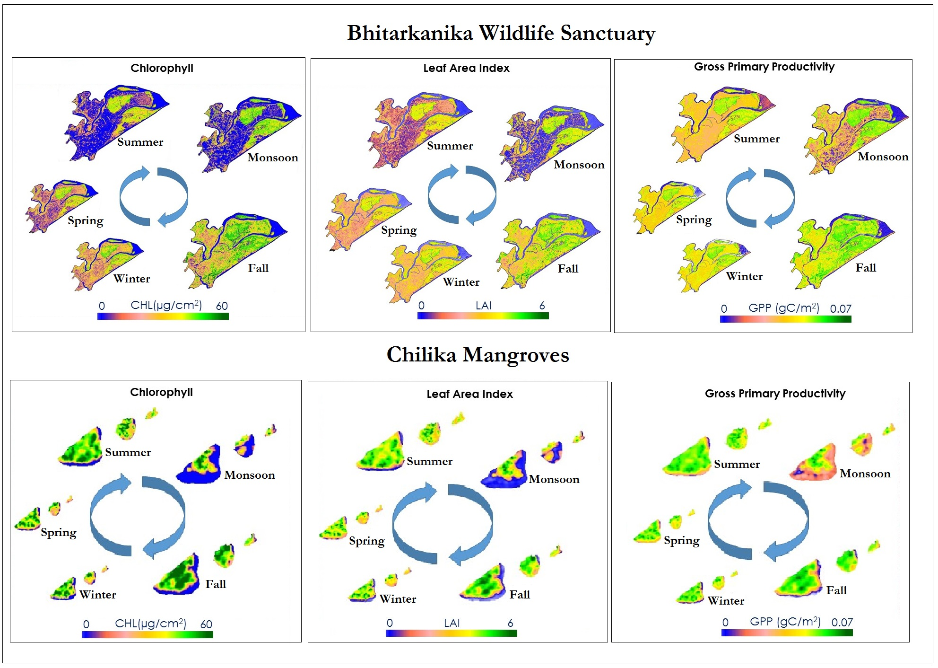

Figure 5. Seasonal spatio-temporal variability in mangroves’ CHL, LAI, and GPP values. The graphics show distinct, seasonal trends in the biophysical parameters in the summer, monsoon, and fall seasons.

The small three patches of mangrove corresponding to our other study area (Chilika) also showed similar seasonal variability in all biophysical parameters (Fig. 5). This is mainly because both study area are very close to each other and face similar seasonal changes. However, data related to species type is lacking for this study and we will try to incorporate in future study. One major change was noticed in spatial maps of Chilika mangrove related to fluctuation in water level surrounding the mangrove area during monsoon. As these mangroves are island type surrounded by water from all sides, heavy precipitation during monsoon increases the water level of Chilika Lagoon which results in fluctuation of signals received from mangrove. CHL model is based on NDVI which clearly captured this phenomenon (fluctuation in water level) as NDVI values were found to be negative for water pixels and shown in blue color (Fig. 5). This result again showed the usefulness of integration of radar data with optical sensor which lacks cloud free data during heavy rainfall.

***4.4 Long-term Seasonal and Inter-annual variability***

The long-term (2000 -2016) data extracted from MODIS 8-day products (LAI, GPP) averaged on monthly basis and monthly ET data (2000-2014) are presented in Figs. 6 (a-f). Only 8 months were included in analysis and monsoon moths were excluded because of lack of cloud-free quality data. Monthly/Seasonal variability was dominant for all the parameters compared to inter-annual trend (annual trend is shown in Avg blue line: Fig. 6). The standard deviation bars represented spatial variability (among extracted mangrove pixels) in biophysical parameters within the study area. This is mainly because of variability in mangrove species type and clustering pattern (dense versus open mangrove). The detailed statistical data for each parameter are presented in (Appendix F). October month, which is typical cyclone month in eastern India, showed the highest variability among years for LAI (Std. deviation: 0.72) and GPP (Std. deviation: 0.006 gC/m2).

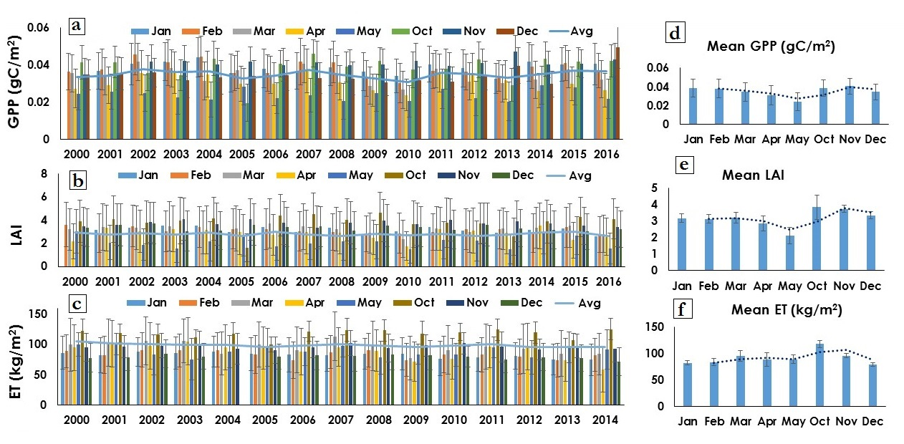

Figure 6. These graphs show the inter-annual and seasonal trend of biophysical parameters for Bhitarkanika Wildlife Sanctuary from 2000 – 2016 (a-c). All biophysical parameters were averaged monthly for entire years (2000-2016 for LAI and GPP) and (2000-2014 for ET) to show monthly variability clearly (d-f).

Further, long-term (2000-2016) physical-meteorological (precipitation, surface runoff, and surface temperature) data were analyzed to observe their association with biophysical parameters (Figs. 7 a-c). Again, monthly variability was dominant compared to inter-annual variability in all the parameters. Detailed statistics are presented in Table X for all parameters (Appendix F). Also, October month showed highest variability in precipitation (Std. deviation: 189.63mm) and surface runoff (Std. deviation: 48.64 kg/m2) due to cyclone season. Recently, in October 2013, eastern India and Bhitarkanika faced a very severe category-5 cyclone ‘Phailin’ and heavy precipitation (Mean: 601.65 mm) and surface runoff (Mean: 126.33 kg/m2) were observed during this month. The surface temperature phenology showed consistent pattern with slight increase in long-term annual trend (Fig. 7c).

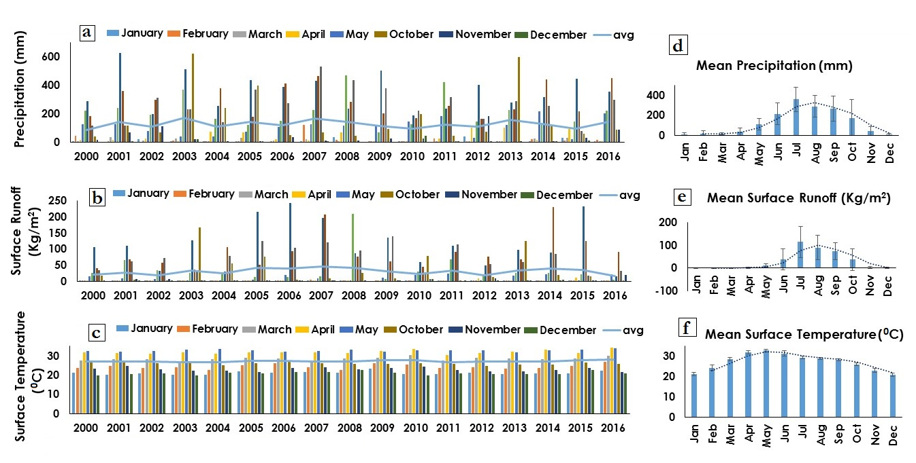

Figure 7. These graphs show the inter-annual and seasonal trend of physical-meteorological parameters for Bhitarkanika Wildlife Sanctuary from 2000 – 2016 (a-c). All parameters were averaged monthly for entire years (2000-2016) to show monthly variability clearly (d-f).

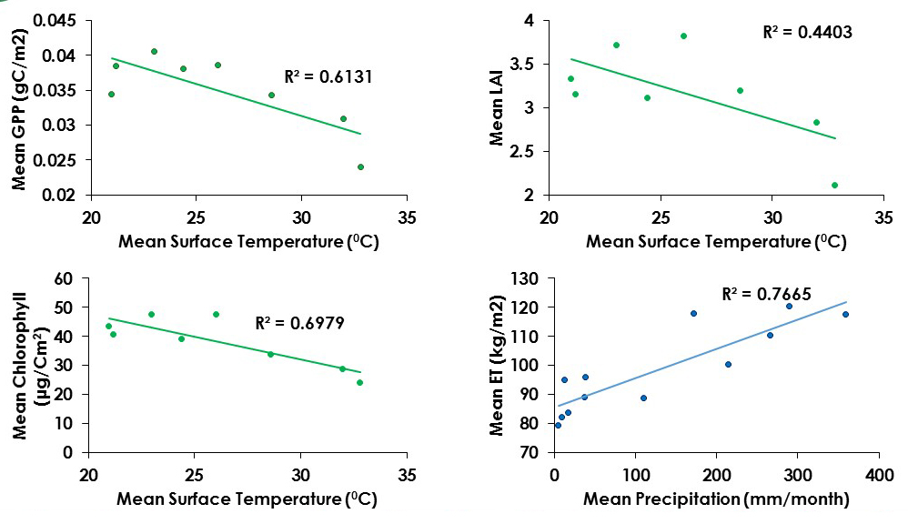

Figure 8. Correlation analysis between mean biophysical parameters and physical-meteorological variables.

To correlate biophysical parameters with physical-meteorological parameters, first data were averaged for each month (2000 – 2016), except monsoon months. ET data were averaged for 2000 -2014 due to lack of data availability. Correlation analysis revealed significant correlation (P<0.01) between biophysical parameters (CHL, LAI, GPP) and surface temperature and between ET and precipitation (Fig. 8). However, no direct correlation between precipitation/surface runoff and CHL, LAI, and GPP was observed. This is mainly because of time lag in response of these biophysical parameters with variability in precipitation and surface runoff. However, surface temperature showed direct relationship such as with increase in temperature all biophysical parameters showed decreasing trend. This result was consistent with seasonal biophysical maps produced using radar data which showed lowest range for all parameters during summer.

***4.5 Future Work***

One of the major challenges of this project was to access the field data of biophysical parameters to refine the biophysical models. If this project continues in future, incorporating the field data would be beneficial to validate and improve the models. The phenological pattern of long-term extracted data (biophysical and physical-meteorological) of this term will help in creating a forecasting tool in future for biophysical parameters. The classification accuracy can be improved by incorporating high resolution radar data in future. Additionally, quantitative data extraction and comparing the range with optical sensors for biophysical parameters would be interesting as promising results shown by Sentinel-1A data in this term. The future term of project may also focus on analyzing biophysical parameters of similar mangrove types from other parts of India and around the world.

# 5. Conclusions

Three major objectives were achieved in this study including LULC classification, integration of radar data to MODIS, and long-term biophysical data analysis. Classification results indicated gradual decline in dense mangrove area and increase in open mangrove area which invokes the need for enhanced management practices of Bhitarkanika mangrove forest in future. Calibration of radar data with MODIS enabled us to capture the variability in biophysical parameters for the first time even during heavy rainfall (monsoon season). All the biophysical parameters (CHL, LAI, and GPP) showed similar seasonal pattern for both study areas (Bhitarkanika and Chilika) such as peaked during fall, moderate during winter and spring and lowest during summer consistent with results of previous term. The long-term biophysical data analysis suggested that seasonal variability is dominant compared to inter-annual variability, and the typical cyclone month (October) showed the highest variability not only for biophysical parameters but also for precipitation and surface runoff. The correlation analysis did not reveal direct association of precipitation and surface runoff with biophysical parameters because of time lag effect. However, surface temperature showed direct impact on biophysical parameters such as lower range for higher temperature and higher range for lower temperature. The results of this study revealed the advantages of multi-sensor approach for monitoring mangrove biophysical parameters and LULC change analysis and will be useful for other study areas as well in future.

# 6. Acknowledgments

We would like to thank our science advisors, Dr. Deepak Mishra and Dr. Marguerite Madden at UGA. We would also like to acknowledge our partners at the Government of Odisha’s CDA, especially Dr. Gurdeep Rastogi for his involvement with the project and international communication during the term. Additionally, our team would like to thank UGA Assistant Center Lead Sean Cameron for his support.

Any opinions, findings, and conclusions or recommendations expressed in this material are those of the author(s) and do not necessarily reflect the views of the National Aeronautics and Space Administration.

This material is based upon work supported by NASA through contract NNL16AA05C and cooperative agreement NNX14AB60A.

# 7. Glossary

Advanced Spaceborne Thermal Emission and Reflection Radiometer (ASTER) **–** an imaging instrument onboard Terra. ASTER data is used to create detailed maps of land surface temperature, reflectance, and elevation.

Backscattering Coefficient – The amount of illumination from the radar on a unit of surface or echo for a unit of volume.

Biophysical Parameters **–** a numerical or other measurable factor derived from in-situ data that can be used to assess changes in wildlife habitat, watersheds, permafrost and vegetation in support of cumulative impact monitoring and ecosystem assessment. Examples include leaf area index, leaf chlorophyll, gross primary productivity.

Chlorophyll **–** a green pigment that absorbs sunlight and uses its energy to synthesise carbohydrates from CO2 and water.

Gross Primary Productivity **–** the rate at which ecosystem’s producers store and capture provided amount of energy as biomass in a given time duration.

Ground Range Detection Interferometric Wide Data (GRDIW) – A 250 km wide area of radar data collection over land with a spatial resolution of 10 x 10 m.

Landsat 8 **–** launched on February 11, 2013, the Landsat 8 satellite images the entire Earth every 16 days in an 8-day offset from Landsat 7 and acquires moderate resolution, multispectral images of the globe.

Leaf Area Index **–** the total one‐sided area of leaf tissue per unit ground surface area.It is defined as the one-sided green leaf area per unit ground surface area (LAI = leaf area / ground area, m2 / m2) in broadleaf canopies.

Mangroves **–** tropical trees or shrubs that grow in coastal saline or brackish water.

Moderate Resolution Imaging Spectroradiometer (MODIS) **–** moderate-resolution imaging spectroradiometer is ideal for tracking large-scale changes with its high temporal resolution and 36 discrete spectral bands.

Multi Spectral Instrument (MSI) **–** onboard the Sentinel-2 satellite, it collects wide swath (290 km) high-resolution (10 m) images with 13 spectral bands.

Normalized Difference Vegetation Index (NDVI) **–** an index of plant “greenness” or photosynthetic activity, and is one of the most commonly used vegetation indices.

Operational Land Imager (OLI) **–** one of two instruments onboard Landsat 8, the OLI collects image data for nine visible shortwave bands.

Radiometric Calibration – The calibration of multi-date images to a reference image instead of using field data, causing the images to have similar illumination and atmospheric properties as the reference image.

Sentinel-1A - launched on April 3, 2014 by the European Space Agency, the Sentinel-1A satellite’s mission is mainly to aid with emergency response (earthquakes and floods), monitor oceans, and track land use and deformation changes.

Sentinel-2 **–** launched on June 23, 2015 by the European Space Agency, the Sentinel-2 satellite’s mission is mainly to provide information for agricultural and forestry practices. It expands on the French Spot and US Landsat missions.

Speckle Filtering – The reduction of radar return noise interference from objects on a surface.

Surface Reflectance (Rrs) **–** ratio of the amount light not absorbed by a surface to the amount of light striking the surface.

Terra **–**launched December 18, 1999, the Terra satellite acquires data in 36 groups of wavelengths and promotes understanding of energy balance and climate regimes across the Earth.

# 8. References

Azam, N. N. A. (2011). The Importance of Mangrove Forests Management. *International Islamic University Malaysia*.

Badola, R., Barthwal, S., & Hussain, S.A. (2012). Attitudes of local communities towards conservation of mangrove forests: A case study from the east coast of India. *Estuarine, Coastal and Shelf Science* *96*, 188-196.

Behera, D. P. & Nayak, L. (2013). Floral Diversity of Bhitarkanika, East Coast of India and its potential uses. *Journal of Chemical, Biological and Physical Sciences*, *3*, 1863-1874.

Chauhan, R., & Ramanathan, A. L. (2008). Evaluation of water quality of Bhitarkanika mangrove system, Orissa, east coast India. *Indian Journal of Marine Sciences, 37*, 153-158.

Das, S., & Vincent, J. R. (2009). Mangroves protected villages and reduced death toll during Indian super cyclone. *Proceedings of the National Academy of Sciences of the United States of America, 106,* 7357-7360.

Giri, C., Ochieng, E., Tieszen, L. L., Zhu, Z., Singh, A., Loveland, T., Masek, J., & Duke, N. (2010). Status and distribution of mangrove forests of the world using earth observation satellite data. *Global Ecology and Biogeography, 20*, 154-159. doi: 10.1111/j.1466-8238.2010.00584.x

Hussain, S. A. & Badola, R. (2010). Valuing mangrove benefits: contribution of mangrove forests to local livelihoods in Bhitarkanika Conservation Area, East Coast of India. *Wetlands Ecology and Management, 18,* 321 331. doi: 10.1007/s11273-009-9173-3

Ibharim, N.A., Mustapha, M.A., Lihan, T., & Mazlan, A.G. (2015). Mapping mangrove changes in the Matang Mangrove Forest using multi temporal satellite imageries. *Ocean & Coastal Management, 114*, 64-76.

Ishtiaque, A., Soe, W.M., & Wang, C. (2016). Examining the ecosystem health and sustainability of the world's largest mangrove forest using multi-temporal MODIS products. *Science of the Total Environment,* *569–570*, 1241-1254.

Kauffman, J. B., & Donato, D. C. (2012). Protocols for the measurement, monitoring and reporting of structure, biomass and carbon stocks in mangrove forests. *Center for International Forestry Research*.

Lovelock, C.E., Simpson, L. T., Duckett, L. J., & Feller, I. C. (2015). Carbon budgets for Caribbean mangrove forests of varying structure and with phosphorus enrichment. *Forests, 6*, 3528 – 3546.

Pastor-Guzman, J., Atkinson, P. M., Dash, J., & Rioja-Nieto, R. (2015). Spatiotemporal Variation in Mangrove Chlorophyll Concentration Using Landsat 8. *Remote Sensing*, *7*, 14530-14558; doi:10.3390/rs71114530

Pattanaik, C., Reddy, C. S., Murthy, M. S. R., & Swain, D. (2008). Assessment and Monitoring the Coastal Wetland Ecology Using RS and GIS with Reference to Bhitarkanika Mangroves of Orissa, India. *Monitoring and Modelling Lakes and Coastal Environments*, 226-236. doi: 10.1007/978-1-4020-6646-7_17

Peetabas, N., & Panda, R. P. (2015) Conservation and Management of Bioresources of Chilika Lake, Odisha, India. *International Journal of Scientific and Research Publications, 5*.

Reddy, S. C., & Murthy, M. (2007) Assessment and Monitoring of Mangroves of Bhitarkanika Wildlife Sanctuary, Orissa, India using Remote Sensing & GIS. *Current Science*, *92*, 1409-1415.

The Ramsar Convention Secretariat (Ed.). (2014). Ramsar. Retrieved March 29, 2017, from http://www.ramsar.org/

Townshend, J.R.G. (2017). MOD44B MODIS/Terra Vegetation Continuous Fields Yearly L3 Global 250m SIN Grid V006. NASA EOSDIS Land Processes DAAC.<https://doi.org/10.5067/MODIS/MOD44B.006>

U.S. Geological Survey (2014). Provisional Landsat 8 OLI Surface Reflectance 16 Day Global 30m. U.S. Geological Survey Earth Resources Observation And Science Center.<https://doi.org/10.5066/F78S4MZJ>

U.S. Geological Survey (2012). Provisional Landsat 5 TM Surface Reflectance 16 Day Global 30m. U.S. Geological Survey Earth Resources Observation And Science Center.<https://doi.org/10.5066/F7KD1VZ9>

Vermote, E. & Wolfe, R. (2015). MOD09GQ MODIS/Terra Surface Reflectance Daily L2G Global 250m SIN Grid V006. NASA EOSDIS Land Processes DAAC. [https://doi.org/10.5067/MODIS/MOD09GQ.006](https://mail01.ndc.nasa.gov/owa/redir.aspx?C=5X0akEfvt2bt1pws8Es1Z_OoxHXpBbnueRikV_1pWy6mxf4gf3fUCA..&URL=https%3a%2f%2fdoi.org%2f10.5067%2fMODIS%2fMOD09GQ.006)

Vermote, E. (2015). MOD09Q1 MODIS/Terra Surface Reflectance 8-Day L3 Global 250m SIN Grid V006. NASA EOSDIS Land Processes DAAC.

https://doi.org/10.5067/MODIS/MOD09Q1.006

# 9. Appendices

Appendix A: Seasons for study area and corresponding months.

|  |  |
| --- | --- |
| **Season** | **Months** |
| Fall (post-monsoon/wet) | October and November |
| Winter | December and January |
| Spring | February and March |
| Summer (pre-monsoon/dry) | April and May |
| Monsoon | June, July, August, and September |

Appendix B: Google Earth Image used for creating training classes for classification.

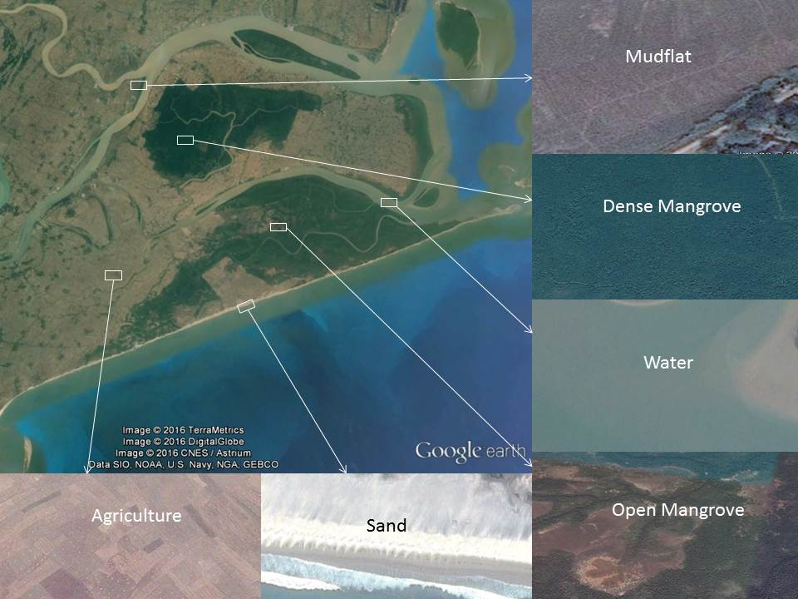

Appendix C: Selected point locations for extraction of the pure Mangrove pixels.  
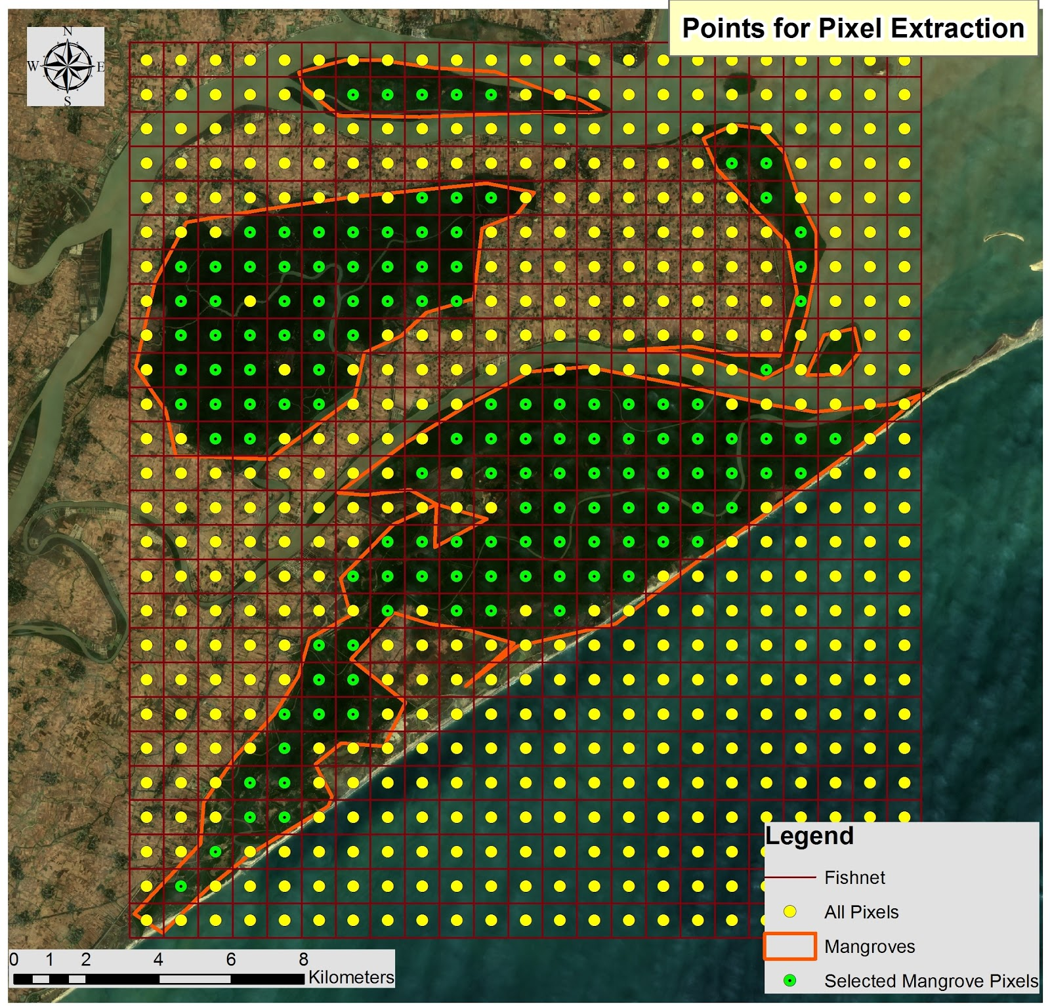

Appendix D: The SNAP and ArcGIS tool used for projecting, clipping and extracting pixel values of the satellite imagery.

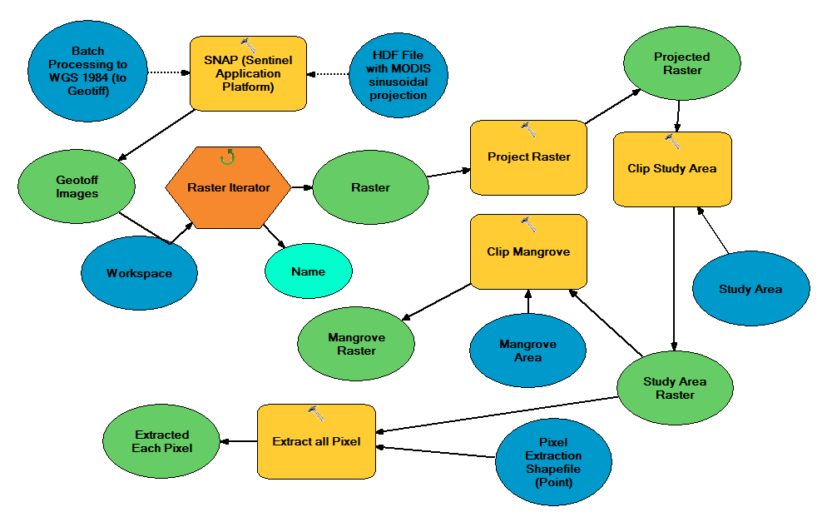

Appendix E: Historical trend of dense and open Mangrove area including published data

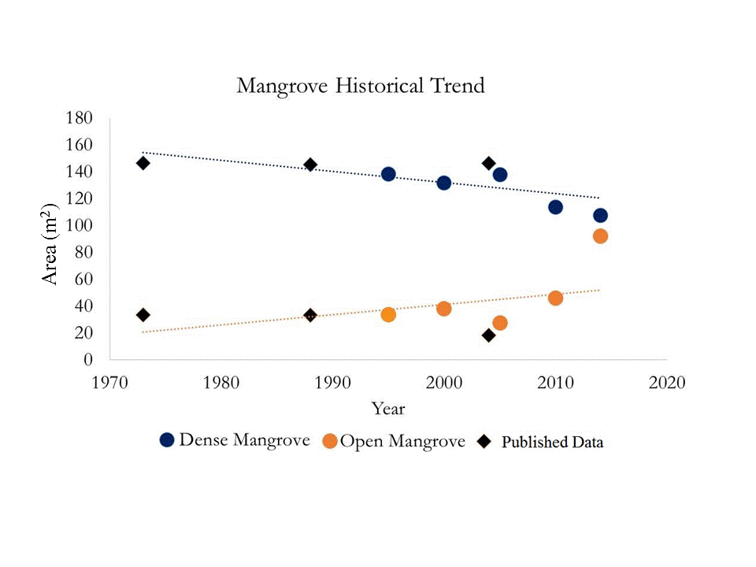

Appendix F: Summary of long term Biophysical, Physical, and Meterological parameters for Bhiterkanika Wildlife Sanctuary (2000-2016).

|  |  |  |  |  |  |  |  |  |  |
| --- | --- | --- | --- | --- | --- | --- | --- | --- | --- |
| **Parameters** | **Statistics** | **Jan** | **Feb** | **Mar** | **Apr** | **May** | **Oct** | **Nov** | **Dec** |
| **LAI** | Min | 2.59 | 2.76 | 2.37 | 1.76 | 1.48 | 1.61 | 3.35 | 3.01 |
|  | Max | 3.54 | 3.61 | 3.69 | 3.51 | 3.02 | 4.64 | 4.05 | 3.73 |
|  | Mean | 3.16 | 3.11 | 3.20 | 2.84 | **2.11** | 3.82 | 3.72 | 3.33 |
|  | Std. dev. | 0.27 | 0.25 | 0.32 | 0.46 | 0.49 | **0.73** | 0.22 | 0.22 |
| **GPP** | Min | 0.03 | 0.03 | 0.03 | 0.02 | 0.02 | 0.02 | 0.03 | 0.03 |
|  | Max | 0.04 | 0.05 | 0.04 | 0.04 | 0.03 | 0.05 | 0.05 | 0.05 |
|  | Mean | 0.04 | 0.04 | 0.03 | 0.03 | **0.02** | 0.04 | 0.04 | 0.03 |
|  | Std. dev. | 0.00 | 0.00 | 0.00 | 0.00 | 0.00 | **0.01** | 0.00 | 0.00 |
| CHL | **Min** | 33.24 | 34.35 | 24.60 | 22.06 | 19.74 | 30.45 | 45.21 | 37.77 |
|  | **Max** | 46.36 | 44.03 | 40.85 | 34.42 | 30.20 | 53.12 | 51.27 | 47.77 |
|  | **Mean** | 40.59 | 39.11 | 33.69 | 28.87 | **24.05** | 47.32 | 47.66 | 43.68 |
|  | **Std. dev.** | 3.84 | 2.53 | 4.17 | 3.90 | 2.95 | **5.80** | 1.57 | 2.74 |
| **ET** | Min | 74.99 | 73.73 | 77.09 | 58.35 | 75.47 | 99.77 | 90.09 | 71.17 |
|  | Max | 88.24 | 90.83 | 113.09 | 105.03 | 100.29 | 125.22 | 102.09 | 84.08 |
|  | Mean | 82.35 | 83.71 | 95.07 | 88.99 | 88.91 | 117.82 | 95.93 | 79.39 |
|  | Std. dev. | 4.19 | 6.18 | 9.78 | 12.95 | 8.25 | 7.08 | 3.54 | 3.31 |
|  | Min | 0.00 | 0.00 | 0.00 | 0.21 | 19.74 | 39.08 | 4.32 | 0.00 |
| **Precipitation** | Max | 39.18 | 120.05 | 35.84 | 102.72 | 214.87 | 623.43 | 184.43 | 43.08 |
|  | Mean | 8.93 | 16.97 | 13.15 | 37.73 | 109.81 | 171.48 | 39.03 | 5.12 |
|  | Std. dev. | 13.72 | 29.04 | 12.19 | 37.22 | 58.23 | **189.64** | 48.80 | 11.38 |
|  | Min | 0.00 | 0.01 | 0.00 | 0.00 | 2.00 | 0.84 | 0.00 | 0.00 |
| **Surface Runoff** | Max | 1.55 | 4.83 | 2.32 | 10.61 | 24.73 | 167.84 | 18.83 | 7.00 |
|  | Mean | 0.29 | 0.63 | 0.46 | 2.08 | 11.61 | 37.14 | 3.45 | 0.93 |
|  | Std. dev. | 0.45 | 1.18 | 0.62 | 2.94 | 8.23 | **48.65** | 4.96 | 2.02 |
|  | Min | 20.27 | 22.56 | 27.39 | 30.52 | 31.79 | 24.75 | 21.50 | 19.72 |
| **Surface Temperature** | Max | 23.43 | 26.80 | 30.51 | 34.34 | 33.96 | 27.20 | 24.70 | 22.67 |
|  | Mean | 21.17 | 24.38 | 28.57 | 31.99 | **32.81** | 26.03 | 22.99 | 20.97 |
|  | Std. dev. | 0.83 | 1.23 | 0.80 | 0.94 | 0.55 | 0.61 | 0.96 | 0.83 |

Appendix G: Confusion matrixes for Land use/Land cover classification.

|  |  |  |  |  |  |  |
| --- | --- | --- | --- | --- | --- | --- |
| User's Accuracy | | | | | | |
| Year | Dense  Mangrove | Agriculture | Water | Sand | Mudflat | Open  Mangrove |
| 1995 | 88.00% | 93.55% | 60.00% | 25.00% | 25.00% | 0.00% |
| 2000 | 84.00% | 96.67% | 60.00% | 57.14% | 40.00% | 0.00% |
| 2005 | 84.00% | 93.44% | 63.16% | 66.67% | 22.22% | 20.00% |
| 2010 | 94.44% | 96.49% | 60.00% | 75.00% | 8.33% | 27.27% |
| 2014 | 89.47% | 98.18% | 52.17% | 50.00% | 33.33% | 29.41% |
| Producer's Accuracy | | | | | | |
| Year | Dense  Mangrove | Agriculture | Water | Sand | Mudflat | Open  Mangrove |
| 1995 | 84.62% | 82.86% | 85.71% | 20.00% | 100.00% | 0.00% |
| 2000 | 80.77% | 82.86% | 85.71% | 80.00% | 100.00% | 0.00% |
| 2005 | 80.77% | 81.43% | 85.71% | 40.00% | 100.00% | 20.00% |
| 2010 | 65.38% | 78.57% | 85.71% | 60.00% | 50.00% | 60.00% |
| 2014 | 65.38% | 77.14% | 85.71% | 20.00% | 100.00% | 100.00% |