New Hampshire Ecological Conservation

Predicting Future Conflicts between Loon Habitats and Human Development in New Hampshire using NASA Earth Observations

 **Technical Report**

Final – March 30, 2023

Jane Zugarek (Project Lead)

Madison Arndt

Jessica Gray

Amelia Untiedt

***Advisors:***

Dr. Cedric Fichot, Boston University (Science Advisor)

Joseph Spruce, Science Systems and Applications, Inc (Science Advisor)

***Fellow:***  
Tyler Pantle (Massachusetts – Boston)

# 1. Abstract

Bioindicator species monitoring allows researchers to infer the overall ecological health of a given area. Among these species, the Common Loon (*Gavia immer*), occupies the land-water interface on lakefront habitats in New Hampshire (NH) which exposes nest sites to human encroachment. In collaboration with the Loon Preservation Committee (LPC), we utilized NASA Earth observations to predict future conflicts between loon habitats and human development in New Hampshire. Land use & land cover (LULC), water clarity, and land surface temperature (LST) were analyzed to determine habitat suitability for loons. We used land cover classifications from the National Land Cover Database (NLCD) to analyze development around eight NH lakes (Canobie, First Connecticut, Massabesic, Newfound, Onway, Squam, Umbagog, and Winnipesaukee) from 2001 to 2019. Terra Moderate Resolution Imaging Spectroradiometer (MODIS), Landsat 5 Thematic Mapper (TM), and Landsat 8 Operational Land Imager (OLI) data provided land surface temperature between 2000 and 2022. Additionally, we utilized Landsat 8 OLI imagery to estimate water clarity between 2013 and 2022. LULC analysis identified areas of development around each lake for 2001, 2019, and land available for future development as of 2019. Assessment of mean summer land surface temperature revealed that loons' presence persists, despite increasing temperatures. We observed increased average water clarity in lakes that were more developed, in general the southernmost lakes analyzed within NH. We synthesized these results to assist the LPC in future conservation efforts.

**Key Terms**

ACOLITE, Landsat 5, Landsat 8, Land Surface Temperature, Land Use Land Change, Terra MODIS, Turbidity

# 2. Introduction

***2.1 Background Information***

The Common Loon (*Gavia immer*)*,* an aquatic diving bird, is an important bioindicator species across the northern United States (U.S.). Their presence has been cited to reflect specific environmental conditions, providing indications for both ecological and economic concerns. Common Loons, hereafter referred to as loons, are susceptible to reproductive complications affected by bioaccumulative toxins, water quality degradation, and anthropogenic impacts (Evers, 2006). Furthermore, previous studies have linked the presence of loons with lakeshore property values, reporting evidence for the average home valuing $46,158 higher than property on a lake without loons (Tuttle & Heintzelman, 2015). Loons have streamlined bodies with powerful legs placed towards the back of their body, making them agile swimmers. With a diet consisting primarily of fish (Audubon, 2022), loons are visual predators that prefer clear water, selecting lakes with three to four meters of visibility (Kuhn et al., 2011). Due to the combination of these factors, they spend most of their life in or near water, primarily venturing on land to mate and nest (All About Birds, 2023). During breeding season, loons are found on lakes across the northern U.S. (Kuhn et al., 2011) where they remain from spring to late fall, after which they migrate to coastal waters to overwinter (Loon Preservation Committee, n.d.). Loons are monogamous and build nests at the interface of land and water. Typically, two chicks are laid per season and chicks fledge approximately 10–11 weeks after hatching (Audubon, 2022).

Despite their historical existence, loons currently face anthropogenic and environmental threats; lakeshore development can lead to habitat degradation and reduced water clarity (Kuhn et al., 2011). Thus, loons are sensitive to human encroachment and prefer undeveloped lakes (Lindsay, 2002). Climate change may also lead to a reduction in suitable habitats. As temperatures and precipitation increase, nest success has markedly decreased (Loon Preservation Committee, n.d.). Consequently, loon breeding range is predicted to shift northward (Piper et al., 2020).

To further understand these challenges, previous studies used field-based observations and modeling algorithms to explore loon habitat preferences and reproductive success (Field & Gehring, 2015; Kuhn et al., 2011). Observational data included water quality parameters (i.e., turbidity and chlorophyll-a), nest monitoring, and recreational activities (Badzinski and Timmermans, 2006) which require extensive resources. Some studies utilized remote sensing techniques to monitor and assess loon habitat. Hammond et al. (2012) used remote sensing to spatially assess how disturbances affect loon nest site selection and territory success. McCarty and Destefano (2001) utilized both Geographic Information System (GIS) and Global Positioning System (GPS) to track motorboat movements and their subsequent effects on loon breeding success.

The impetus for this study was to expand on loon habitat analyses by Kuhn et al. (2011) through the lens of remote sensing. The aforementioned study considered how loon demographic & nest monitoring data, water quality sampling, and human development affected loon nest success in the state of New Hampshire (NH). This work will continue to analyze similar parameters using remote sensing to assess larger scale changes within the same study area. Located in the New England region of the U.S., NH spans ~190 miles long and ~50 miles wide. There are ~1,300 lakes and ponds (NH.gov, n.d.) in NH, eight of which served as case studies due to loon nesting presence for this study: Canobie, First Connecticut, Massabesic, Newfound, Onway, Squam, Umbagog, and Winnipesaukee.

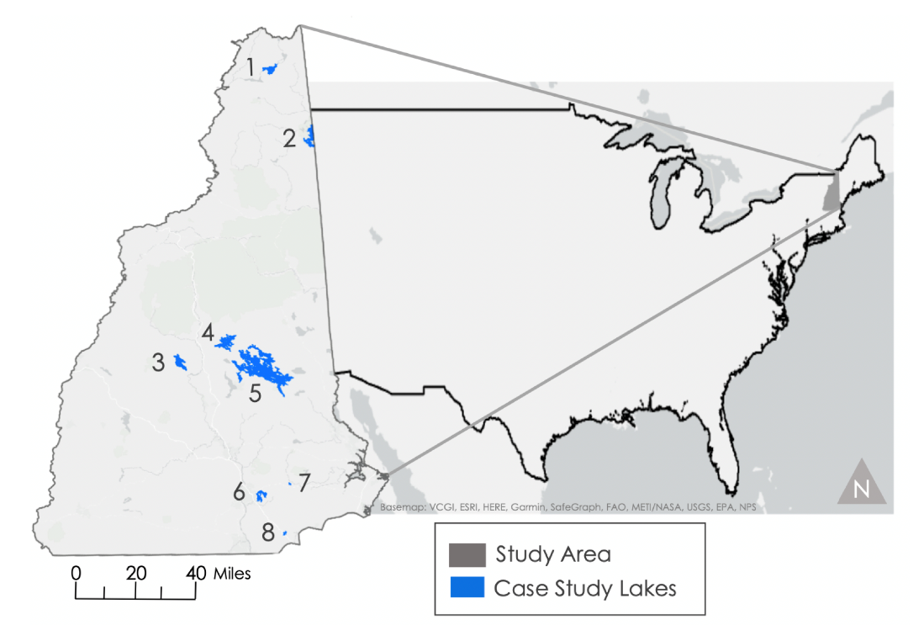

*Figure* 1. The study area (New Hampshire) includes the eight case study lakes explored in this study: 1) First Connecticut, 2) Umbagog, 3) Newfound, 4) Squam, 5) Winnipesaukee, 6) Massabesic, 7) Onway, 8) Canobie.

This study explored both longer and shorter duration temporal datasets given available data quality and accessibility. Land surface temperature (LST) and land use & land cover (LULC) data offer more robust historical measurements and therefore range from 2000 to 2022 for LST and 2001 to 2019 for LULC. Lake water clarity parameters are best estimated using the most recent Landsat sensors due to improvements in radiometric resolution and calibration. Therefore, we chose to work with Landsat 8 Operational Land Imager (OLI) products from 2013 to 2022. Due to loon migration and nesting patterns, for LST and water quality analysis data was refined to solely include May through August, when they are most annually prevalent in the Northeast.

***2.2 Project Partners & Objectives***

This project partnered with the Loon Preservation Committee (LPC); a nonprofit organization committed to maintaining healthy loon populations in New Hampshire. The LPC was founded in 1975 in response to drastic loon population decline. Since its creation, the LPC has worked to inform the public about loons and reviving population growth using their long-term database. These extensive observations helped drive our analysis by providing loon presence and absence data on NH waterbodies (Loon Preservation Committee, n.d.). This collaboration will augment the LPC’s capacity to use Earth observations in support of loon monitoring, providing end products to reference in future assessment efforts.

The objective of this project was to assess risk vulnerability of common loons via three parameters. The first criterion was to assess historical land change and forecast future conflict between anthropogenic intrusion and loon habitat through the creation of a land cover change and human-loon conflict site map. The second was to identify and visualize key water clarity parameters impacting loon habitat selection. Lastly, we analyzed the potential effects of historical land and water surface temperature on the breeding range through time series analysis. These three parameters will assist the LPC with future loon monitoring and protection efforts.

# 3. Methodology

***3.1 Data Acquisition***

For LULC analysis, we used Landsat-based data from the National Land Cover Database (NLCD), provided by the Multi-Resolution Land Characteristics (MRLC) Consortium, to analyze land cover in 2001 and 2019. We also used two additional datasets from the NH GRANIT GIS Clearinghouse Geodata Portal: NH Conservation/Public Lands and NH Hydrography Dataset (Area).

The LPC provided nearly 30 years of field-based presence data that is referenced to the loon’s default territory locations using GPS coordinates. We paired this with Landsat 8 OLI/Thermal Infrared Sensor (TIRS) Collection 2 Level 1 to obtain scenes for water clarity analysis in NH from the U.S. Geological Survey (USGS) EarthExplorer data portal. Images were filtered to display scenes with less than 30% cloud cover obtained during the summer months (May 1st to August 31st) from 2013 to 2022. With a temporal resolution of 16 days, we obtained 101 scenes within the four tiles covering NH. We used Google Earth Engine (GEE) to extract land surface temperature (LST), derived from MOD11A2 Version 6.1 from Terra MODIS, Landsat 5 TM, and Landsat 8 OLI. The MOD11A2 Version 6.1 product shows an average eight-day per pixel Land Surface Temperature and Emissivity grid. From this, we selected scenes from May 1st to August 31st of each year from 2000 to 2022 to align with LPC’s field data collection. We repeated the same steps for Landsat 5 and 8, selecting from 2000–2004 and 2018–2022 respectively.

*Table 1.* NASA Earth observation data, parameters, and date range.

|  |  |  |  |  |
| --- | --- | --- | --- | --- |
| **Platform and Sensor** | **Data Product** | **Date Range** | **Acquisition Method** | **Parameters** |
| Landsat 8 OLI & TIRS | OLI/TIRS Collection 2 Level 1 16-Day Global 30 m Red | May to August 2013–2022 | USGS EarthExplorer | LULC, Water Clarity, LST |
| Landsat 5 TM | USGS Landsat 5 TM Collection 2 Tier 1 Raw Scenes | May to August 2000–2004 | GEE | LST |
| Terra MODIS | MOD11A2 Land Surface Temperature and Emissivity 8-Day L3 Global 1 km SIN Grid V0006 | May to August 2000–2022 | GEE | LST |

***3.2 Data Processing***

We extracted the GPS coordinates of nesting pairs (2000–2022) from the LPC’s data and split them into individual years within ArcGIS Pro 3.1.0. Individual years of the loon presence data were then converted from vector to raster. We reclassified the data from float to short integer to extract cell statistics across the time series. We began analyzing 2001 and 2019 NLCD datasets in ArcGIS Pro. We clipped each year of NLCD data to New Hampshire and filtered our loon nesting data by the corresponding year. Next, we filtered the NH Hydrography Dataset by year using the Spatial Join tool with annual nesting data to create layers of NH lakes where loons were present for each NLCD year. Then we created 500-meter buffers around each lake and then clipped NLCD data to the lake buffers. To find the land available for future development as of 2019, we used both the dataset of NH Conservation/Public Lands and NLCD wetland classifications to mask out areas within the buffers that were protected or unfit for future development.

Landsat 8 OLI imagery was then collected and processed to assess water clarity parameters using the Atmospheric Correction for OLI Lite (ACOLITE) software, developed at the Royal Belgian Institute for Natural Sciences. ACOLITE bundles atmospheric correction algorithms and processing software for various water quality parameters. We utilized the Dark Spectrum Fitting (DSF) algorithm for atmospheric correction while also retrieving turbidity estimates using Nechad’s 2009 algorithm (Nechad et al., 2009) that was recalibrated in 2016 (specifically for Landsat 8 OLI) to explore water clarity (RBINS, 2021).

To calculate LST estimates, we processed the MODIS images into averages across multiple date ranges (2000–2004, 2008–2013, 2013–2015, and 2018–2022) to reduce influence from any unusual fluctuations occurring for a given observed year. We then converted the mean temperature from Kelvin to Fahrenheit and clipped it to the study area. For finer resolution land surface temperature data, we used Landsat 5 and Landsat 8 raw scenes, filtered to the study area, and applied a cloud cover filter set to less than 10%. A JavaScript code within the Urban Heat Island Toolkit in the NASA DEVELOP GEE repository was utilized to calculate LST (Heslin et al., 2018). This toolkit required the Top of Atmosphere (TOA) radiance and the Normalized Difference Vegetation Index (NDVI) input images.

Equation 1 was used by the code to calculate NDVI using the respective NIR and Red bands for Landsat 5 and Landsat 8. We then used Equation 2 to convert TOA radiance (L) in B10 for Landsat 8 and B6 for Landsat 5 from the thermal infrared band to the at-sensor brightness temperature (Tsensor) in Fahrenheit (°F) where $k_{1}$ and $k_{2}$ are 1321.08 K and 774.89 [W/(m2srμm)] (respectively) for Landsat 8, and $k_{1}$ and $k_{2}$ are 1260.56 K and 607.76 [W/(m2srμm)] (respectively) for Landsat 5. Equation 3 was used to model the relationship between NDVI and brightness temperature by calculating the emissivity (ε). Finally, we calculated LST using the brightness temperature and emissivity through Equation 4 where α = 1.438 × 10-2 mK and =0.0000115.

$$\begin{aligned}NDVI=\frac{\left(NIR-RED\right)}{\left(NIR+RED\right)}\#Eq.1\end{aligned}$$

$$\begin{aligned}T_{Sensor}=\frac{k_{1}}{\ln\left(\frac{k_{2}}{L}+1\right)}*\frac{9}{5}-459.67\#Eq. 2\end{aligned}$$

$$\begin{aligned}ε=\left[\left(1.0094+0.047\right) ×\left(\log\left(NDVI\right)\right)\right]\# Eq. 3\end{aligned}$$

$$\begin{aligned}LST= \frac{T_{sensor}}{\left(1+\left(λ\left(\frac{T_{sensor}}{α}\right)\log\left(ε\right)\right)\right)}\#Eq. 4\end{aligned}$$

We then took the mean LST for each individual date range. Both the Landsat and MODIS LST images were then exported to ArcGIS Pro to perform change detection analyses.

***3.3 Data Analysis***

The first set of analyses addressed LULC and changes in urban development. From our NLCD pixel classification tables in ArcGIS Pro, we calculated the existing development in 2001 and increases in development from 2001 to 2019 within 500-meter buffers. We calculated the categorical difference of pixels that were not classified as developed in 2001 but were classified as developed in 2019 to identify the number of changed pixels per lake. Then, we calculated the gross and percent increase in developed pixels per lake buffer. This information identified the lakes with the greatest increase in development between 2001 and 2019. To predict where future development may occur, we calculated the percentage of land available for development as of 2019. We first masked out any conserved or public lands within each buffer since these will not be available for development in the future. Additionally, we identified which pixels within each buffer are classified as any type of land cover other than developed or wetlands. We could then calculate the gross pixels and percent of available land for development within each lake buffer. The land available for development only describes land that could be developed upon in the future, and we are not suggesting there be more development.

The second set of analyses explored the effect of development on NH lake water clarity. Loons have been cited to preferentially select nesting locations with increased water clarity to visually enhance predation (Kuhn et al., 2011). Therefore, turbidity estimates derived from ACOLITE were chosen as the proxy for water clarity in this study. We used NASA’s SeaDAS software to generate visualizations of each scene and roughly identify coordinate locations depicting the average turbidity for a given lake. Using these specific locations, annual mean turbidity estimates were calculated within MATLAB version 9.13.0 (R2022b) and logarithmically regressed with development (Figure 3b), and linearly regressed with latitude (Figure 4) and loon nesting pair density (Figure 5; e.g., the number of nesting pairs observed at each lake of interest normalized by the area of the lake). We calculated the coefficient of determination (R2) and ran a single-factor analysis of variance (ANOVA) to obtain a p-value for each relationship.

Lastly, we analyzed the change in LST to understand its impact on the extent of the breeding range. The Compute Change tool in the Raster Functions toolbox was used to calculate the difference between the 2000–2004 MODIS LST and 2018–2022 MODIS LST imagery. This was repeated to include the smaller incremental time periods: 2000–2004 vs. 2008–2010, 2008–2010 vs. 2013–2015, 2013–2015 vs 2018–2022. We also performed a change detection on the 2000–2004 Landsat 5 and the 2018–2022 Landsat 8 imagery. We clipped the Landsat change detection map to a 500-meter buffer around the eight case study lakes and visually compared it to the Urban Development 2001–2019 change detection.

Using zonal statistics, we found the average LST for two categories of cities in New Hampshire using the NH GRANIT GIS Clearinghouse Political Boundaries. The first category included the eight cities with the largest total population. The cities were Concord, Derry, Keene, Laconia, Lebanon, Manchester, Nashua, and Rochester. The second category included the eight cities with the largest population growth. The cities were Conway, Epping, Henniker, Hooksett, Meredith, Raymond, Whitefield, and Woodstock.

Using the cell statistics tool, we calculated the total number of nest occurrences and identified the most recent year of nest observations. Then we converted the cell statistics output to vector data for simpler visualizations. We used this data to find the nests that were in areas of extreme heat change by reclassifying the MODIS 2000–2022 change detection map and intersecting it with the loon nest sites.

# 4. Results & Discussion

***4.1 Analysis of Results***

*4.1.1 Land Use & Land Cover Assessment*

Case study lake shorelines within the 500-meter buffers show varying levels of urban development in 2001 and all had an increase in development by 2019. The largest increase in urban development is around Canobie Lake (+7.36%) and the smallest increase is around Umbagog Lake (+0.12%; Table 2). There is variation in how much available land for development there is around the lake buffers for our eight study lakes. Lakes that are surrounded by protected lands and wetlands, such as Umbagog Lake and First Connecticut Lake, do not have much available land for development and do not have much overall development. However, it is important to note that we only analyzed the portion of Umbagog Lake in New Hampshire, and we excluded analyzing the area in Maine. Also, lakes that are popular for human recreation, such as Lake Winnipesaukee and Squam Lake, still have lots of undeveloped land that is available for future development. It will be imperative to monitor urban development on such lakes as it could potentially lead to increased human encroachment on loon nesting sites.

*Table 2.*

The percentage of land developed for each of our 8 case study lakes’ 500-meter buffers in 2001 and 2019, in addition to the percent of land that is available for future development in these areas as of 2019.

|  |  |  |  |  |
| --- | --- | --- | --- | --- |
| **Lake** | **Developed 2001** | **Developed 2019** | **Available for Future Development c. 2019** | **Lake Surface Area** |
| Canobie Lake | 64% | 72% | 24% | 1.52 km2 |
| Lake Winnipesaukee | 27% | 29% | 59% | 183.9 km² |
| Newfound Lake | 24% | 25% | 60% | 18.01 km² |
| Massabesic Lake | 16% | 17% | 22% | 10.36 km² |
| Squam Lake | 15% | 15% | 59% | 27.48 km² |
| Onway Lake | 11% | 13% | 57% | 0.72 km² |
| First Connecticut Lake | 7% | 7% | 18% | 12.43 km² |
| Umbagog Lake | 3% | 3% | 6% | 31.77 km² |

To visualize changes in land cover, we mapped 2001 urban development, increases in development by 2019, and land available for development by 2019 around all our case study lakes (Appendix A1). The southwestern region of Lake Winnipesaukee (Figure 2) shows increasing development in red and moderate amounts of land available for future development in orange. By 2019, approximately 58% of the shoreline around Lake Winnipesaukee is available for future development. Some of the limitations of LULC analyses include pixel and land cover percentage calculations which could be due to various uncertainties. One uncertainty is NLCD 30-meter resolution where land could be misclassified due to tree and cloud cover. Also, ArcGIS Pro recalculates the total number of buffer pixels per year, leading to small variations in the total pixel count; thus, for consistency, we used the total pixel count from the 2019 lake buffers. Regarding the land available for future development, we could not account for all land protected from development via laws, regulations, accessibility, private property, and trusts, so our calculations are likely overestimations.

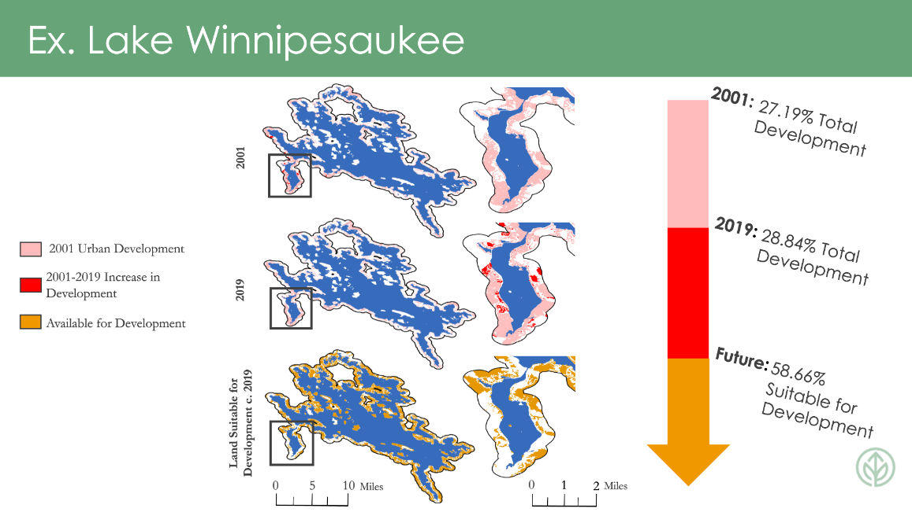

*Figure 2.* From top to bottom,Lake Winnipesauke areas of development in 2001, areas of increase in development between 2001–2019, and areas available for development as of 2019. On the right side are corresponding figures depicting the same trends but focused on the southwestern portion of the lake.

*4.1.2 Water Clarity Assessment*

The average turbidity level of each lake assessed within this study was reported representing data from 2013 to 2022 (Table B1). With turbidity values ranging from 1.01 – 2.04 Formazin Nephelometric Units (FNU; equivalent to a visibility of ~2.2 – 3.4 m), we explored trends in both extremes, and correlated the patterns within the turbidity data to the respective lakeshore development (Figure 3), latitudinal location (Figure 4), and abundance of nesting pairs (Figure 5) for each lake of interest. Interestingly, Canobie Lake which had the highest percentage (71.68%) of surrounding development also had the lowest turbidity estimates (1.01 ± 0.22 FNU) while Umbagog Lake, a National Wildlife Refuge and therefore the lowest percentage of surrounding development (3.40%), had the highest turbidity estimate (2.04 ± 0.18 FNU). When compared through regression analysis across each of the eight lakes, turbidity generally increased as the percentage of lakeshore development decreased (p = 0.01; Figure 3b).

Although we originally collected 101 scenes from May 1st – August 31st of 2013 – 2022 with less than 30% cloud cover, 58 scenes were processed within MATLAB for average turbidity estimates and returned as no data values. Therefore, there was limited data availability for each lake across each year, because the focal point of our study period temporally coincided with increased precipitation in the state of NH due to the warmer LST in the summertime. Since each lake had a different number of scenes available for processing and averaging over each year, our results lacked equal sample sizes which should be considered when comparing values across lakes. The number of scenes associated with each average value can be found outlined in Table B2, but the number of observations averaged across each lake were not represented within our analysis.

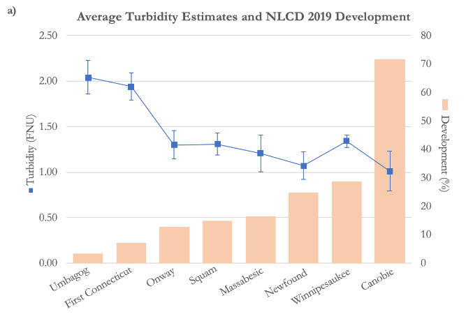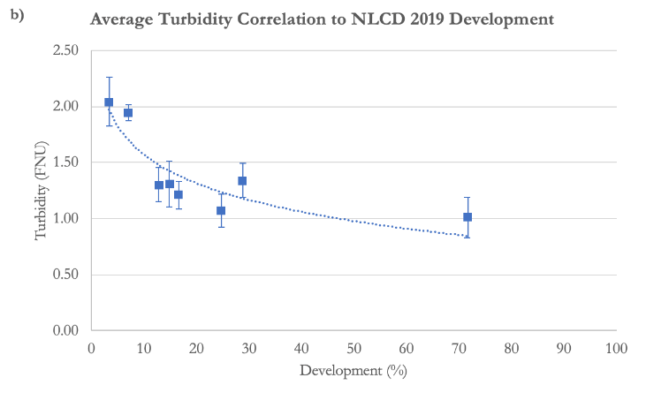*Figure 3.*The visual relationship (a) and the correlation (b) between turbidity estimates (blue square) averaged from 2013 to 2022 for each of the eight lakes of interest and the percent development (orange bar) of each lake calculated from NLCD 2019 data with error bars representative of one standard deviation from the mean turbidity (R2 = 0.44).

When lakes of interest were organized along a latitudinal gradient (ranging from 42.50 – 45.50 °N) and plotted with turbidity, the linear regression depicted a significant increase in average turbidity estimates with an increase in latitude (p = 0.01; Figure 4). The northernmost lakes, First Connecticut and Umbagog (located at approximately 44.80 and 45.10°N, respectively), were estimated to have nearly double the turbidity values of the lakes located in southern NH. These northern lakes fall within the mountainous ecoregion of NH (Kuhn et al., 2011), a higher energy environment particularly susceptible to increased runoff. Figure 5 illustrates the relationship between turbidity and loon abundance within each of the eight lakes assessed in this study. To calculate a nesting pair density at each lake by summing the nesting pairs at each lake from 2013 to 2022 and dividing that sum by the surface area of each lake (Table B3). This relationship lacked statistical significance (p = 0.33) with less than half of the data described by the line of best fit (R2 = 0.47).

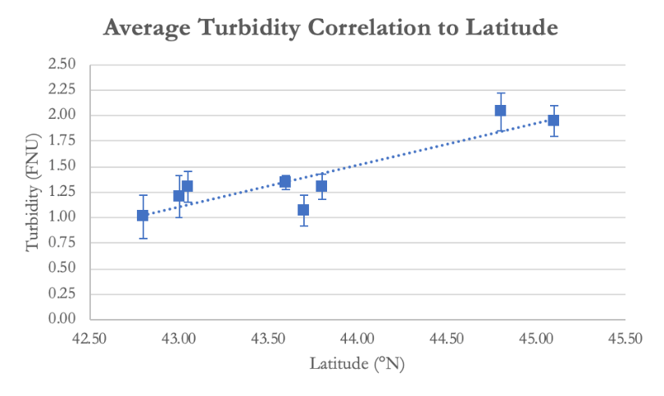

*Figure 4.*The correlation between turbidity estimates averaged from 2013 to 2022 for each of the eight lakes of interest and the lake’s specific latitude with error bars representative of one standard deviation from the mean turbidity (R2 = 0.80).

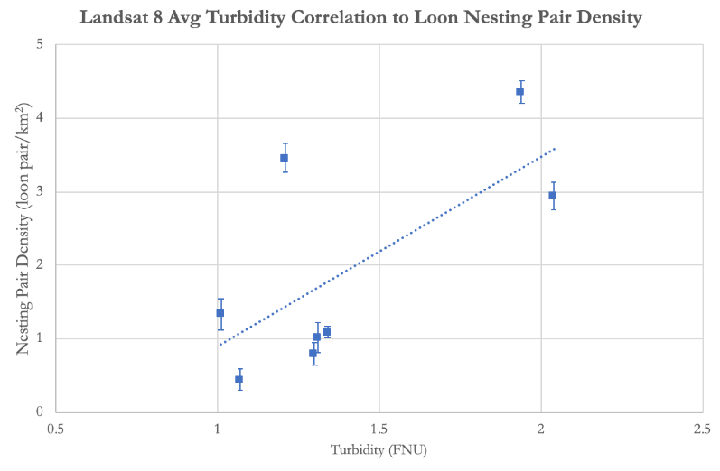

*Figure 5.*The correlation between turbidity estimates averaged from 2013 to 2022 for each of the eight lakes of interest and the calculated loon nesting pair density for each specific lake with error bars representative of one standard deviation from the mean turbidity (R2 = 0.47).

*4.1.3 Land Surface Temperature Assessment*

The results from the LST analysis showed the variations in temperature trends across New Hampshire over time. From 2000 to 2022, there was an average increase of 1.77 °F (Figure 6a). 2000–2010 and 2008–2015 have very similar increments of temperature increase: 0.14 °F and 0.17 °F, respectively (Figure C1, Figure C2). During the 2013–2022 period, there was an average increase of 1.4 °F, which was the highest increment of change (Figure C3). A possible explanation for the large increase during this period could be drought. The New Hampshire Department of Environmental Services classified the state as experiencing moderate to severe drought from 2020–2022 (NH Department of Environmental Services, 2022). In the northern region of the state, multiple groundwater level monitoring wells belonging to the New Hampshire Geological Service were classified as low and below normal during the 2018–2022 time period (NH Department of Environmental Services, 2023).

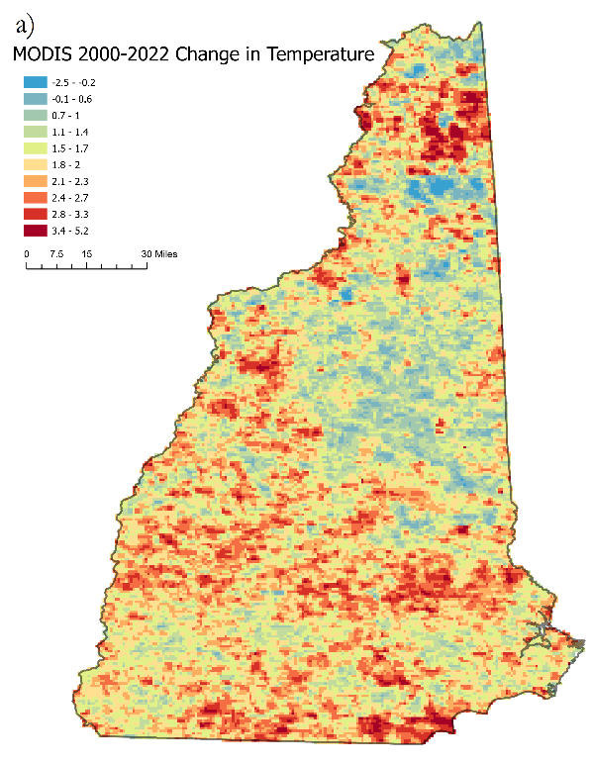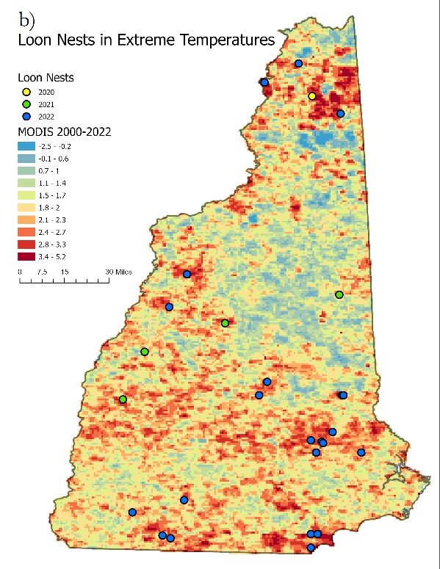

*Figure 6.*MODIS 2000–2022 Average Change in LST (a) and loon nests (circles) in the areas of extreme temperature change (b).

Extreme heat increase was identified as at least a 2.7 °F increase, which is two or more standard deviations from the mean of the MODIS 2000–2022 Average Change in LST. The mean temperature change was an increase of 2 °F. 3% of pixels in the MODIS 2000–2022 Average Change in LST were categorized as extreme temperature change, and 18% of pixels were categorized as above the mean. There were 22 nests experiencing extreme temperature change in total. 1% of nests were experiencing extreme temperature changes in 2020 and 2021 and 4% of nests were experiencing extreme temperatures change in 2022. 42% of nests experiencing extreme temperatures were in areas of above average urban development (Figure 6b). Despite increasing temperatures, there has been continued loon nest presence suggesting that loons may be more resilient to temperature change than previously expected.

Analysis of average LST in city boundaries could explain some of the temperature change trends. As expected, the cities with the highest temperature change such as Manchester, Nashua, and Concord, had the highest total population (Figure C4). Both Manchester and Nashua experienced extreme temperature changes. These trends could be caused by the urban heat island effect. None of the cities with the largest population growth reached extreme temperature change, but they did reach above the mean temperature change (Figure C5). Many of these cities were small rural towns so they lacked the urban density to reach extreme temperature change. Additionally, the cities in this category tended to be farther north than the larger more populated cities, which may also explain temperature change in the middle of the state seen in the MODIS 2000–2022 Average Change in LST (Figure 6a).

We also overlaid the Urban Development Change from 2001–2019 with the Landsat Change of Average LST and visually analyzed the intersecting areas (Figure C6). Commonly, areas with change in development and hotspots of temperature change line up with each other. Though not exact, this suggests that there are higher temperatures in areas of development compared to undeveloped areas. It is important to note that images collected from Landsat 5 had extreme temperature values due to an edge effect on the margins of the scene. This created extreme negative values. These values still impacted the results even after masking out the extreme negative values, so the Landsat LST change detection is an overestimation.

***4.2 Future Work***

For LULC, we would like to include more property data into our land available for future development calculations to account for any misclassified land in our original calculations. It would also be useful to use land change modeling software, such as Clark Lab’s TerrSet Land Change Modeler, to create maps of modeled future urban development. Also, a statistical analysis between increases in urban development and LST should be pursued.

As water clarity deteriorates, turbidity increases and subsequently lessens the optical visibility of the predation environment for loons (Kuhn et al., 2011). But there are several other parameters (organic matter, nutrient abundance, chlorophyll-a, etc.) that also contribute to the reduction of water clarity and subsequently water quality that can be explored to evaluate the habitat suitability of a given lake for loons. Future work should seek to incorporate these factors into analysis to generate more robust conclusions regarding the overall water quality of NH lakes.

Our results depicted an increasing trend in turbidity estimates across a northward latitudinal gradient (Figure 4) and an inverse relationship when plotted with the percentage of lakeshore development for a particular lake (Figure 3). Further, NH lakeshore development decreases with an increase in latitude (Figure B1) as the northern region of the state is generally less populous than its southern counterpart but higher in elevation and with more rugged topography. The scientific community should continue to explore this relationship as it relates to loon nesting sites by incorporating additional satellite imagery obtained from additional available sensors, (e.g., Sentinel-2) and *in situ* observations to further gain confidence in the relationships identified within this study.

Lastly, incorporating topographic data into the geospatial analysis of water clarity could aid in our interpretation of results. By identifying areas of increased slope, inferences could be made on the speed at which water moves and therefore the relative number of particles suspended in a particular lake region.

Due to time constraints and limits with remote sensing techniques, we were not able to calculate any lake water surface temperature information. Considering loons are aquatic birds, water temperatures may impact their breeding and nesting habits. They would be an important element to consider in the future to create a more complete understanding of factors impacting loons.

# 5. Conclusions

Our results and findings will assist the LPC in their conservation efforts and allow them to target their community outreach in areas that are experiencing increases in urban development, more turbid lakes, and higher land surface temperatures. For LULC, variations in the amount of urban development and the rate at which shoreline is developed are important for the LPC to visualize, so they can target their educational outreach for lakes that harbor more human activity. The LULC maps will be beneficial to use in conjunction with the LPC’s observations to see how future changes in shoreline development could conflict with loon nesting territories.

Loons are visual predators and therefore prefer water with at least three meters of visibility, which is why we explored turbidity as a metric of water clarity. When compared to the percentage of lakeshore development within a 500 m buffer around eight select NH lakes, we found that the least turbid waters were observed within the most developed lakes. Further, these lowest estimations for turbidity were observed at lower latitudes. The LPC can use these results to visualize trends in turbidity over the past decade to better understand the relative visibility of select NH lakes for predatory loons.

Despite an average increase of 1.77 °F from 2000–2022, there has been continued loon presence in New Hampshire. This suggests that loons may have a higher tolerance to temperature change than previously expected. As temperatures continue to increase, there will be more nests in areas of extreme temperature change. Identifying areas of extreme temperature change will assist the LPC in determining lakes at higher risk, especially when the other factors of this study are considered.

# 

# 6. Acknowledgments

The Spring 2023 NASA DEVELOP New Hampshire Ecological Conservation team would like to thank our project partners at the Loon Preservation Committee: Harry Vogel, John Cooley, and Caroline Hughes, as well as Dr. Anne Kuhn-Hines from the Environmental Protection Agency. We would also like to thank our science advisors, Dr. Cedric Fichot and Joseph Spruce. We would like to express our gratitude for the guidance of our Fellow, Tyler Pantle. Lastly, thank you to the DEVELOP Project Coordination Fellows Laramie Plott, Cecil Byles, and Olivia Landry for their guidance and edits.

Some of the maps in this work were created using ArcGIS® software by Esri. ArcGIS® and ArcMap™ are the intellectual property of Esri and are used herein under license. All rights reserved.

Any opinions, findings, and conclusions or recommendations expressed in this material are those of the author(s) and do not necessarily reflect the views of the National Aeronautics and Space Administration.

This material is based upon work supported by NASA through contract NNL16AA05C.

# 

# 7. Glossary

**ACOLITE** –Atmospheric Correction for OLI Lite; a processor designed for coastal and inland water applications and atmospheric correction

**ArcGIS** – Geographic Information System software; used for collecting and managing data, creating maps, and performing spatial analyses

**Earth observations** – Satellites and sensors that collect information about the Earth’s physical, chemical, and biological systems over space and time

**Fledge** – to acquire feathers necessary for flight

**FNU** – Formazin Nephelometric Unit

**GEE** – Google Earth Engine; an online repository of satellite data and geospatial datasets hosted on Google Services

**MODIS** – MODerate Resolution Imaging Spectroradiometer

**Remote sensing** – The acquisition of data of an object(s) without making physical contact

**Turbidity** – An optical characteristic of water that measures the amount of light that gets scattered by sediment particles suspended within the water column

# 8. References

All About Birds. (n.d.). *Common loon overview, all about birds, Cornell Lab of Ornithology*. Overview, All About Birds, Cornell Lab of Ornithology. Retrieved February 6, 2023, from <https://www.allaboutbirds.org/guide/Common_Loon/overview>

Audubon. (2022, December 17). *Common loon*. Audubon. Retrieved February 6, 2023, from <https://www.audubon.org/field-guide/bird/common-loon>

Badzinski, S. S., & Timmermans, S. T. (2006). Factors influencing productivity of common loons (Gavia immer) breeding on circumneutral lakes in Nova Scotia, Canada. *Hydrobiologia*, *567*(1), 215-226. <https://doi.org/10.1007/s10750-006-0043-1>

Evers, D. (2006). Loons as biosentinels of aquatic integrity. Environmental Bioindicators. 1. 18-21. <https://doi.org/10.1080/15555270600605402>

Field, M., & Gehring, T. M. (2015). Physical, human disturbance, and regional social factors influencing Common Loon occupancy and reproductive success. The Condor: Ornithological Applications, 117(4), 589-597. <https://doi.org/10.1650/CONDOR-14-195.1>

Hammond, C. A., Mitchell, M. S., & Bissell, G. N. (2012). Territory occupancy by Common Loons in response to disturbance, habitat, and intraspecific relationships. *The Journal of Wildlife Management*, 76(3), 645-651. <https://doi.org/10.1002/jwmg.298>

Heslin, J., Dialesandro, J., Heck, M., & Lin, C. (2018). UHIT: Urban Heat Island Toolkit. [Source Code]. <https://code.earthengine.google.com/1de6ec28cb8220f72518fe4865b8b5e1.>

Kuhn, A., J. Copeland, J. Cooley, H. Vogel, K. Taylor, D. Nacci, and P. August. (2011). Modeling habitat associations for the Common Loon (Gavia immer) at multiple scales in northeastern North America. *Avian Conservation and Ecology* 6(1): 4. Retrieved from <http://dx.doi.org/10.5751/ACE-00451-060104>

Lindsay, A. R., Gillum, S. S., & Meyer, M. W. (2002). Influence of lakeshore development on breeding bird communities in a mixed northern forest. *Biological Conservation*, *107*(1), 1-11. <https://doi.org/10.1016/S0006-3207(01)00260-9>

Loon Preservation Committee. (n.d.). *Loon preservation in New Hampshire.* Loon Preservation Committee. Retrieved February 6, 2023, from <https://loon.org/about-the-common-loon/>

McCarthy, K. P., & Destefano, S. (2011). Effects of spatial disturbance on common loon nest site selection and territory success. The Journal of Wildlife Management, 75(2), 289-296. <https://doi.org/10.1002/jwmg.50>

Multi-Resolution Land Characteristics Consortium (MRLC). (2001). *National Land Cover Database (NLCD) 2001 Land Cover (CONUS)*. MRLC Data Downloads. Retrieved March 29, 2023, from <https://www.mrlc.gov/data/nlcd-2001-land-cover-conus>

Multi-Resolution Land Characteristics Consortium (MRLC). (2019). *National Land Cover Database (NLCD) 2019 Land Cover (CONUS)*. MRLC Data Downloads. Retrieved March 29, 2023, from <https://www.mrlc.gov/data/nlcd-2019-land-cover-conus>

NASA Goddard Space Flight Center. (2001-2011). *Landsat 7 Enhanced Thematic Mapper Plus (ETM+) Aqua L2 Inherent Optical Properties*. [NLCD Land Cover (CONUS) All Years]. Multi-Resolution Land Characteristics Consortium. Retrieved February 22, 2023, from <https://www.mrlc.gov/data>

NASA Goddard Space Flight Center. (2013-2019). *Landsat 8 Operational Land Imager (OLI)*. [NLCD Land Cover (CONUS) All Years]. Multi-Resolution Land Characteristics Consortium. Retrieved February 22, 2023, from <https://www.mrlc.gov/data>

Nechad, B., Ruddick, K. & Neukermans, G. (2009). Calibration and validation of a generic multisensor algorithm for mapping of turbidity in coastal waters. Proceedings of *SPIE - The International Society for Optical Engineering*. [https://doi.org/7473. 10.1117/12.830700.](https://doi.org/7473.%2010.1117/12.830700.%20)

New Hampshire Department of Environmental Services. (2022). *Drought*. NH Department of Environmental Services. Retrieved March 29, 2023, from <https://www.des.nh.gov/climate-and-sustainability/storms-and-emergencies/drought>

New Hampshire Department of Environmental Services. (2023). *NH Groundwater Level Monitoring Network*. NH Department of Environmental Services. Retrieved March 29, 2023 from <https://nh-department-of-environmental-services-open-data-nhdes.hub.arcgis.com/apps/NHDES::nh-groundwater-level-monitoring-network/explore>

New Hampshire GRANIT GIS Clearinghouse. (2022). *New Hampshire Conservation/Public Lands*. ArcGIS Hub. Retrieved March 29, 2023, from <https://hub.arcgis.com/datasets/NHGRANIT::new-hampshire-conservation-public-lands/about>

New Hampshire GRANIT GIS Clearinghouse. (2022). *New Hampshire Hydrography Dataset (Area)*. NH GRANIT Geodata Portal. Retrieved March 29, 2023 from <https://new-hampshire-geodata-portal-1-nhgranit.hub.arcgis.com/datasets/NHGRANIT::new-hampshire-hydrography-dataset-area-1/about>

New Hampshire GRANIT GIS Clearinghouse. (2022). *New Hampshire Political Boundaries*. ArcGIS Hub. Retrieved March 29, 2023 from <https://hub.arcgis.com/datasets/4edf75ab263b4d92996f92fb9cf435fa/explore?location=43.992853%2C-71.629700%2C8.96>

NH.gov. (n.d.) *A brief history of New Hampshire, New Hampshire Almanac*. NH.gov. Retrieved February 8, 2023, from <https://www.nh.gov/almanac/history.htm>

Piper, W. H., Grear, J., Hoover, B., Lomery, E., & Grenzer, L. M. (2020). Plunging floater survival causes cryptic population decline in the common loon. *The Condor*, *122*(4). <https://doi.org/10.1093/condor/duaa044>

RBINS. (2021). ACOLITE User Manual. <https://github.com/acolite/acolite/releases/tag/20210802.0>

Tuttle, C. M., & Heintzelman, M. D. (2015). A loon on every lake: A hedonic analysis of lake water quality in the Adirondacks. Resource and Energy Economics, 39, 1-15. <https://doi.org/10.1016/j.reseneeco.2014.11.001>

US Geological Survey (USGS). (2013). Landsat 5 Thematic Mapper (TM) Level 2, Collection 2, Tier 1 Top of Atmosphere Reflectance [Dataset]. Earth Engine Data Catalog/USGS. Retrieved October 2022, from <https://doi.org/10.5066/P9IAXOVV>

US Geological Survey (USGS). (2013). Landsat 8 Operational Land Imager (OLI) Level 2, Collection 2, Tier 1 Top of Atmosphere Reflectance [Dataset]. Earth Engine Data Catalog/USGS. Retrieved October 2022, from <https://doi.org/10.5066/P9OGBGM6>

Wan, Z., Hook, S., Hulley, G. (2015). MOD11A2 MODIS/Terra Land Surface Temperature/Emissivity 8-Day L3 Global 1km SIN Grid V006 [Data set]. NASA EOSDIS Land Processes DAAC. Accessed 2023-02-21 from <https://doi.org/10.5067/MODIS/MOD11A2.006>

# 9. Appendices

**Appendix A: LULC**

*Table A1.* LULC analysis for each of our eight case study lakes depicting developed land in 2001, increase in development between 2001 – 2019, and land available for development as of 2019.

|  |  |
| --- | --- |
|  |  |
|  |  |
|  | Inserting image... |
|  |  |

***Appendix B: Water Clarity***

*Table B1*. Remotely sensed turbidity estimations averaged across each selected case study lake from 2013 – 2022.

|  |  |  |
| --- | --- | --- |
| **Lake** | **Latitude (°N)** | **Average Turbidity (FNU)** |
| Canobie Lake | 42.80 | 1.01 ± 0.22 |
| Lake Winnipesaukee | 43.60 | 1.34 ± 0.07 |
| Newfound Lake | 43.70 | 1.07 ± 0.15 |
| Massabesic Lake | 43.00 | 1.21 ± 0.20 |
| Squam Lake | 43.80 | 1.31 ± 0.12 |
| Onway Lake | 43.05 | 1.30 ± 0.15 |
| First Connecticut Lake | 45.10 | 1.94 ± 0.15 |
| Umbagog Lake | 44.80 | 2.04 ± 0.18 |

*Table B2.* The number of observations included within each average turbidity estimation made for each lake, excluding outliers.

|  |  |
| --- | --- |
| **Lake** | **Number of Observations** |
| Canobie Lake | 15 |
| Lake Winnipesaukee | 32 |
| Newfound Lake | 12 |
| Massabesic Lake | 18 |
| Squam Lake | 19 |
| Onway Lake | 19 |
| First Connecticut Lake | 20 |
| Umbagog Lake | 23 |

*Table B3.* The calculated loon nesting pair density taking the sum of loon nesting pairs since 2013 and dividing by the surface area of each respective lake.

|  |  |  |  |
| --- | --- | --- | --- |
| **Lake** | **Sum of Loon Nesting Pairs since 2013** | **Area of Lake (km2)** | **Calculate Loon Nesting Pair Density (loon/km2)** |
| Canobie Lake | 2 | 184.8 | 1.33 |
| Lake Winnipesaukee | 202 | 202 | 1.09 |
| Newfound Lake | 8 | 18 | 0.44 |
| Massabesic Lake | 36 | 10.4 | 3.46 |
| Squam Lake | 89 | 27.4 | 1.02 |
| Onway Lake | 8 | 0.72 | 0.80 |
| First Connecticut Lake | 54 | 12.4 | 4.35 |
| Umbagog Lake | 91 | 30.92 | 2.94 |

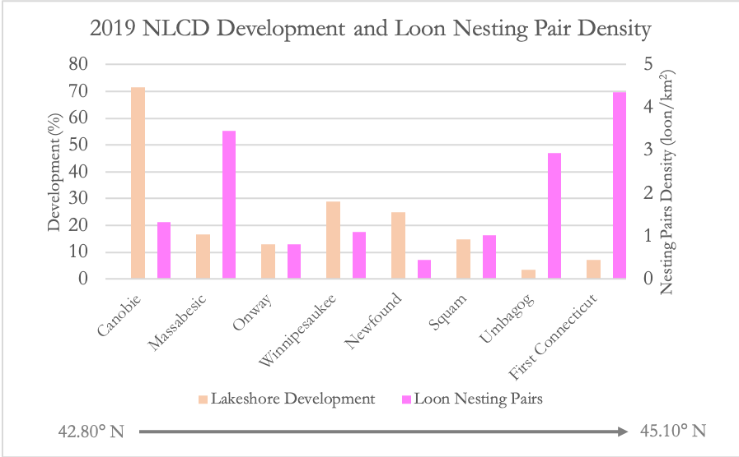

*Figure B1.* The percentage of lakeshore development within a 500 m buffer from the lake’s edge acquired from the 2019 NLCD dataset (orange) and the normalized number of loon nesting pairs summed from 2013 to 2022 (pink) across a latitudinal gradient (south to north) for the eight selected NH lakes.

**Appendix C: LST**

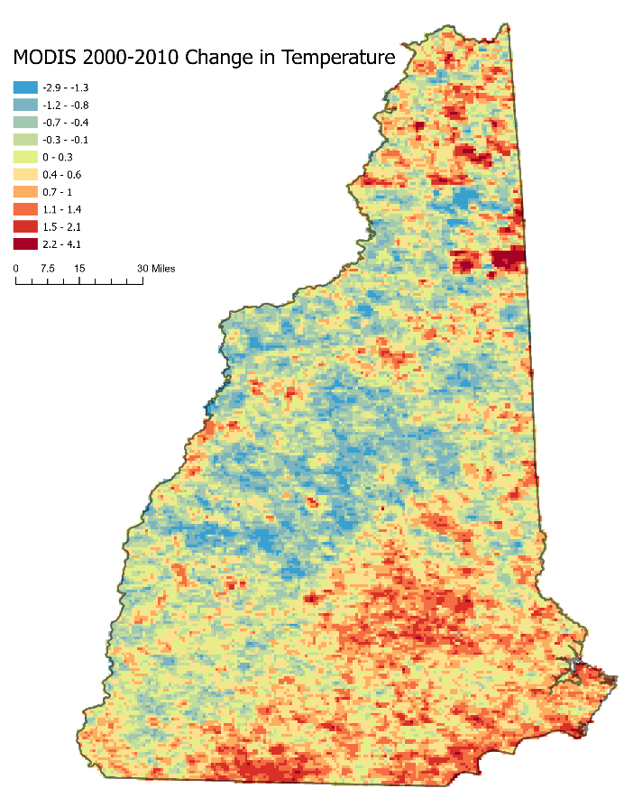

*Figure C1.* MODIS change detection in LST from 2000–2004 to 2008–2010

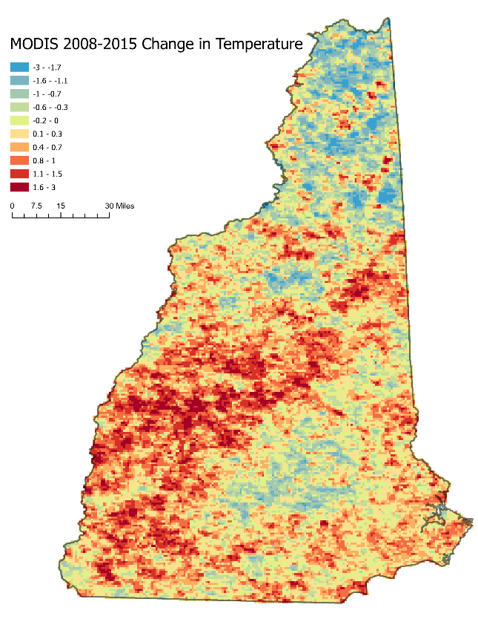

*Figure C2.* MODIS change detection in LST from 2008–2010 to 2013–2015

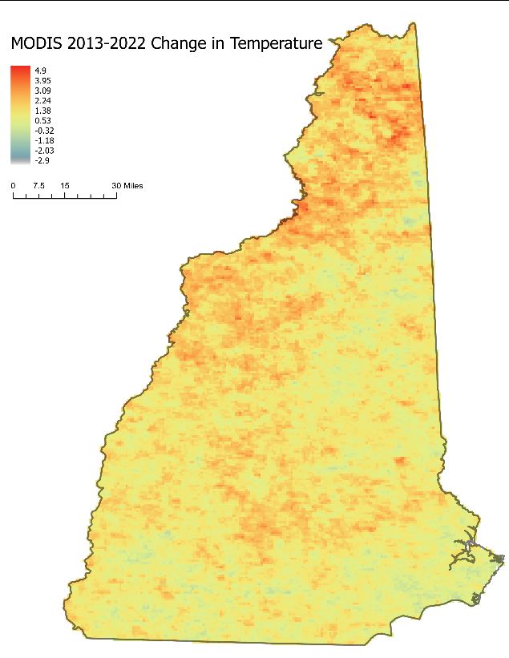

*Figure C3.* MODIS change detection in LST from 2013–2015 to 2018–2022

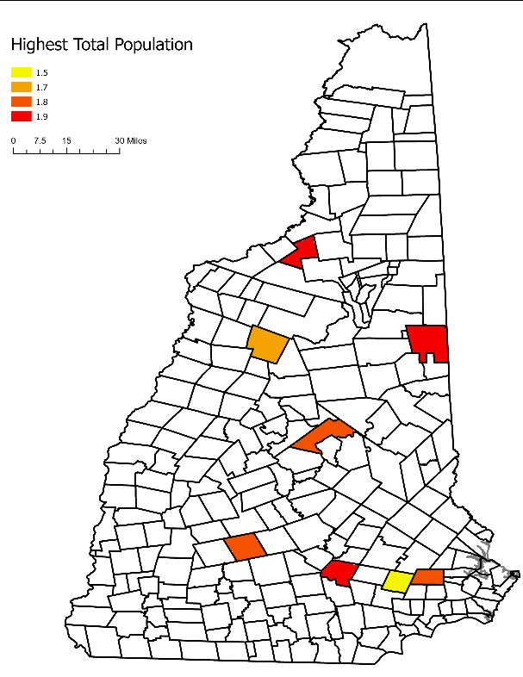

*Figure C4.* Average Temperature Change of Cities with Largest Total Population

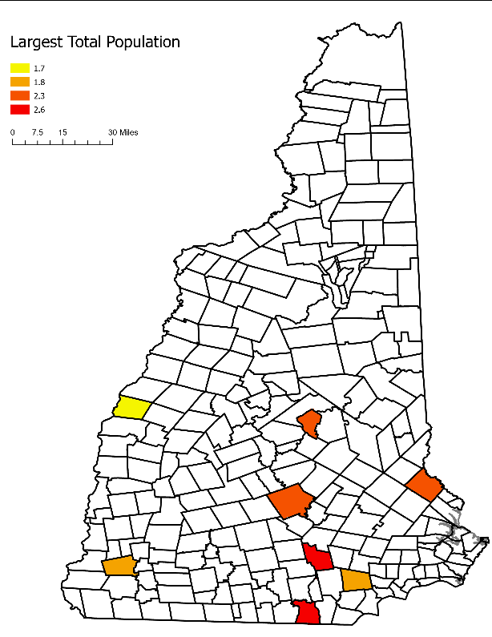

*Figure C5.* Average Temperature Change of Cities with Largest Population Increase

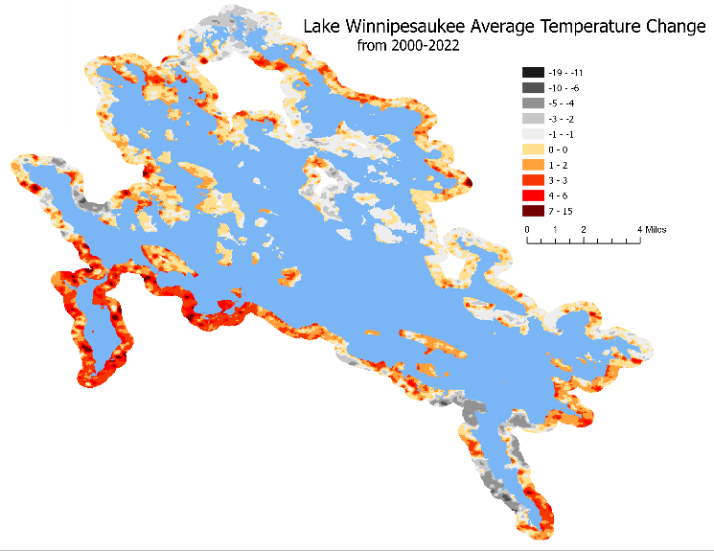

*Figure C6.* Landsat Change of Average Temperature of Lake Winnipesaukee