Medicine Bow Disasters

Utilizing Remote Sensing to Evaluate Herbicide Treatment Efficacy on Invasive Cheatgrass in Medicine Bow National Forest, Wyoming

 **Technical Report**

Final Draft – November 21st, 2019

Chiara Phillips (Project Lead)

Stacy Armbruster

Forrest Corcoran

Byron Schuldt

Dr. Paul Evangelista, Colorado State University, Natural Resource Ecology Laboratory (Science Advisor)

Dr. Catherine Jarnevich, USGS, Fort Collins Science Center (Science Advisor)

Peder Engelstad, Colorado State University, Natural Resource Ecology Laboratory (Science Advisor)

Nicholas Young, Colorado State University, Natural Resource Ecology Laboratory (Science Advisor)

Tony Vorster, Colorado State University, Natural Resource Ecology Laboratory (Science Advisor)

# 1. Abstract

The Medicine Bow National Forest (MBNF) consists of approximately 1,383,790 acres of forested land, grassland, and sagebrush steppe in southeastern Wyoming. Cheatgrass (*Bromus tectorum*), an invasive plant species in the Western US, occurs in the grasslands throughout MBNF. Cheatgrass is known to rapidly colonize disturbed sites and dramatically alter historic fire regimes and nutrient/water dynamics as well as outcompete native plant species that are important forage for mule deer (*Odocoileus hemionus*) and elk (*Cervus canadensis*). In 2012, the Squirrel Creek Fire burned approximately 10,587 acres of land within MBNF, exacerbating the spread of cheatgrass. In 2015, the Wyoming Ecological Forecasting DEVELOP team identified areas of high cheatgrass abundance within the fire boundary in order to guide US Forest Service (USFS) herbicide spraying efforts to reduce cheatgrass in 2016. This research used Landsat 8 Operational Land Imager (OLI) and Sentinel-2 MultiSpectral Instrument (MSI) data to create a 2019 probabilistic cheatgrass occurrence map. This map allowed an analysis of the effectiveness of aerial spraying to inform future land management techniques for the USFS. Based on the results of the Generalized Linear Model, we found that treated areas decreased in cheatgrass cover by 36% while untreated areas increased in cheatgrass cover by 6%, suggesting that herbicide treatment has been effective.

**Keywords**

machine learning, Landsat 8 OLI, Sentinel-2 MSI, invasive species, Boosted Regression Tree, Multi-Adaptive Regression Splines, Random Forest, Generalized Linear Model

# 2. Introduction

* 1. ***Background Information***
     1. *Community Concern*

Medicine Bow National Forest (MBNF) has ecological, economic and recreational importance as it provides space for hunting, hiking, grazing, and forage for wildlife. In MBNF, cheatgrass (*Bromus tectorum*) has the potential to disrupt these land uses and is a primary concern of the US Forest Service (USFS). Cheatgrass is shown to have negative impacts on ecosystem health throughout the Western US, as it alters nutrient cycles, water availability (Menalled, Mangold, Orloff & Davis, 2008), and replaces native plant species that are an important food source for wildlife (Brooks et al., 2004). In some regions, the alteration of wildfire regimes due to cheatgrass invasion has created advantageous conditions for cheatgrass seeds to take hold in subsequent seasons (Menalled et al., 2008). In 2012, the Squirrel Creek Fire burned approximately 10,587 acres of land within MBNF, including critical winter habitat and forage for elk and mule deer, and exacerbated the spread of cheatgrass across the burn area.

**May - June**

**June - July**

**August - September**

*Figure 1.* This graphic visualizes the annual cheatgrass life cycle.

Cheatgrass (also known under other common names like downy brome, military grass, downy cheat, and downy bromegrass) can outcompete native plants in several ways. It is an annual plant that goes through three life stages: emergence, maturation, and senescence (*Figure 1*) (Menalled et al., 2008). Unlike most plants in MBNF, cheatgrass germinates in the fall and develops its root structure throughout the winter. As soon as warmer temperatures arrive in the spring, cheatgrass shoots can emerge while native plants begin germination. In addition, cheatgrass roots are extremely efficient in extracting moisture from the soil, thus depriving other plants of water. In mid-summer, cheatgrass turns a reddish-purple color, matures, and sets seed. Cheatgrass is a prolific seed generator, with one plant being able to produce around 500 seeds that can remain viable for 2-3 years (Young, Evans, Eckert, & Kay, 1987). By early fall, cheatgrass senesces and contributes to a more continuous path of fuel for potential grassland fires. Cheatgrass responds well to disturbances like fires, as its main limiting factor is space to take root (Menalled et al., 2008). With the combination of its early germination, effective water extraction, profuse seed generation, and propensity to invade post-disturbance, cheatgrass can outcompete native plants in MBNF.

Because cheatgrass emerges earlier than native plants in the spring, turns a reddish-purple color in mid-summer, and senesces in late-summer and early-fall, it is a great candidate species for detection using remote sensing. This project employed remote sensing classification methods like those of West et al. (2017) and other studies of cheatgrass utilizing remotely sensed data, including multi-temporal Landsat imagery (Bradley & Mustard, 2006; Sherrill & Romme, 2012; Singh & Glenn, 2009). Additional studies have assessed the utility of the Terra Moderate Resolution Imaging Spectroradiometer (MODIS; Clinton et al., 2010) or imagery from multiple sensors (Landsat and Sentinel; Neal, Wylie, & Wu, 2018). Among these and related studies, random forests and boosted regression tree algorithms have commonly been used to generate accurate models of cheatgrass distribution (Clinton et al., 2010; Neal et al., 2018; Peeler & Smithwick, 2018; West et al., 2017).

* + 1. *Study Area & Period*

The study area for this project covers the 10,587 acres that burned in the 2012 Squirrel Creek Fire in MBNF (*Figure 2*). The area is characterized by rugged, hilly terrain and a windy, semi-arid climate. Three different Landsat scenes overlap the primary study area in Southeastern Wyoming (Worldwide Reference System 2, Path 34, Row 31; Worldwide Reference System 2, Path 34, Row 32; and Worldwide Reference System 2, Path 35, Row 31). Additionally, two Sentinel granules (T13TCF & T13TDF) covered our scene. The dates for the Landsat/Sentinel scenes used in this study ranged from May 2019 to October 2019.

= Study Area

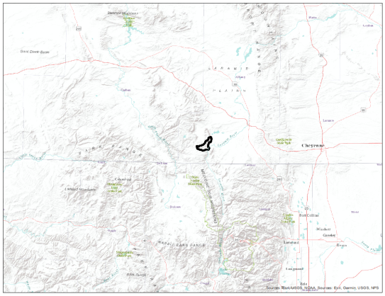 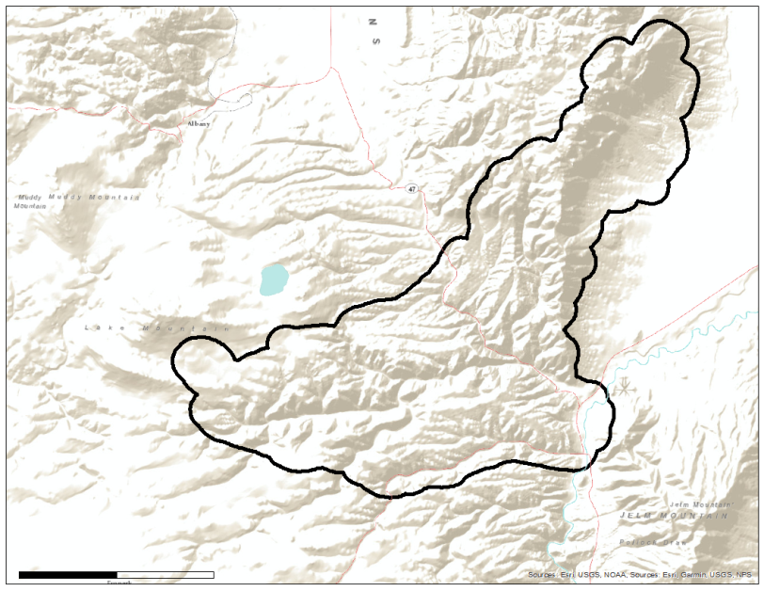

N

0 1.5 3

km

*Columbine*

*Cheyenne*

**WYOMING**

**COLORADO**

*Figure 2.* The study area is the boundary of the Squirrel Creek Fire in Medicine Bow National Forest, WY.

* 1. ***Project Partners & Objectives***
     1. *Project Partners*

We partnered with the USFS to address the need to monitor the impact of chemical herbicide treatment on invasive cheatgrass. Working on public and private land, the USFS is actively managing cheatgrass to provide ecosystem benefits for native flora and fauna. Current efforts for managing cheatgrass have already cost the USFS over $100,000. To help inform future landscape management, the USFS requires up-to-date and accurate maps of cheatgrass to inform managers about the species response to aerial herbicide treatment.

* + 1. *Objectives*

In 2015, a study by West et al. (2017) identified areas with high likelihoods of 40% or more cheatgrass cover. In 2016, the USFS used the results of the study by West et al. (2017) to spray such areas with an herbicide called Imazapic. Imazapic is an herbicide commonly used to suppress annual and perennial grasses by inhibiting seed germination (Tu, Hurd, & Randall, 2001). Because considerable resources and efforts have already been put into this mitigation technique, the USFS wanted to understand how cheatgrass populations have responded post-treatment. However, exhaustive field data collection of the entire Squirrel Creek region would require significant time and effort. As such, the objective of this project was to generate a probabilistic cheatgrass occurrence map for 2019 by utilizing remotely sensed data. The resulting map was compared to the pre-treatment occurrence map and treatment polygons to determine the efficacy of the 2016 herbicide application. The USFS can use the probabilistic map and our analyses to inform future land management efforts.

# 3. Methodology

***3.1 Data Acquisition***

To conduct this research, we used both remotely sensed data and vector data. We acquired data from Landsat 8 Operational Land Imager (OLI) and Sentinel-2 MultiSpectral Instrument (MSI) to produce spectral indices to be used as inputs for classification models (Table 1). In addition, we used the Squirrel Creek Fire boundary shapefile to limit the study area, the field samples as ground truth data points to train the classification models, and the Imazapic spray boundary shapefile to evaluate the effectiveness of the herbicide treatment by comparing model output results with those of the West et al. (2017) model (Table 2).

Table 1

*The table below showcases the NASA satellite data used in this project*.

|  |  |  |
| --- | --- | --- |
| **Earth Observation Data** | | |
| **Product Title** | **Image Dates** | **Source** |
| **Landsat 8 Operational Land Imager tier 1** | May 13th, 2019  July 16th, 2019 July 23rd, 2019  August 17th, 2019 September 2nd, 2019  October 4th, 2019 | Google Earth Engine - USGS |
| **Sentinel-2 MultiSpectral Instrument level 1C** | June 26th, 2019 | Google Earth Engine - USGS |

Table 2

*The table below showcases the ancillary data used in this project*.

|  |  |  |  |
| --- | --- | --- | --- |
| **Ancillary Data** | | | |
| **Data Type** | **Specifications** | **Dates** | **Source** |
| **Squirrel Creek Fire boundary data** | Shapefile | 2012 | Natural Resource Ecology Laboratory |
| **Pre-treatment probabilistic cheatgrass occurrence map** | Raster | 2015 | West et al. 2017 |
| ***In situ* field samples of *Bromus tectorum*** | GPS Points | May to September 2019 | USFS, NASA DEVELOP Program |
| **Imazapic spray boundary data** | Shapefile | 2016 | USFS |

With the assistance of the USFS, we collected field data from across the study area via ocular assessment of the percent cheatgrass cover within 15-meter diameter plots. These plots were chosen opportunistically with a minimum separation of 30 meters between plots. A total of 156 plots were used in this study.

***3.2 Data Processing***

We calculated the percentage of total pixels contaminated by clouds for each image in the May 2019 to October 2019 time period (Table 1). Then, we assessed cloud contamination in Google Earth Engine using the Quality Assurance (QA) band for each image, selecting only cloud-free images for further analysis. We calculated several spectral indices listed below for each image: Normalized Difference Vegetation Index (NDVI; Equation 1), Normalized Burn Ratio (NBR; Equation 2), Enhanced Vegetation Index (EVI; Equation 3), Plant Senescence Reflectance Index (PSRI; Equation 4), Modified Normalized Difference Water Index (MNDWI; Equation 5), Normalized Difference Water Index (NDWI; Equation 6), Normalized Multiband Drought Index (NMBDI; Equation 7), Soil Adjusted Vegetation Index (SAVI; Equation 8), Tasseled Cap Brightness, Tasseled Cap Greenness, and Tasseled Cap Wetness. The Tasseled Cap indices were computed using a linear combination of bands and empirical coefficients (Baig, Zhang, Shuai, & Tong, 2014; Shi & Xu, 2019). The bands and empirical coefficients were calculated using Principal Component Analysis (PCA) to highlight different attributes of the observed spectrum (Tables 3 & 4). The team computed these indices on the Landsat 8 imagery using Google Earth Engine and exported the resulting spectral indices as GeoTIFFs.

$\text{NDVI = }\frac{\text{NIR - Red}}{\text{NIR + Red}}$ (1)

$\text{NBR = }\frac{\text{NIR - SWIR}}{\text{NIR + SWIR}}$ (2)

$\text{EVI = }\frac{\text{NIR - Red}}{\text{(NIR + 6)(Red - 7.5)(Blue + 1)}}$ (3)

$\text{PSRI = }\frac{\text{Red - NIR}}{\text{Green}}$ (4)

$\text{MNDWI = }\frac{\text{Green - SWIR6}}{\text{Green + SWIR6}}$ (5)

$\text{NDWI = }\frac{\text{NIR - SWIR}}{\text{NIR + SWIR}}$ (6)

$\text{NMBDI = }\frac{\text{NIR - (SWIR6 - SWIR7)} }{\text{NIR + (SWIR6 - SWIR7)}}$ (7)

SAVI $\text{ = 1.5 *} \frac{\text{NIR - Red}}{\text{NIR + Green + 0.5}}$ (8)

Table 3

*The Landsat 8 Tasseled Cap Band coefficients are used in the linear transformation of the bands to the tasseled cap indices (Baig et al., 2014).*

|  |  |  |  |  |  |  |
| --- | --- | --- | --- | --- | --- | --- |
| **Landsat 8 Tasseled Cap Surface Reflectance Band Coefficients** | | | | | | |
| **Component** | **Band 1** | **Band 2** | **Band 3** | **Band 4** | **Band 5** | **Band 7** |
| **Brightness** | 0.3037 | 0.2793 | 0.4343 | 0.5585 | 0.5082 | 0.1863 |
| **Greenness** | -0.2848 | -0.2435 | -0.5436 | 0.7243 | 0.0840 | -0.1800 |
| **Wetness** | 0.1509 | 0.1793 | 0.3299 | 0.3406 | -0.7112 | -0.4572 |

Table 4

*The Sentinel-2 MSI Tasseled Cap Band coefficients are used in the linear transformation of the bands to the tasseled cap indices (Shi et al., 2019).*

|  |  |  |  |  |  |  |
| --- | --- | --- | --- | --- | --- | --- |
| **Sentinel-2 MSI Tasseled Cap Surface Reflectance Band Coefficients** | | | | | | |
| **Component** | **Band 2** | **Band 3** | **Band 4** | **Band 8** | **Band 11** | **Band 12** |
| **Brightness** | 0.3510 | 0.3813 | 0.3437 | 0.7196 | 0.2396 | 0.1949 |
| **Greenness** | -0.3599 | -0.3533 | -0.4734 | 0.6633 | 0.0087 | -0.2856 |
| **Wetness** | 0.2578 | 0.2305 | 0.0883 | 0.071 | -0.7611 | -0.5308 |

A cloud-free June 26th Sentinel-2 level 1C image was also retrieved from Google Earth Engine. However, this level 1C product represented top-of-atmosphere reflectance values and needed to be corrected to surface reflectance for accurate comparison with the Landsat images. To accomplish this correction, the team employed the improved dark object subtraction technique (Chavez, 1988). This technique first finds the pixel, or the pixels with the lowest radiance value in a particular band, and then measures the associated radiance value. This radiance is attributable to atmospheric scattering (or haze) instead of surface reflectance as a dark object is assumed to have little or no reflectance. Then, the user selects a relative atmospheric scattering model to predict the haze value for each band which is subtracted from the radiance value per-pixel to achieve estimated surface reflectance. Once atmospherically corrected, the team then calculated each of the indices from the Sentinel-2 image.

The team chose to use NDVI, EVI, SAVI, PSRI, and Tasseled Cap Greenness and Brightness indices to account for the emergence and senescence of cheatgrass compared to other plants in the region. Also, to capture the “red” phase of cheatgrass, the team decided to use the Red Band for each date. The team chose to evaluate wetness and drought indices like NBR, MNDWI, NDWI, NMBDI, and Tasseled Cap Wetness since cheatgrass is extremely efficient in extracting water from the soil.

Once the team calculated all indices for each image date, they produced temporal charts to compare the difference in values of each index for plot locations with less than 40% cheatgrass compared to plot locations with greater than or equal to 40% cheatgrass across all dates. Based on these temporal charts, the team decided to produce derived variables by combining two or more dates. For example, NDVI for July 16th was subtracted from NDVI for July 23 to create an NDVI difference variable. Due to the difference in timing of cheatgrass’ phenological phases, specifically the maturation or “red” phase and senescence, the team anticipated these differenced variables to be a useful way of capturing changes in reflectance associated with phenological shifts in cheatgrass compared to non-cheatgrass vegetation.

The main software the team used for modeling was the Software for Assisted Habitat Modeling (SAHM; Morisette et al., 2013). SAHM requires three inputs in order to run machine learning models: a list of all raster inputs, a raster to indicate the extent and resolution of the model outputs, and a file containing absence and presence points (Appendix A). After importing all inputs for modeling, the team split the field data observations into cross-validation folds to evaluate model accuracy and removed highly correlated variables and examined how each variable explains the distribution of the sampled data points. If two variables were highly correlated (coefficient equal to or greater than .7), the team decided to keep the variable that explained the greater percent deviance of the data (Appendix B). This correlation selection process identified nine candidate variables (Appendix C).

The team tested the predictive power of these variables in four machine learning models: Boosted Regression Tree (BRT), Generalized Linear Model (GLM), Multi-Adaptive Regression Splines (MARS), and Random Forest (RF) models. Of the four models, Random Forest alone retains all input variables. The others reduce the total number of variables based on their relative importance to the model. Each model output a binary occurrence map of the fire boundary where a pixel with a value of 1 signified a 50% or higher likelihood of at least 40% cheatgrass cover, while a value of 0 signified less than 50% likelihood of at least 40% cheatgrass cover. As such, the output maps are directly comparable with the occurrence map produced by West et al. (2017)

***3.3 Data Analysis***

The outputs from the four models were compared to determine which was most accurate utilizing several measures of model performance including calibration plots, confusion matrices, and the test area under the receiving operating characteristic curve (AUC). A calibration plot provides information to determine whether the model’ predicted probabilities are reflective of the true probabilities in the test data. A diagonal line from the bottom-left to the top-right corner of the plot indicates a perfectly accurate model, while deviations from the diagonal reveal inaccuracies. A confusion matrix can be used to describe how accurately the model classifies presence and absence points. Lastly, the AUC is a common metric in assessing model fit, and measures how well the model correctly predicts cheatgrass presence and absence across all probability thresholds from 0% to 100%. An AUC value of 0.5 indicated the model did no better than random, while a value of 1 indicated a perfect fit model.

To assess the efficacy of herbicide application, the cheatgrass probability map from the GLM model was

converted to a binary presence-absence map where pixels with a 50% or higher probability value were assigned a value of 1, while pixels with less than 50% probability were assigned a value of 0. This binary presence-absence map was then compared to that of West et al. (2017) to determine if cheatgrass cover increased, decreased, or remained constant within and outside of the treatment area polygons. The team accomplished this analysis by calculating the percentage of each treatment area occupied by pixels with a value of 1 (cheatgrass present) and differenced between 2015 and 2019 maps for each treatment area polygon.

# 4. Results & Discussion

***4.1 Results***

Of the four models (GLM, BRT, MARS, RF), the team determined that the GLM output was the most accurate based on model metrics and visual validation of the presence map against on-the-ground knowledge of the study area (Table 5). When checked against the withheld test data, the GLM AUC scores were 0.865 when all training data was included and 0.838 for the mean of the 10-fold cross-validation, 0.365 higher than a random prediction (Table 5 & *Figure 3*). The confusion matrix analysis showed model accuracies of 77% and 71.7% correct classification for training data and cross-validation, respectively (Table 5). The calibration plot indicated that the model tends to under-predict the probability of cheatgrass presence at values around 70% probability (*Figure 3*). However, of the four models, GLM was the most accurate model for all probability thresholds overall.

Table 5

*We used model evaluation metrics to choose the best model.*

|  |  |  |  |  |
| --- | --- | --- | --- | --- |
| **Model Evaluation Metrics** | | | | |
| **Metric** | **BRT** | **GLM** | **MARS** | **RF** |
| **Training Split AUC** | 0.890 | 0.865 | 0.844 | 0.738 |
| **CV Mean AUC** | 0.791 | 0.838 | 0.820 | 0.715 |
| **Training Data Accuracy** | 80.4% | 77% | 76.3% | 68.4% |
| **CV Accuracy** | 71.6% | 71.7% | 73.7% | 65.7% |

**Calibration Plot for Cross-Validation Split**

**ROC Plot for Cross-Validation**

1.0

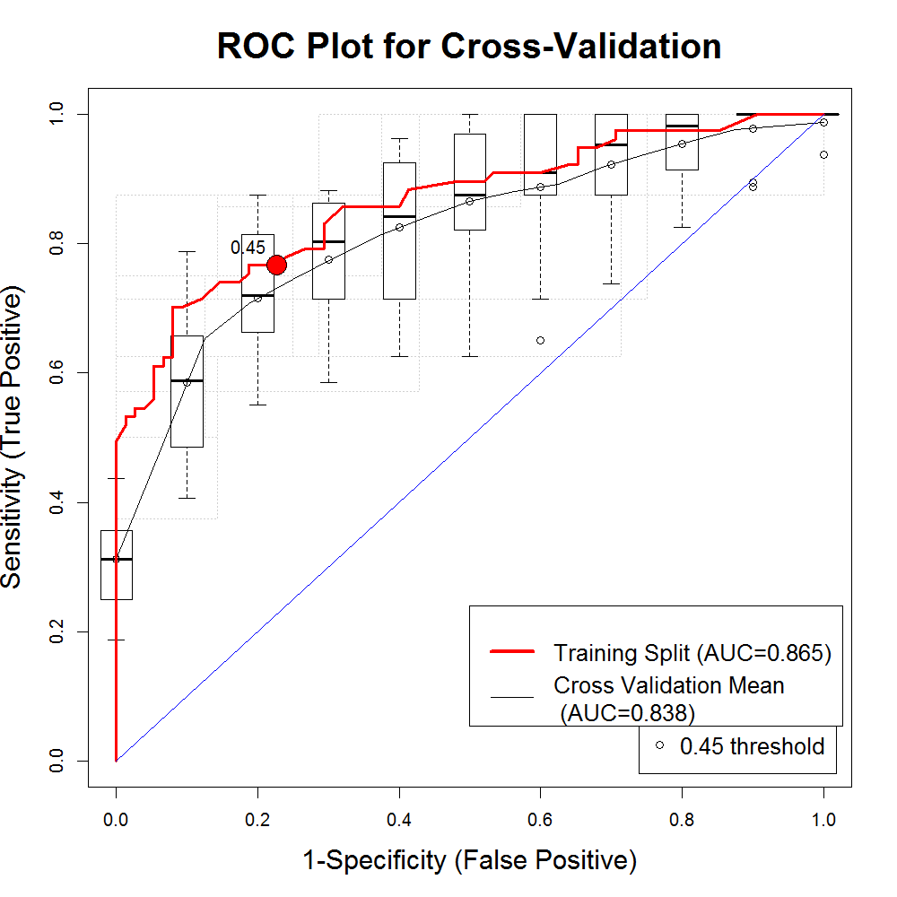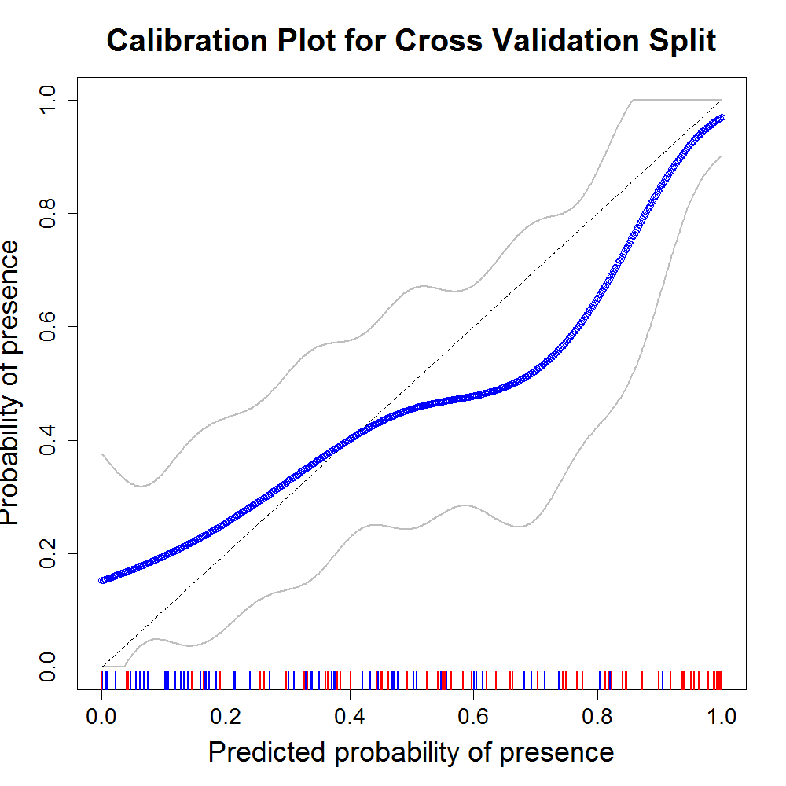

0.45 threshold

Training Split (AUC=0.865)

Cross Validation Mean (AUC=0.838)

0.0

0.2

0.4

0.6

0.8

1.0

0.0

0.2

0.4

0.6

0.8

1.0

Probability of Presence

Sensitivity (True Positive)

**­­**

0.0

0.2

0.4

0.6

0.8

1.0

0.8

0.6

0.4

0.2

0.0

Predicted Probability of Presence

1-Specificity (False Positive)

*Figure 3*. The graphics above visualize the Receiver Operator Characteristic plot and calibration plot for the GLM model, which were critical in evaluating model accuracy.

The GLM model employed the following variables: the difference in Tasseled Cap Wetness from 06/26 to 07/23, the difference in Tasseled Cap Wetness from 07/16 to 07/23, the difference in PSRI from 07/16 to 07/23, and the difference in the NMBDI from 06/26 to 07/23. Of these four variables, Tasseled Cap Wetness from 07/16 to 07/23 was the most important in boosting model performance, followed by Tasseled Cap Wetness from 06/26 to 07/23. The PSRI from 07/16 to 07/23 and NMBDI from 06/26 to 07/23 variables carried less importance in the model. The importance was determined by calculating the change in the AUC when a given variable is permuted.

The model predicted the highest probabilities in areas with southern-facing slopes and most of the northeastern portion of the study area (*Figure 4*). These predictions are consistent with our ground knowledge of cheatgrass’ preference for these aspects and its high abundance in the northeast. To assess the efficacy of herbicide treatment, this probabilistic map was compared to the pre-treatment probabilistic map of West et al. (2017). Based on this comparison, cheatgrass cover in treated areas decreased from 59% to 23% from 2014 to 2019, while cheatgrass cover increased in untreated areas from 17% to 23%. In reference to the area, the GLM model predicts that 3384.40 acres of the study area contained at least 40% cheatgrass cover post-treatment.

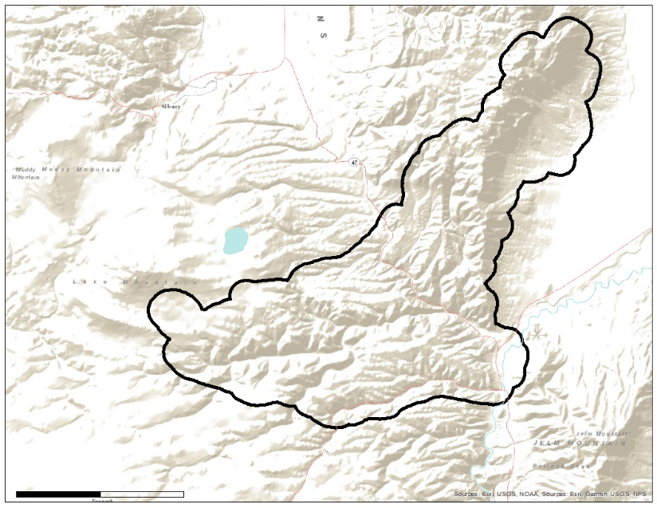

0% 100%

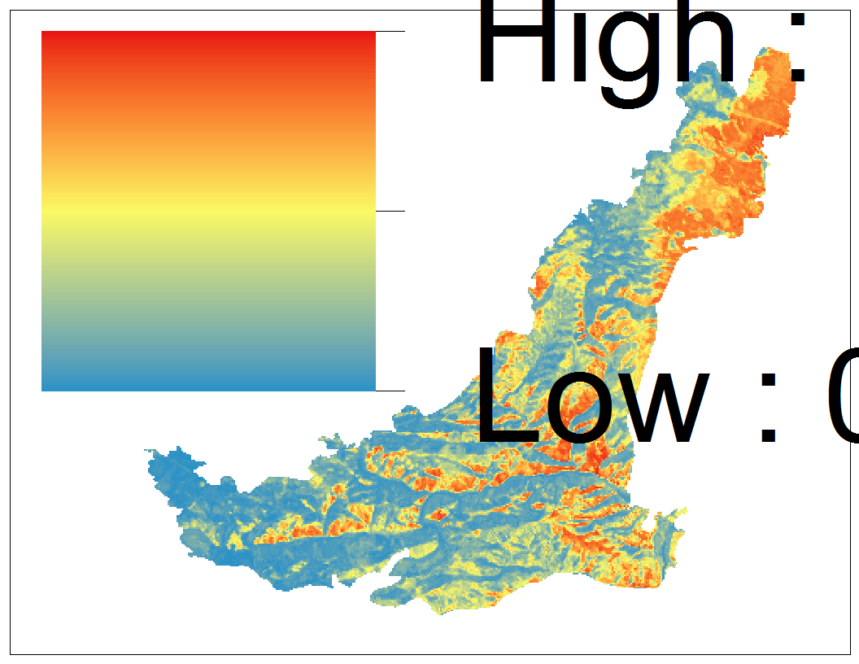

**2019 Probability of >= 40% Cheatgrass**

N

0 1.5 3

km

*Figure 4*. The map above visualizes the probability of >= 40% cheatgrass cover for the study area from the GLM model at a 30-meter spatial resolution.

An assessment of all four final model outputs showed that the combined acreage of areas with less than 40% cheatgrass ranged from approximately 11300 acres to 11900 acres, while the combined acreage of areas with greater than 40% cheatgrass ranged from approximately 3300 acres to 4000 acres (Table 6). The total acreage of both greater than and less than 40% cheatgrass was reduced in the RF due to the inclusion of an image containing masked clouds within the Squirrel Creek Fire boundary.

Table 6

*The four models had differing combined acreages of areas with greater than and less than 40% cheatgrass.*

|  |  |  |  |
| --- | --- | --- | --- |
| **Model** | **Greater than 40% Cheatgrass Acreage** | **Less than 40% Cheatgrass Acreage** | **Notes** |
| **BRT** | 4003.768 | 11313.431 | N/A |
| **GLM** | 3384.400 | 11932.799 | N/A |
| **MARS** | 3741.343 | 11575.856 | N/A |
| **RF** | 3865.661 | 11416.177 | Contained Clouds |

***4.2 Discussion***

Using a combination of field data and satellite-derived spectral indices, the final GLM model produced an accurate cheatgrass occurrence map for 2019 in the post-treatment Squirrel Creek Fire area. When compared with the 2014 pre-treatment map, the results suggest that the 2016 herbicide treatment was effective in mitigating cheatgrass. The estimated cheatgrass cover within treatment areas was reduced by 36%, while a slight increase is estimated outside of treatment areas. 

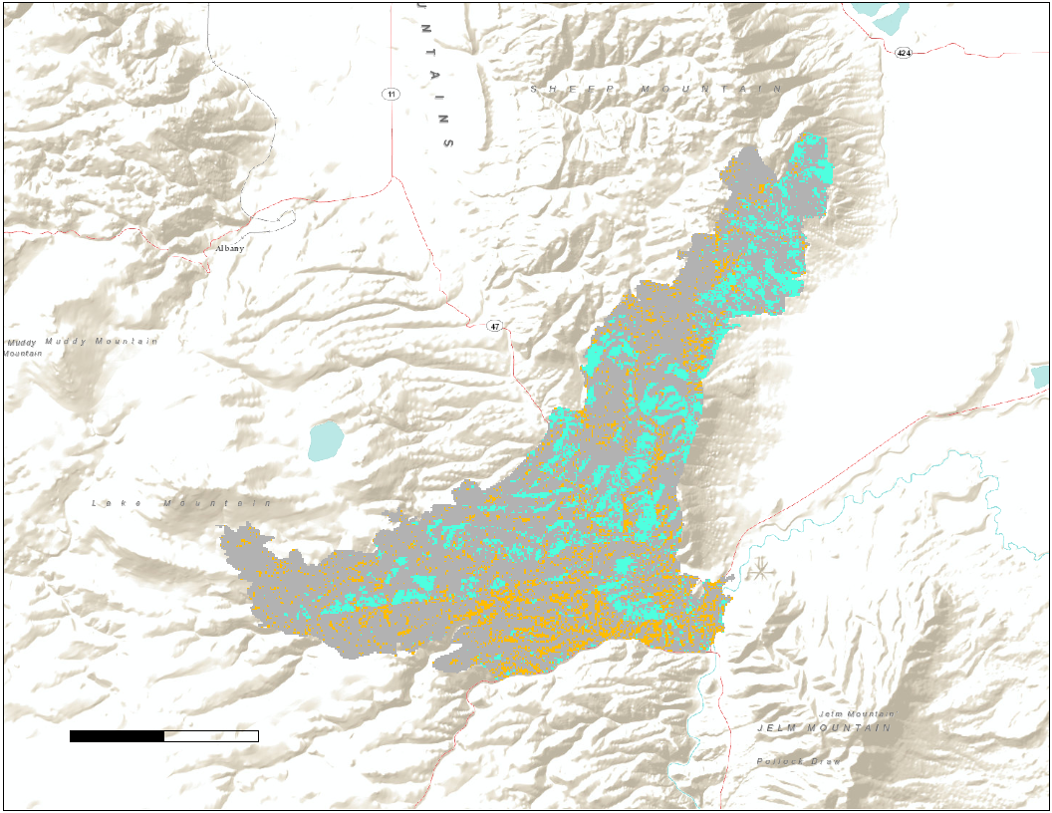

**2014/2019 Cheatgrass Change Map**

= Cheatgrass Decrease

= No Change

0 2.5 5

N

= Cheatgrass Increase

km

*Figure 5*. This map shows areas of relative increase and decrease of cheatgrass presence from 2014 to 2019. Areas in blue indicate cheatgrass decrease, while areas in orange indicate cheatgrass increase.

­

Based on *Figure 5*, it appears that herbicide treatment was most effective in the central and northern portions of the study area, while the treatment in the southernmost section was the least effective, as cheatgrass cover increased in these areas after treatment. Causal factors for any spatial differences may be due to randomness or differences in herbicide effectiveness based on slope angle, aspect, or the size of the cheatgrass patch.

Each of the variables in the GLM model involved a difference between July 23rd and an earlier date, suggesting that a weather event may have occurred in that timeframe. Indeed, the Parameter-elevation Regressions on Independent Slopes Model (PRISM) Daily Spatial Climate Dataset (Daly et al., 2008) estimates that a small precipitation event took place on July 22nd, resulting in approximately 4 mm of rain in the study area. Both Tasseled Cap Wetness variables were most important in the model, which may be due to differences in water retention between areas with varying cheatgrass cover following this precipitation event. The PSRI variable may have been important given the tendency for cheatgrass to senesce earlier than native vegetation, thereby exhibiting a distinct timing in the change in reflectance for areas of cheatgrass. This project demonstrates the utility of employing these methods in future research to monitor treatment efforts long-term in the Squirrel Creek Fire area. The software used in this project is open source, including SAHM, further facilitating future replication of this work.

***4.3 Limitations***

There are several limiting factors to this analysis. First, field plots were collected opportunistically and therefore do not match in size and location with single Landsat 8 OLI pixel or Sentinel pixel. This may introduce error in the association of spectral information and cheatgrass abundance at these points. Additionally, the opportunistic collection of field data and lack of accessibility in certain regions left large portions of the study area unsampled, especially in the northeastern section where slopes were particularly steep and lacked road access. Due to this spatial sampling bias, the model may be less accurate in the areas without representative field data. The field data was collected via ocular assessment of the percent cheatgrass cover within a 7.32-meter radius plot, introducing some measure of human error to the ground truth values.

These sources of error also influence the treatment effectiveness analysis, as this involved the comparison of two cheatgrass occurrence maps that are both influenced by spatial sample bias, human error, and model design. Notably, West et al.’s (2017) 2014 species distribution map was produced using topographic variables such as slope and aspect to predict cheatgrass habitat, while our 2019 species detection map did not incorporate topographic data. Furthermore, the treatment effectiveness analysis was accomplished by reducing the pre- and post-treatment probabilistic maps to binary presence/absence maps based on a 50% probability threshold. Making a comparison in this way ignores the magnitude of change in presence probability, and only identifies areas where the probability value crossed the 50% threshold. Therefore, many areas of change may be omitted, while some areas may have been identified as changed based on slight differences in the models attributable to error.

***4.4 Future Work***

# The scope of this project was limited to understanding how cheatgrass in MBNF has responded to aerial herbicide spraying three years after its first application in 2016. Moving forward, it may be necessary to repeat these methods to continue to monitor cheatgrass regeneration three years after the 2019 and planned 2022 spraying events. Because this research mainly focused on the effects of Imazapic on cheatgrass regeneration, we recommend that future work should also observe the impacts of Imazapic on native plants in spray areas, as the goal of this mitigation strategy is to increase forage availability for mule deer and elk. If Imazapic has unintended consequences on native plants, other mitigation strategies should be tested to increase forage availability.

# 5. Conclusions

# The goal of this research was to evaluate the efficacy of a 2016 aerial herbicide treatment in mitigating cheatgrass populations in MBNF using satellite imagery, *in situ* data, and machine learning algorithms to inform future USFS land management efforts. GLM was the best performing model with AUC scores of 0.865 and 0.838 for training split and cross-validation respectively with input variables of difference in Tasseled Cap Wetness from 06/26 to 07/23, difference in Tasseled Cap Wetness from 07/16 to 07/23, difference in PSRI from 07/16 to 07/23, and difference in the NDBI from 06/26 to 07/23. According to the GLM model, cheatgrass cover in treated areas decreased from 59% to 23% from 2014 to 2019 inside treated areas while cheatgrass cover increased in untreated areas from 17% to 23%, suggesting that treatment has been effective. Moving forward, if native species are not affected by Imazapic, the USFS should continue to treat infested areas and assess the efficacy of that treatment with remote sensing and machine learning techniques.

# 6. Acknowledgments

The Medicine Bow National Forest Disasters team would like to thank the mentors and partners who dedicated their time and assistance to this project. Without them, this project would not have been possible.

We appreciate the cooperation and help from our partners at the US Forest Service:

* Jacquilyn Roaque, Range specialist
* Katie Haynes, Forest Botanist
* Wyatt Good, Field Technician
* John Kenney, Field Technician

Mentors/Science Advisors:

* Dr. Paul Evangelista, Colorado State University, Natural Resource Ecology Laboratory
* Dr. Catherine Jarnevich, USGS, Fort Collins Science Center
* Peder Engelstad, Colorado State University, Natural Resource Ecology Laboratory
* Nicholas Young, Colorado State University, Natural Resource Ecology Laboratory
* Tony Vorster, Colorado State University, Natural Resource Ecology Laboratory
* Kristen Dennis, NASA DEVELOP

This material contains modified Copernicus Sentinel data (2019), processed by ESA.

Any opinions, findings, and conclusions or recommendations expressed in this material are those of the author(s) and do not necessarily reflect the views of the National Aeronautics and Space Administration.

This material is based upon work supported by NASA through contract NNL16AA05C.

# 

# 7. Glossary

**AUC** – Area under the curve (the curve meaning the ROC), a metric used to evaluate classification models

***Bromus tectorum*** – Scientific name for cheatgrass

**BRT** – Boosted Regression Tree, a machine learning model within SAHM

**Cheatgrass** – Invasive grass from Eurasia that has expanded throughout MBNF

**Earth observations** – Satellites and sensors that collect information about the Earth’s physical, chemical, and biological systems over space and time

**EVI** – Enhanced Vegetation Index, an index measuring vegetation health

**Germination** – The development of a plant from a seed or spore after a period of dormancy

**GLM** – Generalized Linear Model, a machine learning model within SAHM

**Imazapic** – Herbicide that suppresses cheatgrass seed germination, used by the USFS in MBNF

**Landsat** – Jointly managed earth-observing NASA/USGS satellite mission

**MARS** – Multi-Adaptive Regression Splines, a machine learning model within SAHM

**MBNF** – Medicine Bow National Forest

**MNDWI** – Modified Normalized Difference Water Index, an index measuring water presence

**NDVI** – Normalized Difference Vegetation Index, an index measuring vegetation health

**NDBI** – Normalized Difference Burn Index, an index measuring burn severity

**NDWI** – Normalized Difference Water Index, an index measuring water presence

# NIR – Near Infrared, energy frequency used in calculating indices

# NMBDI – Normalized Multiband Drought Index, an index measuring drought severity

**PCA** – Principal Component Analysis, a statistical tool used to transform variable into a new, linearly uncorrelated, set of orthogonal variables

**PSRI** – Plant Senescence Reflectance Index, an index measuring plant senescence

# RF – Random Forest, a machine learning model within SAHM

# ROC – Receiver Operator Characteristic, a threshold independent metric used to evaluate classification models

# SAHM – Software for Assisted Habitat Modeling, used to run machine learning models

# SAVI – Soil Adjusted Vegetation Index, an index measuring vegetation health

# Senescence – The process of aging in plants

# SWIR – Short Wave Infrared, energy frequency used in calculating indices

# USFS – US Forest Service, a governmental agency that is responsible for managing public lands in national forests and grasslands

# 8. References

Baig, M. H. A., Zhang, L., Shuai, T., & Tong, Q. (2014). Derivation of a tasselled cap transformation based on Landsat 8 at-satellite reflectance. *Remote Sensing Letters*, *5*(5), 423-431. https://doi.org/10.1080/2150704X.2014.915434

Bradley, B. A., & Mustard, J. F. (2006). Characterizing the landscape dynamics of an invasive plant and risk of invasion using remote sensing. *Ecological Applications*, *16*(3), 1132-1147. https://doi.org/10.1890/1051-0761(2006)016[1132:CTLDOA]2.0.CO;2

Brooks, M., D’Antonio, C., Richardson, D., Grace, J., Keeley, J.E., DiTomaso, … Pyke, D. (2004). Effects of invasive alien plants on fire regimes. *Bioscience*, *54*(7), 677-688. https://doi.org/10.1641/0006-3568(2004)054[0677:EOIAPO]2.0.CO;2

Chavez Jr., P. S. (1988). An improved dark-object subtraction technique for atmospheric scattering correction of multispectral data. *Remote Sensing of Environment*, *24*(3), 459-479. <https://doi.org/10.1016/0034-4257(88)90019-3>

Clinton, N. E., Potter, C., Crabtree, B., Genovese, V., Gross, P., & Gong, P. (2010). Remote sensing-based time-series analysis of cheatgrass (*Bromus tectorum*) phenology. *Journal of Environmental Quality*, *39*(3), 955-963. https://doi:10.2134/jeq2009.0158

Daly, C., Halbleib, M., Smith, J.I., Gibson, W.P., Doggett, M.K., Taylor, G.H., …Pasteris, P.A. (2008). Physiographically-sensitive mapping of temperature and precipitation across the conterminous United States. *International Journal of Climatology, 28*(15)*,* 2031-2064*.* https://doi:10.1002/joc.1688

Menalled, F., Mangold, J., Orloff, N., & Davis, E. (2008). Cheatgrass: Identification, biology and integrated management. Montana State University Extension. Accessed from http://www.msuinvasiveplants.org/documents/publications/extension_publications/Cheatgrass_MT200811AG.pdf

Morisette, J. T., Jarnevich, C. S., Holcombe, T. R., Talbert, C. B., Ignizio, D., Talbert, M. K., … Young, N. E. (2013). VisTrails SAHM: Visualization and workflow management for species habitat modeling. *Ecography*, *36*(2), 129-135. https://doi.org/10.1111/j.1600-0587.2012.07815.x

Neal, J. P., Wylie, K. B., & Wu, Z. (2018). Spatiotemporal analysis of Landsat-8 and Sentinel-2 data to support monitoring of dryland ecosystems. *Remote Sensing. 10*(5), 791. https://doi.org/10.3390/rs10050791

Peeler, L. J., & Smithwick, E. A. (2018). Exploring invasibility with species distribution modeling: How does fire promote cheatgrass (*Bromus tectorum*) invasion within lower montane forests? *Biodiversity Research*, *24*, 1308-1320. https://doi.org/10.1111/ddi.12765

Sherill, R. K., & Romme, W. H. (2012). Spatial variation in postfire cheatgrass: Dinosaur National Monument, USA. *Fire Ecology*, *8*(2), 38-56

Shi, T. & Xu, H. (2019). Derivation of tasseled cap transformation coefficients for Sentinel-2 MSI at-sensor reflectance data. *IEEE Journal of Selected Topics in Applied Earth Observations and Remote Sensing*, *12*(10), 4038-4048. https://ieeexplore.ieee.org/stamp/stamp.jsp?arnumber=8836649

Singh, N., & Glenn, N. F. (2009). Multitemporal spectral analysis for cheatgrass (*Bromus tectorum*) classification. *International Journal of Remote Sensing, 30*(13), 3441-3462. https://doi.org/10.1080/01431160802562222

Tu, M., Hurd, C., & Randall, J. (2001). Weed control methods handbook: Tools & techniques for use in natural areas. The Nature Conservancy. Accessed 2019-10-29 from https://www.invasive.org/gist/products/handbook/methods-handbook.pdf

US Geological Survey Earth Resources Observation and Science Center. (2014). Provisional Landsat OLI Surface Reflectance [Image Collection]. US Geological Survey. [Accessed 2019-10-08 from https://dx.doi.org/10.5066/F78S4MZJ](https://dx.doi.org/10.5066/F78S4MZJ)

West, A. M., Evangelista, P. H., Jarnevich, C. S., Kumar, S., Swallow, A., Luizza, M.W., & Chignell, S. M. (2017). Using multi-date satellite imagery to monitor invasive grass species distribution in post-wildfire landscapes: an iterative, adaptable approach that employs open-source data and software. *International Journal of Applied Earth Observation and Geoinformation, 59*, 135-146. https://doi.org/10.1016/j.jag.2017.03.009

Young, J. A., Evans, R. A., Eckert, R. E. Jr, & Kay, B. L. (1987). Cheatgrass. *Rangelands,* *9*(6), 266-270.

# 9. Appendices

**Appendix A. SAHM Pipeline to Run Machine Learning Models**

Model Map  
Viewer

Model Map  
Viewer

Model Map  
Viewer

Model Map  
Viewer

Model Map  
Viewer

Model Map  
Viewer

Model Map  
Viewer

Model Map  
Viewer

Random Forest

MARS

GLM

Boosted  
Regression Tree

Covariate Correlation and Selection

Model Selection Cross Validation

MDS Builder

PARC

Output  
Name

Field Data Aggregate and Weight

Field Data   
Query

Template Layer

Field Data

Predictor List File

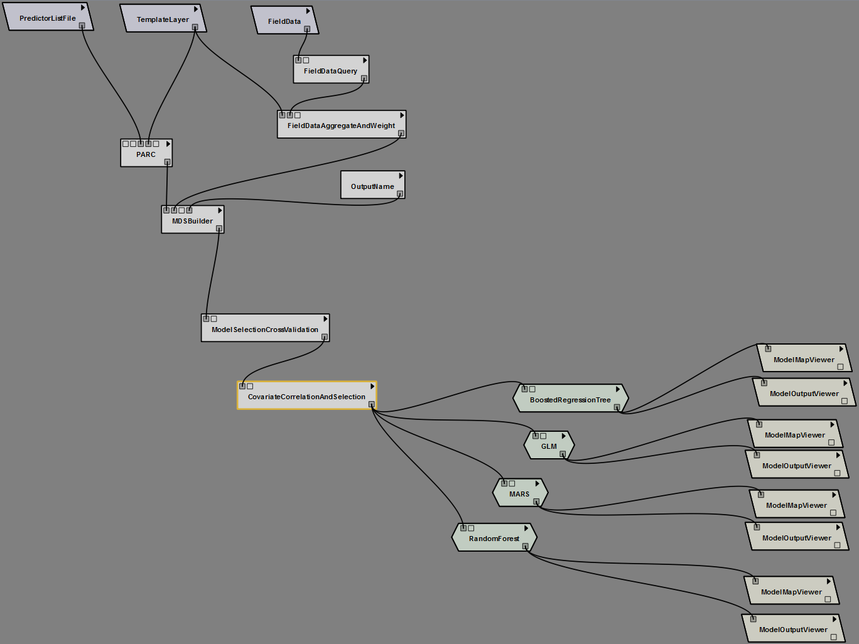

**Appendix B. SAHM Parameter Selection Visualization**

Total Cor=0

Total Cor=0

Total Cor=0

Total Cor=0

Total Cor=0

Total Cor=0

Total Cor=0

Total Cor=0

Response

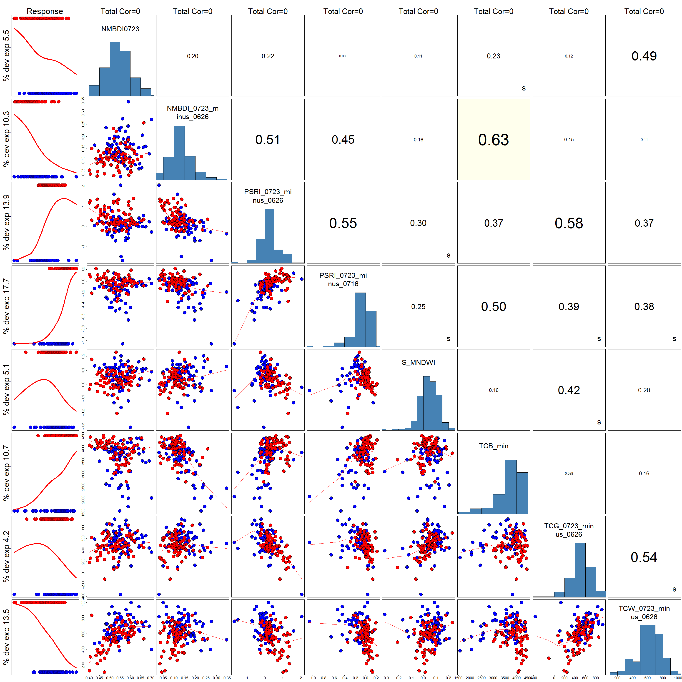

MNDWI  
06/26

TCW 07/23 – 06/26

PSRI 07/23 - 06/26

% dev exp 13.5

% dev exp 4.2

% dev exp 10.7

% dev exp 17.7

% dev exp 17.7

% dev exp 13.9

% dev exp 5.5

% dev exp 10.3

PSRI  
07/23 – 07/16

TCB Min

TCG 07/23 – 06/26

NMBDI  
07/23 -6/26

NMBDI  
07/23

0.63

0.54

0.42

0.086

0.088

0.50

0.50

0.20

0.16

0.25

0.39

0.49

0.11

0.15

0.58

0.37

0.38

0.37

0.30

0.55

0.12

0.23

0.11

0.16

0.45

0.51

0.22

0.20

**Appendix C.**

|  |  |  |  |
| --- | --- | --- | --- |
| **Candidate Non-Correlated Input Variables** | | | |
| **Index Name** | **Differenced** | **Date 1** | **Date 2** |
| **Normalized Multiband Drought Index** | No | 07/23 | N/A |
| **Normalized Multiband Drought Index** | Yes | 06/26 | 07/23 |
| **Plant Senescence Reflectance Index** | Yes | 06/26 | 07/23 |
| **Plant Senescence Reflectance Index** | Yes | 07/16 | 07/23 |
| **Modified Normalized Difference Water Index** | No | 06/26 | N/A |
| **Tasseled Cap Brightness** | No | 07/16 | N/A |
| **Tasseled Cap Greenness** | Yes | 06/26 | 07/23 |
| **Tasseled Cap Wetness** | Yes | 06/26 | 07/23 |
| **Tasseled Cap Wetness** | Yes | 07/16 | 07/23 |