**NASA DEVELOP National Program**

****NASA Goddard Space Flight Center

**Fall 2016**

**Short Title: North Carolina Water Resources**

**Subtitle:** Utilizing NASA Earth Observations and Hydrological Modeling to Monitor Nutrient Levels in Jordan Lake, North Carolina for Improved Water Quality Management

**VPS Title:** Taking a SWAT at Eutrophication: Modeling Water Quality in Jordan Lake, NC

**Project Team & Partners**

**Project Team:**

Tammy Ashraf (Project Lead), tashraf@outlook.com

Elisa Ahern

Jessica Fayne

John Fitz

Sara Lubkin

Sean McCartney

**Advisors & Mentors:**

Dr. Amita Mehta, UMBC, NASA

Dr. Prasad Daggupati, University of Guelph

**Partner Organizations:**

|  |  |  |  |
| --- | --- | --- | --- |
| **Organization** | **POC (Name, Position/Title)** | **Partner Type** | **Boundary Org?** |
| Town of Cary, NC | Jeff Adkins, Water Resources Manager | End-User | No |
| Hazen and Sawyer P.C. | Dr. Josh Weiss, Water Resources Engineer | End-User | Yes |
| University of Guelph | Dr. Prasad Daggupati, Postdoctoral Research Associate | Collaborator | No |

**Project Details**

**Applied Sciences National Applications Addressed:** Water Resources

**Study Area:** Jordan Lake Watershed, Haw River Basin, NC

**Study Period:** March 2005 - August 2016

**Earth Observations & Parameters:**

Global Precipitation Measurement (GPM), Integrated Multi-satellite Retrievals for GPM (IMERG) – Daily precipitation

Tropical Rainfall Measuring Mission (TRMM), Multi-satellite Precipitation Analysis (TMPA) – Daily precipitation

**Ancillary Datasets Utilized:**

* NASA Modern-Era Retrospective analysis for Research and Applications (MERRA) Reanalysis Model – Climatological data, including daily relative humidity, surface wind speed, maximum and minimum temperatures
* USGS South Atlantic Water Science Center *in situ* data – *In situ* stream gauge data
* USGS National Land Cover Database (NLCD) – Land cover
* USGS National Elevation Dataset (NED) – Topography
* USGS Surface-Water Data for the Nation - Surface water flow data
* USDA SSURGO - Soil classification
* USDA STATSGO2 - Soil classification
* USDA Cropland Data Layer - Land cover
* Town of Cary Water Resources Department – *In situ* nitrogen and phosphorus concentration

**Models Utilized:**

* Soil and Water Assessment Tool (SWAT)

**Software Utilized:**

* ESRI ArcGIS– Satellite imagery processing, classification, raster manipulation/analysis, map creation, running ArcSWAT
* Python – Data extraction and statistical analysis
* R – Data extraction and statistical analysis

**Project Overview**

**80-100 Word Objectives Overview:**

B. Everett Jordan Lake reservoir is a eutrophic to hyper-eutrophic lake that serves as a major source of drinking water and wastewater management for the Town of Cary, North Carolina. The North Carolina Environmental Management Commission (EMC) declared Jordan Lake “impaired” in 2005 and permanent rules and long-term management strategies were developed to improve water quality. The objective of this study was to develop a GIS-based soil and water analysis tool for monitoring and mapping nitrogen and phosphorus levels in the lake to help the Town of Cary’s Water Resources Department with monitoring efforts and water treatment activities.

**Abstract:**

B. Everett Jordan Lake reservoir, located in Chatham County, North Carolina, provides drinking water for approximately 250,000 people in the state. Since 1974, the same year construction of the reservoir was completed, excessive nutrient levels from wastewater treatment plants and agricultural runoff has led to eutrophic and hyper-eutrophic conditions in the reservoir. As a result, the lake was determined to have Nutrient-Sensitive Waters (NSW) and declared “impaired” by the North Carolina Environmental Management Commission. The Jordan Lake Nutrient Management Strategy was established to improve water quality. Monitoring of water quality is performed by the United States Geologic Survey (USGS) at six sampling sites on a bi-monthly basis in order to guide management and policy decisions. However, more frequent data collection would allow regulators to better understand how nutrient levels and management policies affect the lake. A GIS-based tool was developed to monitor nitrogen and phosphorus levels in Jordan Lake using Global Precipitation Measurement (GPM) satellite data, ancillary data sources, and *in situ* data, at a weekly latency. The Soil & Water Assessment Tool (SWAT) was calibrated and validated for Jordan Lake using ArcSWAT, and an operational tool was provided to the Town of Cary Water Resources Department. This project is the first to model water quality using Earth observations in conjunction with the SWAT model within the reservoir and provides near-real time monitoring of nutrient levels for improved water management.

**Keywords:**

Remote sensing, ArcSWAT, eutrophication, TRMM, GPM, hydrologic modeling, nitrogen, phosphorus

**Community Concerns:**

* Nutrients enter Jordan Lake from several local sources, including wastewater discharges, rainfall runoff from agriculture, and storm water runoff.
* The North Carolina Environmental Management Commission (EMC) has consistently rated Jordan Lake as eutrophic or hyper-eutrophic. Excessive nutrients in the lake have led to dense algal growth and anoxic water conditions.
* Although the water can still be used for drinking, fishing and recreation, one fish kill has been reported to date, and complaints about taste and odor problems have prompted the Town of Cary to add chemical treatment to its drinking water process.
* The EMC determined that Jordan Lake is “impaired” after the lake exceeded the state’s chlorophyll-a limits in 2006. Under the federal Clean Water Act, the EMC is required to establish a Total Maximum Daily Load (TMDL) for the pollutants causing the impairment.
* The USGS monitors Jordan Lake, but limited sample sites, infrequent sample collection, and irregularities in sample collection practices across these sites limits complete and accurate analysis of water quality conditions in Jordan Lake.

**Current Management Practices & Policies**:

The Clean Water Responsibility Act of 1997, or House Bill 515, requires the North Carolina Environmental Management Commission (EMC) to implement management plans and establish improvement goals for nutrient-impaired waters. As a result, phosphorus limits were imposed after Jordan Lake was designated a Nutrient Sensitive Water (NSW) in 2002. A later law, S.L. 2005-190, or Senate Bill 981, directed the EMC to adopt permanent rules and long-term management strategies to protect drinking water supply reservoirs. The Division of Water Quality held public meetings and solicited public comments on a rules framework after the 2005 law was passed. The Jordan Lake Nutrient Management Strategy (“Jordan Rules”) was established in June of 2008 to meet these requirements following the approval of the North Carolina Rules Review Commission (RRC). These rules, which became effective on August 11, 2009, require a calibrated nutrient response model, specific reductions for nutrients from all sources, a timeline for implementation, cost analysis, stakeholder involvement, and progress evaluation reports. The Jordan Rules also require local city and town governments to implement Stage One programs that include public education, mapping of the Municipal Separate Storm Water Systems (MS4s), and the establishment of best management practices (BMPs) maintenance. Bi-monthly water sampling is carried out by the U.S. Geological Survey at six sampling locations to aid water treatment and management decisions. At each location, temperature, dissolved oxygen, pH, chlorophyll, nutrient levels, metals, and conductivity are recorded and analyzed. Residents are also making an effort. Local property owners have been educated on BMPs, such as reducing fertilizer use, decreasing lawn irrigation, and installing and maintaining riparian buffers. Residents are asked to contact the Town’s Storm Water Engineering Department before clearing trees and other vegetation to request a “buffer call.” Residents are also encouraged to submit a soil test to the North Carolina Department of Agriculture (NCDA) before applying fertilizer and lime. Currently, no Earth observations are being used to ensure a calibrated nutrient response model in meeting the requirements for Jordan Rules.

**Decision Support Tools & Benefits:**

|  |  |  |  |
| --- | --- | --- | --- |
| **End-Product** | **Earth Observations Used** | **Benefit & Impact** | **Software**  **Release** |
| SWAT model for predicting *in situ* water quality from remotely sensed data | Global Precipitation Measurement (GPM) Integrated Multi-satellite Retrievals for GPM (IMERG); Tropical Rainfall Measuring Mission (TRMM) Microwave Imager (TMI) | Provide the Town of Cary’s Water Resources Department with the ability to use satellite data to measure nutrient levels and estimate water quality in Jordan Lake in near real-time | I |
| Tool/scripts to download imagery and create maps and time series of the Jordan Lake watershed parameters (precipitation, streamflow) and calculated values of nitrogen and phosphorus | Global Precipitation Measurement (GPM) Integrated Multi-satellite Retrievals for GPM (IMERG) | Provide the Town of Cary with ready access to NASA’s satellite remote sensing data, in a way that is easy for utility staff to analyze and summarize for use by decision-makers (tools will be shared through a web interface created and maintained by Hazen and Sawyer after the tool has gone through the software release process) | IV |

**Project VPS/Booklet Imagery**

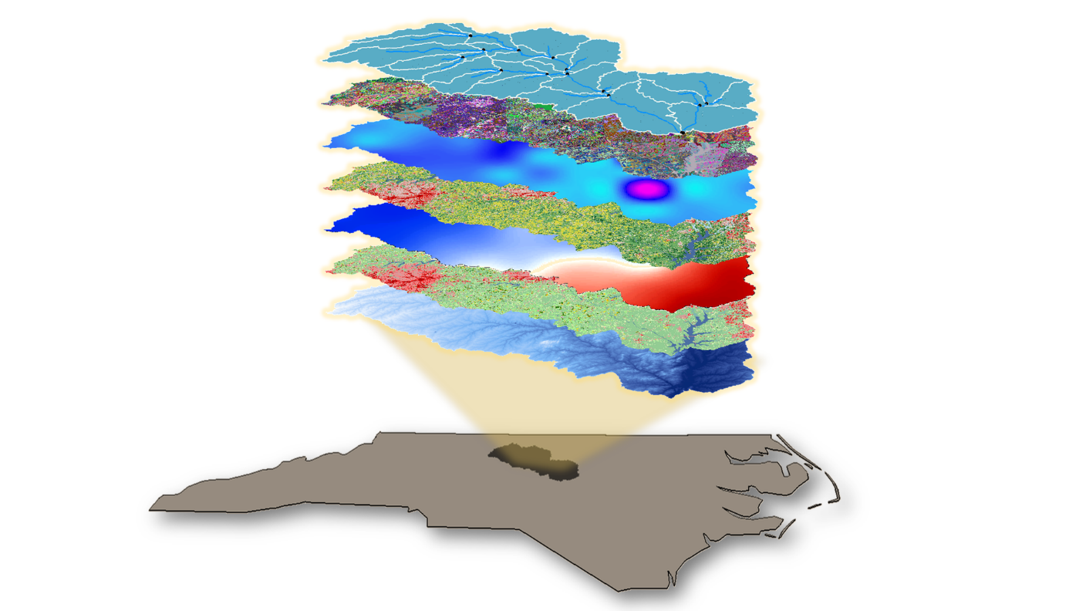

**Caption:** Jordan Lake watershed with layers representing inputs to the SWAT model. NASA Earth observations from SRTM (2000) and GPM/IMERG (November 2015) are depicted. Image Credit: North Carolina Water Resources Project Team.

**Image:** 2016Fall_GSFC_NCWater_VPS_Image.png