Hawaii Climate

Utilizing Earth Observations to Delineate Wetland Extents, Model Sea Level Rise Inundation Risk, and Assess Impacts on Historic Hawaiian Lands

**Technical Report**

Final – August 11th, 2022

Lisa Tanh (Project Lead)

Matilda Anokye

Ian Lee

Connor Racette

***Advisors:***

Dr. Roberta Martin (Arizona State University)

Dr. Jiwei Li (Arizona State University)

Dr. David Hondula (Arizona State University)

# 1. Abstract

Climate induced sea level rise poses a risk to coastal areas on the Island of Hawaii and many of the island’s historic cultural lands are in danger of becoming inundated. In partnership with the County of Hawaii, the State of Hawaii Department of Land and Natural Resources, and Arizona State University, our AZ NASA DEVELOP team modeled short-term sea level rise inundation risk and wetland extent. The team utilized NASA Earth observations over a 10-year span (2013 – 2022) that include data from the NASA MEaSUREs Gridded Sea Surface Height Anomalies (SSHA) and the Group for High Resolution Sea Surface Temperature (GHRSST) to model sea level rise inundation risk. We used a random forest model to classify short-term inundation risk along the entire coast of Hawaii for five known local flood events from 2019 – 2021, using physically meaningful features like sea surface height anomalies and soil permeability. Additionally, the team compared the *in-situ* local tidal gauge data at two sides of Hawaii Island to the SSHA data. Current wetland extents and probabilistic locations of new wetlands were modeled with data from PlanetScope Surface Reflectance optical imagery (2022), United States Geographic Survey (USGS) 3D Elevation Program 10m DEM (2013), temperature and precipitation data from the Hawaii Climate Atlas (2021), and soils data from the Hawaii Soil Atlas (2014) using the Wetland Intrinsic Potential (WIP) tool. Results indicated locations with the highest probability for wetlands. Our project deliverables will assist our Hawaii partners in their efforts to evaluate short-term sea level inundation risk, meet regulation requirements for wetlands protection, and guide decision-making for their Shoreline Setback and Climate Adaption plans.

**Key Terms**

remote sensing, wetlands, sea level rise, random forest, inundation risk, NASA MEaSUREs, Sentinel-1

# 2. Introduction

**2.1 Background Information**

Hawaii Island (Figure 1) is the largest island in the state of Hawaii with ~200,000 people. Coastal areas of the island currently face significant erosion and flooding due to climate change-induced sea level rise (Kane et al., 2015). To protect historical sites, ecosystems, and private properties, the County of Hawaii and the State of Hawaii Department of Land and Natural Resources (DLNR) are developing the Shoreline Setback Plan and Climate Adaptation Plan. The Shoreline Setback Plan utilizes tidal gauges and flood risk projections to assist with determining their setback delimitations, and the Climate Adaptation Plan’s goal is to utilize NASA Earth observations to guide their mitigation and adaptation efforts.

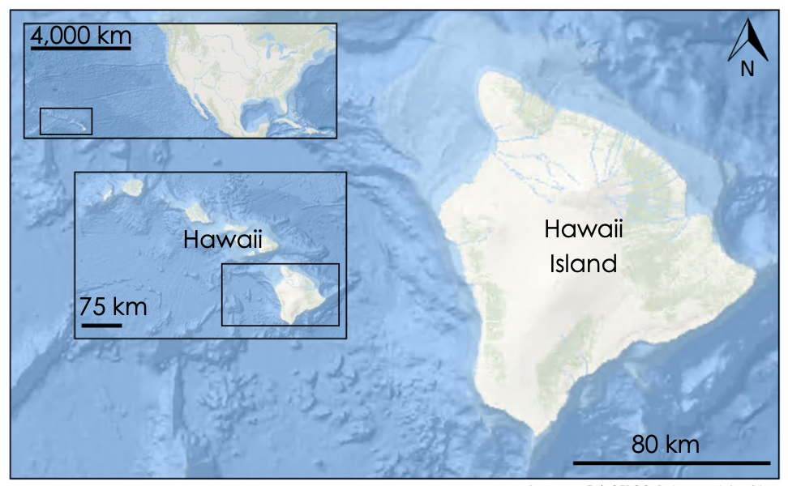***Figure 1.*** *Study area map of Hawaii Island, Hawaii.*

To support their mitigation efforts, the County of Hawaii and DLNR require new and improved information to locate flood risk priority areas, particularly in areas of key economic and cultural significance, and to locate wetlands to meet planning and regulation requirements regarding wetland protection. The NASA DEVELOP Arizona team addressed these concerns by partnering with the County and DLNR to provide remote sensing expertise to map probable wetland extent, calibrate tidal gauge data, and model sea level rise inundation flood risk areas. The team aimed to tackle three main issues: 1) Locate unmapped and probabilistically determine formation of new wetlands in Hawaii Island, 2) Calibrate local tidal gauge data against NASA remote sensing data to enable future investigations of historical local sea surface height, 3) Create a short-term flood risk map to identify vulnerable zones.

**2.2 Scientific Basis**

The team produced three products to address sea level rise-induced problems faced by the county and its residents. The trio of products were placed into a geodatabase and provided an integrated sample of how NASA remote sensing data can aid the County and State of Hawaii with evaluating the risks caused by sea level rise. The county will use these products to support decision-making for their Shoreline Setback and Climate Adaptation Plans. The DLNR plans to use these products to find and prioritize at-risk areas which are threatened as they are mandated to enhance, protect, conserve, and manage Hawaii’s natural and historic resources.

To obtain up-to-date knowledge about wetland extent in Hawaii, the team modeled current Hawaiian wetlands using the Wetland Intrinsic Potential (WIP) tool. The WIP tool is a publicly available tool developed by the University of Washington Remote Sensing and Geospatial Analysis Lab and Seattle TerrainWorks, used for wetland mapping and modeling. The team chose the WIP tool for its variety of available inputs, and powerful classification capabilities which can delineate the probability and extent of wetland creation in Hawaii Island. Following the workflow of the WIP tool phases in ArcGIS Pro, the team created a wetland probability map and updated the Hawaii wetlands inventory.

To accurately assess sea level changes around Hawaii, the team calibrated local tidal gauge measurements at the Hilo and Kawaihae coastal stations against NASA MEaSUREs Gridded Sea Surface Height Anomaly (SSHA) data. Previous studies had compared tidal gauge data with remotely sensed data by calculating their statistical relationship throughout time at the tide gauge locations (Leibsch et al., 2002; Saraceno et al., 2008). Using local tide gauges is the most accurate method for long-term coastal sea level studies, but their spatial extents are limited; the amalgamation of tide gauges with global satellite altimetry will allow us to observe sea level on a larger scale (Adebisi et al., 2021).

To mitigate flood risk caused by sea level rise, the team developed a machine learning model to calculate and classify flood risk. A random forest algorithm was selected because it can capture non-linear relationships and is robust to overfitting and outliers due to the large number of independent decision trees in the forest that is actively reducing the variance while maintaining a low bias per tree. For the final product, the team generated a short-term food risk map that the County of Hawaii and DLNR will use to support decision-making for the mitigation and adaptation planning.

# 3. Methodology

***3.1 Data Acquisition***

*3.1.1 Wetlands Model*

The team acquired multiple Hawaii datasets to use as inputs for the WIP tool. The coastline shapefile for Hawaii Island was from the Hawaii Statewide GIS Program Data portal by the Office of Planning and Sustainable Development, State of Hawaii. United States Geological Survey 3D Elevation Program (USGS 3DEP) DEM data (2013) was downloaded from the USGS National map downloader. High-resolution imagery was acquired from Planet and downloaded from Planet Base maps. The team selected PlanetScope First Quarter 2022 Regional Mosaic dataset and clipped it to Hawaii Island using Arc GIS Pro software. The team also acquired soil data and climate data from the Hawaii Soils Atlas and Hawaii Climate Atlas respectively, maintained by the College of Tropical Agriculture and Human Resources at the University of Hawaii at Mānoa. Current wetland extent data was downloaded from the US Department of Fish and Wildlife National Wetlands Inventory. Various hydrographic datasets were acquired from the Hawaii Statewide GIS Program Data portal by the Office of Planning and Sustainable Development. More information about our datasets is found in Appendix Table A1.

*3.1.2 Sea Surface Height Anomaly Data and In-Situ Mean Sea Level*

The team acquired SSHA data, measured in meters, from NASA MEaSUREs using the Physical Oceanography Distributed Active Archive Center (PO.DAAC). The team utilized Python to acquire data between 2013–2022. Mean sea level (MSL) measurements were acquired from two tidal gauges, measured in meters, at Hilo and Kawaihae stations from NOAA Tides & Currents Stations. MSL data were also acquired between 2013–2022 for comparison purposes to the SSHA data.

*3.1.3 Sea Level Inundation Risk Model*

The team selected six features that had sound physical reasonings to influence flood risk. The six features are elevation (separated into min. elevation and largest elevation difference), water permeability, precipitation, sea surface height anomaly (SSHA), and sea surface temperature anomaly (SSTA). We used the USGS DEM data (2013). We obtained precipitation data from the Hawaii Rainfall Atlas, as well as water permeability data from the Hawaii Soils Atlas. Monthly SSHA and SSTA data were both obtained from PO.DAAC. SSHA data came from NASA MEaSUREs Gridded SSHA dataset from 2013–2022, and SSTA data came from the Group for High Resolution Sea Surface Temperature (GHRSST) MODIS sea surface temperature from 2019–2022. For the label, we used the Global Flood Mapper Tool, a Google Earth Engine (GEE) application for rapid flood mapping that utilizes Sentinel‑1 SAR to generate flood maps for five flood events in Hawaii from 2019–2021. More information about our datasets is found in Appendix Table B1.

For the initial physical justifications for every feature, elevation would determine how easily storm surges can encroach onto land and affect the relative sea level. Water permeability can affect a region’s resistance to inundation through the ability to absorb more water. Precipitation contributes directly to the land water input and can also lead to stronger storm surge. SSHA also directly contributes to local inundation input. SSTA can serve as a proxy for regional thermosteric sea level components and assist in storm surge formation.

***3.2 Data Processing***

*3.2.1 Wetlands Model*

The team began by obtaining input data shown in Appendix C Figure C1 for the WIP tool by downloading and mosaicking the USGS 3DEP 10m DEM tiles. This was the most important step in the data processing workflow as this base DEM was the basis from which most of our topographic indices were derived. After the DEM was processed, we derived topographic indices, including Topographic Wetness Index (TWI) and Depth to Water (DTW) Index, for the entire island. Next, the Hawaii Soil and Climate Atlas features were rasterized to the same image properties of the DEM, TWI, and DTW. Next, all these inputs were clipped to Hydrographic Unit (HU) extents so that models could be run by HU as shown in Appendix C Figure C2. The team chose these HUs as model extents because they were the most up-to-date delineations of large-scale watershed boundaries available through the Hawaii State GIS data portal. Running models by HU has a few key advantages. First, it breaks up the processing load for different sections of the Island. Second, HUs group similar smaller watersheds on the landscape to create these larger HUs. This means that from a hydrologic landscape perspective, similar regions of the island are being processed and modeled together. DEMs for the clipped HU were then individually used as inputs into the Surface Metrics tool within the WIP toolbox. Surface metrics topographic indices were derived at three length scales (50m, 150m, 300m) to account for variability in landscape surfaces at different scales. Next, we used Planet data to derive Normalized Difference Vegetation Index (NDVI) for each HU to be used as an imagery input for the model where (Pettorelli et al., 2005):

$$NDVI=\frac{NIR-RED}{NIR+RED}$$

(1)

NIR is the light reflected in the near infrared spectrum and RED is the light reflected in the red range of the visible light spectrum. Training data of known wetland and upland locations were required to properly calibrate the model. Due to a lack of field verified training data for the Island of Hawaii, the team decided to rely on the US Fish and Wildlife’s National Wetland Inventory (NWI) wetland location data for deriving wetland training points. We created separate polygons for wetland areas and upland areas within each HU as shown in Appendix C Figure C1. Then, within each polygon, we generated random points and attributed them as either wetland (WET) or upland (UPL), respectively. The wetland and upland training points were then merged to create a single data set and manually reviewed against the Planet data for misclassification.

The team then built random forest models by HU using all derived inputs for the model creation. Generated probability maps and statistical accuracy measurements were reviewed, and inputs/training data were revised to refine the model and increase accuracy. The models were run and revised multiple times until satisfactory outputs were achieved. Appendix C Figure C2 shows an in-depth chart of the workflow for generating the models for each HU.

*3.2.2 Sea Surface Height Anomaly Data and In-Situ Mean Sea Level*

The team converted the NASA MEaSUREs SSHA dataset from a 5-day interval to a monthly interval for all data between 2013–2022 by combining data, by month, and computing the mean. All rows with missing data values were removed. The team also extracted monthly SSHA values at the tidal gauge locations, matching it with the NASA MEaSUREs dataset by finding the closest grids to the tidal gauge coordinates and taking the average. Finally, the monthly tidal gauge SSHA values were matched with the corresponding monthly NASA MEaSUREs MSL value. The team plotted the monthly SSHA and MSL prior to statistical analysis.

*3.2.3 Sea Level Inundation Risk Model*

The team relied on literature reviews, discussion with sea level rise experts, and local knowledge to build our sea level rise inundation machine learning model from scratch. Domain knowledge to guide feature selection was obtained from literature reviews of prior flood risk projects (Benveniste, 2020; Bryan et al., 2001; Nieves et al., 2021), and our random forest model was built with no previous architecture references. The input data were projected into NAD 1983 UTM Zone 5N coordinates and are shown in Figure 2.

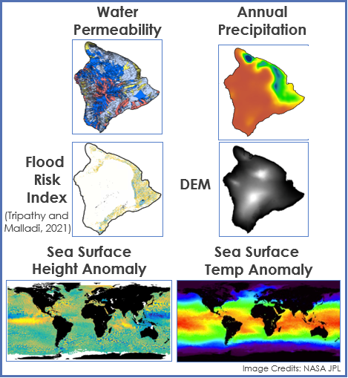  
  
**Figure 2.** Sample maps showing all the various input data used for the sea level rise inundation risk machine learning model.

The team created 20 m transects normal to the coastline along the 428 km Hawaii Island coastline using the coastline shapefile and set buffer zones of 500 m inland and 15 km seaward for each transect to compute their corresponding feature values. The team chose the 500 m inland buffer value based on both local knowledge of where cliffs (if any) were expected to be and giving a reasonably sized area for computing the mean water permeability (20 m resolution), precipitation (500 m resolution), and flood risk index (335 m resolution) for a transect. Elevation was also at 20 m resolution. Moreover, the team chose the 15 km seaward buffer value based on the need to reach the open ocean (defined as ~15 km from the coast) where surface temperature changes are still influencing regional coastal sea level variability changes (Nieves et al., 2021). To mitigate the lower resolution of SSHA data (0.16°), the team extrapolated data up to 15 km, and this was supported by an ESA paper that found no significant difference (± 1 mm/year) between open ocean and coastal sea level trends (Benveniste et al., 2020). A couple of transects are shown in Appendix D Figure D1 that illustrate this trend.

Each transect has one value for every feature and label, which was computed based on the inland or seaward buffer and converted into a row in a combined .CSV file. For elevation, since the mean value within a buffer does not capture cliffs nor provide any information about slope, the team split elevation into two more meaningful features in minimum elevation and largest absolute elevation difference. For both the water permeability and precipitation values, the team computed the mean value within the 500 m inland buffer. For SSTA and SSHA data, for each pixel within the transect the team computed the largest absolute difference in SSTA/SSHA over the flood period ± 3 days to capture significant changes during the flood event and then took the mean value of all the pixels within the 15 km buffer zone.

To generate the flood risk labels, the team referenced five flood events in Hawaii from 2019 – 2021 (12/19/2019 - 12/23/2019, 01/12/2021 - 01/16/2021, 03/04/2021 - 03/09/2021, 11/07/2021 - 11/12/2021, 12/02/2021 - 12/12/2021) and input the dates into the Global Flood Mapper tool to generate and georeference the flood maps. Due to the size of Hawaii Island, each flood event required two flood maps (one for either the leeward side or windward side) to be combined to obtain full flooding coverage per event. The flood risk map output was qualitative, separated into four different descriptions (“High-Confidence Flood”, “Low-Confidence Flood”, “Permanent Open Water”, and “Non-Water”). Assigning the values of 2 for “High-Confidence Flood”, 1 for “Low-Confidence Flood”, and 0 for “Non-Water”, the team first took the highest flood risk value for each pixel in the flood map between the leeward and windward side. For the “Permanent Open Water” classification, very dark lava is spectrally similar to water. To overcome this hurdle, the team differentiated them by overlaying a Hawaii Carbon Assessment Landcover map over the flood maps. Embayed “Permanent Open Water” pixels that were overlain by “non-vegetated” pixels were labeled as “Lava” with flood risk values of 0. For the remaining “Permanent Open Water” pixels, the team performed a final test to check if they were embayed open water that were connected to the ocean (that should/would contribute flooding from storm surge). In this test, they developed a pixel-hopping algorithm that for every unidentified “Permanent Open Water” pixel, they checked the pixels around it and recorded open water pixels. They would then “hop” to the first pixel in this record and perform the same surrounding checks, adding more open water pixels to the record but not adding duplicates or pixels that were already visited. That pixel data was then removed from the record, and then they would start exploring the next pixel in the record. The process continues in a loop until either the open ocean (defined as being surrounded by all open water pixels) is reached or no other open water pixels remain in the record. “Permanent Open Water” pixels connected to the ocean were assigned a value of 1.5 and the remainder “Permanent Open Water” pixels were assigned a value of 0.5. Every transect then had a mean flood risk index computed for the flood risk values within the 500 m inland buffer.

***3.3 Data Analysis***

*3.3.1 Wetlands Model*

The WIP tool reserves a portion of training data points to use for model validation. Once a model is built and a wetland probability raster is derived, out-of-bag (OOB) error statistics are generated using this reserved pool of training point data in a confusion matrix. This results in a single OOB percentage of error for the model. Other statistical metrics are plotted when models are built to help refine inputs and training data such as input importance, RF class error, PRC, and ROC. Further analysis of the WIP model outputs was limited. Each HU was refined to meet accuracy thresholds recommended by Meghan Halabisky, one of the developers of the WIP tool (personal communication, 2022). Further analysis primarily consisted of visual interpretation of models against recent aerial imagery, with a cycle of refinement of inputs and running new models until acceptable statistics were achieved.

*3.3.2 Sea Surface Height Anomaly Data and In-Situ Mean Sea Level*

The team calculated linear regression, Pearson’s correlation, and root mean square error (RMSE) to quantify the relationship between the matched MSL and SSHA at Kawaihae and Hilo tidal gauges. Linear regression quantifies the relationship between the independent variable, MSL, and the dependent variable, SSHA, by fitting a linear equation to the observed data. The team created two scatter plots of the two variables for Kawaihae and Hilo and a linear regression line is fitted to the data. The linear regression line is represented by Equation 2,

$$y = a + bX$$

(2)

where X is the independent variable, Y is the dependent variable, b is the slope of the line, and a is the intercept. Pearson’s correlation coefficient was calculated for monthly Kawaihae MSL and SSHA as well as monthly Hilo MSL and SSHA. The correlation coefficient is defined as r in Equation 3

$$r=\frac{n\sum_{ }^{ }{xy}-\left(\sum_{ }^{ }{x}\right)\left(\sum_{ }^{ }{y}\right)}{\sqrt{\left[n\sum_{ }^{ }{x^{2}}-{\left(\sum_{ }^{ }{x}\right)}^{2}\right]\left[n\sum_{ }^{ }{y^{2}} -{\left(\sum_{ }^{ }{y}\right)}^{2}\right]}}$$

(3)

where n is the sample size, x represents the individual sample points, and y represents the dependent sample points. Pearson’s correlation coefficient quantifies the association between two variables. The values range from –1 to 1, –1 representing a strong negative relationship, 0 indicating no correlation, and 1 representing a strong positive relationship. RMSE is the standard deviation of the prediction errors, or residuals, and it measures how spread-out or concentrated residuals are around the line of best fit. RMSE was calculated for matched monthly MSL and SSHA at Kawaihae and Hilo. RMSE is represented by Equation 4 where *f* is the forecast, or expected values, and *o* is the observed values.

$$RMSE=\sqrt{{\left(f-o\right)}^{2}}$$

(4)

RMSE measures the error of a model in predicting quantitative data values. RMSE values close to 0 indicates the model can predict the data accurately.

*3.3.3 Sea Level Inundation Risk Model*

The team completed feature and label processing for the Hawaii island coastline for the five flood events, generated ~30,000 data points per flood event, and appended the data into a centralized CSV file to input into the random forest model, which was built using the scikit-learn package on Python. For the train-test process, they excluded 20% of the data for validation and used the remaining 80% for training. For tuning, the team initialized the model using the default values in sklearn.ensemble.RandomForestClassifier. They then applied a small-scale randomized search to optimize our model tuning the hyperparameters n_estimator, max_features, max_depth, min_samples_split, min_samples_leaf, and bootstrap. Ranges are shown below:

n_estimators = [200, 400, 600, 800, 1000] # *Number of trees*  
max_features = ["sqrt", None] # *Number of features to consider at each split*  
max_depth = [0, 10, 20, 30, 40, 50] # *Maximum number of levels*  
min_samples_split = [20, 30, 40, 50, 60, 70, 80, 90, 100] # *Minimum number of samples to split a node*  
min_samples_leaf = [10, 15, 20, 25, 30, 35, 40, 45, 50] # *Minimum number of samples per leaf node*  
bootstrap = [True, False] # *Method of selecting training samples for each tree*  
  
Following random search tuning, the team then adjusted for imbalanced data by using the “balanced” class_weight mode which uses the label values and automatically adjusts weight inversely proportional to class frequencies in the input data. Additionally, the different resolutions of transects, features, and labels could result in overfit data due to certain features having similar values over long stretches of consecutive transects. Bootstrapping, which is random sampling with replacement, helps with this by avoiding showing any one flood event model the full dataset. The team noted most of their trees had an average depth of 22, so they limited max_depth to 20 as though the features could be separated into more complex sub-features. Attempting to model these complex interactions using low order features does not provide much information and is prone to overfitting. For the min_sample_split and min_samples_leaf hyperparameters, setting too low of (e.g., <5) values caused the highest resolution features to disproportionally influence the flood risk classification.  
  
Each flood event was run through the random forest model, and the team evaluated the model performance using a confusion matrix, precision, recall, F-1 score, classification accuracy, and also ran the model against the out-of-bag (OOB) testing data. To ensure similar results for reproducibility, they used a constant seed value of 29.

# 4. Results & Discussion

***4.1 Analysis of Results***

*4.1.1 Wetlands Model*

Initial model outputs for all HU’s required fine tuning of the training data sets. Initial models tended to over-map wetland extents, or map wetland presence that were clearly upland in recent aerial imagery interpretation. After multiple rounds of review of training data for misclassification and re-building models, all HU output resulted in an OOB of less than 10%. This means that based on the training data set provided, the model predicted 90% of wetland and upland locations accurately. When looking at individual RF class results by HU, HU1, HU2, HU3, and HU5 all had satisfactory results of wetland class errors below 20%. These HU’s are located primarily on the Eastern side of the Island and have a consistently wetter climate with more wetland training data available to work with. HU4 is on the West side of the Island (which has a much drier climate, higher variability in terrain changes due to volcanic activity, and therefore less wetland training data to work with). The model for HU4 was much more difficult to tune, and while OOB error of below 10% was achieved, RF class results for wetlands had sub-par results with an error of approximately 40%. Refining NWI wetland locations via aerial imagery interpretation was the most challenging part of tuning all HU models. Due to the lack of field verified wetland location data, the team relied on NWI data to create the wetland class training data. With improved training data for wetland locations, model results could be greatly improved. The output map is shown in Figure 3.

Looking more broadly at model performance, for all HU’s soils, climate, and DTW data continuously ranked highly for variable importance during all model iterations. Generally, TWI ranked lower in importance, which was unexpected. TWI may not have contributed much to overall model performance because it is generated from DEM data that is ~10 years old. Due to the changing topography of the island from volcanic activity, that may explain why TWI did not correlate well with the wetland training data that was used. Using newer and higher resolution elevation data may correlate to higher ranked importance in future models. Lastly, NDVI only ranked highly in importance for HU4. This HU has a much more arid climate, with a more dynamic volcanic environment than the other HUs. HU4 is broadly covered with lava flows and has evidence of hydrologic activity during high precipitation events, but vegetation presence is limited in these areas based on aerial imagery interpretation. Due to these factors NDVI is an input variable that the team would highly recommend including in future iterations of the WIP tool for HU4.

*4.1.2 Sea Surface Height Anomaly Data and In-Situ Mean Sea Level*

Linear regression results are shown in the scatter plot in figure 4 with MSL on the y-axis and SSHA on the x-axis, representing the observed gauge data versus the mapped satellite data. The black line represents MSL plotted against the predicted SSHA. The linear regression line demonstrates a positive, linear relationship between tidal gauge MSL and SSHA for both Kawaihae (Figure 4C) and Hilo (Figure 4D).

The monthly Kawaihae and Hilo SSHA (Figure 5A) and MSL (Figure 5B) are plotted for the years 2013–2022. A numerical comparison of these data is shown as standard deviation graphs (Figure 5C). Kawaihae RMSE value between MSL and SSHA was 0.3 while the correlation coefficient was 0.88. The Hilo RMSE value for MSL and SSHA was 0.4 while its correlation coefficient was 0.9. RMSE results indicate predicted values are close to the observed values for Kawaihae and Hilo. The correlation coefficient for these two locations indicates a near perfect, positive relationship between SSHA and MSL (Figure 5D).

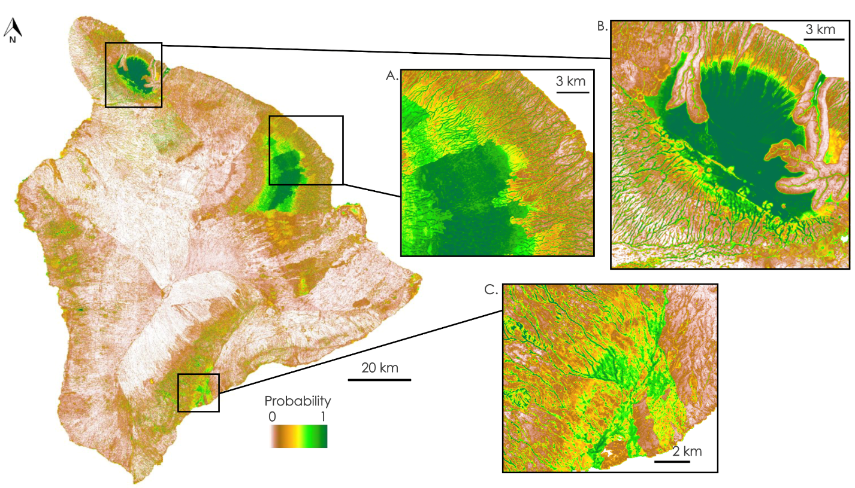**Figure 3.** WIP probability raster outputs for the entire island of Hawaii, with a few areas of where high probability wetlands were mapped. Figure 3A is an area that was confirmed by our project partners to be a consistently very wet forested area. Figure 3B is an area that was confirmed by project partners as a large bog ecosystem. Figure 3C is a confirmed area where some wetlands are known but is an area of interest for potentially new wetlands being mapped.

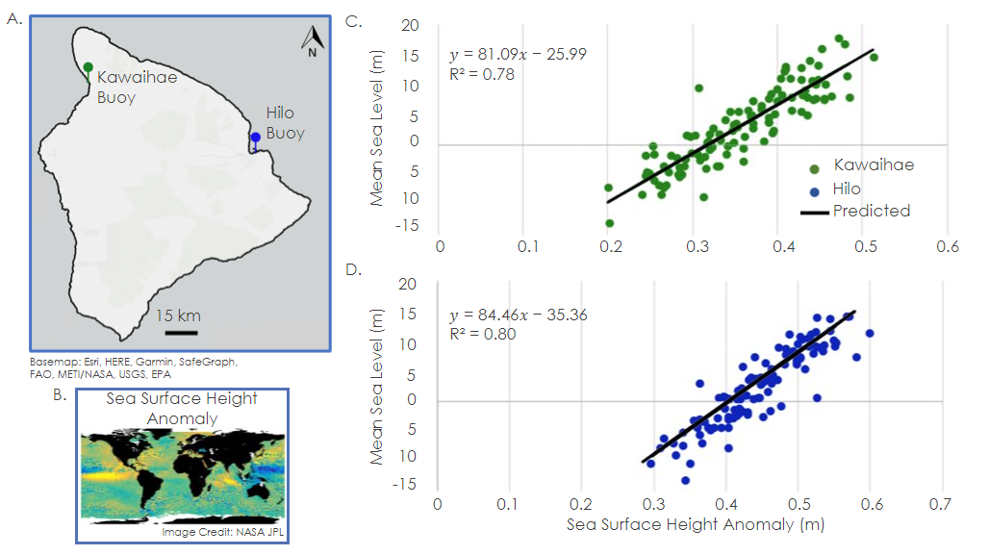**Figure 4.** Linear regression graphs show the relationship between monthly Mean Sea Level (MSL) from two tidal gauges on both sides of Hawaii Island and monthly Sea Surface Height Anomaly (SSHA) between 2013–2022. (A.) Location of the tidal gauges at Kawaihae and Hilo. (B.) Global NASA MEaSUREs Gridded SSHA dataset which was extracted at the location of the buoys. (C.) Kawaihae MSL plotted against SSHA (in green) and the black line shows the predicted SSHA output plotted against the Kawaihae MSL input. (D.) Hilo MSL (in blue) plotted against SSHA and the black line shows predicted SSHA.

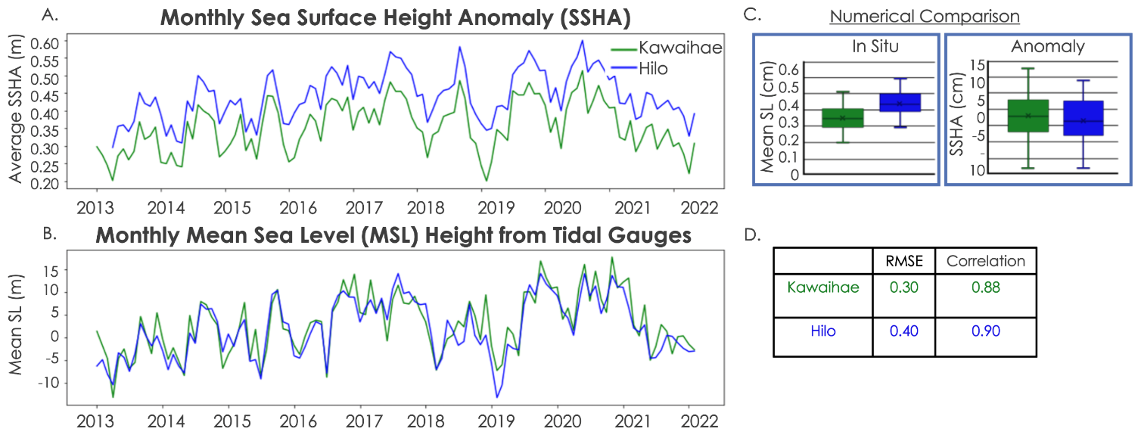**Figure 5.** Numerical comparison of NASA MEaSUREs Sea Surface Height Anomaly (SSHA) and tidal gauge Mean Sea Level (MSL) extracted at the Kawaihae and Hilo buoy locations. (A.) Line graph of monthly SSHA for Kawaihae and Hilo throughout 2013–2022. (B.) Line graph of monthly MSL for Kawaihae and Hilo throughout 2013–2022. (C.) Numerical comparison of the data distributions of in situ data, or MSL, and the anomaly data, or SSHA. (D.) A table of root mean square error and Pearson’s correlation coefficient values for Kawaihae MSL and SSHA and Hilo MSL and SSHA.

*4.1.3 Sea Level Inundation Risk Model*

Running the random forest model through the five flood events, the team achieved on average a 90% classification accuracy and 10% OOB error. The model was relatively simple and lightly tuned but remained robust as our results did not change significantly within our parameter space.

In addition to being able to capture nonlinear relationships and being highly robust to outliers, random forest is also able to generate feature importance charts based on Gini impurity, which is the probability of incorrect classification of a randomly chosen element in a dataset if it were randomly labeled according to how the class distribution was originally labelled in the dataset. We found sea surface temperature anomaly (SSTA) and precipitation consistently ranked as the two most important features for flood risk classification, frequently being on top of the feature importance charts throughout tuning. The high importance of precipitation was surprising because of its low temporal monthly resolution which likely speaks to the seasonality of flooding. An example feature importance chart for one of the flood events is shown in Figure 6A.

For uncertainties, a common issue with the features were dated data such as elevation and precipitation along with the small sample size of flood events (the number of data points for an individual event was no problem though). Global SSHA data was not corrected near certain coastal regions (though that was mitigated through extrapolating data up to 15 km from the coast to the open ocean). However, collected SSHA data were already corrected for tides which removes potentially important seasonal variations. Another potential issue was from multicollinearity of our features, namely the minimum elevation and absolute largest differential. This one was a tricky problem since it is difficult to rank the relative importance of different variables if they have the same underlying effect. However, we found that this was not the case as either of these features by themselves were not meaningful since the minimum elevation does not indicate where steep rises or cliffs (if any) occurred and the difference in elevation does not provide complete information about whether an area is low-lying to flood. In addition, we tested our theory by omitting either of the elevation sub-features from the random forest model, and both features performed similarly or poorer than if they were both included in the models. An alternative would be using principal component analysis (PCA) to reduce these two features into one instead.

The random forest model performed as expected, excelling at interpolation, and to extend the study to inter-flood event classification (or even flood risk prediction) would require significantly more data and time beyond the scope of this study. For the partners, the team combined data from the five known flood events to generate an interim short-term flood risk map along the Hawaii Island coast that shows higher flood risk primarily on the windward side. The map is shown in Figure 6B.

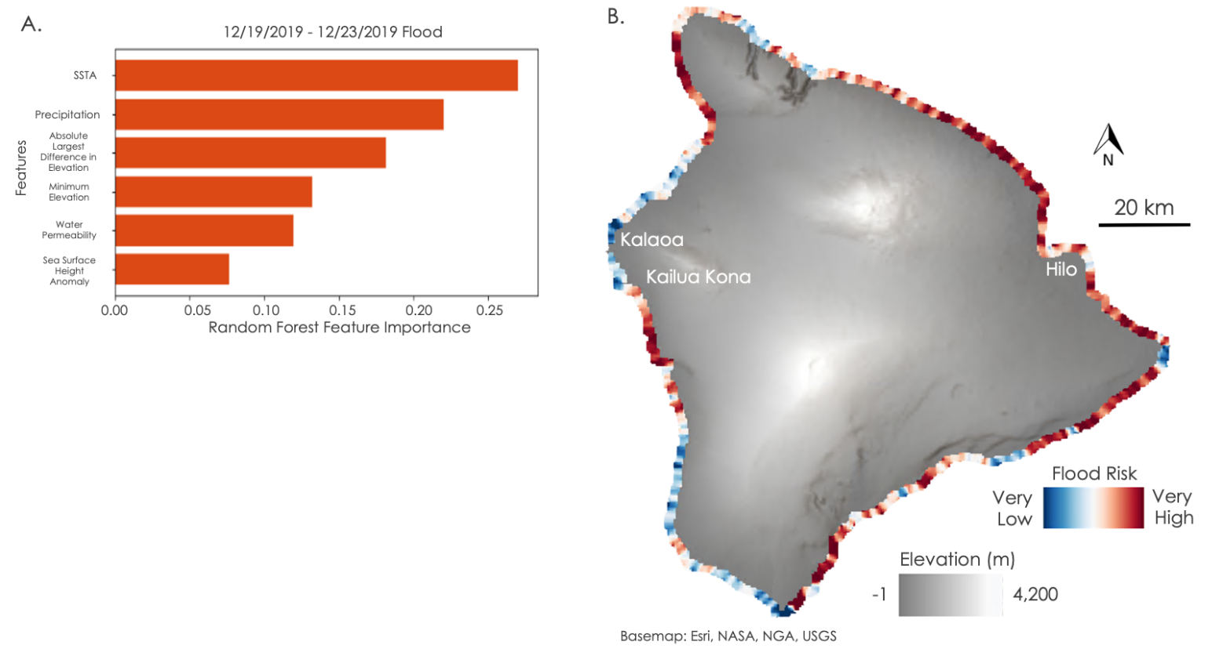**Figure 6.** Flood risk outputs from the random forest machine learning model. (A.) Feature importance chart for one of the flood events. SSTA and precipitation ranked as the two most important features, accounting for about 50% between them. A higher feature importance means that these features will have a larger effect on the model being used to predict the flood risk labels. The feature importance is based on the Gini impurity, and for each feature, the team computed the average decrease in impurity over all trees in a forest. (B.) An interim short-term flood risk map made from the five flood events used in our study. The team determined the largest flood risk among all flood events per transect and assigned that to the final output map shown here, to provide our partners with a visual of where the recent strongest flooding has occurred.

***4.2 Future Work***

Given more time, the team would be able to refine both models with higher-resolution and up-to-date data to further improve the model’s accuracy. For WIP and wetland model, tuning HU4 more would be a priority for improving overall model performance. The map could also be further improved using the County’s incoming high-resolution elevation data. For the sea level rise inundation risk model, additional available features could be explored like wind and fetch. Existing features like SSTA could also be broken down into sub-features like currents and thermosteric components, helping to refine understanding of what influences the flood risk. The partners can combine the wetlands extent and flood risk maps in tandem to inform decision-making for their mitigation and adaptation plans.

**5. Conclusions**

This project used NASA Earth satellite observations and remote sensing techniques to create three products that will aid the County of Hawaii and State of Hawaii DLNR in their upcoming Shoreline Setback Plan and Climate Action Plan. The team first developed a Hawaii wetland extent map showing probability rasters for wetland presence and location and found that soil and climate variables were the most important for modeling wetlands in Hawaii. Secondly, the team validated the use of NASA MEaSUREs SSHA for analysis at coastal locations in Hawaii Island by grounding truthing them with in situ tidal gauges. They performed the statistical comparison of SSHA to MSL at Kawaihae and Hilo and demonstrated the reliability of SSHA as a reliable predictor for a sea surface height time series. Lastly, the team completed a successful feasibility study of using machine learning to classify flood risk and identified SSTA and precipitation as the most important features for flood risk classification. The study has important implications for future SLR research due to its applicability to local scale coastal sea level changes (using Hawaii as an example) and helping SLR researchers focus on the most impactful features for future flood risk studies.

For the Hawaii partners, the wetlands extent and sea level inundation risk maps can be combined to identify and focus on priority areas for their Shoreline Setback and Climate Action plans. The validation of local tidal gauge data also sets up future work by the County to track historical local sea levels.

# 6. Acknowledgments

The NASA DEVELOP Arizona team collaborated with the Arizona State University’s Center for Global Discovery and Conservation Science (GDCS) to work with our organization partners from the County of Hawaii and the State of Hawaii Department of Land and Natural Resources (DLNR) for this project. The team’s Arizona State University science advisors include Dr. Roberta Martin, Dr. Jiwei Li, and Dr. David Hondula. Dr. Martin provided local knowledge based on her research in Hawaii, Dr. Li provided machine learning expertise in remote sensing, and Dr. Hondula’s research focuses on the social and health effects of natural hazards like flooding and heat waves. Meghan Halabisky, one of the WIP tool developers, provided the team with insight into suggested inputs and model refinement. Pratyush Tripathy and Teja Malladi from the Geospatial Lab at the Indian Institute for Human Settlements developed and open-sourced the Global Flood Mapper application. We thank all our collaborators for their assistance and support.

This material contains modified Copernicus Sentinel 1 SAR data (2015 – 2022), processed by ESA and Global Flood Mapper developers Pratyush Tripathy and Teja Malladi.

Maps throughout this work were created using ArcGIS® software by Esri. ArcGIS® and ArcMap™ are the intellectual property of Esri and are used herein under license. All rights reserved.

Any opinions, findings, and conclusions or recommendations expressed in this material are those of the authors and do not necessarily reflect the views of the National Aeronautics and Space Administration.

This material is based upon work supported by NASA through contract NNL16AA05C.

# 

# 7. Glossary

**Earth observations** – Satellites and sensors that collect information about the Earth’s physical, chemical, and biological systems over space and time.

**Feature** – An input variable for machine learning algorithms, e.g., mean sea surface temperature, monthly precipitation

**Label** – A predictor variable for machine learning algorithms, e.g., flood risk probability

**Random forest** – An ensemble machine learning classification method based on decision trees. The algorithm outputs a class selected/voted on by most of the trees.

**Randomized search** – A method used for tuning the hyperparameters in a machine learning model to increase model generalizability. As opposed to a grid search that performs exhaustive testing of parameter combinations, randomized search selects combinations randomly but enough times to be similarly effective.

**Sea surface height anomaly** – The difference between the sea surface height observed by satellites and the long-term average sea surface height in different regions of the ocean.

# 8. References

Adebisi, N., Balogun, A. L., Min, T. H., & Tella, A. (2021). Advances in estimating Sea Level Rise: A review

of tide gauge, satellite altimetry and spatial data science approaches. *Ocean & Coastal Management*, 208, 105632. <https://doi.org/10.1016/j.ocecoaman.2021.105632>

Benda, L., Andras, K., and Miller, D. (2017). Wetland Intrinsic Potential: A Screening Tool for Detecting

Wetlands in Forested and Non-Forested Environments. Mt. Shasta, California/Seattle, Washington:

TerrainWorks. <https://www.dnr.wa.gov/publications/bc_fpb_wiptoolfindings_20210811.pdf>

Benveniste, J., et al. (2020). Coastal sea level anomalies and associated trends from Jason satellite altimetry

over 2002–2018. *Scientific Data,* 7(1), 357. <https://doi.org/10.6084/m9.figshare.12999596>

Bryan, B., Harvey, N., Belperio, T., & Bourman, B. (2001). Distributed process modeling for regional

assessment of coastal vulnerability to sea level rise. *Environmental Modeling & Assessment*, 6(1), 57-65.

<https://doi.org/10.1023/A:1011515213106>

Frazier, A. G., Giambelluca, T. W., Diaz, H. F. and Needham, H. L. (2016), Comparison of geostatistical

approaches to spatially interpolate month-year rainfall for the Hawaiian Islands. *Int. J. Climatol.*, 36(3), 1459-1470. <https://doi.org/10.1002/joc.4437>

Giambelluca, T.W., X. Shuai, M.L. Barnes, R.J. Alliss, R.J. Longman, T. Miura, Q. Chen, A.G. Frazier, R.G.

Mudd, L. Cuo, and A.D. Businger (2014). Evapotranspiration of Hawaii. Final report submitted to

the U.S. Army Corps of Engineers—Honolulu District, and the Commission on Water Resource Management, State of Hawaii. <http://evapotranspiration.geography.hawaii.edu/assets/files/PDF/ET%20Project%20Final%20Report.pdf>

Kane, H. H., Fletcher, C. H., Frazer, L. N., & Barbee, M. M. (2015). Critical elevation levels for flooding due

to sea level rise in Hawaii. *Regional Environmental Change*, *15*(8), 1679-1687. <https://doi.org/10.1007/s10113-014-0725-6>

Liebsch, G., Novotny, K., Dietrich, R., & Shum, C. K. (2002). Comparison of multimission altimetric sea

surface heights with tide gauge observations in the Southern Baltic Sea. *Marine Geodesy*, 25(3), 213-234.

<https://doi.org/10.1080/01490410290051545>

Miller, D., and Halabisky, M. (2019). Wetland Mapping Tool Project Phase 2 Report. *Remote Sensing and*

*Landscape Ecology Lab: University of Washington*.

<https://www.dnr.wa.gov/publications/bc_fpb_wip_final_report_20210721.pdf>

Nieves, V., Radin, C., & Camps-Valls, G. (2021). Predicting regional coastal sea level changes with machine

learning. *Scientific Reports*, 11(1), 1-6. <https://doi.org/10.1038/s41598-021-87460-z>

Pettorelli, N., Vik, J.O., Mysterud, A., Gaillard, J., Tucker, C., & Stenseth, N. (2005). Using the satellite

derived NDVI to assess ecological responses to environmental change. *Trends in Ecology and Evolution*.

<https://doi.org/10.1016/j.tree.2005.05.011>

State of Hawaii Hazard Mitigation Plan. (2018). Prepared by Tetra Tech for Hawaii Emergency Management

Agency. <https://dod.hawaii.gov/hiema/files/2022/06/2018-SHMP-Amended-for-EMAP-4.2.3-Supplemental-Period.pdf>

Tripathy, P. & Malladi, T. (2022). Global Flood Mapper: a novel Google Earth Engine application for rapid flood mapping using Sentinel-1 SAR. *Natural Hazards*. <https://doi.org/10.1007/s11069-022-05428-2>

University of Hawaii, College of Tropical Agriculture and Human Resource (2014). Hawaii Soil Atlas.

<http://gis.ctahr.hawaii.edu/SoilAtlas>

# 9. Appendices

**Appendix A**

**Table A1**

*Datasets acquired for wetlands delineation model.*

|  |  |  |  |  |  |
| --- | --- | --- | --- | --- | --- |
| **Dataset Name (Source)** | **Date** | **Resolution** | **Sensor** | **Parameters Observed** | **Use** |
| 3DEP DEM (USGS) | 2013 | 10 m | Various LiDAR sources | Elevation (m) | DEM was used to derive various topographic indices for use as inputs into the WIP model. |
| High-resolution surface reflectance optical imagery (PlanetScope) | 2022 | 3m | PlanetScope | Surface reflectance | Current multispectral imagery was used to derive NDVI for the WIP model. Imagery was also used for heads up visual verification of model training points. |
| Hawaii Soils Atlas (University of Hawaii) | 2014 | N/A | Collected in-situ by the Natural Resources and Conservation Service (NRCS) | Water permeability, organic matter (pH) | Soil Atlas provided aggregated soil features from NRCS SSURGO soils data allowing for easy targeting of soil variables and integration into the WIP model. |
| Hawaii Climate Atlas (University of Hawaii) | 2021 | 10m | N/A | Mean Monthly Precipitation and Temperature | Mean precipitation and temperature rasters were used for the months of June and December 2021 to account for seasonal climate variations. |
| Hawaii Stream Catalog (DLNR) | 2008 | N/A | N/A | Stream locations | Stream features were used to be erased from upland polygon used in training data creation. |
| National Wetland Inventory (U.S. Fish & Wildlife Service) | 1979–2022 | N/A | N/A | Wetland Locations | NWI data was acquired for training data creation. |
| National Hydrography Dataset Waterbodies (USGS) | 2013–2022 | N/A | N/A | Inland deep-water habitat locations | NHD Waterbodies were used to create a Depth to Water (DTW) index, as well as removing deep water features from upland polygons used in training data creation. |

**Appendix B**

**Table B1**

*Datasets acquired for sea level inundation risk model.*

|  |  |  |  |  |  |
| --- | --- | --- | --- | --- | --- |
| **Dataset Name (Source)** | **Date** | **Resolution** | **Sensor** | **Parameters** | **Use** |
| NASA MEaSUREs Gridded Sea Surface Height Anomalies (PO.DAAC) | 2017– 2022 | 0.16° (~18 km) | Advanced microwave radiometer (AMR), POSEIDON-3, TOPEX microwave radiometer (TMR) | Sea surface height anomalies (m) | Harmonized Jason-2 and Jason-3 dataset locate regions of high waters and are used as an input feature into the model, and to calibrate local tidal gauges. |
| GHRSST MODIS Sea Surface Temperature (PO.DAAC) | 2017–2022 | 0.01° (~1.1 km | MODIS | Sea surface temperature anomalies  (° C) | Accounts for thermosteric sea level rise and is used as an input feature into the model. |
| 3DEP DEM (USGS) | 2013 | 10 m | Various LiDAR sources | Elevation (m) | DEM was used to derive local coastal elevations and is used as an input feature into the model. |
| Hawaii Soils Atlas (University of Hawaii) | 2014 | 10 m | Collected in-situ by NRCS | Water permeability (K_sat) | Soil water permeability affects susceptibility to floods and is used as an input feature into the model. |
| Hawaii Rainfall Atlas (University of Hawaii) | 1978 – 2007 | 500m | Developed from rainfall observations at > 1,200 sites in Hawaii | 30-year average of monthly or annual rainfall (mm) | Precipitation along the coast accounts for inland flows and is used as an input feature into the model. |
| Global Flood Mapper (Google Earth Engine) | 2019 – 2021 | ~335 m | Sentinel-1 SAR | Flood vulnerability risk (high, low, none, permanent open water) | Maps from past floods in Hawaii are used to create our risk index input label for the model. |

**Appendix C**

**Figure C1**

*A high-level overview of the methodology workflow used for running the WIP tool is shown here. A. Derived inputs for the WIP tool are listed categorically. B. Hydrographic Unit extents are shown as well as an example of derived wetland and upland polygons for the entire island of Hawaii.*

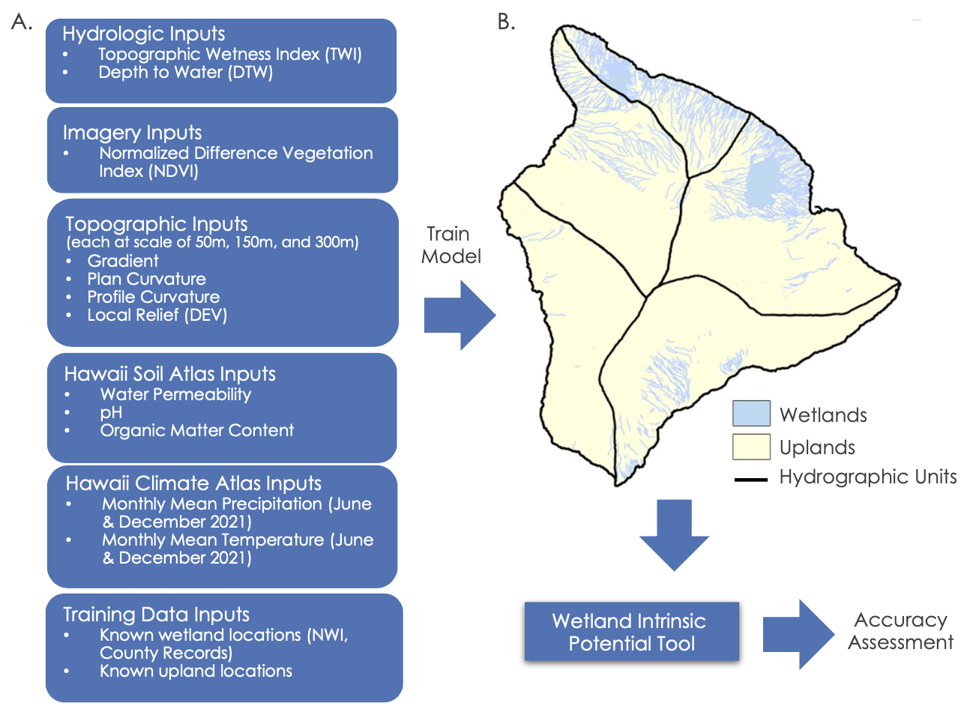

**Appendix C (Cont.)**

**Figure C2**

*WIP tool workflow for building models by Hydrographic Unit.*

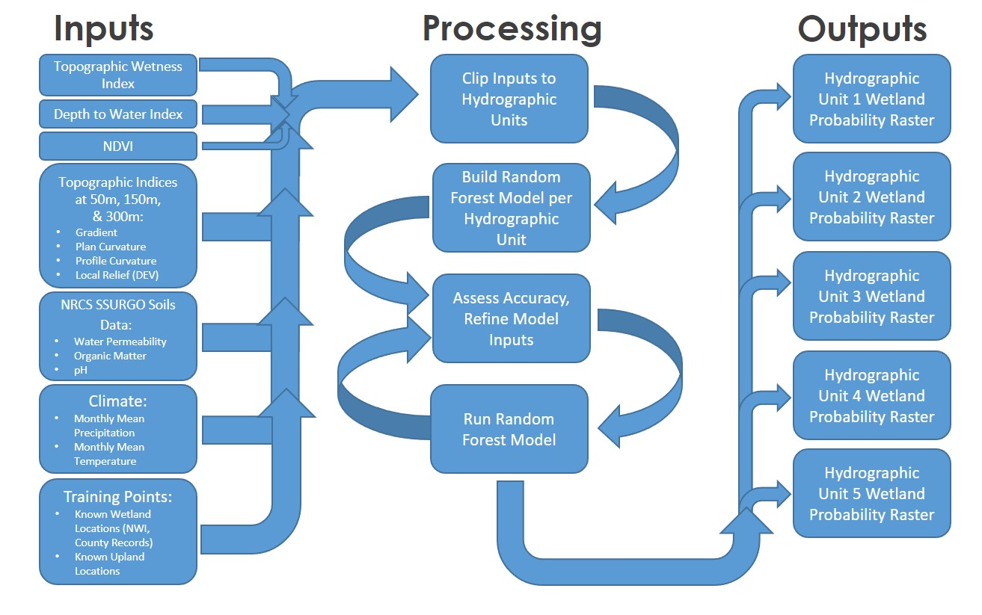

**Appendix D**

**Figure D1**

*Sample 100 km transects of two random points on the Hawaii coastline going 100 km towards the open ocean. Plots on the left show the SSHA data for both of these transects, showing no changes within the first ~15 km from shore. We also observed very similar patterns of minimal to no changes in SSHA within the first ~15 km from shore at various other points and at different times.*

