**NASA DEVELOP National Program**

 Wise County Clerk of Court’s Office

**Summer 2016**

**Short Title: Northern Great Plains Water Resources**

**Subtitle:** Discovering Archeological Sites Utilizing NASA Earth Observations to Detect Changes in Snowpack Coverage in Intermountain National Parks

**VPS Title:** Retreating Ice: The Beginnings of Discovery

**Project Team & Partners**

**Project Team:**

Anne Gale (Team Lead), anne.gale32@gmail.com

Michael Brooke

Xin Hong

Cody Vineyard

**Advisors & Mentors:**

Dr. Kenton Ross (NASA Langley Research Center)

Dr. DeWayne Cecil (NOAA NCEI, Global Science and Technology)

Bob VanGundy (The University of Virginia’s College at Wise)

Mike Bender (Wise County, Virginia)

**Partner Organizations:**

|  |  |  |  |
| --- | --- | --- | --- |
| **Organization** | **POC (Name, Position/Title)** | **Partner Type** | **Boundary Org?** |
| National Park Service, Intermountain Region | Tom Lincoln, Archeologist/ Assistant Regional Director of Cultural Resources for the Intermountain Region of the National Park Service | End-User | Yes |
| National Park Service, Rocky Mountain National Park (RMNP) | Kelly M. Stehman, Cultural Resource  Specialist | End-User | Yes |

**Project Details**

**Applied Sciences National Applications Addressed:** Water Resources, Climate

**Study Area:** Rocky Mountain National Park, CO

**Study Period:** January 1998 – December 2015

**Earth Observations & Parameters:**

Landsat 5 Thematic Mapper (TM) – ice/glacier/snow mapping

Landsat 8 Operational Land Imager (OLI) – ice/glacier/snow mapping

**Ancillary Datasets Utilized:**

* USGS Landsat-based Snow Cover product
* PRISM Climate Data – Oregon State University

**Software Utilized:**

* ArcGIS 10.4 - raster manipulation and analysis, image enhancement & map creation
* ArcScene - 3D Visualization
* ERDAS IMAGINE 2015 - preprocessing of Landsat imagery
* TerrSet – Land Change Modeler to detect the changes in glacier, ice, and snow cover over time

**Project Overview**

**80-100 Word Objectives Overview:**

Changes in the climate continue to decrease snow and ice coverage in Rocky Mountain National Park. The main objective of this project is to identify ice patches in the study area. Once the ice patches are identified, they are classified into persistent ice and snow cover verses temporary ice and snow cover. As the snow and ice extent change, undiscovered archeological sites are revealed. By mapping these spatial and temporal changes in snow and ice with the application of NASA Earth observations, we are able to discover the possible archeological sites.

**Abstract:**

National Parks in the Intermountain region of the northern United States Great Plains are experiencing snow and ice melt due to changes in climate. As the ice recedes, it has the potential to reveal previously undiscovered archaeological sites. Therefore, investigating the changes of Persistent Ice and Snow Cover (PISC) in this region is crucial to identifying archaeological sites. To address the changes of PISC, a two phase methodology was implemented: 1) map the PISC in the Rocky Mountain National Park, CO over the period from 1998 to 2014 using Landsat scenes; and 2) detect the changes of PISC over time. This research was a case study to document the retreat of PISC in the Intermountain National Parks, namely Rocky Mountain National Park, by applying NASA Earth observations. This research can also aid in testing hypotheses about the drivers of human behavioral variability and support the National Park Service in its mission to mitigate impacts of climate change to mountain cultural heritage resources.

**Keywords:**

Glaciers, snow and ice, remote sensing, Rocky Mountain National Park, Landsat, climate change

**Community Concerns:**

* One of the missions of the National Park Service is to mitigate impacts of climate change to mountain cultural heritage resources. The Intermountain region of the northern United States Great Plains region is experiencing snow and ice melt due to changes in climate.
* As the ice recedes, it has the potential to reveal previously undiscovered archaeological sites. Rocky Mountain National Park desires to preserve the archeological artifacts from the newly exposed sites.

**Current Management Practices & Policies**:

The National Park Service is responsible for safeguarding and recording cultural resources across the Intermountain parks. As annual snow and ice coverage decreases, previously buried archeological sites are exposed and need to be documented and preserved. Currently the National Park Service Intermountain Region relies on aerial photography and ground surveys to map the extent of snowpack and ice. While accurate, these methods require considerable time and financial resources.

**Decision Support Tools & Benefits:**

|  |  |  |  |
| --- | --- | --- | --- |
| **End-Product** | **Earth Observations Used** | **Benefit & Impact** | **Software**  **Release** |
| Recently Visible Land Area Map | Landsat 5 TM  Landsat 8 OLI | This product will be used by the NPS to identify areas that have historically been covered by snow and ice in order to identify previously covered archeological sites. | N/A |

**Project VPS/Booklet Imagery**

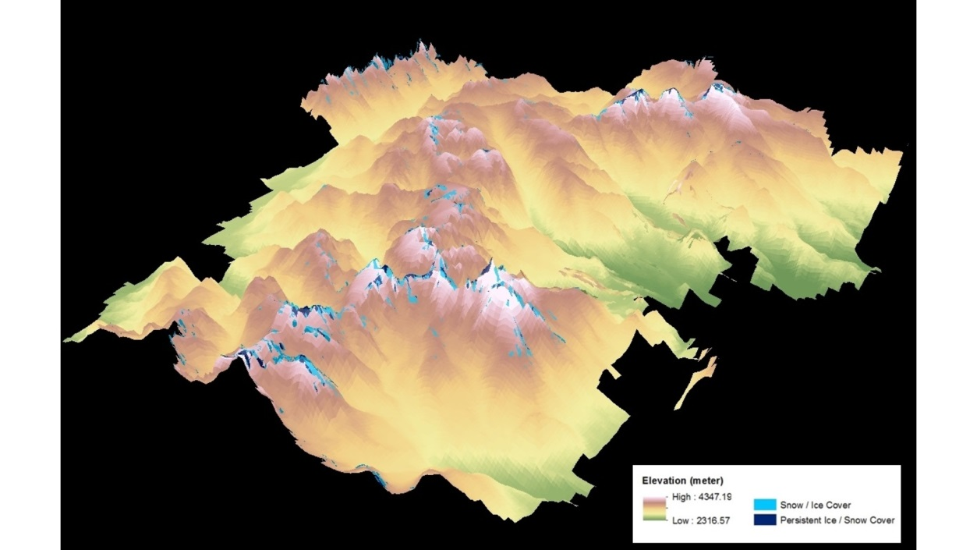

**Caption:** Retreating Ice: The Beginnings of Discovery**.** Image Credit: Northern Great Plains Water Resources Team.

**Image:** 2016Sum_WC_NorthernGreatPlainsWater_VPSimagery.jpg