**NASA DEVELOP National Program**



NASA Marshall Space Flight Center

*Summer 2015*

Texas and Arizona Ecological Forecasting

Utilizing NASA Earth Observations to Monitor and Manage Ocelot Habitat Loss

 **Technical Report**

Final Draft – August 6, 2015

Daryl Ann Winstead (Project Lead)

Kaushik Narasimhan

Christina Fischer

Amberle Keith

Dr. Jeff Luvall, NASA at National Space Science and Technology Center (Science Advisor)

Dr. Robert Griffin, University of Alabama in Huntsville (Mentor)

# I. Abstract

Although ocelot (*Leopardus pardalis*) habitat is found throughout Central America, portions of South America, and the United States, the species is currently listed as endangered with less than 100 remaining in the United States. This cat requires a minimum home range of 6.5 square kilometers (km), which aids in deadly interactions with humans on roadways. Many conservation efforts have been attempted, from ocelot translocation to habitat restoration. In this project, a remote sensing approach was developed, using NASA Earth-observing sensors. Landsat 8 Operational Land Imager (OLI) and Landsat 5 Thematic Mapper (TM) imagery were used to create supervised land cover classifications for 1996, 2005, and 2014 during January through March to assess land use and cover over time. Surface reflectance imagery from Terra and Aqua Moderate Resolution Imaging Spectroradiometer (MODIS) were then used to derive Normalized Difference Vegetation Index (NDVI values) to verify the results from the land cover classification layer. The verified land cover classification was then used with *in situ* data in the Princeton Maximum Entropy model to identify suitable ocelot habitat. A proximity risk map to roads and urban areas was created using multiband buffer zones over this habitat. The products were delivered to the Pittsburgh Zoo & PPG Aquarium, Caesar Kleberg Wildlife Research Institute, Denver Zoo, Texas Department of Transportation, South Texas Refuge Complex, and Secretaria de Medio Ambiente y Rescusos Naturales. The use of GIS and remote sensing will greatly aid the project partner’s decision-making process in directing conservation efforts for this endangered species.

**Keywords**

Princeton Maximum Entropy Model, Endangered Species, Land Cover Classification, Normalized Difference in Vegetation, Landsat, Time Series, Habitat, Ocelot

# II. Introduction

The ocelot (*Leopardus pardalis*) is critically endangered in the United States with less than a hundred individuals remaining in the wild (Zerinskas & Pollio 2013). Some estimates predict as few as fifty extant cats (Booth-Binczik et al. 2013). The historical ocelot range extended from Argentina (Caso et al. 2008) into Arizona, Texas, Louisiana, and Arkansas (Connolly 2009). Ocelots have since been extirpated from most of its range in the United States, largely due to habitat loss and hunting by humans for their pelts and to reduce perceived livestock conflicts (Connolly 2009). Congress added the ocelot to the U.S. Endangered Species Act (ESA) in 1981 (Zerinskas & Pollio 2013). The largest remaining populations exist in the Laguna Atascosa National Wildlife Refuge (LANWR) and in private ranches, both in southern Texas (Haines et al. 2005a). In Arizona, researchers have documented the presence of ocelots, but population numbers are not well known (Avila-Villegas & Lamberton-Moreno 2012).

The ocelot is an elusive nocturnal felid (Laack et al. 2005; Janecka et al. 2014). Throughout most of the ocelot’s Neotropical range, ocelots occupy a spectrum of habitats, including grasslands, tropical forests, wetlands, and vegetated deserts (Trolle & Kery 2003; Zerinskas & Pollio 2013). In the United States, ocelots strongly prefer dense, closed canopy thornscrub communities (Haines *et al.* 2005a). Ocelots maintain a diet of small prey (Di Bitetti et al. 2006)), with rodents and lagomorphs representing the majority of their prey (Grigione & Mrykalo 2004). Ocelots are largely solitary, with males maintaining larger territories encompassing smaller female territories (Dillon & Kelly 2008). Individuals interact primarily to mate, producing small, yearly litters after a long gestation period (Laack *et al.* 2005; Zerinskas & Pollio 2013). Following a successful brood, females maintain at least a one year interbirth period prior to reentering estrus (Laack *et al.* 2005). Two subspecies are represented in the U.S.: *L. p. albescens* in Texas and *L. p. sonoriensis* in Arizona (Zerinskas & Pollio 2013).

The ocelot’s specific ecological and behavioral requirements render it susceptible to disturbance. Anthropogenic disturbances like poaching and land conversion have taxed ocelot populations. Over 95% of the dense thornscrub that comprises the preferred ocelot habitat in Texas has undergone conversion into urban or agricultural land (Connolly 2009). This conversion had resulted in a patchwork mosaic of forest fragments, isolating ocelot populations which must disperse further to find suitable habitat. Human land use has also resulted in development of road networks, which serve as further barriers to movement and, through increased risk of vehicle collisions, a major source of mortality (Haines et al. 2005b). Furthermore, migration from source populations in Northern Mexico has been severed due to closed national borders (Grigione & Mrykalo 2004). This isolation has resulted in inbreeding depression, reducing adult and juvenile survivorship (Zerinskas & Pollio 2013).

**Project Objectives**

The purpose of this project was to create a Habitat Percent Cover Map, Suitable Habitat Map, and Proximity to Road Risk Map for ocelot habitat. These maps aided the project partners in their decision making process towards ocelot conservation efforts.

**Study Area and Period**

This study selected 37 counties in Texas and 6 counties in Arizona for analysis. The Texas counties comprise the southeastern most portion of the state, along the Mexico border, up to San Antonio. The area surrounding the LANWR was of particular interest to this study as it is the fastest growing human population in the United States (Haines *et al.* 2005b). The Arizona counties were also located in the southeastern most part of the state, bordering Mexico and extending up into the southern part of the Tonto National Forest.

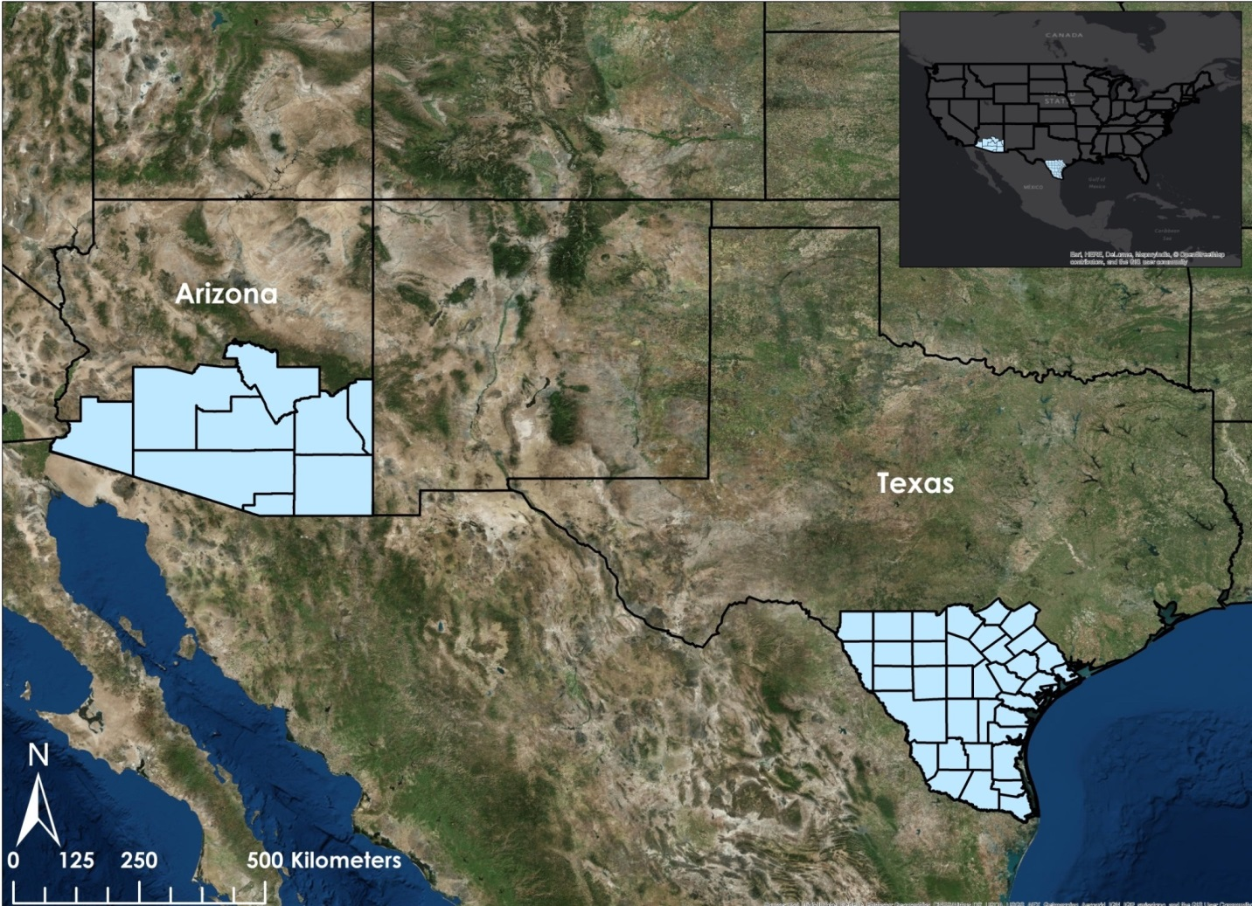

Figure 1: Map of Study Area

The study period ranged from 1996 through 2014. This timespan was sufficient to quantify the growth of urbanization and agriculture, as well as recent conservation efforts to convert land back to native ecosystems. The team used Landsat imagery from January, February, or March in 1996, 2005, and 2014. These months correspond to the dry seasons in the regions of interest and represent the least amount of vegetation available in ocelot habitats in that year. In the event that there was significant cloud cover, data were taken from either December or April of that year.

**National Applications Addressed**

The focus of this project was ecological forecasting of ocelot habitat in the United States was. Project deliverables were utilized by the project partners in creating policies that promote rehabilitation efforts of the ocelot population.

**Project Partners**

The partners for this project were Mr. Ken Kaemmerer and Dr. Joseph Gaspard from the Pittsburg Zoo & PPG Aquarium, Dr. Mike Tewes and Mr. Humberto Perotto from the Caesar Kleberg Wildlife Research Institute at Texas A&M University - Kingsville, Ms. Nanette Bragin from the Denver Zoo, Mr. Mitch Sternberg with the South Texas Refuge Complex, Dr. John Young Jr. from the Texas Department of Transportation, Dr. Arturo Caso from Secretaria de Medio Ambiente y Rescusos Naturales (SEMARNAT), and Dr. Tyler Campbell from the East Wildlife Foundation.

Currently, conservation efforts include a variety of practices, such as the use of camera trappings, radiotelemetry, translocation of Mexican ocelots, and the restoration of native vegetation in the area. These management practices can be costly and time-consuming for the partners and each technique has its limitations. Trapping and collaring ocelots is an invasive method which causes the animal undue stress. Additionally, previously trapped ocelots avoid traps in the future, further increasing the difficulty of future research. While camera trapping is a non-invasive practice, accurate assessments of population density for ocelots are difficult as trap placement bias, small sample size, repeated captures of the same individual can skew the data. The methodological framework and results of this project will be integrated into the partners’ decision-making to assess specific locations that are preferable for ocelot habitat. With this knowledge, conservation efforts will be focused for the restoration of vegetation, future translocation sites for ocelots, and the development of wildlife crossing structures for current and future road networks. Overall, the project offered the partners a methodology that will help save time and money.

# III. Methodology

**Data Acquisition**

Landsat 8 Operational Land Imager (OLI) and Landsat 5 Thematic Mapper (TM) Level 1 TIFF 30 meter resolution data products were downloaded from United States Geological Survey (USGS) Global Visualization Viewer website. The imagery was acquired for January through March during 1996, 2005, and 2014 and then used to derive land cover classification for each year. The land cover classifications were used to derive the change of land cover and land use over time. The classification image for 2014 was used to derive the current coverage of ocelot habitat within the study area.

Terra Moderate Resolution Imaging Spectroradiometer (MODIS) 500 meter (m) resolution MOD09A1 data product during January through March in 2005 and 2014 were downloaded using the DEVELOP National Program Python Package (dnppy). The dnppy script for MODIS data retrieval utilized databases from the USGS and the National Snow and Ice Data Center (NSIDC). The data were used to derive Normalized Difference in Vegetation Index (NDVI).

Terra Advanced Spaceborne Thermal Emission and Reflection Radiometer (ASTER) Global Digital Elevation Model (GDEM) Level 3 30 m resolution imagery were downloaded from the USGS Earth Explorer website. The Terra ASTER GDEM images were used to derive stream networks within the study area.

**Data Processing**

The Landsat images were processed by correcting the top of the atmosphere (TOA) reflectance by using the NASA DEVELOP dnppy script. The TOA-corrected images were then used in the “Con” tool in ArcMap 10.2.1. This tool took out any negative and zero values within the images. The images were then combined using the “Composite Band” tool. This tool combined the Landsat bands into a single layer and then each image was set to a specific band combination (Landsat 8 6-5-4 & Landsat 7 & 5 5-4-3). The images were then mosaicked for each year and used to derive land cover classification.

After the Landsat images were mosaicked, the data were clipped down to the counties from Texas and Arizona within the study area using the “Clip (Data Management)” tool in ArcMap 10.2.1. Using the clipped Landsat data, Regions Of Interest (ROIs) were collected for Texas and Arizona for 1996, 2005, and 2014 using 11 different classes (Appendix A Table 2). For each ROI class, at least 100 samples were obtained to better train the program for classifications. Once all of the classes had been collected, the file was saved as a signature .GSG file. The signature file was used to run the Maximum Likelihood Classification on the clipped Landsat data with the reject fraction set to 0.0 and the A priori probability weighting set to equal.

Once the classification for each time period was completed, minor modifications needed to be done by resampling areas in which classes were misclassified. This step was repeated for each classification multiple times to ensure better accuracy of the classes. This was cross-referenced in Google Earth to verify accuracy.

The Terra MODIS images were georeferenced then used in the “Con” tool in ArcMap 10.2.1 to eliminate negative values. The corrected images were then used to derive NDVI (Appendix B Figure 1) in ArcMap 10.2.1 using the “Raster Calculator” tool. The equation used in the tool is listed in Figure 2.

$$NDVI = \frac{\left(NIR-RED\right)}{\left(NIR+RED\right)}$$

**Equation 1: Normalized Difference in Vegetation Index**

The Terra ASTER GDEM images were used to derive stream networks within the study area using ArcMap 10.2.1. These images were mosaicked using the “Mosaic” tool and sinks were rectified using the “Fill” tool in ArcMap 10.2.1. The team then used “Flow Direction” and “Flow Accumulation” Tools which aided in producing stream networks. Stream networks were derived using the “Stream Order” tool utilizing the Shreve method.

**Data Analysis**

Point data on Texas ocelot populations were received from the project partners and then used in a Princeton Maximum Entropy (MaxEnt) model in R Studio(R Core Team 2013). Using the Raster Package (Hijmans 2015), raster objects were created using the Texas 2014 NDVI and the Texas 2014 land cover classification. The land cover classification raster necessitated resampling in ArcMap 10.2.1 to match the spatial resolution of the NDVI raster. Pseudo absence points were randomly generated within 100 iterations in a 10 kilometers radius, which is the dispersal distance for ocelots, from each observation point. This data were then combined into a single data frame, where variables were grouped into 5 sets for model training. This data frame was then inserted in the MaxEnt function of the Dismo package (Hijmans et al. 2015) where predictions were derived. The resulting analysis was then exported as a raster layer and used to confirm other models.

The land cover classification, NDVI, and steam network layers were weighted to a scale of 0 to 1 using the “Fuzzy Membership” tool in ArcMap 10.2.1. The weight assigned to each layer was based on the pixel values corresponding to the in situ data. The weighted layers were then used in the “Fuzzy Overlay” tool in ArcMap 10.2.1. The result was the Suitable Habitat Map (Appendix B Figure 3). This was completed for years 2014, 2005, and 1996 (excluding NDVI).

From the Suitable Habitat Map, the layer was used in the “Reclassify” tool in ArcMap 10.2.1 where only the most suitable areas were present in the layer. From this, the percent area was assessed for each year (Appendix A Table 3, Appendix B Figure 6).

The road network data (Appendix B Figure 4) was added to the most suitable habitat areas. The “Intersect” tool in ArcMap 10.2.1 was used with these layers which pulled out roads at risk. The result was the Proximity Risk Map (Appendix B Figure 5).

# IV. Results & Discussion

**Analysis of Results**

The Fuzzy Logic model yielded an error matrix (Table 1) with an accuracy rate of 71% and misclassification rate of 29%.

|  |  |  |  |
| --- | --- | --- | --- |
|  | | **Predicted** | |
| Negative | Positive |
| **Actual** | Negative | 35 | 13 |
| Positive | 18 | 40 |

Table 1: Error Matrix

The suitable habitat area derived from 1996 data totaled 47,746km2 in Texas and 73,208km2 in Arizona (Appendix A Table 3). With 2005 data, Texas and Arizona contained 54, 511km2 and 81,811km2 respectively. Texas and Arizona in 2014 held 38,773km2 and 63,952km2 respectively. Appendix C Chart 1 demonstrates a downward trend of suitable habitat over time, resulting in a depreciation of 7.2 % in Arizona and 8.4 % in Texas over 18 years. Between 1996 and 2005, the total percent cover increased in both states. The reason for this change is likely not an artifact of human error as predicted suitable habitat increased by a similar amount in both habitats. Furthermore, most misclassification during land cover classification occurred mostly between other land classes and had little discernible effect on potential habitat classification. Landsat 5 imagery was used for analysis in both 1996 and 2005 data, so the remote sensing platform used was consistent for both years. The 2014 imagery was generated from Landsat 8, and the improved sensor likely resulted in a more accurate classification over Landsat 5. More research must be conducted to determine if climate or another factor will explain the increase. If legitimate, the percent decrease of suitable habitat between 2005 and 2014 is 14.7% in Texas and 13.9% in Arizona, representing a larger decrease than between 1996 and 2014.

In Arizona, 11,011km of road intersected with potential ocelot habitat (Appendix A Table 4), with Maricopa county having significantly more high risk road than other Arizona counties (Appendix C Chart 3). In Texas, 2,948.9km of major roads intersected with potential ocelot habitat (Appendix A Table 5). In Texas, Gonzalez, Bexar, and Cameron counties were the top three counties with high risk roads (Appendix C Chart 2). Cameron, Willacy and Kenedy counties, where ocelots have been recorded in greatest numbers, local roads were included in the analysis. As a result, Cameron, Kenedy, and Willacy counties had 335.6km, 105.4km, and 50.2km of high risk roads respectively (Chart 1).

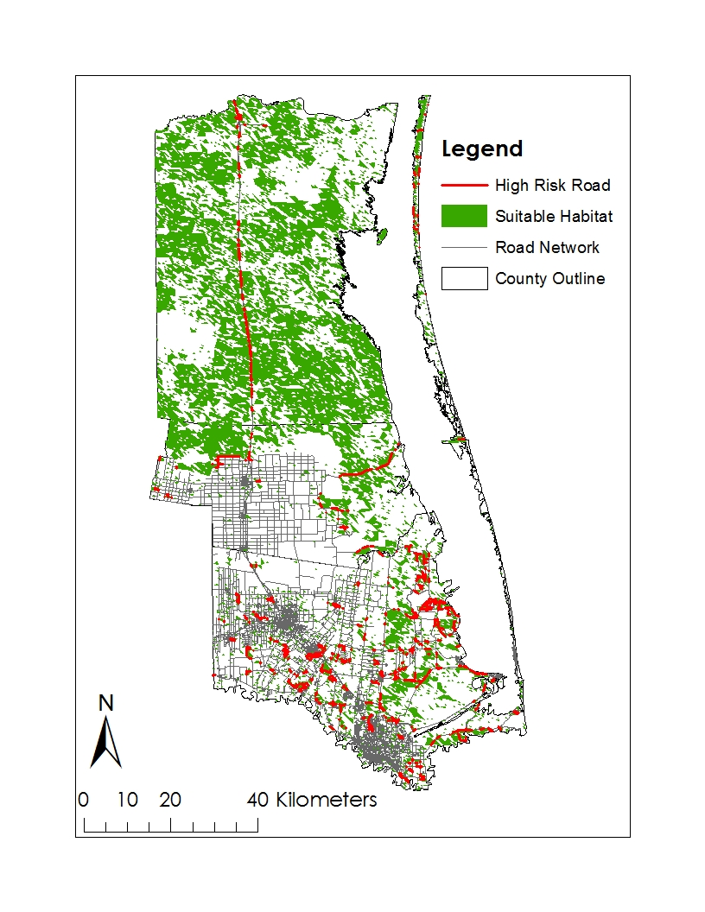

Figure 2: Proximity Map of Cameron, Kenedy, and Willacy counties in Texas

**Errors & Uncertainty**

Due to the sensitivity of the data, limited point data, which consisted of ocelot sightings, were obtained. Few of the points had to be neglected due to the location either being over unlikely ocelot habitat or not transposing the coordinates properly. All of the point data that were acquired were located in Texas which posed for inaccuracies in the models over the study area in Arizona. With the limited point data available, ground-truthing will be needed to validate results from the project.

After vigorous literature review and creating land cover classifications, it was determined that ocelots located in Arizona had different habitat preferences. This also posed for uncertainties in the models used.

The Landsat suite passes over the study area every 16 days with a resolution of 30m and the Terra satellite passes over daily with a resolution of 250m. With these resolutions, the satellites picked up cloud cover which obstructed the data needed for deriving land cover classification and NDVI. Due to the difference in spatial resolutions between the two satellites, when used in the models the Landsat data had to be resampled to the Terra data which caused the output to not be as precise.

Another uncertainty was with the land cover classifications. In Arizona, unimproved roads were misclassified as bare earth and rock. For Texas, marsh areas were misclassified as urban areas. Cloud cover also posed an uncertainty as it reduced visibility and cause misclassifications of other classes.

**Future Work**

For the fall of 2015, this project will be continued in which the methodology and results will be further refined. This continuation will focus on portions of north Mexico where conservation efforts will be most useful. In part of the refinement, more point data may be obtained to validate the refined results from the Habitat Percent Cover, Suitable Habitat and Proximity to Roads Risk Maps.

Another means of refining the methodology would be to ground-truth the results to better determine the accuracy. Ground-truthing would be needed before partners could install wildlife crossing structures or determining where best to place a translocated Mexican ocelot.

# V. Conclusions

The results supported the findings that suitable habitat in southern Texas and Arizona has decreased over time. This data helped to inform the general public of the historical and continuing degradation of potential ocelot habitat. Furthermore, conservationists may more effectively direct translocation efforts by focusing on areas of unused potential habitat in proximity to other known populations. Corroborating this information with larger ocelot datasets will allow the Texas Department of Transportation to selectively determine locations of roads with the highest instances of ocelot road mortalities. Ocelot underpasses may then be installed at these points of highest traffic.

# VI. Acknowledgments

The Texas and Arizona Ecological Forecasting team would like to say thank you to the many partners and mentors who provided their time, support, and expertise to this project:

Advisors/Mentors:

* Dr. Jeffrey Luvall, NASA at NSSTC
* Dr. Robert Griffin, University of Alabama in Huntsville

Partners:

* Pittsburg Zoo & PPG Aquarium
* Caesar Kleberg Wildlife Research Institute at Texas A&M University–Kingsville
* The Denver Zoo
* South Texas Refuge Complex
* Texas Department of Transportation
* Secretaria de Medio Ambiente y Rescusos Naturales (SEMARNAT)
* East Wildlife Foundation

This material is based upon work supported by NASA through contract NNL11AA00B and cooperative agreement NNX14AB60A. (“USGS Global Visualization Viewer” n.d.)

# VII. References

Avila-Villegas, S., and J. A. Lamberton-Moreno. 2012. Wildlife Survey and monitoring in the Sky Island region with an emphasis on neotropical felids. Pages 441–447 Gottfried, GJ, PF Ffolliott, BS Gebow, LG Eskew, and LC Collins, comps., Merging Science and Management in a Rapidly Changing World: Biodiversity and Management of the Madrean Archipelago III and 7th Conference on Research and Resource Management in the Southwestern Deserts. Available from http://www.fs.fed.us/rm/pubs/rmrs_p067/rmrs_p067_441_447.pdf (accessed June 10, 2015).

Booth-Binczik, S. D., R. D. Bradley, C. W. Thompson, L. C. Bender, J. W. Huntley, J. A. Harvey, L. L. Laack, and J. L. Mays. 2013. Food Habits of Ocelots and Potential for Competition With Bobcats In Southern Texas. The Southwestern Naturalist **58**:403–410.

Caso, A., C. Lopez-Gonzalez, E. Payan, E. Eizirik, T. de Oliviera, R. Leite-Pitman, M. J. Kelly, and C. Valderrama. 2008. *Leopardus pardalis*. Available from www.iucnredlist.org (accessed June 15, 2015).

Connolly, A. R. 2009. Defining Habitat for the Recovery of Ocelots (*Leopardus* *pardalis*) in the United States. Texas State University-San Marcos.

Di Bitetti, M. S., A. Paviolo, and C. De Angelo. 2006. Density, habitat use and activity patterns of ocelots (*Leopardus pardalis*) in the Atlantic Forest of Misiones, Argentina. Journal of Zoology **270**:153–163.

Dillon, A., and M. J. Kelly. 2008. Ocelot home range, overlap and density: comparing radio telemetry with camera trapping. Journal of Zoology **275**:391–398.

Grigione, M. M., and R. Mrykalo. 2004. Effects of artificial night lighting on endangered ocelots (*Leopardus paradalis*) and nocturnal prey along the United States-Mexico border: A literature review and hypotheses of potential impacts. Urban Ecosystems **7**:65–77.

Haines, A. M., M. E. Tewes, L. L. Laack, W. E. Grant, and J. Young. 2005a. Evaluating recovery strategies for an ocelot (*Leopardus pardalis*) population in the united states. Biological Conservation **126**:512–522.

Haines, A. M., M. E. Tewes, L. L. Laack, and Morrison. 2005b. Survival and sources of mortality in ocelots. Journal of Wildlife Management **69**:255–263.

Hijmans, R. J. 2015. raster: Geographic Data Analysis and Modeling. R Foundation for Statistical Computing. Available from http://CRAN.R-project.org/package=raster.

Hijmans, R. J., S. Phillips, J. Leathwick, and J. Elith. 2015. dismo: Species Distribution Modeling. R Foundation for Statistical Computing. Available from http://CRAN.R-project.org/package=dismo.

Janecka, J. E., M. E. Tewes, L. Laack, A. Caso, L. I. Grassman, and R. L. Honeycutt. 2014. Loss of genetic diversity among ocelots in the United States during the 20th century linked to human induced population reductions. PloS ONE **9**. Available from http://dx.plos.org/10.1371/journal.pone.0089384 (accessed June 10, 2015).

Laack, L. L., M. E. Tewes, A. M. Haines, and J. H. Rappole. 2005. Reproductive life history of ocelots (*Leopardus pardalis*) in southern Texas. Acta Theriologica **50**:505–514.

R Core Team. 2013. R: A Language and Environment for Statistical Computing. R Foundation for Statistical Computing. Available from http://www.R-project.org/.

Trolle, M., and M. Kery. 2003. Estimation of ocelot density in the pantanal using capture-recapture analysis of camera-trapping data. Journal of Mammalogy **84**:8.

USGS Global Visualization Viewer. (n.d.). Available from http://glovis.usgs.gov/ (accessed June 15, 2015).

Zerinskas, D., and C. A. Pollio. 2013. US Wildlife Management Plan: Recovery of the Endangered Ocelot (*Leopardus pardalis*) in Arizona, New Mexico, and Texas. Poultry, Fisheries & Wildlife Sciences **1**:2.

# VIII. Content Innovation

Featured Multimedia for this Article: 2015Sum_MSFC_TXAZEcoForecasting_InnovativeContent_podcast

Featured Multimedia for this Article: 2015Sum_MSFC_TXAZEcoForecasting_VPS

# IV. Appendices

Appendix A

|  |  |  |
| --- | --- | --- |
| **Texas/Arizona 1996** | **Texas/Arizona 2005** | **Texas/Arizona 2014** |
| Earth/Rock | Earth/Rock | Earth/Rock |
| Water | Water | Water |
| Cloud | Cloud | Cloud |
| Agriculture: Growing | Agriculture: Growing | Agriculture: Growing |
| Agriculture: Tilled | Agriculture: Tilled | Agriculture: Tilled |
| Forest/Trees | Forest/Trees | Forest/Trees |
| Scrub/Shrub/Grasslands | Scrub/Shrub/Grasslands | Scrub/Shrub/Grasslands |
| Urban | Urban | Urban |
| Unimproved Roads | Unimproved Roads | Unimproved Roads |
| Snow | Snow | Snow |

Table 2: Classes used for the Landsat Maximnum Likelihood Classifications

|  |  |  |  |  |
| --- | --- | --- | --- | --- |
|  |  | **Suitable Habitat Area (km2)** | **Total Area in Study Area (km2)** | **Percent Cover** |
| **2014** | **Texas** | 38,772.6 | 107,226.8 | 36.2% |
| **Arizona** | 63,952.1 | 128,651.2 | 49.7% |
| **2005** | **Texas** | 54,511.3 | 107,226.8 | 50.8% |
| **Arizona** | 81,811.9 | 128,651.2 | 63.6% |
| **1996** | **Texas** | 47,745.7 | 107,226.8 | 44.5% |
| **Arizona** | 73,208.4 | 128,651.2 | 56.9% |

Table 3: Percent Cover Table for Texas and Arizona

|  |  |
| --- | --- |
| **Name** | **High Risk Roads (km)** |
| Cochise | 1108.7 |
| Gila | 1254.4 |
| Graham | 327.2 |
| Pima | 1422.9 |
| Pinal | 1366.1 |
| Santa Cruz | 320.2 |
| Yuma | 500.6 |
| Maricopa | 4210.1 |
| Greenlee | 501.3 |

Table 4: Length of High Risk Roads in Arizona

|  |  |
| --- | --- |
| **Name** | **High Risk Roads (km)** |
| Gonzales | 225.5 |
| Bexar | 182.5 |
| Cameron | 139.6 |
| Goliad | 132.7 |
| Atascosa | 129.5 |
| Duval | 126.4 |
| Refugio | 120.5 |
| Frio | 107.5 |
| Victoria | 104.2 |
| Webb | 101.9 |
| San Patricio | 96.8 |
| De Witt | 91.1 |
| Live Oak | 90.9 |
| Jim Wells | 88.3 |
| Guadalupe | 86.1 |
| Bee | 85.6 |
| Calhoun | 80.7 |
| La Salle | 78.0 |
| Mcmullen | 74.3 |
| Uvalde | 73.7 |
| Karnes | 70.8 |
| Kenedy | 66.7 |
| Kleberg | 57.9 |
| Wilson | 57.4 |
| Medina | 54.0 |
| Nueces | 53.0 |
| Zavala | 52.7 |
| Hidalgo | 51.8 |
| Dimmit | 46.3 |
| Maverick | 44.0 |
| Brooks | 38.9 |
| Aransas | 35.9 |
| Willacy | 25.2 |
| Kinney | 24.6 |
| Starr | 24.0 |
| Zapata | 15.8 |
| Jim Hogg | 14.5 |
| **Total** | **2948.9** |

Table 5: Length of High Risk Roads in Texas

Appendix B

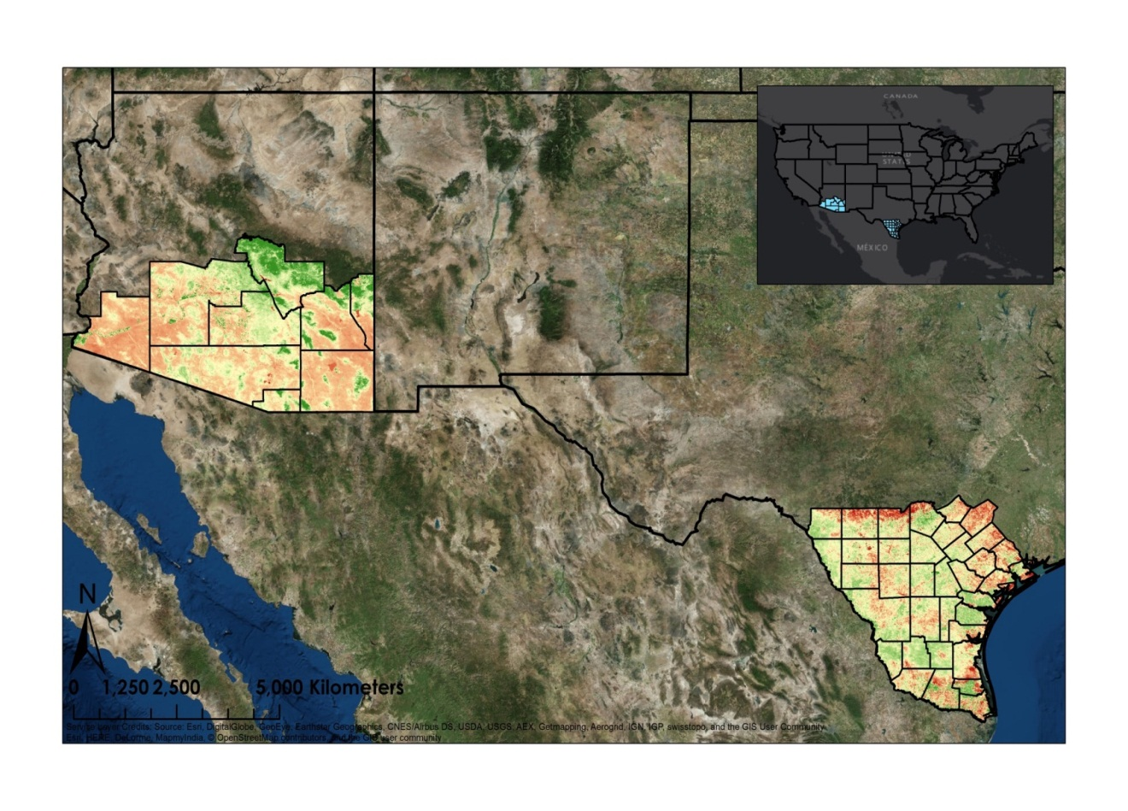

Figure 3: Map of the Study Area showing NDVI values

High: 0.9

Low: -0.8

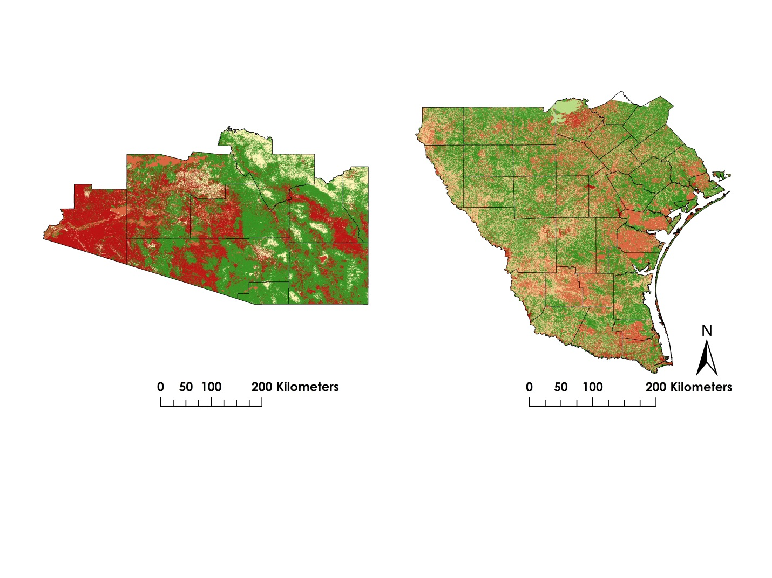

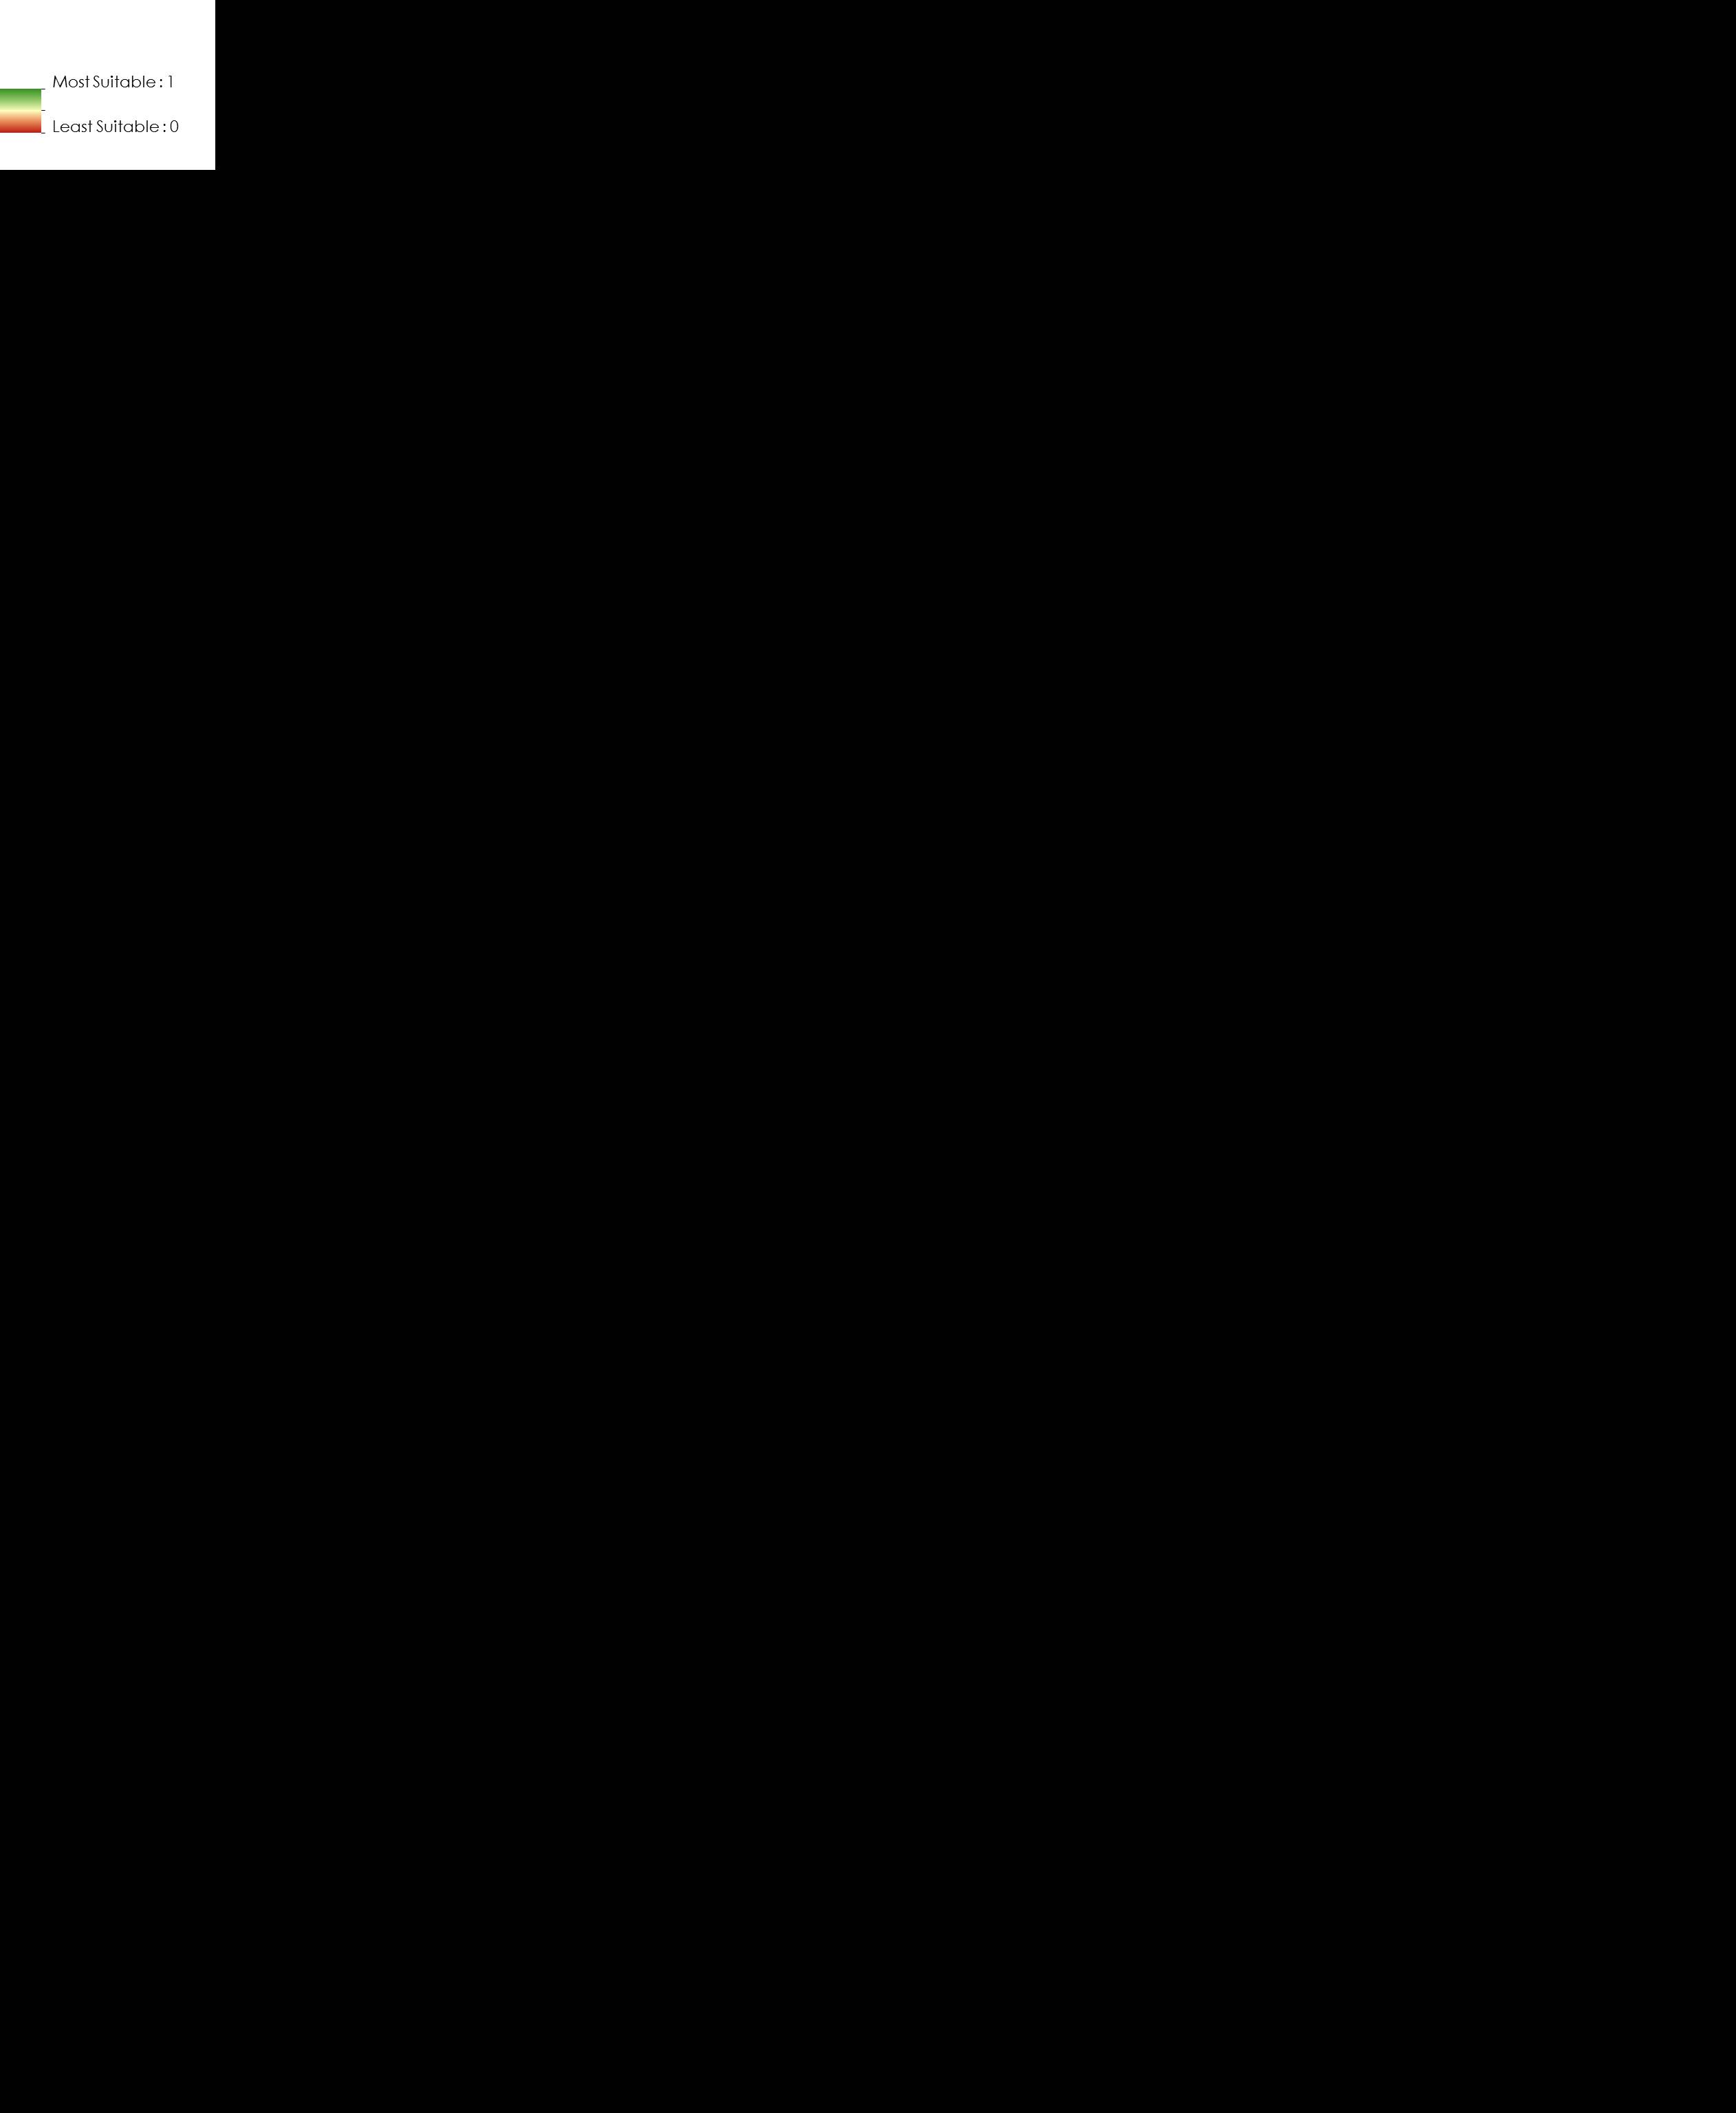

Figure 4: Image of the suitable ocelot habitat in Texas and Arizona in 2014

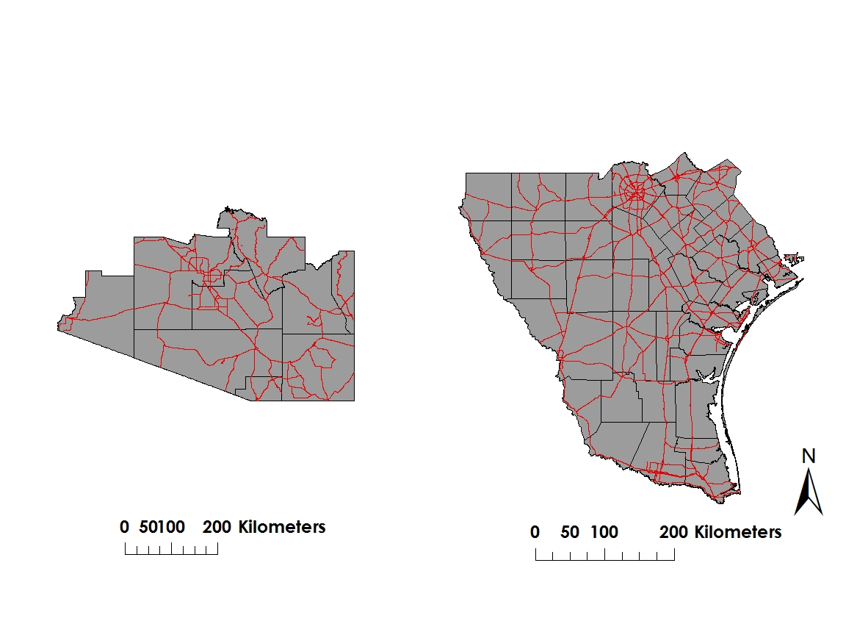

Road Network

Figure 5: Map of the Road Networks in the study regions

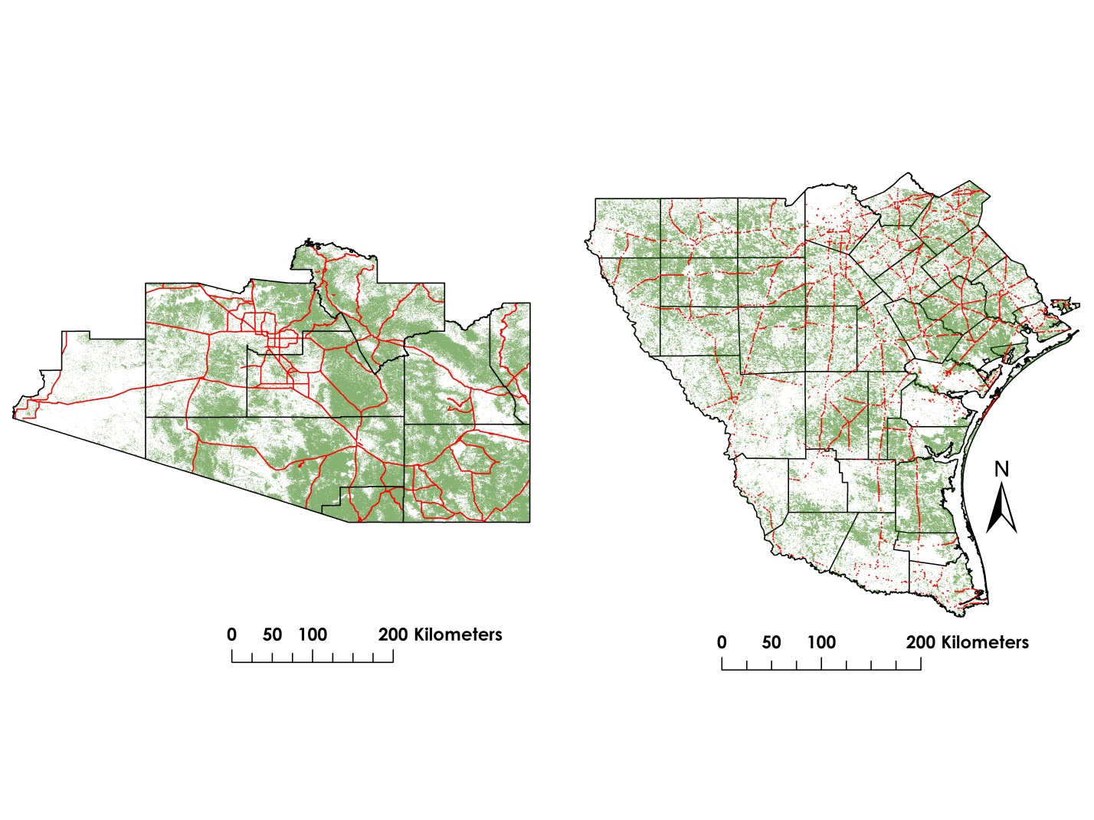

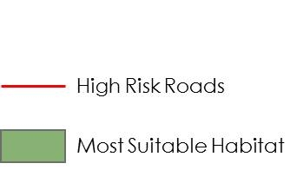

**Figure 6: Proximity risk map of the ocelot habitat for the study area in 2014**

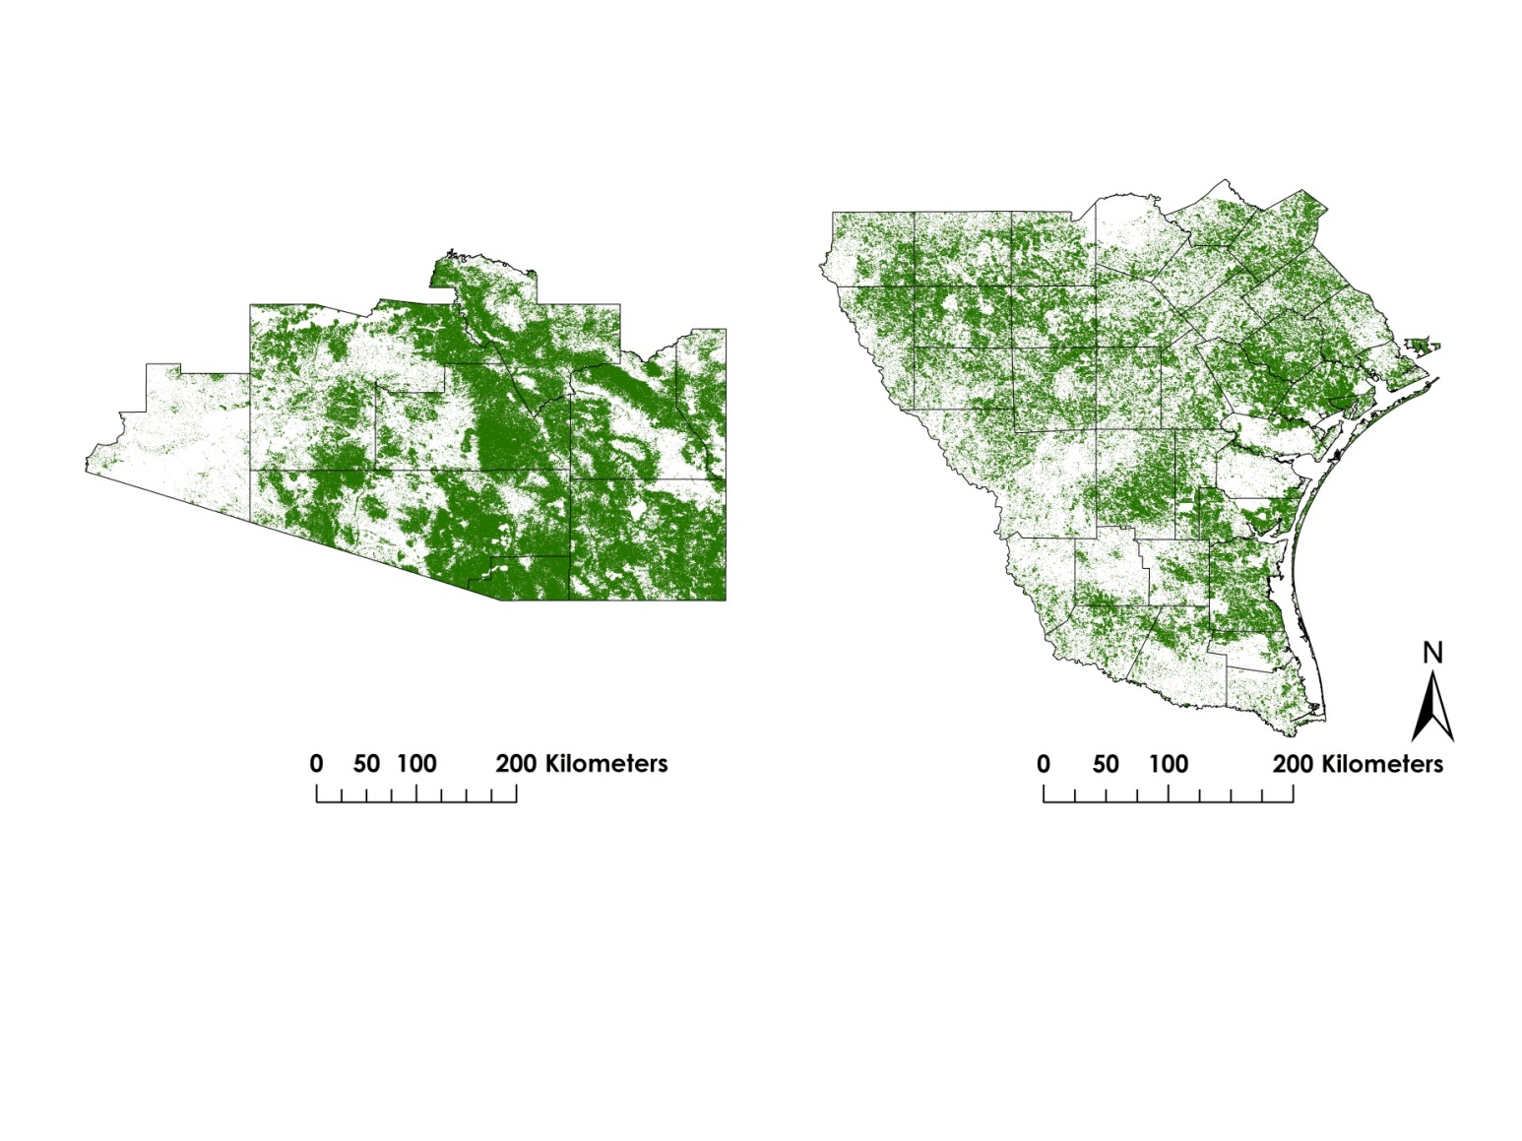



**Figure 7: Map of the suitable habitat percent cover for the study area**

Appendix C

Chart 1: Change in Percentage of Suitable Habitat in Texas and Arizona between 1996 and 2014



Chart 2: Length of High Risk Roads in Texas counties in 2014

Chart 3: Length of High Risk Roads in Arizona counties in 2014