NASA DEVELOP National Program
NASA Ames Research Center
Summer 2015

Gulf of Mexico Water Resources
Utilizing NASA Earth Observations to Detect Factors Contributing to Hypoxic Events in the Southern Gulf of Mexico


Technical Report
Final Draft – August 6, 2015

Rebecca Chapman (Project Lead)
Irma Caraballo Álvarez
Alannah Johansen
Åse Mitchell
Bridget Smith
Mackenzie Taggart

Dr. Juan L. Torres-Pérez, Bay Area Environmental Research Institute, DEVELOP National Program
(Science Advisor)
Dr. Sherry L. Palacios, Bay Area Environmental Research Institute (Science Advisor)
Chase Mueller, Bay Area Environmental Research Institute (Science Advisor)

I. Abstract
This project used NASA’s Earth observations as a viable alternative for studying regions with no in-situ data. This study uncovered trends and dynamic characteristics of chlorophyll-a (Chl) concentration, sea surface temperature (SST), colored dissolved organic matter (CDOM) index, and photosynthetically available radiation (PAR). Inter-annual and seasonal trends of these 8-day standard mapped images (SMI) from the MODIS instrument on the Aqua platform from 2002-2015 were determined using Clark Labs TerrSet Earth Trends Modeler (ETM). Predicted dissolved oxygen images were classified using a Multi-Layer Perceptron (MLP) regression approach with in-situ data from the northern Gulf of Mexico (GoM). Additionally, sediment and nutrient loading values of the Grijalva-Usumacinta watershed were modeled using the ArcGIS Soil and Water Assessment Tool (SWAT). Lastly, a turbidity index (TI) was generated using Landsat 8 Operational Land Imager (OLI) scenes for 2013-2014. Results will assist local environmental and health authorities in revising water quality standards and mitigating the impacts of future harmful algal blooms (HABs) and hypoxic events in the region.

Keywords
Hypoxia, Time Series Analysis, Remote Sensing, Watershed Modeling

II. Introduction
2.1 Background
Coastal occurrences of dead zones, harmful algal blooms (HABs), and hypoxic events have been increasing worldwide since the 1960s (Diaz and Rosenberg, 2008). Excess nutrients in the water result in a rapid proliferation of algae, including several species that produce toxic substances. Subsequent algal death and decomposition ultimately results in hypoxia, which is characterized by dissolved oxygen concentrations that are below the threshold required to support aquatic life. This process occurs naturally and cyclically in coastal waters during upwelling events. However, deforestation, fertilizer runoff, and erosion have all contributed to excess nutrient and sediment loading in coastal zones, thereby increasing the frequencies of dead zone events (Rabalais et al., 2002).

Hypoxic events and HABs have affected millions of people in the southern Gulf of Mexico (GoM) (Diaz and Rosenberg, 2008). These coastal communities rely on healthy ecosystems for food, shelter, drinking water, and other natural resources. Local economies in this region are also heavily dependent on the fisheries industry (Álvarez Torres, P., CIIMAR-GoMC, Personal Communication, 2015). However, increasing frequencies of hypoxic events and HABs have been observed along the coast of the Bay of Campeche, especially surrounding the Grijalva-Usumacinta River Delta (Signoret et al., 2006). These events have resulted in eutrophication, fish kills, human illness, and a decline in water quality (Rabalais et al., 2002). Understandably, this has perpetuated a regional culture in which changes in the color of coastal waters have resulted in a boycott of local seafood. However, a water quality monitoring system is lacking in the region. Therefore, local authorities are currently unable to determine if changes in the water are benign, or if they indicate occurrences of HABs or hypoxic events (Álvarez Torres, personal communication).

The federal government of Mexico has adopted a variety of laws aimed at the protection of surface and coastal water resources (Gutierrez, 2008). Unfortunately, many of the current water quality standards are outdated, and few are enforced (Oswald Spring, 2014). Therefore, a current assessment of the region is needed in order to create adequate environmental protection policies. Recently, a large collaborative effort between governmental and academic organizations has formed to focus resources on monitoring and controlling hypoxic events and HABs (Álvarez Torres & Gold, 2012). Combining these efforts with analyses of NASA Earth observations will be vital in understanding the most important factors contributing to the degradation of water quality in this system due to HABs and hypoxic events.

2.2 Objectives
This project addressed the Water Resources Application area within NASA’s Applied Sciences Program. The main objectives were to use NASA Earth observations to identify indicators of hypoxic events and HABs in the southern GoM, and to understand the impact of nutrient and sediment loading from the Grijalva-Usumacinta River Basin.

Although challenges exist in directly measuring dissolved oxygen using remote sensing techniques, several known indicators of hypoxic events and HABs can be detected or derived from Earth observations. These indicators include chlorophyll-a (Chl), colored dissolved organic matter (CDOM) index, sea surface temperature (SST), photosynthetically-available radiation (PAR), and turbidity index (TI).

We performed four separate analyses in order to achieve our objectives:
- Time series of Chl, SST, CDOM and PAR were constructed for the entire GoM from 2002-15 using TerrSet Earth Trends Modeler (ETM) (Clark Labs, 2015). The time series analysis was performed to uncover anomalies and determine the timing and occurrences of potential indicators of hypoxic events.
- A Multi-Layer Perceptron (MLP) regression analysis was used to classify predicted dissolved oxygen images based on in-situ data from the northern GoM.
- Landsat 8 Operational Land Imager (OLI) remotely sensed imagery was used to perform TI analysis in the southern Bay of Campeche from 2013-14.
- Nutrient and sediment loadings were modeled for the entire Grijalva-Usumacinta Watershed using the ArcGIS Soil and Water Assessment Tool (SWAT) (ESRI, 2015).

2.3 Study Areas
Analyses were performed in three separate study areas: the Grijalva-Usumacinta River Basin, the coastal region along the southern end of the Bay of Campeche, and the GoM as a whole (Appendix A, Figure 1). The Grijalva-Usumacinta River Basin is the second largest freshwater contributor to the GoM and is an important source of drinking water, hydroelectric energy, fisheries, and other natural resources to the 6 million people who live within the region. The coastal waters influenced by the inflow from the Grijalva-Usumacinta River are located in the southern Bay of Campeche, off the coast of Tabasco. The natural resources of this coastal ecosystem support the local communities, as well as the fisheries and tourism industries.

The headwaters for both the Grijalva and Usumacinta Rivers are in Guatemala, however, the majority of the basin falls within the political boundaries of Mexico, with drainage from the states of Tabasco, Chiapas, and Campeche. In the lowlands, the rivers extend into an expanse of marshes, swamps, bogs, and mangroves along the coast and delta. Unfortunately, both rivers have been engineered to reduce flooding, which has resulted in significant degradation of these wetlands. Tropical rain forests historically dominated the basin, however, extensive deforestation has occurred in the region for the purposes of coffee plantations, cattle ranching, and slash-and-burn agriculture. This has resulted in increased erosion and fertilizer runoff into the southern GoM.

2.4 Project Partners
The NASA DEVELOP Mexico Water Resources team at the Ames Research Center partnered with a variety of governmental and academic organizations for this international project. The goal of these partnerships was to add analyses from NASA Earth observations to the recent efforts in water quality assessment and management in the region. This large collaborative effort includes the following organizations: Consorcio de Instituciones de Investigación Marina del Golfo de México y del Caribe (CiiMar-GoMC); Centro del Cambio Global y la Sustentabilidad en el Sureste (CCGSS); Comisión Nacional para el Conocimiento y Uso de la Biodiversidad (CONABIO); Centro Nacional de Datos Oceanográficos (CENDO); Universidad Autónoma de Baja California (UABC); Universidad Juárez Autónoma De Tabasco (UJAT); Secretaría de Marina (SEMAR).

Recently, CiiMar-GoMC, UJAT, CONABIO, UABC, and CCGSS have collaborated to focus resources on implementing in-situ water quality monitoring and management strategies for both hypoxia and HABs in the Bay of Campeche (Álvarez Torres and Gold, 2012). Additionally, the Federal Ministry of Health is conducting surveys to identify and quantify the phytoplankton species that proliferate during HAB events.

III. Methodology
3.1 Earth Trends Modeler (ETM) and Multi-Layer Perceptron (MLP) Analyses
3.1.1 Data Acquisition
Aqua MODIS Standard Mapped Image (SMI) Products: Aboard NASA’s Aqua satellite is the Moderate Resolution Imaging Spectroradiometer (MODIS) instrument, containing 36 spectral bands. SMI L3, 8-day composites for 2002-2014 were downloaded through the Ocean Color database. These data were produced and distributed through NASA Goddard Space Flight Center's Ocean Color Data Processing System (OCDPS) (NASA Goddard OCDPS, 2010). SMI products are byte-valued two-dimensional arrays of an equidistant cylindrical projection of the globe containing scaled real values. These products were used in creating a time series of Chl, SST, PAR, and CDOM Index.

In-situ Data: Bottom depth dissolved oxygen (DO) concentrations were obtained from the NOAA National Centers for Environmental Information Database (NOAA, 2015). These data were collected during 30-day, June-July Southeast Monitoring and Assessment Program (SEAMAP) cruises as part of the NOAA National Marine Fisheries Service Hypoxia Watch Project. Measurements from approximately 240 stations along the Texas-Louisiana coastal continental shelf were obtained per yearly cruise from 2003-2014.

Ancillary Data: Bathymetry data, in the form of a one arc-minute global relief model, were also obtained from the NOAA National Centers for Environmental Information Database (NOAA, 2015).

3.1.2 Data Processing
Satellite Data: MODIS products were processed using TerrSet’s Geospatial Monitoring and Modeling Software. TerrSet Earth Trends Modeler (ETM) was used to analyze Chl, SST, CDOM, and PAR for patterns consistent with algal blooms or hypoxic events.

In-situ Data: In-situ DO data were prepared for MLP analysis by extracting data points from the original shapefiles that fell within the time period for each 8-day MODIS product. Masks from the resultant datasets were then constructed and overlaid into a master mask that only showed pixels that had corresponding valid observations for all of the independent variables (See Section 3.1.3).

3.1.3 Data Analysis
ETM Analyses: Short and long-term global trend analyses and temporal profiling for the GoM were performed for Chl, SST, CDOM, and PAR using Earth Trends Modeler (ETM). First, an image time series was constructed for each parameter. To explore inter-annual trends, the time series data were then de-seasoned and analyzed for anomalies. The resultant outputs gave spatial representations of a Mann-Kendall significance test for monotonic trends, linearity (r²), linear correlation (r), as well as linear, median, and monotonic trends. Linear trends were represented by an ordinary least squares (OLS) slope coefficient (β), median trends were represented by a Thiel-Sen slope coefficient (m), and monotonic trends were represented by a Mann-Kendall test statistic (Z). To better visualize monotonic trends, Mann-Kendall Z-scores were masked at a significance level of p<0.05, which yielded a spatial representation of regions that experienced significant monotonic increases or decreases during our study period.

To look at seasonal trends, each year of data was submitted to a harmonic regression to generate a series of shape parameters, known as amplitudes and phases, which characterize annual and semi-annual cycles. In the second stage of this analysis, a Thiel-Sen median trend analysis was performed on the shape parameters for all years in the time series in order to decrease noise and variability in the results (Eastman, 2015).

MLP Analysis: A non-parametric regression analysis was performed using TerrSet’s Multi-Layer Perceptron (MLP) module. MLP is a neural network model that uses a back-propagation learning algorithm to convert remotely sensed input images into a desired classification map. For our MLP regression analysis, we used bathymetry, Chl, CDOM Index, PAR, and SST as independent variables and in-situ dissolved oxygen from the northern GoM as our dependent variable. This allowed the MLP classifier to map the input to the output using known data, and then produce outputs in regions with no known values (Eastman, 2015). Using this method, we were able to take limited in-situ coverage and predict DO concentrations for the entire GoM.

3.2 Turbidity Index (TI)
3.2.1 Data Acquisition
Landsat 8 Surface Reflectance (SR) Products: Landsat 8 scenes were also acquired, processed, and analyzed for this project. SR climate data records (CDRs) were obtained and accessed through the USGS Earth Explorer database. CDR data from the OLI sensor were generated using the L8SR algorithm to atmospherically correct images online (USGS, 2015). Landsat 8 has eight 30-meter resolution spectral bands and one 15-meter resolution panchromatic band. These data were used for analyzing years 2013 - 2014 to derive the TI for the southern coast of the Bay of Campeche. Additional Landsat 8 tiles were downloaded in the Northern areas of the GoM for the year 2014 in order to analyze how well in-situ buoy data readings compare with the indices applied to the raster datasets. Bands 2, 3, 4, 5, and 6 were used to derive the TI and the visual composites.

In-situ Data: Turbidity In-situ data were needed to validate TI results, which were acquired through the GoM Coastal Ocean Observing System (GCOOS) data portal.

3.2.2 Data Processing
Satellite Data: Landsat 8 scenes were processed using an ArcPy reflectance to index script in order to produce TI. TI was developed by Güttler et al. (2013) as a method to isolate turbidity from all other spectral signatures (Appendix B, Figure 2). Only scenes with very minimal cloud cover were used for this project, which significantly reduced the range of dates available for analysis.

Scientific advisors from the Bay Area Environmental Research Institute (BAERI) provided the script to automate the TI. Within the script, TI requires a customized setting for the minimum and maximum target land pixels. There is a default setting to choose from, but for more accurate results in the study region, the invariants were chosen by hand. This was done by selecting and averaging multiple satellite image target pixel values of where the brightest and darkest land pixels were within a 3 x 3 grid. These values were set to 0.1752 maximum and 0.0289 minimum.

In-Situ Data: To prepare in-situ data for TI analysis, turbidity in-situ data values and coordinates were transformed into point shapefiles for point to pixel comparison in ArcMap. Turbidity buoy data were recorded at ten locations in Nephelometric Turbidity Units (NTU).

3.2.3 Data Analysis
After the TI was applied to the raster datasets, index values were assigned to each pixel and analyzed further. Validation of the indices was performed in the northern GoM by correlating in-situ data with index values in ArcMap and MS Excel.

3.3 Soil and Water Assessment Tool (SWAT)
3.3.1 Data Acquisition
Ancillary Data: Weather data, land cover maps, soil maps, and Digital Elevation Models (DEMs) were acquired to run SWAT. A river shapefile displaying the main drainages in the watershed were obtained from the Natural Earth database. Weather data utilized for this study were obtained from Texas A&M University. These data included temperature, precipitation, wind speed, relative humidity, and solar radiation. Land cover rasters were obtained from the Climate Data Record (CDR). Soil rasters for North America were obtained from the United Nations University – Institute for Water, Environment, and Health (UNU-INWEH) database (UNU-INWEH, 2015).

Satellite Data: Digital Elevation Models (DEM) were obtained from the USGS Earth Explorer database. ASTER GLOBAL DEMs provided 27 detailed tiles needed for this analysis.

3.3.2 Data Processing
Ancillary Data: Weather data were downloaded pre-formatted for SWAT. No processing or conditioning was necessary for these data. The land cover and soil rasters were projected to North American Lambert Conformal Conic Projection in ArcGIS. Soils raster data were lacking an attribute table, so one was created within ArcGIS. The corresponding soil dataset was then matched to the soils raster. Within the land cover raster, the dominant land cover for the study area was Tropical Rainforest. No representative land use category exists within the SWAT database for Tropical Rainforest, so it was necessary to create a new land use class to accurately represent the conditions for a Tropical Rainforest. This was completed by editing SWAT land use inputs through the SWAT toolbar and by adding a table to the SWAT database that contained necessary information about the new Tropical Rainforest land use class. Parameter values for this land use class were followed from Strauch and Volk (2013) who calibrated the SWAT model to better reflect the hydrology of a tropical rainforest ecosystem.

Satellite Data: ASTER GLOBAL DEMs were mosaicked within ArcGIS to create the final DEM used during the watershed delineation portion of SWAT.

3.3.3 Data Analysis
ArcSWAT is a hydrologic modeler developed by ESRI that was used in this project to analyze stream, soil, slope, weather and land use data in the Grijalva-Usumacinta River Basin. ArcMap was utilized for analyzing ancillary and satellite data using the SWAT tool. The conditioned soils and land cover rasters were reclassified after being added into SWAT in order to increase output accuracy. Data outputs can be gathered on a daily, monthly or yearly basis; however, due to the lack of in-situ data, validation of the model was not possible, and a simple analysis of the SWAT numerical outputs was conducted. Averages of sediment and nutrient outputs were graphed for each month of a year as a means of displaying potential analysis options project partners could pursue.

IV. Results & Discussion
4.1 Analysis of Results
Inter-Annual Trend Analysis
CDOM Index: A weakly negative trend between CDOM pixel values over time and a perfectly linear series was seen in the coastal GoM regions that are known to have seasonally persistent HABs and hypoxic events. These regions extend west from the Mississippi River Delta to the southern coast of Texas, west from the Grijalva-Usumacinta River Delta to the coast of Veracruz, along the northern coast of the Yucatan Peninsula, and along the coast of Florida. The Pearson correlation coefficient (r) values in these regions ranged from -0.08 to -0.17 (Appendix C, Figure 3). These results indicated a slightly negative linear trend in the CDOM:Chl ratio over time, which would suggest either decreasing levels of CDOM or increasing levels of chlorophyll a in these regions. A weakly negative linear trend (OLS) was also seen in these regions as evidenced by CDOM index values decreasing at a rate of between 0.0008 and 0.002 every 8 days. Since a relatively long time series was analyzed, a similar pattern was seen between both the OLS and Thiel-Sen median trends, with median slope values (m) also ranging from -0.002 to -0.0008. A Mann- Kendall test for monotonic trends showed a significantly low probability that the negative CDOM:Chl trends seen in the regions west of each river delta were due to chance (p<0.05) (Appendix C, Figure 4).

Chl: A slightly positive linear trend over time was seen for Chl values in the immediate eastern vicinities of both the Mississippi River Delta (0.08<r<0.2, 0.001<β<0.013 mg∙m⁻³/8 days, 0.0001<m<0.0084 mg∙m⁻³/8 days) and the Grijalva-Usumacinta River Delta (0.07<r<0.3, 0.001<β<0.003 mg∙m⁻³/8 days, 0.0006<m<0.002 mg∙m⁻³/8 days), as well as the region surrounding the Florida Keys (0.02<r<0.47, 0.03<β<0.09 mg∙m⁻³/8 days, 0.003<m<0.009 mg∙m⁻³/8 days) (Appendix C, Figure 5). The Mann Kendall Test for Monotonic Trends showed significantly low probabilities that the increasing Chl values over time in the immediate vicinities of either river delta were due to chance (p<0.05) (Appendix C, Figure 6).

SST: A weakly negative linear trend was seen for SST in the southwestern region of the GoM along the coasts of Veracruz, Tabasco, and southern Texas (-0.2<r<-0.1) (Appendix C, Figure 7). Although this was also reflected by a slightly negative OLS slope (-0.03<β<-0.01 °C/8 days) and Thiel-Sen median slope (-0.002<m<-0.0009 °C/8 days) in this region, the linear regression line showed a poor fit (r²<0.04). By contrast, the Mann-Kendall test showed a significantly low probability that the trend of decreasing SST values in this western GoM region were due to chance. This test also uncovered a trend of significantly increasing SST values off the southwestern coast of Florida (p<0.05) (Appendix C, Figure 8).

PAR: Similarities between the inter-annual trends of PAR and SST were evidenced by a spatially similar negative linear and median trend pattern for both variables in the southwestern GoM (PAR: -0.16<r<-0.05, -0.005<β<-0.001 E∙m⁻²∙d⁻¹/8 days, -0.004<m<-0.001 E∙m⁻²∙d⁻¹/8 days) (Appendix C, Figure 9). Additionally, the Mann-Kendall test showed a significantly low probability that the trend of decreasing PAR values in this southwestern GoM region were due to chance (p<0.05) (Appendix C, Figure 10). The decrease in PAR and SST seen in these regions could possibly have been due to hurricanes or dust storms that occurred during our study period.

Seasonal Trend Analysis
Amplitude and phase color composite maps compiling trends in mean annual values (Amplitude 0), annual cycles (Amplitude 1, Phase 1), and semi-annual cycles (Amplitude 2, Phase 2) were generated for each variable. With the exception of grey, all similar colors give a spatial representation of the regions that exhibit a similar type of seasonal trend. Fitted seasonal curves were produced from the amplitude and phase color composite maps for each variable by compiling all pixel values in the southern Bay of Campeche. These curves allowed for visualization of the generalized seasonal patterns of the region, as well as the temporal changes in these patterns between the start (green curve) and end (red curve) of the time series. Dates corresponding to the maximum rate of increase (green up) and maximum rate of decrease (green down) for each parameter were also generated from the fitted seasonal curves.

CDOM Index: The fitted seasonal curves for CDOM index in the southern Bay of Campeche are represented by a bimodal distribution (Appendix C, Figure 13). At the start of the time series, the distribution shows a global seasonal maximum in late-January, minimum in mid-May, as well as a local maximum in mid-August and min in early-October. At the end of the time series, the distribution exhibits an approximate 2-week phase lag with a global seasonal maximum in mid-February, minimum in early-June, as well as a local maximum in late-August and min in late-October (Appendix C, Figure 13).

The consistent 2-week phase lag from beginning of series to end of series indicates a shift of seasonality for CDOM index values with the bimodal pattern occurring later in the year than previously seen. Higher CDOM index values indicate higher dissolved organic matter concentrations and/or lower concentrations of chlorophyll a. Conversely, lower CDOM index values indicate lower dissolved organic matter concentrations and/or higher chlorophyll a concentrations. The fitted seasonal curves show that from 2003-2014, the maximum CDOM index values have shifted later in the winter season, from late-January to mid-February, and the minimum values have shifted later in the spring-summer season, from mid-May to early-June. Additionally, the date of maximum rate of increase shifted forward 31.6 days, from Nov 6 to Dec 8, and the date of the maximum rate of decrease shifted forward 17.9 days, from Mar 29 to April 16 (Appendix C, Figure 13).

Chl: Much variation exists in the seasonal trends along the GoM coastlines based on the amplitude color composite map of Chl. The fitted seasonal curves for Chl in the southern Bay of Campeche follow a bimodal distribution. The curves representing the start and end of the time series both show a global maximum Chl concentration in December to January and minimum in mid-April, as well as a local maximum in early-July and min in late-August to early-September. No clear phase lag is evident between the start and end of the time series. However, the date of maximum rate of increase shifted forward 8.8 days, from Sept 30 to Oct 9, and the date of the maximum rate of decrease shifted forward 4.6 days, from Feb 19 to Feb 23 (Appendix C, Figure 16).

A lagged relationship is evident between the seasonal curves for Chl and CDOM Index. Both follow a similar bimodal distribution with an approximate 2 month phase lag between Chl and CDOM. This result is expected since Chl is an indicator of live phytoplankton, and CDOM is an indicator of complete decomposition of these organisms.

PAR: The fitted seasonal curves for PAR follow a unimodal distribution. Both curves showed that seasonally high PAR values were maintained from May to August, and minimums occurred in December to January. No phase shift was observed between the curves, however, consistently lower amplitudes were seen for the curve representing the second half of the time series (Appendix C, Figure 19).

Global patterns of PAR are generally dependent on latitude with the highest values closest to the equator and decreasing values toward each pole. In the GoM, PAR values are grossly consistent with those of the same latitude during summer months, however, a seasonal pattern of lower than expected PAR values emerges in the southwestern GOM during the winter months.

SST: The seasonal curves for SST followed a unimodal distribution that was similar to PAR with seasonally high temperatures being maintained from June to October, and seasonal minimums occurring in late-January to early-February (Appendix C, Figure 22).

Multilayer Perceptron Analysis
Pixels with DO concentration values were randomly divided between training and testing. The purpose of training is to get the proper weights for the neuron connections between the input and hidden layers, and between the hidden and output layers for the classification of unknown pixels. We found an r² as high as 0.7814 for our MLP models (Appendix C, Figure 23), with Chl being the most influential variable on the model. This was determined by forcing independent variables to be constant.

For the MLP classification, we defined our study areas as regions that contain valid observations for all independent variables. We also chose to mask out regions further than 200 km from shore. Output maps of predicted dissolved oxygen concentrations were produced for each 8-day time period corresponding to our MODIS images (Appendix C, Figure 24). Our results allow users to see historical and current proximities and extent of hypoxia. With these maps, we can better understand the distribution and timing of hypoxic events for mitigation efforts.

Landsat 8 vs. In-situ Data (TI Results Analysis)
Graphing Landsat 8 index values to in-situ turbidity data from the north resulted in an r² value of 0.33 (Appendix C, Figure 26). After having verified a moderate correlation between satellite imagery and in-situ turbidity data, the index was determined to be an appropriate indicator and tool to study turbid waters within the GoM. Upon further analysis of the northern GoM Landsat 8 tiles, the index was observed to perform best with increased proximity to river mouths and near-shore environments. In these regions, index values showed higher correlations with in-situ turbidity data. However, with further distance from coastal environments, index values began to decrease substantially. This may be a result of the fact that clusters of sediment particles become more dispersed by ocean and wind currents as they are carried farther away from their original sources. As a result, it was determined that the turbidity index works best in shallow coastal waters where satellite sensors can more accurately detect floating sediment particles in those areas.

After confirming strong index performance in the North, application of the TI on the Southern tiles of the GoM allowed for additional analysis of plume patterns and environmental trends in the southern coast of the Bay of Campeche (Appendix C, Figure 25). Plumes were observed to follow both ocean and wind currents in the GoM flowing towards the North East. No two plumes are alike however, as plume patterns varied in size based upon the seasons. Larger plumes formed during the wetter spring and summer seasons with July 27th, 2013 being the largest plume extent observed that originated from the Grijalva-Usumacinta river mouth. On this particular day, the plume was calculated to extend approximately 87 km NE into the Bay of Campeche with an approximate plume width of 10 km near the river mouth that decreased to an approximate width of 2 km at the plume’s farthest reach (Appendix C, Figure 27). During the drier winter seasons, plume extents and sizes were much smaller, averaging approximately 40 km in lengths, with widths approximately 5 km nearshore to 1 km offshore. Plume sizes also correlated well with SWAT total sediment outputs, as trends of larger plumes coincided with high sediment discharge data on those same dates. This correlation was similarly observed with smaller plumes and lower sediment discharge rates outputted from SWAT data.

SWAT Analysis & Results
Due to limitations such as lack of available in-situ data needed for validation of the model, the SWAT outputs are untested and are therefore unreliable as a means for analysis. However, the model still serves as a valuable resource for our project partners as a platform for continued improvement and development of the SWAT model. To complement the completed SWAT run, a manual was created to assist our project partners in running the model and improving it through calibration and validation when up-to-date data become available. The SWAT user manual provides information detailing processes including downloading data, conditioning data, running the SWAT model, and common troubleshooting solutions.

4.2 Limitations
While executing this project, certain limitations arose within our methodological approach due to the nature of the models incorporated, as well as limited in-situ data and the spatial resolution of the Earth observations utilized. For the ETM and MLP analyses, the algorithm used to derive level III SMI MODIS products was designed for case 1 open ocean waters. Therefore, additional uncertainty exists within case 2 waters that are influenced by the river basin (Moore et al., 2009). The TI analysis was limited by a lack of coverage of the southern GoM by Landsat 4 and 5. Also, cloud cover limited the amount of usable Landsat 8 images. Use of the SWAT model is limited in a global context since the model was developed for agricultural systems in the continental United States. Therefore, land use and soil classifications for other regions need to be input and formatted manually.

4.3 Errors & Uncertainty
TI validation would have been much stronger if in-situ data were available in the southern GoM. Since we were not able to assess the index for our study region, it is advised that this index be treated as a preliminary approach to assessing the turbidity in the Bay of Campeche. Due to the lack of available in-situ data, the SWAT model was unable to be validated. Furthermore, calibration of the model with discharge data was not possible, resulting in untested numerical outputs for analyses such as sediment loading and water movement throughout the watershed. The SWAT outputs are only as accurate at the data inputs; therefore, as more relevant data becomes available, these uncertainties could be ameliorated.

4.4 Future Work
Products created from this project will continue to help assist further water quality research in the Southern GoM for partners and end users. The approach and methods used to assess the water quality and indicators of hypoxic events in the GoM can be modeled similarly to create additional geo-narrative research for other areas around the world that are also threatened by issues of poor water quality.

V. Conclusions
Supplementing environmental monitoring efforts with analyses of Earth observations is especially important in regions where little in-situ data exists. Project results show that remote water quality monitoring is possible in the southern GoM. However, acquisition of in-situ data is necessary to improve the accuracy of our results. The ETM and MLP analyses can be used to forecast the timing and occurrences of hypoxic events and HABs. However, identifying species-specific blooms remains a challenge in remote sensing and may be mitigated by the availability of hyperspectral missions. Application of indices, such as the turbidity index, to satellite imagery can allow decision makers and specialists to analyze and assess water quality for large bodies of waters such as the GoM. Although the TI should be taken cautiously, it does display potential use within water quality research and application to assist in monitoring water resources. Once higher quality inputs and in-situ data become available, the SWAT model could serve as a valuable decision support tool to influence water quality regulations. The analyses and models performed in this project serve as a starting point that will aid project partners once data become freely available. Each of the analyses has the potential to benefit the larger community by helping to reduce the harmful health and economic effects of hypoxic events and HABs.

VI. Acknowledgments
Special thanks to Chase Mueller from the Bay Area Environmental Research Institute for assistance with the project and creation of the ArcPy Reflectance to Index script. The authors also wish to thank the Ames DEVELOP management team for their overall support and help with this project.

This material is based upon work supported by NASA through contract NNL11AA00B and cooperative agreement NNX14AB60A.

VII. References
Álvarez Torres, P. and G. Gold. (2012). Monitoring in the Gulf of Mexico Large Marine Ecosystem: Hypoxia, HABIOS, and Monitoring Pilot Project. Gulf of Mexico Alliance, All Hands Meeting. Corpus Christi, TX, 19 June 2012.

Clark Labs. (2015). [Online]. Available at http://www.clarklabs.org/index.cfm. (Accessed 29th June, 2015). Clark University, Worcester, MA.

Diaz, R. and R. Rosenberg. (2008). Spreading Dead Zones and Consequences for Marine Ecosystems. Science 321: 926-929.

Earth Explorer. Sioux Falls, SD. USGS Earth Resources Observation and Science (EROS) Center. 2011. Available at: http://earthexplorer.usgs.gov/

Eastman, J.R. (2015). TerrSet Manual. Clark University: Clark Labs, Worcester, MA.

Eastman, J.R., Sangermano, F., Ghimire, B., Zhu, H., Chen, H., Neeti, N., Machado, E.A., and Crema, S.C. 2009. Seasonal Trend Analysis of Image Series. International Journal of Remote Sensing 30(10): 2721-2726.

Enriquez, S. and M. Laird. Integrated Climate Change Adaptation, Land Use and Watershed Management Plan for the Grijalva-Usumacinta River Basin. Abt Associates Research Firm. abtassociates.com.

ArcGIS Resources: SWAT: Soil and Water Assessment Tool. (2015). [Online]. Available at http://blogs.esri.com/esri/arcgis/2012/03/14/swat-soil-water-assessment-tool. (Accessed 29th June, 2015). ESRI, Redlands, CA.

Gutierrez, C. (2008). Standards and Thresholds for Wastewater Discharges in Mexico. In M. Schmidt, J. Glasson, L. Emmelin, and H. Helbron (Eds.), Standards and Thresholds for Impact Assessment (pp. 113–124). Berlin: Springer Verlag.

Güttler et al. (2013). Turbidity Retrieval and Monitoring of Danube Delta Waters Using Multi-Sensor Optical Remote Sensing Data: An integrated View From the Delta Plain Lakes to the Western-Northwestern Black Sea Coastal Zone. Remote Sensing of Environment. 132: 86-101.

Moore, T. S., Campbell, J. W., and M. D. Dowell. (2009). A Class based approach to characterizing and mapping the uncertainty of the MODIS ocean Chlorophyll Product. Remote Sensing of Environment. 113: 2424-2430.

Morel, A. and B. Gentilli. (2009). A simple band ratio technique to quantify the colored dissolved and detrital organic material from ocean color remotely sensed data. Remote Sensing of Environment 113: 998–1011.

NASA Goddard Space Flight Center Ocean Color Data Processing System (OCDPS). Ocean Color Level-3 Standard Mapped Image Products. 2010. [Online]. Available at http://oceancolor.gsfc.nasa.gov/DOCS/Ocean_Color_Level-3_SMI_Products.pdf (accessed 17th June, 2015). Goddard Space Flight Center, Greenbelt, MD.

Neeti, N., J.R. Eastman. Novel Approaches in Extended Principal Component Analysis to Compare Spatio-Temporal Patterns Among Multiple Image Time Series. Remote Sensing of Environment. (2014): 148 (84-96).

NOAA National Centers for Environmental Information (NCEI). Hypoxia Watch: Latest Bottom Dissolved Oxygen Maps and Data. 2015. [Online]. Available at http://www.ncddc.noaa.gov/hypoxia/products/ (accessed 15th June, 2015). US Department of Commerce - NOAA, Washington DC.

Oswald Spring, U. (2014). Water security and national water law in Mexico. Earth Perspectives 1:7.

Rabalais, N. N., Turner, R. E., and D. Scavia. (2002). Beyond Science into Policy: Gulf of Mexico Hypoxia and the Mississippi River. BioScience 52(2): 129-142.

Signoret, M., Monreal-Gomex, M. A., Aldeco, J. and D.A. Salas-de-Leon. (2006). Hydrography, Oxygen Saturation, Suspended Particulate Matter, and Chlorophyll-a fluorescence in an Oceanic Region Under Freshwater Influence. Estuarine, Coastal, and Shelf Science 69: 153-164

Strauch, M. and M. Volk. (2013). SWAT Plant Growth Modification for Improved Modeling of Perennial Vegetation in the Tropics. Ecological Modeling 269: 98-112.

Stumpf, R. P., Tomlinson, M. P., Calkins J. A., Kirkpatrick, B., Fisher, K., Nierenberg K., Currier, R., and T. T. Wynne. (2009). Skill assessment for an operational algal bloom forecast system. Journal of Marine Systems 76: 151-161.

United States Geological Survey. Landsat Surface Reflectance High Level Data Products. 2015. [Online]. Available at http://landsat.usgs.gov/CDR_LSR.php (accessed 17th June 2015). US Department of the Interior-USGS, Washington, DC.

United Nations University- UNU-INWEH. (2015). Shibuya-Ku, Tokyo. Available at: http://waterbase.org/.

Yáñez-Arancibia, A., Day, J.W., and E. Reyes. (2013). Understanding the Coastal Ecosystem-Based Approach in the Gulf of Mexico. Journal of Coastal Research 63: 244-262.

VIII. Content Innovation
Audio Slides: Earthzine Virtual Poster Session (VPS): Haunting the Gulf: Dead Zones Linger in Shallow Waters

Glossary Viewer: Creation of a glossary application of all the terms, methods, and abbreviations used in this project to allow for an effortless and enjoyable reading experience.

IV. Appendices
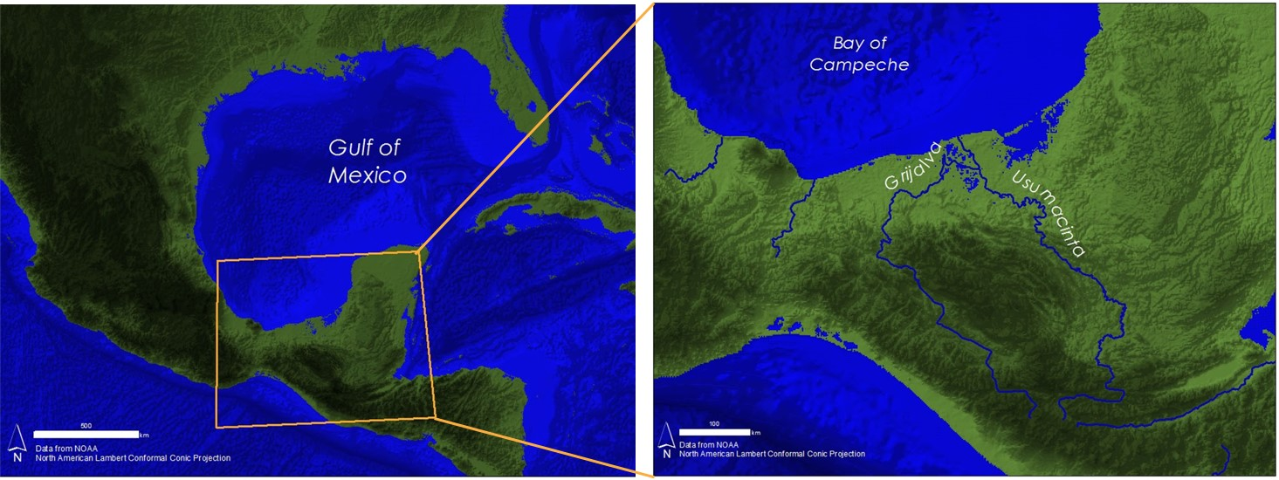
Appendix A. Study Areas

Figure 1: Study areas showing the entire GoM, the Bay of Campeche, and the Grijalva-Usumacinta River Basin

Appendix B. Index Algorithm
$$\frac{(R_{Red}-R_{Reference min})}{(R_{Reference max}-R_{Reference min})}$$

Figure 2. Turbidity Index (TI) developed by Güttler et al. (2013).

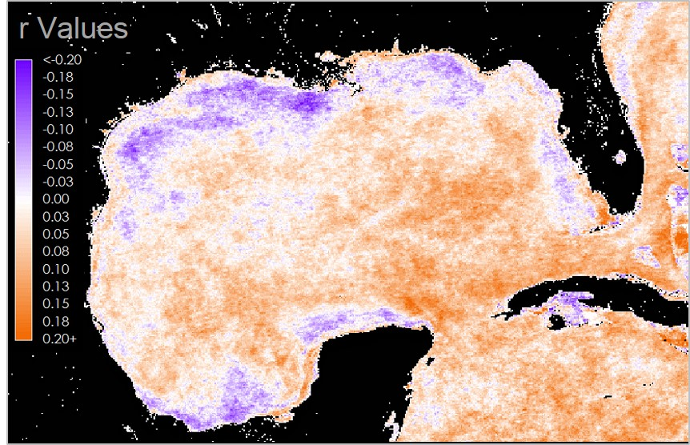
Appendix C. Tables & Graphs

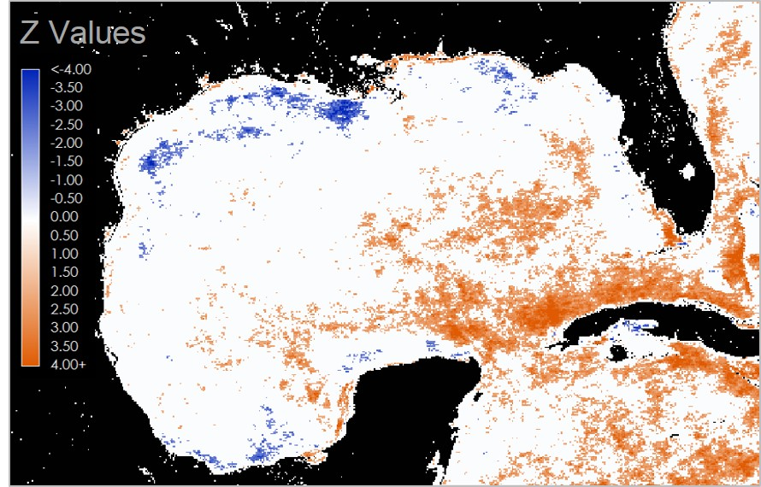

Figures 3 & 4: Terrset Earth Trends Modeler (ETM) outputs showing inter-annual trends for CDOM Index. Top: Linear correlation map (Orange = positive, purple = negative). Bottom: Monotonic trends map evaluated at a 0.05 significance level. (Orange = significantly increasing, blue = significantly decreasing).

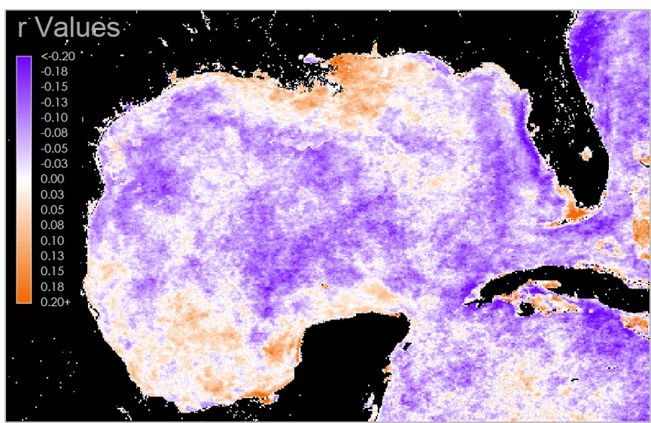

Figures 5 & 6: Terrset Earth Trends Modeler (ETM) outputs showing inter-annual trends for Chl. Top: Linear correlation map (Orange = positive, purple = negative). Bottom: Monotonic trends map evaluated at a 0.05 significance level. (Orange = significantly increasing, blue = significantly decreasing).

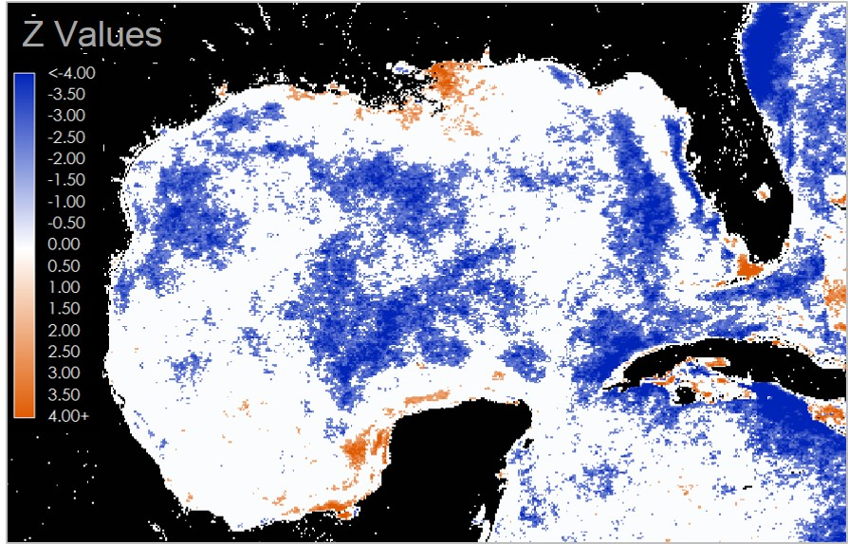

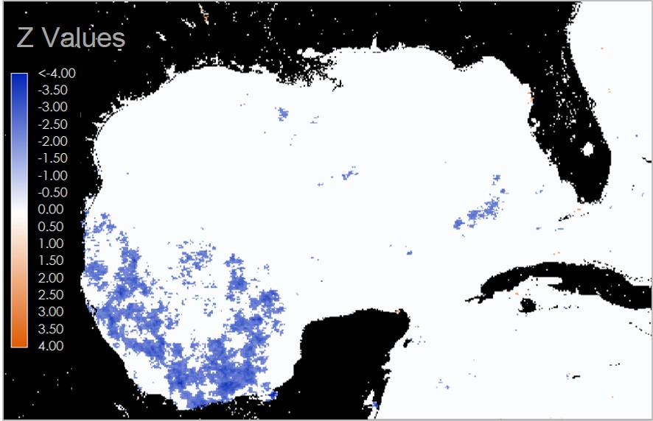
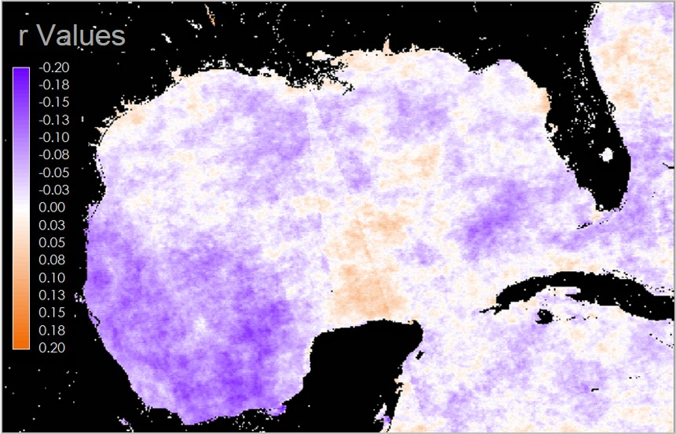
Figures 7 & 8: Terrset Earth Trends Modeler (ETM) outputs showing inter-annual trends for PAR. Top: Linear correlation map (Orange = positive, purple = negative). Bottom: Monotonic trends map evaluated at a 0.05 significance level. (Orange = significantly increasing, blue = significantly decreasing).

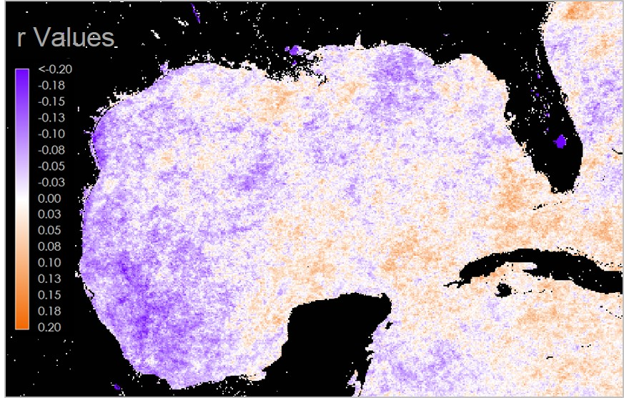

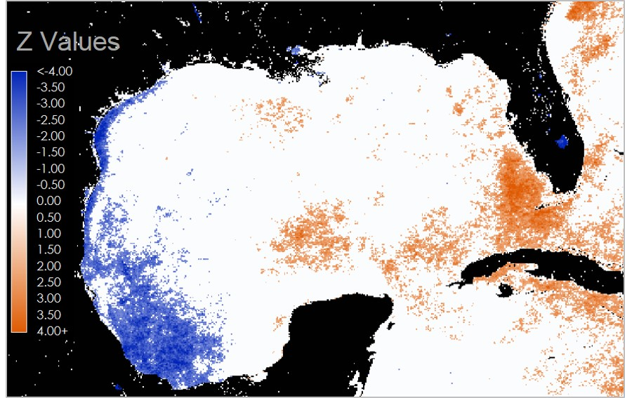

Figures 9 & 10: Terrset Earth Trends Modeler (ETM) outputs showing inter-annual trends for SST. Top: Linear correlation map (Orange = positive, purple = negative). Bottom: Monotonic trends map evaluated at a 0.05 significance level. (Orange = significantly increasing, blue = significantly decreasing).

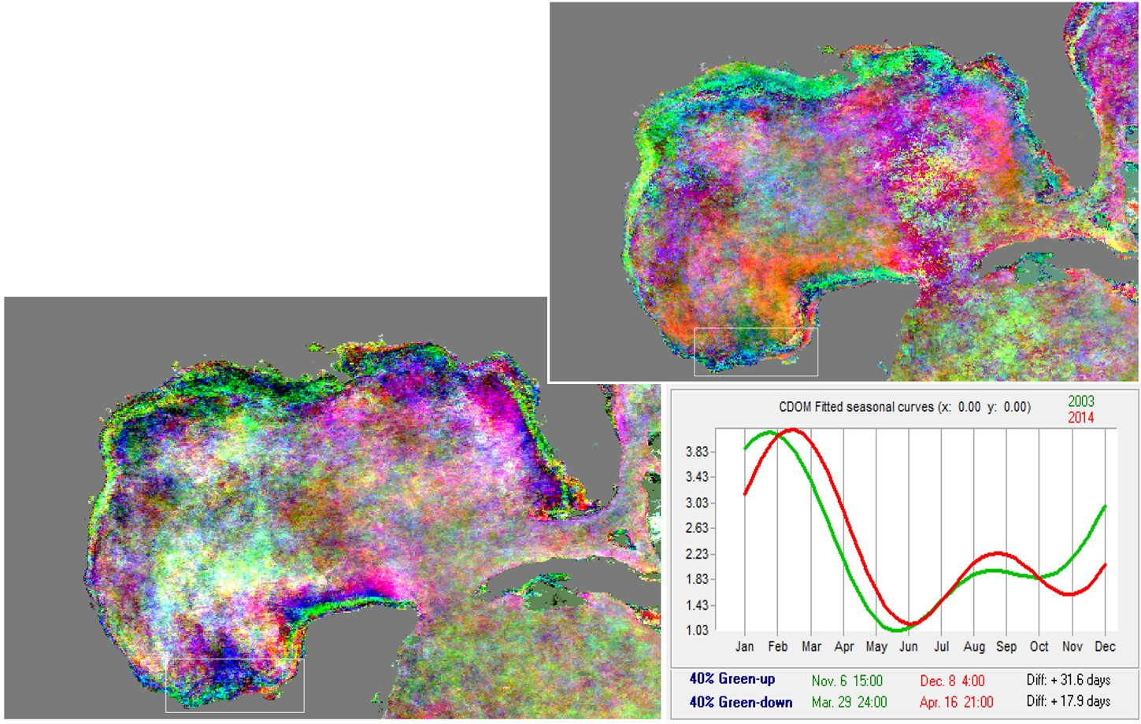
Figures 11, 12 & 13: Color composite maps of phases (top) and amplitudes (bottom) derived from a seasonal trend analysis of CODM Index. Fitted seasonal curves were generated from the amplitude map for the southern coast of the Bay of Campeche. Green curves represent the first 6 years and red curves represent the last 6 years of each time series. Green-up and green-down refer to the dates corresponding to the maximum rates of increase and decrease, respectively.

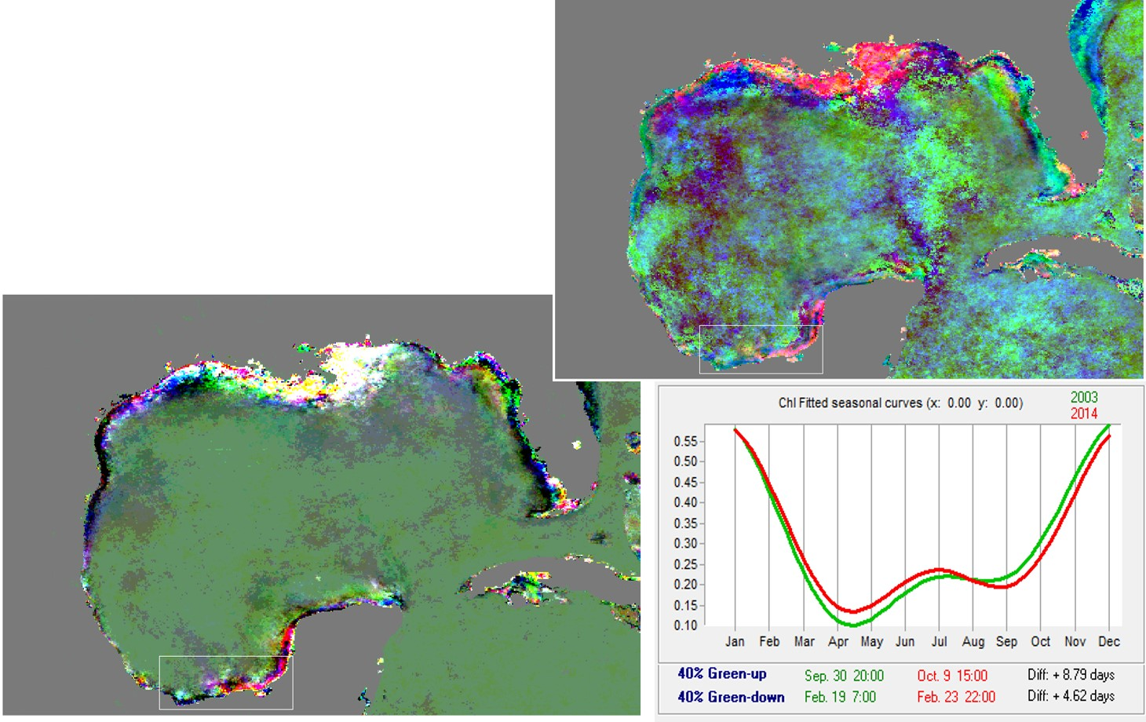
Figures 14, 15 & 16: Color composite maps of phases (top) and amplitudes (bottom) derived from a seasonal trend analysis of Chl. Fitted seasonal curves were generated from the amplitude map for the southern coast of the Bay of Campeche. Green curves represent the first 6 years and red curves represent the last 6 years of each time series. Green-up and green-down refer to the dates corresponding to the maximum rates of increase and decrease, respectively.

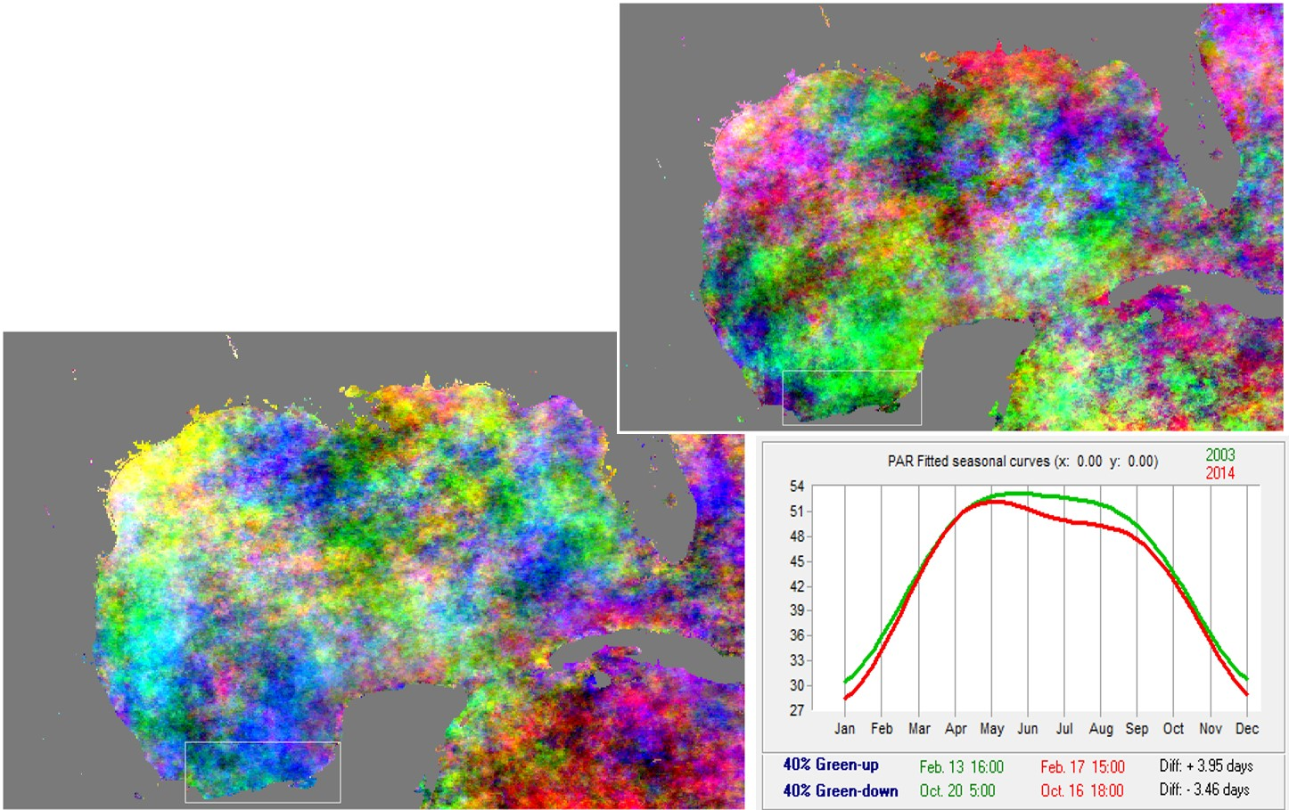
Figures 17, 18 & 19: Color composite maps of phases (top) and amplitudes (bottom) derived from a seasonal trend analysis of PAR. Fitted seasonal curves were generated from the amplitude map for the southern coast of the Bay of Campeche. Green curves represent the first 6 years and red curves represent the last 6 years of each time series. Green-up and green-down refer to the dates corresponding to the maximum rates of increase and decrease, respectively.

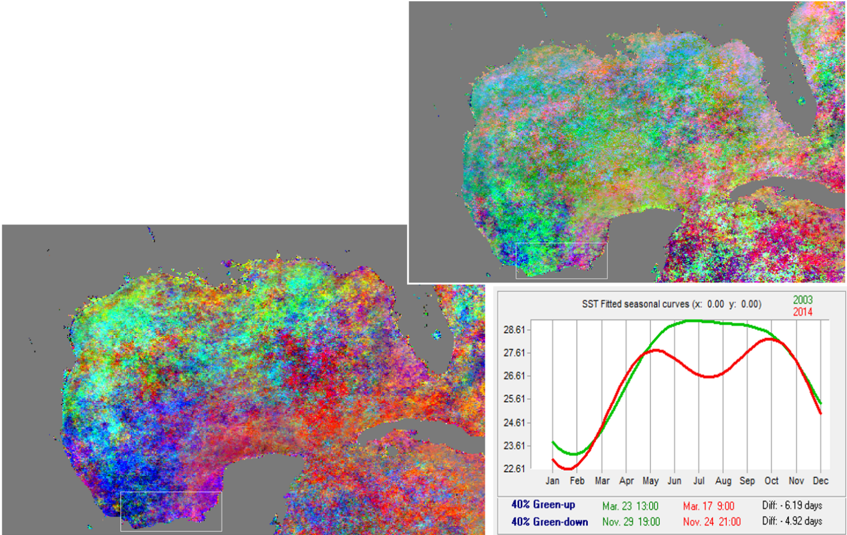

Figures 20, 21 & 22: Color composite maps of phases (top) and amplitudes (bottom) derived from a seasonal trend analysis of PAR. Fitted seasonal curves were generated from the amplitude map for the southern coast of the Bay of Campeche. Green curves represent the first 6 years and red curves represent the last 6 years of each time series. Green-up and green-down refer to the dates corresponding to the maximum rates of increase and decrease, respectively.

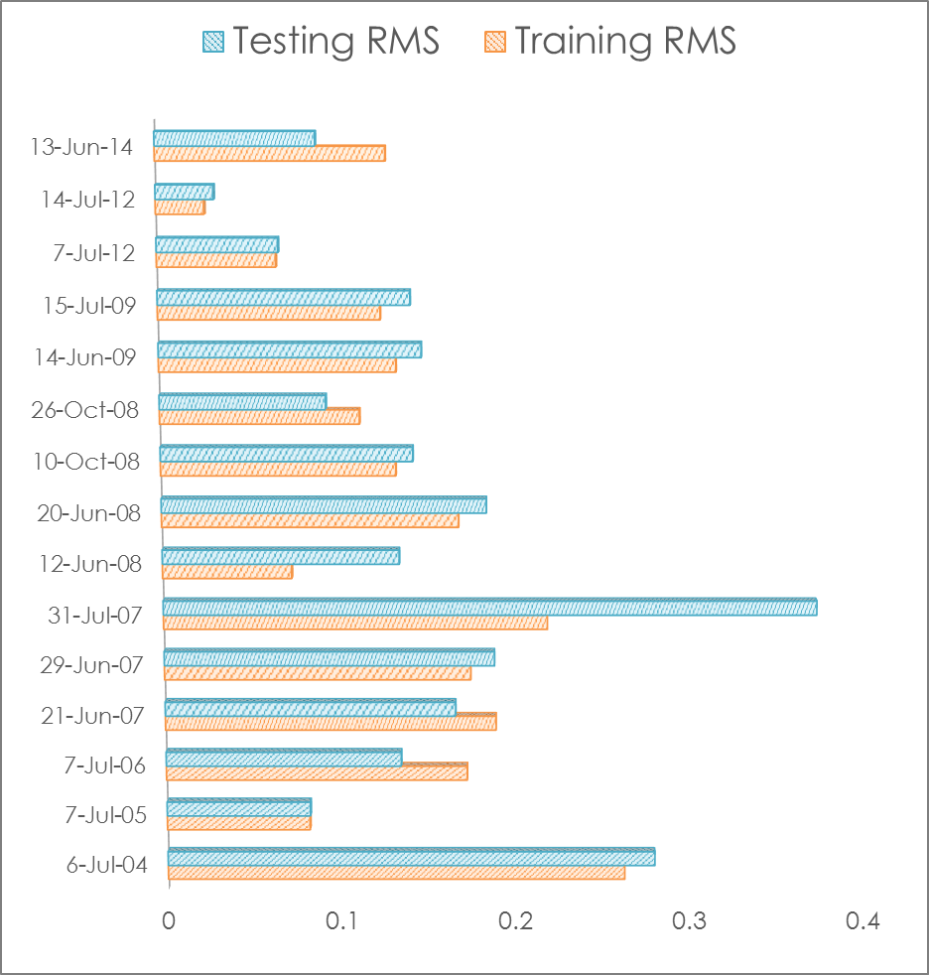
Figure 23: Comparison of testing vs. training Root Mean Square (RMS) values for each predicted dissolved oxygen (DO) concentration map produced by TerrSet’s MLP classifier.

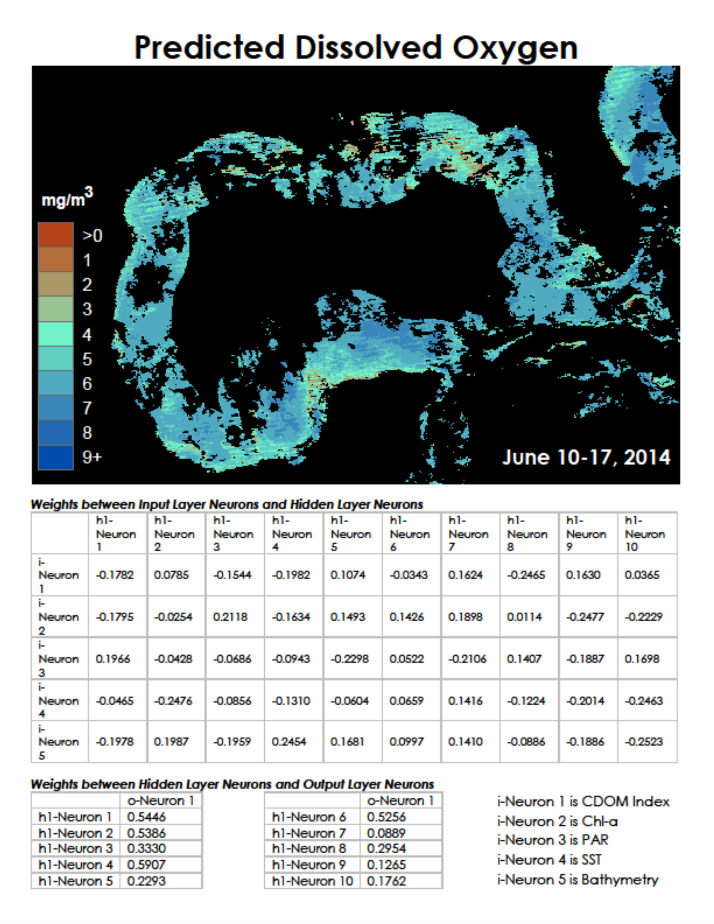
Figure 24: Map of predicted dissolved oxygen (DO) concentrations for June 10-17, 2014 generated from TerrSet’s Multi-Layer Perceptron (MLP). DO was estimated using Chl, CDOM, SST, PAR, and bathymetry, and trained using in-situ dissolved oxygen from buoy stations in the northern GoM.

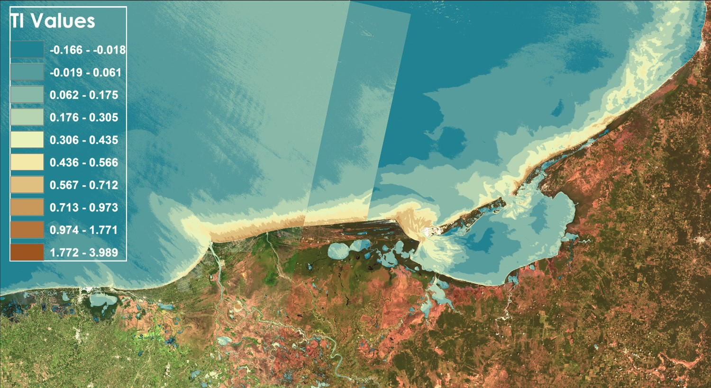
Figure 25: Turbidity index (TI) generated from Landsat 8 OLI scenes along the southern coast of the Bay of Campeche.

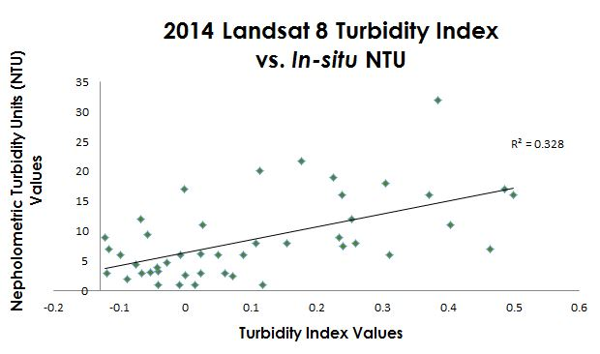
Figure 26: Linear regression between in-situ turbidity and turbidity index. (R² = 0.328)

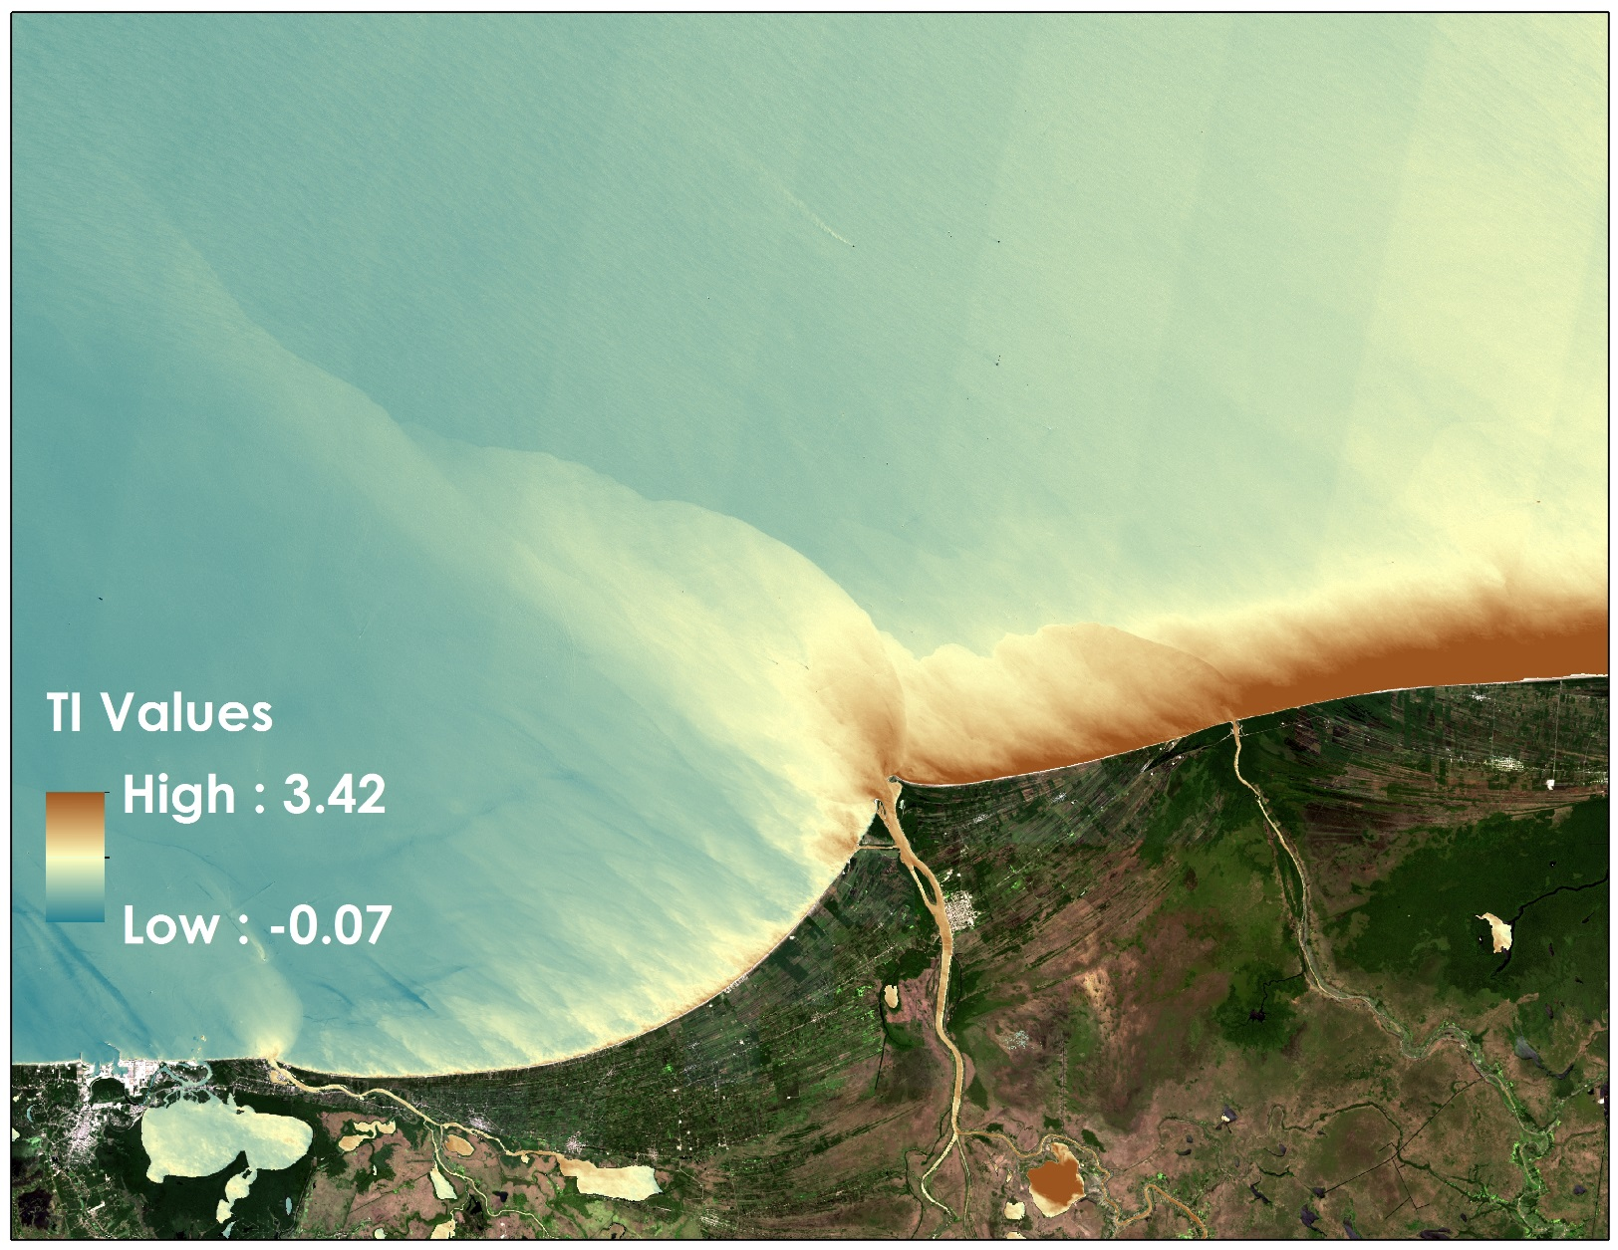
Figure 27: Turbidity index (TI) from 7/27/2013 representing the largest plume seen during the 2013-2014 study period. Plume extent measured approximately 87 km offshore to the northeast. TI images were generated from Landsat 8 OLI scenes along the southern coast of the Bay of Campeche.

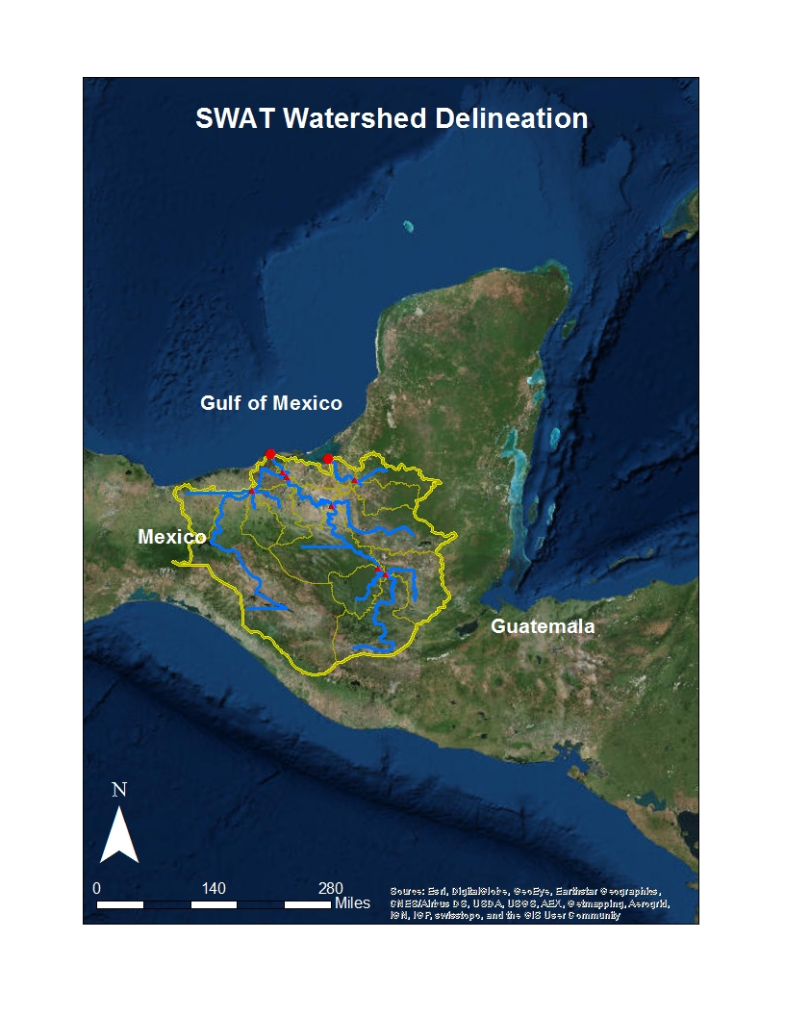
Figure 28: Soil and Water Assessment Tool (SWAT) delineated watershed boundary for the Grijalva-Usumacinta River Basin.

Figure 29: Monthly timeseries showing trends in Soil and Water Assessment Tool (SWAT) sediment, nitrogen, and phosphorous outputs.

