**NASA DEVELOP National Program**



North Carolina – NCEI

*Fall 2017*

Northeast US Cross-Cutting

Developing Annual, Seasonal, and Monthly Temperature Indices over the Northeast United States to Represent Recent Temperature Trends using NASA and NOAA Datasets

 **Technical Report**

Final Draft – November 16th, 2017

Lilian Yang (Project Lead)

Laurel Mahoney

Shannan Hurley

Anthony Arguez, NOAA National Centers for Environmental Information (Science Advisor)

Anand Inamdar, Cooperative Institute for Climate and Satellites – NC, NOAA National Centers for Environmental Information (Science Advisor)

# 1. Abstract

Since 1977, every year has been in the top ten warmest years on record when first ranked, reflecting the upward progression of annual global temperatures. However, some years within this time frame, such as 2012, are significantly cooler than surrounding years like 2010 or 2013. The variability of yearly rankings makes it difficult to differentiate the relative warmth or coolness of individual years from the secular trend. This project consists of two parts. First, the team devised a simple algorithm to create monthly, seasonal, and annual temperature scores regionally, within the Northeast US, and globally for the time periods ranging from 1975 to 2016 and 1880 to 2016. The temperature score product allows users to differentiate the relative coolness or warmth of a particular year in regard to the warmth or coolness of surrounding years from the overall temperature rankings. The algorithm also provides context for the temperatures in the Northeast region, accounting for recent year-to-year fluctuations with respect to longer term trends. Secondly, this project utilized daily Aqua and Terra MODIS Land Surface Temperature (LST) data to provide useful, high-resolution, temperature-based metrics to the energy and agriculture industries. This consisted of producing heating, cooling, and growing degree days (for energy and agriculture industries respectively) for the Northeast US using satellite derived data. The results of this study, which give users the ability to visualize maps of monthly degree days at a higher spatial resolution than indices previously available, are expected to be distributed to various clients by NOAA's Northeast Regional Climate Services Directorate and the NCEI Climate Monitoring Branch.

**Keywords**

Cross-cutting, climate monitoring, remote sensing, MODIS, temperature analysis, degree days, land surface temperature

# 2. Introduction

* 1. ***Background Information***

The National Oceanic and Atmospheric Administration (NOAA) routinely assesses the temperature rankings of individual months, seasons, and years for various spatial scales (Arguez et al., 2013). These findings are not only used for climate assessment reports, but also by climate-affected industries as an indicator of the climatic impact on their operations. Since the 1970’s, global temperatures have generally increased, and annual global rankings have consistently placed recent years in the top 10 (Blunden et al., 2017). The year 2016 was recently determined to be the warmest year on record by both NASA and NOAA, but 2012 was determined to be significantly cooler than surrounding years, such as 2011 and 2013, ranking as the 9th warmest year on record by NASA and the 10th warmest year by NOAA (Blunden et al., 2017). Although global temperatures are generally trending upward, there are still meaningful fluctuations of global temperature associated with natural variability. This supports the need to differentiate relatively cool years from warmer years in a manner that complements the associated ranking. We propose a new “temperature score” algorithm that provides such context of natural variability relative to secular trends.

In addition to rankings and metrics of natural variability, another useful suite of indicators of temperature impacts are degree days. Cooling degree days (CDD) and heating degree days (HDD) are quantitative indices that reflect the demand for energy to cool or heat buildings, respectively (Mourshed, 2012). Heating and cooling degree days are used for many applications, including the estimation of energy consumption. For agricultural applications, growing degree days (GDD) are utilized to describe the timing of biological processes as well as agricultural production (McMaster, 1997), including the prediction of sowing and harvesting dates, crop yield, length of plant stages, etc. (Elnesr & Alazba, 2016). For this study, cooling, heating and growing degree days are calculated using daily mean temperatures over the Northeastern United States using satellite retrieved land surface air temperature data to provide higher spatial resolution temperature information that may better discern spatial differences throughout the Northeast.

The Northeastern United States, as defined by the National Climate Assessment, consists of Maine, Vermont, New Hampshire, Massachusetts, Rhode Island, Delaware, Connecticut, Washington, D.C, New York, Pennsylvania, New Jersey, Maryland, and West Virginia. Projections of future temperature variations in this area based on the Hadley climate model and Canadian climate model suggest lower than average temperature increases in comparison with other regions of the United States (Barron et al., 2002). However, in 2016, above average temperature spanned the United States with record warmth observed in the Northeast (Blunden et al., 2017). The study period for part 1 (temperature scores) is from January 1975 to December 2016, and the study period for part 2 (degree days) is from January 2002 to August 2017. These time intervals allow the team to test project-specific methodology and provide data to a multitude of local climate-affected industries based on recent global temperature data and degree days.

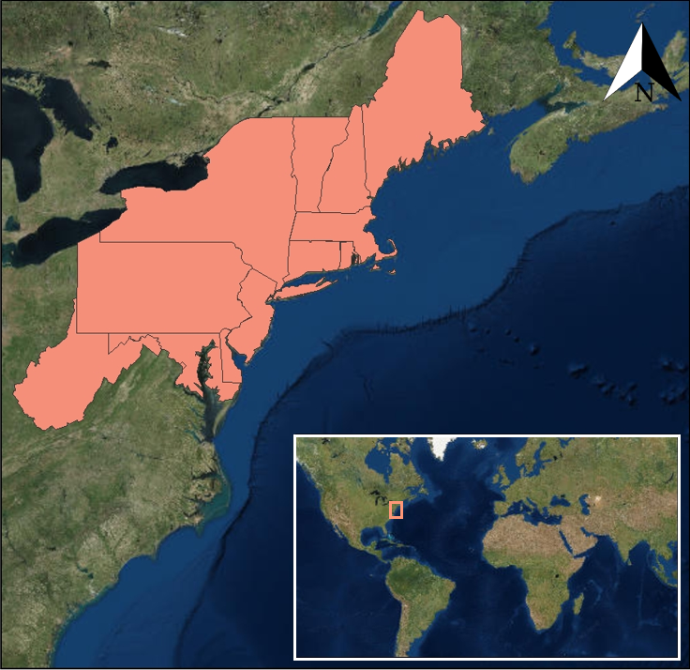

*Figure 1.* Project study area. The Northeast United States as defined by National Climate Assessment.

* 1. ***Project Partners & Objectives***

This project addresses NASA’s Applied Sciences Cross-Cutting National Application Area. This involves extraction of data from different sources, such as global surface temperature datasets and NASA earth observation satellites, into a final product. These end products were designed to be easily digestible and useful to partners in the Assessment, Energy, and Agriculture communities. The project partners that will be utilizing these data are NOAA’s Regional Climate Services Director (RCSD) Ellen Mecray (Eastern Region) and NOAA NCEI’s Climate Monitoring Branch (CMB). The project partners are interested in this project because (1) temperature scores provide additional context to the existing reporting of rankings, and (2) users are in need of a high-quality degree day dataset at a much higher spatial resolution (~5 km) for better interpretation and evaluation practices, which is what the deliverables will provide.

These deliverables have the potential to be utilized by a diverse set of end users. The CMB will be able to take the project’s temperature score methodology and potentially expand it to other regions of the United States. This will provide end users with a differentiated perspective of recent temperature fluctuations. Both end users will be able to operationalize the indices in future Quarterly Impact and State of the Climate reports to provide additional context. The blended satellite-*in situ* degree day products will also provide higher spatial resolution temperature information to better discern spatial variability throughout the Northeast.

# 3. Methodology

*Figure 2.* Temperature Score Methodology. The methods used to complete the data acquisition and analysis sections on the temperature scores.

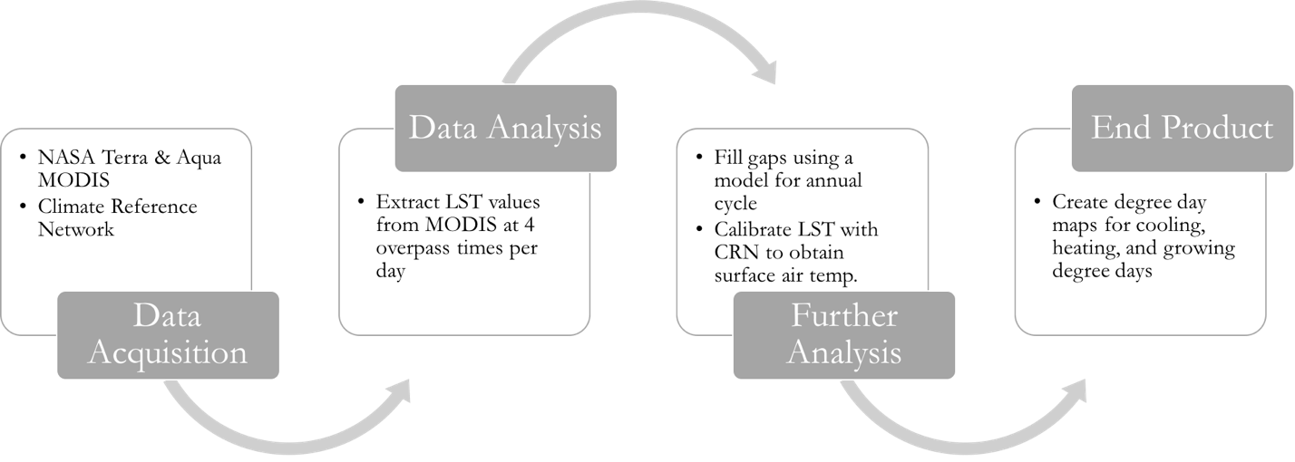

*Figure 3.* Degree Day Methodology. The methods used to complete the data acquisition and analysis sections on the degree day data and maps.

***3.1 Data Acquisition***

To calculate global temperature indices for a study period from January 1975 to December 2016, the team acquired monthly global surface temperature data from NASA’s Goddard Institute for Space Studies Surface Temperature Analysis (GISTEMP). For the Northeastern US temperature indices, the team acquired monthly temperature averages from NOAA’s Gridded GHCN-Monthly Temperature dataset (nClimGrid) for the Northeastern United States, as defined by the National Climate Assessment. This allows (after weighing ach state within the Northeast Region based on its areal extent) for a specific aggregation of monthly surface temperature data for the area of interest.

MODIS Daily clear-sky LST data were acquired through download from NASA’s Reverb science discovery tool for our study period from January 2000 to December 2016. MODIS clear-sky LST values were extracted from the Terra MODIS and Aqua MODIS platforms for daily (MOD11C1 MODIS/Terra Land Surface Temperature/Emissivity Daily L3 Global 0.05Deg CMG V006, MYD11C1 MODIS/Aqua Land Surface Temperature/Emissivity Daily L3 Global 0.05Deg CMG V006) Level 3, 0.05 by 0.05 degree grid data. Land surface temperature data was extracted from four overpass times each day. Monthly average air temperature and average surface infrared temperature information from the Climate Reference Network (CRN) were also utilized, allowing for the estimation of temperature values 2 m above the surface.

***3.2 Data Processing***

*3.2.1 Temperature Score Data Processing*

Temperature scores were computed in a three-step process. First, the long-term trend was removed from the time series to identify residuals. This trend can either be linear, using an ordinary least squares regression, or nonlinear, using a low-pass filter. The residuals of the anomaly dataset were divided by the group standard deviation to arrive at values analogous to z-scores. Finally, these z-scores were transformed to a scale from 1 to 10, such that each score had a 10% probability of occurrence based on the cut-off values of the Gaussian distribution. The temperature scores provide a real-time perspective relative to the secular trend, with a 1 representing a very cold year and a 10 representing a very warm year.

In order to define meaningful temperature scores, some measure of a long-term trend needed to be subtracted from the time series to differentiate relative warm or cold years. For 1975-2016, both the global and NE annual time series were well-modeled as ordinary least squares (OLS) fits. However, century-scale time series include substantial multi-decadal variability that preclude the use of OLS. Thus, in addition to OLS, the team also employed a low-frequency smoother to define a nonlinear trend. Specifically, we apply 25 consecutive 1-2-1 hannings in such a way that endpoints were partially smoothed.

In addition to utilizing the monthly temperature data, the team also processed the seasonal (DJF, December-February; MAM, March-May; JJA, June-August; and SON, September-November) and annual averages. All processing was performed using the Interactive Data Language (IDL).

*3.2.2 Degree Day Data Processing*

Degree days were calculated using LST data from daily NASA MODIS satellites. The extracted MODIS clear-sky LST values correspond to the overpass times of Terra (10:30, 22:30 local solar time) and Aqua (13:30, 01:30 local solar time). From these overpass time values, maximum and minimum LSTs (LSTmax, LSTmin) were derived by constructing a semi-empirical diurnal fit (Duan et al 2014, doi:10.3390/rs604324). Thus, LSTmax and LSTmin represent values reconstructed from MODIS observations. After extracting MODIS LST for the four overpass times, there were gaps void of data in the time series due to cloud interference. These overpass gaps were filled by using an annual cycle model to fit, similar to a diurnal cycle fit, instead of linear interpolation. Monthly average air temperature and infrared surface temperature data acquired from CRN were used in a least square fit to obtain 2 m surface air temperature from LST. Once each overpass time had a measurement, the team employed a daytime only diurnal cycle to fit these observations. This was done by utilizing an algorithm derived from Inamdar et al (2008) (see Equation 1).

LST=T0+Ta*cos(π!(t-tm)/Ω) **(1)**

From this equation, *T0* stands for the day’s minimum temperature around sunrise; *Ta* is the amplitude, which is the difference between the maximum and minimum temperature, *t* is the time of observation, *tm* is the time of max temperature; and Ω is the number of daylight hours (sunrise to sunset). With three observations available and three free parameters, the values were fitted to the daytime only diurnal cycle, and LST values were obtained.

***3.3 Data Analysis***

For the degree days, the team created five different variables with various base temperatures to observe the differences. Heating and cooling days were set to a base average daily temperature of 65 °F. There were three different variables to observe growing degree days to analyze three different types of crops that are popular in the northeast: onions, alfalfa, and corn. Onion has a base temperature of 35 °F, alfalfa has a base temperature of 41 °F, and corn has a base temperature of 50 °F. Note that when the mean temperature for the day is less (more) than the threshold value, no cooling (heating) degree days or growing degree days are generated.

# Degree Days in the Northeast United States

|  |  |
| --- | --- |
| **Base Mean Temperature (F)** | **Degree Days** |
| Below 65 ° | Heating Degree Days equates to a greater amount of houses or buildings using heaters or gas. |
| Above 65 ° | Cooling Degree Days equates to a greater amount of houses or buildings using air conditioners or fans. |

# 

|  |  |
| --- | --- |
| **Base Mean Temperature (F)** | **Growing Degree Days Crops** |
| 41 ° | Alfalfa |
| 50 ° | Corn |
| 35 ° | Onion |

# *Table 1.* Degree Day background and temperature thresholds for heating, cooling, and specific crop growing degree days.

# 4. Results & Discussion

***4.1 Analysis of Results***

*4.1.1 Temperature Score Results Analysis*

The temperature scores show an upward trend annually for the globe (figure 4) and Northeast US region (figure 5). However, the globe and Northeast US are not trending upward in unison. 2016, for example, is much hotter than all other previous years in the globe, but in the Northeast US, 2016 is the 3rd hottest year on record. The Northeast US, as characterized by the temperature scores, has exhibited a great degree of oscillation between two extreme readings rather than clustering around the median, which is more prevalent in the global temperature score. This is most prevalent after the year 1988, as seen in figure 5.

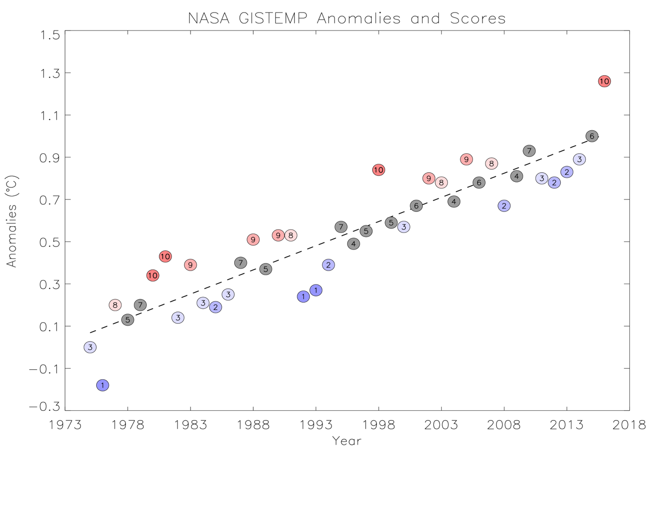

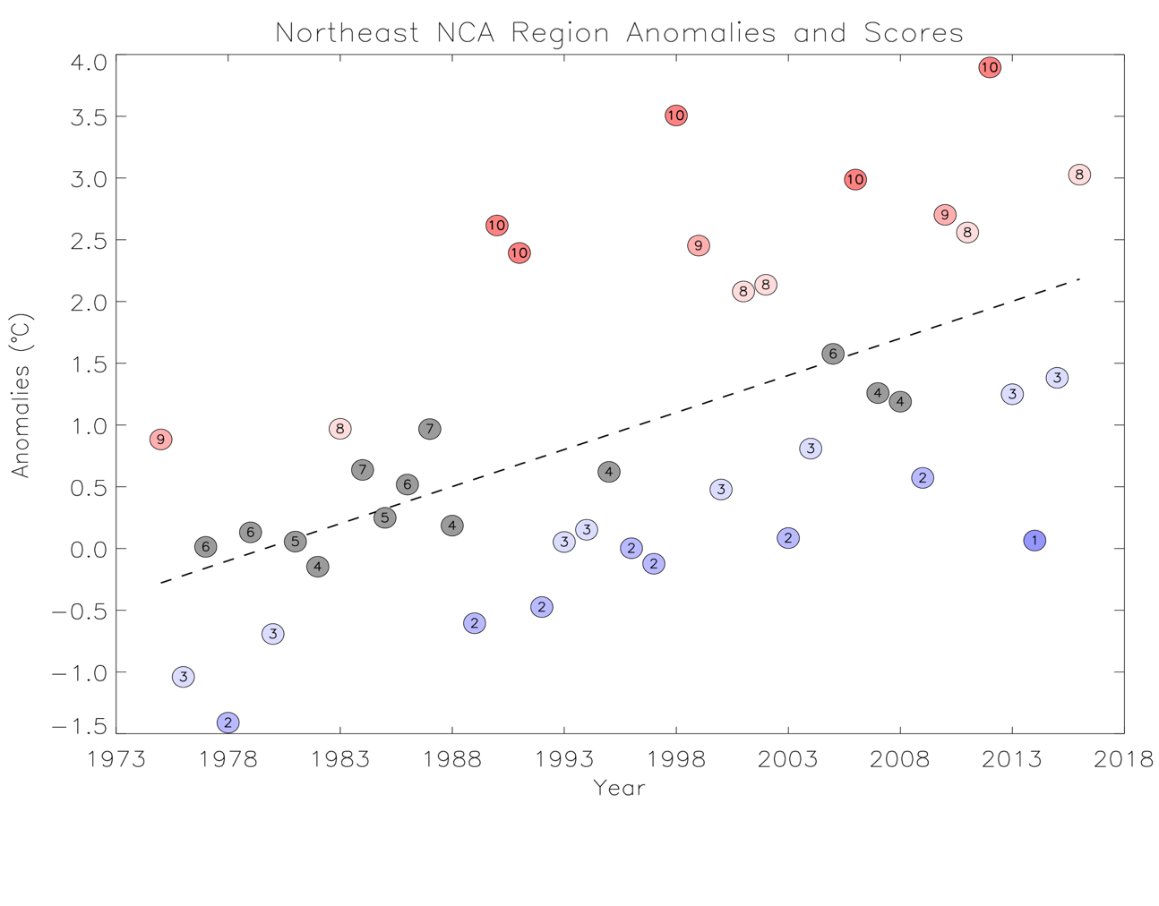*Figure 4*. Annual anomaly temperature score of the globe from 1975-2016. This figure shows a color gradient of the temperature scores with 1 in blue, representing a colder year, and 10 in red, representing a warmer year

*Figure 5.* Annual anomaly Temperature score of the Northeast United States from 1975-2016. This figure shows the same color gradient as figure 4, with 1 in blue, representing a colder year, and 10 in red, representing a warmer year

*4.1.2 Degree Days Results Analysis*

The team utilized ESRI ArcGIS 10.3 to create maps of the heating (figure 6), cooling (figure 7), and growing (figure 8) degree days. To verify our maps, the team compared the degree day maps to other degree day maps at the Northeast Regional Climate Center. The maps were found to be not only synonymous, but also have higher spatial resolution. The heating (figure 6) and cooling (figure 7) degree days maps highlight the change in degree days in the Northeast in relation to the temperature trend throughout our study period. For example, January of 2003 is ranked as a 1 in the temperature score algorithm and is shown to be colder than January of 2017 in the heating degree days. The onion growing degree day maps (figure 8) also show the difference in the amount of degree days between two months with March having less growing degree days than August.

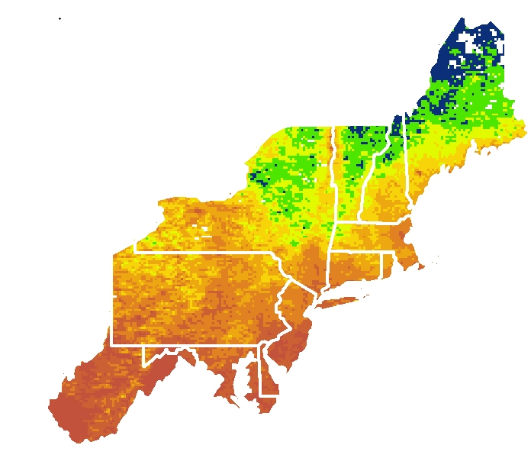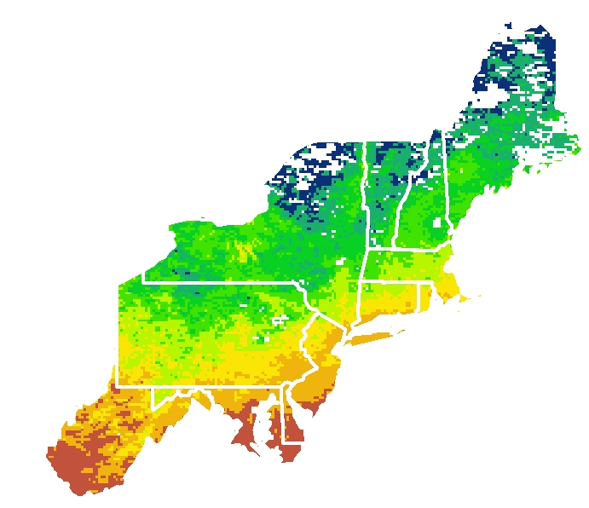



1865

1865

1058

1058

*Figure 6.* Heating Degree Days for the Northeast United States. On the left is January 2003 and on the right, is January 2017.

***4.2 Future Work***

In terms of future work, both of these projects have the potential to expand geographically,

Future work for the temperature scores may be used for research in other parts of the scientific realm, such as El Niño, La Niña, North Atlantic Oscillation, etc. The Climate Monitoring Branch has also expressed interest in using the temperature scores specifically for research in climate “unusualness.” More research may also go into potential causes for the fluctuating behavior of the Northeast temperatures. The methodology and algorithm may also be applied to other regions of the United States or other continents as well.

Degree day future work will also include the addition of more variables into the algorithm such as proximity to the coast, urban fraction, or vegetation index. The project may also be applied to other sectors besides the energy and agriculture industries, and the project has the ability to be turned into a tool for users to choose their crop or threshold temperature. As with the temperature score, the methodology also has the ability to extend to the entire contiguous United States.

# 5. Conclusions

This project provided viable methodologies and graphics for recent temperature scores and degree days in the Northeast United States. Based on the temperature scores, recent Northeast temperature trends have exhibited a great degree of oscillation between two extreme readings rather than clustering near the median. The Climate Monitoring Branch will use this information and the temperature scores for context and for future quarterly state of the climate reports. For each map created based on cooling, heating, and growing degree days it was determined that Land Surface Temperature data from MODIS is capable of providing higher spatial resolution temperature information to better discern spatial differences throughout the Northeast. The use of the degree days data and maps will also be operationalized within agriculture and energy sectors. The data, methodologies, and maps created during the term will provide our project partners with valuable information about temperature trends and the impacts of this variation that can be used to inform their decision-making process.

# 6. Acknowledgments

The Northeast US Cross-cutting team would like to thank the mentors and partners who dedicated their time and assistance to this project. Without any of them, this project would not have been possible.

Science Advisors/Mentors:

* Anthony Arguez (NOAA NCEI)
* Anand Inamdar (Cooperative Institute for Climate and Satellites – NC, NOAA NCEI)

End-Users:

* Ellen Mecray (NOAA, Regional Climate Services, Eastern Region)
* Karin Gleason (NOAA NCEI Climate Monitoring Branch)

Others:

* Derek Arndt (NOAA NCEI Climate Monitoring Branch Chief)
* Alec Courtright (DEVELOP Center Lead at NCEI)
* Jonathan O’Brien (DEVELOP Center Lead at NCEI, Assistant Center Lead, and Communications Fellow at NCEI)

Any opinions, findings, and conclusions or recommendations expressed in this material are those of the author(s) and do not necessarily reflect the views of the National Aeronautics and Space Administration.

This material is based upon work supported by NASA through contract NNL16AA05C and cooperative agreement NNX14AB60A.

# 7. Glossary

**Earth Observations** – Satellites and sensors that collect information about the Earth’s physical, chemical, and biological systems over space and time

**MODIS** – MODerate resolution Imaging Spectroradiometer

**NASA GISTEMP** – NASA’s Goddard Institute for Space Studies Surface Temperature Analysis

**nClimGrid** – Gridded GHCN-Monthly Temperature dataset

**LST** – Land surface temperature

**OLS** – Ordinary least squares

**Heating degree days** – A greater amount of houses and buildings are using heaters or gas

**Cooling degree days** – A greater amount of houses and buildings are using air conditioners or fans

**Growing degree days** – A weather-based indicator for assessing crop development

# 8. References

Arguez, A., Karl, T. R., Squires, M. F., & Vose, R. S. (2013). Uncertainty in annual rankings from NOAA’s

global temperature time series: ANNUAL GLOBAL TEMPERATURE RANKINGS. *Geophysical Research Letters, 40*(22), 5965–5969. <https://doi.org/10.1002/2013GL057999>

Barron, E. (2001). Potential consequences of climate variability and change for the northeastern United

States. *Climate Change Impacts on the United States-Foundation Report: The Potential Consequences of Climate Variability and Change*, 109.

Blunden, J., & Arndt, D. (2017). State of the Climate in 2016. *Bulletin of the American*

*Meteorological Society*, *98*(8), Si–S277. https://doi.org/10.1175/2017BAMSStateoftheClimate.1.

Elnesr, M. N., & Alazba, A. A. (2016). An integral model to calculate the growing degree-days and heat units,

a spreadsheet application. *Computers and Electronics in Agriculture*, *124*, 37–45. <https://doi.org/10.1016/j.compag.2016.03.024>

Duan, S.-B., Li, Z.-L., Tang, B.-H., Wu, H., Tang, R., Bi, Y., & Zhou, G. (2014). Estimation of diurnal cycle

of land surface temperature at high temporal and spatial resolution from clear-sky MODIS data. *Remote Sensing*, *6*(4), 3247–3262. <https://doi.org/10.3390/rs6043247>

Good, E. (2015). Daily minimum and maximum surface air temperatures from geostationary satellite data:

Satellite min and max air temperatures. *Journal of Geophysical Research: Atmospheres*, *120*(6), 2306–2324. <https://doi.org/10.1002/2014JD022438>

Inamdar, A. K., French, A., Hook, S., Vaughan, G., & Luckett, W. (2008). Land surface temperature retrieval

at high spatial and temporal resolutions over the southwestern United States. *Journal of Geophysical Research*, *113*(D7). https://doi.org/10.1029/2007JD009048

Karl, T. R., Arguez, A., Huang, B., Lawrimore, J. H., McMahon, J. R., Menne, M. J., … Zhang, H.-M. (2015).

Possible artifacts of data biases in the recent global surface warming hiatus. *Science, 348*(6242), 1469–1472. <https://doi.org/10.1126/science.aaa5632>

McMaster, G. S., & Wilhelm, W. W. (1997). Growing degree-days: one equation, two interpretations.

*Agricultural and Forest Meteorology*, *87*(4), 291–300.

Mourshed, M. (2012). Relationship between annual mean temperature and degree-days. *Energy and Buildings*,

*54*, 418–425. <https://doi.org/10.1016/j.enbuild.2012.07.024>

NRCC Home Page. (n.d.). Retrieved November 14, 2017, from

<http://www.nrcc.cornell.edu//regional/regional/regional.html>

The Land Processes Distributed Active Archive Center, (2017), MOD11C1 MODIS/Terra Land Surface

Temperature/Emissivity Daily. Version 006. NASA EOSDIS Land Processes DAAC, USGS Earth

Resources Observation and Science (EROS) Center, Sioux Falls, South Dakota (https://lpdaac.usgs.gov), accessed 09 29, 2017, at <http://dx.doi.org/10.5067/MODIS/MOD11C1.006>

The Land Processes Distributed Active Archive Center, (2017), MYD11C1 MODIS/Aqua Land Surface

Temperature/Emissivity Daily. Version 006. NASA EOSDIS Land Processes DAAC, USGS Earth Resources Observation and Science (EROS) Center, Sioux Falls, South Dakota (https://lpdaac.usgs.gov), accessed 09 29, 2017, at http://dx.doi.org/10.5067/MODIS/MYD11C1.006

GISTEMP Team, 2017: GISS Surface Temperature Analysis (GISTEMP). NASA Goddard Institute for

Space Studies. Dataset accessed 2017-09-27 at <https://data.giss.nasa.gov/gistemp/>

Vose, Russell S., Applequist, Scott, Squires, Mike, Durre, Imke, Menne, Matthew J., Williams, Claude N. Jr.,

Fenimore, Chris, Gleason, Karin, and Arndt, Derek (2014): Gridded 5km GHCN-Daily Temperature

and Precipitation Dataset (nCLIMGRID), Version 1. NOAA National Centers for Environmental Information. DOI:10.7289/V5SX6B56

Diamond, H. J., T. R. Karl, M. A. Palecki, C. B. Baker, J. E. Bell, R. D. Leeper, D. R. Easterling, J. H.

Lawrimore, T. P. Meyers, M. R. Helfert, G. Goodge, and P. W. Thorne, 2013: U.S. Climate Reference

Network after one decade of operations: status and assessment. Bull. Amer. Meteor. Soc., 94,

489-498. doi: [10.1175/BAMS-D-12-00170.1](http://dx.doi.org/10.1175/BAMS-D-12-00170.1)

# 9. Appendices



*Figure 1.* Project study area. The Northeast United States as defined by National Climate Assessment.

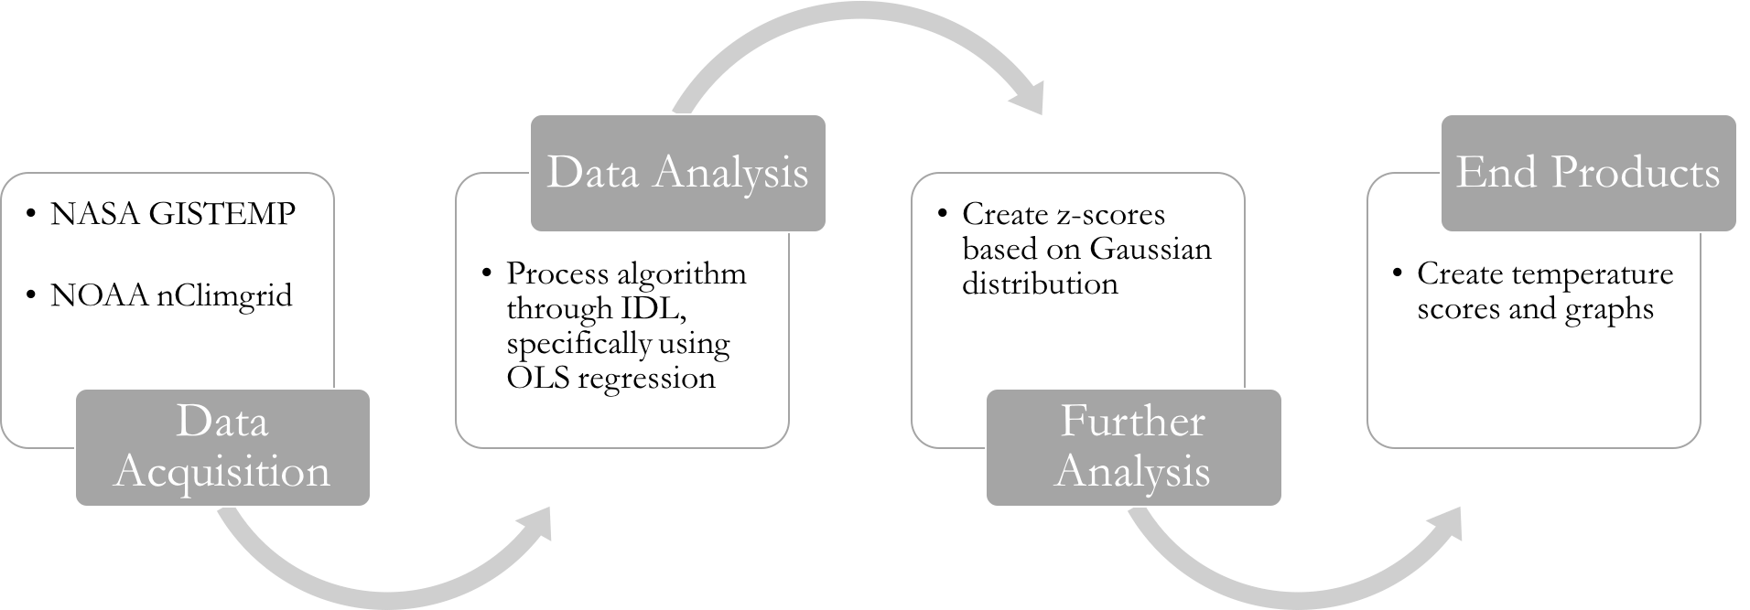

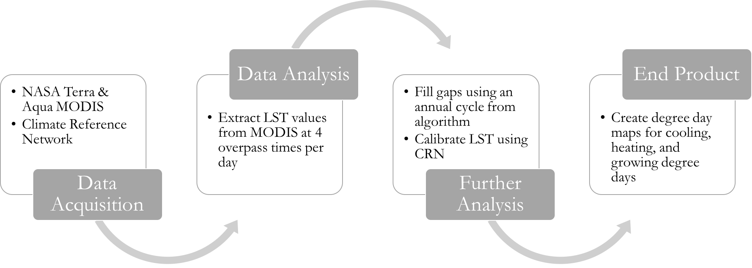*Figure 2.* Temperature Score Methodology. The methods used to complete the data acquisition and analysis sections on the temperature scores.

*Figure 3.* Degree Day Methodology. The methods used to complete the data acquisition and analysis sections on the degree day data and maps.

# Degree Days in the Northeast United States

|  |  |
| --- | --- |
| **Base Mean Temperature (F)** | **Degree Days** |
| Below 65 ° | Heating Degree Days equates to a greater amount of houses or buildings using heaters or gas. |
| Above 65 ° | Cooling Degree Days equates to a greater amount of houses or buildings using air conditioners or fans. |

|  |  |
| --- | --- |
| **Base Mean Temperature (F)** | **Growing Degree Days Crops** |
| 41 ° | Alfalfa |
| 50 ° | Corn |
| 35 ° | Onion |

# *Table 1.* Degree Day background and temperature thresholds for heating, cooling, and specific crop growing degree days.

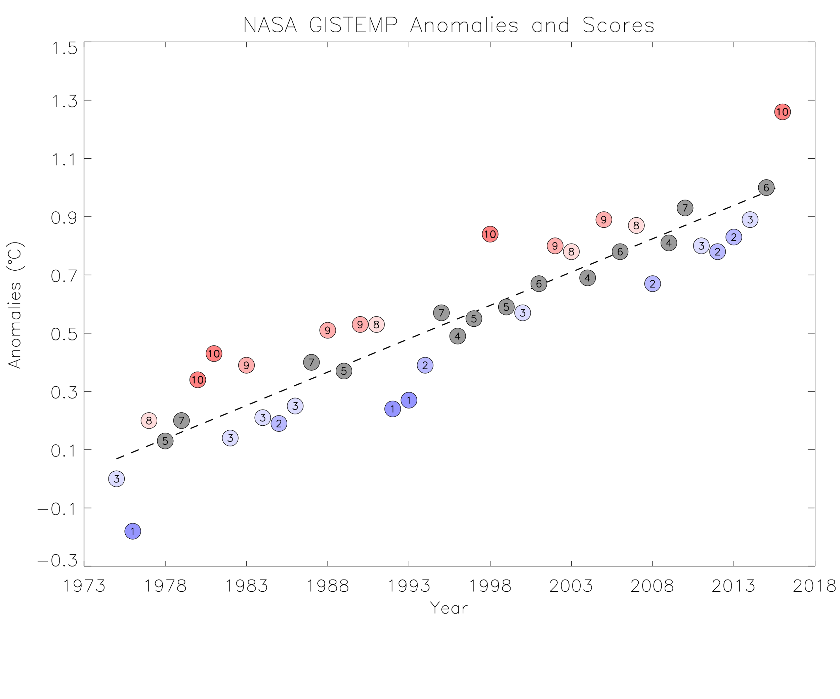*Figure 4*. Annual anomaly temperature score of the globe from 1975-2016. This figure shows a color gradient of the temperature scores with 1 in blue, representing a colder year, and 10 in red, representing a warmer year

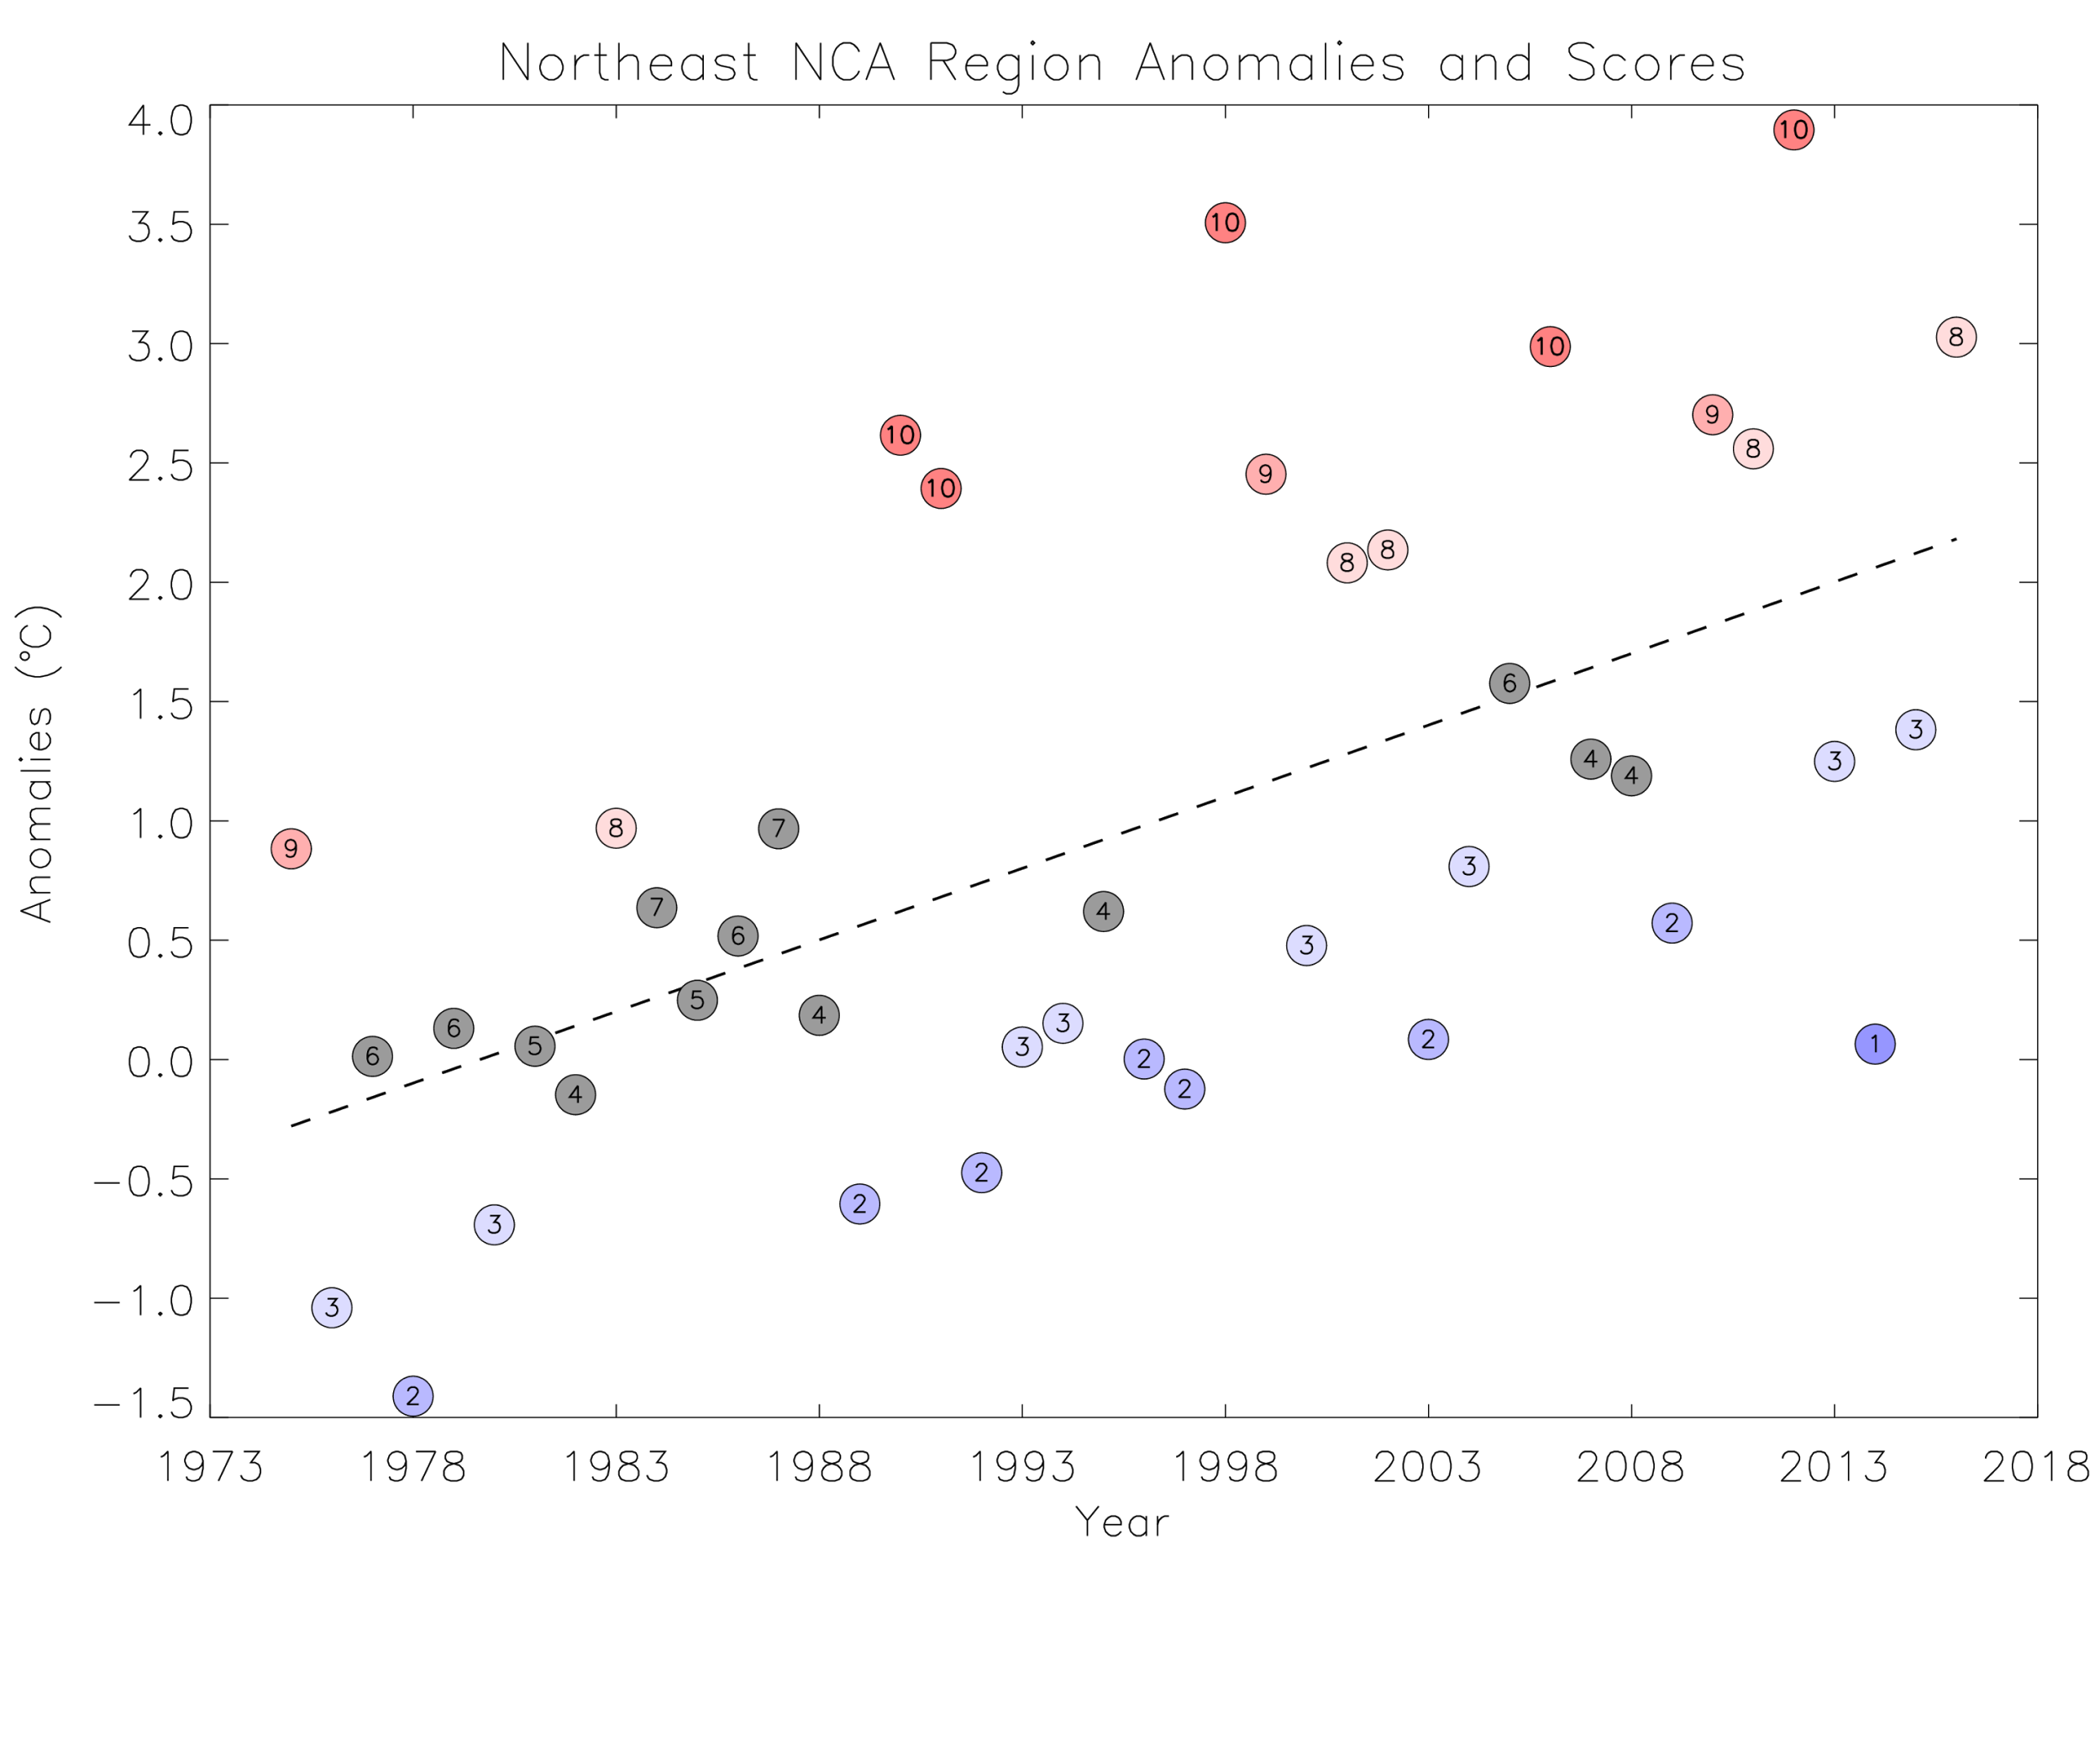

*Figure 5.* Annual anomaly Temperature score of the Northeast United States from 1975-2016. This figure shows the same color gradient as figure 4, with 1 in blue, representing a colder year, and 10 in red, representing a warmer year

1865



1865

1058

1058

*Figure 6.* Heating Degree Days for the Northeast United States. On the left is January 2003 and on the right, is January 2017.

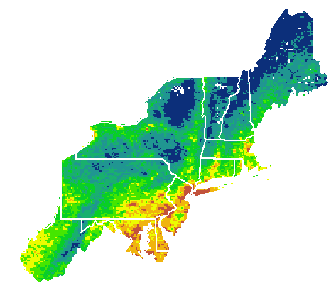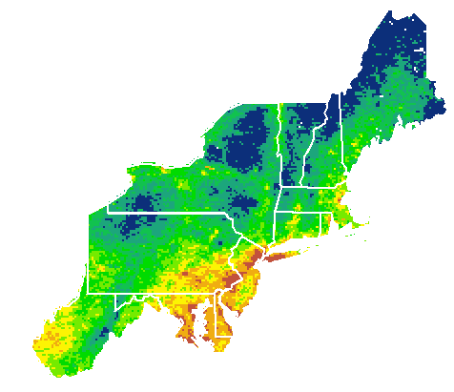

../Downloads/CDD%20Scale%20.png../Downloads/CDD%20Scale%20.png

360

360

0

0

*Figure 7.* Cooling Degree Days for the Northeast United States. On the left is August 2002 and on the right, is August 2017.

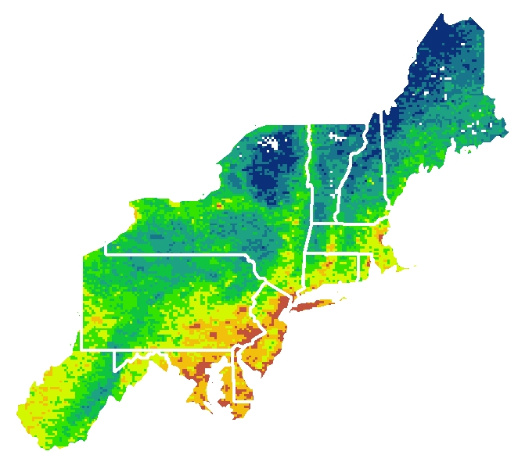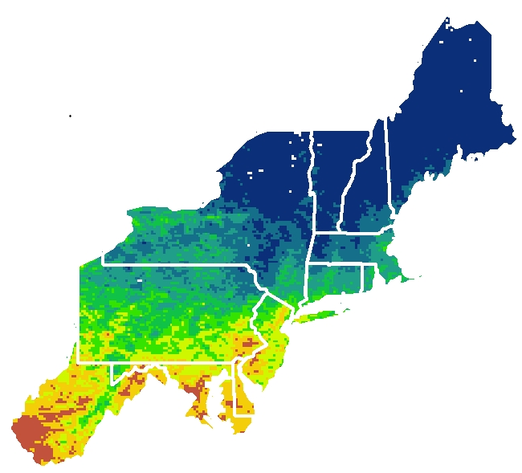



1257

396

869

9

*Figure 8.* Growing Degree Days for the Northeast United States. On the left is March 2017 and on the right, is August 2017.