**NASA DEVELOP National Program**



Georgia – Athens

*Fall 2017*

Georgia Energy II

Reducing Conflicts in Siting Solar Power Facilities by Identifying Sensitive Habitats and Wildlife Populations in Areas with High Generation Potential

 **Technical Report**

Final Draft – November 16, 2017

Suravi Shrestha (Project Lead)

Emad Ahmed

Amanda Aragón

Marie Bouffard

Fabiola Clermont

Peter Hawman

Nick Morgan

Caren Remillard

Austin Stone

Dr. Marguerite Madden, University of Georgia (Science Advisor)

Previous Contributors:

Lynn Abdouni

Natalia Bhattacharjee

Roger Bledsoe

Christopher Cameron

# 1. Abstract

Solar energy is a rapidly growing industry in the state of Georgia. The increasing popularity of solar farms has encouraged decision-makers and developers to incorporate a sustainable plan for utility-scale solar developments. However, the construction and siting of solar farms could have a threatening impact on environmentally sensitive habitats and associated species. NASA DEVELOP partnered with The Nature Conservancy and the Georgia Department of Natural Resources to conduct an analysis to inform solar site planning and to communicate with key stakeholders. The team analyzed land cover trends from Landsat 8 Operational Land Imager (OLI), in addition to solar insolation datasets from Terra’s Clouds and the Earth’s Radiant Energy Systems (CERES) sensor. These Earth observations were combined to classify and extract data layers for a solar site suitability and conflict identification model following the Land Use Conflict Identification Strategy (LUCIS). Additionally, the DEVELOP team utilized habitat layers of the endangered gopher tortoise *(Gopherus polyphemus)* primarily due to its role as a keystone species in these sensitive areas. These data were used to generate end products that depict potential conflicts between ideal solar energy sites and endangered species habitats, and prioritize development areas outside of these conflicts. The team examined potential conflicts in Decatur and Taylor counties with additional datasets on existing solar utility infrastructure and parcel data to provide a local-level analysis. The results of this project will be utilized by The Nature Conservancy and Georgia Department of Natural Resources to recommend suitable sites for environmentally conscious solar farm construction.

**Keywords**

Landsat, remote sensing, gopher tortoise, suitability analysis, solar energy, solar farm

# 2. Introduction

* 1. ***Background Information***

In recent years, the development of solar energy production has expanded in the United States. According to the U.S. Department of Energy (2017), solar installations have increased nationally by seventeen-fold since 2008, from 1.2 gigawatts (GW) to an estimated 30 GW in 2017. The solar industry has observed significant growth across the board, but the largest growth has been seen in the utility-scale segment which has increased by 145% since 2015 (SEIA, 2017). This rise in solar energy production is in part due to the reduction in production cost. The cost of a solar electric system has dropped by 50% since 2010, and this trend has allowed the industry to become economically competitive with conventional energy sources (U.S. Department of Energy, 2017). This rapid growth in the solar energy industry has widespread economic ramifications. The Solar Energy Industries Association (SEIA) reports that solar industry jobs have grown in the U.S. by 20% each year for the past four years and have tripled in number since 2010 (SEIA, 2017).

As one of the top ten states for solar capacity, Georgia stands in a unique position to benefit from the growth in solar energy production (SEIA, 2017). The state has seen a rapid increase, between 30-45% annually, in utility-scale solar power development, making it an important industry for policy makers to consider, especially when there are environmental drawbacks to these developments. The construction of large-scale solar installations can significantly alter the site environment and could lead to habitat loss (Hernandez, 2014). This is particularly important to consider since much of the development is taking place on rural lands, including the habitat of the vulnerable gopher tortoise (*Gopherus polyphemus),* raising concerns over the protection of the species (Southern Environmental Law Center, 2017). It is important to be cautious of developmental impacts on gopher tortoise habitat because they are an at-risk species that play a critical role in the coastal plain ecosystem. Gopher tortoises are considered a keystone species whose burrows provide shelter and protection to about 300 different species of birds, reptiles, and amphibians, including the gopher frog (*Rana capito*), indigo snake (*Drymarchon couperi*), and southern hognose snake (*Heterodon simus*) (US Fish and Wildlife Services, 2017). However, avoiding development in environmentally vulnerable areas can reduce the potential of negative impacts on sensitive wildlife.

To address these issues and mitigate conflict between environmental and developer concerns, this study conducted a suitability analysis evaluating potential solar installation sites on the grounds of environmental and developer priority factors. Our model identified potential conflict zones between ideal solar sites and sensitive habitats to help decision makers and developers prioritize development sites outside of important habitat areas. This project builds off the work that a previous project conducted on site suitability analysis, by expanding it to include an in-depth analysis of two Georgia counties, Decatur and Taylor, which our partners identified as crucial areas due to their rapid solar development and presence of gopher tortoise habitat (Figure 1).

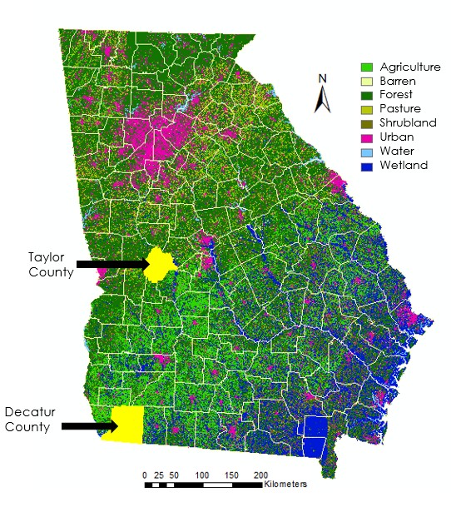

Figure 1: Georgia study area, with highlighted focal counties, depicting land cover classification (2016) derived from Landsat 8 OLI

The goal of this project was to develop a series of maps to provide the framework for a tool that integrates environmental variables with solar site development potential. An assessment of solar farms’ siting and their impact on environmentally sensitive areas is needed for planning the development of future utility-scale solar farms. This project’s study period followed the time frame of recent solar farm development and the most recently available data, which spanned from January 2015 to August 2017.

* 1. ***Project Partners & Objectives***

NASA DEVELOP partnered with The Nature Conservancy (TNC) and the Georgia Department of Natural Resources (GADNR) to identify suitable areas for utility-scale solar development sites that do not overlap with environmentally sensitive areas. This project will contribute to the TNC’s “Conservation by Design,” which is their formatted approach towards conservation projects, for science-based decision making and planning in partnership with solar developers. This project will expand the use of geospatial analysis to address these concerns in addition to previously accessed information gathered through on-the ground-survey, remote sensing, and expert opinion. The focus of GADNR is to provide historic and cultural hands-on management of resources in a sustainable manner, whereas the TNC explores conservation efforts and creates partnerships with non-confrontational nature stewardship and diversity of life. The analysis for solar farm siting, which considers both optimal conditions for solar farms as well as environmentally sensitive areas, will serve as an outreach tool for our project partners to aid in siting solar installations.

This project addressed NASA’s Applied Sciences’ Energy National Application Area. By assessing the suitability of solar development within Georgia, this project highlights the growth of renewable energy in the recent years and addresses the potential impacts on environmentally sensitive areas. The project partners will use the end products of this project to bring environmental stakeholders and solar developers together to site solar farms within Georgia by considering environmentally sensitive areas.

# 3. Methodology

***3.1 Data Acquisition and Data Processing***

The U.S. Department of Agriculture’s CropScape, a product generated from Landsat 8 Operational Land Imager (OLI), was downloaded and reclassified to serve as a land cover base map for year of 2016 to examine recent land cover changes in Georgia. We digitized solar farms installed between 2010 and 2016 across the state, and land use classes were extracted for each site across the study period. Locations of these solar farms were provided by SouthFace Energy Institute. Based on the solar farm’s installation year, the previous year’s CropScape class was identified and the most frequently converted land cover classes were determined.

Additionally, the Terra Clouds and the Earth’s Radiant Energy System (CERES) instrument provided all sky insolation and irradiance from 2012 – 2016 (Level 3- SYN1deg-month product). We used the CERES data to identify areas with suitable solar insolation conditions for solar farm siting. The team used the shortwave surface flux as it included different weather conditions and accounted for aerosol intervention and diffuse flux effect. This dataset helped characterize solar insolation in the state of Georgia, which showed that most of the state receives radiation and insolation levels suitable for solar panel installation.

We also used Digital Elevation Models (DEM) in our analysis, specifically 30-meter and 10-meter resolution datasets provided by Carl Vinson Institute of Government at the University of Georgia. Slope and aspect products derived from the DEM were incorporated into the solar farm suitability model for the state of Georgia and the two counties.

We acquired additional layers from the TNC to include a protected lands layer that identified protected areas. A model created by Dr. Jeff Hepinstall-Cymerman was implemented to locate gopher tortoise habitats (UGA, Warnell School of Forestry and Natural Resources). We also identified a rock outcrop layer which indicated soil types in the state by reclassifying data derived from the STATSGO (Digital General Soil Map of the United States) dataset.

The team conducted a more in-depth solar site suitability analysis on Decatur and Taylor counties, involving higher resolution data and additional datasets such as roads, parcels, and floodplains acquired from the Georgia State Clearinghouse, and a streams layer acquired from U.S. Fish and Wildlife Service. In addition, because proximity to transmission lines lowers costs for developers, the project included transmission line data provided by the TNC in our suitability analysis. To ensure a seamless analysis procedure, we unified the terms of projections and classification for all datasets (Appendix A).

All the data were processed in ArcMap 10.5 using a classification method to identify areas of suitability and then combined the variables using a weighted analysis to produce a low, medium, and high suitability scale.

***3.2 Data Analysis***

This term continued to build on the methodology that was implemented in the first term of the project (Figure 2). To identify datasets and layers relevant to solar development and conservation of sensitive species, the team used the Land-Use Conflict Identification Strategy (LUCIS) method. Building onto the model, the team added more layers (such as transmission lines) to make the analysis more accurate.

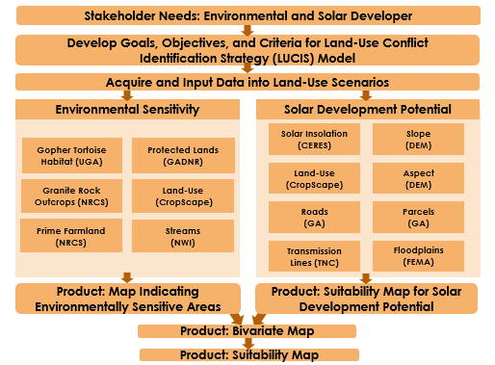

Figure 2: Summary of overall project methodology to create a suitability map for solar development potential.

The team continued with the two main goals: identification of (1) areas that are suitable for utility-scale solar installation, and (2) environmentally sensitive areas. Within each of ­­­these two goals are different objectives indicating how the goal would be met. These objectives created pathways to determining criteria and weighting these data to properly meet the objective, and ultimately accomplish the corresponding goal (Appendix B & C).

The criteria used to determine solar development potential in Georgia included slope, aspect, land cover, incoming solar radiation, and transmission lines (Table B1). The team devised a reclassified USDA CropScape land cover dataset to display eight broad land uses, then issued a scale regarding the most suitable land cover types for utility scale solar farms: barren lands, pasture, shrubland, and agricultural land. Three different rankings were used in the development potential map ranging from 1 to 3, with 1 being the least suitable and 3 being most suitable.

The method for determining the environmental sensitivity focused on weighting objectives to create a map showing sensitive hot spots. The model used an updated gopher tortoise habitat layer, rock outcrops, conservation lands, and land cover (Table B2). The environmental sensitivity map used a similar ranking system to the solar map where value 3 represents the most sensitive areas (blue) while 1 indicates the least sensitive areas (white).

Using the information on solar development potential and environmental sensitivity, we chose to perform a bivariate analysis to present how these two factors overlap. Using the Raster Calculator, the team generated a classification that reflected the conflict between interests and prioritized areas depending on values characterizing conflicts using the following expression (Equation 1).

$\text{Conflict = Environmental Sensitivity + 10 × Solar Development Potential }$ (1)

We considered protected lands as restricted for solar farm development and were therefore masked out by multiplying the raster values by 0. Results for this bivariate map yielded nine classes that we collapsed into three classes for the suitability analysis: low, moderate and high suitability. An example of the reclassification process for a high suitable area is as follows.

If an area has low environmental sensitivity, the area is assigned a value of 1 and an area of high solar developmental potential is assigned a value of 3. Combining the two variables onto our bivariate analysis using equation (1), we get a value that equals to 31. Here, the value 31 represents areas that are ideal for solar farm development and have the least environmental impact, therefore it is reclassified as high suitability. Similarly, a value of 13 would represent areas that are highly sensitive and have low solar development potential, thus categorized as low suitability.

Our suitability analysis model generated four updated maps: (1) a solar map depicting the suitability of areas in the state of Georgia (or Decatur and Taylor Counties) for solar farm installation, (2) an environment map depicting the environmental sensitivity of areas within the state of Georgia (or Decatur and Taylor Counties), (3) a bivariate map depicting areas where development and environmental protection interests overlap, and (4) a suitability map prioritizing areas for either solar development or environmental protection depending on values characterizing the overlap.

# 4. Results & Discussion

***4.1 Analysis of Results***

The team created a solar map that identified areas highly suitable for solar development under the buffer regions of the transmission lines (Figure 3). This result coincides with the idea that closer proximity to transmission lines is economically beneficial to solar developers as it lowers the cost of transferring the electricity generated. Overall, areas most suitable for solar farm installation were concentrated on southern areas. Additionally, areas south of the Piedmont region in Georgia are relatively flat, which provided suitable aspect and slope, and thus has a high potential for solar farm development.

We also conducted further analysis on Decatur and Taylor Counties with additional layers such as proximity to roads, floodplains and parcel data (Figure D1).

*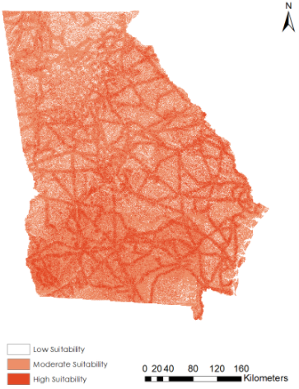*

Figure 3: Solar Development Potential Map of Georgia.

Based on models and ancillary datasets, we created an environmental sensitivity map that determined locations that corresponded well with known areas of conservation and habitats (Figure 4). We also indicated areas with the least environmental sensitivity, many of which are under urban areas and agricultural land throughout the state. Areas with the highest levels of environmental sensitivity were more concentrated in the southern areas of Georgia, which corresponded to the high levels of gopher tortoise habitat patches.

The most sensitive areas highlight areas where gopher tortoise habitats are known and expected in the Coastal Plain, as well as highlighting wetlands like the Okefenokee Swamp in southeast Georgia. In the northeastern region of Georgia, sensitive areas are located in the Appalachian Mountains. We also conducted further analysis on Decatur and Taylor Counties with additional layers such as streams and prime farmlands (Figure D2).

*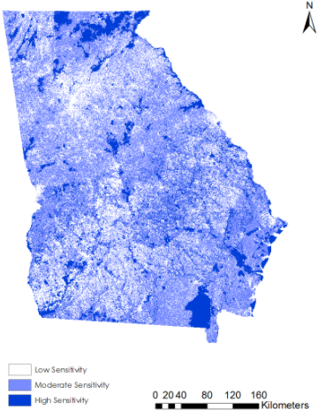*

Figure 4: Environmental Sensitivity Map of Georgia.

Using data from both the environmental sensitivity and solar development potential maps, we created a bivariate map that indicated areas where solar developmental and environmental interests overlap the most (Figure 5; Figure D3). The ideal scenario is represented by the orange areas which depict high solar farm development potential and low environmental suitability. On the contrary, blue areas depict high environmental sensitivity and low solar development potential.

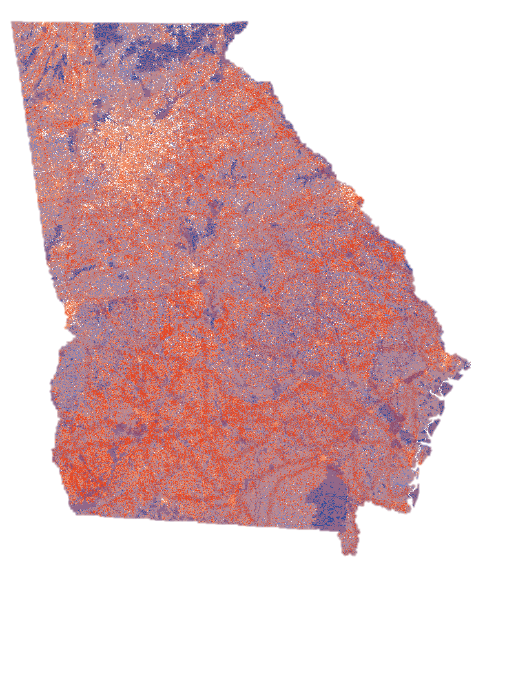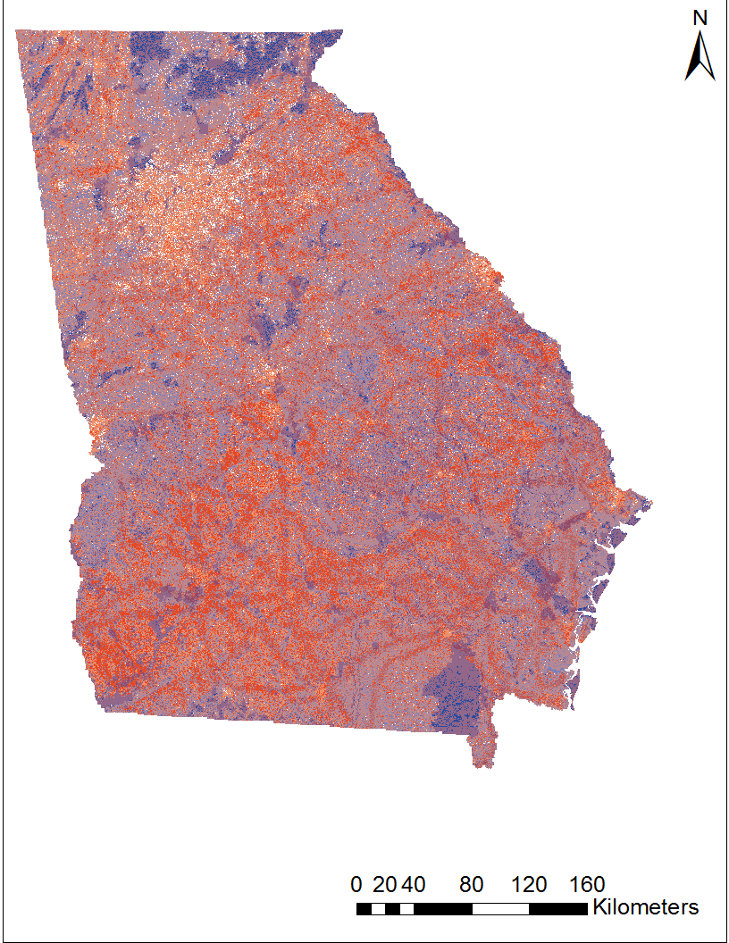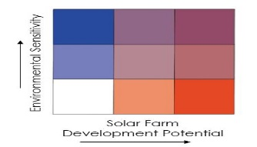

Solar Farm

Development Potential

Environmental Sensitivity

Figure 5: Bivariate Map of Georgia

After further reclassification of the bivariate map, our suitability map depicted highly suitable areas for solar development in the southern regions of the state (Figure 6). Military bases were highlighted to indicate that although solar farm construction may be possible in these locations, there may be certain restrictions on building sites. Similar maps were produced for Decatur and Taylor counties (Figure D4).

*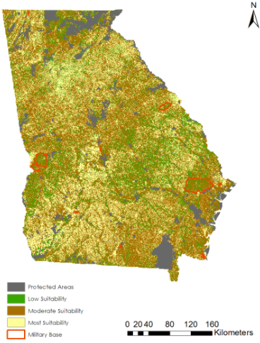*

Figure 6: Suitability Map of Georgia

Statewide, 24% of solar farm development occurred on land classified as Grassland/Pasture and 21% on Evergreen Forest (Table E1). In Decatur County, 57% of all solar farm area utilized land previously classified as Evergreen Forest (Table E2). In Taylor County, approximately 37% of solar farm area was installed on Grassland/Pasture and 23% on Hay/Non-Alfalfa (Table E3). This information is valuable in learning what land cover classes have been used for the development of solar farms in Georgia over the recent years.

***4.2 Future Work***

The first two terms of the Georgia Energy project delivered an initial statewide suitability analysis and handed off additional insights into broad suitability parameters, as well as a refined focus on Decatur and Taylor County. An additional term could expand on this foundation through one of the following directions: by adding focus counties based on locations deemed important by partners, expanding suitability analysis into economic and social factors in addition to physical ones, or by integrating more data into specific tools and outreach materials that developers and stakeholders can implement in their decision-making processes. Also, an additional layer for black bear habitats from data collected by Dr. Michael J. Chamberlain at the University of Georgia could be added to supplement the environmental sensitivity analysis.

Future work can also incorporate weather data. These data can be used to further identify areas with suitable solar insolation conditions for solar farm siting. It is possible to use shortwave surface flux from Terra CERES to include different weather conditions and account for aerosol intervention and diffused flux effect.

With the updated model from this term, increasing collaboration with solar development authorities would be beneficial to achieving the goal of an environmentally oriented solar farm development. This collaboration will help accurately assess the solar developers’ perspective as well as gain insight on how developers currently site solar farms. Knowing the criteria of a utility developer will further help the environmental stakeholders and the solar farm developers form a close partnership to better site solar development sites. Further, the future term has room for emphasizing in different areas within Georgia as well as include additional layers onto the model to add to the analysis of suitability for solar development. In addition, the possibility of expanding the analysis to urban regions of the state can be explored after getting input from stakeholders.

# 5. Conclusions

Georgia has one of the fastest growing solar industries in the United States. The staggering growth of solar development is promising, however, there are environmental concerns regarding environmentally sensitive ecosystems throughout the state. Through our analysis, we found that the southern regions of the state have higher potential for solar development due to its landscape and insolation received in relation to the northern regions. In addition, regions that were closer in proximity to the transmission lines showed higher suitability for solar development.

Comparing the two counties in terms of solar farm suitability, we found that Decatur county had more areas that were highly suitable than Taylor county. Our suitability map also indicated that majority of the existing solar farms in the counties were under areas of high potential for solar development and low environmental sensitivity. These farms are prime examples of solar farm development with minimal environmental impact. The working model this project provides is an adaptable tool that can aid environmental stakeholders and solar developers in selecting optimal sites for solar farms while protecting sensitive habitats. Project partners can use these tools to bring environmental stakeholders and solar developers together to promote sustainable solar farm development in Georgia.

# 6. Acknowledgments

The Georgia Energy II Team would like to acknowledge their science advisor Dr. Marguerite Madden at UGA. The team would also like to thank their partners, Cassidy Jordan at The Nature Conservancy, and Matt Elliot at the Georgia Department of Natural Resources, for their continuous involvement with the project and communication during the summer project term. Additionally, the team would like to thank Caren Remillard, (GA Center Lead) and Lynn Abdouni (Term I Team Lead) for their timely support and feedback.

Any opinions, findings, and conclusions or recommendations expressed in this material are those of the author(s) and do not necessarily reflect the views of the National Aeronautics and Space Administration.

This material is based upon work supported by NASA through contract NNL16AA05C and cooperative agreement NNX14AB60A.

# 7. Glossary

**Earth observations** **–** Refers to satellites and sensors that collect information about the Earth’s physical, chemical, and biological systems over space and time

**CERES –** Clouds and the Earth’s Radiant Energy System

**CVIOG** - Carl Vinson Institute of Government

**GADNR –** Georgia Department of Natural Resources

**Landsat –** A joint NASA and U.S. Geological Survey (USGS) mission; the observatory consists of the spacecraft bus and its play load of two Earth-observing sensors

**LUCIS –** Land Use Conflict Identification Strategy

**OLI –** Operational Land Imager

**STATSGO –** Digital General Soil Map of the United States

**Terra –** An Earth science satellite that provides global data on the condition of the atmosphere, land, and oceans, as well as their interactions with solar radiation and with one another

**TNC –** The Nature Conservancy

**USFWS –** United States Fish and Wildlife Service

# 8. References

CERES Science Team. (2015). CERES Level 3 SYN1DEGDAYTerra+Aqua netCDF file, Edition 3A.

NASA Atmospheric Science Data Center, accessed 30 June 2017. doi://10.5067/Terra+Aqua/CERES/SYN1degDAY\_L3.003A

Chapman, D. (2017). “Boosting the gopher tortoise,” US Fish and Wildlife Services. Retrieved September 28, 2017, from https://www.fws.gov/southeast/articles/boosting-the-gopher-tortoise/

Georgia Energy Data - Solar Map. (n.d.). Retrieved from http://www.georgiaenergydata.org/solarmap

Hart, D. (2008). Smart Land-Use Analysis: The LUCIS Model: Land-Use Conflict Identification

Strategy. *Journal of the American Planning Association, 75*(1), 89. https://doi.org/10.1080/01944360802540125

Hernandez, R., Easter, S., Murphy-Mariscal, M., Maestre, F., Tavassoli, M., Allen, M. (2014). Environmental impacts of utility-scale solar energy. *Renewable and Sustainable Energy Reviews, 29*, 766-779. doi:10.1016/j.rser.2013.08.041

Jafari, N., Nuse, B. L., Moore, C. T., Dilkina, B., Hepinstall-Cymerman, J. (2017). Achieving full connectivity of sites in the multiperiod reserve network design problem. *Computers & Operations Research, 81,* 119-127. ISSN 0305-0548, http://dx.doi.org/10.1016/j.cor.2016.12.017.

Natural Resources Conservation Service. (n.d.). Retrieved from https://www.nrcs.usda.gov/wps/portal/nrcs/detail/soils/survey/geo/?cid=nrcs142p2\_053629

Ong, S., Campbell, C., Denholm, P., Margolis, R., & Heath, G. (2013). Land-Use Requirements for Solar Power Plants in the United States. Retrieved from https://www.osti.gov/scitech/biblio/1086349 doi:10.2172/1086349

SEIA (2017). Retrieved from http://www.seia.org/research-resources/us-solar-market-insight

Southern Environmental Law Center (2017). Retrieved from https://www.southernenvironment.org/uploads/words\_docs/Solar\_EnvReviewProcess\_SitingSolar\_Final.pdf

US Department of Energy (2017). Retrieved https://energy.gov/eere/solarpoweringamerica/solar-energy-united-states

U.S. Geological Survey Earth Resources Observation and Science Center. (2014). Provisional Landsat OLI Surface Reflectance. US Geological Survey. https://doi.org/10.5066/F7KD1VZ9

Uyan, M. (2013). GIS-based solar farms site selection using analytic hierarchy process (AHP) in Karapinar region, Konya/Turkey. *Renewable and Sustainable Energy Reviews, 28*, 11-17. doi:10.1016/j.rser.2013.07.042

# 9. Appendices

**Appendix A**

Ancillary dataset used for analysis

|  |  |
| --- | --- |
| **Dataset** | **Source** |
| Solar insolation | NASA CERES |
| Land cover | USDA CropScape |
| Gopher tortoise habitat | Warnell School of Forestry |
| Black bear habitat | Warnell School of Forestry |
| Protected lands | GADNR |
| Granite rock outcrops | NRCS |
| Prime farmland | USDA NRCS |
| Streams | USFWS |
| Digital Elevation Model (DEM) | CVIOG |
| Slope | CVIOG |
| Aspect | CVIOG |
| Parcel | Georgia Clearing House |
| Floodplains | Georgia Clearing House |
| Roads | Georgia Clearing House |
| Transmission Lines | TNC |
| Existing Solar Farms in Georgia | Southface Energy Institute |

**Appendix B**

LUCIS Criteria Matrix for the state of Georgia

|  |  |  |  |  |  |  |  |  |  |  |  |
| --- | --- | --- | --- | --- | --- | --- | --- | --- | --- | --- | --- |
| Table B1: Solar Farm Criteria - Georgia | | | | | | | | | | | |
| **Goal** | | **Weight** | | **Objective** | **Weight** | **Criteria** | | **Rank-ing** | **Method** | **Data** | **Source** |
| Identify Suitable Solar Farm Sites in Georgia | | 50 | | Locate on proper aspect | 20 | Least Suitable: North, west, and east facing slopes. | | 1 | Derive aspect from DEM and reclassify. | DEM  30 m | CVIOG |
|  | | Moderately Suitable: Southwest and southeast facing slopes. | | 2 |
|  | | Highly Suitable: South facing slopes and flat areas. | | 3 |
|  | | Locate on proper slope | 20 | Least Suitable: >5% slopes | | 1 | Derive slope from DEM and reclassify. | DEM  30 m | CVIOG |
|  | | Moderately Suitable: 2% - 5% slopes | | 2 |
|  | | Highly Suitable: Less than 2% slopes | | 3 |
|  | | Locate in areas with adequate solar insolation | 10 | Least Suitable: Lowest values | | 1 | Reclassify CERES data. | CERES 1 degree^2 | NASA |
|  | | Moderately Suitable: Moderate values. | | 2 |
|  | | Highly Suitable: Highest values | | 3 |
| Locate on proper land covers | 30 | Least Suitable: Water, wetland, and urban | | 1 | Reclassify CropScape data. | CropScape 30 m | USDA |
|  | | Moderately Suitable: Forest | | 2 |
| Highly Suitable: Pasture, barren, shrubland, and agriculture | | 3 |
| Locate on areas close to Transmission lines | 20 | Least Suitable: >2 miles  Moderately Suitable: 1- 2 miles  Highly Suitable: <1 miles | | 1 | Create buffers around transmission lines. | Transmission Line data | TNC |
| 2 |
| 3 |
| Table B2: Environmental Criteria – Georgia | | | | | | | | | | | |
| **Goal** | **Weight** | | **Objective** | | **Weight** | | **Criteria** | **Rank-ing** | **Method** | **Data** | **Source** |
| Protect Environmentally Sensitive Areas | 50 | | Avoid Environmental Sensitive Areas  (Gopher Tortoise Habitat, Protected Lands, Rock outcrops) | | 70 | | Least Sensitive: Areas where all of them show less sensitive | 1 | Raster analysis where it overlay the three factors and picks the highest number in the pixel | GT  Protected Lands  Rock outcrops | Warnell School of Forestry, DNR, NRCS and USDA |
| Moderately Sensitive: Areas where any of the three factors show moderate sensitivity | 2 |
| Highly Sensitive: Areas where any of the three factors show high sensitivity | 3 |
| Locate on proper land covers  Avoid environmentally sensitive land covers | | 30 | | Least Sensitive: Barren and urban | 1 | Reclassify CropScape data. | CropScape 30 m | USDA |
| Moderately Sensitive: Agriculture, pasture, and shrubland | 2 |
| Highly Sensitive: Water, wetland, and forest | 3 |
| \*https://www.nrcs.usda.gov/wps/portal/nrcs/detail/ga/soils/?cid=nrcs144p2\_021870 | | | | | | | | | | | |

**Appendix C.**

LUCIS Solar Farm Criteria Matrix for County Level

|  |  |  |  |  |  |  |  |  |
| --- | --- | --- | --- | --- | --- | --- | --- | --- |
|  | | | | | | | | |
| **Goal** | **Weight** | **Objective** | **Weight** | **Criteria** | **Ranking** | **Method** | **Data** | **Source** |
| Identify Suitable Solar Farm Sites in Taylor County | 50 | Avoid floodplains | Decatur:  16  Taylor:  14 | Least Suitable: 100-year floodplain | 1 | Reclassify floodplain zones and buffer 100-year floodplain by 100 feet. | FEMA floodplain | Georgia State Clearinghouse |
| Moderately Suitable: 100 foot of the 100-year floodplain | 2 |
| Highly Suitable: Areas outside of the 100-year floodplain and 100 foot buffer | 3 |
| Locate on large parcels | Decatur:  Not available  Taylor:  14 | Least Suitable: <5 acres | 1 | Reclassify parcel data. | Taylor County parcel data | Georgia State Clearinghouse |
| Moderately Suitable: 5 - 13 acres | 2 |
| Highly Suitable: >13 acres | 3 |
| Locate near roads | Decatur:  16  Taylor:  14 | Least Suitable: >2 miles | 1 | Buffer roadways and reclassify. | Roads | Georgia State Clearinghouse |
| Moderately Suitable: 1 - 2 miles | 2 |
| Highly Suitable: <1 mile | 3 |
| Locate on proper aspect | Decatur:  16  Taylor:  14 | Least Suitable: North, west, and east facing slopes. | 1 | Derive aspect from DEM and reclassify. | DEM 10 m | CVIOG |
| Moderately Suitable: Southwest and southeast facing slopes. | 2 |
| Highly Suitable: South facing slopes and flat areas. | 3 |
| Locate on proper slope | Decatur:  16  Taylor:  14 | Least Suitable: >5% slopes | 1 | Derive slope from DEM and reclassify. | DEM 10 m | CVIOG |
| Moderately Suitable: 2% - 5% slopes | 2 |
| Highly Suitable: Less than 2% slopes | 3 |
| Locate on proper land covers | Decatur:  18  Taylor:  14 | Least Suitable: Water, wetland, and urban | 1 | Reclassify CropScape data. | CropScape 10 m | USDA |
| Moderately Suitable: Forest | 2 |
| Highly Suitable: Pasture, barren, shrubland, and agriculture | 3 |
|  | Decatur:  18  Taylor:  16 | Least Suitable: >2 miles | 1 | Create buffers around transmission lines. | Transmission Line data | TNC |
| Locate on areas close to Transmission lines | Moderately Suitable: 1- 2 miles | 2 |
|  | Highly Suitable: <1 miles | 3 |

**Appendix D**

County level maps

|  |  |
| --- | --- |
| C:\Users\crms\Downloads\Developmental_Decatur.png  *(a)* | *(b)*C:\Users\crms\Downloads\Taylor_Developmental.png |

*Figure* D1: Solar development potential map for (a) Decatur and (b) Taylor counties

|  |  |
| --- | --- |
| E:\GA_Energy II_Fall17\Final Maps_Map Package\Final Maps\Decatur County\Environmental_Decatur.png  *(a)* | *E:\GA_Energy II_Fall17\Final Maps_Map Package\Final Maps\Taylor County\Taylor_Environmental.png*  *(b)* |

*Figure* D2: Environmental sensitivity maps for (a) Decatur and (b) Taylor counties

|  |  |
| --- | --- |
| E:\GA_Energy II_Fall17\Final Maps_Map Package\Final Maps\Decatur County\Legend.JPG*E:\GA_Energy II_Fall17\Final Maps_Map Package\Final Maps\Decatur County\Bivariate_Decatur.png*  *(a)* | E:\GA_Energy II_Fall17\Final Maps_Map Package\Final Maps\Decatur County\Legend.JPGE:\GA_Energy II_Fall17\Final Maps_Map Package\Final Maps\Taylor County\Taylor_Bivariate.png *(b)* |

*Figure* D3: Bivariate maps for (a) Decatur and (b) Taylor counties

|  |  |
| --- | --- |
| E:\GA_Energy II_Fall17\Final Maps_Map Package\Final Maps\Decatur County\Suitability_Decatur.png  *(a)* | *E:\GA_Energy II_Fall17\Final Maps_Map Package\Final Maps\Taylor County\Taylor_Suitability.png*  *(b)* |

*Figure* D4: Solar farm suitability maps for (a) Decatur and (b) Taylor counties

**Appendix E**

Land Use Land Cover (LULC) used for existing solar farm production

Table E1: LULC used for Solar Energy Production (2010-2016) for Georgia

|  |  |
| --- | --- |
| **USDA Cropscape LULC Class** | **Total % Cover** |
| Grassland/Pasture | 24.044 |
| Evergreen Forest | 20.702 |
| Other Hay/Non-Alfalfa | 11.476 |
| Fallow/Idle Cropland | 11.334 |
| Shrubland | 8.536 |
| Deciduous Forest | 4.202 |
| Cotton | 3.397 |
| Mixed Forest | 2.739 |
| Peanuts | 2.368 |
| Woody Wetlands | 1.961 |
| Oats | 1.550 |
| Developed/Open Space | 1.385 |
| Barren | 1.285 |
| Soybeans | 1.038 |
| Pecans | 0.823 |
| Developed/Low Intensity | 0.782 |
| Corn | 0.658 |
| Developed/Med Intensity | 0.521 |
| Herbaceous Wetlands | 0.352 |
| Millet | 0.128 |
| Developed/High Intensity | 0.119 |
| Peaches | 0.119 |
| Herbs | 0.082 |
| Sod/Grass Seed | 0.078 |
| Rye | 0.078 |
| Dbl Crop WinWht/Soybeans | 0.069 |
| Winter Wheat | 0.069 |
| Sorghum | 0.046 |
| Watermelons | 0.014 |
| Blueberries | 0.014 |
| Open Water | 0.014 |
| Canola | 0.005 |
| Christmas Trees | 0.005 |
| Greens | 0.005 |
| Olives | 0.005 |

Table E2: LULC used for Solar Energy Production (2013-2016) for Decatur County

|  |  |
| --- | --- |
| **USDA CropScape Class** | **Total % Cover** |
| Evergreen Forest | 57.718 |
| Fallow/Idle Cropland | 10.128 |
| Peanuts | 9.872 |
| Cotton | 6.705 |
| Grassland/Pasture | 6.147 |
| Developed/Med Intensity | 2.049 |
| Developed/Low Intensity | 1.769 |
| Deciduous Forest | 1.467 |
| Developed/Open Space | 0.978 |
| Woody Wetlands | 0.908 |
| Mixed Forest | 0.605 |
| Developed/High Intensity | 0.559 |
| Shrubland | 0.489 |
| Corn | 0.210 |
| Other Hay/Non Alfalfa | 0.116 |
| Pecans | 0.116 |
| Sod/Grass Seed | 0.093 |
| Herbaceous Wetlands | 0.047 |
| Soybeans | 0.023 |

Table E3: LULC used for Solar Energy Production (2014-2016) for Taylor County

|  |  |
| --- | --- |
| **USDA CropScape Class** | **Total % Cover** |
| Grassland/Pasture | 36.793 |
| Other Hay/Non-Alfalfa | 23.031 |
| Fallow/Idle Cropland | 11.602 |
| Oats | 6.307 |
| Shrubland | 4.625 |
| Soybeans | 4.128 |
| Evergreen Forest | 3.765 |
| Deciduous Forest | 3.593 |
| Cotton | 1.854 |
| Barren | 0.593 |
| Developed/Open Space | 0.459 |
| Developed/Med Intensity | 0.420 |
| Peaches | 0.382 |
| Winter Wheat | 0.363 |
| Developed/Low Intensity | 0.363 |
| Pecans | 0.325 |
| Peanuts | 0.268 |
| Mixed Forest | 0.248 |
| Rye | 0.248 |
| Sorghum | 0.153 |
| Corn | 0.134 |
| Sod/Grass Seed | 0.134 |
| Dbl Crop WinWht/Soybeans | 0.076 |
| Watermelons | 0.057 |
| Developed/High Intensity | 0.038 |
| Herbs | 0.019 |
| Herbaceous Wetlands | 0.019 |