**NASA DEVELOP National Program**



Mobile County Health Department & NASA Marshall Space Flight Center

*Summer 2017*

Coastal Alabama Oceans

Using NASA Earth Observations to Evaluate Water Quality in Coastal Alabama to Enhance Marine Wildlife Management

**Technical Report**

Final Draft – August 10, 2017

Mercedes Bartkovich (Project Co-Lead)

Xin Hong (Project Co-Lead)

Leah Parker

Amy Schwarber

Bernard Eichold II, M.D., Dr. PH, Mobile County Health Department (Mentor)

Dr. Jeffrey Luvall, NASA Marshall Space Flight Center (Science Advisor)

Dr. Robert Griffin, University of Alabama in Huntsville (Science Advisor)

Dr. Maury Estes, University of Alabama in Huntsville (Science Advisor)

Joseph Spruce, NASA Langley Research Center (Science Advisor)

Dr. Kenton Ross, NASA Langley Research Center (Science Advisor)

Leigh Sinclair, University of Alabama in Huntsville, Information Technology and Systems Center (Mentor)

# 1. Abstract

The Mobile Bay and Mississippi Sound are the main coastal estuaries along the Alabama and Mississippi Gulf Coast. They serve as the primary drainage outlets for the Mobile Bay and Pascagoula River watersheds and provide a gradient of coastal water salinity conditions needed for a diversity of wildlife species and coastal habitat types. Coastal water “health” conditions have a direct impact on the native biota that are sensitive to water quality, including the Eastern oyster (*Crassostrea virginica*), a keystone species, and the West Indian manatee (*Trichechus manatus*), a vulnerable species. This project addressed the dynamic coastal ecosystem by creating time series analyses to monitor salinity, temperature, and turbidity changes for the Mobile Bay and Mississippi Sound from June 2007 to May 2017. The Aqua Moderate Resolution Imaging Spectroradiometer (MODIS) was used to detect salinity and sea surface temperature, while Landsat 5, Landsat 8, and Sentinel-2 Multispectral Instrument (MSI) data were employed to map and assess turbidity and sea surface temperature fluctuations. Such data products were also used to compute habitat suitability maps for oysters and manatees in the Mobile Bay and Mississippi Sound for assessing optimal areas for aiding habitat restoration initiatives. Project partners will use product results to better understand manatee movements and habitat suitability for oysters.

**Keywords**

MODIS, Landsat, Sentinel-2, habitat suitability analysis, Mobile Bay, Mississippi Sound, oysters, manatees

# 2. Introduction

* 1. ***Background Information***

The Mobile Bay and Mississippi Sound have historically provided vital habitat for an array of wildlife species, including oysters and manatees. Located on the southern coast of Alabama, Mobile Bay is an estuary that drains into the Gulf of Mexico. This area is regarded a wildlife biodiversity hot spot with over 1,600 species of invertebrates, fish, amphibians, reptiles, birds, and mammals (“The Mobile Bay Watershed,” 2015). The Mississippi Sound, located on the coast of Jackson County, Mississippi, is a 90-mile-long intercoastal waterway that is removed from the Gulf of Mexico by sandbars and Dauphin, Petit Bois, Horn, East and West Ship, and Cat Islands (“Northern Mississippi Sound,” 2013). The health of these estuaries can have both direct and indirect effects on marine wildlife, commercial fisheries, and recreational activities.

The Eastern oyster (*Crassostrea virginica*) is a coastal species in the Mobile Bay and Mississippi Sound area that is considered a keystone species because of its unique abilities that enhance and stabilize ecosystem quality. By filtering 50 gallons of water daily, oysters dramatically improve water quality, regulate nutrients and microorganisms in the water, and increase water clarity (Orff, 2013; Baggett et al., 2015). Oysters increase surface area for habitats and consequently increase biological diversity by arranging themselves in complex, irregular conglomerates on the seafloor (Orff, 2013). Through shoreline stabilization and wave attenuation, oysters are also able to mitigate storm surge effects (Orff, 2013). Additionally, oysters provide economic benefits such as providing nursery and foraging environments for fisheries and expanding the oyster industry, which includes cultivating, harvesting, transporting, processing, and serving the oysters (Kaplan, Olabarrieta, Frederick, & Valle-Levinson, 2016). Despite all of these benefits, oyster numbers in the Gulf of Mexico have decreased by 50-80% (Beseres Pollack, Cleveland, Palmer, Reisinger, & Montagna, 2012). Oyster reef destruction is mainly due to overfishing, natural disasters, land erosion, construction and development, dredging, water chemistry changes, climate change, and pollution (Kaplan et al., 2016).

Another coastal wildlife species that is found within the study area is the West Indian manatee (*Trichechus manatus*), which is classified as vulnerable by the International Union for Conservation of Nature (IUCN) Red List. Less than 7,000 manatees remain in US waters and suitable habitat is decreasing each day (Deutsch, Sullivan, & Mignucci-Giannoni, 2008). Manatee migration is correlated directly to salinity and temperature levels, and recently they have been found stranded along the coastline due to the rapid changes of these water quality parameters (Swain & Decker, 2009). As a result, local research organizations seek more precise and economical water quality measurements than their current methods in order to analyze the movement patterns of these mammals.

Coastal water variables such as sea surface temperature (SST), turbidity, and salinity contribute to habitat health and marine animal patterns in this region. To produce reliable and beneficial data for these research initiatives, this project focused on analyzing water quality of the 1,065 mi² of water within Mobile Bay and Mississippi Sound from June 1, 2007 to May 31, 2017. Specifically, the study area reaches as far west as Horn Island, as far east as Perdido Pass, and includes the coastal waters north of the barrier islands (Figure 1).

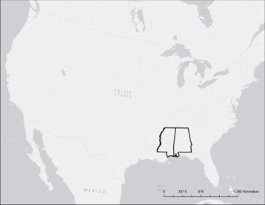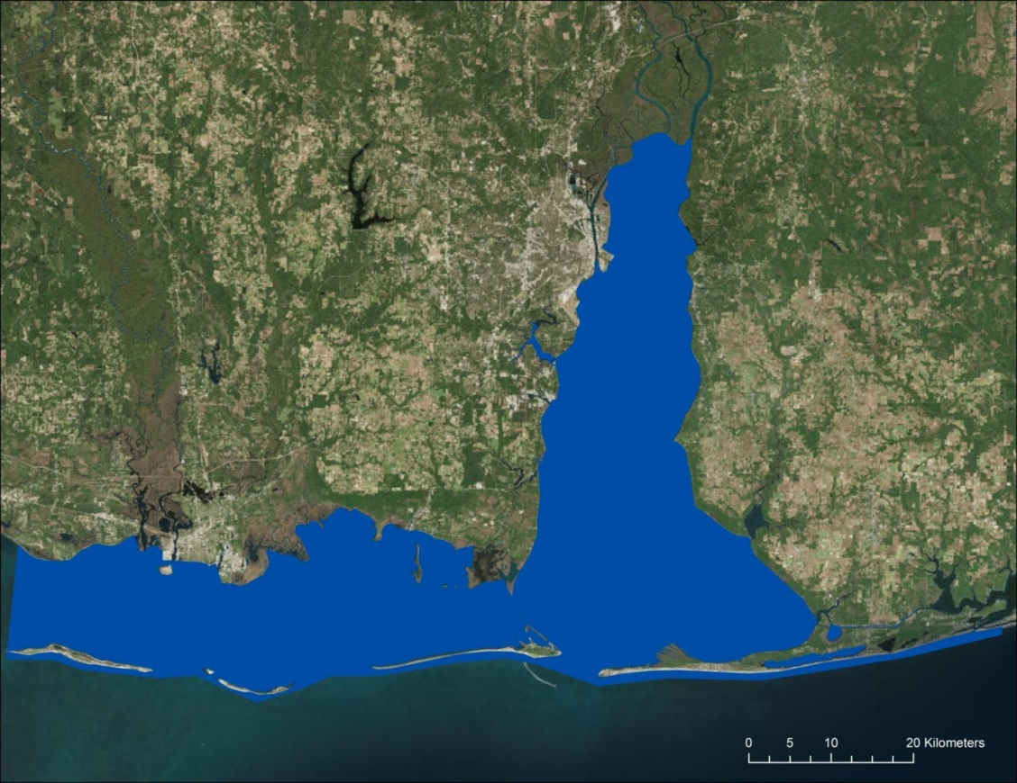

Mobile Bay

Study Area

Mississippi Sound

*Figure 1*. Project study area of the Mobile Bay and Mississippi Sound located within the Gulf of Mexico along the coastline of Alabama and Mississippi.

* 1. ***Project Partners & Objectives***

The Mobile Bay and Mississippi Sound provide vital water resources for the United States. The conservation and management of these resources are being aided by state and federal government agencies and the organizations that are partnering with this project. The project partners include Mark Berte with the Alabama Coastal Foundation (ACF), Dina Knight with The Nature Conservancy (TNC), and Dr. Ruth Carmichael with Dauphin Island Sea Lab (DISL) and their Manatee Sighting Network.

The ACF, TNC, and DISL currently rely on field measurements and buoy data to collect and assess coastal water salinity, temperature, and turbidity measurements for management practices involving aquatic wildlife. The ACF is working on a restoration project that collects oyster shells from local restaurants and then places them back into coastal waters in hopes of reintroducing oyster habitat and creating a “living shoreline”. The ACF relies on their partners and the state for data and research. Federal and local councils decide which projects they will fund, which limits the ACF from pursuing certain research topics. To ensure this project’s broad impact, they will not only utilize information from the project themselves, but will use the information to educate the public and distribute the resulting products amongst their partners. Additionally, the DISL collects data from reported manatee sightings and tracking devices on certain manatees to study their movement patterns. They are currently researching ways to forecast manatee movement in the future, as well.

A major objective of this project was to produce spatiotemporal analyses for sea surface temperature, salinity, and turbidity that will allow for more accurate and economical water quality evaluations. Secondly, by combining the spatiotemporal analyses and defining the thresholds in which Eastern oysters and West Indian manatees thrive, three habitat suitability maps were created. The habitat suitability map for the Eastern oyster will provide the ACF and TNC with predictive locations of where to implement oyster restoration in order to obtain the highest probability of success. The high season and low season habitat suitability maps for the West Indian manatee will provide the DISL a predictive map of suitable water conditions that can be used to analyze manatee migration patterns in the past and forecast the locations of future sightings.

# 3. Methodology

***3.1 Data Acquisition***

This project used imagery from Aqua MODIS, Landsat 5 Thematic Mapper (TM), Landsat 8 Operational Land Imager (OLI), and Sentinel-2 Multispectral Instrument (MSI). More specifically, Aqua MODIS Ocean Color remote sensing reflectance data were used to measure salinity, Aqua MODIS Ocean Color SST products were used to detect SST, and Landsat 5 TM, Landsat 8 OLI, and Sentinel-2 MSI were used to examine turbidity.

Aqua MODIS Level-2 remote sensing reflectance data (MODIS_OC.2014.0) at 1 km resolution and Level-2 sea surface temperature products (MODIS_OC.2014.0) at 1 km resolution were acquired from the Goddard Space Flight Center’s Ocean Color website (NASA Goddard Space Flight Center, 2014) to estimate the salinity and SST of the study area. To improve temporal coverage of the study area for turbidity, images from multiple sources were combined as a constellation to fulfill the study period from 2007 to 2017. Landsat 5 TM scenes collected during 2007 and 2012, Landsat 8 OLI and Sentinel-2 MSI products acquired during 2013 and 2017 were used as the datasets for producing synoptic turbidity maps and analyses. Multiple scenes from Sentinel-2 MSI were used in order to cover the entire study area.

Salinity buoy data were obtained from Mobile Bay National Estuary Program (MBNEP), the Mississippi Department of Marine Resources (MDMR), and Gulf of Mexico Coastal Ocean Observing System (GCOOS). Turbidity buoy measurements were acquired from the Alabama Department of Environmental Management (ADEM). MBNEP, DISL, the National Data Buoy Center (NDBC),GCOOS, the United States Geological Survey (USGS), and ADEM buoys provided *in situ* data for SST (Figure 2 & Table A1). Certain buoys recorded water quality measurements every 15 minutes, but a daily average was calculated for all buoys to allow for consistency.

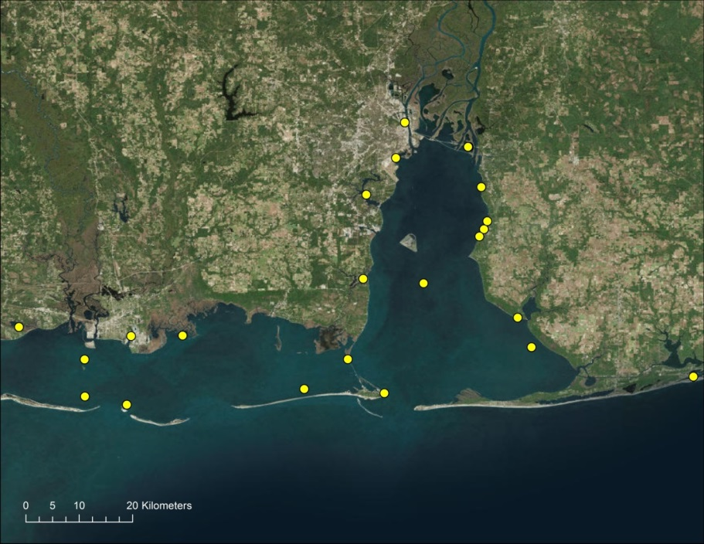

Buoy Locations



*Figure 2*. Buoy locations for salinity, sea surface temperature, and turbidity measurements in Mobile Bay and Mississippi Sound.

Buoy Locations

***3.2 Data Processing***

***3.2.1 Aqua MODIS data process for retrieving salinity***

After data acquisition, Aqua MODIS Ocean Color remote sensing reflectance data were loaded into SeaDAS for reprojection into a Universal Transverse Mercator Zone 16 map projection (North American Datum 1983) and each band was exported as a tiff file. These files were then processed in ESRI’s ArcMap to compute the Lemieux (2013) salinity algorithm using the Raster Calculator tool (Equation 1).

$\text{Remote Sensing Reflectance Ratio=}\frac{\text{667nm}}{\text{488nm}}$ (1)

To test the validity of the remote sensing reflectance ratio, thirty random days were chosen between 2012 and 2017 and were compared to the measurements from 13 corresponding salinity buoy sensors (Table B1) located at least 1 km away from land. The resulting test produced an R2 of 0.52 (n=287) for the entire study area over the 5 year period (Figure 3).

*Figure 3*. Linear regression comparing salinity data from buoys to Lemieux (2013) remote sensing reflectance ratio of 30 random days from 2012 - 2017 (n = 287, R2 = 0.52).

***3.2.2 Sea surface temperature retrieval***

Sea surface temperature products from the Aqua MODIS sensor were processed by the NASA Ocean Biology Processing Group (OBPG). The OBPG computed the SST products to Level-2 at 1 km resolution, and they were generated by the short-wave algorithm, which makes use of bands 22 and 23 at 3.959 and 4.050 µm, and the long-wave algorithm, which makes use of bands 31 and 32 at 11 and 12 µm (Franz, 2006).

To assess the validity of the MODIS SST products and processing techniques, data from 4 randomly selected dates between 2008 and 2016 were compared to corresponding measurements from 24 buoy sensors located around the Mobile Bay and the Mississippi Sound (Table A1 & D1). A linear regression was done to model the relationship between the SST data obtained from buoys and the SST data obtained from NASA Earth observations (EO) products. An R2 of 0.867 (n = 37) was produced, indicating a high correlation between the data sets (Figure 4).

*Figure 4*. Linear regression comparing sea surface temperature data from buoys to Aqua MODIS Ocean Color Sea Surface Temperature product of four random days in 2008 and 2016 (n = 37, R2 = 0.87).

***3.2.3 Turbidity retrieval***

According to literature, turbid estuarine water can be detected in the 0.63-0.69 µm and 0.75-0.9 µm channels. Turbid water is the source of approximately 80% of the reflectance signals in the 0.63-0.69 µm channel and between 70% - 90% of the reflectance signals in the 0.75-0.9 µm channel (Doxaran, Froidefond, Lavander, & Castaing, 2002). Therefore, Band 3 (red) and Band 4 (the Near Infrared Band), from Landsat 5 TM at 30-m resolution were used to retrieve turbidity between 2007 and 2013. Bands 1, 2, and 3 of Landsat 8 OLI at 0.43-0.45 µm, 0.45-0.51 µm, and 0.53-0.59 µm channels at 30 m resolution captured during 2013 and 2017, and Bands 4 and 8 of Sentinel-2 at 0.665 µm and 0.842 µm at 10 m resolution taken between 2015 and 2017 were applied to examine the turbidity during 2013 and 2017. Software ACOLITE v. 20170718.0 with the Dogliotti et al. (2015) algorithm was utilized to compute the turbidity estimation from the aforementioned satellite images. Turbidity measurements in this study were reported in the Formazin Nephelometric Unit (FNU), which is specified by the United States Environmental Protection Agency (EPA).

The turbidity products were validated using seven randomly selected buoys surveyed by ADEM (Table A1 & D1). The turbidity data from the seven buoys were collected on January 09, 2007. This was the only date that had both turbidity buoy data and EO images. A linear regression model was generated to compare the correlation between the ground truth turbidity and the estimated turbidity. The R2 of the regression is 0.88 (n=7), which implies a strong accuracy of the estimated turbidity products inquired from the EO images (Figure 5).

*Figure 5*. Linear regression comparing turbidity data from buoys to Dogliotti et al. (2015) turbidity algorithm results of one day from 2007 (n = 7, R2 = 0.88).

***3.3 Data Analysis***

***3.3.1 Spatiotemporal change detections for salinity, sea surface temperature, and turbidity***

Twenty-five dates of data from June 1, 2007 to May 31, 2008 and 42 days from June 1, 2016 to May 31, 2017 were chosen for the salinity and SST time series, while one day within June 1, 2007 to May 31, 2008 and five days within June 1, 2016 to May 31, 2017 were chosen for the turbidity time series (Table C1). These dates were chosen using a 10% or less cloud cover filter. After all data were processed, ArcMap was used to realign the pixel values for each day and reclassify the No Data value for SST and salinity. The average for each water quality parameter between 2007-2008 and 2016-2017 were then calculated using Cell Statistics Mean tool. Lastly, the Image Analysis Difference tool was used to compute the difference between the 2007-2008 average and the 2016-2017 average for salinity, SST, and turbidity.

***3.3.2 Habitat suitability analyses***

The Fuzzy Logic Model in ArcMap was used to assess the habitat suitability of the study area for both Eastern oysters and West Indian manatees from 2016 to 2017. Additionally, two seasonal suitability maps were created for the West Indian manatee. Manatees are impacted by a number of seasonal variables that influence their migration patterns. Manatees can be seen in Alabama and Mississippi during their peak season from June 1 to October 31, while fewer can be seen during the low season between November 1 and March 30 (“Alabama Manatees ‘Join The Club,’” n.d.). Salinity, SST, and turbidity measurements from 2016 to 2017 were calculated from multiple scenes and grouped into two themes, high and low seasons of habitat use frequency. Each parameter was averaged for both seasonal periods to generate one final map in each season for manatee habitat suitability. Oyster occurrence does not change seasonally; therefore, a single habitat suitability map was created for them based upon annual averages rather than seasonal.

Fuzzy Logic is a decision-making process involving two steps, the Fuzzy Membership process and Fuzzy Overlay analysis (Environmental Systems Research Institute, Inc., 2016). Fuzzy Membership was assigned using the information in Table 1 which summarizes the optimal ranges of salinity, SST, and turbidity for the Eastern oyster and the West Indian manatee. For the oyster suitability map, Fuzzy Near membership was used for SST with 25 measured in Celsius (°C) as the midpoint and salinity with 20 measured in parts per thousands (PPT) as the midpoint, while a Linear membership was used for turbidity with 0 as a min and 50 as a maximum. For the manatee suitability map, linear memberships were used for all water quality parameters - for salinity, 0 was the minimum and 15 was the maximum, for SST, 20 was the minimum and 25 was the maximum, and for turbidity, 30 was the minimum and 90 was the maximum. Once all memberships were assigned, the Fuzzy Overlay “And” tool was then used in ArcMap to combine the 3 parameters together to output the habitat suitability maps for each species. Manatee sighting data was added to assess the accuracy of the manatee habitat suitability map. This is shown in Figure E1.

Table 1.

*The optimal habitat ranges of salinity, sea surface temperature, and turbidity for the Eastern oyster and West Indian manatee. Turbidity units are stated in Jackson turbidity units (JTU), which are an obsolete unit replaced by nephelometric turbidity units (NTU) which have higher precision and accuracy. JTU are approximately equivalent to both NTU and Formazin nephelometric units (FNU) (World Health Organization, 2017).*

|  |  |  |  |  |  |
| --- | --- | --- | --- | --- | --- |
|  | **Eastern Oyster** | | **West Indian Manatee** | |  |
|  | **Optimal Range** | **Membership Type** | **Optimal Range** | **Membership Type** | **Reference** |
| **Salinity** | 12-27 PPT | Fuzzy Near (20 PPT) | 0-35 PPT | Linear (0, 15) | Linhoss et al., 2016; “Freshwater,” 2017; Butler & Reid, 2004 |
| **Temperature** | 20-30°C | Fuzzy Near (20 °C) | >20°C | Linear (20, 25) | Cake, 1983; “West Indian,” 1999; Oceanic Research Group, 1994; |
| **Turbidity** | <50 FNU | Linear (0,50) | < 90 FNU | Linear (30, 90) | Cake, 1983; Teng et al., “How Does Increasing Water Temperature Affect Manatees?”, n.d. |

# 4. Results & Discussion

***4.1 Analysis of Results***

Increases and decreases in salinity, SST, and turbidity from 2007 to 2017 varied geographically. The most evident salinity changes occurred within the northern Mobile Bay (Figure 6A). Fifty-six percent of the total salinity change was within one PPT from the original value in 2007 and only 2% was greater than ten PPT increase or decrease. An overall decrease was found across the study area in the SST time series analysis, with only 15% of the study area experiencing an increase (Figure 6B). Ninety-four percent of the decreases ranged within 2°C of the original values in 2007, however, more notable decreases were present in the western Mississippi Sound. The turbidity time series analysis from 2007 to 2017 portrays distinct decreases in central Mobile Bay and near the northern coast of the Mississippi Sound, while increases were present in the eastern and southern parts of the Mobile Bay (Figure 6C).

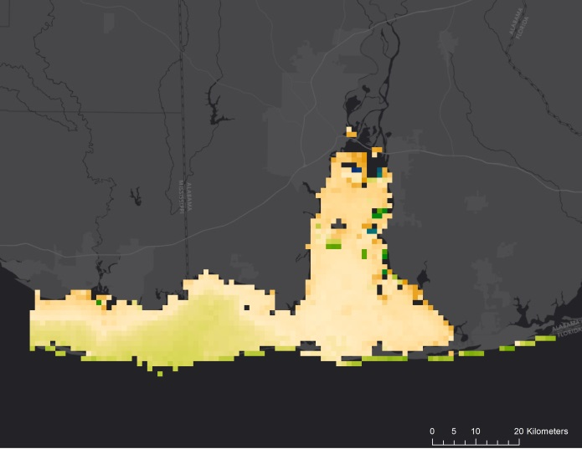 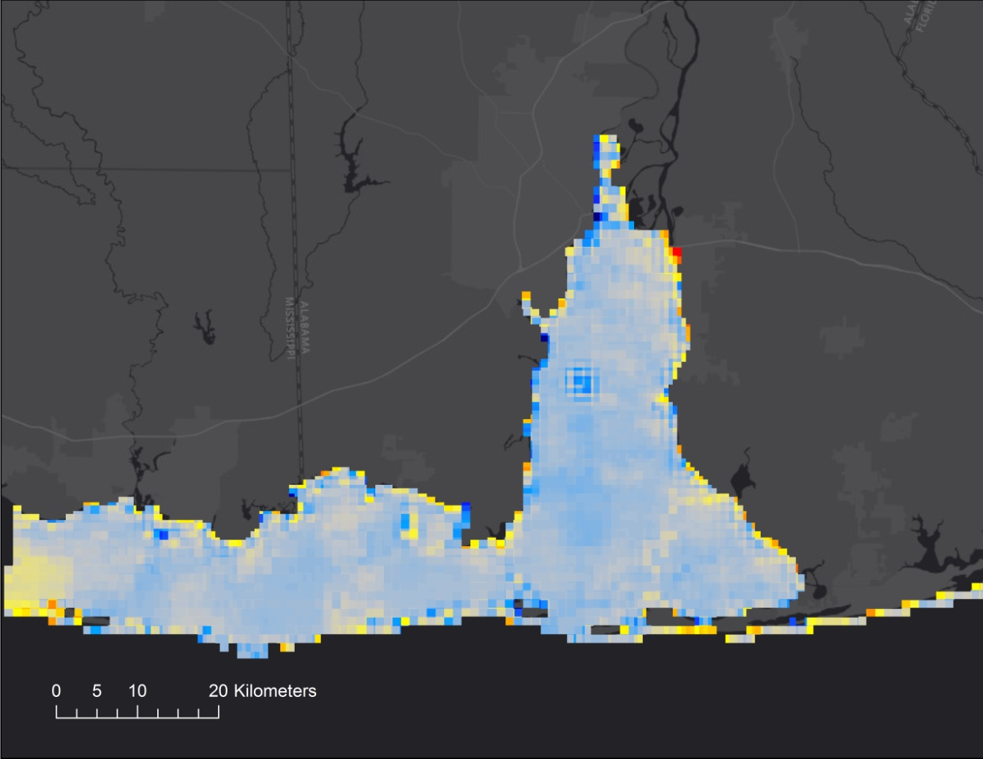

29.47

-26.71

Salinity Changes (PPT)



**A**

**B**

12.52

-12.81

Temperature Changes (°C)



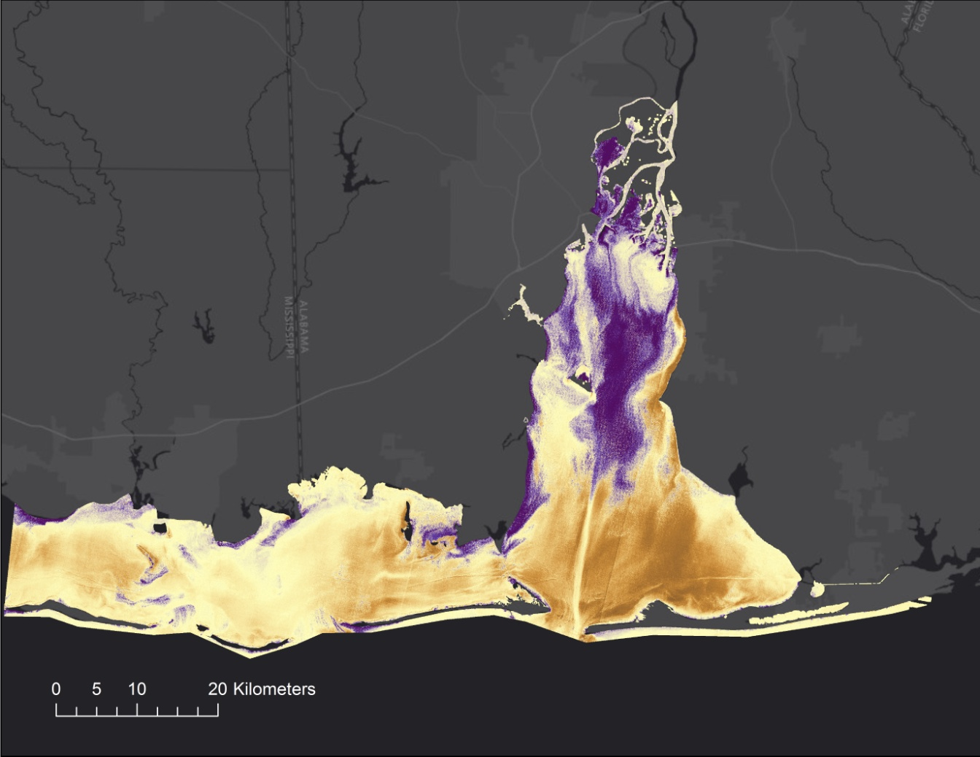

**C**

57.78

-66.10

Turbidity Changes (FNU)



*Figure 6*. Changes in salinity (A), sea surface temperature (B), and turbidity (C) levels within Mobile Bay and Mississippi Sound from 2007-2008 to 2016-2017 where the negative values represent a decrease and the positive values represent an increase.

The western Mississippi Sound and southern Mobile Bay are to be more suitable for Eastern oysters. The northern Mobile Bay, especially the delta area, have low suitability for oysters (Figure 7). During the peak season, June 1 to October 31, 2016, prime West Indian manatee habitat was found in the coastal areas of the study area where freshwater rivers drain into the Mobile Bay and Mississippi Sound (Figure 8A). The low season for manatee sightings within our study area includes November 1, 2016 to March 31, 2017, where the suitable habitat is limited to small areas along the coast of the Mississippi Sound and within the rivers of the northern Mobile Bay (Figure 8B). DISL’s manatee sighting data aligns with the suitable habitat areas that were established from NASA EO (Carmichael, 2016) (Figure E1).

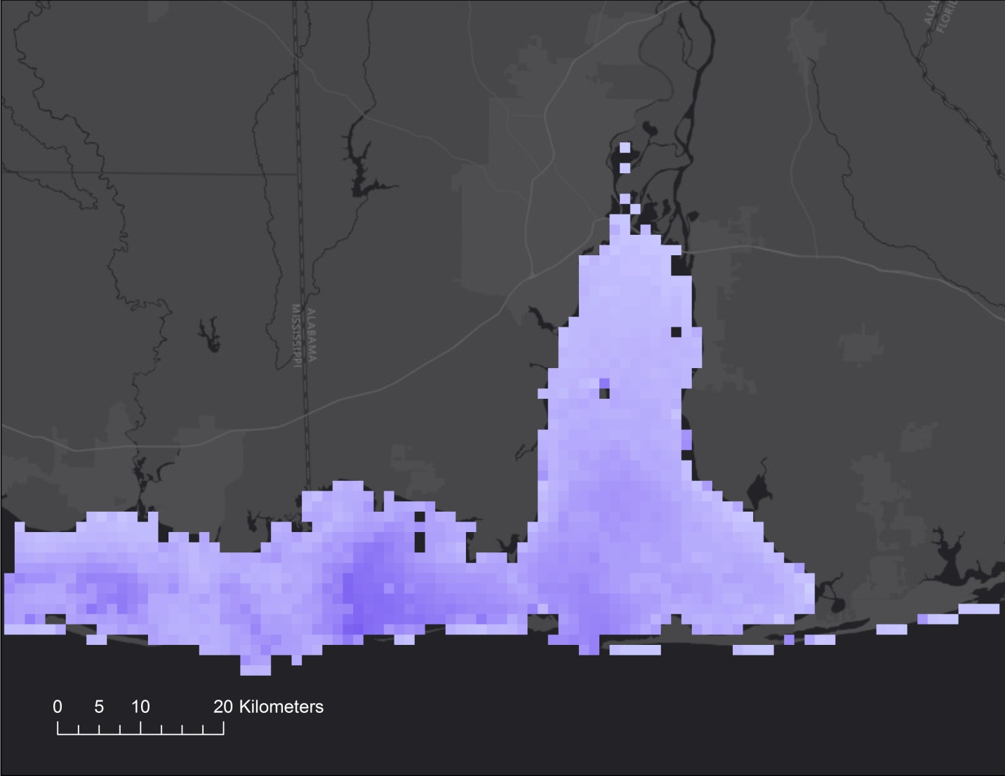



Higher

Lower

Habitat Suitability

*Figure 7*. Habitat suitability map for Eastern Oysters from June 1, 2016 to May 31, 2017 where the darker areas represent areas of higher suitability and the lighter areas represent areas of lower suitability.

**B**

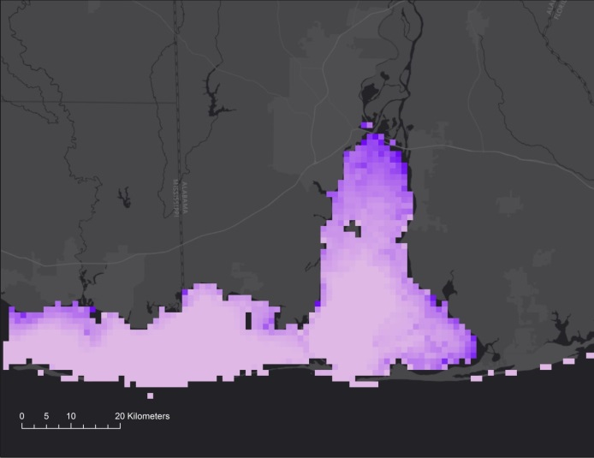 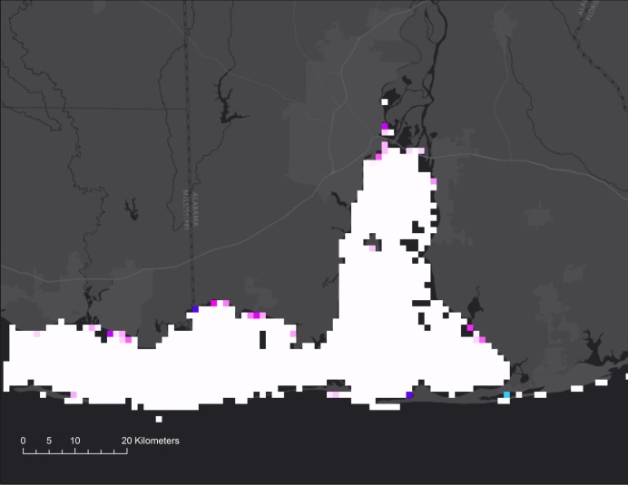



Higher

Lower

Low Season

Habitat Suitability



Higher

Lower

High Season

Habitat Suitability

**A**

*Figure 8*. Habitat suitability map for West Indian manatees during the high season (A) (June 1 – October 31, 2016) and low season (B) (November 1, 2016 – March 31, 2017) where the darker areas represent areas of higher suitability and the lighter areas represent areas of lower suitability.

***4.2 Future Work***

Additional work needs to be performed to determine how realistic the mean annual salinity, turbidity, and SST maps are given the frequencies of cloud cover that occur in the region. Additional analysis of buoy data could help in making this determination. In the future, this project could be expanded to include variables such as water depth, precipitation and discharge, as well as the fluctuations of salinity, SST, and turbidity between individual years within the ten year time period. These additional data could be used to refine the suitability maps and could increase the ability to forecast future changes in water quality, and therefore, predict where optimal oyster and manatee habitat will be in the future. In addition, by incorporating weather patterns with this, researchers could better predict how seasonal changes in precipitation and natural disasters can alter habitat suitability and local water quality. For the suitability maps, comparisons to known occurrences of oysters and manatees could be made in a subsequent study.

Oyster restoration reefs are not only utilized for generating oysters, but also to improve erosion and water quality. By incorporating current turbid and eroded areas as variables that reefs could enhance, a restoration suitability map could be produced to depict zones that are beneficial not only for oyster production, but also for water quality and erosion. Another factor that could be used to better the oyster habitat suitability map is the exclusion of suitable habitat for the predatory oyster drill that destroys oyster reefs within our study area.

A key limitation in this project was the low spatial resolution of pixels, prohibiting the expansion of additional study area within the estuarine zones. By applying sensors with a higher resolution, a more precise analysis could be produced. For example, Suomi NPP VIIRS can be tested by applying the same salinity algorithm used with Aqua MODIS in order to generate a more accurate result with a higher resolution. Suomi NPP VIIRS and Landsat 8 OLI could also be applied to conduct SST analyses for the study area.

Another key limitation lies on the low temporal resolution of available data for turbidity estimation. This is acerbated by frequent cloud cover in the region, particularly in the late spring, summer, and early fall months. The turbidity time series analysis was limited by the availability of cloud-free images available for our study period and area, however, with the use of different, more frequent satellite sensors the change over time may be more accurately computed in the future. In addition, the location and relatively small amount of buoy locations can be a limitation. Many of the buoy locations were near the coastal shoreline which can be problematic for MODIS data at a 1 km resolution.

# 5. Conclusions

NASA EO were used to produce spatio-temporal estimates of salinity, SST, and turbidity in the Mobile Bay and Mississippi Sound. The Lemieux et al. (2013) salinity algorithm was validated with buoy data over a five year period and resulted in a R2 of 0.52 that could be improved with further seasonal statistical analysis. For example, when analyzed by buoy location or by date, the majority of R2s reflected that of 0.70, providing confidence in continuing use of this ratio to monitor salinity levels based on MODIS data (that has the needed spectral bands).

Useful geospatial data products were produced for aiding manatee wildlife management and oyster restoration. The oyster suitability map from the project showed that the west Mississippi Sound and south Mobile Bay comparatively more suitable for the eastern oyster habitat possibly more likely to produce a successful oyster restoration site.

The West Indian manatee habitat suitability map appears to be satisfactory for depicting manatee migration patterns in the Mobile Bay and Mississippi Sound. Using data from DISL, manatee sighting locations were added to the habitat suitability maps to visualize the overlay of sightings to suitable habitat (Figure E1). By using NASA EO with a higher spatial resolution and the necessary spectral bands, more suitable habitat could be mapped for the rivers that feed the coastal estuaries of the study area.

# 6. Acknowledgments

The Coastal Alabama Oceans team would like to thank the mentors and partners who dedicated their time and assistance to this project. Without any of them, this project would not have been possible.

Mentors & Science Advisors

* Bernard Eichold, M.D., Dr. PH, Mobile County Health Department
* Dr. Jeffrey Luvall, NASA Marshall Space Flight Center
* Dr. Robert Griffin, University of Alabama in Huntsville
* Dr. Maury Estes, University of Alabama in Huntsville
* Dr. Kenton Ross, NASA Langley Research Center
* Joseph Spruce, NASA Langley Research Center
* Leigh Sinclair, University of Alabama in Huntsville, Information Technology and Systems Center

Partners

* Mark Berte, Alabama Coastal Foundation
* Dina Knight, The Nature Conservancy
* Dr. Ruth Carmichael, Dauphin Island Sea Lab’s Manatee Sighting Network

Others

* Maggi Klug, NASA DEVELOP MSFC
* Dashiell Cruz, NASA DEVELOP MSFC
* Tyler Lynn, NASA DEVELOP MCHD
* Elaina Gonsoroski, NASA DEVELOP MCHD

Any opinions, findings, and conclusions or recommendations expressed in this material are those of the author(s) and do not necessarily reflect the views of the National Aeronautics and Space Administration.

This material is based upon work supported by NASA through contract NNL16AA05C and cooperative agreement NNX14AB60A.

# 7. Glossary

**Earth observations** – satellites and sensors that collect information about the Earth’s physical, chemical, and biological systems over space and time

**Keystone species** – a species in which other species depend on in an ecosystem

**Spatiotemporal changes** – the changes concerning in both space and time

**Biodiversity** – the diversity or variety of life within a given ecosystem

**Estuary** – brackish water which multiple rivers or streams flow into

**High Season** – the season when manatees are in abundance within the Mobile Bay and Mississippi Sound area

**Low Season** – the season when manatees are scarce within the Mobile Bay and Mississippi Sound area

# 8. References

Alabama Manatees “Join The Club” (n.d.). Retrieved July 19, 2017 from http://www.savethemanatee.org/news_feature_alabama_manatees_11.html

Baggett, L. P., Powers, S. P., Brumbaugh, R. D., Coen, L. D., DeAngelis, B. M., Greene J. K., … & zu Ermgassen, P. S. E. (2015). Guidelines for evaluating performance of oyster habitat restoration. *Restoration Ecology, 23(*6), 737-745.

Beseres Pollack, J., Cleveland, A., Palmer, T. A., Reisinger, A. S., & Montagna, P. A. (2012). A restoration suitability index model for the Eastern Oyster (*Crassostrea virginica*) in the Mission-Aransas Estuary, TX, USA. *PLoS ONE 7*(7), 1-11. doi:10.1371/journal.pone.0040839

Butler, S. & Reid, J. (2004). Saltiness of Manatee Habitats Changes with the Seasons Can That Affect Manatee Migration? Retrieved July 18, 2017 from https://www.learner.org/jnorth/tm/manatee/Salinity.html.

Cake, E. W. (1983). Habitat suitability index models: Gulf of Mexico American oyster. *U.S. Department of the Interior Fish and Wildlife Service*, 1-37.

Carmichael, R. H. (2016) *The West Indian manatee population in Mobile Bay, AL and surrounding waters (1912-2016)*. Dauphin Island Sea Lab: Data Management Center. Retrieved July 27, 2017 from http://cf.disl.org/datamanagement/metadata_folder/DISL-Carmichael-MSN-010-2016.xml

Dogliotti, A. I., Ruddickb, K. G., Nechadb, B., Doxaranc, D., & Knaeps, E. (2015). A single algorithm to retrieve turbidity from remotely-sensed data in all coastal and estuarine waters. *Remote Sensing of Environment, 156*(1), 157-168.

Doxaran, D., Froidefond, J., Lavender, S., & Castaing, P. (2002). Spectral signature of highly turbid waters: application with SPOT data to quantify suspended particulate matter concentrations. *Remote Sensing of Environment 81*(1), 149-161. doi:10.1016/S0034-4257(01)00341-8

Deutsch, C., Self-Sullivan, C., & Mignucci-Giannoni, A. (2008). Trichechus manatus. Retrieved June 22, 2017, from <http://www.iucnredlist.org/details/22103/0>

Environmental Systems Research Institute, Inc. (2016.) Applying fuzzy logic to overlay rasters. *ArcMap*. Retrieved August 8m 2017 from http://desktop.arcgis.com/en/arcmap/10.3/tools/spatial-analyst-toolbox/applying-fuzzy-logic-to-overlay-rasters.htm

Feldman, G. C. (n.d.). Ocean Color Web. Retrieved August 02, 2017, from https://oceancolor.gsfc.nasa.gov/

Franz, B. (2006). Implementation of SST processing within the OBPG. Earth Data. Retrieved June 25, 2017 from https://oceancolor.gsfc.nasa.gov/docs/modis_sst/

Freshwater. (2017) *New World Encyclopedia*, Retrieved June 27, 2017. <http://www.newworldencyclopedia.org/entry/Freshwater>

US Geological Survey Earth Resources Observation and Science Center. (2012). Provisional Landsat TM Surface Reflectance. US Geological Survey. doi: 10.5066/F7kd1vz9

US Geological Survey Earth Resources Observation and Science Center. (2014). Provisional Landsat OLI Surface Reflectance. US Geological Survey. doi: 10.5066/F78S4MZJ

How Does Increasing Water Temperature Affect Manatees? (n.d.). Retrieved July 18, 2017 from http://www.savethemanatee.org/faq_rising_temperatures.html.

Kaplan, D.A., Olabarrieta, M., Frederick, P., & Valle-Levinson, A. (2016). Freshwater detention by oyster reefs: quantifying a keystone ecosystem service. *PLoS ONE 11*(12), 1-12. doi:10.1371/journal.pone.0167694

Lemieux, P. A. (2013). Development of an Algorithm for Salinity Estimates in Mobile Bay Alabama and Mississippi Sound. *American Institute of Aeronautics and Astronautics*. Retrieved June 05, 2017.

Linhoss, A. C., Camacho, R., & Ashby, S. (2016). Oyster habitat suitability in the Northern Gulf of Mexico. *Journal of Shellfish Research 35(*4):841-849.

NASA Ocean Biology Processing Group. CZCS Level 2 Ocean Color Data Version 2014. NASA Ocean Biology DAAC. Accessed 11 July 2017. doi:10.5067/NIMBUS-7/CZCS_OC.2014.0.

NASA Ocean Biology Processing Group. MODIS-Aqua Level 2 Ocean Color Data Version 2014. NASA Ocean Biology DAAC. Accessed 11 July 2017. doi: 10.5067/AQUA/MODIS_OC.2014.0.

Northern Mississippi Sound and Mon Louis Island. (2013). *Alabama Gulf Ecological Management Site (GEMS),* [Retrieved June 22, 2017 from http://www.mobilebaynep.com/images/uploads/library/GEMS-NorthernMissSound.pdf](http://www.mobilebaynep.com/images/uploads/library/GEMS-NorthernMissSound.pdf)

Oceanic Research Group. (1994). Manatees and How they Live. Retrieved July 19, 2017 from http://www.oceanicresearch.org/education/films/manaspt.html.

Orff, K. (2013). Shellfish as living infrastructure. *Ecological Restoration, 31*(3), 317-322.

Swain, E. D., & Decker, J. D. (2009). Development, Testing, and Application of a Coupled Hydrodynamic Surface-Water/ Groundwater Model (FTLOADDS) with Heat and Salinity Transport in the Ten Thousand Islands/Picayune Strand Restoration Project Area, Florida. Retrieved June 28, 2017, from <https://pubs.usgs.gov/sir/2009/5146/>

Teng, W., Guoxiang, W., & Qiang, L. (2007). Effects of Water Turbidity on the Photosynthetic Characteristics of *Myriophyllum spicatum* L. *Asian Journal of Plant Sciences,* *6*(5), 773-780.

The Mobile Bay Watershed. (2015). *Mobile Baykeeper.*[Retrieved June 21, 2017 from http://www.mobilebaykeeper.org/watershed/](http://www.mobilebaykeeper.org/watershed/)

The Watershed. (2017). *Mobile Bay National Estuary Program.*[Retrieved June 21, 2017 from](http://www.mobilebaykeeper.org/watershed/) <http://www.mobilebaynep.com/the_landscape/watershed_map/>

West Indian Manatee. (1999). *Multi-Species Recovery Plan for South Florida,* Retrieved June 26, 2017 from <https://www.fws.gov/verobeach/MSRPPDFs/WestIndianManatee.pdf>

World Health Organization. (2017). Turbidity Measurement: the Importance of Measuring Turbidity. Retrieved August 3, 2017 from <http://www.who.int/water_sanitation_health/publications/envsanfactsheets/en/index1.html>

# 9. Appendices

APPENDIX A.

Table A1.

*Location of Buoys used to validate satellite data for salinity, sea surface temperature, and turbidity.*

|  |  |  |  |  |
| --- | --- | --- | --- | --- |
| **Name** | **Source** | **Water Quality Parameter** | **Latitude** | **Longitude** |
| Alba Club Dog River | ADEM | SST, Turbidity | 30.5864 | -88.1083 |
| Back Bay of Biloxi, Biloxi, MS | MDMR | Salinity | 30.2456 | -88.5833 |
| Back Bay of Biloxi, Biloxi, MS | USGS | SST | 30.4156 | -88.9758 |
| Biloxi Bay, Point Cadet Harbor | MDMR | Salinity | 30.2318 | -88.5126 |
| Bon Secour | MBNEP | Salinity, SST | 30.3287 | -87.8293 |
| BSCA1 | DISL - GCOOS | Salinity, SST | 30.3288 | -87.8293 |
| Cedar Point | MBNEP | Salinity, SST | 30.3085 | -88.1395 |
| Coast Guard Sector, Mobile, AL | GCOOS | SST | 30.6483 | -88.0583 |
| CRTA1 | GCOOS | SST | 30.3085 | -88.1395 |
| Dauphin Island | MBNEP | Salinity, SST | 30.2513 | -88.0778 |
| Dock E. Port of Pascagoula, MS | GCOOS | SST | 30.3477 | -88.5054 |
| DPHA1 | GCOOS | SST | 30.2513 | -88.0778 |
| Fairhope Beach | ADEM | SST, Turbidity | 30.5281 | -87.9096 |
| Fowl River at Hwy 193 | ADEM | SST, Turbidity | 30.4443 | -88.1136 |
| gndpcwq | NERRS - GCOOS | Salinity | 30.3486 | -88.4185 |
| Graveline Bayou, Gautier, MS | USGS | SST | 30.3629 | -88.6947 |
| KATA1 | DISL - GCOOS | Salinity, SST | 30.2583 | -88.2131 |
| Katrina Cut | MBNEP | Salinity, SST | 30.2583 | -88.2131 |
| Mary Ann Nelson Beach | ADEM | Turbidity | 30.3787 | -87.8528 |
| Mayday Park, Daphne, AL | ADEM | SST, Turbidity | 30.5992 | -87.9141 |
| MBLA1 | DISL - GCOOS | Salinity, SST | 30.4367 | -88.0117 |
| Meaher Park | MBNEP | SST | 30.6671 | -87.9353 |
| MHPA1 | GCOOS | SST | 30.6671 | -87.9365 |
| Middle Bay Lighthouse | MBNEP | Salinity, SST | 30.4367 | -88.0117 |
| Mississippi Sound at USGS Round Island Light | USGS | SST | 30.3081 | -88.5839 |
| Mobile State Docks | GCOOS | SST | 30.7083 | -88.0433 |
| Orange St. Pier, Fairhope, AL | ADEM | SST, Turbidity | 30.5158 | -87.9174 |
| Perdido Pass | MBNEP | Salinity | 30.2791 | -87.5561 |
| Voltana Ave., Fairhope, AL | ADEM | SST, Turbidity | 30.5415 | -87.9041 |

APPENDIX B.

Table B1.

*Julian dates and years associated with salinity validation analysis.*

|  |  |
| --- | --- |
| Year | Julian Date |
| 2012 | 14 |
| 2012 | 16 |
| 2012 | 135 |
| 2012 | 198 |
| 2012 | 263 |
| 2013 | 69 |
| 2013 | 162 |
| 2013 | 238 |
| 2013 | 252 |
| 2013 | 336 |
| 2014 | 39 |
| 2014 | 69 |
| 2014 | 99 |
| 2014 | 208 |
| 2014 | 266 |
| 2015 | 79 |
| 2015 | 125 |
| 2015 | 189 |
| 2015 | 285 |
| 2015 | 324 |
| 2016 | 6 |
| 2016 | 50 |
| 2016 | 114 |
| 2016 | 169 |
| 2016 | 345 |
| 2017 | 22 |
| 2017 | 41 |
| 2017 | 96 |
| 2017 | 110 |
| 2017 | 121 |

APPENDIX C.

Table C1.

*Julian Date and years used for time series analyses for salinity, sea surface temperature, and turbidity*.

|  |  |  |  |
| --- | --- | --- | --- |
| Satellite | Water Quality Parameter | Year | Julian Date |
| Aqua MODIS | SST & Salinity | 2007 | 160 |
| Aqua MODIS | SST & Salinity | 2007 | 164 |
| Aqua MODIS | SST & Salinity | 2007 | 180 |
| Aqua MODIS | SST & Salinity | 2007 | 192 |
| Aqua MODIS | SST & Salinity | 2007 | 203 |
| Aqua MODIS | SST & Salinity | 2007 | 219 |
| Aqua MODIS | SST & Salinity | 2007 | 233 |
| Aqua MODIS | SST & Salinity | 2007 | 272 |
| Aqua MODIS | SST & Salinity | 2007 | 281 |
| Aqua MODIS | SST & Salinity | 2007 | 285 |
| Aqua MODIS | SST & Salinity | 2007 | 288 |
| Aqua MODIS | SST & Salinity | 2007 | 317 |
| Aqua MODIS | SST & Salinity | 2007 | 327 |
| Aqua MODIS | SST & Salinity | 2007 | 331 |
| Aqua MODIS | SST & Salinity | 2007 | 365 |
| Aqua MODIS | SST & Salinity | 2008 | 39 |
| Aqua MODIS | SST & Salinity | 2008 | 41 |
| Aqua MODIS | SST & Salinity | 2008 | 54 |
| Aqua MODIS | SST & Salinity | 2008 | 85 |
| Aqua MODIS | SST & Salinity | 2008 | 90 |
| Aqua MODIS | SST & Salinity | 2008 | 104 |
| Aqua MODIS | SST & Salinity | 2008 | 117 |
| Aqua MODIS | SST & Salinity | 2008 | 140 |
| Aqua MODIS | SST & Salinity | 2008 | 145 |
| Aqua MODIS | SST & Salinity | 2008 | 147 |
| Aqua MODIS | SST & Salinity | 2008 | 151 |
| Landsat 5 TM | Turbidity | 2008 | 75 |
| Aqua MODIS | SST & Salinity | 2016 | 162 |
| Aqua MODIS | SST & Salinity | 2016 | 169 |
| Aqua MODIS | SST & Salinity | 2016 | 173 |
| Aqua MODIS | SST & Salinity | 2016 | 178 |
| Aqua MODIS | SST & Salinity | 2016 | 201 |
| Aqua MODIS | SST & Salinity | 2016 | 210 |
| Aqua MODIS | SST & Salinity | 2016 | 219 |
| Aqua MODIS | SST & Salinity | 2016 | 244 |
| Aqua MODIS | SST & Salinity | 2016 | 251 |
| Aqua MODIS | SST & Salinity | 2016 | 253 |
| Aqua MODIS | SST & Salinity | 2016 | 260 |
| Aqua MODIS | SST & Salinity | 2016 | 272 |
| Landsat 8 OLI | Turbidity | 2016 | 274 |
| Aqua MODIS | SST & Salinity | 2016 | 281 |
| Aqua MODIS | SST & Salinity | 2016 | 283 |
| Aqua MODIS | SST & Salinity | 2016 | 286 |
| Aqua MODIS | SST & Salinity | 2016 | 292 |
| Aqua MODIS | SST & Salinity | 2016 | 299 |
| Aqua MODIS | SST & Salinity | 2016 | 304 |
| Sentinel-2 | Turbidity | 2016 | 304 |
| Aqua MODIS | SST & Salinity | 2016 | 308 |
| Aqua MODIS | SST & Salinity | 2016 | 320 |
| Aqua MODIS | SST & Salinity | 2016 | 322 |
| Landsat 8 OLI | Turbidity | 2016 | 322 |
| Aqua MODIS | SST & Salinity | 2016 | 324 |
| Sentinel-2 | Turbidity | 2016 | 324 |
| Aqua MODIS | SST & Salinity | 2016 | 326 |
| Aqua MODIS | SST & Salinity | 2016 | 329 |
| Aqua MODIS | SST & Salinity | 2016 | 336 |
| Sentinel-2 | Turbidity | 2016 | 344 |
| Aqua MODIS | SST & Salinity | 2016 | 345 |
| Aqua MODIS | SST & Salinity | 2016 | 361 |
| Sentinel-2 | Turbidity | 2017 | 8 |
| Aqua MODIS | SST & Salinity | 2017 | 13 |
| Aqua MODIS | SST & Salinity | 2017 | 24 |
| Aqua MODIS | SST & Salinity | 2017 | 31 |
| Aqua MODIS | SST & Salinity | 2017 | 40 |
| Aqua MODIS | SST & Salinity | 2017 | 47 |
| Aqua MODIS | SST & Salinity | 2017 | 50 |
| Aqua MODIS | SST & Salinity | 2017 | 56 |
| Aqua MODIS | SST & Salinity | 2017 | 68 |
| Aqua MODIS | SST & Salinity | 2017 | 77 |
| Aqua MODIS | SST & Salinity | 2017 | 79 |
| Aqua MODIS | SST & Salinity | 2017 | 88 |
| Aqua MODIS | SST & Salinity | 2017 | 96 |
| Aqua MODIS | SST & Salinity | 2017 | 111 |
| Aqua MODIS | SST & Salinity | 2017 | 129 |
| Aqua MODIS | SST & Salinity | 2017 | 134 |
| Aqua MODIS | SST & Salinity | 2017 | 146 |

APPENDIX D.

Table D1.

*Julian Dates and years associated with sea surface temperature and turbidity validation using buoy data and linear regression analysis.*

|  |  |  |
| --- | --- | --- |
| Year | Julian Date | Water Quality Parameter |
| 2007 | 8 | Turbidity |
| 2008 | 117 | SST |
| 2008 | 140 | SST |
| 2016 | 178 | SST |
| 2016 | 286 | SST |

APPENDIX E.

**A**

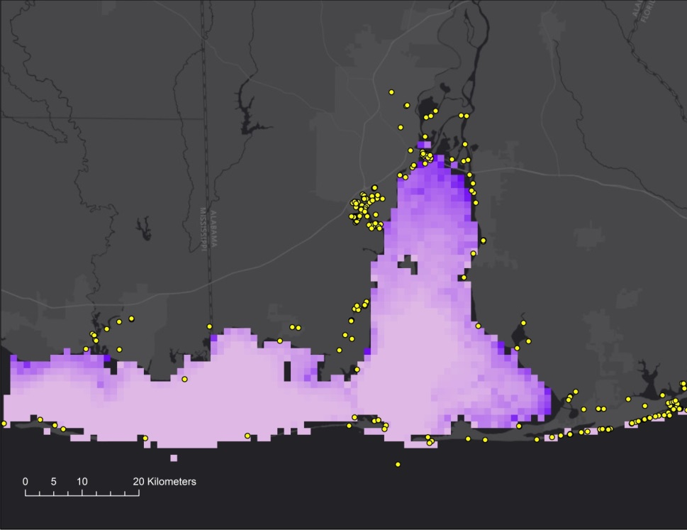



Higher

Lower

High Season

Habitat Suitability

Manatee Sighting Locations (DISL)



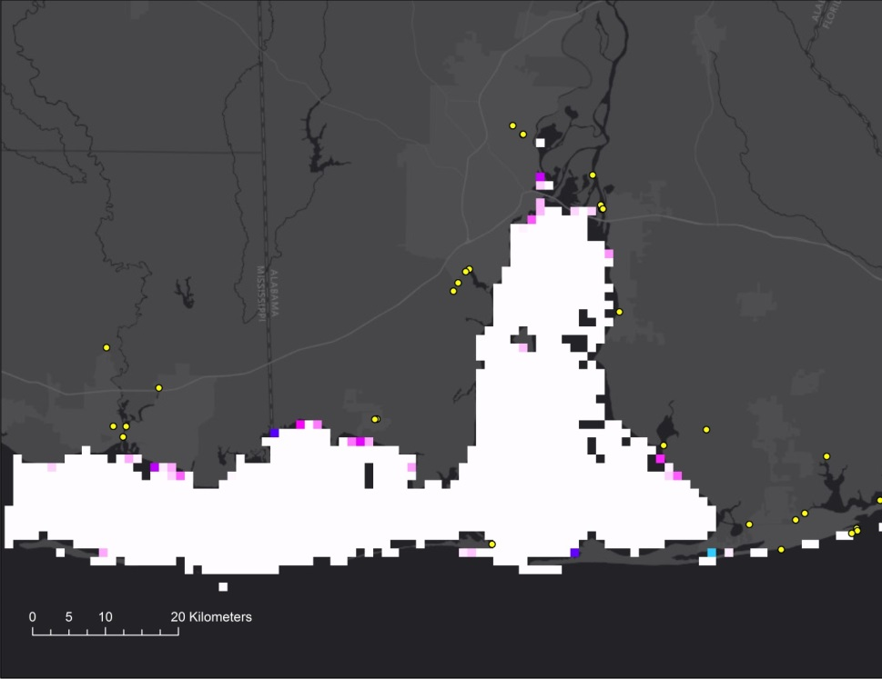

**B**

Manatee Sighting Locations (DISL)



Higher

Lower

Low Season

Habitat Suitability

Figure E1. West Indian Manatee high season (A) (June 1 - October 31, 2016) and low season (B) (November 1, 2016 - March 31, 2017) suitability maps compared with manatee sighting data from the Dauphin Island Sea Lab.