**NASA DEVELOP National Program**



NOAA National Centers for Environmental Information

*Spring 2016*

Levant and Central American Climate

Monitoring Precipitation and Drought to Enhance U.S. Air Force Predictions and Decision-Making in the Levant and Central America

**Technical Report** 

Rough Draft – Feb 18, 2016

Alec Courtright (Project Lead)

Christie Stevens

Hayley Hajic

DeWayne Cecil, Global Science & Technology, Inc. (Science Advisor)

Raymond Kiess, 14th Weather Squadron

Major Ryan Harris, 14th Weather Squadron

Rob Blevins, Meteorological Connections, LLC

# I. Abstract

**Keywords**

Drought, Precipitation, Monitoring, Levant Region, Central America, Water Resources, Climate

# II. Introduction

Due to significant climate variations, several regions of the world are experiencing more frequent and extreme droughts and heavy precipitation events. These extreme events often result in food scarcity and economic hardship, and act as catalysts for civil unrest. Such weather-related disasters have consequently resulted in forced migrations reported at 22.5 million people every year from 2008 to 2014 (Martinez 2016). Periods of extreme drought leading up to the beginning of the 2011 Syrian Crisis gave way to significant agricultural failure and civil conflict (Martinez  2016). It is imperative that monitoring and predictive modeling of highly vulnerable regions occur to better prepare policy makers and the general public for future droughts and heavy precipitation events. The Levant and Central American regions have been recognized as highly vulnerable regions that continue to experience the consequences of these extreme weather events (Maddocks et al. 2015).

For centuries, the Middle East has been considered one of the most arid climates in the world. Out of 167 countries, 33 countries will face extremely high water stress by 2040 and 33% of those countries are located in the Middle East (Maddocks et al. 2015). Recent weather extremes have diminished the region’s already limited water resources (Kaniewski et al. 2011). In the Levant region, comprised of Syria, Lebanon, Jordan, Israel, and Iraq, an increasing population and diminishing water supply have created an unstable and competitive environment. As villages run out of water, their populations are moving to large urban areas (Voss et al. 2013). These urban areas become overpopulated and water stress is compounded. Corrupt government allocation of resources in these countries results in alarmingly poor water management (Kelley et al. 2014). This environment of distrust and desperation breeds hostility and is a significant contributor to civil unrest in the region.

Central America endures issues similar to the Levant as several countries experience change in duration, intensity, and frequency of drought and precipitation events (Maurer et al. 2009). The “dry corridor” in Central America is dramatically impacted by these climate extremes and spans across Honduras, El Salvador, Guatemala, and Nicaragua (Watson 2015). During 2015, particularly strong El Niño Southern Oscillation (ENSO) events exacerbated the already delicate state of Central America’s climate (Becker 2015). Due to the drastic changes, farmers are losing the majority, if not all, of their crops or cattle each growing season (Marengo et al. 2014). In 2011, flooding from Tropical Depression 12E cost El Salvador $840 million in damages. This was equivalent to 4% of the country’s Gross Domestic Product, ruining an approximate 60% of El Salvador’s corn and bean production (Gourmelon 2015). Farming practices in both study regions are not efficient and governments are not encouraging smart irrigation practices to reduce water loss (Vidal 2015). The governments allow wealthier residents to dig their own wells, which tap into aquifers (Vidal 2015). These wells are not regulated, leading to over pumping and water pollution (Vidal 2015). The lack of government assistance for farmers, in addition to the overall poor water management, has consequently contributed to a growing water crisis that is leading to malnutrition and hunger for the Central American population.

This research focuses on the Levant and Central American regions from June 1981 to December 2015. The project addresses NASA’s Applied Science’s Program National Application Areas of Climate, Water Resources, and Agriculture. The vastly different climates of the two study regions allow for comparisons of vegetation and evapotranspiration for a foundational examination of environmental status and impact. The Levant and Central American water supplies are heavily impacted by conditions surrounding drought and dense precipitation. This project evaluates water resources and agriculture by examining the influence of water stress on resource management and agricultural production.

Both the Levant region and Central America are in need of more consistent *in situ* monitoring and remote sensing to prepare their governments and population for the inevitable future changes in water availability. This project seeks to enhance the United States Air Force 14th Weather Squadron's monitoring of heavy precipitation and drought in these two vulnerable regions through analysis of Normalized Difference Vegetation Index (NDVI) and evapotranspiration. The 14th Weather Squadron collects, protects, and exploits climate data to utilize in military operations and planning. They seek to assist the Department of Defense and other partner organizations in planning for long-range climatic changes in all regions of the world. The Squadron will use this project as the foundation for a comprehensive assessment of variables typically less focused upon in these regions to indicate the extent of drought and precipitation. Their goal is to optimize monitoring and analysis techniques utilizing data findings in the environmentally sensitive regions of the world as they face crucial societal challenges and decision-making.

This project employs NDVI data from NOAA’s Climate Data Record to achieve the following objectives: 1) create comprehensive climatologies of both baseline and anomalous years in both regions to enhance the 14th Weather Squadron’s decision-making capabilities, 2) analyze extreme weather events, primarily incidences of El Niño and La Niña occurrences, 3) create maps displaying land cover change, and 4) study land-use change in both regions. These variables will help to reveal more about the relationship between conflict and unrest and climatic changes.

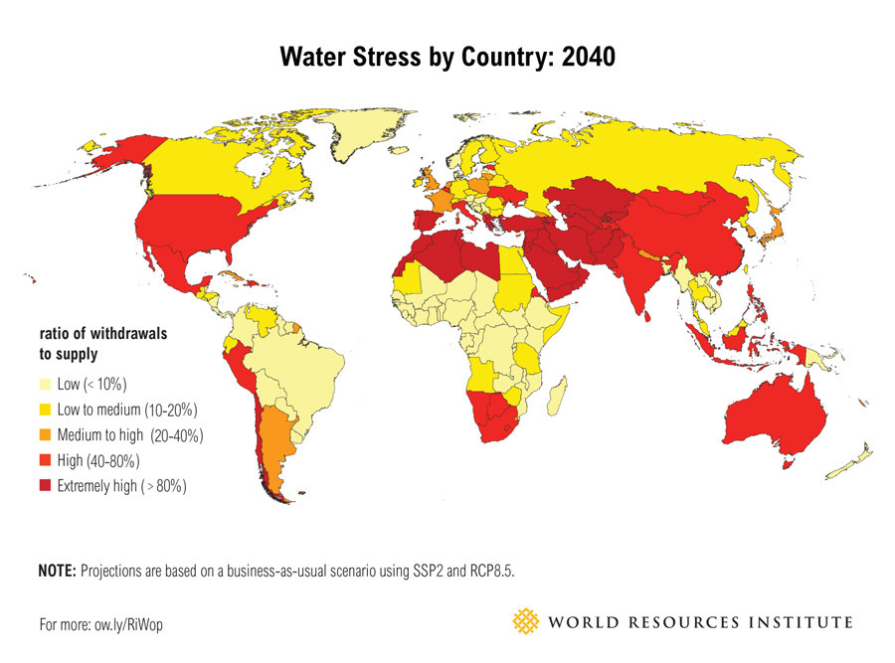

**Figure 1** World Resource Institute ranking of future water stress for 167 countries by 2040. The map shows the average exposure of water users in a given country to the ratio of total withdrawals to total renewable supply in the given area. A higher percent indicates there are more water users competing for fewer supplies.

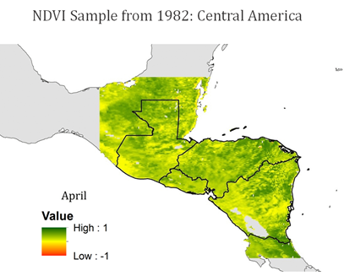

**Figure 2** Sample Central America NDVI values for a day in April 1982. The NDVI values range from -1 to 1. Values close to -1 indicate barren areas of rock, sand or snow. Values close to 1 indicate lush forests.

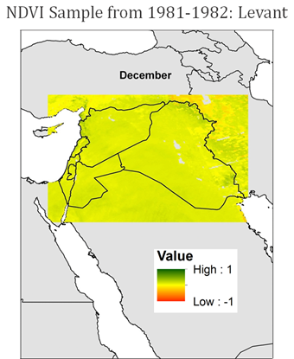

**Figure 3** Sample Levant region NDVI values for a day in December 1981. The NDVI values range from -1 to 1. Values close to -1 indicate barren areas of rock, sand or snow. Values close to 1 indicate lush forests.

# III. Methodology

**Data Acquisition**

Gridded 0.05 degree by 0.05 degree daily Advanced Very High Resolution Radiometer (AVHRR) Surface Reflectance of Normalized Difference Vegetation Index (NDVI) data derived from the NOAA Climate Data Record (CDR) were gathered for the study regions from June 1981 to December 2015. The data are from seven different NOAA polar orbiting satellites, NOAA-7, -9, -11, -14, -16,-17, and -18.

Moderate Resolution Imaging Spectroradiometer (MODIS) near real-time data from NASA’s Terra satellite, holds a spatial resolution of 1km, and gathers data in 16-day intervals. NDVI data from this source was acquired for the study regions from 2000 to 2016.

|  |  |  |  |
| --- | --- | --- | --- |
| Data Set | Spatial Resolution | Temporal Resolution | Available Study Period |
| NOAA NDVI | 0.05 degrees | Daily | June 1981-November 2015 |
| NASA MODIS NDVI | 1 km | 16-day | 2000-2015 |

**Data Processing**

The AVHRR daily data sets and MODIS NDVI data sets were processed using an R code script. The daily data files were converted from NetCDF files to GeoTIFF files and cropped to the study regions’ bounding boxes.

**Data Analysis**

Daily and monthly climatologies were made by averaging pixel values over the study period, June 1981- December 2015, using R statistical programming to analyze data. The team used ArcGIS to create climatology maps. Next, the project compared both NOAA AVHRR and NASA MODIS data within both regions to find the more accurate and beneficial data source. The project compared both datasets to ancillary precipitation data. The dataset that was most useful for the 14th Weather Squadron was used for the remaining analyses. The team determined anomalous seasons using standard deviation calculations in R when comparing monthly averages to the climatologies. Anomalous seasons were compared to both historic El Niño and historic La Niña events using statistical analyses in ArcGIS and R. The project identified predictive seasonal anomalies by analyzing anomalies in seasons prior to and after historic drought or heavy precipitation years. Lastly, this project studied land use change throughout the study period. The team used ArcGIS to compare climatologies with past studies that associated NDVI signatures with types of land cover.

# IV. Results

Through our study, we hope to create a beneficial analysis of NDVI to be used by the 14th Weather Squadron in their endeavors to forecast heavy precipitation and drought in the Levant region and Central America. Our first product will be created as a result of daily, seasonal, and yearly NDVI climatologies for both regions, using both NOAA AVHRR and NASA MODIS data sets. We will then compare both data sets for each region to identify which data source is more beneficial to our end-users. Next, we will analyze the correlation between anomalous NDVI years and El Niño Southern Oscillation (ENSO) events - such as El Niño and La Niña. Lastly, we will analyze land use change through NDVI and compare it to ancillary data sets.

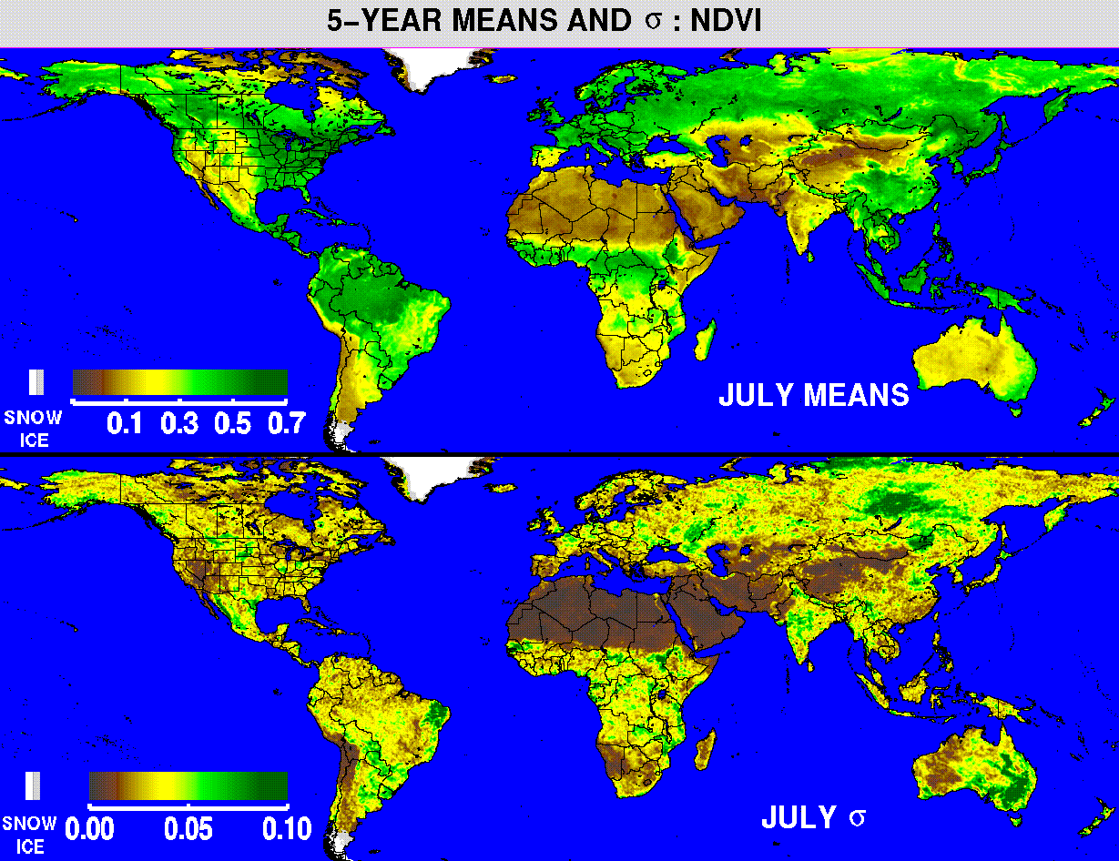Figure 4 is an example of the NDVI climatologies that will be presented to the 14th Weather Squadron. Hopefully we will be able to find some helpful trends and patterns over our study period from June 1981 to November 2015. These trends may reveal events that precede periods of drought or heavy precipitation, which can then be used to more accurately predict disastrous events. This project will utilize statistical comparisons to compare months leading into detrimental drought/precipitation events. These climatologies will also be used as tools of communication between the NASA DEVELOP team, the 14th Weather Squadron, and any relevant third party.

**Figure 4** (Placeholder) Example NDVI monthly climatology maps

Figure 5 is an example graphic comparing a series of years and their normal and atypical categorizations. This project will create similar graphics with an emphasis on ENSO event years to study how El Niño and La Niña affect vegetation throughout both study regions. These graphics will serve as concise ways to communicate what changes the 14th Weather Squadron should expect from ENSO events in both regional vegetative health and precipitation. This project will compare anomalous years to years with ENSO events and use statistical comparisons to search for correlations. The strength of each ENSO event will also be included in both the analysis and the graphics based on the Oceanic Niño Index (ONI).

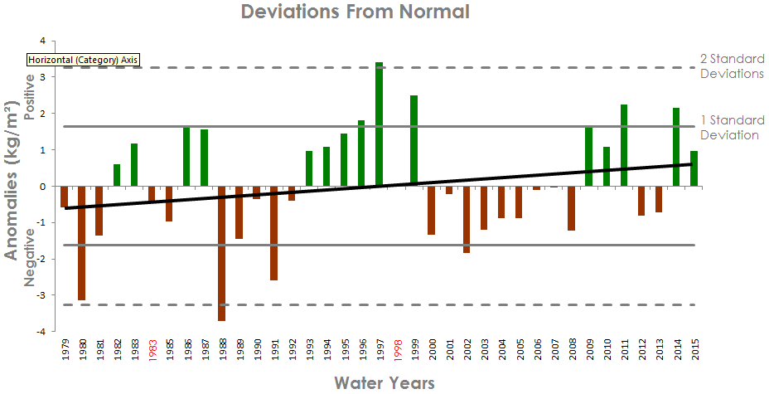

**Figure 5** (Placeholder) Example of Anomalous year graph highlighting ENSO events

The sample map in Figure 6 represents the thirty year trends for each pixel. This project will provide NDVI trend maps for both regions on several time-scales to visualize the land use change. Trend analysis will compare the general changes of seasonal vegetation, yearly vegetation, and land-use change using monthly climatologies and land-use change data. NDVI values and changes will be compared to peer-reviewed methods of land-cover classification to decipher how regional land use has developed over the study period from June 1981 to November 2015. The trends will also give the 14th Weather Squadron insight into how land use is likely to change in the future.

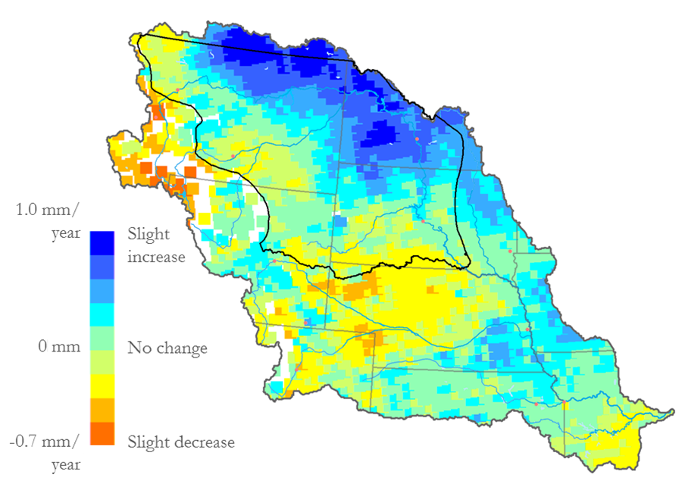

**Figure 6.** (Placeholder) Example land use change trend map

# V. Conclusions

# VI. Acknowledgments

We wish to thank our center lead Jessica Sutton, assistant center lead Emma Baghel, and our science advisor Dr. DeWayne Cecil for their guidance and expertise through the entire project. We would also like to thank all of the people at NCEI who gave us advice along the way (list people here).

Any opinions, findings, and conclusions or recommendations expressed in this material are those of the author(s) and do not necessarily reflect the views of the National Aeronautics and Space Administration.

This material is based upon work supported by NASA through contract NNL11AA00B and cooperative agreement NNX14AB60A.

# VII. References

Becker, Emily. 2015. September 2015 El Niño Update and Q&A. *National Oceanic and*

*Atmospheric Administration,* <https://www.climate.gov/news->features/blogs/enso/september-2015-el-ni%C3%B1o-update-and-qa.

Gleick, Peter.  2014. Water, Drought, Climate Change and Conflict in Syria. *American*

*Meteorological Society*, 6, 331-340.

Gourmelon, Gaelle. 2015. Who Will Pay for Central America’s Climate Change Losses?

*Worldwatch Institute*. <http://blogs.worldwatch.org/who-will-pay-for-central-americas-climate-change-losses/>.

Kaniewski, David, Van Campo, Elise, and Weiss, Harvey. 2011. Drought is a recurring

challenge in the Middle East. *PNAS*, 109 (10), 3862-3867.

Kelley, Colin. et al. 2014. Climate change in the Fertile Crescent and implications of the

recent Syrian drought. *PNAS*, 112 (11), 3241-3246.

Maddocks, Andrew, Young, Samuel and Reig, Paul. 2015 Ranking the World’s Most

Water-Stressed Countries in 2040. *World Resources Institute.* <http://www.wri.org/blog/2015/08/ranking-world%E2%80%99s-most-water-stressed-countries-2040>.

Maregno, Jose et al. 2014. Climate Change in Central and South America: Recent Trends, Future Projections, and Impacts on Regional Agriculture. *International Center for Tropical Agriculture*, 73, 1- 93.

Martinez, Stephanie. 2016. The Disproportionate Consequences of Climate Change.

*National Center for Disaster Preparedness NDCP Earth Institute|Columbia* *University.* <http://ncdp.columbia.edu/ncdp-perspectives/the-disproportionate-consequences-of-climate-change/>.

Maurer, E. P., Adam, J.C. and Wood, A. W. 2009. Climate model based consensus on

the hydrologic impacts of climate change to the Rio Lempa basin of Central America. *Hydrology and Earth System Science*, 13, 183-194.

Vidal, John. 2015. Middle East faces water shortages for the next 25 year, study says. The

Guardian Magazine. <http://www.theguardian.com/environment/2015/aug/27/middle-east-faces-water-shortages-for-the-next-25-years-study-says>.

Watson, Kate. 2015. Guatemala families struggle for food in Central American

drought. *BBC New.*<http://www.bbc.com/news/world-latin-america-34416771>.

# VIII. Content Innovation

# IV. Appendices