**DEVELOP** Style Guide

**NASA** Regulations

The [NASA Style Guide](http://sservi.nasa.gov/wp-content/uploads/2011/10/NASA_Style_Guide_v2.1.pdf) is an outline of the required components, styles, and agency guidelines for any publication that displays the official NASA insignia. All external collateral (anything that is shared with an external audience) must include the official NASA insignia, as wells as required insignia components. This includes brochures, recruiting materials, summer booklets, bookmarks, annual reports, event invitations, etc.

All externally-facing documents must be approved by DEVELOP’s National Program Office (NPO). The Communications team will work to obtain agency approval for external release of any documents that will be available to the public. Once a requested document is approved by the agency, the DEVELOP Communications team will request an agency-assigned publication number. Do not place the NASA insignia on anything, without NPO approval.

Internal publications, such as powerpoints, nameplates, etc., should include the DEVELOP logo, and therefore do not need NASA approval. However, to ensure the quality of our program and the consistency of branding efforts, internally-facing documents should follow the style guidelines outlined in this document.

**DEVELOP** Logos

DEVELOP has multiple [logos](https://drive.google.com/open?id=0B0NBT3lYVZkRU2MxQnJ4b3JuZUU). One full-color logo, and what we call “the DEVELOP letters”. We also have white versions of both logos that can be put over dark colors.





The full-color DEVELOP logo cannot be used on the front of a publication that displays the NASA insignia, but the DEVELOP Letters can. The DEVELOP Letters are good for external publications that require use of the NASA insignia. The full-color DEVELOP logo is the prefered logo for publication use. The DEVELOP Letters should only be used when the design will benefit from the aesthetic, shape, and legibility functions.

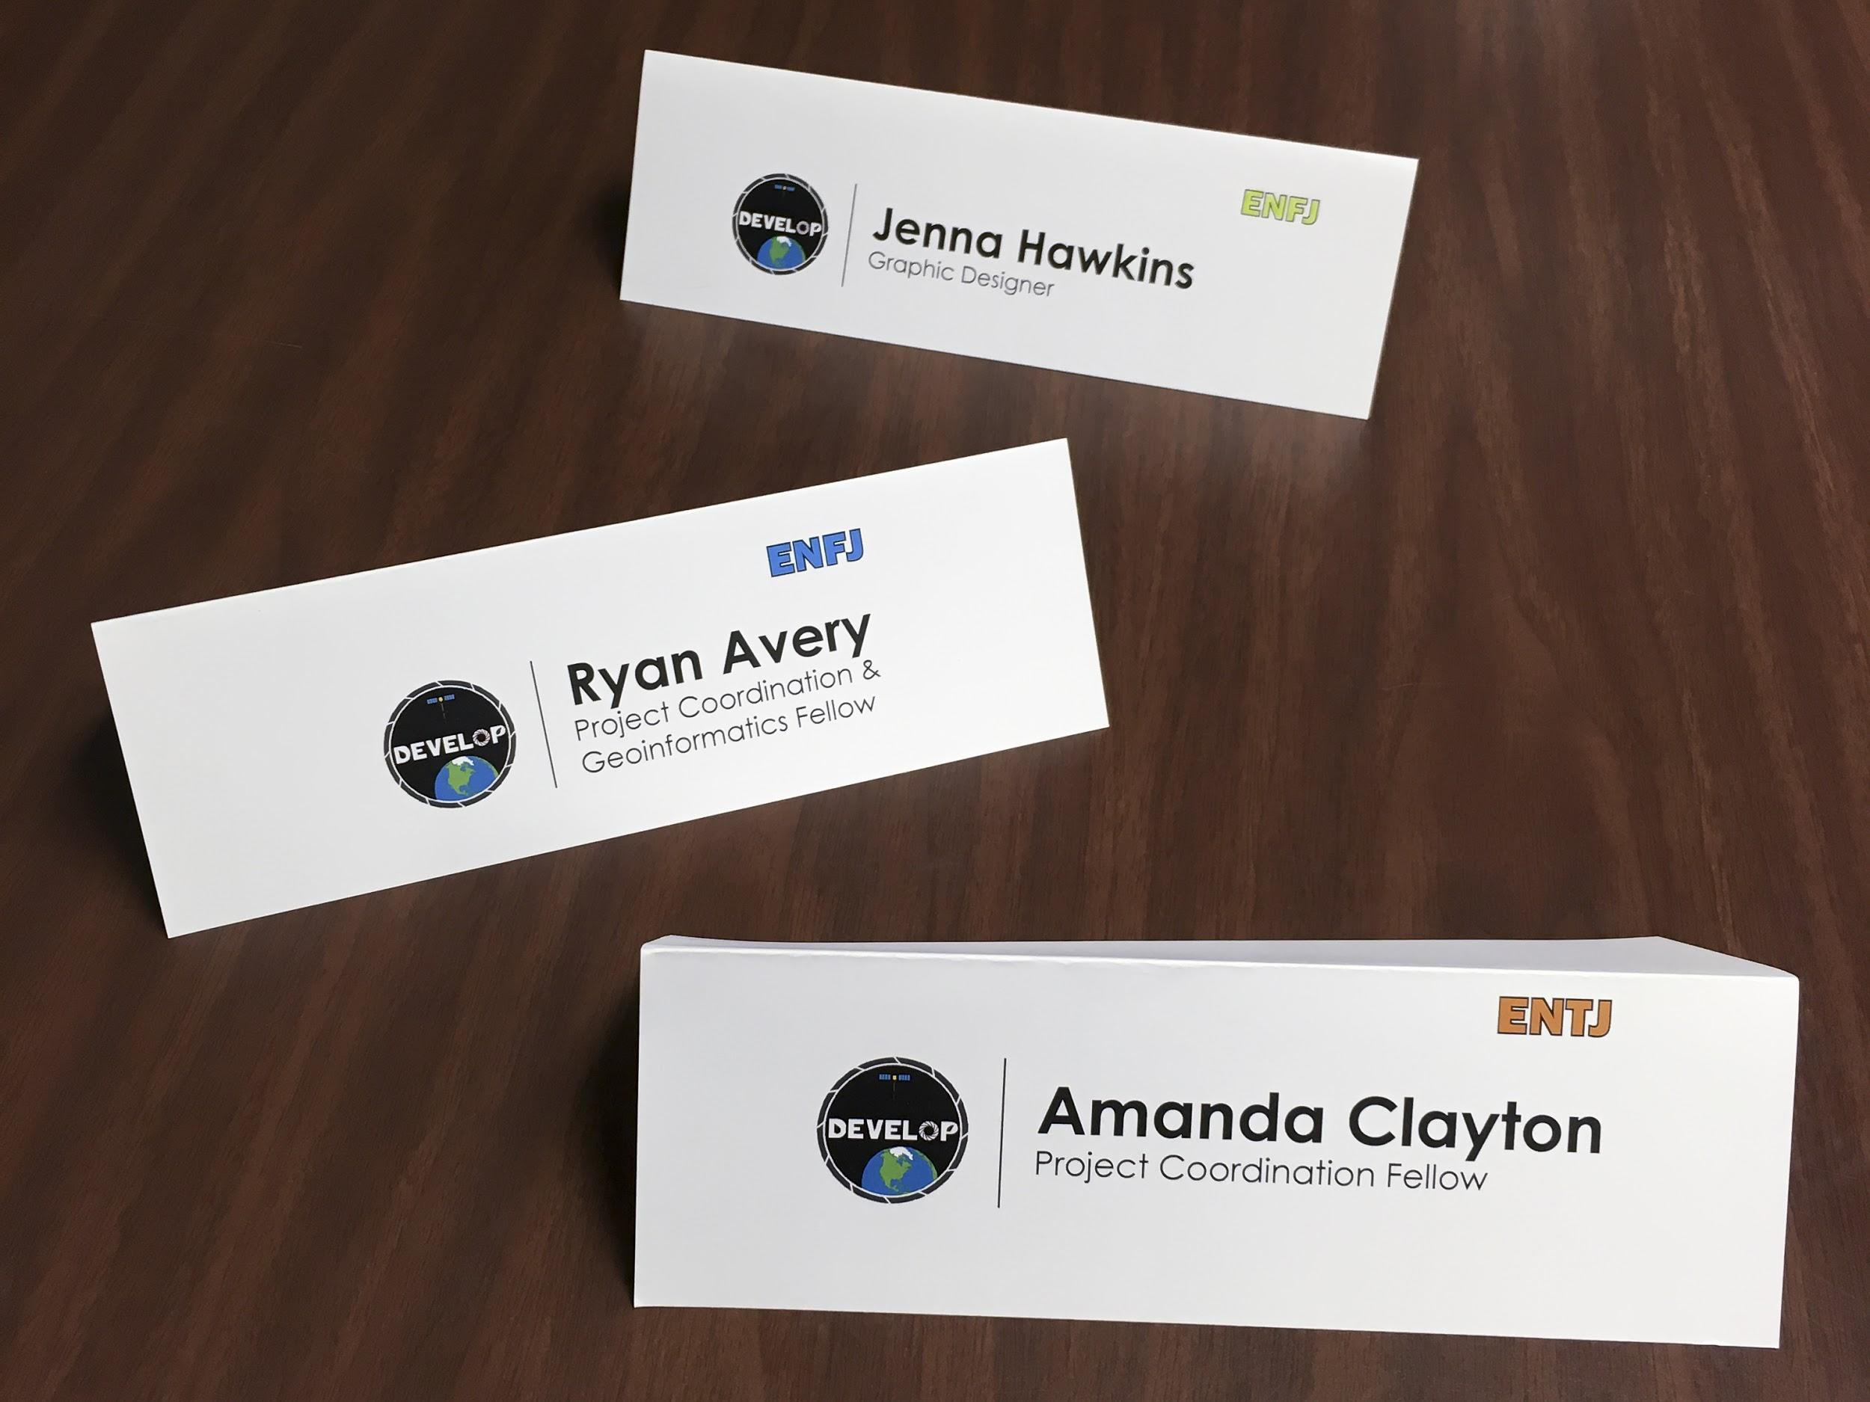

The LaRC nameplates (Fall 2016, by Carrie Kelley) are a good example of when to use the full-color logo. Because they’re purely internal they do not need the NASA insignia, so the full-color logo is allowed.

**DEVELOP** Motifs

DEVELOP uses certain design motifs that correspond with the program’s values and culture. These motifs can easily be turned into watermarks and background designs, as well as covers for publications. DEVELOP pairs these motifs with vivid photo imagery and full color maps.

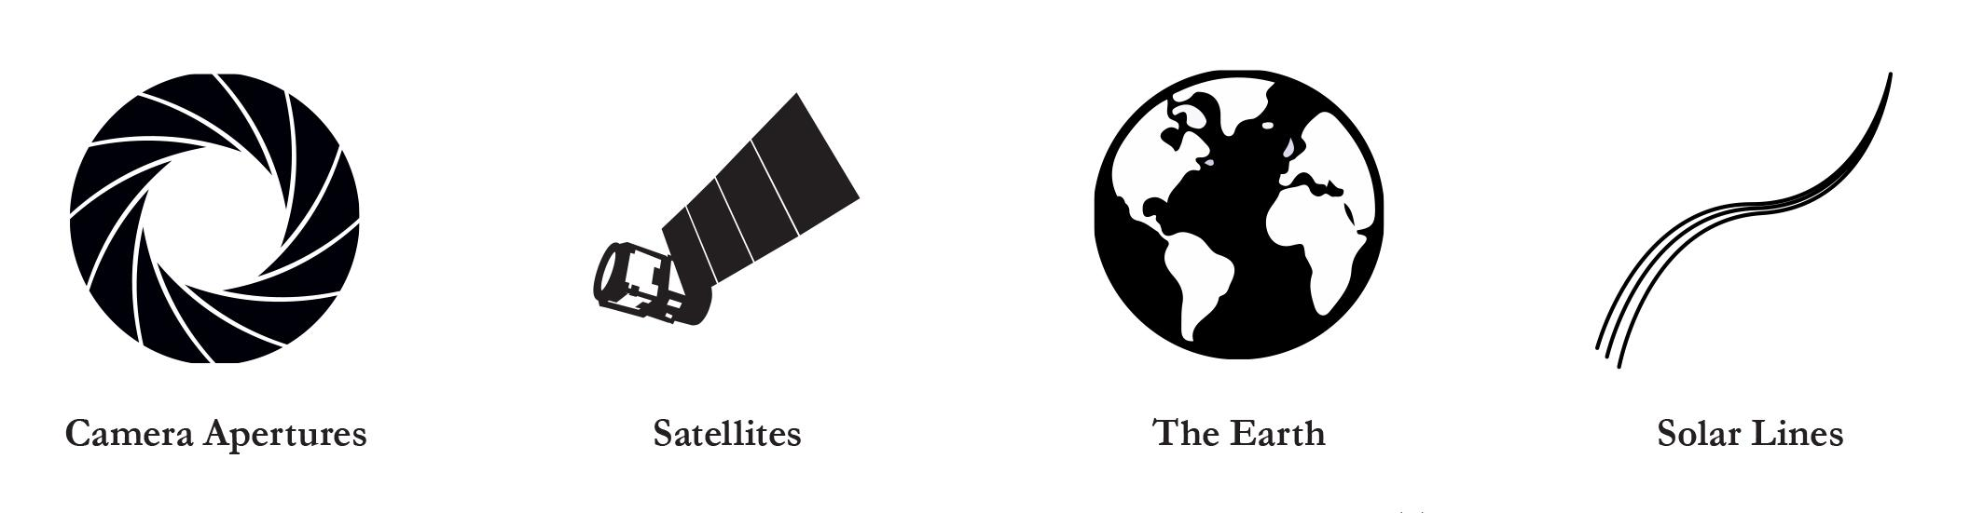

**Keep your publication clean and modern**. DEVELOP is an innovative program that is constantly looking toward the future. Your design choices are part of the overall

appearance of DEVELOP, and should professionally represent the program, as well as the agency.

**DEVELOP** Swatches

DEVELOP has suggested color [swatches](https://drive.google.com/open?id=0B0NBT3lYVZkRelM3bDlHN0syYjA) for any designs that don’t require specific application area colors. These swatches are not the only colors available to DEVELOP designs, but are preferred for uniformity.

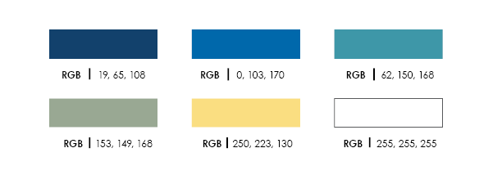

White may seem like a superfluous swatch, but DEVELOP relies heavily on clean, white space in our designs. It’s not a rule that everything has to be white, in fact some of our more circulated publications are over black backgrounds. But having open space is an essential aspect of DEVELOP style.

**Icon** Best Practices

DEVELOP strives for easy understanding and legibility. [Icons](https://drive.google.com/open?id=0B0NBT3lYVZkRMm4xNFI1ZXVoVWM), infographics, and hi-resolution images are essential to conveying complex information to a general public. DEVELOP’s signature style for icons is best described as “flat”. these icons are one, sometimes two colors, and can be easily scaled without losing their legibility.

   

   

**Keep it Simple, Clean, and Modern.** DEVELOP lets the information do the talking, and that means having icons that support without distracting. Your images and information should be the main events on any publication. Stick to either all outlined icons, or all fill. Stay away from icons with outlines and multiple fills, as they can easily become clutter and look outdated. The simpler they are, the easier they are to read. Complex icons become illegible when small, and multi-colored icons don’t show up well when printed in black and white. Icons are meant to easily separate and identify different information, they do not need to convey an entire point on their own. Too many icons distract from the necessary information.

**Images** & Maps

DEVELOP “bridges the gap between NASA Earth science and society”, meaning that part of what we do is put scientific information into the hands of decision-makers. Images, video, icons, and infographics break down complex information into separate ideas, making data easier to understand.

**Use DEVELOP Images.** DEVELOP projects result in many beautiful photos, maps, and images of study areas all over the world. Any DEVELOP images or videos are available to DEVELOPers for publications, including images off our [Flickr](https://www.flickr.com/photos/nasa_develop/albums). Proper citation is required. 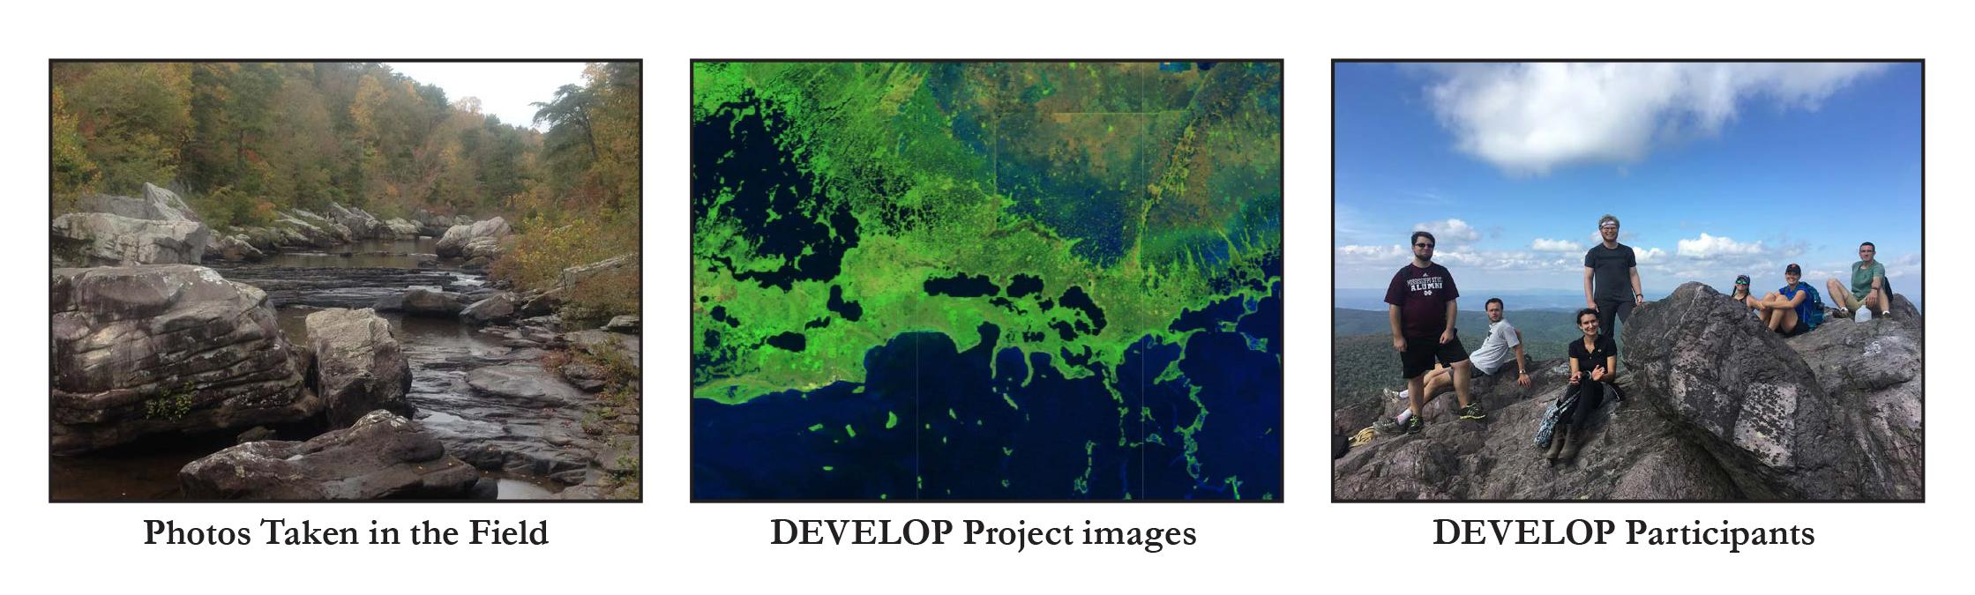

**Use NASA Images**. DEVELOP is a NASA program utilizing NASA satellites, so the use of NASA imagery is appropriate. [NASA imagery](http://eros.usgs.gov/imagegallery) is all under the public domain, meaning it is free to use as long as it is properly cited.

**Use Maps**. DEVELOP projects impact areas all over the globe and maps help to quickly identify study areas. Maps also allow context for what environmental issues a particular study area might have.

**Example** Publications

*Recruitment materials by Carrie Kelley, Bookmark by Jenna Hawkins, Summer booklet 2016 excerpt by Jenna Hawkins.*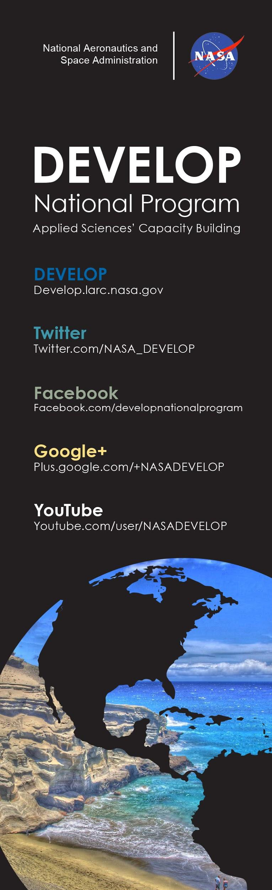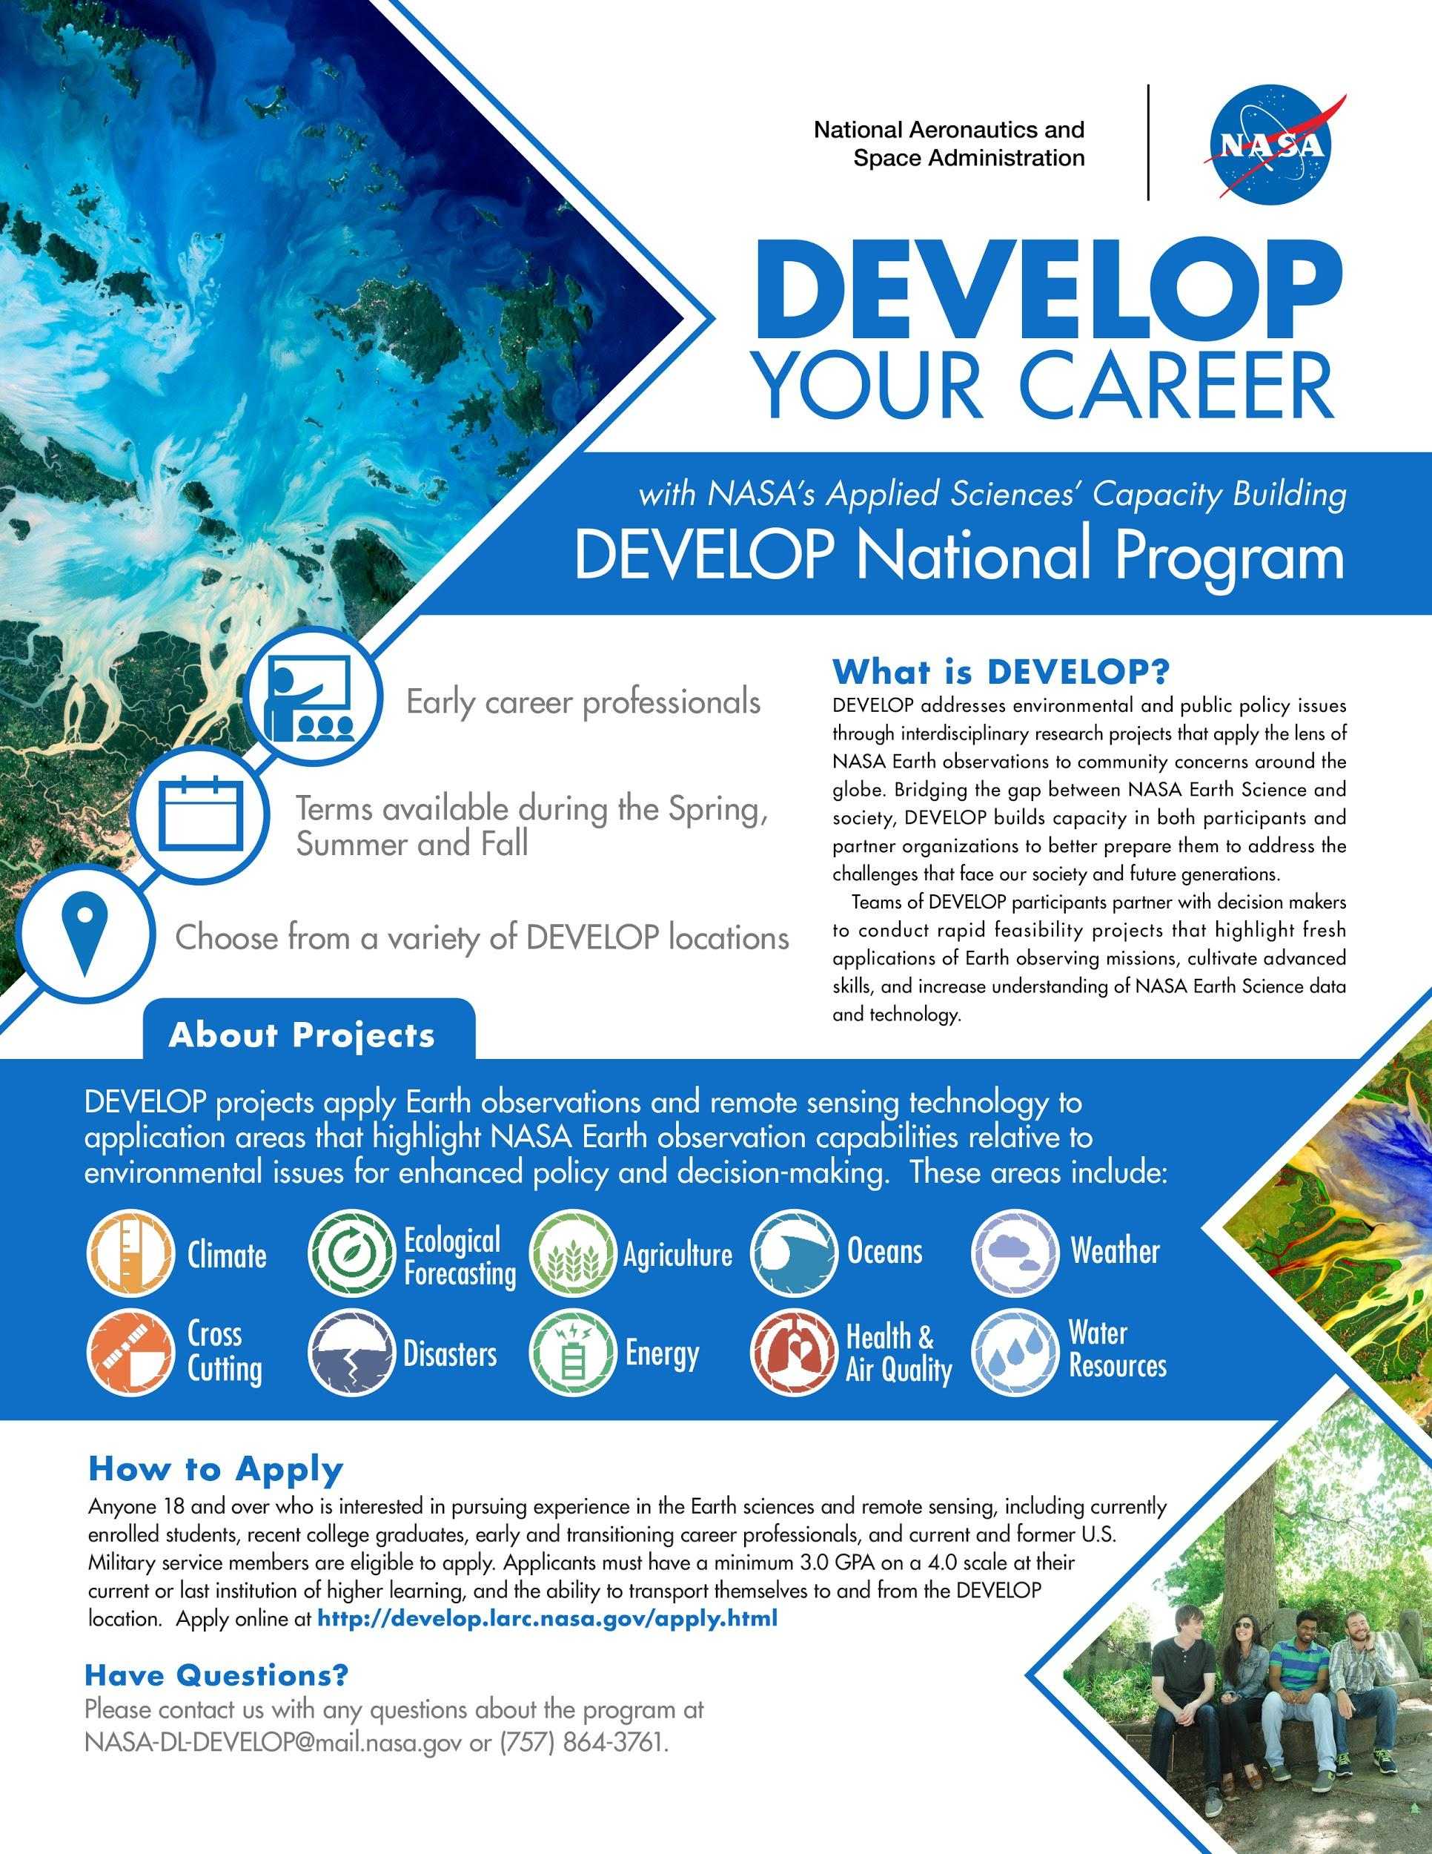

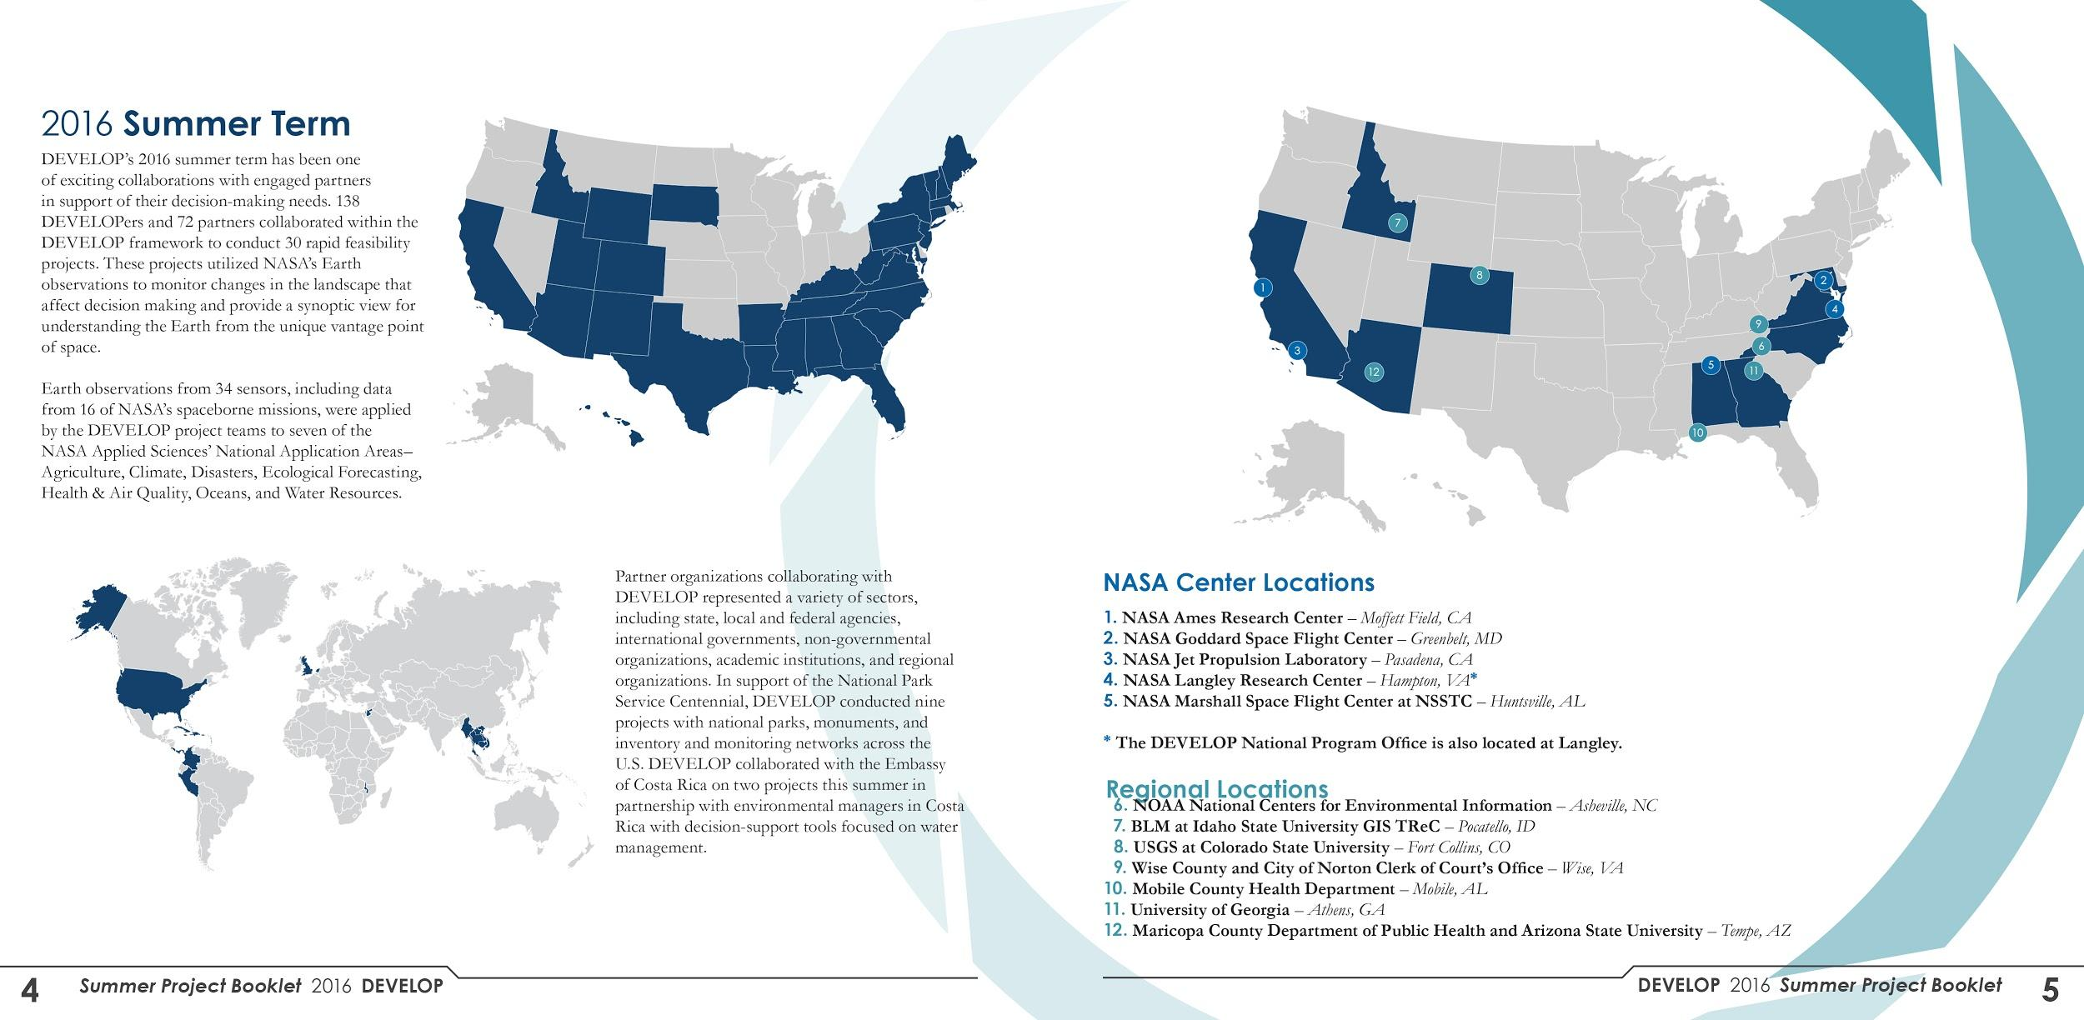

**Application** Areas

DEVELOP has nine application areas, plus Cross-Cutting. Each area has it’s own signature [color](https://drive.google.com/open?id=0B0NBT3lYVZkRVGZQUmxQc3pqdms) and [icon](https://drive.google.com/open?id=0B0NBT3lYVZkRemZNWGw0d1FMUjg) which they use to identify themselves with. This makes each project easily identifiable, and keeps a unified look across all DEVELOP publications. Close Out posters, powerpoint presentations, and project cards are all color coded, as well as the corresponding sections in the summer booklet.

There are also [white](https://drive.google.com/open?id=0B6ziaHNXMy_1azM0OHA3Mk4xR1U) versions of each icon, so they can be put over color.

The graphic design team frequently has to make PPT templates for the teams to add their own information to. These templates can be for anything from their Closeout Posters to Project Cards. Make sure when you create these templates that there is one slide for each app area, and ONLY use that app area’s color.

**Cross-Cutting** is a “catch all” category for projects that cover multiple app areas, such as the CALIPSO project.

|  |  |
| --- | --- |
|  |  |
|  |  |
|  |  |
|  |  |
|  |  |

**DEVELOP** Fonts

DEVELOP fonts are standardized across the board, and should be available on every computer. For the sake of uniformity, all DEVELOP publications and projects use Century Gothic for headings, and Garamond for body text. This applies to everything from this Style Guide, to Summer Booklets, to Tech Papers.

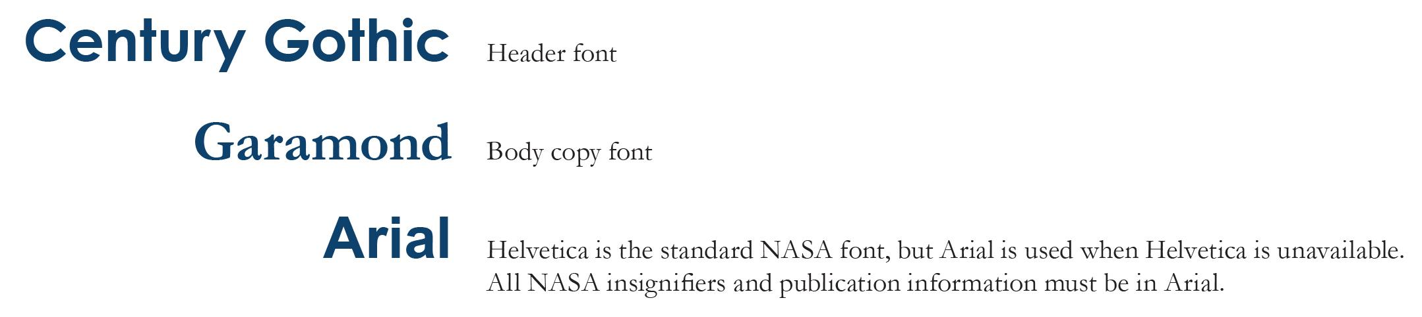

Never use below 7 point font on anything. 10-12 pt is preferable.

**Citations** andReferences

DEVELOP uses [APA](https://owl.english.purdue.edu/owl/resource/560/01/) style for all scientific papers, so we also use APA citing and referencing to keep everything uniform.

**Grammatical and Stylistic** Preferences

To ensure consistency in our communication efforts and reflect agency communication guidelines, found [here](https://drive.google.com/file/d/0B0NBT3lYVZkRSWV1bVhKRlBqVmM/view?usp=sharing), please follow the quick guide to DEVELOP specific stylistic preferences, beyond the APA style guidelines that is frequently used:

### **Active Voice** - Use active voice in all content, and avoid passive voice. Find a simple and memorable trick to check for active/passive voice in this [writing tips list](https://www.prsa.org/Intelligence/Tactics/Articles/view/8980/1025/New_Year_s_writing_resolutions_5_ways_to_improve_y#.VsYeGUb8RUk) (#3).

### **Agency, nation, department, etc.** - Do not capitalize words like agency, nation, department, mission directorate or administration – even if lawyers and bureaucrats insist on it. It violates AP style.

### **Ampersand** - Per AP, use the ampersand when it is part of a company's formal name, such as *Ball Aerospace & Technologies Corp*. The ampersand should not be used in place of *and*.

### **Center Names** - The centers are part of NASA and require the possessive case. On first reference, always use NASA's before the center name and include location after center name (comma always follows location when the state is included). The exception is NASA Headquarters, which is not possessive. Do not add *the* before a center name (e.g. the Langley Research Center) and, on second reference, do not add *NASA* (e.g. NASA Langley).

* **Climate Change** - Is currently a sensitive and political term and should be stated as “a changing climate”. This term should only be referenced to the variation in Earth's global climate over time, either cooling or warming. This term describes changes in the average state of the atmosphere over a long time scale, as opposed to brief changes in weather. It is not synonymous with *global warming*.

### **Closeout** - One word in nearly all cases: closeout crew, closeout photos, etc., except when used as a verb: *When they close out the remaining tasks, we'll be ready to go.*

* **Data vs datum:** “Data” is a term referring to multiple statistics/quantities.

### **Earth** - For NASA, generally capitalize *Earth* to indicate the proper name of the planet. Do not use *the* before *Earth*.

* **EO vs EOS** (there is a difference) - NASA Earth observations (EO) refer to all NASA airborne and flight missions that study Earth. NASA’s Earth Observing System (EOS) is a subset of EO focused on long-term global observations of the land surface, biosphere, solid Earth, atmosphere, and oceans to improve understanding of the Earth as an integrated system. EOS only includes Aqua, Aura, Landsat 7, Landsat 8. OSTM/Jason-2, QuikSCAT, SORCE, and Terra.
* **Earth observations** (EO) - When spelled out, “Earth” is upper-case and “observations” is lower-case, as written above, unless used as a heading.
* **Earth Observing System** (EOS) - is rarely referenced in DEVELOP projects and is only used when referring to [NASA’s Earth Observing System](https://eospso.nasa.gov/).
* **Equations** - Write your equation in the text lines, without altered leading. More specifics on proper spacing and formatting can be found, here: https://graduate.asu.edu/sites/default/files/cdpm/apa-quick-reference.pdf
* **Fellows** - Always use upper-case when referring to DEVELOP Fellows and Fellowships.
* Words in **foreign languages** are always italicized. Foreign words that have no English equivalent are frequent in scientific papers, and they must all be italicized. Phrases are not hyphenated.
  + “Joseph collected *in situ* data for our team.”
* **Hyphens** - Words such as end user and decision making should not be hyphenated unless they are being used as an adjective.
  + “This company was the end user for our project.” vs “We handed these items off to our end-user organization.”
  + “These maps will benefit decision making by allowing our partners to…” vs “These maps will greatly contribute to our end user’s decision-making process.”
  + “This project will contribute to the program’s capacity-building efforts” vs “Capacity building is a major function of this group.”
* **Hyphenated compound**, proper use - In the example below, hits are compared with false alarms. If these two conditions were each a single word, they would be separated by a hyphen. However, false alarms is hyphenated because it precedes comparison, so the relationship between hits and false alarms would be unclear if another hyphen was used. A slash clarifies this relationship.
  + Correct: The hits/false-alarms comparison did not yield significant results, indicating the presence of a methodological error, a ceiling effect, or both.
  + Incorrect: The hits-false-alarms comparison did not yield significant results, indicating a methodological error and/or a ceiling effect.

### **Image Credits** - All images taken by, or conceptions created by, a NASA employee or contractor for official use are NASA images, not center images, and should be credited accordingly. When available, also include the photographer’s or artist’s name.

* + Photo Credit: NASA/Bill Ingalls
* **Methodology** - Use past tense when explaining methodology.

### **Politics, Ideology and Religion** - Never insert any political, personal, ideological or religious beliefs or opinions into communications products.

* **Scientific names** are always italicized. Scientific names, which are Latin, fall under this same rule. The first word of the scientific name is always capitalized, and the second word is always lowercase. General names are not italicized.
  + “*Hydrilla verticillata* is an aquatic species. Hydrilla are invasive to Texas.”
* **Seasons** - DEVELOP often uses the seasons to reference the three project terms of each year, occurring during the spring, summer, and fall. When seasons are used this way, they should be capitalized, as proper nouns. Seasons should follow APA style guidelines, when referring to the annual season, not DEVELOP terms.
  + “DEVELOPers worked together this fall to complete the project.”
  + “During the Summer 2017 Term, the Fort Collins node hosted three guest speakers.”
* **Slashes** may ONLY be used in the following cases:
  + Fractions - 3/5
  + To separate units of measurement when accompanied by a numerical value (if the meaning of each unit is clear) - 0.5 deg/s
  + Citing unpublished work - Freud (1923/1961)
  + Clarify a relationship in which a hyphenated compound is used - In the example below, hits are compared with false alarms. If these two conditions were each a single word, they would be separated by a hyphen. However, false alarms is hyphenated because it precedes comparison, so the relationship between hits and false alarms would be unclear if another hyphen was used. A slash clarifies this relationship.
    - Correct: The hits/false-alarms comparison did not yield significant results, indicating the presence of a methodological error, a ceiling effect, or both.
    - Incorrect: The hits-false-alarms comparison did not yield significant results, indicating a methodological error and/or a ceiling effect.

I would suggest adding the following:

* **Data DOI Citations** (Again, it may not be grammar per se, but is something that many teams struggled with this term.)