Tutorial

Kankakee River Water Resources | NASA DEVELOP | Summer 2023

Monitoring Temperature and Vegetation to Detect River Flow Impediments at Energy Intake Structures

**Tutorial**

Marisa Smedsrud (Project Lead)

Hayden Hoffmeister

Oluwatosin Orimolade

Barira Rashid

***Advisors:***

Dr. Austin Madson, University of Wyoming (Science Advisor)

***Fellow:***  
Caroline Williams (Pop-Up Project)

Table of Contents

Overview 3

Set up & Requirements 3

Methods 3

1. Data Acquisition 3

1.1 Creating a Study Area Shapefile 3

1.2 Downloading Earth Observation Data 4

1.3 Downloading Environmental Data 5

1.4 Data Processing 6

2. Monitoring Floating Aquatic Vegetation 9

2.1 Creating an Index Model 9

3. Environmental Monitoring Trends 12

3.1 Acquiring Cell Count 12

Brief Conclusion 15

Acknowledgements 15

Licensing 16

Citations 16

# 

# Overview

The goal of this tutorial is to provide a comprehensive and accessible guide for detecting aquatic vegetation within the Kankakee River using Earth Observation techniques as well as pairing these detections with environmental trends monitoring. By offering step-by-step instructions and insights into the latest remote sensing technologies, this tutorial aims to equip readers with the knowledge and tools necessary to identify and track aquatic vegetation within a river extent of their choice.

# Set up & Requirements

**ArcGIS Pro (Version 3.1.2)**

Go to <https://www.esri.com/en-us/arcgis/products/arcgis-pro/buy> and purchase the software. If you already have the license, open the program and log in using your credentials. The “Spatial Analyst Toolbox” is needed to complete this tutorial. A basic background understanding of ArcGIS Pro is strongly recommended. For a free introduction web course by Esri, visit <https://www.esri.com/training/catalog/5cad02469b1f4010cad9ac46/arcgis-pro-basics/>.

**EROS Account**

To download data from USGS EarthExplorer, you will need a USGS EROS account. You can register at <https://ers.cr.usgs.gov/register>.

# Methods

## 1. Data Acquisition

### 1.1 Creating a Study Area Shapefile

1. In the ArcGIS Pro, open a new map project.
2. Go to the “Catalog” pane. In the “Folders” sub-menu, right click the project folder.
3. Hover over “New” and click “Shapefile”. Name the file “StudyArea,” select “Polygon” as the “Geometry Type” and set the “Coordinate System” to “WGS 1984”.
4. If the map is not already added to the project, navigate to “Insert” on the ribbon and click New Map.
5. Go to the Edit tab on the ribbon and click Create to open the Create Features pane.
6. Select the “StudyArea” layer in the Create Features pane. Numerous polygon drawing tools will appear under the layer in the Create Features pane. Using the add vertices tool, draw your study area.
7. Click the Save button in the Edit button.
8. Within your project folder, create a new folder called “StudyArea” and copy the StudyArea shapefile to it. Zip the StudyArea folder.

### 1.2 Downloading Earth Observation Data

**Landsat 8 OLI and 9 OLI-2**

1. Go to <https://earthexplorer.usgs.gov/>. Make sure you are logged into your EROS account.
2. Under the Search Criteria tab, go to the KML/Shapefile upload tab and upload your Study Area shapefile. Then, select the date range you would like to retrieve data for.
3. Select the Data Sets tab. Search for Landsat and Select “Landsat Collection 2 Level-2 and then select Landsat 8-9 OLI/TIRS C2 L2.

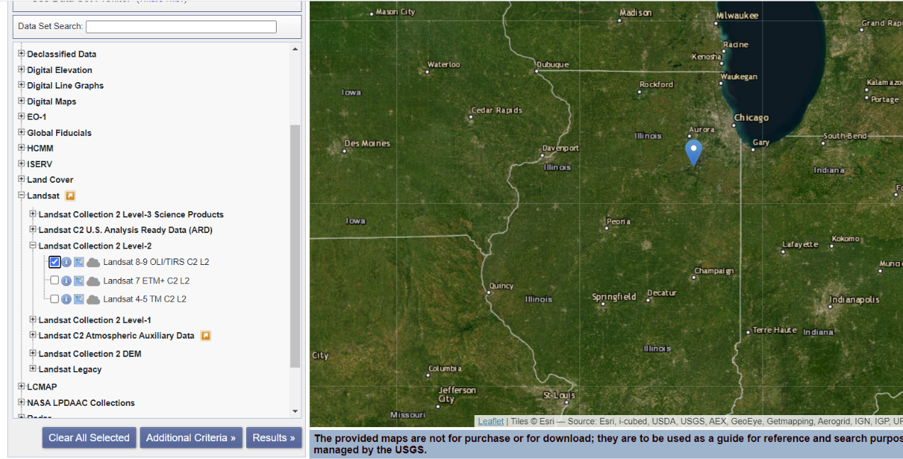

1. Now, visually inspect all the scenes and select the images with little to no cloud cover over the study area and click on the  option to download the desired images.
2. Once the data is downloaded the scene will be in a zipped folder. Once you extract it, you should see a series of .tiff files and a variety of metadata files. The files you should be interested in are the ones ending in “SR_B<#>.TIF” where the number represents the band. See below for a table of Landsat 8 and Landsat 9 band assignments.

|  |  |  |
| --- | --- | --- |
| Landsat 8/9 | | |
| **Band Number** | **Name** | **Wavelength** |
| 1 | Coastal Aerosol | 0.43 – 0.45 µm |
| 2 | Visible Blue | 0.45 – 0.51 µm |
| 3 | Visible Green | 0. 53 – 0.59 µm |
| 4 | Red | 0.64 – 0.67 µm |
| 5 | Near Infrared | 0.85 – 0.88 µm |
| 6 | SWIR 1 | 1.57 – 1.65 µm |
| 7 | SWIR 2 | 2.11 – 2.29 µm |
| 8 | Panchromatic | 0.50 – 0.68 µm |
| 9 | Cirrus | 1.36 – 1.38 µm |

### 1.3 Downloading Environmental Data

**Water Data**

1. Go to the USGS Water Data portal for the Wilmington gage <https://waterdata.usgs.gov/monitoring-location/05527500/>.
2. Use the “Change time span” button to select the desired date range.

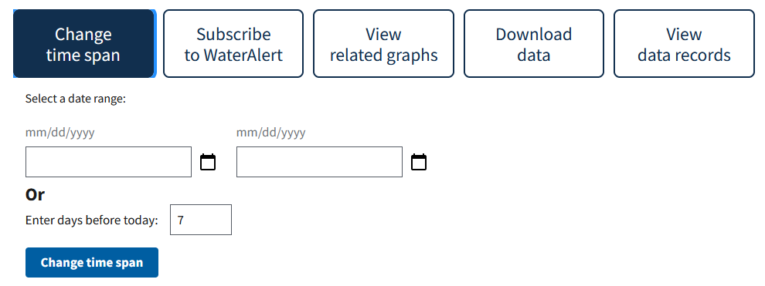

1. Select the desired data.

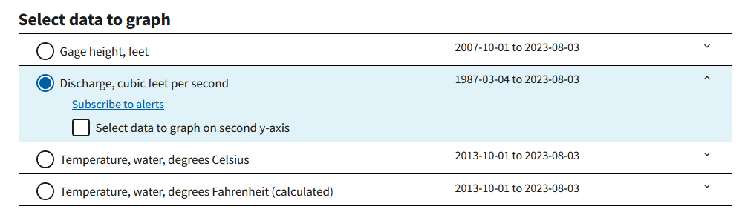

1. Use the “Download data” button to acquire the RDB formatted version of this data. Make sure “Primary time series” is selected.

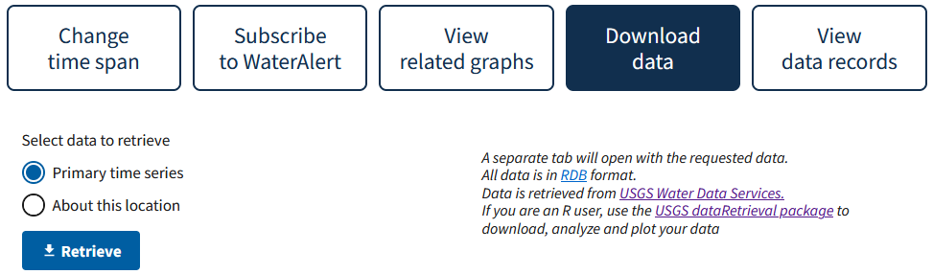

1. From here, the RDB data can be copy and pasted into any tabular data engineering program (such as Excel) for more advanced statistics to be calculated.

### 1.4 Data Processing

**Land Masking**

Before starting the land masking step, search for a day with high flow rates (for instance 11,000 cfs) using the USGS gage data. Pick a Landsat scene close to this date to use when creating the land mask.

1. In the ArcGIS Pro, open a new map project.
2. Add the satellite images to the map by dragging the .tiff files into the window or using the “Add Data” browser found in the top ribbon. After ensuring the study area boundary and the satellite images are in the same projection.
3. Navigate to the “Analysis” tab in the ribbon and select “Tools.” This will open the “Geoprocessing” pane.

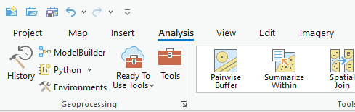

1. In the Geoprocessing pane, search for “Raster Calculator”. Find the tool named “Raster Calculator (Spatial Analyst Tools)” (this is usually the second “Raster Calculator” tool that appears in the search). Drag it into your model.
2. Right click on the “Raster Calculator” box and click “Open…”. This will open the map algebra expression builder.
3. You will use this expression builder to build your NDVI expression. The formula for NDVI is as follows:

$$\text{(NIR-RED)/(NIR+RED)}$$

Based on this equation copy the following expression into your map algebra expression builder:

("%<NIR band>%"-"%<red band>%")/("%<NIR band>%"+"%<red band>%")

Where <NIR band> is the name of your NIR band image (band 5), and <red band> is name of your red band image (band 4).

In the “Output raster” box, rename your raster to “NDVI”—do not change the path it is being saved to, and click “Run.”

1. Go back to the “Geoprocessing” pane and search for “Clip Raster” and select the “Clip Raster (Data Management Tools).”
   1. In the box named “Input raster,” select your newly made NDVI raster.
   2. In the box named “Output Extent,” select your study area shapefile.
   3. Name the “Output Raster Dataset” “NDVI_Clip.” Do not change the path it is being saved to.
   4. Make sure “Use Input Features for Clipping Geometry” is selected then click “Run.”

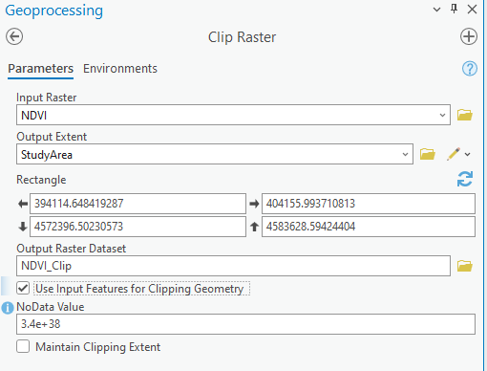

1. Go back to the “Geoprocessing” pane and search for the “ISO Cluster Unsupervised” tool in the search bar and click on the “ISO Cluster Unsupervised Classification (Spatial Analyst Tools)” tool.
   1. For the input raster bands, select the “NDVI_clip” raster.
   2. For the number of classes, type “2”.
   3. Change the “Minimum

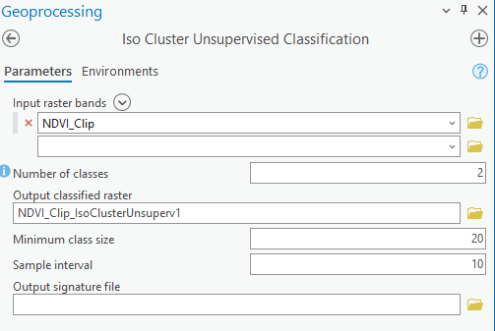

1. The new raster will populate in the “Contents” pane. Navigate back to the “Geoprocessing” pane and search for “Extract by Attributes.” Click on the “Extract by Attributes (Spatial Analyst Tools)” tool.
   1. In the “Input Raster” box, select your ISO cluster raster.
   2. Populate the clause box as follows:  
      “Where VALUE is equal to 1”
   3. Name the “Output raster” “water”
   4. Click “Run.”

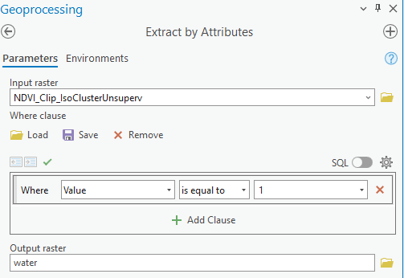

1. A new “water” raster should populate the “Contents” pane. Next navigate back to the “Geoprocessing” pane and search for “Raster to Polygon” and select the “Raster to Polygon (Conversion Tools)” tool.
   1. For the “Input raster” select water.
   2. Change the “Output polygon features” to “landmask.”
   3. Make sure the “Simplify polgyons” is **unchecked**. Click “Run”

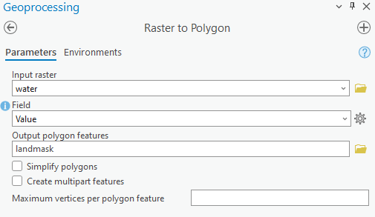

1. This should provide you with an initial river boundary. To include areas of the river that were not included when masking land in previous steps, select the polygon layer and go to the “Edit” section in the top ribbon. From there, select “Modify” in the “Features” section and select “Reshape” in the “Modify Features” pane. Here, you outline areas on the ground to be included in your river boundary.

## 2. Monitoring Floating Aquatic Vegetation

### 2.1 Creating an Index Model

**Normalized Difference Vegetation Index (NDVI)**

1. In the ArcGIS Pro, open a new map project.
2. Add the red band tiff file. near infrared band tiff file, and land mask shapefile to the map.
3. Navigate to the “Analysis” tab in the ribbon and select ModelBuilder. This will open a new, blank model for us to work with for our analysis.

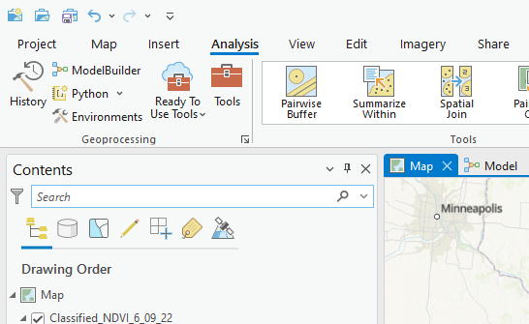

1. Navigate back to the “Analysis” tab in the ribbon and click on the large red toolbox labeled “Tools.” This will open the Geoprocessing panel on the right.
2. At the top of the Geoprocessing panel there is a search bar. In the search bar, type “Clip Raster.” Find the tool that is named “Clip Raster (Data Management Tools). Click on the tool and drag it onto the empty model canvas.

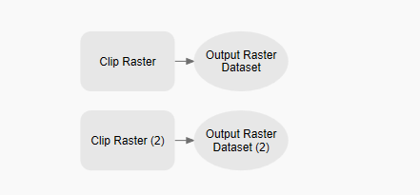

1. Right click on the first “Clip Raster” box and click on “Open…”.
   1. In the “Input Raster” box, click the dropdown arrow and select your red band .tiff file.
   2. In the “Output Extent” box, click the dropdown arrow and select the land mask shapefile.
   3. In the “Output Raster Dataset” box, rename it to “RedBandClip”—do not change the path it is being saved to.
   4. Ensure the “Use Input Features for Clipping Geometry” box is checked.
   5. Set the “NoData Value” to -99.
   6. Click “OK”

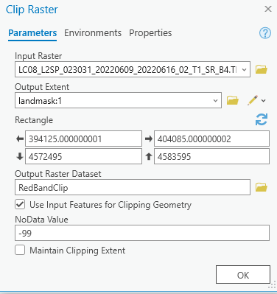

1. Repeat the previous steps a through f with the “Clip Raster (2)” box in your model, but with the near infrared band .tiff file. Name the output “NIRBandClip.”
2. Navigate to the ModelBuilder tab on the ribbon, and in the “View” section, click the button showing a piece of paper with various shapes labeled “Auto Layout.”

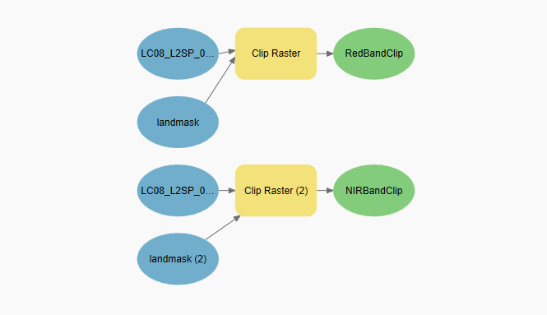

1. In the Geoprocessing pane, search for “Raster Calculator.” Find the tool named “Raster Calculator (Spatial Analyst Tools)” (this is usually the second “Raster Calculator” tool that appears in the search). Drag it into your model.
2. Right click on the “Raster Calculator” box and click “Open…”. This will open the map algebra expression builder.
3. You will use this expression builder to build your NDVI expression. The formula for NDVI is as follows:

$$\text{(NIR-RED)/(NIR+RED)}$$

Based on this equation copy and paste the following expression into your map algebra expression builder:

("%NIRBandClip%"-"%RedBandClip%")/("%NIRBandClip%"+"%RedBandClip%")

In the “Output raster” box, rename your raster to “NDVI_<date>”—do not change the path it is being saved to, and click “OK.”

NOTE: It is at this point where you can change the index that is being calculated by your model. If you want your model to calculate a different index, utilize the expression builder to recreate the index formula using the clipped version of the bands. If you are unsure of a particular index formula, visit the Index DataBase at <https://www.indexdatabase.de/> to find it.

1. Use the “Auto Layout” button to adjust the layout. Before you run your model, right click on the final oval that should be named “NDIV_<date>” and click on “Add To Display”.

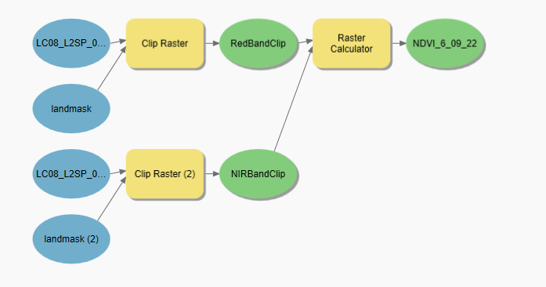

1. Navigate to the ModelBuilder tab on the ribbon, and in the “Run” section, click on the green check mark labeled “Validate”, then click the blue play button labeled “Run” (if your model did not successfully validate, check each input and output to ensure they’re correctly selected).
2. The NDVI output will be added to your map. You can see it by navigating back to the map frame by clicking the “Map” tab at the top of the model window.



## 3. Environmental Monitoring Trends

### 3.1 Acquiring Cell Count

1. Open the ArcGIS Pro project you used to make your index image.
2. On the left-hand side of the window, in the “Contents” pane, you should see a layer named “<index>_<date>” or whatever nomenclature you used.  
   NOTE: If you utilized the ModelBuilder, the layer may be in the “ModelBuilder” group and have a slightly different name.
3. Click on your index image layer to select it.

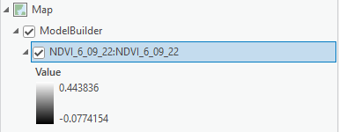

1. Once selected, right click the layer and hover over the “Create Chart” option. Then, in the new context menu, click on “Histogram.”
2. This will open a blank histogram chart. To populate it with cell values, go to the “Chart Properties” panel on the right-hand side of the window and where it says “Number” click the dropdown menu and select “Band_1”.

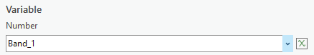

1. The histogram should now be populated with the cell values of the index image. You can explore the various statistics of the histogram by using the “Chart Properties” pane. You will notice that the water cells are grouped together on the left, with cells of vegetation creating a long tail on the right. On the left, the water should form a somewhat normal curve with a clear end—determine what value is at the end of the distribution of water cells. This value will be the threshold you use to classify vegetation and water.

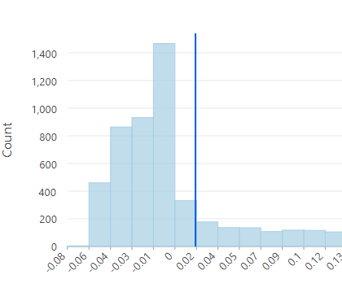

1. Once you can determine a threshold, open the “Geoprocessing” pane by navigating to the “Analysis” section on the top ribbon, and clicking “Tools”.
2. In the search box, search for “Con” and click on the one labeled “Con (Spatial Analyst Tools)”. This should open the conditional raster calculator tool.
   1. In the “Input conditional raster” box use the drop down to select your index image.
   2. Using the clause builder, fill out the clause as follows:

“Where VALUE is greater than <threshold>”

Where the threshold is the one you determined from the histogram (in the below example, 0.08 was used).

* 1. In the “Input true raster or constant value” box, input “1”.
  2. In the “Input false raster or constant value” box, input “0”.
  3. For the “Output raster” name the raster something like “Classified_<index>_<date>” and be sure to not change the path to which it is being saved. Click “Run”.

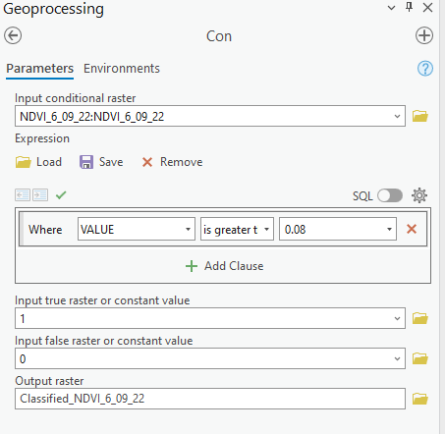

1. A new layer will appear in your “Contents” pane. This is the outcome of your conditional raster calculation. Click on the layer to select it. Then, right click the layer and click “Attribute Table”. This will open the layer’s attribute table.
2. There should be two records in this table. The one with the “Value” of “1” represents the number of cells classified as vegetation. The record with the “Value” of “0” represents the number of cells classified as water. The “Count” is the total number of each one, respectively. To get a percentage, you can divide the “Count” of “1” by the total of both “Count” records combined.
3. From here, a count/percentage of vegetation can be assigned to the days you acquired imagery for, and further analysis can be conducted.

# Brief Conclusion

Through the integration of remote sensing indices and environmental trends analysis, this project aims to provide feasibility for the detection of floating vegetation in the Kankakee River. The utilization of advanced remote sensing techniques, such as Earth observation, and spatial data, enables accurate and timely identification of floating vegetation, which has been a recurring challenge for Constellation Nuclear and the USGS Central Midwest Water Science Center.

This innovative approach will greatly enhance the response to the grassing events that pose a threat to the energy operations at the Dresden Generating Station. By continuously monitoring vegetation presence and growth patterns, the organizations can anticipate potential hazards during similar environmental conditions. Equipped with this knowledge, they can take proactive measures to mitigate any risks, ensuring smooth power generation and uninterrupted power supply to the community.

Furthermore, this methodology holds broader significance as it establishes a baseline workflow for partners to delve deeper into these events by incorporating Earth observations into their existing modeling efforts. This integration of remote sensing data with conventional modeling approaches will provide a comprehensive understanding of how floating vegetation impacts the power plant's operation. Consequently, this will lead to more effective and informed decision-making processes in handling future incidents.

Overall, the project's synergy of remote sensing technologies and environmental trends analysis will bring immense benefits to the partners. It will allow Constellation Nuclear to protect their operations from potential disruptions caused by floating vegetation. Additionally, the knowledge gained, and workflow established will serve as a foundation for further research and collaboration in managing and mitigating environmental challenges in energy generation. This endeavor marks a significant stride towards sustainable and resilient energy practices that prioritize both environmental monitoring and community service.

# Acknowledgements

Thank you, Dr. Austin Madson from the University of Wyoming, for assisting in the development of these methods. Thank you, Caroline Williams for your feedback in the creation of this document.

This material contains modified Copernicus Sentinel data (2022), processed by ESA.

Any opinions, findings, and conclusions or recommendations expressed in this material are those of the author(s) and do not necessarily reflect the views of the National Aeronautics and Space Administration.

This material is based upon work supported by NASA through contract NNL16AA05C.

# Licensing

Copyright Information ArcGIS Pro 3.1 | Other versions | Help archive Copyright © 1995-2022 Esri. All rights reserved. Published in the United States of America.

EarthExplorer software and photographs licensed for use in the U.S. Public Domain.

# Citations

Esri Academy. (n.d.). *ArcGIS Pro Basics* [Web Course]. Esri. <https://www.esri.com/training/catalog/5cad02469b1f4010cad9ac46/arcgis-pro-basics/>.

EarthExplorer software and photographs courtesy of the U.S. Geological Survey.