**NASA DEVELOP National Program**

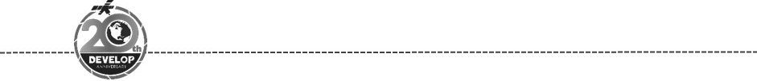Virginia – Langley

*Spring 2018*

Amistad Ecological Forecasting

Using Landsat and Sentinel to Identify and Detect Giant Cane in Amistad National Recreation Area for Future Invasive Species Land Management

 **Technical Report**

Final Draft – March 29­­­­­­­th, 2018

W. Patrick Frier (Project Lead)

Michaela Britt

Kaitlyn Carter

Joseph Ladd

Dr. Kenton Ross (NASA Langley Research Center)

# 1. Abstract

Portions of Amistad National Recreation Area (NRA) are threatened by the presence of an invasive grass species known as giant cane (*Arundo donax*), which drastically alters riparian habitats by out-competing native vegetation and depleting vital resources. Giant cane does notprovide viable habitat or food for native species of wildlife, making it an important eradication target of land managers at the National Park Service (NPS). The NPS requires precise distribution maps of giant caneover the entire extent of Amistad NRA for effective land management, however their typical monitoring methods are ground based, labor intensive, and limited in scope. The Amistad Ecological Forecasting team created historic and current classified species distribution maps for the entire extent of Amistad NRA using Landsat 5 TM, Landsat 7 ETM+, Landsat 8 OLI, and Sentinel-2 MSI data for the years 1996 to 2018. Persistence maps were then constructed from these classified images to differentiate between long-lasting and ephemeral stands of giant cane. Finally, the team analyzed year-over-year change in the abundance of giant cane to highlight temporal trends and assess the efficacy of this classification approach. The products of this work will help the NPS prioritize their future land management efforts.

**Keywords**

*Arundo donax*, image classification, remote sensing, Landsat, Sentinel-2, vegetation mapping, invasive species, random forests

# 2. Introduction

***2.1*** ***Background Information***

Asymmetric competition dynamics from invasive species are one of the principal contributing factors to global habitat degradation and extinction (e.g., Wilcove et al., 1998) and constitute environmental losses with significant economic costs numbering in the hundreds of billions of dollars (Pimentel et al., 2005; Pimentel et al., 1999). Giant cane (*Arundo donax*) is an invasive grass species that occupies riparian ecosystems throughout much of western North America. It grows at prodigious rates, sometimes in excess of 5 cm per day (Perdue, 1958), and has been recognized as a threat to riparian ecosystem health for decades (e.g., Hoshovsky, 1987). The grass is capable of growing up to 10 meters in height and owes much of its competitive advantage to its ease of propagation by plant fragment, lack of natural predators, and ability to adapt to and respond quickly after environmental disturbances, such as fire (Bell, 1997; Perdue, 1958).

Furthermore, giant cane contributes neither viable habitat nor food for native wildlife (Bell, 1997). In fact, giant cane tissue has been found to have high concentrations of certain noxious chemicals, which make it unsuitable to most native insects and grazers (Bell, 1997; Miles et al., 1993; Zuniga et al., 1983). The negative environmental impacts of giant cane also extend into the aquatic environment. The canopy structure of giant cane provides less shade than mature native vegetation, resulting in marginally higher average bank-edge water temperatures that negatively affect aquatic animal habitats (Bell, 1997; Dunne & Leopold, 1978). The accumulated effects of giant cane make it a significant threat to the ecosystem health of lands managed by the National Park Service (NPS).

This study was focused on Amistad National Recreation Area (NRA) (Figure 1), which includes the American portions of Amistad International Reservoir along the Texas-Mexico border and associated reaches of the Rio Grande River, including several of its tributaries. The primary objectives of the project were to map the distribution of giant cane along the riparian corridors of Amistad NRA, to determine how that distribution changed through time, and to generate a reproducible method by which giant cane can be mapped into the future by officials at Amistad NRA. Mapping grasses such as giant cane via remotely-sensed data has become increasingly common over the past several decades (e.g., Anderson et al., 1993). Giant cane has been specifically targeted in some such studies; however, those studies utilized AVIRIS (DiPietro et al., 2002; DiPietro, 2002; Ustin et al., 2002) and QuickBird (Yang et al., 2009) data, whereas this study utilized sensors aboard the Landsat and Sentinel satellites. Multispectral and hyperspectral imagery have been widely successful in discriminating between wetland species more generally (e.g., Adam et al., 2010). The

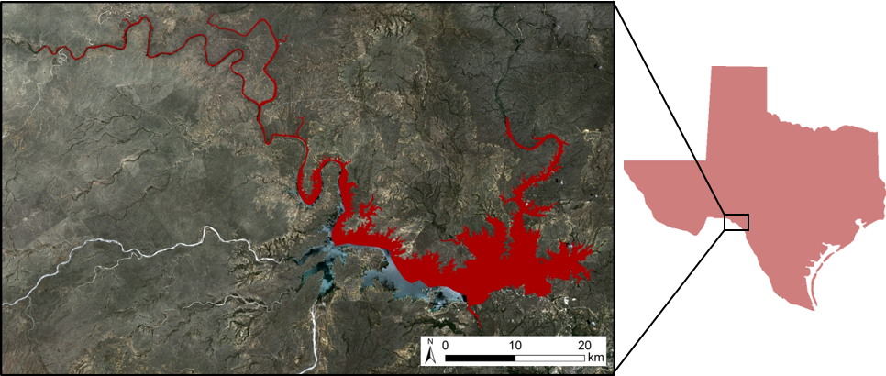

Amistad National

Recreation Area

**Overview of Study Area**

*Figure 1.* Study area map and insets depicting the extent of Amistad National Recreation Area and the state of Texas.

effectiveness of this type of analysis elsewhere and the continuity of NASA Earth observations across multiple decades suggest this is a viable means by which to assess variation in giant cane distribution and abundance through time at Amistad NRA.

***2.2*** ***­­­­­Project Partners & Objectives***

The Amistad Ecological Forecasting team worked to address the needs of NPS land managers at Amistad NRA. Amistad attracts over a million visitors a year (NPS, 2018), providing excellent recreation while preserving the area’s natural and cultural resources. As such, part of their work involves the removal of invasive species from park land in order to maintain the health of natural ecosystems. Current monitoring methods are ground based and labor intensive, making a thorough survey across the entire extent of the park difficult and unrealistic. This project was born out of a desire to integrate remotely-sensed data into the management of these park resources so that giant cane monitoring can be conducted remotely and in a reliable, reproducible manner hereafter.

In order to support the NPS in their riparian ecosystem management, the primary objectives of this project were to utilize NASA Earth observations to: (1) create a reliable map of current giant cane distribution within Amistad NRA, (2) generate historic giant cane distribution maps from 1996-2017, (3) analyze changes in giant cane distribution through time, (4) differentiate ephemeral versus persistent stands of giant cane, and (5) provide a reproducible monitoring methodology that can be used hereafter.

# 3. Methodology

***3.1 Data Acquisition***

The Amistad Ecological Forecasting team obtained Landsat 5 Thematic Mapper (TM), Landsat 7 Enhanced Thematic Mapper Plus (ETM+), and Landsat 8 Operational Land Imager (OLI) surface reflectance imagery for the years 1996 – 2017 from the United States Geological Survey (USGS) Earth Explorer platform. Initially, several images were chosen from each year. One image was collected from the peak growing season (June – August), one from autumnal brown down (September – November), and one from winter senescence imagery (December – February). Within these time periods, preference was given to the images with the least cloud cover. The team used similar means to obtain Sentinel-2a Multispectral Instrument (MSI) imagery from the Sentinel2Look viewer and download agent from the USGS. These data were also sorted based on date and cloud cover. Images with the least cloud cover were chosen from each season of 2016, 2017, and 2018. All collected and processed imagery was transferred to our NPS partners; however, the analyses conducted throughout this project and presented herein were exclusively based on the imagery collected during winter senescence (December – February; see section 3.3).

Several ancillary datasets were also used for this project. Amistad NRA provided a vegetation association map and the location of a few giant cane treatment areas that gave insight into the distribution of some giant cane stands. United States Department of Agriculture (USDA) National Agriculture Imagery Program (NAIP) imagery from 2016 was utilized for its finer 1 m resolution to supplement Landsat and Sentinel-2a imagery. The team also utilized the publicly available height above nearest drainage (HAND) elevation raster dataset from the University of Texas at Austin’s Center for Water and the Environment (CWE) and the Texas Division of Emergency Management (TDEM). The HAND data is a processed and altered form of the National Elevation Dataset (NED), which is produced by the USGS. Lidar data collected and processed by the USGS in collaboration with Amistad NRA was also used to corroborate the publicly available elevation data. The park specific lidar could not be incorporated into the analyses of this project due to computing and time constraints. Finally, the abundance of giant cane from classified images was compared against publicly available water level values for Amistad Reservoir. These data were sourced from waterfortexas.org, which aggregates data collected by the International Boundary Waters Commission (IBCW) and the USGS. The IBWC is the legal repository for all data pertaining to Amistad Reservoir water levels as per international treaties and agreements between the United States and Mexico.

***3.2 Data Processing***

After acquisition and downloading of Sentinel-2a data, the Amistad Ecological Forecasting team composited all appropriate bands (Table A1), excluding the 60 m water vapor, coastal aerosol, and CIRES bands such that the resulting composite was generated at 10 m spatial resolution. Each Sentinel-2a image was then mosaicked with the appropriate adjacent composited images. The resulting mosaic was then clipped to an area around the bounds of the study area. The same procedure was used to generate composited and mosaicked Landsat 5 TM, Landsat 7 ETM +, and Landsat 8 OLI satellite imagery. The resulting composites were generated at 15 m (Landsat 7 EMT + and Landsat 8 OLI) and 30 m (Landsat 5 TM) resolution depending on the sensor used. The HAND hydrogeological model was treated as an additional band and composited with each image to produce all final rasters.

***3.3 Data Analysis***

A Random Forest (Breiman, 2001) classification approach was used to classify and map giant cane within Amistad NRA from the resulting images. Random Forest classifications are an ensemble method that capitalize on multiple decision tree classifiers, which are aggregated in a voting procedure to generate a final classified output (Gislason et al., 2006; Breiman, 2001). Random Forests have the benefit of being relatively computationally light, have high accuracy rates in land cover classification studies, and are uniquely capable of preforming classifications with multisource remote sensing and geographic data (Gislason et al., 2006). In terms of this study, the Random Forest method allowed for seamless integration of spectral satellite data with the HAND hydrogeological model within the same classification method. This was important because the growth characteristics of giant cane result in long linear stands that hug waterways. Using the HAND model allowed the classifier to integrate spectral and hydrogeological properties into the same approach.

This project used the Random Forest classification algorithm available in Esri ArcMap 10.5 (Random Trees tool) to classify all images. Prior to using the classifier, the team chose training areas by comparison of spectral characteristics at various band combinations with the vegetation association map and treatment areas provided by the NPS and, when available, high resolution NAIP imagery. Training sites were tailored to each specific image before classification.

Winter senescence imagery was used to make all final classifications because imagery from this period showed significant spectral differences between giant cane and other vegetation types, especially when using band

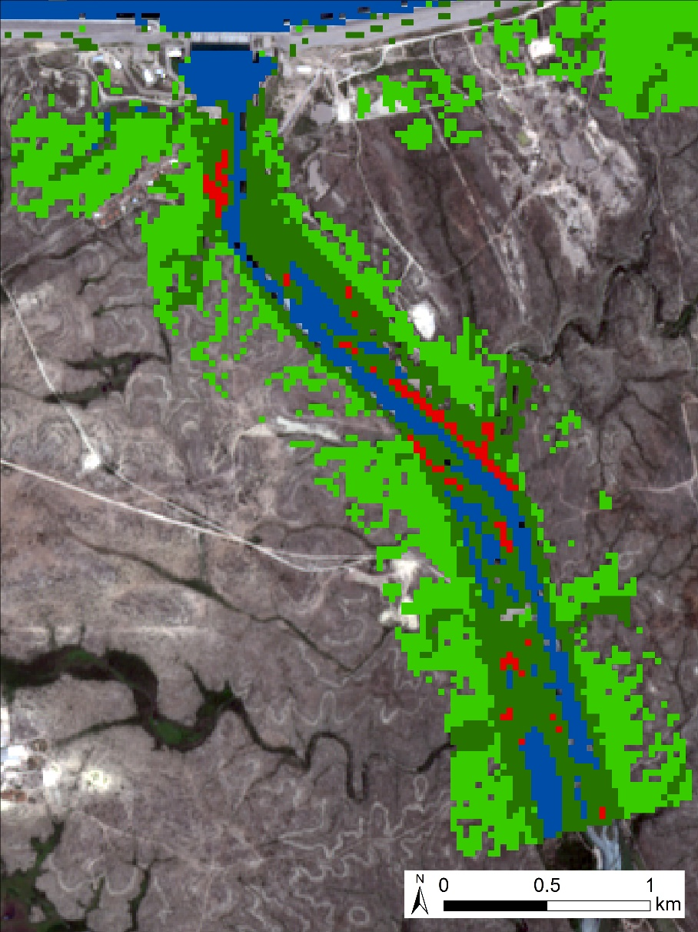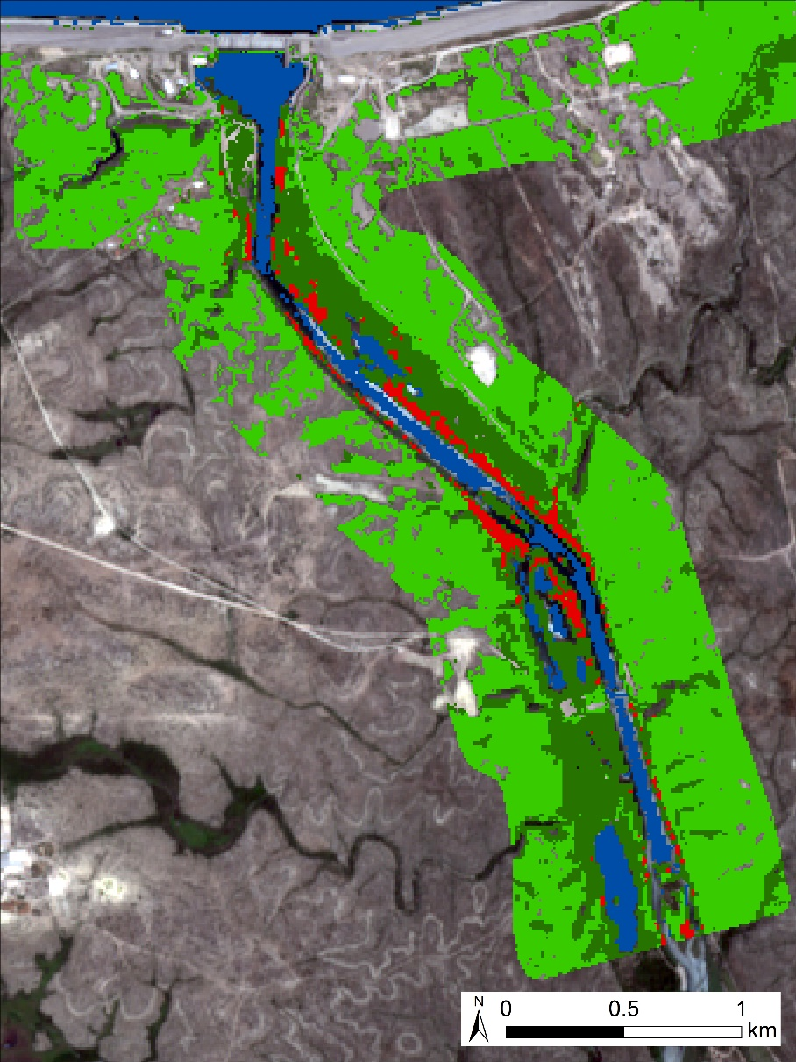

B.

A.

Upland Vegetation

**2018 Classified Image**

Riparian Vegetation

Water

Giant Cane

Upland Vegetation

**1996 Classified Image**

Riparian Vegetation

Water

Giant Cane

*Figure 2.* Classified species distribution maps depicting a portion of Amistad National Recreation Area, south of Amistad dam. Part (A) depicts a classification generated from 1996 Landsat 5 TM imagery. Part (B) depicts a classification generated from 2018 Sentinel-2a imagery.

combinations that capitalize on the Short Wave Infrared (SWIR), Near Infrared (NIR), and red bands. This allowed for the easiest discrimination between giant cane and adjacent riparian vegetation types when choosing areas to train the Random Forest classifier. When compared against the vegetation association maps provided by the NPS, the SWIR, NIR, and red bands showed significant spectral variation between giant cane and other vegetation. This helped inform the selection of other training areas.

Throughout this process, each image was treated entirely separate and classified independent of other images in the study. Upon completion, each image was assessed for its giant cane classification accuracy. It was important to use an equalized stratified random approach to assign accuracy assessment points because the principle focus of the project was to locate giant cane, a small land cover type relative to the entire image. This approach places the same number of accuracy assessment points in each land cover type and ensures that even small land cover classes are properly assessed. Finally, the team aggregated classified giant cane rasters into persistence maps for each decade of the study and for the entire study period. These maps highlight pixels that were classified as giant cane in multiple independently-generated classified images.

# 4. Results & Discussion

***4.1 Analysis of Results***

The team created classified distribution maps from fourteen unique winter seasons spanning Jan 1996 – Jan 2018. Figure 2 shows two of the project’s classified images from 1996 (Landsat 5 TM; 30 m spatial resolution; Figure 2a) and 2018 (Sentinel-2a; 10 m spatial resolution; Figure 2b) with giant cane mapped in red. The distribution of classified giant cane areas in the images is consistent with the growth characteristics of the species, hugging riparian areas and waterways. The consistency with which the classifier mapped giant cane

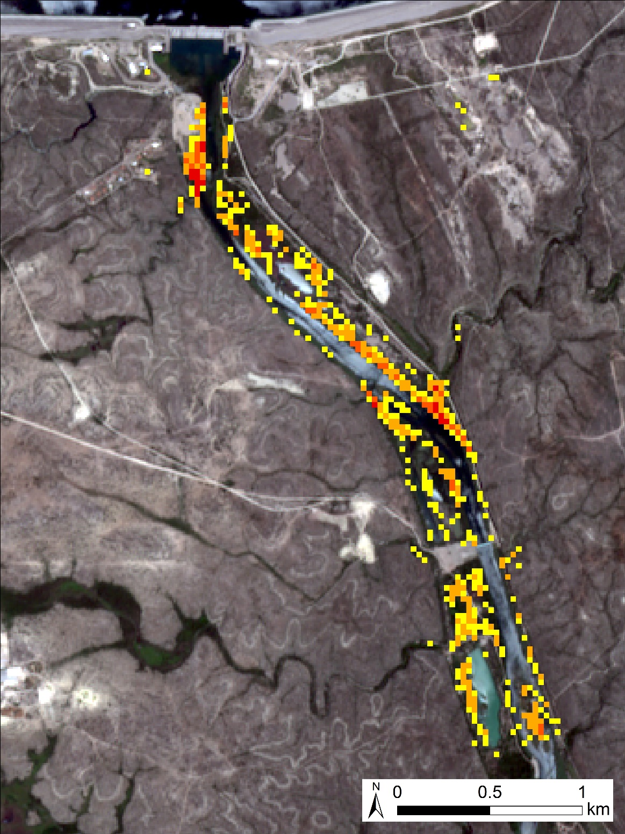along such areas lends credence to the efficacy of this classification approach, even when using sensors that operate at different spatial resolutions.

Giant cane group accuracy was assessed for all classified images (Table A1). Producer’s accuracy (the probability that an actual value of a given class was output and named as that class accurately) exceeded 95% for all final images. User’s accuracy (the probability that a value predicted and named as a certain class by the classifier really is that class) varied from 64 – 84 % across the classifications. Another way to consider this value is as its reciprocal, which indicates that 16 – 36 % (Table A2) of pixels that were called giant cane by the classifier actually belong to another land cover type. The high producers accuracy and modest users accuracy values for the giant cane class, suggest that the classification approach used herein generously includes pixels into the giant cane class and produces a modest overestimate of giant cane abundance. While the classifier successfully maps giant cane accurately, it also includes a significant number of pixels into the giant cane class that do not belong.

9 + Occurrences

6 - 8 Occurrences

3 - 5 Occurrences

1 - 2 Occurrences

**1996-2018**

**Persistence Map**

Compiled from 14 classified images spanning date range

Multiple classified images were used as inputs into a series of persistence maps for the entire study period and for each individual decade of that period. Persistence maps (Figure 3) represent the aggregation of information from multiple classified images. Pixels that are repeatedly classed as giant cane throughout multiple images have higher persistence values than those which were only classed as giant cane in one or two images. Presenting the data in this manner provides an *en masse* examination of giant cane distribution by considering multiple classified images and minimizing the effect of errors associated with any single classification.

*Figure 3.* Giant cane persistence maps for the entire study period, showing the same region of the study area as seen in Figure 2.

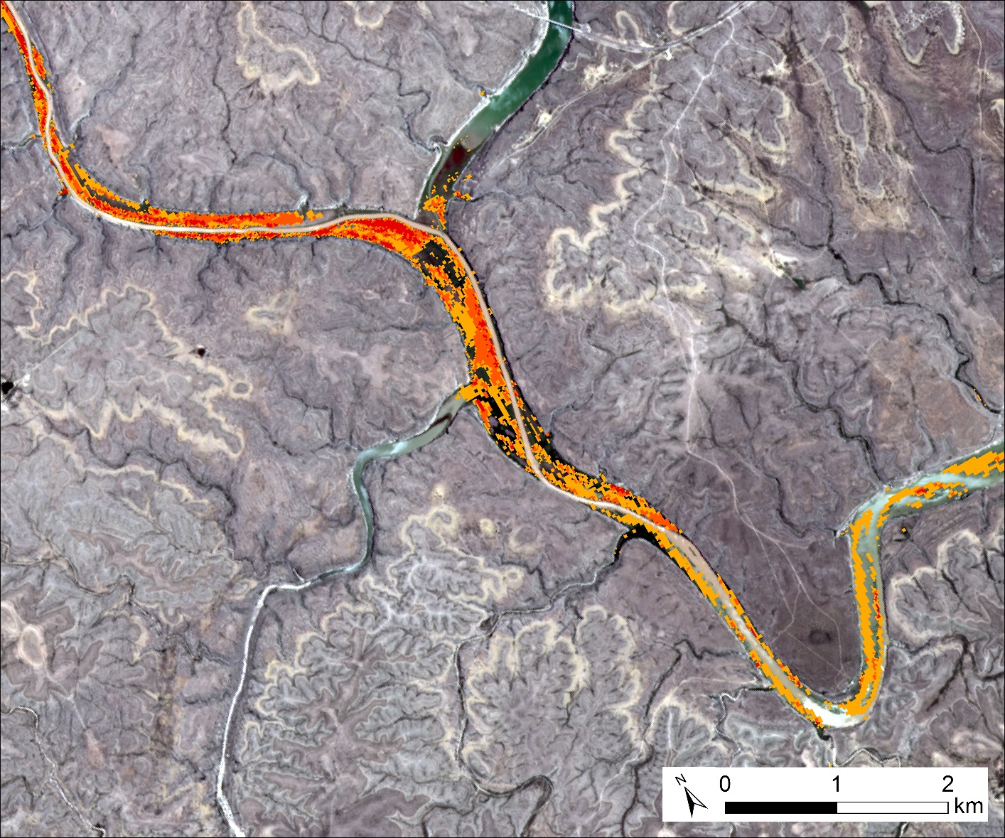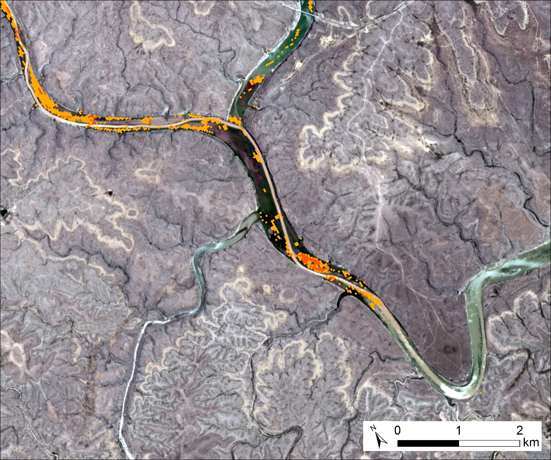

A.

B.

**1996-200**

**Persistence Map**

Compiled from 5 classified images spanning date range

**2014-2018**

**Persistence Map**

Compiled from 5 classified images spanning date range

4 + Occurrences

1 Occurrence

1 Occurrence

2 Occurrences

4 + Occurrences

2 Occurrences

3 Occurrences

3 Occurrences

*Figure 4.* Persistence maps for a portion of Amistad NRA, south of the confluence between the Rio Grande and Pecos Rivers. Part (A) shows persistence for the earliest five years of the study period. Part (B) shows persistence for the last five years of the study period.

Figure 3 is a persistence map that covers the same area as shown in figure 2, south of Amistad dam. When aggregating persistence across all images, large long-lived stands of giant cane are visible in a manner highlights the pixels that were repeatedly classed as giant cane. Since each classification was produced independently, this is the best way to visualize the most probable and consistent stands of giant cane. The late 1990s (Figure 4a) and late 2010s (Figure 4b) persistence maps demonstrate an example of how the distribution of giant cane has changed throughout the study period. Comparing the persistence of the earliest and latest periods of this study demonstrates changes in the precise distribution of giant cane through time. Along this particular stretch of the Rio Grande, south of its confluence with the Pecos River, giant cane appears to have moved downstream between the two images.

Classified giant cane abundance vs. water level

*Figure 5.* Giant cane abundance through time given as a proportion of the total classified image space (red) and water height of Amistad Reservoir (blue). Reservoir data were sourced from the IBWC.

Reservoir height (feet above sea level)

Abundance of giant cane relative to entire classified image (%)

Each classified image was also clipped and snapped to the same spatial extent, such that the proportion of giant cane relative to the entire study area could be assessed by determining the proportion of giant cane pixels to the total number of pixels in any given classified image. Figure 5 is a graph of giant cane abundance, presented as a proportion of giant cane pixels vs total pixels for each image in this study (shown in red). The water height of Amistad Reservoir in the image is based on data from the IBWC (shown in blue).

The giant cane abundance in Figure 5 shows some variation between the classified images of this study; however the overall proportion of giant cane does not vary significantly through time and ranges from ~0.2 % to 1.0% across the images. We view the variation in the abundance of giant cane pixels image-to-image as more likely a product of variation in image quality than actual changes in giant cane abundance on the ground. Despite a very slight upward slope to the giant cane trend line shown in Figure 5, we feel that the total change in giant cane abundance cannot be said to have definitively increased over the study period. Instead, we suggest that more robust and complete data is needed to determine if this modest change in the total abundance of giant cane classification can be attributed to true changes on the ground. Despite a lack of change in overall abundance, the various decadal persistence maps (Figure 4) do showcase variation in the precise location of giant cane stands through time. The non-intuitive discrepancy between these findings – that giant cane distribution has varied while total abundance is generally unchanged – demonstrates the need to determine the possibility of an ecological mechanism capable of generating this result.

***4.2 Future Work***

*4.2.1 TerrSet Land Change Modeler and Lidar based HAND model*

Classified images from this project were used as inputs into a predictive modeling program (TerrSet Land Change Modeler), but the model failed to adequately predict any substantive change in the distribution of giant cane. Any future attempt to project giant cane distribution based on these or similar classifications should consider the method and variables that failed to successfully encapsulate giant cane here. Several input rasters were used as driver variables within the TerrSet platform. These included: proximity to water, proximity to shoreline, proximity to previous giant cane, elevation, slope, and HAND. In all iterations the TerrSet platform generated probabilities that any given class would transition to giant cane based on multiple classified images and these variables. The program then generated predictive maps that were effectively identical to the most recent classified image input because the resultant model probabilities were extremely low (0.02 % - 2.00%), such that no discernable change in giant cane distribution was created in the prediction.

This failure to adequately predict giant cane distribution likely indicates that the driver variables used do not sufficiently encapsulate the controls on giant cane distribution within the study area. The model may be generally incapable of creating a viable output for a land cover class that constitutes such a small proportion of the overall image when the change between input images is also relatively small. The resolution at which the model operated could not predict the change in giant cane. Alternatively, an ecologically driven explanation could be that giant cane has almost fully occupied its probable habitat within the study area and future expansion is generally unlikely; however, it seems more likely that the model inputs simply failed to capture the drivers of change. Further work is needed to assess the viability of applying such a modeling approach to the type of land cover classification demonstrated herein. It may be more appropriate to attempt to model viable habitat space, rather than actual projected giant cane distribution.

The project team also attempted to incorporate a new high resolution Lidar data set into the classification procedure by creating a new HAND model from that dataset. The publicly available HAND model used in this study was generated using a set of freely available hydrogeological tools (the TauDEM toolkit for ArcMap) generated by the Utah State University Hydrology Research Group. The team attempted to utilize the same procedure to process the new 1 m Lidar into a viable HAND model, but failed to do so due to computing and time constraints. The Texas state-wide HAND model used here provided a good test as to the viability of this approach and suggests that a finer resolution model would further benefit future giant cane classification studies.

*4.2.2 Additional Classifications*

This project was aimed at creating a reproducible methodology by which giant cane could be tracked within Amistad NRA hereafter. Moving forward, land managers at Amistad NRA, and the NPS more generally, will be able to use the same methods outlined in this project to track giant cane distribution with a yearly reapplication of this project methodology. These methods are likely appropriate for future mapping within Amistad NRA and at other NPS managed lands that face similar challenges; however, the classification approach could likely be improved in several ways that are uniquely available to the NPS. For example, selection of new training areas or alteration of the training areas used in this project based on additional *in situ* vegetation data has the potential to drastically alter the project’s classified outputs. The project’s accuracy assessment procedure could also be altered by capitalizing on physically verified field locations.

# 5. Conclusions

This project successfully utilized a Random Forest classification method to delineate the distribution of giant cane within Amistad NRA and differentiate it from other land cover types. NASA Earth observations can be used to create classified images of giant cane distribution and aggregated into persistence maps, particularly when combined with Sentinel data and a HAND hydrogeological model. The resulting maps from this project identified significant portions of the Rio Grande River and its tributaries that are affected by the presence of giant cane, both up and downstream of Amistad Reservoir. Throughout the study period, the overall abundance of giant cane varied only slightly image-to-image while the precise distribution of giant cane varied significantly. These methods provide a viable, reproducible method for future giant cane distribution monitoring and can be incorporated into NPS management practices.

# 6. Acknowledgments

* Dr. Kenton Ross (NASA Langley Research Center)
* Lauren M. Childs-Gleason (Wise County, NASA Langley Research Center)
* Amanda L. Clayton (Science Systems & Applications, Inc., NASA Langley Research Center)
* Sean McCartney (Science Systems & Applications, Inc., NASA Goddard Space Flight Center)
* Sarah Howard (NPS, Amistad National Recreation Area)

This material contains modified Copernicus Sentinel data (2016 and 2017), processed by ESA.

Any opinions, findings, and conclusions or recommendations expressed in this material are those of the author(s) and do not necessarily reflect the views of the National Aeronautics and Space Administration.

This material is based upon work supported by NASA through contract NNL16AA05C and cooperative agreement NNX14AB60A.

# 7. Glossary

**NPS - National Park Service**

**NRA - National Recreation Area**

**SWIR - Short Wave Infrared**

**NIR - Near Infrared**

**HAND - Height Above Nearest Drainage**

**USGS - United States Geologic Survey**

**NED - National Elevation Dataset**

**TM - Thematic Mapper**

**ETM+ - Enhanced Thematic Mapper Plus**

**OLI - Optical Land Imager**

**MSI - Multispectral Instrument**

**IBCW - International Boundary Waters Commission**

**CWE - Center for Water and the Environment**

**TDEM - Texas Division of Emergency Management**

**USDA - United States Department of Agriculture**

**NAIP - National Agriculture Imagery Program**

# 8. References

Adam, E., Mutanga, O., Rugege, D. (2010). Multispectral and hyperspectral remote sensing for identification

and mapping of wetland vegetation. *Wetlands Ecology and Management*, *18*(3), 281 - 296.

Anderson, G. L., Everitt, J. H., Richardson, A. J., & Escobar, D. E. (1993). Using satellite data to map false

broomweed (*Ericameria austrotexana*) infestations on south Texas rangelands. *Weed Technology*, *7*(4), 865-871.

Barandela, R., & Juarez, M. (2002). Supervised classification of remotely sensed data with ongoing learning

capability. *International Journal of Remote Sensing*, *23*(22), 4965-4970.

Bell, G. P. (1997). Ecology and management of *Arundo donax* and approaches to riparian habitat restoration

in Southern California. In Wade, J.H.,Pysek, P., and Green, D. (eds.), Plant Invasions: Studies from North America and Europe. Blackhuys Publishers, Leiden, The Netherlands, pp. 103 - 113.

Breiman, L. (2001). Random forests. *Machine Learning, 45*(1), 5-32.

DiPietro, D. Y. (2002). Mapping the invasive species *Arundo donax* and associated riparian vegetation using

hyperspectral remote sensing (Master’s Thesis, University of California, Davis).

DiPietro, D., Ustin, S. L., & Underwood, E. (2002). Mapping the invasive plant *Arundo donax* and

associated riparian vegetation using AVIRIS. In Proceedings 11th Airborne visible/infrared image spectrometer (AVIRIS) Workshop: Jet Propulsion Laboratory, Pasadena, CA CD-ROM.

Dunne, T., & Leopold, L.B. (1978). Water in environmental planning. San Francisco: W.H. Freeman and Co.

European Space Agency. (2013-2017). Sentinel-2 Data [Data set]. Geoscience Australia. https://doi.org/10.4225/25/566a407cd2e2b

Gislason, P.O., Benediktsson, L.A., & Sveinsson, J.R. (2006). Random forests for land cover classification. *Pattern Recognition Letters, 27*(4), 294 – 300. DOI: https://doi.org/10.1016/j.patrec.2005.08.011

Hoshovsky, M. (1987). *Arundo donax*. Element Stewardship Abstract. The Nature Conservancy, San

Francisco, CA.

Miles, D. H., Tunsuwan, K., Chittawong, V., Kokpol, U., Choudhary, M. I., & Clardy, J. (1993). Boll weevil

antifeedants from *Arundo donax*. *Phytochemistry, 34*(5), 1277-1279.

National Park Service Amistad NRA Statistics. Accessed Feb 13, 2018. https://www.nps.gov/amis/learn/management/statistics.htm

Perdue, R. E. (1958). *Arundo donax*—Source of musical reeds and industrial cellulose. *Economic Botany*,

*12*(4), 368-404.

Pimentel, D., Lach, L., Zuniga, R., & Morrison, D. (2000). Environmental and economic costs of

nonindigenous species in the United States. *BioScience*, *50*(1), 53-65.

Pimentel, D., Zuniga, R., & Morrison, D. (2005). Update on the environmental and economic costs

associated with alien-invasive species in the United States. *Ecological Economics*, *52*(3), 273-288.

U.S. Geological Survey Earth Resources Observation and Science Center. (2012). Provisional Landsat ETM+ Surface Reflectance [Data set]. US Geological Survey. https://doi.org/10.5066/f7q52mnk

U.S. Geological Survey Earth Resources Observation and Science Center. (2012). Provisional Landsat TM Surface Reflectance [Data set]. US Geological Survey. https://doi.org/10.5066/f7kd1vz9

U.S. Geological Survey Earth Resources Observation and Science Center. (2014). Provisional Landsat OLI Surface Reflectance [Data set]. US Geological Survey. https://doi.org/10.5066/f78s4mzj

Ustin, S. L., DiPietro, D., Olmstead, K., Underwood, E., & Scheer, G. J., (2002). Hyperspectral remote

sensing for invasive species detection and mapping. In Geoscience and Remote Sensing Symposium, 2002. IGARSS’02. 2002 IEEE International (Vol. 3, pp. 1658-1660). IEEE.

Wilcove, D. S., Rothstein, D., Dubow, J., Phillips, A., & Losos, E. (1998). Quantifying threats to imperiled

species in the United States. *BioScienc*e, *48*(8), 607-615.

Yang, C., Goolsby, J. A., & Everitt, J. H. (2009). Mapping giant reed with QuickBird imagery in the Mexican

portion of the Rio Grande Basin. *Journal of Applied Remote Sensing*, *3*(1), 033530.

Zuniga , G. E., Argandoña, V. H., Niemeyer, H. M., & Corcuera, L. J. (1983). Hydroxamic acid content in wild and cultivated Gramineae. *Phytochemistry*, *22*(12), 2665-2668.

# 9. Appendices

9.1 Appendix A

*Table A1: Band ranges and wavelengths used for giant cane classification from various satellites and sensors and the image years for which they were used in this study.*

|  |  |  |  |  |
| --- | --- | --- | --- | --- |
| **Satellite & Sensor** | **Bands** | **Satellite Band Numbers** | **Resolution (m)** | **Wavelength (µm)** |
| Landsat 5 TM  1996, 1997, 1998, 1999, 2004, 2007, 2010 | Blue | 1 | 30 | 0.45 - 0.52 |
| Green | 2 | 30 | 0.52 - 0.60 |
| Red | 3 | 30 | 0.63 - 0.69 |
| NIR | 4 | 30 | 0.76 - 0.90 |
| SWIR 1 | 5 | 30 | 1.55 - 1.75 |
| Thermal | 6 | 30 | 10.40 -12.50 |
| SWIR 2 | 7 | 30 | 2.08 - 2.35 |
| Landsat 7 ETM+  2000, 2002 | Pan | 8 | 15 | 0.52 - .90 |
| Blue | 1 | 30 | 0.45 - 0.52 |
| Green | 2 | 30 | 0.52 - 0.60 |
| Red | 3 | 30 | 0.63 - 0.69 |
| NIR | 4 | 30 | 0.77 - 0.90 |
| SWIR 1 | 5 | 30 | 1.55 - 1.75 |
| Thermal 1 | 6_1 | 30 | 10.40 - 12.50 |
| Thermal 2 | 6_2 | 30 | 10.40 - 12.50 |
| SWIR 2 | 7 | 30 | 2.09 - 2.35 |
| Landsat 8 OLI  2014, 2015, 2017 | Pan | 8 | 15 | 0.503 – 0.676 |
| Blue | 2 | 30 | 0.452 - 0.512 |
| Green | 3 | 30 | 0.533 - 0.590 |
| Red | 4 | 30 | 0.636 - 0.673 |
| NIR | 5 | 30 | 0.851 - 0.879 |
| SWIR 1 | 6 | 30 | 1.566 - 1.651 |
| SWIR 2 | 7 | 30 | 2.107 – 2.294 |
| Thermal IR 1 | 10 | 30 | 10.60 – 11.19 |
| Thermal IR 2 | 11 | 30 | 11.50 – 12.51 |
| Sentinel-2 MSI  2016, 2017, 2018 | Blue | 2 | 10 | 0.439 – 0.535 |
| Green | 3 | 10 | 0.537 – 0.582 |
| Red | 4 | 10 | 0.646 – 0.686 |
| Vegetation Red Edge | 5 | 20 | 0.694 – 0.714 |
| Vegetation Red Edge | 6 | 20 | 0.731 – 0.749 |
| Vegetation Red Edge | 7 | 20 | 0.768 – 0.796 |
| NIR | 8 | 10 | 0.767 – 0.908 |
| Narrow NIR | 8A | 20 | 0.848 – 0.881 |
| SWIR 1 | 11 | 20 | 1.539 – 1.681 |
| SWIR 2 | 12 | 20 | 2.072 – 2.312 |

*Table A2: Giant cane class accuracies for the various images of this study. All accuracies were determined via assignment of randomly generated points by the equalized stratified random method.*

|  |  |  |
| --- | --- | --- |
| **Image Year** | **Producer's Accuracy** | **User's Accuracy** |
| 1996 | 1.00 | 0.70 |
| 1997 | 1.00 | 0.64 |
| 1998 | 1.00 | 0.78 |
| 1999 | 1.00 | 0.72 |
| 2000 | 0.97 | 0.70 |
| 2001 | 1.00 | 0.84 |
| 2002 | 1.00 | 0.82 |
| 2003 | 0.95 | 0.72 |
| 2004 | 0.97 | 0.72 |
| 2005 | 1.00 | 0.82 |
| 2006 | 1.00 | 0.64 |
| 2007 | 1.00 | 0.76 |
| 2008 | 1.00 | 0.72 |
| 2009 | 1.00 | 0.84 |