Wisconsin Agriculture & Food Security
Employing NASA Earth Observations to Model Distributions of Crop Wild Relatives, in Support of USDA ARS Genetic Resource Conservation Efforts


Technical Report
Final Draft – November 15th, 2018

Eli Simonson (Project Lead)
Anastasia Kunz
Vanesa Martin
Nicole Pepper

Past Contributors:
Tim Mayer
Dan Carver

Dr. Paul Evangelista, Colorado State University, Natural Resource Ecology Laboratory (Science Advisor)
Dr. Catherine Jarnevich, USGS Fort Collins Science Center (Science Advisor)
Tony Vorster, Colorado State University, Natural Resource Ecology Laboratory (Mentor)
Nicholas Young, Colorado State University, Natural Resource Ecology Laboratory (Mentor)
Brian Woodward, Colorado State University, Natural Resource Ecology Laboratory (Mentor)

1. Abstract
Crop wild relatives (CWR) are genetically related to cultivated crops and function as repositories for genetic diversity. These plants have the potential to improve the yield, nutritional value, and resilience of crops, thereby buffering against widespread crop failure and supporting rural economic productivity. As such, our partners at the United States Department of Agriculture, Agricultural Research Service (USDA ARS) National Plant Germplasm System (NPGS) are tasked with preserving CWRs. This project focused on two species of the Vaccinium L. genus: Vaccinium oxycoccos (littleleaf cranberry), and Vaccinium macrocarpon (largeleaf cranberry). The species in this genus are critical to preserve both in situ and ex situ given their relatively low genetic diversity and scarcity in seed banks. Currently, the NPGS relies primarily on habitat distribution modeling approaches to predict suitable habitats for CWRs. In order to refine these modeling approaches, the NASA DEVELOP team incorporated Sentinel-1 Synthetic Aperture Radar, Shuttle Radar Topography Mission, and Landsat 8 Operational Land Imager (OLI) observations into the existing predictive strategies of the NPGS. Surface reflectance products from Landsat 8 OLI were successfully utilized to detect the habitat of our cranberry species. Similarly, we found that including spectral variables derived from these sensors considerably improved the statistical and geospatial outputs of habitat distribution models, a finding that can bolster the USDA ARS’s future conservation efforts of CWRs.

Keywords
Vaccinium L., crop wild relative, habitat distribution modeling, detection, Landsat, Sentinel, MaxEnt, RandomForest

2. Introduction
2.1 Crop Wild Relatives & Focal Species
Approximately one in every five plant species across the world is at risk of extinction; threats include habitat degradation, invasive species, pollution, and agricultural modernization (Brummitt & Bachman, 2010). Crop wild relatives (CWR) are genetically related to cultivated crops and function as repositories for genetic diversity (USDA Forest Service, 2014). They also comprise a significant portion of threatened native plant species across the United States (Meilleur & Hodgkin, 2004). The conservation of CWRs both in their natural habitat (in situ) and in seed banks (ex situ) is critical to safeguard genetic diversity and prevent species loss, especially for staple crops. Domestication of crops contributes to both phenotypic and genetic alteration, where species may lose important traits necessary for survival in their natural habitat (Suszkiw, 2014). Conserving CWRs in situ allows for the genetic preservation of these populations and subsequent species within their natural habitat, and these unique genetic traits can be reintroduced to bolster crop strength, resiliency, yield, and nutritional value of domestic crops (Khoury, 2013).

This study’s focal species are littleleaf cranberry (Vaccinium oxycoccos) and the commonly cultivated largeleaf cranberry (Vaccinium macrocarpon). Both species occur co-dominantly, forming large stands where it is often difficult to distinguish between the two species. The cranberry stands are found in acidic peat bogs that have a pH range of 2.9-4.7 and high moisture content (Mathews, 2018). These shade-intolerant perennial shrubs occupy unique niche habitats with low nutrient levels, forming dense contiguous patches in open canopies. Although they are commonly found adjacent to many different forest types, they do not typically form large colonies below tree cover (Mathews, 2018). Additional species in the Vaccinium genus, as well as sphagnum mosses, are found in these bog habitats with both the largeleaf and littleleaf cranberries. Both focal species flower in the spring and fruit in the fall, with an accompanying foliage transition from green to red (Mathews 2018).

Notably, both cultivated and wild largeleaf cranberries have low genetic diversity and are underrepresented in gene banks, making them particularly vulnerable to pests, diseases, and environmental changes (Bruederle et al., 1996). Conversely, the wild littleleaf cranberry has a wider geographic range and higher genetic diversity which makes it a valuable genetic resource for its cultivated relative (Mahy et al., 2000). Maintaining both largeleaf and littleleaf in situ populations ensures the ongoing preservation of traits that may be important for commercial cranberry resilience. Moreover, the United States supplies 98% of commercial cranberries worldwide, with 60% of this supply grown in Wisconsin (Colquhoun & Johnson, 2009). Such a significant economic contribution to the state and the country furthers the importance of preserving CWRs within Wisconsin to secure adaptations to this environmental profile.

2.2 Project Partners & Objectives
The United States Department of Agriculture, Agricultural Research Service (USDA ARS) is the principal end user of this research. Under the ARS, the National Plant Germplasm System (NPGS) is tasked with collecting, preserving, and making available for research an array of CWR species. The preservation of CWRs complies with Executive Order 13603, National Defense Resources Preparedness. Section 201 of Executive Order 13603 (1) falls within the jurisdiction of the USDA to manage or oversee food resources, food resources facilities, and plant health resources (USDA Forest Service & USDA ARS, 2014).

Currently, our partners at the NPGS employ Maximum Entropy (MaxEnt) modeling in R studio (version 1.1.463) to predict habitat distributions (Merow et al. 2013). These predictive models are the key informants of conservation strategies for the preservation of CWRs. Alternative habitat distribution models can be generated using a RandomForest (RF) algorithm (Stohlgren et al., 2010), which was employed in this study along with MaxEnt. These distribution models draw from national to global-scale environmental conditions to predict suitable habitats of the focal species (Bradley et al., 2012). Therefore, these models only allow for a rough prediction that exclusively considers environmental conditions, rather than the real world locations of the species. Additionally, this methodology relies on field-collected presence points as input data. Techniques, such as satellite detection modeling, incorporate satellite-derived spectral data to generate more precise estimates of species presence and absence (Bradley et al., 2012). For this reason, the incorporation of NASA Earth observations into the current NPGS methodology has the potential to improve model accuracy and efficiency (Kerr and Ostrovsky, 2003).

The aim of this project’s research was to provide the NPGS with a feasibility analysis of an integrated spectral and habitat prediction methodology for identifying relatively inconspicuous CWR species such as wild cranberry. This study has the potential to result in improved land management practices and geographically informed policy. The primary objectives of this project were to 1) utilize NASA Earth observations to detect largeleaf and littleleaf cranberry populations, 2) employ habitat distribution models and compare the efficacy of model iterations, and 3) integrate spectral variables into habitat distribution models.

3. Methodology
3.1 Study Area and Period
Our study area extent covers a singular Landsat scene (Worldwide Reference System 2, Path 25, Row 28) in North Central Wisconsin (Figure 1). This extent spans roughly 24,750 square kilometers and ranges from 180 to 575 meters in elevation. The landscape is home to a wide variety of geographical features including fertile plains, sand and acidic peat bogs, and mixed wetland forests (Wisconsin Historical Society, 2018). The unique wetland and bog habitats across the study area create ideal growing conditions for cranberry populations; as such, these conditions make Wisconsin the nation’s leading producer of cranberries. To assess current distributions of cranberry CWRs in Wisconsin, the study period covers 2017.

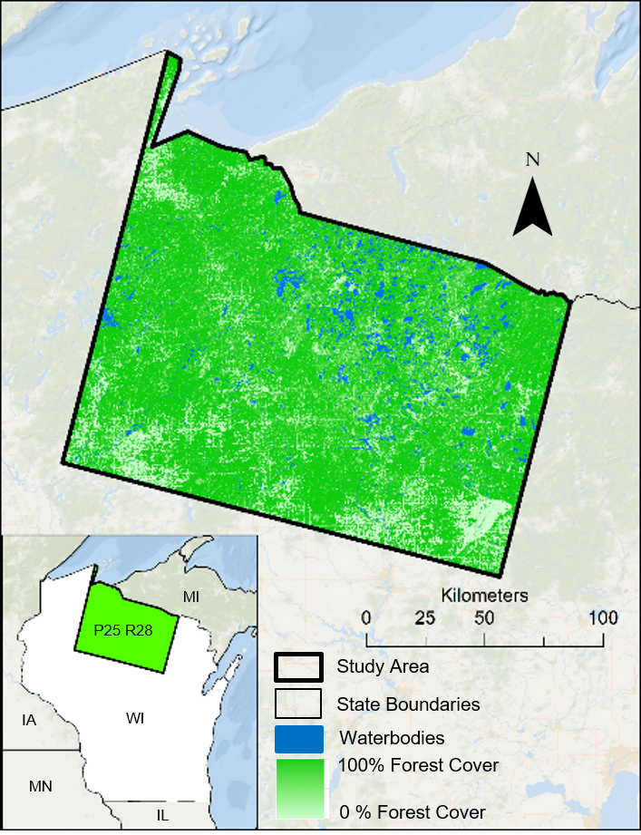
Figure 1. Study area extent, Landsat Path 25, Row 28, clipped to the state of Wisconsin

3.2 Data Acquisition and Processing
Species Presence Data (1980-2018)
Presence data for largeleaf and littleleaf cranberries were downloaded from the Global Biodiversity Information Facility (GBIF) and the USGS Biodiversity Information Serving Our Nation (BISON) databases. Additional data were obtained from researchers at the Consortium of Midwest Herbaria, the University of Wisconsin, and the USDA ARS (GBIF Secretariat, 2017; USGS BISON, 2018; Consortium of Midwest Herbaria, 2018; University of Wisconsin-Madison, 2018). All species presence data were transformed into the WGS 1984 coordinate reference system and clipped to the study area extent. The presence locations used to guide this study were predominantly concentrated in the northern region of the state (Appendix A). Points with invalid coordinates were removed from the analysis, as well as points that overlapped with impervious urban surfaces or water pixels.

In Google Earth Engine (GEE) (Gorelick et al. 2017), one-meter resolution aerial imagery from the National Agricultural Imagery Program (NAIP) was utilized for the July to October 2017 growing season to visually validate presence point locations and to guide the generation of an opportunistic sample of presence points (Figure 2). Dataset derived and user-generated presence data were further validated through discussion with partners and field experts. In this process, a total of 150 presence and 150 absence user-generated presence points were created. To implement MaxEnt, which requires a presence/pseudo-absence approach, 10,000 background pseudo-absence points were generated within a 1,000 m buffer around the presence points (Merow et al. 2013).

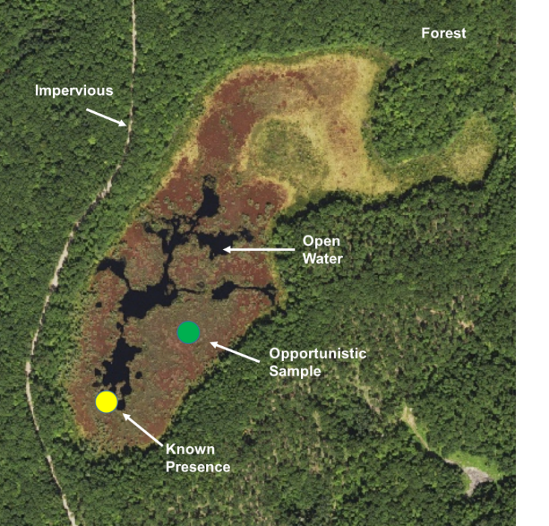
Figure 2. Database derived (yellow) and user-generated (green) species presence data over NAIP imagery

Bioclimatic Data (1960-2010)
Bioclimatic variables for the years 1960 through 1990 at 1 km spatial resolution from WorldClim Version 1 (Hijmans et al. 2005) were obtained via GEE. Decadal climate normals for 2000 through 2010 were also generated via ClimateNA v5.10 software at 30 m resolution (Wang et al., 2016). ClimateNA utilizes a digital elevation model (DEM) as an input to apply the Parameter Regression of Independent Slopes Model (PRISM) and ANUSLIN interpolation method to generate current climate normals (Wang et al., 2016).

Satellite-Derived Spectral Data (2013-2017)
All satellite imagery and datasets were acquired and processed using GEE. Tier-1 surface reflectance bands, vegetation indices, and tasseled cap components were derived from the Landsat 8 Operational Land Imager (OLI). Topographic features, such as elevation, slope, and aspect, were obtained from the Shuttle Radar Topography Mission (SRTM v3). Sentinel-1 extra wide swath C-band Synthetic Aperture Radar (SAR) imagery was processed to obtain radar backscatter and backscatter variance (Appendix C2).

To accommodate different modeling approaches, satellite-derived predictor variables were processed in two different manners. For satellite detection modeling, we utilized the phenological change of the focal species’ leaves from green to red to filter Landsat 8 OLI and Sentinel 1 SAR image collections by the summer (July to August) and fall (September to October) seasons of 2017. A cloud filter was applied to the Landsat 8 OLI collection to obtain imagery with 15% or less cloud cover. An image composite was produced by taking the median value at each pixel for all multispectral bands. Median composite surface reflectance bands were also used to produce spectral indices and tasseled cap components (Appendix C2). Generalized spectral indicators for habitat distribution were generated by obtaining the median values of each reflectance band across the entire Landsat 8 image collection, from 2013 through 2018.

3.3 Data Analysis
Classification Models
The primary models utilized in this study were MaxEnt and RF. The MaxEnt and RF models used species presence data as an input, in combination with environmental predictors, such as precipitation, topography, and spectral reflectance, to produce both a probability and binary measure of habitat suitability across our study area for littleleaf and large leaf cranberry (Appendix C). RF requires true-presence and true-absence data, and these algorithms are known to produce more robust outputs when compared to other habitat distribution models (Stohlgren et al., 2010). On the other hand, MaxEnt can only use true-presence data and generated pseudo-absence points and can produce suitable habitat predictions with just a small number of true-presence input points (Merow et al., 2013).

Satellite Detection Modeling
The values for each predictor variable across all user-generated species presence and absence locations were extracted in GEE, where spectral predictor variables were also compiled. The Variable Selection Using Random Forest (VSURF), version 1.0.3 library in R studio was used to determine which spectral predictor variables had the most explanatory power when distinguishing the focal species from the surrounding landscape. The top 10 predictors (Appendix D1) were ranked in order of importance and highly correlated variables (|r|>0.85) were removed. Based on the predictor variables defined by the variable selection process, the associated imagery was called into GEE. These variables were incorporated into RF models and used to predict the location of the focal species across a Landsat scene in Wisconsin. The performance metrics used to evaluate our model iterations consisted of area under curve (AUC), sensitivity, specificity, and true skill statistic (TSS) (Shabani & Ahmadi, 2018).

Habitat Distribution Modeling
The team replicated the NPGS methodology to create a baseline for comparison between exclusively predictive models and models with an integrated detection component. To accomplish this, we employed MaxEnt and RF with inputs from our dataset-derived presence points, including points from the GBIF, BISON, Consortium of Midwest Herbaria, University of Wisconsin-Madison, and USDA datasets. For our predictor variables, we utilized topographic variables from the SRTM v3 and bioclimatic variables from WorldClim Version 1 (Appendix C). Subsequent model iterations incorporated user-generated points instead of dataset-derived points to assess the change in model accuracy. The number of presence points used to train the model was adjusted to determine whether there was a minimum threshold required to run robust prediction models (Table 2). Additionally, WorldClim predictors were substituted with higher resolution ClimateNA predictors in order to analyze the significance of the resolution of predictor variables (Table 1).

Model building was conducted using SAHM. In parallel with the satellite detection modeling, the top predictors were ranked in order of importance and highly correlated variables (|r|>0.85) were removed. The predictor’s environmental significance to the presence of our focal species was also taken into consideration. Model iterations were evaluated using the same four performance metrics as the satellite detection component. In addition to statistical evaluation, probability surface maps were generated.

Integrated Modeling
Spectral predictors were incorporated into our habitat distribution models to integrate both methodologies. We began by including only one spectral variable, the normalized difference moisture index (NDMI), into model iterations along with bioclimatic and topographic variables; NDMI is a measurement of crop water stress level and can be used to distinguish bogs from their surrounding habitats (Agricolus, 2018). We included additional spectral predictors in later iterations (Appendix C2).

Performance metrics from all of the habitat distribution and satellite detection models were compiled and evaluated together to determine which combination of training data and modeling techniques provided the strongest outputs (Table 1). Subsequently, we provided our partners with the resulting habitat distribution maps to determine their relative accuracy. They provided field expertise and knowledge to verify the viability of the predictions in our probability surface maps.

Comparison of Modeling Approaches
In order to spatially compare the different modeling approaches, the binary absence/presence satellite detection output was overlaid with the habitat distribution models. The percentage of the total detected cranberry habitat was calculated within varying levels of habitat suitability (0-50%, 50-75%, 75-99%), as defined by different model iterations, with and without spectral variables (Table 3).

4. Results
Satellite Detection Modeling
Model Type | MaxEnt |  |  |  | RandomForest
Variable Combination | AUC | TSS | Sensitivity | Specificity | AUC | TSS | Sensitivity | Specificity
Spectral Detection | N/A | N/A | N/A | N/A | 0.66 | 0.93 | 0.98 | 0.95
WorldClim + Topographic | 0.92 | 0.67 | 0.77 | 0.90 | 0.99 | 0.91 | 0.96 | 0.95
ClimateNA + Topographic | 0.89 | 0.60 | 0.74 | 0.86 | 0.99 | 0.93 | 0.97 | 0.95
WorldClim + Topographic + NDMI | 0.96 | 0.81 | 0.90 | 0.91 | 0.99 | 0.90 | 0.93 | 0.97
ClimateNA + Topographic + NDMI | 0.95 | 0.79 | 0.89 | 0.91 | 0.99 | 0.91 | 0.95 | 0.97
CimateNA + Topographic + All Spectral | 0.99 | 0.90 | 0.93 | 0.98 | 0.99 | 0.97 | 0.97 | 0.99
Table 1. MaxEnt and RF model evaluation statistics using 150 user-generated presence points and different combinations of input variables. The performance metrics used to evaluate our model iterations consisted of AUC, sensitivity, specificity, and TSS. For a description of the bioclimatic variables derived from WorldClim and ClimateNA, see Appendix C1. For a description of topographic and spectral variables derived from Earth observations, see Appendix C2.

Variables incorporated into the satellite detection model included Red Summer, Normalized Difference Vegetation Index Summer, Green Fall, and Short-wave Infrared Fall. Therefore, Landsat 8 spectral variables were the top predictors used for this type of modeling approach. VSURF analysis showed that predictors from different seasons in 2017 were important for distinguishing our focal species from the surrounding landscape. Model results showed that high proportions (>90%) of both presence and absence were correctly predicted (Table 1).

Habitat Distribution Modeling
We compared MaxEnt output statistics from dataset-derived presence points to the output statistics from our user-generated presence points (Table 2). The same nine bioclimatic and topographic variables were used in each model iteration: bio 2, bio 7, bio 8, bio 10, bio 11, bio 12, bio 13, bio 14, and elevation (Appendix C).

# of Data  Points | Original Dataset-Derived Presence Points |  |  |  | User-Generated Presence Points
 | AUC | TSS | Sensitivity | Specificity | AUC | TSS | Sensitivity | Specificity
20  50  100  150 | 0.61  0.73  0.79  0.84 | 0.14  0.33  0.52  0.53 | 0.64  0.69  0.81  0.81 | 0.50  0.64  0.71  0.72 | 0.74  0.81  0.89  0.89 | 0.47  0.37  0.52  0.57 | 0.76  0.76  0.85  0.85 | 0.70  0.60  0.67  0.73
Table 2. MaxEnt habitat distribution models using dataset-derived vs user-generated presence points. See Appendix B1 for further model comparisons, assessing MaxEnt vs RF models with differing numbers of user-generated points.

Integrated Modeling
The integration of spectral variables saw statistical improvements specific to MaxEnt models (Table 1). AUC, TSS, sensitivity, and specificity all increased, with the addition of a singular spectral variable, NDMI. In RF model iterations, increases in the accuracy of the model were seen predominantly in the visual outputs, as there was little to no change in TSS, sensitivity, specificity, and AUC values (Appendix E). Given the negligible variance in our statistical outputs between RF model iterations, we emphasize the importance of ocular comparisons of our spatial outputs.
Comparison Across Modeling Approaches

 | Satellite Detection Presence, % Overlap w/ HDMs
HDM Probability (RF) | HDM w/ No Spectral Variables | HDM Including Spectral Variable
0-25% | 37% | 27%
25-50% | 20% | 36%
50-75% | 23% | 24%
75-99% | 20% | 13%
Table 3. Habitat probability from two Random Forest models, one without spectral variables and the other including one spectral variable (NDMI), compared to the satellite detection output of cranberry presence.

5. Discussion
Satellite Detection Modeling
Outputs from the detected cranberry habitat aligned well with the red vegetation seen in the NAIP imagery, which we concluded was likely the site of wild cranberry habitat (Figure 3). It is important to note that detected cranberry presence may also include co-occurring species. Through a discussion with partners at the United States Forest Service (USFS) Chequamegon-Nicolet National Forest and the University of Wisconsin-Madison, we determined that the other vegetation that this model could likely have detected include sphagnum moss and other members of the Vaccinium genus. The inclusion of other vegetation is virtually unavoidable when viewing the landscape through a 30-by-30 meter resolution, as is the case with Landsat; as such, it is important to reiterate that these models are not purely cranberry, but this habitat detection is typical to what one would expect to see in nature.
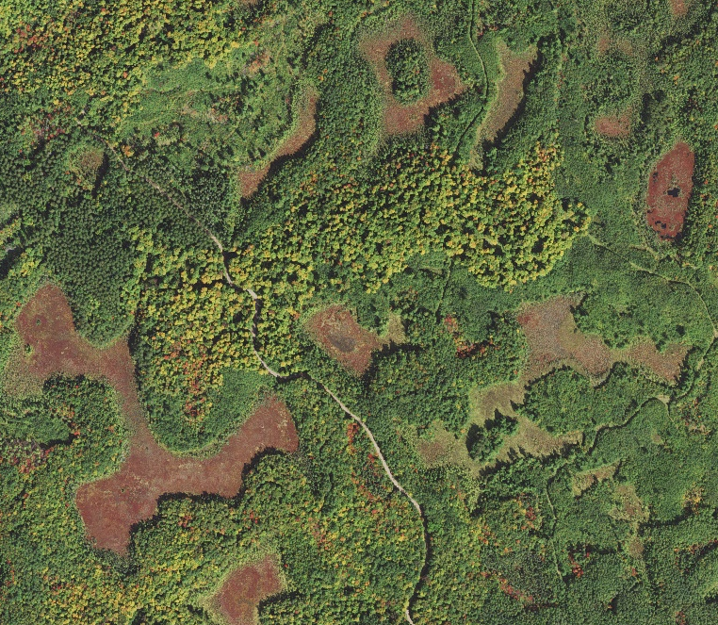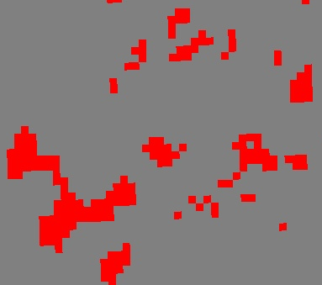
Figure 3. Example of NAIP imagery (left) and detected landscape features that are characteristic of cranberry habitat (right). In this case, red represents cranberry presence and gray represents cranberry absence.

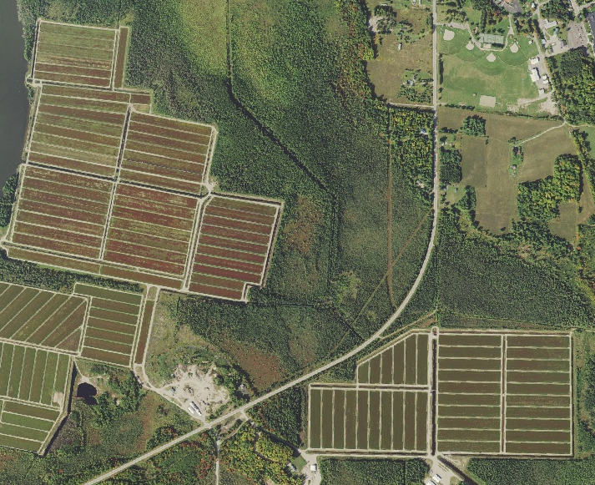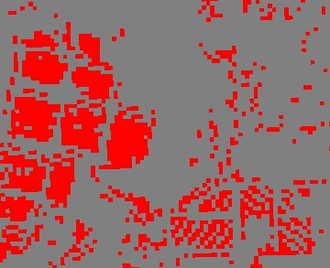
Figure 4. Example of NAIP imagery (left) over commercial cranberry bogs, as defined by the Wisconsin Department of Natural Resources, and detected commercial cranberry bogs (right).

We were able to confirm that our model was successfully picking up cranberry vegetation by visually assessing model outputs over commercial cranberry bogs, as defined by the Wisconsin Department of Natural Resources (Figure 4). This was an interesting finding because the presence locations used to train our model did not include any presence points from within these commercial cranberry bogs. Thanks to this successful yet independent detection of commercial cranberry bogs, we can further validate that what these models are detecting is truly cranberry.

Habitat Distribution Modeling
Model iterations were compared to see which modeling approaches and which combination of input data produced the most robust models. Generally speaking, models based on the user-generated presence points performed better statistically than models with dataset-derived presence points (Table 2). Iterations focused on input points determined that 100 presence points should be used as the recommended minimum threshold per 25,000 square kilometers in order to generate a robust model prediction. When including only topographic and bioclimatic variables, RF with ClimateNA predictors (30m) showed negligible improvement over more coarse WorldClim (1km) inputs (Table 1). In MaxEnt model iterations, the statistics decreased despite the use of higher resolution data. Spatially, however, ClimateNA’s higher resolution appeared to have refined the probability surface maps without integrating spectral variables, as pixelation is more evident in the coarse WorldClim probability map (Figure 5).

Integrated Modeling
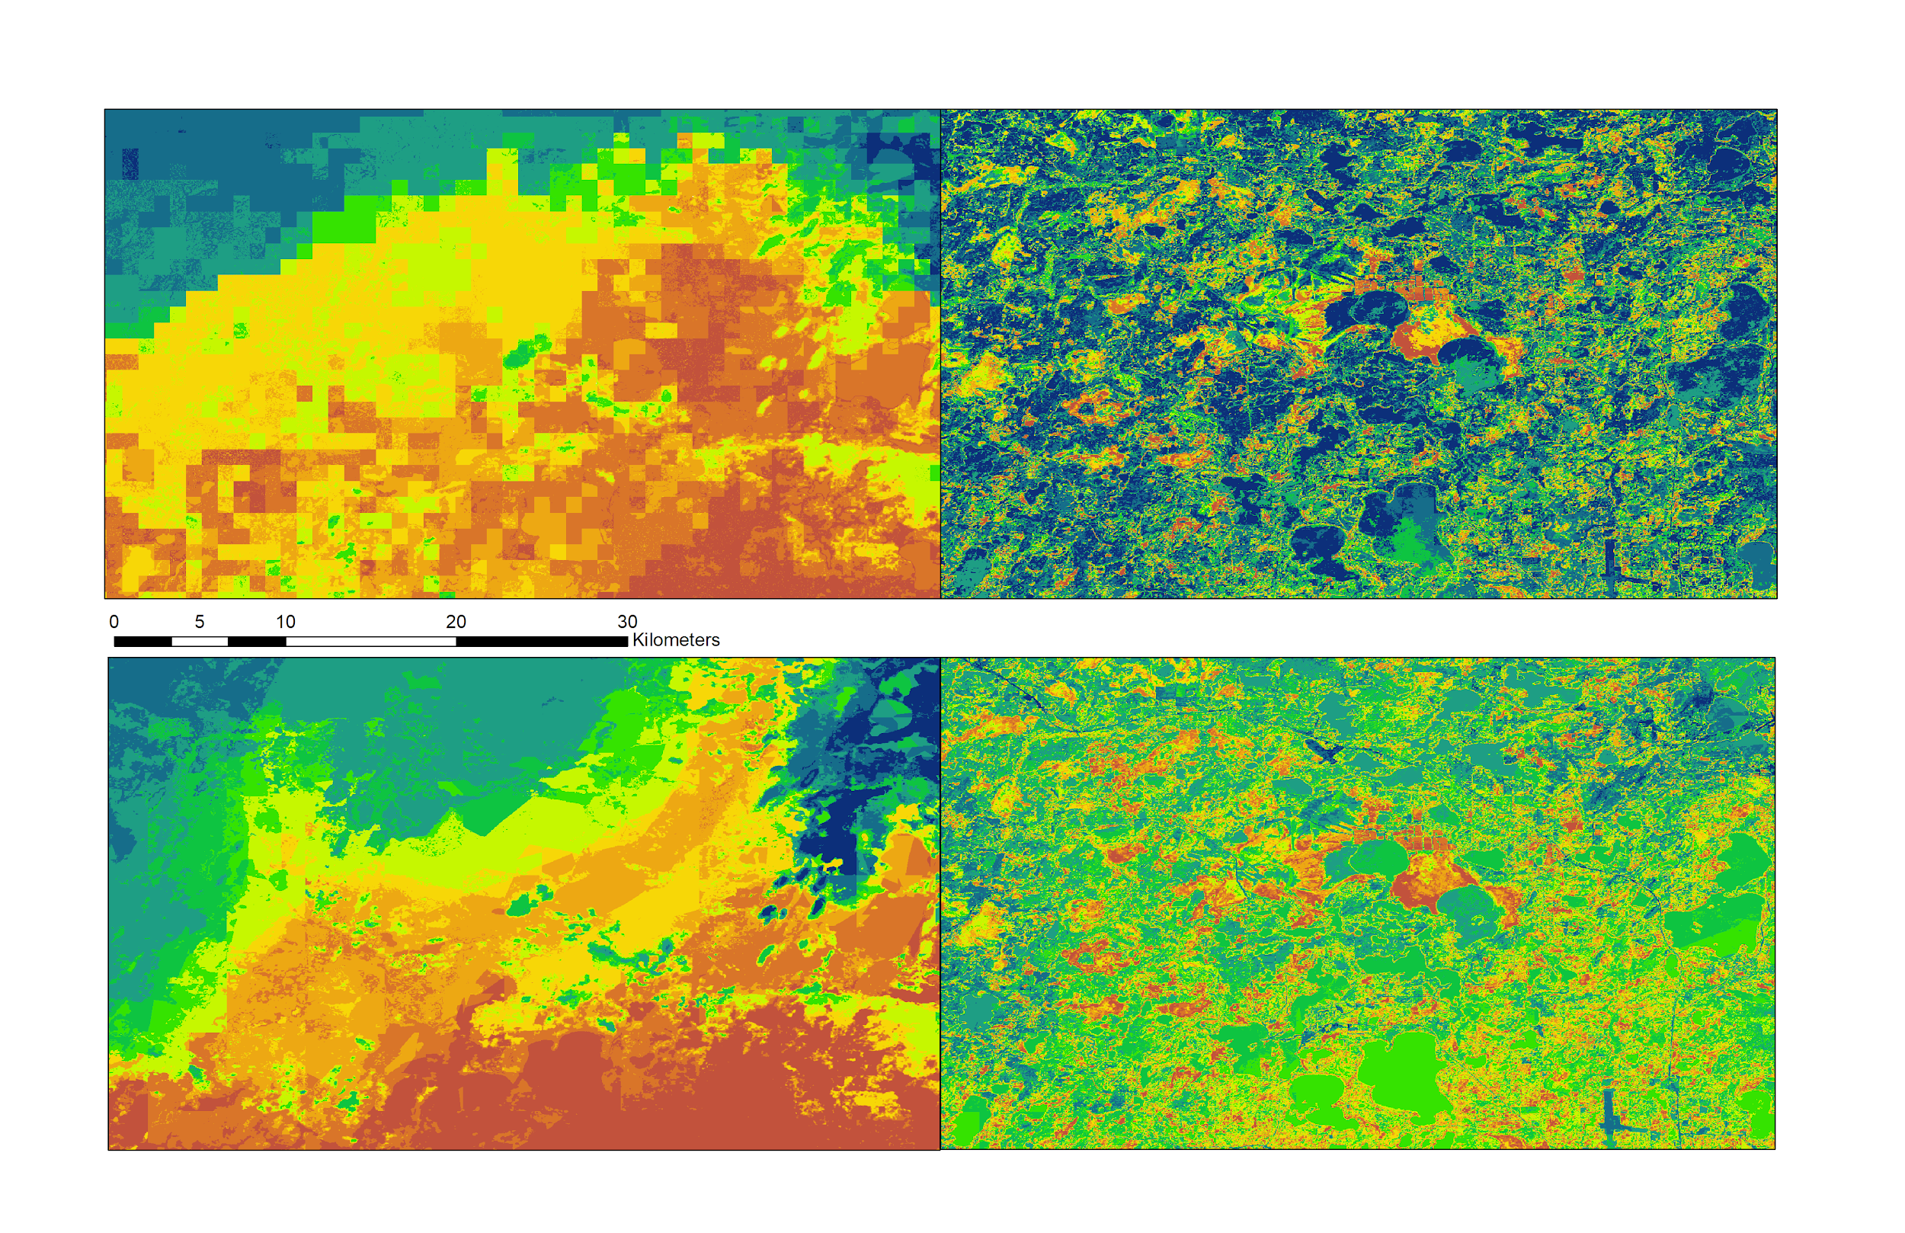
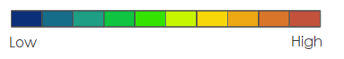

Figure 5. A comparison of spectral integration using both WorldClim (top) and ClimateNA (bottom) climatic variables. All images span the same extent. The two images on the left do not include spectral variables, while those on the right do.

A notable finding was that by including only one spectral variable in models using either topographic and WorldClim or ClimateNA, results included a significant increase in the spatial accuracy of the model (Figure 5, Appendix E). Furthermore, a comparison between the integrated WorldClim model and the ClimateNA model shows that the core discrepancy is between their probability range values. For instance, the range of values for ClimateNA extends from around 0.40 to 0.90, while WorldClim values range from 0.01 to 0.99. This suggests that bioclimatic variables with a higher resolution only improve the model up to a certain point when applied to a small region of interest. Scaling up to a larger study area extent may allow for more spatial variation between the different bioclimatic variables, potentially increasing the explanatory power of these environmental variables.
Comparison of Modeling Approaches
This analysis allowed the team to determine the level of agreement between satellite detection and habitat distribution models (Table 3). It also serves as a potential source of model refinement. Detection outputs can be refined down to areas deemed to be highly suitable. For example, only 13% of the land we detected as cranberry habitat was found to overlap with 75-100% suitable habitat, as defined by the final habitat distribution model that incorporated spectral data. Therefore, end users could direct field scientists to these refined areas for practical use in the field.

Limitations & Future Work
This study was a feasibility analysis that focused on detecting wild cranberry across a single Landsat scene. We found that two principal implications resulted from this assessment. The first is related to geographic scope, namely the fact that the topographic and climatic range across our study site had relatively low variation. As such, the combination of a limited geographic scale and the relatively coarse resolution of bioclimatic variables may have resulted in model iterations relying disproportionately on Landsat-derived spectral variables to predict cranberry habitat. When compared to environmental variables, variation in spectral reflectance can be relatively substantial from pixel to pixel across a small area and is likely due to more abrupt variations in land cover. Therefore, it will be interesting to see how the explanatory power of spectral variables translates when applied to a larger area extent matched with a more diversified range of climatic and topographic variables. Furthermore, it is important to reiterate that the cranberry habitat detected by our models inevitably included other vegetation given the 30 by 30 m resolution that was employed. This means that these detections were not restricted purely to wild cranberry species. Project partners confirmed that other species that were likely detected throughout our models include sphagnum moss and other members of the Vaccinium genus, all of which are co-occurring species.

Looking forward, partners at the USFS Chequamegon-Nicolet National Forest and the University of Wisconsin-Madison have expressed interest in validating user-generated presence points along with the outputs of our predictive models. This process would involve sending researchers out to the field to assess how well these models match-up with the real world landscape. This in-field validation has the potential to provide additional insights into the accuracy of these models, further highlighting the need for another term for this project with the DEVELOP National Program. Additionally, models utilized by our partners at the USDA ARS are typically applied at the national level to hundreds of different crop varieties, so future work would ideally involve adapting this study’s integrated methodology to detect different CWRs over larger study area extents.

6. Conclusion
Surface reflectance products from NASA Earth observations were successfully utilized to detect the habitat of our focal cranberry species. The spatial output from this detection component aligned well with the habitat distribution models executed in SAHM (Table 3). Considering the study area extent, spectral predictor variables provided higher explanatory power to habitat distribution models than standard bioclimatic variables of the same resolution (30m). Both spatial and spectral evaluation metrics showed that RandomForest models produced more accurate outputs as compared to MaxEnt models. We found that user-generated presence points consistently outperformed database-derived presence points in model outputs. This can largely be attributed to the reality that existing species presence data were not always optimal for remote sensing purposes, namely, in capturing the unique spectral signature of focal species. Future work will involve incorporating spectral variables over a larger spatial extent and across a wider variety of CWRs to improve the USDA’s current conservation efforts.

7. Acknowledgments
The Wisconsin Agriculture and Food Security team would like to thank our partners over at the USDA and USFS for engaging with NASA DEVELOP to make this research possible. We would also like to give a special thanks to Tim Mayer (Colorado Node Center Lead), Nick Young (Science Advisor), and Dr. Colin Khoury (USDA ARS NPGS) for working closely with our team throughout this research project. This research includes modified Copernicus Sentinel data (2017), processed by ESA. Any opinions, findings, and conclusions or recommendations expressed in this material are those of the authors and do not necessarily reflect the views of the National Aeronautics and Space Administration. This material is based upon work supported by NASA through contract NNL16AA05C.

8. Glossary
ARS - Agricultural Research Service
Area Under Curve (AUC) - A statistic obtained via the Receiver Operating Characteristic (ROC) curve that is used for model evaluation and comparison, which describes the predictive power of a suite of environmental variables relative to presence and absence points, ranging from 0 to 1
CWR - Crop Wild Relative
Earth observations - Satellites and sensors that collect information about the Earth’s physical, chemical, and biological systems over space and time
GEE - Google Earth Engine
In situ - “On site” conservation; the process of protecting an endangered plant or animal species in its natural habitat
Ex situ - “Off site” conservation; the process of preserving components of biological diversity outside their natural habitats (ie. in seed banks or other genetic repositories)
MaxEnt - Maximum Entropy classification
NASA - National Aeronautics and Space Administration
NAIP - National Agricultural Imagery Program
NDVI - Normalized Difference Vegetation Index
NDMI - Normalized Difference Moisture Index
NPGS - National Plant Germplasm System
NASA - National Aeronautics & Space Administration
Opportunistic - sampling method where participants are selected based on naturally occurring groups.
RF - Random Forest classification
SAHM - Software Assisted Habitat Modeling
HDM - Habitat Distribution Model
Sensitivity - A statistic that measures the proportion of positives (presences) correctly identified
Specificity - A statistic that measures the proportion of negatives (non-presences) correctly identified
SRTM - Shuttle Radar Topography Mission
True Skill Statistic (TSS) – Sum of sensitivity and specificity minus one
VSURF - Variable Selection Using Random Forest

9. References
Agricolus, (2018). https://www.agricolus.com/en/indici-vegetazione-ndvi-ndmi-istruzioni-luso/

Biodiversity Information Serving Our Nation (BISON). (2018). Vaccinium macrocarpon and Vaccinium oxycoccos dataset. USGS. Accessed through https://bison.usgs.gov.
Bradley, B. A., Olsson, A. D., Wang, O., Dickson, B. G., Pelech, L., Sesnie, S. E., & Zachmann, L. J. (2012). Species detection vs. habitat suitability: are we biasing habitat suitability models with remotely sensed data?. Ecological Modelling, 244, 57-64.

Bruederle, L., Hugan, M., Dignan, J., & Vorsa, N. (1996). Genetic variation in natural populations of the large cranberry, Vaccinium macrocarpon Ait. (Ericaceae). Torrey Botanical Society. Bulletin of the Torrey Botanical Club, 123(1), 41-47

Brummitt, N., & Bachman, S. (2010). Plants under pressure: A global assessment. The first report of the IUCN sampled red list index for plants. Natural History Museum, London, UK.

Colquhoun, J., & Johnson, H. (2009). Sustainable cranberry production for a vibrant future: The Wisconsin experience. University of Wisconsin-Madison Horticulture Department.

Consortium of Midwest Herbaria. Vaccinium macrocarpon and Vaccinium oxycoccos . (2018). http//:midwestherbaria.org/portal/index.php
GBIF Secretariat. (2017). Vaccinium macrocarpon Aiton. GBIF Backbone Taxonomy. Checklist dataset https://doi.org/10.15468/39omei via GBIF.org.

Gorelick, N., Hancher, M., Dixon, M., Ilyushchenko, S., Thau, D., & Moore, R. (2017). Google Earth Engine: Planetary-scale geospatial analysis for everyone. Remote Sensing of Environment.

Hijmans, R.J., Cameron, S.E., Parra, J.L., Jones, P.G., & Jarvis, A. (2005). Very high resolution interpolated climate surfaces for global land areas. International Journal of Climatology 25: 1965-1978.

Khoury, C. (2013). An Inventory of Crop Wild Relatives of the United States. Crop Sci, 53:1496–1508. doi: 10.2135/cropsci2012.10.0585

Mahy, G., Bruederle, L., Connors, B., Van Hofwegen, M., & Vorsa, N. (2000). Allozyme evidence for genetic autopolyploidy and high genetic diversity in tetraploid cranberry, Vaccinium oxycoccos (Ericaceae). American Journal of Botany 87(12): 1882–1889.

Matthews, R. (2018). Vaccinium oxycoccos. In: Fire Effects Information System, [Online].
U.S. Department of Agriculture, Forest Service, Rocky Mountain Research Station,
Fire Sciences Laboratory (Producer).
https://www.fs.fed.us/database/feis/plants/shrub/vacoxy/all.html [2018, November 13].

Meilleur, B. A., & Hodgkin, T. (2004). In situ conservation of crop wild relatives: status and trends. Biodiversity & Conservation, 13(4), 663-684.

Merow, C., Smith, M. J., & Silander Jr, J. A. (2013). A practical guide to MaxEnt for modeling species’ distributions: What it does, and why inputs and settings matter. Ecography, 36(10), 1058-1069.

Shabani, F., Kumar, L., & Ahmadi, M. (2018). Assessing Accuracy Methods of Species Distribution Models: AUC, Specificity, Sensitivity and the True Skill Statistic. Global Journal of Human-Social Science Research.

Stohlgren, T. J., Ma, P., Kumar, S., Rocca, M., Morisette, J. T., Jarnevich, C. S., & Benson, N. (2010). Ensemble habitat mapping of invasive plant species. Risk Analysis: An International Journal, 30(2), 224-235.

Suszkiw, Jan. (2014). National Inventory Takes Stock of Crops’ Wild Relatives. Agricultural Research Magazine.

United States Department of Agriculture Farm Service Agency, National Agriculture Imagery Program (NAIP) [Image collection]. Retrieved from: https://code.earthengine.google.com/

University of Wisconsin-Madison. (2018). Vaccinium macrocarpon and Vaccinium oxycoccos dataset. Department of Horticulture.
U.S. Geological Survey Earth Resources Observation And Science Center. (2014). Landsat 8 OLI Level-2 Surface Reflectance (SR) Science Product [Data set]. U.S. Geological Survey. https://doi.org/10.5066/f78s4mzj
USDA Agricultural Research Service, USDA Forest Service. (2014). Joint Strategic Framework on the Conservation and Use of Native Crop Wild Relatives in the United States.

USDA Forest Service. (2014). USDA Forest Service and Agricultural Research Service Crop Wild Relatives Partnership Projects: The Importance of Research Natural Areas, Wilderness Areas, and More.

Wisconsin Historical Society. (2018). https://www.wisconsinhistory.org/Records/Article/CS387

10. Appendices
Appendix A

A1. Map of database derived (yellow) and user-generated (red) cranberry presence locations. There are a combined 167 presence points from species presence databases and 150 user-generated presence points.

Cranberry Presence Points
Dataset Points
User- Generated Points

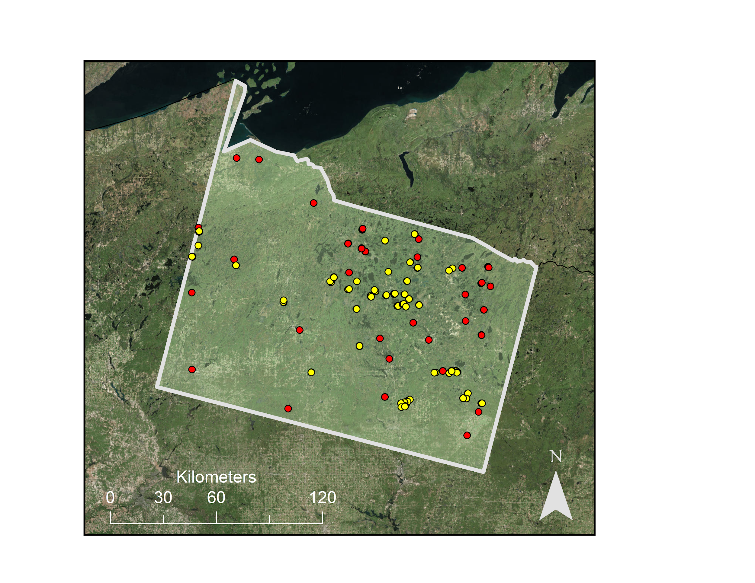

Appendix B
B1. Comparison between RandomForest and Maxent models with user-generated presence points
Variables Used | Data  Points | RandomForest |  |  |  | MaxEnt
bio 2  bio 7  bio 8  bio 10  bio 11  bio 12  bio 13  bio 14  elevation |  | AUC | TSS | Sensitivity | Specificity | AUC | TSS | Sensitivity | Specificity
 | 20  50  100  150 | 0.93  0.98  0.99  0.99 | 0.65  0.78  0.87  0.93 | 0.95  0.88  0.92  0.97 | 0.70  0.90  0.95  0.95 | 0.74  0.81  0.89  0.89 | 0.47  0.37  0.52  0.57 | 0.76  0.76  0.85  0.85 | 0.70  0.60  0.67  0.73

Appendix C

C1. Bioclimatic variables utilized in habitat distribution modeling: WorldClim (1km) v. ClimateNA (30m)

WorldClim Variables | ClimateNA Variables
BIO1 - Annual Mean Temperature | MAT - mean annual temperature (°C)
BIO2 - Mean Diurnal Range | MWMT - mean warmest month temperature (°C)
BIO3 - Isothermality (BIO2/BIO7) (* 100) | MCMT - mean coldest month temperature (°C)
BIO4 - Temperature Seasonality (standard deviation *100) | TD - temperature difference between MWMT and MCMT, or continentality (°C)
BIO5 - Max Temperature of Warmest Month | MAP - mean annual precipitation (mm)
BIO6 - Min Temperature of Coldest Month | MSP - May to September precipitation (mm)
BIO7 - Temperature Annual Range (BIO5-BIO6) | AHM - annual heat-moisture index (MAT+10)/(MAP/1000))
BIO8 - Mean Temperature of Wettest Quarter | SHM - summer heat-moisture index ((MWMT)/(MSP/1000))
BIO9 - Mean Temperature of Driest Quarter | eFFP - the day of the year on which frost-free period ends
BIO10 - Mean Temperature of Warmest Quarter | DD<0 - degree-days below 0°C, chilling degree-days
BIO11 - Mean Temperature of Coldest Quarter | DD<18 - degree-days below 18°C, heating degree-days
BIO12 - Annual Precipitation | EMT - extreme minimum temperature over 30 years
BIO13 - Precipitation of Wettest Month | EXT - extreme maximum temperature over 30 years
BIO14 - Precipitation of Driest Month | FFP - frost-free period
BIO15 - Precipitation Seasonality (Coefficient of Variation) | MAR - mean annual solar radiation (MJ m^{‐2} d^{‐1})
BIO16 - Precipitation of Wettest Quarter | NFFD - the number of frost-free days
BIO17 - Precipitation of Driest Quarter | PAS - precipitation as snow (mm) between August in previous year and July in current year
BIO18 - Precipitation of Warmest Quarter | RH - mean annual relative humidity (%)
BIO19 - Precipitation of Coldest Quarter

C2. Topographic and Spectral Data Utilized in Habitat Distribution/Satellite Detection Modeling

Product | Spatial Resolution (meters) | Temporal Resolution | Source
Digital Elevation Model | 30 | 2000 | Shuttle Radar Topography Mission (SRTM V3)
Slope, Aspect, Hillshade | 30 | 2000 | Derivatives of DEM using ee.Terrain (GEE)
Surface Reflectance  (Bands 2-7) | 30 | 2013-2017 | Landsat 8 OLI Surface Reflectance Tier 1
Spectral Indices  (NDVI, NDMI) | 30 | 2013-2017 | Landsat 8 OLI Surface Reflectance Tier 1
Tasseled Cap Components (Brightness, Greenness, Wetness) | 30 | 2013-2017 | Landsat 8 OLI Surface Reflectance Tier 1
Radar Backscatter and Variance | 10 | 2014-2017 | Sentinel 1 SAR C-Band Synthetic Aperture Radar

Appendix D

D1. Variable importance for satellite detection modeling, as determined through VSURF
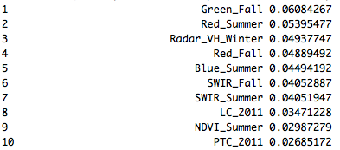

D2. Variable importance plot of RF model utilizing WorldClim and topographic variables

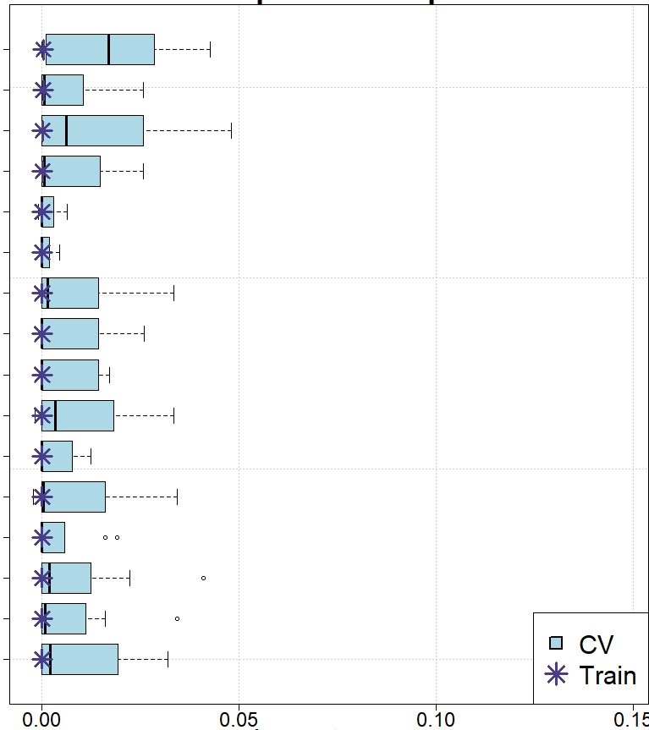
Mean Temperature of Coldest Quarter

Mean Diurnal Range

Elevation

Temperature Seasonality

Slope

Hillshade

Mean Temperature of Driest Quarter

Mean Temperature of Wettest Quarter

Mean Temperature of Annual Range

Minimum Temp. of Coldest Month

Isothermality

Precipitation Seasonality

Precipitation of Driest Month

Precipitation of Wettest Month

Annual Precipitation

Precipitation of Warmest Quarter

Importance

D3. Variable importance plot of RF model utilizing WorldClim variables with one spectral variable added, in this case Normalized Difference Moisture Index

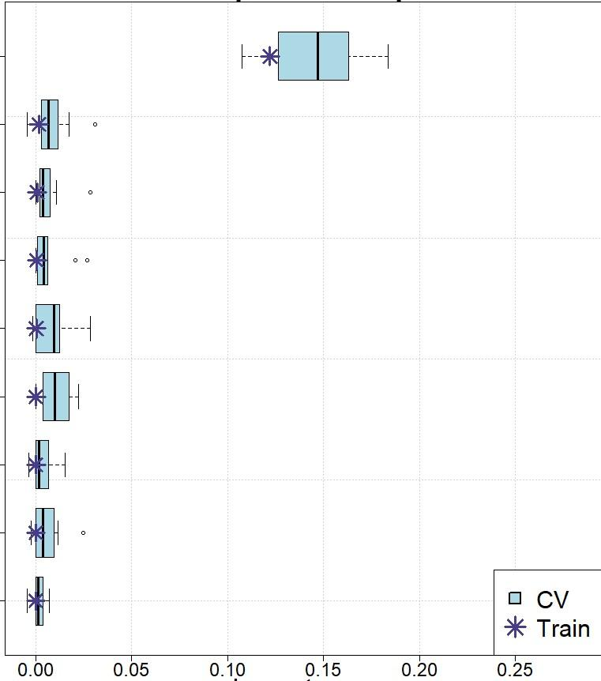
Normalized Difference Moisture Index

Precipitation of Warmest Quarter

Precipitation of Driest Month

Mean Diurnal Temp. Range

Elevation

Mean Temperature of Coldest Quarter

Temperature Seasonality

Mean Temperature of Wettest Quarter

Precipitation of Wettest Quarter

Importance

Appendix E
Habitat distribution map comparison between different combinations of variable inputs in RandomForest models over same area extent. Figure E1 highlights the difference between bioclimatic variables derived from WorldClim and ClimateNA. Figure E2 presents these same models with the addition of a single spectral variable, the Normalized Difference Moisture Index (NDMI). Figure E3 similarly shows models incorporating multiple spectral variables.
WorldClim ClimateNA
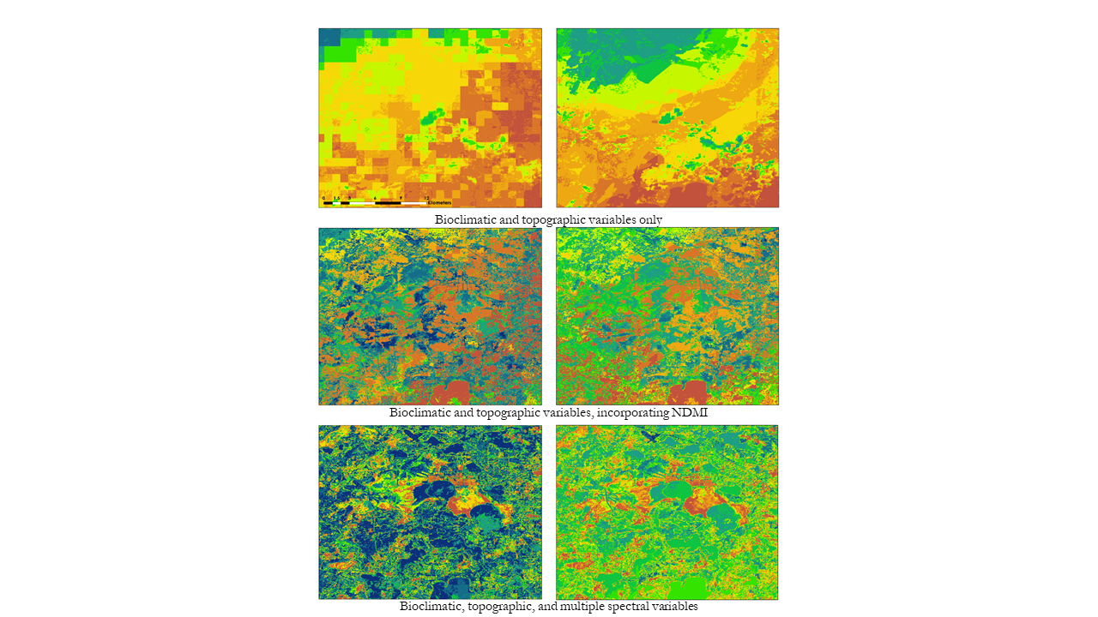

Figure E1

Figure E2

Figure E3

