**NASA DEVELOP National Program**



NASA Marshall Space Flight Center

*Spring 2017*

Alabama Agriculture

Using NASA Earth Observations to Assess Vegetative Stress of Row Crops in Irrigated and Non-Irrigated Plots in Alabama

 **Technical Report**

Final Draft – March 30, 2017

Chris Ploetz (Project Lead)

Olivia Callaway

Maggi Klug

Emilene Sivagnanam

Dr. Jeffery Luvall (NASA at the National Space and Technology Center)

Dr. Robert Griffin (University of Alabama in Huntsville)

Leigh Sinclair (University of Alabama in Huntsville)

# 1. Abstract

Over the past decade, drought in Alabama had a major impact on agriculture causing crop yields to fall well below normal levels. High resolution satellite remote sensing can enhance current drought monitoring practices led by the Alabama Office of the State Climatologist (AOSC). The AOSC monitors drought using a myriad of data types and sources and compiles the information into a weekly drought-monitoring map, the United States Drought Monitor (USDM). This project explored using two vegetation indices, Green Normalized Difference Vegetation Index (GNDVI), Normalized Difference Vegetation Index (NDVI), and one water index, the Normalized Difference Water Index (NDWI), from high-resolution satellites, Landsat 5 TM, Landsat 8 OLI, and Sentinel 2 MSI to increase the level of detail in drought depiction for the USDM. Additionally, the project considered whether farms with center pivot irrigation fared better than farms relying solely on precipitation during the 2011 and 2016 drought using data provided by the Earth System Science Center (ESSC) at University of Alabama in Huntsville. The results were compared to the USDM output and the crop’s water stress index, which was provided by the ESSC’s Gridded Decision Support System for Agrotechnology Transfer (GriDSSAT) crop model. The project resolved that although higher resolution satellites do provide information on when a crop is under vegetative stress before the USDM depicts drought conditions, the resolution of Landsat 5 and Landsat 8 was not high enough to analyze crops at a field level scale.

**Keywords:** Alabama, center pivot irrigation, corn, drought, Landsat, GNDVI, NDVI, NDWI

**2. Introduction**

* 1. ***Background Information***

According to the most current agricultural census led by the United States Department of Agriculture National Agricultural Statistics Service (USDA NASS) (2012), in the state of Alabama, of the 21,283 farms with harvested cropland, only 1,584 farms (7.44 percent) were irrigated. This leaves most crops vulnerable to impacts from drought conditions. Depending on the duration and type of drought, impacts can range from significant crop yield loss, impacted local and global economies, lower reservoir levels, and depleted groundwater levels (Otkin et al., 2013).

The current drought monitoring system that policymakers and the media use to allocate drought relief is the U.S. Drought Monitor (USDM). This is a weekly map of drought conditions for the entire country at a county level (National Drought Mitigation Center (NDMC), 2017). The USDM is a composite index that uses both quantitative and qualitative data, including community observations, from over 350 contributors. Eleven authors take two-week shifts to compile several datasets using GIS software (Luebehusen, 2014).

The following datasets and models are typically used: Advanced Hydrological Prediction Service (AHPS), a gridded precipitation dataset; the United States Geological Survey (USGS) 7-day average streamflow; North-American Land Data Assimilation Systems (NLDAS) Soil Moisture; the Natural Resources Conservation Service (NRCS) SNOwpack TELemetry (SNOTEL) snow-water equivalent; and other remote-sensing data, such as the vegetation health index (Luebehusen, 2014). This project focuses on the incorporation of additional remote sensing indices in order to add value to the United States Drought Monitor.

The incorporation of remotely sensed data in the USDM is useful for monitoring drought because it provides complete, up-to-date, and comprehensive coverage of drought conditions (Peters et al., 2002). In particular, this project uses 30m Landsat 5 Thematic Mapper (TM), 30m Landsat 8 Operational Land Imager (OLI), and 10m Sentinel-2 MultiSpectral Instrument (MSI) to complete the assessment. Two vegetation indices—the Normalized Difference Vegetation Index (NDVI) (Equation 1), Green Normalized Difference Vegetation Index (GNDVI) (Equation 2), and one water index— the Normalized Difference Water Index (NDWI) (Equation 3), were used to provide near-real time vegetation drought assessments.

$$NDVI= \frac{Band\left(NearIR\right)-Band (Red)}{Band\left(NearIR\right)+Band(Red)} (1)$$

$$GNDVI= \frac{Band\left(NearIR\right)-Band (Green)}{Band\left(NearIR\right)+Band(Green)} (2)$$

$$NDWI= \frac{Band\left(NearIR\right)-Band (SWIR)}{Band\left(NearIR\right)+Band(SWIR)} (3)$$

***2.2 Indices Used***  
NDVI is widely used for remote sensing of vegetative health (Gao, 1996) and drought monitoring (Rhee et al., 2010); (Gu et al., 2007). NDVI measures changes in chlorophyll content and in spongy mesophyll within vegetation and is useful for monitoring purposes because the data is available to be displayed in a time series (Gu et al., 2007). NDVI has been used as means to monitor vegetative health using the Advanced Very High Resolution Radiometer (AVHRR) sensor since 1981; however, in terms of drought monitoring, there is an apparent lag between rainfall and NDVI response (Gu et al., 2007).

GNDVI is a modified version of the NDVI intended to be more sensitive to variation in chlorophyll content in crops. It is useful in assessing variation of biomass and is used as an indicator of stress or late maturity stage (Gitelson et al. 1996).

NDWI has important applications in agriculture because it indicates the liquid water content of vegetation. It is less sensitive to atmospheric scattering effects than NDVI (Gao, 1996), but does not completely remove the soil background. Gu et al. (2007) studied grassland and found that NDWI responds more quickly to drought than NDVI. Since this project focuses on crops, and soil likely affects the spectral reflectance, it is used as a complement to NDVI, but not as a replacement (Gao, 1996).

***2.3 Study Area & Study Period***

The study area was chosen based on the high density of farms located in the Northern counties of Alabama within the HUC-8 watershed and the Landsat tile Path 21, Row 36 (Figure 1).

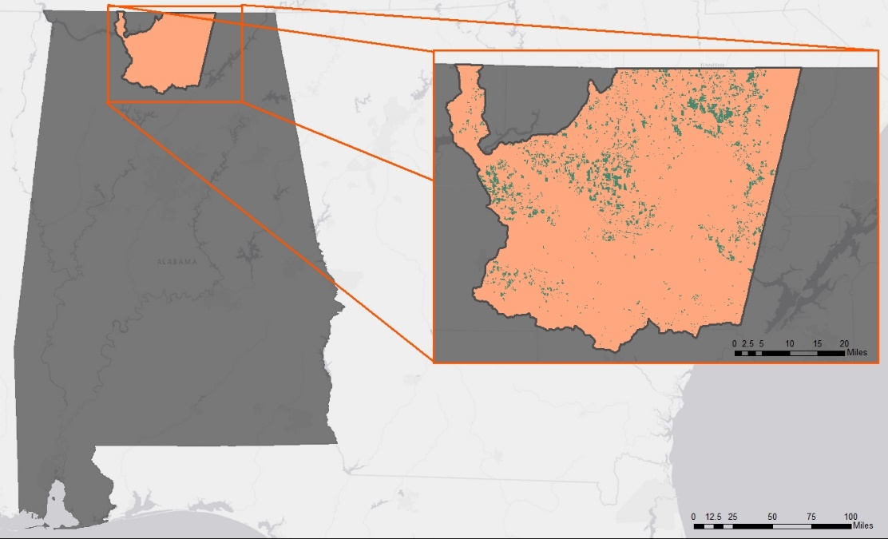

Figure 1: Project study area: the HUC-8 watershed

Based on the USDM Statistics Graph for the State of Alabama, the project focused on two drought periods, 2011 and 2016, and used 2009 data as a non-drought baseline for comparison. The focal months of the study are March-September, which accounts for Alabama’s varying growing season. Alabama’s growing season varies for numerous reasons, such as temperature, crop type, fertilizer application, irrigation, and/or a farmer’s cropping system. For example, in Madison County corn should be planted April-May and harvested June-August (The Old Farmer’s Almanac, 2017). On the other hand, cotton is typically planted in March or April (Phillps and Roberts, 2016); therefore, March-September encompasses the varying growing season of our study area.

***2.4 Objectives***

The objectives were to determine relevant indices for monitoring drought in Alabama, create a time series for the indices selected, assess suitability of Landsat satellite for monitoring drought conditions, and qualitatively compare the indices to ESSC’s GriDSSAT crop model.

***2.5 Project Partners***

The Alabama Agriculture Team collaborated with the Alabama Office of the State Climatologist (AOSC) and the Earth System Science Center (ESSC) at University of Alabama in Huntsville. The AOSC is responsible for creating the USDM for the state of Alabama and is interested in this project because this research may provide an enhanced understanding for the output of drought conditions, allowing farmers, policymakers, and the media to have a more accurate and thorough understanding of droughts and their impact on the state.

Additionally, the ESSC releases a daily product, called the Gridded Decision Support System for Agrotechnology Transfer (GriDSSAT) that provides information on a crop’s water stress level for Alabama, Florida, Georgia, and South Carolina. The project’s remotely sensed indices are compared to GriDSSAT’s output to determine the accumulated vegetative stress in crops and to potentially add value to GriDSSAT’s daily output.

**3. Methodology**

***3.1 Data Acquisition***

NASA Earth observations acquired for this study were Landsat 5 TM and Landsat 8 OLI. The data were downloaded from United States Geological Survey’s (USGS) EarthExplorer. For the years 2009, 2012, and 2016, from March-September each year as well as 2016 Sentinal-2 data, and the following products were obtained: Crop data for the state of Alabama were obtained from the USDA and the NASS through CropScape. CropScape provided the Cropland Data Layer (CDL), which is a crop-specific land cover data. The ground resolution is 30 m and the layer was created from Landsat 8 OLI, United Kingdom Disaster Monitoring Constellation 2 (UK-DMC2), and DEIMOS-1 sensors during the growing season. The crops selected were corn, soybeans, and cotton, as these crops are included in the GriDSSAT crop model created by the ESSC.

Additionally, the project partner from the ESSC at UAH, Dr. Cameron Handyside, provided a shapefile that contained manually surveyed crop circles representing center pivot irrigation for 2009, 2011, and 2013, as well as the Hydrologic Unit Code (HUC)-8 watershed shapefiles for Alabama. The 2013 center pivot irrigation file was used as a proxy for 2016.

***3.2 Data Processing***

This project used ArcMap to process all data. Before any processing of data began, the proper projection was selected. The projection used was North American Datum (NAD) 83 Universal Transverse Mercator (UTM) Zone 16N.

First, all data in Table 1 and Table 2 in Appendix A were projected into NAD 83 UTM Zone 16N. Then, all data were clipped to the study area.

|  |  |  |
| --- | --- | --- |
| **Earth Observations** | | |
| ***Platform & Sensors*** | ***Product /Year/ Resolution / Band*** | ***Data Source*** |
| Landsat 5 TM | Surface reflectance / 2009 / 2011 / 30m /4, 5, 6 | United States Geological Survey (USGS) EarthExplorer |
| Landsat 8 OLI | Surface reflectance / 2016 / 30m / 3, 4, 5 | USGS EarthExplorer |
| Sentinel- 2 MSI | Surface reflectance / 2016 / 10m / 8, 4 | USGS EarthExplorer |
| MODIS TERRA | NDVI / 2016 / 250m / NA | USGS EarthExplorer |

*Table 1: NASA Earth Observations and their respective sources*

The CropScape data had thousands of overlapping polygons which represented each type of crop. The file required reclassification in order to simplify the crop data for analysis. First, the corn, cotton, and soybeans attributes were selected and isolated using the Select by Attribute tool. Next, the Field Calculator tool was used to calculate the area of each polygon. The Select by Attributes tool was again used to identify and isolate crop polygons with an area greater than or equal to 10,000 acres. To further simplify the crop data, the Dissolve tool was used on the crops leaving only corn, cotton, and soybean crops with an area of greater than or equal to 10,000 acres. The resultant shapefile data layer was then exported as a new layer and renamed Row_Crop_09, Row_Crop_11, and Row_Crop_16, respectively.

In order to minimize potential sources of error and maintain the consistent variables of the study, the Intersect tool was used on Row_Crop_09 and Row_Crop_11 to ensure that only the fields that grew corn, cotton, and soybeans for both 2009 and 2011 were compared. The same process was used on Row_Crop_09 and Row_Crop_16.

The final step of processing before analysis was separating the irrigated crops from the non-irrigated crops. To do this, the Intersect tool was used to ensure that only center pivots with corn, cotton, or soybean crops were used. The intersected center pivot shapefiles were renamed Center_Pivot_(year). This file was used to analyze center pivot or irrigated crops in the study area. For the non-irrigated crops, the Erase tool was used on the Row_Crops_(year) files to remove the area of the crops that overlapped the Center_Pivot_(year) crops. This file was renamed Rain_Fed_Crops_(year).

***3.3 Data Analysis***

NDVI, GNDVI, and NDWI were computed from Landsat 5 TM and Landsat 8 OLI. A time series of the indices were created for the 2009, 2011, and 2016 growing seasons. These time series indices were then reviewed and compared to one another.

# 4. Results & Discussion

***4.1 Analysis of Results***

Samples of the NDVI, GNDVI, and NDWI calculations for April 2016 are shown below in Figures 2, 3, and 4, respectively. NDVI, the most well known and most commonly used vegetation index, was found to be the most effective for quantifying green vegetation. GNDVI proved that it indicates where water isolation occurs or varies throughout a field. Finally, NDWI determined the vegetation and water content based on physical principles.

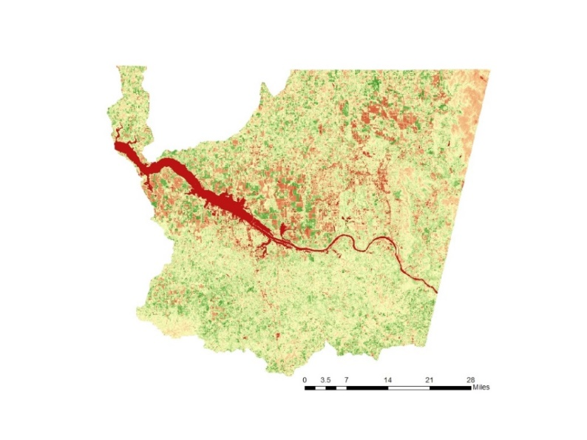

Figure 2: NDVI of April 20126

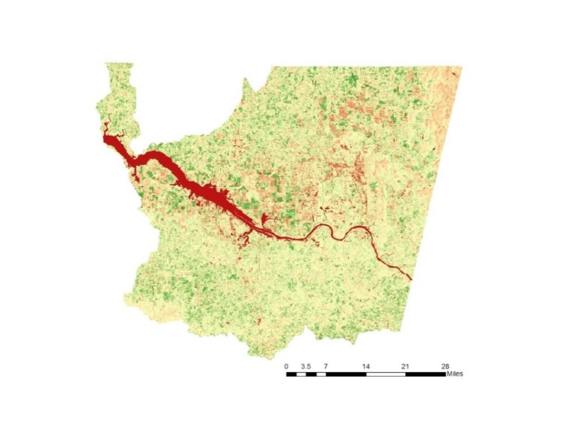

Figure 3: GNDVI of April 2016

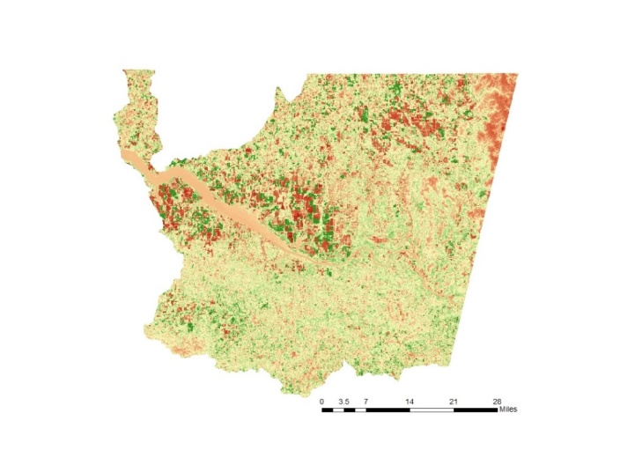

Figure 4: NDWI of April 2016

Below in Figure 5, it shows the results of the time series of the indices over 2011 and 2016 for irrigated and rainfed crops. It was expected for there to be less variability under pivots, which can be seen on the 2016 crops. Also on the 2016 graphs, one can identify the drastic decline in water over the rainfed areas whereas it remains positive under the pivots due to irrigation practices.

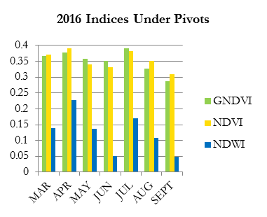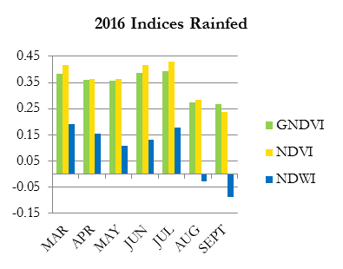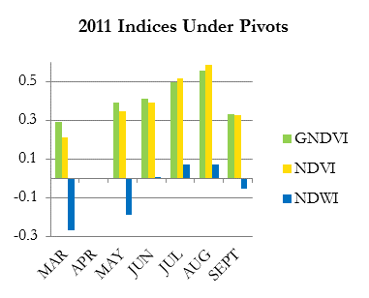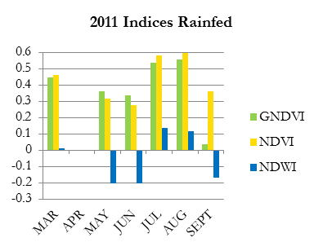

a)

b)

c)

d)

Figure 5: a) 2011 time series of the indices under pivots 2011, b) 2011 time series of indices rainfed, c) 2016 time series of indices under pivots, and d) 2016 time series of indices rainfed

One of the other objectives of this project was to assess the suitability of Landsat to monitor drought conditions. Figure 6 shows three different NDVI calculations (MODIS, Landsat 8, and Sentinel-2) along with the National Agriculture Imagery Program (NAIP) data. NDVI is very sensitive to exposed soil and tends to oversaturate lush forests. Both of those factors can be seen clearly in the NAIP imagery. Both can skew the range of the NDVI values when high-resolution data is not used. Lower resolution data may not pick up the small soil patches. Additionally many farms in Alabama are adjacent to forested areas, which is the pixel values are included in the lower resolution, MODIS, data under the center pivot crop circle. These reasons are why it can be difficult to tell the difference between a healthy and unhealthy crop in Alabama; therefore, it is concluded that at this scale, a higher resolution sensor is needed.

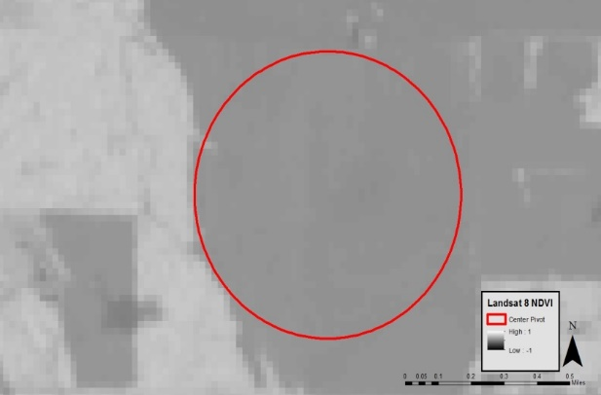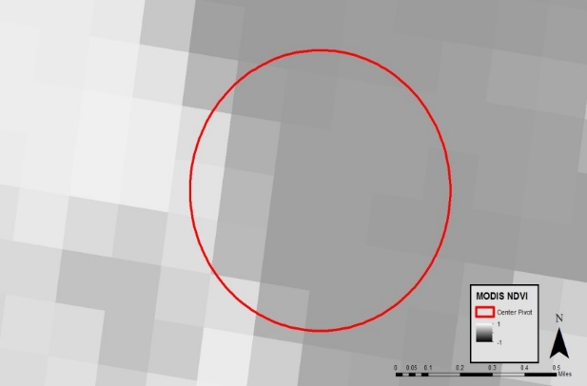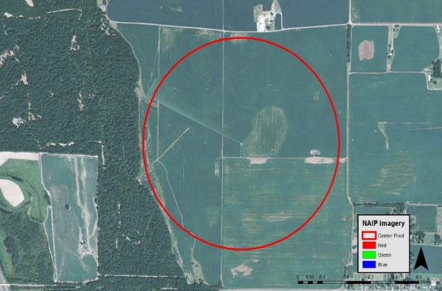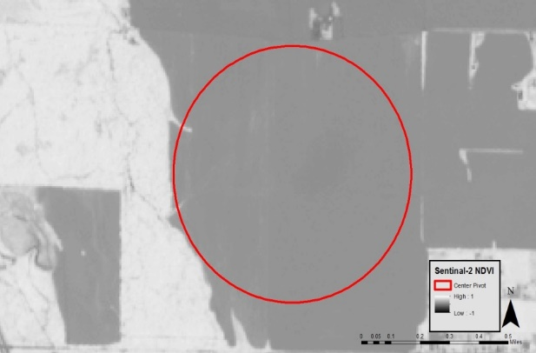

Figure 6: MODIS NDVI (top left), Landsat 8 NDVI (top right), Sentinel-2 NDVI (bottom left) and NAIP true color imagery (bottom right)

***4.2 Errors and Uncertainties***

Over the course of the project, several challenges and uncertainties were discovered that potentially affected the project’s conclusions. The first challenge was derived from selecting Landsat as the source for satellite imagery. The 16-day temporal resolution of Landsat coupled with the frequency of cloud cover during the growing season made it difficult to obtain usable data over a large area that aligned with the research. The 30m spatial resolution impeded the ability to identify crop health, as row crops typically have a larger amount of visible barren soil that affects the amount of green per pixel. Additionally, the coniferous vegetation surrounding agricultural fields remain green year round—despite dry seasons, which skew the appearance of fields.

The second challenge arose from uncertainties with correctly identifying fields and crop types. CropScape uses the maximum likelihood classifier using an in-house software package, as well as ground truth surveying to classify crops (NASS, 2017). While being reliable at a large scale for identifying general crop types, at a smaller scale, assumptions were made for specific crop fields that potentially negatively impacted results.

Thirdly, due to the limited data available, the Center Pivot Irrigation Survey provided by the ESSC became the sole identifier to classifying a field as irrigated or non-irrigated. This possibly resulted in a misclassification of crops because other forms of irrigation exist. Finally, the planting and harvesting times of the crops were not precisely known, which might have affected the indices values as well.

***4.3 Future Work***Additional research on this topic includes adding evapotranspiration remote sensing indices to the USDM weekly map. The Evaporative Stress Index (ESI) or the Evaporative Demand Drought Index (EDDI) would be useful to incorporate because both indices provide early warning of drought impacts (Otkin et al., 2013); (McEvoy et al., 2016). Additionally, the Soil Moisture Active Passive (SMAP) and WorldView-2 satellites would provide soil moisture data and higher temporal and spatial resolution that leads to further developed conclusions.

# 5. Conclusions Project results showed that the NDVI and GNDVI both had similar values and are useful in indicating vegetative stress in row crops before the USDM depicts drought. The NDWI also provided useful registration of water-stressed crops before the USDM. The intention of creating a time times of each index with and without center pivot irrigation was to determine the variability of vegetative health between the two types of farms. However, the results were inconclusive because data acquisition of Landsat was limited by the temporal resolution and a statistically significant trend could not be determined. Further, during analysis, the spatial resolution of Landsat was determined to be too coarse to characterize the difference between high-density coniferous vegetation and farm plots. Finally, the remote sensing indices’ values were qualitatively compared to GriDSSAT’s water stress index and USDM’s categorical drought severity index to find that all three indices were depicting stressed crops appropriately.

# 6. Acknowledgments

The Alabama Agriculture team would like to thank the mentors and partners who dedicated their time and assistance to this project. Without any of them, this project would not have been possible.

Mentors/Science Advisors:

* Dr. Jeffrey Luvall (NASA Marshall Space Flight Center)
* Dr. Robert Griffin (University of Alabama in Huntsville)
* Cameron Handyside (University of Alabama in Huntsville, Earth System Science Center)
* Leigh Sinclair (University of Alabama in Huntsville, Information Technology and Systems Center)

Partners:

* Dr. John Christy (Alabama Office of the State Climatologist)

Any opinions, findings, and conclusions or recommendations expressed in this material are those of the author(s) and do not necessarily reflect the views of the National Aeronautics and Space Administration.

This material is based upon work supported by NASA through contract NNL16AA05C and cooperative agreement NNX14AB60A.

# 7. Glossary

Define acronyms and field specific terms. These should be terms unfamiliar to a general audience

**AHPS** – Advanced Hydrological Prediction Service

**AOSC –** Alabama Office of the State Climatologist

**AVHRR** – Advanced Very High Resolution Radiometer

**CDL** – Cropland Data Layer  
**DMC** – Disaster Monitoring Constellation

**EDDI** – Evaporative Demand Drought Index

**ESI** – Evaporative Stress Index

**ESSC** – Earth Systems Science Center

**GIS** – Geographic Information System

**GNDVI** –Green Normalized Difference Vegetation Index

**GriDSSAT** -Gridded Decision Support System for Agrotechnology Transfer

**HUC** – Hydrologic Unit Code

**MSI** – MultiSpectral Instrument

**NAD** – North American Datum

**NASS** – National Agricultural Statistics Service

**NDMC** – National Drought Mitigation Center

**NDVI –** Normalized Difference Vegetation Index

**NDWI** – Normalized Difference Water Index   
**NLDAS** – North-American Land Data Assimilation Systems

**NRCS** – Natural Resources Conservation Service

**OLI** – Operational Land Imager

**SNOTEL** – SNOpack TELemetry

**SMAP** – Soil Moisture Active Passive

**TM** – Thematic Mapper

**UAH** – University of Alabama - Huntsville

**USDA** – United States Department of Agriculture

**USDM** – United States Drought Monitor

**USGS** – United States Geological Survey

**UTM** – Universal Transverse Mercator

**8. References**

European Space Agency. (2016). Sentinel-2 scene GS2A_20170329T000731_009222_N02.04, L-1C, USGS, Sioux Falls, accessed 09 February 2017.   
doi:// 10.4225/25/566A407CD2E2B

Gao, B. (1996). NDWI—A normalized difference water index for remote sensing of vegetation liquid water from space. *Remote Sensing of Environment, 58*(3). Retrieved from http://www.sciencedirect.com/science/article/pii/S0034425796000673

Gitelson, A. A., Kaufman, Y. J., & Merzlyak, M. N. (1996). Use of a green channel in remote sensing of global vegetation from EOS-MODIS, *Remote Sensing of Environment,* *58*(3). Retrieved from

http://www.sciencedirect.com/science/article/pii/S0034425796000727

Gu, Y., Brown, J.F., Verdin, J.P., & Wardlow, B. (2007). A five-year analysis of MODIS NDVI and NDWI for grassland drought assessment over the central Great Plains of the United States. *Geophysical Research Letters, 34.* Retrieved from http://onlinelibrary.wiley.com/doi/10.1029/2006GL029127/epdf

Luebehusen, E. (2014). *U.S. Drought Monitor: A Look Behind the Scenes.* [PDF document]. Retrieved from https://www.usda.gov/oce/forum/past_speeches/2014_Speeches/Luebehusen.pdf

McEvoy, D. J., Huntington, J. L., Hobbins, M. T., Wood, A., Morton, C., Anderson, M., & Hain, C. (2016). The Evaporative Demand Drought Index. Part II: CONUS-Wide Assessment against Common Drought Indicators. *American Meteorological Society, 17*(6). Retrieved from http://journals.ametsoc.org/doi/abs/10.1175/JHM-D-15-0122.1

NASA Landsat Program. (2009). Landsat 5 TM scene LT 50210362011276GNC01, L-1, USGS, Sioux Falls, accessed 09 February 2017.   
doi:// 10.5066/F7KD1VZ9

NASA Landsat Program. (2011). Landsat 5 TM scene LT 50210362011276GNC01, L-1, USGS, Sioux Falls, accessed 09 February 2017.  
doi:// 10.5066/F7KD1VZ9

NASA Landsat Program. (2016). Landsat 8 OLI/TIRS scene LC81061072017088LGN00, L-1, USGS, Sioux Falls, accessed 09 February 2017.

doi:// 10.5066/F78S4MZJ

National Agricultural Statistics Service [NASS]. (2017). *Frequently Asked Questions: 42) How has the methodology used to create the CDL changed over the program's history?* Retrieved from https://www.nass.usda.gov/Research_and_Science/Cropland/sarsfaqs2.php#Section1_1.0

National Drought Mitigation Center [NDMC]. (2017). *U.S. Drought Monitor Background*. Retrieved from http://droughtmonitor.unl.edu/AboutUSDM/Background.aspx

Otkin, J. A., Anderson, M. C., Hain, C., Mladenova, I. E., Basara, J. B., & Svoboda, M. (2013). Examining rapid onset drought development using the thermal infrared–based evaporative stress index. *Journal of Hydrometeorology, 14*, 1057-1074.  
doi:// 10.1175/JHM-D-12-0144.1.

Peters, A. J., Walter-Shea, E. A., Ji, L., Vina, A., Hayes, M., & Svoboda, M. D. (2002). Drought monitoring with NDVI-based Standardized Vegetation Index. *Photogrammetric Engineering & Remote Sensing, 68*(1). Retrieved from http://info.asprs.org/publications/pers/2002journal/january/2002_jan_71-75.pdf

Phillips, K. E. & Roberts, J. (2016). *Cotton*. Retrieved from

http://www.encyclopediaofalabama.org/article/h-1491

Rhee, J., Im, J., & Carbone, G. (2010). Monitoring agricultural drought for arid and humid regions using multi-sensor remote sensing data. *Remote Sensing of Environment, 114,* 2875-2887.   
doi: 10.1016/j.rse.2010.07.005

The Old Farmers Almanac. (2017). *Planting dates calculator for Madison, AL.* Retrieved from  http://www.almanac.com/gardening/planting-dates/AL/Madison%2C+Madison+County

United States Department of Agriculture National Agricultural Statistics Service [USDA NASS]. (2012). *Historical Highlights: 2012 and Earlier Census Years*. Retrieved from https://www.agcensus.usda.gov/Publications/2012/Full_Report/Volume_1,_Chapter_1_State_Level/Alabama/st01_1_001_001.pdf

# 9. Appendices

**Appendix A – Tables**



Figure 1: Project study area: the HUC-8 watershed



Figure 2: NDVI of April 20126



Figure 3: GNDVI of April 2016



Figure 4: NDWI of April 2016



a)

b)

c)

d)

Figure 5: a) 2011 time series of the indices under pivots 2011, b) 2011 time series of indices rainfed, c) 2016 time series of indices under pivots, and d) 2016 time series of indices rainfed



Figure 6: MODIS NDVI (top left), Landsat 8 NDVI (top right), Sentinel-2 NDVI (bottom left) and NAIP true color imagery (bottom right)

|  |  |  |
| --- | --- | --- |
| **Earth Observations** | | |
| ***Platform & Sensors*** | ***Product /Year/ Resolution / Band*** | ***Data Source*** |
| Landsat 5 TM | Surface reflectance / 2009 / 2011 / 30m /4, 5, 6 | United States Geological Survey (USGS) EarthExplorer |
| Landsat 8 OLI | Surface reflectance / 2016 / 30m / 3, 4, 5 | USGS EarthExplorer |
| Sentinel- 2 MSI | Surface reflectance / 2016 / 10m / 8, 4 | USGS EarthExplorer |
| MODIS TERRA | NDVI / 2016 / 250m / NA | USGS EarthExplorer |

*Table 1: NASA Earth Observations and their respective sources*

|  |  |
| --- | --- |
| ***Data Type*** | ***Data Source*** |
| Center Pivot Survey | ESSC, UAH Office |
| Cropland Data Layer (CDL) | United States Department of Agriculture (USDA) National Agricultural Statistics Service (NASS) |
| Drought Area & Severity data | United States Drought Monitor (USDM) |
| GriDDSAT data | ESSC, UAH Office |
| National Agricultural Imagery Program (NAIP) | USDA Farm Service Agency |
| Hydrologic Unit Code | ESSC, UAH Office |

*Table 2: Ancillary data types and their respective sources*