**NASA DEVELOP National Program**



National Centers for Environmental Information (NCEI)

*Summer 2015*

Southwest United States Disasters

Incorporating CDRs and MODIS to Create a Predictive Model of Post-Burnout Vegetation Regrowth in Relation to Flood Hazards

 **Technical Report**

Final Draft – August 6, 2015

Jason Zylberman (Project Lead)

Jennifer Holder

Lance Watkins

DeWayne Cecil, GST & NOAA NCEI (Science Advisor)

# I. Abstract

This study investigated the relationship between post-fire vegetation regrowth and flooding in Arizona within the Lower Colorado River Basin. Extensive studies have been conducted on post-burnout rainfall-runoff relationships or post-burnout vegetation response, but few establish a relationship between both processes. In this study, MODIS-NDVI Earth Observations were first used to record vegetation regrowth following historical wildfire events. Next, historical flood events were identified in the NOAA PERSIANN precipitation Climate Data Records to establish return intervals associated with increased post-wildfire flooding hazards. The relationships between recurrence intervals, time since the fire, and vegetation regrowth were then used to identify watershed recovery and supplement the post-fire warning systems of local management. By utilizing remotely-sensed vegetation and precipitation data in a study area with limited *in situ* data, this analysis developed an additional long-term predictive tool for managing future post-fire hazards.

**Keywords**

Remote Sensing, Post-Wildfire Flooding, NDVI, Vegetation Regrowth, MODIS, PERSIANN, CDR

# II. Introduction

**Background Information**

Annual post-wildfire runoff events have fatigued land management teams in the Southwest United States as seasonal runoff events increase in intensity and frequency across the region. While wildfires and subsequent flooding and debris flows are an inevitable reality for the Southwest, the immediate and long-term effects of both events necessitate increasing preparedness for natural hazards in a changing climate.

Currently, the Burned Area Emergency Response (BAER) Imagery Support program, in coordination with the USGS Center for Earth Resources Observation and Science and USDA Forest Service Remote Sensing Applications Center, provide satellite imagery on burn severity. After a fire event, the USGS Landslide Hazards program incorporates the burn severity classifications, basin morphology, soil properties, and rainfall history for the affected area into the Emergency Assessment of Post-Fire Debris-Flow Hazards model to assess potential debris flow volumes. The inputs represent conditions, before or immediately following a wildfire, that most strongly influence debris flow potential. Although post-burnout environments are dynamic, the model generates a static image of debris flow hazards. Additionally, the USGS tool only addresses debris flow as opposed to determining the general impact of runoff hazards.

As the landscape begins to recover after a wildfire, the initial conditions used to predict hazards change at varying rates. Accordingly, the temporal component of hazard prediction can be difficult to capture. Research suggests vegetation regrowth may serve as an appropriate proxy for vulnerability to runoff hazards, and satellite imagery has the potential to identify change in vegetation over time.

**Previous Studies**

Numerous studies have assessed post-fire vegetation response using satellite imagery. Vegetation regeneration is determined by a number of natural and anthropogenic factors including topography, vegetation type, hydrology, and land management practices. Remotely sensed Normalized Difference Vegetation Index (NDVI) products are effective tools for monitoring vegetation dynamics. In “Monitoring post-wildfire vegetation response with remotely sensed time-series data in Spain, USA, and Israel,” van Leeuwen et al. (2010) explain that vegetation cover and pattern are among the most important aspects of analyzing ecological consequences of disturbances (p. 75). One objective of their study was to monitor post-wildfire vegetation response using 250-meter Terra MODIS NDVI time-series data. Their study concluded that remotely sensed NDVI time-series data is beneficial in assessing post-wildfire vegetation response (p. 91). In a similar study called “Using MODIS-NDVI for the Modeling of Post-Wildfire Vegetation Response as a Function of Environmental Conditions and Pre-Fire Restoration Treatments,” Leon et al. (2012) selected three wildfires that occurred in Bandelier National Monument in New Mexico between 1999 and 2007, and three adjacent control sites. A time-series analysis was performed by taking the average NDVI during monsoon season each year after a fire occurred, to establish long term trends in vegetation response. Thus, remotely sensed NDVI products have successfully measured trends in post-fire phenology.

A similar set of studies establish a relationship between runoff response and burned watersheds. In “Linking runoff response to burn severity after a wildfire,” Moody et al. (2008) note that runoff response is a function of rainfall and soil properties. Changes in runoff response are temporally and spatially variable and depend on factors such as vegetation, burn severity, climate, and topography. Runoff response and burn severity were measured in seven sub-watersheds in Rendija Canyon of New Mexico, USA. Moody et al. established a linear rainfall-discharge relationship in which a rainfall intensity greater than 8.5 mm h-1 is indicative of runoff potential (p. 2063). Furthermore, research has shown that remote sensing can be used to simulate runoff at regional and global scales, although directly linking runoff to disturbances such as wildfires requires further study. In “A first approach to global runoff simulation using satellite rainfall estimation,” Hong et al. (2007) explain that hydrological models used to predict runoff are not common decision support tools due to data requirements and complicated modeling processes. Remote sensing offers a supplemental tool in rainfall-runoff simulation where global satellite-based rainfall estimation is the main input parameter. Hong et al. use the USDA Natural Resources Conservation Service (NRCS) runoff curve number (CN) method to model rainfall-runoff, using the first nine years of rainfall estimates from the Tropical Rainfall Measuring Mission (TRMM) data (p. 2).

Overall, numerous studies have successfully identified repeatable post-wildfire vegetation recovery and rainfall-runoff relationships, but less research assesses the impact of wildfire on runoff vulnerability over an extended period of vegetation regrowth.

**Objectives**

This project established a spatio-temporal relationship between vegetation regrowth as a function of NDVI and post-wildfire flood hazards for three watersheds within the Lower Colorado River Basin in Arizona. Historical flood events were identified in the NOAA PERSIANN precipitation Climate Data Records to establish return intervals associated with increased post-wildfire flooding hazards in relation to vegetation regrowth. This study demonstrates the usefulness of satellite products by utilizing NOAA Climate Data Records (CDRs), NASA Earth Observations, and *in situ* data as alternative sources for input parameters to access watershed recovery via changes in vegetation regrowth for emergency and flood managers.

**Study Area**

This study analyzes historic wildfire events in the Lower Colorado River Basin, specifically within or adjacent to the Active Management Areas (AMA) Planning Area of Arizona. The planning area ranges in geographic extent from Prescott to the Mexican border, including the major cities of Tucson, Phoenix, and Prescott. Over 80% of the state’s 6.2 million population lives within this planning area (ADWR, 2010, p.19). The climate within the AMA Planning Area varies significantly due to its large spatial magnitude (p. 34). Temperatures in Phoenix and Tucson are generally the warmest in the region, with the exception of the summer monsoon season in which Tucson receives most of its precipitation, producing cooler temperatures (p. 34). The region also experiences strong year to year variations in precipitation due to El Niño events, including notable multi-decadal ocean variations linked to the wet and dry periods.

**Study Period**

This study addresses post-burnout conditions from 2002 to 2014. Data was collected specifically for monsoon season, from July through September, when extreme heat and wildfire events are most likely to be followed by rainfall conditions conducive to flooding.

**National Application Addressed**

The Southwest US Disasters project addresses Disasters by improving the long-term predictive capability of tools currently available for managing future post-fire hazards.

**Project Partners**

Gregg Garfin (Investigator, Climate Assessment for the Southwest (CLIMAS)) serves as an advisor on the project. Dr. Garfin is an academic, who works at the interface between the research community and the stakeholder-practitioner community. Dr. Garfin is interested in this project because it shows promise to develop insights into understanding and predicting a critical natural hazard in his region – the post-fire flood. Dr. Garfin hopes to use the outputs of the project, when consulting with stakeholder-practitioners whose jobs require them to use the best available science in decision making. The benefits of the project to Dr. Garfin include: (a) it provides information and insights relevant to his region, (b) it intersects with one of his areas of investigation, i.e., increasing preparedness for natural hazards in a changing climate.

Tim Brown (Director, Western Regional Climate Center (WRCC)) serves as project partner for the project. Dr. Brown is interested in conducting applied climatology research and wants to gain insight in better understanding the wildland fire – climatology relationship. Dr. Brown hopes to gain a decision support tool for post-fire flooding hazards to be used at the interface between science and decision-making in the Southwest US.

Michael Schaffner (Hydrology Program Manager, NWS Western Region Headquarters) acts as a project advisor and boundary organization for the Southwest US Disasters project. From an end-user standpoint, providing precipitation thresholds associated with post-fire-runoff risk is crucial to local managers in predicting post-fire flooding and debris flow hazards.

# III. Methodology

**Data Used**

Terra - MODIS (Moderate Resolution Imaging Spectroradiometer) Vegetation Indices 16-Day L3 Global 250m SIN Grid (MOD13Q1) Version 5 data was acquired from the HTTP server, e4ftl01.cr.usgs.gov, using the Fetch_MODIS dnppy function. MODIS-NDVI (Normalized Difference Vegetation Index) data was acquired every sixteen days from 2000 to 2014 for the study area. Using Python programming, the data was reprojected to North American Datum (NAD) 1983 Universal Transverse Mercator (UTM) Zone 12N and clipped to the state of Arizona. The range of NDVI values was changed by applying the appropriate scale factor of 0.0001 (MODIS NDVI Metrics Table). Then, all MODIS NDVI scenes were clipped to the extent of each wildfire.

Wildfire data was acquired from the USDA Forest Service Burned Area Emergency Response (BAER) Imagery Support Data Download page. Wildfires in the USFS Region 2 between the years of 2002 and 2011 within Arizona were downloaded from the BAER archives. These wildfires were formatted as burn severity raster images. Each image was reclassified to a common scale of 1-4, with 1 indicating low burn severity and 4 indicating high burn severity. Then, each reclassified burn severity raster was reprojected to NAD 1983 UTM Zone 12N and converted to a shapefile. The final output was a series of wildfire polygons used to clip the MODIS NDVI scenes.

Forty-two Terra - ASTER (Advanced Spaceborne Thermal Emission and Reflectance Radiometer) Global Digital Elevation Model Version 2 tiles were downloaded from http://gdem.ersdac.jspacesystems.or.jp/ and mosaicked in ArcMap to produce one Digital Elevation Model (DEM) at 30 meter resolution for the study area. The DEM was reprojected to NAD 1983 UTM Zone 12N.

PERSIANN (Precipitation Estimation From Remote Sensing Information Using Artificial Neural Network) precipitation data, a satellite data product from NOAA’s Climate Data Record (CDR) program, was downloaded via ftp, ftp://persiann.eng.uci.edu/pub/PERSIANN/daily/ at 0.250 resolution from 1984 to 2014. PERSIANN precipitation data was converted to NetCDF Raster Layers and then reprojected to NAD 1983 UTM Zone 12N. The reprojected PERSIANN raster layers were then clipped to our study area.

Flood data was acquired from the NOAA Storm Events Database. Flood records were then geo-referenced in ArcMap as a Feature Layer. The Feature Layer was also reprojected into NAD 1983 UTM Zone 12N. Floods were then associated with wildfire events as a function of proximity to the burned area, slope, and time since burn.

Areas of influence for each fire were determined by identifying sub-watersheds within the Lower Colorado River Basin. Sub-watersheds shapefiles were obtained using 6-digit Hydrologic Unit Code (HUC) identifiers from the National Hydrography Dataset produced by the USGS and downloaded from The National Map Viewer at http://viewer.nationalmap.gov/viewer/. Precipitations thresholds associated with each flood event were then recorded by obtaining the PERSIANN precipitation raster properties on the day of the flood for the corresponding NHD watershed, or basin. The mean raster properties were used to produce precipitation thresholds indicative of post-fire flooding. The precipitation records were then organized into categories based on years since fire, producing a series of precipitation thresholds required to initiate post-wildfire floods for each year post-burn for five years.

MODIS NDVI data was clipped to each of the eleven fires with corresponding flood records based on the same time series as precipitation thresholds. The “many_stats” raster dnppy function was used to generate an average NDVI raster for each year post-burn. The mean raster properties were then extracted to generate an average NDVI value for each year post-burn.

**Analysis**

The relationship between post-wildfire flooding and vegetation regrowth was established using several different analytical approaches. Raw precipitation and vegetation input datasets are not available at identical temporal or spatial resolutions, so data was first aggregated to common scales for each independent analysis.

First, PERSIANN precipitation data was aggregated to a monthly time scale to identify trends for each individual summer month. Trends were determined based on a 30-year climatology established for each of the three watersheds: Salt, Santa Cruz, and Little Colorado. The climatology was created by first clipping PERSIANN precipitation to each watershed. Daily precipitation surfaces for individual watersheds were summed by month. The 30-year average monthly sum for July, August, and September between 1985 and 2014 was then designated the 30-year normal for each respective month. Monthly precipitation anomalies were then derived by subtracting the normalized sum from individual monthly sums for each year from 2001 through 2014. Minimum, maximum, and mean raster statistics were generated for each of the PERSIANN precipitation anomaly surfaces. MODIS NDVI was then clipped to fire boundaries within each watershed and the sixteen-day MODIS scenes were averaged to attain monthly values for each summer month using the dnppy “many_stats” function. Minimum, maximum, and mean raster statistics were then generated for average monthly NDVI for each watershed from 2001 to 2014 (Figures 1-3). In addition to calculating monthly averages, NDVI values were collected for each burn severity category (low burn to high burn) for the 2002 Rodeo-Chediski fire within the Salt basin. NDVI values were plotted from 2001 to 2014 based on burn severity (Figure 4).

The aggregate basin precipitation anomalies, NDVI, and post-fire flood incidents were then analyzed using a generalized linear model and graphed based on average values across each watershed (Figures 5-8). The data was resampled to a common one-kilometer spatial resolution and analyzed using a multivariate statistical regression with R Programming.

Post-wildfire flooding and vegetation regrowth were also analyzed on a daily temporal scale by producing a 30-year daily PERSIANN precipitation normal. Precipitation anomalies were calculated for days with historical post-wildfire flood events based on the respective 30-year daily normal. Minimum, maximum, and mean raster statistics were generated for each of the daily PERSIANN precipitation anomaly surfaces. The daily precipitation anomaly information was then aggregated to each of the summer months and compared to the average monthly MODIS NDVI data.

Lastly, both precipitation data and NDVI were aggregated and compared based on years since a wildfire event. First, the mean PERSIANN precipitation value from post-wildfire flood incidents was generated for each watershed. Daily precipitation statistics were then collected for all associated fires and watersheds within the larger study area and combined based on the years since a wildfire (Figure 9). The average precipitation value for each yearly category was then generated to create a single post-wildfire flood threshold for each year on a five year timescale. MODIS NDVI data clipped to wildfire events was then also binned according to year since a wildfire and averaged to produce a mean NDVI vegetation regrowth value. MODIS NDVI and PERSIANN post-wildfire flood data were plotted to identify correlations between both variables over time (Figure 9).

# IV. Results & Discussion

First, wildfire disturbances in the MODIS NDVI satellite record are prominent. In the graphs below, monthly NDVI values indicate a marked drop immediately after a wildfire event, followed by an extended period of recovery (Figures 1-3). NDVI values were also plotted for each BAER burn severity classification for the 2002 Rodeo-Chediski fire, revealing the impact of initial burn conditions on the vegetation recovery process (Figure 4).

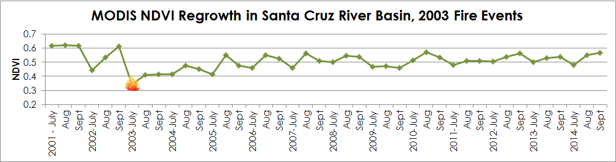Figure 1. Post-wildfire vegetation recovery within 2003 fire areas in the Santa Cruz River Basin based on MODIS NDVI.

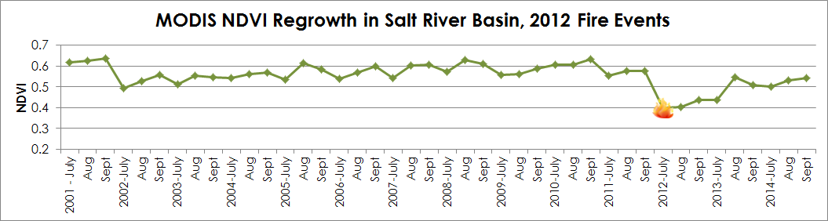Figure 2. Post-wildfire vegetation recovery within 2012 fire areas in the Salt River Basin based on MODIS NDVI.

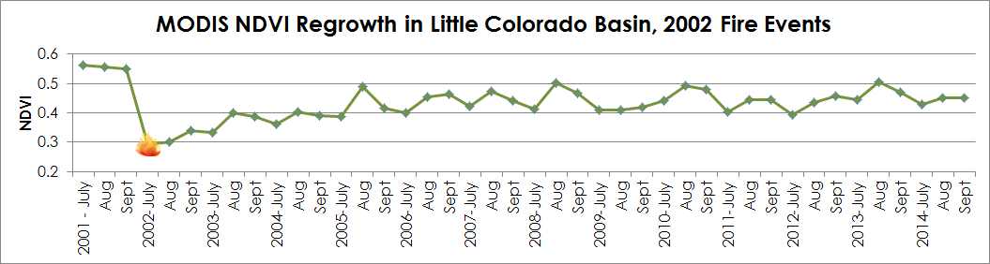Figure 3. Post-wildfire vegetation recovery within 2002 fire areas in the Little Colorado Basin based on MODIS NDVI.

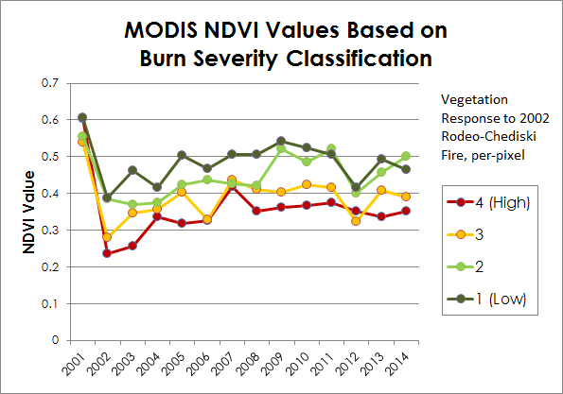

Figure 4. Vegetation recovery based on the 2002 Rodeo-Chediski fire in the Salt bain from 2001 to 2014

A Generalized Linear Model in R Programming was then used to identify how well precipitation anomalies and NDVI predicted the likelihood of a flooding event in the Little Colorado River Basin based on historical records from 2001 to 2014.

|  |  |  |  |  |
| --- | --- | --- | --- | --- |
| **Flood Event ~ Precipitation Anomaly + Average NDVI** | | | | |
|  | Coefficient | Standard Error | Z-value | Pr(>|z|) |
| (Intercept) | 0.46966 | 1.88487 | 0.249 | 0.8032 |
| Precipitation Anomaly | **-0.02583** | **0.01173** | **-2.202** | **0.0277**  **(0.01 significant )** |
| Average NDVI | 1.93816 | 3.55814 | 0.545 | 0.5860 |

Figure 5. Results of a Generalized Linear Model in R Programming, indicating that negative precipitation anomalies correlate to flood events within the Little Colorado River Basin.

Next, fire events, flood events, average monthly NDVI and total monthly precipitation were graphed for each basin (Figures 6-8).

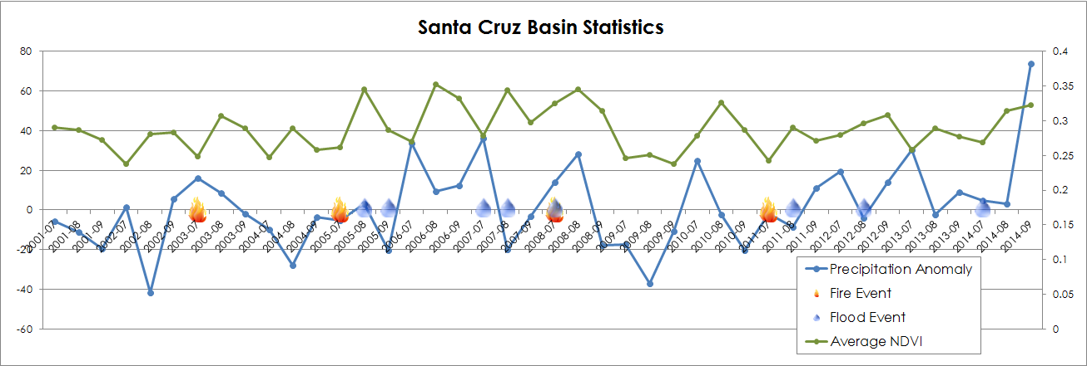

Figure 6. Precipitation anomalies, average NDVI, and post-fire flood events plotted from 2001-2014 for the Santa Cruz River Basin

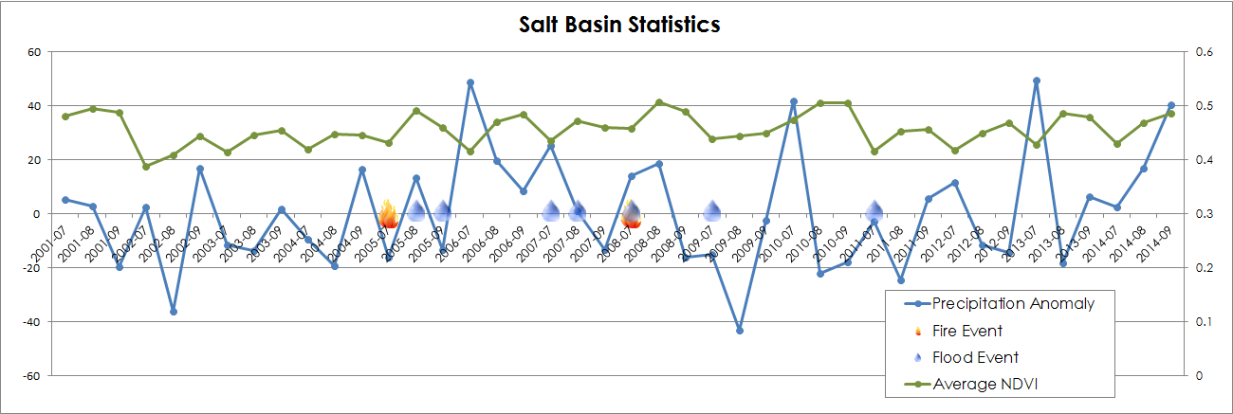

Figure 7. Precipitation anomalies, average NDVI, and post-fire flood events plotted from 2001-2014 for the Salt River Basin

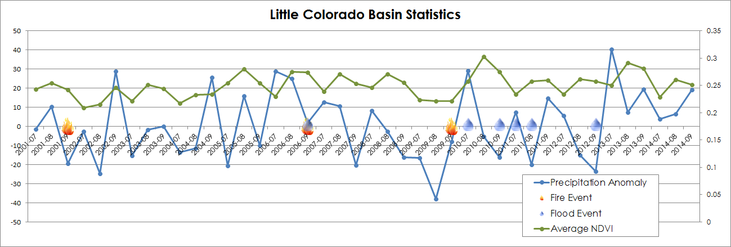

Figure 8. Precipitation anomalies, average NDVI, and post-fire flood events plotted from 2001-2014 for the Little Colorado River Basin

A general correlation exists between post-fire vegetation recovery and associated flooding incidents. As a watershed recovers from a wildfire event, increasingly more precipitation is required to initiate flooding (Figure 9). Although the R values indicate that the relationship between vegetation recovery and daily precipitation is not statistically significant, the two variables were positively correlated across all three watersheds for the five-year study period. The positive correlation between precipitation and flood occurance was the only statistically significant relationship across variables.

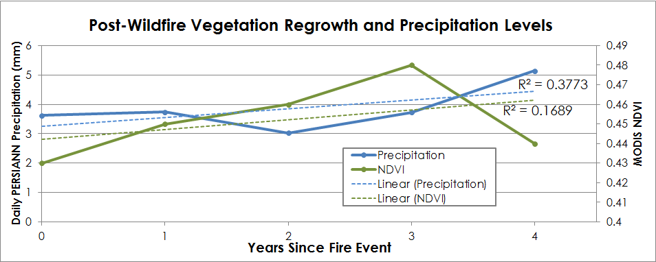

Figure 9. Correlation between Daily PERSIANN Precipitation as a function of post-fire flooding thresholds and MODIS NDVI as a function of vegetation recovery over Years Since Fire Event, suggesting a relationship between vegetation regrowth and burn severity.

**Analysis of Results**

Overall, both flood and fire events can be identified in respective precipitation and NDVI satellite records. The most complicated variable to capture, however, was time. First, by calculating monthly NDVI values across all three watersheds, fire events were easily captured in the MODIS NDVI satellite record through a distinctive dropoff in vegetation after wildfire events. NDVI values then experience minor oscillations as the watershed continues to recover, likely due to ancillary factors such as burn severity, soil recovery, and evapotranspiration. Much of the Southwest US is sparsely vegetated with low NDVI values under pre-burn conditions, but spatial extents were chosen specifically to encompass areas affected by wildfires. By choosing only burned areas, the relative change in NDVI was more pronounced compared to values across the entire watershed. Although NDVI values were averaged for all burned areas within watersheds, the per-pixel nature of the analysis captured nuanced changes in vegetation, particularly when subdividing vegetation regrowth based on initial burn severity. The positive growth rate following wildfire events confirms the presence of a long-term recovery regime within the Lower Colorado River Basin.

With limited *in situ* data to validate satellite records, flooding was more difficult to depict, resulting in less statistically significant relationships between precipitation anomalies and post-wildfire flood incidents during vegetation recovery. The first method compared the occurance of fire and flood events with precipitation and NDVI based on monthly precipitation sums. When assessing the tabular values summarized for each watershed, a generalized linear model was used to determine the relationship between precipitation and NDVI based on the binary absence or presence of a flood event. In general, records from the NOAA Storm Events Database did not correlate with high monthly precipitation anomalies, likely because the monthly sums were not indicative of the same storm intensity and duration measures used to classify flood events. On the contrary, the analysis indicated that flood events were more likely to occur after wildfires when monthly precipitation sums were anomalously low. While the limited number of post-wildfire flood records may skew the sample, the threshold indicates that less precipitation is necessary to initiate a flood event after a wildfire than under normal conditions. However, the relationship between NDVI and monthly precipitation was not a strong indicator of flooding when using a generalized linear model.

Next, daily precipitation anomalies were calculated based on a 30-year climatology for each day during summer monsoon season. The individual daily values, rather than monthly sums, were averaged for each month and compared to monthly NDVI values. There was a positive correlation between precipitation anomalies and vegetation regrowth, although the relationship was not strong.

Finally, daily precipitation rates from the PERSIANN satellite record were used to establish post-wildfire precipitation thresholds. By combining flood events according to the time since the fire event, the precipitation thresholds were more closely related to the vegetation regrowth process. After aggregating data by month and by day, progressing along calendar years, datasets proved too limited to establish statistically significant relationships. However, by reorganizing the unit of time to represent each fire as “Year Zero,” flood events for all three watersheds could be combined. The approach resulted in a positive trend between both vegetation regrowth and precipitation that aligns with previous post-wildfire research, suggesting that vegetation is an indicator of flood susceptibility. The initial approaches were constructed to address floods, fires, and the associated satellite data on a single timeline. While the approach could predict the absence or presence of an event, the spatial location and magnitude of flooding were ignored. By associating events based on environmental time scales, changes in precipitation thresholds and vegetation can be used in a more predictive capacity readily used and understood by local flood and emergency managers.

Our results show that for each year, post-burn, more precipitation is required to initiate a post-wildfire flood or debris flow. Providing an index of rainfall thresholds across a recovery timeline can help local emergency managers better prepare for natural hazards and understand the changes in hazards as time progresses after a wildfire event. Using NOAA Climate Data Records and NASA Earth Observations, a regional picture of the Southwest United States can better capture the relationship between the two variables and enhance long-term predictive post-fire flood and debris flow hazard tools.

**Errors & Uncertainty**

Analyzing data to find a correlation between precipitation anomalies, post-fire flooding incidents, and vegetation recovery made us aware of limitations with the datasets used. First of all, the flood records from the NOAA Storm Events Database were quite limited. Prior to 2005, Arizona flood events within the NOAA Storm Events Database do not contain a GPS location, excluding any prior flood records from spatial analysis. Further, events from the NOAA Storm Events Database with spatial references only include a single point or starting and ending points. The extent of floods, then, is not captured by the Storm Events Database dataset. Instead, a NOAA Flood CDR with spatial extent of flooding would be a very useful dataset for post-wildfire flood modeling. Similarly, the number of flood events associated with wildfires was even fewer, reducing the data available to establish a statistically significant relationship among the variables for post-fire flood applications.

Next, aligning floods with post-wildfire conditions was challenging. Floods were associated with wildfire events as a function of proximity to the burned area, slope, and time since burn. For instance, if the flood record from the NOAA Storm Events Database was within five years after a wildfire occurred, and the flood was within close proximal distance downstream of the wildfire, the flood was linked to the fire as a post-wildfire flood incident and incorporated in the analysis. As mentioned previously, Moody et al. established a post-wildfire flood threshold from gage data, where 8.5 mm h-1 indicated potential runoff. However, within the Lower Colorado River Basin, *in situ* data is limited, so flood events could not be validated. Overall, satellite data was a useful tool to gather long-term, regional data. NOAA Climate Data Records in particular are potentially very useful in post-wildfire flood applications, but identifying trends for specific regions requires extensive verification before flood managers can derive explicit precipitation thresholds for land management and hazard preparation.

Once insufficient flood records were removed from the input dataset, few records remained. Without access to additional flood information, data had to be aggregated based on daily, monthly, and yearly events. Additionally, the raw precipitation, NDVI, flooding, and fire data was recorded in a variety of formats at different temporal and spatial scales by a number of different organizations. By converting and resampling to a common format and scale, specific events were likely averaged out of the data. The analysis generalized trends across the watersheds. By aggregating data to obtain a statistically significant sample size, many important indicators and thresholds were averaged out.

**Future Work**

Data and associated methodological limitations greatly impact the efficacy of post-wildfire flood modeling. Conditions after a wildfire change at varying rates across a dynamic landscape, leading to incomplete data collection as researchers and land managers assess the various ecological indicators used to understand watershed recovery. The relationships identified in this research could be enhanced by contacting additional land management and flood hazard teams across the Southwest United States to first identify additional flood and fire data with better spatial representation. Gathering and combining additional data was outside the scope of this analysis, but would supplement the statistical component of establishing relationships among post-wildfire variables. By assembling a bigger body of historical records, floods can be more closely linked to the satellite record. Alternatively, additional modeling should be conducted in another study area with a more extensive network of ground stations. Although average and anomalous precipitation is specific to individual regions and study areas, verifiying the NOAA precipitation CDRs would be beneficial for flood applications. Given the limited flood data currently available, flooding extents may also be established using pixel brightness values in the satellite record. NASA’s Near-Real-Time (NRT) Global Flood Mapping product currently maps the spatial extent of flood events around the world using the MODIS sensor on NASA’s Terra satellite. By developing a similar NOAA CDR, land managers can address the spatial component of flooding, leading to better predictive capabilities for flood extent in relation to both precipitation levels and physical damage. As CMORPH (Climate Prediction Center Morphing Technique) becomes an operational CDR hosted by NOAA, the 30-minute intervals of precipitation data will also better identify flood events. Land managers typically categorize flash flood and debris flow events as a function of precipitation volumes over a cumulative 30-minute interval. CMORPH, then, could be used retroactively to isolate flood events in the satellite record and identify a precipitation rate that would closely match the volumes generated by ground stations and radar.

While other approaches like hydrologic modeling can incorporate flow direction, debris flows and floods often occur across wide areas on hillsides and can erode slopes that do not perfectly align with the stream network. Current hydrologic modeling processes may accurately predict flow volumes directed to a pour point between basins, but associating precipitation rates, flow volumes, and changes in basins as a result of wildfire disruption remains challenging. Conditions vary across burned areas, as the NDVI values for individual burn severity categories indicated. Further investigation is required to understand the impact of burn severity on flooding and vegetation regrowth. Deriving disruptions from the satellite record and hydrologic modeling are two approaches to post-wildfire flood modeling, but future research is needed to combine the connectivity of hydrologic modeling with the ability of satellite records to isolate changes to a landscape over time.

Most importantly, post-wildfire flood modeling efforts need be coordinated with local flood management offices for full access to fire and flood information to further improve post-wildfire flood modeling.

# V. Conclusions

While previous studies have confirmed post-wildfire vegetation recovery and rainfall-runoff relationships using satellite data, less research assesses the impact of wildfire on runoff vulnerability over an extended period of vegetation regrowth. The findings of this study substantiate the repeatability of capturing vegetation regrowth using MODIS NDVI to recording changes in NDVI for three basins within Arizona. By utilizing the NOAA Climate Data Record PERSIANN precipitation, post-wildfire flood precipitation trends were also identified at a regional scale. Both satellite records host a wealth of potential for the continued study of arid environments with limited *in situ* data.

This study also confirmed that a positive trend exists between vegetation regrowth and precipitation thresholds after wildfires in the Lower Colorado River Basin. However, insufficient flood records and a lack of satellite validation limit the statistical significance of the relationship. More research is needed to better identify specific thresholds for flood initiation as vegetation recovers within a watershed.

Post-wildfire flood modeling requires the reconciliation of layers of information at often disparate spatial and temporal scales. Extensive data collection is required both at the time of a wildfire disturbance and throughout the long-term recovery process to better understand the vulnerability and variability of watershed dynamics.

# VI. Acknowledgments

* DeWayne Cecil (Chief Climatologist and Program Manager, Global Science & Technology (GST) National Centers for Environmental Information (NCEI))
* Gregg Garfin (Investigator, Climate Assessment for the Southwest (CLIMAS))
* Tim Brown (Director, Western Regional Climate Center (WRCC))
* Dennis Staley (Research Physical Scientist, USGS Landslide Hazards Program)
* Jason Kean (Research Hydrologist, USGS Landslide Hazards Program)
* Michael Schaffner (Hydrology Program Manager, NWS Western Region Headquarters)

This material is based upon work supported by NASA through contract NNL11AA00B and cooperative agreement NNX14AB60A.

# VII. References

Arizona Department of Water Resources. (2010). *Arizona Water Atlas, Volume 8, Active Management Area Planning Area.* Retrieved August 3, 2015, from <http://www.azwater.gov/azdwr/StatewidePlanning/WaterAtlas/ActiveManagementAreas/documents/Volume_8_final.pdf>

Hong, Y., R. F. Adler, F. Hossain, S. Curtis, and G. J. Huffman. (2007). A first approach to global runoff simulation using satellite rainfall estimation. *Water Resources Research,* 43, W08502. doi:10.1029/2006WR005739.

Leon, J.R.R.; van Leeuwen, W.J.; Casady, G.M. (2012). Using MODIS-NDVI for the Modeling of Post-Wildfire Vegetation Response as a Function of Environmental Conditions and Pre-Fire Restoration Treatments. *Remote Sensing*, 4, 598-621. doi: 10.3390/rs4030598.

Moody, J. A., Martin, D. A., Haire, S.L., and Kinner, D. A. (2008). Linking runoff response to burn severity after wildfire. *Hydrological Processes*, 22(13), 2063-2074. doi: 10.1002/hyp.6806.

van Leeuwen, Willem J.D.; Casady, Grant M.; Neary, Daniel G.; Bautista, Susana; Alloza, Jose Antonio; Carmel, Yohay; Wittenberg, Lea; Malkinson, Dan; Orr, Barron J. (2010). Monitoring post-wildfire vegetation response with remotely sensed time-series data in Spain, USA and Israel. *International Journal of Wildland Fire*, 19, 75-93. doi: 10.1071/WF08078.

# VIII. Content Innovation



Animation created in GRASS GIS illustrating vegetation regrowth after the 2002 Rodeo-Chediski fire in the Salt Basin, 2001-2014 *(double-click to view)*

File name: (need to upload to DEVELOP EXCHANGE****************)



Animation created in GRASS GIS illustrating PERSIANN precipitation and MODIS NDVI from 2001 to 2014 for the state of Arizona *(double-click to view)*

File name: (need to upload to DEVELOP EXCHANGE****************)

# IV. Appendices

[Insert here]