
DEVELOP NATIONAL PROGRAM
Summer 2011

Marshall Space Flight Center
University of Alabama at Birmingham

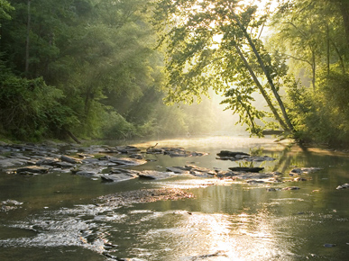
Hunter Nichols/Encyclopedia of Alabama

Estimation of Urban Growth Impact on Fish Habitats Using Spatial Analysis Techniques: A Case Study of the Cahaba Watershed Area

Technical Report

Contributors:
Katharine Campbell, Samford University
Michelle Foreman, Samford University
Danielle Keyes, University of Alabama at Birmingham
Semiha Caliskan, M.S., University of Oklahoma
Kevin Cowart, Thomas University
Joseph Olson, University of Alabama at Birmingham
Steve Padgett-Vasquez, M.S., University of Alabama at Birmingham

Jeff Luvall, Ph.D., Marshall Space Flight Center (Science Advisor)
Donna Burnett, Ph.D., University of Montevallo (Research Advisor)

Executive Summary

Alabama’s Cahaba River is among the most biologically diverse rivers in North America, supplying drinking water to 20% of Alabama residents. Recent declines in the number of aquatic species, a rise in endangered wildlife, and issues of water quality are of great concern. A river’s watershed influences the dynamics, structure, and health of the stream. Major water projects are generally the most apparent form of habitat alteration, but transformations of the landscape are probably the most widespread and potent threat to rivers. This is due to the associated consequences of landscape transformation on hydrology, vegetation cover, and terrestrial-aquatic linkages (Allan & Flecker, 1993).
The NASA DEVELOP team from Marshall Space Flight Center-University of Alabama at Birmingham investigated the association between landscape changes and water quality within the Cahaba Watershed. The team processed Landsat 5 TM images from 2001, 2006, and 2010 and ASTER imagery from 2004 and 2005 using the Normalized Difference Vegetation Index (NDVI) to measure the distribution and amount of vegetation within the watershed. Ground truth classification points were manually collected using a hand-held GPS unit in order to provide a standard for accuracy assessment of the remote sensing analyses.
Students compiled previously collected in-situ population and biodiversity data pertaining to fish species in the Cahaba Watershed. Many fish species are particularly susceptible to increases in suspended particles, such as fish that depend on sight for feeding. Therefore, these organisms are viable indicators of significant changes in water quality. The Cahaba Shiner is an example of a fish that is endangered in the Cahaba River watershed because of its dependency on sight to feed (U.S. Fish and Wildlife Service, 2009).
By running spatial analyses on the data in the form of Ordinary Kriging, the team analyzed the satellite results in conjunction with the biological data to determine a relationship between local land use practices and conservation concerns within the Cahaba Watershed. The locations with lower biodiversity are mainly due to urbanization effects which cause changes in habitats due to increased sedimentation, urban run-off, and water quality (Cielinski, n.d. ). Jefferson and Shelby counties (counties of Birmingham sprawl) have the highest number of endangered fish, mussel/clam, amphibian, and snail species (U.S. Fish and Wildlife Service, 2011). Our spatial analyses of biological data revealed lower levels of biodiversity within the Greater Birmingham Metropolitan area, coinciding with lower levels of vegetation within the same area (as demonstrated by NDVI analyses). Lower levels of vegetation indicate higher levels of urban development, showing an inverse relationship between development and species diversity within a specific area, in this case the Greater Birmingham Metropolitan area.
These findings will help target conservation efforts and assist in more efficient resource management. The team’s collaboration with the Cahaba River Society has allowed NASA Earth Observing System to be used by local environmental organizations. The results of the study were shared with the Cahaba River Society for the purpose of making informed decisions when determining future policies involving the Cahaba River watershed and conservation efforts.

Table of Contents

Executive Summary 1
Abstract 5
Project Objectives 5
Introduction 6
A. Background Information 6
B. Study Area 8
C. Study Period 9
D. National Application(s) Addressed 9
F. Project Partners 9
Methodology 10
A. Data Acquisition 10
B. Data Processing 12
C. Data Analysis 13
Results 15
Discussion 30
A. Analysis of Results 30
B. Errors & Uncertainty 30
C. Future Work 31
Conclusions 33
Transition to Partner 33
Acknowledgments 34
References 34
Appendices 40

Abstract

The Cahaba River in Alabama is recognized as one of the most biologically diverse rivers in the United States. In recent years, urbanization around the Cahaba River has led to increased surface runoff and sedimentation, which are detrimental to the health of the river, specifically the wildlife. The Marshall Space Flight Center DEVELOP Team partnered with the Cahaba River Society to investigate the effects of urban growth on fish populations and habitats using spatio-temporal analysis utilizing remote sensing and GIS. Landsat 5 TM and Terra’s ASTER imagery were employed to calculate land-cover characteristics. Historical biodiversity data on species living in the Cahaba River were gathered from surveys and literature review for statistical analysis. The team used ASTER imagery to help identify areas of concern that require immediate attention due to loss of vegetation and/or increased urbanization. Ground truth data were also collected within the watershed, identifying land cover classes to determine the accuracy of the remote sensing analyses. Spatial Analysis in the form of Ordinary Kriging shows that lower levels of biodiversity for fish populations are found around the I-65 and I-459 junction in the Greater Birmingham Metropolitan Area. Conservation efforts will be maximized by focusing resources on the identified interest areas resulting from this study. Findings and end products will be vital to policy makers for the Cahaba River Society, The Freshwater Land Trust, and Alabama Department of Environmental Management in development of conservation strategies and new land-use plans pertaining to the Cahaba River watershed.

Keywords
Cahaba River, watershed, Alabama, urbanization, water quality, fish, spatial analysis, satellite imagery, biodiversity, sediment

Project Objectives
The goals of this project are to:
- Utilize satellite imagery to show changes in vegetation and urbanization in the Cahaba River watershed over time;
- Analyze the relationship between urbanization and land use in the Cahaba River watershed and different biological indicators of stream health in the river;
- Aid the Cahaba River Society by identifying areas of interest to maximize conservation efforts.

Introduction

A. Background Information

The cumulative impact of human activities on land use throughout a watershed is reflected in the stream’s health (Wear, Turner, & Naiman, 1998). Knowledge of the relationship between land use and stream conditions can allow for predictions of the river’s future health to be made based on projected future population growth and development (Baker et al., 2004). One study in Wisconsin showed the change in the amount of impervious surface (a surface that does not allow infiltration and has direct hydraulic connection to the downstream drainage system) from agricultural to urban land was the single best predictor of diversity of fish communities (Wang, Lyons, & Kanehl, 2001). Another study in Georgia showed that increases in urbanization at 30 sites within a catchment was inversely correlated with water quality, habitat quality and measures of macro-invertebrate assemblages (Roy et al., 2003). The goal of this project is to determine if similar conclusions can be observed within the Cahaba River watershed.

A.1 Biodiversity

The Upper Cahaba River has more fish species (N = 139) per mile than any river of its size in North America (Oberholster, 2006). The river supports 69 rare and imperiled species, 10 of which are listed on the U.S. Endangered Species Act (Allen, 2001). In recent years, this rich biodiversity has been declining. There are six main factors which contribute to species loss: habitat degradation, spread of invasive species, over-exploitation, secondary extinctions, chemical and organic pollution, and climate change (Allan and Flecker, 1993). Stream environments are some of the most fragile ecosystems in the world due to strong interactions between aquatic and terrestrial environments and the human disturbances that can affect either system (Guneroglu, 2010).

A.2 Biometrics

A.2.1 Fish Species

The amount and variance of fish species within a stream are often important indicators of the water quality of that stream, particularly if these data can be compared over a period of several years. The loss of certain species over time can be indicative of the presence of harmful chemicals in the water. An area of the river that is abounding with new species can also be a sign of significant changes in water chemistry. Many fish species that have historically been found within the Cahaba River are particularly sensitive to changes in the chemical composition of the river, as well as other factors directly caused by urbanization or increased industry. Analyzing any changes in the fish populations of the river can help further an understanding of how modern practices are affecting the health of the river and species living within it.

A.3 Hydrology and Water Chemistry

Birmingham comprises 151 square miles located inside Alabama’s largest metropolitan region measuring 5,331 square miles (Pierson et al., 1989). The urbanization of Birmingham and possible stream eutrophication are serious threats to the ecological value of the surrounding rivers. A river’s watershed impacts stream health, structure, and dynamics. Transformations of the surrounding landscape are a potent threat to rivers because of the strong link between terrestrial and aquatic environments (Allan and Flecker, 1993). Urbanization increases the variety and volume of pollution in surface runoff, leading to increases in sedimentation and certain chemicals, such as nitrogen and phosphorus. Conductivity, the measure of a water’s ability to conduct an electrical current (“CADDIS: The Causal Analysis/Diagnosis Decision Information System”), is affected by the presence of inorganic compounds in the water. Increases in conductivity correlate to an increase in runoff of inorganic materials. Conductivity varies between ecosystems but should remain steady in an individual ecosystem. Most organisms need a specific range in which to survive; changes may result in harm to the biota ("CADDIS: The Causal Analysis/Diagnosis Decision Information System").

Landscape changes create more erratic hydrology leading to an increase in water temperature (Paul and Meyer, 2001). This change in hydrology results from an increase in run-off from impervious surface areas into storm water drainage that is then directed into the river. The increased water temperature may be due to the loss of vegetation and the warming of surface run-off (Allan, 2004). The increase in water temperature results in lower dissolved oxygen levels and detrimentally affects the habitat of the river.

A.4 Remote Sensing and GIS

GIS and satellite remote sensing are research tools that can be used to address spatial questions in a cost-effective way. Satellite imagery provides visual and digital interpretation of the landscape, which is essential to solving water management problems (Meijerink & Mannaerts, 2000).
This satellite imagery can also provide information about vegetation cover. Normalized Difference Vegetation Index (NDVI) is a common remote sensing technique used in study of vegetative cover in watersheds, measuring the amount of vegetation in an area. This technique lends information about the urbanization of the area, which in turn can be used as an indication of water quality (Wear, Turner,& Naiman, 1998).

B. Study Area

The Cahaba River is approximately 200 miles long and its entire watershed covers 1,870 square miles, making it the longest free-flowing river in Alabama (Pierson et al., 1989). The Upper Cahaba River Basin is located next to the city of Birmingham with nearly 60% of Alabama’s population living within 100 miles of the Cahaba River (Pierson et al., 1989). The Cahaba Watershed is separated into two geological regions by a Fall Line. The Upper Cahaba River is found north of the Fall Line in the Valley and Ridge Region, while the Lower Cahaba River is found south of the Fall Line in the Coastal Plain Zone (Shepard et al, 1994).
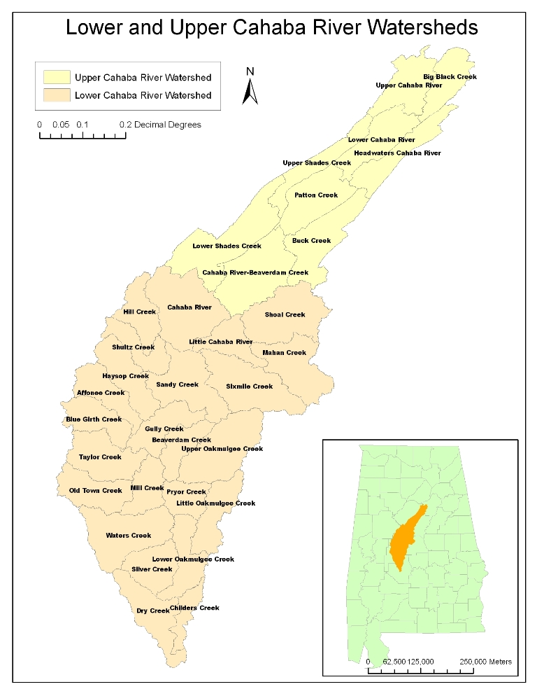
Figure 1: Map showing the Cahaba River Watershed split between the Upper Cahaba River (yellow), and the Lower Cahaba River (beige). Data acquired from ESRI shapefiles.
C. Study Period

Landsat satellite imagery used is from 2001, 2006, and 2010. ASTER imagery is from 2004 and 2005.

D. National Applications Addressed

Water Resources- The Cahaba River is the main drinking water source for the Birmingham Water Works Board. The Birmingham Water Works Board serves approximately one-fifth of Alabama’s population.

Ecological Forecasting- Fish, mussel, and benthic macro-invertebrate populations depend on various environmental factors. By examining these populations along with environmental factors, correlations may begin to be made for future estimations of these indicators of stream health.

Public Health- The water quality of the stream, where a large portion of drinking water is acquired, is crucial to protecting public health. With increased run-off often comes increases of toxic chemicals in a water-body, which can have serious health impacts if left unchecked.

E. Project Partners

The Cahaba River Society’s mission is to protect the Cahaba River watershed and its biodiversity. The Society’s focus is both on improving living conditions for freshwater creatures and ensuring water quality for the Birmingham Metropolitan Area.

The Freshwater Land Trust’s mission is to acquire undeveloped land along the banks of the Cahaba River in order to provide a screen protecting the river from sediment runoff from developed areas near the river. The undeveloped land absorbs the harmful sediment runoff and keeps it from reaching the Cahaba River.

The Alabama Department of Environmental Management’s mission is to protect and improve the quality of Alabama’s environment and the health of its citizens.

Methodology

A. Data Acquisition and Processing

A.1 Remote Sensing Data - All images were obtained from the USGS GloVis online database.

  - Landsat 5 TM - 2001, 2006, and 2010. For each date, two Landsat images were acquired in order to cover the entire Cahaba watershed area, which did not fit into one single Landsat frame. For each year, 8 sets of Landsat 5 TM were used, covering Spring (March), Summer(June), Fall (October) and Winter (December). Landsat imagery is used to compute the Normalized Difference Vegetation Index (NDVI), which calculates atmospherically- corrected reflectance from the visible and near infrared channels as:
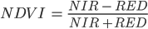 (Equation 1)
This equation provides an index value that is sensitive to the presence of vegetation and information about vegetation’s type and vigor. The resulting index values of Equation 1 are in the range of -1.0 to 1.0. Vegetated areas will have values greater than zero, and negative values indicate non-vegetated surface land cover types.

Table 1: Landsat 5 TM Imagery reference
Date | Season | Path-Row
2001 March 6 | Spring | 20-37 and 20-38
2001 June 26 | Summer | 20-37 and 20-38
2001 October 16 | Fall | 20-37 and 20-38
2001 December 19 | Winter | 20-37 and 20-38
2006 March 4 | Spring | 20-37 and 20-38
2006 June 24 | Summer | 20-37 and 20-38
2006 October 14 | Fall | 20-37 and 20-38
2006 December 17 | Winter | 20-37 and 20-38
2010 March 6 and 31 | Spring | 21-37 and 20-37
2010 June 26 and July 5 | Summer | 21-37 and 20-37
2010 October 9 | Fall | 20-37 and 20-38
2010 December 28 | Winter | 20-37 and 20-38

  - ASTER L1B US Day - August 2004 - February 2005. ASTER (Advanced Spaceborne Thermal Emission and Reflection Radiometer) detects the condition of the Earth’s surface by capturing visible to thermal-infrared images. ASTER images have a higher resolution than Landsat images, making them ideal for analyzing smaller areas. Classifications and indices performed on ASTER imagery cover a smaller area but provide more detail. ASTER imagery consists of 15 different bands--four in the Visible Near-Infrared (VNIR) spectrum, six in the Short Wave Infrared (SWIR) spectrum, and five thermal bands (TIR).

The formula for NDVI of ASTER imagery, calculated using two VNIR bands, is as follows:
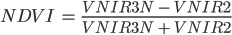 (Equation 2)

Table 2: ASTER L1B US Day Imagery reference
Date | Season | Path-Row
August 4, 2004 | Summer | 21-37
September 30, 2004 | Fall | 20-37
September 30, 2004 | Fall | 20-37
February 12, 2005 | Winter | 20-37
February 12, 2005 | Winter | 20-37

c. ArcGIS- Once the analysis in ENVI and ER Mapper was completed, the NDVI files were exported to ArcGIS where they could be analyzed in conjunction with historical biodiversity, chemical, and land cover data.

A.2 Spatial Data

  - Census data - Population data were collected from U.S. Census Bureau for census years 2000 and 2010. The data were in Excel format and joined with the 2000 block group census shapefile and 2010 block group census shapefile. Two different shapefiles were needed because the block groups were different for each year. Land use data (using population numbers) were reported by the Census Bureau for the year 2000. The data define areas as Urban or Rural. The data for the year 2000, originally in Excel format, were joined with the census block shapefile from the USGS and were exported as a separate shapefile. Land use data for the 2010 census year will not be released until 2012 and so was unavailable for this project.

  - Fish Population Data - Fish data comprise a collection of various studies to determine the nature of fish species found in the Cahaba River. Since fish species are often an important indicator of stream health, changes in species over time give insight to changes in the health of the stream.

Onorato, D. P. (1997). Ichthyological Bioassessment of the Upper Cahaba River of Alabama: An Analysis of the Selection of Sampling Gears, Current Trends in the Fish Assemblages, and Historical Changes Within the Ichthyofaunal Communities. Thesis: M.Sc. Birmingham: University of Alabama at Birmingham.
Morse, K. J. (2005). The effects of urbanization on the health of fish and benthic macroinvertebrate commnunities in the Upper Cahaba River Watershed. Birmingham: University of Alabama at Birmingham.

  - Historical Fish Data - Fish data were acquired from ADEM and include a historical survey from 1949 to 2001 for different fish types.

  - Endangered Species Data - The data collected in 2008 by the U.S. Fish and Wildlife Service indicate the number of threatened, endangered, and extinct species including fish, amphibians, clams/mussels, and snails, for each county in the Cahaba River watershed.

  - TRI Chemical Release Sites - Data were gathered from EPA to show the locations of chemical release sites and how much pounds of chemicals are being produced at each location for 2002 and 2009.

B. Data Analysis

B.1 NDVI Classification - The Normalized Difference Vegetation Index measures plant growth and vegetation cover using the spectral reflectance measurements found in the visible (red) and near-infrared regions of the image. The general formula for NDVI is given in Equation 1 above.

Levels of urbanization are determined by reflectance values, which can range from -1.0 to +1.0. This range is possible because the values represent the ratio of reflected over incoming radiation in the image. Plants absorb light in the visible wavelengths (with the exception of green) while reflecting near infrared light and thus have a higher NDVI value than impervious surfaces.

B.2 Change Detection Analysis- Using ENVI EX and ArcGIS, change detection analyses were conducted on the NDVI classification images from 2001-2006. These analyses typically show changes in vegetation and land cover over time by comparing NDVI values of specified classes, reflecting changes in NDVI values. Depending on the reasons for the changes in land cover, these analyses can reveal areas of interest requiring further investigation.

B.3 Kriging - By running spatial analyses on the data in the form of Ordinary Kriging, the team analyzed the satellite data in conjunction with the biological data. These analyses are helpful in determining a relationship between local land use practices and conservational concerns within the Cahaba. Areas with urban development along the Cahaba River watershed are associated with low biodiversity in the river.

Ordinary Kriging, a type of spatial analysis, is a spatial auto-correlation model provided by ArcGIS’s geospatial analysis package. It uses a linear combination of weights at known points to estimate the value at unknown points, using a semivariogram to measure spatial correlation between the known points (Anselin, 1994). It is different from other estimation procedures in that it provides a measure of the error. The end result is a contour map showing the increasing levels of the data being analyzed.

C. Ground Truth Data Collection

C.1 Ground Truth Data of land cover classifications were collected on July 18 and 19, 2011. Ground truth data are essential in order to determine the accuracy of classifications derived from satellite imagery. An extensive field survey was performed throughout the counties related to the Cahaba River. The Global Positioning System (GPS) equipment used for the data collection was Trimble Juno SP.

a. Over the course of this two-day period, 242 points were identified and classified as one of 16 different land cover classes. All points were used for assessing accuracy. At each location, one or two pictures were taken and the images georeferenced using Google Earth for use in accuracy analyses of satellite imagery from different years.

b. Survey points were collected at homogeneous sites to get a clear spectral signature of the site. Areas with heterogeneous classes of land cover were avoided. Land cover classes used for the survey are listed in Table 3, with the spatial distribution of the points shown in Figure 7.

Table 3: Land Cover Classes from Ground Truth Survey
Land Class | Ground Truth Points
Agriculture | 27
Barren | 8
Commercial | 25
Deciduous Forest | 11
Emergent Wetland | 2
High Residential | 3
Herbaceous | 19
Low Residential | 23
Mixed Forest | 36
Other Grasses (Golf, Park, Urban grasses) | 1
Pasture | 46
Pavement | 6
Quarries | 2
Transitional | 7
Water | 18
Total | 242

Results
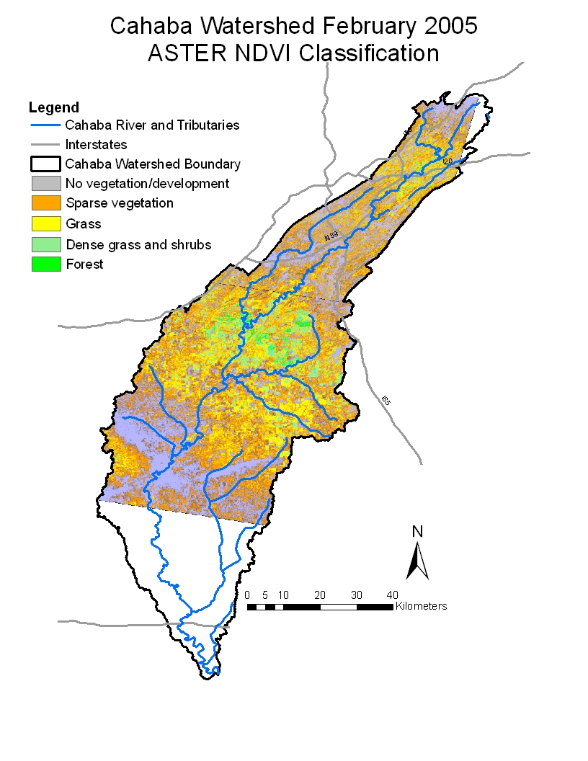
Figure 2: Normalized Difference Vegetation Index (NDVI) was calculated and classified using ASTER imagery from February 2005 to measure vegetation on the Cahaba River Watershed. Higher NDVI values, indicating greater amounts of vegetation, are shown in dark green. Areas shown in white depict areas with low NDVI values, indicating areas of high development or areas of cloud cover within the image. Shape-files for the roads and river were obtained from ESRI.
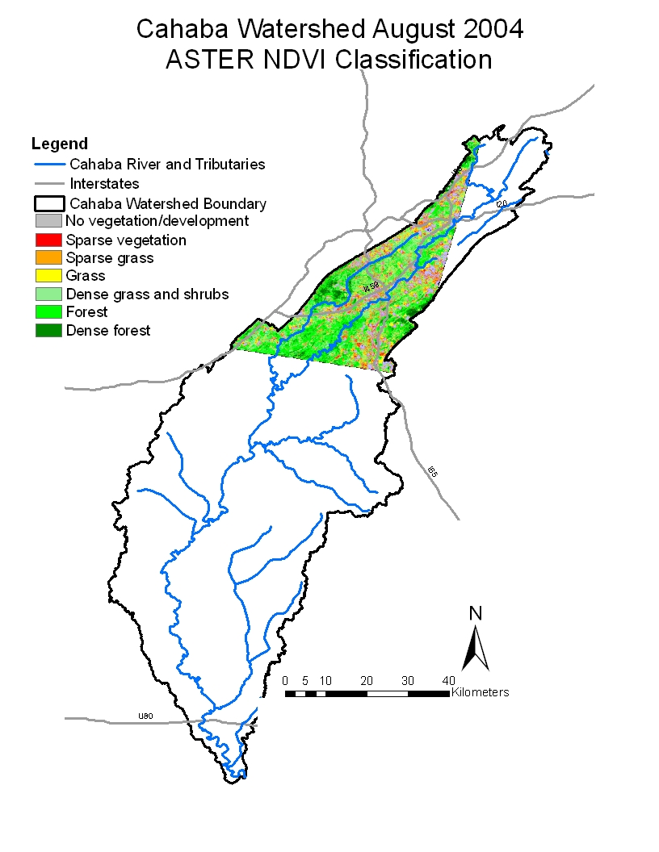
Figure 3: Normalized Difference Vegetation Index (NDVI) was calculated and classified using ASTER imagery from August 2004 to measure vegetation on the Cahaba River Watershed. The map displays the Upper Cahaba River, home to the greater Birmingham area. Areas of higher vegetation are shown in increasingly dark green colors, while areas of low vegetation are shown in gray, red, and orange.Shape-files for roads and river were obtained from ESRI.
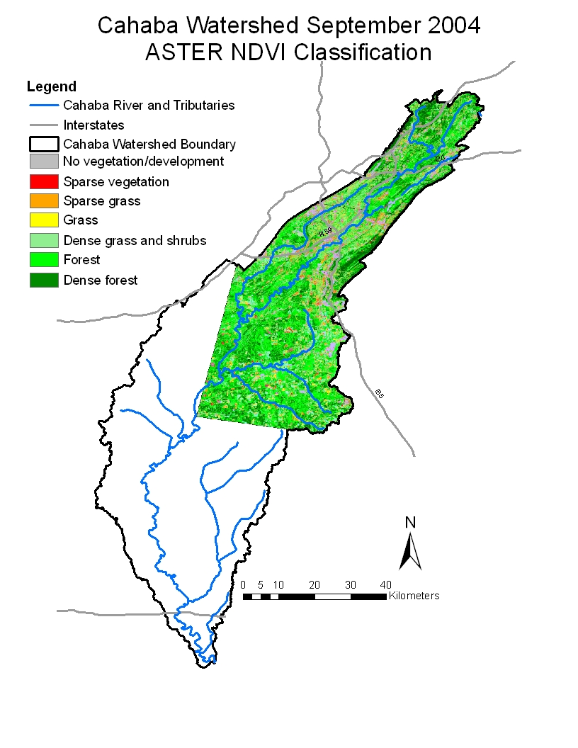
Figure 4: Normalized Difference Vegetation Index (NDVI) was calculated and classified using ASTER imagery to measure vegetation on the Cahaba River Watershed. The map was created using two ASTER images, both dating from September 2004, focusing on the Upper Cahaba River. Areas of higher vegetation are shown in increasingly dark green colors, while areas of low vegetation are shown in gray, red, and orange. Shape-files for the roads and river were obtained from ESRI.

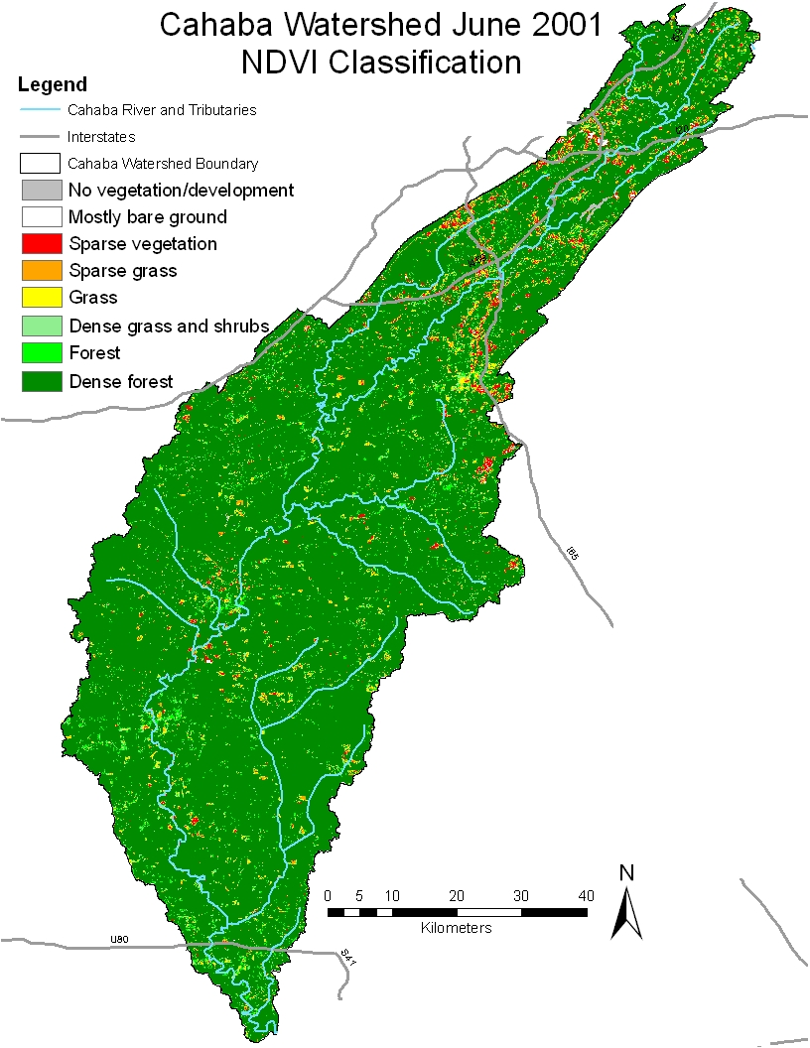
Figure 5: Normalized Difference Vegetation Index (NDVI) was calculated and classified using Landsat 5 TM imagery from June 2001 to measure vegetation in the Cahaba River Watershed. This classification scheme displays areas with higher NDVI values (higher amounts of vegetation) in increasingly dark green colors, while areas with lower or negative NDVI values (areas of development or little/no vegetation) are shown in white, gray, red, and orange. Shape-files for the roads and river were obtained from ESRI.
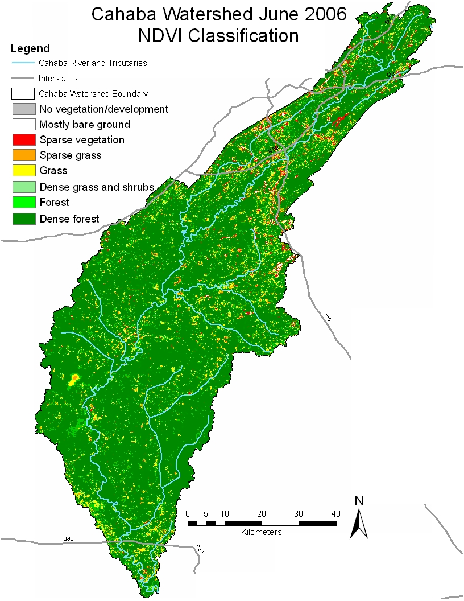
Figure 6: Normalized Difference Vegetation Index (NDVI) was calculated and classified using Landsat 5 TM imagery from June 2006 to measure vegetation in the Cahaba River Watershed. This classification scheme displays areas with higher NDVI values (higher amounts of vegetation) in increasingly dark green colors, while areas with lower or negative NDVI values (areas of development or little/no vegetation) are shown in white, gray, red, and orange. Shape-files for the roads and river were obtained from ESRI.
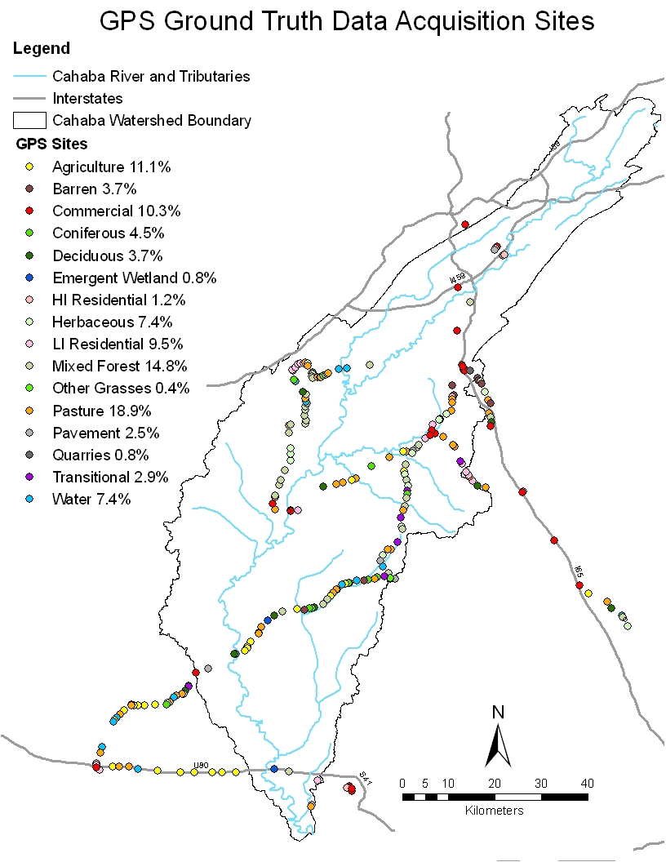
Figure 7: Using a handheld GPS unit (Trimble Juno SP), Ground Truth data was collected across the Cahaba River Watershed and classified into one of sixteen land use classification categories. By analyzing aerial photography of these same locations from previous years, changes in land cover over time were recorded from visual analysis. These classes were then used to test the accuracy of the remote sensing NDVI analyses of land cover within the study area. Shape-files for the roads and river were obtained from ESRI.
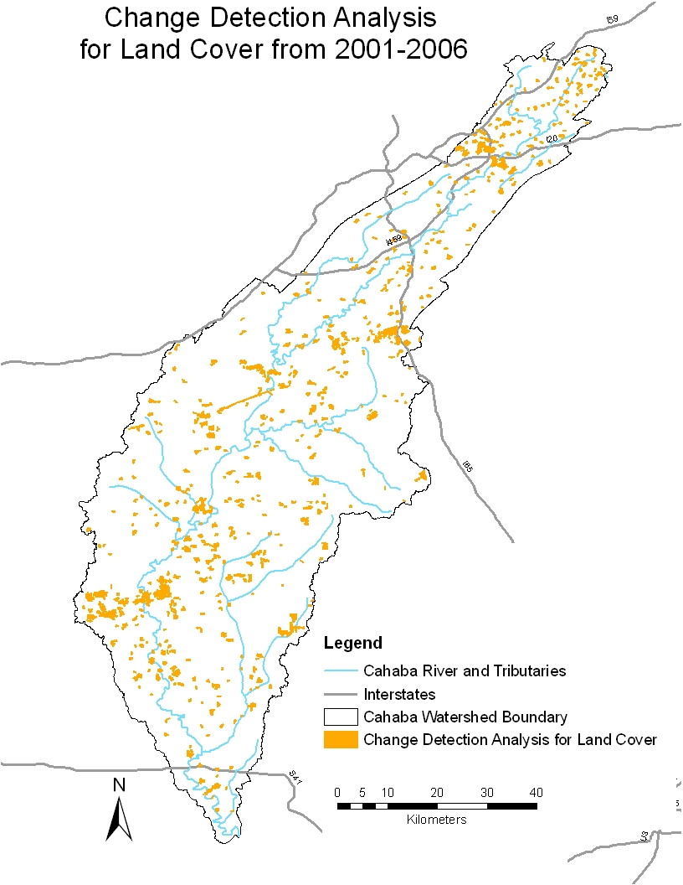
Figure 8: Change detection analysis of Landsat 5 TM NDVI images between June 2001 and June 2006 showing changes in land cover over this five-year period. Changes in land cover classes, as determined by the NDVI classification scheme applied to each Landsat image, are depicted in orange. Shape-files for the roads and river were obtained from ESRI
.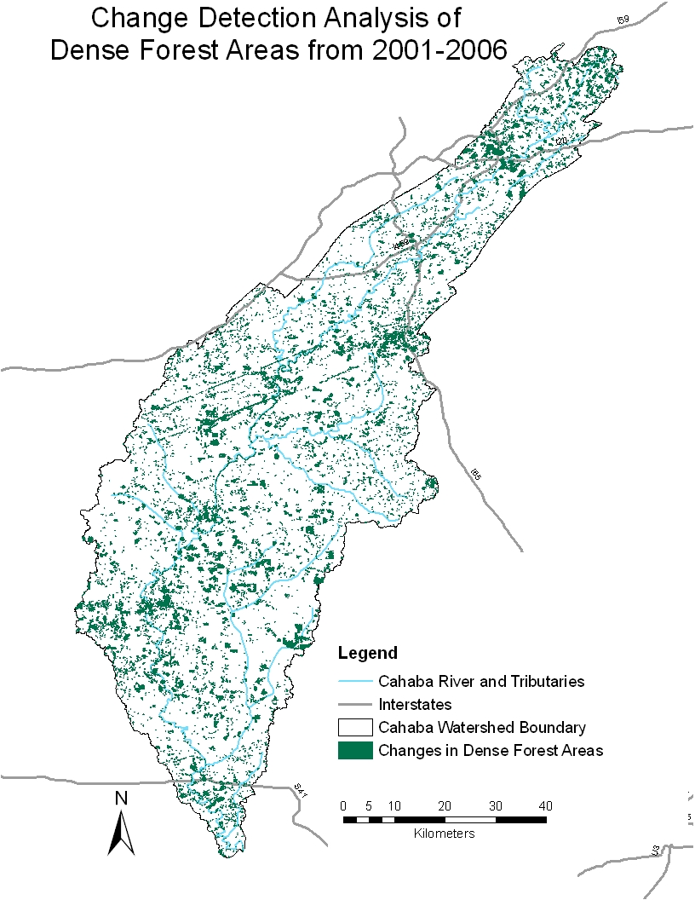
Figure 9: Change detection analysis of Landsat 5 TM NDVI images between June 2001 and June 2006 showing changes in the dense forest area land cover class over this five-year period. The changes in this land cover class, which represents the highest NDVI values, are depicted in dark green. Shape-files for the roads and river were obtained from ESRI.
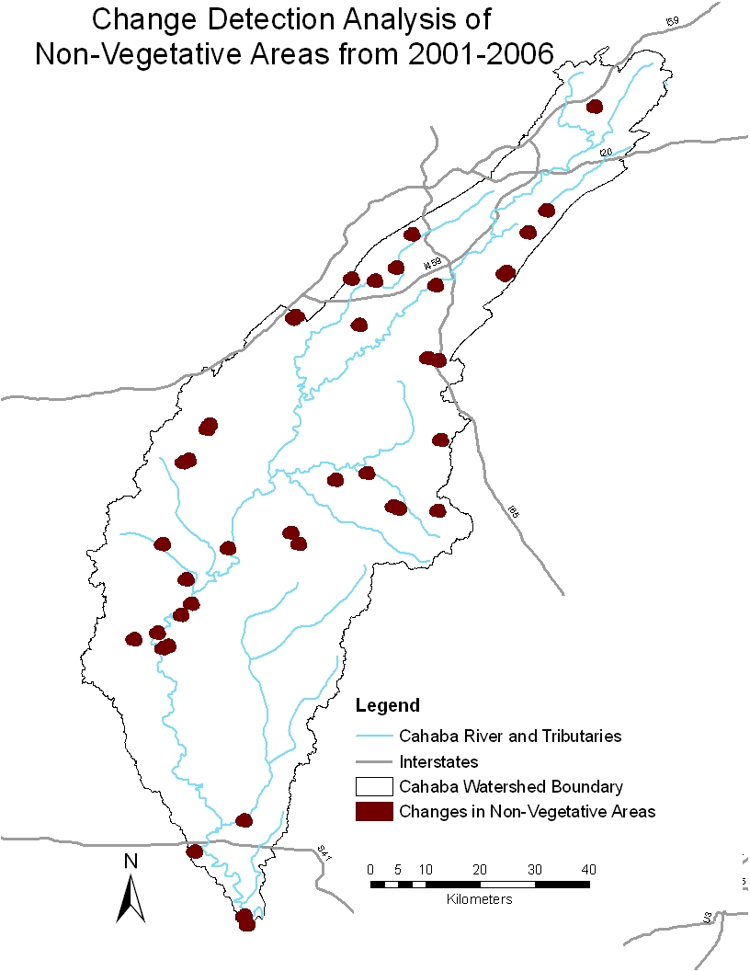
Figure 10: Change detection analysis of Landsat 5 TM NDVI images between June 2001 and June 2006 showing changes in non-vegetative areas over this five-year period. The changes in this land cover class, which represents negative NDVI values, are depicted in maroon and can symbolize changes in development, construction, and water area. Shape-files for the roads and river were obtained from ESRI.
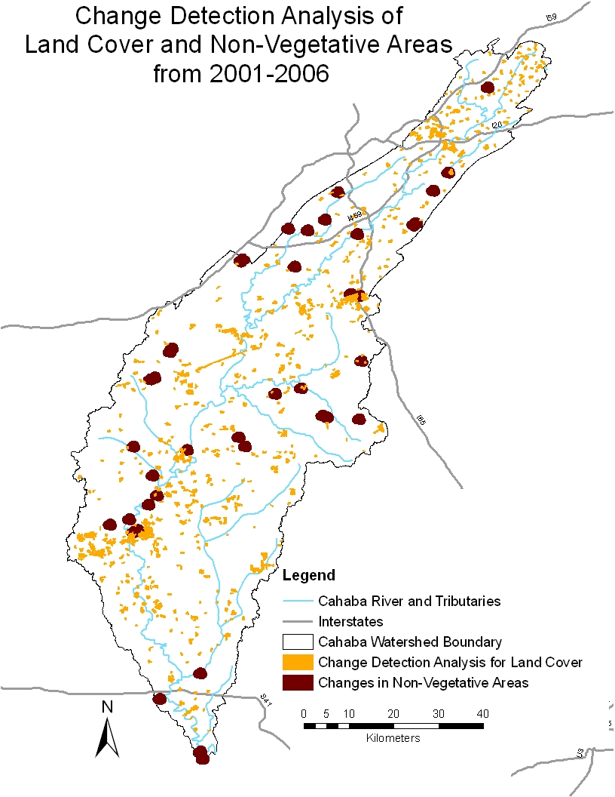
Figure 11: Image combining two change detection analyses of Landsat 5 TM NDVI images between June 2001 and June 2006, depicting changes in non-vegetative areas together with changes in all land cover classes over this five-year period. Displaying these two analyses together can reveal areas of the most change within the watershed. Shape-files for the roads and river were obtained from ESRI.

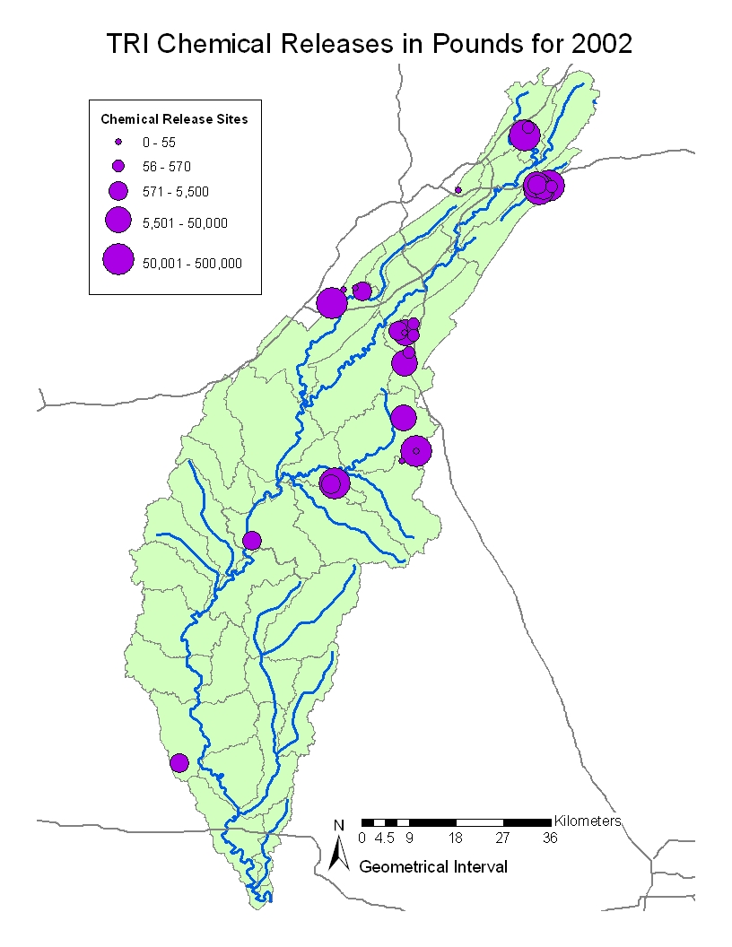
Figure 12: Map created using data gathered from EPA to show the locations of chemical release sites for 2002. It is important to note that in 2009 the chemical sites only released up to 70,500 pounds of chemicals while in 2002 there were sites that released up to 500,000 pounds of chemicals. Four sites were found to release more than 70,500 pounds of chemicals. There was a 7% decrease in facilities reporting for 2009 which might be due to the economic downturn. The EPA is still investigating the cause (Gray, 2010).Shape-files for the roads and river were obtained from ESRI.
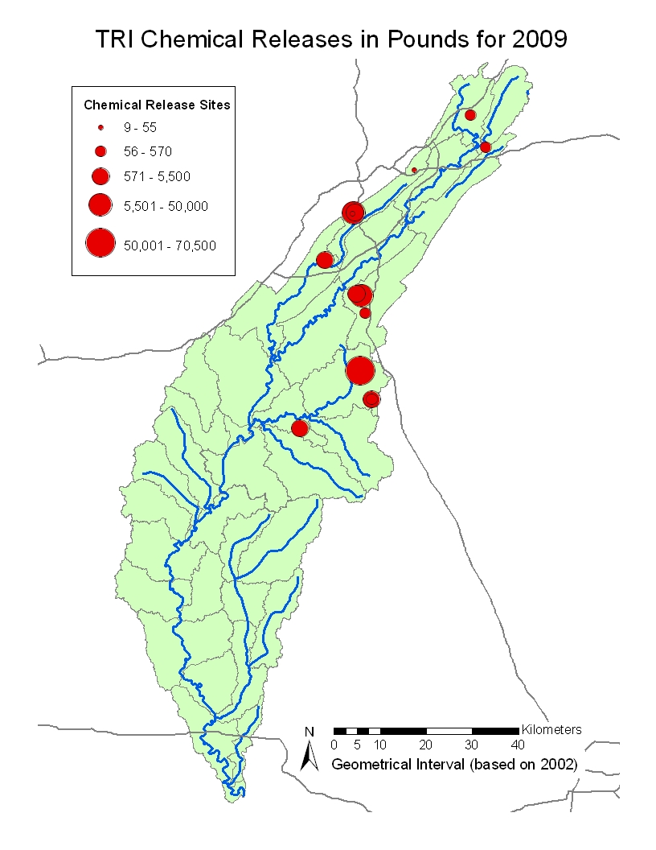
Figure 13: Map created using data gathered from EPA to show the locations of chemical release sites for 2009. It is important to note that in 2009 the chemical sites only releases up to 70,500 pounds of chemicals while in 2002 there were sites that released up to 500,000 pounds of chemicals. There was a 7% decrease in facilities reporting which might be due to the economic downturn in 2009. The EPA is still investigating the cause (Gray, 2010).Shape-files for the river and roads were obtained from ESRI.
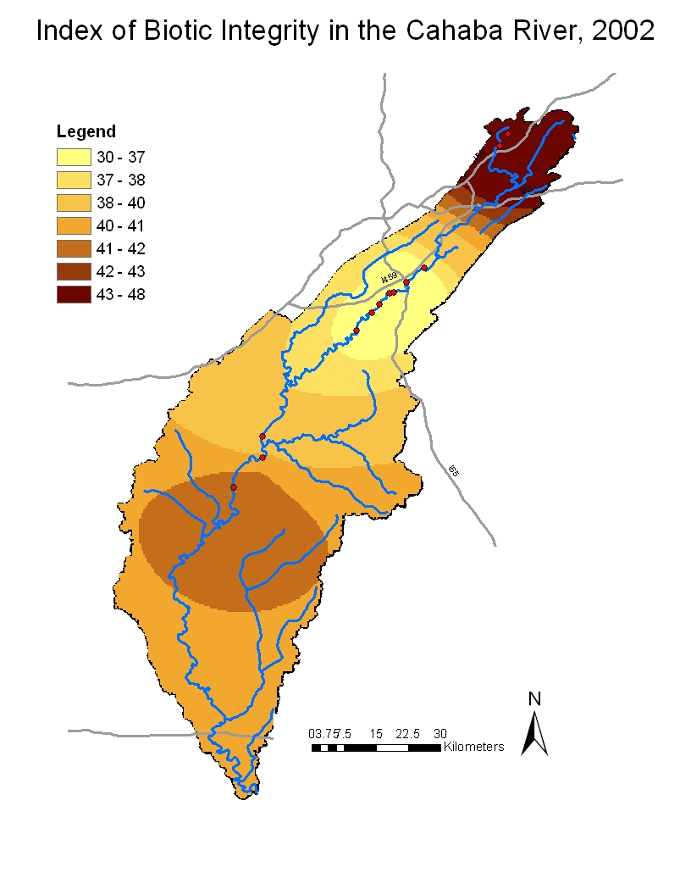
Figure 14: Map displaying spatial analysis in the form of Ordinary Kriging performed on the Index of Biotic Integrity to map varying levels of fish biodiversity.These 2005 data, recording the Index of Biotic Integrity (IBI) (as determined by Kevin Morse in 2002) at several points along the Cahaba River, help show the distribution of fish species and habitat health throughout the watershed. The Kriging analysis creates a contour map of the area based on these IBI levels, which can range from 12 to 60, where 12 represents a low level of biotic integrity and 60 represents a very high level. Shape-files for the roads and river were obtained from ESRI.
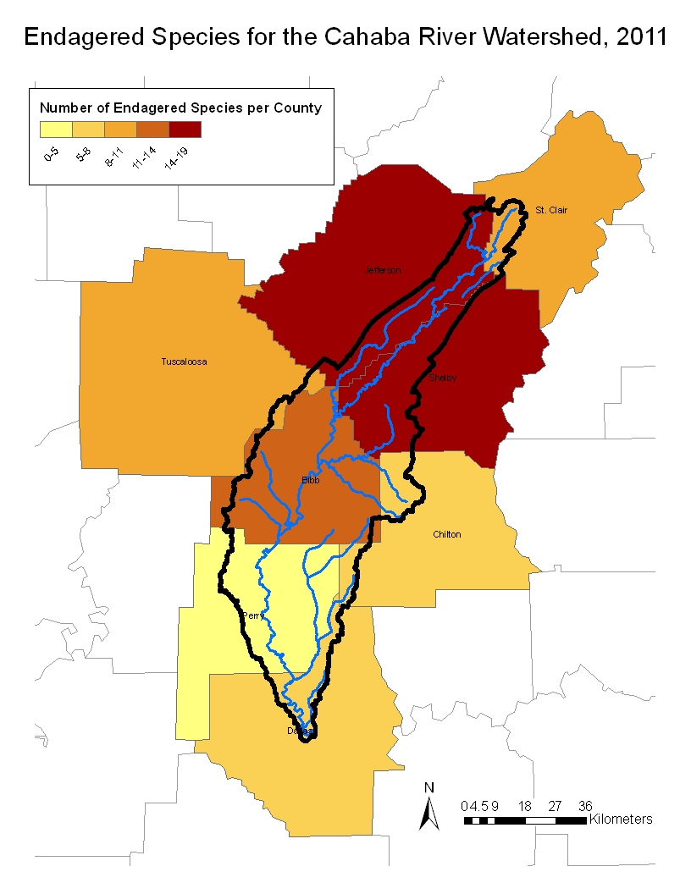
Figure 15: Map showing the number of threatened, endangered, and extinct species of fish, amphibians, clams/mussels, and snails per county in the Cahaba River watershed for 2011. The data were obtained from the U.S. Fish and Wildlife. It is important to note that the counties with the highest number of endangered species are in the northern Cahaba River Watershed (in Jefferson and Shelby counties) which is the location of the city of Birmingham. Thus, more urbanized areas have a higher number of endangered species.Shape-files for the roads and river were obtained from ESRI.
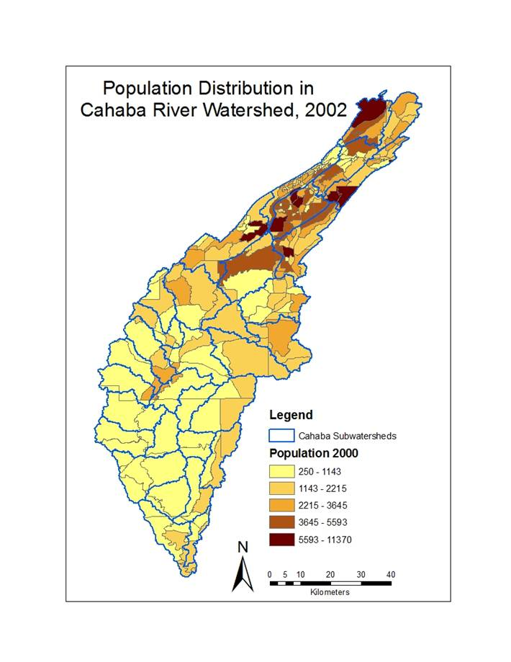
Figure 16: Map showing the population distribution in the Cahaba River watershed area in 2002. The data were obtained from the U.S. Census Bureau. Data shows higher population density in the Upper Cahaba River watershed. Shape-files for the watersheds were obtained from ESRI.
Discussion

A. Analysis of Results
The amount of vegetation around a watershed has been linked to the health of the watershed. The most cost efficient way to measure this vegetation is by satellite remote sensing. The Normalized Difference Vegetation Index was used to measure the amount of vegetation around the Cahaba River Watershed over all four seasons for three years spanning 2001 to 2010. Our analysis of biodiversity data during this time period revealed that the Greater Birmingham Metropolitan Area of the Cahaba River Watershed had the lower IBI index values and a greater number of endangered species than the rest of the watershed. This area had also experienced the largest decrease in vegetation as shown by NDVI classification and change detection analysis images. Change detection analyses can reveal areas of potential concern due to rapid changes in land cover. Depending on the reasons for these changes, the areas represented could require more specialized restoration efforts.

These findings can help the Cahaba River Society focus restoration efforts on areas of greatest need. All remote sensing methods used by the team were helpful in determining areas of concern within the Cahaba River watershed, and the methodology can be used in the future to continue the detection of areas in need of attention.

B. Errors & Uncertainties

Data from the years 2000-2005 were compared with data from 2006-2011; however, there were very little recent data. The most comprehensive data were collected from 1990 to 2005. The team was unable to collect independent data because it would require equipment which was not available. Thus, the research plan was slightly altered.
Landsat 5 imagery must be atmospherically corrected to get the most accurate results. Atmospheric Correction is a process of correcting for chemicals absorbed, scattered, and reflected in the atmosphere (Fallah-Adl, 1995). Performing this correction in ER Mapper requires an extension that was unavailable to the research team. One of the team’s professional contacts was able to atmospherically correct the images on ITT’s ENVI software; however, this procedure rendered the resulting images inaccessible in ER Mapper and ERDAS Imagine for further processing, which the team used for the project. This meant that all further processing had to be accomplished using ENVI, slowing processing time considerably. Additionally, there were several projection errors involving importing processed ASTER imagery into ArcMap that further slowed down the project. This last problem eventually required changing the entire ASTER NDVI analyses in order to get around these problems. Due to differences in projections, there remain errors in the display of the ASTER images within the watershed; the solution to the problem remains uncertain.

Ground truth data collection was limited by factors such as time and area. Due to time limitations, all points were collected along the main road structure within the watershed, so the points follow the general line of the roads in the area. However, the variation of points along the roads was satisfactory for the sampling. Additionally, the water data were the most challenging to obtain since this land cover type occurred often in areas that were difficult to reach, such as remote locations with no access road or areas where vegetation was too dense to traverse.

C. Future Work

C.1 Water Chemistry
Water chemistry provides another type of data that could be used to analyze the health of the Cahaba Watershed. There are many sources detailing this type of data, many of which could be incorporated into a future version of this project. Much of this data has already been obtained and organized but could not be included in the project due to time constraints.

  - Phosphorus and Nitrogen Data - The phosphorus and nitrogen data were collected from an EPA study, Cahaba River:Biological Water Studies, which showed biological and water quality changes for the Cahaba River during March/April, July and September of 2002 (Howard et al, 2002). These data were uploaded to ArcMap as point source data.

  - Nonpoint Source Discharge - Shows Nutrient Total Maximum Daily Loads (TMDLs) for the Cahaba River Watershed gathered by ADEM.

  - USGS Alabama Current Stream-flow Conditions - Water discharge speeds were collected from 14 sites in Cahaba River Watershed by the USGS and reported through the USGS Real-Time Water Data for Alabama. The data were transferred to ArcMap as point source data.

  - Conductivity data - Conductivity Data were collected from 14 sites in the Cahaba River Watershed by the USGS and reported through the USGS Real-Time Water Data for Alabama. The data were then imported into ArcMap as point data.

  - Impaired Waters and Total Maximum Daily Load (303d)- Impaired waters are defined as waters that are too polluted or degraded to meet water quality standards. These data were available as a shapefile for download from the EPA. Total Maximum Daily Load is a calculation of the amount of pollution that a water body can receive and still meet safe water quality standards. The data were imported into ArcMap as point data.

  - Waste Water Treatment plants - The location of Waste Water Treatment plants and the Total Maximum Daily Loads (TMDLs) of each plant that dumps into the Cahaba River Watershed reveals information about sediment and water quality. The data were used to create point source data in ArcMap. This information was gathered by ADEM.

C.2 Improved Vegetation Indices
  - EVI - The Enhanced Vegetation Index is a new data index using the same satellite used for NDVI (Terra’s MODIS), but will improve the quality of the data. It corrects for some distortions in the reflected light caused by air particles and ground cover below vegetation, and is not as saturated as NDVI when viewing large amounts of chlorophyll (Weier & Herring, n.d.). This could have been a useful source for the current research, however it is not yet available.

  - TNDVI / TDVI - The Transformed Normalized Difference Vegetation Index/ Transformed Difference Vegetation Index is another tool to classify and analyze lland use cover. This index does not have problems of soil saturation affecting the reading like NDVI classification.

C.3 Elevation
Additional and valuable information could be added to the present study by incorporating elevation data. A more sensitive algorithm including elevation may accurately distinguish categories within negative NDVI values, since imperviousness can vary greatly over non-vegetated areas. The National Elevation Dataset ⅓ Arc-Second (NED ⅓ ) provided by USGS provides basic elevation data for the contiguous United States, as well as for Alaska, Hawaii, and the territorial islands.

C.4 The Cahaba Lily (Hymenocallis coronaria)
This project mainly focused on the biodiversity of aquatic life in the Cahaba River watershed and did not include research on plant life. The Cahaba Lily is a major draw for visitors to the Cahaba River, but recently its population is dwindling. The Cahaba Lily, also known as the “shoal spider lily,” “rocky shoal spider lily,” or just “shoal lily,” only grows in Alabama, Georgia, and South Carolina. The Cahaba Lily only lives in specialized habitats, such as well-lit rocky shoals and swift-moving, well-oxygenated water free of pollution and sediment (Alabama Tourism Department, 2006). The Cahaba Lily has been put under consideration for federal protection. The main threats are damming, which destroy the unique habitat, and sediment and pollution which collect at the shoals allowing competing vegetation to push out the lilies (Alabama Tourism Department, 2006). Future research could include factors related to the survival of the Cahaba Lily.

Conclusions

In conclusion, the acquisition of Landsat imagery proved to be effective in monitoring vegetation across the Cahaba River over a broad period of time (10 years). Landsat imagery is generally available for the same location each month of the year. ASTER imagery, on the other hand, offers greater resolution but provides less consistent data and a more limited coverage area. If a specific problem area is identified within the watershed, it would be beneficial to attempt to obtain ASTER imagery of the area since it would offer more detail.
The ground-truth land cover classification accuracy testing showed that analysis of ASTER imagery was about 94% accurate and analysis of Landsat imagery was about 98% accurate in the present study. From this test, it was concluded that the remote sensing analysis of the study area was sufficiently accurate to be considered a viable method of studying the watershed area. The spatial analyses of biodiversity data showed lower levels of biodiversity around the I-65 and I-459 junction in the Birmingham area. Spatial analyses and change detection analyses of the study area can reveal areas of concern due to rapid change in land cover, development, and vegetation. Restoration efforts can be focused on interest areas identified in this study, as well as any further areas identified by continuation of this methodology.

In the fall of 2011, the findings and data will be presented to the Cahaba River Society, giving them and their partners, such as the Fresh Water Land Trust and ADEM, valuable information for identifying areas of concern within the Cahaba Watershed and helping them devise restoration strategies and plans to conserve the health of this very important river.

Transition to Partner
- Conservation efforts will be maximized by focusing conservation efforts on the identified interest areas resulting from this study.
- Findings and end products will be vital to policy makers for the Cahaba River Society, The Freshwater Land Trust, and Alabama Department of Environmental Management in development of conservation strategies and new land-use plans pertaining to the Cahaba River watershed.

The team met with Dr. Randy Haddock, Ph.D., field director of the Cahaba River Society, at the beginning of this project. Dr. Haddock identified the priorities of the Society and how the present study can help better preserve the Cahaba River. The team will meet with the Cahaba River Society in the fall of 2011 to transfer findings and data to them.

The current project will provide multiple areas of interest for the Society to investigate further, as well as a detailed methodology for using remote sensing data in the future. The project provides a more cost effective method for analyzing the watershed, essentially eliminating tedious ground work. If the Cahaba River Society continues to use this methodology, satellite imagery will help them determine what areas within the Cahaba River watershed need the greatest concentration of restoration efforts. Using these ideas for future work, the Society can further develop this project in order to include a more comprehensive study of the area and narrow down areas of interest within the watershed.

Acknowledgments

The MSFC/UAB Spring 2001 Team would like to acknowledge the contribution of several important collaborators for facilitating the planning, execution, and completion of this project: Dr. Sarah H. Parcak, Director of the Lab for Global Health Observation; Dr. Randall Haddock, Field Director of the Cahaba River Society; Dr. Jeff Luvall, Science Advisor; and Dr. Donna Burnett, Research Advisor.

References

About Birmingham (n.d). The Official Website For Birmingham Alabama. Retrieved August 1, 2011, from http://www.informationbirmingham.com/about-birmingham.aspx.
Alabama Department of Environmental Management (ADEM) (2002). Surface Water Quality Screening Assessment of the Cahaba and Black Warrior River Basins. Montgomery: ADEM.
Alabama Department of Environmental Management (ADEM) (2006). Nutrient Total Maximum Daily Loads (TMDLs) for the Cahaba River Watershed. Montgomery: ADEM.
Alabama Department of Environmental Management (ADEM) (2010). 2010 Integrated Water Quality Monitoring and Assessment Report. Montgomery: ADEM.
Alabama Tourism Department and Alabama Department of Conservation and Natural Resources (2006). Splendor in the Spring. The Year Of Outdoor Alabama. Retrieved August 1, 2011, from http://www.800alabama.com/yooa/scenic/lilies.cfm.
Allan, J. D. (2004). Landscape and Riverscape: The Influence of Land Use on Stream Ecosystems. Annu. Rev. Ecol. Evol. Syst., 35: 257–284. Ann Arbor: University of Michigan.
Allan, J. D., & Flecker, A. S. (1993). Biodiversity Conservation in Running Waters. BioScience , 43 (1): 32-43. Oakland: University of California.
Allen, W. (2001). Cahaba River National Wildlife Refuge Legislation, Progress Begins with Presidential signature. Alabama Nature News, Spring Issue. Birmingham: The Nature Conservancy of Alabama.
Anselin, L. (1994). Exploratory spatial data analysis and geographic information systems. In: New Tools for Spatial Analysis ed. M.Painho. Luxembourg: EuroStat, 45-54.
Baker, J. P., Hulse, D. W., Gregory, S. V., et al. (2004). Alternative Futures for the Willamette River Basin, Oregon. Ecological Applications, 14 (2): 313-324. Corvallis: U.S. Environmental Protection Agency.
Bannari, A., Asalhi, H., & Teillet, P. M. (2002). Transformed Difference Vegetation Index (TDVI) for Vegetation Cover Mapping. Geoscience and Remote Sensing Symposium, 5: 3053-3055. Ottawa, Canada: University of Ottawa.
Bennet, M. G., Kuhajda, B. R., & Howell, J. H. (2005). Fish Diversity and Conservation in the Mobile Basin in Alabama: An Overview with Case Studies. Tuscaloosa: University of Alabama.
Bennet, M. G., Kuhajda, B. R., & Howell, J. H. (2008). Status of the Imperiled Frecklebelly Madtom, Noturus munitus (Siluriformes: Ictaluridae): A Review of Data from Field Surveys, Museum Records, and the Literature. Southeastern Naturalist, 7 (3): 459-474. Tuscaloosa: University of Alabama.
Buell, G. R., Calhoun, D. L., & Wehmeyer, L. L. (2009). Hydrologic and Land-use / Land-cover Metric Used in Ecological Assessments of Six U.S. Fish and Wildlife Service National Wildlife Refuges in the Southeastern USA. Proceedings of the 2009 Georgia Water Resources Conference. Atlanta: University of Georgia.
Carter-North, John P. (2005). Growth Machine Meets Conservation: A Stakeholder Analysis of the Black Warrior and Cahaba River Watersheds. Thesis, M.Sc. Auburn: Auburn University.
Cielinski, Susan. (n.d). Case Study I: Cahaba River National Wildlife Refuge. Athens: University of Georgia. Retrieved Aug. 11, 2011, from http://coopunit.forestry.uga.edu/GACFWRU_FWS_workshop/cahaba.
Corn, Frances E. (2000). A Bioassessment of Seven Tributaries of the Upper Cahaba River Using Benthic Macroinvertbrate Populations. Thesis, M.Sc. Birmingham: University of Alabama at Birmingham.
Clean Water Partnership (CWP) (n.d.). Alabama Clean Water Partnership Cahaba River Basin. Retrieved Aug. 11, 2011, from http://www.cleanwaterpartnership.org/alabama-river-basins/cahaba/.
Davenport, L. J., Howell, W. M., Morse, K. J., et al. (2005). Fishes and Macroinvertebrates of the Upper Cahaba River: A Three-Year Study. Journal of the Alabama Academy of Science, 76 (1). United States Environmental Protection Agency (EPA) and Alabama Department of Environmental Management (ADEM).
El-Kaddah, D. N. & Carey, A. E. (2004). Water Quality Modeling of the Cahaba River, Alabama. Environmental Geology, 45 (3): 323-338. Tuscaloosa: University of Alabama.
Environmental Protection Agency (EPA) (2004). Total Maximum Daily Load (TMDL) for Siltation, Turbidity, and Habitat Alteration in Shades Creek, Jefferson County, Alabama. Atlanta: EPA.
Environmental Protection Agency (EPA) (2006). Cahaba River: Biological and Water Quality Studies 2002 Appendum 2006. Athens: EPA.
Environmental Protection Agency (EPA) (2008). Watershed Cahaba River Quality Assessment Report WATERS U.S. EPA 2008. Retrieved Aug. 11, 2011, from http://oaspub.epa.gov/tmdl/attains_watershed.control?p_huc=03150202&p_state=AL&p_cycle=2008&p_report_type=T.
Environmental Protection Agency (EPA) (2010). CADDIS: The Causal Analysis/Diagnosis Decision Information System. Retrieved Aug. 11, 2011, from http://www.epa.gov/caddis/.
Environmental Protection Agency (EPA) & National Pollutant Discharge Elimination System (NPDES) (2011). Pesticide General Permit (PGP) for Dicharges from the Application of Pesticides. Retrieved Aug. 11, 2011, from http://cfpub.epa.gov/npdes/home.cfm?program_id=410.
Fallah-Adl, H., JaJa, J., Liang, S., et al. (1995). Atmospheric Correction. Efficient Algorithms for Atmospheric Correction of Remotely Sensed Data. College Park, Maryland: University of Maryland. Retrieved Aug. 11, 2011, from http://www.umiacs.umd.edu/research/GC/atmo/index.html.
Gevrey, M., Sans-Piché, F., Grenouillet, G., et al. (2009). Modeling the Impact of Landscape Types on the Distribution of Stream Fish Species. Canadian Journal of Fisheries and Aquatic Sciences, 66 (3): 484-495. Toulouse, France: Universite Paul Sabatier.
Geological Survey of Alabama (GSA) (2006). Alabama State Oil and Gas Board. Tuscaloosa: Geological Survey of Alabama (GSA). Retrieved Aug. 11, 2011, from http://gsa.state.al.us/.
Gray, Ryan (2010). EPA Says Toxic Chemical Releases Decreased in 2009. School Transportation News. Retrieved Aug. 11, 2011, from http://www.stnonline.com/home/latest-news/2976-epa-toxic-chemical-releases-decrease.
Guneroglu, Abdulaziz (2010). Marine Litter Transportation and Composition in the Coastal Southern Black Sea Region. Rivers, 5 (3): 296-303. Trabzon, Turkey: Kardaniz Technical University.
Guneroglu, Abdulaiz (2010). Marine Litter Transportation and Composition in the Coastal Southern Black Sea Region. Academic Journals, 5 (3), 296-303. Trabzon, Turkey: Karadeniz Technical University.
Hadeed, L. & Thomson, B. (2006). Free-Flowing Rivers: Economic Luxury or Ecological Necessity?. Zeist, Netherlands: World Wide Fund for Nature (WWF).
Honovar, Jaideep V. (2003). Assessment of Ichthyofaunal Assemblages of Sedimentation in the Upper Cahaba River and Its Tributaries. Thesis, M.Sc. Birmingham: University of Alabama at Birmingham.
Howard, H. S., Quinn, B., Flexner, M. C., et al. (2002). Cahaba River: Biological and Water Quality Studies, Birmingham, Alabama. March/April, September andJuly, 2002. U.S. Environmental Protection Agency, Region 4, Science and Ecosystem Support Division, Ecological Support Branch.
Lindsey, Kristen L. (1998). A Bioassessment of the Upper Cahaba River Using Benthic Macroinvertebrate Populations. Thesis, M.Sc. Birmingham: University of Alabama at Birmingham.
Malcom Pirnie, Inc. (2009). Cahaba River/Lake Purdy Watershed Protection Policy. Birmingham: City of Birmingham.
Malcom Pirnie, Inc. (2009). Municipal Separate Storm Sewer System Fiscal Year 2008-2009 Annual Report. Birmingham: City of Birmingham.
Marshall, John E. (1999). Shiner Surprise. Wildlife Conservation, 102 (1): 13. Bronx: New York Zoological Society.
Mayden, R. L., & Kuhajda, B. R. (1989). Systematics of Notropis Cahabae, a New Cyprinid Fish Endemic to the Cahaba River of the Mobile Basin. Birmingham: University of Alabama at Birmingham.
McIndoe, James E. (2008). Alabama’s Water Quality Assessment and Listing Methodology. Montgromery: ADEM.
Meador, M. R., Coles, J. F., & Zappia, H. (2005). Fish Assemblage Responses to Urban Intensity Gradients in Contrasting Metropolitan Areas: Birmingham, Alabama and Boston, Massachusetts. American Fisheries Society Symposium, 47: 409-423. Reston, VA: U.S. Gelogical Survey.
Meijerink, A., & Mannaerts, C. (2000). Introduction to and General Aspects of Water Management with the Aid of Remote Sensing. In G. A. Schultz, & E. T. Engman, Remote Sensing in Hydrology and Water Management, 329-348. Berlin: Springer.
Morse, K. J. (2005). The effects of urbanization on the health of fish and benthic macroinvertebrate commnunities in the Upper Cahaba River Watershed. Birmingham: University of Alabama at Birmingham.
Oberholster, Chris (2006). The Cahaba River is a Unique Biological Resource Partnerships are Important to Manage Threats to the Cahaba River Justification for the Proposed Expansion of the Cahaba Refuge. Washington, D.C: U.S. Committee on Resources.
O'Neil, P. E. & Shepard, T. E. (1999). Water-Quality Assessment of the Lower Cahaba River Watershed, Alabama A Summary Report. Tuscaloosa: Alabama Department of Environmental Management (ADEM).
O'Neil, P. E. & Shepard, T. E. (2005). Hatchet Creek Regional Reference Watershed Study. Tuscaloosa: Geological Survey of Alabama (GSA).
O'Neil, P. E., Shepard, T. E., Mettee, M. F., et al. (2004). A Survey of Alabama's Coastal Rivers and Streams for Fishes of Conservation Concern. Tuscaloosa: Gelological Survey of Alabama (GSA).
Onorato, D. P., Angus, R. A., Marion, K. R. (2000). Historical Changes in the Ichthyofaunal Assemblages of the Upper Cahaba River in Alabama Associated with Extensive Urban Development in the Watershed. Journal of Freshwater Ecology, 15 (1): 47-63. Birmingham: University of Alabama at Birmingham.
Onorato, D. P. (1997). Ichthyological Bioassessment of the Upper Cahaba River of Alabama: An Analysis of the Selection of Sampling Gears, Current Trends in the Fish Assemblages, and Historical Changes Within the Ichthyofaunal Communities. Thesis: M.Sc. Birmingham: University of Alabama at Birmingham.
Outdoor Alabama (2008). The Cahaba River - Alabama's Free Flowing Treasure. Retrieved Aug. 11, 2011, from http://www.outdooralabama.com/fishing/freshwater/where/rivers/cahaba/.
Ozbakir, A. & Bannari, A. (2008). Peformance of TDVI in Urban Land Use/Cover Classification for Quality of Place Measurement. The International Archives of the Photogrammetry, Remote Sensing and Spatial Information Sciences, 38 (B7): 691-694. Istanbul, Turkey: Yildiz Technical University
Park, R. A., Clough, J. S., & Wellman, M. C. (2008). AQUATOX: Modeling Environmental Fate and Ecological Effects in Aquatic Ecosystems. Ecological Modelling, 213 (1): 1-15. Washington, D.C.: EPA.
Paul, M. J., & Meyer, J. L. (2001). Streams in the Urban Landscape. Annu. Rev. Ecol. Syst., 32: 333–65. Athens: University of Georgia.
Phillips, Doug (1996). Cahaba River Watershed. Discovering Alabama, 18: 1-4. Tuscaloosa: Discovering Alabama.
Pierson, M. J., Howell, W. M., Stiles, R. A., et al. (1989). Fishes of the Cahaba River System in Alabama (Vol. Bulletin 134). Tuscaloosa, Alabama: Geological Survey of Alabama.
Pitt, Robert E. (2000). Water Quality Conditions in the Cahaba River and Likely Pollutant Sources. Thesis: Ph.D. Birmingham: University of Alabama at Birmingham.
Roy, A. H., Rosemond, A. D., Paul, M. J., et al. (2003). Stream Macroinvertebrate Response to Catchment Urbanization. Freshwater Biology, 48: 329–346. Athens: University of Georgia.
Shepard, T. E., O’Neil, P. E., McGregor, S. W., et al. (1994). Biomonitering and Water-Quality Studies in the Cahaba River Drainage of Alabama, 1989-94. Geological Survey of Alabama, 165. Tuscaloosa.
Song, C., Woodcock, C. E., Seto, K. C., et al. (2001). Classification and Change Detection Using Landsat TM Data: When and How to Correct Atmospheric Effects? Remote Sensing of Environment, 75: 230-244. Boston: Boston University.
Spencer, Thomas (2010). Green Group Praises River Development: Trussville Project Rising Near Cahaba River. Birmingham News, September 15.
Tate, C. M., Cuffney, T. F., McMahon, G., et al. (2005). Use of an Urban Intensity Index to Assess Urban Effects on Streams in Three Contrasting Environmental Settings. American Fisheries Society Symposium, 47: 291-315. Denver: GSA.
United States Environmental Protection Agency (EPA) (2010). CADDIS: The Causal Analysis/Diagnosis Decision Information System. Retrieved July 1, 2011, from http://www.epa.gov/caddis/index.html.
Unknown (n.d.). Rivers of Alabama Cahaba. Retrieved Aug. 11, 2011, from http://www.riversofalabama.org/Cahaba/Cahaba.htm.
U.S. Fish and Wildlife Service (2007). Cahaba River National Wildlife Refuge Habitat Management Plan. Macon: U.S. Fish and Wildlife Service.
U.S. Fish and Wildlife Service (2007). Final Environmental Assessment, Habitat Management Plan, Cahaba River National Wildlife Refuge. Macon: U.S. Fish and Wildlife Service.
U.S. Fish and Wildlife Service (2009). Cahaba Shiner (Notropis cahabae). Retrieved Aug. 11, 2011, from http://ecos.fws.gov/docs/life_histories/E04C.html.
U.S. Fish and Wildlife Service (2010). Draft Environmental Assessment and Land Protection Plan for the Proposed Expansion of Cahaba River National Wildlife Refuge and the Proposed Establishment of the Cahaba River Conservation Area. Atlanta: U.S. Fish and Wildlife Service.
U.S. Fish and Wildlife Service (2011). Alabama's Federally Listed Species. Retrieved Aug. 11, 2011, from http://www.fws.gov/daphne/es/specieslst.html.
U.S. Fish and Wildlife Service (2011). FWS Critical Habitat for Threatened & Endangered Species. Retrieved Aug. 11, 2011, from http://criticalhabitat.fws.gov/crithab/.
Valavanis, V. D., Pierce, G. J., Zuur, A. F., et al. (2008). Modelling of Essential Fish Habitat Based on Remote Sensing, Spatial Analysis and GIS. Hydrobiologia, 612: 5-20. Hereklion Crete, Greece: Hellenic Centre for Marine Research.
Wang, L., Lyons, J., & Kanehl, P. (2001). Impacts of Urbanization on Stream Habitat and Fish Across Multiple Spatial Scales. Environmental Management , 28 (2), 255-266. Monona: Wisconsin Department of Natural Resources.
Wear, D. N., Turner, M. G., & Naiman, R. J. (1998). Land Cover Along and Urban-Rural Gradient: Implications for Water Quality. Ecological Applications , 8 (3): 619-630.
World Wide Fund for Nature (WWF). Southeastern Rivers and Streams. Retrieved Aug. 11, 2011, from http://wwf.panda.org/about_our_earth/ecoregions/seastern_rivers_streams.cfm.
Weier, J. & Herring, D. (n.d.) Measuring Vegetation (NDVI & EVI). National Aeronautics and Space Administration (NASA). Retrieved Aug. 11, 2011, from http://earthobservatory.nasa.gov/Features/MeasuringVegetation/measuring_vegetation_1.php.

Appendices

Table 3: Comparing Google Earth imagery from 1997/1998/2001/2002/2003 * and 2006 with In-situ data collection from July 17 - July 20, 2011 by the DEVELOP team.
* Preferred 2002 but there were some locations that did not have imagery for 2002 and had to go back to older years such as 1997, 1998, 2001 or later years such as 2003.

