**PART 1:**

**CREATE A LANDSLIDE INVENTORY**

Satellite imagery provides a valuable perspective for identifying landslides, especially in rural regions or areas that lack ground-based data. To validate and calibrate the Susceptibility maps for LHASA (Part 2) it is helpful to have an accurate landslide inventory in the region of interest.

The steps below outline how to create a landslide inventory using Google Earth Pro. For the purposes of this project, we focused primarily on identifying the locations of landslides. Given more time and data availability, identifying the exact date of landslide occurrence would be useful information for cross-analysis with precipitation measurements.

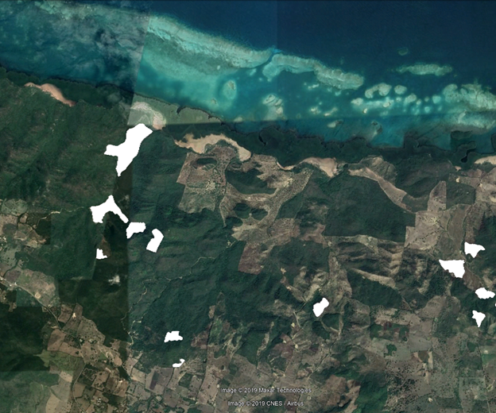

In the ~5,300 km2 northern region of the Dominican Republic interest, identified by SGN, the DEVELOP team located approximately **338 landslide polygons** from 2004-2018 using Google Earth Pro. Follow the steps below to do the same!

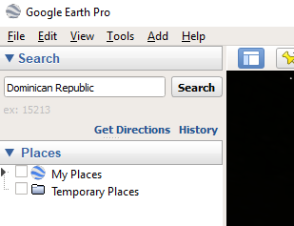

1. Open **Google Earth Pro**. Navigate to a region or country of interest by typing a location in the “Search” bar.
2. 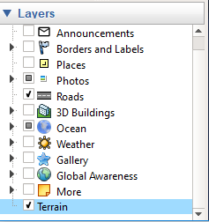In the “Layers” bar, click the “Terrain” box. Displaying “Roads” may be helpful in some areas as well.
3. 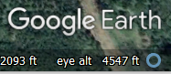Zoom so the elevation is less than 1,500 meters (5,000 feet). Eye altitude can be viewed in the bottom right of your screen (“eye alt”).

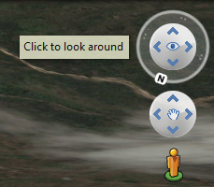

1. Click the up arrow on the “Look Around” tool to get a better view of the terrain.

**Tips and Tricks: Google Earth Pro**

* Press **N** on your keyboard to **orient images northward**
* Press **U** on your keyboard to **view images directly above**
* Press the **arrow keys** to **pan up, down, left, or right**
* Press the **backspace** to return to previous view

1. In the toolbar, click the “Historical Imagery” tool. Then use the left and right arrows to move between acquisition dates.

https://lh6.googleusercontent.com/13y9QRIbe9mqBWdKTgYVQ26uKvf41GmhI8r2VDjO-4CM1CWuT_Cg_CWJkRmdIJdN0IYwdoFL4kemj7mS4_F53Y_tmfBWJCWUCOMyzO91xieKuErtEBiO21W2lUJDdg

1. Examine the area and look for evidence of landslides (i.e. sudden loss of vegetation, clear scaring, etc.). Below is an example. The purple dot is placed at the base of the landslide for clearer visualization.

As you can see, major deforestation occurred along this road between 2012 and 2016. Satellite imagery from March 2018 capture that a landslide occurred along the road.

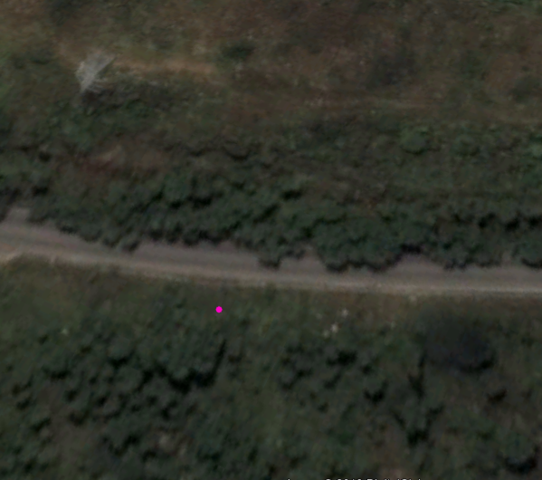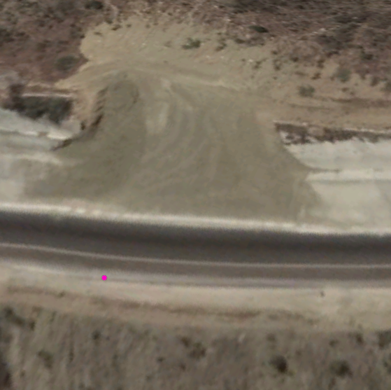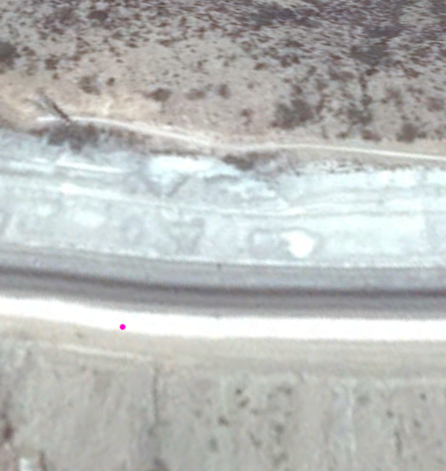

**October 2012**

**March 2018**

**August 2016**

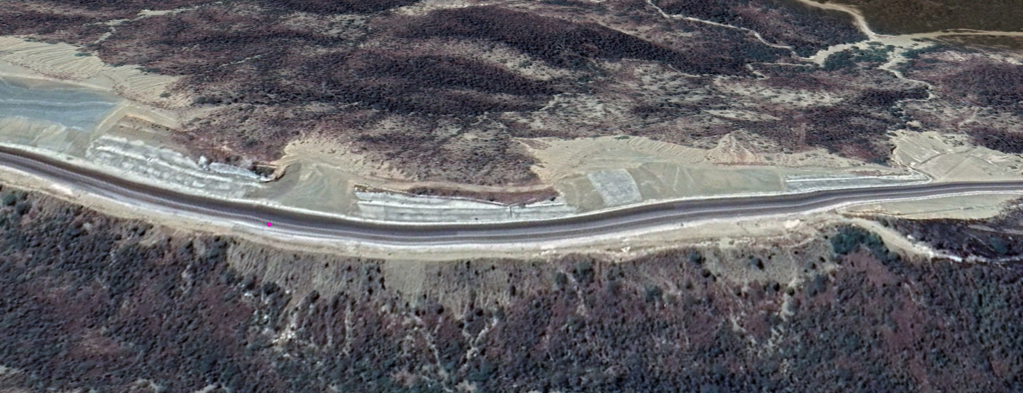

*This landslide corresponds to point #3491 from the SGN data set (puntos deslizamientos)*

1. Once you have identified a landslide, you can begin mapping it. First, you need to create a new folder where you can save all of your landslide polygons**.** 
   1. Navigate to the ‘Places’ pane on the left side of the screen. Right click on “My Places,” then “Add,” then “Folder.”

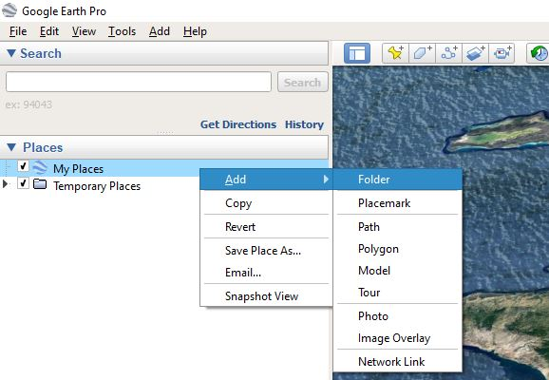

* 1. Name your folder and click “Ok” to create the folder.

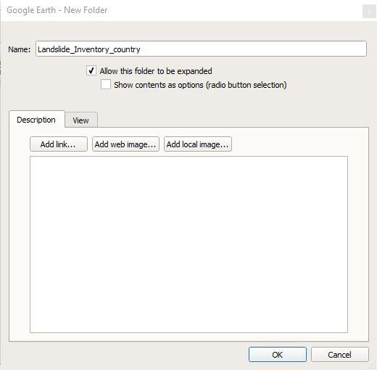

1. To map the landslide, click the “Polygon” tool located in the top banner near the historical imagery tool.

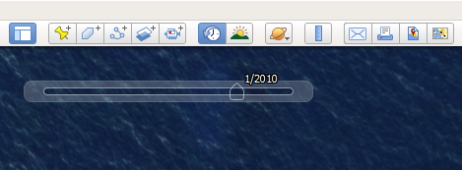

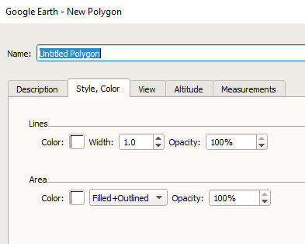

1. A “New Polygon” window will open. Click the “Style, Color” tab. Change the “Filled+Outlined” option to “Outlined.”

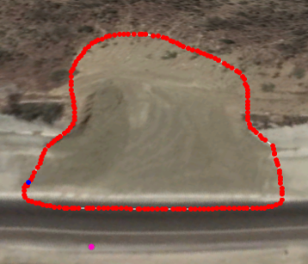

1. On the satellite image, click and drag your mouse to outline the landslide shape.

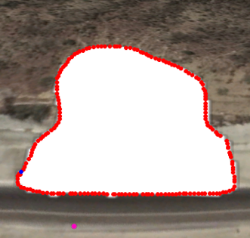

1. In the “New Polygon” window, change the area feature back to “Filled+Outlined” so your polygon looks like this:
2. Save your polygon in the “Name” tab of the “New Polygon” window by creating a name and clicking “Ok.”

**🞂** For our inventory, we saved polygons as: ***initial_number_ConfidenceLevel.***

**🞂** The confidence level, marked as high (h), medium (m), and low (l), helped us record our certainty in each identified landslide event.

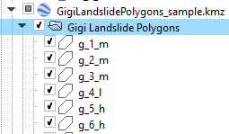

**🞂** Remember, the more landslides identified and the more conclusive your mapping for the inventory, the better!

1. Once you have completed your landslide inventory, you will need to save the folder containing your polygons as a .kmz file (this is an unzipped .kml file).
   1. Right-click on the folder name and select “Save Place As…”. Navigate to the folder in your drive where you want to save your landslide inventory.

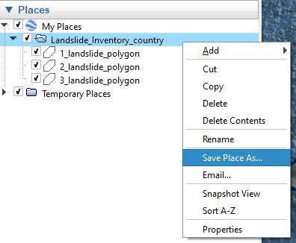

* 1. Either change or keep your folder name and under “Save as type,” select Kmz (*.kmz). Click “Save.” Now, you have a landslide inventory.

1. 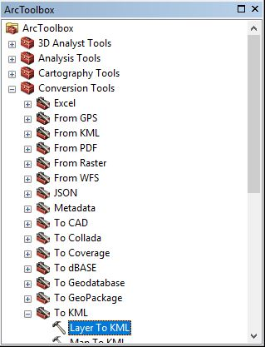You will now import the .kmz file you created in Google Earth into ArcMap. Navigate to the ArcToolbox > Conversion Tools > “**KML to Layer**.” This tool allows you to convert the polygons into a shapefile (.shp) for use in a GIS. Name and save the .shp file to your desired workspace.
2. Lastly, use the “**Feature to Point**” Conversion tool in the ArcToolbox to convert the polygon shapefile (Step 14) into a point shapefile. If needed, you can add new fields and attributes to this feature layer using the **Editor Tool**. This point feature layer of landslide locations can now be used for calibration and validation for either the susceptibility map or LHASA nowcasts (if dates are known for the landslide events).