**NASA DEVELOP National Program**



USGS at Colorado State University

*Summer 2016*

Laramie Mountains Ecological Forecasting II

Modeling Aspen Distribution Utilizing NASA Earth Observations to Identify Critical Habitat for Mule Deer and Elk in the Laramie Range, Wyoming

**Technical Report** 

Final Draft – August 11, 2016

Sarah Carroll (Project Lead)

Katie Butler

Aubrey Hilte

Megan Vahsen

Dr. Paul Evangelista, Colorado State University, Natural Resource Ecology Lab (Science Advisor)

Dr. Amanda West, Colorado State University, Natural Resource Ecology Lab (Mentor)

Brian Woodward, NASA DEVELOP, USGS at Colorado State University (Center Lead)

Previous Contributors:

Stephanie Krail

Alexa Grafton

Darin Schulte

# 1. Abstract

In the Laramie Mountain Range in southeastern Wyoming, quaking aspen (*Populus tremuloides)* stands are a source of high productivity and support a diverse community of vertebrate species. Mule deer (*Odocoileus hemionus*) and elk (*Cervus canadensis*) are dependent on mature aspen communities for forage and fawning habitat, however aspen distribution data are limited and incomplete, making it difficult for wildlife managers to locate and quantify existing critical habitat. This project utilized Landsat 8 Operational Land Imager (OLI) and Thermal Infrared Sensor (TIRS) data, Shuttle Radar Topography Mission (SRTM) version 2, and aspen survey data to fit species distribution models and create a 30 m resolution aspen canopy cover map for the Laramie Mountain Range. The resulting aspen cover data were then combined with fire history data produced by the Laramie Mountains Ecological Forecasting Term I team to examine the relationship between fire and aspen regeneration. Additionally, existing aspen location data were compiled across Wyoming and used to develop bioclimatic models of current and future potential suitable habitat for the species. Our partners at the Wyoming Game & Fish Department (WGFD) will utilize the data, results, and map products produced to estimate the carrying capacity for mule deer and elk in the region, plan effective population management strategies, and support future aspen regeneration and management efforts.

**Keywords**

Quaking Aspen, Landsat 8, MaxEnt, Random Forest, Software for Assisted Habitat Modeling (SAHM), Species Distribution Modeling, Wyoming Game & Fish Department, Climate

# 2. Introduction

***2.1*** ***Background Information***

Quaking aspen (*Populus tremuloides*) is one of the most widely distributed tree species in North America (Little, 1971; Lindroth & St. Clair, 2013; Romme et al., 2000). Aspen occurs in all mountain vegetation zones from 5,000 to 10,500 feet, and thrives in areas that experience cold winters and where precipitation is higher than evapotranspiration (Mueggler, 1988). In the Intermountain West, aspen dominated stands are rich in a variety of vertebrates and understory vegetation, making them ecologically valuable (Reynolds, 1969; Turchi et al., 1995; Wyoming Game and Fish Department, 2010). Aspen stands provide critical habitat for mule deer (*Odocoileus hemionus)* and elk (*Cervus canadensis*) as both game species rely on aspen for forage, parturition, and cover from predators (Reynolds, 1969; Seager et al., 2013; Wyoming Game and Fish Department, 2010). Aspen is also valued for the beauty it contributes to landscapes and the recreational opportunities it provides (Wyoming Game and Fish Department, 2010).

Current threats to aspen include climate change, over-browsing by wild and domestic ungulates, fire suppression, and natural encroachment on aspen stands by conifers (Lindroth & St. Clair, 2013; Rehfeldt et al., 2009; St. Clair et al., 2013; Worrall et al., 2013). Sudden Aspen Decline (SAD) has been recorded throughout western North America within the past decade (Frey et al., 2004). Most commonly linked to drought conditions, this phenomenon results in landscape-level die-off of aspen stands (Kilpatrick & Abendroth, 2001; Rehfeldt et al., 2009). In Wyoming alone, an estimated 48,300 acres have been affected by SAD (Wyoming Game and Fish Department, 2010). Additionally, continuous and intensive browsing by ungulates can degrade aspen habitat, and the trend of increasing elk populations in the Rocky Mountain West over the last half-century has exacerbated the browsing pressure on aspen (Seager et al., 2013; Wyoming Game and Fish Department, 2010).

Maintaining and regenerating aspen habitat is a high priority for land and wildlife managers, particularly in southeastern Wyoming. Aspen reproduction most commonly occurs through clonal processes in which suckers emerge from the root system of the parent organism (Barnes, 1966). Aspen regeneration can occur quite vigorously in areas after a disturbance event, and may particularly benefit from wildland fires (Shinneman et al., 2013). However, limited data on aspen suitable habitat and distribution in this area hinders the effective evaluation of existing aspen habitat and the planning of future habitat management and regeneration plans (Wyoming Game and 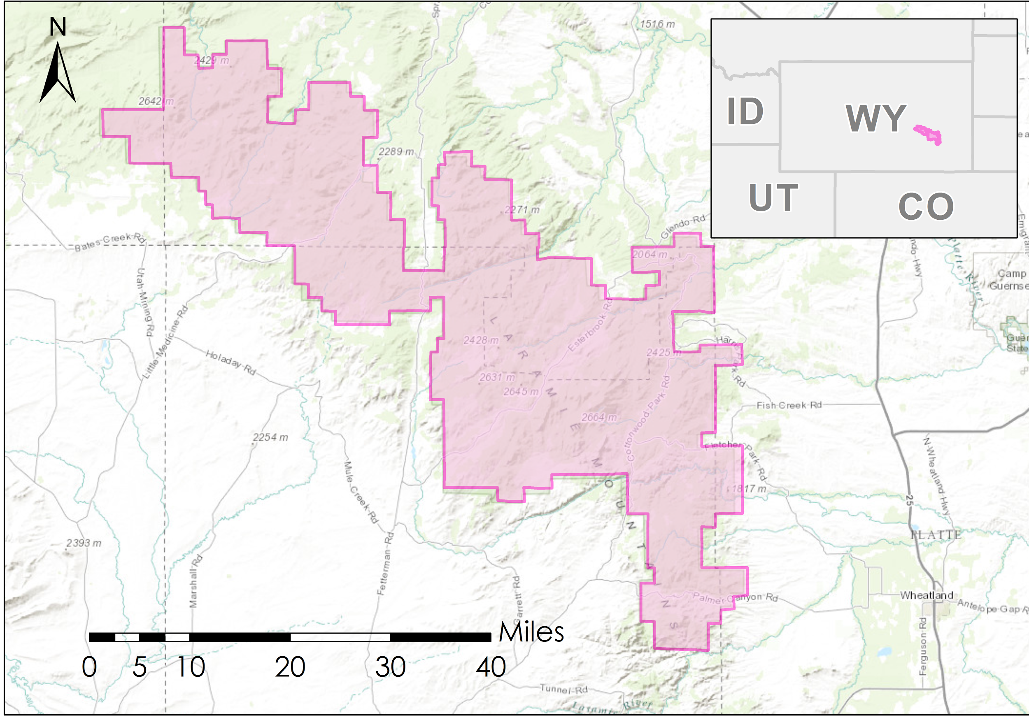Fish Department, 2010). To address this data gap, this project focused on the Laramie Peaks Unit of the Medicine Bow National Forest (MBNF) (hereafter: Laramie Mountains) in southeastern Wyoming (Figure 1).

***Figure 1.*** Map delineating project study area, the Laramie Mountain Range, within the southeast extent of Medicine Bow National Forest, Wyoming.

Laramie Mountains

study area

The Laramie Mountain Range is remote and topographically diverse. The elevation ranges from 6,200 – 10,500 feet, and dominant habitat types include native rangeland, mixed mountain shrub steppe,

and ponderosa pine (*Pinus ponderosa*) forests with intermixed aspen stands (Wyoming Game

and Fish Department, 2010). The study area falls

within Landsat WRS-2 Path 34, Row 31.

***2.2 Project Partners & Objectives***

This project contributed to NASA’s National Application Area of Ecological Forecasting by utilizing Landsat 8 Operational Land Imager (OLI) & Thermal Infrared Sensor (TIRS) and Shuttle Radar Topography Mission (SRTM) data to map current aspen distribution on a local scale, and future potential suitable habitat for aspen on a statewide scale. Our primary objective was to develop a detailed (30-meter resolution) model of current aspen canopy cover in the Laramie Mountains that will be used by partners at the Wyoming Game and Fish Department (WGFD) to delineate critical mule deer habitat and inform estimates of carrying capacity for mule deer and elk. The map product produced provides aspen cover data with greater accuracy and on a larger spatial scale than our partners previously had access to for this region. In addition, the project aimed to investigate the relationship between aspen regeneration and fire history by analyzing fire severity and historical data products produced with Landsat 5 Thematic Mapper (TM) and Landsat 7 Enhanced Thematic Mapper Plus (ETM+) data during the previous term.

In addition to the WGFD, the partners for this project included the USDA Forest Service (USFS) Laramie Ranger District and Colorado State University’s Natural Resource and Ecology Lab (NREL). The products produced included a current map of aspen cover to inform estimates of habitat carrying capacity and management plans for elk and mule deer, as well as a map depicting current and future potential suitable aspen habitat. These products will increase the end-user’s knowledge of aspen density and distribution in the Laramie Mountains and provide user-ready protocols and datasets for future modeling.

# 3. Methodology

***3.1 Data Acquisition***

Imagery was ordered and downloaded from the USGS Earth Resources Observation and Science (EROS) Center Science Processing Architecture (ESPA) on demand interface (USGS, 2016). We downloaded Landsat 8 Operational Land Imager (OLI) and Thermal Infrared Sensor (TIRS) Surface Reflectance Higher Level data products for path 34, row 31 for the summer and fall months of 2013, 2014, 2015, and the summer months of 2016. In addition to the standard Landsat bands 2, 3, 4, 5, 7 and 10, we also ordered Normalized Difference Vegetation Index(NDVI), Normalized Difference Moisture Index (NDMI), and Enhanced Vegetation Index(EVI) for the scene. We accessed Shuttle Radar Topography Mission (SRTM V2) products downloaded during the previous term to provide a 30-meter Digital Elevation Model (DEM) for the study area.

We downloaded climate surfaces for the state of Wyoming from WorldClim at approximately 1 km² spatial resolution (Hijmans et al., 2005). We selected a set of 19 bioclimatic variables derived from monthly temperature and precipitation data for current climate conditions and for future potential climate conditions in the year 2050 based on Geophysical Fluid Dynamics Laboratory (GFDL) global climate model (GCM) developed in the Intergovernmental Panel on Climate Change 5th Assessment Report (AR5). For future climate conditions, a representative concentration pathway of 45 (RCP 45) was selected. The RCP 45 forecasts climate for the year 2050 under a moderate greenhouse gas concentration trajectory.

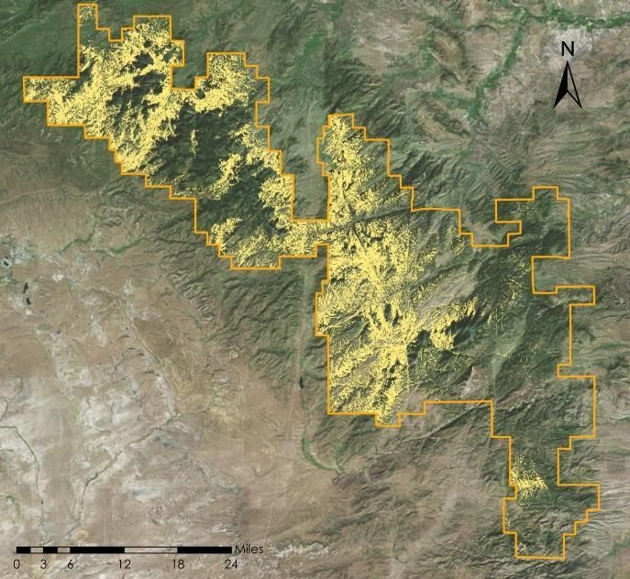**3.1.1 Preliminary Modeling and Field Sampling**

To plan efficient field sampling in the remote Laramie Range we used existing, but limited, aspen presence data (n = 36) sourced from NREL and USFS Forest Inventory and Analysis (FIA) to fit a preliminary aspen distribution model utilizing MaxEnt (Philips, 2006). We used the vegetation indices NDVI and NDMI, derived from Landsat 8 bands (June 2015), and topographic data processed during Term I as predictor variables and fit the MaxEnt model with over 300 aspen presence points. The MaxEnt output maps were then refined to pixels classified as greater than 41% probability of aspen presence (the equal training threshold determined automatically through MaxEnt) and this raster was used to constrain random field sampling point locations (Figure 2). We conducted field surveys June 20-23, 2016 to collect additional aspen data (n = 21) for training species distribution models. The survey was designed as a stratified random sample (Appendix A).

***Figure 2.*** Probability of aspen presence in Laramie Mountain Range as predicted by preliminary MaxEnt model.

41-100% probability of aspen cover

Laramie Mountains District Boundary

***3.2.1 Data Processing***

**3.2.1 Data Pre-processing**

Field data collected from the Laramie Mountain Range was used to train our aspen distribution models. Aspen presence and absence points were characterized by deriving percent cover estimates based on densiometer readings in each plot. Five densiometer readings were taken in each plot and averaged to measure relative percent canopy cover of all tree species present and percent open sky. Plots with greater than 30% aspen cover were considered presence points and plots with less than 5% aspen cover, or plots with no more than one aspen tree greater than 10 feet in height within the plot, were considered absence points. This allowed us to maximize the number of points while considering the ability for the model to correctly identify aspen presence and absence at the 30 m spatial resolution of a Landsat pixel. To increase our sample size, we supplemented our presence data points from a previous survey conducted by NREL in 2015 where all points had estimated aspen cover 90-100%. This resulted in 36 aspen presence points and 27 absence points.

We processed the DEM, Landsat 8 bands, and derived indices using the Spatial Analyst package in ArcMap. As a standard, all geospatial data were projected in WGS 1984 UTM Zone 13N. All images were cloud-masked and clipped to the study area. To supplement the indices included in the Landsat data, Tasseled Cap transformations were derived in ArcMap to obtain Brightness (TCB) Greenness (TCG) and Wetness (TCW) for each Landsat scene. We derived slope and aspect rasters from the DEM, and lastly, clipped the climate surface rasters to the extent of the state of Wyoming.

To obtain aspen presence data across the state of Wyoming, we downloaded a raster layer representing fuzzed, or altered, FIA tree plot locations at a 3-km resolution for aspen across western North America from Data Basin, a Conservation Biology Institute public data access platform. As these pixels do not represent exact locations, we derived aspen presence points from this raster by assigning a random point location within each pixel in ArcMap, resulting in a total of 272 presence points falling within 9 km² of the original FIA tree plot location.

**3.2.2. Modeling**

We constructed our final aspen distribution and habitat suitability models utilizing The Software for Assisted Habitat Modeling (SAHM) developed by the USGS. SAHM operates within VisTrails, an open source workflow platform, and was chosen for its ability to run multiple models at once, flexible workflow management, visualization capabilities, and ease of model reproduction (Morisette et al., 2013). SAHM allows up to five models to be run concurrently, and produces several statistical evaluation metrics to assess model performance.

After image processing, we rejected several Landsat images for use in our final aspen distribution model due to an abundant amount of cloud cover over the study area. As a result, we selected a late June 2016 image that was cloud free and represents the current growing season in the Laramie Range. After initial experimental modeling, we selected the Random Forest classifier to fit our aspen cover models because it repeatedly outperformed the other models tested (i.e. Boosted Regression Trees (BRT), Generalized Linear Model (GLM), and Multivariate Adaptive Regression Splines (MARS)) based on evaluation metrics. Further, Random Forest classification with remotely sensed data is supported by the literature especially when there are a limited number of presence and absence points available to train the model (Savage et al., 2015). Landsat bands (2, 3, 4, 5, 7, and 10), vegetation indices (NDVI, NDMI, and EVI), and topographic indices (DEM, Slope, and Aspect) were input into SAHM as predictor variables in conjunction with 36 presence and 27 absence points. Data processing steps within SAHM modules clip and re-project data to the desired cell-size as defined by a template raster, and values from each predictor layer are extracted and assigned to the corresponding absence or presence point. SAHM allows for initial model evaluation by displaying results from a univariate model fit with each individual predictor and a covariate correlation between predictors. When two predictors had a correlation coefficient of |r| > 0.70, one of the two was eliminated as highly correlated predictors can create “unstable model fits” (Morisette et al., 2013). Predictor retention was based on covariate contribution to the univariate model.

To model suitable bioclimatic habitat for aspen, we used a similar workflow within SAHM but instead selected the MaxEnt model. MaxEnt has been widely applied to species distribution models using projected climate data, and it does not require true absence; it can be run with background points or pseudo-absence points (Phillips, Anderson, & Schapire, 2006; Phillips, 2008; West et al., 2015). We selected predictors for the model from 19 BioClim climatic variables, and beyond the covariate selection process noted above, we informed our choice of predictors with results from previous studies that used climatic variables to map aspen distribution or suitable habitat (Rehfeldt et al., 2009; Worrall et al., 2013). Three climate variables matched these criteria and were used as predictors in the final bioclimatic habitat model: precipitation of the driest month (BIO14), precipitation of the warmest quarter (BIO 18), and annual temperature range (BIO7). To model current and future potential aspen habitat, we added the “Apply Model” module to our SAHM workflow, which applied the forecasted climate conditions to the model fit with aspen presence data (n = 270), background points (n = 10,000), and current climate conditions.

***3.3 Data Analysis***

******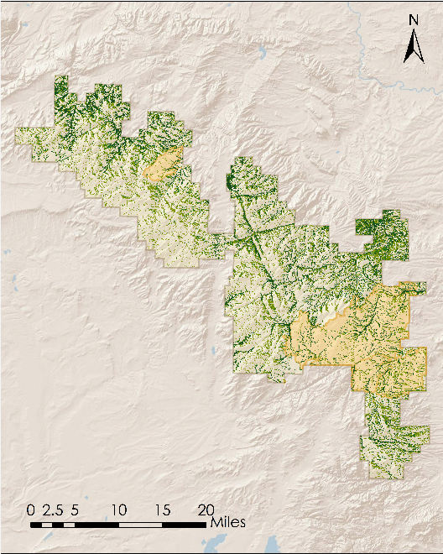We assessed the validity and predictability of our models using threshold independent and threshold dependent evaluation metrics produced by SAHM. The first metric evaluated was test area under the receiver operating characteristic curve (AUC), which measures the ability of the model to accurately discriminate between aspen presence and absence (or background) points for the test dataset (i.e. the data held aside in a 10-fold cross validation split). An AUC value of 0.5 shows that model predictions are not better than random; less than 0.5 are worse than random; 0.5–0.7 indicates poor performance; 0.7–0.9 reasonable/moderate performance; and 0.9, high performance (Peterson et al., 2011). The difference between the test AUC and training AUC value can reveal potential overfitting of the models. To select our final aspen distribution model informed by canopy cover data from the field, we tested multiple models (i.e. BRT, GLM, MARS, and Random Forest) with varying predictor combinations and compared outputs based on the evaluation metrics described above. We further evaluated our models based on the percent correctly classified (PCC), which represents the percent of true presence and absence (or background) points correctly classified, sensitivity, and specificity. To supplement the aspen cover model that relied on a single image from June 2016, we constructed another model that included imagery from October 2014 to determine if a spectral signature could be derived during the fall season when aspen leaves were likely yellow or had fallen from the trees.

**Percent probability**

0 - 0.25

0.25 - 0.50

0.50 - 0.75

0.75 - 1.00

Fire occurrence in 2012

***Figure 3.*** Probability of significant aspen cover derived from Random Forest model. Polygons represent the extent of fires which occurred in 2012.

# 

# 4. Results & Discussion

|  |  |  |  |  |  |  |
| --- | --- | --- | --- | --- | --- | --- |
| **Model** | **Description** | **PCC** | **AUCtr** | **AUCcv** | **Sensitivity** | **Specificity** |
| **MaxEnt 1** | Preliminary aspen presence for field sampling | - | 0.82 | 0.77 | - | - |
| **Random Forest 1** | Aspen cover (30m resolution) using June 2016 imagery only | 79.24 | 0.89 | 0.90 | 0.80 | 0.78 |
| **Random Forest 2** | Aspen cover (30m resolution) using June 2016 & October 2014 imagery | 80.52 | 0.92 | 0.96 | 0.87 | 0.72 |
| **MaxEnt 2** | Bioclimatic habitat suitability (1km resolution) for Wyoming | 83.50 | 0.91 | 0.90 | 0.80 | 0.84 |

***4.1 Model Results***

**4.1.1 Aspen Distribution Modeling Results**  
The preliminary MaxEnt 1 model performed fairly well in distinguishing aspen presence, with elevation and NDVI as the most important predictors (AUCCV=0.77, Table 1). The final Random Forest 1 model with TCG, elevation, Landsat blue band (June), and aspect as predictors best identified areas in the Laramie Mountains with significant aspen cover (AUCCV= 0.90, PCC=79.24, Table 1 and Figure 3). We verified that Random Forest 1 accurately distinguished aspen cover from other vegetative cover types by conducting visual inspections when overlaying our outputs over high-resolution base imagery in ArcMap.

***Table 1.*** Evaluation metrics for all models of aspen presence, aspen cover, and suitable aspen habitat. Metrics include PCC= Percent Classified Correctly, AUCtr= area under curve for training set, AUCcv= area under curve for cross-validation, sensitivity (percent of actual presences predicted correctly), and specificity (percent of actual absences or pseudo-absences predicted correctly).

Further visual inspection of the spatial outputs revealed that the multi-temporal model over predicted aspen cover and had difficulty in correctly classifying absence points in areas with high moisture content. We suspect this is partially due to our use of a relatively small number of training points, and believe that a multi-temporal model could predict aspen more accurately with a significantly increased number of field samples and a combination of seasonally distinct images.

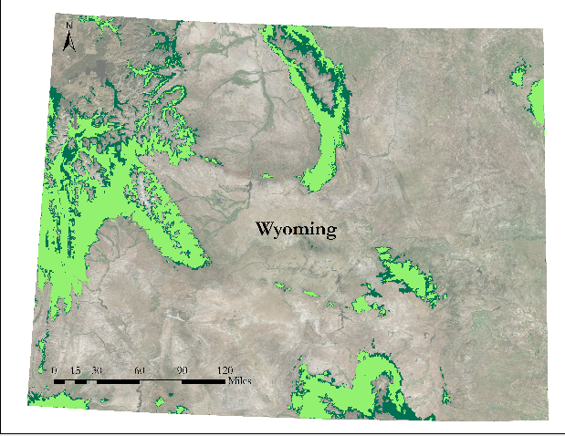**4.1.2 Bioclimate Model Results**

MaxEnt 2 accurately distinguished suitable aspen habitat from unsuitable habitat in current and future climate conditions (Figure 4). Test evaluation metrics (AUCCV=0.90, PCC=83.50, Table 1) as well as visual inspection of spatial outputs overlaid with high-resolution (60cm) imagery in ArcMap indicated that the model distinguished suitable aspen habitat sufficiently. Our model forecasted a 31.7% reduction in suitable aspen habitat under future potential climate conditions in 2050 based on the GFDL GCM and RCP 45 as compared to current climate conditions. This future decline in suitable aspen habitat is likely due to rising temperatures, a decrease in precipitation, and an increase in annual temperature extremes as projected by this climate model for the region. The precision of the bioclimatic model was limited by the coarseness of the FIA aspen tree plot data as well as the uncertainty of climate data in mountainous areas of varying elevation (Hijmans, 2005).

***Figure 4***. Probability of presence of suitable aspen habitat derived from a MaxEnt model under current climate conditions (light green) and 34 years in the future (dark? green) overlaid on map of current conditions.

***4.2 Analysis of Results***

Areas that were classified by the preliminary aspen model to have greater than 41% probability of aspen presence were used to guide sampling, thus the performance of this model was also assessed with ground-truthing during the field survey. Of the 14 locations that we accessed in the field that were predicted by this model to have aspen cover, most did have aspen present at the point, or within 30-50 m of the point. While the accuracy of the model was moderate and it generally over-predicted presence of aspen across the range, there was undeniable utility in using this model as a guide to locate aspen plots in the field across a large, remote area. This unique approach can be recommended for future aspen field surveying efforts.

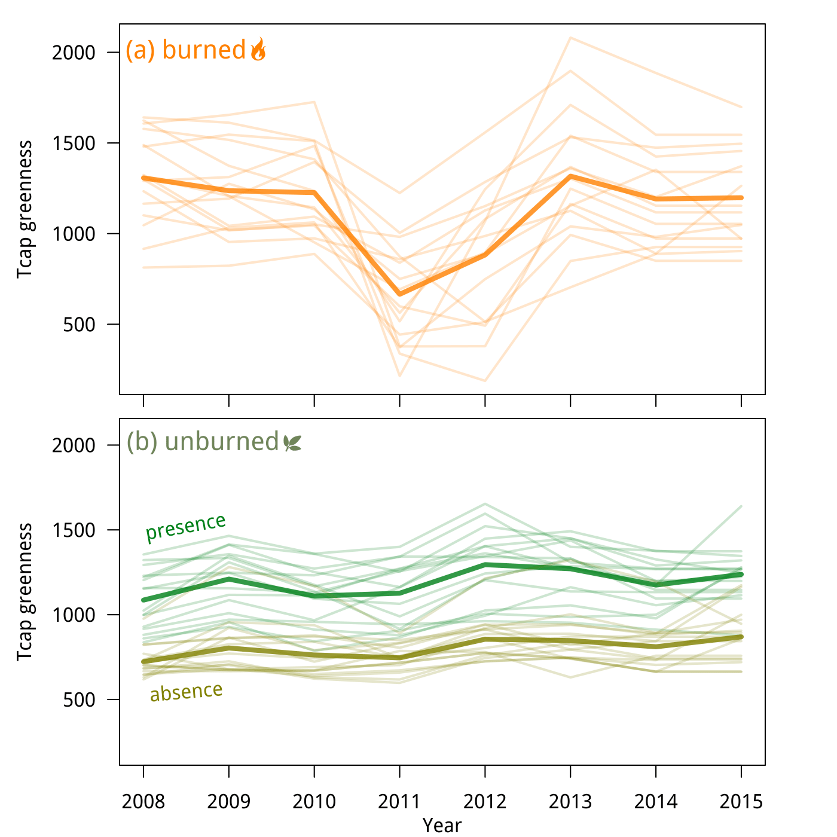The final aspen distribution model predicted aspen cover well and had strong evaluation metrics. However, a visual inspection of our probability outputs, overlaid with high-resolution imagery, revealed some areas where absence points were incorrectly classified as presence and aspen cover was not distinguished from other deciduous vegetation such as willow (*Salix* spp.). This was most common in areas where moisture collects across the landscape such as riparian areas, and open meadows with small aspen patches. This is likely due to the relatively small number of absence points we were able to sample in the field and the single month (June) of surface reflectance data. While the model over-predicted aspen presence in these areas, wet areas in the Laramie Range are often ecologically suitable for aspen. Aspen may be difficult to distinguish spectrally in June, and in the Laramie Range, we observed dense, mature aspen stands to be very patchy in distribution. It is possible that this inconsistent distribution could not be precisely captured at a 30m resolution (Heyman et al., 2003).

To address the relationship between fire history and aspen regeneration in the Laramie Range, we analyzed Tasseled Cap greenness values from 2008 through 2015 produced during Term I. We compared TCG values in aspen presence plots in the study area that had burned in 2012 during the most recent fire, to values in aspen presence and absence plots that had not burned (Figure 5). The sharp decrease in TCG values in burned areas highlights disturbance events and here represents the fire event in 2012. In unburned areas, there is less variation in TCG values from year to year, however, values are consistently greater in aspen presence points than in absence points. After the fire event, the values steadily increase and show recovery and a return to pre-fire values through 2015, when dominant aspen cover was recorded in these locations.

***Figure 5***. Tcap derived indices across time for (a) aspen presence points in previously burned areas and (b) aspen presence and absence points in unburned areas. Bold lines represent mean values.

***4.3 Future Work***

The limiting factor in the scope of this project was the minimal availability of aspen cover datasets in southern Wyoming. For this reason, a primary focus of future work would be to spend several weeks in the field in order to survey more plots. With a larger training dataset, the aspen distribution models developed could be refined to greater accuracy and employed to predict aspen canopy cover over a larger geographical area. Additionally, a larger and more comprehensive dataset would make it possible to model continuous percent canopy cover for aspen. The data collected in the field, including size class and understory condition, will serve to be useful in classifying areas of regeneration and consequently modeling change in aspen stands over time. Finally, in future research the aspen map we produced can be utilized as an ancillary dataset in a regional habitat connectivity model for elk and mule deer.

# 5. Conclusions

By incorporating NASA Earth observations and field data collected by the team in species distribution models, a current aspen probability map was produced by this project that successfully delineates the spatial distribution of aspen cover across the Laramie Mountain Range. This map provides a landscape-scale aspen dataset for our partners at WDGF to incorporate into their habitat management efforts, and specifically into their estimates of carrying capacity for mule deer and elk in the Laramie Mountains. We provided an initial analysis of burned versus unburned areas that were delineated during Term I of this project that will provide a platform for future research concerning aspen regeneration in these areas. In addition, the bioclimatic habitat model forecasts a decline of suitable aspen habitat in the future which could be used to inform WDGF management plans. These products, and the plot level data collected in the field, increase the available information about aspen distribution in southeastern Wyoming. The methods employed and results produced can inform future attempts to map aspen distribution and demonstrate the benefits of utilizing multispectral imagery in ecological forecasting.

# 6. Acknowledgments

This project was made possible through support and mentorship of select individuals and organizations.

We extend a kind thank you to the following:

* Ryan Anderson, Colorado State University, Natural Resource Ecology Laboratory
* Dr. Paul Evangelista, Colorado State University, Natural Resource Ecology Laboratory
* Dr. Amanda West, Colorado State University, Natural Resource Ecology Laboratory
* Brian Woodward, NASA DEVELOP- Fort Collins Center Lead
* NASA DEVELOP Laramie Mountains Ecological Forecasting, Spring 2016 Team

Any opinions, findings, and conclusions or recommendations expressed in this material are those of the author(s) and do not necessarily reflect the views of the National Aeronautics and Space Administration.

This material is based upon work supported by NASA through contract NNL11AA00B and cooperative agreement NNX14AB60A.

# 7. References

Barnes, B. (1966). Natural variation and delineation of clones of *Populus tremuloides* and *P. grandidentata* in

Northern Lower Michigan. *Silvae Genetica, 18*(4), 130-142.

Correia, Kelsey. (2016). Aspen Study on Roan Plateau, Colorado. Unpublished Master’s Thesis. *Colorado State University.* Methods Section.

Frey, B.R., Lieffiers, V.J., Hogg, E.H., & Landhausser & S.M. (2004). Predicting landscape patterns of

aspen dieback: mechanisms and knowledge gaps. *Canadian Journal of Forest Research, 34,* 1379-1390.

Heyman, O., Gaston, G. G., Kimerling, A. J., & Campbell, J. T. (2003). A per-segment approach to

improving aspen mapping from high-resolution remote sensing imagery. *Journal of Forestry*, *101*(4), 29–33. Retrieved from <Go to ISI>://000183132700007

Hijmans, R.J., S.E. Cameron, J.L. Parra, P.G. Jones, and A Jarvis. (2005). Very high resolution interpolated

climate surfaces for global land areas. *International Journal of Climatology,* 25: 1965-1978.

Kilpatrick, S., & Abendroth, D. (2001). Aspen response to prescribed fire and wild ungulate herbivory.

*USDA Forest Service Proceedings.* RMRS-P18.

Kota, A.M., Bartos, D.L. (2010). Evaluation of techniques to protect aspen suckers from ungulate browsing in the Black Hills. *Western Journal of Applied Forestry*, 25(4), 161-168.

Lindroth, R.L., & St. Clair, S.B. (2013). Adaptations of quaking aspen (*Populus tremuloides* Michx.) for defense

against herbivores. *Forest Ecology and Management*, *299*, 14-21.

http://dx.doi.org/10.1016/j.foreco.2012.11.018

Little, E.L. (1971). Conifers and important hardwoods. *Atlas of United States Trees.* (Vol. 1). Miscellaneous

Publication 1146. Washington DC: U.S. Department of Agriculture, Forest Service.

Morisette, J. T., Jarnevich, C. S., Holcombe, T. R., Talbert, C. B., Ignizio, D., Talbert, M.K., …Young, N. E. (2013). VisTrails SAHM: Visualization and workflow management for species habitat modeling. *Ecography*, *36*(2), 129-135. http://doi.org/10.1111/j.1600-0587.2012.07815.x

Mueggler, W.F. (1988). Aspen community types of the Intermountain Region. General Technical Report

INT-250. Ogden, UT: U.S. Department of Agriculture, Forest Service, Intermountain Research

Station.

Peterson, A. Townsend. *Ecological niches and geographic distributions (MPB-49)*. No. 49. Princeton University Press, 2011.

Phillips, S. J., & Dudík, M. (2008). Modeling of species distribution with Maxent: new extensions and a comprehensive evaluation. *Ecography, 31*(December 2007), 161-175.

http://doi.org/10.1111/j.2007.0906-7590.05203.x

Phillips S. J., Anderson R.P., & Schapire R.E. (2006). Maximum entropy modeling of species geographic

distributions. *Ecological Modelling, 190*, 231–259. doi:10.1016/j.ecolmodel.2005.03.026

Rehfeldt, G.E., Ferguson, D.E., & Crookston, N.L. (2009). Aspen, climate, and sudden decline in the western

USA. *Forest Ecology and Management, 258,* 2353-2364. doi:10.1016/j.foreco.2009.06.005

Reynolds, H.G. (1969). Aspen grove use by deer, elk, and cattle in southwestern coniferous forests. USDA

Forest Service Rocky Mountain Forest and Range Experiment Station Research Note RM 138.

Rogers, P.C. (2013). Resilience in quaking aspen: recent advances and future needs. *Forest Ecology and*

*Management, 299,* 1-5.

Romme, W.H., Floyd, M.L., Hanna, D., & Redders, J.S. (2002). Using natural disturbance regimes as a basis

for mitigating impacts of anthropogenic fragmentation. In R.L. Knight (Ed.), *Forest fragmentation in the*

*southern Rocky Mountains*. Boulder, CO: University Press of Colorado.

Savage, S. L., Lawrence, R. L., & Squires, J. R. (2015). Predicting relative species composition within mixed conifer forest pixels using zero-inflated models and Landsat imagery. *Remote Sensing of Environment, 171,* 326-336. http://doi.org/10.1016/j.rse.2015.10.013

Seager, S.T., Eisenberg, C., & St. Clair, S.B. (2013). *Forest Ecology and Management, 299,* 81-90. doi:

10.1016/j.foreco.2013.02.017

Shinneman, D.J., Rogers, P.C., & Kulakowski, D. (2013). Fire regimes of quaking aspen in the Mountain West.*Forest Ecology and Management, 299,* 22-34. doi: doi:10.1016/j.foreco.2012.11.032

St. Clair, S.B., Cavard, X., & Bergeron, Y. (2013). The role of facilitation and competition in the development

and resilience of aspen forests. *Forest Ecology and Management, 299,* 91-99.

doi:10.1016/j.foreco.2013.02.026

Turchi, G.M., Kennedy, P.L., Urban, D., & Hein, D. (1995). Bird species richness in relation to isolation of

aspen habitats. *The Wilson Bulletin, 107*(3), 463-474.

USFS. (2015). Forest inventory and analysis national core field guide volume I: Field data collection

procedures for phase 2 plots. http://www.fia.fs.fed.us/library/fact-sheets/data collections/Phase2_3.pdf

USGS. (2016). “LSDS Science Research and Development (LSRD).” US Department of the Interior,

Geological Survey, May 2010. 15 June 2016. <http://espa.cr.usgs.gov/>>.

West, A. M., Kumar, S., Wakie, T., Brown C. S., Stohlgren, T. J., Laituri, M., Bromberg, J. (2015) Using High-Resolution Future Climate Scenarios to Forecast Bromus tectorum Invasion in Rocky Mountain National Park. http://dx.doi.org/10.1371/journal.pone.0117893

Wirsing, John M., and R. R. Alexander (1975). Forest Habitat Types on the Medicine Bow National Forest, Southeastern Wyoming: Preliminary Report. 13 June 2016. <http://hdl.handle.net/2027/uiug.30112104053647>>.

Worrall, J.J., Rehfeldt, G.E., Hamann, A., Hogg, E.H., Marchetti, S.B., Michaelian, M., & Gray, L.K. (2013).

Recent declines of *Populus tremuloides* in North America linked to climate. *Forest Ecology and*

*Management, 299,* 35-51. http://dx.doi.org/10.1016/j.foreco.2012.12.033

Wyoming Game and Fish Department. (2010). Wyoming State Wildlife Action Plan.

# 8. Content Innovation

**Content Innovation #1:**

Featured Author Video: Home on the Laramie Range: Mapping Aspen in Medicine Bow National Forest

**Content Innovation #2**

Glossary Viewer

***Area Under Curve (AUC):*** Measurement used to communicate binary classification where a value close to “1” indicates that a classifier is a true positive, versus a false positive.

***Boosted Regression Trees (BRT):*** Ensemble learning classification model that generates decision trees where subsequent trees are then generated based upon error of the tree that precedes it.

***Critical habitat:*** Specific areas within a geographic range containing aspects essential for conservation of a particular wildlife species.

***Digital Elevation Model (DEM):*** Demonstration of continuous elevation values over a bare terrain surface.

***Earth Observation (EO):*** Current NASA Satellite Missions.

***Earth Observing System (EOS):*** A subset of the full suite of NASA Earth observing missions focused on long-term global observations of the land surface, biosphere, and oceans to improve understanding of the Earth as an integrated system.

***Enhanced Vegetation Index (EVI):*** an index that improves the sensitivity of vegetation signals for remote sensing in areas with heavy canopy cover.

***Fuzzed/Fuzzing:*** privacy – preserving technique used by FIA where ecological signals of the data are maintained but the plot coordinate data is altered.

***Geophysical Fluid Dynamics Laboratory (GFDL):***  Facility that develops and uses models and simulations to improve understanding and prediction of climate behavior.

***Intergovernmental Panel on Climate Change (IPCC):*** Intergovernmental body tasked with providing a scientific explanation of the economic and political impacts of climate change. Currently, they have completed their Fifth Assessment Report (IPCC5).

***Landsat 5 & 7:*** Individual NASA EOs from the Landsat Series.

***Maximum Entropy Modeling (MaxEnt):*** Machine learning software used to model species habitat.

***Normalized Difference Moisture Index (NDMI):*** Vegetation index used to determine differences in vegetation moisture content.

***Normalized Difference Vegetation Index (NDVI):*** Index used to determine whether an area contains green vegetation using remote sensing metrics.

***Operational Land Imager (OLI):*** NASA EO

***Parturition:*** Giving birth to and rearing young.

***Percent Correctly Classified:*** Evaluation metric that reports the overall percentage of observations correctly classified in predictions (Aspen presence and absence in this case).

***Random Forest (RF):*** Ensemble learning classification method that generates multiple decision trees and selects outputs based upon the class that receives the mode number of votes.

***Representative Concentration Pathways (RCP):*** Four greenhouse gas pathways proposed by the IPCC5 in order to depict multiple outcomes of future climate conditions.

***ROC curve:*** A diagnostic test evaluation plotting sensitivity (the models’ rate of true positive prediction) vs. specificity (the models’ rate of false positive prediction).

***Sensitivity:*** Evaluation metric that reports the proportion of true positive predictions.

***Software for Assisted Habitat Modeling (SAHM):*** Software created to generate maps and forecast suitable species habitat by combining environmental predictor layers with field sampling measurements.

***Specificity:*** Evaluation metric that reports the proportion of true negative predictions.

***Suckers:*** New shoot growth of a tree that originates from the parent trees’ meristem, rather than germinating from a seed.

***Sudden Aspen Decline (SAD):*** Ecological phenomenon where aspen (*Populus tremuloides*) stands experience rapid, landscape-level, die-off.

***Shuttle Radar Topography Mission (SRTM):*** NASA EO

***Tasseled-cap:*** Indices that generates a 3-band image, each corresponding to brightness (R), greenness (G), and wetness (B) of individual pixels within an area.

***Thermal Infrared Sensor (TIRS):*** NASA EO

***Ungulate:*** A member of the mammalian order that has hoofed-feet.

**Content Innovation #3**

Interactive Map Viewer – <https://drive.google.com/open?id=0B8h0q6nF0KwIb04zWkhXSVNYR2M>

**Content Innovation #4**

Inline figures and tables.

# 9. Appendices

**Appendix A: Plot sampling methodology**

**I. Background**

Field data collection for the project took place in the Laramie Peaks Unit of the Medicine Bow National Forest from June 20, 2016 – June 23, 2016. Spanning 440,000 acres, the Laramie Peaks Unit lies at an elevation of 6,300 to 10,272 feet and is characterized by rugged topography and dominated by ponderosa pine (*Pinus ponderosa*) forests interspersed with aspen (*Populus tremuloides*)(Wirsing and Alexander, 1975).

Survey points were designed as a stratified random sample. Random points were stratified on the following conditions: 1) must fall within USFS land and, 2) be at the center of a Landsat pixel, and 3) have a high probability for deciduous forest/aspen cover based upon the preliminary MaxEnt species distribution model fit with limited aspen data. 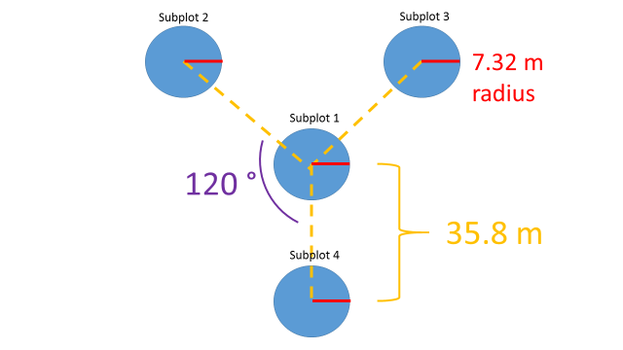

A total of 3,006random points were selected from areas within the above constraints using ArcMap(10.3.1). It was not expected that all random points would be sampled; an excessive number of random points were generated under the assumption that terrain ruggedness and limited accessibility via car and foot would prevent many areas from being surveyed. Additional points were randomly selected in the field in order to encapsulate landscape features that were under-represented in the points that were accessed. Coordinates of the randomly generated points were uploaded onto GPS units and traveled to via car and foot.

***Figure A1*:** Subplot Design used in field sampling.

**II. Forest Structure and Age Sampling**

The plot sampling method was a modification from protocol set by the United States Forest Service Forest Inventory & Analysis (USFSFIA). For each random point generated in ArcGIS, 4 subplots were measured systematically (Figure A1). The random point was marked with flagging and served as the center of subplot 1. All subplots were separated by 120° circumventing subplot 1, beginning with subplot 2 due north from subplot 1. From the center point of subplot 1, 35.8 meters were paced to the center point for each additional subplot (2, 3, & 4), where a 7.32 meter fixed-radius was established. All trees whose base center was within the radius of the subplot had the following measurements collected:

*Species:* short hand of the first two letters of the genus and the first two letters of the species.

*Canopy Cover:* measured using a densiometer at 1.37 meters above the ground at 5 locations within the subplot (the center, and 5 meters from the center at 0°, 90°, 180°, and 270°). Densiometer count was recorded for each individual over-story species. The resulting percentages were calculated and subtracted from 100% to determine percent sky.

For subplots that contained no aspen trees within the fixed-radius, all measurements were recorded for present species, and the plot was processed as absence data within the Maximum Entropy Modeling (MaxEnt) model.

**III. Regeneration Sampling**

From the center point of each subplot, a fixed-radius (7.32m) plot was established to measure all regeneration. All live trees had the following measurements collected:

*Size Class:* Class 1 (0’-3’), Class 2 (3’-6’), Class 3 (6’-10’), Class 4 (10’+). Provided by the Wyoming Game and Fish Department, size class was determined by overall height of tree once fully erect.

*Browsing Damage:* Recorded as presence or absent within each subplot.

**IV. Vegetative Ground Cover Sampling**

For each subplot, the basic ground cover class was determined as Mesic (M) or Xeric (X) and recorded. An ocular assessment of the understory vegetation was taken, and the plot was placed, overall, into one of the following classes:

*Class A:* Mature aspen trees present with no understory aspen regeneration.

*Class C:* Mature aspen trees present with conifer occupying >25% of the understory.

*Class S:* Mature aspen trees present with sagebrush dominating >50% of the understory.

Shrub species present in the center plot only were recorded.

**Appendix B: Sampling Datasheets**

