**NASA DEVELOP National Program**



International Research Institute for Climate and Society

*Summer 2015*

Indonesia Disasters

Creating an Enhanced Methodology for Mapping Burn Scars in Indonesia by Transforming Red Green Blue False Color Composites to Hue Saturation Value Images using Landsat

 **Technical Report**

Final Draft – August 6, 2015

Jerrod Lessel (Project Lead)

Alex Sweeney

Dr. Pietro Ceccato, Research Scientist, Lead Environmental Monitoring Program, The International Research Institute for Climate and Society, The Earth Institute, Columbia University (Science Advisor)

# IV. Appendices

Five locations of burn scars highlighting the two methods used in this study for mapping burn scars.

**A)** Image acquired from Landsat Path/Row 118/061 for November 14, 2006

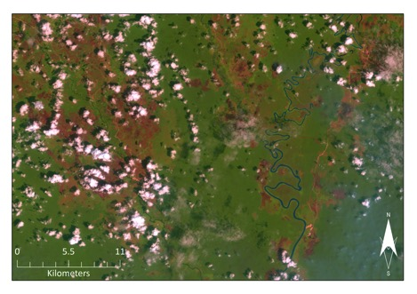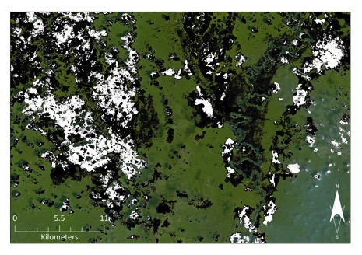

Above, RGB false color composite, left, next to the same image with the isolated hues (grey-scale) associated with soil overlain on the RGB false color composite, right. In the hue image, clouds were picked up as they had high reflectances’ in the MIR causing their hues to be within the range of burn scars.

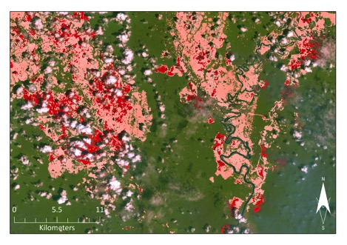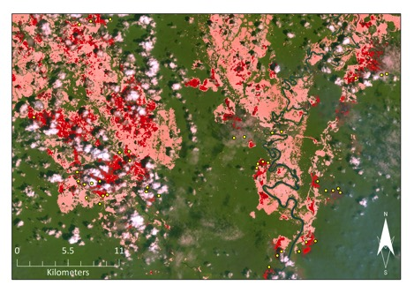

Above, RGB false color composite overlain with the hue plus saturation (red-scale) isolated pixels, left. Same image with the MODIS Active Fire Product (yellow dots) shown. Here the hue plus saturation method worked well to distinguish burn scars from clouds.

**B)** Image acquired from Landsat Path/Row 118/061 and 062 for November 14, 2006

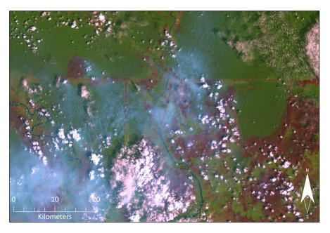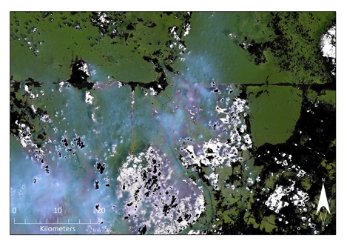

Above, RGB false color composite, left, next to the same image with the isolated hues (grey-scale) associated with soil overlain on the RGB false color composite, right.

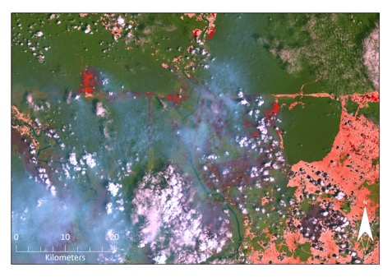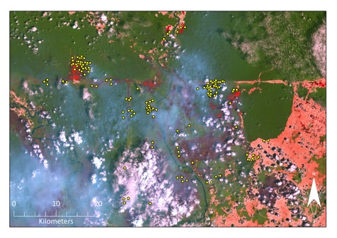

Above, RGB false color composite overlain with the hue plus saturation (red-scale) isolated pixels, left. Same image with the MODIS Active Fire Product (yellow dots) shown. Here, the hazy area (middle portion of image) did not allow for retrieval of burn scars below in either method.

**C)** Image acquired from Landsat Path/Row 118/062 for September 11, 2006

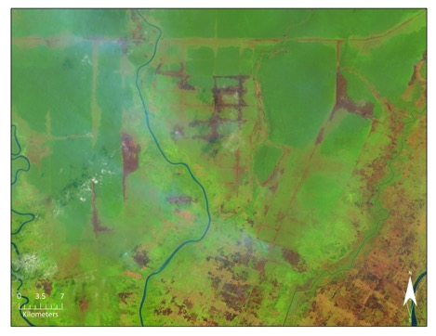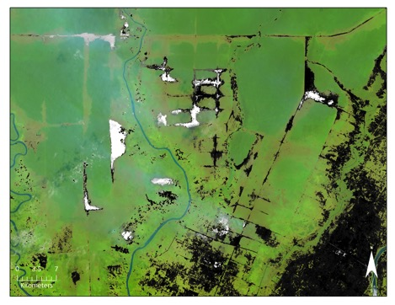

Above, RGB false color composite, left, next to the same image with the isolated hues (grey-scale) associated with soil overlain on the RGB false color composite, right. Older burn scars can been seen in the image, but were not picked up by isolating only the hues of soil.

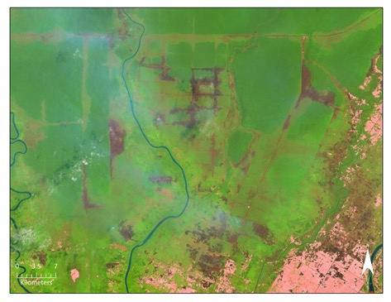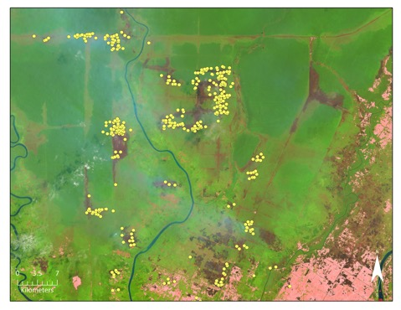

Above, RGB false color composite overlain with the hue plus saturation (red-scale) isolated pixels, left. Same image with the MODIS Active Fire Product (yellow dots) shown. Here, the hue plus saturation method resulted in omission errors, with previously identified burn scars by the hue method were eliminated.

**D)** Image acquired from Landsat Path/Row 118/062 for September 27, 2006

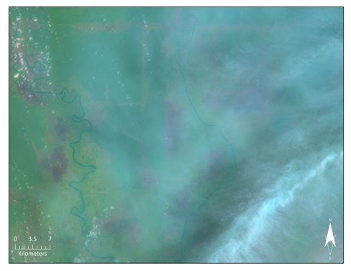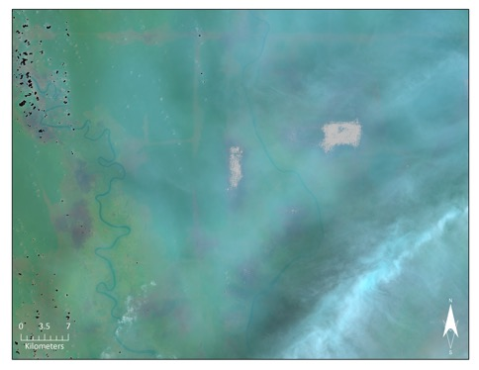

Above, RGB false color composite, left, next to the same image with the isolated hues (grey-scale) associated with soil overlain on the RGB false color composite, right. Burn scars are apparent underneath the haze (red/pink patches), however the methods are unable to retrieve most of them.

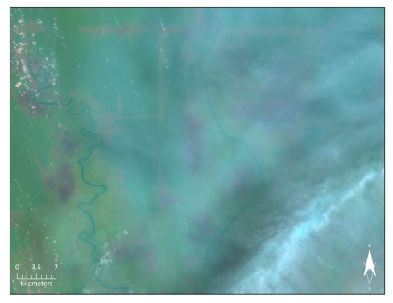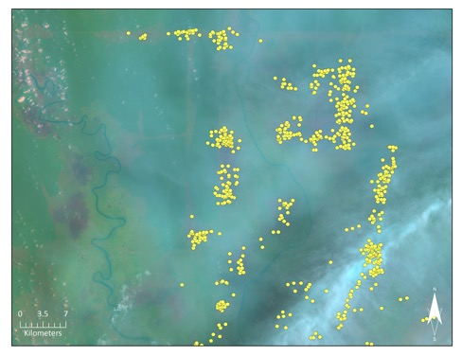

Above, RGB false color composite overlain with the hue plus saturation (red-scale) isolated pixels, left. Same image with the MODIS Active Fire Product (yellow dots) shown. In these two hazy images, the hue plus saturation method eliminated the identified burn scars by the hue only method (top right image).

**E)** Image acquired from Landsat Path/Row 118/062 for November 30, 2006

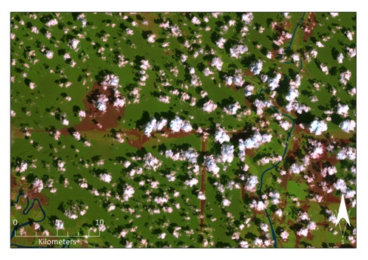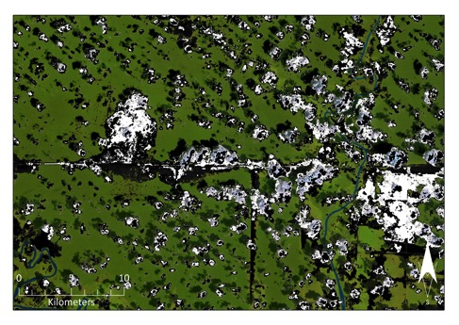

Above, RGB false color composite, left, next to the same image with the isolated hues (grey-scale) associated with soil overlain on the RGB false color composite, right.

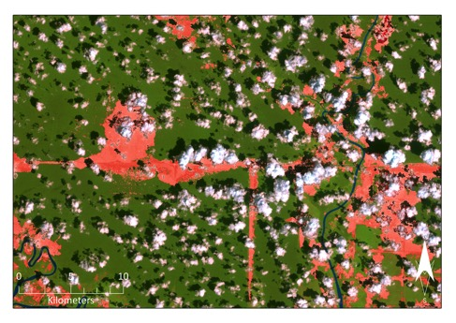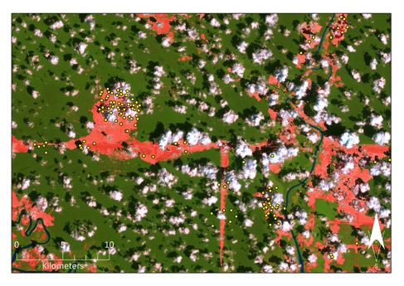Above, RGB false color composite overlain with the hue plus saturation (red-scale) isolated pixels, left. Same image with the MODIS Active Fire Product (yellow dots) shown. Here the hue plus saturation method worked well to eliminate the cloud noise.