**NASA DEVELOP National Program**



International Research Institute for Climate and Society

*Summer 2015*

Indonesia Disasters

Creating an Enhanced Methodology for Mapping Burn Scars in Indonesia by Transforming Landsat Red Green Blue False Color Composites to Hue Saturation Value Images

 **Technical Report**

Final Draft – August 6, 2015

Jerrod Lessel (Project Lead)

Alex Sweeney

Dr. Pietro Ceccato, Research Scientist, Lead Environmental Monitoring Program, The International Research Institute for Climate and Society, The Earth Institute, Columbia University (Science Advisor)

# I. Abstract

Fires associated with land use conversion activities such as agricultural expansion, palm and pulp plantations, peat land alteration, and industrial deforestation are significant in the country of Indonesia. The use of remotely sensed data to assess deforestation and carbon emissions over Indonesia is crucial in the monitoring of fires, as ground-based methods are not viable. Fires are currently mapped using data from the MODIS sensors, but its spatial resolution (500 m) is not ideal for accurate mapping of burn scars in the region. Thus, researchers have sought to map burn scars at a higher spatial resolution. We proposed using Landsat to accomplish this task, given its spatial resolution of 30 m. This study tested a new methodology for identifying burn scars utilizing remotely sensed products over Central Kalimantan, Indonesia using scenes from Landsat’s Thematic Mapper (TM) and Enhanced Thematic Mapper Plus (ETM+). These scenes were used to assess a technique of transforming Red, Green, and Blue (RGB) color space to Hue, Saturation, and Value (HSV) space to decouple the hue from the saturation and value. When this technique was applied to a mid-infrared (MIR), near-infrared (NIR), and red false color composite, it enhanced the discrimination between vegetation, soil, and water – distinguishing burn scars from their surroundings. A hue value range for burn scars was determined; however, clouds were a limiting factor in the analysis. The approach was a good first step in reducing the amount of information one must sift through to isolate burn scars; however, more work is needed to improve this technique and develop a more automated approach for their detection.

**Keywords**

Burn Scars, Hue Saturation Value, Landsat, Fires, RGB, Color Transformation

# II. Introduction

Indonesia experiences extensive deforestation due to different land conversion activities such as agricultural expansion, establishment of palm and pulp plantations, and peatland alteration, mostly as a result of fires (Tansey et al., 2008; Carlson et al., 2012; McDonald Pittman et al., 2013; Spessa, et al., 2015). Between 1989-2008, fire was the dominant cause of deforestation, accounting for 93% of forest loss, as well as 69% of total carbon emissions in Indonesia (Carlson et al., 2012). Further, the El Niño Southern Oscillation (ENSO) is positively associated with fires in Indonesia, with a greater number of fires observed during El Niño years (e.g.1982-83, 1997-1998, 2002, 2004, 2006, and 2009) [Hayasaka et al., 2014; Spessa et al., 2015]. Fires adversely affect air quality, human health, biodiversity, and productivity [McDonald Pittman et al., 2013; Hayasaka et al., 2014; Spessa et al., 2015], and the impact has become so severe that in September of 2014, Indonesia finally ratified a regional agreement signed in 2002, which decided to concentrate efforts to reduce pollution from forest fires [Minnemeyer, S., 2014].

The use of remotely sensed data to asses deforestation and carbon emissions over Indonesia is crucial in the monitoring of fires, as ground-based methods are not viable for exhaustive information on fire activity, on a geographically and temporally relevant scale [Hyer et al., 2012]. Fires are currently mapped using data from the Moderate Resolution Imaging Spectroradiometer (MODIS) but its 500 meter (m) spatial resolution is not ideal for the accurate mapping of fires in Indonesia and elsewhere. Thus, researchers have sought to map fire scars at higher spatial resolution, such as using Landsat data with its 30 m resolution (e.g. Garcia-Haro et al., 2001; Bastarrika et al., 2011; Koutsias et al., 2013). This study presents a new methodology for effectively identifying and mapping burn scars using scenes from Landsat 5 Thematic Mapper (TM) and Landsat 7 Enhanced Thematic Mapper Plus (ETM+). Landsat TM and ETM+ scenes were used to test a technique of transforming Red Green Blue (RGB) false color composites to Hue Saturation Value (HSV) in order to determine whether it was an effective procedure for identifying burn scars.

The advantage of using this color transformation technique is that by converting the normal RGB color space into an HSV space, we are able to decouple the hue from the saturation and the value. This in turn, when applied to a false color composite consisting of shortwave infrared, near infrared, and red wavelengths allows for a superior discrimination between vegetation, soil, and water [Pekel et al., 2011]. This enhanced classification between the various land covers aids in the identification of burn scars at high spatial resolution.

The Kalimantan region of Indonesia on the island of Borneo experiences a large number of fires from land use activities, particularly the clearing of land for palm oil plantations [Tansey et al., 2008; Carlson et al., 2012; McDonald Pittman, 2013; Spessa et al., 2015]. Specifically, this study focused on the province of Central Kalimantan in Indonesia (Figure 1). Landsat TM and ETM+ images and MODIS Active Fire Product were acquired for the months of June through November in 2006.

Figure 1. The project's study region was Central Kalimantan, Indonesia, located on the island of Borneo.

The Bogor Agricultural University (IPB), the Ministry of Forestry in Indonesia and the Center for International Forestry Research (CIFOR) currently use the Fire Early Warning System developed by the International Research Institute for Climate and Society (IRI) to monitor and forecast risks of active fires based on climate information. Climate information is based on precipitation anomalies derived from NOAA’s Climate Prediction Center (CPC) Morphing Technique (CMORPH) data, active fires are monitored using MODIS hotspots (at moderate spatial resolution), fire vulnerability is derived from a Landsat land cover map created by IRI and IPB, vegetation status is monitored using MODIS and fire risk is created by combining a fire vulnerability map with precipitation anomalies. In order to analyze the impact of fires on deforestation and CO2 emissions, it is now required to monitor burn scars in the country. This work falls under the NASA national application area of disasters.

# III. Methodology

**Data Acquisition and Preprocessing**

194 Landsat TM and ETM+ scenes were downloaded from United States Geological Survey’s (USGS) [Earth Explorer](http://earthexplorer.usgs.gov/) website over Central Kalimantan for 12 different path/row combinations (Figure 2). Level 1 products were downloaded, however, bands 5, 4, and 3 pertaining to the shortwave infrared (1.55-1.75 micrometers (µm)), near infrared (0.77-0.90 µm), and red (0.63-0.69 µm) wavelengths, respectively, were used for this study. This false color composite was chosen because of its sensitivity to discriminate vegetation from soil and water [Pekel et al., 2011; Ceccato, 2005; Ceccato et al., 2002]. This sensitivity results from the fact that the red band is centered near the absorption peak of chlorophyll, the NIR band is centered around the maximum vegetation spectral reflectance, and the SWIR band is centered near the water absorption and water content of the vegetation canopy [Pekel et al., 2011]. These bands have a spatial resolution of 30 m, with an approximate scene size of 170 kilometers (km) from north to south by 183 km from east to west [USGS, 2015].

In order to cross reference burn scars to active fire data, the MODIS Active Fire Product was used over the southern part of Central Kalimantan. MODIS employs sensors aboard the Aqua and Terra satellites, and can make four fire observations daily at 10:30 and 22:30 (Terra) and 13:30 and 01:30 (Aqua). Specifically, the fire product uses the 1 km fire channels at 3.9 µm and 11 µm, and uses a contextual algorithm to detect fires utilizing the middle infrared radiation from fires, where it exhibits strong emission [Justice et al., 2006]. MODIS Active Fire Product was obtained via the Land Processes Distributed Active Archive Center using the [EOS Data Gateway](http://reverb.echo.nasa.gov/reverb/#utf8=%E2%9C%93&spatial_map=satellite&spatial_type=rectangle) web interface and downloaded for the period of June through November 2006.

Figure 2. Landsat path (e.g. 117) and row (e.g. 060) combinations obtained for the study, over Central Kalimantan, Indonesia.

False color images using the 5, 4, and 3 bands were created using ENVI and subsequently the null values were removed from each scene. The false color images were then transformed from RGB color space to HSV space using the RGB to HSV transformation technique within ENVI. After the color transformation was completed, the hue band as well as the saturation band for each scene were isolated and exported in geotiff format for use within ArcMap.

**Modeling**

To identify the burn scars, the hue images were first processed to isolate the pixel values between 200-255 and 0-40 using the extract by attributes tool in ArcMap model builder. These values are associated with the soil range within the hue color wheel after conversion to HSV space (Figure 3).

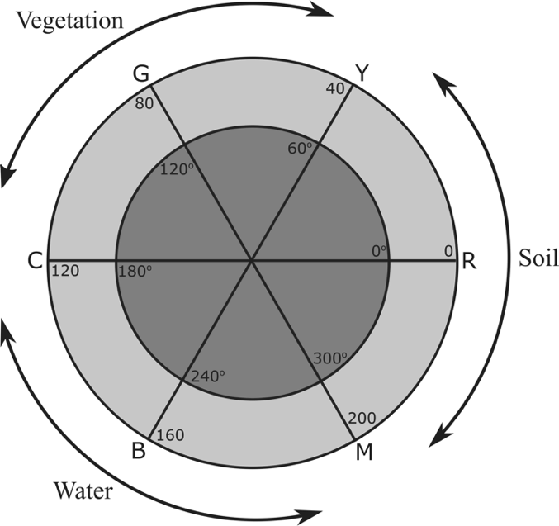For superior isolation of the specific range of pixels that encompassed burn scars, the saturation values also underwent the same seclusion. Saturation values were isolated between 150-240, as these were the values that were associated with burn scars throughout the Landsat scenes. Once the hue values and the saturation values were isolated we added them together using the raster calculator tool in model builder (Figure 4) using the raster calculator’s addition operator.

The advantage of using the raster calculator for this task was that it combined only the areas where the hue value was within the soil range (200-255 and 0-40) and had a saturation value associated with burn scars (150-240). Once this process was completed the resulting layers could be visualized in ArcMap and compared against the MODIS Active Fire Product.

Figure 3. Hue value color wheel displaying hue values (light grey ring) that are associated with vegetation typically range from 40-120, while hue values associated with water range from 120-200, and soil hue values range from 200-255 and 0-40.

# FlowChart.pngIV. Results & Discussion

Figure 4. Flow chart representation of the model used to isolate and extract pixel values associated with burn scars.

Final analysis of the project concluded that the method isolating only soil hue values (e.g. hue values between 200-255 and 0-40) resulted in commission errors, causing areas that were not burn scars to be identified, such as clouds or fallow agricultural fields. While the method that isolated hue values (200-255 and 0-40) plus saturation values (150-240) resulted in omission errors. This caused previously identified burn scars to be lost in many images that utilized the hue plus saturation method.

Cloudy and hazy images presented many problems, which resulted in numerous errors for both methods. In many images, the cloud edges were higher in the MIR range, causing the clouds to appear reddish in color in the RGB false color composites, consequently causing their hues to fall within those that were associated with burn scars (Figure 5).

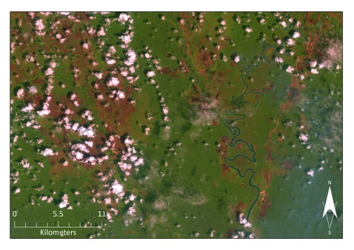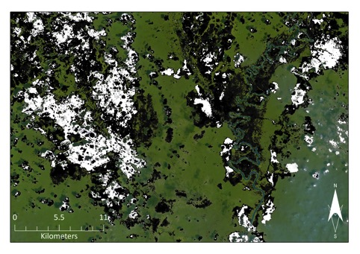

Figure 5. Reddish clouds are present in the RGB false color composite (left), where they exhibited high reflectances' in the MIR. This caused their edges to appear reddish in color and were consequently picked up with hues associated with burn scars (right).

The hue plus saturation method improved recognition of burn scars in cloudy images, however it was unable to enhance detection of them in hazy images. Isolation of only the hue values resulted in better identification of burn scars during hazy periods, when compared to the hue plus saturation method. Although, both were inadequate in their recovery of burn scars (Figure 6 and Appendix).

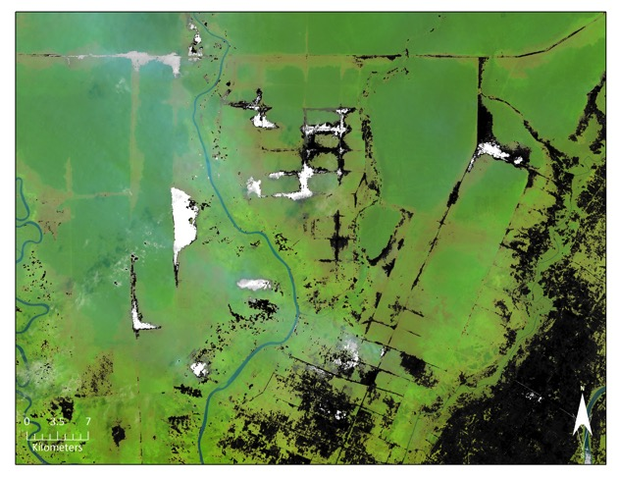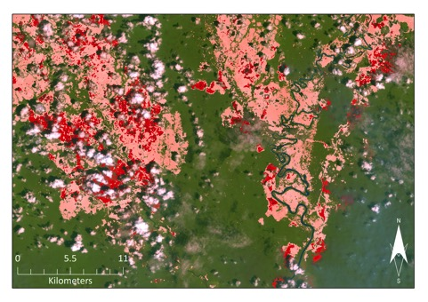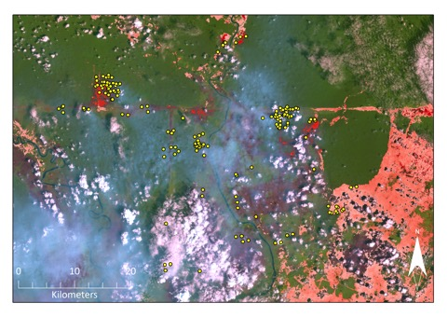

Figure 7. RGB false color composite with isolated hues (greyscale). Older burn scars can be seen in the image, one such scar is circled.

Figure 6. Hue plus saturation (red-scale) method eliminated cloud noise and isolated burn scars underneath them (left). Right, hazy image with burn scars that were not identified with the hue plus saturation method. MODIS Active Fire Product data is represented by yellow dots.

These methods were only able to detect fresh burn scars within the landscape. Isolating hue values that pertained to the soil range did not detect older burn scars that were present in the RGB false color composites and seen by the human eye (Figure 7). This was a result of older burn scars exhibiting hue values closer to those displayed by vegetation (see Figure 3). An algorithm that was able to discriminate between vegetation and older burn scars would be beneficial for future pursuits.

**Further Research**

While the approaches discussed in this paper were able to narrow down the search for burn scars in Landsat imagery, and was semi-automated, a fully automated algorithm would be extremely beneficial for researchers, project partners, and/or land managers. The threshold of hue and saturation values used to detect the burn scars could be narrowed, in order to eliminate other soil areas. Additionally, site-specific determination of hue and saturation values that pertain to burn scars could improve accuracy. This type of methodology could also be applied to hazy images.

The development of an algorithm to identify the irregular edges of burn scars that are characteristic of them and not fallow agricultural fields, bare patches of soil, etc., would be advantageous.

# V. Conclusions

Overall, the methodology tested in this study could help project partners narrow down the amount of information needed to map burn scars at high spatial resolution. The semi-autonomous nature of the two methods described above would enable for faster processing and acquisition of burn scar data. However, visual inspection of the final images would be needed to ensure proper identification of burn scars.

Both methods resulted in commission errors in regards to other soil types as well as fallow agricultural areas. The method incorporating only hue values tended to result in commission errors, where it improperly observed fallow agricultural areas and bare ground, while the method incorporating both hue and saturation values resulted in more omission errors, causing burn scars to be left unrecognized. In addition, these methodologies only discovered fresh burn scars, while older patches were not picked up as they had seen a regrowth in vegetation.

Clouds and haze were major obstacles in the recovery of burn scars. Although the hue plus saturation method was able to eliminate some of the cloud noise in many images, further refinement is needed to enhance the detection of burn scars in cloudy and hazy images. Additional development and successive iterations of the methods described within this paper are needed to construct a more robust identification methodology for mapping burn scars at high spatial resolution.

# VI. Acknowledgments

Thank you to Dr. Ceccato for his guidance and expertise on this project.

This material is based upon work supported by NASA through contract NNL11AA00B and cooperative agreement NNX14AB60A.

# VII. References

Bastarrika, A., Chuvieco, E., & Martín, M. P. (2011), Mapping burned areas from Landsat TM/ETM+ data with a two-phase algorithm: Balancing omission and commission errors. *Remote Sensing of Environment, 115*(4), 1003-1012.

Carlson, K.M., Curran, L.M., Ratnassari, D., Pittman, A.M., Soares-Filho, B.S., Asner, G.P., Trigg, S.N., Gaveau, D.A., Lawrence, D., and Rodrigues, H.O. (2012), Committed carbon emissions, deforestation, and community land conversion from oil palm plantation expansion in West Kalimantan, Indonesia. *Proceedings of the National Academy of Sciences, 109*(19), 7559-7564, doi: 10.1073/pnas.1200452109.

Ceccato, P., Nengah Surati Jaya, I., Qian, J.H., Tippett, M.H., Robertson, A.W., Someshwar, S. (2010), IRI Technical Report 10-14: Early Warning and Response to Fires in Kalimantan, Indonesia. *IRI Technical Report.* Available from: http://iri.columbia.edu/docs/publications/TR10-14_EarlyWarningandResponse_PCeccato.pdf (Accessed 15 June, 2015)

Ceccato, P. (2005). [Operational Early Warning System Using SPOT-VGT and TERRA-MODIS to Predict Desert Locust Outbreaks](http://iri.columbia.edu/%7Epceccato/Public-Desert-Locust/Ceccato_full.pdf). In Proceedings of the 2nd VEGETATION International Users Conference, 24-26 March 2004, Antwerpen. Editors: Veroustraete, F., Bartholome, E., Verstraeten, W.W. Luxembourg: Luxembourg: Office for Official Publication of the European Communities, ISBN 92-894-9004-7, EUR 21552 EN, 475 p

Ceccato, P., Gobron, N., Flasse, S., Pinty, B., & Tarantola, S. (2002). Designing a spectral index to estimate vegetation water content from remote sensing data: Part 1: Theoretical approach. *Remote Sensing of Environment*, *82*(2), 188-197.

Garcia-Haro, F. J., Gilabert, M. A., & Melia, J. (2001), Monitoring fire-affected areas using Thematic Mapper data. *International Journal of Remote Sensing, 22*(4), 533-549.

Hayasaka, H., Noguchi, I., Indra Putra, E., Yulianti, N., and Vadrevu, K. (2014). Peat-fire-related air pollution in Central Kalimantan, Indonesia, *Environmental Pollution, 195*, 257-266, doi: 10.1016/j.envpol.2014.06.031.

Hyer, E.J., Reid, J.S., Prins, E.M., Hoffman, J.P., Schmidt, C.C., Miettinen, J.I., and Giglio, L. (2012). Patterns of fire activity over Indonesia and Malaysia from polar and geostationary satellite observations, *Atmospheric Research, 122*, 504-519, doi: 10.1016/j.atmosres.2012.06.011.

Justice, C., Giglio, L., Boschetti, L., Roy, D., Csiszar, I., Morisette, J., and Kaufman, Y. (2006), Algorithm Technical Background Document: MODIS Fire Products. Available from: http://modis-fire.umd.edu/files/atbd_mod14.pdf (Accessed 22, June, 2015)

Koutsias, N., Pleniou, M., Mallinis, G., Nioti, F., & Sifakis, N. I. (2013), A rule-based semi-automatic method to map burned areas: exploring the USGS historical Landsat archives to reconstruct recent fire history. *International journal of remote sensing, 34*(20), 7049-7068, doi: 10.1080/01431161.2013.816452.

McDonald Pittman, A., Carlson, K.M., Curran, L.M., and Ponette-González. (2013), NASA Satellite Data Used to Study the Impact of Oil Palm Expansion Across Indonesian Borneo, *The Earth Observer, 25*(5), 12-16, Available from: http://lcluc.umd.edu/Documents/Publications/2014/Pittman_et_al_Earth_Observer_Sept_Oct_2013_12-16.pdf (Accessed 22 June 2015)

Minnemeyer, S., Putraditama, A., Anderson, J., Sizer, N., and Song, C. (2014), Fires Spread Across Indonesia as Parliament Approves Haze Treaty, Available from: <http://www.wri.org/blog/2014/09/fires-spread-across-indonesia-parliament-approves-haze-treaty> (Accessed 23 June 2015)

Spessa, A.C., Field, R.D., Pappenberger, F., Langner, A., Englhart, S., Weber, U., Stockdale, T., Siegert, F., Kaiser, J.W., and Moore, J. (2015). Seasonal forecasting of fire over Kalimantan, Indonesia, *Natural Hazards and Earth System Science, 15*(3), 429-442, doi: 10.5194/nhess-15-429-2015.

Tansey, K., Beston, J., Hoscillo, A., Page, S.E., and Paredes Hernández, C.U. (2008), Relationship between MODIS fire hot spot count and burned area in a degraded tropical peat swamp forest in Central Kalimantan, Indonesia. *Journal of Geophysical Research: Atmospheres, 113*(D23), 112. doi: 10.1029/2008JD010717.

United States Geological Survey (USGS). (2015), Frequently Asked Questions about the Landsat Missions, Available from: <http://landsat.usgs.gov/band_designations_landsat_satellites.php> (Accessed 22 June 2015)

# VIII. Content Innovation

1) Interactive Map Viewer Files:

-2015Sum_IRI_IndonesiaDisasters_TechPaper_MapViewerFigure_Hue.kmz

-2015Sum_IRI_IndonesiaDisasters_TechPaper_MapViewerFigure_HueSat.kmz

-2015Sum_IRI_IndonesiaDisasters_TechPaper_MapViewerFigure_RGB.kmz

2) Featured Multimedia – video

- 2015Sum_IRI_IndonesiaDisasters_TechPaper_Media.pptx

# IV. Appendices

See additional document.