Panama Water Resources

Characterizing Vegetation Water Use in the Panama Canal Watershed to Inform Water Management in the Panama Canal

**Technical Report**

Final Draft – November 21st, 2019

Roger Ly (Project Lead)

Erica Carcelén

Max Dunsker

Camille Pawlak

Dr. Erika Podest, Jet Propulsion Laboratory, California Institute of Technology (Science Advisor)

Dr. Kyle McDonald, City College of New York and Jet Propulsion Laboratory, California Institute of Technology (Science Advisor)

# 1. Abstract

The Panama Canal is major socioeconomic resource for the region. Surrounding cities such as Panama City, Colón, and San Miguelito rely on the Panama Canal Watershed (PCW) for electricity and potable water. The canal connects the Atlantic Ocean to the Pacific making it the most crucial piece of infrastructure supporting the flow of shipping in the Western Hemisphere (Wang 2017). The PCW’s water resources must be carefully managed to maintain community water needs alongside the operation of the Panama Canal as a shipping path during the dry season. To help inform decision-makers about the future effects on the watershed’s resources, this project was conducted to explore the feasibility of using remotely sensed data to observe the impacts of land cover on water availability in the PCW. The team observed evapotranspiration (ET) in the PCW using data from Terra Moderate Resolution Imaging Spectroradiometer (MODIS). NASA Gulfstream III Uninhabited Aerial Vehicle Synthetic Aperture Radar (UAVSAR), Advanced Land Observing Satellite (ALOS) Phased Array L-band Synthetic Aperture Radar (PALSAR), and Sentinel-1 C-band Synthetic Aperture Radar (Sentinel-1 C-SAR) were utilized to create land cover classifications and compare the classification capabilities of different sensors. PALSAR imagery provided the most successful classifications with an overall accuracy of 85.8%. The MODIS data values differed from *in situ* ET measurements, but were significantly correlated. Through a sensitivity test involving land cover and MODIS ET, it was concluded that MODIS ET values were not particularly sensitive to changes in land cover.

**Keywords**

remote sensing, hydrology, Synthetic Aperture Radar, evapotranspirtation

# 2. Introduction

* 1. ***Background Information***

The Panama Canal Watershed (PCW) is home to the most important maritime commerce route in the Western Hemisphere, the Panama Canal. Approximately three percent of global maritime commerce passes through the manmade strait, shortening the passage from the Atlantic to the Pacific by 7,900 miles (National Association of Credit Men, 1913). The Canal is responsible for ten percent of Panama’s Gross Domestic Product, providing a domestic incentive for its continued operation.

The principal limiting factor in the operation of the Canal is water scarcity in the PCW. For each passage, thirteen tons of water are required per ton of cargo (Stallard, Ogden, Elsenbeer, & Hall, 2010). In addition to operating the locks, the PCW is used for the generation of hydroelectricity and the supply of potable water to nearby Panama City, Colon, and San Miguelito. As urbanization and population growth increase the demand for freshwater, other forces decrease its supply. Deforestation and agricultural land degradation that follows are leading to increased sedimentation in the PCW and decreased groundwater recharge. Several agencies are committed to reforesting the PCW in order to regain the ecosystem services provided by forest land cover. The Ministerio de Ambiente de Panamá (MiAmbiente) is one such organization, creating a national water safety plan prioritizing sustainable watershed management through reforestation (Goal 4, PNSH).

Within the PCW, the Smithsonian Tropical Research Institute (STRI) operates the Agua Salud Project (ASP; Figure 1), which focuses on understanding the forestry, hydrology, and ecosystem services of the central Panama Basin. In addition to the ASP, STRI also operates another long-term research site on Barro Colorado Island (BCI; Figure 1). STRI established its environmental monitoring program in the PCW in 1996, partnering with United States Agency of International Development and the government of Panama. Over twenty years of forest management and meteorological observations by STRI have made ASP and BCI ideal sites to study the connection between water scarcity and land cover (Stallard, 1999).

One such study observed saturated hydraulic conductivity (Ks), the measure of a saturated soil’s ability to transmit water when subjected to a hydraulic gradient, of different land cover types in the Agua Salud study area. The findings show that the topsoil of older secondary forests is more effective at allowing water to pass through than young secondary forests and much more effective than pastures (Hassler, Zimmermann, van Breugel, Hall, & Elsenbeer, 2011). Another study found that older forests need less water, indicating that these forests may be soaking up and storing much more water than their younger counterparts (Bretfeld, Ewers, & Hall, 2018).

While *in situ* studies give great insight, remote sensing provides the opportunity to upscale and capture variability across the landscape. Evapotranspiration (ET) is a variable that is included in the water balance equation and will be used as a proxy for water availability. In order to further investigate how secondary forests behave during the dry season, this study used remotely sensed inputs, alongside *in situ* data provided by STRI, to better understand the mechanisms behind the recharging of groundwater for secondary forests in ASP and BCI. This study used data from 2010 to 2018, with an emphasis on wet and dry seasons in 2010, an exceptionally wet year, and 2015, an El Niño year that produced exceptionally dry conditions.

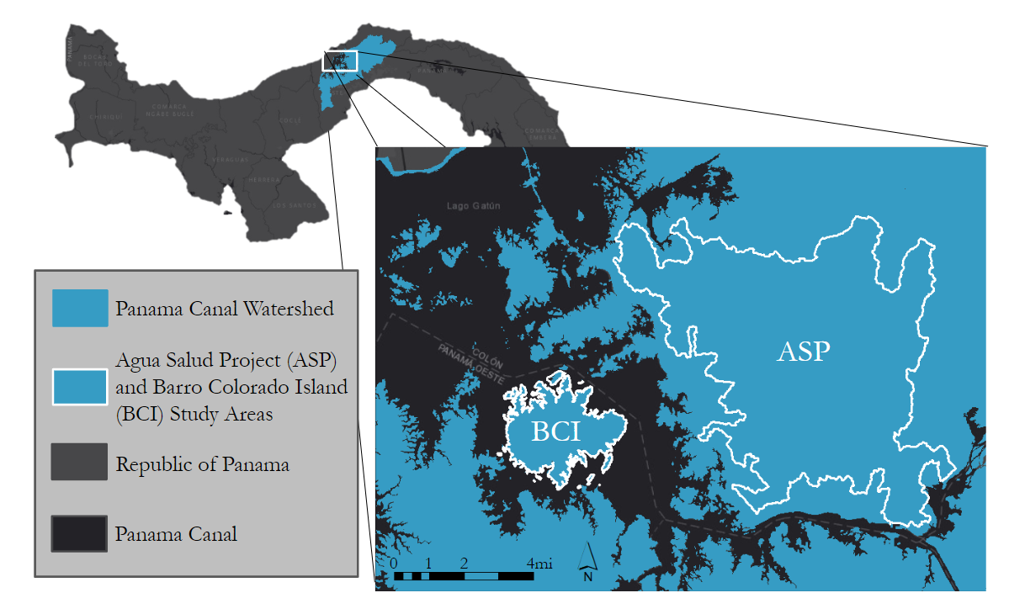

*Figure 1*. The study area map includes a reference map of Panama in the top left, with the Panama Canal Watershed colorized in blue. Additionally, the inset map shows the locations of ASP and BCI, demarcated in white. Basemap imagery was provided by Esri.

* 1. ***Project Partners & Objectives***

We partnered with the Republic of Panama’s Ministry of Environment (MiAmbiente). Their agency is in charge of sustainably managing the water resources of the Panama Canal Watershed to continue the function of the Panama Canal as a major transportation route as well as prevent scarcity of potable drinking water to the residents that rely on the canal watershed. MiAmbiente stated that Goal Two of their National Plan for Water Security is the use of water for inclusive socioeconomic growth. Cities that rely on the watershed and would benefit from increased water security include Panama City, Colón, and San Miguelito. MiAmbiente hopes to use our findings to help determine the location and vegetation type that will help increase water availability during the dry season in the PCW.

To help MiAmbiente with their water conservation goals, the team investigated the effect of vegetation type on ET. By analyzing the relationship between the two variables, water-saving vegetation could be identified and planted by MiAmbiente in the PCW to increase groundwater recharge. The main objective of this project was to create a replicable methodology of comparing land cover type and ET in the ASP and BCI. The team created a standard operating procedure that the partners could use to replicate the study on the greater PCW.

# 3. Methodology

***3.1 Data Acquisition***

The NASA Earth observations utilized in this study included data collected by Terra MODIS. The team acquired the MOD11A1 MODIS/Terra Land Surface Temperature/Emissivity Daily L3 Global 1km SIN Grid V006 product, referred to as MOD11A1. This dataset is a level 3 product that measures land surface temperature. (Wan, Hook, & Hulley, 2015). ET to assess water availability was measured with the level 4 MOD16A2 MODIS/Terra Net Evapotranspiration 8-day L4 Global 500m SIN Grid V006 product, referred to as MOD16A2 (Running, Mu, & Zhao, 2017).

Evapotranspiration is measured in actual or potential ET. Actual ET (AET) differs from potential ET (PET), AET depends on PET as well as additional factors such as water supply to evaporating surfaces, soil water content, and rainfall distribution (Kristensen, 1975). The team used the Terra MODIS Global 8-day terrestrial ecosystem evapotranspiration dataset for analysis. The Terra MODIS ET dataset is based on an improved version of the Penman-Monteith equation, which calculates ET based on solar radiation, air temperature, humidity, and wind speed and outputs reference ET (Zotarelli, 2013). The MODIS ET product differs from the reference ET derived from the Penman-Monteith equation because it includes remotely sensed inputs of leaf area index (LAI), land cover, albedo, and fraction of photosynthetically absorbed radiation (FPAR) which it derives from MODIS and Visible Infrared Imaging Radiometer Suite data in addition to daily meteorological data inputs (Mu, 2013). The MODIS16A2 ET product gives us an adjusted reference ET estimate that we can use to relate to the fine resolution land cover type maps we created using SAR imagery. All MODIS products were downloaded using the MODIStsp R Package (Busetto & Ranghetti, 2017).

Land cover was characterized using synthetic aperture radar (SAR) data from three sensors: NASA Gulfstream III Uninhabited Aerial Vehicle Synthetic Aperture Radar (UAVSAR), Sentinel-1 C-band Synthetic Aperture Radar (Sentinel-1 C-SAR), and Advanced Land Observing Satellite Phased Array type L-band Synthetic Aperture Radar (ALOS PALSAR). Imagery from these sensors was downloaded from the Alaska Satellite Facility Distributed Active Archive Center (ASF DAAC). We used the UAVSAR level 1 L-band polarimetric radar backscatter, the Sentinel-1 C-band dual-polarization radar backscatter, and ALOS PALSAR L-band dual-polarization radiometrically terrain corrected high-resolution radar backscatter product. SAR is an active imaging method that uses microwaves that penetrate clouds and partial canopy to obtain information on surface roughness (Bamler, 2000). For this reason, only SAR imagery was used for the study area located in the tropics where clouds and forest canopy are common. C-band imagery (6 cm. wavelength) and L-band imagery (24 cm. wavelength) were used to explore the classification capabilities of both wavelengths in the tropics.

*In situ* data was necessary to validate the satellite and airborne observations. STRI provided us with data the organization has been collecting from 1933 to the present. Ancillary data for calibration and validation purposes included *in situ* potential ET observations collected from STRI and Empresa de Transmision Electrica Sociedad Anónima (ETESA) meteorological stations. Information on land cover, such as forested and pasture plots on both Agua Salud and BCI, were provided by STRI and downloaded on STRI’s GIS Data Portal. Additional information about every dataset used is detailed in Appendix A.

***3.2 Data Processing***

SAR data was processed using ENVI, ArcMap, and the Sentinel Application Platform (SNAP). We used ENVI and ArcMap to mosaic SAR imagery as well as crop it to our study areas, ASP and BCI in Panama. MODIS mosaics were created using the MODIStsp R package, and fill values were reclassified to a “No Data” value of 9999 in R. Additionally, we created a time series of Boolean rasters to evaluate data coverage in our study area during the wet and dry seasons for our study period. To remove the impact of transitional periods between the wet and dry seasons, we focused on data in the core wet and dry seasons defined as June to November and mid-January to March, respectively. All SAR, MODIS, and ancillary data were projected in WGS 1984 UTM 17N.

When factors such as clouds or limited reliable meteorological observations inhibit the algorithm from producing an ET value for a pixel in the MODIS data, the pixel is assigned a fill value. The fill values in the MODIS ET product range from 3276.1 to 3276.7 based on the land cover type of the pixel. We reclassified those fill values to a no data value, which left some gaps in our data. To make up for those gaps we aggregated the 8-day products to 16-day products by taking the sum to represent total net ET in mm of water lost over the 16 days. We also aggregated a total net ET product for each year and a yearly product representing annual total net ET into a core dry season as well as a core wet season.   
  
Normalization of SAR imagery is required for meaningful multi-sensor comparisons, accurate backscatter values, and robust land cover classifications (Small et al. 2011). Terrain topography affects position and backscatter values across all sensors and is responsible for most radiometric variation in radar imagery (Simard et al., 2016). To produce accurate land cover classifications of forest structure in Agua Salud and BCI, radiometric terrain correction (RTC) was performed across all sensors. The ALOS PALSAR L-Band RTC product was downloaded directly from the ASF DAAC. With this product, the imagery has already been terrain corrected using the SRTM GL.1, 30 m digital elevation model into an algorithm in the GAMMA software implemented by ASF. RTC on Sentinel-1 C-Band SAR was applied using ASF’s Hybrid Pluggable Processing Pipeline (HyP3) which applies the same GAMMA RTC as ALOS PALSAR but through ASF’s cloud computing service (Hogenson et. al 2016). Sentinel-1 C-Band imagery over the span of 2017 was corrected, resulting in 31 RTC Sentinel-1 C-band images. UAVSAR used a new algorithm created for airborne SAR imagery that takes into account antenna steering angle and target geometry (Simard et. Al, 2016). This new algorithm performs better than algorithms that only use a DEM to correct for terrain and allows for better correction in areas with significant terrain topography (Simard et. Al, 2016).

Speckle noise in SAR imagery makes interpretation and classification difficult, degrading the quality of the image (Yommy, Liu & Wu 2015). To correct for speckle across our SAR imagery the Lee filter was applied in SNAP. This filter uses minimum mean square error filtering in a window of pixels to carry out despeckling (Yommy, Liu & Wu, 2015). Across all SAR imagery we applied the Lee filter with a 5x5 window to remove speckle. Despeckled backscatter intensity was then converted from a linear scale to a decibel in SNAP to normalize values for further data processing.

To maximize contrast between land cover types, polarization ratios of the HH polarization minus the HV polarization and Pauli decompositions were created for the PALSAR and UAVSAR imagery, respectively, and added as additional bands to classifications. Gray level co-occurrence matrices (GLCM) were created across all SAR imagery to maximize contrast between land cover types as well. The “glcm” R package was used to produce rasters to add as additional bands into our classification input raster, the output is shown in Appendix C. A 9x9 window and a 1 cell shift in all directions were set to generate our GLCM statistics. ALOS PALSAR and UAVSAR imagery included mean and homogeneity rasters, while Sentinel-1 imagery included only the mean. These rasters were selected because of the visual contrast they created between land cover types. Contrast and dissimilarity were not used due to large areas of misclassification around the borders of BCI and ASP.

For training data used in the final classification, the team create two classes, one for forested areas, and one for non-forested areas. *In situ* secondary forest plots provided by STRI were also included in our training data. For non-forested areas, we looked at the distribution of the backscatter values to create a separable class from the forest class. The team used the same forest training data for each image, but retrained the non-forested area. Team members chose to retrain because reforestation efforts in the area led to a change in the location of non-forest areas over time; therefore, at different times, non-forested areas were at different levels of growth and had different backscatter values. In an effort to keep the training data consistent, approximately the same number of pixels were used for training of each class. After creating the training data, the Random Forest classification algorithm was used in SNAP to classify our data using HH polarization, HV polarization, ratio band, and gray level co-occurrence matrix bands as inputs.

***3.3 Data Analysis***

*3.3.1 SAR Imagery Validation*

The classifications created were validated to *in situ* land cover observations using confusion matrices in ENVI. Land cover samples were created from Google Earth Imagery and were used along with land cover shapefiles provided by the STRI. The *in situ* data of forested and non-forested areas were spatially aggregated into one location within our study site. This validation dataset was compared pixel by pixel to the land cover classification to assess accuracy. The resulting accuracy percentage represented the agreement between radar created land cover classification and the validation dataset. Initial confusion matrix validations resulted in 50% overall accuracy. Different temporal resolutions between the validation dataset and the radar land cover classification could have a role in the disagreement. This was also because the spatial scale of the *in situ* dataset was smaller than the resolution of any of the three sensors we used to create land cover maps (in addition to being clustered into small areas in ASP, creating a sample bias). To resolve this issue, Google Earth imagery was used to create additional validation data for locations that appeared to be non-forest consistently. The Google Earth validation dataset was added to a subset of our *in situ* training dataset. All of the validation data for BCI came from an *in situ* based land cover map provided by STRI.

*3.3.2 Evapotranspiration in situ Comparison*

The MODIS ET product was validated using *in situ* measurements of ET from meteorological stations managed by STRI. On BCI there are two locations with stations, a small clearing known as The Clearing, located between the forest and old laboratory buildings, and at the mouth of the Lutz catchment, which is comprised of forest that has regenerated since the building of the Panama Canal. Each location has two datasets of daily potential ET measured manually with an ET gauge atmometer. These locations are referred to as Clearing 1, Clearing 2, 42m, and 48m in this document. The Lutz 42m dataset describes the tower built in 1972 at a height of 42 meters and the Lutz 48m dataset refers to the tower built in 2001 at a height of 48 meters due to the expansive forest growth in the Lutz catchment. There is only one station in ASP, referred to as Celestino, which estimates ET with the Penman-Monteith equation using only meteorological inputs measured at the station. For validation, we took a sum of the *in situ* daily potential ET values for every 16-days of each year in our study period and compared it to the ET values of the MODIS 16-day composites. *In situ* values in Agua Salud were directly compared to MODIS since there is only one dataset, but the 4 datasets in BCI were averaged before comparing to MODIS ET. The values representing the same 16-day period were plotted across time to visualize the temporal patterns in both datasets. To explicitly evaluate the similarity between the datasets, the team created correlation scatterplots with a correlation coefficient (R). This indicates the percentage of variance in the *in situ* data explained by the variance in the MODIS data and a p-value to indicate whether the correlation between datasets is significant (i.e. greater than random).

*3.3.3 ET to Land Cover Type*

In order to compare ET with the land cover types produced by the classifications, the MODIS data were resampled using the nearest neighbor method. This method reduces the pixel size of the MODIS data to match that of the classification without altering the values. Once the MODIS data and classification have the same extent and resolution, we used a zonal statistics function to extract total net ET as a mean value for the forest class and a mean value for the non-forest class. Since our study aimed to identify temporal and spatial trends in ET, we used the seasonal composite of MODIS ET to extract a forest mean and a non-forest mean of total net ET during the core dry and core wet season during the year that the classification represents. These values were then compared to determine whether we could identify any trends in ET across land cover type and between years.

*3.3.4 Sensitivity Analysis*

Since MODIS measures ET at a larger scale than the classification, we used a sensitivity analysis to examine how changes in area forested and non-forested impact annual ET of the entire study area. Team members calculated annual ET of the entire study area as a weighted average (Equation 1) where the products of percent area of each class ($A_{f}$, $A_{n}$) and their respective mean values of total net ET in the core dry ($E_{df}$, $E_{dn}$), core wet ($E_{wf}$, $E_{wn}$), and transitional periods ($E_{tf}$, $E_{tn}$) are summed. Overall annual ET was calculated using values from a classification with a low percentage of forest to represent a minimum case and a classification with a high percentage of forest to represent a maximum case. To complete the sensitivity analysis, the overall annual ET was calculated using only the values from the minimum case. Overall annual ET was then recalculated when the value for one variable, $A_{f}$ for example, in Equation 1 was replaced with a value from the maximum case and all other variables were kept the same. The percent change in the result of Equation 1 when the value of $A_{f}$ was changed from the minimum case value to maximum case value indicates how much a change in $A_{f}$ impacted changes in overall annual ET. This process was repeated for each variable in Equation 1, changing the value of a single variable from the minimum to the maximum case, one at a time. The variables with the highest percent change in ET all have the biggest impact on annual ET.

$ETall =A_{f} ( E_{df} + E_{wf} +E_{tf}) + A_{n} (E_{dn} + E_{wn} + E_{tn})$ (1)

# 

# 4. Results & Discussion

***4.1 SAR Land Cover Results & Analysis***

SAR across all three sensors was successfully able to classify land cover into two classes: forested and non-forested (Figure 3). Our forest class included both primary and secondary forests as they could not be separated. The non-forested class includes bare ground, pasture, and water. Examples of each classification are shown below. Although ALOS PALSAR created the most successful classification when compared to our *in situ* observations, it’s very limited temporal availability makes it a problematic radar source. Each sensor has strengths and weaknesses, and a superior sensor was unable to be determined. All accuracy assessments are listed in Appendix B with source sensor, date classified, and accuracy percentages.

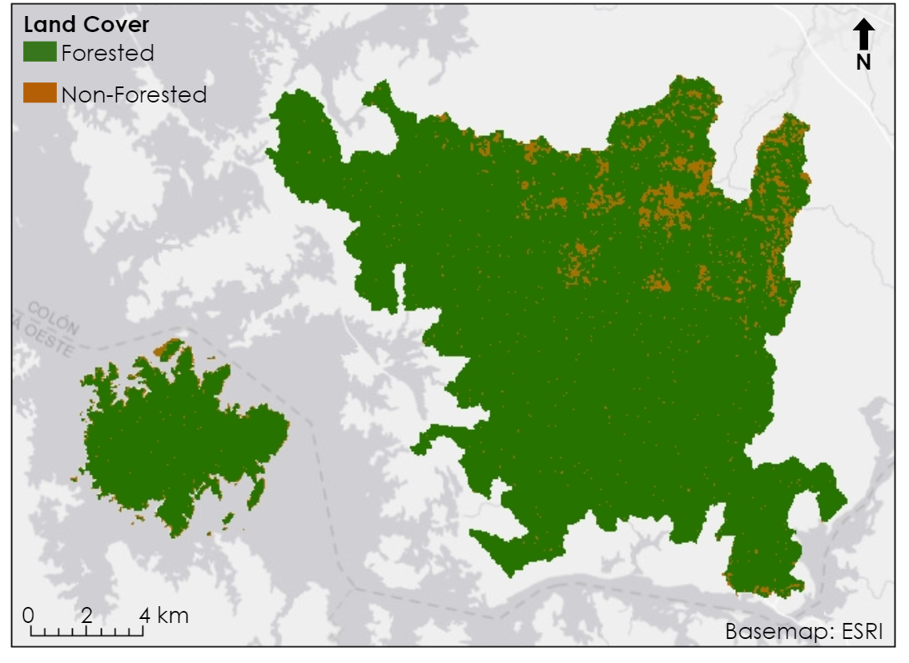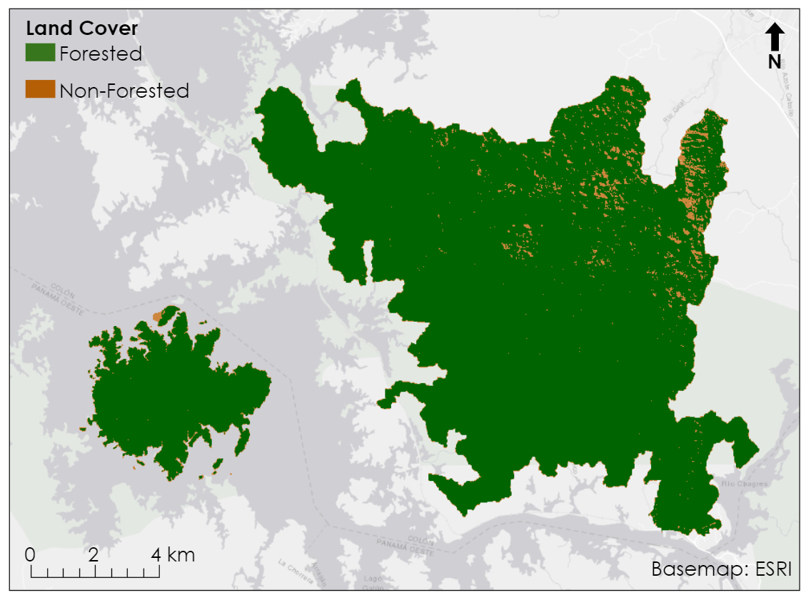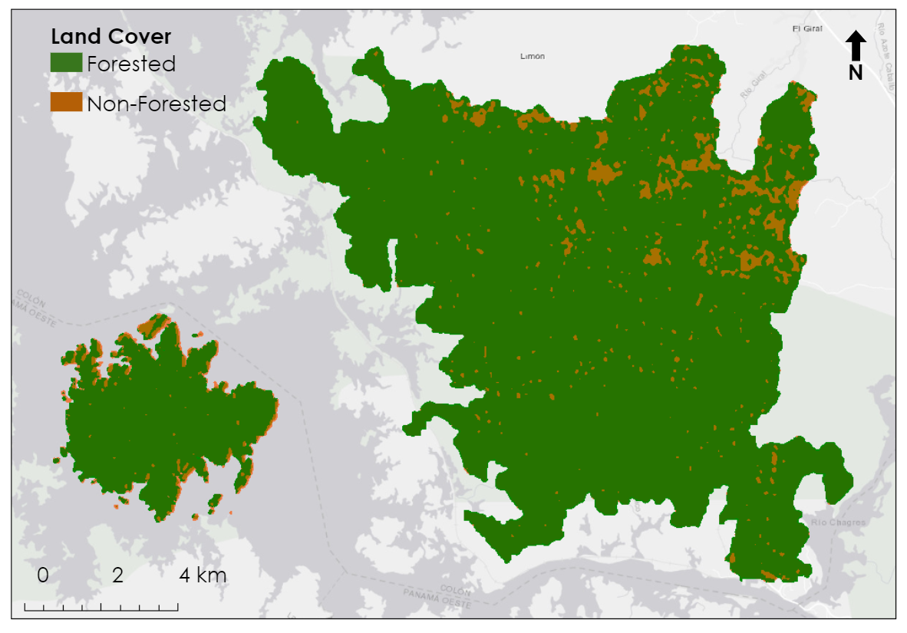

*Figure 2.* Land classifications of Agua Salud and BCI. From left to right: ALOS PALSAR -2 from 5/30/2010, UAVSAR PolSAR from 2/6/2010, Sentinel-1 from 3/7/2017.

*4.1.1 ALOS PALSAR*

On average, the PALSAR classifications returned 95% forested area and 5% non-forested area (Figure 2). The overall accuracy was 85.8% with an average kappa coefficient of 0.61. The average accuracy for forested areas was 98.6% while non-forested was 42%. Overall, when compared to optical imagery and previous land cover maps, the classification did create clusters of non-forested pixels over pastures of barren ground. However, there was a high error for the pasture class. This error could be due to the speckling present in the data. There are non-forested speckles that appear throughout the classification in areas known to be forested. The team considered eliminating this with a majority filter; however, the filter reduced the size of the larger cluster classified as non-forested areas when applied. This indicates that estimations were already slightly under classifying the non-forested area, and the team did not want to reduce accuracy of the non-forested area further so the filter was not applied.

Initially, the team had hoped to be able to create classes that distinguished forest based on age. Team members had *in situ* plotswhich had the age of each forest stand, but after comparing the average backscatter value returned for each plot, the team determined there was no relationship between backscatter value and age (Figure 3). Attempts were also made to train the classifier based on the *in situ* plot age, but it was found that the classes in the resulting classification were not separable.

*Figure 3.* This figure shows what average backscatter value each plot of forest with a known age returns for the polarizations HH and HV from ALOS PALSAR. Forest plot age was given to us by STRI. There is no visible trend between forest age and backscatter.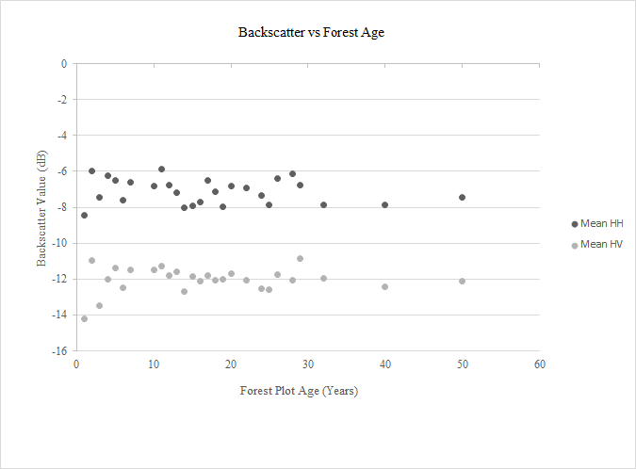

*4.1.2 UAVSAR L-Band*

The UAVSAR classifications observed a similar pattern of non-forested areas to those of ALOS PALSAR. However, the effectiveness of UAVSAR was limited by distortions from the flight path, incidence angle, and mountainous terrain. To prevent these distortions from skewing the results of the classifications, an error class was included alongside forest and non-forest classes in the Random Forest Classifier. The overall accuracy of the 2015 classification, 79.2%, was higher than the 2010 classification, 68.3%, despite 2015 having a greater number of pixels in its error class.

Unlike PALSAR and Sentinel-1, the backscatter values of UAVSAR were subject to a gradient, where backscatter values were influenced by proximity to the sensor and differences in elevation (Figure 4). Because 2010 and 2015 images were recorded on perpendicular flight paths, the gradient is very pronounced in this false-color image which compares 2010 HH values in pink and 2015 HH values in green, with their flight paths and incidence angles visualized in the same colors. In the northeast and southeast corners of the ASP study area, the large swaths of green are indicative of terrain error.

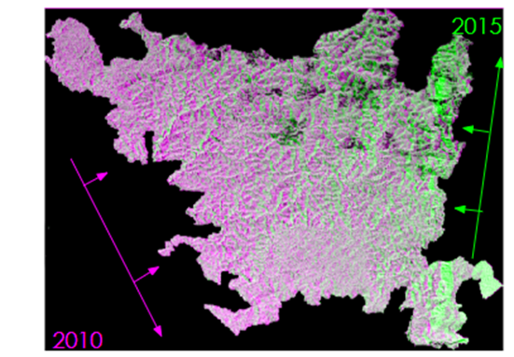

*Figure 4.* A false-color image of 2010 HH backscatter in pink and 2015 HH backscatter. Additionally, the flight paths and incidence angle of each flight are shown in its respective color.

In an attempt to use the terrain effects of UAVSAR to improve the classification, the classifier was trained to distinguish between flat and sloped forests. Flat forests could be visibly distinguished in the northwest corner and southcentral part of the study area, but the team was unable to distinguish flat and sloped forests based upon backscatter values, as the histograms were not separable.

*4.1.3 Sentinel-1 C-Band*

Land cover classifications by Sentinel-1 C-Band imagery could only be produced during the dry season due to the disappearance of non-forested areas (Figure 5). In the dry seasons, non-forested areas are shown as darker tones in the VH polarization. However, through all the wet season imagery the entire ASP study area was homogeneous. Upon discussion with STRI, the team was informed that it was likely these pasture areas experienced growth of grasses that reached up to 2 meters tall. This would cause C-band SAR to be unable to penetrate the grass and scatter, creating a similar backscatter response as forest canopy. For this reason, training data was extremely difficult to identify in the wet season dates and further classification of wet season dates using C-Band SAR was stopped. In the dry season, classifications produced using Sentinel-1 C-Band SAR during the dry season had an average accuracy percentage of 60.3%. Misclassification was present (forest classified as non-forest) in the ASP protected areas. This might be attributed to the large amounts of speckle in the 10 meter product. 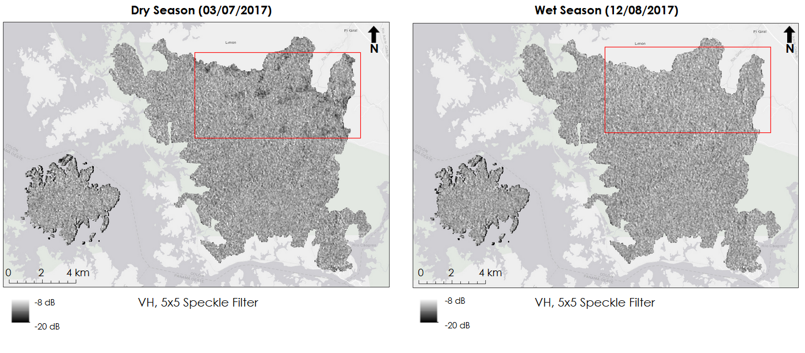

*Figure 5.* A side by side comparison of the dry season and wet season Sentinel-1 C-SAR images. Darker tones indicated non-forested areas, during the wet season these darker tones are not present.

*4.1.4 Evapotranspiration vs in situ Comparison*

The ET data shows a seasonal pattern with higher values at the beginning of the year during the dry season and lower values during the wet season (Appendix D). This indicates that water is not the main limiting factor of ET, as water is abundant during the wet season and this is when ET is lowest. If water was the main limiting factor, then ET would be lowest during the dry season when water is scarce. However, this is not the pattern evident in both the MODIS and *in situ* data. Other factors such as humidity, limited radiation from cloud cover, and vapor pressure deficit could explain why ET is lower in the wet season. The MODIS ET values follow the same general pattern (Appendix D) and are correlated (Figure 6) with the *in situ* ET values. However, the magnitude of the *in situ* measurements is higher (Appendix D) and the variance in the *in situ* measurements explained by MODIS are limited with values of 0.39 in ASP and 0.63 in BCI (Figure 6). This difference in magnitude is due to the differences in the nature of the ET measurements. The *in situ* measurements represent a potential ET in BCI and a reference ET in ASP; whereas, the MODIS measurement represents an adjusted reference ET that accounts for differences in demand between vegetation types and non-vegetated areas and is closer to a measure of actual ET. Although both datasets show a seasonal pattern with higher ET in the dry season and lower ET in the wet season, partners at STRI recently found that a colleague studying actual ET in Panama does not see a seasonal pattern. Unfortunately, there was not enough time to investigate this further before the end of the term.

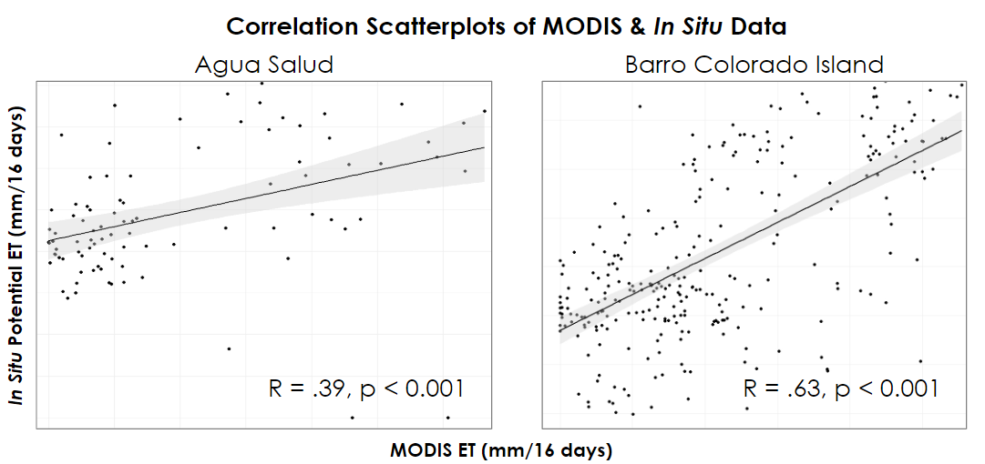

*Figure 6.* Correlation scatterplots of the *in situ* potential ET measurements by the MODIS adjusted reference ET measurements in ASP (left) and BCI (right). The datasets are significantly correlated, but the R-value is not high.

*4.1.5 Evapotranspiration vs Land Cover, Seasonal Comparison*

The classifications produced came from dates in five different years: 2007, 2009, 2010, 2015, and 2017. To extract ET for each land cover class, we selected the most accurate classification available for each year. The classifications using ALOS PALSAR had the highest accuracy for 2007-2010 (85%, 86%, and 85%, respectively), UAVSAR for 2015 (79%), and Sentinel for 2017 (69%). Figure 7 shows the mean value of total net ET during the core dry and core wet season in forested and non-forested pixels. ET was typically higher in the forested class; however, this pattern varies in some years such as the 2009 wet season and 2017 dry season (Figure 9). Although there appears to be a trend in ET between forested and non-forested classes, the variance in classification accuracy prevents a clear comparison between the classes. Classification accuracy ranged from 69 to 86%, so the pixels classified as forest or non-forest may not be fully representative of what is on the ground. Additionally, the size of non-forest patches in our study area were much smaller than the actual resolution of MODIS data, so a MODIS ET value in one pixel likely covers a mixture of forest and non-forest land cover types. Thus, we cannot clearly link values of MODIS ET to land cover type and determine that the patterns shown in Figure 7 are representative of the actual relationship between ET and land cover type in our study area.

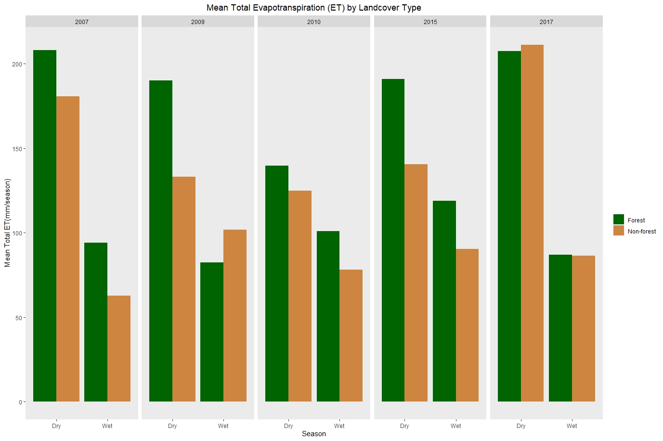

*Figure 7.* Bar graph showing the mean values in forested and non-forested classes of seasonal total net ET for the five years from which we have classifications. ET generally appears to be higher in forested areas; however, this pattern is not consistent.

*4.1.6 Sensitivity Analysis*

The minimal forest case (the base case) we used for our analysis came from the 2017 classification and the maximum forest case we used came from the 2009 classification. These dates were selected as they had no known errors with terrain, a difference in forest percent area (1.2% change), and represent a time period (8 years) in which forest coverage would be expected to change. If the MODIS data was sensitive to changes in land cover, then changes in percent area forested and percent area non-forested would result in the greatest change in resulting annual ET. The results of our sensitivity analysis are shown in Appendix C. The first column indicates the value of overall annual ET (ETall) when only the value of the variable in the row is changed from the 2017 base case to the 2009 maximum forest case. Appendix C also indicates the percent change in the variable value and percent change in overall annual ET (ETall) from the 2017 base case to the 2009 maximum case. Total net ET during the core dry and transition periods within forested pixels ( $E_{df}$ and $E_{tf}$, respectively) had the greatest impact on annual ET (ETall). An 8% decrease in $E_{df}$ resulted in a 3% increase in ETall and a 16% increase in $E_{tf}$ resulted in a 5% increase in ETall (Appendix C). This indicates that the MODIS ET data is most sensitive to changes in the MODIS product values, not percent area forested or not-forested. This confirms that differences in ET observed in Figure 9 may not necessarily be linked to changes in land cover, as defined by classifications.

***4.2 Future Work***

This project could be expanded upon. Land cover classifications could be refined in two ways. With the launch of Nisar in 2021, which will have both L-band and S-Band data, perhaps the more subtle differences between younger and older forest could be picked up. Additionally, land cover classifications could be refined by the addition of optical imagery into the classifier. The combination of L-Band SAR and Landsat optical imagery has been shown to improve land cover classifications and detect land cover change in tropical forests (De Alban 2018). With more time, optical imagery could be included as inputs into the classification to better detect change and refine the classification to more specific training data than just forested and non-forested areas.

Because the study area was so small, there was not a lot variation in land cover. We had very few pixels that were non-forested compared to forested. With an expanded study area, our results would become more significant because there would be more data for non-forested areas. Expanding the study area would also allow for greater variations of training data, which may result in the addition of classes. For example, urban and plantations would likely be added as classes. This would also be beneficial to inform how land cover affects ET in a larger area in the Panama Canal Region than just ASP and BCI.

This project could also be expanded with the replacement of MODIS with ECOSTRESS. ECOSTRESS is a NASA sensor on the ISS that measures ET at a finer spatial resolution than MODIS. However, ECOSTRESS is relatively new, and only one image was available over our study area. As more data becomes available, ECOSTRESS is a great option for refining the ET dataset. For data outside of the temporal availability of ECOSTRESS, MODIS data could be downscaled. With more time, the team would have developed methods to downscale the MODIS data. Overall, the team would have liked to work on downscaling MODIS data and to include optical imagery into land cover classifications. These measures would have allowed to the team to produce more refined land cover maps and further identify the relationship between land cover and ET.

# 

# 5. Conclusions

After using both L-Band and C-Band SAR imagery to create land cover classifications, the team determined that L-Band is better at identifying distinctions in tropical tree canopy. This is because L-Band can penetrate deeper within the canopy than C-Band can. Out of our three sensors, ALOS PALSAR created the most accurate land cover classification. UAVSAR has a finer spatial resolution, but errors due to incidence angle and terrain reduced accuracy, meaning ALOS PALSAR still created the best results.

In examining the relationship between backscatter value and secondary forest age, the team discover that the two are not correlated when using ALOS PALSAR data. Finer spatial resolution and deeper penetration could potentially allow for the classifying of forest age based on backscatter value.

MODIS data was correlated with the *in situ* measurements we received from STRI. The seasonal pattern of higher ET in the wet season and lower ET in the dry season was observed in both the *in situ* and MODIS data, and statistical analysis revealed that the two data sets are correlated. However, in our smaller study area, ET values were more sensitive to changes in values of the MODIS data rather than changes in land cover.

With new sensors set to improve the data quality in the coming years, this study was successful in laying the groundwork for a larger study of the effect of land cover on ET. With a larger, more heterogeneous study area, finer resolution ET data, and additional imagery to complement SAR in the land cover classification, this methodology could be successfully applied moving forward.

# 6. Acknowledgments

* Science Advisors: Dr. Erika Podest (NASA Jet Propulsion Laboratory, California Institute of Technology) and Dr. Kyle McDonald (City College of New York, NASA Jet Propulsion Laboratory. California Institute of Technology)
* Partners at the Smithsonian Tropical Research Institute: Dr. Robert Stallard (Smithsonian Tropical Research Institute), Dr. Jefferson Hall (Smithsonian Tropical Research Institute), Dr. Helene Muller-Landau (Smithsonian Tropical Research Institute), and Milton Solano (Smithsonian Tropical Research Institute)
* Partners at el Ministerio de Ambiente de Panamá: Francisco Abre (MiAmbiente), Victor Gomez(MiAmbiente), Roney Samaniego (MiAmbiente)
* SICA & NASA Coordination: Sean McCartney (NASA Goddard Space Flight Center)
* JPL Node Support: Cecil Byles, Benjamin Holt (NASA Jet Propulsion Laboratory, California Institute of Technology), Adam Vaccaro (NASA Jet Propulsion Laboratory, California Institute of Technology), and Jessica Fayne (NASA Jet Propulsion Laboratory, California Institute of Technology)

This material contains modified Copernicus Sentinel data (2017), processed by ESA.

Any opinions, findings, and conclusions or recommendations expressed in this material are those of the author(s) and do not necessarily reflect the views of the National Aeronautics and Space Administration.

This material is based upon work supported by NASA through contract NNL16AA05C.

# 

# 7. Glossary

**ASP** - Agua Salud Project

**ALOS PALSAR** - Advanced Land Observing Satellite Phased Array type L-band Synthetic Aperture Radar

**BCI** - Barro Colorado Island

**ASF DAAC –** Alaska Satellite Facility, Data Active Archive Center, a location to download satellite imagery

**Earth observations** - Satellites and sensors that collect information about the Earth’s physical, chemical, and biological systems over space and time

**ETESA** - Empresa de Transmision Electrica, Sociedad Anónima

**MiAmbiente** - Republic of Panama’s Ministry of Environment

**MODIS** - MODerate resolution Imaging Spectroradiometer

**PCW** - Panama Canal Watershed

**SAR** - Synthetic Aperture Radar

**Sentinel-1 C-SAR** - Sentinel-1 C-band Synthetic Aperture Radar

**SNAP** - Sentinel Application Platform

**STRI** - Smithsonian Tropical Research Institute

**UAVSAR** - Unmanned Aerial Vehicle Synthetic Aperture Radar

# 8. References

87:6609 Monsoon flood boundary delineation and damage assessment using space borne imaging radar and Landsat data. (1987). *Deep Sea Research Part B. Oceanographic Literature Review*, *34*(11), 1002.  
 <https://doi.org/10.1016/0198-0254(87)91072-7>

ASF Engineering, 2015. ASF Radiometrically Terrain Correct ALOS PALSAR Products Product Guide

Revision 1.2.

Bamler, R. (n.d.). *Principles Of Synthetic Aperture Radar*. 12.

Busetto, L., & Ranghetti, L. (2016). MODIStsp: An R package for automatic preprocessing of MODIS Land   
 Products time series. *Computers & Geosciences*, *97*, 40–48.<https://doi.org/10.1016/j.cageo.2016.08.020>

Dataset: ASF DAAC (2019), ALOS PALSAR_Radiometric_Terrain_Corrected_high_res; Includes Material

© JAXA/METI 2007, 2009, 2010. Accessed through ASF DAAC 2 October 2019. DOI: 1 0.5067/JBYK3J6HFSVF

Dataset: UAVSAR POLSAR, NASA [2010-2015]. Retrieved from ASF DAAC [02/10/2019].

De Alban, J., Connette, G., Oswald, P., & Webb, E. (2018). Combined Landsat and L-Band SAR Data   
 Improves Land Cover Classification and Change Detection in Dynamic Tropical Landscapes. *Remote   
 Sensing*, *10*(2), 306.<https://doi.org/10.3390/rs10020306>

Dusseux, P., Corpetti, T., Hubert-Moy, L., & Corgne, S. (2014). Combined Use of Multi-Temporal Optical   
 and Radar Satellite Images for Grassland Monitoring. *Remote Sensing*, *6*(7), 6163–6182.<https://doi.org/10.3390/rs6076163>

Copernicus Sentinel-1 C-SAR data [2017]. Retrieved from ASF DAAC [10 October 2019], processed by ESA

Hogenson, K., Arko, S.A., Buechler, B., Hogenson, R., Herrmann, J. and Geiger, A., 2016. Hybrid Pluggable

Processing Pipeline (HyP3): A cloud-based infrastructure for generic processing of SAR data. Abstract [IN21B-1740] presented at 2016 AGU Fall Meeting, San Francisco, CA, 12-16 December.

Kristensen, K. J., & Jensen, S. E. (1975). A MODEL FOR ESTIMATING ACTUAL   
 EVAPOTRANSPIRATION FROM POTENTIAL EVAPOTRANSPIRATION. *Hydrology Research*,  
 *6*(3), 170–188.<https://doi.org/10.2166/nh.1975.0012>

National Association of Credit Men (U.S.). (1913). Bulletin of the National Association of Credit Men. New

York, N.Y.: The Association.

Mu, Qiaozhen & Zhao, Maosheng & Running, Steven. (2013). Algorithm Theoretical Basis Document:

MODIS Global Terrestrial Evapotranspiration (ET) Product (NASA MOD16A2/A3) Collection 5. NASA Headquarters.

Running, S., Mu, Q., & Zhao, M. (2017). *MOD16A2 MODIS/Terra Net Evapotranspiration 8-Day L4 Global*

*500m SIN Grid V006* [Data set]. NASA EOSDIS Land Processes DAAC. Accessed 2019-10-01 from https://doi.org/10.5067/MODIS/MOD16A2.006

Shimada, M., Itoh, T., Motooka, T., Watanabe, M., Shiraishi, T., Thapa, R., & Lucas, R. (2014). New global   
 forest/non-forest maps from ALOS PALSAR data (2007–2010). *Remote Sensing of Environment*, 19.

Simard, M., Riel, B. V., Denbina, M., & Hensley, S. (2016). Radiometric Correction of Airborne Radar Images   
 Over Forested Terrain With Topography. *IEEE Transactions on Geoscience and Remote Sensing*, *54*(8),   
 4488–4500.<https://doi.org/10.1109/TGRS.2016.2543142>

Small, D. (2011). Flattening Gamma: Radiometric Terrain Correction for SAR Imagery. *IEEE Transactions on   
 Geoscience and Remote Sensing*, *49*(8), 3081–3093.<https://doi.org/10.1109/TGRS.2011.2120616>

Soria-Ruiz, J., Fernandez-Ordoñez, Y., & Woodhouse, I. H. (2010). Land-cover classification using radar and   
 optical images: A case study in Central Mexico. *International Journal of Remote Sensing*, *31*(12),   
 3291–3305.<https://doi.org/10.1080/01431160903160777>

Wang, M. (2017). The role of Panama Canal in global shipping. *Maritime Business Review*, *2*(3), 247–260.<https://doi.org/10.1108/MABR-07-2017-0014>

Wan, Z., Hook, S., & Hulley, G. (2015). *MOD11A1 MODIS/Terra Land Surface Temperature/Emissivity Daily L3*

*Global 1km SIN Grid V006* [Data set]. NASA EOSDIS Land Processes DAAC. Accessed 2019-10-01 from https://doi.org/10.5067/MODIS/MOD11A1.006

Yommy, A. S., Liu, R., & Wu, A. S. (2015). SAR Image Despeckling Using Refined Lee Filter. *2015 7th   
 International Conference on Intelligent Human-Machine Systems and Cybernetics*, 260–265.<https://doi.org/10.1109/IHMSC.2015.236>

Zotarelli, L., Dukes, M. D., Romero, C. C., & Migliaccio, K. W. (n.d.). *Step by Step Calculation of the   
 Penman-Monteith Evapotranspiration (FAO-56 Method)*. 10.

# 9. Appendices *Appendix A.* Raster and vector data sets utilized in this study

|  |  |  |  |  |
| --- | --- | --- | --- | --- |
| **Variable** | **Product** | **Date Range** | **Spatial Resolution** | **Download Source** |
| Adjusted Reference Evapotranspiration | Terra MODIS Level-4 8-day Evapotranspiration (MOD16A2) | 2010 - 2019 | 1 km | MODIStsp R Package |
| Land Surface Temperature | Terra MODIS Level-3 Daily Land Surface Temperature/Emissivity  (MOD11A1) | 2010-2019 | 1 km | MODIStsp R Package |
| Radiometric Backscatter | NASA Gulfstream III UAVSAR L-band  (UAVSAR-L PolSAR) | 02/2010 - 03/2015 | 2 m | ASF DAAC  JPL |
| Radiometric Backscatter | Sentinel-1 C-SAR  (S1A_IW_GRDH_1SDV) | 2017 | 10 m. | ASF DAAC (HyP3) |
| Radiometric Backscatter | PALSAR L-band  (ALPSRP) | 05/2006 - 03/2011 | 12.5 m | ASF DAAC |
| Potential Evapotranspiration | STRI and ETESA Meteorological Stations | 2010-2017 | Ground Point Stations | STRI Physical Monitoring Program, ETESA, |
| *In situ* non-forested observations | STRI Agua Salud Pasture Inventory, BCI Forest Age Inventory | 2009 |  | STRI GIS Data Portal |
| *In situ* Forest observations | Agua Salud Secondary Forest Forest Age Inventory, BCI Forest Age Inventory | 2011 | 50 ha. plots | STRI GIS Data Portal |

*Appendix B.* SAR Land Cover Classification Information & Accuracy Assessments

|  |  |  |  |  |  |  |
| --- | --- | --- | --- | --- | --- | --- |
| **Sensor** | **Date** | **% Forest** | **% Non Forest** | **Forest Accuracy %** | **Non- Forest Acc. %** | **Overall Accuracy** |
| Sentinel-1 C-SAR | 12/08/2017 | 0.9044489545 | 0.09555104547 | 47.5 | 15.64 | 22.8029 |
| Sentinel-1 C-SAR | 02/11/2017 | 0.9553699686 | 0.04463003145 | 96.85 | 59.38 | 52.3436 |
| Sentinel-1 C-SAR | 01/06/2017 | 0.9501997207 | 0.04980027932 | 93.35 | 51.98 | 57.4685 |
| Sentinel-1 C-SAR | 03/19/2017 | 0.9306733045 | 0.06932669547 | 91.6 | 54.82 | 62.484 |
| Sentinel-1 C-SAR | 03/07/2017 | 0.9477704774 | 0.05222952265 | 93.59 | 61.45 | 68.7762 |
| ALOS PALSAR | 08/22/2007 | 0.9437557419 | 0.05624425812 | 98.2 | 35.54 | 85.0369 |
| ALOS PALSAR | 07/15/2010 | 0.9538326827 | 0.04616731728 | 97.78 | 43.51 | 85.2751 |
| ALOS PALSAR | 05/30/2010 | 0.9470801264 | 0.05291987356 | 98.11 | 46.45 | 85.5162 |
| ALOS PALSAR | 08/24/2009 | 0.948209219 | 0.05179078097 | 98.81 | 41.58 | 85.9116 |
| ALOS PALSAR | 08/27/2009 | 0.9538326827 | 0.04616731728 | 99.16 | 46.13 | 86.41 |
| ALOS PALSAR | 10/12/2009 | 0.9575770544 | 0.0424229456 | 99.67 | 44.09 | 86.5585 |
| UAVSAR | 2/6/2010 | 0.969933239 | 0.03006676105 | 99.1 | 39.5 | 68.344 |
| UAVSAR | 3/14/2015 | 0.8350053378 | 0.01226415707 | 98.8 | 51.31 | 79.156 |

Appendix C.

*Sensitivity analysis indicating changes in overall annual ET when there are changes in land cover*

|  |  |  |  |  |
| --- | --- | --- | --- | --- |
| **Land Cover Class** | **Variable** | **Overall Annual ET (mm/year)** | **Change in Variable (%)** | **Change in Overall Annual ET (%)** |
| **Forested** | **Area (Af )** | 466.05 | 1.20 | 1.20 |
| **Dry ET (Edf )** | 443.79 | -8.49 | **-3.63** |
| **Wet ET (Ewf)** | 455.99 | -5.48 | -0.98 |
| **Transition ET (Etf )** | 485.67 | 16.04 | **5.46** |
| **Non-forested** | **Area (An )** | 454.87 | -1.20 | -1.23 |
| **Dry ET (Edn )** | 456.44 | -36.98 | -0.88 |
| **Wet ET (Ewn )** | 461.31 | 17.75 | 0.17 |
| **Transition ET (Etn )** | 459.61 | -10.07 | -0.19 |

*Appendix D.* 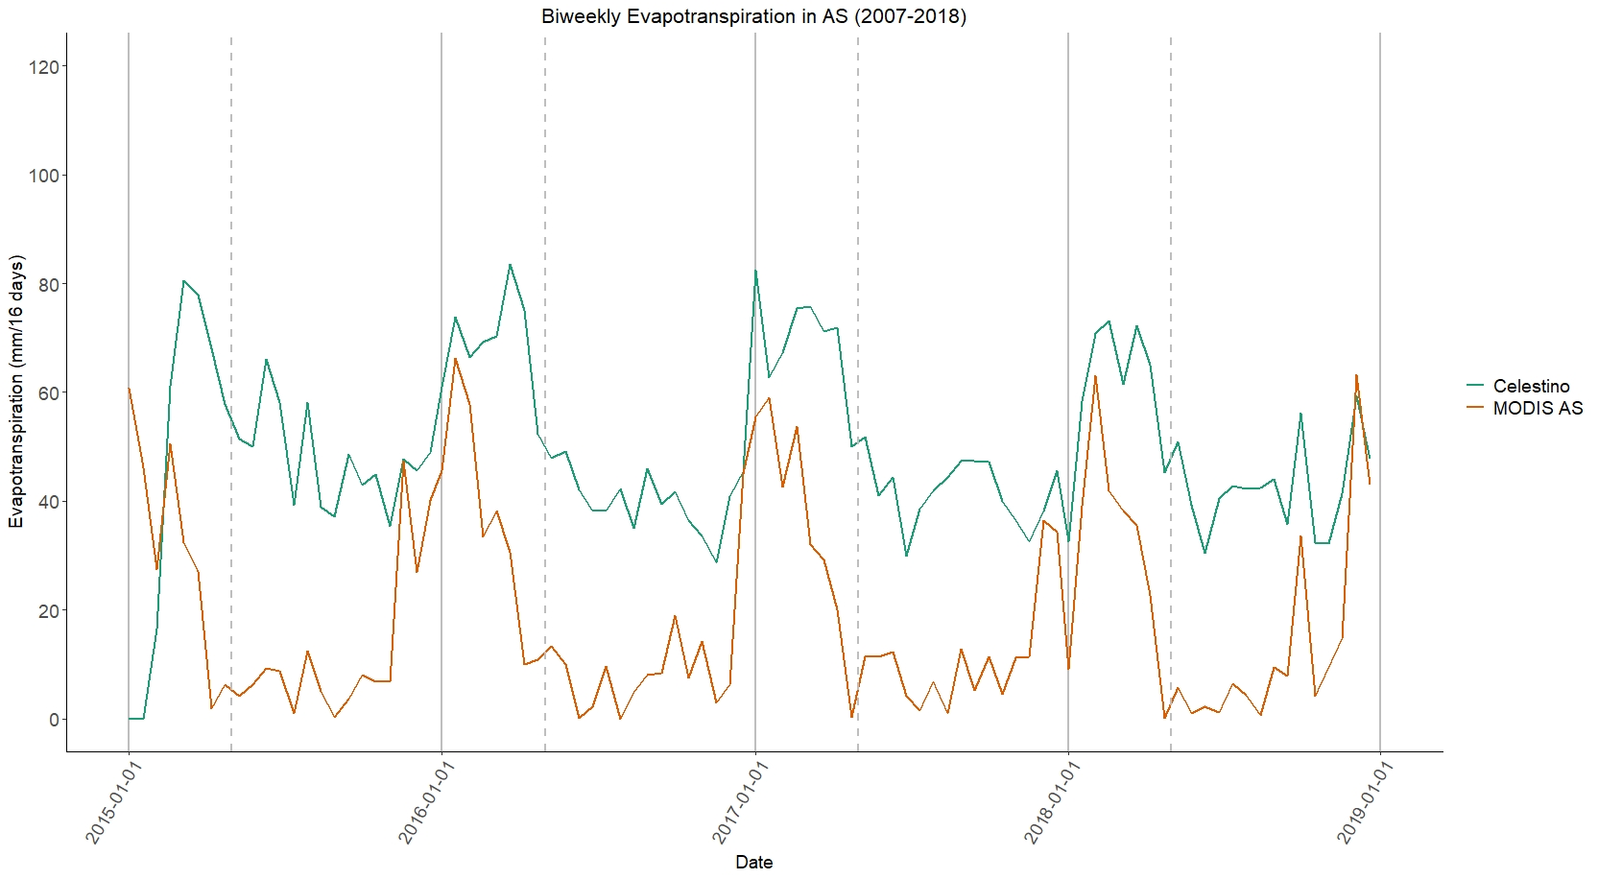

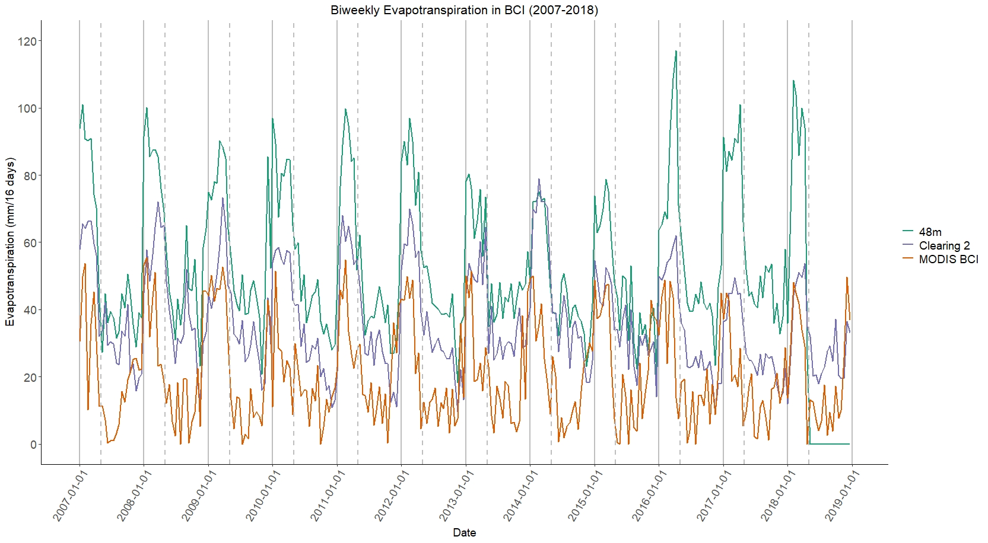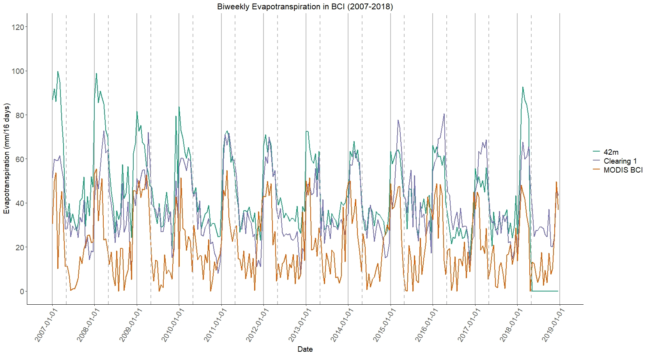

A graph of 16-day total net ET measured by MODIS, shown in orange, and *in situ* stations, shown in shades of blue, in ASP (top) and BCI (middle and bottom). The solid grey line indicates the beginning of the year and the dashed grey line indicates the beginning of May when the seasons generally transition from dry to wet