Jobos Bay Water Resources II

Using Earth Observations to Analyze Shoreline Changes and Understand the Effects of Sea Level Rise in Southern Puerto Rico

 **Technical Report**

Final Draft – March 31st, 2022

Lily Oliver (Project Lead)

Katherine Hahn

Rachael Barrows

Susan Jarvis

***Advisors:***

Dr. Juan Torres Pérez, NASA Ames Research Center (Science Advisor)

Dr. Kenton Ross, NASA Langley Research Center (Science Advisor)

***Previous Contributors:***

Olivia Spencer

Ethan McGhee

Liliana Hernandez Gonzalez

Taylor Conklin

Andrew Altizer

# 1. Abstract

High-intensity storms and coastal development negatively impact the ecosystems of Jobos Bay, Puerto Rico, by causing reductions in mangrove forests and degradation of water quality. These changes compromise the ecosystem services, economic value, and cultural significance that Jobos Bay provides to the community. In collaboration with the Jobos Bay National Estuarine Research Reserve (JBNERR), a NASA DEVELOP team used Earth observations to investigate water quality, watershed land use land cover (LULC), and the impact of Hurricanes Maria and Irma on this mangrove forest area. The team examined mangrove extent using imagery from Landsat 8 Operational Land Imager (OLI), WorldView-2 WV110, and WorldView-3 WV110. Imagery from Sentinel-2 MultiSpectral Instrument (MSI) was used to map watershed LULC. Landsat 8 OLI and Sentinel-2 MSI data were analyzed to investigate water quality in Jobos Bay. Analysis of current watershed LULC produced a map that is similar to ground-truth imagery. Reduction in mangrove extent was observed following the 2017 hurricane events and extent increased over the following years. This information will improve JBNERR’s understanding of the impacts of development and weather events on Jobos Bay, as well as inform future shoreline management decisions that ensure continued quality of the ecosystem.

**Key Terms**

Satellite remote sensing, Landsat 8, Sentinel-2, water quality, mangroves, ORCAA, land use land cover

# 2. Introduction

***2.1 Background Information***

Jobos Bay is the second largest estuary in Puerto Rico and home to economically, ecologically, and socially valuable mangrove forests and associated ecosystems (i.e., coral reefs, seagrass beds). In general, mangroves can provide between $200,000-$900,000 in ecosystem services per hectare (Wells et al., 2006). Within Jobos Bay, mangroves provide these services by minimizing coastal erosion, filtering pollutants, storing nutrients, and creating habitat (Cintrón et al., 1985; Mcleod & Salm, 2006). These mangroves also support the life of many organisms, including economically valuable fish and protected Antillian Manatees (Dieppa et al., 2008).

The Jobos Bay National Estuarine Research Reserve (JBNERR) monitors and protects the bay’s ecology which includes mangrove forests, coral reefs, seagrass meadows, lagoons, and salt marshes (JBNERR, n.d.-a). JBNERR provides education, recreation, and a nature preserve for the communities of Guayama and Salinas (JBNERR, n.d.-b). The goal of JBNERR’s research and education is sustainability in the face of changing land cover use and increased intensity storms (JBNERR, n.d.-c).

Located between the North Equatorial Current and the Gulf Stream, Puerto Rico (PR) faces an increased frequency of high-intensity storms. Jobos Bay has a shallow basin and is located on the South-East coast of PR, causing storm flooding and wind to have more extreme effects (Boose et al., 1994). In 2017, Hurricanes Irma and Maria took place only two weeks apart and caused serious forest disturbance in Puerto Rico (Pasch et al., 2019; Uriarte et al., 2019). Hurricanes cause forest defoliation, small and large-scale branch loss, and the snapping or uprooting of trunks (Lugo, 2008). Land use and land cover (LULC) change can also exacerbate hurricane effects. Run-off from agriculture and urban areas negatively impact the water quality in Jobos Bay (Otero et al., 2015), which harms mangrove root systems. Inspection of water quality and LULC change can help researchers at JBNERR understand current impacts to the bay.

There were very few comprehensive studies on Jobos Bay in the past decade, and most previous studies on hurricane impact to estuaries have used *in situ* data for forest and water quality changes (Feng et al., 2020). *In situ* data can show detailed effects but are harder to use for large-scale changes and time-series analysis. To observe larger-scale changes, remote sensing and spatial analysis is starting to be utilized more frequently, especially to study hurricane affected areas like Jobos Bay (Feng et al., 2020).

In 2021, the NASA DEVELOP Jobos Bay Water Resources I team, used a combination of *in situ* data and Earth observations to research the ecosystem at the Jobos Bay Reserve (JBR). They created an updated LULC map and evaluated coastal change and mangrove forest extent in the JBR. They assessed the water quality of the bay by comparing *in situ* sensor data, provided by JBNERR partners, and water quality datasets through the Optical Reef and Coastal Area Assessment (ORCAA) tool (Pippin et al., 2019). They discovered that 17% of the reserve had changed from land to water since 1997, and that 4.85 square kilometers of mangrove habitat had been lost over the past decade (Spencer et al., 2021).

The information gathered by Jobos Bay Water Resources I provides a baseline for more research of the bay, which can further inform JBNERR partners on management and recovery practices. Building off of this baseline, our Jobos Bay Water Resources II team examined a wider study area and a more detailed, but smaller study period, between 2017 and 2022. We provided additional detail on the classification of mangrove extent in the JBR, further analyzed LULC in 2021, and compared satellite water quality data to *in situ* measurements taken at the time of satellite overpass.

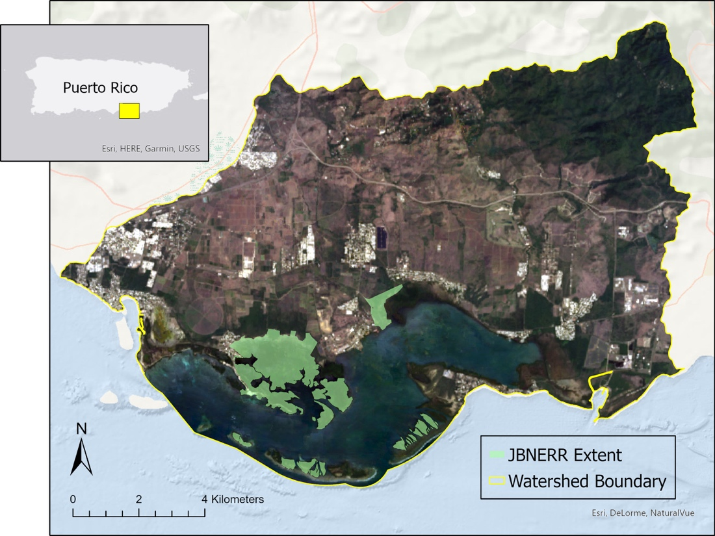

*Figure 1.* Study Area Map of Jobos Bay, Puerto Rico (Data source: Landsat 8 OLI 2021 composite; Light Grey Base from ESRI [Extent Map]; ESRI World Ocean Base [Study Area])

***2.2 Project Partners & Objectives***

The JBR, managed by the Puerto Rico Department of Natural and Environmental Resources and the National Oceanic and Atmospheric Administration (NOAA) Office of Coastal Management, is a protected area for long-term research, water-quality monitoring, education initiatives, and coastal stewardship. The JBNERR conducts outreach to enhance community understanding of Jobos Bay by providing workshops, seminars, and hands-on field experience. Drone imagery and *in situ* data collection contribute to JBNERR’s current decision-making processes. Our project’s main objective was to provide JBNERR with information to inform their conservation and restoration efforts on Jobos Bay. To accomplish this, we aimed to provide a map of watersheds LULC, an analysis of mangrove recovery after Hurricanes Irma and Maria, and a comparison of *in situ* water quality measurements with satellite-derived data. The study and analysis of LULC, along with mangrove and water quality changes will help JBNERR pinpoint certain areas that are in need of restoration or conservation. This data will assist JBNERR’s research and outreach in future shoreline management decisions and in continuation of last terms efforts, will provide JBNERR with more comprehensive and larger scale results.

# 3. Methodology

***3.1 Data Acquisition***

We utilized multiple satellite datasets (Table 1) to map the impacts of Hurricanes Irma and Maria on mangrove extent, analyze land use land cover change in the Jobos Bay watersheds, and compare *in situ* water quality measurements with satellite-derived values. We acquired Landsat 8 Operational Land Imager Collection 2 Level 1 imagery within Google Earth Engine. Additionally, we ordered WorldView 2 WorldView-110 camera imagery and WorldView 3 WorldView-110 camera imagery from Maxar. WorldView 2 and 3 images were accessed from NASA’s commercial archive. Land Use Land Cover data was acquired and exported within Google Earth Engine, and processed in Arc GIS Pro. Sentinel-2 MSI Level 2-A imagery composites were retrieved for January 1 through June 30, 2021. Water quality data were downloaded and processed through Google Earth Engine using NASA’s Optical Reef and Coastal Area Assessment (ORCAA) tool. ORCAA was developed by the Belize and Honduras Water Resources NASA DVELOP team in 2019 (Pippin et al., 2019). Sentinel-2 MSI Level 1-C imagery was already loaded into the ORCAA code and was used to download turbidity, Chlorophyll-a, and colored dissolved organic matter (CDOM) data. Landsat 8 OLI Surface Reflectance Collection 1 Tier 2 imagery was input to ORCAA to update the pre-loaded collection and used to download turbidity data. Satellite data for both Landsat 8 and Sentinel-2 were retrieved for March 23rd,the same day the *in situ* measurements were taken by our partners.

Table 1.

*Satellite and sensor variables used to analyze land use changes, water quality, and mangrove health in Jobos Bay*

|  |  |  |  |  |
| --- | --- | --- | --- | --- |
| **Platform & Sensor** | **Data Products** | **Dates** | **Resolution** | **Use** |
| **Landsat 8 OLI** | USGS Landsat 8 Level 2, Collection 2, Tier 1  USGS Landsat 8 Surface Reflectance Tier 2 | Mangroves: January 1 – June 30, 2017; 2018; 2021  Turbidity: March 23, 2022 | 30 meters | Mangroves  Water quality: turbidity |
| **Sentinel-2 MSI** | Sentinel-2 MSI: MultiSpectral Instrument, Level-2A  Sentinel-2 MSI: MultiSpectral Instrument, Level-1C | LULC: Jan 1 – June 30, 2017; 2021  Water Quality: March 23, 2022 | 10 – 60 meters | Land cover and land use  Water quality: Color Dissolved Organic Matter (CDOM), Chlorophyll-a (Chl-a), turbidity |
| **Maxar WorldView-2 WV110** | WorldView-110 camera imagery | April 6 2016;  October 24, 2017 | ~2 meters | Mangroves |
| **Maxar WorldView-3 WV110** | WorldView-110 camera imagery | September 13, 2021 | ~2 meters | Mangroves |

***3.2 Data Processing***

*3.2.1 Mangroves*

In order to analyze mangrove extent, we adapted methods and Google Earth Engine code from a NASA Applied Remote Sensing Training Program course as the basis for our mapping effort (Barenblitt & Fatoyinbo, 2020). Landsat 8 imagery taken between January 1 and June 30 of 2017, 2018, and 2021 was cloud masked within Google Earth Engine. We used the years 2017, 2018, and 2021 to capture mangrove extent both pre- and post-hurricanes, and to observe how mangrove forests have recovered since the hurricanes occurred. These months were chosen in order to reduce the possibility of high cloud cover in the study site since they are within PR’s “dry” season. We also calculated 7 spectral indices commonly used for mangrove identification, detailed in Table A1. The imagery was masked using Normalized Difference Vegetation Index (NDVI) and Modified Normalized Water Index (NWI) minimum values. Areas with elevation greater than 65 meters, identified from a 2018 LiDAR digital elevation model, were also removed in order to focus the analysis on areas where mangroves most likely exist (OCM Partners, 2018). We then applied median compositing to these images for each year analyzed, and visualized them in false color using Landsat 8 OLI bands 5, 6, 4, which were placed into RGB visualization in the respective order.

*3.2.2 Land Use Land Cover*

We created LULC change composite imagery for the watersheds of Jobos Bay using Sentinel-2 MSI Level 2-A data. After collecting the imagery, we clipped it to the study area and filtered for the least cloudy image composites from Google Earth Engine. The composites were exported into ArcGIS Pro for further analysis.

Our team used the least cloudy image composites to design a LULC classification theme with 10 classes (Table 2), with the goal to match the previous Jobos Bay Team’s 2020 Land Use Land Cover product. By running an unsupervised classification, we developed an automated process of breaking classes apart to establish boundaries and match what is happening on the ground. We then ran the imagery through a supervised classification process, and utilized GEE's random forest classification plugin to cluster and classify homogeneous land cover areas in the form of points and polygons to create the classes. Afterwards, the data was processed through the Image Classification Wizard tool in Arc GIS Pro, to verify the training points for accuracy.

Table 2. *Visualization of the LULC classes chosen*

|  |  |  |
| --- | --- | --- |
| **Value** | **Land Cover Type** | **Description** |
| **1** | Water | Networks and dense patches of mangrove trees. |
| **2** | Agriculture | Land devoted to planting, growing, cultivating or harvesting crops for human or livestock consumption and pasturing. |
| **3** | Barren | The landscape is dry and bare, and has very few plants and no trees. |
| **4** | Urban buildup | Land that is formed and shaped mainly under the influence of human activities. |
| **5** | Mudflats | Barren land that is regularly flooded by tides and is usually barren. |
| **6** | Forest (land) | A large area primarily covered by trees and undergrowth. |
| **7** | Forest (wet) | Moist forest containing broad-leaved tall shrubs and small trees. |
| **8** | Scrub (upland) | Low, woody vegetation in young or stunted stages of growth. |
| **9** | Scrub (wet) | Trees, shrubs and scrub that are located in the coastal intertidal zone. |
| **10** | Grasslands | A large open area dominated by a nearly continuous cover of grass. |

*3.2.3 Water Quality*

Using the ORCAA tool we only atmospherically corrected the Sentinel-2 data imagery, since the Landsat 8 Level 2 images are already atmospherically corrected as part of the Level 2 processing. We then used ORCAA to cloud mask the Landsat 8 imagery. Sentinel-2 imagery was not cloud-masked in the ORCAA tool, which was a limitation for the project, as this can distort data. Because the ORCAA tool gave only one value for the geometry of the bay and several *in situ values* for each parameter were taken,the *in situ* values need to be averaged. Then both the satellite data point and *in situ* data point for each parameter have to be converted to the same units in order to calculate the difference between them. However, due to time constraints, these final steps will be carried out in a future project, which will continue the water quality portion of this project.

***3.3 Data Analysis***

*3.3.1 Mangroves*

Using supervised classification within GEE, we mapped mangrove extent by classifying training points into three categories: 1) Mangrove; 2) Non-Mangrove Forest; 3) Other. These categories were selected to help differentiate mangrove vegetation from adjacent non-mangrove vegetation. With the resulting map, we used stratified random sampling to create 50validation points for each of the three categories. These classified points were compared to Google Earth Pro time series imagery in order to assess the accuracy of the mangrove extent maps. The classification of 10 validation points from each of the three categories were then reassessed using WorldView-2 and WorldView-3 imagery for each time period. We compared this second validation to the same points in the first validation from the Google Earth Pro accuracy assessment in order to perform an independent check of our accuracy values.

*3.3.2 Land Use Land Cover*

We configured the 2021 Land Use Land Cover product in the ArcGIS Pro Image Classification Wizard. The parameters chosen for the supervised classification included an object-based classification type. To create the same classes as Jobos Bay I, we modified the default classification schema of ArcGIS Pro (National Land Cover Dataset for North America) into the final classification shown in Table 2, and then selected an appropriate output location for the training samples. After configuring the parameters, the 10 chosen land cover classes were created by providing a minimum of 15 polygons per land cover class. Once the polygons were created, we applied the Random Trees classifier to the training data. The final image resulted in a visualization that misclassified the mudflats, so we utilized the Reclassifier tool to correct any small errors in the classification result. For validation and accuracy assessment, we created 500 values of accuracy assessment points, and cross compared the points with the Sentinel-2 data to differentiate land cover classes with ground-truthed data. Our team then used the accuracy assessments points to create a confusion matrix table, to verify accuracy.

*3.3.3 Water Quality*

While time didn’t permit, our team initially intended to compare the difference between the corresponding *in situ* measurement and the satellite data for each parameter, to literature values for Jobos Bay. This step would have allowed us to analyze whether the satellite and *in situ* measurements were within a reasonable range of each other. Therefore, to wrap up this analysis, this will be conducted in a future project.

# 4. Results & Discussion

***4.1 Analysis of Results***

*4.1.1. Land Use Land Cover*

Our team produced an updated composite imagery of our study area to serve as a visual guide for JBNERR and to conduct future research on land use land cover change. Compared to last terms LULC work, we observed an increase in agriculture and urban buildup in the study area, between January 1st and June 30th, 2021 (Figure 2.). The LULC component of this project highlights opportunities to continue capacity building within JBNERR by experimenting with different remote sensing strategies for comparison and validation. The accuracy assessment of the LULC analysis compared to the ground-truthed Sentinel-2 imagery composites for our study period was 92%.

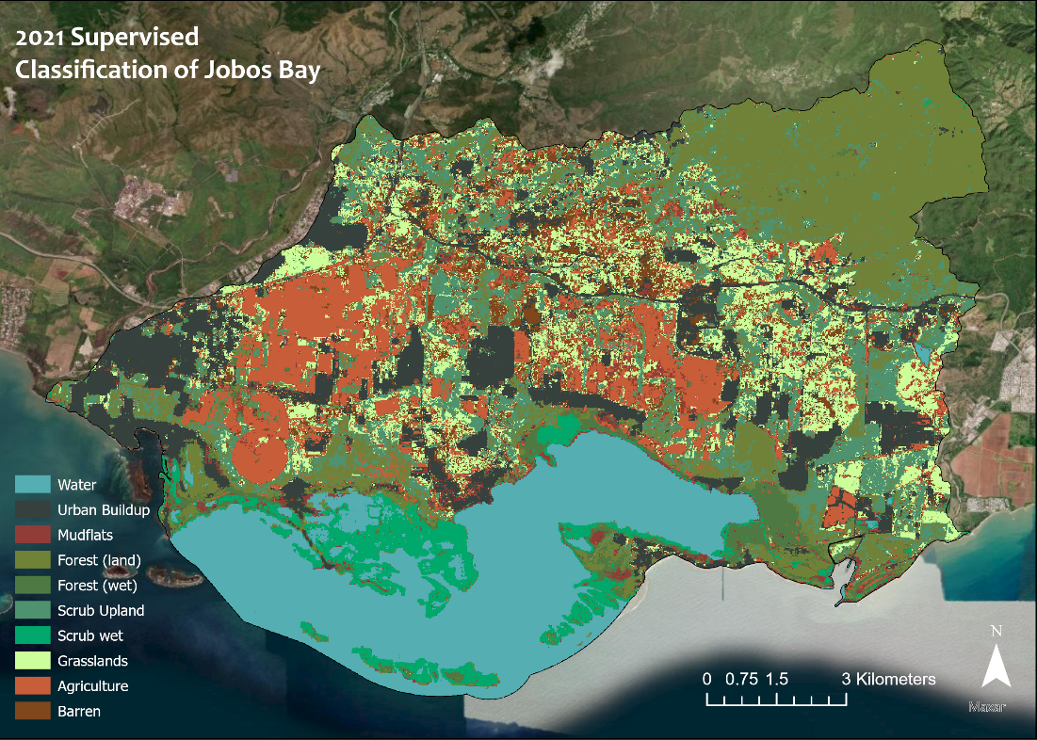

*Figure 2.* 2021 LULC map of Jobos Bay, Puerto Rico and associated watersheds (Basemap: Esri Imagery)

Challenges in this section of the project provided notable limitations on the accuracy of the LULC analysis. Potential errors in the specified training data may have confused the algorithm and lowered its accuracy. For example, during processing, the training data misclassified mudflats, which we then reclassified. It is possible that certain areas were still misclassified, especially under the limited time we had to reclassify the data.

Our study area also contains dynamic, big, and growing data, which creates room for uncertainty when specifying labels and defining polygon training data. Understanding how land cover, use, condition and management vary in space and time is challenging. Changes in land cover can occur to both human and climate drivers. Therefore, understanding these relationships can also help JBNERR conduct work in the future.

*4.1.2 Mangroves*

We estimated a pre-hurricane mangrove extent of 10.02 km2 in 2017. In the modelled 2018 post hurricane extent this area decreased to about 1.25 km2. We found that mangrove area increased to 7.27 km2 in the 2021 mangrove extent estimate. Mangrove loss is especially apparent along the eastern shoreline of Jobos Bay, where mangrove loss first observed in the 2018 extent map appears to persist into 2021 (Figure 3).

1. Map

   Description automatically generated
2. Map

   Description automatically generated
3. Map

   Description automatically generated

*Figure 3.* 2017 (a), 2018 (b), and 2021 (c) maps of mangrove extent (Basemap: ESRI Light Grey Base)

The overall accuracy for the 2017, 2018, and 2021 maps, in comparison to the Google Earth Pro imagery, were 75%, 82%, and 69%, respectively (Tables A2.a, A3.a, A4.a). When the 30 points from each year’s accuracy assessment were validated against land cover in WorldView-2 and -3 imagery, we found that the accuracy assessments for each year were at least 90% correct (Tables A2.b, A3.b, A4.b). This suggests that we can have reasonable confidence in these accuracy assessments.

It must be noted that areas where mangrove interfaced with water or with non-mangrove forest were sometimes classified incorrectly by the mangrove model. While we masked out water before running the classification model, it is possible that tidal areas were not removed in this process, thereby some pixels at the boundaries of mangrove and water were not filtered out. Furthermore, the pixel size of Landsat 8 OLI may not capture the intricacies of the coastal interface, allowing some pixels that are predominantly water but contain some land cover to remain in the map. This is particularly relevant in the 2021 map, where mangrove forest was sparsely growing in some of the areas still recovering from the 2017 hurricanes. When mangrove cover was sparse over bare tidal ground, it was sometimes classified in the model as “other,” though mangrove cover could be seen in the higher resolution of the imagery. Other sources of error for this model were observed where mangrove cover transitioned to non-mangrove forest. In this case, either forest type was classified as the other. Meanwhile, at the borders of mangrove forest and water, pixels predominantly filled with water were classified as mangroves.

JBNERR observed that the 2010 mangrove habitat map produced by the previous team appeared to map mangroves in areas where non-mangrove forest was expected, especially on the eastern coast of Jobos Bay where mangrove forest transitions into non-mangrove forest. Our map of mangrove extent delineated mangrove from the adjacent non-mangrove forest, showing a reduced mangrove extent in comparison to the previously mapped 2010 extent (Figures 4.a,b). This was not a direct comparison because the past map was from 2010, while our earliest map was from 2017. However, it illustrated an area where the transition from mangrove to non-mangrove forest was difficult to delineate due to similarity in the spectral indices between these vegetation types.

*a. 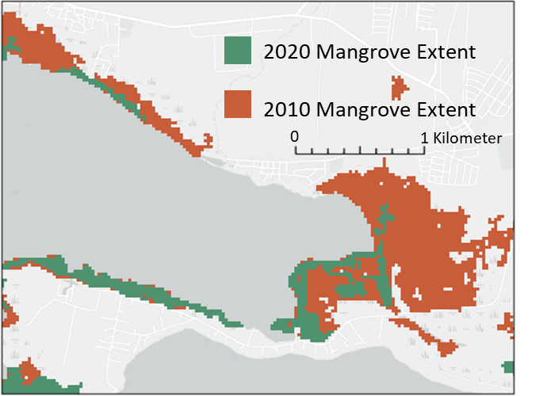 b.* 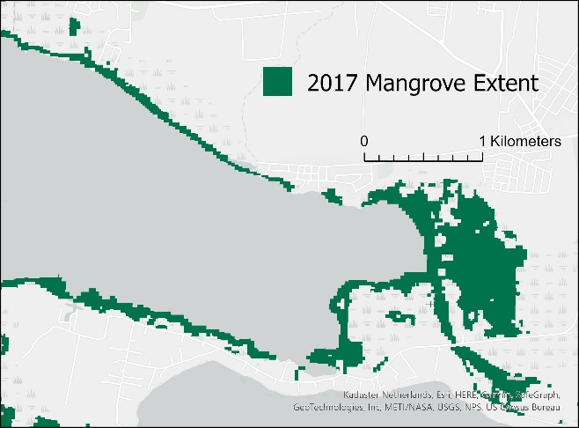

*Figure 4.* Comparison of modeled mangrove extent. (a) 2010 mangrove extent mapped by Jobos Bay Water Resources I in which 2010 mangrove extent was mapped into the non-mangrove forest to the east (adapted from Spencer et al. 2021). (b) Jobos Bay Water Resources II map showing reduced mangrove extent with delineation between mangrove cover and adjacent non-mangrove forest (Basemap: Esri Light Grey Base).

*4.1.3 Water Quality*

Sources of error in our water quality analysis come from the ORCAA tool, which does not have advanced cloud masking techniques for Sentinel-2 data. Also, bottom surface reflectance was a source of error with satellite data in shallow, clear coastal waters, as in the case of Jobos Bay, because the image is affected by the interference of the bottom albedo. These limitations will be considered in future water quality analysis.

***4.2 Future Work***    
Future work should analyze the reason behind growth in mangrove extent, and narrow it down to specific causes, such as natural growth or restoration efforts. Exploring causes for mangrove growth can help researchers at JBNERR know which management efforts are working and continue to implement useful practices. Future partner collaborations with DEVELOP could also delve further into water quality analysis by using the updated version of DEVELOP’s ORCAA tool — ORCAA 2.0 — which is currently being finalized. This would be beneficial for JBNERR because the bottom surface reflectance, sun glint, and the limitations of the original ORCAA software create obstacles in water quality analysis for Jobos Bay. Leveraging ORCAA 2.0 with partner collected water quality samples from both the wet and dry season would improve the water quality analysis by including additional parameters such as ‘diffuse vertical attenuation coefficients’ (KD490 and KDPAR), which are beneficial for comparing satellite and *in situ* observations.

Overall, this new ORCAA tool could help the partners connect their *in situ* monitoring to the larger-scale outlook that remote sensing provides. Some other future considerations are to continue to provide updated LULC maps because of development of the shoreline, which can drastically change mangrove extent and impact the ecosystem. Providing tutorials on how the partners can use programs such as ArcGIS Pro and Google Earth Engine would also be useful so that they can continue analysis on their own accord moving forward.

# 5. Conclusions

To identify areas where future mangrove restoration efforts may be most impactful, partners can compare the maps of mangrove extent (Figure 5). Based on information shared by JBNERR, restoration on the eastern shoreline of Jobos Bay is currently planned. The need for this restoration is supported by our mangrove extent maps, which show that mangrove presence has remained minimal in this area following the hurricanes. These maps can be used by JBNERR to support the importance of mangrove restoration and to understand the impacts of high-intensity storms on mangrove extent over immediate and 3-year timescales.

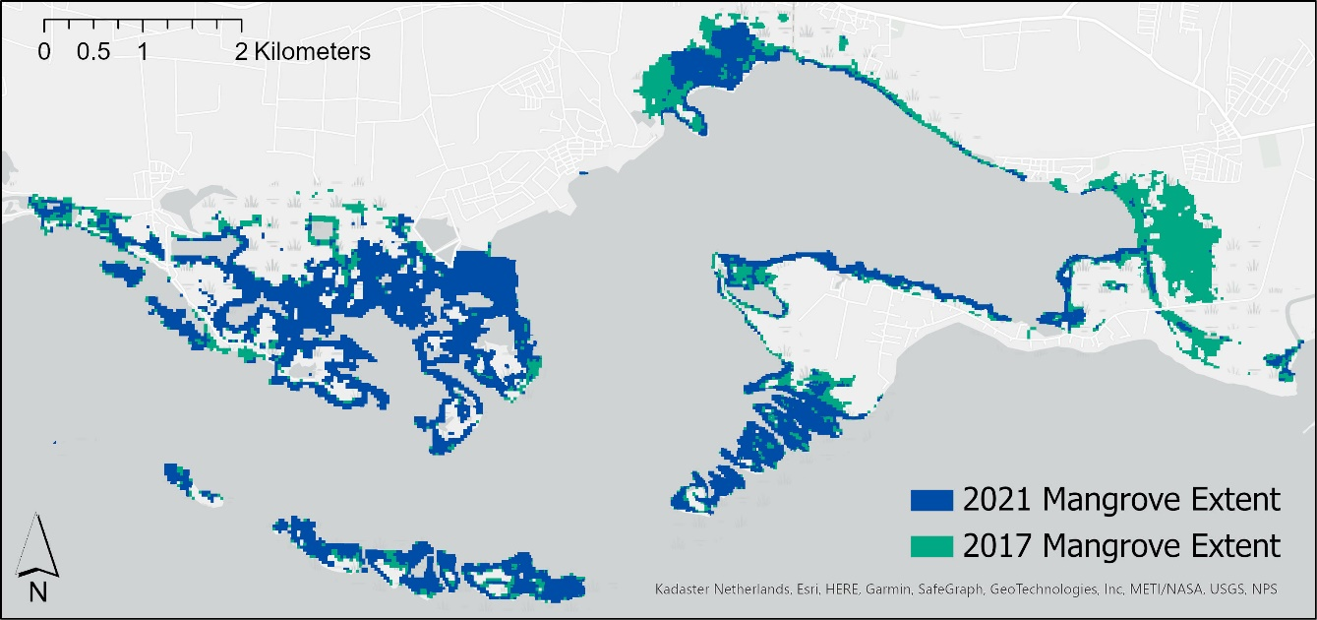

*Figure 5.* Pre-hurricane 2017 mangrove extent in green (10.02 km2) overlayed by 2021 mangrove extent in blue (7.27 km2), with blue areas partially visually covering parts of green. The green peeking through depicts former mangrove areas that have not re-grown by 2021.

Our analysis of LULC provided insight into current land cover conditions for Jobos Bay and the associated watersheds. The 2021 visualization (Figure 2) can be a useful tool for baselining future LULC observations by providing remotely sensed guided visuals for *in situ* field survey data. This can help the partners and the wider community understand how land use dynamics in the Jobos Bay watersheds impact ecosystem health, and as a result support future planning and management efforts. In comparison with the previous 2020 LULC analysis by the Jobos Bay Water Resources I team, it can be concluded that varying methodologies have the capacity to expand research opportunities and provide a more holistic approach to better understanding Earth observation capacities and feasibility for similar study areas.

**6. Acknowledgments**

* Dr. Kenton Ross | Science Advisor for NASA Langley Research Center
* Dr. Juan L. Torres Pérez | Science Advisor NASA Ames Research Center
* Aitza E. Pabón Valentín | Director JBNERR
* Angel Dieppa | Research and Monitoring Coordinator JBNERR
* Milton Muñoz Hincapié | Stewardship Coordinator
* Dr. Roy Armstrong | University of Puerto Rico, Department of Marine Sciences
* Dr. William Hernández | University of Puerto Rico, Department of Marine Sciences
* Adriana Le Compte | NASA DEVELOP Fellow

This material contains modified Copernicus Sentinel data 2021, processed by ESA.

DigitalGlobe/Maxar data were provided by NASA’s Commercial Archive Data for NASA investigators (cad4nasa.gsfc.nasa.gov) under the National Geospatial-Intelligence Agency’s NextView license agreement.

Maps throughout this work were created using ArcGIS® software by Esri. ArcGIS® and ArcMap™ are the intellectual property of Esri and are used herein under license.

Any opinions, findings, and conclusions or recommendations expressed in this material are those of the author(s) and do not necessarily reflect the views of the National Aeronautics and Space Administration.

This material is based upon work supported by NASA through contract NNL16AA05C.

# 

# 7. Glossary

**CDOM (Colored Dissolved Organic Matter) –** The measurable component of the dissolved organic matter within a body of water

**Chlorophyll-a –** The form of chlorophyll used in photosynthesis and a measure of primary production within a body of water

**Earth observations** – Satellites and sensors that collect information about the Earth’s physical, chemical, and biological systems over space and time

**Google Earth Engine (GEE) –** Publicly available platform for scientific analysis and visualization of geospatial datasets that contains public data archives of satellite imagery in analysis-ready format.

***In Situ* Data –** Data collected at the study site/area of interest

**Landsat –** NASA/USGS Earth observation program

**LiDAR (Light Detection and Ranging) –** Remote sensing technique that is useful for assessing 3-dimensional parameters such as topography and bathymetry.

**LULC (Land Use/Land Cover) –** Both the physical land type and the human-related activities of how the land is being used

**ORCAA (Optical Reef and Coastal Area Assessment) –** GEE tool used to analyze water quality changes

**Sentinel-2 –** Two identical satellites in constellation from the Copernicus Programme that acquire high resolution imagery of land and vegetation

**Turbidity –** Measure of cloudiness or opacity within a water body

# 8. References

Barenblitt, A., Fatoyinbo, T. (2020). Remote Sensing for Mangroves in Support of the UN Sustainable Development Goals. NASA Applied Remote Sensing Training Program (ARSET). https://appliedsciences.nasa.gov/join-mission/training?program_area=All&languages=All&source=All&page=1

Boose, E. R., Foster, D. R., & Fluet, M. (1994). Hurricane Impacts to Tropical and Temperate Forest Landscapes*.* *Ecological Monographs*, *64(4), 369–400*. <https://doi.org/10.2307/2937142>

Cintron, G., Lugo, A. E., Pool, D. J., & Morris, G. (1978). Mangroves of Arid Environments in Puerto Rico and Adjacent Islands. *Biotropica,* *10(2), 110–121.* https://doi.org/10.2307/2388013

Dieppa, A., Laboy, E. N., Capella, J., O.Robles, P., González, C. M. (2008). Jobos Bay National Estuarine Research Reserve. *National Oceanic and Atmospheric Association, Office for Coastal Management, National Estuarine Research Reserves*. <https://coast.noaa.gov/data/docs/nerrs/Reserves_JOB_SiteProfile.pdf>

European Space Agency (2021). Sentinel-2 Multispectral Instrument Level-2A. [Dataset]. Google Earth Engine. https://developers.google.com/earth-engine/datasets/catalog/COPERNICUS_S2_SR

European Space Agency (2021). Sentinel-2 Multispectral Instrument Level-1C. [Dataset]. Google Earth Engine. https://developers.google.com/earth-engine/datasets/catalog/COPERNICUS_S2

Feng, Y., Negrón-Juárez, R. I., & Chambers, J. Q. (2020). Remote sensing and statistical analysis of the effects of hurricane María on the forests of Puerto Rico. *Remote Sensing of Environment*, 247, 111940. <https://doi.org/10.1016/j.rse.2020.111940\>

Jobos Bay National Estuarine Research Reserve (n.d.-a). *Natural Reserve.* Departmento de Recursos Nationales y Ambientales de Puerto Rico [Puerto Rico Department of Natural and Environmental Resources]. <https://www.drna.pr.gov/jbnerr/programa_educacion/>

Jobos Bay National Estuarine Research Reserve (n.d.-b). *Education Program*. Departmento de Recursos National y Ambientales de Puerto Rico [Puerto Rico Department of Natural and Environmental Resources]. <https://www.drna.pr.gov/jbnerr/programa_educacion/>

Jobos Bay National Estuarine Research Reserve (n.d.-c). *Investigation Program.* Departmento de Recursos National y Ambientales de Puerto Rico [Puerto Rico Department of Natural and Environmental Resources]. https://www.drna.pr.gov/jbnerr/programa_educacion/

Lugo, A. E. (2008). Visible and invisible effects of hurricanes on forest ecosystems: An international review. *Austral Ecology*, *33(4), 368–398.* <https://doi.org/10.1111/j.1442-9993.2008.01894.x>

Mcleod, E., Salm, R. V., International Union for Conservation of Nature and Natural Resources, Global Marine Programme, & Nature Conservancy. (2006). Managing mangroves for resilience to climate change. *World Conservation Union* (IUCN). https://portals.iucn.org/library/sites/library/files/documents/2006-041.pdf

OCM Partners, 2022: (2018) USGS Lidar DEM: Post Hurricane Maria - Puerto Rico from 2010-06-15 to 2010-08-15. NOAA National Centers for Environmental Information https://www.fisheries.noaa.gov/inport/item/60105/citation

Otero Morales, E., Detres, Y., Armstrong, R., Williams, S., & Hernandez, W. (2015). Integration of Field, Aerial Photography and Water Quality Measurements for the Assessment of Anthropogenic Impacts and Stressors in Southern Puerto Rico. *Puerto rico Seagrass Fund.* https://doi.org/10.13140/RG.2.1.3163.2723

Pasch, R. J., Penny, A. B., & Berg, R. (2018). National Hurricane center tropical cyclone report: Hurricane Maria. Available: https://www.nhc. noaa.gov/data/tcr/AL152017_Maria.pdf [Accessed 15 Feb 2022].

Pippin, H., Valenti, V., Olarte, A. Pilot, R. (2019). Developing a Google Earth Engine Dashboard for Assessing Coastal Water Quality in the Belize and Honduras Barrier Reefs to Identify Adequate Waste Control and Inform Coastal Resource Monitoring and Management [Unpublished Manuscript]. NASA DEVELOP National Program.

Spencer, O., McGhee, E., & Conklin, T. (2021). Jobos Bay Water Resources: Using Earth Observations to Analyze Shoreline Changes and Understand the Effects of Sea Level Rise in Southern Puerto Rico [Unpublished Manuscript]. NASA DEVELOP National Program.

Uriarte, M., Thompson, J., & Zimmerman, J. K. (2019).Hurricane María tripled stem breaks and doubled tree mortality relative to other major storms. *Nature Communications, 10*(1), 1362*.* <https://doi.org/10.1038/s41467-019-09319-2>

USGS (2021) USGS EROS Archive – Landsat Archives – Landsat 8 OLI and TIRS Level –2 Data Products [data]. https://doi.org/10.5066/P9OGBGM6

Wells, S., Ravilious, C., Corcoran, E. (2006). In the front line. Shoreline protection and other ecosystem services from mangroves and coral reefs. *UNEP-WCMC Biodiversity Series 24. UNEP-WCMC.* http://archive.org/details/infrontlineshore06well

# 9. Appendix

Appendix A

*Table A1.* Spectral indices used in NASA ARSET model for classification of mangrove land cover

|  |  |  |  |
| --- | --- | --- | --- |
| **Indices** | | **Formula** | **Purpose** |
| NDVI | Normalized Difference Vegetation Index | (NIR - Red) / (NIR + Red) | Vegetation |
| NDMI | Normalized Difference Mangrove Index | (SWIR 2 - Green) / (SWIR 2 + Green) | Mangrove identification |
| MNDWI | Modified Normalized Difference Water Index | (Green - SWIR 1) / (Green + SWIR 1) | Water information |
| SR | Simple Ratio | NIR / Red | Simple vegetation index |
| Ratio54 | Band Ratio 54 | SWIR1 / NIR | Water features |
| Ratio35 | Band Ratio 35 | Red / SWIR 1 | Water features |
| GCVI | Green Chlorophyll Vegetation Index | (NIR / Green) - 1 | Greenleaf biomass |

*Table A2*. Confusion matrices of 2017 mangrove accuracy assessment (a) and independent check of accuracy assessment (b)

|  |  |  |  |  |  |  |  |
| --- | --- | --- | --- | --- | --- | --- | --- |
| *a.* |  | Google Earth Pro | | | | | |
|  |  | **Non-Mangrove Forest** | **Other** | **Mangrove** | **Total** | **U_Accuracy** | **Kappa** |
| Classified | **Non-Mangrove Forest** | 35 | 4 | 11 | 50 | 70% | N/A |
| **Other** | 3 | 38 | 9 | 50 | 76% | N/A |
| **Mangrove** | 0 | 10 | 40 | 50 | 80% | N/A |
| **Total** | 38 | 52 | 60 | 150 | N/A | N/A |
| **P_Accuracy** | 92% | 73% | 67% | N/A | 75% | N/A |
| **Kappa** | N/A | N/A | N/A | N/A | N/A | 63% |
|  |  |  |  |  |  |  |  |
|  |  |  |  |  |  |  |  |
| *b.* |  | WorldView-2 | | | | | |
|  |  | **Non-Mangrove Forest** | **Other** | **Mangrove** | **Total** | **U_Accuracy** | **Kappa** |
| Google Earth Pro | **Non-Mangrove Forest** | 4 | 1 | 0 | 5 | 80% | N/A |
| **Other** | 1 | 9 | 1 | 11 | 82% | N/A |
| **Mangrove** | 0 | 0 | 14 | 14 | 100% | N/A |
| **Total** | 5 | 10 | 15 | 30 | N/A | N/A |
| **P_Accuracy** | 80% | 90% | 93% | N/A | 90% | N/A |
| **Kappa** | N/A | N/A | N/A | N/A | N/A | 84% |

*Table A3*. Confusion matrices of 2018 mangrove accuracy assessment (a) and independent check of accuracy assessment (b)

|  |  |  |  |  |  |  |  |
| --- | --- | --- | --- | --- | --- | --- | --- |
| *a.* |  | Google Earth Pro | | | | | |
|  |  | **Non-Mangrove Forest** | **Other** | **Mangrove** | **Total** | **U_Accuracy** | **Kappa** |
| Classified | **Non-Mangrove Forest** | 38 | 11 | 1 | 50 | 76% | N/A |
| **Other** | 0 | 42 | 8 | 50 | 84% | N/A |
| **Mangrove** | 0 | 7 | 43 | 50 | 86% | N/A |
| **Total** | 38 | 60 | 52 | 150 | N/A | N/A |
| **P_Accuracy** | 100% | 70% | 82% | N/A | 82% | N/A |
| **Kappa** | N/A | N/A | N/A | N/A | N/A | 73% |
|  |  |  |  |  |  |  |  |
|  |  |  |  |  |  |  |  |
| *b.* |  | WorldView-2 | | | | | |
|  |  | **Non-Mangrove Forest** | **Other** | **Mangrove** | **Total** | **U_Accuracy** | **Kappa** |
| Google Earth Pro | **Non-Mangrove Forest** | 7 | 1 | 0 | 8 | 88% | N/A |
| **Other** | 0 | 11 | 0 | 11 | 100% | N/A |
| **Mangrove** | 0 | 2 | 9 | 11 | 82% | N/A |
| **Total** | 7 | 14 | 9 | 30 | N/A | N/A |
| **P_Accuracy** | 100% | 79% | 100% | N/A | 90% | N/A |
| **Kappa** | N/A | N/A | N/A | N/A | N/A | 85% |

*Table A4.* Confusion matrices of 2021 mangrove accuracy assessment (a) and independent check of accuracy assessment (b).

|  |  |  |  |  |  |  |  |
| --- | --- | --- | --- | --- | --- | --- | --- |
| *a.* |  | Google Earth Pro | | | | | |
|  |  | **Non-Mangrove Forest** | **Other** | **Mangrove** | **Total** | **U_Accuracy** | **Kappa** |
| Classified | **Non-Mangrove Forest** | 30 | 5 | 15 | 50 | 60% | N/A |
| **Other** | 1 | 38 | 11 | 50 | 76% | N/A |
| **Mangrove** | 0 | 14 | 36 | 50 | 72% | N/A |
| **Total** | 31 | 57 | 62 | 150 | N/A | N/A |
| **P_Accuracy** | 97% | 67% | 69% | N/A | 69% | N/A |
| **Kappa** | N/A | N/A | N/A | N/A | N/A | 54% |
|  |  |  |  |  |  |  |  |
|  |  |  |  |  |  |  |  |
| *b.* |  | WorldView-3 | | | | | |
|  |  | **Non-Mangrove Forest** | **Other** | **Mangrove** | **Total** | **U_Accuracy** | **Kappa** |
| Google Earth Pro | **Non-Mangrove Forest** | 4 | 0 | 0 | 4 | 100% | N/A |
| **Other** | 0 | 12 | 0 | 12 | 100% | N/A |
| **Mangrove** | 0 | 1 | 13 | 14 | 93% | N/A |
| **Total** | 4 | 13 | 13 | 30 | N/A | N/A |
| **P_Accuracy** | 100% | 92% | 100% | N/A | 97% | N/A |
| **Kappa** | N/A | N/A | N/A | N/A | N/A | 95% |