**NASA DEVELOP National Program**

****NASA Ames Research Center

**Summer 2016**

**Short Title: Caribbean Oceans II**

**Subtitle:** Addressing Inundation Events: A Comparative Study of Remote Sensing Techniques Utilizing NASA Earth Observations to Identify *Sargassum* for Caribbean Nations

**VPS Title:** *Sargassum* Returns! Seeing Inundation Events with Earth Observations

**Project Team & Partners**

**Project Team:**

Jordan Ped (Project Lead), Jordan.w.ped@nasa.gov

Emma Accorsi

Maria Lopez-Peña

**Advisors & Mentors:**

Dr. Juan Torres-Pérez (Bay Area Environmental Research Institute)

Sherry Palacios (Bay Area Environmental Research Institute)

**Past or Other Contributors:**

Erica Scaduto

**Partner Organizations:**

|  |  |  |  |
| --- | --- | --- | --- |
| **Organization** | **POC (Name, Position/Title)** | **Partner Type** | **Boundary Org?** |
| Consorcio de Instituciones de Investigación Marina del Golfo de México y del Caribe (CiiMar-GoMC) | Dr. Porfirio Alvarez Torres, Executive Secretary | End-User | Yes* |
| Comisión Nacional para el Conocimiento y Uso de la Biodiversidad (CONABIO) | Dr. Sergio Cerdeira, Marine Monitoring Coordinator | Collaborator | No |
| University of Puerto Rico, Department of Marine Sciences | Dr. Roy A. Armstrong, Professor | Collaborator | No |
| Regional Activity Center for Specially Protected Areas and Wildlife (SPAW-RAC) | Frédérique Fardin, Project Coordinator | Collaborator | No |
| Sea Education Association | Deb Goodwin, Assistant Professor; Jeff Schell, Associate Professor; Amy Siuda, Associate Professor | Collaborator | No |

**Project Details**

**Applied Sciences National Application Addressed:** Oceans

**Study Area:** Caribbean Sea, Caribbean Nations (Cuba, Haiti, Dominican Republic, Puerto Rico, Jamaica, Trinidad and Tobago, Guadeloupe, Bahamas, Saint Lucia, Curacao, Aruba, Saint Vincent and the Grenadines, Grenada, Antigua and Barbuda, Dominica, Cayman Islands, Saint Kitts and Nevis, Saint Maarten, Turks and Caicos, British Virgin Islands, Anguilla, Caribbean Netherlands, Saint Barthelemy, Montserrat, Martinique, Barbados, United States Virgin Islands)

**Study Period:** January 2003 - Aug 2016

**Earth Observations & Parameters:**

Aqua, Moderate Resolution Imaging Spectroradiometer (MODIS) – low resolution detection, index based detection

Sentinel-II, MultiSpectral Instrument (MSI) – hyperspectral detection at high resolution

Landsat 8, Operational Land Imager (OLI) – high resolution detection

SAC-D Aquarius – Sea Surface Salinity

Advanced Very High Resolution Radiometer (AVHRR) - Sea Surface Temperature

**Ancillary Datasets Utilized:**

* Sea Education Association Cruise *in situ* data - Cruise tow datasets

**Models Utilized:**

* TerrSet Earth Trends Modeler (ETM)- Seasonal trends analysis, inter-annual trends analysis
* Multiple Endmember Spectral Mixture Analysis (MESMA) – Pixel classification

**Software Utilized:**

* TerrSet – Time series, statistical analysis, forecasting
* ArcGIS – Raster manipulation/analysis, ground truth spatial identification
* SeaDAS – Image processing, atmospheric correction
* ENVI – MESMA model

**Project Overview**

**80-100 Word Objectives Overview:**

In 2015, Caribbean nations were inundated by an unprecedented amount of *Sargassum* sp.*,* apelagic brown seaweed, triggering great concern across the region. In the open ocean, floating *Sargassum* mats serve as diverse, nutrient-rich ecosystems for a range of invertebrate and vertebrate species. However, when *Sargassum* reaches coastlines in large quantities, it imposes an enormous cost on local ecotourism-based economies. This project compares methods for using NASA Earth observations to detect *Sargassum* across the Caribbean Sea while assessing the reliability of ground truth data from social media. A better understanding of these events will help these economies and promote sustainable management practices.

**Abstract:**

In 2015, Caribbean nations were overwhelmed by an unprecedented quantity of *Sargassum* that washed ashore. This issue prompted international discussion to better understand the origin, distribution, and movement of *Sargassum*, a free-floating brown seaweed with ecological, environmental, and economic importance. In the open ocean, *Sargassum* mats serve a vital ecological function. However, when large quantities appear onshore without warning, *Sargassum* threatens local tourist industries and near-shore ecosystems. As part of the international response, this project investigated the proliferation of this seaweed using National Aeronautics and Space Administration (NASA) Earth observations for detection of *Sargassum* and available nutrients across the region. The NASA DEVELOP National Program Caribbean Oceans team at the NASA Ames Research Center compared Landsat 8 Operational Land Imager (OLI) imagery to Aqua Moderate Resolution Imaging Spectroradiometer (MODIS) and Sentinel II MultiSpectral Instrument (MSI) imagery across a number of indices for the identification of *Sargassum*. The presence of *Sargassum* was then compared to ground truth data points from Sea Education Association cruises and social media platforms, as well as various oceanic variables, to determine the ideal pelagic environment for *Sargassum* growth. As part of the international effort to better understand the life cycle of *Sargassum* in the Caribbean, the results of this project will assist local economies and help promote sustainable management practices.

**Keywords:**

MODIS, Landsat, Sentinel II, Floating Algal Index, Biodiversity

**Community Concerns:**

* The origins of major *Sargassum* events are unknown. This prevents (1) an accurate forecasting of the arrival of *Sargassum* and (2) a proactive, ecosystem-sensitive, solution for its removal.
* Near-shore ecosystems, especially sea turtle nesting sites, are often harmed by the efforts to remove large quantities of *Sargassum*. The heavy machinery that is used to clear it can be destructive to these sites.
* Communities, as well as federal and local governments across the Caribbean region, are concerned about the adverse effects of *Sargassum* influxes on the tourist industry.

**Current Management Practices & Policies**:

Currently, tourist industries within affected coastal areas are utilizing live webcams to monitor shores for *Sargassum* influxes. The Mexican government has released regulation standards on how to remove *Sargassum* on beaches, which usually requires the use of heavy machinery. This method can kill marine species or significantly stir the sand, thereby disrupting coastal environments. Other methods include removal of *Sargassum* by hand, which is time-consuming and costly. Caribbean governments rely mostly on sightings reports from local fishermen and other coastal community members, as Earth observations have not been incorporated into governmental policies and practices.

**Decision Support Tools & Benefits:**

|  |  |  |  |
| --- | --- | --- | --- |
| **End-Product** | **Earth Observations Used** | **Benefit & Impact** | **Software**  **Release** |
| Index Accuracy Assessment | Landsat 8 OLI, Aqua MODIS | Determination of the relationship between MODIS FAI values and *Sargassum* quantity for improved forecasting of influxes | N/A |
| Oceanic Variables Relationship | Landsat 8 OLI, Aqua MODIS, SAC-D, AVHRR | A more detailed understanding of the ideal pelagic environment for *Sargassum reproduction* | N/A |
| Ground Truth Assessment | Landsat 8 OLI, Aqua MODIS | Assessment of Instagram and cruise data relative to Earth observations | N/A |

**Project VPS/Booklet Imagery**

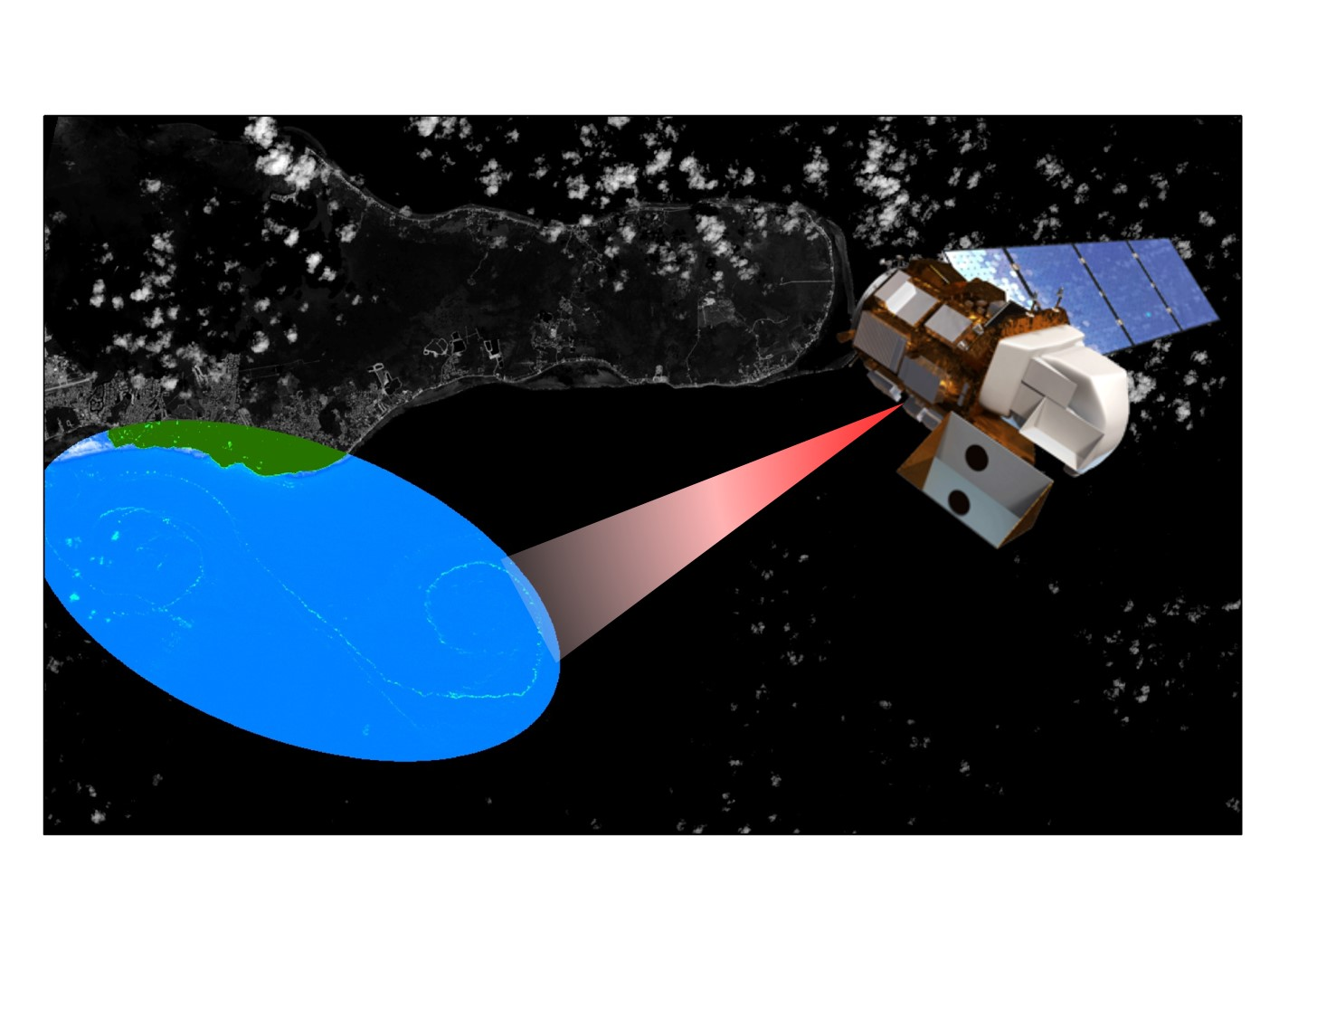

**Caption:** The Floating Algal Index (FAI) applied to a Landsat 8 scene from 2015, clearly shows *Sargassum* windrows caught in an eddy off the Cayman Islands. Image Credit: Caribbean Oceans II team.

**Image:** 2016Sum_ARC_CaribbeanOceansII_VPSimage.jpeg