**NASA DEVELOP National Program**



NASA Jet Propulsion Laboratory

*Spring 2016*

Louisiana Ecological Forecasting II

Using UAVSAR, AVIRIS, and AirSWOT to Model Coupled Water Flow and Sediment Transport for Delta Building within the Wax Lake Delta, Louisiana to Inform Coastal Restoration Efforts

 **Technical Report**

Final Draft – March 31, 2016

Erika Higa (Project Lead)

Mark Barker

Emily Beck

Dr. Cathleen Jones, NASA Jet Propulsion Laboratory (Science Advisor)

Dr. Marc Simard, NASA Jet Propulsion Laboratory (Science Advisor)

Previous Contributors:

Brittany Zajic

Raul Garcia

# I. Abstract

Erosion, land subsidence, and sea level rise along the Louisiana coast have led to 4900 km2 of land loss since the 1930's. It is estimated that Louisiana has the potential to lose an additional 4500 km2 over the next 50 years if no restoration action is taken. While most of the Louisiana coast is eroding, the Wax Lake Delta has continued to grow at a rate of approximately 5 km2 per year since the 1970's. Currently, labor intensive boat-based surveys are conducted to understand the delta building dynamics at Wax Lake. There have been a number of studies on the natural processes that contribute to this growth, but many of these studies lack tested models. We used remotely sensed and *in situ* data, as well as Deltares Delft3D modeling software, to model water flow and sediment transport in the delta—calibrating the model using AirSWOT data. Model outputs will be used to inform coastal research by project partners at the United States Naval Research Laboratory in Mississippi and the Louisiana Universities Marine Consortium to assist the efforts of coastal managers in predicting coastline change and planning restoration projects to reduce land loss along Louisiana's coast.

**Keywords**

Hydrological Modeling, Remote Sensing, Sediment Transport, Delta Formation, Coastal Restoration, Delft3D, Wax Lake Delta

# II. Introduction

Erosion, land subsidence, and sea level rise along the Louisiana coast have led to the loss of 4900 km2 of land since the 1930’s, threatening one of the most economically important port systems in the United States as well as the tapestry of unique cultures that contribute to the region’s rich history (Olea & Coleman, 2014). According to the State of Louisiana’s Comprehensive Master Plan for a Sustainable Coast (2012), Louisiana has the potential to lose up to an additional 4500 km2 over the next 50 years unless immediate action is taken. Although most of the coast is suffering land loss, the Wax Lake Delta has created over 50 km2 of new deltaic surface since the early 1970’s, building at a rate of approximately 0.8 km2 per year (Kleiss 2009).

The primary objective of this study was to use remotely sensed data, *in situ* data, and hydrological modeling software to model water flow and sediment transport within the Wax Lake Delta in order to examine delta formation and obtain a better understanding of why the area is experiencing aggregation. The results will support current research in the region, provide data to coastal scientists and managers, and offer insight into potential ways to direct coastal restoration projects in areas of Louisiana where coastal marshes are eroding, often at rapid rates. The study area for this project is the Wax Lake Delta in Louisiana (see Figure 1), and the study period is from April 2015 to May 2015. The NASA Earth observations used in this project were the Uninhabited Aerial Vehicle Synthetic Aperture Radar (UAVSAR), Air Surface Water and Ocean Topography (AirSWOT), and Airborne Visible-Infrared Imaging Spectrometer – Next Generation (AVIRIS-NG). UAVSAR, mounted beneath the Gulfstream-III, measures Earth surface change (Chapman 2015) and has the capability to see below vegetation, examine water level and examine properties of both thick vegetation cover and the ground below it (Dr. Jones, C., personal communication, November 2015) using an L-band radar antenna with a wavelength of about one foot (Chapman 2015). AirSWOT is a multi-purpose Ka-band radar, mounted on a King Air B200, which can be used to obtain centimeter-level digital elevation models of water surfaces and floodplains (Srinivasan 2015). AVIRIS-NG, a hyperspectral optical sensor with 432 bands and onboard the ER-2 jet , has been developed to provide continued access to high signal-to-noise ratio imaging spectroscopy measurements in the solar reflected spectral range from a DHC-6 Twin Otter platform (Lundeen 2015).

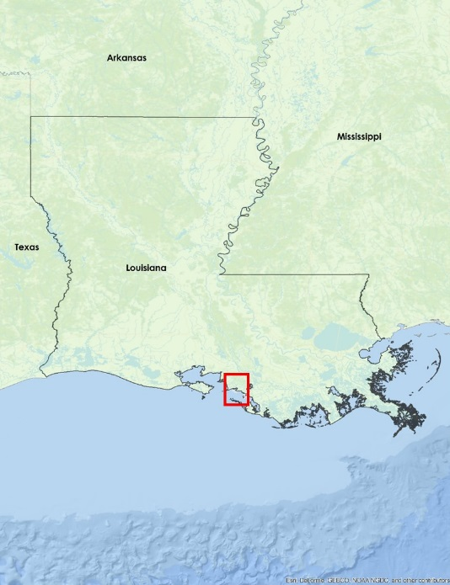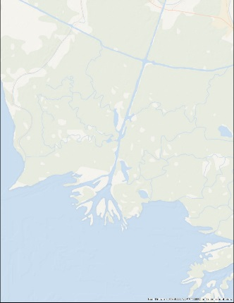

Figure 1: Wax Lake Delta, LA

This project addresses the Ecological Forecasting National Application Area by combining UAVSAR, AirSWOT, and AVIRIS-NG sensor data with *in situ* data in hydrological modeling software to forecast coastal aggregation in the Wax Lake Delta. Results of this project will inform restoration efforts to promote better management strategies.

End products of the study will include a Wax Lake Delta vegetation elevation raster and a hydrological model of the Delta, depicting sediment transport, water flow, and an elevation time series. These end products will help to inform the decision making process of our project partners. Those partners include Richard Crout, an oceanographer from the Naval Research Laboratory at NASA Stennis Space Center in Mississippi, and Dr. Alexander Kolker from the Louisiana Universities Marine Consortium. Mr. Crout is investigating buoyancy plume modulation of coastal processes in the area impacted by the Mississippi and Atchafalaya River discharge. His project utilizes an ocean circulation model, which uses *in situ* water level and discharge rates from the Atchafalaya Bay and Wax Lake outlet region. The end products from our project will provide greater accuracy and also complement this model. Dr. Kolker is an academic liaison to Louisiana’s Comprehensive Master Plan for a Sustainable Coast that is being developed for 2017. Our resulting products will provide Dr. Kolker with a broad-scale picture of the accretion process to inform the development of an improved sediment distribution algorithm that will help coastal management in understanding how to direct land restoration efforts along the Louisiana coast.

# III. Methodology

**Vegetation Classification of AVIRIS-NG and Landsat 8 OLI**

We used AVIRIS-NG images that were collected from May 2015 to examine the vegetation around the Wax Lake Delta. The three AVIRIS-NG images were acquired from our project advisor, Dr. Marc Simard, and had already been calibrated for reflectance, mosaicked, and masked for clouds and shadows. Water was also masked out of the images since it would greatly interfere with the vegetation classification process. AVIRIS-NG has 432 spectral bands and only 11 bands that are sensitive to vegetation conditions was used for vegetation classification mapping. The 11 bands used for classification included 6 bands in the visible, three bands in the near infrared, and 2 in the short wave infrared (see Table 1 in Appendix). An Iso Cluster Unsupervised Classification tool in ArcGIS was used on the 11 bands to classify the vegetation classes. The resulting classification produced 15 classes. The classes were combined into 8 generalized land cover classes (see Figure 2).

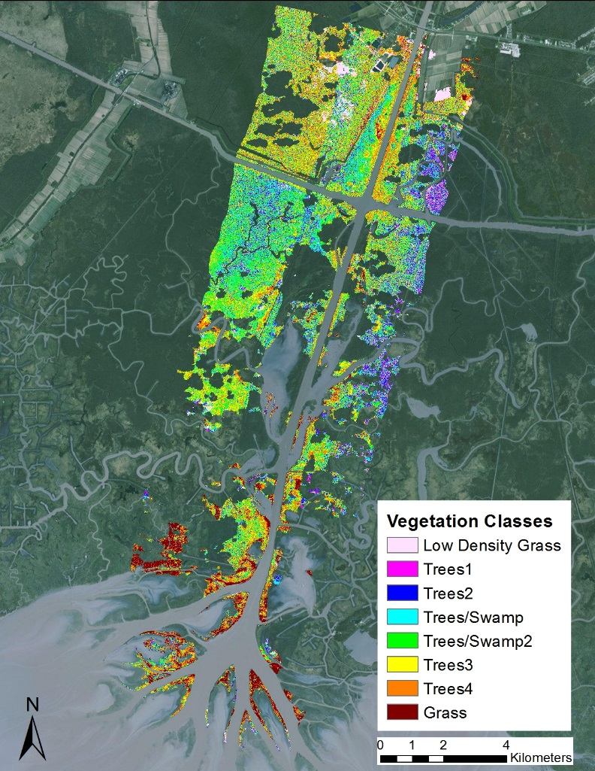

Figure 2. AVIRIS-NG image classified into 8 generalized vegetation types using an ISODATA unsupervised classification method.

We also created a land cover map from Landsat 8 Operational Land Imager (OLI) data, since the AVIRIS-NG image has multiple gaps due to the cloud, shadow, and water mask. A cloud free Level 1T Landsat 8 OLI image from April 19th, 2015 was downloaded from USGS EarthExplorer. The Landsat 8 OLI came terrain and atmospherically corrected and an ISODATA unsupervised classification was used on bands 3 (Green), 5 (NIR), and 6 (SWIR). Bands 3, 5, and 6 were optimal to use in land cover mapping since these bands are the least correlated with each other and thus are able to distinguish features without the noise from the other bands. The resulting classification produced 10 classes and the Combine Classes tool in ENVI was used to merge the classes into 6 generalized land cover classes (see Figure 6 in Appendix).

**Vegetation Elevation Classification of UAVSAR Data**

We used UAVSAR data to classify the vegetation in the Wax Lake Delta and later reclassify the vegetation into elevation values. There were multiple UAVSAR images collected along the Louisiana coastline from May 2015 and a calibrated and mosaicked UAVSAR image was acquired from our project science advisor, Dr. Marc Simard. The acquired UAVSAR image was also already converted to decibels (dB) for ease of interpretation and analysis.

To create an elevation raster, we first classified the UAVSAR data based on vegetation type. The UAVSAR image was reclassified into three vegetation classes based on the backscatter values. With Dr. Simard’s suggestion, the decibel ranges were chosen by creating Region of Interests (ROIs) to delineate areas of water, low vegetation (grass), and high vegetation (tree) in the image and observing the mean and standard deviation ranges of the decibel value per class. Water was classified in areas that had a value below -24 dB. Grass was classified in areas that had a value below -17 dB, and trees was classified in areas that had a value below -2 dB (see Figure 7 in Appendix). Under Dr. Simard’s suggestion, the vegetation classes were later reclassified to elevation values in which water were classified as -1 meter, grass as -0.40 meter, and trees as 1 meter. The reclassified UAVSAR was created using the Geospatial Data Abstraction Library (GDAL) package within Python. This layer was used as a proxy layer to create the final bathymetry layer of the study area.

**Bathymetry**

We created the final bathymetry layer for use in Delft3D by merging the proxy vegetation elevation classified UAVSAR image with three additional topo-bathymetric datasets. We used a Wax Lake Outlet upper channel bathymetry that was interpolated from the United States Army Corps of Engineers (USACE) 1998 Atchafalaya River Hydrographic Survey transect points. The bathymetry for the upper channel was created using the Kriging interpolation method in ArcGIS 10.3 on the transect points. The interpolated layer was masked using the UAVSAR water mask shapefile that Dr. Marc Simard provided us since last term. Dr. John Shaw, from the University of Arkansas, who has worked on the morphology of the Wax Lake Delta, kindly provided us with a high resolution bathymetry image of the Wax Lake Delta. We also used the Coastal National Elevation Dataset (CoNED) Topobathymetric Digital Elevation Model (TBDEM) dataset for the offshore and middle channel bathymetry. The CoNED TBDEM is a comprehensive topobathymetric digital elevation model that contains over 400 different data sources including topographic and bathymetric LiDAR data, hydrographic surveys, and multibeam surveys from USGS, NOAA, the U.S. Army Corps of Engineers, and other agencies. We decided to use the CoNED TBDEM dataset for the middle channel since it contained channel bathymetry from the Coastal Protection and Restoration Authority (CPRA) which was collected in 2012, which is more recent than the 1998 Hydrographic Survey from USACE. Two 3 meter spatial resolution CoNED TBDEM datasets that encompassed the Wax Lake Delta topography and the offshore bathymetry was downloaded from the USGS EarthExplorer website. The two scenes were mosaiced together in ArcGIS, and the middle channel and the offshore bathymetry was clipped out separately. The three bathymetric datasets were reprojected to WGS UTM 15N and resampled to 10 meters using the GDAL gdalwarp utility.

The areas that were classified as -1 (water) in the proxy reclassified UAVSAR image were replaced with depth values from these three topo-bathymetric datasets. The Con tool in ArcGIS was used to replace the areas classified as -1 with the offshore CoNED TBDEM data. The clipped middle channel CoNED TBDEM and delta image from Dr. John Shaw was merged on top of the reclassified UAVSAR image using the GDAL gdal_merge.py python code. The areas that were classified as -1 but were not covered in these bathymetry datasets remained with a proxy value of -1 meter. This value was mainly given to streams and other water bodies located outside of the channel.

The areas that were classified as trees in the UAVSAR image were replaced with bare earth elevation values from the USGS National Elevation Dataset (NED). A 1/3 arc second (approximately 10 meters) NED data was downloaded from the USGS National Map website. The NED dataset is built from LiDAR sources and interferometric synthetic aperture radar and is a seamless elevation layer that contains bare earth elevation values in meters. The NED layer was also reprojected to WGS UTM 15N and resampled to 10 meters using the GDAL gdalwarp utility. Belle Isle, which is located southwest of Morgan City in the lower Atchafalaya Basin, rises 24 feet above sea level and this area had to be masked out to avoid problems in the Delft3D modeling process. We thus replaced the elevation value at Belle Isle with 1 meter. The elevation value of -0.40 meters remained for areas that were classified as grass. This final bathymetry layer created from the classified UAVSAR image and multiple topo-bathymetric datasets was used as an input layer in Delft3D (see Figure 8 in Appendix).

**Delta Hydrological Model**

*Model Set-Up*

A hydrological and sediment transport model of the Wax Lake Delta was created using Deltares Delft3D open source software. Delft3D is a 2D/3D modeling suite that is designed to study hydrodynamics, sediment transport and morphology for fluvial, estuarine and coastal environments. The software consists of several modules for model grid creation and analysis of flow, tides, waves and water quality. We constructed a 2D model of the Wax Lake Outlet and Delta using the Delft3D-FLOW module. In order to preserve the possibility of using the model setup in the Delft3D TIDE module in the future, the bathymetry dataset was converted from Cartesian coordinates to GCS-WGS84 spherical coordinates before importing it into Delft3D. We converted the bathymetry into an XYZ file using the r.out.xyz tool in GRASS GIS, and the file was imported into the Delft grid generation utility RGFGRID. The model domain was delineated using a rectangular mesh grid covering the study area and two open water boundaries were built in the model. The upstream boundary is a discharge boundary using time series flow data from the USGS Wax Lake Outlet gage at Calumet, LA. The offshore ocean boundary is a water level boundary using time series water level data from the NOAA Eugene Island gage (see Figure 3). Both time series consist of gage measurements at 30 minute intervals from May 8, 2015 to May 12, 2015. Data from this time period was used since those dates covered the time when the AirSWOT sensor data was collected. The initial water level in the model was set at 1 meter based on visual analysis of average measured water height at several gage stations within the Delta. Since the Wax Lake Delta is a river dominated system, wind and wave forces were omitted from the model for the sake of simplification. We created a roughness value map using GDAL and ArcGIS to replicate the roughness in the domain caused by vegetated areas. Sediment transport was modeled using two sediment fractions: non-cohesive very fine sand with a median grain size of 100 µm and cohesive mud with a median grain size of 15 µm and a fall velocity of 0.00025 m/s2.

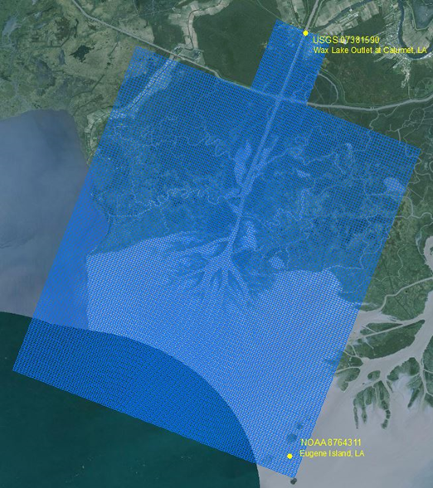

Figure 3. The Wax Lake Delta model domain, including model grid and boundary gage stations.

*Model Calibration*

Preliminary model calibration efforts consisted of comparing modeled water level height outputs to measured water level height at several points in the model domain. Observation points were built into the model at sites matching the physical location of several Coastal Reference Monitoring System (CRMS) stations within the Delta so that modeled water level throughout the run time would be collected at those points. The time series of modeled water height was then compared to measured height at the CRMS stations to assess model fit. Water level at a transect within the model was also visually compared to a cross-section of AirSWOT sensor data (see Figure 4). Roughness values were adjusted to improve model fit, assigning values of 0.017 s/m1/3 for water and 0.15 s/m1/3 for vegetated areas.

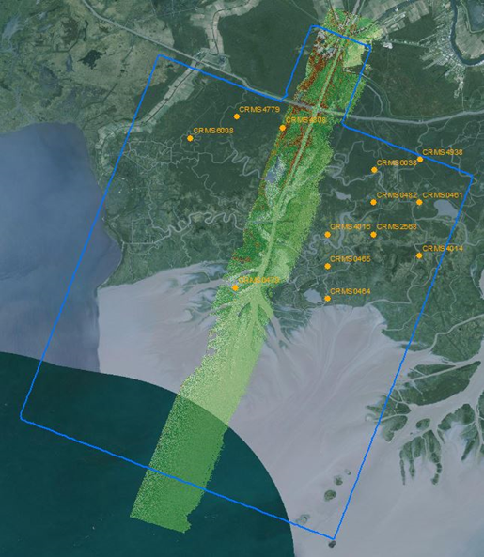

Figure 4. Water level measurements from CRMS stations and the AirSWOT sensor were used to calibrate the Delft3D model.

# IV. Results & Discussion

**Vegetation Classification of AVIRIS-NG and Landsat 8 OLI**

As stated before, an AVIRIS-NG and Landsat 8 OLI land cover maps was created to study the vegetation in the Wax Lake Outlet and Delta. The AVIRIS-NG data had many holes since clouds, shadows, and water had to be masked out so it would not interfere with the classification process. The end result from the ISODATA unsupervised classification and merging of classes resulted with 8 generalized vegetation classes. Dr. Marc Simard collected multiple *in situ* vegetation biomass and vegetation species data within our study area at Mike Island and at the CRMS 0465. Unfortunately, the Mike Island *in situ* data did not overlay with the AVIRIS-NG data due to the cloud mask and the CRMS 0465 station *in situ* data was located outside the three calibrated swaths. We were thus unable to test the accuracy of the land cover map and was not able to generate a spectral library for the vegetation species that AVIRIS-NG could have identified and mapped. Hence, we were only able to create a generalized vegetation classification with 8 classes for the AVIRIS-NG data. Since there were holes in the AVIRIS-NG image, a cloud free Landsat 8 OLI data was used to observe the differences with the AVIRIS-NG land cover classification. Landsat 8 OLI has more coverage but its 30 meter resolution was not desirable for mapping vegetation species and biomass since there may be more than one species of plants within one pixel. AVIRIS-NG has a spatial resolution of 4 meters and has a number of spectral bands sensitive to vegetation conditions and was thus ideal to use for mapping vegetation species.

A more extensive *in situ* data taken throughout the study area is recommended since clouds will affect the classification process of AVIRIS-NG data. A vegetation species classification map was needed to incorporate vegetation roughness in the Delft3D model. Unfortunately, we were not able to generate this layer using classified AVIRIS-NG data which could have been used to create a simulated plant layer in Delft3D to see the effect of vegetation on water flow. Future work in incorporating vegetation roughness from AVIRIS-NG data will be needed to accomplish this task.

**Vegetation Elevation Classification of UAVSAR Data and Bathymetry**

Potential sources of error in the bathymetry layer used in Delft3D is the reclassified UAVSAR image and the input of other topo-bathymetric datasets. The ranges used to reclassify the UAVSAR image were approximate and caused some areas to be over classified. This meant a few areas were classified as water when it should actually be classified as trees. Future work may be needed to create an accurate reclassified UAVSAR image by adjusting the ranges to reclassify.

Finding up to date bathymetry for areas around the delta proved troublesome and in some cases, like the upper channel itself, bathymetry needed to be created from interpolating points. There is possible error in the final bathymetry layer since it contains bathymetry from three data sources which were acquired from different dates. The upper channel bathymetry from USACE was interpolated from 1998 data. The middle channel and offshore bathymetry from the CoNED TBDEM has multiple datasets of varying dates between 1888 to 2013, and the delta bathymetry provided from Dr. John Shaw was collected in 2013. The differences in the data acquisition dates would be a source for error since the bathymetry in the Wax Lake Outlet and Delta can change over time.

**Delta Hydrological Model**

Preliminary results from the Delft3D hydrological model of the delta show modeled depths consistent with the water depth measured in the bathymetry (see Figure 5). Initial efforts at calibration show similar trends at some of the observation/gage sites (see Figure 9 in Appendix), but further work is needed to finalize model parameter adjustment and calibration.

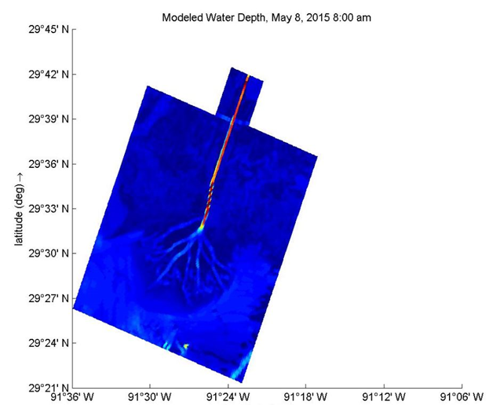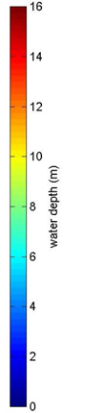

Figure 5. Deflt3D hydrological model output showing modled water depth in the Wax Lake Delta, LA.

There are some potential sources of error in the model outputs. Since our bathymetry layer includes approximated values for submerged grass and several bathymetric datasets collected at different times, this could affect our modeled results. Also, the roughness map used in the model only includes two values: one for water and one for vegetated areas. Assigning more detailed roughness values based on vegetation type may give a more accurate model fit. Due to time constraints, the model calibration was not finalized, so further work is needed before the model can be used to forecast sediment deposition and land building.

Future work should include finalizing the model calibration, and further sediment modeling to examine morphological change over time. The effect of vegetation on flow could also be assessed, using either a simulated layer that represents plant species with cylindrical rods or incorporating vegetation roughness estimated using the classified AVIRIS-NG data. When calibration is completed, this Delft3D offers a tool with the potential to analyze many different flow and sediment transport scenarios that could occur in the Delta over time. Model runs with different flow rates, sediment concentrations and offshore water level heights could be used to examine possible impacts of floods, changes in sediment availability and sea level rise as a result of climate change.

# V. Conclusions

Expanding on the previous work done in the Fall term, this project was able to create an extensive bathymetry layer and implement a flowing model to simulate the conditions of land growth within the Wax Lake Delta. The same techniques applied in this project can be implemented on many other study areas to help build a better base of knowledge for this field of modeling. The UAVSAR derived vegetation elevation layer and AVIRIS-NG data can be more properly combined in future applications to increase the spatial resolution and accuracy of water roughness and topological measurements. However, the main limitation with AVIRIS-NG data is that it is an optical sensor and therefore affected by cloud cover so it must be masked with other data from different times or use sensors like Landsat to fill in gaps. Practical application of AVIRIS-NG, UAVSAR, and AirSWOT all help to also provide case studies that demonstrate the usefulness of each sensors future respective mission Hyspiri, NISAR, and SWOT, scheduled for 2020. This model will also be immediately relevant and beneficial to decision makers such as Alex Kolker who are creating plans in the very near future to mitigate coastal land loss in Louisiana. Overall, the use or airborne sensors in delta research and modeling will contribute to existing research and enable further analysis of sediment transport and water flow in the Wax Lake Delta.

# VI. Acknowledgments

We would like to thank our science advisors—Marc Simard and Cathleen Jones for data retrieval and assisting us in data analysis. We would also like to acknowledge our project partners: Alex Kolker at the Louisiana Universities Marine Consortium and Richard Crout with the U.S. Naval Research Laboratory. Their contributions, along with the NASA DEVELOP Program, have made this project possible.

Any opinions, findings, and conclusions or recommendations expressed in this material are those of the author(s) and do not necessarily reflect the views of the National Aeronautics and Space Administration.

This material is based upon work supported by NASA through contract NNL11AA00B and cooperative agreement NNX14AB60A.

# VII. References

Chapman, B. (2015, October 1). *UAVSAR Uninhabited Aerial Vehicle Synthetic Aperture*

*Radar*.Retrieved from <http://uavsar.jpl.nasa.gov/>

Dr. Jones, C. (2015, November 3). Personal Interview.

Kleiss, B. 2009. The Utilization of the Mississippi River in the Restoration of Coastal Louisiana. US Army Corps of Engineers Mississippi Valley Division. Retrieved from <http://www.conference.ifas.ufl.edu/NCER2009/PPTPDF_pres/4-Thursday/3-Avalon%20Room/PM/0220%20B%20Kleiss.pdf>

Louisiana (2012). Coastal Protection and Restoration Authority. Louisiana ’s Comprehensive Master Plan for a Sustainable Coast.

Lundeen, S. (2015, July 1). *Airborne Visible/Infrared Imaging Spectrometer AVIRIS Next*

*Generation*. Retrieved from <http://avirisng.jpl.nasa.gov/>

Olea, R. a., & Coleman, J. L. (2014). A Synoptic Examination of Causes of Land Loss in Southern Louisiana as Related to the Exploitation of Subsurface Geologic Resources. *Journal of Coastal Research*, *297*(5), 1025–1044. http://doi.org/10.2112/JCOASTRES-D-13-00046.1

Srinivasan, M. (2015, October 1). *Surface Water and Ocean Topography*.Retrieved from

<http://swot.jpl.nasa.gov/airswot>

# VIII. Content Innovation

**AudioSlides**

2016Spring_JPL_LouisianaEcoII_TechPaper_AudioSlides.pptx

Eight (8) audio files in which the audio number corresponds to slide number.

2016Spring_JPL_LouisianaEcoII_TechPaper_AudioSlides_Audio1.m4a

2016Spring_JPL_LouisianaEcoII_TechPaper_AudioSlides_Audio2.m4a

2016Spring_JPL_LouisianaEcoII_TechPaper_AudioSlides_Audio3.m4a

2016Spring_JPL_LouisianaEcoII_TechPaper_AudioSlides_Audio4.m4a

2016Spring_JPL_LouisianaEcoII_TechPaper_AudioSlides_Audio5.m4a

2016Spring_JPL_LouisianaEcoII_TechPaper_AudioSlides_Audio6.m4a

2016Spring_JPL_LouisianaEcoII_TechPaper_AudioSlides_Audio7.m4a

2016Spring_JPL_LouisianaEcoII_TechPaper_AudioSlides_Audio8.m4a

**Featured Multimedia for this Article**

VPS Video

**Glossary Viewer**

**In situ data**: measurements taken directly from the source/ground.

**Remotely Sensed data**: measurements taken from a distance, typically from an aircraft or satellites.

**Raster**: A spatial data model that defines space as an array of equally sized cells arranged in rows and columns, and composed of single or multiple bands.

**Bathymetry**: the measurement of depth of water in oceans, seas, or lakes.

**L-Band**: the range of 1 – 2 GHz frequency of the radio spectrum.

**Ka-Band**: the range of 26.5 – 40GHz frequency of the microwave band.

**Hyperspectral**: imagery technique where recorded spectra have fine wavelength resolution and cover a wide range of wavelengths.

# IV. Appendices

Table 1. The AVIRIS-NG bands selected for ISODATA unsupervised classification and the characteristic sensitivities per band that makes it optimal for use in land cover classification mapping.

|  |  |  |
| --- | --- | --- |
| AVIRIS-NG Bands | Spectral Region | Characteristics per Band |
| 29 | Blue | Soil, water, and vegetation |
| 37 | Green | Vegetation - chlorophyll reflectance |
| 41 | Green | Vegetation - chlorophyll reflectance at peak |
| 49 | Yellow | Vegetation - reflectance of chlorotic foliage |
| 57 | Orange | Vegetation - reflectance of necrotic foliage |
| 70 | Red | Vegetation - chlorophyll absorption |
| 80 | Red/NIR | Vegetation - red edge portion |
| 97 | NIR | Vegetation condition, soil moisture, and water body detection |
| 134 | NIR | Vegetation condition, soil moisture, and water body detection |
| 262 | SWIR-1 | Clouds, snow, soil moisture, and vegetation moisture |
| 373 | SWIR-2 | Mineral, rock type, and vegetation moisture |

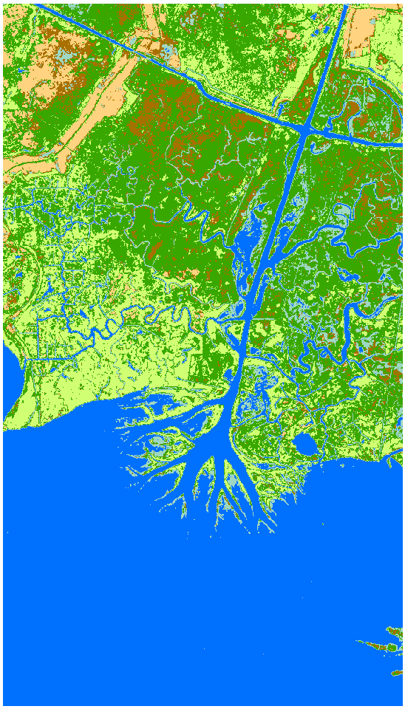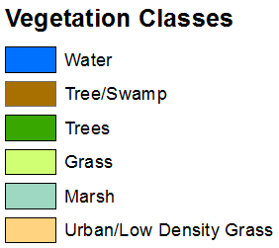

Figure 6. Landsat 8 OLI image classified into 6 generalized vegetation types using an ISODATA unsupervised classification method.

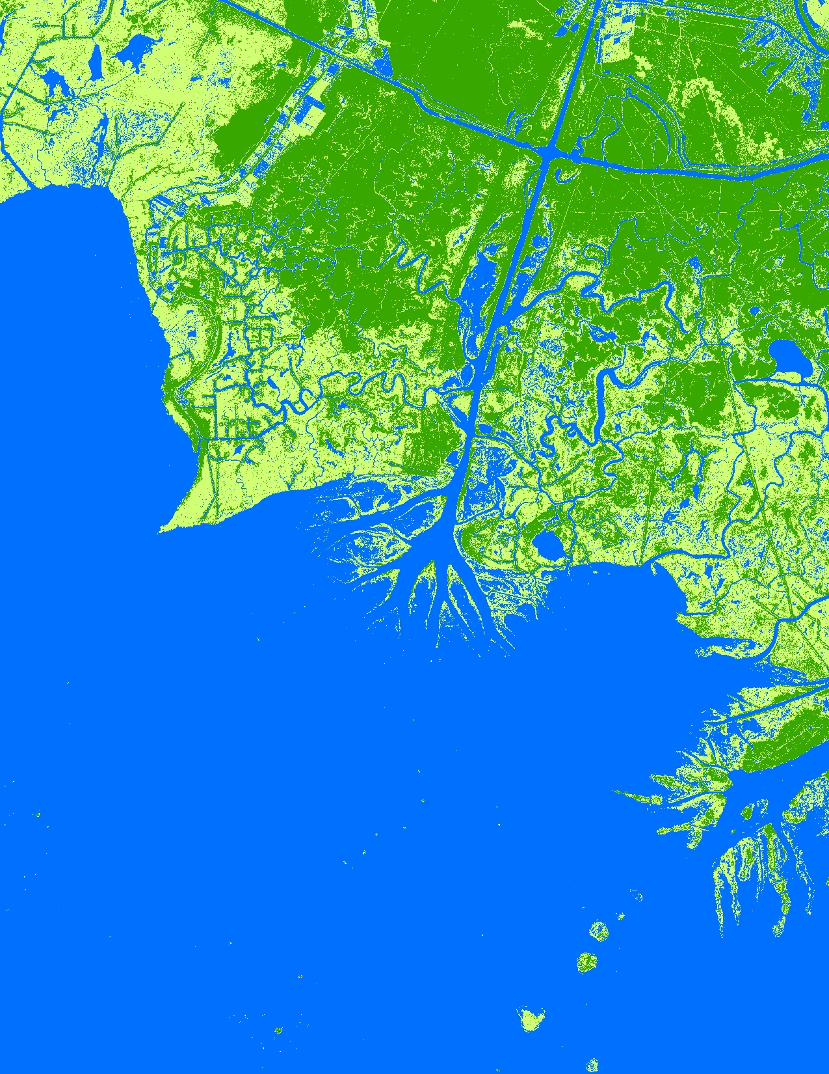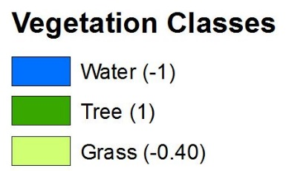

Figure 7. Classified UAVSAR data of the Wax Lake Delta into three generalized vegetation classes and corresponding elevation values.

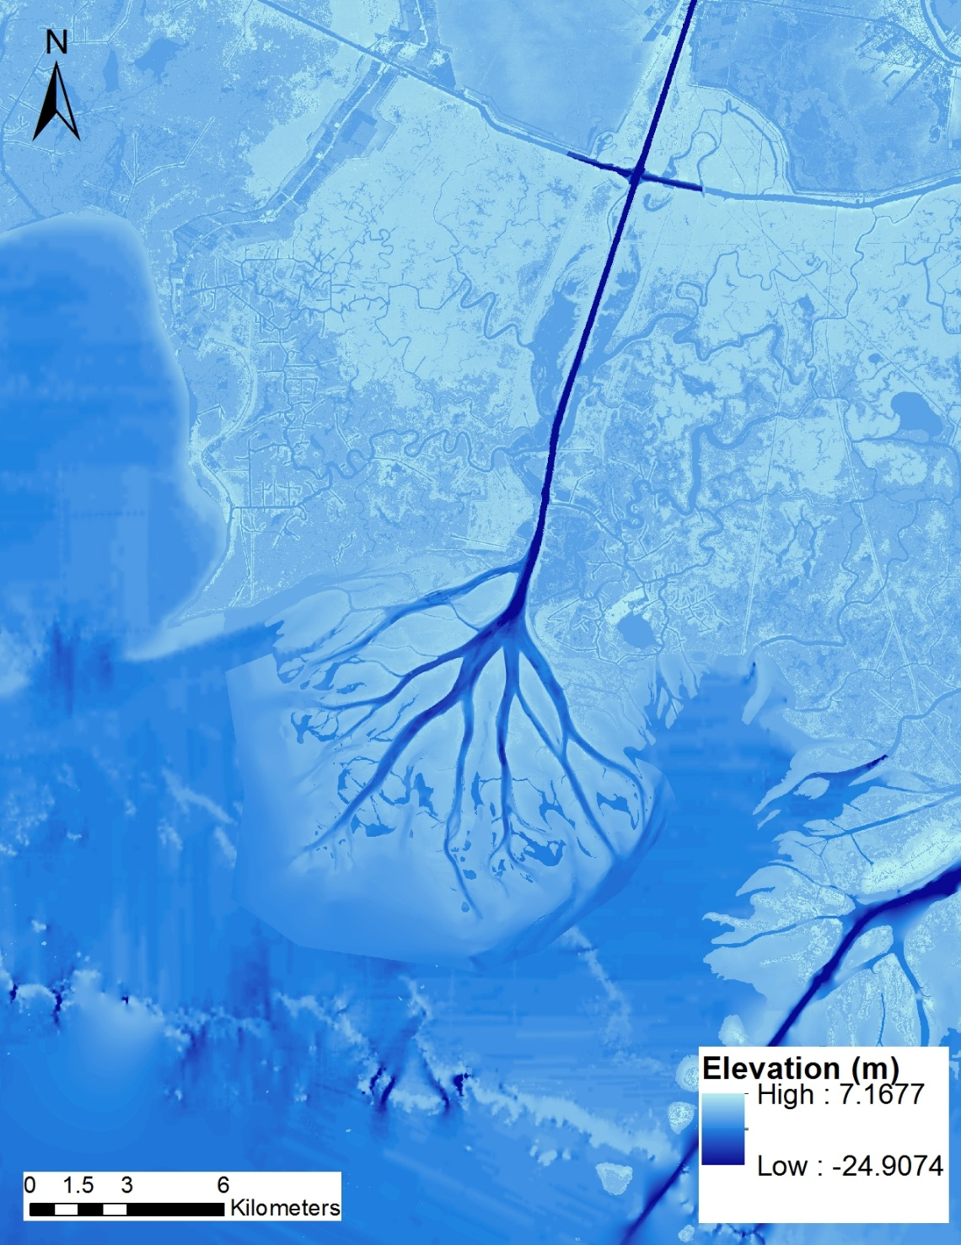

Figure 8. Bathymetry layer created from multiple topo-bathymetric datasets merged into the reclassified UAVSAR image.

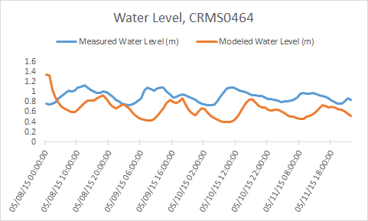

Figure 9. Comparison of modeled water level vs. measured water level at CRMS0464 after initial calibration efforts.