Bhutan Agriculture III

Monitoring Cropland Changes in Bhutan using Remote Sensing to Bolster Food Security and Support Crop Monitoring

 **Technical Report- Draft**

August 11th, 2023

Sonam Seldon Tshering (Project Lead)

Garab Kuenphen Dorji

Ugyen Thinley Dorji

Sangay Choden

Tenzin Lhaden

***Advisors:***

Aparna R. Phalke, NASA SERVIR Science Coordination Office (Science Advisor)

Timothy Mayer, NASA SERVIR Science Coordination Office (Science Advisor)

Marcus Taylor Hallett, NASA SERVIR Science Coordination Office (Science Advisor)

Kenton Ross, NASA Langley Research Center (Science Advisor)

Sean McCartney, NASA Goddard Space Flight Center (Science Advisor)

Robert Griffin, University of Alabama Huntsville (Science Advisor)

Jeffrey Luvall, NASA Marshall Space Flight Center (Science Advisor)

***Previous Contributors:***

Yeshey Seldon

Sherab Dolma

Kusal Khandal

Wangdrak Dorji

Tenzin Wangmo

Karma Thinley Dorjee

***Fellow:***  
Laramie Plott (LaRC)

# 1. Abstract

The Bhutan Agriculture III team aimed to improve agricultural efficiency in Bhutan. Bhutan is a nation heavily reliant on agriculture, but it faces challenges such as geophysical limitations and lack of scientific agricultural practice. The team partnered with a primary end user, Bhutan’s Department of Agriculture (DoA), and with collaborators; the Bhutan Foundation, National Plant Protection Centre (NPPC), Agricultural Research Department Centre (ARDC), National Statistics Bureau (NSB), and the Ugyen Wangchuck Institute for Conservation and Environment Research (UWICER). Advised by NASA SERVIR, the team developed crop masks and monitored rice distribution from 2015 to 2022 utilizing Earth observations such as Landsat 8 Operational Land Imager (OLI), Landsat 9 OLI-2, Sentinel-1 C-Band Synthetic Aperture Radar (C-SAR), Sentinel-2 MultiSpectral Instrument (MSI) and Shuttle Radar Topography Mission (SRTM). The team gathered 5,000 points from the five dzongkhags that yield the most rice in Bhutan (Paro, Punakha, Samtse, Sarpang and Wangue Phodrang) using Collect Earth Online (CEO). With the data collected, the team split the data into training and validation data on Google Earth Engine (GEE) for a random forest (RF) classifier for rice and non-rice classification. After running the data on the Random Forest (RF) model, the team got an accuracy score of 81.48%, a kappa score of 55.75% and an F1 score of 86.11%. This data supports better agricultural decision-making for the governing body of Bhutan, helps enhance farming efficiency and foster sustainable practices, assists in overcoming data inaccuracy and bolsters food security in the country.

**Key Terms**

Remote Sensing, Earth observations, Google Earth Engine, Collect Earth Online, crop mask, rice plantation, Random Forest, graphical user interface

# 2. Introduction

***2.1 Background Information***

Bhutan is a small nation centrally positioned between the Himalayan ranges and is an agrarian society with about 57% of the population depending on agriculture (Chhogyel & Kumar, 2018). As a crucial sector in Bhutan, agriculture plays a significant role in reducing poverty and strengthening food security. The agriculture sector contributes to 17.37% of the national GDP and is a key component of Bhutan’s economy (Lakey & Chophel, 2020). As a mountainous country with elevation levels varying from 100 m to over 7,500 m (Ohsawa, 1987), there are various geophysical limitations when it comes to agriculture such as rugged terrain and climate changes. Additionally, numerous other factors such as pests and diseases, soil erosion of fertile lands, and other conditions significantly diminish crop productivity.

With competing challenges that hinder agricultural progress, such as rural-urban migration, human-wildlife conflict, and the lack of scientific agricultural innovations, the Bhutan Agriculture III team has conducted research to tackle these pressing agricultural issues by providing sampling protocol and crop mask identification to improve the efficiency of crop management. At present, Bhutan’s Department of Agriculture (DoA) relies on expensive and time-consuming field surveys as the primary method of decision-making and record-keeping regarding crop productivity in terms of quality and quantity. However, the approach has not been able to provide accurate and precise data. Previously, NASA DEVELOP teams have collaborated with Bhutan DoA and codeveloped a crop masking application utilizing the data from NASA Earth observations and remote sensing, which is yet to be implemented.

The previous Bhutan Agriculture I team from NASA DEVELOP utilized Earth observations including Landsat 8 Operational Land Imager (OLI), Sentinel-1 C-band Synthetic Aperture Radar (C-SAR), and Shuttle Radar Topography Mission (SRTM) imagery to enhance the monitoring capacity of the agriculture sector in Bhutan (Dolma et al., 2021). They created a sampling protocol to identify rice plantations in eight dzongkhags (provinces) in central and southern Bhutan (Paro, Punakha, Samtse, Sarpang, Trongsa, Zhemgang, Wangdue Phodrang, and Samdrup Jongkhar) from June to November 2020. The team developed a crop mask for rice using the model of Random Forest for these dzongkhags. The team provided the partners in Bhutan with both this sampling protocol for generating the crop mask and remote sensing capacity tutorials that would aid them in generating the crop masks.

The NASA DEVELOP Bhutan Agriculture II team built upon the previous team’s work by extending the crop masking to the entire region of Bhutan from the time frame of May through October 2015 – 2020 (Dorjee et al., 2022). Using a Random Forest (RF) model, the team collected rice points from five Dzongkhags with maximum rice production using Collect Earth Online (CEO) (Saah et at., 2019). For greater accuracy, the team updated the sampling protocol produced by the previous team with additional guidelines on how to work with the CEO. To help provide a visual analysis of rice distribution across Bhutan, the team also developed a graphical user interface (GUI) with graphs showing the variables of precipitation, temperature, and soil moisture over the years which help determine its correlation with agricultural statistics.

In continuation, the Bhutan Agriculture III team aimed to study the cropland change analysis throughout Bhutan where they focused on the five districts which include Paro, Wangdiphodrang, Punakha, Samtse, and Sarpang (Figure 1). Using Landsat and Sentinel data to create secure and sustainable farming in Bhutan. For data collection, the team analyzed and monitored rice crop masks, data samples, and cropland changes throughout Bhutan each summer (defined as June through September) from 2015–2022. Much of this work was based on Mayer et al. (2023), which created a methodology for classifying rice farms in Bhutan.

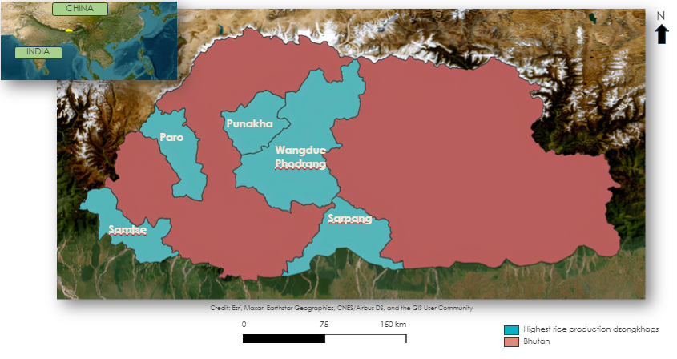

*Figure 1.* The Kingdom of Bhutan with the Dzongkhags used in the study area

***2.2 Project Partners & Objectives***

The team partnered with DoA, and its two other departments: National Plant Protection Centre (NPPC) and Agriculture Research and Development Centre (ARDC). Alongside, the team also worked with other collaborator organizations which includes Bhutan’s National Statistics Bureau (NSB), the Ugyen Wangchuck Institute for Conservation and Environment Research (UWICER), and the Bhutan Foundation to fine-tune the yearly crop masks, improve data sampling accuracy, and identify cropland area changes throughout Bhutan. The DoA is familiar with NASA Earth observations data, but it currently does not use them. Instead, it conducts in-field crop and land-use assessments in multiple-year rotations. It mostly depends on field reports for developing national statistics and crop reports. Integrating more diverse remote sensing approaches with the DoA’s methodology for reporting and developing planning efforts will help decrease the multi-year rotation assessments to annual assessments. The team aimed to expand on the data collected in the prior projects by optimizing the yearly rice crop masks, enhancing data sampling accuracy, and identifying farmland area change throughout the country. In collaboration with the partners, the team attempted to inform agricultural decisions within the country, improve farming efficiency, and support future research.

The primary objectives of these collaborations were to fine-tune yearly crop masks, improve data sampling accuracy and identify changes in cropland area across Bhutan. Actionable steps are as follows:

1. Enhancing Crop Masks: Utilizing Landsat and Sentinel data, the team applies advanced algorithms and vegetation indices like NDVI, SAVI, NDWI, MNDWI and NDBI to develop precise crop masks.
2. Data Sampling Optimization: The team utilizes Collect Earth Online (CEO) to collect random sampling points in high rice production districts. Points are manually classified, considering factors such as terrace, plant structure and land use, supplemented by Google Earth Engine (GEE) for clearer satellite imagery.
3. Cropland Change Identification: Through analysis of Landsat and Sentinel data from 2015 to 2022, the team identified temporal trends and shifts in cropland distribution. Utilizing diverse Earth observation sources enables effective monitoring of these changes.
4. Integrating Remote Sensing with DoA’s Methodology: The team collaborated with DoA, introducing them to the NASA Earth Observations data and integrating more diverse remote sensing planning efforts, transitioning from multi-year rotation assessments to more frequent and accurate annual assessments.
5. Making informed Agricultural Decisions: Accurate data sampling and precise evaluations enable DoA, NPPC and ARDC to make effective and educated agricultural decisions. These data-driven choices support planning, reporting and crop management strategy.
6. Supporting Future Research: This project contributes valuable insights into crop dynamics and their interaction with environmental factors. These insights provide a foundation for future agricultural research, with the goal of promoting sustainable farming practices and food security in Bhutan.

# 3. Methodology

***3.1 Data Acquisition***

The team used random sampling points and various observation sources. For the random sample data, the team collected 1000 random points of rice and non-rice from CEO that focused on the five heavy rice production districts which include Paro, Punakha, Wangdue Phodrang, Samtse, and Sarpang. The data from CEO was manually classified by considering factors such as terrace, structure of the plant, land use of the plot, and in some cases, using Google Earth Engine (GEE) to generate clear satellite images. For the observation data, the team used the NASA EO data (Table 1). For the non-EO data, the team used the datasets in Table 2 to use the additional indices for crop classification (Karjalainen et al., 2008; Abatzoglou et al., 2018; Zhang et al., 2019).

The team utilized Landsat 8 Operational Land Imager (OLI) and Landsat 9 OLI-2 to study parameters such as NDVI, SAVI, surface reflectance, tasseled cap brightness, greenness, and wetness enabling them to analyze rice paddy fields and assess new crop varieties. For a broader area analysis, the team integrated Sentinel-1 C-Band Synthetic Aperture Rader (C-SAR) data, actively using high temporal resolution imagery to track crop distribution over time. To differentiate between various crop species with precision, Sentinel-2 Multi Spectral Instrument (MSI) data was incorporated, providing high spatial resolution. Moreover, they actively analyzed the relationship between rice classification and terrain characteristics by incorporating Shuttle Rader Topography Mission (SRTM) data, offering essential slope and elevation parameters. Through their active integration and analysis of these diverse data sources, the team gained profound insights into crop dynamics and their interaction with environmental factors, contributing significantly to the field of agriculture.

Table 1

*Earth Observations and Imagery used in Data Processing*

|  |  |  |  |  |
| --- | --- | --- | --- | --- |
| **Dataset** | **Parameter(s)** | **Use** | **Study Period** | **Source** |
| Landsat 8 Operational Land Imager (OLI) Level 2, Collection 2, Tier 1 | Normalized Difference Vegetation Index (NDVI), Soil-Adjusted Vegetation Index (SAVI), Modified Normalized Difference Water Index (MNDWI), Normalized Difference Water Index (NDWI), Normalized Difference Moisture Index (NDMI), Normalized Difference Built-up Index (NDBI)  surface reflectance, tasseled cap brightness, greenness, and wetness | NDVI, SAVI, surface reflectance, tasseled cap brightness, greenness, and wetness will be used to analyze rice paddy fields. | June till September from 2015 - 2022 | GEE |
| Landsat 8 Collection 2 Tier 1 Top of Atmosphere (TOA) Reflectance | Brightness, Greenness, Wetness, Fourth, Fifth and Sixth | TOA reflectance for tasseled cap brightness, greenness and wetness | June till September from 2015 - 2022 | GEE |
| Landsat 9 OLI-2, Level 2, Collection 2, Tier 1 | NDVI, SAVI, surface reflectance, tasseled cap brightness, greenness, and wetness | NDVI, SAVI, surface reflectance, tasseled cap brightness, greenness, and wetness will be used to analyze new crop varieties. | June till September from 2022 | GEE |
| Sentinel-1 C-Band Synthetic Aperture Radar (C-SAR) Ground Range Detected, log scaling | VH Ascending, VV Ascending, VH Descending, VV Descending, Normalized Difference Ratio Ascending, Normalized Difference Ratio Descending | These data will provide high temporal resolution imagery to analyze crop distribution over a larger area. | June till September from 2015 - 2022 | GEE |
| Sentinel-2 MultiSpectral Instrument (MSI) Level-2A | MNDWI, NDVI, SAVI, NDWI, NDMI, NDBI | These data will provide high spatial resolution data to differentiate between different crop species. | June till September from 2016 - 2022 | GEE |
| Shuttle Radar Topography Mission (SRTM) Digital Elevation 30m | Slope, elevation | Slope and elevation will be used as features in the classification of different crops, showing their relation to different elevation. | 2000-02-11 to 2000-02-22 | GEE |

Table 2

*Ancillary Datasets*

|  |
| --- |
| **Datasets** |
| Height Above Nearest Drainage (HAND) |
| Temperature from the ECMWF Reanalysis 5th Generation-Land (ERA5-Land) dataset |
| Precipitation from the Terra Climate dataset |
| Canopy interception from the Penman-Monteith-Leuning Evapotranspiration (PML) dataset |

***3.2 Data Processing***

For the data processing, the team prepared the data by enlarging each training point to reflect a 30-meter resolution. The plot size was set to match the coarsest resolution (Landsat, 30m) for interpretation. The 1000 plots utilized a uniform sampling approach with 9 equidistant points. The team used Landsat 8 OLI data to calculate NDVI, SAVI, NDWI, NDMI, MNDWI, and NDBI (Equations 1 – 6) after importing the training points into GEE. These indexes offer details on the presence of vegetation, water, and built-up regions. Additionally, these indices use the Red, Near Infra-Red (NIR), Green, and Shortwave Infra-Red 1 bands (Xu, 2006; Valdiviezo-N et al., 2017; Gao, 1996; Huete, 1988).

$$1. NDVI = \frac{NIR - RED}{NIR +RED}$$

$$2. SAVI = \frac{\left(NIR - RED\right) ⋅1.5}{\left(NIR + RED +0.5\right)}$$

$$3. NDWI=\frac{GREEN-NIR}{GREEN+NIR}$$

$$4. NDMI = \frac{NIR - SWIR_{1}}{NIR + SWIR_{1}}$$

$$5. MNDWI = \frac{GREEN - SWIR_{1}}{GREEN + SWIR_{1}}$$

$$6. NDBI = \frac{SWIR_{1}- NIR}{SWIR_{1}+NIR}$$

The team also computed the Kauth-Thomas Tasseled Cap Transformation (TCT) indices of Greenness, Brightness, Wetness, Fourth, Fifth, and Sixth using Landsat 8 TOA data, which aid in analyzing changes in man-made development and vegetation phenology while minimizing atmospheric impacts (Baig et al., 2014).

Using the data from SRTM, the team calculated the Slope and elevation indices to determine the surface steepness, slope, and elevation (Mukul et al., 2017). Further, the team employed a refined Lee-Filter to reduce speckle noise and applied terrain correction to the Sentinel-1 C-Band Synthetic Aperture Radar (C-SAR) images (Banerjee et al., 2021; Markert et al., 2020). To distinguish vegetation using microwaves, they calculated several indices using the modified Sentinel-1 C-SAR data, including VH (Vertical transmit, horizontal receive), VV (Vertical transmit, vertical receive), the VV/VH ratio, and the normalized difference between VV and VH (Karjalainen et al., 2008).

Using the Random Forest (RF) classifier in GEE, the team produced crop masks. The five districts with high rice production each contributed 5000 points, which were divided into training (70%), validation (10%), and testing (20%) sets. All the indices were used as features in the RF model during training utilizing the training data to predict the presence of rice. The testing data was categorized to assess the model's performance, and the validation dataset assisted in fine-tuning the model's parameters.

***3.3 Data Analysis***

Several approaches were used to analyze the data, including statistical analysis and validation. Confusion matrices were constructed by comparing the RF model's projected classifications with the training point classifications provided by CEO to evaluate the effectiveness of the RF model for rice classification. These matrices allowed for the results to be broken down into true positives, true negatives, false positives, and false negatives (Zeng, 2020).

Table 3

*Confusion matrix*

|  |  |  |
| --- | --- | --- |
|  | **True** | **False** |
| **Positive** | True – Positive  (**TP)** | False – Positive  **(FP)** |
| **Negative** | True - Negative  **(TN)** | False – Negative  **(FN)** |

Various performance measures were produced using the confusion matrices to quantify the model's effectiveness on the validation data. Accuracy, Cohen's kappa score, precision, recall (sensitivity), and F1 score were among the metrics used. The team evaluated the model's performance and made improvements to its parameters by examining these indicators. The average of all 36 models is computed since the RF model was generated for the months of May to October from 2015 to 2020. The following are the equations used by the team where $P_{0}$ is the probability of both classes correctly agreeing and $P_{e}$ is the probability of both classes agreeing when randomly assigned classifications (Mayer et al., 2023):

$$7. Accuracy = \frac{TP + TN}{TP+TN+FP+FN}$$

$$8. Kappa = \frac{P_{0} - P_{e}}{1 - P_{e}}$$

$$9. precision\left(P\right) = \frac{TP}{TP + FP}$$

$$10. recall\left(R\right) = \frac{TP}{TP + FN}$$

$$11. F1 score \left(F\right) = \frac{2PR}{P + R}$$

# 4. Results & Discussion

***4.1 Analysis of Results***

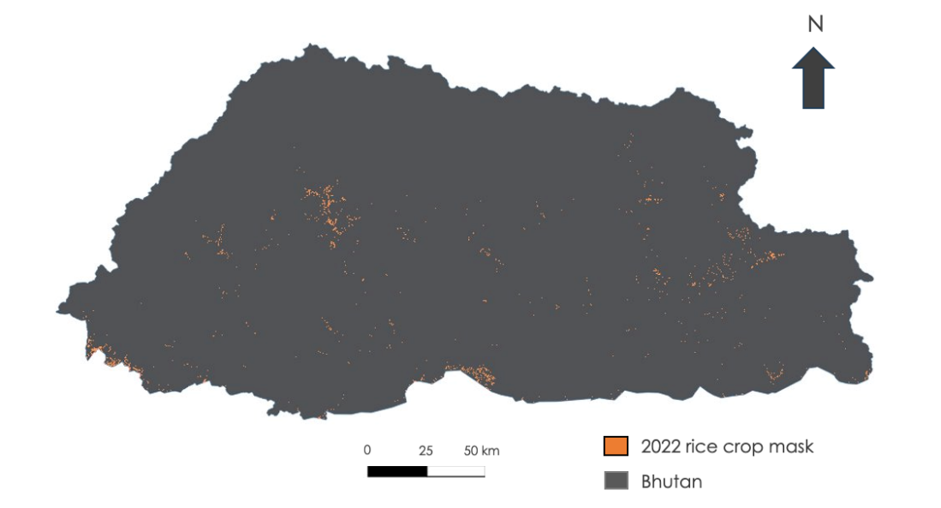

*Figure 2.* 2022 aggregated map

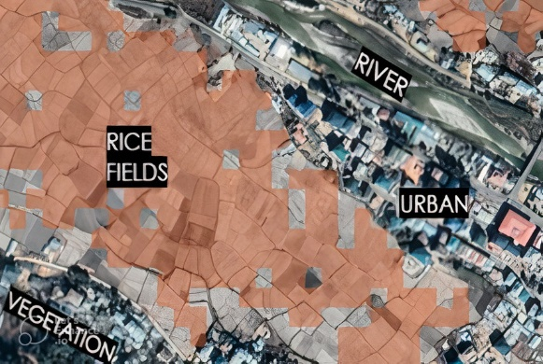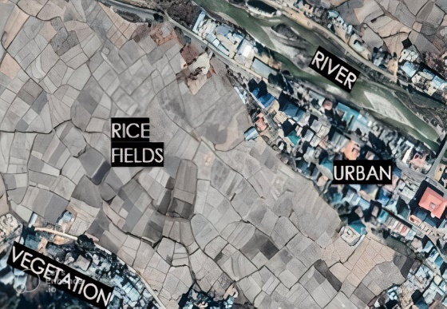

*Figure 3.* Applying RF model in the Paro region.

The overall rice crop mask for the year 2022 is shown in Figure 2 with the white layer depicting the rice crops in Bhutan. The crop masks were generated by the RF model which is more specifically portrayed in Figure 3 where it illustrates the application of the RF model for classifying rice crops in a region called Paro. The images shown above are zoomed versions of satellite imagery. On the right, the image depicts the mask produced by the random forest model. The RF model effectively identifies and highlights most of the paddy fields in the area, represented in orange, while accurately excluding non-rice areas such as water bodies (rivers), urban structures, and some non-rice vegetation.

However, there are a few rice areas that the rice mask fails to include. This could be attributed to the model's limited ability to recognize these specific areas as rice due to the lack of robust patterns in the training data. Additionally, the use of the Regional Land Cover Monitoring System layer to clip out other types of non-rice land features might introduce certain limitations in the model's performance.

*Figure 4.* Comparison of indices in the Random Forest Model

Figure 4 presents a depiction of variable importance, signifying the relative contributions of various spectral indices to differentiate between rice and non-rice points during the generation of the crop mask. The model's analysis reveals essential factors influencing the classification process. Elevation emerges as a primary determining factor in the model's classification. This observation can be attributed to the diverse rice ecosystems in Bhutan, categorized by different altitudes (low, mid, and high), each exerting unique influences on rice cultivation. The Tasseled Cap Transformation of Fourth also holds notable importance. This is due to the model detecting distinct patterns of vegetation phenology and changes in urban development around the rice fields.

In the case of other indices, the model assigns relatively equal levels of importance. This indicates that, in the absence of a dedicated index for rice identification, the model effectively integrates various other indices to achieve accurate classifications.

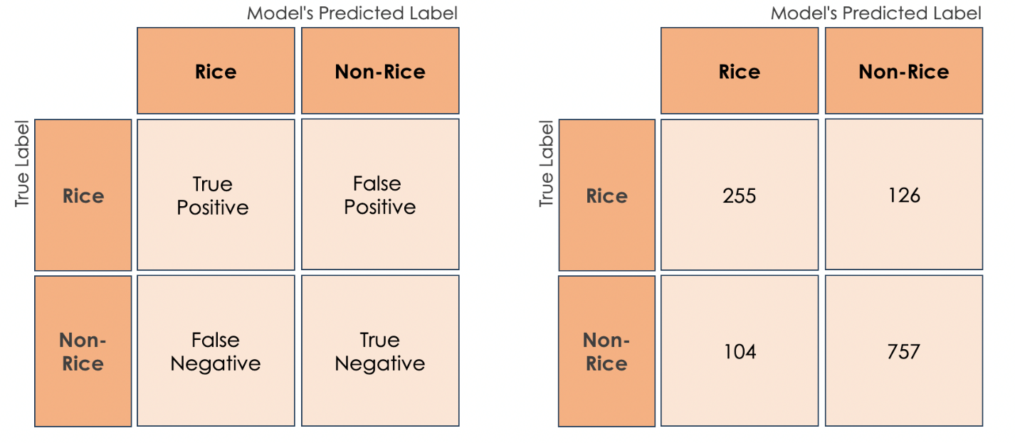*Figure 5.* Confusion matrices with average number of true positives, true negatives, false positives and false negatives for all RF models generated.

As seen in figure 5, the RF model identified 255 rice points and 757 non-rice points correctly. The RF model misclassified 126 points as rice and 104 points as non-rice. The confusion matrices show that the RF model is less successful in identifying non-rice areas compared to rice areas. A machine learning model is only as effective as the amount and how accurate the data is trained on. With the current training data our team collected, the region that is heavily biased is toward the western side the of Bhutan. This means that there are certain rice patterns in the measured indices that are not captured by the RF model. In addition, since the training scores are randomly generated in CEO, it is likely that not all generated scores include information about all rice field shapes, rice types and other characteristics. Certain characteristics of non-rice crops or vegetation measured by the indices may overlap with rice, introducing erroneous patterns into the model. To test the validity of our performance mask in GEE, the team calculated statistical measures for all prediction results in the confusion matrices and averaged them (Figure 6). The team used 3,000 test points from the CEO as a test set for the RF model and found that our model has an accuracy score of 81.48%, a kappa score of 55.75%, a recall score of 87.92%, a precision score of 85.73% and an F1 score of 86.11% for distinguishing between rice and non-rice areas.

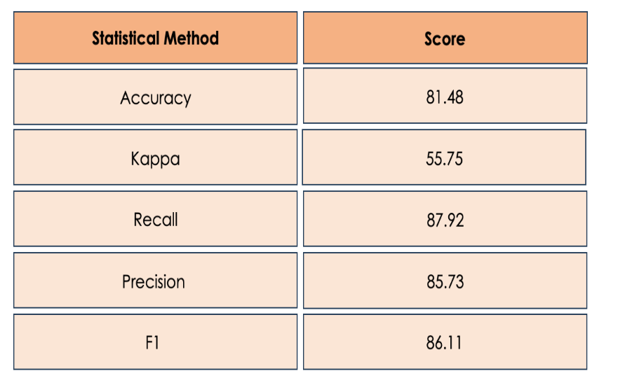

Figure 6. *Statistical measurements from GEE*

***4.2 Feasibility Assessment***

The team utilized Earth observations to differentiate between rice and non-rice plots. Even though there was error in the classification, the fairly high accuracy shows that the chosen imagery is effective for classification at rice and non-rice. This will help the end users to bolster food security and support crop monitoring. Further, these Earth observations have potential to further assist our partners in more in-depth crop monitoring, and all avenues of this should be explored.

***4.3 Future Work***

Future work will build upon the previous term’s sampling methodology and crop mask to include additional crop types into the crop mask protocol all over Bhutan. The potential future team should focus on expanding the GUI and its functionalities to bolster food security by monitoring cropland changes and by distinguishing between abandoned farmland and active agricultural lands. The team can also support decision making for the governing body of Bhutan by enhancing farming efficiency, fostering sustainable practices and lastly, overcome data inaccuracy to bolster food security in the country. These end products will help the partners meet their goals of incorporating remote sensing in their decision-making processes regarding agriculture in Bhutan.

# 5. Conclusions

# In conclusion, the Bhutan Agriculture III team undertook significant work by developing crop masks for five districts using a random forest classifier. To enhance the data sampling accuracy, the team collected 5000 points from CEO considering factors which includes lived in experience, terrace, and landscape of the agricultural plot This methodology (along with the support from NASA SERVIR) helped create an accurate aggregate crop mask for each year from 2016 to 2022 which had an 81.48% accuracy. The team also observed that both the partner’s report and our classification showed an overall decrease in planted rice areas from 2016 to 2022.

Additionally, the team also created a tutorial for GEE as per partners expectation to guide the users on how to navigate GEE, as well as the various other features that they include. The tutorial consists of an overview explaining the goal of GEE, followed by set up and requirements. It also presents an ordered list of instructions for data acquisition, data modeling and analysis. This tutorial will help the end user in using GEE to encourage collaboration and data sharing by allowing users to grant access to specific datasets, publish interactive maps, share code scripts, and collaborate with others for facilitating research cooperation and information exchange. These findings and tools will enable partners to calculate and understand trends in national rice output more effectively.

# 6. Acknowledgements

The team would like to thank everyone listed below for the unwavering support in making this project a successful one:

* Tim Mayer (NASA SERVIR Science Coordination Office)
* Aparna R. Phalke, NASA SERVIR Science Coordination Office (Science Advisor)
* Biplov Bhandari (NASA SERVIR Science Coordination Office)
* Marcus Taylor Hallett, NASA SERVIR Science Coordination Office (Science Advisor)
* Stephanie Jimenez (NASA SERVIR Science Coordination Office)
* Sean McCartney (NASA Goddard Space Flight Center)
* Dr. Kenton Ross (NASA Langley Research Center)
* Dr. Robert Griffin (The University of Alabama Huntsville)
* Dr. Jeffry Luvall (NASA Marshall Space Flight Center)
* Laramie Plott (NASA DEVELOP - Langley Research Center)
* Amanda Clayton (NASA NPO)
* Tshering Wangchen (Bhutan Department of Agriculture)
* Nidup Dorji (National Plant Proctection Centre)
* Loday Phuntsho (Agriculture Research and Department Centre)
* Tobden Tobden (National Statistics Bureau)
* Tshewang Wangchuk (Bhutan Foundation)
* Changa Tshering (Ugyen Wangchuk Institute for Conservation and Environment Research)
* ICIMOD for RLCMS
* SERVIR-HKH
* SERVIR

This material contains modified Copernicus Sentinel data (2015-2020), processed by ESA.

Any opinions, findings, and conclusions or recommendations expressed in this material are those of the author(s) and do not necessarily reflect the views of the National Aeronautics and Space Administration.

This material is based upon work supported by NASA through contract NNL16AA05C.

# 7. Glossary

**Accuracy** –The ratio of correct predictions and it is calculated by the sum of true negatives and true positives divided by the total number of events.

**CEO** – Collect Earth Online. An open-source system that can be used for projects requiring land cover and/or land use reference data.

**Cohen’s kappa score** –The comparison of the probability of agreement (Po) to the random probability agreement (Pe).

**C-SAR** – C-band Synthetic Aperture Radar instrument provides an all-weather, day and night imaging capability to capture measurement data at high and medium resolutions for land, coastal zones, and ice observations.

**Dzongkhags**: 20 Provinces of Bhutan

**Earth observations** – Satellites and sensors that collect information about the Earth’s physical, chemical, and biological systems over space and time.

**ETM+** – Enhanced Thematic Mapper Plus instrument provides multispectral high-resolution imaging information of the Earth's surface.

**F1 score** – Is the average of precision and recall.

**Gewogs** –Smaller territorial divisions under the 20 districts.

**Google Earth Engine (GEE)** – A cloud-based geospatial processing platform that combines multi-petabyte catalog of satellite imagery and geospatial datasets with planetary-scale analysis capabilities.

**MODIS** – Moderate Resolution Imaging Spectroradiometer

**NDMI** – Normalized Difference Moisture Index. Ratio between the difference and the sum of the refracted radiation in near infrared and short infrared.  
**NDVI** – Normalized Difference Vegetation Index. Ratio between the difference and the sum of the near infrared and visible reflectance of vegetation.

**NDWI** – Normalized Difference Water Index. The ratio between the difference and the sum of near infrared and green channels.  
OLI – Operational Land Imager, uses long detector arrays with over 7000 detectors per spectral band, aligned across its focal plane to view across the swath.

**MODIS** – Moderate Resolution Imaging Spectroradiometer

**Polarization** – Polarization refers to the direction of travel of an electromagnetic wave vector’s tip.

**Polarization signatures** – In changing the polarization of the transmitted signal and receiving several different polarized images from the same series of pulses, SAR systems provide details on the polarimetric properties of the observed surface.

**Precision** – Determines the accurate prediction for the positive classes.

**Random Forest (RF)** – A supervised learning method that is a combination of decision trees where every tree classifies inputs based on random features and the label predicted by the majority of trees is the classification of the input.

**Recall or sensitivity** – Provides the ratio of predicted positive classes.

**RLCMS** – The Regional Land Cover Monitoring System is a functioning system to create annual land cover maps and detect land cover changes.

**SRTM** – Shuttle Radar Topography Mission was an international project, led by NASA and the National Imagery and Mapping Agency (NIMA), to create a digital elevation model on a near global scale to generate a high resolution digital topographic database of Earth

# 8. References

Abatzoglou, J. T., Dobrowski, S. Z., Parks, S. A., & Hegewisch, K. C. (2018). TerraClimate, a high-resolution global dataset of monthly climate and climatic water balance from 1958–2015. Scientific Data, 5(1).

<https://doi.org/10.1038/sdata.2017.191>

Baig, M. H. A., Zhang, L., Shuai, T., & Tong, Q. (2014). Derivation of a tasselled cap transformation based on Landsat 8 at-satellite reflectance. *Remote Sensing Letters*, *5*(5), 423–431. <https://doi.org/10.1080/2150704x.2014.915434>

Banerjee, S., Sinha Chaudhuri, S., Mehra, R., & Misra, A. (2021). A Survey on Lee Filter and Its Improved Variants. Advances in Smart Communication Technology and Information Processing, 371–383. <https://doi.org/10.1007/978-981-15-9433-5_36>

Chhogyel, N., Kumar, L. (2018). Climate Change and potential impacts on agriculture in Bhutan: a discussion of pertinent issues. *Agriculture and Food Security, 7 (79)*. <https://doi.org/10.1186/s40066-018-0229-6>

Dolma, S., Dorji, W., Khandal, K., & Seldon, Y. (2021). Bhutan Agriculture I: Developing a crop mask for rice and creating a data collection protocol utilizing remotely sensed data in Bhutan [Unpublished manuscript]. NASA DEVELOP National Program, Alabama – Marshall.

Dorjee, K.T., Dorji, W., Tshering, S.T., Wangmo, T. (2022). Bhutan Agriculture II: Creating a Graphical User Interface, Crop Mask, and Data Collection Protocol for Analysis of Rice Crop in Bhutan using Remotely Sensed Data [Unpublished manuscript]. NASA DEVELOP National Program, Alabama – Marshall.

Gao, B. (1996). NDWI—A normalized difference water index for remote sensing of vegetation liquid water from space. *Remote Sensing of Environment*, *58*(3), 257–266. <https://doi.org/10.1016/s0034-4257(96)00067-3>

Huete, A. R. (1988). A soil-adjusted vegetation index (SAVI). *Remote Sensing of Environment*, *25*(3), 295–309. <https://doi.org/10.1016/0034-4257(88)90106-X>

Karjalainen, M., Kaartinen, H., & Hyyppä, J. (2008). Agricultural monitoring using Envisat alternating polarization SAR images. *Photogrammetric Engineering & Remote Sensing*, *74*(1), 117–126. <https://doi.org/10.14358/pers.74.1.117>

Lakey, L., Chophel, S. (2020). Agricultural Research and Development: Policy and Program Priorities in Bhutan. In S. Chophel (Ed.), *Agricultural Policy and Program Framework: Priority Areas for Research & Development in South Asia.*

Markert, K. N., Markert, A. M., Mayer, T., Nauman, C., Haag, A., Poortinga, A., Bhandari, B., Thwal, N. S., Kunlamai, T., Chishtie, F., Kwant, M., Phongsapan, K., Clinton, N., Towashiraporn, P., & Saah, D. (2020). Comparing Sentinel-1 surface water mapping algorithms and radiometric terrain correction processing in Southeast Asia utilizing Google Earth Engine. *Remote Sensing*, *12*(15), Article 2469. <https://doi.org/10.3390/rs12152469>

Mayer, T., Bhandari, B., Martínez, F. G., Walker, K., Jiménez, S. A., Kruskopf, M., Maganini, M., Phalke, A., Wangchen, T., Phuntsho, L., Dorji, N., Tshering, C., & Dorji, W. (2023). Employing the agricultural classification and estimation service (ACES) for mapping smallholder rice farms in Bhutan. *Frontiers*  *in Environmental Science*, *11*, 1137835. <https://doi.org/10.3389/fenvs.2023.1137835>

Mukul, M., Srivastava, V., Jade, S., & Mukul, M. (2017). Uncertainties in the Shuttle Radar Topography Mission (SRTM) heights: Insights from the Indian Himalaya and Peninsula. *Scientific Reports*, *7*(1). <https://doi.org/10.1038/srep41672>

Ohsawa, M. (1987). *Life zone ecology of the Bhutan Himalaya*. Laboratory of Ecology, Chiba University.

Saah, D., Johnson, G., Ashmall, B., Tondapu, G., Tenneson, K., Patterson, M., et al. (2019). Collect Earth: An online tool for systematic reference data collection in land cover and use applications. *Environ. Model. Softw.* 118, 166–171. doi:10.1016/j.envsoft.2019.05.004

Sasaki, Y. (2007, October 26). The truth of the F-measure. Retrieved July 5, 2022, from <https://cs.odu.edu/~mukka/cs795sum10dm/Lecturenotes/Day3/F-measure-YS-26Oct07.pdf>

Valdiviezo-N, J. C., Téllez-Quiñones, A., Salazar-Garibay, A., & López-Caloca, A. A. (2017). Built-up index methods and their applications for urban extraction from Sentinel 2A satellite data: Discussion. *Journal of the Optical Society of America A*, *35*(1), Article 35. <https://doi.org/10.1364/josaa.35.000035>

Xu, H. (2006). Modification of normalized difference water index (NDWI) to enhance open water features in remotely sensed imagery. *International Journal of Remote Sensing*, *27*(14), 3025–3033. <https://doi.org/10.1080/01431160600589179>

Zeng, G. (2020). On the confusion matrix in credit scoring and its analytical properties. *Communications in Statistics - Theory and Methods*, *49*(9), 2080–2093. <https://doi.org/10.1080/03610926.2019.1568485>

Zhang, Y., Kong, D., Gan, R., Chiew, F.H.S., McVicar, T.R., Zhang, Q., & Yang, Y., (2019). Coupled estimation of 500m and 8-day resolution global evapotranspiration and gross primary production in 2002-2017. Remote Sens. Environ. 222, 165-182. <https://doi.org/10.1016/j.rse.2018.12.031>