Black Hills Wildfires

Mapping Post-Fire Conifer Regeneration using Snow-On Imagery

 **Technical Report**

Casey Menick (Project Lead)

Yeshey Seldon

Haley Stuckmeyer

Heidi Rogers

***Advisors:***

Dr. Wade Tinkham, Colorado State University (Science Advisor)

Lauren Lad, Colorado State University (Science Advisor)

# 1. Abstract

The 2000 Jasper Fire in the Black Hills of South Dakota was the largest wildfire to date in the region, burning over 83,000 acres of ponderosa pine forest. In collaboration with partners from the United States Forest Service (USFS) Black Hills Experimental Forest, USFS Rocky Mountain Research Station, and United States Geological Survey Geosciences and Environmental Change Science Center, we characterized post-fire forest regeneration within high-severity burn patches. We accomplished this by implementing novel conifer detection techniques using a snow index mask to create a winter, snow-on image composite from Landsat 8 Operational Land Imager (OLI) and Sentinel-2 Multispectral Instrument (MSI) data. We utilized 2015 USFS stem maps of field-observed regeneration plots and ocularly sampled additional reforestation sites planted in 2001–2013. In Google Earth Engine (GEE), the field data and imagery were used to train a Random Forest (RF) model. The RF model classified 2021 conifer regeneration density as low, medium, or high across the high-severity burn area with an overall accuracy of 81.3%. Approximately 45.9% of the high-severity burn had low or no regeneration (0-40 trees per acre) 20 years post-fire. Given our partners' desire to find easily accessible low conifer regeneration zones, we identified 4,079 acres of priority planting sites that were within 1,500 feet of roads, had not been planted previously, and were larger than 50 acres. This method supports the use of snow-on imagery as a successful technique to identify conifer regeneration.

**Key Terms**

Random Forest classification, forestry, conifer, regeneration, snow-on composites, high-severity fire

# 2. Introduction

***2.1 Background Information***

Wildfire has increased in frequency and severity over the past few decades, with the most dramatic changes occurring in mid-elevation conifer forests of the western United States. These shifts have been linked to hotter and drier climatic conditions and earlier timing of spring snowmelt (Westerling, 2016). Climate change has been shown to further impact these ecosystems by creating adverse conditions for conifer seedling success, greatly limiting natural regeneration (Rodman et al., 2020; Stevens-Rumann et al., 2018).

Between August 24th and September 9th, 2000, the Jasper Fire burned 83,508 acres of ponderosa pine (*Pinus ponderosa)* forest in the Black Hills of South Dakota. Around 27% of this burned area experienced high-severity fire (Figure 1), completely removing established forest and resetting ecological succession across large areas (Keyser et al., 2010). High-severity fire at this scale has large implications on the region’s timber economy and ecological function.

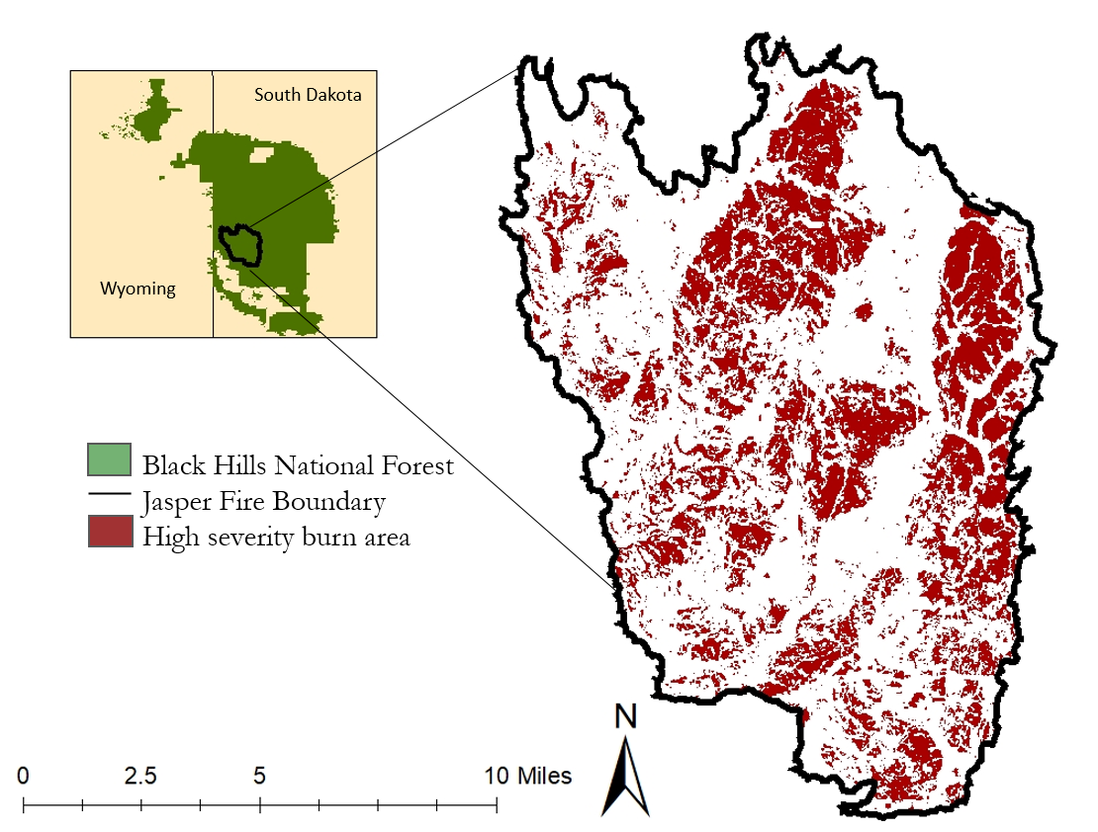

*Figure 1*. Study area map illustrating high-severity burn areas of the Jasper fire in the Black Hills National Forest, South Dakota.

The Black Hills National Forest is dominated by ponderosa pine forest, with other species occupying wetter and higher elevation regions. This includes white spruce (*Picea glauca*), the second-most abundant coniferous species, bur oak (*Quercus macrocarpa*) the most abundant deciduous species, and quaking aspen (*Populus tremuloides*) (Walters et al., 2013). Ponderosa pine regeneration is particularly hindered within high-severity burn areas that have experienced near-total stand loss. Its heavy, small-winged seeds make long-distance dispersal difficult, limiting regeneration by distance from surviving forest (Chambers et al., 2016). As a result, ponderosa pine recolonization within high-severity burn patches may be slow and dependent on meeting certain environmental conditions.

Large-scale forest wildfires not only pose a challenge for conifer regeneration, but also for monitoring these well due to the laborious nature of field surveys. In contrast to field survey methods, satellite remote sensing can cover larger areas across longer time scales. Therefore, remote sensing is an advantageous supplement to analyzing forest fire impacts over large temporal and spatial extents (Pérez-Cabello et al., 2021). Commonly, remote sensing is used to monitor post-fire regeneration of forests based on a return to growing-season greenness, measured with the Normalized Difference Vegetation Index (NDVI). However, this method does not distinguish between the recovery of different plant growth forms (i.e., shrubs, grasses, trees), nor deciduous and coniferous species. In forests like those in the Black Hills, the re-establishment of coniferous tree species is integral to the return to historical forest composition. It has been proposed that using a combination of snow cover (snow-on) and growing season satellite images may better differentiate conifer from deciduous growth via remote sensing (Vanderhoof & Hawbaker, 2018). This study applies these methods in tandem with field-collected data to verify the application of snow-on imagery to isolate and map conifer regeneration 20 years following the Jasper Fire.

***2.2 Project Partners & Objectives***

We collaborated with members from the United States Forest Service (USFS) Black Hills Experimental Forest, USFS Rocky Mountain Research Station, and United States Geological Survey (USGS) Geosciences and Environmental Science Center to identify and understand natural regeneration patterns within large, high-severity fire patches of the Jasper Fire. Given the challenges posed to successful ponderosa pine recolonization, forest managers are concerned with the ecological resilience of these forests, which have the potential to convert to shrub or grassland if conifer regeneration is not successful (Coop et al., 2020). Ensuring a return to the previous ponderosa pine dominated ecosystem is important in order to maintain timber production and ecological function.

It is critical that forest managers have accurate information on the status of forest regeneration in order to prioritize reforestation efforts and develop long-term management plans. Current management decisions within the Black Hills National Forest are based on field-collected forest inventories, which can be time consuming and costly. Furthermore, resource managers are limited in what reforestation they can prescribe based on planting feasibility, expense, and time required to manage the 83,508 acres burned by the Jasper Fire. These assessments are more feasible via remote sensing. However, in conifer-dominant forests like the Black Hills, existing remote sensing techniques need further development to separate conifer regeneration from other vegetation.

Utilizing snow-on imagery from open-source Earth observation data is a promising novel technique to detect conifer-specific regeneration. To provide our partners with valuable and cost-effective data on the status of forest recovery, we utilized Earth observations of Sentinel-2 Multispectral Instrument (MSI) and Landsat 8 Operational Land Imager (OLI) to estimate forest recovery. Using snow-on imagery with Random Forest modeling, we provided our partners with a map of regeneration density distribution 20 years post-fire. These results will help USDA Black Hills National Forest managers to assess and track Jasper Fire conifer regeneration success.

# 3. Methodology

***3.1 Data Acquisition and Processing***

***3.1.1 In-situ Data***

Our project partners at USFS collected field data on seedling density 15 years post-fire (2015). They established six, 4-hectare square plots across high-severity burn patches of the Jasper Fire (herein referred to as stem maps). Three plots were within 200m of a parent tree and three greater than 200m from a parent tree. Species, location, and height were recorded for all trees within these plots. Plots encompassed a range of tree densities but were largely skewed towards lower-density composition.

We identified areas of known reforestation planting from the USFS Forest Activity Tracking System (FACTS) that had prescribed planting densities of 400 trees-per-acre (TPA). FACTS has records of all USFS plantings that occurred during our study period in the Activity Silviculture Reforestation geospatial layer. We added additional high-density areas to our dataset by randomly sampling points within reforestation areas planted between 2001 and 2013, to be relatively consistent with seedling size in the stem maps measured in 2015.

***3.1.2 Satellite Data***

Burn severity across the Jasper Fire area was identified using Monitoring Trends in Burn Severity (MTBS) Thematic Burn Severity classifications. MTBS is a multi-agency program that maps the perimeter and burn severity of all wildfires in the United States larger than 1,000 acres to achieve consistent metrics when studying wildfires.

We utilized images from both Landsat 8 OLI(Collection 2, Tier 1, Level 2) and Sentinel-2 MSI(Level-2A). Using both satellites allowed us to capture a wider range of dates and snow conditions. We compiled images collected by these satellites from December 11th – April 10th, as these dates contained the most reliable snow cover in any given year based on a visual inspection of 2015 NAIP imagery. We applied this date range for the winters of 2019, 2020, and 2021 to provide a consistent picture of the vegetation and control for snow variation across the years. The final image collection contained 222 scenes between the two satellites.

Topographic data were taken from the 30m-resolution NASA Digital Elevation Model (NASADEM) to calculate elevation, slope, and cosine-corrected aspect across the study area. NASADEM is a modernized DEM generated from the Shuttle Radar Topography Mission (SRTM) that incorporates Advanced Spaceborne Thermal Emission and Reflection Radiometer Global DEM (ASTER GDEM), Ice, Cloud, and Land Elevation Satellite Geoscience Laser Altimeter System (ICESat GLAS), and Parameter-elevation Regressions on Independent Slopes Model (PRISM) datasets to create a robust elevation dataset.

***3.2 Data Processing***

***3.2.1 In-situ Data***

The stem map data were filtered to include only conifer tree species, reducing our dataset to almost entirely ponderosa pine (99.5%). We then rasterized the filtered stem map dataset based on the number of trees calculated within a 20m x 20m grid to match the pixel size of the Sentinel-2 MSI images. We reclassified pixels based on their conifer density into categories of low (0-40 TPA), medium (40-150 TPA), and high (>150 TPA). These categories were chosen based on assumed spectral separability, interests of resource managers, and data availability. This process gave us a total of 583 points, classified as low (521), medium (45), and high (17) regeneration.

Due to the abundance of low-density pixels from the field data, we established additional data points from planting sources focused on the medium and high-density classes. We assigned these randomly selected points within the reforestation plantings by ocularly categorizing density class within a 20m grid. We utilized NAIP imagery from 2015 in order to ensure similar growing status to the stem map data. This process gave us an additional 336 points classified as medium (181) and high (155) regeneration density. Combining the stem map and reforestation planting data produced a final dataset of 919 points, classified as low (521), medium (226),and high (172) regeneration density.

***3.2.2 Satellite Data***

After filtering the satellite images to our study area and date range, we used the pixel quality assessment (QA_Pixel) band of our Landsat 8 OLI images to mask clouds and cloud shadows. Sentinel-2 images did not undergo cloud masking because of frequent errors between snow and cloud cover by the QA pixels due to the satellite’s lack of a thermal band.

We then calculated the Normalized Difference Forest Snow Index (NDFSI) and Normalized Difference Snow Index (NDSI) for each image within the collection (Table 1). NDSI and NDFSI are spectral indices that are both used in the detection of snow cover. NDSI has improved performance in tree-less areas (Equation 2), where NDFSI has improved performance within tree cover (Equation 3). We included both index filters to account for a diversity of conditions found within the high-severity burn area. We applied a snow index filter across all images in the collection to only include pixels with NDSI and NDFSI values between 0.4 and 0.8. From the filtered images, we took the median pixel value from all resulting images to create our final image composite. The image composite was then clipped to the high-severity burn boundary as defined by MTBS.

Using the composite image, spectral indices included in the initial testing of the model were calculated over the area. NDVI, a common measure of vegetation greenness, served as our primary metric to detect conifer regeneration (Equation 1). We also calculated the Normalized Difference Water Index (NDWI) for vegetation water content (Equation 4), Normalized Burn Ratio (NBR) for burn severity (Equation 5), and Soil-Adjusted Vegetation Index (SAVI) for areas of low vegetation cover (Equation 6) as additional variables in the Random Forest classification.

Table 1

*Indices used for variable selection of Random Forest classification and image processing*

|  |  |  |  |
| --- | --- | --- | --- |
| **Spectral Indices Utilized** | | |  |
| Index Acronym | Index | Equation | Description |
| NDVI | Normalized Difference Vegetation Index | $NDVI = \frac{NIR-Red}{NIR +Red}$*(eq. 1)* | Used to identify vegetation greenness (Buma, 2012) |
| NDSI | Normalized Difference Snow Index | $NDSI =\frac{Green-SWIR}{Green+SWIR}$*(eq. 2)* | Used to identify snow cover (Wang et al., 2015) |
| NDFSI | Normalized Difference Forest Snow Index | $NDFSI = \frac{NIR - SWIR}{NIR + SWIR}$*(eq. 3)* | Used to identify forested snow cover (Wang et al., 2015) |
| NDWI | Normalized Difference Water Index | $NDWI= \frac{Green-NIR}{Green +NIR}$*(eq. 4)* | Used to measure water content in leaves (Gao, 1996) |
| NBR | Normalized Burn Ratio | $NBR= \frac{NIR-SWIR 2}{NIR +SWIR 2}$*(eq. 5)* | Used to identify burn severity (Roy et al., 2005) |
| SAVI | Soil-Adjusted Vegetation Index | $SAVI= \frac{NIR-Red}{NIR +Red + 0.5}× 1.5$*(eq. 6)* | Used to correct for soil brightness in low vegetated areas (Vani & Mandla, 2017) |

***3.3 Model***

We first examined all spectral indices for collinearity and importance. We found that NDVI had a high degree of correlation to NDWI, NBR, and SAVI, leading us to remove them from the model. NDSI and NDFSI were also highly correlated, so we chose to include NDSI given that the majority of our study area was not considered forested. For topographic variables, we found no initial correlation between slope or aspect and regeneration density in our data, and therefore also removed them from our model. For our final model, we chose to include NDVI, NDSI, and elevation as predictors of conifer regeneration classes.

We utilized Google Earth Engine’s Random Forest classifier (smileRandomForest) for modeling. Random Forest is a machine learning algorithm used to perform classification through a series of decision trees. It offers a non-parametric alternative and additional flexibility to better model large, noisy remote sensing datasets.

We combined the stem map and reforestation planting points as evaluation data for the model with an approximate 80% training, 20% validation split. The 177 points picked for validation are classified as low (107), medium (44) and high (26) regeneration density. NDVI, NDSI, and elevation were used as predictor layers in the model. We incorporated these inputs into the smileRandomForest classifier. We performed a separate validation analysis in R using the randomForest package to identify decision tree size. We chose 340 decision trees, as this selection produced the lowest mean squared error given our variable selection. The final model was applied across the snow image composite to classify the entire high-severity burn area as low, medium, or high conifer regeneration.

# 4. Results & Discussion

***4.1 Model Accuracy***

The model produced an overall accuracy of 81.4% but varied across regeneration density classes, with accuracy decreasing as regeneration density increased (Table 2). This trend could be attributable to a limited dataset in the medium and high regeneration classes as well as increased spectral heterogeneity within the higher density classes. Furthermore, the higher density classes were largely comprised of ocularly sampled points, which may introduce additional errors when compared with the field-collected stem maps.

Table 2

*Model accuracy assessment of the high-severity regeneration classification. The accuracy calculation is based on 177 points picked for validation.*

|  |  |  |  |  |  |
| --- | --- | --- | --- | --- | --- |
|  | **Model Accuracy Assessment** | | | | |
| Class | | Classification according to in-situ data | | | Accuracy % |
| Low | Medium | High |
| Classification according to model | Low | 97 | 4 | 1 | 95.1% |
| Medium | 7 | 26 | 4 | 70.3% |
| High | 3 | 14 | 21 | 55.3% |

***4.2 Model classification***

The model classified the majority of the high-severity burn area as low (45.9%) or medium (44.1%) regeneration, with high regeneration accounting for only 10% of the assessed area (Figure 2). These percentages suggest that 20 years post-fire, the majority of high-severity burn from the Jasper Fire is not at desirable regeneration densities

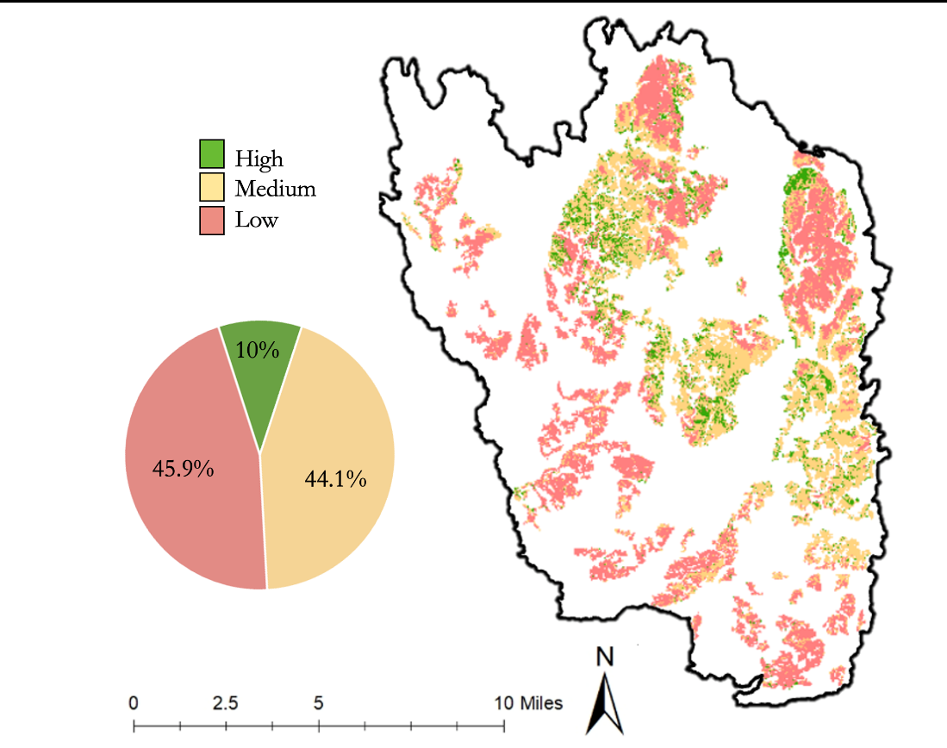

*Figure 2*. Classified regeneration density across the high severity burn areas of the Jasper Fire.

From the areas of low regeneration, we then identified 4,079 acres as high priority for reforestation efforts by our partners. These areas met additional criteria from our partners for feasibility and efficiency of planting, including patches greater than 50 acres each, less than 1500ft from roads, and not previously planted by USFS post-fire (Figure 3).

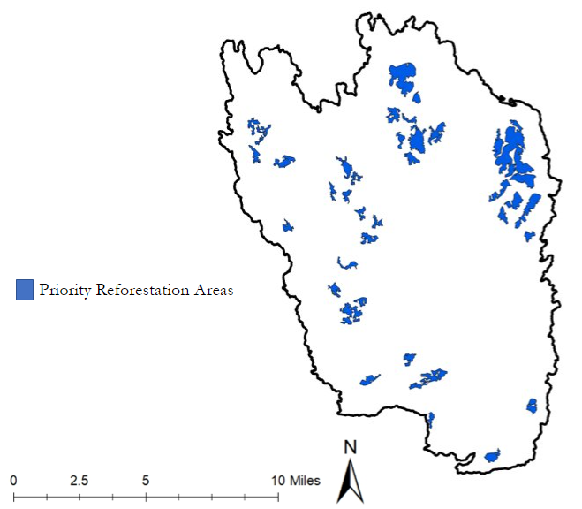

*Figure 3*. 4,079 acres classified as low regeneration and meets partner criteria for feasible replanting.

***4.3 Project Limitations***

We identified several challenges in applying snow-on imagery to detect conifer regeneration that have implications for future use of these techniques. The largest obstacles were accommodating the uncertainty of snow-cover imagery and adapting field data not initially collected for this purpose. While we found snow cover to be a viable technique to isolate conifer regeneration, it introduces an amount of uncertainty to analysis. Snow cover can be highly variable over the course of a season, between years, and over large regions. Some understanding of the site of interest is needed to properly determine snow cover dates and identify if any snow index filtering would be required to ensure even snow cover. Additionally, an understanding of the general vegetation composition of the site is needed to properly assess if evergreen shrub cover would be a large component of the snow-cover NDVI. Applying these techniques to sites lacking snow cover, or to sites with large amounts of competing vegetation that would not be masked by snow, may not be feasible.

We also found that a large field-collected evaluation dataset is required in order to accurately assess density, as high-resolution satellite imagery is largely still not detailed enough to digitize individual seedling-sized trees. While the model seems to reliably represent the presence and absence of conifer regeneration at a low threshold, separating between multiple densities becomes challenging without robust field data designed for remote sensing analysis. In future study designs, there may be improved accuracy from collecting field data across an increased range of regeneration conditions and topographic variables (e.g., elevation, aspect, slope). As remote sensing indices are influenced by visible light differences introduced by these topographic variations, we would expect to see improved model performance by including data from a range of terrain conditions.

Additionally, post-fire analyses must be completed several years post-fire to ensure conifer seedlings have enough time for recruitment and subsequent growth to a spectrally-detectable size. When conducting multi-temporal analyses, additional field data would likely be needed in order to account for differences between seedling recruitment and seedling growth. Additional understanding of site-specific seedling growth rates would enable choosing an appropriate amount of time post-fire to ensure regeneration is detectable by these techniques.

***4.4 Future Work***

These techniques could be used in the Black Hills National Forest to continue to monitor the forest recovery within the high-severity burn area. Additional assessments could help monitor the success of reforestation efforts and save resource managers time from conducting intensive field assessments. Expansion of snow-on imagery monitoring applied to other wildfires occurring in conifer dominated landscapes would test the transferability of these methods.

# 5. Conclusions

Overall, we found snow-on remote sensing to be a viable technique to detect conifer regeneration in the Jasper Fire burn area. We were able to successfully map low, medium, and high regeneration across the high-severity burn and create data products to aid forest managers in reforestation efforts. The model’s higher accuracy in the low regeneration class provides confidence in the ability of our model to prioritize areas in need of reforestation efforts. Characterizing the spatial pattern of forest regeneration will help resource managers prioritize reforestation efforts in the Black Hills. Additionally, this technique could be used to monitor and identify planting success long-term. This project will help the partner organizations better leverage Earth observations to understand natural conifer regeneration and spectrally distinguish conifer growth from other vegetation. Providing a link between field data and coarse-resolution imagery will provide replicable, scalable, and affordable techniques for future post-fire recovery efforts.

# 6. Acknowledgments

The team would like to acknowledge the following individuals for their influence on our work:

* Dr. Wade Tinkham (Colorado State University, Forest and Rangeland Stewardship)
* Lauren Lad (Colorado State University, Forest and Rangeland Stewardship)
* Paula Fornwalt (Rocky Mountain Research Station, United States Forest Service)
* Melanie Vanderhoof (Geosciences and Environmental Change Science Center, United States Geological Survey)
* Mike Battaglia (Black Hills Experimental Forest, United States Forest Service)
* Dr. Paul Evangelista (Colorado State University, Natural Resource Ecology Laboratory)
* Dr. Catherine Jarnevich (United States Geological Survey, Fort Collins Science Center)
* Dr. Anthony Vorster (Colorado State University, Natural Resource Ecology Laboratory)
* Nicholas Young (Colorado State University, Natural Resource Ecology Laboratory)
* Peder Engelstad (Colorado State University, Natural Resource Ecology Laboratory)
* Sarah Hettema (Fellow, NASA DEVELOP Colorado – Fort Collins)

This material contains modified Copernicus Sentinel data (2015–2016), processed by ESA.

DigitalGlobe/Maxar data were provided by NASA’s Commercial Archive Data for NASA investigators (cad4nasa.gsfc.nasa.gov) under the National Geospatial-Intelligence Agency’s NextView license agreement.

Any opinions, findings, and conclusions or recommendations expressed in this material are those of the author(s) and do not necessarily reflect the views of the National Aeronautics and Space Administration.

This material is based upon work supported by NASA through contract NNL16AA05C.

# 

# 7. Glossary

**Conifer** – Trees or shrubs with needle-like leaves and seed-bearing cones. Most species are evergreen, keeping their green leaves despite seasonal changes.

**Deciduous** – Trees or shrubs which shed their leaves annually/seasonally.

**Earth Observations** – Satellites and sensors that collect information about the Earth’s physical, chemical, and biological systems over space and time.

**Random Forest** – The Random Forest model is a machine learning algorithm that utilizes a collection of decision trees using random subsets of variables. The Random Forest algorithm attempts to split the decision trees in a way that resulting groups are as different from each other as possible while maintaining that members within the subgroup are as similar to each other as possible.

# 8. References

Buma, B. (2012). Evaluating the utility and seasonality of NDVI values for assessing post-disturbance recovery in a subalpine forest. *Environmental Monitoring and Assessment*, *184*, 3849–3860. <https://doi.org/10.1007/s10661-011-2228-y>

Chambers, M. E., Fornwalt, P. J., Malone, S. L., & Battaglia, M. A. (2016). Patterns of conifer regeneration following high severity wildfire in ponderosa pine – dominated forests of the Colorado Front Range. *Forest Ecology and Management*, *378*, 57–67. <https://doi.org/10.1016/j.foreco.2016.07.001>

Coop, J. D., Parks, S. A., Stevens-Rumann, C. S., Crausbay, S. D., Higuera, P. E., Hurteau, M. D., Tepley, A., Whitman, E., Assal, T., Collins, B. M., Davis, K. T., Dobrowski, S., Falk, D. A., Fornwalt, P. J., Fulé, P. Z., Harvey, B. J., Kane, V. R., Littlefield, C. E., Margolis, E. Q., … Rodman, K. C. (2020). Wildfire-driven forest conversion in western North American landscapes. *BioScience*, *70*(8), 659–673. <https://doi.org/10.1093/biosci/biaa061>

European Space Agency. (2015). Sentinel-2 Data (Version 1.0) [Data set]. Geoscience Australia. <https://doi.org/10.4225/25/566a407cd2e2b>

Gao, B. (1996). NDWI—A normalized difference water index for remote sensing of vegetation liquid water from space. *Remote Sensing of Environment, 58*(3), 257–266. <https://doi.org/10.1016/S0034-4257(96)00067-3>

Keyser, T. L., Smith, F. W., & Shepperd, W. D. (n.d.). Growth Response of Pinus ponderosa following a Mixed-Severity Wildfire in the Black Hills, South Dakota.

Pérez-Cabello, F., Montorio, R., & Alves, D. B. (2021). Remote sensing techniques to assess post-fire vegetation recovery. *Current Opinion in Environmental Science & Health*, *21*, Article 100251. <https://doi.org/10.1016/j.coesh.2021.100251>

NASA JPL (2020). NASADEM Merged DEM Global 1 arc second V001 [Data set]. NASA EOSDIS Land Processes DAAC. Accessed 2020-12-30 from https://doi.org/10.5067/MEaSUREs/NASADEM/NASADEM_HGT.001

Rodman, K. C., Veblen, T. T., Battaglia, M. A., Chambers, M. E., Fornwalt, P. J., Holden, Z. A., Kolb, T. E., Ouzts, J. R., & Rother, M. T. (2020). A changing climate is snuffing out post-fire recovery in montane forests. *Global Ecology and Biogeography*, *29*(11), 2039–2051. <https://doi.org/10.1111/geb.13174>

Roy, D. P., Boschetti, L., & Trigg, S. N. (2006). Remote sensing of fire severity: Assessing the performance of the normalized burn ratio. *IEEE Geoscience and Remote Sensing Letters, 3*(1), 112–116. https://doi.org/10.1109/LGRS.2005.858485

Stevens-Rumann, C. S., Kemp, K. B., Higuera, P. E., Harvey, B. J., Rother, M. T., Donato, D. C., Morgan, P., & Veblen, T. T. (2018). Evidence for declining forest resilience to wildfires under climate change. In Ecology Letters, 21(2), 243–252. <https://doi.org/10.1111/ele.12889>

U.S. Geological Survey (2014). Provisional Landsat OLI Surface Reflectance [Data set]. Earth Resources Observation and Science Center. <https://doi.org/10.5066/F78S4MZJ>

Vanderhoof, M. K., & Hawbaker, T. J. (2018). It matters when you measure it: Using snow-cover Normalised Difference Vegetation Index (NDVI) to isolate post-fire conifer regeneration. *International Journal of Wildland Fire*, *27*(12), 815–830. <https://doi.org/10.1071/WF18075>

Vanderhoof, M. K., Hawbaker, T. J., Ku, A., Merriam, K., Berryman, E., & Cattau, M. (2020). Tracking rates of post-fire conifer regeneration distinct from deciduous vegetation recovery across the western United States. *Ecological Applications*, *31*(2), Article e02237. <https://doi.org/10.1002/eap.2237>

Vani, V., & Mandla, V. R. (2017). Comparative study of NDVI and SAVI vegetation indices in Anantapur district semi-arid areas. *International Journal of Civil Engineering and Technology*, *8*(4), 559–566.

Walters, B. F., Woodall, C. W., Piva, R. J., Hatfield, M. A., Domke, G. M., & Haugen, D. E. (2013). Forests of the Black Hills National Forest 2011. *US Forest Service Resource Bulletin*, *NRS-*(83). <https://doi.org/10.2737/nrs-rb-83>

Wang, X., Wang, J., Jiang, Z., Li, H., & Hao, X. (2015). An effective method for snow-cover mapping of dense coniferous forest in the Upper Heihe River Basin using Landsat Operational Land Imager data. *Remote Sensing*, *7*(12), 17246–17257. <https://doi.org/10.3390/rs71215882>

Westerling, A. L. (2016). Increasing western US forest wildfire activity: Sensitivity to changes in the timing of spring. Philosophical Transactions of the Royal Society B, 371, Article 20150178. https://doi.org/10.1098/rstb.2015.0178