**NASA DEVELOP National Program**



NOAA National Centers for Environmental Information

**Fall 2016**

**Short Title: Levant & Central America Climate II**

**Subtitle:** Enhancing Drought Monitoring and Prediction Capabilities by the US Air Force, 14th Weather Squadron in Levant and Central America

**VPS Title:** A Climate News Special Report: Feeding the Machine

**Project Team & Partners**

**Project Team:**

Evan Henry (Project Lead), evan.henry@noaa.gov

Patrick Pierce

Lauren Cater

Alec Courtright

**Advisors & Mentors:**

Raymond Kiess (US Air Force 14th, Weather Squadron)

Major Jason Scalzitti (US Air Force 14th, Weather Squadron)

Dr. L. DeWayne Cecil (Global Science & Technology, Inc.)

**Past or Other Contributors:**

Christie Stevens

Hayley Hajic

**Partner Organizations:**

|  |  |  |  |
| --- | --- | --- | --- |
| **Organization** | **POC (Name, Position/Title)** | **Partner Type** | **Boundary Org?** |
| US Air Force, 14th Weather Squadron | Major Jason Scalzitti, Operations Officer  Raymond Kiess, Lead Scientist | End-User | No |

**Project Details**

**Applied Sciences National Applications Addressed:** Climate, Water Resources, Agriculture, Disasters

**Study Area:** The Levant region, including Syria, Lebanon, Jordan, Israel, and Iraq and the Central America region, including Guatemala, El Salvador, Honduras, and Nicaragua, Costa Rica, and Panama

**Study Period:** July 2002 - October 2014

**Earth Observations & Parameters:**

Terra, Moderate Resolution Imaging Spectroradiometer (MODIS) – NDVI, ET, and LST

NOAA CPC Morphing Technique (CMORPH) Satellite-derived global precipitation

**Ancillary Datasets Utilized:**

* Global Precipitation Climatology Center (GPCC) – Drought Index Product

**Models Utilized:**

* Random Forest Classification Model

**Software Utilized:**

* ESRI ArcGIS – map creation
* R – statistical analysis and data processing

**Project Overview**

**Objectives Overview:**

Drought in the Levant and Central America regions is of grave concern as it exacerbates water scarcity and deteriorates agricultural potential. These issues have caused various forms of civil unrest and have led to the migration of 1.5 million people from rural farming communities to urban areas. The US Department of Defense (DoD) and the Intelligence Community understand the relationship between conflict and extreme drought events and know that understanding the spatial and temporal variations in precipitation is extremely important to better predict drought. Using NASA and NOAA Earth observations, the NCEI Levant & Central America Climate II team is taking a machine learning approach to model drought for each location.

**Abstract:**

Drought is caused by extreme variations in precipitation, which include volume, frequency, and type, and can contribute to water shortages, crop failures, and socio-economic stress. The multiplicity of factors and temporal variability that influence drought proves challenging to model. Current drought models utilize remotely sensed satellite data, *in situ* ground measurements, or a combination of both, to assess drought severity. In this study, multiple MODIS derived variables, CMORPH precipitation data, and the Global Precipitation Climatology Centre (GPCC) *in situ* drought index product were used to create novel drought models through several machine learning approaches. The models were tested on two regions: the humid climates of Central America and arid climates in the Levant. In an effort to better the prediction of drought, the 14th Weather Squadron will integrate the final product into their current operational procedures, which may be used to better globally predict drought in a more robust and scientifically sound method.

**Keywords:**

Remote sensing, drought, machine learning, MODIS, GPCC, CMORPH

**Community Concerns:**

* The environmental, social, political and economic consequences of extreme weather and drought events are major concerns across the world.
* In the Levant and Central America, extreme variations in precipitation, resulting in drought, is of particular concern.
* The two regions have witnessed an increase in extreme weather and drought events in recent years. The implications of these events are varied, but include potential impacts on agriculture, water quantity and quality, economic productivity, and social and political systems.
* Of particular concern to the US defense and intelligence communities is the potential impact of extreme weather and drought on conflict and civil unrest. To address this concern, developing a stronger understanding of the relationship between the two is essential.

**Current Management Practices & Policies**:

The US Air Force, 14th Weather Squadron supports the defense and intelligence communities through the collection and analysis of climate data (temperature, precipitation, etc.). They currently use various NOAA datasets as well as their own collective system to ingest observational data feed from the 2nd Systems Operational Squadron (2SYOS) at the 557th Weather Wing (557WW) Headquarters at Offutt Air Force Base, NB. Additionally, the 14th Weather Squadron uses the Global Precipitation Climatology project (GPCP) provided by the NASA Goddard Space Flight Center through the Remote Sensing Data (RSD) server for their precipitation data.

A current focus of the 14th Weather Squadron is on monitoring drought and enhancing their capacity to do so through the use of ET and NDVI data in drought-prone regions of the world where data is often less easily available or accessible. Predictive models help to inform understanding of the environmental, social, political and economic impacts of climate change.

**Decision Support Tools & Benefits:**

|  |  |  |  |
| --- | --- | --- | --- |
| **End-Product** | **Earth Observations Used** | **Benefit & Impact** | **Software Release** |
| Machine Learning Model Performance Analysis of Drought Assessment | CMORPH, MODIS, GPCC | Drought models will provide region-specific insight on drought assessment | N/A |
| Maps, Figures, Tables, and Images | CMORPH, MODIS, GPCC | Data and product visualization, demonstrating location of study regions, results of r2 and RMSE, and analysis from the relative importance of variables | N/A |
| Script Packages | MODIS, CMORPH, GPCC | Future usage and repeatability | III |
| Comparison of Machine Learning Using CMORPH | CMORPH | Provides confidence in the precipitation data and ultimately the Machine Learning approach | N/A |

**Project VPS/Booklet Imagery**

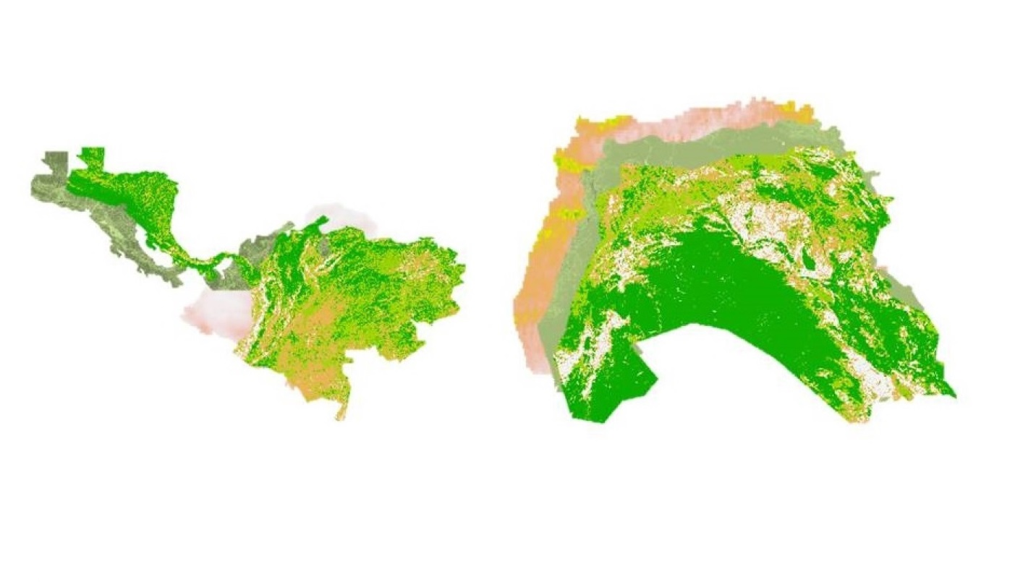

**Caption:** Levant & Central America study regions for drought monitoring. Image Credit: Levant & Central America Climate II Team.

**Image:** 2016Fall_NCEI_LevCAClimateII_FinalImagery.jpg