**NASA DEVELOP National Program**

****NASA Ames Research Center

**Summer 2015**

**Short Title: Gulf of Mexico Water Resources Project**

**Subtitle:** A Geospatial Evaluation of Drivers, Occurrences, and Distribution of Hypoxic Events within the Grijalva-Usumacinta River Delta System and the Southern Coast of the Gulf of Mexico

**VPS Title:** Haunting the Gulf: Dead Zones Linger in Shallow Waters

**Project Team & Partners**

**Project Team:**

Rebecca Chapman (Project Lead), rebecca.chapman@nasa.gov, [chapman.reb@gmail.com](mailto:chapman.reb@gmail.com)

Irma Caraballo Álvarez

Åse Mitchell

Alannah Johansen

Mackenzie Taggart

Bridget Smith

**Advisors & Mentors:**

Dr. Juan L. Torres-Pérez (Bay Area Environmental Research Institute)

Dr. Sherry L. Palacios (Bay Area Environmental Research Institute)

Chase Mueller M. Sc. (Bay Area Environmental Research Institute)

**Past or Other Contributors:**

Andrew Nguyen (DEVELOP National Program, Ames Research Center)

Chippie Kislik (DEVELOP National Program, Ames Research Center

**Partner Organizations**

Consorcio de Instituciones de Investigación Marina del Golfo de México y del Caribe (CIIMar-GoMC), End-Users, POC: Dr. Porfirio Álvarez Torres and Dr. José Manuel Piña Gutiérrez

Centro del Cambio Global y la Sustentabilidad en el Sureste (CCGSS), End-User, POC: Dr. Mariana Elvira Callejas Jiménez

Centro Nacional de Datos Oceanográficos (CENDO), End-User, POC: Dr. Carlos Torres

Comisión Nacional para el Conocimiento y Uso de la Biodiversidad (CONABIO), Collaborator, POC: Dr. Rainer Ressl and Dr. Sergio Cerdeira

Universidad Autónoma de Baja California (UABC), Collaborator, POC: Dr. Eduardo Santamaria del Ángel

Universidad Juarez Autónoma De Tabasco (UJAT), Collaborator, POC: Rosa Martha Padrón

Secretaría de Marina (SEMAR), Collaborator, POC: Captain Joel Pensamiento

**Project Details**

**Applied Sciences National Applications Addressed:** Water Resources

**Study Area:** The Gulf of Mexico, the coastal region along the southern end of the Bay of Campeche, and the Grijalva-Usumacinta River Basin – which extends through the Mexican States of Tabasco, Chiapas, and Campeche, as well as south into Guatemala.

**Study Period:** July 2000 - May 2015

**Earth Observations & Parameters**

Landsat 8, OLI - Floating Algal Index (FAI) and Normalized Difference Turbidity Index (NDTI) utilizing bands 2, 3, 4, 5, and 6.

Aqua, MODIS - Level 3 SMI Products: Chlorophyll *a* (Chl-*a*), Sea Surface Temperature (SST) Photosynthetically Available Radiation (PAR), and Colored Dissolved Organic Matter (CDOM)

**Ancillary Datasets Utilized**

* USGS Earth Explorer Database - DEM
* NOAA National Centers for Environmental Information (NCEI) Database- Dissolved oxygen
* The National Centers for Environmental Prediction (NCEP) Climate Forecast System Reanalysis (CFSR) Texas A&M University Global Weather for SWAT Database – Precipitation, wind speed, relative humidity, solar radiation
* International Ocean Observing System (IOOS) Gulf of Mexico Coastal Ocean Observing System (GCOOS) Data Portal - Chlorophyll, dissolved oxygen, turbidity, surface water temperature
* United Nations University Institute for Water, Environment, and Health (UNU-INWEH) Database – Soil profiles
* European Space Agency (ESA) Climate Change Initiative (CCI) Climate Research Data Package (CRDP) – Land Cover
* Natural Earth Database - Shapefiles of rivers and water bodies
* Banco Nacional de Datos de Aguas Superficiales (BANDAS) – Streamflow gauge data

**Models Utilized**

* ESRI ArcGIS Soil and Water Analysis Tool (SWAT)
* Clark Labs TerrSet Earth Trends Modeler (ETM)

**Software Utilized**

Esri ArcGIS Desktop - Raster Manipulation/Analysis, Image Enhancement & Map Creation of Landsat ETM+, NPP VIIRS, Aqua/Terra MODIS

Clark Labs TerrSet - Modeling Earth trends, anomaly detection, time series analysis

**Project Overview**

**80-100 Word Objectives Overview**

The environmental health of the Grijalva-Usumacinta River Basin is essential for the survival and economic well-being of millions of people who rely on this ecosystem for drinking water, food, and other natural resources. However, an increasing frequency of hypoxic events and harmful algal blooms (HABs) has been observed in the lowlands and coastal regions of this system in recent years. This project utilized NASA Earth observations to detect these events and then relate their occurrences to nutrient and sediment loading from the Grijalva-Usumacinta River Basin. Results of this study will be used to aid local authorities in revising water quality standards in the region.

**Abstract**

Monitoring and analyzing harmful algal blooms (HABs) and hypoxic events in the southern coastal areas of the Gulf of Mexico (GoM) is important for watershed management and mitigation of environmental degradation. This study uncovered trends and dynamic characteristics of chlorophyll-*a* (Chl) concentration, sea surface temperature (SST), colored dissolved organic matter index (CDOM), and photosynthetically available radiation (PAR); as evident in 8-day standard mapped image (SMI) products from the Moderate Resolution Imaging Spectroradiometer (MODIS) instrument on the Aqua platform from 2002-2015 using Clark Labs’ TerrSet Earth Trends Modeler (ETM). Additionally, sediment and nutrient loading values of the Grijalva-Usumacinta watershed were modeled using the Soil and Water Assessment Tool (SWAT) within ArcGIS. Normalized Difference Turbidity Index (NDTI) and Floating Algae Index (FAI) were generated using Landsat 8 Operational Land Imager (OLI) scenes for 2014-2015. Results will assist local environmental and health authorities in revising water quality standards and mitigating the impacts of future HABs and hypoxic events in the region.

**Community Concerns**

* The Grijalva-Usumacinta River Basin is an important source of drinking water, hydroelectric energy, fisheries, and other natural resources to the 6 million people who live within the region. This system is also one of the largest freshwater inflows to the Gulf of Mexico, second only to the Mississippi River Basin.
* Deforestation, fertilizer runoff, and slash and burn agricultural techniques have degraded the water quality in this river basin through increased erosion and nutrient loading.
* Since the early 2000s, increasing frequencies of hypoxic events and harmful algal blooms (HABs) have been observed along the coastal continental shelf surrounding the Grijalva-Usumacinta River Delta.
* Algal blooms are cyclic and natural phenomena that occur in both coastal and freshwater systems worldwide. However, an unnatural influx of nutrients and organic matter has contributed to frequent and rapid algal proliferation events. This, in turn, has resulted in persistent seasonal hypoxia and the death of many marine organisms.
* Many blooms in recent years have been composed of toxin-producing algal species. These harmful algal blooms (HABs) have been implicated in eutrophication, fish kills, economic loss for fisheries, and human illness.

**Current Management Practices & Policies**

The federal government of Mexico has adopted a variety of laws aimed at the protection of surface and coastal water resources. Among these are The Federal Law of the Sea and the National Waters Law, which offer protection and regulatory standards for marine and surface water environments, respectively. Unfortunately, many of the current water quality standards are outdated, and few are enforced (Oswald Spring, 2014). Therefore, a current assessment of the region is required in order to create adequate environmental protection policies. Recently, partner organizations CIIMar-GoMC, UJAT, CONABIO, UABC, and CCGSS have collaborated to focus resources on implementing *in-situ* water quality monitoring and management strategies for both hypoxia and HABs (Alvarez Torres and Gold, 2012). They have also allocated resources toward utilizing NASA Earth observations to assist in creating effective regulatory and management strategies. Additionally, the Federal Ministry of Health, through its directorship on Sanitary Risks Protection, is conducting surveys to identify and quantify the toxin-producing algal species that proliferate during HABs.

**Decision Support Tools & Benefits**

|  |  |  |
| --- | --- | --- |
| **End-Product** | **Earth Observations Used** | **Benefit & Impact** |
| Normalized Difference Turbidity Index (NDTI), Floating Algal Index (FAI) | Landsat 8 OLI | Display the spatial extent of hypoxia indicators to prioritize water quality monitoring locations. |
| TerrSet ETM time series analysis, detection of Chl, SST, PAR, and CDOM anomalies | Aqua MODIS Level III SMI products | Determine inter-annual and seasonal trends of known indicators of HABs and hypoxic events to aid partner organizations in forecasting these events. |
| SWAT modeled nitrogen, phosphorus, and sediment load | *In-situ* data | Model historical and projected nutrient and sediment influx from the Grijalva-Usumacinta watershed to aid local agencies in setting regulatory standards. |

**References**

Alvarez Torres, P. and G. Gold. (2012). Monitoring in the Gulf of Mexico Large Marine Ecosystem: Hypoxia, HABIOS, and Monitoring Pilot Project. Presentation PowerPoint for Gulf of Mexico Alliance, All Hands Meeting. Corpus Christi, TX, 19 June 2012.

Gutierrez, C. (2008). Standards and Thresholds for Wastewater Discharges in Mexico. In M. Schmidt, J. Glasson, L. Emmelin, and H. Helbron (Eds.), *Standards and Thresholds for Impact Assessment* (pp. 113–124). Berlin: Springer Verlag.

Oswald Spring, U. (2014). Water security and national water law in Mexico. *Earth Perspectives* 1:7.

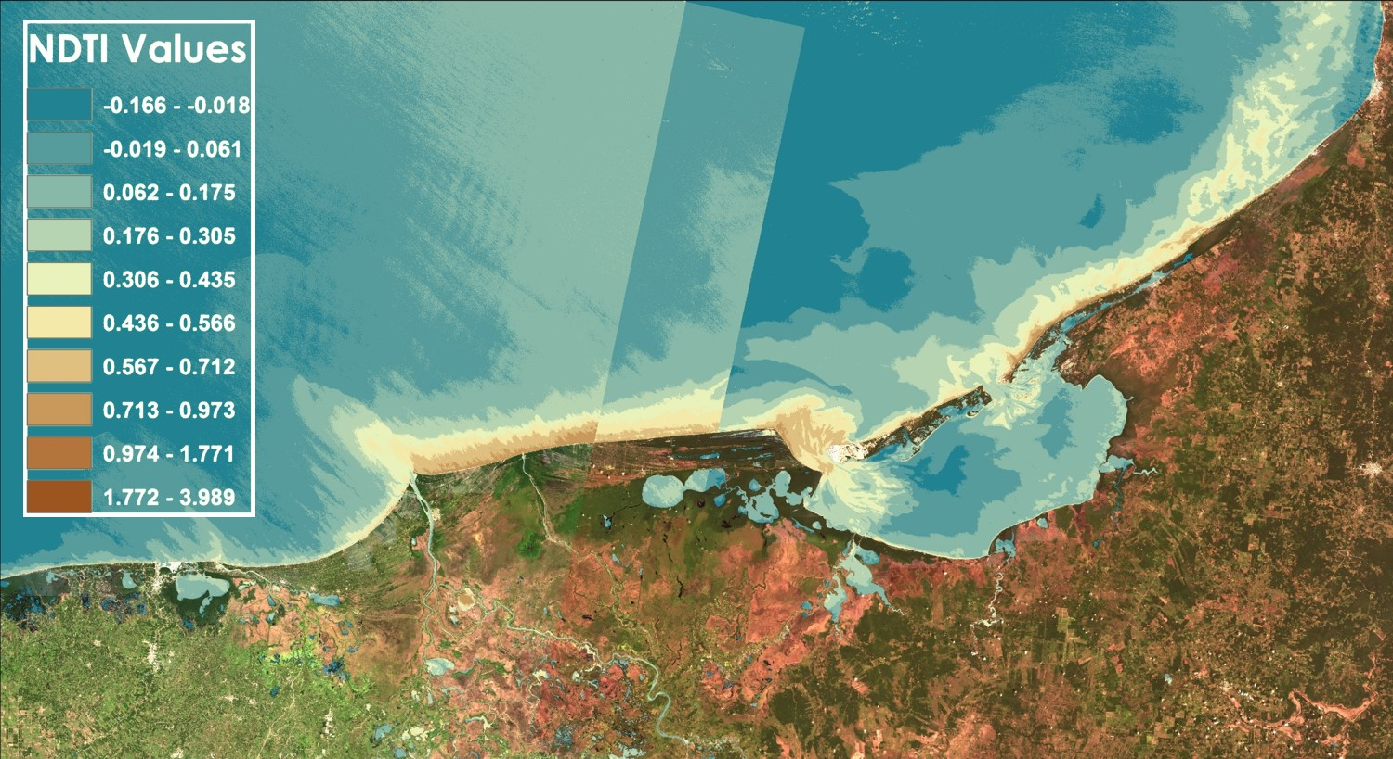**Project Imagery**

**Caption:** Normalized Difference Turbidity Index (NDTI) generated from Landsat 8 Operational Land Imager (OLI) scenes in the Bay of Campeche. Image Credit: Gulf of Mexico Water Resources Team.

**Image:** 2015Sum_ARCMexicoWR_FinalImage.jpg