**NASA DEVELOP National Program**



Goddard Space Flight Center

*Summer 2015*

Thailand Disasters

Monitoring Risk and Extent of Drought for Enhanced Decision Making and Resource Allocation in the Kingdom of Thailand

 **Technical Report**

Rough Draft – June 25, 2015

Sean McCartney (Project Lead)

Nobphadon Suksangpanya

Chisaphat Supunyachotsakul

Srisunee Wuthiwongyothin

Sahakait Benyasut

Thanapat Vichienlux

Dr. John Bolten, NASA Goddard Space Flight Center (Science Advisor)

Colin Doyle, NASA –Goddard Space Flight Center (Science Advisor)

# I. Abstract

**Keywords**

Thailand, Drought Indices, NASA Earth Observations, Remote Sensing, NDVI, Land Surface Temperature, Precipitation, Soil Moisture Content

# II. Introduction

In recent decades, observed climate change has impacted natural and human systems across the planet, with changes in extreme weather and climatic events (IPCC, 2014). Hewitt (1997) reported that throughout the world, drought ranks first among

natural disasters in numbers of persons directly affected. Drought is a natural phenomenon resulting from deficiencies in precipitation from regional climatological norms, which are insufficient in meeting the needs of humans and the environment (Wilhite, 2005). In contrast to short-term variations in precipitation, drought is a slow-onset disaster lasting seasonally to annually. The severity of a drought depends on its duration, intensity, and spatial extent (Shaw et al., 2011). As more than half of the world’s population depends on Asian monsoon rainfall, changes in the timing, duration, and severity of precipitation can have significant effects (Buckley et al., 2006).

As one of the largest rice exporting countries in the world (USDA, 2014), Thailand farmers rely on rainfall for roughly 75% of the total 9.2 million ha of rice growing areas in the country as opposed to irrigation (Jongdee et al., 2006). Extreme climatic events like drought affect not only rainfed crops during the monsoon season but limit the availability of water for off-season irrigated crops. After the 2014 – 2015 drought in Thailand, rice exports were down by 4% in the first quarter of 2015 (Prasertsri, 2015), and the Thai cabinet allocated roughly 6.8 billion baht ($208.65 million) to alleviate drought through the installation of water pumps and mobile water tanks to the most drought affected regions (Kaewjinda et al., 2015).

In 2015, the Royal Thai Government established a four-part integrated plan for drought management. Currently, the drought monitoring system is provided by the Geo-Informatics and Space Technology Development Agency (GISTDA) to monitor agricultural drought, but there are no systems in place to monitor other droughts that also impact the population.

The objectives of this project were to: 1) Use three different drought indices to monitor meteorological, hydrological and agricultural drought in Thailand to assist in drought management and mitigation; 2) Identify extreme drought anomalies based on a climatological baseline; 3) Create a near-real time drought monitoring tool that will aid in mitigating risk and improve resource allocation in the country. The indices we will examine to achieve our objectives are: the Standardized Precipitation Index (SPI) which incorporates precipitation data for monitoring meteorological drought; the Stream-Flow Drought Index (SDI) which incorporates in situ data from gauging stations and is used in monitoring hydrological drought; and the Drought Severity Index (DSI) which incorporates precipitation, land surface temperature (LST) and vegetation indices (VI), and is used in monitoring agricultural drought.

The study area for this project was the Kingdom of Thailand (Figure 1). Located in the tropics from 5 - 21˚ N latitude and 97 - 106˚ E longitude, Thailand has a total area of roughly 513,000 km² (CIA, 2015). From mid-May to September the monsoon rains provide precipitation for rainfed crops, of which rice is the dominant cultivar. November through mid-March is the dry season when irrigation provides water for off-season agriculture. Most of the country has a tropical wet and dry climate, with the southern isthmus always hot and humid.

This project examined the period from 1998 - 2015 in creating indices for meteorological and hydrological drought, and the period from 2000 - 2015 in examining agricultural drought. The difference in time periods for each analysis related to data accessibility. All analysis was done on a monthly temporal resolution.

This project addressed the NASA Applied Science’s application area for Disasters, due to the severity of drought afflicting populations and economies in Thailand. The data analysis completed for this project contributes to improve drought monitoring, mitigation and response in Thailand. The study demonstrates how a combination of various indices can offer better understanding of drought conditions, with data derived from Earth Observing (EO) satellites offering the ability to monitor drought across the entire country and in near-real time.

The project partners for this study are the Royal Thai Embassy and the Asian Disaster Preparedness Center (ADPC). These partners are interested in the project because they are currently only monitoring agricultural drought, and this project expands on that role in analyzing three types of drought as well as creating a tool to monitor agricultural drought in near-real time. The drought indices allow Thai government agencies and NGOs the ability to identify the timing and severity of drought from 2000 - present. The methods employed allow for better allocation of resources to target the most affected areas of the country.

# III. Methodology

**Data Acquisition**

The Tropical Rainfall Measuring Mission – Microwave Imager (TRMM-TMI) data was collected as a Level 3 product (3B42) in HDF format from the Goddard Space Flight Center downloads portal. Data was downloaded as a RT Derived Daily Product at 0.25˚ spatial resolution. Daily data was collected from January 1st, 1998 – February 28th, 2015. Precipitation measurements were collected as millimeters/hour (mm/hour).

The Global Precipitation Measurement - Microwave Imager (GPM-GMI) data was collected as a Level 3 product (Integrated Multi-satellite Retrievals for GPM [IMERG]) in HDF5 format from the Goddard Space Flight Center downloads portal. Data was downloaded at 0.1˚ spatial resolution. Thirty minute data was collected from March 6th, 2015 – June 15th, 2015. Precipitation measurements were collected as millimeters/hour (mm/hour).

The Terra and Aqua - Moderate Resolution Imaging Spectroradiometer (MODIS) Land Surface Temperature (LST) data was acquired using the USGS Earth Explorer tool. Both MOD11C2 and MYD11C2 products were downloaded in HDF format at 0.05˚ spatial resolution at a monthly temporal resolution. Data sets were collected from March 2000 – June 2015.

The Terra and Aqua (MODIS) Normalized Difference Vegetation Index (NDVI) was acquired using the USGS Earth Explorer tool. Data was downloaded as both MOD13A3 and MYD13A3 products in HDF format at 0.01˚ spatial resolution at a monthly temporal resolution. Data sets were collected from March 2000 – June 2015.

The streamflow data used in this study is a time series at monthly temporal resolution from January 1998 – June 2015. *In situ* data was acquired from gauging stations from the Thailand Royal Irrigation Department ([www.rid.go.th](http://www.rid.go.th)) for each region in Thailand.

**Data Processing**

Since TRMM provides cumulative daily precipitation and GPM provides rate of precipitation per hour in 30 minute increments, their data needs to be processed into cumulative monthly precipitation. The processing of the TRMM data is the summation of daily precipitation within a month while the processing of the GPM data is to first convert the precipitation rate into cumulative 30 minute precipitation and then sum them into a full month. TRMM and GPM provide the precipitation data from 01/1998 to 02/2015 and 03/2015 to present, respectively. However, their spatial resolutions are different than the TRMM’s is 0.25° and the GPM’s is 0.1°. The spatial resolution of 0.1° is chosen because GPM would be the main source of precipitation data from now on since TRMM is no longer operational. Therefore, TRMM data needs to be resampled from 0.25° to 0.1°. The resampling methodology is based on area interpolation.

SDI is the index based on stream flow data which is point locations of each basin or sub-basin. Therefore, this study for hydrological drought index for Thailand disasters will select mostly based on the completeness of readily available data and will consider primarily in the main streams.

**Data Analysis**

1.) SPI (meteorological drought)

SPI is an indicator of the amount of precipitation in a study area for a certain period of time (1, 3, 6, or 12 months) when compared with its historical record. Therefore it shows the statistics of rainfall in a study area, specifically the *Z* – score of the cumulative rainfall probability. The interpretation of the SPI values is the following:

* SPI ≥ 2.0 : extreme wet condition
* SPI = 1.5 to 1.99 : severe wet condition
* SPI = 1.0 to 1.49 : moderate wet condition
* SPI = 0.5 to 0.99 : mild wet condition
* SPI = -0.49 to 0.49: optimum rainfall
* SPI = -0.5 to -0.99 : mild drought condition
* SPI = -1.0 to -1.49 : moderate drought condition
* SPI = -1.5 to -1.99 : severe drought condition
* SPI ≤ -2.0 : extreme drought condition

In this work, the period of time for drought analysis is set to be 1 month. Thus, the monthly precipitation from TRMM and GPM are calculate.

The monthly precipitation data is then processed by the statistical methods to determine the *Z* – score of the cumulative rainfall probability or SPI for each month and area. Firstly, the monthly precipitation data in a month in an area (*X*) from 1998 to present are gathered and are subsequently fitted into Gamma function (*g(X)*) in which the rainfall is statistically converted into the probability.

$$g\left(X\right)=\frac{1}{β^{α}\int_{0}^{∞}{y^{α-1}e^{-y}dy}}X^{α-1}e^{{-X}/β}$$

Where β and α are a scale parameter and a shape parameter, respectively. Nevertheless, the Gamma function is undefined for zero precipitation (*X*=0). Therefore, the probability of zero-precipitation (*g(0)*) is manually calculated from the ratio of the number of zero-precipitation in a time series (*m*) to the number of total precipitation observation (*n*).

$$g\left(0\right)=\frac{m}{n}$$

Then, the Accumulative Probability Function (*H(X)*) can be determined from:

$$H\left(X\right)=g\left(0\right)+\left(1-g\left(0\right)\right)\int_{1}^{X}{g\left(X\right)dX}$$

Finally, the inverse normal of *H(X)* with standardization of mean 0 and standard deviation of 1.0 would give the Z-score or, in another words, SPI.

***Hydrological drought: the Stream-Flow Drought Index (SDI)***

The Streamflow Drought Index (SDI) is used for investigating hydrological drought occurrence. It has an advantage of simplicity and effectiveness by exclusively using streamflow as the key variable for assessing drought (Nalbantis, 2008). The treatment of time in this study time can be defined as:

1. April is considered as the beginning of the hydrological year; therefore March is the last month of Thailand water year.
2. Time period which is time intervals of duration for study will set as time period of three, six, nine and twelve months. Therefore, the reference period which is the overlapping time periods are uses. These are April-June, April-September, April-December and April-March.

The index SDIi,k requires streamflow volume values Qi,j where I denotes the hydrological year and j the month within that year ( j=1 for April and j=12 for March which follow the water year in Thailand). The Vi,K cumulative streamflow volume for the i-th hydrological year and k-th reference period.

The steps to obtain SDI value and its drought state can be defined as follow

1. The cumulative streamflow volume (Vi,k) can be obtained from
$$v_{i,k}= \sum_{j=1}^{3k}{Q_{i,j}} where i=1,2,… j=1,2,…,12 k=1,2,3,4$$

2. The Streamflow drought index (SDI) can be calculated by

$${SDI}_{i,k}=\frac{v_{i,k}-{\overline{v}}_{k}}{S_{k}}$$

where ${\overline{v}}_{k}$ and $S_{k}$ are respectively the mean and the standard deviation of cumulative streamflow volumes of reference period k which are estimated over a long period of time.

The states of hydrological drought are classified into five states which are denoted by an integer number ranging from 0 (non-drought) to 4 (extreme drought) as shown in the following;

|  |  |  |
| --- | --- | --- |
| State | Description | Criterion |
| 0 | Non-drought | SDI ≥ 0.0 |
| 1 | Mild drought | -1.0 ≤ SDI < 0.0 |
| 2 | Moderate drought | -1.5 ≤ SDI < -1.0 |
| 3 | Severe drought | -2.0 ≤ SDI < -1.5 |
| 4 | Extreme drought | SDI < -2.0 |

3.)SDCI (agricultural drought)

For agricultural drought the Scaled Drought Condition Index (SDCI) was used (Rhee et al, 2011). The SDCI combines land surface temperature (LST), vegetation condition (NDVI), and precipitation (R) to monitor the extent of drought.

Each component of the index was scaled calculated as follows.

Scaled LST = $\frac{{LST}_{max}-LST}{{LST}_{max}-{LST}_{min}}$

Scaled precipitation(R) = $\frac{R- R_{min}}{R_{max}-R_{min}}$

Scaled NDVI = $\frac{NDVI - {NDVI}_{min}}{{NDVI}_{max}-{NDVI}_{min}}$

Finally, the components were weighted and summed together.

SDCI = 0.25(scaled LST) + 0.5(scaled precipitation) + 0.25(Scaled NDVI)

The resulting index contains values ranging from 0 to 1 with 0 indicating dry conditions and 1 indicating wet conditions.

# IV. Results & Discussion

# V. Conclusions

# VI. Acknowledgments

* Dr. John Bolten (NASA DEVELOP National Science Advisor)
* Colin Doyle (NASA GSFC - USRA)
* Dr. Dalia Kirschbaum (NASA DEVELOP National Science Advisor)
* Dr. Peter Cutter (ADPC)
* Lance Watkins (NASA DEVELOP Geoinformatics)
* Summer 2013 Great Plains Agriculture Team (Langley Research Center)

This material is based upon work supported by NASA through contract NNL11AA00B and cooperative agreement NNX14AB60A.

# VII. References

Buckley, B., Palakit, K., Duangsathaporn, K., Sanguantham, P., and Prasomsin, P., 2006: *Decadal scale droughts over northwestern Thailand over the past 448 years: links to the tropical Pacific and Indian Ocean sectors*, Springer.

CIA, 2015: “*The World Factbook – Thailand*.” *cia.gov* Central Intelligence Agency, 18 June, 2015.

Hewitt, K., 1997: *Regions at Risk. A Geographical Introduction to Disasters*, Addison Wesley Longman Limited. England.

IPCC, 2014: *Climate Change 2014: Synthesis Report. Contribution of Working Groups I, II and III to the Fifth Assessment Report of the Intergovernmental Panel on Climate Change* [Core Writing Team, R.K. Pachauri and L.A. Meyer (eds.)]. IPCC, Geneva, Switzerland, 151 pp.

Kaewjinda, K., Hariraksapitak, P., and Thepgumpanat, P., 2015: “Thai crops to suffer worst drought in 15 years.” *Reuters.com.* Reuters, 5 Feb. 2015.

Jongdee, B., Pantuwan, G., Fukai, S., and Fischer, K., 2006: *Improving drought tolerance in rainfed lowland rice: An example from Thailand.* Agricultural Water Management, 80:225–240

Nalbantis,I., 2008: *Evaluation of a Hydrological Drought Index*. European Water 23/24: 67-77.

Prasertsri, P., 2015: *Thailand Grain and Feed Update – Global Agricultural Information Network.* USDA Foreign Agricultural Service, Washington, D.C.

Rhee, J., Im, J., and Carbone G., 2010: Monitoring agricultural drought for arid and humid regions using multi-sensor remote sensing data, *Remote Sensing of Environment,* 114:2875-2887

Shaw, R., Nguyen, H., Habiba, U., and Takeuchi, Y., 2011: *Droughts in Asia Monsoon Region – Overview and Characteristics of Asian Monsoon Drought*. Bingley, UK: Emerald Group Pub: 1-25.

Soleimani Sardou, F., Bahremand,F., 2013: *Hydrological Drought Analysis Using SDI Index in Halilrud Basin of Iran*, The International Journal of Environmental Resources Research, Vol.1, No. 3.

USDA, 2014: *Economic Research Service*, <http://www.ers.usda.gov/topics/crops/rice/trade.aspx#Exports> (2015)

Wilhite, D., 2005: *Drought and Water Crises – Science, Technology, and Management Issues*, Taylor and Francis Group, Boca Raton, Florida.

# VIII. Content Innovation

Inline Supplementary Material (figures, tables, computer code)

Database Linking Tool

Data Profile

Executable Papers

Interactive Map Viewer

# IV. Appendices

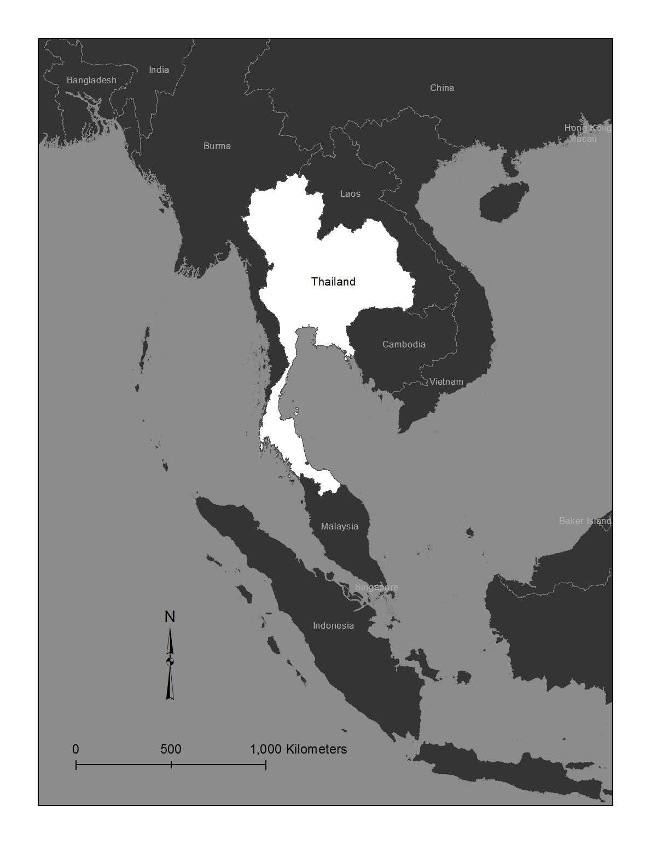

Figure 1. Study area map for the Kingdom of Thailand