**NASA DEVELOP National Program**

****NASA Langley Research Center

**Summer 2015**

**Short Title:** North Carolina Ecological Forecasting

**Subtitle** Evaluating the Application of NASA Earth Observations to Rapidly Detect Change in Wetland Types at a Regional Scale

**VPS Title:** Delineating Wetland Extent in the Albemarle-Pamlico Estuary System

**Project Team & Partners**

**Project Team:**

Zand Bakhtiari, (Project Lead), zand.m.bakhtiari@nasa.gov

Stephen Zimmerman

Kayla Patel

Brad Gregory

**Advisors & Affiliations:**

Dr. Kenton Ross (NASA DEVELOP National Program)

Michael Bender (NASA DEVELOP National Program)

Emily Adams (NASA DEVELOP Langley Center Lead)

**Partner Organizations**

Albemarle-Pamlico National Estuary partnership (APNEP), End-User, POC: Jim Hawhee

National Oceanic and Atmospheric Association (NOAA), Boundary Organization POC: Don Field

North Carolina Department of Environmental and Natural Resources, Boundary Organization,

(NCDENR),POC: Dean Carpenter, Bill Crowell, Cyndi Karoly

**Project Details**

**Applied Sciences National Applications Addressed:**

Ecological Forecasting

**Study Area:** Albemarle-Pamlico watershed located in Virginia (VA) and North Carolina (NC)

**Study Period:** 2000 - 2015

**Earth Observations & Parameters**

Landsat 5 TM – Land cover

Landsat 7 ETM+ – Land cover

Landsat 8 OLI – Land cover

**Ancillary Datasets Utilized**

* USGS Dataset – Digital Elevation Model (DEM)
* U.S. Census Bureau – State and County boundaries - Shapefile
* Albemarle-Pamlico National Estuary partnership (APNEP) – Watershed boundary - Shapefile

**Software Utilized**

ArcGIS - Raster manipulation/analysis, image enhancement & map creation of Landsat 5, 7, and 8 imagery

DNPPY – Raster Analysis tool kit

**Project Overview**

**80-100 Word Objectives Overview**

This project looked at wetland extent in the Albemarle-Pamlico estuary over time. Using a dense time stacking of Landsat Imagery, wetland extent was mapped throughout the Albemarle-Pamlico watershed between the years 2000 and 2015. NASA’s Landsat 5, 7, and 8, were used to collect imagery. Two indices were used, one that measured change in water extent over the years and one that measured the relative health of the wetlands themselves. This two pronged approach sought to capture both natural and anthropogenic effects on the Albemarle-Pamlico estuary system.

**Abstract**

As a result of their sensitivity to sea level rise, wetlands are one of the most vulnerable ecosystems to climate change. In addition, wetland extents have diminished over time due to population increases and associated land change patterns. This project, partnered with the Albemarle-Pamlico National Estuary Partnership (APNEP), sought to delineate wetland extent within the Albemarle-Pamlico watershed from 2000 to 2015 using NASA’s Landsat 5 Thematic mapper (TM), Landsat 7 Enhanced Thematic mapper (ETM+), and Landsat 8 Operational Land Imager (OLI). Four images (representing spring, summer, fall, and winter) were collected for each year from 2000 to 2015. Multiple images were used for each year to account for tidal changes and to minimize the noise produced by clouds. After pre-processing the images, indices that measure water extent and wetland health were calculated for each image. A Normalized Difference Water Index was used to delineate shoreline. A wetland health index that ratios the near infrared and short wave infrared bands, and a Normalized Difference Pigment Index were used to assess wetland health. From these indices, wetland extent and relative health were measured more rapidly than contemporary classification methods. A tutorial was provided to APNEP to support the organization in implementing policies toward wetland monitoring, protection, and restoration.

**Community Concerns**

* Impact of wetland degradation on local ecosystems
  + Water Filtration, Nursery for juvenile fish, carbon sequestration
* Impact of wetland degradation on local and regional economies
  + Eco-tourism, fishing industry

**Current Management Practices & Policies**

In 1987, the Albemarle-Pamlico watershed region was considered an “estuary of national significance” and was among the first 28 National Estuary Programs (NEP) established by the U.S. Environmental Protection Agency (EPA) through amendments of the federal Clean Water Act (CWA). A recent implementation of an Ecosystem-Based Management (EBM) in addition to the Comprehensive Conservation Management Plan (CCMP) seeks to identify, protect, and restore the significant resources provided by the Albemarle-Pamlico estuary system. Current conservation efforts are directed through a watershed approach including management practices at headwaters, rivers, and streams all the way to the sounds, addressing a broad range of issues throughout the watershed. Currently, the North Carolina Governor's Executive Order #133 provides advisory structure through a Policy Board, a Science and Technical Advisory Committee, and an Implementation Committee. North Carolina relies primarily on the 401 certification for state-level wetland regulation administered by the North Carolina Department of Environment and Natural Resources (NCDENR) and Division of Water Quality (DWQ). Since 2001, a similar set of rules, also administered by DWQ and pertaining to isolated wetlands not regulated under Section 404 of the Clean Water Act, requires a permit to be obtained for authorized activities that do not alter existing uses. North Carolina’s Coastal Area Management Act (CAMA) requires developments in “Areas of Environmental Concern” (AECs) to obtain a separate permit from NCDENR Division of Coastal Management. In 1997, North Carolina adopted Riparian area buffer rules which create a 50-ft wide riparian buffer along waterways of the Neuse river basin; similar rules were adopted for the Tar-Pamlico river basin in 2000 and for the Randleman Lake basin in 2001.

**Decision Support Tools & Benefits**

|  |  |  |
| --- | --- | --- |
| **End-Product** | **Earth Observations Used** | **Benefit & Impact** |
| Statistics showing water extent and wetland health over time | Landsat 5, 7, and 8 | Quantitative output regarding the health of the Albemarle-Pamlico wetlands. |
| Maps showing Landover change from 2000 – 2015 | Landsat 5, 7, and 8 | These maps can be used to demonstrate the change in wetland extent over the past 15 years. |
| Tutorial | Landsat 5, 7, and 8 | A tutorial that can be used to replicate the projects methodology and deliverables. |

**Project Imagery**

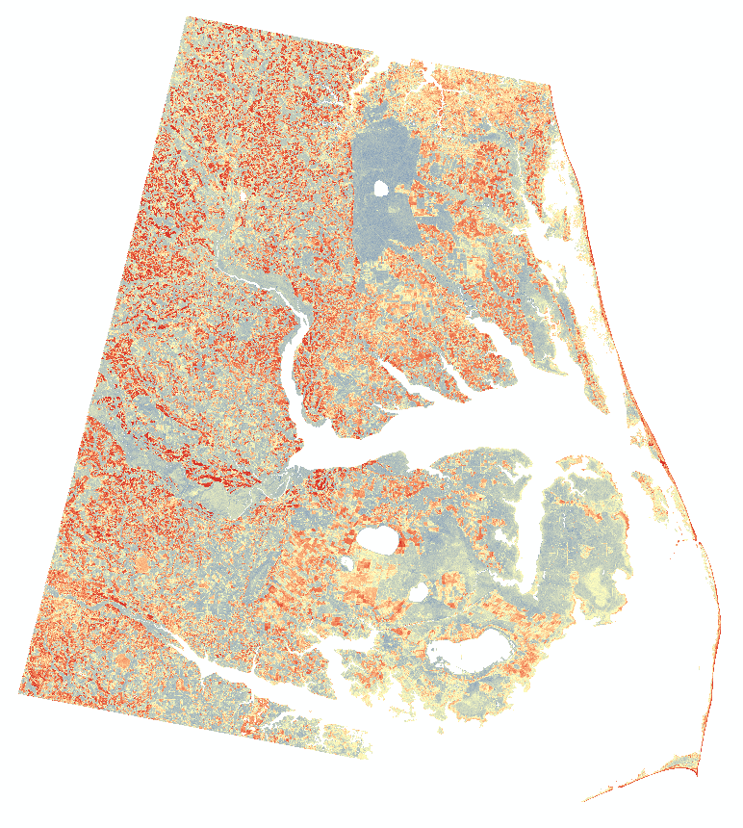

**Caption** Above is an image representing wetland health derived from a spring 2000 Landsat 7 ETM+ image (path 14 row 35). Wetland health was calculated by using a Normalized Difference Pigment Index (NDPI). Darker blue pixels represent healthy wetlands while dark red pixels are unhealthy.

**Image:** File Name (Please submit your image as a separate .jpeg as well as inserting it in this document)