Maldives Climate II

Evaluating the Potential Impacts of Sea Level Rise on Human Development and Coastal Infrastructure

 **Technical Report**

March 31st, 2023

Ben Dahan (Project Lead)

Evan Barrett

Gabriel Halaweh

Tiffany Hsu

***Advisors:***

Dr. Juan Torres-Pérez, NASA Ames Research Center (Science Advisor)

***Previous Contributors:***

Aidan Harvey

Daniel Lopez

Derek Chin

Mitch Porter

***Fellow:***  
Lisa Tanh (California - Ames)

# 1. Abstract

The Republic of the Maldives is a low-lying island nation in the Indian Ocean which has experienced rapid urbanization, landcover changes, and sea level rise over recent years. The growth of tourism, coastal erosion, and urbanization have all driven land reclamation efforts across many islands. As in-situ landcover change monitoring has proven difficult across the vast archipelago, the NASA DEVELOP team collaborated with the Maldives Ministry of Environment, Climate Change, and Technology; USAID; and the U.S. Department of State, to utilize Earth observations to predict sea level rise impacts on coastal infrastructure. The team used a supervised classification algorithm within Google Earth Engine to create land use maps and time series analyses of nine islands and atolls using imagery from Landsat 7 Enhanced Thematic Mapper Plus, Landsat 8 Operational Land Imager, Sentinel-2 Multispectral Instrument, and PlanetScope, covering a combined period of 2000 through 2023. Additionally, the team projected coastal inundation with a modified deterministic Bathtub model utilizing elevation data from CoastalDEM and 2050-2100 Shared Socioeconomic Pathway scenarios identified in the NASA Sea Level Rise Projection Tool. The team found that islands undergoing urban growth experienced a 23% decrease in vegetation between 2014 and 2022. Furthermore, the model predicted that 51–57% of the study area’s-built environment has a chance of inundation by 2100 under the low and high sea level scenarios. These analyses demonstrate how remote sensing can be used to both track land use changes over time and project how coastlines will be affected by sea level rise.

**Key Terms**

remote sensing, LCLU, sea level rise, land reclamation, coastal inundation, time series analysis

# 2. Introduction

***2.1 Background Information***

As climate change causes global ocean levels to rise, anticipating and mitigating its impacts on coastlines is critically important to Small Island Developing States (SIDS) (Storlazzi et al., 2018). The Republic of the Maldives (referred to as “the Maldives” hereafter), an archipelago composed of 1,192 islands in the Indian Ocean, typifies this dilemma since 80% of its land area is less than 1 meter above sea level (Voiland, 2021). Understanding historical land use and projected shoreline changes in these islands is key to predicting how sea level rise may affect the islands. Currently, 200 islands are permanently inhabited by the Maldivian population of 560,000 and 80 more are used as tourist resorts (Stojanov et al., 2016). The growth of the Maldives economy, tourism industry, and continued land scarcity has led to rapid urban development along coastlines, reclamation projects inside lagoons, and construction at previously uninhabited islands for tourist resorts (Fallati et al., 2017). However, these developments are oftentimes in hazard-prone areas due to heavy rainfall, tsunamis, and other natural disaster events (NDMA Maldives, 2022). In response to these changes, the national government is further modifying island coastlines to increase living space, facilitate air and sea transport, and fortify shorelines (Duvat & Magnan, 2019). Projecting the impacts of sea level rise on erosion and flooding will be integral to coastal infrastructure adaptation planning for the project partners.

The goal of this study is to measure the change in land use and projected shoreline changes. Fu et al. (2022), Lin et al. (2017), and Fallati et al. (2017) have conducted land cover and land use (LCLU) change analyses in Sri Lanka, Haitan Island, and the Maldives, respectively, using supervised classification analyses on PlanetScope and Landsat 7 and 8 satellite imagery in Google Earth Engine (GEE). Meanwhile, Aslam & Kench (2017) demonstrated that atoll islands do not respond uniformly to sea level rise through erosion because they are dynamic landforms. However, recent studies suggest that the impact of sea level rise on coastal flooding can be quicker, more severe, and more widespread than previously thought (Storlazzi et al., 2018; Kulp & Strauss, 2019). Others have shown the feasibility of using regionalized datasets, such as the Intergovernmental Panel on Climate Change’s (IPCC) 6th Assessment Report (AR6) Sea Level Projection Tool used here, to model coastal submersion and inform local planning decisions in the Maldives (Amores et al., 2021; “IPCC AR6 Sea Level Projection Tool”).

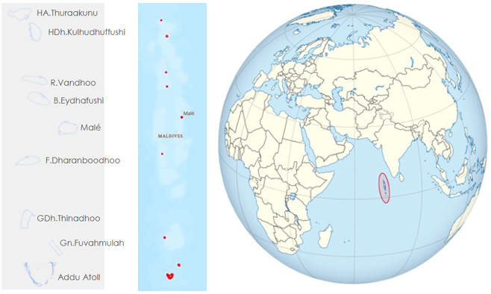

*Figure 1*: The nine study areas and their shoreline boundaries (left), the Maldives archipelago in the Indian Ocean (center), and the location of the Maldives (right) (Image credit: TUBS)

The previous term of this project focused on assessing water quality and analyzing shoreline change of the Haa Alifu, Haa Daalu, and Kaafu atolls in the Maldives. Focusing on the years between 2016 and 2022, that team created a methodology for implementing QGIS and GEE to carry out the analysis. They utilized satellite imagery from PlanetScope, Landsat 8 Operational Land Instrument (OLI), Sentinel-2 Multi Spectral Instrument (MSI), and Aqua & Terra Moderate Resolution Imaging Radiospectrometer (MODIS). The group’s findings indicated more shoreline change in natural areas of the island compared to developed areas (Harvey et al., 2022). The water quality assessment yielded inconclusive results due to bottom reflectance in shallow reef waters (Harvey et al., 2022).

In consultation with partners in the Maldives, the NASA DEVELOP Maldives Climate II team chose to study eight islands and one island atoll, shown in Figure 1, that ranged from highly urbanized to uninhabited. The team focused on land use changes between 2000 and 2023, and sea level projections between 2023 and 2100. The goal of the project was to produce maps and time series analyses that depict land use change over the study period and projected shoreline extent in the future based on satellite imagery and sea level projections.

***2.2 Project Partners & Objectives***

The Maldives Ministry for Environment Climate Change and Technology (MMECCT); the U.S. Department of State, Bureau of South and Central Asian Affairs, Office of Bangladesh, Nepal, Sri Lanka, Maldives, and Bhutan; and the United States Agency for International Development (USAID) Maldives Office are the partners for this project. The MMECCT promotes climate change mitigation and adaptation policies and procedures throughout the Maldives. The Ministry is interested in using satellite data to track LCLU changes. The USAID Maldives Office and U.S. Department of State, Bureau of South and Central Asian Affairs, Office of Bangladesh, Nepal, Sri Lanka, Maldives, and Bhutan both seek to support the Republic of Maldives’ climate change adaptation efforts by identifying the most helpful areas for development assistance to the Maldives.

The Maldives Climate II team created LCLU time series analyses, projected future shoreline change maps, and maps of hazard-prone regions in the study areas. The team developed tutorials to help the project partners conduct similar analyses through GEE and QGIS beyond the results of this study in future regions of interests. The partner organizations will utilize the results of this study to determine which coastal areas of the Maldives are most susceptible to the negative effects of sea level rise and to shape future mitigation programs and policies.

# 3. Methodology

***3.1 Data Acquisition***

The team obtained imagery through GEE for 2000 to 2023 and the Planet web browser tool for imagery from 2017 to 2023. From Planet, team members acquired January 2023 basemap tiles and daily images from 2017-2022 at 4-band, 3m resolution. Within GEE, the team acquired Landsat 5 Thematic Mapper (TM) Collection 2 Raw Scenes, Landsat 7 Enhanced Thematic Mapper Plus (ETM+) Collection 2 Raw Scenes, Landsat 8 OLI Level 2 Raw Scenes, and Sentinel-2 MSI Level 2A Surface Reflectance. The years in the analyses that involved each of these datasets are summarized below in Table 1.

The team obtained elevation data from products derived from the NASA Shuttle Radar Topography Mission (SRTM), which offers a 30m and 90m resolution Digital Elevation Model (DEM). Spaceborne DEMs include non-negligible height errors, such as speckle noise and tree height bias. The Multi-Error-Removed Improved-Terrain (MERIT) DEM, developed by Yamazaki et al. (2017), uses SRTM data and filtering techniques to provide a more accurate product at 30m resolution. CoastalDEM, developed by Climate Central, likewise minimizes vertical error from SRTM—particularly in low-lying coastal areas—using an artificial neural network with 23-inputs, including vegetation, population density and land-slope (Kulp & Strauss, 2018). The filtered DEMs provide more coverage of the Maldives and better spatial resolution of areas that are more at-risk of sea level rise.

The NASA Sea Level Projection Tool provides sea level projection data, in terms of meters of sea level rise, from the IPCC AR6. The tool spans from 2020 to 2150, in both global and regional projections, across several warming levels or Shared Socioeconomic Pathways (SSPs). Additionally, the tool offers access to historical sea level data from tidal gauges in the islands of Malé and Gan within the Maldives.

Table 1.

*Data sources used for the land cover analyses and shoreline change projections*

|  |  |  |  |
| --- | --- | --- | --- |
| **Sensor** | **Spatial Resolution** | **Imagery Dates** | **Data Source** |
| PlanetScope: SkySat, Dove Classic, Dove R, and SuperDove | 3 m | Near Daily:  2017 - 2022 | Planet Labs Web Tool |
| Landsat 7 ETM+ | 30 m | Monthly:  1999-2021 | United States Geological Survey (USGS) through GEE |
| Landsat 8 OLI | 30 m | Monthly:  2013 - 2023 | United States Geological Survey (USGS) through GEE |
| Sentinel-2 MSI | 10 m | Monthly:  2016 - 2022 | European Space Agency (ESA) through GEE |
| CoastalDEM (SRTM-derived DEM) | 30, 90 m | 2000 | Climate Central |

***3.2 Data Processing***

To create a cloud-free image of the Maldives for land use analysis, team members applied a cloud filter and cloud mask to the composited image. The team created the cloud mask using the values of Landsat’s Pixel Quality Assessment Band (QA_PIXEL), which uses quality statistics to determine clouds and cloud shadows. Additionally, they calculated the Normalized Difference Vegetation Index (NDVI) for each image using near-infrared and red channels (Equation 1) (Weier & Herring, 2000).

$$\begin{aligned}\text{NDVI} \text{=} \frac{\text{NIR} \text{-} \text{Red}}{\text{NIR} \text{+} \text{Red}}\#(1)\#\end{aligned}$$

To classify the land use in the study areas, the team applied a Random Forest algorithm, which relies on training data and multiple decision trees to classify each pixel in a region (Breiman, 2001). The team used high resolution 2022 and 2000-2013 imagery to acquire the training data for the regions. The 2022 training points were used to train the classifiers that utilized Landsat 8, PlanetScope, and Sentinel-2 data, whereas the 2000-2013 training points were used to train the classifier that was used with Landsat 7. Team members collected training points in GEE to classify the study areas into 5 classes: shallow water, deep water, vegetation, built land, and barren land. The criteria and number of training points for each class are shown in Table A2.

Team members also experimented with additional land classifications, such as distinguishing mangroves and grasslands from other types of vegetation. To analyze each set of satellite imagery, the team chose spectral bands based on their effectiveness at differentiating between different land classes (Table A1). The team trained a series of classifiers using these training points and the band values to allow the team to determine which classifiers would work best in the regions of interest. After testing various classifiers, the team utilized a 100-tree Random Forest classifier to create land cover maps for the region using each respective classification algorithm.

***3.3 Data Analysis***

*3.3.1 Land Use Maps*

The team applied the trained classifiers to create land use maps and calculate summary statistics over the study areas. To calculate the area of each pixel in square kilometers, the area of each pixel in square meters was multiplied by 0.0009 for 30m resolution imagery. Using the area values for each year and land class, the team was able to aggregate total surface area values across the entire study region.

To conduct the error analyses, team members used 80% of the training points for the classification algorithm and the remaining 20% for accuracy assessment. The team calculated an error matrix and a Kappa coefficient of agreement to determine the overall accuracy of each of the classifiers.

*3.3.2 Land Use Time Series Analysis and Change Detection*

The team plotted time series graphs displaying land cover class surface area over time for the study area by indicating the study region, defining the date range, and applying GEE’s built-in column chart function. Each band value represents a land cover class and is plotted as a column in the chart. Percent change over time was calculated for each island and land cover class. Team members also implemented change detection to detect urbanization over time.

The team leveraged the land classification data to perform a temporal analysis of land use changes. Specifically, the team compared how a given land class transitioned to a different class across two different years. To accomplish this, they collected class data for each year and identified the intersection between the two classes and years being compared. The resulting change detection map indicates the pixels where land use has transitioned from the first class to the second class by highlighting the overlap between the different class data from different years.

*3.3.3 Sea Level Rise Inundation Mapping*

To anticipate coastal inundation from sea level rise, the team adopted a hydrostatic bathtub approach whereby a submerged area is identified where land elevation is below the new shoreline water level. Bathtub modelling can overpredict flood extent compared to hydrodynamic models but minimizes input data and computational requirements. The team adapted the uncertainty Bathtub Model (uBTM), an open-source GEE code from Terres de Lima (2021a), which incorporates the inherent uncertainty of the elevation and sea level rise projection inputs. It uses a modified deterministic method (Gesch, 2019) to bound the extremes of error, from lowest probability of inundation (where the lower error range value of the DEM is above the upper error range value in sea-level rise projection) and highest probability (where the upper error range value of the DEM is lower than the lower error range value in sea-level rise projection). The final projected submersion is put through a circular Kernel filter to better visually represent flooding and is remapped in 12.5% increments from 0% to 100% probability of submersion. The team overlayed the projected submersion probabilities with the built land pixels of a given island to observe how flooding would affect coastal infrastructure.

The team took Sea Level Rise Projections from the NASA AR6 Sea Level Rise Modelling Tool based on the IPCC AR6 Shared Socio-Economic Pathways (SSP) SSP1-2.6, which holds global warming to below 2°C by 2100; SSP2-4.5, which holds warming to the climate policy outlined by Nationally Determined Contributions (NDC) under the Paris Accords; and SSP5-8.5, which holds warming under “business-as-usual" (Oppenheimer et al., 2019) (Table B1). To approximate a value which can account for uncertainty, the team assumed the *likely* range of sea level rise of a scenario (defined as between the 17th-83rd percentile) to be a standard distribution. The difference between the upper and lower range was assumed to have roughly 3 standard deviations, such that an error interval could be found (Equation 2).

$$\begin{aligned}\text{Error} = \frac{\left(\text{upper} \text{bound} - \text{lower} \text{bound}\right)}{3}\#\left(2\right)\end{aligned}$$

For DEM input, the team acquired CoastalDEM at 30m resolution from Climate Central. To account for vertical uncertainty, the model incorporates a global error metric–specifically, the root means square error (RMSE) of 3.10m identified by Kulp & Strauss (2018). To validate this, the team used a dataset of 711 ground control points from the Maldives Land and Survey Ministry to determine a locally specified RMSE of 1.51m. A common practice among bathtub models is to derive a minimum sea level rise increment as a direct function of the DEM’s vertical accuracy, as determined by the RMSE (Gesch, 2018). However, as the high-confidence minimum increment would be significantly higher than the elevation of the Maldives, this was not possible.

# 4. Results & Discussion

***4.1 Analysis of Results***

*4.1.1 Land Use Maps*

The team created annual land use maps of nine islands in the Maldives. Across the whole study region, the overall accuracy of the classification ranged from 90.54% to 93.58% and the Kappa coefficient ranged from 0.878 to 0.924 (Table A3). Higher resolution satellite imagery from the Sentinel-2 MSI and PlanetScope sensors generally allowed for higher resolution classification maps that yielded higher accuracies than those created from lower resolution Landsat imagery (Figure 2).

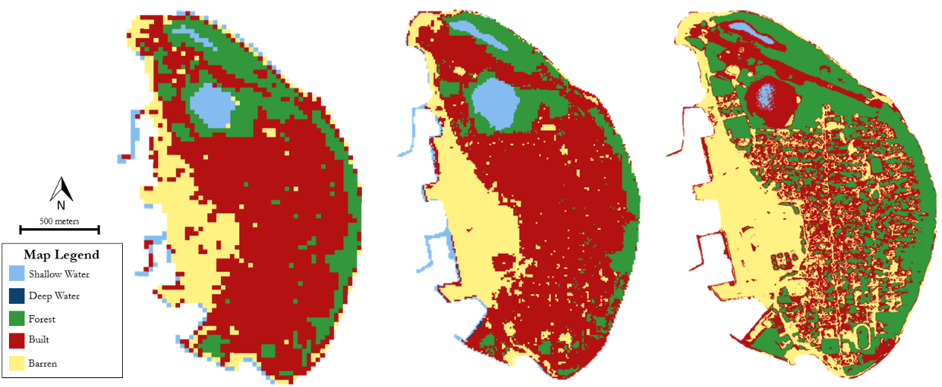

*Figure 2:* Land classification map of HDh.Kulhudhuffushi in 2021 using 30m Landsat 8 OLI imagery (left), 10m Sentinel-2 MSI imagery (middle), and 3m PlanetScope imagery (right; Includes copyrighted material of Planet Labs PBC. All rights reserved.)

The team was able to differentiate different types of vegetation cover to a certain extent. Team members divided the vegetation class into three separate classes: grasslands, mangrove wetlands, and non-mangrove forests. When running the Random Forest classifier with the separate vegetation classes, the team found that the classifier had a lower overall accuracy (83.84%) when compared to that of the classifier that only had one vegetation class (93.58%). Without a distinct wetland class, the algorithm tended to classify some wetland areas as barren land where there were less trees (Figure A1).

With the distinct vegetation classes, the algorithm classified non-mangrove forests as mangrove wetlands, and vice versa. The team compared the 2020 mangrove extent on Gn.Fuvahmulah calculated from the Random Forest classifier to data from the Maldives Ministry of the Environment to observe the accuracy of the algorithm (Asian Development Bank, 2020). The classifier was able to identify the same mangrove regions as the Ministry, but many other regions were also classified as mangroves (Figure 3). Behera et al., (2021) used synthetic aperture radar (SAR) data to improve their classification of mangroves; however, GEE does not have reliable SAR data for the region and thus team members could not use it for their classification.

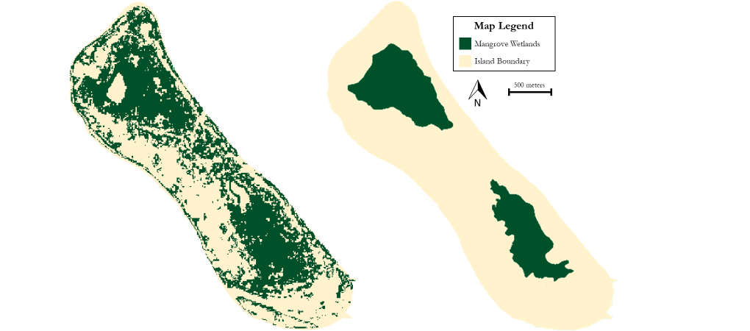

*Figure 3*: Random Forest classification of mangrove wetlands in Gn.Fuvahmulah from Sentinel-2 MSI imagery (left) compared to mangrove extent data from the Maldives Ministry of the Environment (right) (Asian Development Bank, 2020)

The results indicate that it is possible to utilize GEE to classify land using satellite data on the islands of the Maldives. The team identified the spatial extent of five different land classes and found that they were widely distributed across the studied islands. Higher resolution satellites provided land classification maps with a higher resolution; however, lower resolution satellites have a larger temporal range for analyzing historic changes and were able to provide land use statistics for a whole island. Furthermore, the team was limited by the spatial and temporal limits of the satellite data within GEE. There is no Sentinel-2 MSI data available for the Maldives for the years 2017-2020, and there is a general lack of reliable imagery for any year before 2000. The team was thus unable to look at historic land use prior to the year 2000 and the high-resolution imagery was only available for 2016 and onwards. Despite these challenges, the team’s calculated overall accuracies indicate that it is feasible to create high-accuracy land use maps from all Earth observations employed (Landsat 7 ETM+, Landsat 8 OLI, Sentinel-2 MSI, and PlanetScope) using supervised classification algorithms within GEE (Table A3).

*4.1.2 Land Classification Time Series*

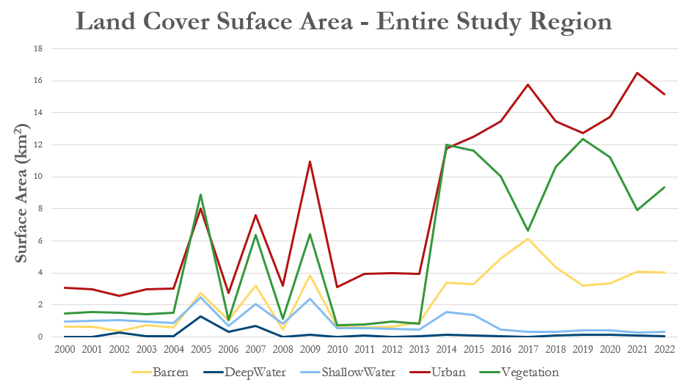

*Figure 4*. Land Classification Time Series 2000-2022 derived from Landsat 7 ETM+ and Landsat 8 OLI. Data values for the years 2000-2004, 2006-2008, 2010-2013 do not capture all islands due to lack of available data for the southern islands (GDh.Thinadhoo, Gn.Fuvahmulah, and Addu Atoll).

The team performed time series analysis across the entire study area to analyze the change in surface area for each land cover class over time (Figure 4). Overall, there was an 89% increase in built environment across the study region between 2005 and 2022. In addition, vegetated area decreased by roughly 23% between 2014 and 2022. The correlation between the general increase in urban environment and the decrease in vegetation may be explained by urbanization over previously vegetated areas. Land reclamation also contributes to the decrease in shallow water as those areas become replaced by barren land.

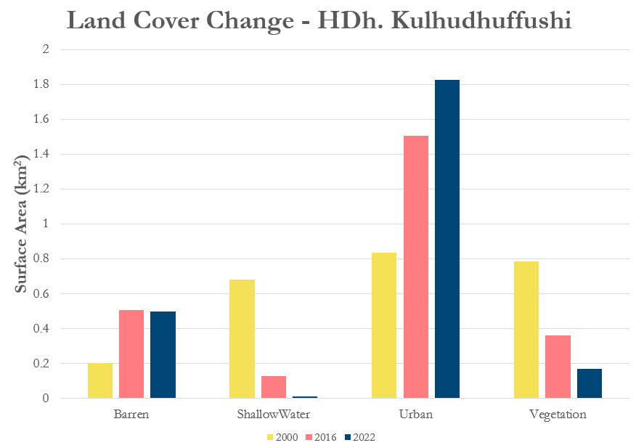

*Figure 5*. Land Cover Change Comparisons between 2000, 2016, and 2022 for HDh.Kulhudhuffushi

Consistent with the general trends in land cover change mentioned above, the island HDh.Kulhudhuffushi underwent a 99% decrease in shallow water and 78% decrease in vegetated environment between 2000 and 2022. Meanwhile, barren and urban area increased by 145% and 119%, respectively. Figure 5 visualizes the change across barren, shallow water, urban, and vegetated areas for the years 2000, 2016, and 2022. Time series analyses allow for visualizing trends over time such as capturing changes from land reclamation projects and urbanization. For example, a land reclamation project that occurred in the western region of HDh. Kulhudhuffushi is reflected by the increase in barren land and decrease in shallow water surface area. The construction of the airport in 2018 is also represented by the slight increase in urban area from 2016 to 2022.

*4.1.3 Change Detection*

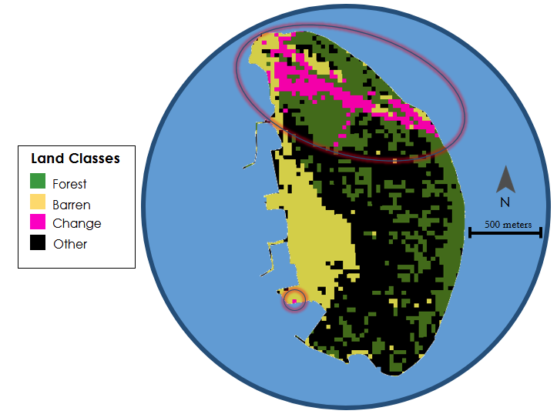

*Figure 6*. Change detection in forest to barren classes between 2017 and 2019 for HDh.Kulhudhuffushi derived from Landsat 8 OLI

To create a change detection map, the team utilized classified Landsat 8 imagery. Figure 6 illustrates an example of the resulting maps, in which green pixels indicate the forest class from the 2017 land classification, and yellow pixels represent the barren class from 2019. Located at the top of the image in magenta is the area where pixels that were previously classified as forest in 2017 have transitioned to barren in 2019 which could be easily explained by the 2018 airport runway construction. This type of detection employing Landsat 8 OLI is an effective means of identifying changes in urbanization and other land-use practices, as exemplified in this study area where it is used to reveal the construction of the HDh.Kulhudhuffushi airport.

*4.1.4 Sea Level Rise Mapping*

The team created coastal inundation maps for each island of interest, based on the NASA AR6 Sea Level Rise projections for 2050 and 2100 for SSP1-2.6, SSP2-4.5, and SSP5-8.5. These maps indicate that coastlines are not uniformly impacted by sea level rise (Figure 7). Though they are not a probabilistic approach, these maps incorporate the uncertainty inherent in both satellite-derived elevation data and uncertainty in projecting sea level rise.

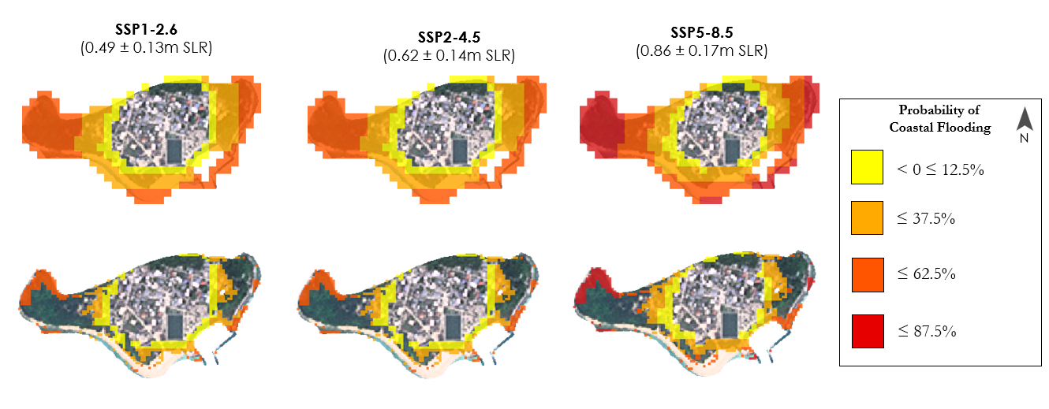*Figure 7*. The maps on the top row show the probabilities of submersion by 2100 from sea level rise in HA. Thuraakunu under scenarios SSP1-2.6 (left), SSP2-4.5 (center), and SSP5-8.5 (right) based on the uBTM tool. The maps on the bottom row show the inundation probabilities of only the pixels that were classified as built environment. Basemaps are 2022 Planetscope Imagery. (© Planet Labs PBC {2022}. All rights reserved.)

In addition to the coastal inundation maps, the team created maps showing the risk level of submersion to coastal infrastructure flooding for 2100 based on SSP1-2.6, SSP2-4.5, and SSP5-8.5 projections (Figure 7). Based on the inundation data from the uBTM tool, team members found that 51–57% of the study area’s-built environment has a chance of inundation by 2100 based on the SSP projections, with higher levels of predicted sea level rise correlating with higher probability of flooding in built areas (Table B2).

These results indicate it is possible to create inundation maps that incorporate uncertainties in both the DEM and sea level rise projections across islands using CoastalDEM & the uBTM tool in GEE. However, there are several limitations to using such a tool for planning purposes. Firstly, the uBTM tool does not incorporate storm surge or other weather effects, or even tidal dynamics. Additionally, as CoastalDEM is based on SRTM data gathered in 2000, it misses recently reclaimed areas, in some cases automatically mapping it as high risk of submersion even though they were likely built to higher elevations. Though CoastalDEM minimizes vertical bias from structures to the extent possible, vertical uncertainty will remain a significant limiting factor for mapping fine-scale sea level rise increments with a significant level of confidence. Further, due to the spatial resolution of such a tool, it is unlikely to capture local-scale adaptation measures that may exist.

***4.2 Future Work***

A continuation of this project could benefit from enhancing the land classification maps by classifying subclasses, such as mangroves and coral reefs, and incorporating additional satellite data. Specifically, future researchers could use vertical-vertical and vertical-horizontal polarization data from Sentinel-1 to help classify different types of vegetation. To validate the Random Forest-derived classification maps, future studies should use in-situ land classification data of the islands. Furthermore, future analyses would look at historic rates of land reclamation and urbanization based on the values obtained in the team’s time series analysis and compare those rates to projected rates of sea level rise. Doing so would help the partners understand the effectiveness of their current mitigation plans.

Additional work could improve upon the uBTM tool used for projecting shoreline changes. Accounting for hydrodynamics, the effect of climate change on tidal patterns, and how ecosystems affect coastal flooding would enhance the tool and allow for more precise predictions of sea level rise. The model could be improved by inputting a more recent and higher resolution DEM dataset, such as one derived from terrestrial or airborne lidar, structure from motion (SfP) from drones, or higher resolution satellites like Airbus’ WorldDEM Neo, which Gesch (2019) has identified as having a significantly reduced RMSE. Further incorporation of additional hazards, such as storm surge and groundwater intrusion, would increase the partners’ understanding of the full effects of sea level rise in the Maldives. Finally, the partners could leverage another open-source tool – the End Point Rate Tool for QGIS (EPR4Q) – also put forward by Terres de Lima et al. (2021b), to predict future shoreline change using the historic shoreline changes identified by the Maldives Climate I team.

# 5. Conclusions

The Republic of Maldives is a dynamic nation undergoing rapid environmental change. The final land classification maps showed that it is possible to automate the process of creating LCLU maps with supervised classification of a variety of Earth observation data within GEE. The LCLU maps and time series indicated that the amount of development varies from island to island, but there is a general trend of increasing urbanization. Team members found that urbanization was usually accompanied by vegetation loss and land reclamation, resulting in the degradation of terrestrial and aquatic ecosystems. Furthermore, the team was able to use sea level rise data to produce flood inundation maps for each island in the study area. Team members applied the submersion probability data to better understand how the different land classes—particularly built environments—would be affected by sea level rise.

Partners will be able to use the LCLU time series analysis to track how the nation has changed in the past 23 years to better anticipate how the islands will continue to change in the future. As the number of inhabitants and tourists in the Maldives continues to increase, past trends of urbanization will likely continue. The people of the Maldives are worried about what that future development looks like in the context of climate change and sea level rise. The partners will apply the methodology that the team used to continue to monitor LCLU changes in the islands in the future. Additionally, project partners will be able to use the coastal inundation maps and data to better predict which islands are likely to be affected by sea level rise. With an understanding of hazard-prone areas, the partners will be able to mitigate the effects of sea level rise by planning infrastructure accordingly and reinforcing the shorelines that are most at-risk of flooding.

# 6. Acknowledgments

The authors would like to thank the following people for their help and support throughout the duration of this project:

* Lisa Tanh (NASA Ames Research Center)
* Dr. Juan Torres-Pérez (NASA Ames Research Center)
* Britnay Beaudry (NASA Ames Research Center)
* Aishath Reesha Suhail (Maldives Ministry of Environment, Climate Change, and Technology)
* Ahmed Raidh (Maldives Ministry of Environment, Climate Change, and Technology)
* Aidan Harvey, Daniel Lopez, Derek Chin, Mitch Porter (Past Contributors)

This material contains modified Copernicus Sentinel data (2016-2022), processed by ESA.

This material contains copyrighted material of Planet Labs PBC. All rights reserved.

This work utilized data made available through the NASA Commercial Smallsat Data Acquisition (CSDA) program.

Any opinions, findings, and conclusions or recommendations expressed in this material are those of the author(s) and do not necessarily reflect the views of the National Aeronautics and Space Administration.

This material is based upon work supported by NASA through contract NNL16AA05C.

# 

# 7. Glossary

**Bathtub Model –** The use of a model where the water level is simply raised on a coastal DEM by selecting all areas whose elevation is below the new sea level

**Decision Trees –** The use of a defined or learned set of attributes, such as band values, to return a decision regarding an unknown object/pixel

**Modified Deterministic Method –** A sea level rise mapping model that is deterministic, as it does not consider uncertainty in the mapping itself, but maps both the minimum and maximum extremes of vertical error

**Ensemble Learning Algorithms** – Machine-learning algorithms that rely on multiple decision trees

**Error Matrix** – A matrix that shows how pixels in a machine learning-derived classification map vary from the reference data to measure the accuracy of the model

**Hydrostatic –** The dynamics of water motion are not considered

**Hydrodynamics** – The dynamics of water motion (i.e., waves, currents, vegetation, and land cover)

**IPCC AR6 Sea Level Projection Tool** – NASA-operated tool that allows the user to visualize sea level projection data from the Intergovernmental Panel on Climate Change (IPCC) 6th Assessment Report (AR6)

**Kappa Coefficient of Agreement** – A statistical measurement of the level of accuracy between classification map derived from machine-learning algorithms and the reference data

**Shared Socioeconomic Pathways (SSP)** – A series of pathways developed by scientists studying climate, economics, and energy systems to consider how global climates may change in the 21st century

**Speckle noise** – Fluctuations in data that obscure the true data values of an image because of the interference between scattered light rays

**Training Data** – Data inputted into a machine-learning classifier to define attributes for decision trees

**Tree height bias** – Bias that occurs when a sensor records the height of trees rather than the height of the ground on which they stand

# 8. References

Asian Development Bank. (2020). Multihazard Risk Atlas of Maldives (Vol. 4). <http://dx.doi.org/10.22617/TCS200049>.

Amores, A., Marcos, M., Pedreros, R., Le Cozannet, G., Lecacheux, S., Rohmer, J., Hinkel, J., Gussmann, G., van der Pol, T., Shareef, A., & Khaleel, Z. (2021). Coastal flooding in the Maldives induced by mean sea-level rise and wind-waves: From global to local coastal modelling. *Frontiers in Marine Science*, *8*. <https://doi.org/10.3389/fmars.2021.665672>.

Aslam, M., & Kench, P. (2017). Reef Island Dynamics and Mechanisms of Change in Huvadhoo Atoll, Republic of Maldives, Indian Ocean. *Anthropocene*, *18*. <https://doi.org/10.1016/j.ancene.2017.05.003>.

Breiman, L. (2001). Random Forests. *Machine Learning****,*** *45*. <https://doi.org/10.1023/A:1010933404324>.

Behera, M. D., Barnwal, S., Paramanik, S., Das, P., Bhattyacharya, B. K., Jagadish, B., Roy, P. S., Ghosh, S.M. & Behera, S.K. (2021). Species-Level Classification and Mapping of a Mangrove Forest Using Random Forest—Utilisation of AVIRIS-NG and Sentinel Data. *Remote Sensing, 13*(11). MDPI AG. Retrieved from <http://dx.doi.org/10.3390/rs13112027>.

Duvat, V. K., & Magnan, A. K. (2019). Rapid human-driven undermining of atoll island capacity to adjust to ocean climate-related pressures. *Scientific Reports*, *9*(1). <https://doi.org/10.1038/s41598-019-51468-3>.

European Space Agency. (2015) Sentinel 2 Multispectral Imagery (MSI) / Level-2 Surface Reflectance [Dataset]. <https://sentinels.copernicus.eu/web/sentinel/user-guides/sentinel-2-msi/processing-levels/level-2>.

Fallati, L., Savini, A., Sterlacchini, S., & Galli, P. (2017). Land use and land cover (LULC) of the Republic of the Maldives: First National Map and LULC change analysis using remote-sensing data. *Environmental Monitoring and Assessment*, *189*(8). <https://doi.org/10.1007/s10661-017-6120-2>.

Fu, T., Zhang, L., Chen, B., & Yan, M. (2022). Human Disturbance on the Land Surface Environment in Tropical Islands: A Remote Sensing Perspective. *Remote Sensing, 14*(9), 2100. <https://doi.org/10.3390/rs14092100>.

Gesch, Dean (2018). Best Practices for Elevation-Based Assessments of Sea-Level Rise and Coastal Flooding Exposure. *Frontiers in Science, 6:*230. [https://doi.org/10.2289/feart.2018.00230](https://doi.org/10.3389/feart.2018.00230).

Harvey, A., Lopez, D., Chin, D., & Porter, M. (2022). *Maldives Climate: Monitoring Shoreline Changes and Island Loss in Response to Climate Change* [Unpublished manuscript]. NASA DEVELOP National Program, California — Ames Research Center.

Kulp, S. A. & Strauss, B. H. (2018). CoastalDEM: A global coastal digital elevation model improved from SRTM using a neural network. *Remote Sensing of Environment, 209, 231.* <https://doi.org/10.1016/j.rse.2017.12.026>.

Kulp, S.A., Strauss, B.H (2019). New elevation data triple estimates of global vulnerability to sea-level rise and coastal flooding. *Nat Commun* **10**, 4844. <https://doi.org/10.1038/s41467-019-12808-z>

Lin, L., Hao, Z., Post, C. J., Mikhailova, E. A., Yu, K., Yang, L., & Liu, J. (2020). Monitoring Land Cover Change on a Rapidly Urbanizing Island Using Google Earth Engine. *Applied Sciences, 10*(20), 7336. <https://doi.org/10.3390/app10207336>.

NASA. (n.d.). IPCC AR6 Sea Level Projection Tool. NASA Earthdata. <https://sealevel.nasa.gov/data_tools/17>.

NDMA Maldives [@NDMAmv]. (2022, December 26). Improving Disaster Data Management is a key area we have been working on. Evidence based decision making can only be [Image attached] [Tweet]. Twitter. <https://twitter.com/NDMAmv/status/1607416124580429826>.

Oppenheimer, M., B.C. Glavovic , J. Hinkel, R. van de Wal, A.K. Magnan, A. Abd-Elgawad, R. Cai, M. Cifuentes-Jara, R.M. DeConto, T. Ghosh, J. Hay, F. Isla, B. Marzeion, B. Meyssignac, and Z. Sebesvari. (2019) Sea Level Rise and Implications for Low-Lying Islands, Coasts and Communities. In: *IPCC Special Report on the Ocean and Cryosphere in a Changing Climate* [H.-O. Pörtner, D.C. Roberts, V. Masson-Delmotte, P. Zhai, M. Tignor, E. Poloczanska, K. Mintenbeck, A. Alegría, M. Nicolai, A. Okem, J. Petzold, B. Rama, N.M. Weyer (eds.)]. Cambridge University Press, Cambridge, UK and New York, NY, USA, pp. 321-445. [https://doi.org/10.1017/9781009157964.006.](https://doi.org/10.1017/9781009157964.006)

Planet Team (2017). Planet Application Program Interface: In Space for Life on Earth. San Francisco, CA. <https://api.planet.com>.

Stojanov, R., Duží, B., Kelman, I., Němec, D., & Procházka, D. (2016). Local perceptions of climate change impacts and migration patterns in Malé, Maldives. *The Geographical Journal*, *183*(4), 370–385. [https://doi.org/10.1111/geoj.12177.](https://doi.org/10.1111/geoj.12177)

Storlazzi, C. D., Gingerich, S. B., Van Dongeren, A.,Cheriton, O. M., Swarzenski, P. W., Quataert, E.,Voss, C. I., Field, D. W., Annamalai, A., Piniak, G. A., & McCall, R. (2018). Most atolls will be uninhabitable by the mid-21st century because of sea-level rise exacerbating wave-driven flooding. Science Advances. <https://www.science.org/doi/pdf/10.1126/sciadv.aap9741>.

U.S. Geological Survey Earth Resources Observation and Science Center. (2018). Digital Elevation — Shuttle Radar Topography Mission (SRTM) 1 Arc-Second Global. Google Earth Engine. [doi.org/10.5066/F7PR7TFT](http://doi.org/10.5066/F7PR7TFT).

U.S. Geological Survey Earth Resources Observation and Science Center. (2018). Sentinel-2. Google Earth Engine. [doi.org/10.5066/F76W992G](http://doi.org/10.5066/F76W992G).

U.S. Geological Survey Earth Resources Observation and Science Center. (2020). USGS Landsat 7 ETM+ Collection 2 Level 1 Raw Scenes. Google Earth Engine. [doi.org/10.5066/P9TU80IG](http://doi.org/10.5066/P9TU80IG).

U.S. Geological Survey Earth Resources Observation and Science Center. (2020). USGS Landsat 8/9 OLI Collection 2 Tier 1. Google Earth Engine. [doi.org/10.5066/P918ROHC](http://doi.org/10.5066/P9OGBGM6).

Terres de Lima, L., Fernández-Fernández, S., Francisco Gonçalves, J., Magalhães Filho, L., & Bernardes, C. (2021a). Development of Tools for Coastal Management in Google Earth Engine: Uncertainty Bathtub Model and Bruun Rule. *Remote Sensing 13, no. 8: 1424*. <https://doi.org/10.3390/rs13081424>

Terres de Lima, L., Fernández-Fernández, S., Marcel de Almeida Espinoza, J., da Guia Albuquerque, M., & Bernardes, C. (2021b). End Point Rate Tool for QGIS (EPR4Q): Validation Using DSAS and AMBUR. *ISPRS International Journal of Geo-Information 10, no. 3: 162.* <https://doi.org/10.3390/ijgi10030162>

TUBS. (2012). *Maldives on the globe (Afro-Eurasia centered)* [.svg image]. Wikimedia Commons. <https://commons.wikimedia.org/wiki/File:Maldives_on_the_globe_%28Afro->Eurasia_centered%29.svg

Voiland, A. (2021). Preparing for rising seas in the Maldives. NASA Earth Observatory image of the day. Retrieved from <https://earthobservatory.nasa.gov/images/148158/preparing-for-rising-seas-in-> the-maldives.

Weier, J. and Herring, D. (2000) *Measuring Vegetation (NDVI & EVI)*. NASA Earth Observatory, Washington DC. <https://earthobservatory.nasa.gov/features/MeasuringVegetation>.

Yamazaki, D., Ikeshima, D., Tawatari, R., Yamaguchi, T., O'Loughlin, F., Neal, J. C., Sampson, C. C., Kanae, S., & Bates, P. D. (2017). A high-accuracy map of global terrain elevations. *Geophysical Research*  *Letters, 44*, 5844-5853. [doi.org/10.1002/2017GL072874](http://doi.org/10.1002/2017GL072874).

# 9. Appendices

**Appendix A: Land Classification Inputs and Results**

Table A1.

*Spectral bands form each sensor used for land use classification*

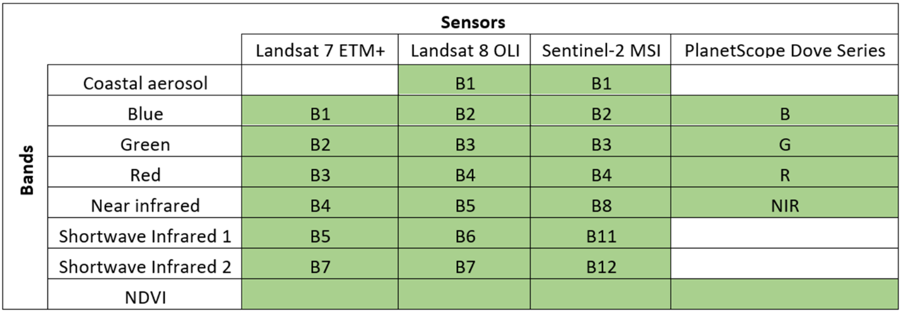

Table A2.

*Land classification criteria and respective training points*

|  |  |  |  |
| --- | --- | --- | --- |
| **Land Classification** | **Criteria** | **2000-2013 Training Points** | **2013-2023 Training Points** |
| Shallow Water | Water with visible ocean floor | 71 | 100 |
| Deep Water | Water with no visible ocean floor | 101 | 100 |
| Vegetation | Green, vegetated areas | 87 | 100 |
| Built | Urban environments, buildings | 58 | 100 |
| Barren | Open regions of sand or soil | 37 | 116 |

Table A3.

*Overall accuracy and Kappa coefficient for each sensor used to train a Random Forest classifier*

|  |  |  |
| --- | --- | --- |
| **Sensor** | **Overall Accuracy** | **Kappa Coefficient** |
| Landsat 7 ETM+ | 90.54% | 0.878 |
| Landsat 8 OLI | 91.00% | 0.887 |
| Sentinel-2 MSI | 93.58% | 0.924 |
| PlanetScope | 92.66% | 0.908 |

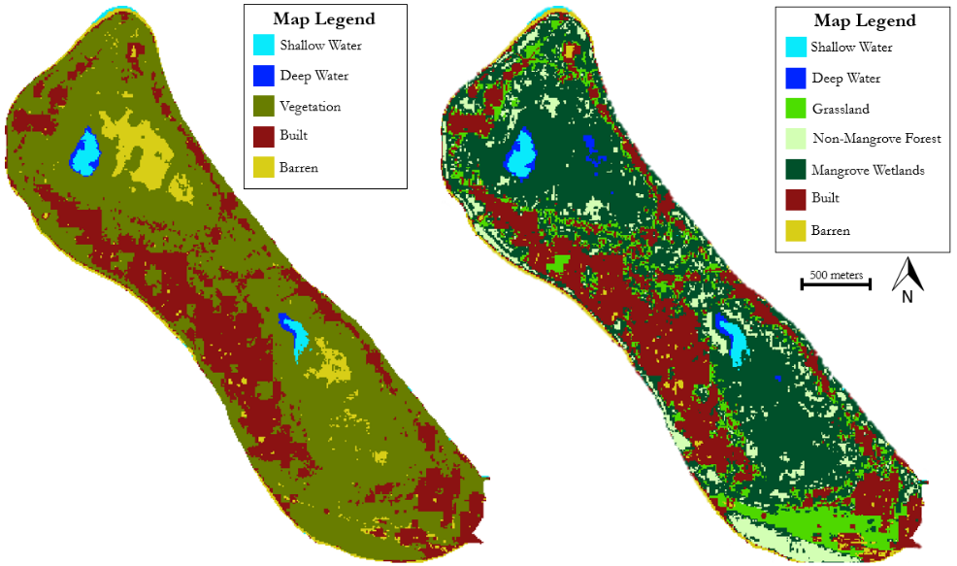

*Figure A1:* Land classification of Gn.Fuvahmulah using 2020 Sentinel-2 MSI imagery with one vegetation class (left) and three separate vegetation classes (right)

**Appendix B: Sea Level Rise Inputs and Results**

Table B1.

*Sea level rise scenario projections and calculated uncertainty margins used in uBTM tool*

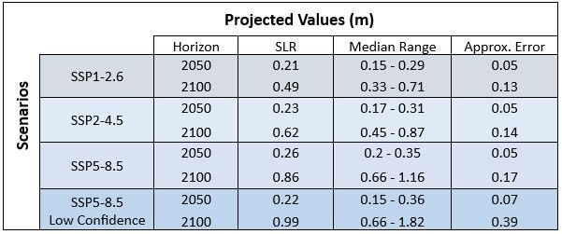

Table B2.

*The percentage of built environment in the study area that is at-risk of coastal inundation by 2100*

|  |  |  |
| --- | --- | --- |
| **SSP** | **Percent of classified built area with > 0% chance of flooding** | **Percent of classified built area with ≥ 75% chance of flooding** |
| SSP1-2.6 | 51.21% | 3.16% |
| SSP2-4.5 | 51.42% | 3.26% |
| SSP5-8.5 | 57.19% | 10.35% |