Chao Phraya Water Resources

Assessing Water Quality in Thailand’s Chao Phraya Watershed through Modeling Sediment Concentration and Urban Footprint

 **Technical Report**

Final Draft – August 9th, 2018

Kathrene Garcia (Project Lead)

Claire Nauman

Matthew Preisser

Dr. Jeffrey Luvall, NASA Marshall Space Flight Center (Science Advisor)

Dr. Robert Griffin, University of Alabama in Huntsville (Science Advisor)

# 1. Abstract

The Chao Phraya River and surrounding watershed have seen an extensive increase in urban development in the last century, while simultaneously experiencing a significant degradation in water quality. Covering 30% of Thailand, the Chao Phraya watershed encompasses rural areas and major metropolitan centers, including Bangkok. The poorest water quality is found in the southernmost reaches of the river, which directly flows through the administrative capital. Due to rising concerns from the Bangkok Metropolitan Administration (BMA) and the Asian Institute of Technology (AIT), this study identifies locations to prioritize watershed remediation efforts. Using the Tropical Rainfall Measuring Mission (TRMM) Multi-Satellite Precipitation Analysis (TMPA), and Shuttle Radar Topography Mission (SRTM) datasets as inputs, this study applied the Soil and Water Assessment Tool (SWAT) to model the change in water quality over four time steps from 2003 – 2017. The change in water quality, defined as sediment concentration, was analyzed in comparison with the historical changes in the urban footprint. Additionally, a regression analysis was completed to determine the potential relationship between urbanization and sediment concentrations. The team found that the greatest increases in sediment contributions occurred in the upper and middle sub-basins of the watershed. No correlation was found between percent change in urbanization and percent change in sediment contribution from 2003-2017, suggesting that urban land cover change does not directly impact sediment loads. The results from this analysis will be used by project end users for future mitigation efforts and, more generally, to expand their use of GIS and NASA Earth observations.

**Keywords**

SWAT model, remote sensing, NASA ACCESS, SERVIR-Mekong Regional Land Cover Monitoring System, TRMM TMPA, SRTM

# 2. Introduction

* 1. ***Background Information***

The Chao Phraya watershed is located in northern Thailand and expands over 30% of the country’s surface area, encompassing rural areas and major metropolitan centers (Molle, 2007). Among those metropolitan centers is Bangkok, the largest city in Thailand. As the southernmost riparian stakeholder, Bangkok receives polluted runoff from the entire watershed. Consequently, samples from the central and lower reaches of the Chao Phraya river indicate poor water quality, while the upper basins continue to have fair water quality (Pollution Control Department, 2015; Simachaya, Watanamahart, Kaewkrajang, & Yenpiem, 2000). This degradation in water quality has coincided with a period of extensive urban development within the watershed (Molle, 2007; Pollution Control Department, 2015). Cities have expanded rapidly in the latter half of the 20th century, which has encouraged a mix of economic activities, from fishing to industry, to take place, which has increased the demand for clean water from the Chao Phraya (Murakami, Zain, Takeuchi, Tsunekawa, & Yokota, 2005; Molle, 2007). Over this time, the need for water has increased to the point that the available water resources can only meet half of the demonstrated demand during the dry season, underscoring the importance of protecting the quality of available water resources (Molle, 2007). Currently, there is a limited understanding of the relationship between the intense urbanization that occurred within the watershed and changes in water quality (Pollution Control Department, 2015).

This study utilized the Soil and Water Assessment Tool (SWAT model), an ArcGIS extension, to model the change in water quality and the effect of changing land use throughout the entire Chao Phraya watershed from 2000 - 2017. The Chao Phraya watershed expands over roughly 160,000 km2 of northern Thailand (Figure 1) and is made up of numerous sub-basins. Water quality is directly impacted by the specific land use of each sub basin (Bronstert, Niehoff & Bürger, 2002). In particular, urban land cover expansion has been linked to a rise in total suspended solids (Wang & Kalin, 2017; Rossi et al., 2013). Suspended solids are recognized threats to aquatic communities, water treatment, and overall aesthetics of water bodies, as they increase turbidity and lead to expensive treatment (Bilotta & Brazier, 2008). While suspended solids can incorporate both inorganic and organic matter, this study considered the inorganic component by focusing solely on sediment concentrations as an indicator of water quality.

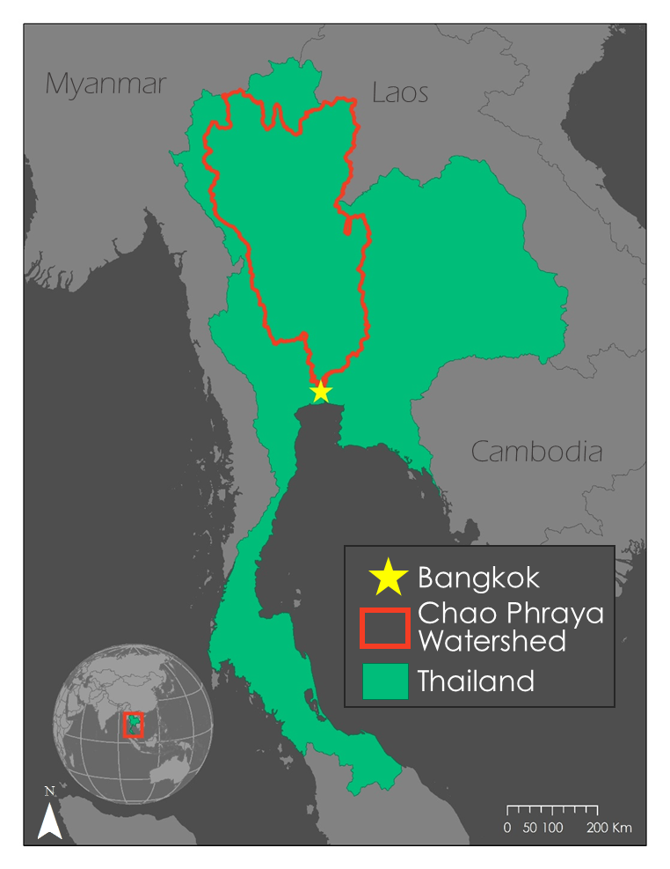

*Figure 1***.** Study Area Map for the Chao Phraya Watershed

The SWAT model is a popular method for modeling the effect that land cover alterations might have on water quality and streamflow (Ligaray et al., 2015; Zhou et al, 2013; Vigiak et al., 2017). Such modeling has been applied to the Chao Phraya river, however, few studies have applied the SWAT model to analyze the relationship between urbanization and changing water quality.

* 1. ***Project Partners & Objectives***

Our team worked in collaboration with the Royal Thai Embassy, Office of Science and Technology (OST), the Asian Disaster Preparedness Center (ADPC), and the NASA SERVIR Science Coordination Office to address community concerns expressed by the Asian Institute of Technology (AIT) and the Bangkok Metropolitan Administration (BMA). The AIT is a postgraduate education institute located in Bangkok that works to promote sustainable development throughout the Asian-Pacific region, while the BMA is a local policy maker focused on urban planning, waste management, and environmental protection in and around Bangkok (Asian Institute of Technology, 2018; Bangkok Metropolitan Administration, 2007). Both the AIT and the BMA have an interest in understanding processes occurring within the watershed that have contributed to poor water quality, and in expanding their use of GIS and remotely sensed data to do so. Currently, the BMA uses GIS mapping to assist in their local infrastructure development and assessment, but the use of GIS technologies is not ubiquitous and the use of remotely sensed data is nearly non-existent (Sirikasem, n.d.). At the AIT, various GIS tools and remotely sensed data are utilized to aid in research across numerous disciplines; however, few people know both hydrologic modeling and remote sensing. Integrating NASA Earth observations into the BMA’s and the AIT’s data analysis will help bridge this knowledge gap and improve the tools they use to make decisions regarding watershed remediation.

In order to promote water quality improvement, this project sought to encourage a basin-wide approach to restoration efforts. To do this there were three guiding objectives: locate areas within the Chao Phraya watershed contributing to high sediment concentrations; understand how water quality has changed historically throughout the watershed; and analyze the relationship between urbanization and sediment concentration. Through the consideration of changes in water quality and how it relates to changes in land cover, this study provided support to our end users, so they may better prioritize locations for watershed restoration.

# 3. Methodology

In order to accomplish these objectives, we utilized the SWAT model. This ArcGIS extension is capable of measuring streamflow and sediment concentrations throughout the watershed by taking numerous layers into consideration, such as elevation, soil type, land cover, slope, and daily weather variables which include surface temperature, relative humidity, solar radiation, wind speed, and precipitation. With these data inputs, the SWAT model creates intermediate layers, which we then analyzed to create our final products (Figure 2).

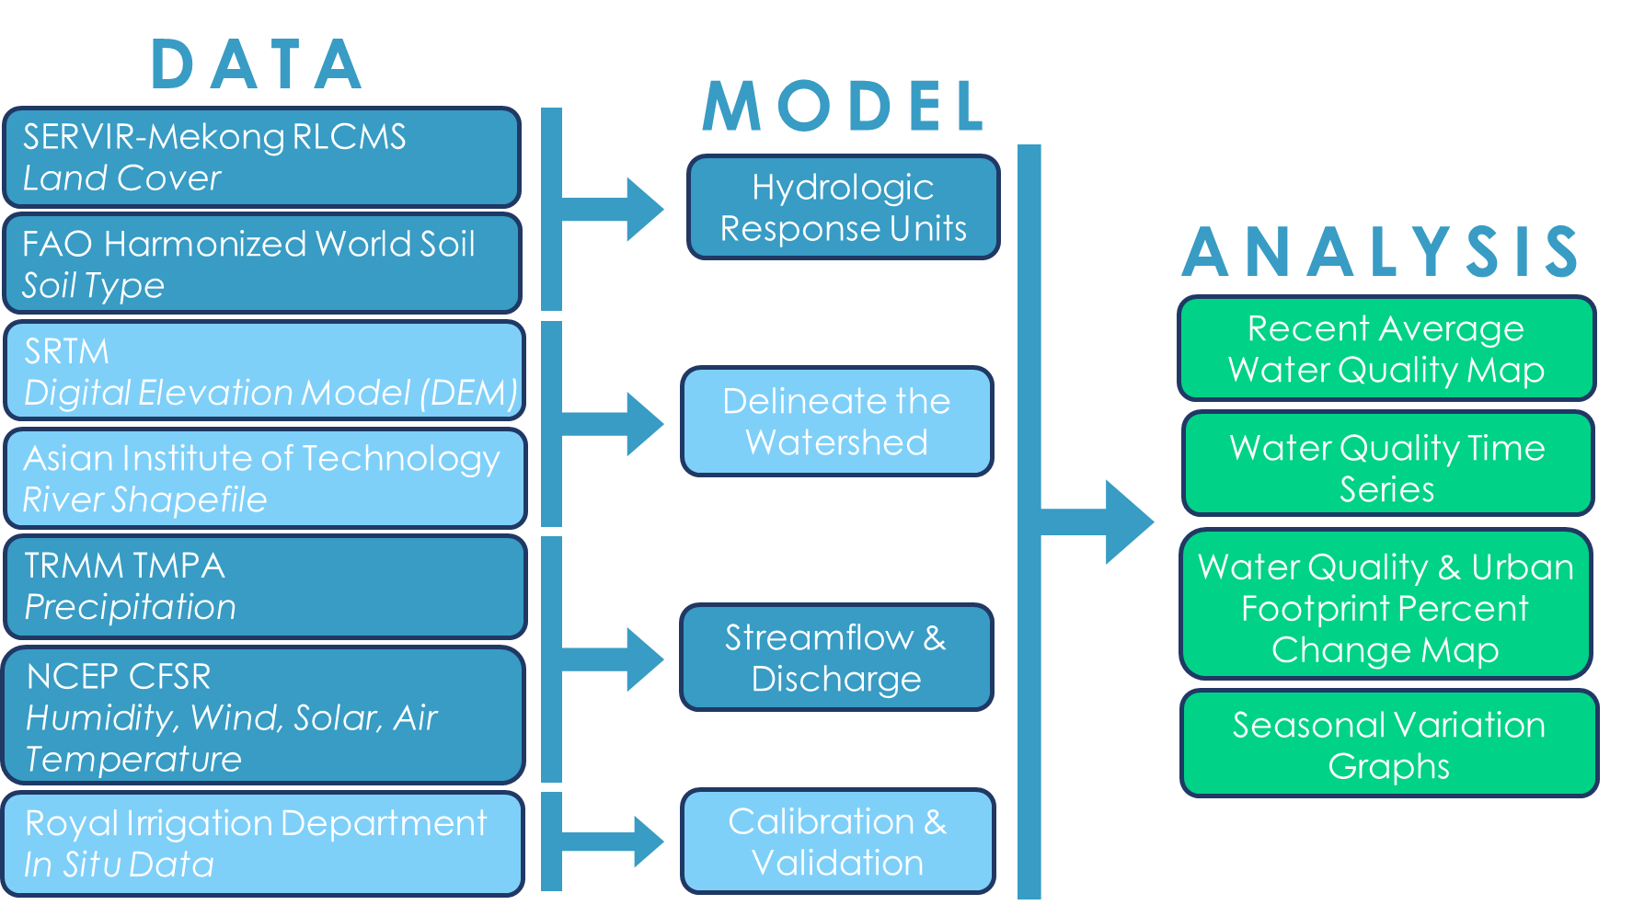

*Figure 2***.** Methodology Flowchart

***3.1 Data Acquisition***

We used two NASA Earth observations for our study. The daily precipitation totals from the Tropical Rainfall Measuring Mission (TRMM) Multi-Satellite Precipitation Analysis (TMPA) satellite constellation served as the main meteorological inputs in the SWAT model. We acquired Level-3 Version 7 TRMM TMPA data from 2000 to 2017 with a spatial resolution of 0.25° from the Goddard Earth Sciences Data and Information Services Center using a NASA Advancing Collaborate Connections for Earth System Science (NASA ACCESS) bulk download tool (Mohammed, Bolten, Srinivasan, & Lakshmi, 2018). This R script downloaded the necessary NC4 files and transposed them to the appropriately formatted text files that could be read by the SWAT model. Each of the TRMM TMPA measurements within the study area corresponds with a geographic coordinate location. The SWAT model treats these locations as stations and interpolates precipitation values between them. We also acquired Version 4 Shuttle Radar Topography Mission (SRTM) 90 m resolution Digital Elevation Models (DEMs), taken in 2000, from the CGIAR Consortium for Spatial Resolution (CGIAR-CSI), which we used as an input to the SWAT model.

Ancillary datasets supplemented the Earth observations as inputs into the SWAT model. Our team acquired NASA SERVIR Regional Land Cover Monitoring System (SERVIR-Mekong RLCMS) 30 m land use files from 2000 – 2016 by using Google Earth Engine to access the SERVIR Mekong Land Cover Database. We also obtained soil profiles from the Food and Agriculture Organization branch of the United Nations (FAO UN) Harmonized World Soil Database V1.2. The National Center for Environmental Prediction Climate Forecast System Reanalysis (NCEP CFSR), an online SWAT model resource maintained by Texas A&M University, provided additional meteorological data from 2000 – 2014, including wind speed, relative humidity, solar radiation, and air surface temperature. Finally, we collected a stream shapefile for water-bodies in Thailand from the AIT in order to delineate the sub-basins within the watershed. Our team separated the datasets into four distinct periods from 2003 to 2017, creating a separate SWAT run for each period (2003-2006, 2007-2010, 2011-2014, and 2015-2017). We created four periods in order to visualize average water quality at different times throughout the study period. We chose to create a break between 2014 and 2015 because the additional NCEP CFSR meteorological data was only available until 2014.

***3.2 Data Processing***

Before the data could be used by the SWAT model for final processing, our team had to pre-process numerous files. To begin, we projected all datasets to WGS 1984 UTM 47N and prepared the SRTM DEMs by mosaicking the tiles to generate a single DEM file. Our team overlaid a generalized mask for the area of interest in order to clip the study area to a reasonable limit. The ancillary datasets required additional formatting and processing steps to be formatted appropriately for the SWAT model (Table 1).

Table 1

*Summary of data pre-processing for SWAT model*

|  |  |  |
| --- | --- | --- |
| Dataset | Pre-Processing | SWAT Model Input Format |
| SERVIR Land Use | 1. Projected to UTM 47N 2. Clipped to mask 3. Created attribute table with matching land classification 4. Reclassified land use categories to match SWAT model lookup table | Land use raster dataset |
| FAO Soil Profile | 1. Projected to UTM 47N 2. Clipped to mask 3. Created soil SWAT input table with appropriate soil classifications | Soil raster dataset |
| NCEP CFER Meteorological Data | N/A - Acquired in correct format | Gridded weather station data in text files |
| AIT Stream Shapefile | 1. Projected to UTM 47N 2. Clipped to mask | Stream raster dataset |

Our team used the pre-processed datasets as inputs in SWAT. We burned the stream raster file into the SRTM DEM, to delineate 61 sub-basins in the watershed using a sub-basin threshold area of 1200 km2. We manually added three additional outlets to the watershed including two monitoring points (16.79o N, 99.19o E, and 15.73o N, 100.13o E), as well as the outlet of the entire watershed (13.761088o N, 100.4901530 E). This manually created outlet is just north of the center of the Bangkok Metropolitan Area, and we chose this point so that streamflow and sediment loads could be modeled at a location that flows into the city. The SWAT model used pre-processed land use, soil, and slope rasters to define the Hydrologic Response Units (HRUs). HRUs are the smallest spatial resolution that the SWAT model uses for analysis purposes. During the HRU definition process, we classified the slope into two categories (0 to 1% and greater than 1%) to account for elevation change without creating too many inputs for the model to process.

In each of our SWAT model runs, we used three years prior to the given time period as our SWAT spin up time. This time period is adjustable and allows the model to develop more stable parameters and establish its own climatology, which is specific to our watershed (Table 2). While the data collected and manipulated by SWAT during the spin up time are deleted, they are essential to formulating the parameters for the time periods used.

Table 2

*Summary of SWAT model time periods and the corresponding datasets used*

|  |  |  |  |
| --- | --- | --- | --- |
| **Run Number** | **Time Period** | **Warm Up Period** | **Land Use File Used** |
| 1 | 2003-2006 | 2000-2002 | 2004 |
| 2 | 2007-2010 | 2004-2006 | 2008 |
| 3 | 2011-2014 | 2008-2010 | 2012 |
| 4 | 2015-2017 | 2012-2014 | 2016 |

***3.3 Data Analysis***

There were little *in situ* data available for the calibration and validation of the model. Nevertheless, we plotted the streamflow and sediment load data acquired from a paper by Butsawan Bidorn et al. (2016), against the modeled data for sub-basins 35 and 41 (Appendix A). Since the observed data only encompassed 9 and 8 days respectively, we were unable to calibrate the model using the Soil and Water Assessment Tool Calibration and Uncertainty Procedures (SWAT-CUP) program at this time.

We would have utilized the Nash-Sutcliff model efficiency coefficient (NSE) to assess the variance/noise from the observed and simulated results (Equation 1). NSE values range from -∞ to 1, with 1 being the optimal value. An NSE that is less than 0.5 is considered unsatisfactory. A value from 0.5 to 0.65 is considered satisfactory, 0.65 to 0.75 as good, and greater than 0.75 as very good (Moriasi et al., 2007).  Future acquisition of the *in situ* data will allow for this analysis to be conducted,

$\text{NSE=1-}\left[\frac{{\sum_{\text{i=1}}^{\text{n}}{\left({\text{Y}}_{\text{i}}^{\text{obs}}\text{-}{\text{Y}}_{\text{i}}^{\text{sim}}\right)}}^{\text{2}}}{{\sum_{\text{i=1}}^{\text{n}}{\left({\text{Y}}_{\text{i}}^{\text{obs}}\text{-}{\text{Y}}^{\text{mean}}\right)}}^{\text{2}}}\right]$ (1)

where Yiobs is observed streamflow at time *i*, Yisim is simulated streamflow at time *i, and* Y mean is mean observed flow.

After running the SWAT simulations, we acquired the modeled data at the sub-basin level and monthly time step for the four time periods. Specifically, we were most interested in water yield (mm of H2O) and sediment yield (metric tons/ha) in order to calculate flow and sediment contributions from each sub-basin. We normalized sediment contribution by the size of the sub-basin (grams of sediment per cubic meter water per square kilometer of land) so that values from different sub-basins could be compared. To analyze seasonal variations, we acquired average daily streamflow (m3/s) and sediment load (metric tons/month) at the outlet of sub-basin 61, which is also the outlet of the entire watershed. Using the modeled sediment outputs, we calculated the percent change in water quality and compared that to percent change in urban expansion calculated using raster calculator and zonal statistics. We then conducted a regression analysis to better understand the relationship between changes in sediment concentrations and land cover.

# 4. Results & Discussion

***4.1 Results & Analysis***

*4.1.1 Water Quality Results*

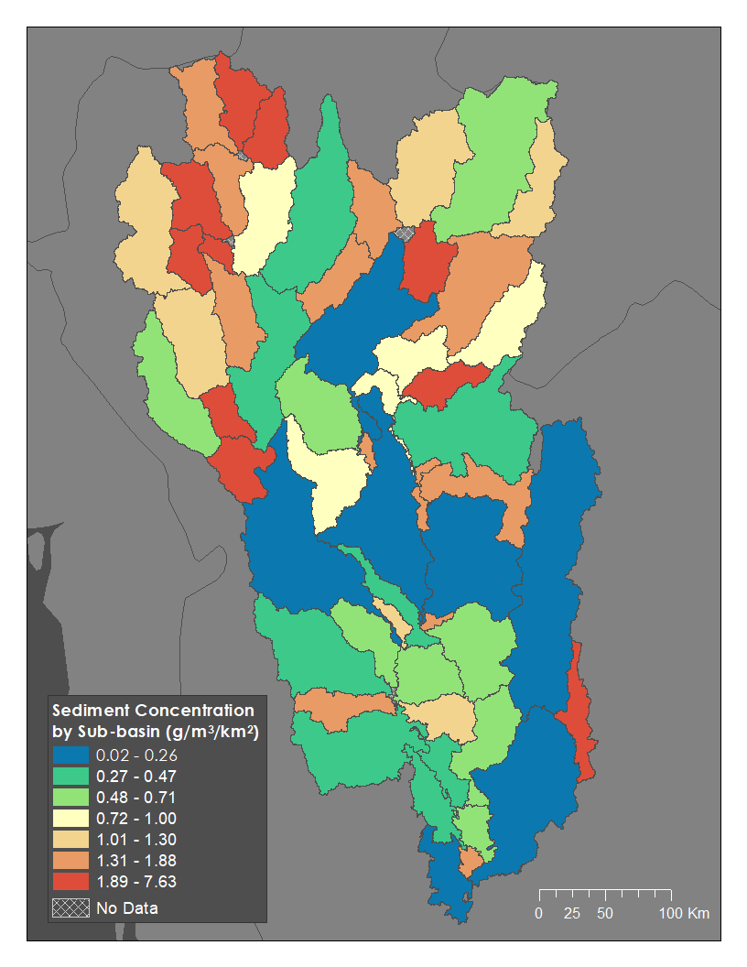Although samples taken from the lower reaches of the watershed, especially near Bangkok, indicate some of the worst water quality issues, results from the most recent SWAT run (2015-2017) indicate that sub-basins in the upper part of the watershed contribute more to sediment concentration per sub-basin unit area than their lower counterparts (Figure 3). A cluster of red sub-basins can be seen in the northwest part of the watershed, while the southern part of the watershed shows mostly blue and green sub-basins. This difference in sediment concentration between upper and lower portions of the watershed occurs consistently over the study period, as can be seen in the Water Quality Time Series (Figure 4a-c). Most of the sub-basins stay in the same sediment concentration category over each of the four time steps, indicating that the upper northwest sub-basins are consistent problem areas and further exploration ought to be done to understand why they are contributing most to higher sediment concentrations. Upon further study, these northwest sub-basins could be good candidates for watershed remediation efforts.

Figure 3: Recent Average Water Quality Map (January 2015-December 2017). We removed the smallest 5 sub-basins because they were extreme outliers.

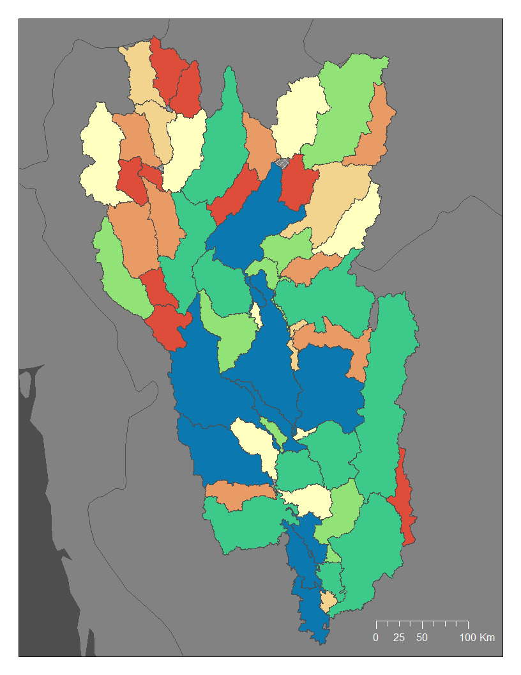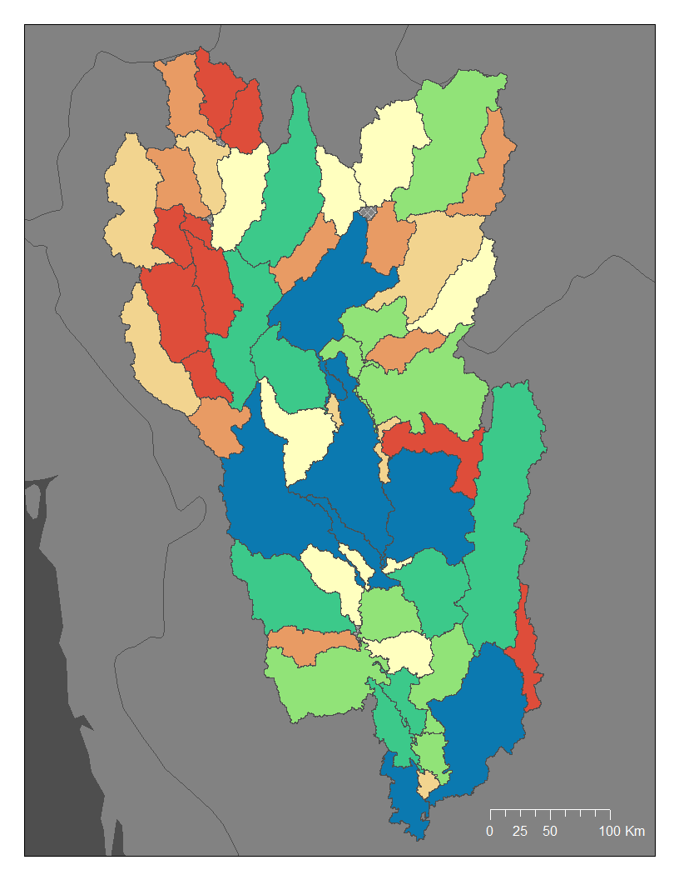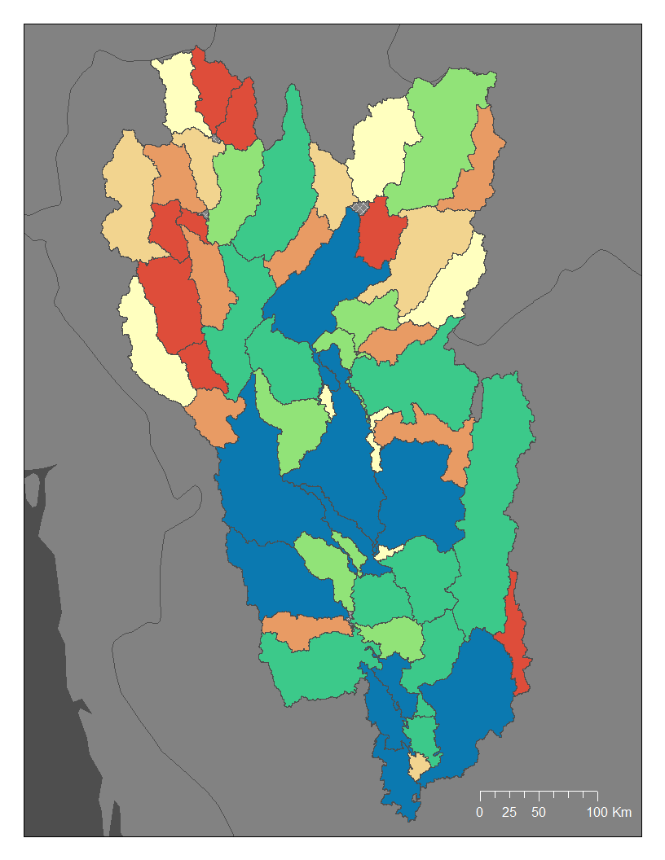

Figure 4b: Water Quality Time Series 2007-2010

Figure 4a: Water Quality Time Series 2003-2006





*Figure 4a-c:* Water Quality Time Series Showing Contribution to Sediment Concentration per Sub-Basin

Figure 4c: Water Quality Time Series 2011-2014

*4.1.2 Correlation between Urbanization and Water Quality Results*

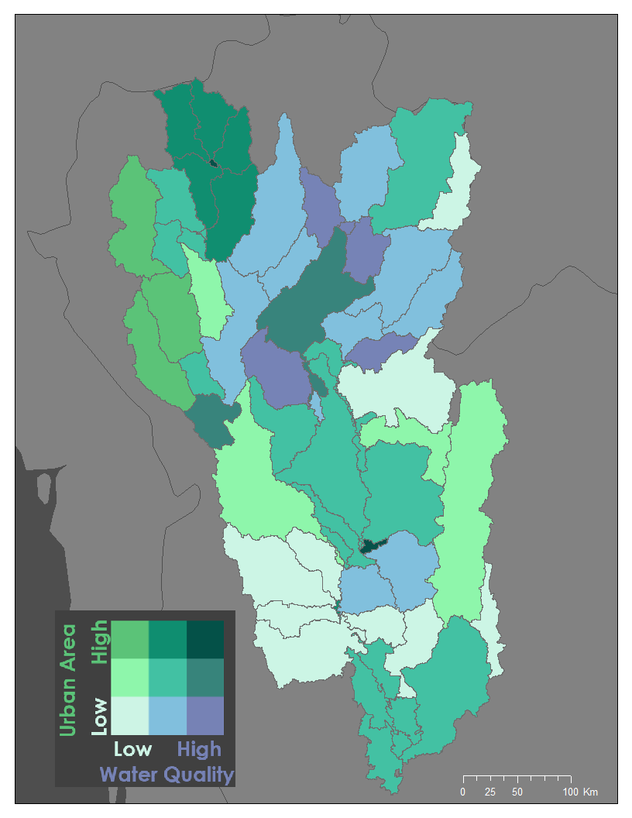To understand the relationship between urbanization and water quality, we created a bivariate map to visualize where percent change in urban area and percent change in water quality overlap (Figure 5). The values were calculated using data from the first and last SWAT model time step in order to capture change over the 15-year study period. Dark green sub-basins symbolize areas that experienced a high percent change in urban area land cover and a low percent change in water quality. Purple sub-basins represent areas that experienced high positive change in water quality and low percent change in urban area. The darkest teal sub-basins had the most significant changes across both variables, indicating the overlap of change in water quality and change in urban land cover.

The highest percent change in urban area is concentrated in the northwestern sub-basins, while the highest percent change in water quality is concentrated in the northern central sub-basins. There is a minimal overlap of high percent change in both variables, but moderate change can be seen in the upper sub-basins in the northwestern corner and north central sub-basins. To quantify the significance of the relationship seen in the bivariate map we completed a statistical regression. We found no correlation between these variables, as our R2 value was 0.0128.

Figure 5: Water Quality and Urban Footprint Percent Change Map

*4.1.3 Seasonal Variation Results*

Since Thailand has a pronounced wet and dry season, seasonal variations in streamflow and sediment loads have the potential to impact remediation efforts. Figure 6 shows these two variables during the four time periods at a monthly time step. During the months of September and October (peak of the wet season), both streamflow and sediment loads reach their maximum levels, suggesting that seasonal weather patterns can heavily influence water quality. In addition, these graphs show the effect of yearly variations in total precipitation on sediment and streamflow. In the most recent time period (2015-2017), streamflow and sediment load are lower than the previous time periods. This is due to severe droughts that occurred in the Chao Phraya region during this time period. Thus, the graphs provide an understanding of how seasonal variation impacts these parameters.

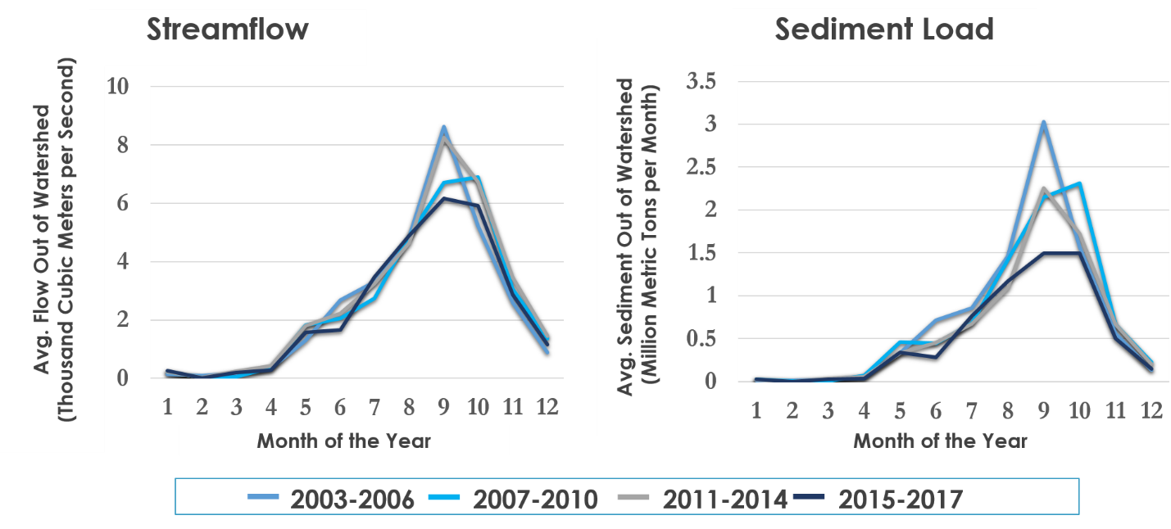

*Figure 6****.***Seasonal Variation Graphs

***4.2 Limitations***

The SWAT model requires calibration and validation, which are adjusted based on observed values in the field. While the Royal Irrigation Department (RID) of Thailand has detailed records and numerous river gauges, we were unable to acquire this data. We were, however, able to gather a small amount of data for a few sub-basins from a paper by Butsawan Bidorn et al. (2016). We noticed that our model is inconsistent, for at times it overestimates and at other times it underestimates the actual value collected from the RID (Appendix A).While the data from the paper is useful for us to visually understand the accuracy of our model, it is not nearly enough to calibrate and validate the model with SWAT-CUP and the NSE equation. Thus, the overall accuracy of the model remains in question, but future research would incorporate the RID *in situ* data.

Since SWAT inputs require advanced processing to text file formats, our team relied heavily on the NCEP CFER Meteorological Data dataset for our ancillary weather data. Unfortunately, these data do not continue past 2014. As a result, our most recent average water quality map (Figure 3), does not have ancillary weather data associated with it, rather the SWAT model assumes past trends and values to try and “make up” the weather conditions itself. Consequently, the outputs from this SWAT run may be inaccurate as they utilized simulated data for solar radiation, wind speed, relative humidity, and air surface temperature.

Point source water and pollution sources were not considered in the scope of this project, but would certainly affect downstream water quality. While the SWAT model has the capability to incorporate thiesedata, it is often hard to come by especially in a watershed as large as the Chao Phraya. Along with this, other anthropogenic alterations, including dams, reservoirs, and large-scale irrigation operations, can become stressors on the natural processes that are occurring in the watershed. Unless well documented, the SWAT model is unable to model these and therefore accuracy around these structures and operations can vary.

Delineating the watershed around the metropolitan area of Bangkok is difficult, as a result, we are unable to account for the cities runoff. Elevation data from the SRTM do not have a high enough vertical resolution to discern the minor changes in elevation near the outlet. As a result, the closer to the bay the watershed gets the more sensitive the model is to the vertical error and more inaccurate delineations occur. Therefore, we placed our watershed outlet just north of the city and are unable to account for run-off from the sub-basins in the Bangkok metropolitan area.

***4.3 Future Work***

This project helps to contextualize the state of water quality in the Chao Phraya watershed; however, to fully understand the effects of urbanization on water quality, future research is needed. While this project focused on non-point source pollution from changes in land cover, our team recognizes the need to incorporate point source pollution into the SWAT model. Taking into account untreated wastewater discharges from industry and densely-populated areas would provide a more accurate representation of processes occurring in the watershed. Furthermore, an analysis of other water quality parameters that are affected by point or non-point source pollution such as nitrogen, phosphorus, and heavy metals, would be beneficial in the future.

Additionally, this project focused solely on the relationship between the change in sediment concentrations and the expansion of urban areas. It did not consider the multitude of other ways urbanization is affecting water resources. For example, the expansion of urban areas may indirectly degrade water quality, as forested areas convert to agricultural fields in order to feed the growing urban populations. Agricultural areas often contribute to increased sediment and nutrient loads, which may explain more of the changes in water quality than urbanization alone. While urban expansion may not contribute directly to the water quality degradation, it may place unintended pressures on other lands. Exploring how other processes of land cover change prompted by urbanization may affect water quality and quantity would be valuable to improving the accuracy of this study and would provide a more holistic understanding of water quality change for policy makers.

# 5. Conclusions

Our project used NASA Earth observations to begin a basin-wide assessment of Thailand’s Chao Phraya watershed. Working alongside the ADPC, NASA SERVIR, and the Royal Thai Embassy OST, we created a replicable framework of watershed analysis for our end users the AIT and the BMA. Despite limitations with validation, we identified the upper sub-basins as locations which contribute the most to sediment concentrations. Since they have historically contributed the most to sediment concentrations than their downstream counterparts, we recognize these sub-basins as potential sites for remediation efforts once more research is completed. We also analyzed the relationship between urbanization and water quality and found no correlation between percent change in urban area and percent change in water quality given the parameters we used. While this was unexpected, we believe the framework we have provided will supply our partners with a means to study other water quality parameters in the future. The results from our project will help our partners enact strategic watershed remediation efforts in the future and continue developing basin-wide assessments of the Chao Phraya watershed.

# 6. Acknowledgments

We would like to thank our science advisors, supervisors, and project partners for all of their feedback and help this term. Without their continued input this project would not have been possible.

* Dr. Jeffrey Luvall, NASA Marshall Space Flight Center
* Dr. Robert Griffin, University of Alabama in Huntsville
* Helen Baldwin, NASA DEVELOP
* Mercedes Bartkovich, NASA DEVELOP
* Leigh Sinclair, University of Alabama in Huntsville/Information Technology and Systems Center
* Thailynn Munroe, World Resources Institute
* Dr. Sarawut Ninsawat, Asian Institute of Technology
* Rattanawadee Charoensook, Bangkok Metropolitan Administration
* Gam Bunyakiat Petri, Royal Thai Embassy, Office of Science and Technology
* Dr. Peeranan Towashiraporn, Asian Disaster Preparedness Center
* Eric Anderson, NASA SERVIR Science Coordination Office
* Amanda Markert, NASA SERVIR Science Coordination Office

Any opinions, findings, and conclusions or recommendations expressed in this material are those of the author(s) and do not necessarily reflect the views of the National Aeronautics and Space Administration.

This material is based upon work supported by NASA through contract NNL16AA05C and cooperative agreement NNX14AB60A.

# 7. Glossary

**AIT** – Asian Institute of Technology

**ADPC ­**– Asian Disaster Preparedness Center

**BMA** – Bangkok Metropolitan Administration

**DEM** –Digital Elevation Model

**Earth observations** – Satellites and sensors that collect information about the Earth’s physical, chemical, and biological systems over space and time

**FAO** –Food and Agriculture Organization

**HRU** – Hydrologic Response Unit

**NASA ACCESS** – NASA Advancing Collaborative Connections for Earth System Science

**NCEP CFER** –National Center for Environmental Prediction Climate Forecast System Reanalysis

**NSE** –Nash-Sutcliffe model efficiency coefficient

**OST** – Office of Science and Technology

**Riparian** – relating to or situated on the banks of a river

**SRTM** – Shuttle Radar Topography Mission

**SWAT Model** – Soil and Water Assessment Tool

**SWAT-CUP** – SWAT Calibration and Uncertainty Procedures

**TRMM TMPA** – TRMM multi-satellite precipitation analysis

# 8. References

Asian Institute of Technology. (2018). About. Retrieved June 26, 2018, from https://www.ait.ac.th/about/

Bangkok Metropolitan Administration. (2007). Organization of BMA. Retrieved June 26, 2018, from http://www.bangkok.go.th/main/page.php?&328&l=en

Bidorn, B., Kish, S., Donoghue, J., Bidorn, K., & Mama, R. (2016). Sediment transport characteristics of the Ping River Basin, Thailand. *Procedia Engineering*, *154,* 557-564.

Bilotta, G. S., & Brazier, R. E. (2008). Understanding the influence of suspended solids on water quality and aquatic biota. *Water Research*, *42*(12), 2849-2861.

Bronstert, A., Niehoff, D., & Bürger, G. (2002). Effects of climate and land‐use change on storm runoff generation: present knowledge and modelling capabilities. *Hydrological Processes, 16*(2), 509-529.

Goddard Earth Sciences Data and Information Services Center (2016). TRMM (TMPA) Precipitation L3 1 day 0.25 degree x 0.25 degree, V7. Goddard Earth Sciences Data and Information Services Center (GES DISC), Accessed 27 June 2018.doi://10.5067/TRMM/TMPA/DAY/7

Ligaray, M., Kim, H., Sthiannopkao, S., Lee, S., Cho, K. H., & Kim, J. H. (2015). Assessment on hydrologic response by climate change in the Chao Phraya River Basin, Thailand. *Water*, *7*(12), 6892-6909.

Mohammed, I., Bolten, J., Srinivasan, R., & Lakshmi, V. (2018). Improved Hydrological Decision Support System for the Lower Mekong River Basin Using Satellite-Based Earth Observations. *Remote Sensing, 10*(6), 885. doi:10.3390/rs10060885

Molle, F. (2007). Scales and power in river basin management: The Chao Phraya River in Thailand. *The Geographical Journal, 173*(4), 358-373.

Moriasi, D. N., Arnold, J. G., Van Liew, M. W., Bingner, R. L., Harmel, R. D., & Veith, T. L. (2007). Model evaluation for systematic quantification of accuracy in watershed simulations. *Transactions of the ASABE*, *50*(3)*,* 885-900.

Murakami, A., Zain, A. M., Takeuchi, K., Tsunekawa, A., & Yokota, S. (2005). Trends in urbanization and patterns of land use in the Asian mega cities Jakarta, Bangkok, and Metro Manila. *Landscape and Urban Planning*, *70*(3-4), 251-259.

NASA JPL (2013). *NASA Shuttle Radar Topography Mission Global 1 arc second*. NASA EOSDIS Land Processes DAAC. doi: 10.5067/MEaSUREs/SRTM/SRTMGL1.003

Pollution Control Department, Ministry of Natural Resources and Environment. [(2015). *Thailand State of Pollution Report 2015*](http://infofile.pcd.go.th/mgt/PollutionReport2015_en.pdf?CFID=2140989&CFTOKEN=61488210)*.* Retrieved from http://infofile.pcd.go.th/mgt/PollutionReport2015_en.pdf?CFID=2140989&CFTOKEN=61488210.

Rossi, L., Chèvre, N., Fankhauser, R., Margot, J., Curdy, R., Babut, M., & Barry, D. A. (2013). Sediment contamination assessment in urban areas based on total suspended solids. *Water Research*, *47*(1), 339-350.

George Huffman(2017), GPM IMERG Final Precipitation L3 1 day 0.1 degree x 0.1 degree V05, Edited by Andrey Savtchenko, Greenbelt, MD, Goddard Earth Sciences Data and Information Services Center (GES DISC), Accessed 6/26/2018 10.5067/GPM/IMERGDF/DAY/05

Simachaya, W., Watanamahart, P., Kaewkrajang, V., & Yenpiem, A. (2000, December). Water quality situation in the Chao Phraya Delta. In *Proceeding of the international conference the chao phraya delta: Historical development, dynamics and challenges of Thailand’s rice bowl, December* (pp. 1-21).

Sirikasem, Peerapong. A case of Bangkok Administration. ISO/TC211 Geographic information/Geomatics in Bangkok: Plenary Meeting.

Vigiak, O., Malago, A., Bouraoui, F. Vanmaercke, M., Obreha, F., Peosen, J., … Groselj, S. (2017). Modelling sediment fluxes in the Danube River Basin with SWAT. *Science of the Total Environment, 599-600,* 992-1012.

Wang, R., & Kalin, L. (2017). Combined and synergistic effects of climate change and urbanization on water quality in the Wolf Bay watershed, southern Alabama. *Journal of Environmental Sciences,* *64*, 107-121. doi:10.1016/j.jes.2016.11.021

Zhou, F., Xu, Y., Chen, Y., Xu, C. Y., Gao, Y., & Du, J. (2013). Hydrological response to urbanization at different spatio-temporal scales simulated by coupling of CLUE-S and the SWAT model in the Yangtze River Delta region. *Journal of Hydrology*, *485*, 113-125.

# 9. Appendices

Appendix A:

The SWAT Model output for two sub-basins and the corresponding observed data found in a paper by Butsawan Bidorn et al. (2016)

