**NASA DEVELOP National Program**



Mobile County Health Department

*Spring 2017*

Southeastern Arizona Water Resources II

Using NASA Earth Observations to Assist the National Park Service in Assessing Snow Cover Distribution and Persistence Changes in the Sky Islands

**Technical Report**

Final Draft – March 30, 2017

Charles Barrow

Saranee Dutta

Elaina Gonsoroski

Tyler Lynn (POC)

Dr. Bernard Eichold, M.D., Dr. PH, Mobile County Health Department (Mentor)

Joseph Spruce, NASA Langley Research Center Science Advisor

Dr. Kenton Ross, NASA Langley Research Center Science Advisor

Previous Contributors:

Farnaz Bayat

Katie Harville

# 1. Abstract

Southeastern Arizona is home to unique mountain ranges known as the Sky Islands. This region includes biodiversity hotspots and various ecosystems, ranging from arid deserts to temperate forests. These ecosystems in this region rely on melting snowpack for maintaining water supplies during dry periods. However, the snow accumulation in this area is being threatened by climate change with the impact of decreasing snow cover a growing concern. Currently, the National Park Service (The NPS) monitors water availability via stream gauges, but a synoptic record of snow presence does not exist due to the remote and rugged topography of the region. This information gap on snow trends makes it more difficult to study how climate change has affected water resources in the Sky Islands and what effect such change has on wildlife and vegetation in the region. In response, this project used NASA Earth observations such as Landsat data to aid the NPS in monitoring and assessing the role of snow cover in the Arizona Sky Islands. Historical snow cover maps were created from satellite data for a representative subset of the study area to help assess the role of annual snow presence and accumulation. With a more complete understanding of the impact of snow cover, the NPS will be able to analyze past snow cover changes to improve future land management decisions.

**Keywords**

Biodiversity hotspot, climate, hydrology, remote sensing, Saguaro National Park, stream gauge, watershed

# 2. Introduction

* 1. ***Background Information***

The Madrean Sky Islands (also known as the Madrean Archipelago) of North America are located between the Sierra Madre Occidental in Sonora, Mexico and the Mogollon Rim in central Arizona. The topography of this region is characterized by more than forty geographically isolated mountain ranges elongated in a northwest-southeast direction surrounded by intervening valleys of grassland and desert which act as barriers to the movement of woodland and forest species (McLaughlin, 1994; Warshall, 1994). The mountains in the region reach peaks of nearly 3300m above sea level with most peaking approximately 1500m high (Warshall 1994).

The Sky Island ecosystem long-term average precipitation input exceeds evapotranspiration forest vegetation (Brown et al, 2007). Due to the arid climate of this region, runoff from melting snowpack provides a critical source of water during the dry summer season (Gottfried and Ffolliott 2011; Ffolliott et al. 1996). Without the contributions from snowmelt runoff, many streams, springs, and seeps located throughout the Sky Islands would exhibit extremely low water levels (Brown et al. 2007). A lack of available water due to dwindling annual snowpack would seriously endanger the flora and fauna that inhabit the Sky Island region.

Given the significant ecological role of snow in the region, how the changing climate will continue to affect snow cover extent and persistence is of growing concern to the region’s natural resource managers. Noted changes in climate in the Southwestern United States include significant increases in temperature across the region in recent decades, which can cause corresponding shifts in winter precipitation patterns with precipitation more frequently falling as rain rather than snow (Misztal et al, 2013; Robles and Enquist 2010). As a result, there can be a reduction in surface and ground water supplies due to changes in the amount of accumulated snow and manner in which snow melts.

The Sky Island region includes the Saguaro National Park managed by the National Park Service (The NPS). This park is heavily utilized as a recreation area to Tucson, Arizona. The NPS is currently monitoring water availability in this park through a series of stream gauges and do not have a system in place to monitor snow pack trends for the park and nearby areas. In response, this project was conducted in the fall term of 2016 and the spring term of 2017.

***2.2 Community Concerns***

The Southwestern United States is experiencing significant increases in temperature due to changes in climate. Effects associated with warming climate include shifts in components of the hydrological cycle such as decreased winter precipitation, changes in precipitation patterns towards rain rather than snow, and earlier yearly snowmelt in the Sky Island region. Shifts in precipitation patterns toward more rainfall raise concern that snow cover will decrease to levels that cannot sustain aquatic ecosystems through dry seasons. Decreasing water resources pose a threat to the aquatic habitats, which are home to unique species as well as to the back country visitors to the park who rely on streams and pools as their main source of hydration (C. Filippone & D. Swann, the NPS, personal communication, January 2017).

***2.3 Study Area******& Period***

The overall study area consisted of the Sky Islands located in southeastern Arizona and portions of Mexico covering roughly 45,156 sq. km in area (Figure 1). Due to time constraints, our team focused analyses on two specific Sky Islands. The Rincon Mountain was chosen for its alignment with Saguaro National Park East and the Santa Catalina Mountain was chosen as a focus area for this study by the NPS due to its comparatively high elevation. In addition, the Upper Rincon Creek Watershed was used for watershed analyses as it directly feeds the Rincon Creek within Saguaro National Park East (Figure 2). The study period for this project ranged from October 1984 to March 2017. This time period was determined in part by the availability of 30 meter Landsat data.

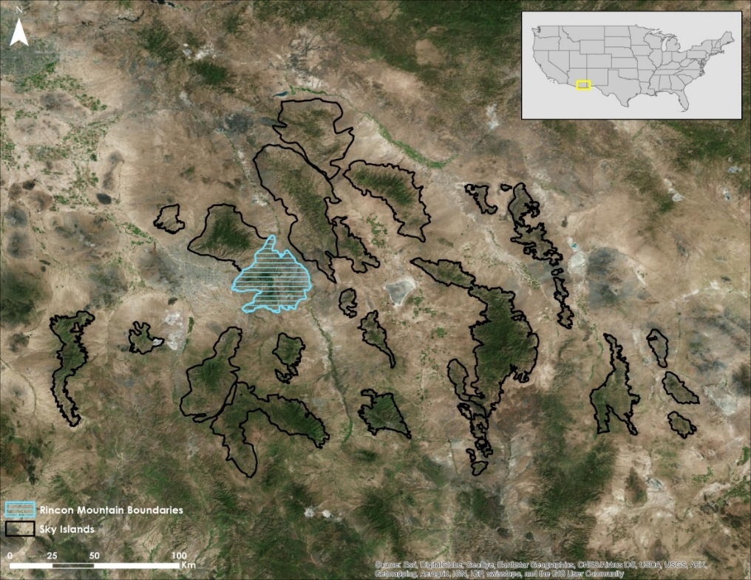

*Figure 1*. Image of entire Sky Island region with the Rincon Mountain highlighted.

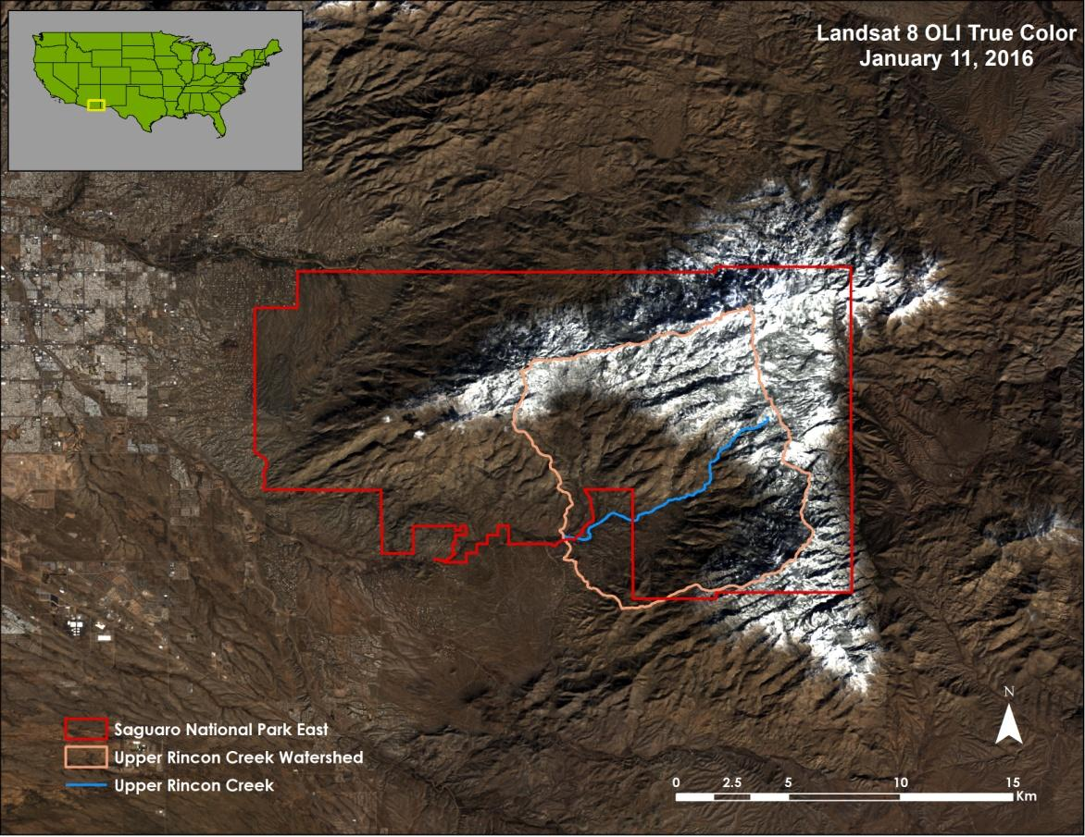

*Figure 2.* Saguaro National Park East boundaries, Upper Rincon Creek Watershed boundaries, and Upper Rincon Creek depicted over Rincon Mountain.

***2.4 Partners & Objectives***

This project addressed NASA’s Water Resources and Climate application areas by using NASA Earth observations to understand the impact of climate on water resources on the Sky Island region in Southeastern Arizona.Partners for this project include the NPS in the Intermountain Region and the Saguaro National Park. Currently, the NPS does not have a method for consistently collecting snow cover data across the region, creating a major gap in information for resource managers. This project aimed to fill gaps in the information by mapping snow cover distribution and persistence from October 1984 to March 2017, using satellite data primarily from Landsat sensors. With these data on spatio-temporal snow trends, the NPS will be more informed about potential future changes in the hydrology of the park and make more informed decisions in implementing natural resource management practices such as implementing prescribed burns, managing for aquatic species threatened by hydrological changes, and managing riparian habitats threatened by changes in streamflow due to changes in snow cover (C. Filippone & D. Swann, the NPS, personal communication, January 2017). Additionally, the project will help the NPS to supplement organizational understanding of changing water resources and of water management needs such as water supplementation for backcountry visitors.

The goal of this project was to provide mapping and geospatial assessment products on snow cover distribution in the Rincon and Santa Catalina mountain ranges, using NASA Earth observational satellite data. A second goal for the team was to compare snow cover and streamflow data in the Upper Rincon Creek Watershed in order to analyze the relationship between the two. A third project goal was to create a Google Earth Engine (GEE) satellite data processing and analysis script that would allow the NPS personnel to map, monitor, assess, and predict snow cover in the surrounding Sky Islands in terms of historic, current, and future trends.

# 3. Methodology

***3.1 Data Acquisition***

Landsat 5 Thematic Mapper (TM) V1 data (LT50380372012126EDC00 16-day 30m ) from 1984 - 2012, Landsat 7 Enhanced Thematic Mapper Plus (ETM +) V1 data (LE71400482017046SGI00 16-day 30m) from Jan 1, 1999 - Feb 7, 2017 and Landsat 8 Operational Land Imager (OLI) V1 data (LC80591162017046LGN00 16-day 30m) ranging from April 11, 2013 - March 31, 2017 were downloaded within GEE. All Landsat data products were calibrated to top-of-atmosphere (TOA) reflectance and included an F-mask program computed quality band. Additionally, Sentinel-2a data containing 13 spectral bands scaled to TOA reflectance (multiplied by 10,000) were downloaded and processed in GEE. Landsat was selected due to its high spatial resolution (30m) and the availability of historical data. Sentinel-2a data was utilized given its similarity to Landsat data and its likely future data availability as well as inclusion of additional data from the recently launched Sentinel-2b satellite. Stream gauge data were downloaded from the USGS website for streams of interest in the Rincon Mountain and Santa Catalina Mountain. Elevation data from the USGS National Elevation Dataset 1/3 arc-second data were downloaded within GEE. Biweekly wetted length data for the Rincon Creek collected by the NPS were also provided. The latter data included the length of Rincon Creek that had water present within a designated 900m stretch of the creek from 2005-2016. Watershed data were downloaded from the Watershed Boundary Dataset for Hydrologic Unit Code 12 (HUC12) for the study area that was obtained from NHD products distributed by the USGS.

***3.2 Data Processing***

Landsat data products were already pre-processed for TOA in GEE. To assess snow cover in the study area, the team used a combination of the Normalized Difference Snow Index (NDSI) described by Hall et al., (2002) and the S3 snow index described by Asaoka & Kominami (2013). The NDSI formula utilized the difference between the Green and Short Wave Infrared (SWIR) bands divided by the sum of the Green and SWIR bands (Equation 1) (Table1):

$NDSI= \frac{(Green-SWIR1)}{(Green+SWIR1)}$ (1)

The S3 snow index used the difference between the Red and SWIR1 bands multiplied by the Near Infrared (NIR) band. This was then divided by the product of the sum of the NIR and Red bands and the NIR and SWIR1 bands (Equation 2) (Table 1).

$S3=\frac{NIR*(Red-SWIR1)}{(NIR+Red)(NIR+SWIR1)}$ (2)

In addition to using these two snow indices to map snow, a cloud threshold was applied to differentiate clouds from snow as they are spectrally similar and an elevation mask was applied to eliminate outlying spectrally similar pixels being classified as snow. For the cloud threshold, pixels were classified as cloudy if the pixel was greater than or equal to 0.12 in the SWIR1 TOA reflectance band and the pixel is greater than or equal to 0.2 in the Blue band. The thresholds were determined by trial and error analysis, comparing results to what is visually apparent on Landsat false color RGB imagery in which snow is clearly defined relative to other surface cover features. For the study area, only pixels that were greater than or equal to 1,500m in elevation were considered to be classified as snow. Overall, the formula created a binary classification of pixels as snow or not-snow in the study area. If the pixel satisfied all of the following criteria, it was classified as snow: greater than or equal to 0.05 in NDSI, greater than or equal to 0.01 in S3, not classified as cloudy in the cloud threshold, and greater than or equal to 1500m in elevation (Figure 3).

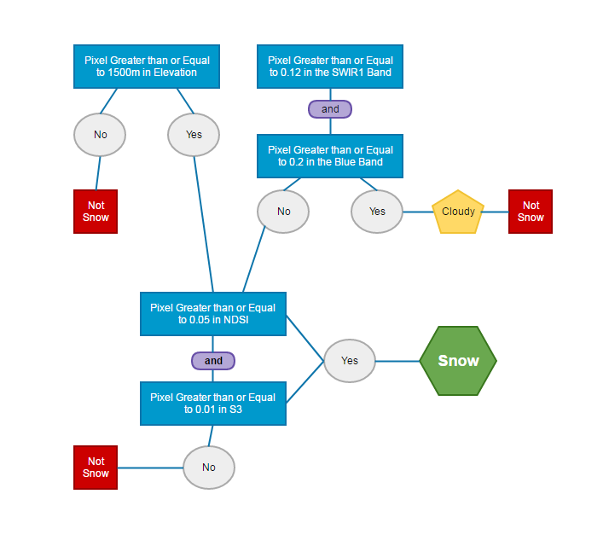

*Figure 3*. Flowchart depiction of how pixels were classified as snow or not snow.

Figure SEQ Figure \* ARABIC 2: Flowchart depicting how pixels were classified as snow or not snow.

Table 1

Spectral band wavelengths used for snow thresholds of NDSI and S3 indices, plus cloud threshold

|  |  |  |  |  |
| --- | --- | --- | --- | --- |
|  | **Landsat 5 TM** | **Landsat 7 ETM+** | **Landsat 8 OLI** | **Sentinel 2a (Central wavelength)** |
| Green | Band 2 (0.52 – 0.60 µm) | Band 2 (0.52 – 0.60 µm) | Band 3 (0.53 – 0.59 µm) | Band 3(560 µm) |
| SWIR | Band 5 (1.55 – 1.75 µm) | Band 5 (1.55 – 1.75 µm) | Band 6 (1.57 – 1.65 µm) | Band 11 (1,610 µm) |
| NIR | Band 4 (0.76 – 0.90 µm) | Band 4 (0.77 – 0.90 µm) | Band 5 (0.85 – 0.88 µm) | Band 8a (865 µm) |
| Red | Band 3 (0.63 – 0.69 µm) | Band 3 (0.63 – 0.69 µm) | Band 4 (0.64 – 0.67 µm) | Band 4 (665 µm) |
| Blue | Band 1 (0.45 – 0.52 µm) | Band 1 (0.45 – 0.52 µm) | Band 2 (0.45 – 0.51 µm) | Band 2 (490 µm) |

***3.3 Data Analysis***

To analyze snow cover in the study area, the percentage of the total snow cover was calculated for the Upper Rincon Creek Watershed. The percentage of snow cover was calculated by totaling the amount of pixels classified as snow in the watershed and then dividing this total by the total area of the watershed polygon. Data was processed seasonally (October – May of the following year) and plotted by individual observation dates (Figure 4). This data was then exported from GEE in a comma separated format and imported into Microsoft Excel for analyses. Snow cover data was calculated for the entirety of the study period for the Upper Rincon Creek Watershed. General trends were observed from the data and compared with the stream flow data and the stream wetted length data.

*Figure 4.* Time series showing mapped snow cover (blue tones) for Rincon Mountain in the 2015-2016 snow season, based on analysis of Landsat data.

# 4. Results & Discussion

***4.1 Results***

Trends from the entire dataset of Upper Rincon Creek Watershed showed that there was a general decrease in the amount of snow cover from 1984 to present day (Figure 5). Additionally, observations indicated that the peaks in streamflow generally aligned with peaks in snow cover observations (Figure 6). The lag between peak streamflow and peak snow cover may have been due to the differences in the acquisition dates of the satellite data relative to when a given weather event occurred. Unlike the stream gauge, the satellite only captures data every few days, meaning data may be collected after a precipitation event when snow is still present but streamflow has decreased. Additionally, in dry years with little snow, the stream gauge registered little-to-no water even after precipitation events. However, in wetter years with more snow, the stream gauge registered streamflow throughout the year and further into the hotter months suggesting snowfall may have some impact on streamflow in addition to higher precipitation at lower elevations. To verify that pixels were correctly identified as snow, an accuracy assessment for a clear, snowy day was performed for randomly sampled locations, resulting in 92% of pixels being correctly classified as snow compared to reference data (Landsat true and false color RGBs) (Figure 7). The accuracy of the method could be less for scenes with more cloud cover. The available time limited the accuracy assessment to one data set.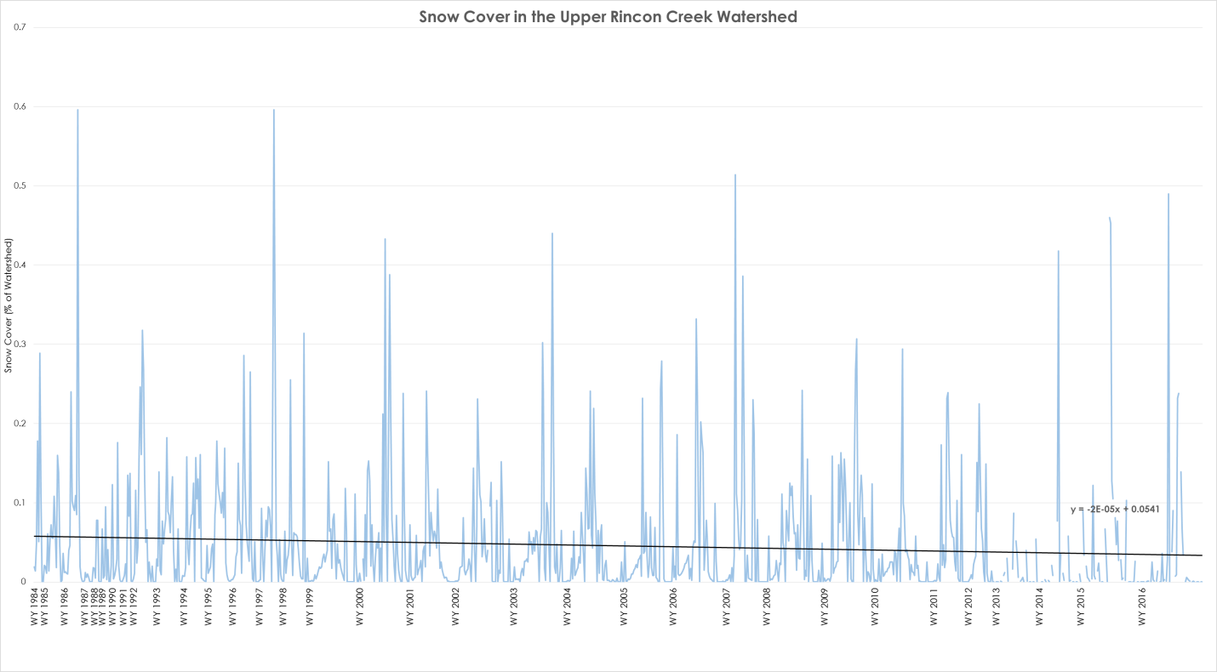*Figure 5.* Graph of all available snow cover data separated by Water Year (WY), suggesting a slight downward trend in snow cover across the record from oldest to most current observations. 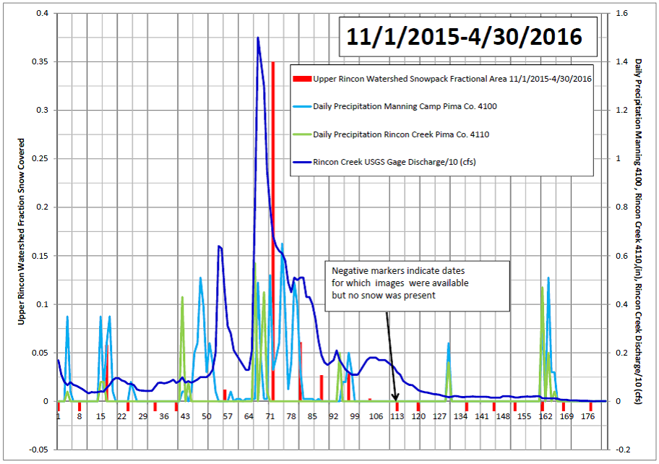*Figure 6.* Graph of precipitation, streamflow, and snow cover percentage in the Upper Rincon Creek watershed for November 2015-April 2016 (Credit: Precipitation data, streamflow data, and graph from Colleen Filippone, the NPS).

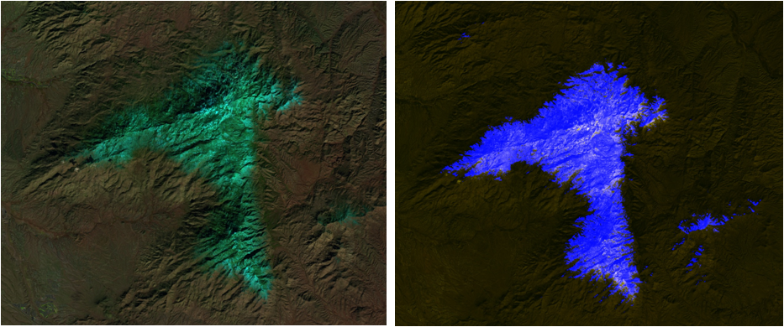Figure 7: Side-by-side comparison of a false color RGB and a classified snow cover image using the combined snow cover index. Data acquired from Landsat 8 OLI imagery for January 11, 2016.

***4.2 Future Work***

The project demonstrated the potential of Landsat data for monitoring snow cover in the study area, focusing on a subset of the overall study area. Future work needs to include expanding the area of analysis to regard all of the Sky Islands. Including additional groundwater and weather data into future analyses of snow cover and surface water flow may reveal more information about the relationship between snow cover and water resources in the region. MODSCAG (MODIS Snow Covered-Area and Grain size retrieval algorithm) data products from NASA’s Jet Propulsion Laboratory could also be incorporated into the analyses to increase the temporal resolution of the dataset. This dataset could also be used to compare to the combined snow S3 and NDSI snow identification to further assess the accuracy of the combined indices. Demonstration of the technique in areas with SNOTEL data could also benefit accuracy assessment of the methods and products from this project. Future work may include incorporating data products into hydrological models to assess impacts of snow trend on hydrologic variables related to surface water supply, such as runoff. In addition, more accuracy assessments will be conducted to include different observational conditions (e.g. data sets with clouds and shadows) to quantify the accuracy of the thresholds used to identify snow based on combined use of two snow indices. The project also suggested that it was feasible to map snow using the Sentinel-2a data but more work is needed to further assess this finding. Additional future work may include efforts towards summarizing the total mapped snow acreage relative to the amount of cloud free area within the designated area of interest. GEE did not allow for the computation of cloud-free area and the addition of this computation would allow for highly cloudy scenes to be eliminated from the calculations. In addition, more effort is needed to refine the methods used in order to increase snow mapping accuracy. Although snow mapping results were positive, due to the short time-frame, more work is needed to increase the level of accuracy for the snow mapping products.

# 5. Conclusions

Landsat snow cover distribution maps provided useful information on annual snowpack phenology; however, some snow classification issues with satellite data (e.g., clouds, cloud shadow, and topographic shadow) were encountered. NDSI and S3 snow index each had unique snow classification errors (commission and omission errors). The singular use of either index can have snow classification errors unique to an individual index (e.g. NDSI showed snow classification errors in areas affected by topographic shadow and S3 snow index showed snow classification errors from clouds). However, the combined use of NDSI and S3 appeared to reduce snow classification errors that occurred when only using either index singularly. The combined use allows the snow detection values to be lowered, resulting in more snow to be classified and less snow to be omitted without being confused with spectrally similar cover types. Additionally, by including elevation data, confused pixels at lower elevations were eliminated and not identified as snow. General trends from the data indicate that snow cover has decreased over time in the Rincon Mountains. In addition, peaks in streamflow generally aligned with peaks in snow cover indicating some visual correlation between the two types of hydrologic observations. However, further analyses are needed in order to determine the strength of the relationship between streamflow and snow cover. The creation of the GEE script for the partners will allow them to continue to explore synoptic snow cover trends within the study area in the future and provides a potential means to expand their area of study with additional remotely sensed data for other portions of the Sky Island region. Additionally, this script will allow the NPS to fill historical information gaps on the study area’s synoptic snow trends and could be used to possibly strengthen the information used for guiding certain natural resource management practices in the park. Outreach of project results and methodologies are planned for this project at both professional conferences and through publications.

# 6. Acknowledgments

The Southeastern Arizona Water Resources II team would like to thank the following for their assistance and support in the completion of this project:

* **Colleen Filippone**, National Park Service, Intermountain Region (Project Partner)
* **Don Swann**, National Park Service, Saguaro National Park (Project Partner)
* **Bernard Eichold**, M.D., Dr. PH, Mobile County Health Department (Mentor)
* **Joseph Spruce**, NASA Langley Research Center (Science Advisor)
* **Kenton Ross**, PhD, NASA Langley Research Center (Science Advisor)
* **Katie Harville**,previous contributor
* **Farnaz Bayat**, previous contributor

Any opinions, findings, and conclusions or recommendations expressed in this material are those of the author(s) and do not necessarily reflect the views of the National Aeronautics and Space Administration.

This material is based upon work supported by NASA through contract NNL11AA00B and cooperative agreement NNX14AB60A.

# 7. Glossary

**Biodiversity Hotspot –** An extremely diverse biogeographic region that also supports high diversity of endemic species and also is threatened with destruction

**Ecosystem –** A natural system consisting plants, animals and other microorganism communities and how they interact with their nonliving environment as a functional unit

**Madrean Archipelago –** Stepping stone chain of isolated mountains between the Rocky Mountains and the Sierra Madre Mountains

**Sky Islands –** Isolated, high elevation, forested mountains that are separated by low desert scrubland

**Watershed –** A drainage basin that receives waters flowing from upland rivers, streams and drains into river systems or other water bodies such as wetlands and estuaries

# 8. References

Asaoka, Y. & Kominami, Y., (2013). Incorporation of satellite-derived snow-cover area in spatial snowmelt modeling for a large area: determination of a gridded degree-day factor. *Annals of Glaciology* *54(*62), 205-213.

Brown-Mitic, C., Shuttleworth, W. J., Harlow, R. C., Petti, J., Burke, E., & Bales, R. (2007). Seasonal water dynamics of a sky island subalpine forest in semi-arid southwestern United States. *Journal of arid environments*, *69*(2), 237-258.

Ffolliott, P. F., Gottfried, G. J., & Baker Jr, M. B. (1996). The Role of Snow in the Hydrology of the Madrean Province in Southeastern Arizona. *Hydrology and Water Resources in Arizona and the Southwest*. Arizona-Nevada Academy of Science.

Gottfried, G. J., & Ffolliott, P. F. (2011). Contributions of Snowmelt to Streamflow in Southeastern Arizona: A Case Study from the Santa Catalina Mountains. *Hydrology and Water Resources in Arizona and the Southwest,* 47.

Hall, D. K., Riggs, G. A., Salomonson, V. V., Barton, J. S., Casey, K., Chien, J. Y. L. & Tait, A. B. (2001). Algorithm theoretical basis document (ATBD) for the MODIS snow and sea ice-mapping algorithms. *NASA GSFC, September.*

McLaughlin, S. P. (1994). An overview of the flora of the Sky Islands, southeastern Arizona: diversity, affinities, and insularity. *Biodiversity and management of the Madrean Archipelago: the Sky Islands of southwestern United States and northwestern Mexico*, 60-70.

Misztal, L. W., Garfin, G., & Hansen, L. (2013). Responding to climate change impacts in the Sky Island Region: From planning to action. In Gottfried, Gerald J.; Ffolliott, Peter F.; Gebow, Brooke S.; Eskew, Lane G.; Collins, Loa C. Merging science and management in a rapidly changing world : Biodiversity and management of the Madrean Archipelago III and 7th Conference on Research and Resource Management in the Southwestern Deserts; 2012 May 1-5; Tuscon, AZ. Proceedings. RMRS –P-67. Fort Collins, CO: U.S. Department of Agriculture, Forest Service, Rocky Mountain Research Station. P. 60-67.

Robles, M. D., & Enquist, C. (2010). Managing changing landscapes in the Southwestern United States. *The Nature Conservancy*.

Warshall, P. (1994). The Madrean Sky Island archipelago: a planetary overview. Pages 408-415 in DeBano L. F, Ffolliot P. F, Ortega-Rubio A, Gottfried G. J, Hamre R. H, Edminster C. B, editors Biodiversity and management of the Madrean Archipelago: the Sky Islands of southwestern United States and northwestern Mexico. U.S Department of Agriculture: Forest Service, Rocky Mountain Forest and Range Experiment Station, Tuscon, Arizona.