**NASA DEVELOP National Program**

NASA Marshall Space Flight Center

**Spring 2016**

**Short Title: Alabama Ecological Forecasting**

**Subtitle:** Assessing Southern Pine Beetle Epidemics in Alabama’s Bankhead National Forest Using NASA Earth Observations

**VPS Title:** Here, There, and Everywhere: Assessing SPB Outbreaks in Alabama

**Project Team & Partners**

**Project Team:**

Ryan Schick (Project Lead), william.r.schick@nasa.gov

Kelsey Herndon

Maggi Klug

Leigh Sinclair

**Advisors & Mentors:**

Dr. Jeffrey Luvall (NASA at the National Space Science Technology Center)

Dr. Robert Griffin (University of Alabama in Huntsville)

**Partner Organizations:**

USDA Forest Service, Bankhead District Ranger (End-user), POC: Dave Casey

USDA Forest Service, SPB Coordinator (End-user), POC: Dr. John Nowak

USDA Forest Service, Forest Health Monitoring Coordinator (End-user), POC: Dr. Chris Asaro

**Project Details**

**Applied Sciences National Application Addressed:** Ecological Forecasting

**Study Area:** AL

**Study Period:** January 2010 - December 2050

**Earth Observations & Parameters:**

SRTM-v2, C-band – Digital Elevation Models (DEM)

Landsat 5, TM – land cover

Landsat 8, OLI – land cover

**Ancillary Datasets Utilized:**

* National Agriculture Imagery Program (NAIP) – land cover
* Landscape Fire and Resource Management Planning Tools data – land cover
* ForWarn Forest NDVI change – change in vegetation health
* WorldClim Climate Data – climate data
* Alabama Forestry Commission *in-situ* Southern Pine Beetle data – GPS location data

**Models Utilized:**

* Princeton University Maximum Entropy (MaxEnt) Model

**Software Utilized:**

ArcGIS - Raster manipulation/analysis, image enhancement & map creation of Landsat TM, OLI and SRTM-v2 C-band

R - Regression analysis, execution of MaxEnt, and land cover delineation

**Project Overview**

**80-100 Word Objectives Overview:**

The Southern Pine Beetle (SPB), *Dendroctonus frontalis*, is an opportunistic species that attacks stressed trees that have been weakened by drought, storm damage, or fire. Outbreaks of SPB typically have a six to twelve year interval, are estimated to destroy about 60,000 pine trees per year in Alabama, and cause about $800,000 in damages annually. This project identified areas in Alabama, with a focus in the Bankhead National Forest, that have been infested with the SPB by creating a Historical SPB Coverage Map, a SPB Prediction Map, and a Near-Real Time SPB Susceptibility Model.

**Abstract:**

The Southern Pine Beetle (SPB), *Dendroctonus frontalis*, is an opportunistic species that attacks stressed trees weakened by drought, storm damage, or fire. In 2000, about 18,600 acres of pine forest were damaged throughout the Bankhead National Forest due to SPB. The United States Department of Agriculture (USDA) Forest Service currently uses expensive manned aerial surveys, such as aerial photography and Light Detection and Ranging (LiDAR), as well as Moderate Resolution Imaging Spectroradiometer (MODIS) ForWarn and Forest Disturbance Monitor data to help with mitigation efforts. This project used remotely sensed data to identify SPB infested areas throughout Alabama and determine outbreak patterns. Aqua/Terra MODIS were used to derive a Normalized Difference Vegetation Index (NDVI) and a Green-Red Vegetation Index (GRVI) to show vegetation health and a Normalized Moisture Difference Index (NMDI) to show the surrounding drought conditions. Shuttle Radar Topography Mission Version 2 (SRTM-v2) Digital Elevation Models (DEM) were used to understand how elevation, slope, and aspect affect SPB susceptibility. Present SPB data and various environmental variables were analyzed using the Princeton University Maximum Entropy model (MaxEnt) to assess areas susceptible to a SPB outbreak by creating a SPB Prediction Map for 2050. Additionally, this project determined where mitigation efforts should be focused by creating a Near Real-Time SPB Susceptibility Model. A Historical SPB Coverage Map was created to understand patterns of previous attacks. The USDA Forest Service used these methodologies and maps to reduce costs and time associated with SPB suppression in Bankhead National Forest and Alabama.

**Community Concerns:**

* SPB is one of the most destructive pine pests in the Southeastern United States causing hundreds of thousands of dollars in damage to pine trees each year.
* Trees killed by SPB can increase the risk or severity of forest fires by increasing the fuel load available to burn.
* Damages caused by the SPB may result in limited diversity in surrounding plants and harm other animals’ habitats, such as the near-threatened Red-cockaded Woodpecker.

**Current Management Practices & Policies**:

Currently, the USDA Forest Service uses expensive manned aerial surveys, such as aerial photography and LiDAR, as well as MODIS ForWarn and Forest Disturbance Monitor data. With the aerial data, field surveys must also be used since the species of beetle must be positively identified before conservation efforts can be implemented. For each species of beetle, specific management control and recommendations are needed as the beetles attack different pine trees at varying health and stress levels. During the winter months, suppression techniques include the removal of infested trees by salvage, piling and burning, or chemical control.

**Decision Support Tools & Benefits:**

|  |  |  |
| --- | --- | --- |
| **End-Product** | **Earth Observations Used** | **Benefit & Impact** |
| Historical Southern Pine Beetle Coverage Map | Landsat 5 TM, Landsat 8 OLI, SRTM v-2 | Determine infected areas and how they have changed to help in prioritizing suppression |
| Southern Pine Beetle Prediction Map | Landsat 5 TM, Landsat 8 OLI, SRTM v-2 | Determine where the efforts should be focused for future conservation |
| Near Real-Time Southern Pine Beetle Susceptibility Model | Landsat 8 OLI, SRTM v-2 | Determines which areas are susceptible to a SPB outbreak in near real-time |

**Project Imagery**

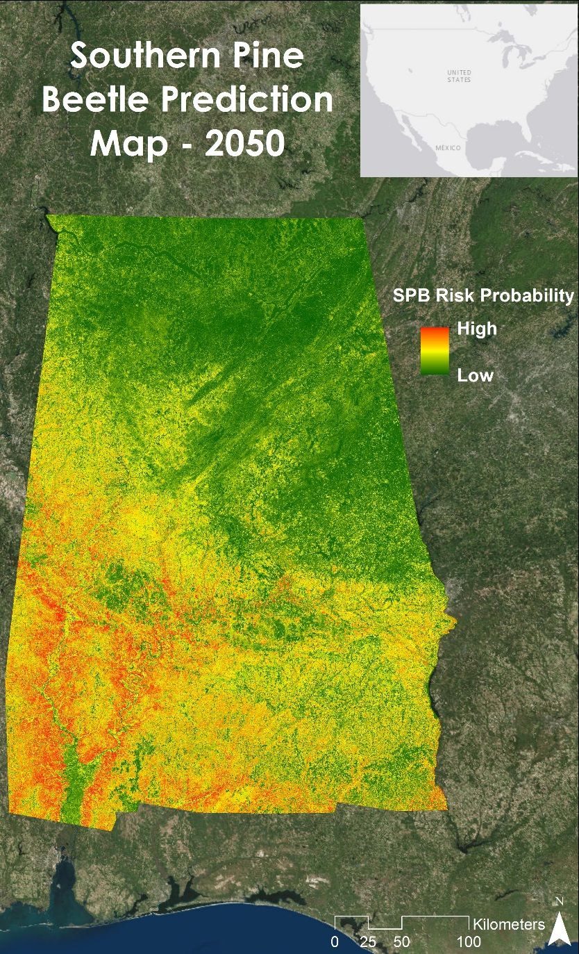

**Caption:** The Future SPB Outbreak Susceptibility Map shows the probability of a Southern Pine Beetle outbreak occurring in 2050. Image Credit: Alabama Ecological Forecasting Team.

**Image:** Future_Susceptibility_50.jpg

**Software Release Requirements**

What category do the tools your project is creating fall within? Category II