**NASA DEVELOP National Program**

****MCHD

**Spring 2014**

**Chagas Transmission Risk in Alabama**

*Habitat Suitability Modeling of Triatoma sanguisuga, the Expected Local Vector for Chagas Disease in the South Eastern United States*

**Team Lead:** James Pickett (University of South Alabama), sp14.sehealth@gmail.com

**Team Members:**

Brandi Stewart, University of South Alabama

Shikher Mishra, University of South Alabama

**Advisors & Mentors:**

Dr. Bernard Eichold, Mobile Public Health Officer

Joe Spruce, Computer Sciences Corporation

Dr. Kenton Ross, DEVELOP National Science Advisor

**Past or Other Contributors:**

Walt Clark, DEVELOP MCHD Center Lead

Amber Jones, DEVELOP MCHD Assistant Center Lead

Sidney King, Fall 2013 Gulf Coast Health & Air Quality Team Member

**Applied Sciences National Applications Addressed:**

Health and Air Quality

**Study Area:** While this project is concerned with predicting habitat suitability within Alabama and neighboring coastal communities, in order to implement the ecological niche model, the data and study area will span the Southeastern United States.

**Study Period:** January 2014 – April 2014, most recent data available

**Community Concerns**

Chagas Disease has long been an affliction of Central and South America, but it is estimated that roughly 300,000 people living in the United States have chronic Chagas Disease. The vast majority of these cases are due to emigration, with six autochthonous cases being reported domestically. Despite this, the CDC has named Chagas Disease as one of the five national Neglected Parasitic Infections. For this study, the primary concern was the chain of transmission to include host reservoirs and the vector species expected to participate locally within this chain, *Triatoma sanguisuga.*

**80-100 Word Blurb**

This project aimed to initiate the GARP (Genetic Algorithm for Rule set Production) environmental suitability model using NASA EOS and ancillary species data to determine optimum habitats for Triatominae species. Goals were to improve on prior research by gaining access to the Alabama Supercomputer and initiating GARP with far less computational limitations, and to initiate the model with an increased number of environmental parameters such as NDVI and NDWI. The end results support collection and testing efforts in order to determine Chagas transmission risk for populations in suburban and rural areas.

**Abstract**

Chagas Disease is a chronic infection caused by the *Trypanosoma cruzi* protozoa

vectored by the *Triatominid* subfamily of insects*.* These insects seek blood meals, often from humans, and transmit the disease through defecation soon after feeding. A lack of treatment leads to irreparable damage to the heart and intestines. Presently, little attention is given to Chagas Disease in the United States despite the presence of vectors and a large reservoir population. Although it is hypothesized that better housing and vector control within the U.S. prevent rampant transmission, increases in the wild-urban interface and climate change may open up new habitats for *Triatominae* and transmission potential for Chagas. Thus, the objective of this project was to determine the risk of contracting Chagas Disease in the rural southeastern United States, more specifically in Alabama. To accomplish this, ecological niche modeling was conducted on the most adaptable vector species inhabiting the U.S., *Tritatoma sanguisuga.* The Genetic Algorithm for Rule-set Production (GARP) was implemented to produce habitat suitability maps of *T. sanguisuga* with the input of data provided from NASA remote sensing satellites. For this study, Landsat 8 and Aqua/Terra platforms were used for classifying land cover and to discriminate between deciduous and evergreen vegetation. Shuttle Radar Topography Mission (SRTM) data were used for deriving terrain elevation and slope maps. Total Rainfall Measuring Mission (TRMM) data were used to calculate rainfall accumulations on a seasonal basis. Along with these bioclimatic parameters, data such as Land Surface Temperature (LST) and Soil Moisture (SM) were implemented as well.

Model outputs indicated that large portions of the study area exceeded 96% habitat

suitability with more than half of this extent crossing the 99% suitability threshold. A

secondary study was conducted to assess which locations within these regions would

be most ideal for trapping sites, as well as which populations within the county are at

greatest risk of encountering *T. sanguisuga*. For this purpose, a map consisting of

wildland-urban interface and socio-economic data was constructed. To prioritize trap

sites, the intersections between the various high percentiles, poorer housing structures,

and both the wildland-urban interface and intermix regions were mapped. Results

were used to determine the likelihood of its presence in Alabama, and to aid in possible

collection of the vector for testing of the disease.

**Partners/Collaborators**

Dr. Francis Mujica, Earth Sciences, University of South Alabama

Dr. John McCreadie, Biological Sciences, University of South Alabama

Dr. Monica Knight, Epidemiologist, Mobile County Health Department

Mr. Jerry Folse, Vector Control, Mobile County Health Department

**Current Management Practices & Policies**

Currently, autochthonous cases of Chagas Disease are quite rare. However, testing of the vectors and reservoirs of Chagas has revealed a high prevalence of the *T. cruzi* agent that causes the disease. This type of testing has not been conducted in the north-central Gulf Coast region or in the interior of the states of Alabama and Mississippi. This testing is the goal of Drs. Mujica and McCreadie’s work. With the chain of infection present, the question arises as to why infection is not more common in the United States. This is a question being actively pursued by both entomologists and epidemiologists in the region. Though Chagas is a reportable disease according to the CDC, the Alabama Department of Public Health does not require reporting of cases.

**Benefit to End-User:**

* GARP output maps indicative of where to begin searching for *T. sanguisuga* locally.
* A methodology on implementing GARP to predict habitat suitability of Chagas vectors.

**Decision Support Tools**

*Species location maps* – The raw outputs of the GARP model are rasters of probable habitats for Triatomines, the vector of Chagas. Each run of the model produces independent results that may reveal distinct trends. The independent outputs were stacked in ArcGIS to create a more complete assessment of habitat suitability. These results could be invaluable to researchers attempting collection, such as Drs. Mujica and McCreadie as they will allow for much more focused use of resources, such as light traps and sentinel flocks.

*Transmission risk maps* – The location maps derived from GARP were combined with population and socioeconomic data to indicate the populations that are most at risk to Chagas. Factors such as increased poverty and a large wildland-urban interface greatly increase chances of an encounter with a Triatomine.

*Suspect Areas* – The two highest risk categories from the GARP results were combined with census poverty data and wildland-urban interface data to suggest domestic areas that have a high chance of Triatomine infestation.

**Earth Observations & Parameters**

Landsat 4 MSS – Land Cover

Landsat 5 TM – Land Cover

Landsat 8 OLI – Land Cover, Wildland-Urban Interface

Aqua/Terra MODIS – Land Cover, Vegetation indices, Land Surface Temperature

Terra ASTER –Landcover

Shuttle Radar Topography Mission (SRTM) – Elevation and Slope

**Future Applicable NASA Missions**

Global Precipitation Measurement (GPM) – launched February 27, 2014

Soil Moisture Active Passive (SMAP) – launching October 14, 2014

**Models Utilized**

GARP- Genetic Algorithm for Ruleset Production

**Ancillary Datasets Utilized**

*T. sanguisuga* specimen locations (67 in all)

USGS National Land Cover Dataset (NLCD)

Worldclim Bioclim Datasets

Soil Moisture Operational Products System (SMOPS) – NOAA NESDIS

**Software Utilized**

ERDAS Imagine 2011 - land classification of Landsat imagery

ArcGIS 10.0 - Raster manipulation/analysis, image enhancement & map creation

**Image**

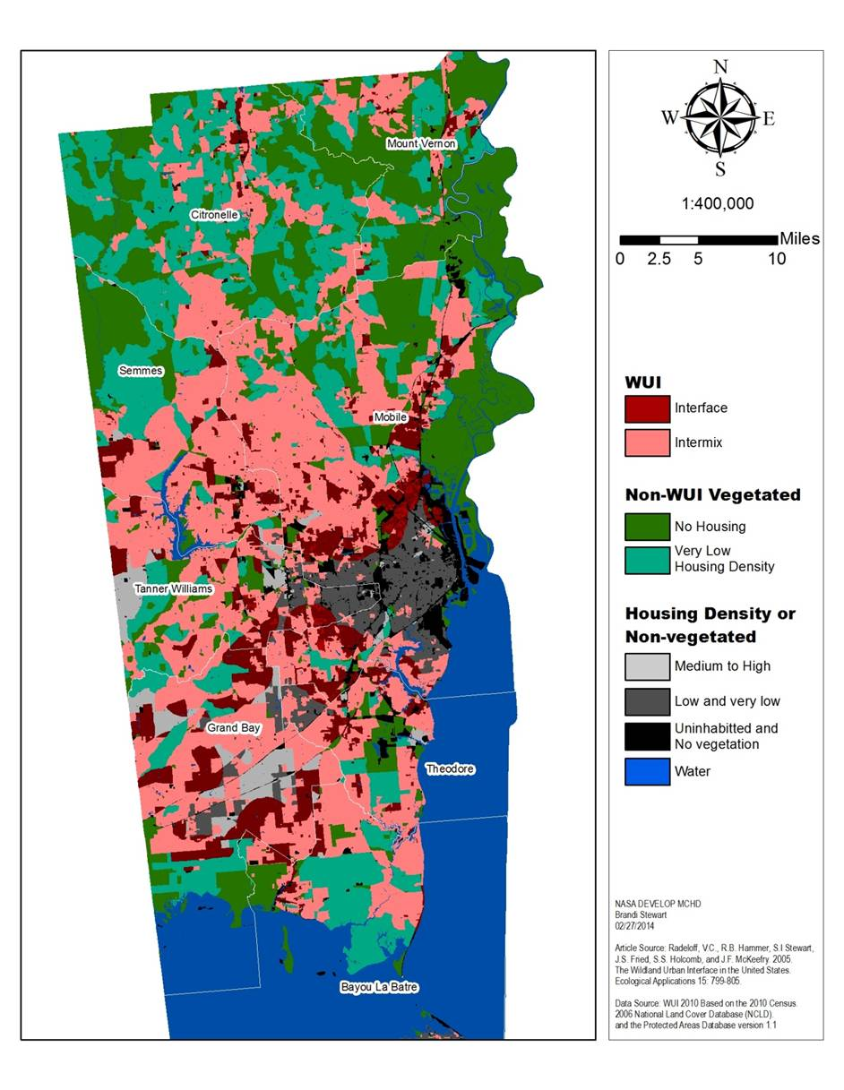

**Caption**

Wild-urban interface and housing density map created for intersection of model outputs to determine priority trap setting locations