**NASA DEVELOP National Program**

****NASA Ames Research Center

**Summer 2016**

**Short Title: Elkhorn Slough Ecological Forecasting**

**Subtitle:** Detecting Eutrophication Sources, Hotspots, and Nutrient Levels in a Central California Estuary to Support Watershed Management Decisions

**VPS Title:** Elkhorn Slough: Detecting Eutrophication through Geospatial Modeling

**Project Team & Partners**

**Project Team:**

Martha Sayre (Project Lead), martha.sayre@nasa.gov

Irma Caraballo Álvarez

Abigail Childs

Kirsten Jurich

**Advisors & Mentors:**

Dr. Juan L. Torres-Pérez (Bay Area Environmental Research Institute)

Dr. Sherry L. Palacios (Bay Area Environmental Research Institute)

**Partner Organizations:**

|  |  |  |  |
| --- | --- | --- | --- |
| **Organization** | **POC (Name, Position/Title)** | **Partner Type** | **Boundary Org?** |
| Elkhorn Slough National Estuarine Research Reserve (ESNERR) | Dr. Kerstin Wasson, Research Coordinator;  Charlie Endris, GIS Specialist;  John Haskins, Water Quality Monitoring Specialist | End-User | Yes |
| Monterey Bay Aquarium Research Institute | Dr. Ken Johnson, Senior Scientist | Collaborator | No |

**Project Details**

**Applied Sciences National Applications Addressed:** Ecological Forecasting, Water Resources, Climate

**Study Area:** Elkhorn Slough, Monterey County, CA

**Study Period:** March 1995 - March 2016; Forecast 2020

**Earth Observations & Parameters:**

Landsat 5, Thematic Mapper (TM) – land cover, eutrophication indices

Landsat 7, Enhanced Thematic Mapper Plus (ETM+) – land cover, eutrophication indices

Landsat 8, Operational Land Imager (OLI) – land cover, eutrophication indices

**Ancillary Datasets Utilized:**

* ESNERR *in situ* data– ammonia, ammonia (unionized), algal cover, chlorophyll a, nitrate, orthophosphates, turbidity, dissolved oxygen, pH, salinity, temperature
* Monterey Bay Aquarium Research Institute *in situ* data - nitrate, water depth, salinity, temperature, oxygen, pH, chlorophyll, colored dissolved organic matter, solar radiation, precipitation, wind speed, wind direction, evapotranspiration
* NOAA Digital Coast – land cover
* NOAA Coastal LiDAR – LiDAR elevation
* NOAA NCEI Climate Data – precipitation, temperature, and wind speed
* USDA SSURGO – soils shapefile and database
* USGS National GAP Analysis Program (GAP) – land cover map
* USGS National Land Cover Database (NLCD) – land cover maps
* USGS stream gauge data – river discharge data

**Models Utilized:**

* Soil and Water Assessment Tool (SWAT)
* TerrSet Earth Trends Modeler (ETM)
* TerrSet Land Change Modeler (LCM)

**Software Utilized:**

* ArcGIS - raster manipulation/analysis, vector manipulation/analysis, image enhancement & map creation of Landsat imagery
* TerrSet - raster manipulation/analysis, model forecasting
* ENVI/IDL - land use classification, land cover classification, band manipulation
* ArcSWAT - model sediment and nutrient loadings
* Microsoft Access - editing of ArcSWAT and SSURGO soils databases
* SWAT-CUP - calibration of SWAT outputs
* Python - code to create eutrophication indices and automate tasks

**Project Overview**

**80-100 Word Objectives Overview:**

Throughout the past 21 years, incidents of eutrophication have increased in Elkhorn Slough due to agricultural intensification. This project seeks to identify and track patterns and sources of eutrophication in the slough and anticipate future hotspots as contributed from sub-basins. Categorization of eutrophic hotspots were achieved through a composite analysis of both primary and secondary indicators of eutrophication, including the floating algal index (FAI), normalized difference turbidity index (NDTI), and suspended sediment concentration (SSC). Eutrophication sources were delineated through a sub-watershed analysis using SWAT modeling to detect primary contributors of nutrient loading.

**Abstract:**

Elkhorn Slough in Monterey, California has experienced substantial nutrient loading and eutrophication over the past 21 years as a result of fertilizer-rich runoff from nearby agricultural fields. This study seeks to identify and track spatial patterns of eutrophication hotspots and the correlation to land use changes, possible nutrient sources, and general climatic trends using remotely sensed and *in situ* data. Threats of rising sea level, subsiding marshes, and increased eutrophication hotspots demonstrate the necessity to analyze the effects of increasing nutrient loads, relative sea level changes, and sedimentation within Elkhorn Slough. The Soil & Water Assessment Tool (SWAT) model integrated specified inputs to assess nutrient and sediment loading and their sources. TerrSet’s Land Change Modeler forecasted the future potential of land change transitions for various land cover classes around the slough as a result of nutrient loading, eutrophication, and increased sedimentation. TerrSet’s Earth Trends Modeler provided a comprehensive analysis of image time series to rapidly assess long term eutrophication trends and detect spatial patterns of known hotspots. Results from this study will inform future coastal management structures and provide greater spatial and temporal insight into Elkhorn Slough eutrophication dynamics.

**Keywords:**

Remote Sensing, Landsat, ArcSWAT, Floating Algal Index, Normalized Difference Turbidity Index, Suspended Sediment Concentration

**Community Concerns:**

* Elkhorn Slough currently faces very high nitrate, phosphate, and turbidity levels in the southern estuary, along with low concentrations of dissolved oxygen in the upper areas that are believed to be a direct result of nutrient influxes from surrounding agricultural plots.
* Changes to water quality in the slough can lead to eutrophication, hypoxia, and implications on the trophic cascade of aquatic and terrestrial species.
* Threats of rising sea level and subsiding marshes—with increased eutrophication hotspots—demonstrate the necessity to further analyze the effects of increasing nutrient loads, relative sea level changes, and sedimentation within the Elkhorn Slough and surrounding watershed.

**Current Management Practices & Policies**:

ESNERR has been working to reduce eutrophication in Elkhorn Slough through land acquisition, education, science, and land restoration initiatives since 1979. ESNERR and the Elkhorn Slough Foundation have both developed stewardship programs to facilitate habitat management and secure restoration plans by employing restoration science and historical ecology strategies to model research and guide management decisions. The Central Coast Regional Water Quality Control Board currently works to monitor and calculate the Total Maximum Daily Load (TMDL) of pollutants entering the watershed by collecting *in situ* turbidity and nutrient measurements. An additional local entity, The Nature Conservancy, has been involved in the management of the Elkhorn Slough by acquiring tracts of land for conservation and restoration efforts.

**Decision Support Tools & Benefits:**

|  |  |  |  |
| --- | --- | --- | --- |
| **End-Product** | **Earth Observations Used** | **Benefit & Impact** | **Software**  **Release** |
| SWAT nutrient and sediment loads by sub-basin | Landsat 7 ETM+ based land cover maps | Model nutrient and sediment loadings in the watershed in order to better understand their origin and how they can be managed | N/A |
| Eutrophication Time Series (1995-2016) | Landsat 5 TM, Landsat 7 ETM+, Landsat 8 OLI, Terra ASTER, AVIRIS | Determine historical and recent eutrophication events and their relationship to weather scenarios (El Niño / drought) | N/A |
| Land Use / Cover Change Map | Terra ASTER, AVIRIS | Determine the change in land use and land cover in the watershed, including how agricultural lands have developed over time | N/A |

**Project VPS/Booklet Imagery**

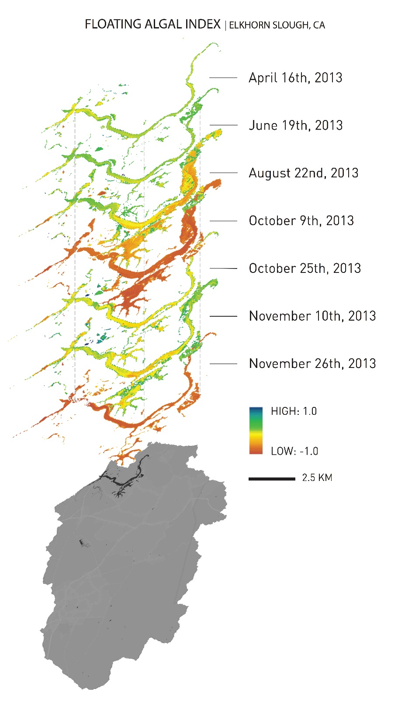

**Caption:**  The Floating Algal Index (FAI) for April - November 2013 in the Elkhorn Slough, CA. Landsat 8 OLI imagery was analyzed to identify eutrophication hotspots. Image Credit: Elkhorn Slough team.

**Image:** File Name: 2016_Sum_ARC_ElkhornSloughEco_VPSimage.jpg