**NASA DEVELOP National Program**



NASA Jet Propulsion Laboratory

*Fall 2015*

Los Angeles Oceans

Using Remotely Sensed Observations to Detect Wastewater Plumes and Assess Their Impact on Public Water Quality in Los Angeles County, California

 **Technical Report**

Rough Draft – October 8, 2015

Rebecca Trinh (Project Lead)

Lindsay Almaleh

Mark Barker

Benjamin Holt, Oceans-Ice Group, NASA Jet Propulsion Laboratory (Science Advisor)

Michelle Gierach, Oceans-Ice Group, NASA Jet Propulsion Laboratory (Science Advisor)

Christine Rains

Jack Pan

# I. Abstract

[Placeholder - do not put anything here until the final draft submission. The abstract in the project summary is where the working draft of the abstract should “live”]

**Keywords**

Remote Sensing, Satellite, SST, Chlorophyll-a, Coastal Ocean, Wastewater, Freshwater Plumes, Los Angeles

# II. Introduction

The coastal waters of the Southern California Bight (SCB) are of great ecological and economical importance because the waters are home to many marine species and serve as a valuable resource to humans in terms of sport and commercial fishing, recreation, and tourism. Pollution management of offshore effluent is necessary to maintain water quality and relies heavily on dispersal and dilution by ocean currents to reduce local concentrations (Uchiyam et al. 2014).

Located in Playa del Rey, California, the Hyperion Treatment Plant (HTP) of The City of Los Angeles-Department of Public Works, Bureau of Sanitation, is one of the largest wastewater plants on the west coast of the United States (Washburn et al. 1992). It serves two-thirds of Los Angeles County, approximately 4 million people, releasing an average of 362 million gallons per day (MGD) into coastal waters (Reifel et al. 2013). Wastewater from HTP undergoes two levels of treatment, removing about 85% of suspended solids before being discharged; however, the treated municipal wastewater, effluent, that is discharged into the ocean still contains oils, grease, particles, metals, chlorine, and other compounds, that may have ecological implications and pose a risk to human health (Raco-Rands and Steinberger 2001). Effluent from HTP is primarily discharged from a 3.7 m diameter outfall pipe that terminates 5 miles (8.05 km) offshore and at a depth of 57 m, near the head of the Santa Monica Marine Canyon. Discharging effluent at depth along the continental slope allows for rapid flushing and mixing with ambient seawater which dilutes the buoyant wastewater plumes before they reach the water’s surface or coastline (Washburn et al. 1992). HTP also has a secondary backup outfall pipe that terminates 1 mile (1.61 km) from shore at a depth of about 15 m (Reifel et al. 2013). During emergencies or scheduled maintenance, effluent is diverted from their primary 5-mile deep ocean pipe to the shallow 1-mile pipe.

A planned short diversion event occurred at HTP on November 28-30, 2006. In the summer of 2014, a previous NASA DEVELOP project team analyzed archived satellite imagery in relation to this diversion event (Pan et al. 2014). HTP has planned a much longer 1-mile outfall diversion for September 21 to October 26, 2015. The effluent wastewater plumes usually remain at the subsurface, but the diversion outfall is much shallower, allowing the effluent to permeate the thermocline without mixing with ambient seawater. This shorter outfall increases the risk of environmental contamination and contact with humans.

Wastewater plumes discharged from treatment plants contain high concentrations of oils that rise to the ocean’s surface, resulting in a smooth slick signature (DiGiacomo et al. 2004). Plumes can be detected by a smooth signature using Synthetic Aperture Radar (SAR) called PALSAR-2 on the Japanese satellite Advanced Land Observing Stattlite-2 (ALOS-2). Plumes are also characteristically rich in suspended particles, giving them a unique spectral response. The Moderate-resolution Imaging Spectroradiometer (MODIS) on NASA’s Aqua satellite can detect this signature in ocean-color images. MODIS is also able to detect the chlorophyll in phytoplankton concentrations, which may bloom in response to the high nutrient load of the effluent. Effluent will have a cold sea surface temperature signature as compared to the ambient water as the buoyant effluent plume entrains and brings colder bottom ocean water to the surface as it rises. The thermal signature can be detected by MODIS, Landsat-8, and the thermal infrared band of the Advanced Spaceborne Thermal Emission and Reflection (ASTER) instrument on Terra.

The objectives of this study are to: (1) evaluate plume signatures, using remote sensing techniques, from HTP’s 5 week planned effluent diversion, (2) compare the results of processed satellite imagery to measurements provided by *in situ* data, and (3) analyze potential ecosystem impacts of this diversion event.

This diversion event has recently been of great public interest because, after a rain storm just before the diversion, an unexpected amount of wastewater trash washed ashore on the beaches adjacent to HTP (Rocha 2015). The beaches remained closed for several days, and the public became increasingly concerned about the water’s pollution due to media coverage of the story. This study, along with our partners’ studies, offers a clear picture of the environmental impacts to the public, the scientific community, and municipalities planning a similar diversion event.

# III. Methodology

We gathered data from prior to the effluent diversion, beginning August 29, 2015, in order to provide a clear picture of the sea state without impacts from surfacing effluent. We used this data as our standard to which we compared the data from the diversion (Sep. 21 to Oct. 26, 2015). Satellite and *in situ* data will continue to be taken for several weeks after the diversion event has ceased to continue monitoring ocean impacts, some of which may be delayed or prolonged, given the high nutrient load of the effluent.

*Surface Roughness – SAR*

SAR is an active sensor capable of obtaining information from planetary surfaces in the presence of cloud cover or even at night. We used SAR data from the Phased Array Type L-band SAR-2 (PALSAR-2) aboard ALOS-2 and the C-band SAR sensor aboard Sentinel-1. We processed Level-1 SAR imageries in SNAP 2.0. Level-1 data has significant radiometric bias; each image was radiometrically calibrated by the signal amplitude and was saved in units of dB in order for each pixel value to represent the true backscattering from the surface. Due to the nature of SAR signals, calibrated images can still have high noise, which causes rough surfaces to be indistinguishable from the background; a 3 x 3 mean speckle filter was applied to each calibrated image in order to limit this signal noise. Additionally, we used the WGS-84 geodetic datum to reproject the scenes to correct geographic locations for further analysis.

*Sea Surface Temperature – ASTER, MODIS-Aqua, Landsat-8*

We derived sea surface temperature (SST) measurements from data recorded by ASTER retrieved from the Land Processes Distributed Active Archive Center (LPDAAC) operated by NASA and USGS. ASTER records data in 14 bands, including five thermal infrared (TIR) bands which we used for deriving SST data. An algorithm similar to the In-Scene Atmospheric Compensation (ISAC) (Johnson and Young 1998) was applied to the TIR bands for thermal atmospheric correction; this process estimated and removed the atmospheric contributions to the thermal infrared radiance data. The thermal infrared radiation is also a function of the SST and emissivity, so the emissivity needed to be separated to derive the SST. An emissivity normalization technique was applied to the data after the thermal atmospheric correction to create temperature output (Kealy et al. 1993; Hook et al. 1992). Lastly, the temperature data was converted from Kelvin to Celsius.

MODIS-derived SST was also used in this study. ASTER-derived SST data has a finer spatial resolution (90 m) in comparison to MODIS-derived SST data (250 m), but MODIS SST data has a greater temporal and spatial coverage. As a result, MODIS-Aqua Ocean Color Level-1 (L1) data were obtained through the OceanColor WEB. We processed the ocean color data with SeaDAS, a python-based image analysis package. Level 1A data was processed to a resolution of 250 m. Atmospheric corrections were automatically applied during the processing. A fixed spatial subset was applied to each image in order to focus on the regions of interest (ROIs). The temperature scale was converted from Kelvin to Celsius, while the data were scaled accordingly to reflect realistic SST.

Landsat 8, launched in 2013, has high-resolution thermal imaging capabilities in bands 10 and 11. We applied a method similar to the one used for ASTER SST processing to the scenes. An equation was used to convert pixel values to top of the atmospheric (TOA) spectral radiance:

Lλ = MLQcal + AL

Lλ = TOA spectral radiance (Watts/( m2 * srad * μm))

ML = Band-specific multiplicative rescaling factor from the metadata

AL = Band-specific additive rescaling factor from the metadata

Qcal = Quantized and calibrated standard product pixel values (DN)

TOA spectral radiance was then converted to brightness temperature, hence the temperature at the ocean surface. We used the equation below to derive the temperature in Kelvins

$$T=\frac{K_{2}}{\ln\left(\frac{K_{1}}{L_{λ}}\right)+1} .$$

T = At-satellite brightness temperature (K)

Lλ = TOA spectral radiance (Watts/( m2 * srad * μm))

K1 and K2 = Band-specific thermal conversion constant

We then converted the results from Kelvin to Celsius and averaged the SST measurements from bands 10 and 11.

*Biological Observation through Ocean Color – MODIS-Aqua*

We applied two separate processing algorithms to each MODIS file to create two distinct L2 products. One algorithm produced a file with normalized water-leaving radiance, SST, and generalized chlorophyll-a concentration bands. The chl-a concentration calculated by this algorithm obtained signals from sediment and detritus in addition to chlorophyll-a (chl-a) from phytoplankton. To help separate the effects of each of these contributors, files were processed using a second algorithm. With these two files in hand, it was possible to compare the total chl-a signature with calculated concentrations of the signature’s components.

*In situ Monitoring and Validation*

Along with satellite remote sensing monitoring, our team also gathered *in situ* data to help validate the satellite data and provide a more comprehensive overview of the ocean impact by the effluent plume. Conductivity, temperature, and depth (CTD) values were measured with a profiling hyperspectral instrument. The levels of chl-a and CDOM are also measured using the hyperspectral profiler. The profiler was used at critical sampling stations within, around, and outside of the effluent plume to provide an accurate cross section of the plume signature, both temporaly and spatially. The profiler was also used during satellite overpasses to give a direct comparison to the measurements obtained by the satellite instruments.

# IV. Results & Discussion

Things to discuss:

* Analysis of Results: What can you tell from your graphs, images, etc? What does this mean for your project?
* Errors & Uncertainty: What factors could you not account for, what things didn’t work out like you expected they would, etc.
* Future Work: If this project was to be selected for another term, what would be the focus? What other areas would be of interest?

*Pre-Diversion*

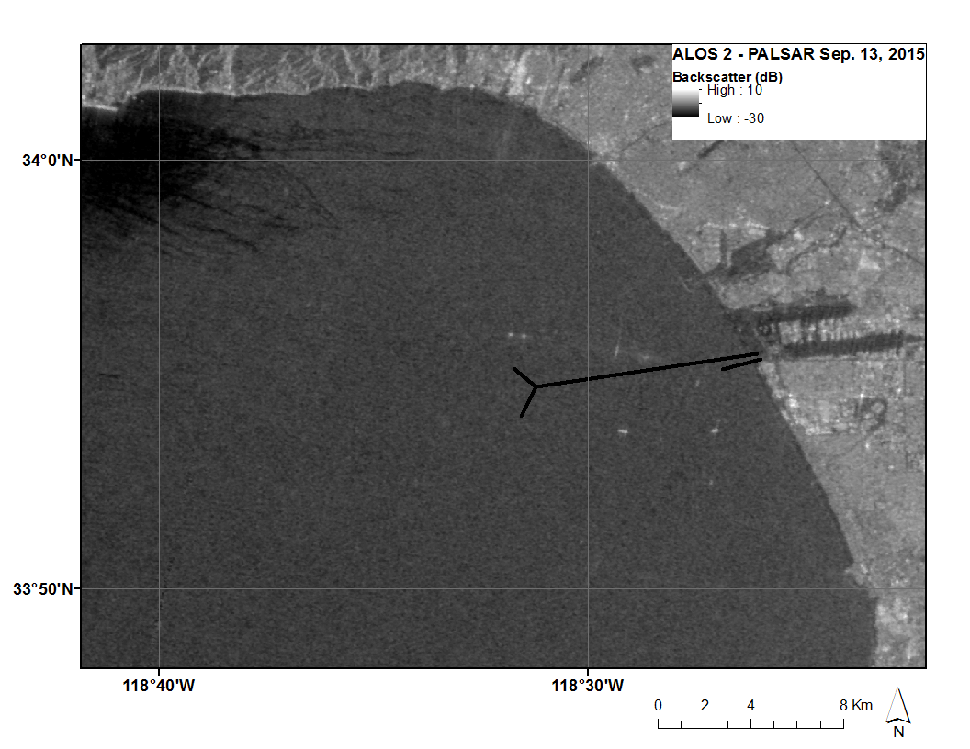

ALOS2-PALSAR-2 synthetic aperture radar (SAR) image of sea surface roughness from Sep. 13, 2014 at 12:59:49 PDT. Areas of decreased roughness have lower backscatter values. This can be used to track the physical surface signature of surfactants that form slicks on the surface of the water. This is a pre-diversion image and there is no signature associated with either the 5-mile or 1-mile outfall pipes.

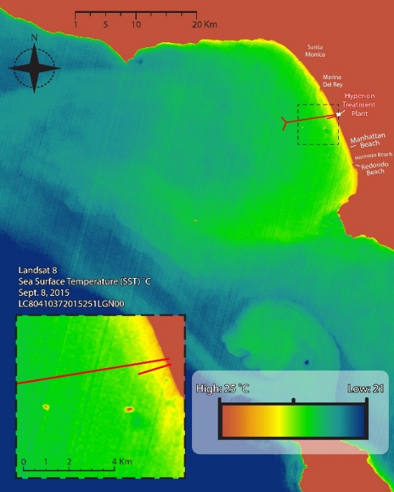

Landsat-8 sea surface temperature (SST) data from Sep. 8, 2015 at 11:25:09 PDT, prior to the diversion. There are no temperature anomalies associated with either the 5-mile pipe or the 1-mile pipe at this time. A high temperature signal can be seen from the large ships south of the 1-mile outfall pipe.

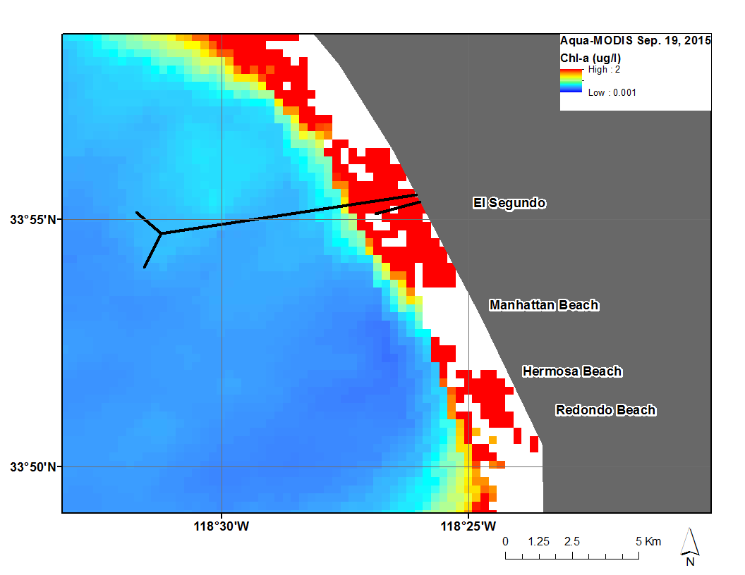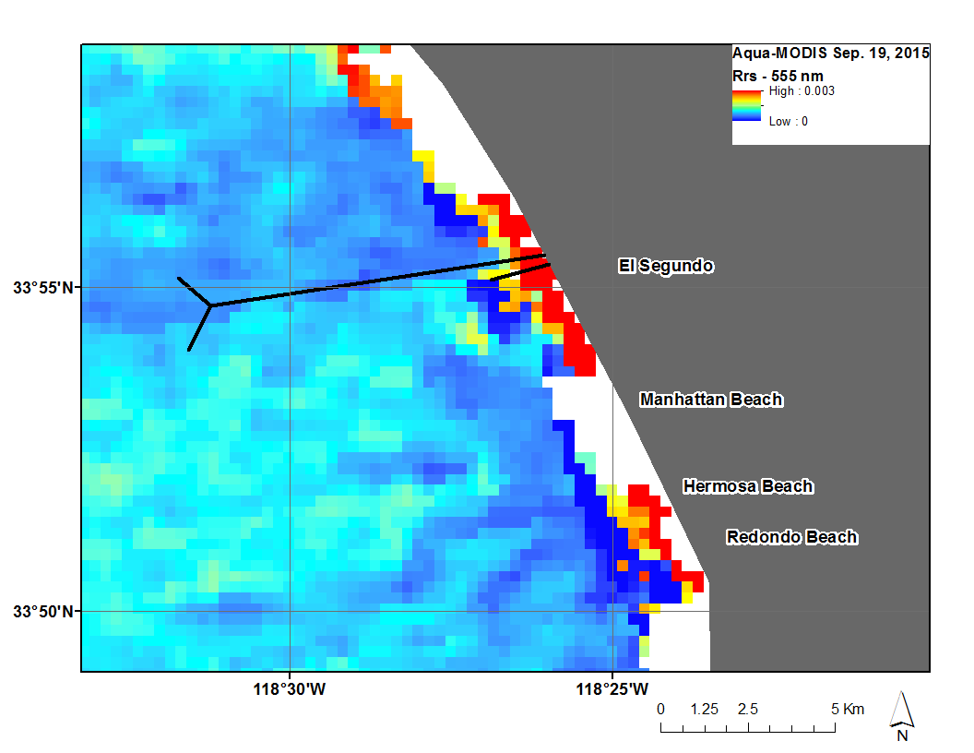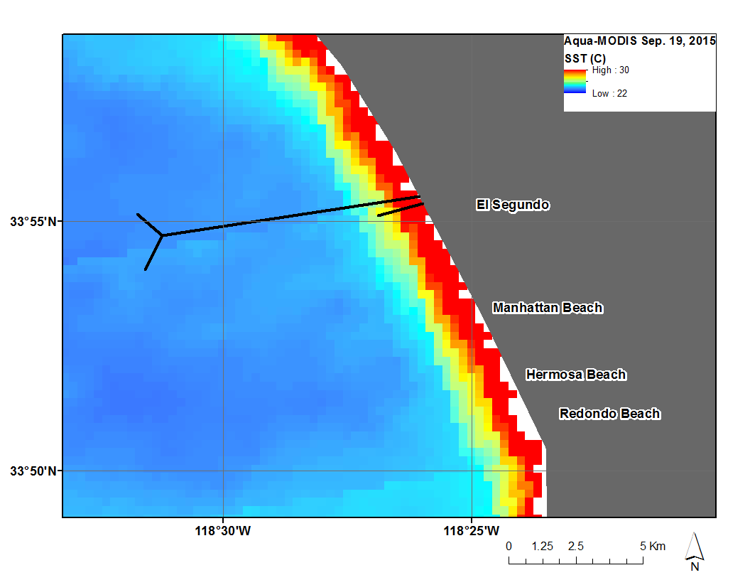

Aqua-MODIS ocean color data from Sep. 19, 2015 at 13:52:45 PDT. This data is from prior to the effluent diversion. There is no anomalous signature associated with either the 5-mile or 1-mile outfall pipes. Persistent near-shore chlorophyll-a (chl-a), suspended particulate matter (Rrs – 555 nm), and increased sea surface temperature (SST) can be consistently seen in MODIS data. MODIS also has a courser resolution (250 m) than comparable data from Landsat-8 and ASTER. It is also more problematic resolving data near the shoreline, leading to data gaps.

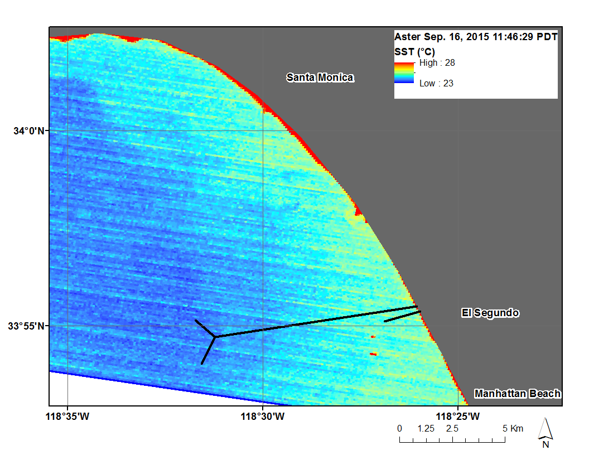

Terra-ASTER sea surface temperature image from Sep. 16, 2015 at 11:46:49 PDT. This data is from prior to the start of the diversion. High temperatures can be seen closer to shore. A high temperature signal can also be seen from the large ships south of the 1-mile outfall pipe. There are no temperature anomalies associated with either the 5-mile pipe or the 1-mile pipe at this time.

*During the Diversion*

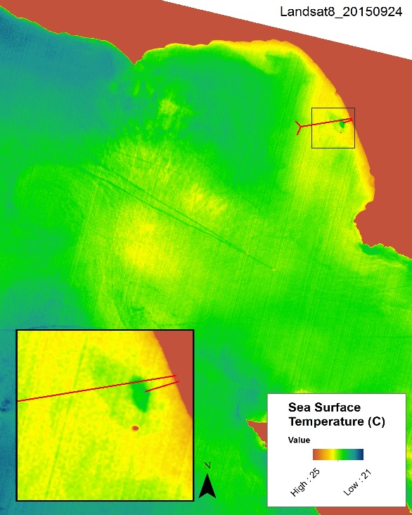

Landsat-8 satellite image of sea surface temperature (SST) on September 24, 2015. A relatively colder temperature signature is seen above the 1-mile outfall pipe that is associated with the surfacing of effluent in the area. The cold temperature effluent-indicator gradually mixes with the surrounding ocean as it spreads away from the 1-mile pipe. Continued examination of sea surface temperature will indicate the dominant spreading direction of the plume. Also visible is the high temperature signature of the large oil tanker to the south of the Hyperion outfall pipes.

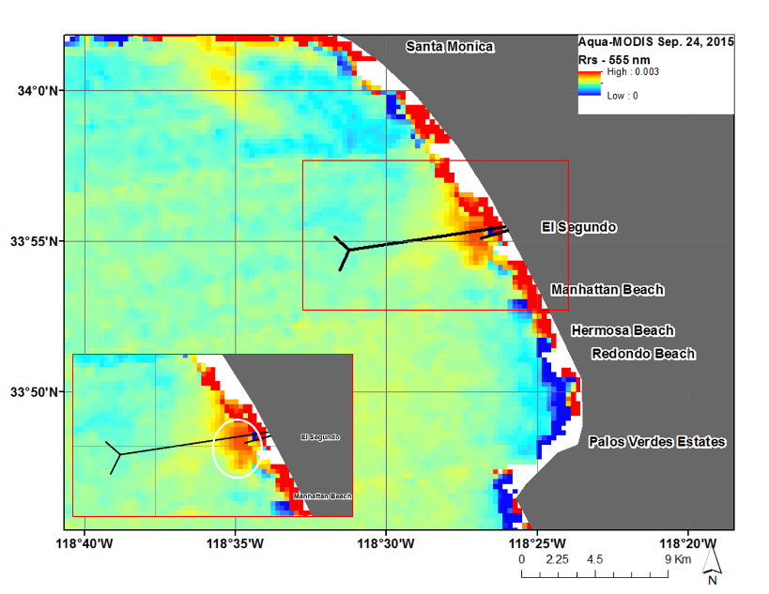

NASA Aqua-MODIS satellite image of surface reflectance on September 24, 2015. Reflectance can show the amount of suspended particles at the surface of the water. An area of high reflectance can be seen above the 1-mile outfall pipe. This signature is associated with the surfacing effluent plume, which contains a high concentration of suspended particles. In this way, we can use reflectance, along with temperature, to monitor the effluent plume.

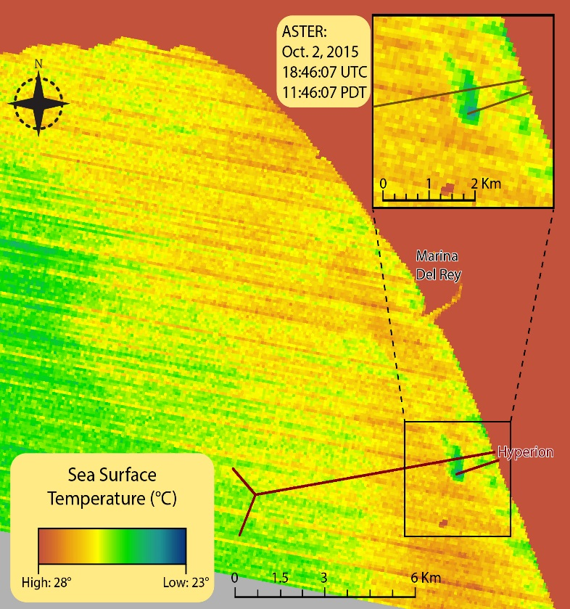

Terra-ASTER sea surface temperature (SST) image from Oct. 2, 2015 at 11:46:07 PDT. A distinct low temperature signature can be seen above the 1-mile outfall pipe. This signature diffuses and mixes with the surrounding warmer waters as it moves towards the north. A high temperature signal can also be seen from the large ships south of the 1-mile outfall pipe.

# V. Conclusions

Final conclusions. Word count: 200-600 (~a page).

# VI. Acknowledgments

We would like to thank our science advisors—Ben Holt and Michelle Gierach for data retrieval and assisting us in data analysis. We would also like to acknowledge our project partners: Curtis Cash, Ashley Booth, and Mas Dojiri at the Hyperion Treatment Plant. Their contributions, along with the NASA DEVELOP Program, have made this project possible.

Any opinions, findings, and conclusions or recommendations expressed in this material are those of the author(s) and do not necessarily reflect the views of the National Aeronautics and Space Administration.

This material is based upon work supported by NASA through contract NNL11AA00B and cooperative agreement NNX14AB60A.

# VII. References

Insert references here. Only include articles/content cited in the body of text above. It’s great if you read many other articles, but they should not all be listed here unless they are being cited in this report.

Use whatever style you want - here are some options:

<http://www.dovepress.com/author_guidelines.php?folder_id=208>

<http://en.wikipedia.org/wiki/Citation>

<http://www.agu.org/pubs/pdf/AuthorRefSheet.pdf>

<http://linguistics.byu.edu/faculty/henrichsenl/apa/apa01.html>

DiGiacomo, P.M., L. Washburn, B. Holt, and B.H. Jones. Coastal pollution hazards in southern California observed by SAR imagery: stormwater plumes, and natural hydrocarbon seeps. Marine Pollution Bulletin, 49, 1013-1024 (2004).

Raco-Rands, V.E. and A. Steinberger. Characteristics of effluents from large municipal wastewater treatment facilities in 1997. Southern California Coastal Water Research, 28-44 (2001).

Uchiyama, Y., E.Y. Idica, J.C. McWilliams, and K.D. Stolzenbach. Wastewater effluent dispersal in Southern California Bays. Continental Shelf Research, 76, 36-52 (2014).

Washburn, L., B.H. Jones, A. Bratkovich, T.D. Dickey, and M. Chen. Mixing, dispersion, and resuspension in vicinity of ocean wastewater plume. J. Hydraul. Eng. 118, 38-58 (1992).

Pan, J., C. Rains, R. Trinh. Southern California oceans and water resources. NASA DEVELOP, (Summer 2014).

Rocha, V. Dockweiler State Beach closed after medical waste washes ashore. Los Angeles Times, September 24, 2015

# VIII. Content Innovation

In preparation for DEVELOP’s coming microjournal, please select three content innovation features to support your paper. For each item, please list the name of the feature, and include the tool itself if possible (eg. glossary terms and definitions). If the tool does not work in Microsoft Word (eg. Interactive MATLAB Figure Viewer), please list the file name and upload the related file to the DEVELOP Exchange. If you choose to use Inline Supplementary Material, please also include where the material should appear in the text.

**Some options include:**

AudioSlides

Database Linking Tool

Data Profile

Executable Papers

Featured Author Videos

Featured Multimedia for this Article (video and podcast options)

Glossary Viewer

Inline Supplementary Material (figures, tables, computer code)

Interactive Map Viewer

Interactive MATLAB Figure Viewer

Interactive Plot Viewer

Nomenclature Viewer

# IV. Appendices

Insert here