**NASA DEVELOP National Program**

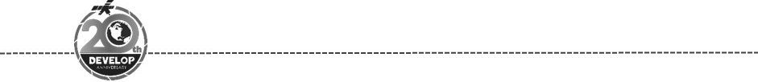North Carolina – NCEI

*Spring 2018*

Alaska Disasters

Development of a Snowmelt Monitoring Tool Using NASA MODIS and NOAA Climate Data Records to Aid Wildfire Managers in Alaska

**Technical Report**

Final Draft – March 29th, 2018

Caroline Jahn (Project Lead)

Laurel Mahoney

Daniel Lucas

Jeshua Pott

Jake Crouch, NOAA NCEI (Science Advisor)

# 1. Abstract

Alaska is warming twice as fast as the rest of the nation due to changes in the climate, causing shorter winters, thawing permafrost, and rapidly receding glaciers. All of these weather changes are lengthening wildfire seasons and increasing the number of wildfires experienced by the state. Due to a current lack of actionable-data, the Alaska Interagency Coordination Center (AICC) and fire risk managers have difficulty determining when various areas within Alaska become snow-free and necessitate fire risk assessment. This project used NASA and NOAA satellite data to inform and improve the current snow monitoring processes of the AICC. The DEVELOP team used MODIS Normalized Difference Snow Index data to map snow cover extent and create a near real-time tool to monitor snowmelt and aid wildfire managers in determining locality for future fire risks. The team also utilized Snow Cover Extent - Climate Data Record (SCE-CDR) to study climatological trends in historic seasonal snow cover melt to provide analysis of historic changes and trends in snowmelt. The results of this study give users the capacity to visualize maps of snow cover melt at a higher spatial resolution than previously utilized. These results will be distributed to and used by the AICC and the National Weather Service Alaska Region to mitigate wildfire risk.

**Keywords**

Suomi NPP VIIRS, MODIS, remote sensing, Snow Cover Extent - Climate Data Record (SCE-CDR), Normalized Difference Snow Index (NDSI), Alaska, wildfire, snowmelt

# 2. Introduction

* 1. ***Background Information***

In recent years, a consistent trend of increasing temperatures has been recorded in the United States (Cochran et al., 2014). Alaska, in particular, has experienced notable climatic changes, including a 3°F-6°F increase in average annual air temperature over the past 60 years, which is twice that of the rest of the United States (Chapin et al., 2014). Along with the observed temperature increase, Alaska is experiencing thawing permafrost, disappearing sea ice, and shrinking glaciers (Chapin et al., 2014). These changes result in shorter winters, earlier snowmelt, and unprecedented changes in yearly weather patterns and disasters. One such outcome is a prolonged fire season in the Alaska wildland.

The extension of the Alaskan fire season, in combination with changes in fuel conditions and ignition sources, has not only increased the number of wildfires, but has also resulted in the highest number of large wildfires in the past decade than any other on record (Chapin et al., 2014). During the 2015 fire season, 5.1 million acres of Alaska’s forests burned, making it the second largest since 1940 (Partain et al., 2016). Early snowmelt during 2015, followed by an unseasonably warm spring, led to dryer fuels which burned 3.8 million acres in two and half weeks (Partain et al., 2016). Increased thunderstorms and lightning alone were credited with igniting 99.5% of the wildland forest fires in the same year (Partain et al., 2016). An assessment of the 2015 Alaska fire season concluded that the fuel conditions responsible for the season's severity are currently 34%-60% more likely to reach the same critical state due to anthropogenic changes in the climate (Partain et al., 2016). The associated uncertainty of this projection is due to the unpredictability in the frequency of lightning events. The National Climate Assessment projects that the current acreage of burned land in Alaska will be doubled by mid-century and tripled by the end of the century (Chapin et al., 2014). This risk is heightened by the size and significant portion of land that is remote to fire managers in Alaska, which impede monitoring efforts.

Wildfires are typically a natural occurrence and are often considered healthy for the landscapes they burn. When wildfires occur in lower intensities and in a controlled manner, they eliminate underbrush, open up the lower levels of the forests to sunlight, nourish the soil, improve vegetation productivity, provide habitat for wildlife, and eliminate diseases and pathogenic insects (California Department of Forestry and Fire Protection, 2018). However, as stated above, wildfires in Alaska have greatly increased in frequency and magnitude in the past decade. These fires have a direct, negative impact on wildlife habitat and timber harvests, and cause fluctuations in soil composition (Joyce et al., 2014). When forests burn, high intensity fires not only eliminate a valuable carbon sink, but also release the stored carbon into the atmosphere. The resulting carbon dioxide has the potential to increase the greenhouse effect, which in turn would augment climate fluctuation and increase wildfire risk, in the fashion of a positive feedback loop (Joyce et al., 2014). All of these aspects of wildfire risk in Alaska are further compounded by limitations in fire risk management.

Fire risk managers in Alaska currently use the Fire Weather Index (FWI), a system that relies on fire weather observations, fuel moisture, and fire behavior indices, to monitor areas at risk during the fire season (Ziel, 2015). The Buildup Index (BUI) is the key indicator of fire risk and represents the amount of fuel available for combustion (Government of Canada, 2018). When a given area is snow-free for 3 consecutive days, BUI begins to increase and fire indices are required to be run on the area. Alaska fire managers do not currently monitor snow cover extent in near real-time, and instead rely on *in situ* data and basic historical trends to observe and predict snowmelt. As Alaska is the largest and most sparsely-populated state, the majority of the land is uninhabited and remote. Compounding the challenge of monitoring such an extent of land, are the effects and fluctuations of the changing climate which make snowmelt less predictable. The Arctic Monitoring and Assessment Programme projects under the Representative Concentration Pathway 8.5 that snow cover will decrease up to 30% in Alaska by 2055 (Brown et al., 2017). This will increase both the spatial and temporal extent of wildfire risk throughout the state, which is why near real-time snow cover information available to wildfire decision makers is critical.

* 1. ***Project Partners & Objectives***

The partners of this project are the Alaska Interagency Coordination Center (AICC) and the National Weather Service (NWS). The AICC facilitates and organizes resources with agencies such as the National Park Service and US Forest Service, and expressed a need for better snow cover data in order to monitor wildfire risk. Both the AICC and the NWS were interested in incorporating more NASA and NOAA Earth observations to address data gaps and improve current wildfire monitoring methods. As snow cover is the initial factor that determines whether a certain location is at wildfire risk, up-to-date knowledge of when and where snow cover is melting is valuable information for decision makers. The AICC developed the Alaska Fire and Fuels (AKFF) website, which distributes information about current wildfires and wildfire risk across the state of Alaska. Even though this tool uses a number of data sources to create figures, snow cover data were not included or taken into account. Due to this data gap, the AICC experienced difficulties knowing when to start calculating wildfire-related indices. The near real-time snow cover melt tool produced by this project will help the AICC determine the location of snow-free areas while informing their decision making on when to prepare, dispatch and organize wildfire management resources during future wildfire seasons.

The objective of this project was to develop a snow cover melt tool to calculate and map near real-time snow cover change in the study area, which was the state of Alaska, from 1967 to present (Figure 1) using Normalized Difference Snow Index (NDSI) Moderate Resolution Imaging Spectroradiometer (MODIS). The same tool also distributed raw gridded snowmelt data to partners for use within existing mapping services. Our team utilized both NASA Earth observations and NOAA data to produce such a tool. The final version of this tool was updated to incorporate near real-time Snow Cover from NASA’s Suomi National Polar-orbiting Partnership (NPP) Visible Infrared Imaging Radiometer Suite (VIIRS) data for the project partners. The project team also studied and documented climatological trends in seasonal snow cover melt to provide insight on historic and expected changes in snowmelt, using the NOAA Snow Cover Extent - Climate Data Record (SCE-CDR).

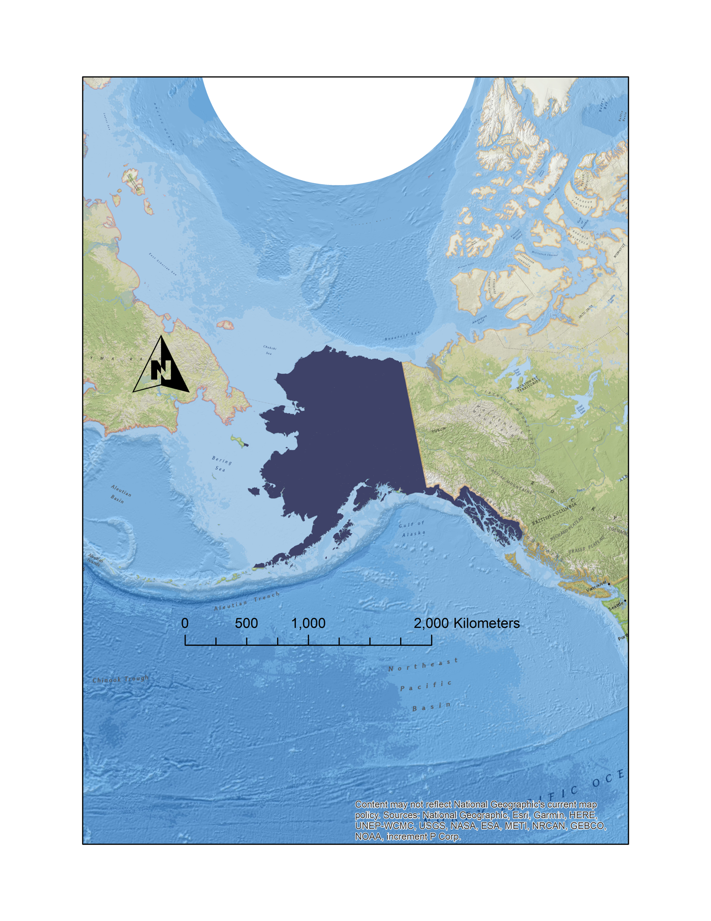

# 

*Figure 1.* Alaska Study Area Shapefile

# 3. Methodology

***3.1 Data Acquisition***

The output of this project is a snow cover melt tool that can calculate changes in the near real-time using Normalized Difference Snow Index from NASA’s Aqua Moderate Resolution Imaging Spectroradiometer (MODIS) data. MODIS Snow Cover Daily data were acquired through download from NASA’s EARTHDATA powered by the Earth Observing System Data and Information System (EOSDIS) for our study period from January 2016 to July 2016 and January 2017 to July 2017. MODIS Snow Cover values were extracted from the Aqua MODIS platforms for daily (MYD10A1 MODIS/Aqua Snow Cover Daily L3 Global 500m SIN Grid V006) Level 3, 500m grid data. The team extracted snow coverage data to create a baseline for the project’s snowmelt tool, which went on to directly input near real-time daily VIIRS data.

Natural Resources Conservation Service Snow Telemetry (SNOTEL) snowpack characteristics *in situ* data were used as validation of snow cover satellite data. SNOTEL data were acquired through the National Water and Climate Center from the NWCC Report Generator on the Natural Resources Conservation Service of the United States Department of Agriculture website. These data were referenced along different latitudes and longitudes/grid cells in Alaska and compared against the output data from the tool.

Post the creation of the tool, using MODIS as a proof of concept, the team revised the tool to produce using VIIRS near real-time Land Cover data for project partners. The project team acquired NASA’s Suomi National Polar-orbiting Partnership (NPP) Visible Infrared Imaging Radiometer Suite (VIIRS) data through download from the Geographic Information Network of Alaska (GINA) Puffin Feeder website. The team coded this process to continuously fetch the data every time the tool is run.

***3.2 Data Processing***

*Figure 2.* Methodology for Data Processing

The Snow Cover Monitoring (SnoCoM) tool was created in Python 2.7. The 32-bit Anaconda Library for Python 2.7 was downloaded and used to access packages throughout the coding process. The code was written using Anaconda Spyder and an additional path was set up to ArcGIS arcpy using the PYTHONPATH Manager preference in Spyder. We established a series of working directories at the beginning of the code, as well as import commands for necessary packages. The first part of data processing within the tool, after downloading four consecutive days of MODIS NDSI data, was to perform a series of geoprocessing tools using arcpy. First, we projected the data files to the Alaska Albers Equal Area Conic Projection and then clipped to a polygon of Alaska that excluded areas deemed non-burnable by the AICC. Next, we classified the NDSI values of each file to a binary: snow (1) or no-snow (0). NDSI values represent: 0-100=NDSI snow, 200=missing data, 201=no decision, 211=night, 237=inland water, 239=ocean, 250=cloud, 254=detector saturated, 255=fill. A 15% threshold was used for classifying no-snow based on information from the National Snow & Ice Data Center (NSIDC). The NDSI values of 16-100 were classified as snow, and all other NDSI values were classified as NoData. Finally, the files were mosaicked by day in order to create one complete raster of Alaska for each day and the renamed day_1, day_2, day_3, and day_4 where day_4 represents the most recent day and day_1 represents four days in the past. This was accomplished by indexing the files by Julian Day, reading the Julian day as an integer, and using the maximum Julian Day files as day_4.

The next section of code was the Change Detection Analysis. The purpose of this section was to analyze the rasters of the four days and detect when snowmelt occurs. The AICC officially considers an area snow-free when it has been snow-free for three consecutive days; therefore, snowmelt occurs when an area is snow-covered on day 1 and then is snow-free for the following three days. This analysis was done using the “gdal” package. Each raster was open through “gdal” and read as an array. Two loops were then constructed to loop through every row and every column of each array. This allowed for the same grid cell of each raster over the four days to be compared. Within these loops was a series of “if” and “elif” statements detecting not only snowmelt but also consistent snow-covered and snow-free areas. Each statement outputted a distinct value representing its classification as snow, no-snow or snowmelt to an empty output array called “outarray.”

The next step was to establish a Historical Day of Thaw file. This is a comma-separated-file that is saved to the working directory and appended each time the tool is run. The “csv” package was used to read and write the Day of Thaw file. Two loops were created to loop over every grid cell of the “outarray” and if the value of the grid cell represented snowmelt then the coordinates as well as the current Julian Day were printed in the Day of Thaw file. Additionally, for every snow-free cell it read through the Day of Thaw file to see if that cell was already recorded in the file, and if it had not been, then it recorded its coordinates as well as the current Julian Day.

The final step for creating the AICC map was to create a new array and raster that included snowmelt cells, snow-covered cells, and the amount of days snow-free cells had been snow-free. This was accomplished by looping through every grid cell of “outarray” and assigning a distinct value to snow-covered cells, “1” to snowmelt cells, and then the Day of Thaw subtracted from the current date plus “1” for each snow-free cell. All other cells were assigned a NoData value of zero. Then a raster was created from this array and mosaicked with the raster of the non-burnable areas in Alaska. The color scheme for this final AICC map was set so that non-burnable areas were black, snow-covered areas were gray and snow-free areas were a gradient from blue to yellow to red based on the amount of days they had been snow-free.

An additional output of raw gridded snowmelt data were requested by the AICC for use within their AKFF online interactive map. The desired data would be an array of Alaska on a 3km scale in which each grid cell contained a Boolean True or False value, where True meant that fire indices should start that day and False meant they should not. The first step for this output was to project the original mosaicked data files to the Alaska Polar Stereographic Projection and set the cell size to the requested 2,976m. Then each new raster was opened with “gdal” and read as an array. Each grid cell was looped over, followed by an if statement detecting snowmelt and outputting True into a new array, and an else statement outputting False into the array. This array is then saved into the working directory as a zipped numpy file.

In order to complete the tool to the standards that our project partners required for data acquisition, the team had to edit the script for the tool to be compatible with VIIRS Land Cover data. Near real-time Land Cover from NASA’s Suomi National Polar-orbiting Partnership (NPP) Visible Infrared Imaging Radiometer Suite (VIIRS) was obtained from GINA Puffin Feeder – SANDY and coded to continuously fetch and download the necessary data. In order to grab the correct data, the team applied a naming convention and parsed the data to only keep the correct tiff files. The data that was parsed was based on data type (‘_I03_I02_I01.tif’), location of processing (University of Alaska – Fairbanks UAFGINA), Julian Day (Max Day + 3 Days Prior), and time of day (17:00 – 22:59). Once all of the parsing finished, the tiff files were saved, clipped together, and then clipped to an Alaska Shapefile. Bands 1 and 3 were extracted from initial raster files by using an arcpy function and directly incorporated in the NDSI equation. Then the NDSI Equation from the NASA S-NPP VIIRS Snow Products Collection 1 User Guide, was used to convert the VIIRS Land Cover data to Normalized Difference Snow Index (NDSI) values to be compatible with the previous code that was run through MODIS using NDSI (Equation 1). Finally, the completed code was added to the SnoCoM tool code, which was modified to be compatible after the removal of VIIRS.

$\text{ND}\text{SI }\text{=}\frac{\text{(Band1 - Band3)}}{\text{(Band1 + Band3)}}$ (1)

***3.3 Data Analysis***

The SnoCoM tool was validated using *in situ* SNOTEL and Snow Course data. The tool was run for the first three days for May 2017 which output three Change Detection Analysis maps. These maps were overlaid with a vector of SNOTEL sites in Alaska using ArcMap. The value of each cell that contained a SNOTEL site was compared to the SNOTEL dataset value for that day. The result was 89% accuracy of verified values excluding NoData points on the Change Detection Analysis map. The verification of the SnoCoM tool gives the Alaska Disasters team, as well as the end-users, confidence in the accuracy and operation of the tool.

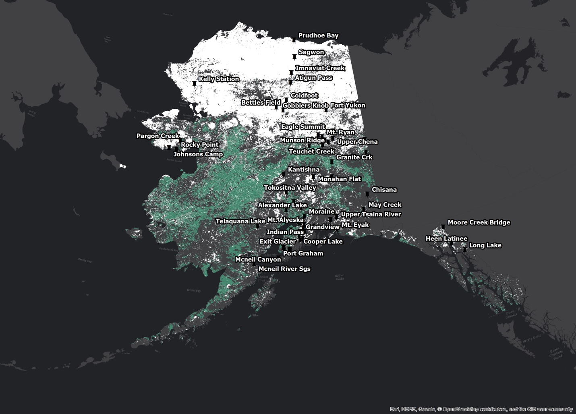

*Figure 3.* Change Detection Analysis April 38th to May 1st 2017 and SNOTEL Sites

***3.3.1 Historical Trend Analysis***

In order to fully analyze the data available and to give the project partners a better perspective on snowmelt, we completed a historical trend analysis. The team studied climatological trends in seasonal snow cover melt using NOAA’s Snow Cover Extent-Climate Data Record (SCE-CDR). These data provided end users with a better idea of historic and expected changes in snowmelt, which is correlated to wildfire probability. NOAA’s SCE-CDR, acquired through the NOAA National Centers for Environmental Information (NCEI) website, was downloaded from 1967 to 2017 for our trend analysis study period (NOAA Climate Data Record (CDR) of Northern Hemisphere (NH) Snow Cover Extent (SCE), Version 1). We conducted a monthly trend per decade analysis from January through July and outputs monthly snow trends depicting the rate of change in snow cover days per decade. The primary conclusion of this analysis was that a greater amount of change is occurring during the transition seasons. We then conducted a comparison of the results to Alaskan temperature trends using the Climate at a Glance tool, created by NCEI, that showed the average temperature of each month from 1925-2017. This comparison showed that even though April (Figure 4) displayed little change through the Historical Trend Analysis, the rate of temperature change in Alaska was greater in April compared to May and June, which led the team to hypothesize that the change in snow cover days has yet to reflect the change in temperature. Upon assessing the increase in snow cover days per decade (green on map) towards the South Coast of Alaska in the June (Figure 6) and July (Figure 7) maps, the team hypothesized that the topography and geographic set up of the state creates a rain shadow effect from the Alaska Range, which is located towards the southeastern part of the state. The moist air blown off the Pacific Ocean and up the southern coast of Alaska reaches the Alaska Range and is forced to rise up the exterior of the mountain range. The rapid change in pressure causes the moisture to precipitate from the air on the southern side of the mountain. The air then continues to travel over the other side of the mountain without moisture, and thus casts a dry shadow on the northern side of the Alaska Range. The conclusions that the team drew from this study were meant to add upon the data that was being outputted from the tool to provide further insight into snow cover in Alaska.

May Snow Trend 1967 – 2017

April Snow Trend 1967 – 2017

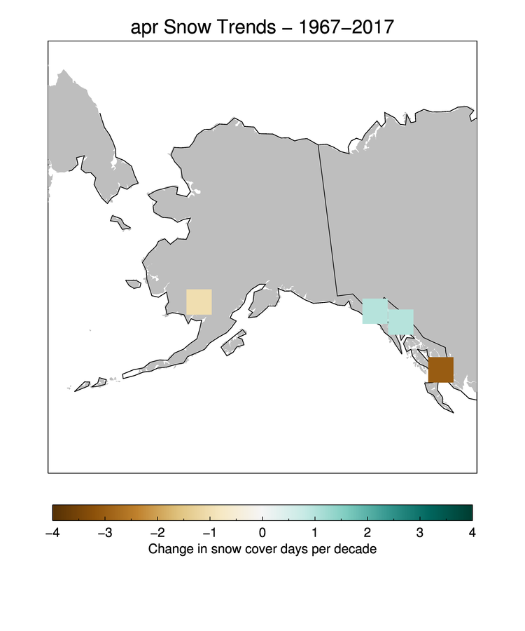

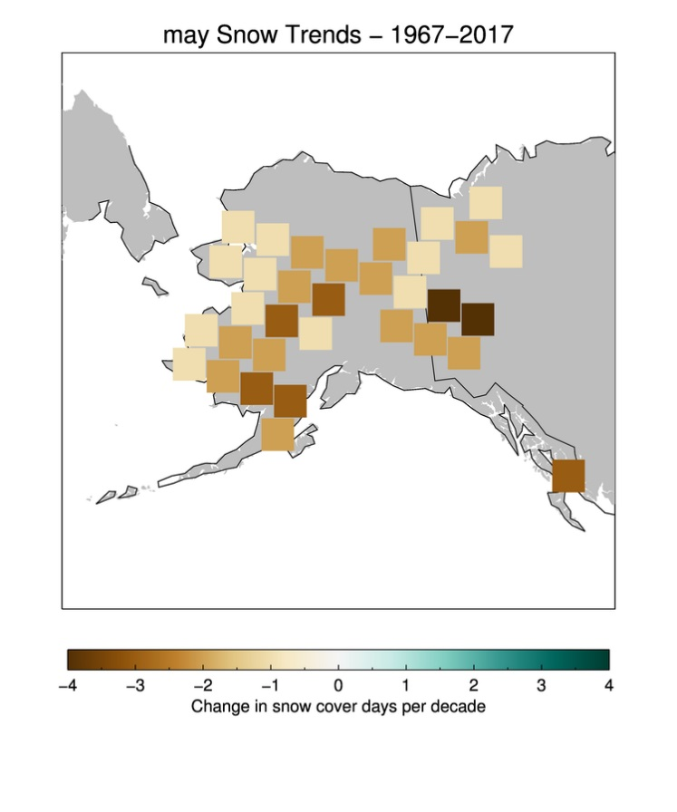

*Figure 4.* Historical Trend Analysis for April

*Figure 5.* Historical Trend Analysis for May

July Snow Trend 1967 – 2017

June Snow Trend 1967 – 2017

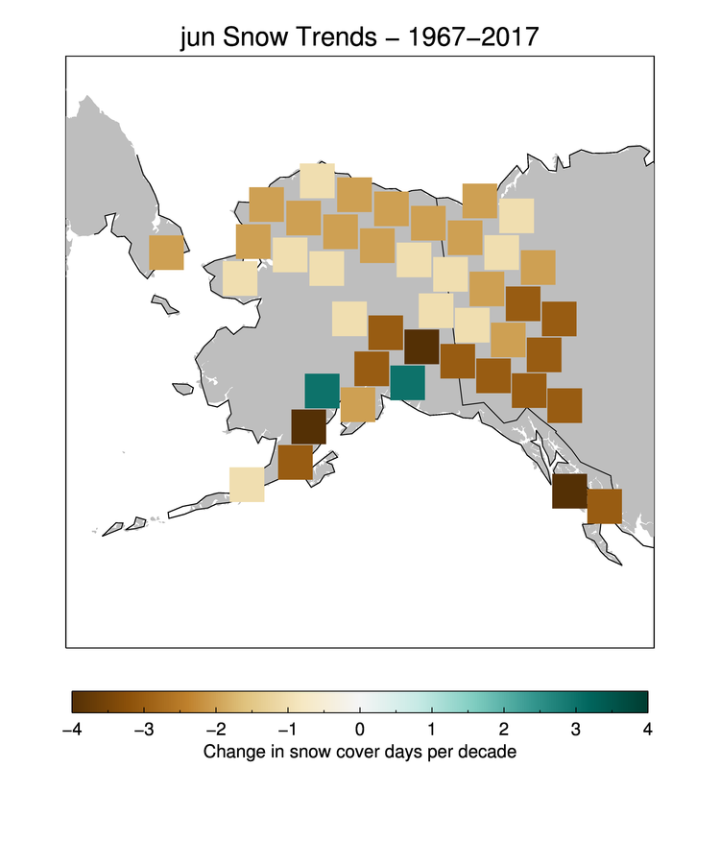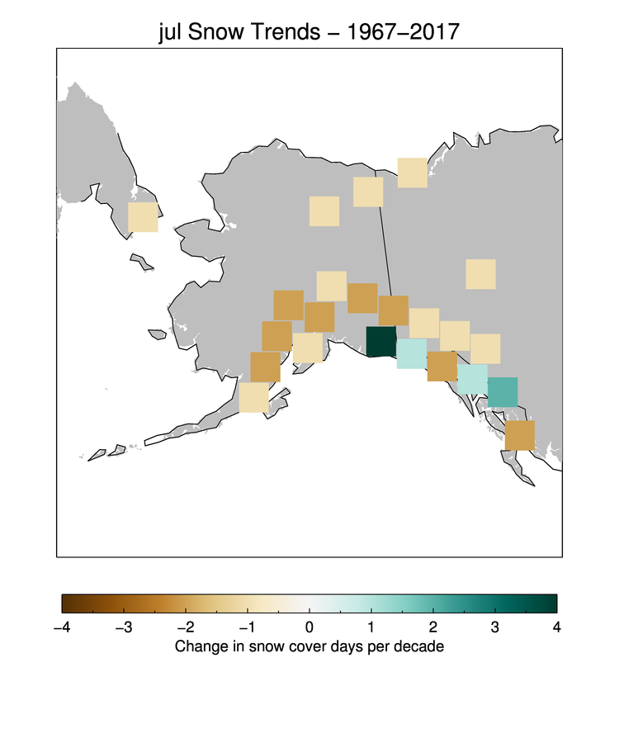

*Figure 7.* Historical Trend Analysis for July

*Figure 6.* Historical Trend Analysis for June

# 4. Results & Discussion

***4.1 Analysis of Results***

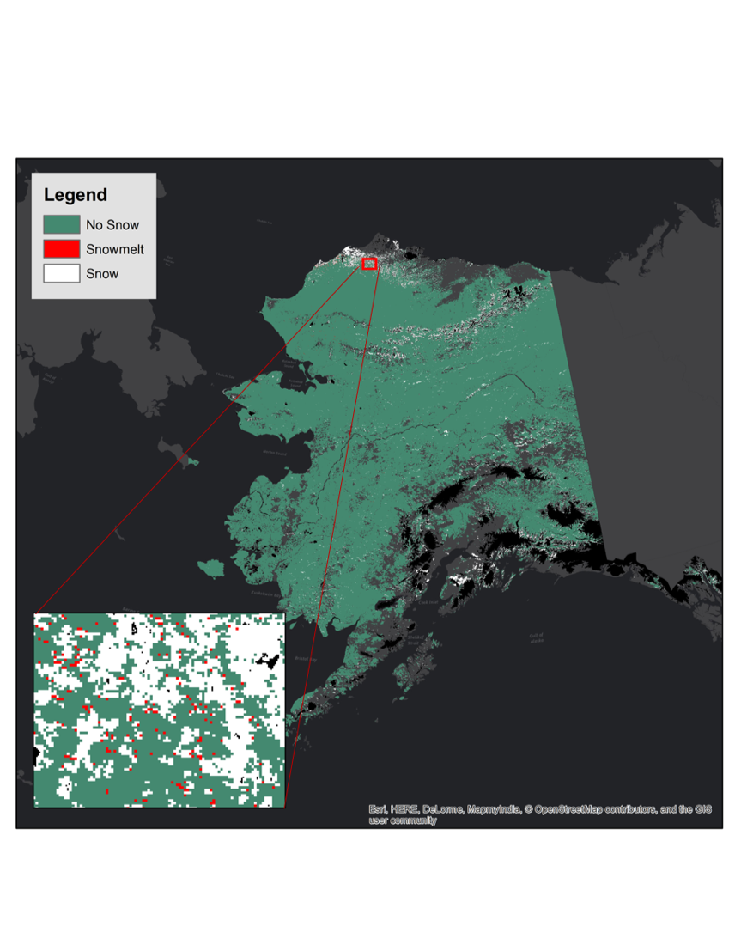

*Figure 8.* Change Detection Analysis June 4th – 7th 2017

This map is the result of a snow-cover change detection analysis of four consecutive days in June 2017, during the height of snowmelt. The black area on the map is a non-burnable layer that was created by our project partners to represent areas that are not at risk of wildfires. This raster was created from the “outarray” output array of the change detection analysis using the gdal package. The majority of the state is snow-free, which can be seen by the significant amount of green no-snow cells and was expected during this season. The Northwestern part of the state experiences a cooler climate and therefore later snowmelt, which can be observed by the cluster of white snow grid cells in the northwest. The linear white cells in northeast and north central Alaska are due to a greater amount of snow cover on the higher elevations of the Brooks Range. The zoomed-in section of the map displays red grid cells that represent recent snowmelt. The red cells appear at the boundary of clusters of white cells, meaning that snowmelt is occurring at the edges of snow-covered areas, which was an expected result of the analysis.

Considering a cell “snow-free” when it has a NDSI value of 15 or under may be a source of error. The approximation of 15% snow cover as a threshold for the binary simplification of snow cover has been commonly used by peer-reviewed physical scientists, which is why it was considered as a good estimate for decision makers (National Snow & Ice Data Center). Moreover, cells containing NoData values have the potential of rendering the change detection analysis less robust. For example, if one of the cells constituting a 1-0-0-0 pattern is replaced with a NoData value, the code will not recognize the snowmelt pattern as it otherwise would. In this particular case, the change detection analysis would assign a NoData value to the resulting cell, which would show neither snowmelt, snow cover, or no snow. A future modification of the change detection analysis of the code would improve the robustness of the code to process NoData cells. Lastly, we calculated NDSI values according to the Earth’s reflectance at certain wavelengths. The amount of daylight greatly impacts what the VIIRS sensor records. As a result, time of day and time of year have the potential to cause changes in the NDSI values the SnoCoM tool downloads and processes.

# 5. Conclusions

Using this tool, the AICC and wildfire managers can better determine when to run wildfire indices to minimize disaster risk. The project partners will receive daily snow cover data in near real-time for the entirety of Alaska, which fills the challenging data gaps that they previously experienced. The SnoCoM tool will be a cost-saving measure that pinpoints locations that require fire management. This is can save time, resource, and money, because the tool will now be the first step for wildfire managers to determine flight paths and monitoring zones. The initial creation of the tool with MODIS data allowed for a proof of concept using SNOTEL to validate outputted data, as well as an improvement from an estimate on historical data, which was previously used for fire indices. Revising the SnoCoM tool to run on VIIRS data will allow our partners to visualize data at a higher resolution than previously utilized. The Historical Trend Analysis suggests that a greater amount of change in snow cover days is occurring during transition seasons, which can add upon the data that was being outputted from the tool to provide further insight into snow cover in Alaska.

# 6. Acknowledgments

The Alaska Disasters team would like to thank the mentors and partners who dedicated their time and assistance to this project. Without any of them, this project would not have been possible.

Science Advisor:

● Jake Crouch, Physical Scientist (NCEI)

End-Users/Partners:

● Heidi Strader, Meteorologist (Alaska Interagency Coordination Center)

● Rick Thoman, Climate Science and Services Manager (National Weather Service, Alaska Region)

Others:

● Aaron Mackey (DEVELOP Center Lead at NCEI)

● Jonathan O’Brien (DEVELOP Assistant Center Lead and Communications Fellow at NCEI)

● James Partain (NOAA Regional Climate Services Director, Alaska Region)

Any opinions, findings, and conclusions or recommendations expressed in this material are those of the author(s) and do not necessarily reflect the views of the National Aeronautics and Space Administration.

This material is based upon work supported by NASA through contract NNL16AA05C and cooperative agreement NNX14AB60A.

# 7. Glossary

**AICC** – Alaska Interagency Coordination Center

**Earth observations** – Satellites and sensors that collect information about the Earth’s physical, chemical, and biological systems over space and time

**Fuel Moisture** – A measure of the amount of water in a fuel (vegetation) available to a fire

**MODIS** – Moderate Resolution Imaging Spectroradiometer

**NDSI** – Normalized Difference Snow Index

**NWS** – National Weather Service

**Remote Sensing** – The science and art of identifying, observing, and measuring an object without coming into direct contact with it

**SCE-CDR** – Snow Cover Extent - Climate Data Record

**Suomi NPP VIIRS** – Suomi National Polar-orbiting Partnership Visible Infrared Imaging Radiometer Suite

# 8. References

Alaska Fire and Fuels. MesoWest. <https://akff.mesowest.org/>

Brown, R., Schuler, D. V., Bulygina, O., Derksen, C., Luojus, K., Mudryk, L., Wang, L., & Yang, D. (2017).

Arctic terrestrial snow cover. In: Snow, Water, Ice and Permafrost in the Arctic (SWIPA) 2017. p. [26]. Arctic Monitoring and Assessment Programme (AMAP), Oslo, Norway.

California Department of Forestry and Fire Protection. Benefits of Fire. California Government. Retrieved

from <http://www.fire.ca.gov/communications/downloads/fact_sheets/TheBenefitsofFire.pdf>

Chapin, F. S., III, S. F. Trainor, P. Cochran, H. Huntington, C. Markon, M. McCammon, A. D. McGuire, &

M. Serreze. (2014). Ch. 22: Alaska. Climate Change Impacts in the United States: The Third National Climate Assessment, J. M. Melillo, Terese (T.C.) Richmond, and G. W. Yohe, Eds., *U.S. Global Change Research Program*, 514-536. doi:10.7930/J00Z7150.

Cochran, P., Huntington, H., Markon, C., McCammon, M., McGuire, A. D., & Serreze, M. (n.d.). Alaska. In

2014 National Climate Assessment. Retrieved from <http://nca2014.globalchange.gov/>

Geographic Information Network of Alaska (GINA). Puffin Feeder. <http://feeder.gina.alaska.edu/>

Government of Canada. (2018, February 12th). *Canadian Forest Fire Weather Index (FWI) System*. Retrieved

from <http://cwfis.cfs.nrcan.gc.ca/background/summary/fwi>

Hall, D. K. and G. A. Riggs. 2016. *MODIS/Aqua Snow Cover Daily L3 Global 500m Grid, Version 6*. Boulder, Colorado USA. NASA National Snow and Ice Data Center Distributed Active Archive Center. doi: <http://dx.doi.org/10.5067/MODIS/MYD10A1.006>. Accessed February 5, 2018.

Joyce, L. A., S. W. Running, D. D. Breshears, V. H. Dale, R. W. Malmsheimer, R. N. Sampson, B. Sohngen,

& C. W. Woodall. (2014). Ch. 7: Forests. Climate Change Impacts in the United States: The Third National Climate Assessment, J. M. Melillo, Terese (T.C.) Richmond, and G. W. Yohe, Eds., *U.S. Global Change Research Program*, 175-194. doi:10.7930/J0Z60KZC.

National Water and Climate Center. Natural Resources Conservation Service SNOw TELemetry (SNOTEL)

snowpack characteristics *in situ* data. <https://www.wcc.nrcs.usda.gov/snow/snotel-wedata.html> Accessed through the NWCC Report Generator on February 2018.

National Snow and Ice Data Center (NSIDC). Snow Research. <https://nsidc.org/>

Partain, J. L., S. Alden, U. S. Bhatt, P. A. Bieniek, B. R. Brettschneider, R. T. Lader, P. Q. Olsson, T. S. Rupp,

H. Strader, R. L. Thoman Jr., J. E. Walsh, A. D. York, and R. H. Ziel. (2016). 2016: An assessment of the role of anthropogenic climate change in the Alaska fire season of 2015 in “Explaining Extremes of 2015 from a Climate Perspective”. Stephanie C. Herring, Andrew Hoell, Martin P. Hoerling, James P. Kossin, Carl J. Schreck III, and Peter A. Stott, Eds., *Bulletin of the American Meteorological Society*, *97*(12), S14–S18, doi:10.1175/BAMS-D-16-0149.

Robinson, David A., Estilow, Thomas W., & NOAA CDR Program. 2012. NOAA Climate Data Record

(CDR) of Northern Hemisphere (NH) Snow Cover Extent (SCE), Version 1. *NOAA National Centers for Environmental Information*. doi:10.7289/V5N014G9 accessed on February 1, 2018.

Riggs, George A., Hall, Dorothy K., Roman, Miguel O. (2016). NASA S-NPP VIIRS Snow Products Collection 1 User Guide. <https://modis-snow-ice.gsfc.nasa.gov/uploads/VIIRS-snow-products-user-guide-version-1.pdf>

Ziel, R. (2015). Alaska Field Guide for CFFDRS Fire Weather Index (FWI) System. Alaska Wildland Fire

Coordinating Group Fire Modeling-Analysis and Fire Weather Committees. Retrieved from <https://docs.google.com/a/firenet.gov/viewer?a=v&pid=sites&srcid=ZmJmcmcub3JnfHJlZjJ8Z3g6MjZhNjQyYzMzMzRmOTEzZQ>