**NASA DEVELOP National Program**



University of Georgia

*Summer 2017*

Georgia Energy

Identifying Sensitive Habitats and Wildlife Populations in Areas with High Solar Power Potential

 **Technical Report**

Final Draft – August 9, 2017

Lynn Abdouni (Project Lead)

Emad Ahmed

Natalia Bhattacharjee

Roger Bledsoe

Christopher Cameron

Suravi Shrestha

Austin Stone

Dr. Marguerite Madden, University of Georgia (Science Advisor)

**1. Abstract**

Solar energy is a rapidly growing industry in the state of Georgia. The increasing number of solar farms is encouraging decision-makers and developers to incorporate a sustainable plan for utility-scale solar developments. However, the construction and siting of solar farms could have a detrimental impact on environmentally sensitive habitats and associated species. NASA DEVELOP partnered with The Nature Conservancy and the Georgia Department of Natural Resources to produce tools to inform solar site planning and to communicate with key stakeholders. The team analyzed land cover trends from Landsat 8 OLI in addition to solar insolation data sets from Terra and Aqua CERES. These Earth observations were combined to classify and extract data layers for a solar site suitability and conflict identification model following the Land Use Conflict Identification Strategy (LUCIS). Additionally, the DEVELOP team utilized protected species habitat layers, with a focus on the gopher tortoise (*Gopherus polyphemus*), due to its role as a keystone species in these sensitive areas. These data were used to generate end products that depicted potential conflicts between ideal solar energy sites and environmentally sensitive areas, and prioritize development areas outside of these conflict zones. This project also developed a case study with higher resolution and supplementary ancillary data in Taylor County, GA in order to illustrate the potential to develop county level models. The results of this project will be utilized by The Nature Conservancy and Georgia Department of Natural Resources to recommend suitable sites for environmentally sensitive solar farm construction.

**Keywords**

Remote sensing, Landsat, Terra, Aqua, gopher tortoise, suitability analysis, LUCIS, solar energy, CERES

# 2. Introduction

* 1. ***Background Information***

Solar energy in the recent years has become more affordable, accessible and prevalent in the United States. Solar installations have grown from 1.2 gigawatts (GW) in 2008 to about 30 GW while the cost of a solar electric system has dropped by 50% (U.S. Department of Energy, 2017). The solar energy market has been rapidly rising around the country and is on the way to becoming economically-competitive with other sources of energy. U.S. solar capacity is expected to triple in size in the next six years (SEIA, 2017).

The state of Georgia enjoys favorable conditions for solar energy development. In the last five years, stakeholder investment has dramatically increased, placing Georgia in the top five states for solar capacity in 2016. Georgia has a high potential to generate a significant energy yield to supply the growing market within the through solar photovoltaic panel installations on rooftops and through utility-scale farms. While rooftop solar panels installations mark the population’s rising interest in sustainable energy, large solar farms are primarily installed in secluded and often environmentally sensitive areas, threatening protected species in the southern part of Georgia. Suitable areas for solar farm installations are often located in fragile ecosystems that are easily disturbed and are difficult to restore (Stoms et al., 2013). While the pace of this solar power generating infrastructure has increased over the past several years, the instances of conflict between the need to generate renewable energy and the need to protect sensitive habitats development have also increased.

The gopher tortoise is the official state reptile of Georgia as well as a candidate for the federal endangered species list (Southern Environmental Law Center, 2017). The habitat of the tortoise, which is shared by other species such as the gopher frog (*Rana capito*), indigo snake (*Drymarchon couperi*), and southern hognose snake (*Heterodon simus*), lie within areas that are also suitable for solar farm development (Southern Environmental Law Center, 2017). While wildlife experts have taken measures to mitigate development impacts, such as physically removing tortoises from active solar farm construction sites, there is a need for a more preemptive approach in planning solar farm sites. To address this growing concern, maps that specifically site suitable solar farm sites as well as highlight areas of environmentally sensitive areas will be useful in mitigating possible conflicts in the development of solar energy development.

The entire state of Georgia was considered as the study area for this project. The goal of this project was to develop a series of maps to support the decision-making process about where to site solar power generating facilities while taking into consideration environmentally sensitive areas. Furthermore, Taylor County, located in southern Georgia, was also considered as an area for a more detailed suitability analysis of solar farm development. This project’s study period followed the time frame of recent solar farm development and the most recently available data, which spanned from January 2016 to December 2016.

* 1. ***Project Partners & Objectives***

NASA DEVELOP partnered with The Nature Conservancy and the Georgia Department of Natural Resources to create resources for sustainable solar energy development that will engage both solar energy stakeholders and wildlife experts. The Nature Conservancy uses a standard framework for decision-making and planning for conservation projects referred to as “Conservation by Design”. The framework takes into account science-based information regarding the current status of conservation “targets” which is assessed through on-the-ground surveys, remote sensing (most often from freely-available sources such as NAIP), and expert opinion. This project’s contribution fits into The Nature Conservancy’s framework, but it will not replace any current processes on this particular topic. Instead, it will anchor The Nature Conservancy’s previous endeavors, and venture into a new interest area while increasing the use of geospatial analysis to address issues of concern in the Conservancy. The Georgia Department of Natural Resources aims to sustain, enhance, protect and conserve Georgia’s natural, historic and cultural resources in a sustainable manner. Through this project, Georgia Department of Natural Resources will support NASA DEVELOP in siting solar farm sites in a sustainable fashion that promotes development and environmental conservation.

This project aimed to create a suitability analysis that accounts for environmental considerations and solar siting criteria to delineate recommended areas for solar farm siting. The process model is sufficiently streamlined to ensure ease of replication, and yield end-products to assist the solar energy industry in siting projects while avoiding environmentally sensitive areas. The analysis for solar farm siting which considers both optimal conditions for solar farms as well as environmentally sensitive areas will serve as an outreach tool for both The Nature Conservancy and the Georgia Department of Natural Resources.

# 3. Methodology

***3.1 Data Acquisition and Processing: NASA Earth Observation data***

This project required distinguishing eight land cover classes to characterize environmentally sensitive areas such as wetlands and land cover types suitable for solar farm siting. For this project, the U.S. Department of Agriculture’s CropScape, a product generated from Landsat 8 OLI, was downloaded and reclassified to serve as a land cover base map for year of 2016 to provide information on recent land cover changes in Georgia.

Additionally, the Aqua and Terra Clouds and the Earth’s Radiant Energy System (CERES) instrument provided all sky insolation and irradiance from 2012 – 2016 (Level 3- SYN1deg-month product). The CERES data were used to identify areas with suitable solar insolation conditions for solar farm siting. The CERES data was accessed through the POWER website. The team used the shortwave surface flux as it included different weather conditions and accounted for aerosol intervention and diffuse flux effect. This dataset helped characterize solar insolation in the state of Georgia, which showed that most of the state receives radiation and insolation levels suitable for solar panel installation.

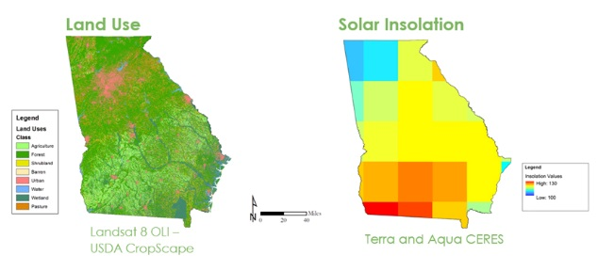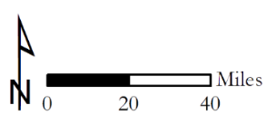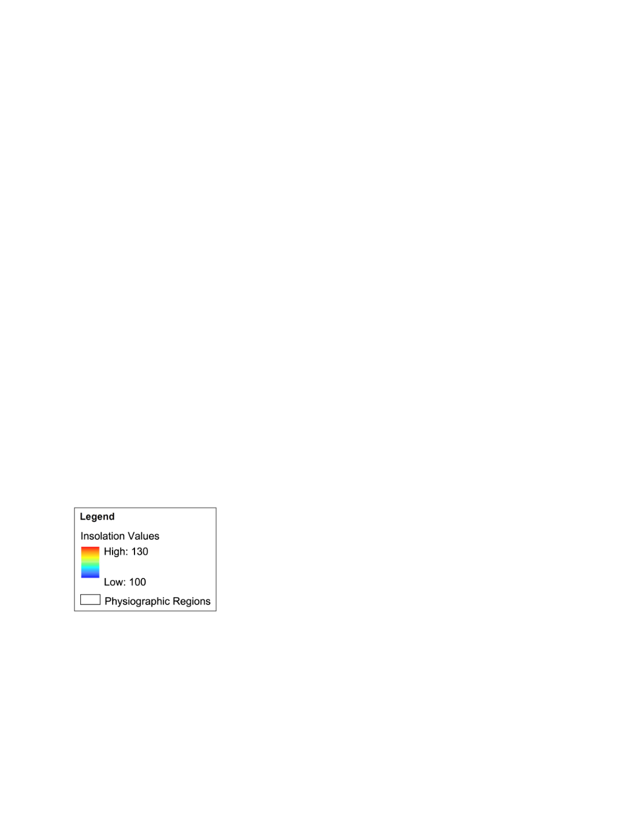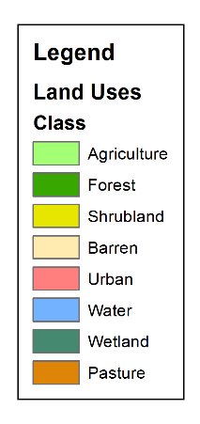

Terra and Aqua CERES

Landsat 8 OLI –

USDA CropScape

**Solar Insolation**

**Land Use**

*Figure 1:* NASA Earth observation data used in the Georgia Energy project

***3.2 Data Acquisition and Processing: Ancillary Datasets***

Digital Elevation Models (DEM) were also implemented in the analysis. These data sets with 30-meter and 10-meter resolution were provided by Carl Vinson Institute of Government at the University of Georgia. Slope and aspect products were derived from theses elevation models and were incorporated into the solar farm suitability model.

The team also acquired additional layers to support the analysis process. These layers included a protected lands layer that identified locations that are protected and conserved. A model created by Dr. Jeff Hepinstall-Cymerman was implemented to locate gopher tortoise habitats. A rock outcrop layer was also identified by reclassifying data derived from the STATSGO data set, which indicated soil types in the state. Together these layers went into a broad analysis within the state of Georgia to identify areas of high environmental sensitivity.

The team also conducted a more detailed analysis on Taylor County, involving higher resolution data and additional datasets such as roads, parcels, and floodplains acquired from the Georgia State Clearinghouse, and a streams layer acquired from U.S. Fish and Wildlife Service. All datasets were unified in terms of projection and classification to ensure a seamless analysis procedure.

***3.3 Data Analysis***

The Land-Use Conflict Identification Strategy (LUCIS) method was used to identify datasets and layers relevant to the purpose of this research from two different perspectives (solar development and environmental protection) and attributing weights to each perspective. The first step in the LUCIS model was to create a matrix that identified goals, objectives, and criteria. The team identified two goals: Identifying areas in the state of Georgia suitable for utility-scale solar energy installation and areas that are the most environmentally sensitive. Within these goals were different objectives indicating how the goal would be met. These objectives created pathways to determining criteria and weighting these data to properly meet the objective, and ultimately accomplish the corresponding goal (see Appendices B and C).

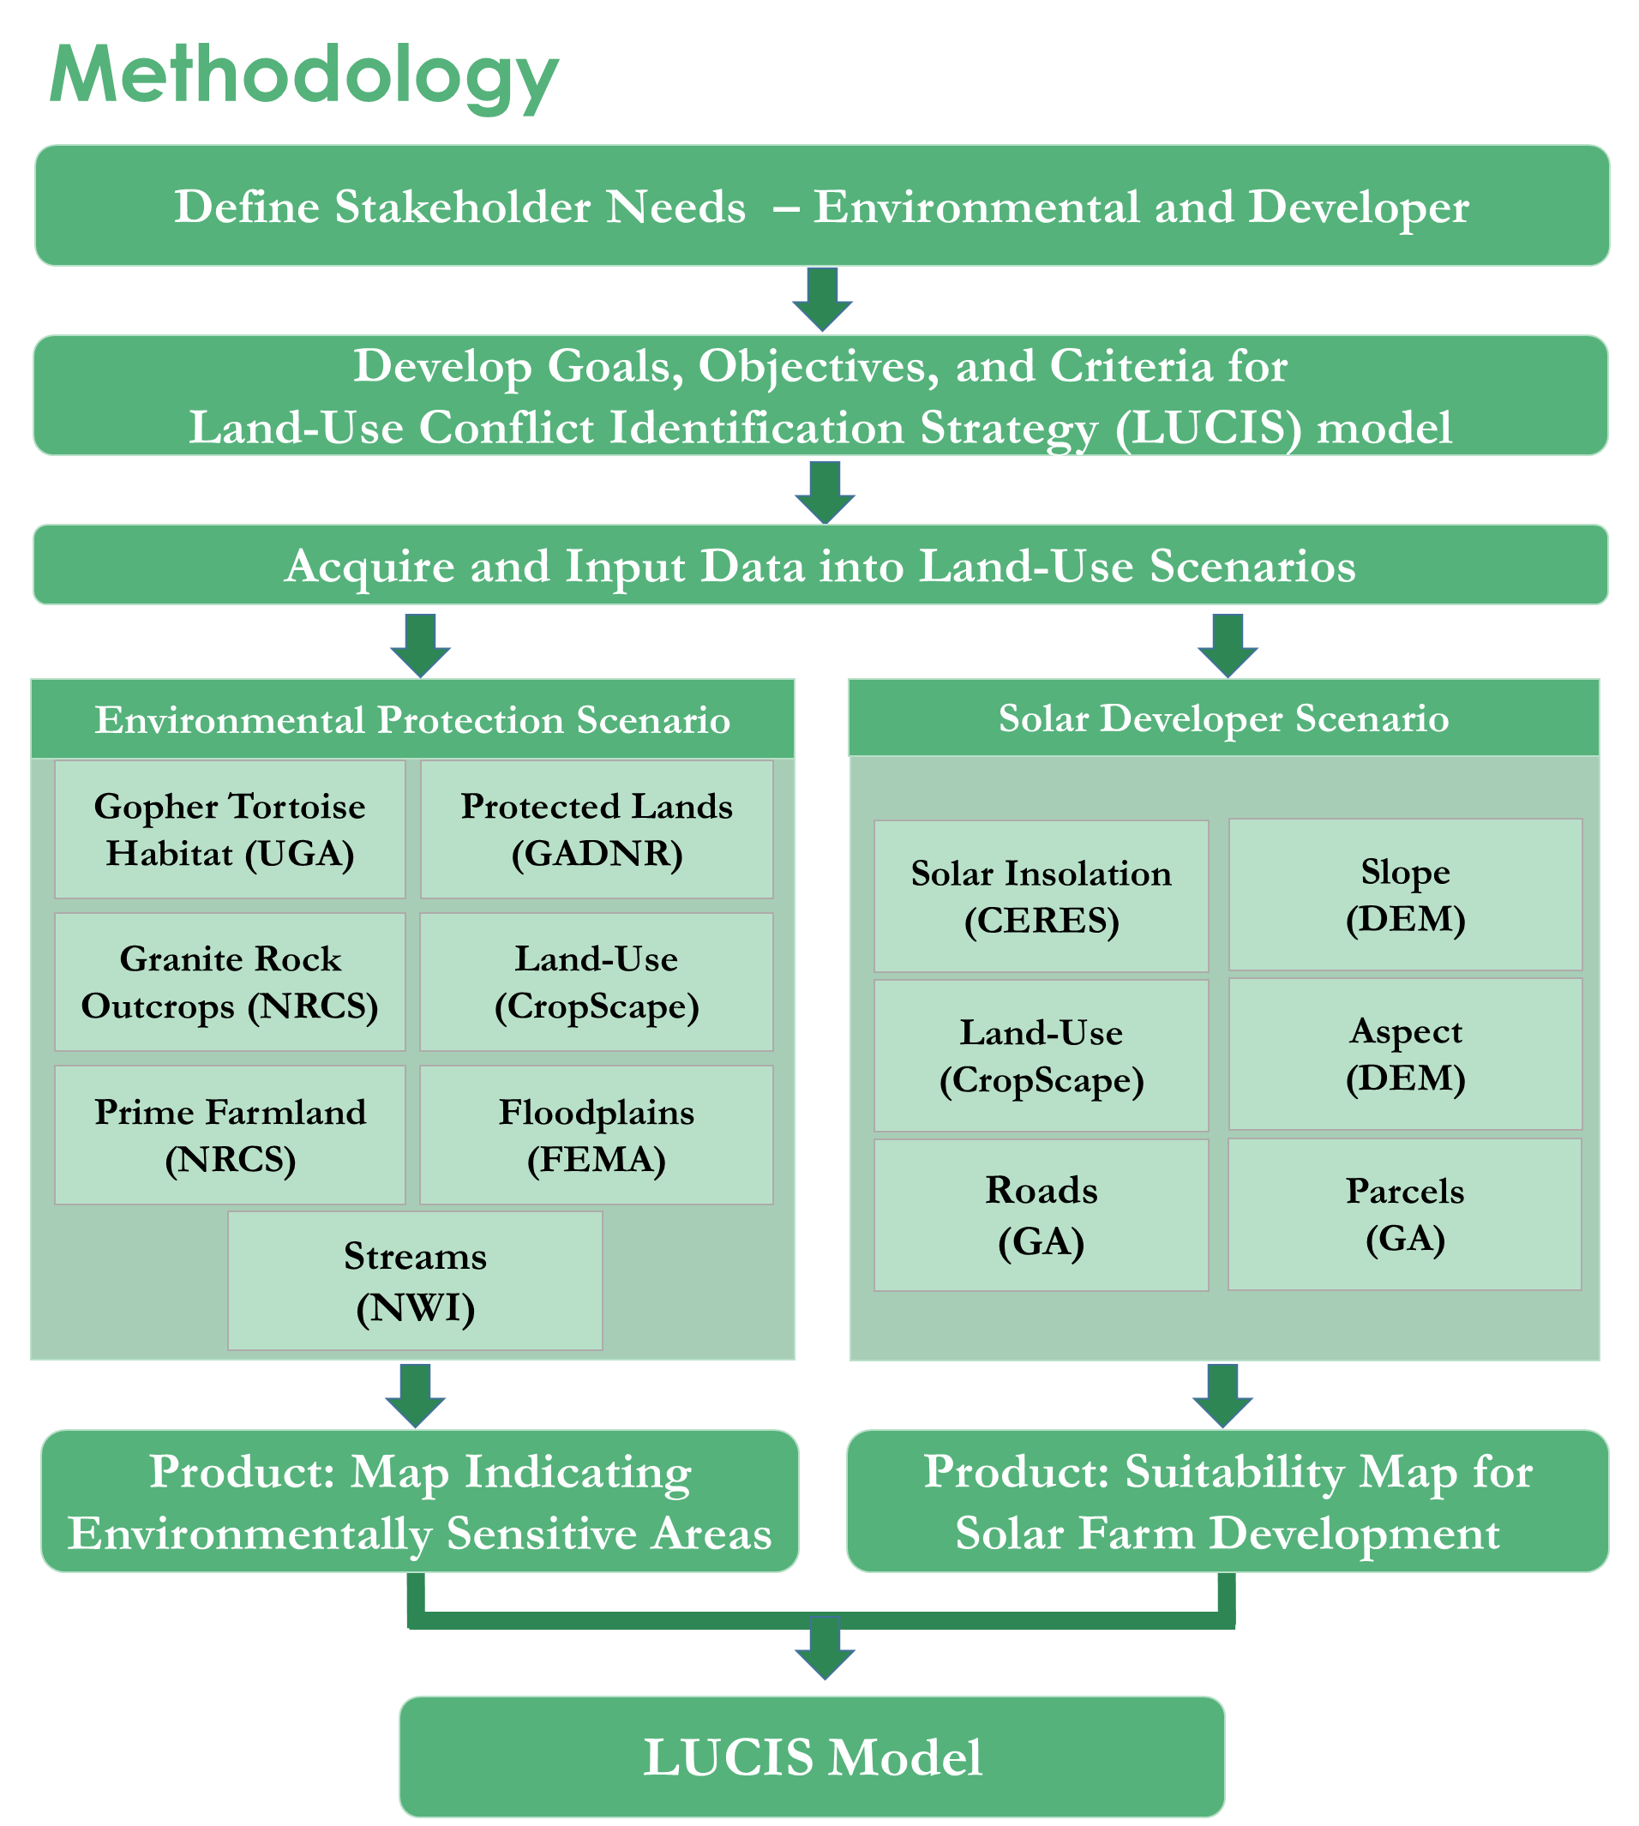

Figure 2: Summary of overall project methodology

The matrix was translated into an ArcMap model using the Raster Calculator to generate a classification that reflected the conflict between interests and prioritized areas depending on values characterizing conflicts using the expression Conflict = “Environment”+ 10* “Solar”. Results for this map yielded 9 classes that were collapsed into three classes. Maps generated by this model, however, did not represent areas such as protected lands as restricted. Therefore, an extra step was added to the model to multiply raster values within these areas with the number 0, which created a class that can be easily identified as restricted. The suitability map was a reclassification of the 9 conflict map classes by favoring an interest for conservation, which depended on the conflict values. This model generated four maps essential to fully integrating the project results: (1) the solar map: depicting the suitability of areas in the state of Georgia (or Taylor County) for solar farm installation, (2) the environment map: depicting the environmental sensitivity of areas within the state of Georgia (or Taylor County), (3) the conflict map: depicting areas where development and environmental protection interests are in conflict, and (4) the suitability map: prioritizing areas for either solar development or environmental protection depending on values characterizing the conflict.

# 4. Results & Discussion

***4.1 Analysis of Results***

*4.1.2 Solar Development Potential*

The weighted criteria used to create this model included slope, aspect, land cover, and incoming solar radiation to highlight locations of best placement. Overall, areas most suitable for solar farm installation were concentrated on southern areas of the state (Figure 3). Data collected from the CERES instrument indicated that the southern portion of Georgia receives the highest amount of solar radiation in comparison to the north. Areas south of the Piedmont region in Georgia are also relatively flat, which is referred to as the Coastal Plain region. This region provided a suitable aspect and slope, and has a high potential for solar farm development. While the northern parts of the state received ample solar radiation, the terrain in North Georgia, comprising of the Appalachians Mountains where slope and aspect varies drastically, detracts from their suitability for these types of developments. The team devised a reclassified USDA CropScape land cover data set to display eight broad land uses, then issued a scale regarding the most suitable land cover types. Barren lands, pasture, shrubland, and agricultural land provided the ideal cases for utility scale solar farms. This classification played a role in further refining the suitability for 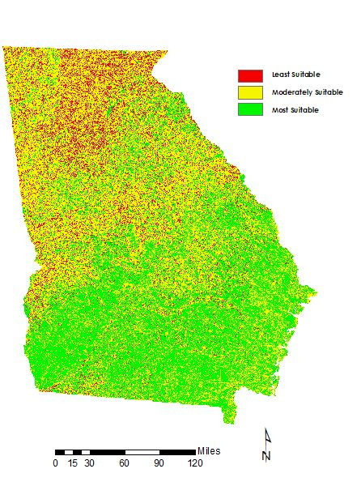solar farm development.

Least Suitable

Moderately Suitable

Most Suitable

*Figure 3*: Georgia Solar Map

Three different rankings were used in the product shown in Figure 3. The rankings ranged from 1 to 3, with 1 (red) being the least suitable and 3 (green) being most suitable. As expected, the number 2 ranking, defined by ‘suitable’, was the largest class with a coverage of 21 million acres. The most suitable class, a rank of 3, was allotted over 10 million acres, and the least suitable class amassed 5 million acres. The results reveal that 85% of Georgia’s total area is at least suitable for solar placement, while 28% falls into the most suitable category. With these statistics, it is extremely optimistic for the solar industry to implement development plans as Georgia continues its surge towards its renewable energy future.

*4.1.2 Environmental Sensitivity*

The purpose of environment map was to identify levels of environmental sensitivity within the state. The method focused on weighting objectives to create a map showing these sensitive hot spots. The criteria used in this process highlighted gopher tortoise habitat, rock outcrops, conservation lands, and land cover. Based on models and ancillary data sets, the team pinpointed locations that corresponded well with known areas of conservation and habitats. The map also indicated areas with the least environmental sensitivity. Many of these areas corresponded with urbanized zones and agricultural land throughout the state. Large plots of agriculture or pasture land, already cleared from wooded plant material, can provide the most effective land use while mitigating environmental harm. Areas with the highest levels of environmental sensitivity were more concentrated in the southern areas of Georgia, which corresponded to the high levels of gopher tortoise habitat patches.

The environment map used a similar ranking system to the solar map, as shown in Figure 5. The value 3 represents the most sensitive areas (Red) while 1 indicated the least sensitive areas (Green). Based on the results of our weighted objectives, sensitive areas (value of 2) dominate throughout Georgia, covering 20 million acres. The amount of most sensitive areas (value of 3) amounted to a 5-million-acre coverage. The most sensitive areas highlight areas where gopher tortoise habitats are known and expected in the Coastal Plain, as well as highlighting wetlands like the Okefenokee Swamp in southeast Georgia. In the northeastern region of Georgia, sensitive areas are located in the Appalachian Mountains. This left 33% of the state 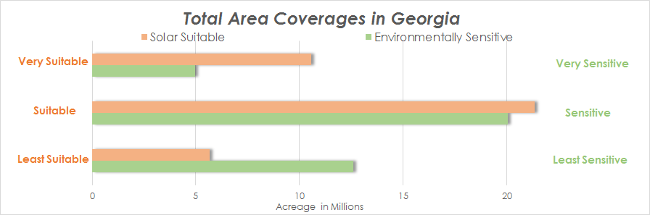capable of hosting developments that would minimize the impact of environmentally sensitive areas.

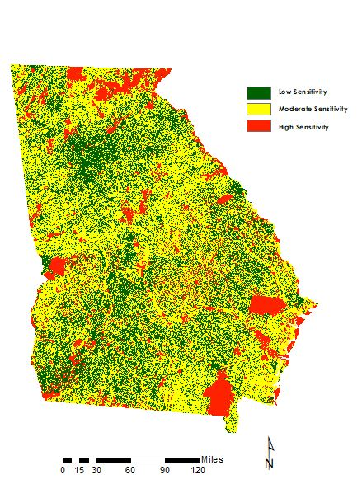Figure 4: Acreage distribution by interest

Low Sensitivity

Moderate Sensitivity

High Sensitivity

*Figure 5:* Georgia Environment Map

*4.1.3 Conflict Mapping*

After generating the two products, the team proceeded with the LUCIS model, producing the conflict map, as shown in Figure 6. The map indicated areas where interests (solar and environmental) are conflicting. Using 9 classes, however, the amount of data distributed among the map was not sufficiently clear to identify areas of conflict; therefore, the team used a reclassified image to delineate these areas. For consistency purposes, this product also used a ranking system from 1 to 3 with 3 representing most conflict (Red) and 1 representing least conflict (Green).

Areas that are marked as no development are apparent as they represent conservation and protected lands as well as bodies of water. This area comprises of approximately 4 million acres. The least conflicting areas, deemed suitable for solar farm installation from an environmental and a solar development standpoint cover over 5 million acres of land. 28 million acres of space show some level of conflict. These are areas in which criteria simply do not match, and will help create buffers to areas that will benefit multiple parties. The conflict map served as intermediate data and cannot be used as a guide for recommending sites. These will be represented in the suitability map, which is described below.

Values corresponding to coverage were extracted by converting pixel counts into accurate spatial density. The extracted data can be viewed in Table 1. The 9 classes are defined in the Conflict Values column, where the left value represents the environmental rank and the right value represents the developer rank. Conflict and 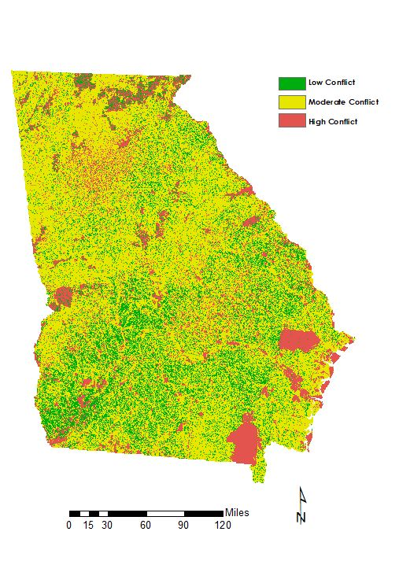Suitability Result columns show attributed values in the conflict and suitability maps. 

Low Conflict

Moderate Conflict

High Conflict

*Figure 6:* Georgia Conflict Map

|  |  |  |  |  |  |  |  |  |
| --- | --- | --- | --- | --- | --- | --- | --- | --- |
| **Environment Value** | **Environment Map** | **Solar Value** | **Solar Map** | **Conflict Values** | **Conflict**  **Result** | **Suitability Result** | **Area (m2)** | **Acres** |
| 1 | Low Sensitivity | 1 | Low Suitability | 1-1 | High | Moderate | 3,615,945,300,000 | 893,518,163.4 |
| 1 | Low Sensitivity | 2 | Moderate Suitability | 1-2 | Moderate | Yes | 14,365,643,220,000 | 3,549,822,267.9 |
| 1 | Low Sensitivity | 3 | High Suitability | 1-3 | No | Yes | 27,849,027,960,000 | 6,881,634,054.1 |
| 2 | Moderate Sensitivity | 1 | Low Suitability | 2-1 | Moderate | Moderate | 10,474,883,550,000 | 2,588,396,099.6 |
| 2 | Moderate Sensitivity | 2 | Moderate Suitability | 2-2 | Moderate | Moderate | 43,469,350,650,000 | 10,741,493,892.4 |
| 2 | Moderate Sensitivity | 3 | High Suitability | 2-3 | Moderate | Moderate | 18,262,056,690,000 | 4,512,645,518.4 |
| 3 | High Sensitivity | 1 | Low Suitability | 3-1 | No | No | 172,925,280,000 | 42,730,701.3 |
| 3 | High Sensitivity | 2 | Moderate Suitability | 3-2 | High | No | 2,288,465,460,000 | 565,491,257.5 |
| 3 | High Sensitivity | 3 | High Suitability | 3-3 | High | No | 2,109,387,420,000 | 521,240,178.4 |

*Table 1*: Conflict values and attributed areas

*4.1.4 Suitability*

Finally, a suitability map was produced to create a visualization of suitable sites for solar development with minimal environmental conflict. Information gathered from the conflict map was used to classify areas of low, moderate, and high suitability for solar farm development. The distribution of most suitable areas is mostly concentrated in the southern areas of Georgia, with some areas in the northern part of the state. In addition, the team also added a class (dark grey) to show areas that are restricted from solar farm development. These restricted areas include conservation areas that have highly sensitive habitats. With this map, solar farm developers and environmental stakeholders will be able to see areas of suitability as well as restricted areas for solar farm development.

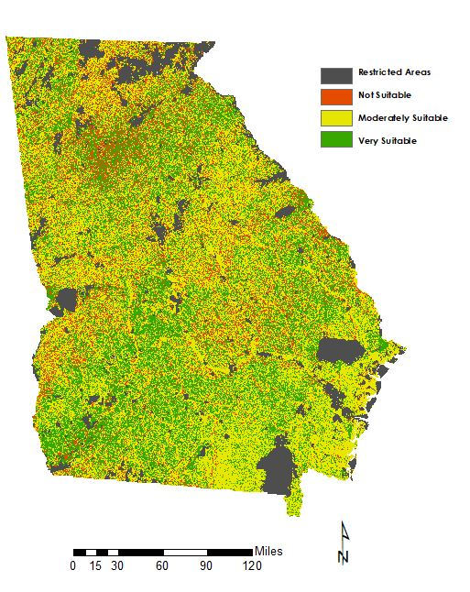*Figure 7:* Georgia Suitability Map

Restricted Areas

Not Suitable

Moderately Suitable

Very Suitable

***4.2 Future Work***

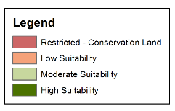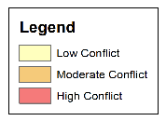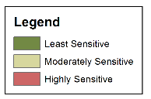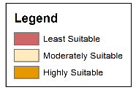The initial term of the Georgia Energy project showed potential for future work. Since the study area of the entire state allowed for broad analysis, future work can help refine the data used as well as create a model that can focus on smaller areas of interest. The team explored this possibility by focusing on Taylor County, home to one of Georgia’s fastest growing solar energy industry. Since the study area was much smaller, more defined data sets were accessible such as parcel data, more accurate stream and wetland locations, and road networks. Additional datasets such as power grid and substation locations could be collected and implemented into the model to create a more thorough analysis that can directly engage solar energy developers. Using the same process based on the LUCIS model with some alterations to the weighting analysis, four distinct maps for Taylor County were generated: the Environment, Solar, Conflict, and Suitability maps. The results aligned very well with the current placements of solar developments. These refined results will be extremely useful as the solar industry continues to grow in the state of Georgia (Figure 8).

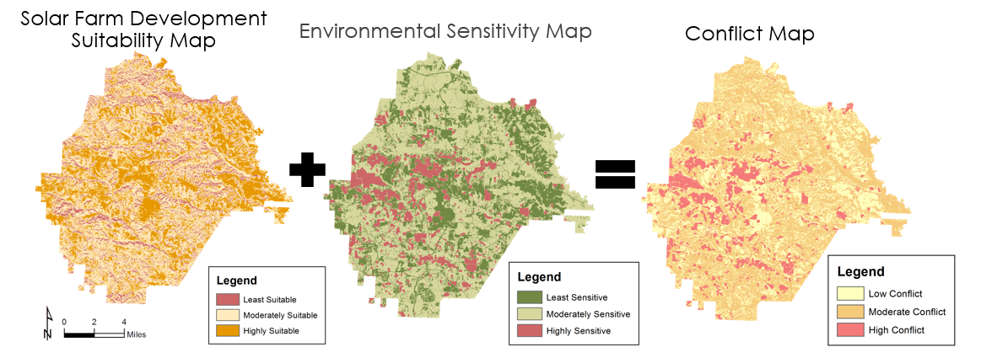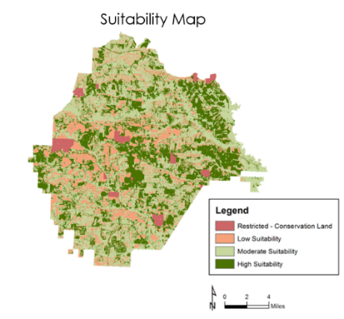

*Figure 8:* Analysis for Taylor County, Georgia

For the current model, increasing collaboration with solar development authorities would be beneficial for all parties. This will help accurately assess the criteria from the perspective of a utility developer, as well as gain insight on how developers currently site solar farms. Knowing this information will anchor the close partnership between environmental stakeholders and solar energy developers, and perhaps models assessing development on different land uses (urban, mixed use, industrial, etc.) could be developed. Overall, there are many improvements and different areas of emphasis that will benefit from a continuation of the Georgia Energy Project, and add to the analysis behind the suitability for conservation-oriented solar power in the state. Additionally, increased input from stakeholders would tweak the classification of suitability maps. For example, the Georgia Energy team considered urban areas as not suitable for utility-scale solar farms; however, it is worth investigating the potential for symbiosis between these land uses. These are all directions that can be taken further with this research.

# 5. Conclusions

The state of Georgia is one of the fastest growing solar industries in the United States due to its suitable landscape. However, upon implementing utility-scale solar developments, environmental concerns have been raised regarding environmentally sensitive ecosystems throughout the state. To address these issues, the Georgia Energy Team utilized the Landsat 8 OLI satellite to gather land cover data, and the Terra and Aqua satellites and their combination of CERES data sets to analyze the distribution of incoming solar radiation.

With these satellite data, other data sets provided from The Nature Conservancy and Georgia Department of Natural Resources, and other freely available sources, we created four major products for the state of Georgia and Taylor County: the environment map, the solar map, the conflict map and the suitability map. These products highlighted areas throughout Georgia that were environmentally sensitive and suitable for solar development, identified the conflicts between these interests, and then proceeded to prioritize land use depending on the values characterizing the conflict. To create a comprehensive analysis of the environmental conflict surrounding the rapid growth of solar developments throughout Georgia, the LUCIS model provided the best framework for our problem.

Our results indicate that there is adequate space throughout Georgia that is suitable for sustainable and abundant solar energy development that minimizes environmental impacts. These sites are highlighted throughout the analysis and can help plan for future developments.

# 6. Acknowledgments

The Georgia Energy Team would like to acknowledge their science advisor Dr. Marguerite Madden at UGA. The team would also like to thank their partners, Cassidy Jordan at The Nature Conservancy, and Matt Elliot at the Georgia Department of Natural Resources, for their continuous involvement with the project and communication during the summer project term. Additionally, the team would like to thank Caren Remillard, UGA Center Lead, for her timely support and feedback.

Any opinions, findings, and conclusions or recommendations expressed in this material are those of the author(s) and do not necessarily reflect the views of the National Aeronautics and Space Administration.

This material is based upon work supported by NASA through contract NNL16AA05C and cooperative agreement NNX14AB60A.

# 7. Glossary

**Aqua –** An Earth science satellite with six different Earth-observing instruments on board, and it is named for the large amount of information it collects about water on Earth

**Earth observations** **–** Refers to satellites and sensors that collect information about the Earth’s physical, chemical, and biological systems over space and time

**CERES –** Clouds and the Earth’s Radiant Energy System

**CVIOG** – Carl Vinson Institute of Government

**GDNR –** Georgia Department of Natural Resources

**Landsat –** A joint NASA and U.S. Geological Survey (USGS) mission; the observatory consists of the spacecraft bus and its play load of two Earth-observing sensors

**LUCIS –** Land Use Conflict Identification Strategy

**NRCS –** Natural Resource Conservation Service

**OLI –** Operational Land Imager

**STATSGO –** Digital General Soil Map of the United States 

**Terra –** An Earth science satellite that provides global data on the condition of the atmosphere, land, and oceans, as well as their interactions with solar radiation and with one another

**TNC –** The Nature Conservancy

**USFWS –** United States Fish and Wildlife Service

# 8. References

Doelling, D (2012). CERES Level 3 SYN1DEGDAYTerra+Aqua netCDF file, Edition 3A. Langley Atmospheric Science Data Center DAAC, accessed 26 June 2017. doi://10.5067/TERRA+AQUA/CERES/SYN1DEGMONTH_L3.003A

Georgia Energy Data - Solar Map. (n.d.). Retrieved June 15, 2017, from http://www.georgiaenergydata.org/solarmap

Hernandez, R., Easter, S., Murphy-Mariscal, M., Maestre, F., Tavassoli, M., Allen, M. (2014). Environmental impacts of utility-scale solar energy.*Renewable and Sustainable Energy Reviews, 29*, 766-779. doi:10.1016/j.rser.2013.08.041

Hart, D. (2008). Smart Land-Use Analysis: The LUCIS Model: Land-Use Conflict Identification Strategy. *Journal of the American Planning Association, 75*(1), 89. https://doi.org/10.1080/01944360802540125

Nahid Jafari, Bryan L. Nuse, Clinton T. Moore, Bistra Dilkina, Jeffrey Hepinstall-Cymerman, Achieving full connectivity of sites in the multiperiod reserve network design problem, Computers & Operations Research, Volume 81, 2017, Pages 119-127, ISSN 0305-0548, http://dx.doi.org/10.1016/j.cor.2016.12.017.

Natural Resources Conservation Service. (n.d.). Retrieved June 30, 2017, from https://www.nrcs.usda.gov/wps/portal/nrcs/detail/soils/survey/geo/?cid=nrcs142p2_053629

Ong, S., Campbell, C., Denholm, P., Margolis, R., & Heath, G. (2013). Land-Use Requirements for Solar Power Plants in the United States. doi:10.2172/1086349

Uyan, M. (2013). GIS-based solar farms site selection using analytic hierarchy process (AHP) in Karapinar region, Konya/Turkey. *Renewable and Sustainable Energy Reviews, 28*, 11-17. doi:10.1016/j.rser.2013.07.042

US Department of Energy (2017). Retrieved July 28, 2017, from https://energy.gov/eere/solarpoweringamerica/solar-energy-united-states

SEIA (2017). Retrieved July 28, 2017, from http://www.seia.org/research-resources/us-solar-market-insight

Southern Environmental Law Center (2017). Retrieved July 28, 2017, from https://www.southernenvironment.org/uploads/words_docs/Solar_EnvReviewProcess_SitingSolar_Final.pdf

CERES Science Team. (2015). CERES Level 3 SYN1DEGDAYTerra+Aqua netCDF file, Edition 3A.

NASA Atmospheric Science Data Center, accessed 30 June 2017. doi://10.5067/Terra+Aqua/CERES/SYN1degDAY_L3.003A (http://www.sciencedirect.com/science/article/pii/S0305054816303136)

# 9. Appendices

**Appendix A.** Ancillary Data

|  |  |
| --- | --- |
| **Dataset** | **Source** |
| Solar insolation | NASA CERES |
| Land cover | USDA CropScape |
| Gopher tortoise habitat | Warnell School of Forestry |
| Protected lands | GDNR |
| Granite rock outcrops | NRCS |
| Prime farmland | USDA NRCS |
| Streams | USFWS |
| Digital Elevation Model (DEM) | CVIOG |
| Slope | CVIOG |
| Aspect | CVIOG |
| Parcel | Georgia Clearing House |
| Floodplains | Georgia Clearing House |
| Roads | Georgia Clearing House |

**Appendix B.** LUCIS Criteria Matrix for the state of Georgia

|  |  |  |  |  |  |  |  |  |  |  |  |  |  |  |  |  |  |
| --- | --- | --- | --- | --- | --- | --- | --- | --- | --- | --- | --- | --- | --- | --- | --- | --- | --- |
| **Solar Farm Criteria - Georgia** | | | | | | | | | | | | | | | | | |
| **Goal** | **Weight** | | **Objective** | | **Weight** | | **Criteria** | | **Ranking** | | **Method** | | **Data** | | **Source** | | |
| Identify Suitable Solar Farm Sites in Georgia | 50 | | Locate on proper aspect. | | 30 | | Least Suitable: North, west, and east facing slopes. | | 1 | | Derive aspect from DEM and reclassify. | | DEM 30 m | | CVIOG | | |
| Moderately Suitable: Southwest and southeast facing slopes. | | 2 | |
| Highly Suitable: South facing slopes and flat areas. | | 3 | |
| Locate on proper slope. | | 30 | | Least Suitable: >5% slopes | | 1 | | Derive slope from DEM and reclassify. | | DEM 30 m | | CVIOG | | |
| Moderately Suitable: 2% - 5% slopes | | 2 | |
| Highly Suitable: Less than 2% slopes | | 3 | |
| Locate in areas with adequate solar insolation. | | 10 | | Least Suitable: Lowest values | | 1 | | Reclassify CERES data. | | CERES 1 degree^2 | | NASA | | |
| Moderately Suitable: Moderate values. | | 2 | |
| Highly Suitable: Highest values | | 3 | |
| Locate on proper land covers. | | 30 | | Least Suitable: Water, wetland, and urban | | 1 | | Reclassify CropScape data. | | CropScape 30 m | | USDA | | |
| Moderately Suitable: Forest | | 2 | |
| Highly Suitable: Pasture, barren, shrubland, and agriculture | | 3 | |
| **Environmental Criteria - Georgia** | | | | | | | | | | | | | | | | |
| **Goal** | | **Weight** | | **Objective** | | **Weight** | | **Criteria** | | **Ranking** | | **Method** | | **Data** | | **Source** |
| Protect Environmentally Sensitive Areas | | 50 | | Avoid gopher tortoise habitat. | | 30 | | Least Sensitive: Areas outside of the habitat areas and 100 foot buffers | | 1 | | Reclassify habitat data provided and buffer habitat areas by 100 feet. | | GT | | Warnell School of Forestry |
| Moderately Sensitive: 100 foot habitat area buffer | | 2 | |
| Highly Sensitive: Gopher tortoise habitat | | 3 | |
| Avoid protected lands. | | 30 | | Least Sensitive: Areas outside of the protected lands and 100 foot buffers | | 1 | | Reclassify protected lands data provided and buffer protected lands by 100 feet. | | Cons lands | | DNR |
| Moderately Sensitive: 100 foot protected land buffer | | 2 | |
| Highly Sensitive: Protected lands | | 3 | |
| Avoid granite rock outcrops. | | 30 | | Least Sensitive: Areas outside of the granite rock outcrops and 100 foot buffers | | 1 | | Reclassify soils data and buffer rock outcrops by 100 feet. | | Soils data | | NRCS |
| Moderately Sensitive: 100 foot granite rock outcrop buffer | | 2 | |
| Highly Sensitive: Granite rock outcrops | | 3 | |
| Avoid environmentally sensitive land covers. | | 10 | | Least Sensitive: Barren and urban | | 1 | | Reclassify CropScape data. | | CropScape 30 m | | USDA |
| Moderately Sensitive: Agriculture, pasture, and shrubland | | 2 | |
| Highly Sensitive: Water, wetland, and forest | | 3 | |

**Appendix C.** LUCIS Criteria Matrix for Taylor County

| **Environmental Criteria - Taylor County** | | | | | | | | |
| --- | --- | --- | --- | --- | --- | --- | --- | --- |
| **Goal** | **Weight** | **Objective** | **Weight** | **Criteria** | **Ranking** | **Method** | **Data** | **Source** |
| Protect Environmentally Sensitive Areas in Taylor County | 50 | Avoid prime farmland. | 16 | Least Sensitive: Areas outside of the prime farmland and 100 foot buffers | 1 | Buffer prime farmland by 100 feet and reclassify areas. | SSURGO/STATSGO | NRCS |
| Moderately Sensitive: 100 foot primer farmland buffer | 2 |
| Highly Sensitive: Prime farmland | 3 |
| Avoid stream buffers. | 16 | Least Sensitive: Areas outside of the streams and 100 foot buffers | 1 | **B**uffer streams by 100 feet and reclassify areas. | NWI | USFWS |
| Moderately Sensitive: 100 foot stream buffer | 2 |
| Highly Sensitive: Streams | 3 |
| Avoid gopher tortoise habitat. | 16 | Least Sensitive: Areas outside of the habitat areas and 100 foot buffers | 1 | Reclassify habitat data provided and buffer habitat areas by 100 feet. | GT | Warnell School of Forestry |
| Moderately Sensitive: 100 foot habitat area buffer | 2 |
| Highly Sensitive: Gopher tortoise habitat | 3 |
| Avoid protected lands. | 20 | Least Sensitive: Areas outside of the protected lands and 100 foot buffers | 1 | Reclassify protected lands data provided and buffer protected lands by 100 feet. | Cons lands | DNR |
| Moderately Sensitive: 100 foot protected land buffer | 2 |
| Highly Sensitive: Protected lands | 3 |
| Avoid environmentally sensitive land covers. | 16 | Least Sensitive: Barren and urban | 1 | Reclassify CropScape data. | CropScape 30 m | USDA |
| Moderately Sensitive: Agriculture, pasture, and shrubland | 2 |
| Highly Sensitive: Water, wetland, and forest | 3 |

| **Solar Farm Criteria - Taylor County** | | | | | | | | |
| --- | --- | --- | --- | --- | --- | --- | --- | --- |
| **Goal** | **Weight** | **Objective** | **Weight** | **Criteria** | **Ranking** | **Method** | **Data** | **Source** |
| Identify Suitable Solar Farm Sites in Taylor County | 50 | Avoid floodplains. | 16 | Least Suitable: 100-year floodplain | 1 | Reclassify floodplain zones and buffer 100-year floodplain by 100 feet. | FEMA floodplain | Georgia State Clearinghouse |
| Moderately Suitable: 100 foot of the 100-year floodplain | 2 |
| Highly Suitable: Areas outside of the 100-year floodplain and 100 foot buffer | 3 |
| Locate on large parcels. | 16 | Least Suitable: <5 acres | 1 | Reclassify parcel data. | Taylor County parcel data | Georgia State Clearinghouse |
| Moderately Suitable: 5 - 13 acres | 2 |
| Highly Suitable: >13 acres | 3 |
| Locate near roads. | 16 | Least Suitable: >2 miles | 1 | Buffer roadways and reclassify. | Roads | Georgia State Clearinghouse |
| Moderately Suitable: 1 - 2 miles | 2 |
| Highly Suitable: <1 mile | 3 |
| Locate on proper aspect. | 16 | Least Suitable: North, west, and east facing slopes. | 1 | Derive aspect from DEM and reclassify. | DEM 30 m | CVIOG |
| Moderately Suitable: Southwest and southeast facing slopes. | 2 |
| Highly Suitable: South facing slopes and flat areas. | 3 |
| Locate on proper slope. | 16 | Least Suitable: >5% slopes | 1 | Derive slope from DEM and reclassify. | DEM 30 m | CVIOG |
| Moderately Suitable: 2% - 5% slopes | 2 |
| Highly Suitable: Less than 2% slopes | 3 |
| Locate on proper land covers. | 20 | Least Suitable: Water, wetland, and urban | 1 | Reclassify CropScape data. | CropScape 30 m | USDA |
| Moderately Suitable: Forest | 2 |
| Highly Suitable: Pasture, barren, shrubland, and agriculture | 3 |