**NASA DEVELOP National Program**



University of Georgia

*Summer 2015*

Costa Rica Water Resources

Utilizing NASA Earth Observations to Develop a Comprehensive Water Budget for the Arenal-Tempisque Irrigation District of Costa Rica

 **Technical Report**

Rough Draft – June 25, 2015

Veronica Fay (Project Lead)

Steve Padgett-Vasquez

Caren Remillard

Eduardo Rendon

Kamala Kanta Sahoo

Xuan Zhang

Dr. Marguerite Madden, University of Georgia (Science Advisor)

Dr. Quint Newcomer, University of Georgia Costa Rica (Science Advisor)

Dr. Adam Milewski, University of Georgia (Science Advisor)

Dr. Kenton Ross, NASA DEVELOP National Program (Science Advisor)

Previous Contributors:

Rachel Will

Benjamin Page

Grant Bloomer

Sarah Medley

# I. Abstract

[Placeholder - do not put anything here until the final draft submission. The abstract in the project summary is where the working draft of the abstract should “live”]

**Keywords**

Costa Rica, Remote Sensing, Hydrological Processes, SWAT, SWAT-CUP, METRIC

# II. Introduction

**Background**

Costa Rica’s watersheds are important sources of drinking water and many other services related to people’s livelihoods, such as hydroelectricity, agricultural irrigation, eco-tourism, and recreational activities. However, the increasing climate variability in the Arenal-Tempisque Irrigation District has impacted the region’s irrigation capability and hydroelectric potentials; in particular, persisting drought conditions have afflicted this region for the past three years. A heightened sense of water vulnerability within this area has arisen as drought conditions linger. Competition over water resources is increasing as water accessibility drops and as water quality issues arise. Water policy makers do not currently utilize GIS software or NASA Earth observation tools and datasets in their decision-making process. By incorporating these data sources and support tools into their policy-making process, the end-users will have access to innovative, continuous hydrological datasets, allowing for more informed and efficient decisions to be made. Therefore, the goal of this project was to provide Servicio Nacional de Aguas Subterráneas, Riego y Avenamiento (SENARA,Costa Rica’s National Service of Underground Water, Irrigation, and Drainage) with datasets and tools derived from NASA Earth observations, which will assist with their future water management decisions and policy making.

**Objectives**

The objective of this project was to develop a comprehensive water budget for the Arenal-Tempisque Irrigation District of Costa Rica using datasets and tools from NASA Earth observations. The Soil and Water Assessment Tool (SWAT) model was implemented in ArcGIS and used to simulate the local hydrological processes of this region. SWAT- CUP (Soil and Water Assessment Tool- Calibration and Uncertainty Procedure) was used to calibrate and validate the model’s original hydrological outputs, and the METRIC (Mapping Evapotranspiration at high Resolution and with Internalized Calibration) processing model was used to supplement SWAT’s simulated evapotranspiration values. An updated water inventory of the Guanacaste region was constructed with the model’s final outputs, and was given to end-users to facilitate their future water management policies.

**Study Area**

The study area was the Arenal-Tempisque Irrigation District (DRAT) in Guanacaste, Costa Rica, which is highlighted in figure X. The DRAT is located in the northwest region of Costa Rica, and is situated between the Pacific Coast, the Gulf of Nicoya and Lake Arenal. The Arenal-Tempisque Irrigation District has experienced continual drought in the last several years, and these conditions complicate the management of environmental services, agricultural practices, and irrigational procedures. The Arenal-Tempisque Irrigation District is the largest irrigation district in the country, extending over 2800 ha. Hydroelectricity derived from the region provides roughly a quarter of Costa Rica’s electrical power annually (Amador, Chacon, and Laporte, 2003). Although the area is suffering from drought conditions, it is still a substantial constituent of agricultural production in Costa Rica.

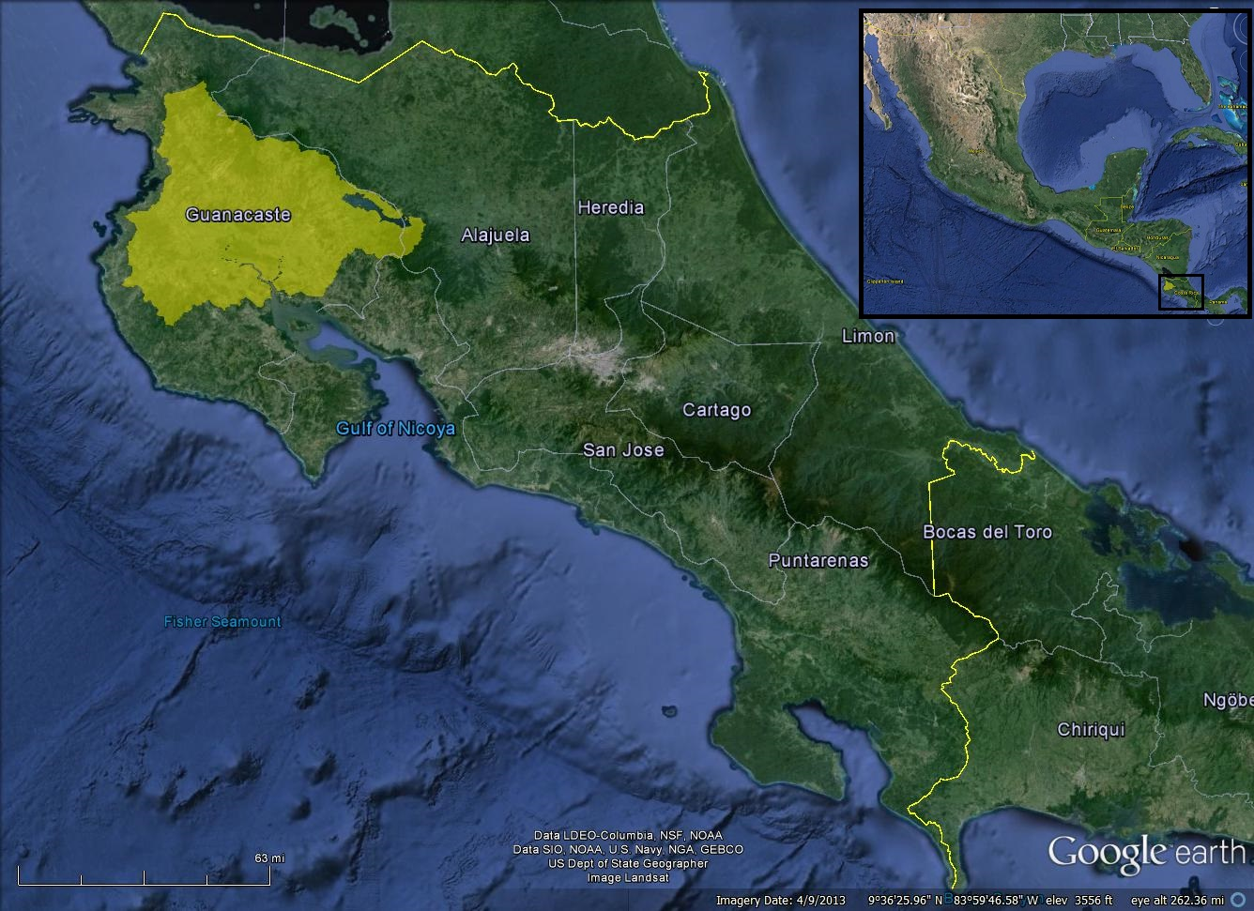

Figure X: The Arenal-Tempisque Irrigation District (DRAT) showed in bright yellow

**Study Period**

The study period for this project extended from January 2000 to December 2013. The dates were chosen to allow a sufficient collection of data to simulate and assess hydrological processes in the models.

**National Application Addressed**

The project addresses the “Water Resources” NASA application area, utilizing NASA Earth observations with soil, land cover, climate, and in situ data to provide the end-user (SENARA) with datasets and resources to enhance the decision-making processes in local water management.

**Project Partners**

The Costa Rica Water Resources team partnered with SENARA’s agronomist for the Arenal-Tempisque Irrigation District, Javier Artiñano Guzmán. Additional partners included the University of Georgia Costa Rica and the Costa Rican Embassy to the United States. Due to the continuing drought conditions afflicting the DRAT region, project partners were interested in incorporating innovative models derived from NASA Earth observations into their decision-making process as they modified their water resource management plan for this region. Project partners were provided with a continuous and precise data inventory of the hydrological processes that affect the region’s water budget. The acquisition of this inventory will allow water policy makers to increase the efficiency of their water management plan.

# III. Methodology

**Data Acquisition**

This project utilized the SWAT river basin model, which was developed to help evaluate the effects of different water management decisions and alternative land management practices on a large watershed. For the Arenal-Tempisque Irrigation District’s watershed, the SWAT model required two Advanced Spaceborne Thermal Emission and Reflection Radiometer (ASTER) Digital Elevation Models (DEMs) which were obtained from the U.S Geological Survey (USGS). Data from the Landsat 8 Operational Land Imager (OLI) Path: 15 Row: 53, acquired on April 2, 2015, were also obtained from USGS. Weather parameter datasets, including relative humidity, solar radiation, precipitation, temperature, and wind speed data, were obtained from the Climate Forecast Reanalysis (CFSR) site, which is a global weather database preformatted to be compatible with SWAT. Soil inputs were downloaded from the World Harmonized Soil Database’s (WHSD) digital soil map. Costa Rica’s National Service of Underground Water, Irrigation, and Drainage (Servicio Nacional de Aguas Subterráneas Riego y Avenamiento, SENARA) provided land cover data, stream gauge data, and calculated evapotranspiration in-situ data. Landsat 8 OLI images were also utilized to update the land cover data.

SWAT-CUP required *in situ* stream gauge data acquired from SENARA, and the parameters and outputs established in SWAT were used for calibration and validation processes.

The (METRIC) model used Landsat 8 OLI data to compute and map the study area’s evapotranspiration (ET).

**Data Processing**

Using ancillary agricultural data provided by project partners, the team converted the vector land use data into a raster dataset in ArcGIS. Landsat 8 OLI data were also utilized to create a Normalized Difference Vegetation Index (NDVI) and a Normalized Difference Water Index (NDWI). These two indexes were used to identify irrigation zones and to update the agricultural areas in the land use data. In order to make all raster data consistent in the SWAT model, soil and land use data were resampled to match the spatial resolution of the DEM, which was approximately a 30-meter resolution. Two updated ASTER DEM images were downloaded and mosaicked to create a continuous elevation model for the entirety of the study area.

The calibration of the SWAT model’s hydrological outputs conducted in SWAT-CUP required a substantial amount of adjusting. Parameters were selected in SWAT-CUP for a sensitivity analysis and these parameters were assigned a numerical range. After running the model, a trend line for simulated values and observed values were produced. The goal was to have these two trend lines align, signifying that simulated values were credible. The team adjusted the range of these sensitive parameters to find a good fit between the two trend lines.

When initially downloaded and imported into ArcGIS, Landsat 8 images displayed 11 different spectral bands, each recording the amount of reflected energy in a specific part of the electromagnetic spectrum. To view the image as a whole, the bands underwent a stacking process. Once this process was completed, the remote sensing analysis was done using ERDAS Imagine.

The METRIC model required less data processing than the SWAT model. The inputs for the METRIC simulation required the creation and rasterization of shapefiles that classified the basin’s area into irrigated and non-irrigated regions.

**Data Analysis:**

SWAT + METRIC

One of the hydrological principles that SWAT takes into consideration is that water will always flow from a higher elevation to a lower elevation. The study area’s watershed and numerous sub-basins were delineated in SWAT based on this principle and the study area’s DEMs. These sub-basins were further divided into hydrologic response units (HRU) based on land cover, soil data, and slope inputs. HRUs are areas that are homogeneous in their soil type, soil properties, and land use. The model was run after the fourteen years of climate data for the study area were entered in the model, and the hydrological outputs were produced. Then the output files of SWAT were employed in the SWAT-CUP for further calibration and validation. In SWAT-CUP, Sequential Uncertainty Fitting version 2 (SUFI2) served as the optimization algorithm to run the model. Several parameters were chosen as calibration inputs. According to the 95% Prediction Uncertainty (95PPU) plot, after thousands of iterations and simulations, the ranges of parameters  were adjusted to approach the actual observation values, which established the credibility of the simulated values.

# IV. Results & Discussion

Several uncertainties exist for the SWAT model. One uncertainty can be attributed to the fact that the accessible land use data was not all-encompassing. Large sections of our study area fell under the classification of “non-forested” land. To account for this generalization, the team cross referenced several images of the study area to verify and update the current land use of the study area. The team classified it as “pasture” land, but it is possible that other types of land use existed within this area. Different land uses would affect and alter the hydrologic processes of the area in question, possibly changing some of the model’s outputs. Although the team lacked access to the study area to account for this possibility, the end-users will be able to easily improve upon the foundations the team has established, as they have personal insight into the region and easier access to their country’s datasets.

ArcGIS software, which is quite powerful but costly, is not commonly used by many organizations in Costa Rica. To make the project’s products more accessible to the public there, we suggest that the project be implemented in QGIS and QSWAT. These programs are free to the public, open source, and have a similar interfaces to ArcGIS software. An instruction manual or a video could be made for users to follow the steps and apply to their own study area.

The SWAT Model requires land use data to simulate different responses in the study area. According to the data we obtained from our end-user and NASA Earth observations, all agricultural areas were classified as one. However, vegetation growth is essential and different for various types in a hydrological model because they have different demands and react to water resources at different times. Detailed land use data and crop information can help make the simulation closer to the reality.

It is important to mention that this research was the result of an analysis of information available. Some aspects have deficiencies to be overcome with additional work aimed at improving the quality of data. Since this study did not consider physicochemical water quality data, it would be interesting for future researchers to design a monitoring system to measure the quality parameters of water at different levels of the mainstream, with the aim of creating a database for analyzing the variability and changes resulting from watershed management.

# V. Conclusions

Final conclusions. Word count: (200-600 a page).

# VI. Acknowledgments

The Costa Rica Water Resources team would like to extend a special thanks to our project partners, SERNARA and the Costa Rica Embassy to the United States. We would like to express our gratitude towards our main contact point at SENARA, Javier Artiñano Guzmán, who provided us with indispensable datasets for our study area. We also appreciate the support of the H.E. Ambassador Roman Macaya and Minister Counselor Alejandra Solano from the Costa Rica Embassy. Thank you to our science advisors Dr. Quint Newcomer, Dr. Marguerite Madden, Dr. Kenton Ross, Dr. Adam Milewski, and Steve Padgett-Vasquez for their support and guidance. Finally, we would like to thank Wondwosen Seyoum, Matt Cahalan, and Mike Durham for their technical support and insight.

This material is based upon work supported by NASA through contract NNL11AA00B and cooperative agreement NNX14AB60A.

# VII. References

Amador, J.A., R.E. Chacón, S. Laporte (2003). Climate and Climate Variability in the Arenal River  Basin of Costa Rica. Climate and Weather. Springer Netherlands. 317-349.

Abbaspour, K. C., Rouholahnejad, E., Vaghefi, S., Srinivasan, R., Yang, H., & Kløve, B. (2015). A continental-scale hydrology and water quality model for Europe: Calibration and uncertainty of a high-resolution large-scale SWAT model. Journal of Hydrology, 524, 733-752.

# VIII. Content Innovation

In preparation for DEVELOP’s coming microjournal, please select two content innovation features to support your paper. For each item, please list the name of the feature, and include the tool itself if possible (eg. glossary terms and definitions). If the tool does not work in Microsoft Word (eg. Interactive MATLAB Figure Viewer), please list the file name and upload the related file to the microjournal folder on the DEVELOP Exchange. If you choose to use Inline Supplementary Material, please also include where the material should appear in the text.

**Some options include:**

AudioSlides

Database Linking Tool

Data Profile

Executable Papers

Featured Author Videos

Featured Multimedia for this Article (video and podcast options)

Glossary Viewer

Inline Supplementary Material (figures, tables, computer code)

Interactive Map Viewer

Interactive MATLAB Figure Viewer

Interactive Plot Viewer

Nomenclature Viewer

# IV. Appendices

Insert here