**NASA DEVELOP National Program**



USGS at Colorado State University

*Summer 2015*

Ethiopia Ecological Forecasting

Mapping Four Decades of Fire History for Targeted Conservation in the South-Central Highlands of Ethiopia

 **Technical Report**

Rough Draft – June 25, 2015

Stephen Chignell (Project Lead)

Chandra Fowler

Kelly Hopping

Darin Schulte

Paul Evangelista, Natural Resource Ecology Lab, Colorado State University (Science Advisor)

# I. Abstract

[Will insert final abstract in final draft]

**Keywords**

Landsat, MODIS, LandTrendr, fire, time series, change detection, Ethiopia, Bale Mountains

# II. Introduction

***Background Information***

The south-central highlands of Ethiopia comprise one of the largest and least-studied mountain systems in Africa. These highlands are home to Bale Mountains National Park (BMNP), a world-renowned biodiversity hotspot that possesses habitat for numerous endemic and endangered species entirely unique to the region. The park and its surrounding area is also home to approximately 30,000 indigenous pastoralists, who have a long history of managing high-elevation Ericaceous shrublands with intentional burning. However, these fires may lead to unintended consequences, such as increased soil erosion and reduced habitat for endangered species such as the Mountain Nyala. Cessation of traditional burning as a management practice could lead to shrub encroachment into Afro-alpine plant communities, reduced forage production for livestock, and accumulation of fuel loads that could support catastrophic fires when the shrublands eventually burn. As a result, both BMNP and local conservation organizations need comprehensive records of the timing and spatial extent of past fires, as well as detection of trends in how burned areas are changing with increasing human populations, climate change, and other factors, in order to inform sustainable management of natural resources and the social-ecological systems they support.

[Will include all citations for background information in final draft]

***Project Objectives***

We quantified fire extent and distribution in Ericaceous shrublands of the Bale-Arsi massif over a 42 year time period (1973-2015), utilizing the entire Landsat record. We validated the? results and filled data gaps with the Moderate Resolution Imaging Spectroradiometer (MODIS) Burned Area product, as well as ancillary fire records collected in the field. Our goal was to provide the most complete record of the extent of past fires in the region, while offering a novel methodology for repeated application in Ethiopia and other regions.

***Study Period and Area***

The study period for this project was January, 1973 - June, 2015. We focused our research on the dry season each year, from January to March, when the majority of burning occurs. The study area was located in south-central Ethiopia and comprises the Bale-Arsi massif, Sanetti Plateau, and surrounding lowlands (WRS1 Landsat Scene Path 180, Row 55; WRS2 Landsat Scene Paths 167 and 168, Row 55.

[Will insert study area map in final draft]

***National Application Addressed***

This project addressed the NASA national application area of Ecological Forecasting, as increased understanding of historical fires informs planning and execution of future management practices seeking to address the dual challenges of climate change and population growth in the region. This will help maintain the health of vulnerable ecosystems while meeting the needs of local stakeholders and promoting economic growth and tourism for the area and BMNP.

**Project Partners**

The primary partner for this project was The Murulle Foundation (TMF), a 501(c)3 organization that “fosters participatory grassroots projects based on human and organizational development and scientific research to promote social, economic, and environmental well-being” in Sub-Saharan Africa (murulle.org). The Murulle Foundation has worked in the Bale region for over a decade, and needs the results of this study to augment their ongoing field-based monitoring and sampling efforts.

Additionally, TMF works closely with the second project partner, the Natural Resource Ecology Laboratory (NREL) at Colorado State University, who will use the spatial data as variables in predictive species distribution models of mountain Nyala habitat and other endangered species in Bale. These will serve as valuable tools with which to support management at the federal level through the existing partnership of NREL with the Ethiopian Ministry of Environment and Forest.

# III. Methodology

***Data Acquisition***

Using the USGS Earth Explorer portal (http://earthexplorer.usgs.gov), we downloaded Level 1 terrain-corrected Multispectral Scanner (MSS) imagery from Landsat satellites 1, 3, and 5. Through the USGS Bulk Surface Reflectance Interface (http://espa.cr.usgs.gov/ordering/new), we downloaded Level 1 terrain-corrected, top of atmosphere and surface reflectance climate data records for Thematic Mapper (TM), Enhanced Thematic Mapper Plus (ETM+), and Operational Land Imager (OLI) imagery.

We also used the USGS Bulk Surface Reflectance Interface to calculate the following spectral indices for all Landsat TM, ETM+, and OLI data: Normalized Difference Vegetation Index (NDVI), Normalized Difference Moisture Index (NDMI), Normalized Burn Ratio (NBR), Normalized Burn Ratio 2 (NBR2), Soil-Adjusted Vegetation Index (SAVI), Modified Soil-Adjusted Vegetation Index (MSAVI), and the Enhanced Vegetation Index (EVI).

We used all available scenes in January through March from WRS1 path 180, row 55 and for WRS2 paths 167 and 168, row 55. In total, this yielded 149 scenes from 25 years, spanning from 1973-2015 (will include a full list of scenes and dates used in an appendix table in final version). We also acquired 30-m resolution digital elevation model data from the Shuttle Radar Topography Mission (SRTM) through the USGS Earth Explorer portal (http://earthexplorer.usgs.gov).

In addition to the Landsat and SRTM data, we downloaded ESRI shapefiles derived from the Moderate Resolution Imaging Spectroradiometer (MODIS) Burned Area Product from March, 2000 to March, 2015 via the University of Maryland's MODIS Fire Science Team ftp server (ftp://ba1.geog.umd.edu/). This dataset is derived from time series analysis of Aqua and Terra imagery using an algorithm that detects fire scars by locating occurrences of rapid changes in daily surface reflectance. We also acquired the entire available time series (2000 – 2015) of Enhanced Vegetation Index (EVI) values for these burned areas using the Oak Ridge National Laboratory Distributed Active Archive Center for Biogeochemical Dynamics Global MODIS Subset Tool (http://daac.ornl.gov/MODIS/modis.shtml). This tool provides standard MODIS products for any location and time period in the historical record (2000 – 2015).

Finally, we acquired ancillary spatial data of the boundary of Bale Mountains National Park and land cover from our partners at the NREL at Colorado State University. Additionally, we compiled point locations and descriptions of fires from our TMF partners and the existing literature.

***Data Processing***

We mosaicked twenty 1-degree tiles of SRTM elevation data to create a digital elevation map for our study area. For this we used R code (R Development Core Team, 2014) provided by Justin Braaten at the Laboratory for Applications of Remote Sensing in Ecology at Oregon State University. To process the Landsat imagery, we used the R LandsatLinkr package (Braaten et al. 2015), which spatially and spectrally links MSS Landsat imagery to TM, and ETM+ data. Within LandsatLinkr we projected all of the data to North America Albers Equal-Area Conic, as LandsatLinkr has not yet been developed to work with projections outside of North America. For MSS imagery, LandsatLinkr decompresses, stacks, resamples, reprojects, and georegisters the scenes. It then converted the data to top-of-atmosphere radiance and surface reflectance, which it then paired with digital elevation data to create a cloud mask. TM and ETM+ data downloaded from the USGS Bulk Surface Reflectance Interface already includes atmospheric corrections and cloud masks derived from LEDAPS, so for scenes from these sensors LandsatLinkr only decompresses, stacks, resamples, and reprojects the data. Then LandsatLinkr calculates tasseled cap indices for all scenes, calibrates MSS to TM scenes, and then produces annual, cloud-free composites based on mean pixel values for all overlapping, cloud-free areas within a year.

Although the LandsatLinkr program documentation recommends using as many images as possible from within a phenological season each year, we were concerned that compositing later dates after which burning had occurred with earlier dates from the same year, before fires started, would cause the composited spectral values in burned areas to be diluted relative to if we used only a single image after the fires had occurred. However, if we prioritized capturing all fires from within the January-March dry season and only selected the very latest dates from this period each year; this would prevent LandsatLinkr from finding cloud-free pixels across several dates in order to create a single cloud-free image for each year. Therefore, to balance this tradeoff between diluting the spectral signature of burned areas and losing information to clouds, we decided to use the scene from the latest date from January to March with few to no clouds each year. When there were moderate levels of clouds at later dates, we paired them with earlier, cloud-free dates.

Although LandTrendr is able to incorporate Landsat 8 imagery, LandsatLinkr does not currently support processing of OLI data. We therefore manually prepared the OLI surface reflectance product for use in LandTrendr by applying the tasseled cap transformation coefficients derived by Baig et al. (2014), and reclassifying the FMask cloud mask to a binary map. We then projected all of these layers to North America Albers Equal Area Conic to match the project of the LandsatLinkr outputs.

In addition to the Landsat data, we processed the Burned Area product data in ArcMap to show yearly and monthly occurrences of wildfire in our study area. We accomplished this by ArcMap; we clipped the MODIS Burned Area product to the extent of our study area and created polygons for fires that occurred there within each year.

[Will include information about point locations derived from ancillary field data and literature in final draft]

***Data Analysis***

We used the LandTrendr model (Kennedy et al. 2010) to detect disturbances in the Landsat time series. The LandTrendr model is designed to work with continuous time series of Landsat data, but for our study area in Ethiopia, we had temporal data gaps in years with no imagery, as well as spatial data gaps from 2004-2009 and 2012-2013 when the only scenes collected were from Landsat 7 ETM+ with the malfunctioned scan line corrector. We were concerned that the temporal gaps in the data record could impede our ability to detect burned areas, particularly if regeneration after a fire occurred during a data gap period. This would prevent LandTrendr from capturing a change in the trajectory of the reflectance of certain pixels through time, which would in turn prevent us from classifying those areas as disturbances due to burning.

To address this potential problem, and provide a validation of the Landsat-based disturbance models, we paired our analyses of Landsat imagery with data from the EVI and Burned Area products from the sensor on the Aqua and Terra satellites. However, the MODIS data is also at a much coarser spatial resolution than the 30 m Landsat data (EVI: 250 m; Burned Area: 500 m), so we were also interested in whether these products would be able to capture smaller fires picked up by the Landsat imagery.

First, to generate a conservative and independent dataset with which to validate the LandTrendr disturbances identified as burned areas, we generated random points within each MODIS burned area polygon in January-March, 2000-2015. These were compared against the Landsat burn areas to calculate user’s, producer’s, and overall accuracies (Table X (error matrix)).

Second, we used the random points (include specific #) generated for the validation to assess trajectories of vegetation change in burned areas. We used the Oak Ridge National Laboratory data for MOD13Q1 (Terra) and MYD13Q1 (Aqua) vegetation indices values for each of the burn points; while this product includes both NDVI and EVI data, we chose to focus on EVI because of its ability to avoid oversaturation due to dense rainforest canopy like that found in the Bale Mountains.

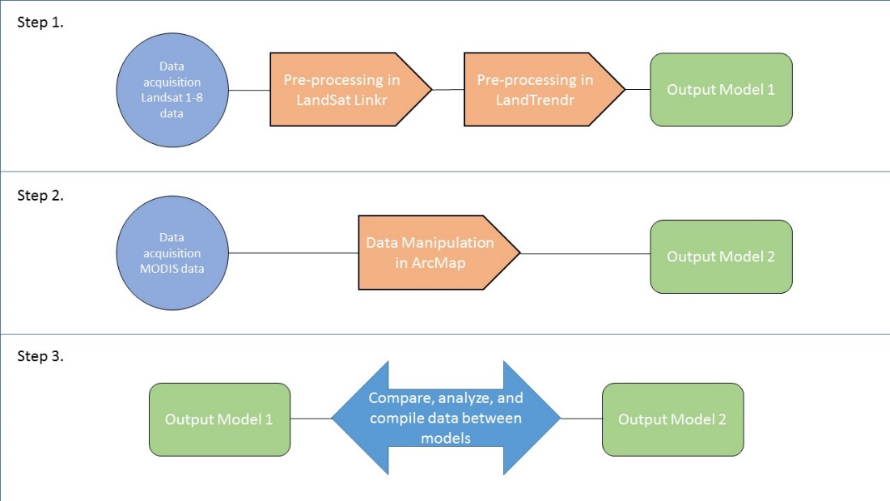The continuous record from MODIS to assess the timescale of vegetation recovery after fires in order to determine whether our 2-3 year data gaps in the Landsat record would allow enough vegetation to regenerate that we would be unable to detect the initial fire using LandTrendr. (We assumed that the 5- and 7-year Landsat data gaps in the early 1980s and 1990s, respectively, would be too long.)

**Figure 1.** Flow chart showing the basic steps of the project methodology [will be updated in final draft].

# IV. Results & Discussion

Coming Soon!

# V. Conclusions

Coming Soon!

# VI. Acknowledgments

The authors would like to thank The Murulle Foundation, and the Natural Resource Ecology Laboratory at Colorado State University for their support and partnership throughout this project. Special thanks to Brian Woodward, Nicholas Young, and Amanda West for their guidance, as well as to Justin Braaten (Oregon State University) for his significant assistance with LandsatLinkr and LandTrendr code.

This material is based upon work supported by NASA through contract NNL11AA00B and cooperative agreement NNX14AB60A.

# VII. References

Braaten, J.D., Cohen, W.B., & Yang, Z. (2015). LandsatLinkr: Tools to spectrally link Landsat data. R package version 0.1.13. http://landsatlinkr.weebly.com/

Kennedy, R. E., Yang, Z., & Cohen, W. B. (2010). Detecting trends in forest disturbance and recovery using yearly Landsat time series: 1. LandTrendr—Temporal segmentation algorithms. *Remote Sensing of Environment*, *114*(12), 2897-2910.

R Core Team. (2014). *R: A Language and Environment for Statistical Computing*. Vienna, Austria: R Foundation for Statistical Computing. Retrieved from <http://www.R-project.org/>

[These will be filled out, updated, and standardized in final draft]

# VIII. Content Innovation

[Will address this section in the final draft]

In preparation for DEVELOP’s coming microjournal, please select two content innovation features to support your paper. For each item, please list the name of the feature, and include the tool itself if possible (eg. glossary terms and definitions). If the tool does not work in Microsoft Word (eg. Interactive MATLAB Figure Viewer), please list the file name and upload the related file to the microjournal folder on the DEVELOP Exchange. If you choose to use Inline Supplementary Material, please also include where the material should appear in the text.

**Some options include:**

AudioSlides

Database Linking Tool

Data Profile

Executable Papers

Featured Author Videos

Featured Multimedia for this Article (video and podcast options)

Glossary Viewer

Inline Supplementary Material (figures, tables, computer code)

Interactive Map Viewer

Interactive MATLAB Figure Viewer

Interactive Plot Viewer

Nomenclature Viewer

# IV. Appendices

Coming Soon!