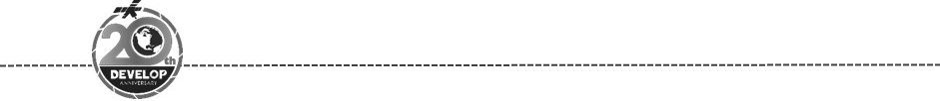**NASA DEVELOP National Program**

**Virginia – Langley**

*Summer 2018*

US Urban Development

Generating Hemispherical Visualizations of Artificial Brightness Using Updated Sky Glow Estimation Tools on Suomi NPP-VIIRS Data

 **Technical Report**

Final Draft – August 10th, 2018

Maximilian Ioffe (Project Lead)

Julia Hink

Tyler Jameson

Charlie McClay

Dr. Kenton Ross, NASA Langley Research Center (Science Advisor)

Previous Contributors:

Margaret Mulhern

Manda Au

Ian Brastow

Veronica Warda

Aubrey Hilte

Christine Stevens

Eric White

Ryan Avery

Steven Chao

Stanley Yu

# 1. Abstract

The growth of the global population along with rapid industrialization has caused an increase in artificial light pollution, also known as artificial sky glow. Anthropogenic light pollution disturbs the world’s ecosystems by interfering with the interconnected life of flora and fauna, degrading the night sky quality for astronomical and aesthetic viewing, and disrupting human circadian rhythms and melatonin production, which can have lasting negative effects on health. The Skyglow Estimation Toolbox (SET) calculates artificial sky glow by applying a model of light propagation to visible light radiance imagery from the Suomi National Polar-orbiting Partnership (NPP) Visible Infrared Imaging Radiometer Suite (VIIRS) Day/Night Band (DNB). The previous iteration of SET was further expanded by adding a hemispherical visualization feature compiled from individual sky glow maps with different zenith/azimuth angle combinations at one location. The graphical user interface (GUI) of SET was also updated to include all functions of the command line interface and the code repository now works with all versions of Python 2.7 and above. Written unit tests were installed to prevent future code breaks, and several issues were fixed such as logic errors, repository bloat, and lack of documentation. The revised SET was tested on four United States national parks to ensure functionality across different environments. The resulting hemispherical visualizations were provided to the National Park Service (NPS) to compare with *in situ* measurements. The team explored validation methods, which provided a basis for future action for measuring and managing light pollution around national park units.

**Keywords**

Suomi NPP VIIRS Day/Night Band, artificial light, remote sensing, light pollution, sky glow, light propagation, national park tourism, Python

# 2. Introduction

* 1. ***Background Information***

Ever since humans harnessed the power of electricity to create light, they have been adding artificial light to the environment (Chepesiuk, 2009). Anthropogenic sky glow has far-reaching implications that affect how people and wildlife behave and interact within their environments. One benefit of artificial light is the extension of the length of productive time per day, allowing more flexible work hours, and the ability to participate in recreational activities after the sun goes down. A major consequence of increasing artificial light is the disruption of the circadian rhythm of humans and animals by reducing the production of the hormone melatonin (Falchi et al., 2011). In humans, this is linked to pineal gland suppression, leading to stress, weight gain, and even cancer (Anisimov, 2006). Wildlife is affected on an even broader scale; birds’ migration and feeding are disrupted, sea turtles have trouble making it to the ocean after hatching, and mammals mating and migration patterns are misguided and can occur at the wrong time (Gaston et al, 2013). Artificial light increases the duration of visibility for predators, decreasing the chance of survival for prey (Longcore & Rich, 2004). More than one-third of the global population is unable to see the Milky Way, including 97% of the United States population (Falchi et al., 2016). Light pollution is one of the most pervasive forms of environmental alteration, damaging night landscapes in occupied communities and protected areas such as national parks (Falchi et al., 2016).

Measuring the impact of light pollution across various national parks can help decision-makers support policy that preserves some of the natural night sky environments in the United States. Our areas of interest included Gulf Islands National Seashore, Indiana Dunes National Lakeshore, Scotts Bluff National Monument, and Denali National Park and Preserve highlighted in Figure 1. Gulf Islands National Seashore stretches eastward from Cat Island, Mississippi to the Okaloosa Area of Florida. Light pollution from coastal communities, boats, and campers can disturb the sea turtle nesting and disorient hatchlings of the seashore (National Park Service, n.d.). Indiana Dunes National Lakeshore extends 15 miles along Lake Michigan in Northwest Indiana. As nearby communities continue to develop and light pollution increases, it becomes harder to view the natural night sky in places like Indiana Dunes. Scotts Bluff National monument in western Nebraska is a significant landmark for travelers of the Oregon and Mormon trails. This monument serves as an attraction for travelers interested in viewing the night sky, and increased light pollution in nearby cities may soon make it impossible to do so. Denali National Park and Preserve in Alaska is unique as Aurora Borealis is viewable within it, providing that the park is not further impacted by excessive artificial light from nearby cities.

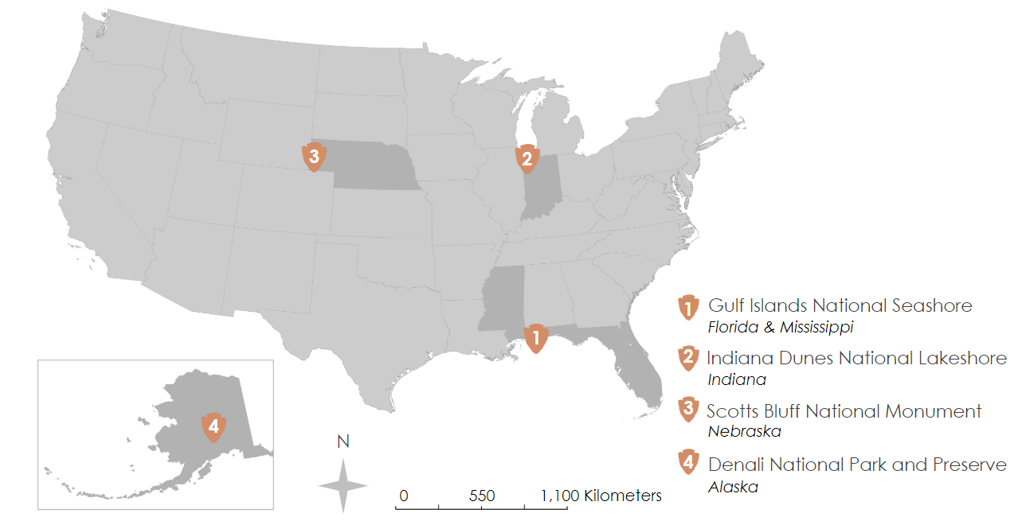

Figure 1: The areas of interest: Gulf Islands National Seashore, Indiana Dunes National Lakeshore, Scotts Bluff National Monument, and Denali National Park and Preserve (from National Park Service – Park Unit Boundaries, 2018).

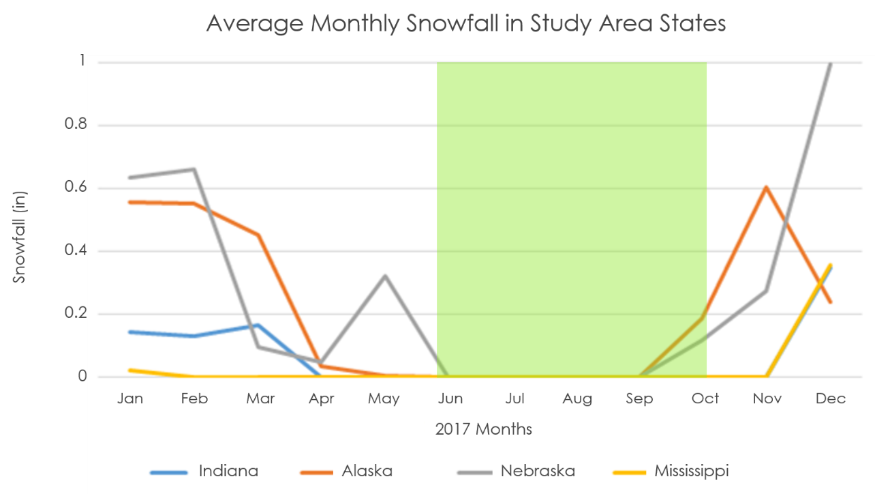

Figure 2: Mean monthly snowfall (in.) for the four study area states; study period is highlighted in green.

The study period for this project encompassed the months of June through October 2014-2017. The team excluded late autumn, winter, and spring months from the study period to eliminate the effects of snow reflection, which can increase artificial sky brightness (Figure 2). When artificial light pollution reflects off of snow coverage, artificial sky brightness in the atmosphere increases by up to 10% (Falchi et al., 2016). Due to the very short duration of night during summer months in Alaska, the team analyzed September and October months for Denali National Park and Preserve so that time of day did not interfere with satellite imagery data-collection.

* 1. ***Project Partners & Objectives***

The Natural Sounds and Night Skies Division of the National Park Service (NPS) relies on engineering, science, and technology to manage resources that national parks offer, such as the dark night sky environment (NPS, n.d.). More specifically, the NPS Natural Sounds and Night Skies Division develops innovative ways to measure the impacts of noise and light pollution, figures out new approaches to safeguard these resources, and identifies management strategies to restore them (NPS, n.d.). By collaborating with parks along with previous partners of NASA DEVELOP’s Wyoming Cross-Cutting I & II, and Colorado Plateau Urban Development teams, the Natural Sounds and Night Skies Division can increase scientific understanding and discovery needed to preserve natural nightscapes.

The project objectives were to update and improve the Skyglow Estimation Toolbox (SET) to be functional across multiple physiographic and environmental regions and to implement a feature that generates hemispherical visualizations. The preexisting SET program needed improvement to streamline toolbox installation, packaging, and runtime. The graphical user interface required expansion to include all functions of the command line interface. A hemispherical visualization feature was added to the toolbox to stitch together multiple sky glow maps for a given location.

# 3. Methodology

***3.1 Data Acquisition***

The National Oceanic and Atmospheric Administration (NOAA) National Centers for Environmental Information (NCEI) Earth Observation Group (EOG) provides monthly average radiance composite images from the Suomi National Polar-orbiting Partnership (NPP) Visible Infrared Imaging Radiometer Suite (VIIRS) Day/Night Band (DNB). Suomi NPP is a joint mission between NASA and NOAA. The EOG at NOAA NCEI filters all data prior to averaging to exclude impacts of stray light, lunar illumination, cloud cover, and temporary light from sources such as wildfires or gas flares (EOG, 2017). The data products are available in geotiff format in six separate tiles that span 120 degrees latitude and split across the equator (EOG, 2017). Each area of interest for this project is located in Tile 1 (75N/180W).

Using data from summer and fall months (June through October) for most locations lessened the chance of encountering snow cover in the imagery. Stray light corrected DNB imagery was not available prior to 2014 (EOG, 2017). Therefore, the study period consisted of a multi-annual composite of twenty months from 2014 to 2017 for June, July, August, September, and October for all areas of interest except Denali National Park and Preserve, which consisted of a multi-annual composite of eight months from 2014 to 2017 for September, and October.

The team obtained a shapefile of the national park unit boundaries from the National Park Service – Park Unit Boundaries feature service published on ArcGIS Online by the Land Resources Division, last updated in June of 2018.

***3.2 Data Processing***

The team created a subset of the national park boundaries shapefile to contain only our areas of interest. The New World Atlas models include the impact of surrounding light sources up to 195 km away (Falchi et al., 2016). The team was interested in assessing light pollution up to 200 km away in the four national park units. In efforts to increase our accuracy, the team generated 400 km buffers around each of the study areas because this distance impacts light pollution at 200 km away from the national park unit.

The Suomi NPP VIIRS DNB data required data processing to account for outliers, such as wildfires, that may impact results. The team produced a composite image of the 20 images using the Cell Statistics tool in ArcMap 10.5. Cell Statistics can calculate the median value of inputs on a cell-by-cell basis. The median is more robust in removing outliers compared to the mean so the median was our cell statistic variable. The median composite image was clipped to a rectangle around each 400 km buffer so that the light propagation measurements were valid at the edges of the images.

***3.3 Skyglow Estimation Toolbox***

The Skyglow Estimation Toolbox (SET) generates a light propagation kernel for a study area given a specific zenith/azimuth angle combination based on a physical model of light propagation described in papers by Cinzano et al. (2000) and Falchi et al. (2016). The kernel is simply an array of numerical coefficients representing weights of light propagation from an emitting source to an observation point (Figure 3).

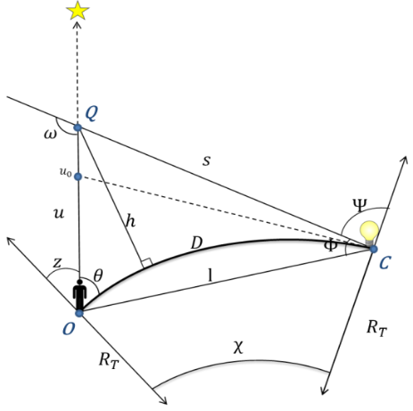

Figure 3: Relationships between light emission and an observer; adapted from Cinzano et al. (2001).

SET then convolves that kernel with the input VIIRS image to create an artificial brightness map at the study area for the given viewing angle. Convolution can be summarized by having each pixel on the VIIRS image take its turn being the observation point and the pixels around it covered by the kernel act as sources of light. The output value at that pixel is the weighted average of the pixel values covered by the kernel (Figure 4). The kernel then slides to the next pixel and repeats the process.

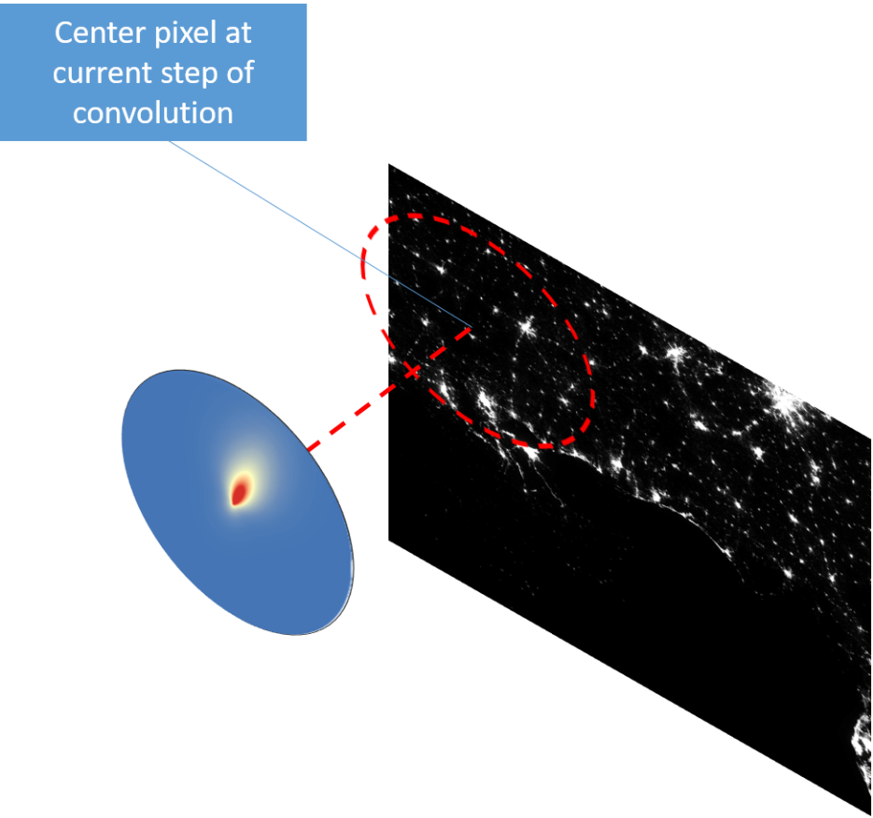

Figure 4: Convolution of VIIRS image with light propagation kernel

For efficiency purposes, SET performs a convolution with the equivalent, but much faster process of multiplication in the frequency domain of both images (see Convolution Theorem). It does so via the Fast Fourier Transform algorithm, which rapidly computes the frequency domains of both input images. By default, 52 kernels are generated, one for a different viewing angle. Pixel values at a geographic point within the study area from the 52 corresponding artificial brightness maps are combined in one hemispherical visualization of sky glow. SET interpolates between the generated samples to completely fill the hemisphere. The result is an intuitive look at sky glow in a given region.

***3.4 Data Analysis***

Though extensive validation of SET has not been done, the team explored foundational methods behind future validation processes. NPS provided the team with hemispherical ground truth data collected in October 2014 from Langdon Beach at Gulf Islands National Seashore. The team used SET to generate artificial brightness maps at the exact latitude and longitude where the NPS collected their data. The team extracted the values from the NPS hemisphere data for the viewing angles that artificial brightness maps were created for. To compare between SET and NPS data, the team produced a scatter plot of these values (Figure 9).

Figure 5: Methodology workflow followed by the US Urban Development team.

# 4. Results & Discussion

Our results consist of hemispherical visualizations of skyglow at our study areas as well as results validation using NPS ground truth data (Figures 6-11).

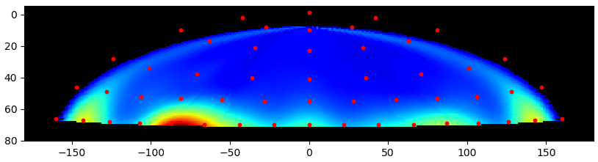

Figure 6: Hemispherical visualization generated by SET in Gulf Islands National Seashore. Several large cities such as New Orleans, LA and Pensacola, FL contribute to the sky brightness in this national park unit.

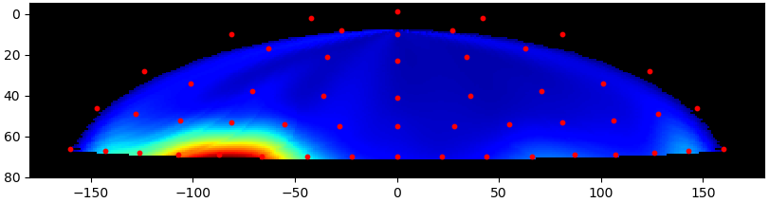

Figure 7: Hemispherical visualization generated by SET in Indiana Dunes National Lakeshore. Chicago, IL is located to the left of this national park unit and

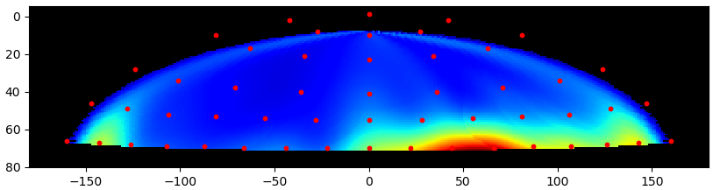

Figure 8: Hemispherical visualization generated by SET in Scotts Bluff National Monument. There are many bright spots present in this map mostly to the right of the monument.

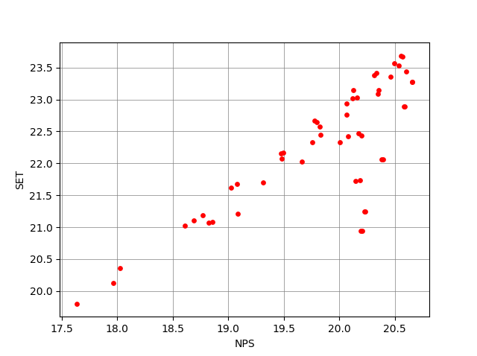

Figure 9: NPS ground truth data vs. SET generated data for Gulf Islands National Seashore at latitude 30.31682, longitude -87.26236 (in magnitudes per square arc second).

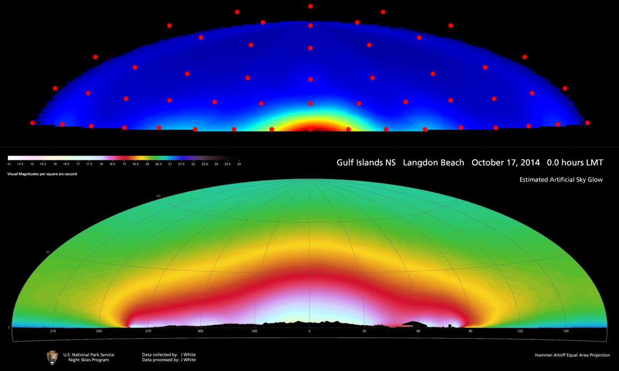

Figure 10: NPS ground truth hemisphere (bottom) vs. SET generated hemisphere (top) for Gulf Islands National Seashore at latitude 30.31682, longitude -87.26236

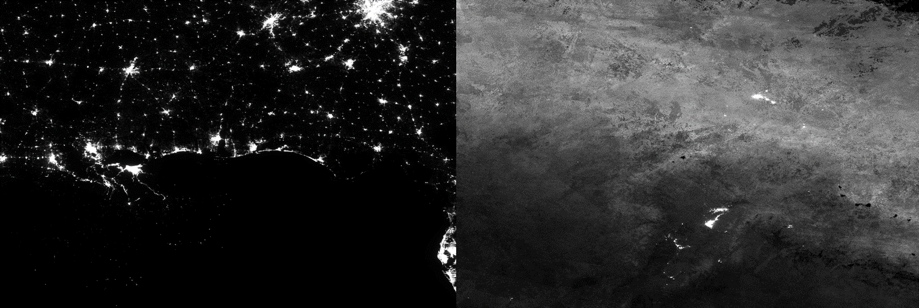

Figure 11: Median composite image of Gulf Islands National Seashore (left) and Denali National Park and Preserve (right).

***4.1 Analysis of Results***

The visualization for Gulf Islands National Seashore shows a long horizontal streak of sky glow near the horizon, which coincides with nearby large cities such as New Orleans, LA, and Pensacola, FL that contribute to the light pollution in the area (Figure 6). As shown, light pollution increases toward the horizon, which is naturally expected as light has to travel through more atmosphere at higher angles from the zenith. There are multiple bright spots across this hemispherical sky brightness map, the brightest around -90 degrees azimuth. This bright spot is most likely indicative of light sources from Biloxi, MS, and Gulfport, MS to the left of the observation point.

In the hemispherical visualization map created for Indiana Dunes National Lakeshore, there is a bright spot to the left around -80 degrees azimuth (Figure 7). The team infers that this bright spot is Chicago, IL, located to the left of Indiana Dunes National Lakeshore. As urban communities outside of this large city continue developing causing the expansion of light pollution, places like Indiana Dunes National Lakeshore will be harder to come across and will threaten the ability of citizens to see the night sky.

Scotts Bluff National Monument has a hemispherical visualization map with many bright areas to the right of the monument, especially near 50 degrees azimuth. This could be due to the proximity of the nearby city of Scottsbluff, NE, which emits a great amount of sky brightness as seen in Figure 8.

The team chose not to generate a sky glow hemisphere for Denali National Park and Preserve. Though we attempted to compile a median composite image for this study area, the light noise captured by the VIIRS DNB sensor from sunlight and snow cover was too severe to yield accurate sky glow maps (Figure 11). This revealed a limitation of VIIRS DNB data in high latitude regions, which is an important result for the functionality of SET. With this limitation aside, the sky glow hemispheres for the other study areas give comprehensive one-picture summaries of the study area environments and source directions of light pollution.

The team compared and validated results from Gulf Islands National Seashore with NPS ground-truth data. Originally, the data were captured in different units (visible magnitudes per square arc second vs. micro candelas per square meter), so we first converted SET data units to NPS units. In reference to the scatter plot (Figure 9), a distinct linear relationship between the two datasets is immediately visible, so we calculated the Spearman’s rank-order correlation coefficient value. This value tests for a monotonic relationship between variables. For our dataset, the correlation coefficient value was 0.73. A higher value could have been achieved by excluding the outliers for the viewing angles (80, -180) and (80, 180). A direct value comparison showed that SET generated values were, on average, 2.4 magnitudes per square arc second larger than NPS ground truth values. A more extensive linear regression analysis could follow to further validate the relationship. This formal validation process can be repeated in future terms on other study areas aided by a simple visual comparison of ground truth hemispheres (Figure 10).

There are a few uncertainties that are not accounted for by SET. The first being topography and topographic shielding. Different locations vary in the makeup of their topography and surroundings. Mountain ranges and the shape of the land can change the way that light travels. This could potentially alter results from SET, especially in mountainous regions. Secondly, light emission model bias is another uncertainty. The light emission model used is a weighted average of three light emission models. The weights are not set dynamically based on the study area environment. This may result in calculations that are biased toward the types of emission in the area that the program was designed for originally. Lastly, water-reflected light is not accounted for by SET. Water-reflected light follows a different emission model than the three used in the current model. Therefore, light pollution calculations in areas near bodies of water may not be completely accurate.

To address the outliers captured in the validation scatter plot (Figure 9) we decided not to include values for azimuth angles -180 and 180 in the hemisphere maps. This significantly improved the visual range of colors on these maps but it did not fix the anomalous values calculated by SET in the artificial brightness maps. Instead, these values were disregarded completely, an impermanent solution for observation points with a lot of light coming from the south. A more thorough look at the calculations involving the azimuth viewing angle may reveal the source of these outliers, whether it is an arithmetic or logic error.

***4.2 Future Work***

If another term were to continue studying light pollution using the SET model, there is more work that can be done. Future terms could expand validation techniques with regression analyses and direct value comparisons to draw more statistically accurate conclusions. They could also work on light emission model hyper-parameter calibration to account for urban and rural lighting differences and model bias associated with these differences. Developing insight into some of the uncertainties observed may be useful if future teams wanted to integrate new equations into the model to make it more accurate in geographically diverse areas. The next team could update the website that was previously created to include current installation instructions and tool usage. There also needs to be an additional section added to include information about the hemispherical visualization feature. The SET model has the potential to be integrated into Google Earth Engine, a mobile application, or a virtual reality environment or can function as a standalone package install through a Python package manager like PyPI or Anaconda.

# 5. Conclusions

SET will allow the NPS to estimate artificial sky glow at park units across the United States without having to conduct as many costly and lengthy field measurements. SET has the ability to generate artificial sky glow brightness maps using Suomi NPP VIIRS DNB data. The addition of the hemispherical visualization feature to the toolbox allows the end-user to produce an easily understandable graphic of the sky glow showing the direction and intensity of light pollution from nearby areas. Limitations of the DNB make it difficult to analyze sky glow in high latitude regions. At lower latitudes, SET is more accurate and useful when comparing results to ground data from NPS. Our partners currently gather data by travelling to sites during a specific window of every month, weather permitting, when the moon is at its darkest. Since there are only a small number of people in the Natural Sounds and Night Skies Division and hundreds of park units to gather data from, there are difficulties associated with gathering good data for all park units. By implementing SET, the NPS will be able to greatly increase the amount and accuracy of park units sampled by using remotely sensed satellite data while cutting down on travel and expenses associated with field observation. Exploring validation methods provided a basis for comparing hemispherical visualizations with on-the-ground measurements and could be useful to future teams conducting further analysis and validation of SET.

# 6. Acknowledgments

Maps throughout this paper were created using ArcGIS® software by Esri. ArcGIS® and ArcMap™ are the intellectual property of Esri and are used herein under license. Copyright © Esri. All rights reserved. For more information about Esri® software, please visit www.esri.com.

Any opinions, findings, and conclusions or recommendations expressed in this material are those of the author(s) and do not necessarily reflect the views of the National Aeronautics and Space Administration.

This material is based upon work supported by NASA through contract NNL16AA05C and cooperative agreement NNX14AB60A.

# 7. Glossary

**Anthropogenic** – caused by or produced by humans, relating to the environment

**Azimuth** – The angular distance between the direction of a celestial object from an observer and the north or south point of the horizon

**Buffer** – A zone around a map feature measured by distance or time

**Circadian rhythm** – A physiological process of living organisms that regulates sleep patterns in a 24-hour day/night cycle

**Convolution** – A mathematical operation used in image processing that takes two functions and demonstrates how one modifies the other

**Convolution Theorem** ­– A mathematical theorem that states convolution in one domain (e.g. spatial for images) is equal to pointwise multiplication in the frequency domain.

**Day/Night Band (DNB)** – A 750 m resolution VIIRS product that obtains total radiance with wavelengths between 500 nanometers (nm) and 900 nm, including parts of the visible and infrared spectra

**Earth Observation Group (EOG)** – A part of NOAA NCEI that specializes in nighttime observations of lights and combustion sources on a global scale

**Fast Fourier Transform** – An algorithm that divides a signal into its frequency components in O(*nlogn*) time, where *n* is the data size.

**GeoTIFF** – A file format which allows for georeferencing information to be attached to the data within the file

**Graphical User Interface (GUI)** – A visual program that uses windows and icons to allow optimal user interaction with a program on the computer

***In Situ*** – A Latin phrase meaning “on site” or “in position”, which refers to any measurement that is taken in the same place that an observation is occurring

**Kernel** – A small matrix that is used to generate an output array by sliding the kernel through all positions within the boundary of an image, similar to a filter. Each kernel value is multiplied by the underlying pixel value and then added together; this process is known as convolution (see *Convolution)*

**Light Pollution** – Undesirable effects as a result of artificial sources of light on natural lighting levels

**Melatonin** – A hormone produced by the pineal gland of the brain that regulates the sleep cycle

**National Centers for Environmental Information (NCEI)** – An authority under NOAA responsible for providing and hosting atmospheric, oceanic, coastal, and geophysical data products and services.

**National Oceanic and Atmospheric Administration (NOAA)** – An agency under the US Department of Commerce that is interested in climate monitoring, oceanic research, and atmospheric science

**National Park Service (NPS)** – A US federal agency established in 1916 aimed at caring for and preserving national parks along with other ecological and historic properties.

**New World Atlas (NWA)** – *The New World Atlas of Artificial Night Sky Brightness* by Falchi et al. (2016), a research article on artificial sky glow and light pollution

**Pixel** – The smallest measurable unit of an image that corresponds to a category or value; a combination of pixels forms an image

**Shapefile** – A storage format used for vector data that stores location, shape, and attributes of geographic features

**Sky brightness** – The light intensity of the sky seen from Earth

**Sky glow** – Brightness of the night sky accumulated from natural and artificial light sources that result in light pollution

**Spearman’s correlation** – A nonparametric measure of strength and direction associated with two variables measured on at least an ordinal scale.

**Stray light** – Light that does not belong to the desired bandwidth

**Suomi National Polar-orbiting Partnership (NPP)** – A NASA joint-mission weather satellite launched in 2011 that gathers land, ocean, and atmospheric data

**Visible Infrared Imaging Radiometer Suite (VIIRS)** – A scanning radiometer on the Suomi NPP satellite that collects visible and infrared imagery and measurements from land, oceans, and the atmosphere

**Zenith** – The point on the celestial sphere directly above the position of an observer.

# 8. References

Anisimov, V.N. (2006). Light pollution, reproductive function and cancer risk. *Neuro Endocrinology Letters,*

*27(*1-2),35-52. Retrieved from http://europepmc.org/abstract/med/16648818

Chepesiuk, R. (2009). Missing the Dark: Health Effects of Light Pollution. *Environmental Health Perspectives,*

*117*(1),20-27. Retrieved June 25, 2018 from

https://www.ncbi.nlm.nih.gov/pmc/articles/PMC2627884/

Cinzano, P., Falchi, F., Elvidge, C. D., & Baugh, K. E. (2000). The artificial night sky brightness mapped

from DMSP satellite Operational Linescan System measurements. *Monthly Notices of the Royal*

*Astronomical Society, 318*(3), 641-657. doi:10.1046/j.1365-8711.2000.03562.x

Cinzano, P., Falchi, F., & Elvidge, C. D. (2001). The first World Atlas of the artificial night sky brightness.

*Monthly Notices of the Royal Astronomical Society,* *328*(3), 689-707. doi:10.1046/j.1365-8711.2001.04882.x

Earth Observation Group. (2017). Version 1 Nighttime VIIRS Day/Night Band Monthly Composites.

NOAA National Centers for Environmental Information. Retrieved June 18 & 19, 2018, from

https://www.ngdc.noaa.gov/eog/viirs/download_dnb_composites.html

Falchi, F., Cinzano, P., Elvidge C.D., Keith D.M., & Haim, A. (2011). Limiting the impact of light pollution

on human health, environment and stellar visibility. *Journal of Environmental Management, 92*(10),

2714-2722. Retrieved June 25, 2018 from

https://www.sciencedirect.com/science/article/pii/S030147971100226X

Falchi, F., Cinzano, P., Duriscoe, D., Kyba, C. C. M., Elvidge, C. D., Baugh, K., Furgoni, R. (2016). The new

world atlas of artificial night sky brightness. *Science Advances*, *2*(6), e1600377. doi:10.1126/sciadv.1600377

Gaston, K.J., Bennie, J., Davies, T.W., Hopkins, J. (2013). The ecological impacts of nighttime light pollution: A mechanistic appraisal. *Biological Reviews, 88*(4), 912-923.Retrieved from https://doi.org/10.1111/brv.12036

Longcore, T., & Rich, C. (2004). Ecological light pollution. *Frontiers in Ecology and the Environment,* *2*(4), 191-

198. doi:10.2307/3868314

National Park Service (n.d.). Gulf Islands. Sea turtles. Retrieved June 25, 2018, from

https://www.nps.gov/guis/learn/nature/seaturtles-help.htm

National Park Service (n.d.). Managing Lightscapes. Retrieved June 21, 2018, from

https://www.nps.gov/subjects/nightskies/management.htm

National Park Service – Park Unit Boundaries. Retrieved June 26, 2018, from

https://services1.arcgis.com/fBc8EJBxQRMcHlei/arcgis/rest/services/NPS_Park_Boundaries/Fea

tureServer