NASA DEVELOP National Program

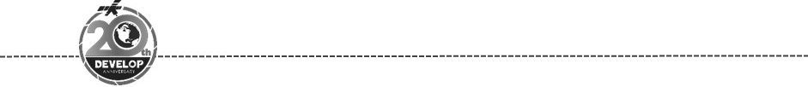
Georgia – Athens
Spring 2018

Miami Beach Urban Development II
Utilizing NASA Earth Observations to Assess Vegetation Resiliency and Water Quality to Enhance Green Infrastructure Plans in Light of Extreme Weather Events


Technical Report
Final Draft – March 29th, 2018

Austin Stone (Project Co-Lead)
Caren Remillard (Project Co-Lead)
Emad Ahmed
Matthew Becton
Shannon Duffy
Charles Lu

Dr. Rosanna Rivero, University of Georgia (Science Advisor)
Dr. Marguerite Madden, University of Georgia (Science Advisor)

Previous Contributors:
Maria Luisa Escobar Pardo
Christopher Cameron
Abhishek Kumar
Sonia Linton
David Rickless
Navid Hashemi Tonekaboni
Sam Weber

1. Abstract
In response to projected sea level rise and extreme weather events, the City of Miami Beach and other urban areas surrounding Biscayne Bay in southeast Florida are developing adaptive strategies to mitigate the effects of changing environmental conditions. City officials are involved with ongoing efforts to reduce storm damage and monitor water quality with the goal of protecting coastal resources. Some important considerations for these adaptive strategies include identifying resilient plant species and gaining a better understanding of water quality patterns. This NASA DEVELOP project employed Earth observations to assess post-Hurricane Irma canopy loss and recovery, in addition to water quality changes of the surrounding bay. These analyses will assist the Miami Beach Public Works Department in evaluating changing conditions across the Biscayne Bay area and provide decision makers with additional predictive insights from deep learning models to enhance restoration plans and undertake proactive countermeasures. The results of the vegetation damage and water quality analyses will aid the ecological management, hurricane preparedness, and land use planning efforts led by the city of Miami Beach to improve coastal resiliency.

Keywords
Sea level rise, coastal resources, Biscayne Bay, Hurricane Irma, deep learning, water quality, coastal resiliency, kriging

2. Introduction
  - Background Information
Due to changing climate influencing tropical storms and increasing sea level, conditions are becoming increasingly precarious for many coastal cities, such as Miami Beach, Florida (Spanger-Siegfried, Fitzpatrick & Dahl, 2014). Since 2006, the rate of sea level rise for Miami Beach has increased by 9 mm per year, well above the global average and thus causing an increase in annual flooding frequency (Wdowinski et al., 2016). The causes of this increase are complex, but what concerns residents and officials the most are the practical outcomes and how to apply counteractive policies to predict and mitigate damage caused by storms and flooding. Coastal vegetation has previously been shown to strongly reduce wave-induced damage from storm events, which has saved the United States an estimated $23.2 billion each year (Costanza et al., 2008). Florida, in particular, greatly benefits from coastal wetlands as the state ranks comparatively high in both total area of coastal wetlands and estimated value of human structures near the coast (Costanza et al., 2008). Due to the ever-increasing negative impacts of extreme weather on coastal communities, Miami Beach is working to evaluate and implement a variety of measures to improve its resiliency and to protect its economy, primarily its tourist industry, from degradation.

The term resiliency is both complex and meaningful. For areas such as Miami Beach, which values not only its urban resources such as buildings, but also natural resources such as vegetation and clear water, resiliency is tied to an understanding of both, as well as their ability to recover after extreme weather events. The resiliency of the City of Miami Beach and the surrounding Biscayne Bay area (Figure 1) depends on its ability to withstand and recover from disasters. Having a thoroughly planned disaster response plan in place is a critical step to successful recovery, rather than reacting to events after the damage has occurred. One major initiative, which strives to plan sustainability and urbanized ecology into the foundations of major cities, is the Rebuild by Design project (“Rebuild by Design”, 2017). This initiative has allowed city governments to develop plans with community members, such as businesses and non-profit organizations, to better understand how environmental and anthropic changes have left cities and other regions vulnerable to natural disasters and changing climate conditions. The goal is resiliency planning: a set of regulations and infrastructure planning which not only looks towards future dynamics between urban and natural systems, but also leverages ecological concepts to combine green and grey infrastructure to maximize disaster preparedness. To properly plan for these events, it is necessary to gather and analyze as much data as possible in a format which is both easily understandable and useful for policy decisions at both the city-wide and county-wide levels.

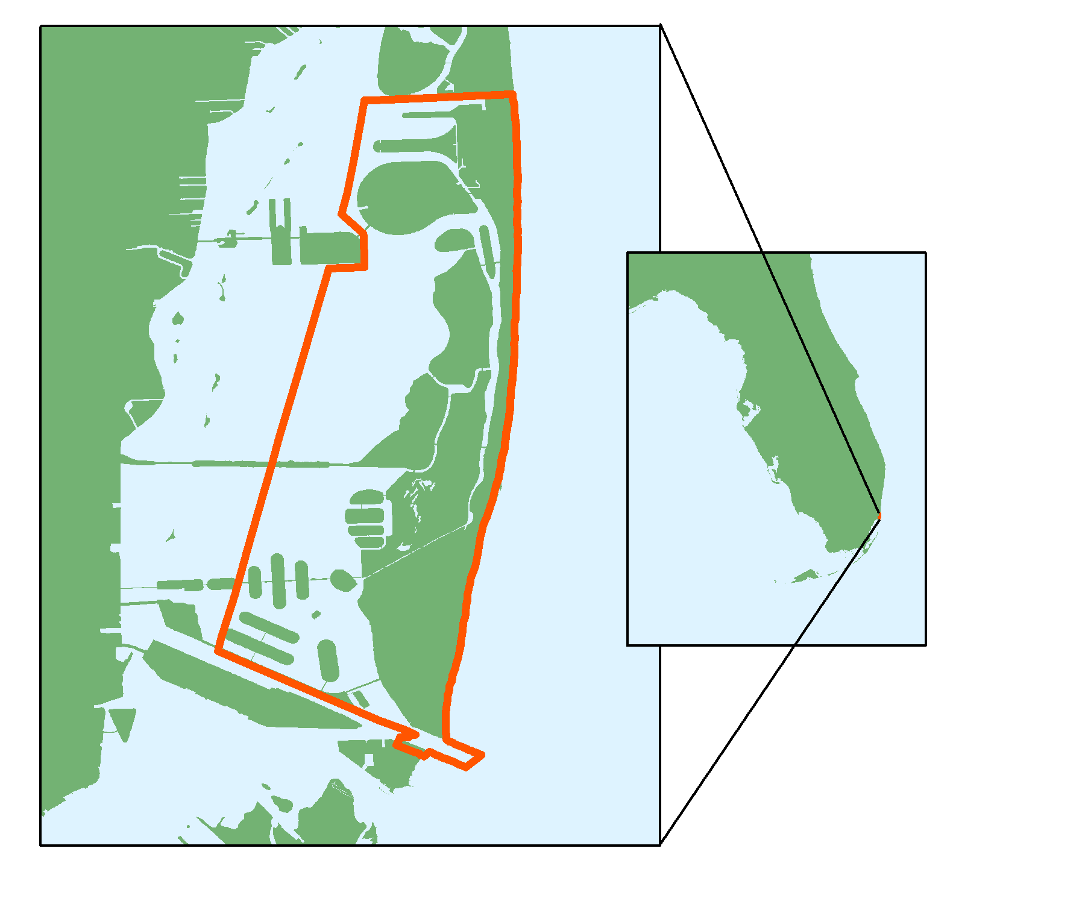
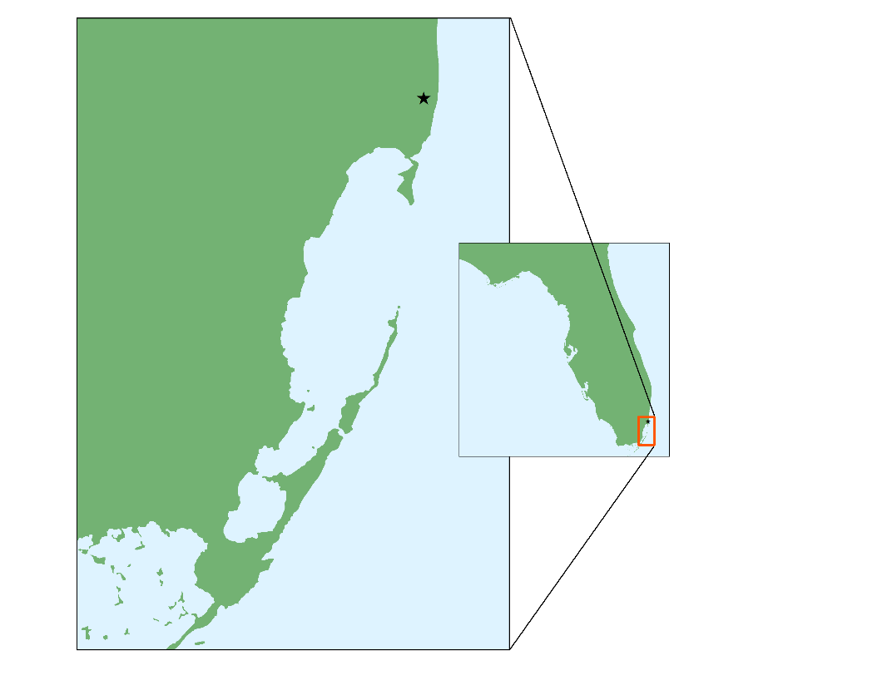
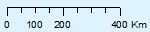
Increasing resilient vegetation for disaster protection initiatives will not only increase the amount of protection afforded to Miami Beach, but using plants that quickly regenerate after a disaster will decrease rebuilding costs in the future. Natural vegetation along coastal areas, denoted as “living shorelines”, have proven to not only reduce the impact of weather-based events on human structures, but they also have extended benefits including carbon sequestration and erosion control (Davis et al., 2015). To aid the City of Miami in its study of storm surge and sea level rise, we analyzed the impact Hurricane Irma had on water quality and the damage it caused to vegetation density, the recovery of damaged vegetation shortly after the hurricane, and the recovery of damaged vegetation by early 2018.
Biscayne Bay
City of
Miami Beach
Florida
Miami Beach
Biscayne Bay
Florida
(a) (b)

Figure 1. (a) Study area map showing the City of Miami Beach and nearby Biscayne Bay; (b) map of Miami Beach city limits

  - Project Partners & Objectives
The information provided by this study will aid the City of Miami Beach Public Works Department in implementing policies relating to the development and management of resilient vegetation, as well as influencing any projects dependent on the water quality in the Biscayne Bay. Currently, the city of Miami Beach’s Public Works Department is looking into several adaptive strategies to address vegetation loss and storm damage to infrastructure. These include raising roads, building seawalls, and upgrading storm water drainage systems (Cox & Araujo, 2017). Extreme weather events, such as hurricanes, can also have a strong influence on shallow coastal waters, such as those of Biscayne Bay. In addition to surface water flooding, Miami Beach faces subsurface water intrusion in lower areas of the city. According to recent geological studies, Miami Beach does not have a shallow confining geological unit that is typically used to retain salt water intrusion, making the city extremely vulnerable to sea level rise (Spanger-Siegfried, Fitzpatrick & Dahl, 2014).

However, the necessary measures designed to prevent flooding also bring a more severe impact to nearby waterways. The implementation of a forced-flow storm water system equipped with pump stations causes higher volumes of water to be discharged into Biscayne Bay over a shorter period of time when compared to the former gravity system originally built in Miami Beach. The presence of the pump stations and the expanded pipes can flush out a much higher volumetric flow rate of water and sediments, imposing more stress to water quality in the surrounding area. To mediate anthropocentric effects, the City of Miami Beach’s Public Works Department has implemented novel plastic filtration mechanisms into the new storm water network, preventing plastic pollution from being released into Biscayne Bay. Despite this, periodic monitoring is necessary to enhance knowledge about how current facilities influence water quality patterns in order to assist future planning and make improvements for the next generation of storm water systems. Thus, the water quality analyzed in this project will be used to help determine the impact of the current system, as well as plan out the next generation.

To help the City of Miami Beach Public Works Department implement countermeasures for extreme weather events in the future, this project used satellite data to highlight vegetation damage and recovery. Alongside vegetation indices, we used satellite imagery for a time series analysis of changes in the water quality in Biscayne Bay to supplement in situ water quality data. The results of this project will be used to enhance decisions on prioritizing areas of interest in relation to water quality and coastal resiliency. The objectives of this project were to: 1) examine vegetation loss and define areas with especially resilient vegetation, 2) determine water quality trends over time and use the data to program a predictive tool in order to have a reasonable metric for future planning, and 3) demonstrate the value of satellite imagery to complement in situ measurements for large-scale analysis to aid in future policy making. By contributing to a more comprehensive understanding of how satellite data can be used to assess vegetation resiliency and water quality change in the wake of natural disasters, this project addresses urban development concerns that arise from exposure to sea level rise and abnormal hurricane seasons. The end products from this project will allow the Public Works Department of Miami Beach to utilize existing Landsat 8 Operational Land Imager (OLI) and Aqua Moderate Resolution Imaging Spectroradiometer (MODIS) data to determine the future directions of their management strategies, especially in terms of improving the city's resiliency, and to mitigate the impacts of extreme weather events.

3. Methodology
Our methodology consisted of a vegetation resiliency and water quality analysis (Figure 2). The team’s first priority was to examine vegetation health prior to and following Hurricane Irma. Level 2 Landsat 8 OLI and PlanetScope imagery were downloaded and clipped to the study area and the Normalized Difference Vegetation Index (NDVI) was calculated to compare the resiliency of vegetation species during storm surges. The NDVI has been shown to be very accurate and reliable for determining vegetation coverage in coastal areas (Hoa, 2017).

To assess water quality in Biscayne Bay, we used data from Aqua MODIS between 2014 and 2017. In situ water quality measurements collected by the Department of Environmental Resources Management (DERM) were used to validate results of a satellite-based water quality analysis and to create a predictive forecasting tool using Deep Learning, which is a state-of-the-art machine learning method in many research fields such as remote sensing (Zhu et. al, 2017). The model’s results were then interpolated into kriged surfaces that we then compared with Aqua MODIS chlorophyll-a products.
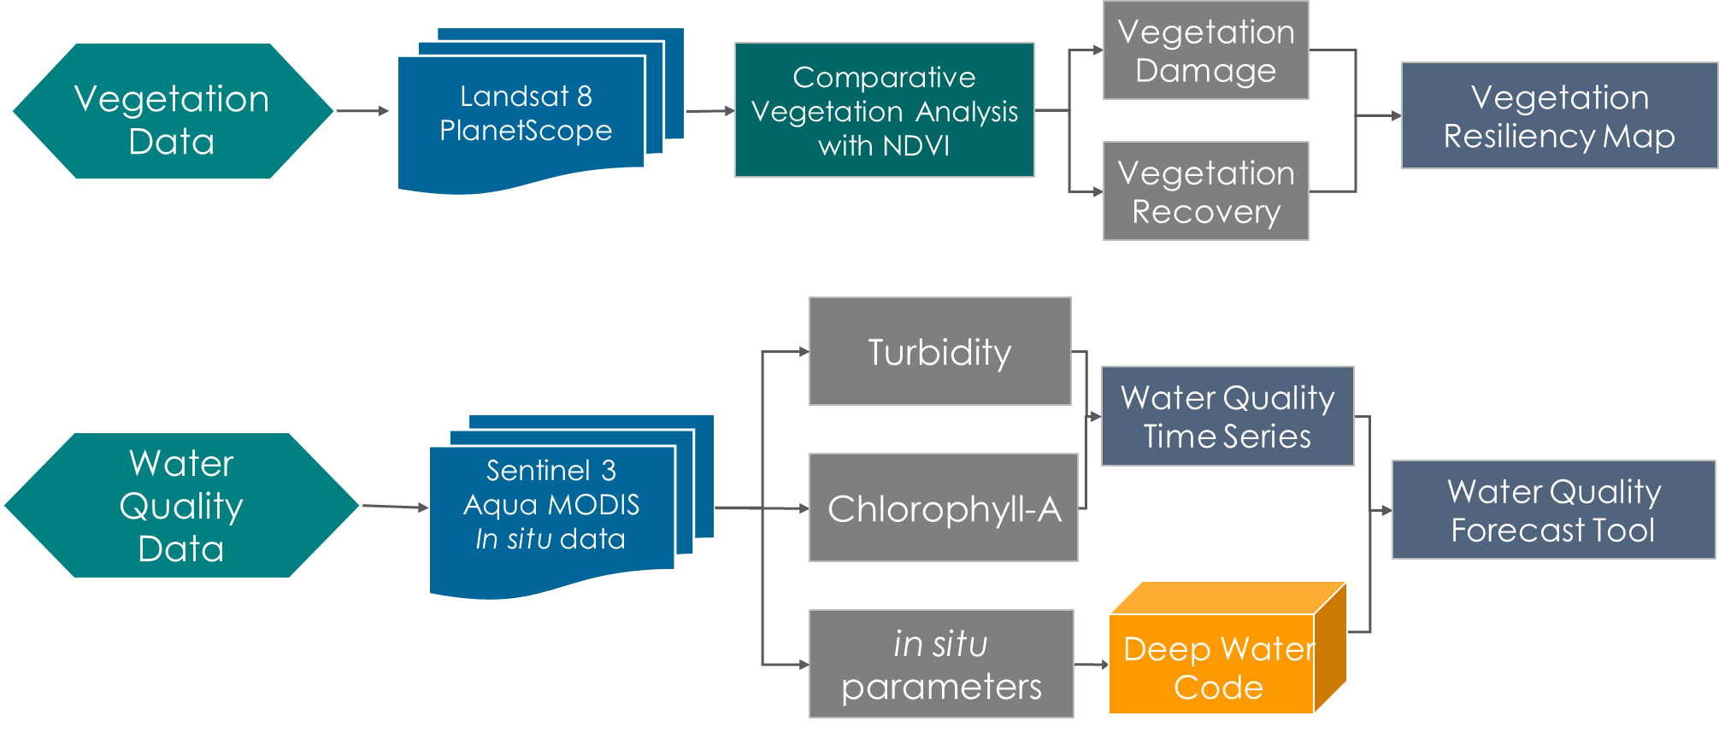
Figure 2. This is a methodology flowchart showing process for water quality and vegetation analysis.

3.1 Data Acquisition
To produce a time-series of vegetation resiliency in response to damage caused by Hurricane Irma in Miami Beach, we downloaded Landsat 8 OLI data from the USGS EarthExplorer and PlanetScope 4-band data from Planet Labs. We analyzed satellite data from Landsat 8 OLI acquired between September 7, 2017-December 12, 2017 and PlanetScope 4-band data from Planet Labs collected between September 7, 2017- December 12, 2017. The water quality analysis used Aqua MODIS data, acquired from NASA Ocean Color, spanning from 2014-2017. Table 1 gives a list of the observation platforms and sensors used in this work. Additionally, our project partner provided supplementary in situ data collected by DERM which tracked water quality variables such as turbidity, chlorophyll, pH, salinity, and dissolved oxygen in Biscayne Bay from 1990-2017 (Figure 3).

Table 1.
Earth observation and parameters used to monitor water quality and vegetation in Miami Beach

Platform & Sensor | Parameter | Dates of Imagery
Aqua MODIS | Chlorophyll-a | - January 2014  - January 2015  - January 2016  - January 2017
Landsat 8 OLI | Spectral vegetation indices | - September 7, 2017  - December 12, 2017
PlanetScope | Spectral vegetation indices | - September 7, 2017  - September 13, 2017  - October 30, 2017  - December 12, 2017

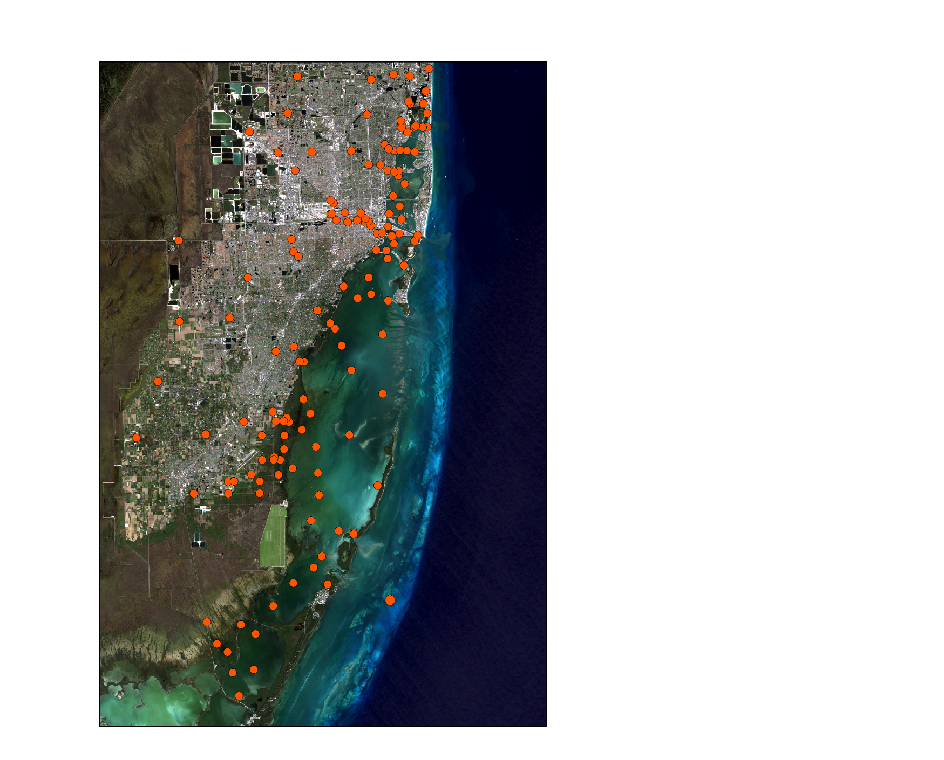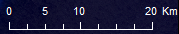
In situ Water Quality Testing Sites
Testing sites
Figure 3. This is a map of the water quality measurement station points provided by DERM

3.2 Data Processing
3.2.1 Vegetation Analysis
To prepare the PlanetScope 4-band images for the NDVI analysis, we mosaicked four different images from the same day to cover the extent of our study area for the following dates: September 7, 2017, September 13, 2017, October 30, 2017, and December 12, 2017. Landsat 8 OLI data covered our entire area and did not require mosaicking. The images were then clipped to the City of Miami Beach study area. We multiplied each band by the respective rescaling factor to convert the digital number (DN) to top of atmosphere reflectance value. Then we calculated the NDVI for each date using Equation 1 and removed numbers less than -1 and greater than 1, as those are outliers found mostly on the corners of images.
$\text{NDVI=}\frac{\text{NIR-Red}}{\text{NIR+Red}}$ (1)

After calculating the NDVI, we combined our results with green band values to more accurately depict vegetation cover. The resulting analysis produced 2 categories: vegetated (NDVI > 0.25 and green band < 0.135) and un-vegetated areas. We then reclassified the vegetated areas as canopy or shrubs and grasses using a similar technique by setting thresholds. We conducted a damage analysis on Landsat 8 OLI images between September 7th and December 12th. The dates collected allowed for data visualization of vegetation before and after Hurricane Irma, which impacted Miami on September 10, 2017. The Landsat 8 OLI data underwent the same process as the NDVI model described for the PlanetScope 4-band data. Because of its higher spatial resolution of 3 meters, the results of the PlanetScope analysis were used to validate our Landsat 8 vegetation loss analysis in greater detail, as Planet data has been shown to be comparable to Landsat 8 data for vegetation identification (McCabe, et al. 2017).

3.2.2 Water Quality Analysis
The data provided from DERM was comprised of 841,058 in situ measurements collected between 1990 and 2017 of 434 different attributes such as turbidity, salinity, and pH across 170 measurement stations in the Biscayne Bay area. Data were missing for the years 2015 and 2016. Only attributes with at least 1,000 measurements were considered for analysis, which left 31 of the 434 total attributes. As evidenced by Figure 4, some attributes are highly correlated and may indicate duplicate attributes measurements e.g. DO% and Dissolved Oxygen (Field), while strongly inverse correlations such as Dissolved Oxygen (Field) and Temperature are intuitive relationships.

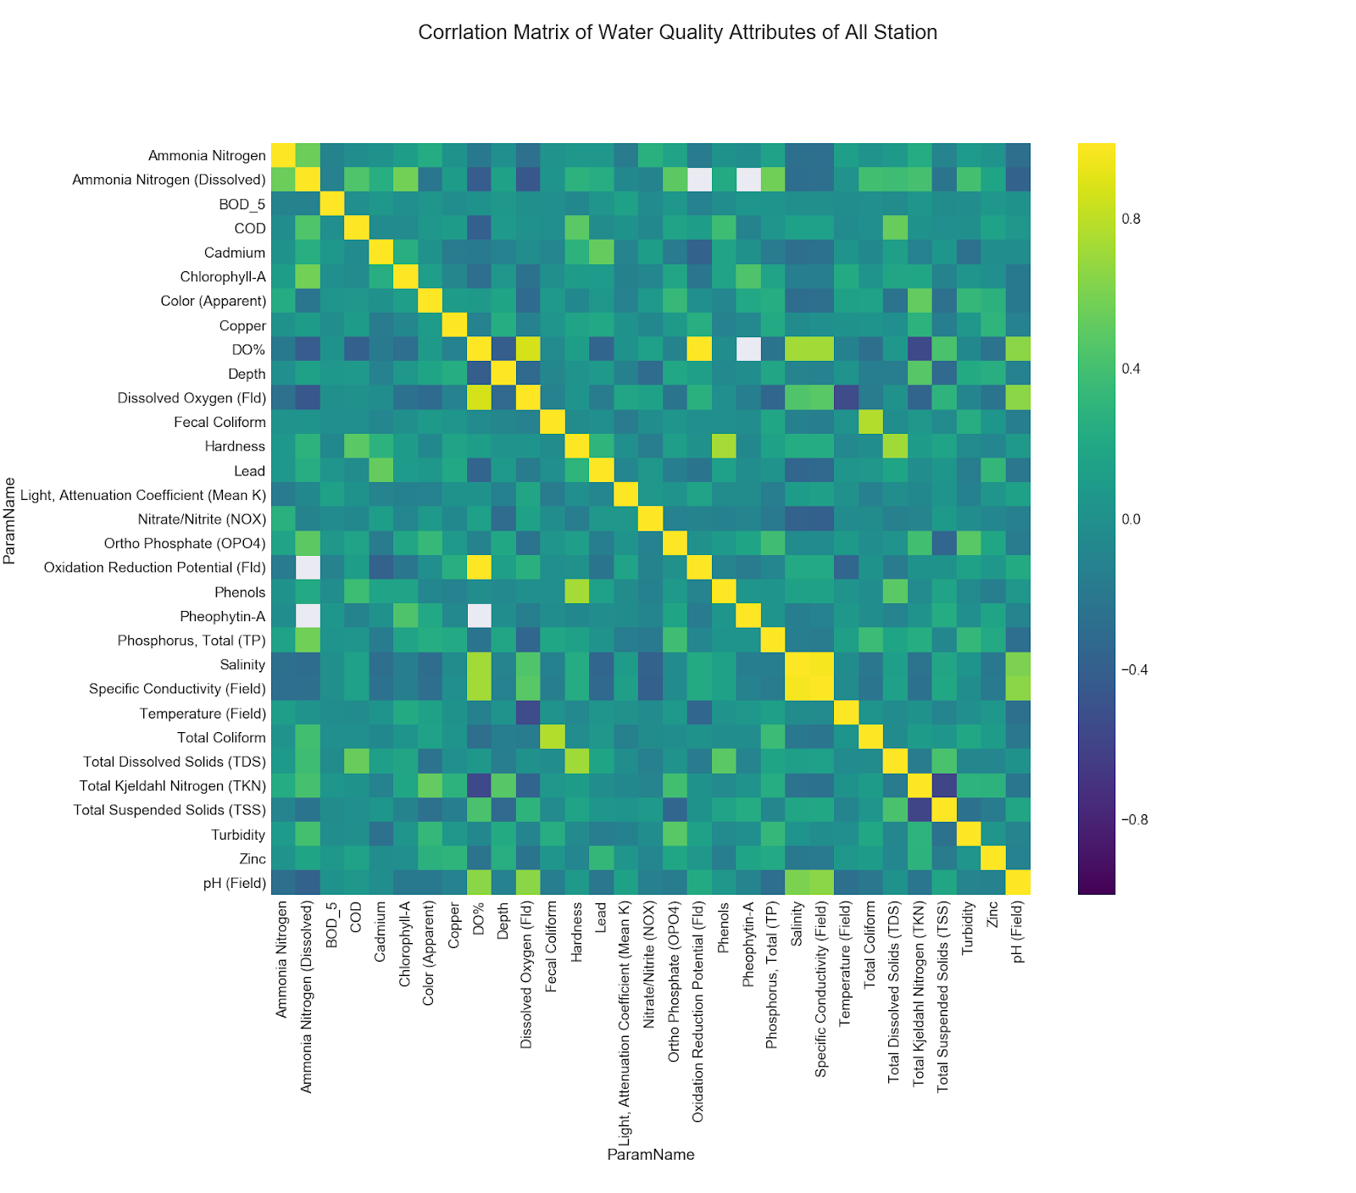
Figure 4. Correlation matrix of water quality attributes with more than 1,000 measurements collected by DERM

Ammonia Nitrogen
Ammonia Nitrogen (Dissolved)
BOD_5
COD
Cadmium
Chlorophyll-A
Color (Apparent)
Copper
DO%
Depth
Dissolved Oxygen (Fld)
Fecal Coliform
Hardness
Lead
Light (Mean K)
Nitrate/Nitrite (NOX)
Ortho Phosphate (OPO4)
Oxidation Reduction (Fld)
Phenols
Pheophytin-A
Phosphorus, Total (TP)
Salinity
Specific Conductivity (Field)
Temperature (Field)
Total Coliform
Total Dissolved Solids (TDS)
Total Kjeldahl NItrogen (TKN)
Total Suspended Solids (TSS)
Turbidity
Zinc
pH (Field)
Ammonia Nitrogen
Ammonia Nitrogen (Dissolved)
BOD_5
COD
Cadmium
Chlorophyll-A
Color (Apparent)
Copper
DO%
Depth
Dissolved Oxygen (Fld)
Fecal Coliform
Hardness
Lead
Light (Mean K)
Nitrate/Nitrite (NOX)
Ortho Phosphate (OPO4)
Oxidation Reduction (Fld)
Phenols
Pheophytin-A
Phosphorus, Total (TP)
Salinity
Specific Conductivity (Field)
Temperature (Field)
Total Coliform
Total Dissolved Solids (TDS)
Total Kjeldahl NItrogen (TKN)
Total Suspended Solids (TSS)
Turbidity
Zinc
pH (Field)

For the time-series analysis, the data was preprocessed to eliminate seasonal trends so that the predictive model is trained on a relatively stationary signal. Some attributes, such as temperature (Figure 5), showed strong non-stationarity and were differenced (subtract the past time step from current time step for all time steps) to get the residuals of the time series. The attribute data were also scaled to be in the range of (0, 1) so that different attribute units could be comparable and no attribute would be disproportionately weighted when the model is trained on the data. Further time-series decompositions are shown in Figures A4 and A5.

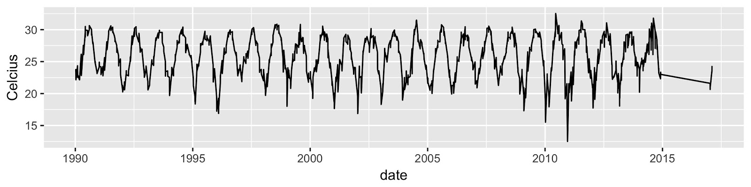
Figure 5. Plot of water temperature measurements for all 170 water quality measurement stations. There was a strong, non-stationary trend in annual seasonality due to natural seasonal temperature changes. Data was missing between 2015 and 2016, resulting in a gap in the results.
Temperature (°C)

To process in situ water quality parameters, we created kriged surfaces of data collection points to display point data collected in the months of January and March in 2014-2017. These surfaces allowed us to create a series of maps tracking both chlorophyll-a and turbidity as observed during Florida’s dry season in January and the onset of its wet season in March. Chlorophyll-a data points were kriged using a simple kriging method since it is suited for datasets in which a spatial trend in the data is generally understood (Liu et al., 2011). Turbidity data was kriged using a bayesian kriging method which allows for interpolation of points with more spatial variability (Cui et al., 1995). This worked well for our turbidity data which did not have as many data points as the chlorophyll-a and thus was not as suited for simple kriging. Our results were compared with Aqua MODIS chlorophyll-a products downloaded from NASA Ocean Color to gain a better understanding of spatial trends in water quality.

3.3 Data Analysis
3.3.1 Vegetation Analysis
To assess vegetation resilience, we conducted a comparative analysis of Landsat 8 and PlanetScope data. We analyzed vegetation damage with Landsat 8 imagery by calculating NDVI values from September 7, 2017 and December 12, 2017. These dates captured images directly before Hurricane Irma to several months after the event. We subtracted the December 12 NDVI values from the September 7 values and divided the result by the initial September 7 NDVI values to assess long-term vegetation damage resulting from the storm (Equation 2).

$\text{Damag}{\text{e}}_{\text{L8}}\text{ = }\frac{\text{NDV}{\text{I}}_{\text{Sep07}}\text{-NDV}{\text{I}}_{\text{Dec12}}}{\text{NDV}{\text{I}}_{\text{Sep07}}}$ (2)

The higher temporal resolution PlanetScope data allowed us to compare NDVI from dates immediately following the storm with values from several months prior to produce both damage and recovery results. We conducted a damage analysis of PlanetScope images by subtracting NDVI values after Hurricane Irma (September 13, 2017) from values before the storm (September 7, 2017) and then dividing the result by the value before the storm to calculate fraction of damage (Equation 3).

$\text{Damag}{\text{e}}_{\text{PS}}\text{ = }\frac{\text{NDV}{\text{I}}_{\text{Sep07}}\text{-NDV}{\text{I}}_{\text{Sep13}}}{\text{NDV}{\text{I}}_{\text{Sep07}}}$ (3)

Recovery could then be evaluated by using the difference in NDVI values between a day immediately after the storm (September 13, 2017) and 3 months after (December 12, 2017). Finally, we divided this value by the damage extent to get a percent recovered from damage (Equation 4).

$\text{Recover}{\text{y}}_{\text{PS}}\text{ = }\frac{\text{NDV}{\text{I}}_{\text{Dec12}}\text{-NDV}{\text{I}}_{\text{Sep13}}}{\text{NDV}{\text{I}}_{\text{Sep07}}\text{-NDV}{\text{I}}_{\text{Sep13}}}$ (4)

3.3.2 Water Quality Analysis
Time-series prediction models typically use a fixed window of timesteps to make predicted forecasts but ignore timesteps outside that window of consideration. This missing information is often important to tasks with complex time-series patterns. We mitigated this issue by using Deep Learning, specifically Recurrent Neural Networks (RNN) – that can “remember” past information inside its internal memory state cells. A popular variant of RNN, Long Short-Term Memory (LSTM) networks, has been successfully used in time-series prediction tasks with state-of-the-art accuracy on many benchmark datasets (LeCun, Bengio & Hinton, 2015). A LSTM model can be modeled using Equation 5, where σ_{g} denotes the sigmoid function, σ_{h} denotes the hyperbolic tangent function, and $∘$ denotes the element-wise multiplication (Hochreiter & Schmidhuber, 1997).

f_{t} = σ_{g} ( W_{f} x_{t} + U_{f} h_{t-1} + b_{f} )
i_{t} = σ_{g} ( W_{f} x_{t} + U_{i} h_{t-1} + b_{i} )
o_{t} = σ_{g} ( W_{o} x_{t} + U_{o} h_{t-1} + b_{o} ) (5)
c_{t} = f_{t} $∘$c_{t -1} + i_{t} $∘$σ_{h} ( W_{c} x_{t} + U_{c} h_{t-1} + b_{c} )
h_{t} = o_{t} $∘$σ_{h} ( c_{t} )

The matrices W_{q} represents the weights of the inputs and U_{q} represents the weights of the recurrent connections, where q is either the input gate i, the output gate o, the forget gate f, or the memory cell c. The input vector is x_{t} where t is the current timestep. The parameters of the weight matrix W and the bias vector b are learned during training usually by a gradient optimization algorithm (Algorithm 1).

Input: Training Data D, learning rate $η$, initialization $σ$, epochs $ε$
Output: Model parameter weights $θ =(W_{0}, W)$
$W_{0} ←$Normal(0, 1);
$W←$Normal(0, 1);

for epoch in $ε$ do
for $(x,y)$ in D do
$$w_{0} ←w_{0} - η ∇ loss ( \hat{y} (x | θ), y) ;$$

for i in $\{1, 2, .... n\}$ do
$$W←W - η ∇\sum_{i=1}^{n}{loss ( (\hat{y_{I}}(x_{i} | θ),y_{i}) ;}$$
end for
end for
end for

Algorithm 1. Gradient Descent, an optimization used to minimize a loss function to train neural networks

An LSTM model was trained for each of the stations for Chlorophyll-a, Turbidity, and pH. The water quality dataset was split into 35% training, 20% validation, and 45% testing sets for walk-forward evaluation (Figure 6). Model hyper-parameters, such as the learning rate, number of LSTM cell units, and number of training epochs, were tuned by a grid search on the validation set as to not introduce data leakage. The performance and efficacy of the learned feature representation of water quality attributes were evaluated on the test set using Root Mean Squared Error (RMSE) (Equation 6) where $y$ is the true value, $\hat{y}$ is the predicted value, and $n$ is the number of observations as the error metric.

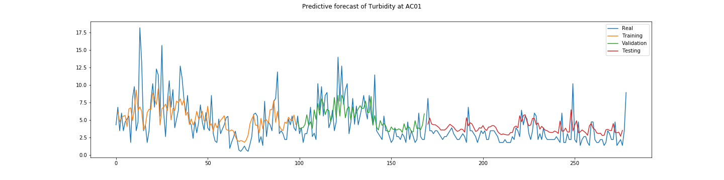
Figure 6. Training of the LSTM model on turbidity forecasting by assessing the accuracy.

Nephelometric Turbidity Unit
1990
2014
1994
1998
2002
2006
2010
Real
Training
Validation
Testing

$\text{MSE=}\sqrt{\frac{\sum_{\text{i=1}}^{\text{n}}{{\text{(}{\text{y}}_{\text{i}}\text{-}{\text{y}\text{̂}}_{\text{i }}\text{)}}^{\text{2}}}}{\text{n}}}$ (6)

We then generated kriged surfaces derived from the results of our model to visualize the spatial distribution of water quality parameters in Biscayne Bay. Kriging has been shown to effectively process water quality data points as a tool for predictive modeling (Yang & Jin, 2010). Using Aqua MODIS Chlorophyll-a products downloaded from NASA Ocean Color, we were able to make comparisons between in situ measurements and remotely sensed chlorophyll-a values.

4. Results & Discussion
4.1 Analysis of Results
4.1.1 Vegetation Results
The vegetation analysis showed that vegetation made up 30% of land cover in Miami Beach before Hurricane Irma (Figure 7A). Of that existing vegetation, 74% experienced moderate to severe damage soon after the storm (Figure 7B). Three months after Irma hit Miami Beach, 80% of initially damaged vegetation recovered over 50%, and 45% of damaged vegetation was more than 80% recovered (Figure 7C). Additionally, a visual comparison of our time-series illustrated that canopy cover experienced the most severe damage while areas of grasses and shrubs were less impacted by the storm (Figure 7A-B).

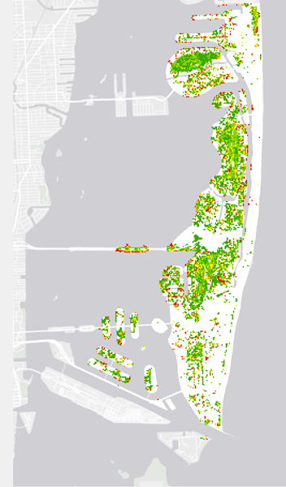
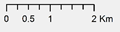


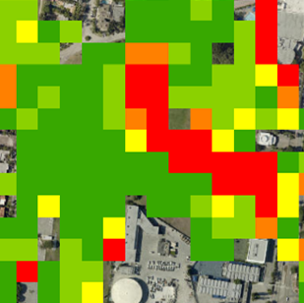
No Damage
Minimal Damage
Moderate Damage
High Damage
Severe Damage
Long-term Damage
September 7, 2017 –
December 12, 2017

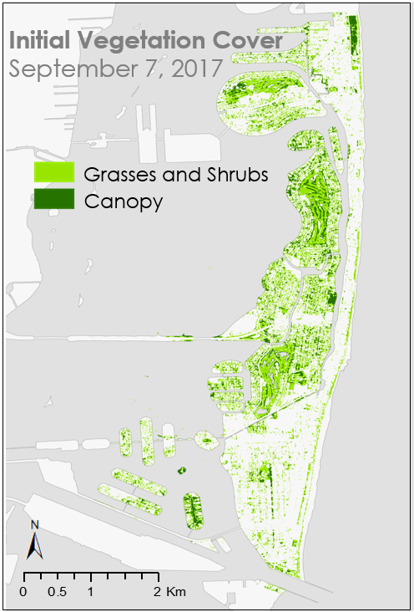
A
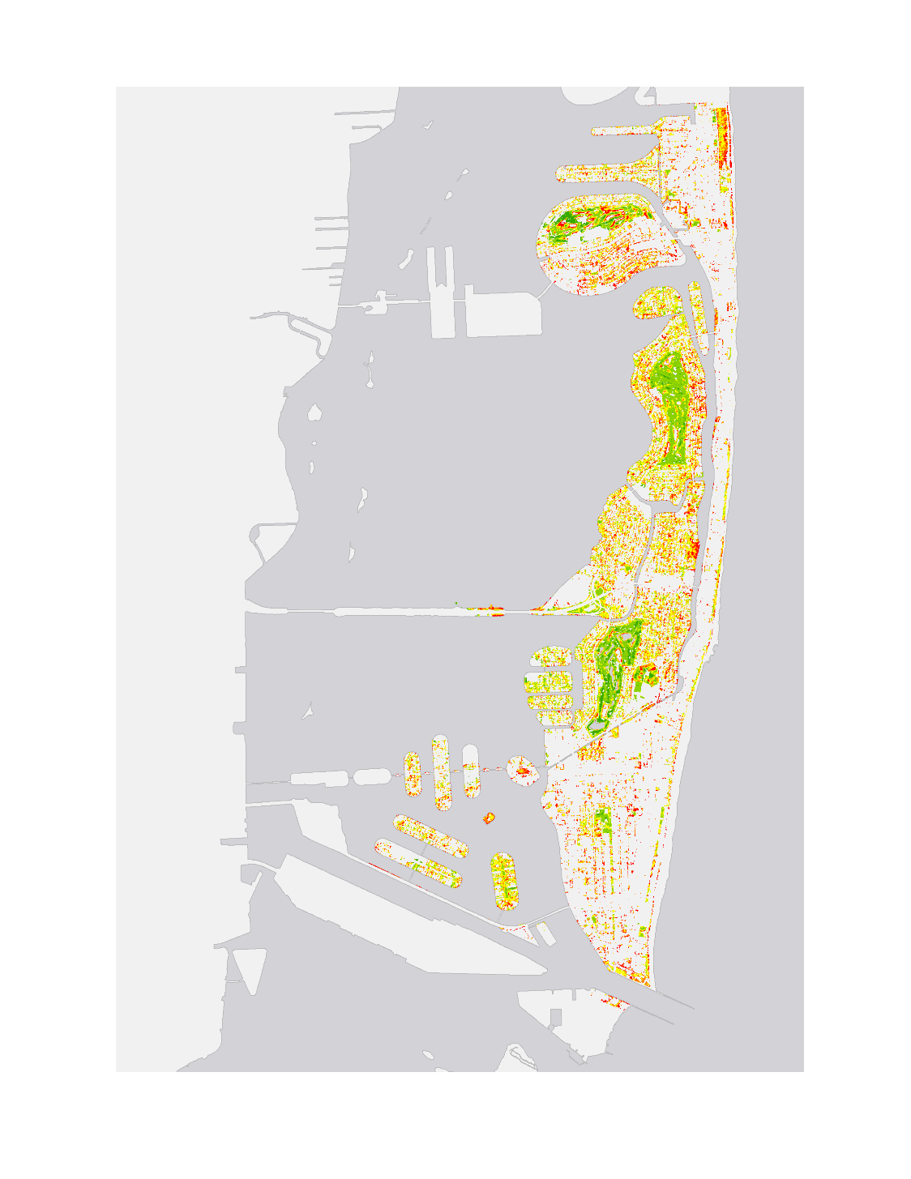
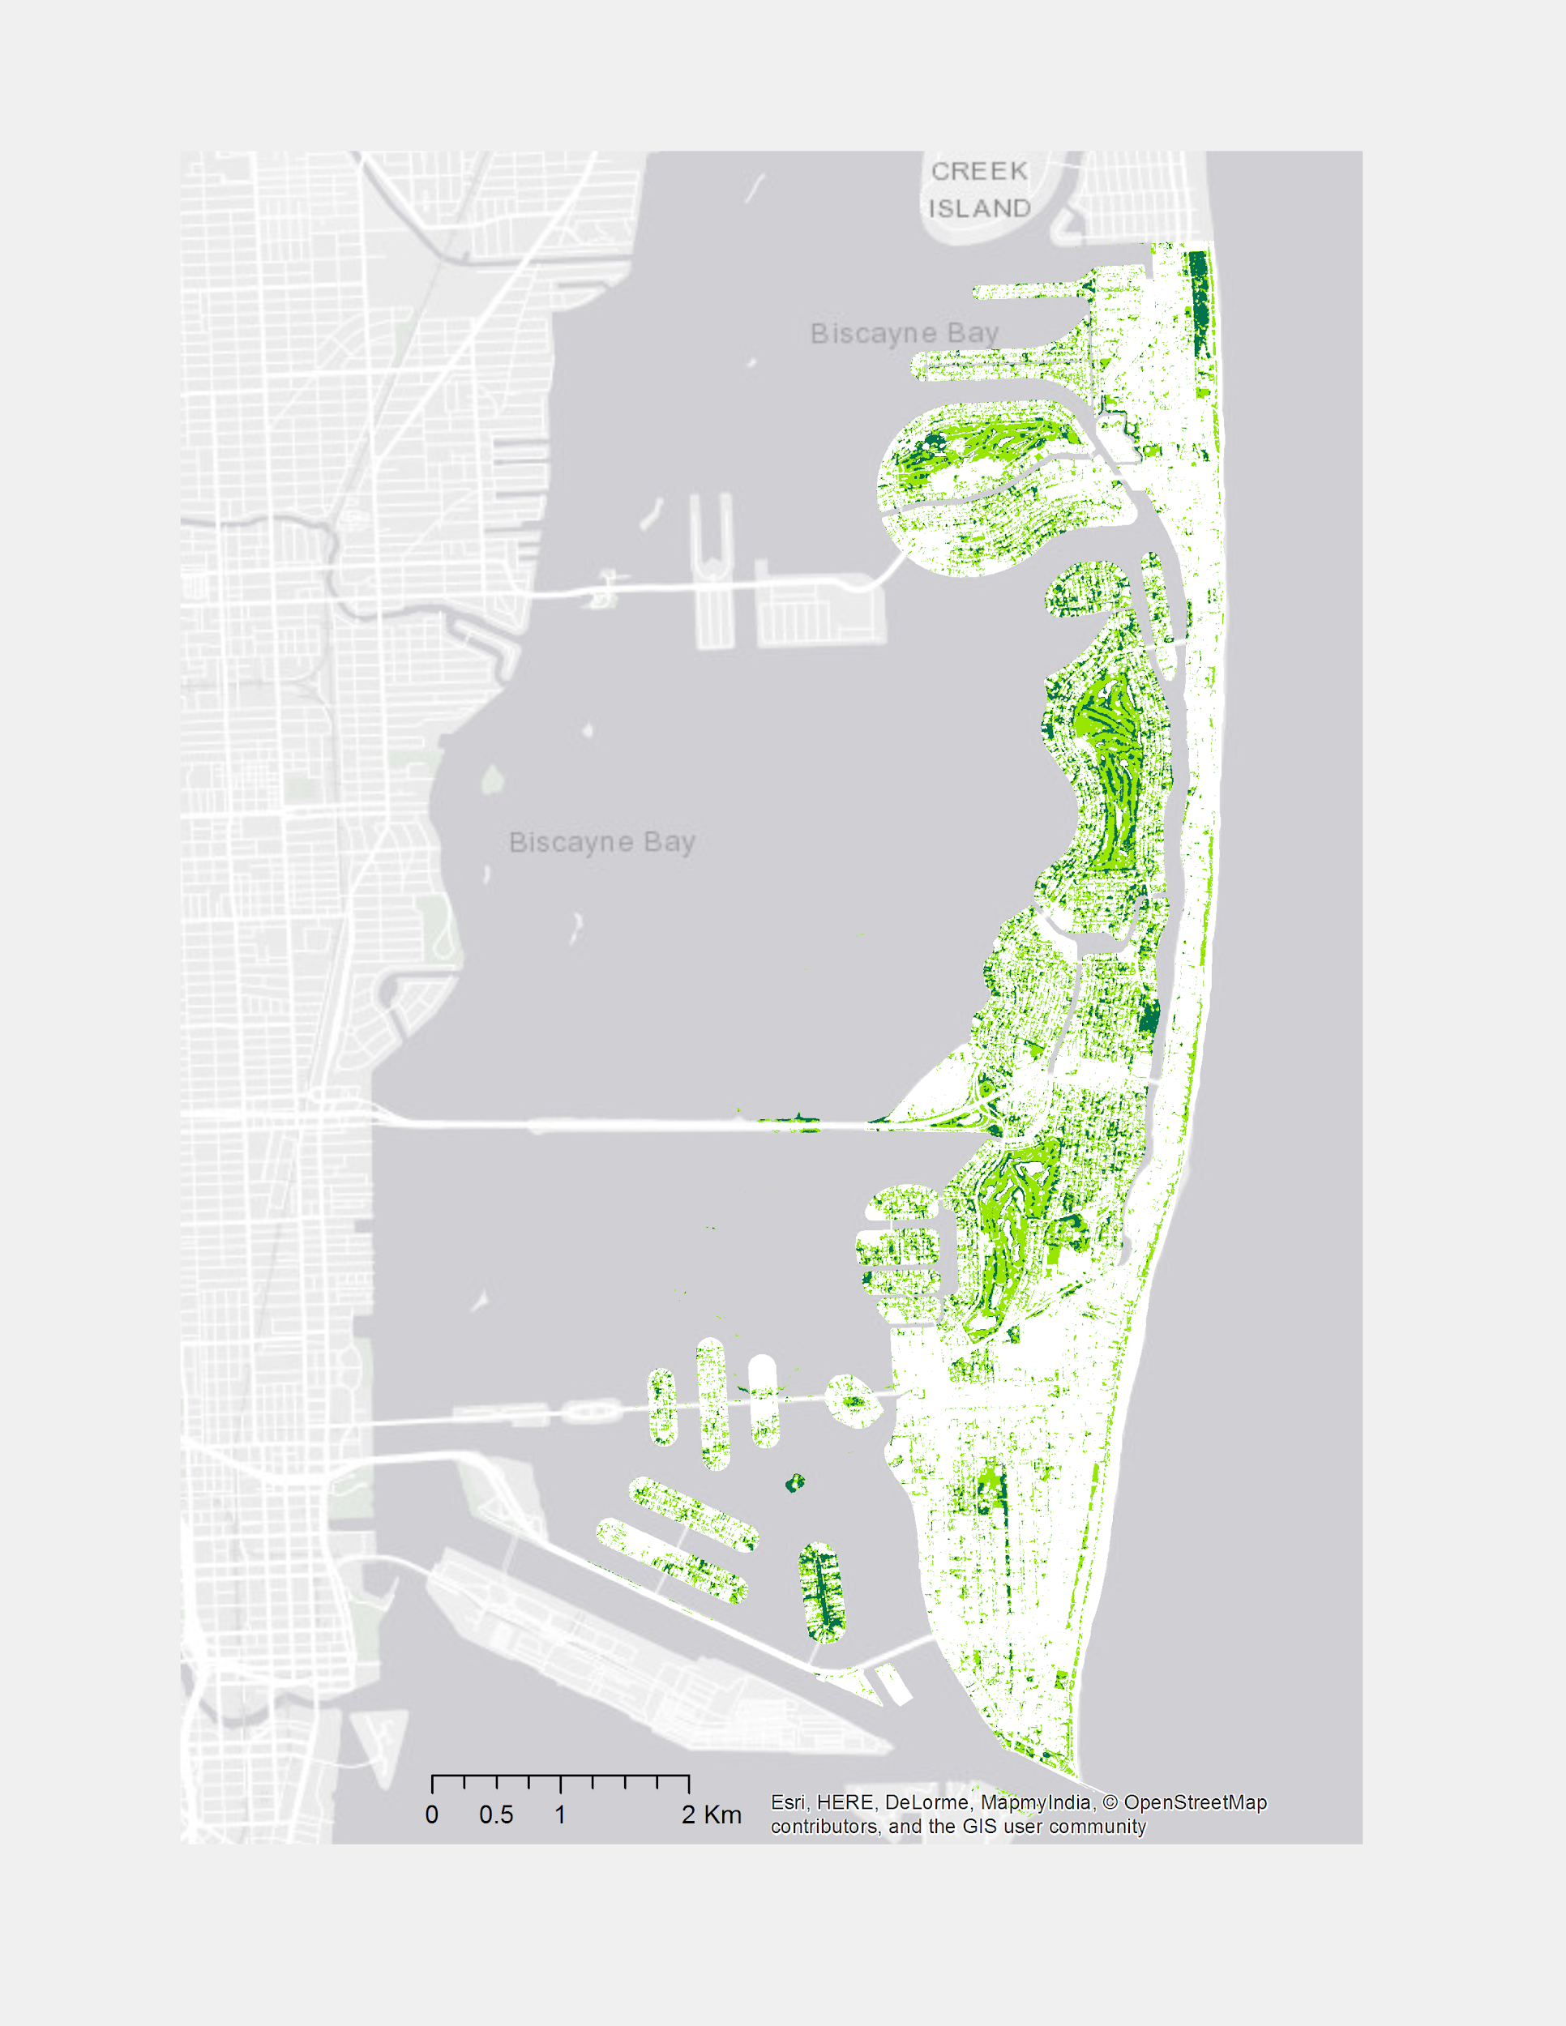
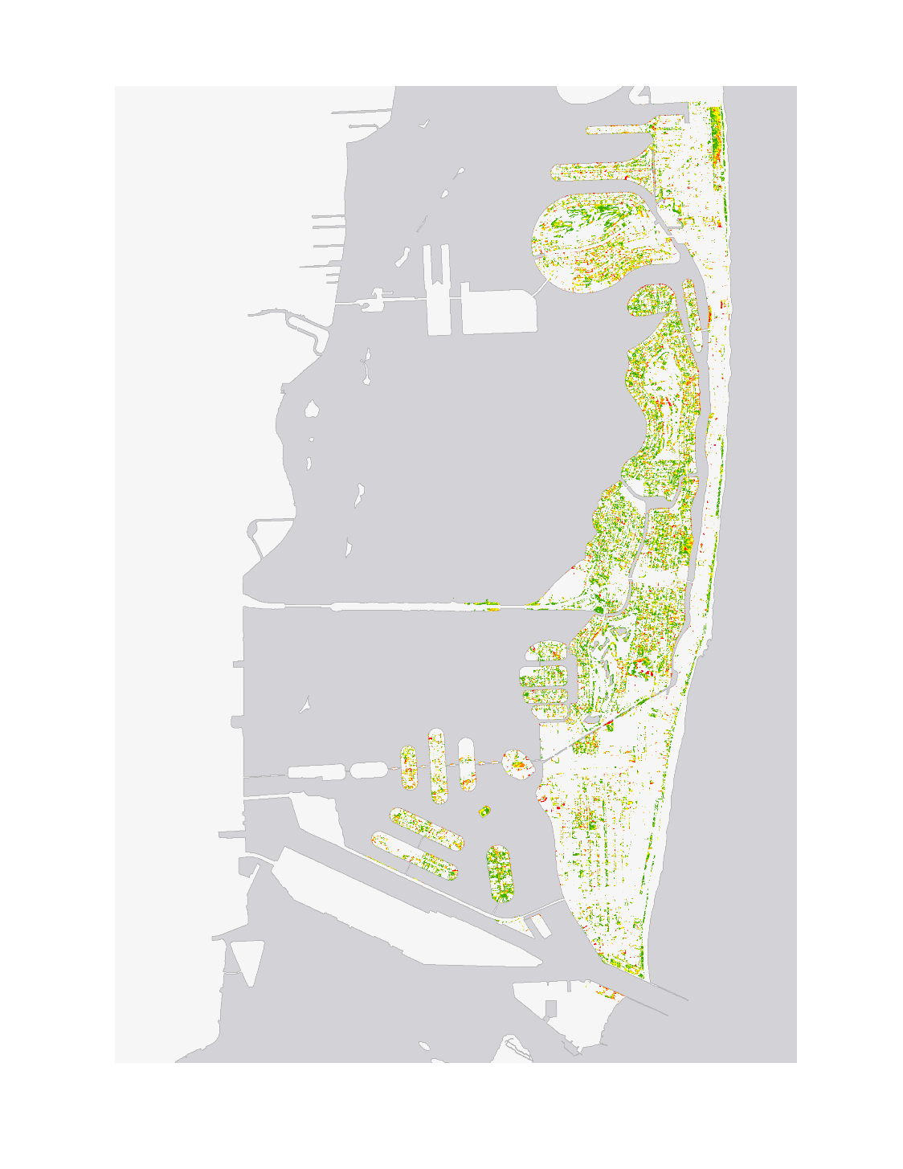

Figure 7. (a) Initial vegetation cover map created with PlanetScope data (b) Immediate vegetation damage map created with PlanetScope data (c) Vegetation recovery map using PlanetScope data

BD
C
No Damage
Minimal Damage
Moderate Damage
High Damage
Severe Damage
Immediate Damage
September 13, 2017

No Recovery
Minimal Recovery
Moderate Recovery
High Recovery
Full Recovery
Vegetation Recovery
December 12, 2017
4.1.2 Water Quality Results
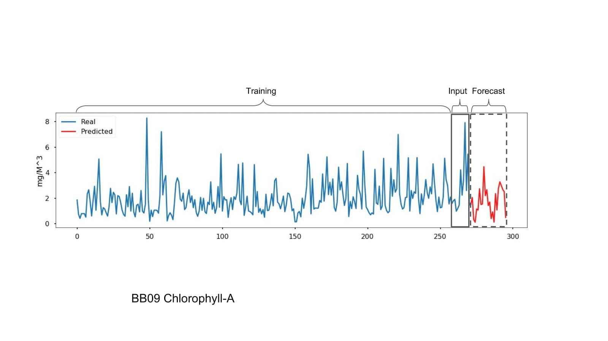
An LSTM model was trained for each Biscayne Bay measurement station for the attributes chlorophyll-a, turbidity, and pH; each measurement set came from 30, 78, and 79 stations respectively. Stations without data for December 2014 were excluded from modeling to maintain comparability during model training and forecasting. After the best hyper-parameter settings for the model were found using the grid search method described above, a separate model was trained on all available data for each station until December 2014 to predict the missing data for years 2015 and 2016. To predict these missing values each station used a window of 6 months (from July 2014 to December 2014) to forecast 24 months ahead (Figure 8).
A
Input
Forecast
Training
ml/m³
Real
Predicted
1994
1998
2002
2006
2010
2014
2017
2015
1990

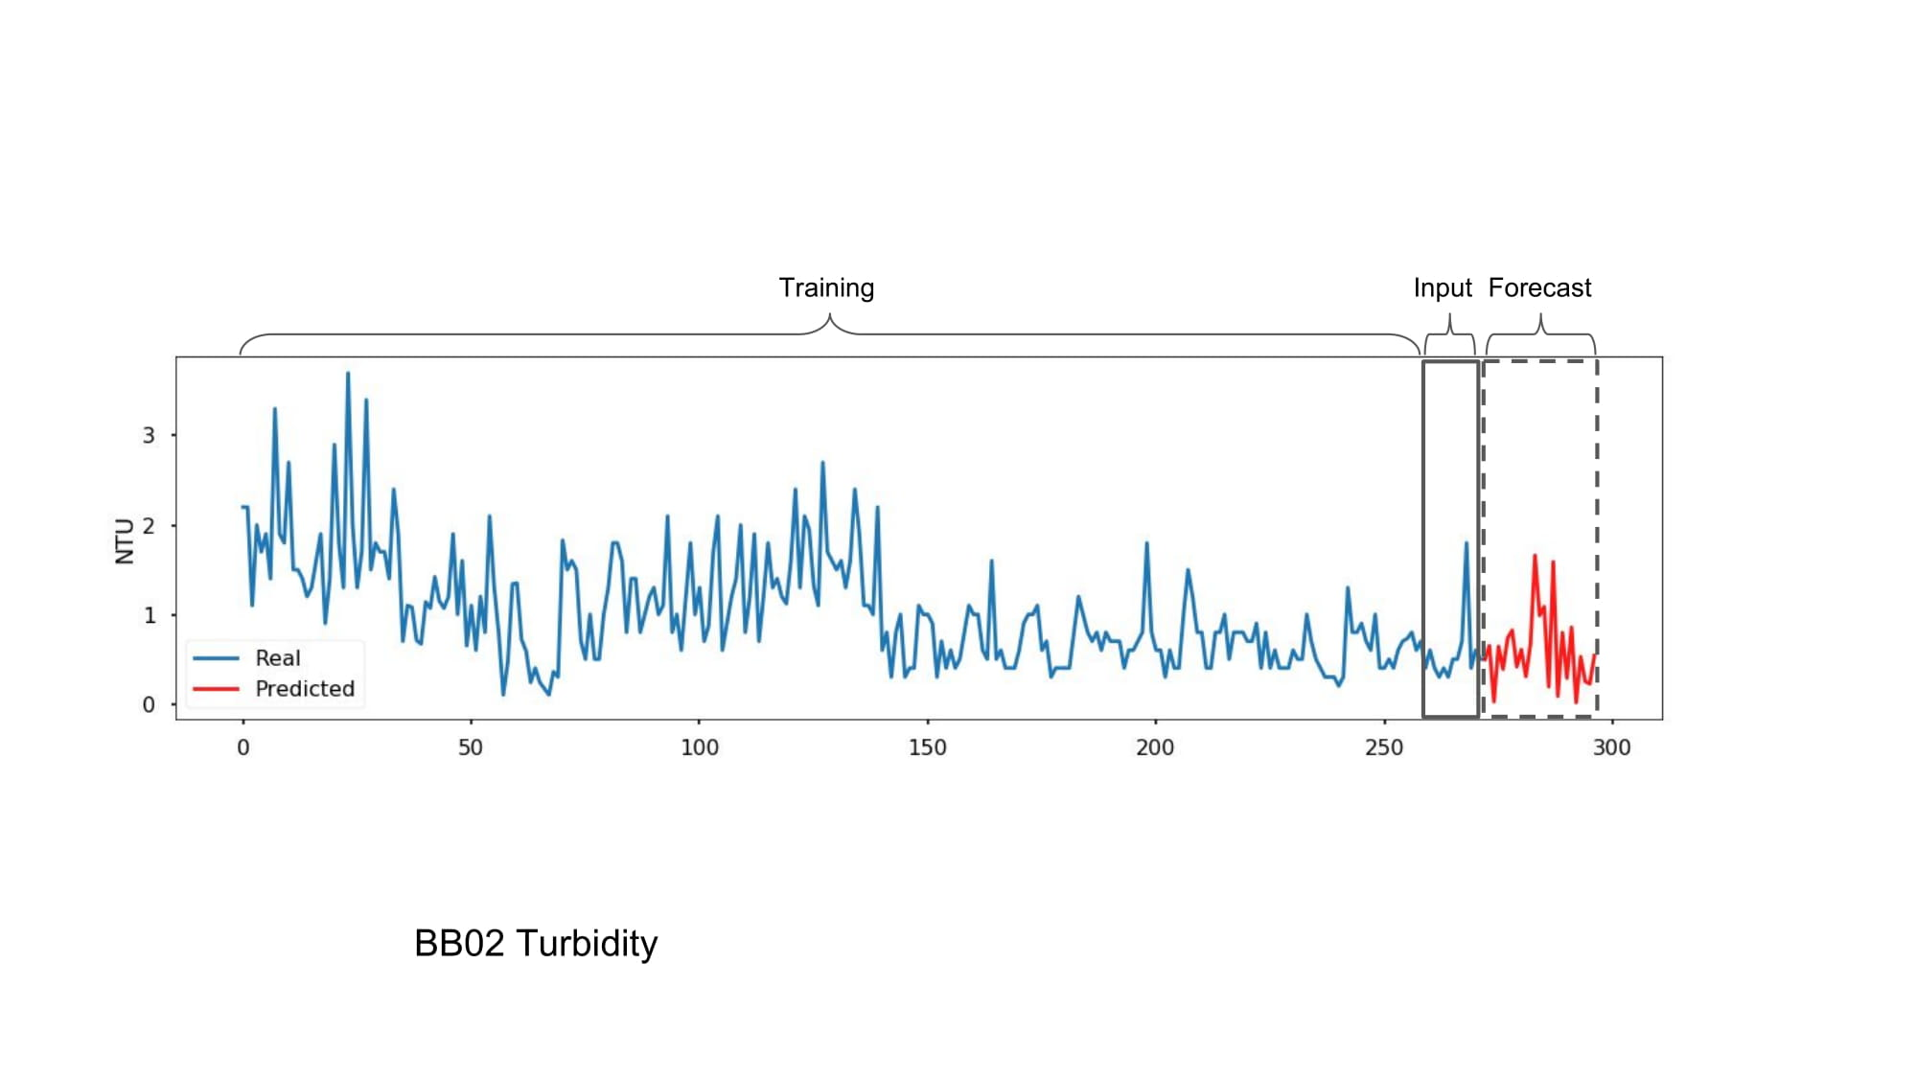
Figure 8. (a) Predicted forecast of chlorophyll-a for station AR03. (b) Predicted forecast of turbidity for station BB02.

1994
1998
2002
2006
2010
2014
2017
2015
1990
NTU
Real
Predicted
Input
Forecast
Training
B

Because neural network models are trained by Stochastic Gradient Descent (SGD) optimization, weights are initialized with different random values every time the model is trained, and the same model can converge to different minimas (LeCun, Bengio & Hinton, 2015). Therefore, models with the same hyper-parameters were re-trained multiple times to produce summary statistics of each model’s performance to analyze the model’s robustness and ability to generalize to new data (Table 2). The boxplot shows the effect of the number of LSTM cells on test accuracy for water station AC01 on turbidity with 10 training runs (Figure 9).

Table 2.
Summary statistics of neural network model
Statistic | 1 | 2 | 3 | 4 | 5 | 6
count | 10 | 10 | 10 | 10 | 10 | 10
mean | 0.399163 | 0.390956 | 0.381053 | 0.381874 | 0.379867 | 0.382649
std | 0.018788 | 0.009577 | 0.007482 | 0.013983 | 0.006877 | 0.011786
min | 0.374459 | 0.378251 | 0.372125 | 0.369307 | 0.372721 | 0.371331
25% | 0.386395 | 0.387534 | 0.375583 | 0.374896 | 0.375530 | 0.374437
50% | 0.398470 | 0.388288 | 0.380134 | 0.379659 | 0.376473 | 0.379707
75% | 0.405753 | 0.394914 | 0.385184 | 0.382340 | 0.382865 | 0.386158
max | 0.434959 | 0.409812 | 0.395880 | 0.418817 | 0.395172 | 0.409651

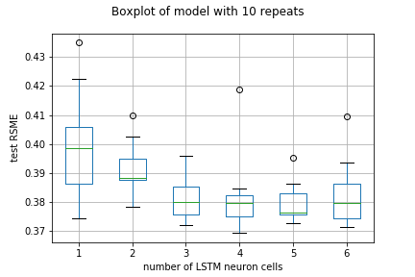
Test RMSE
Number of LSTM Cells
Figure 9. Boxplot of the effect of the number of LSTM cells on test RMSE accuracy over 10 runs.

To visualize these results, we created kriged surfaces of both in situ and predicted chlorophyll-a measurements (Figure 10). The resulting maps showed a general trend in which concentrations are higher in inland turbidites and lower further out into the Biscayne Bay. In addition, we noted an anomaly in the data for the month of January 2014. We hypothesize that this spike in Chlorophyll-a could be a result of the particularly cold winter that year which could contribute to an increase in nutrients in the water and therefore an increase in aquatic vegetation production. Chlorophyll-a concentrations have been known to increase when sea surface temperatures become colder (Walker, et al. 2005).

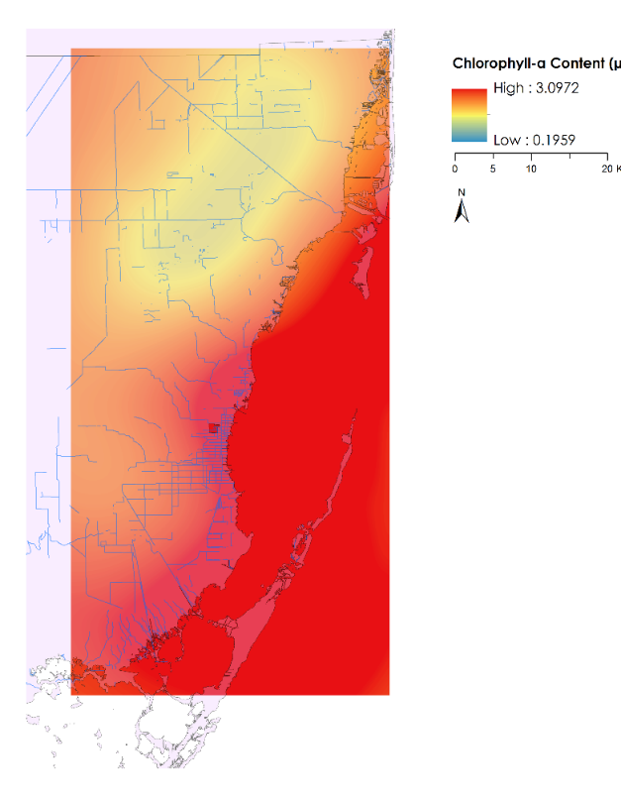
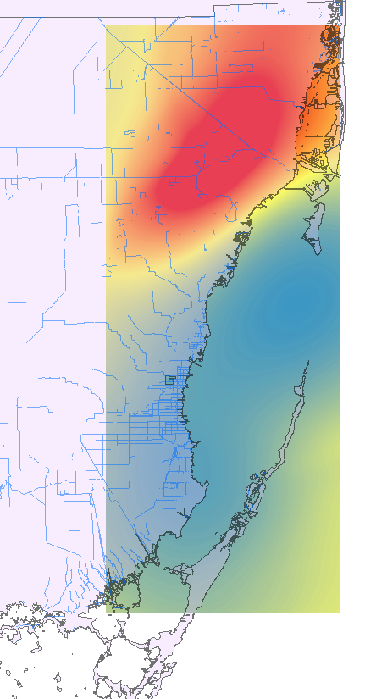
January 2015*

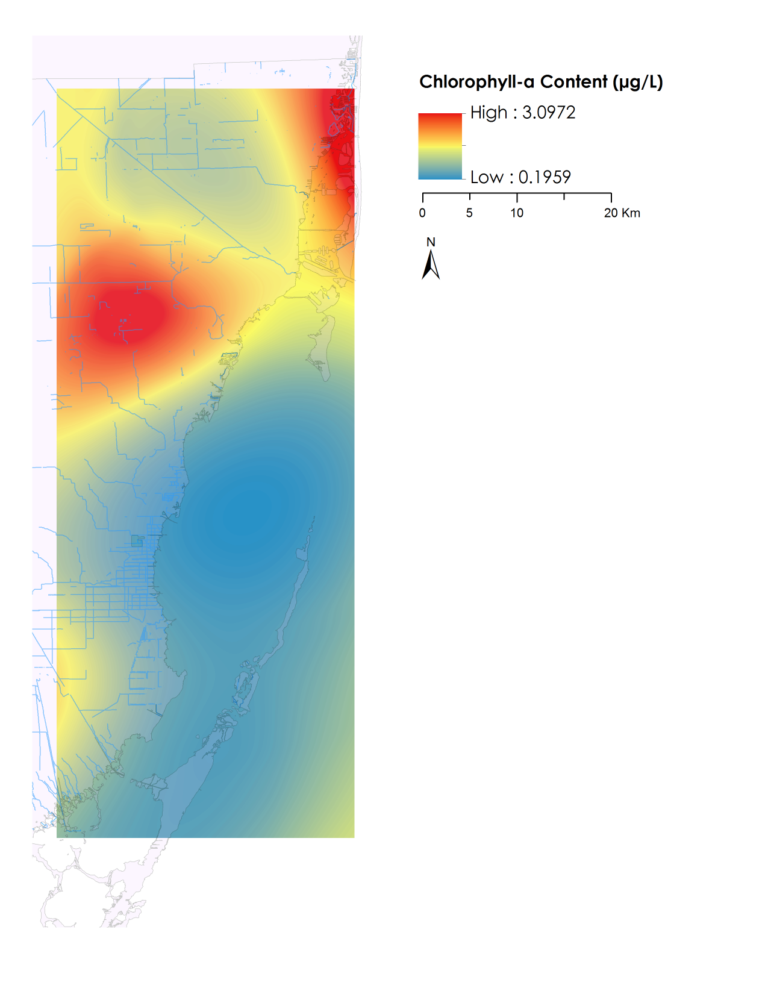
January 2014
Chlorophyll-a Content (µg/L)
High : 3.0972
Low : 0.1959
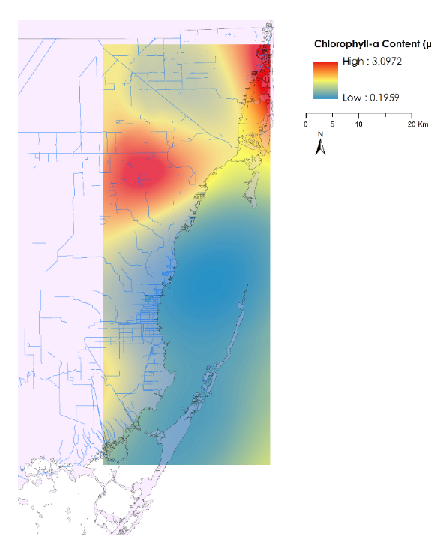
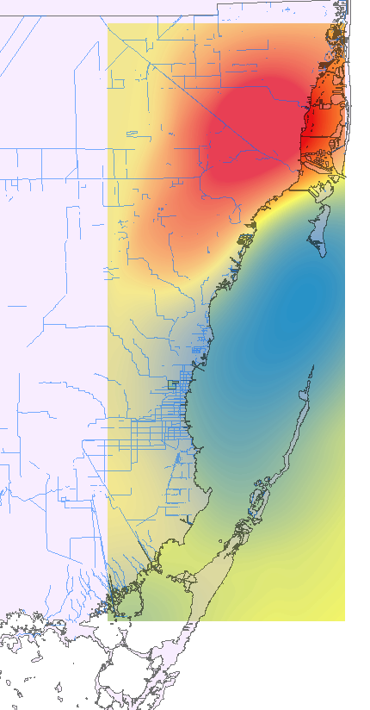
January 2016*

January 2017

Figure 10. Chlorophyll-a concentrations in the Biscayne Bay (January 2014-January 2017) produced using in situ data from DERM and results of our predictive model. Starred months’ values were generated using predictive model.

4.2 Future Work
Higher spatial resolution satellite data, like Sentinel-3, could compensate for the low spatial resolution of Aqua MODIS data used in the water quality analysis of this project. This will help encourage our partners by using Earth observations as a method to improve water management strategies. Our partner could also benefit from further development of the predictive tool that could automatically generate kriged visualizations to complement the graphs already created. This would allow the Miami Beach Public Works Department to efficiently track water quality patterns long term. Future teams could also conduct a similar analysis focused on other hurricanes to compare vegetation resiliency. Finally, project partners could provide data points to help validate areas where vegetation was damaged and to provide more information regarding specific vegetation species.

5. Conclusions
The result from the vegetation analysis clearly showed the importance of using vegetation indices to identify vegetation coverage and to monitor vegetation health after extreme events like hurricanes. However, obtaining images throughout the duration of the event, is crucial to gain a better understanding of the impact and recovery rate of vegetation. The City of Miami Beach Public Works Department will use our results to identify which plant species were most resistant to damage in the short term and which species recovered effectively in the long term. This information will help them identify which species are the most resilient when impacted by extreme weather events. Moving forward, they will also employ this information to better direct their focuses for green infrastructure plans.

Our analysis of water quality showed higher turbidity and chlorophyll-a closer inland and very low variance between 2004 to 2013. Chlorophyll-a showed a large increase around 2005 that may warrant further investigation. Our predicted model forecasted similar distributions of chlorophyll-a and turbidity to the in situ data. As shown in Figure 11, the MODIS distribution for chlorophyll-a were consistently higher than both the in situ and predicted chlorophyll-a values. This is also evident in Figure 12 where MODIS shows very high values for the entire bay area while the LSTM model predicted high chlorophyll-a values around the city and in an inland area.
Figure 11. Comparison of MODIS, in situ, and predicted Chlorophyll-a between 2014 and 2017

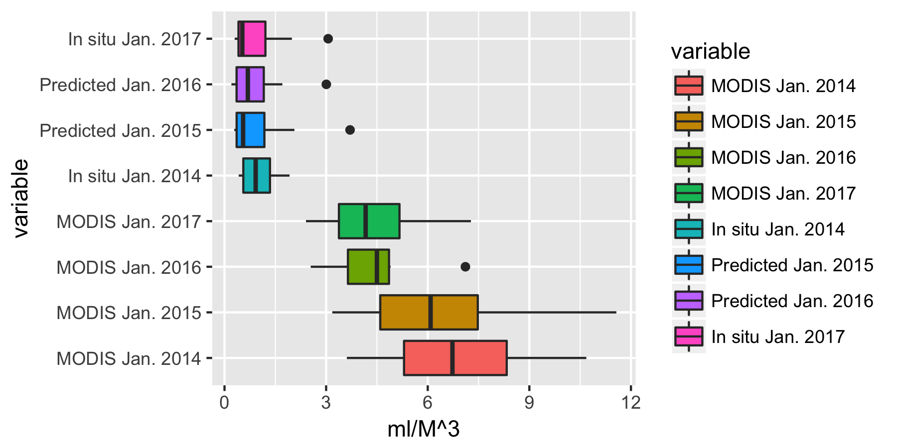
In situ Jan 2017

Predicted Jan 2016

Predicted Jan 2015

In situ Jan 2014

MODIS Jan 2017

MODIS Jan 2016

MODIS Jan 2015

MODIS Jan 2014
mL/m³
Comparison of MODIS, in situ, and predicted Chlorophyll-a
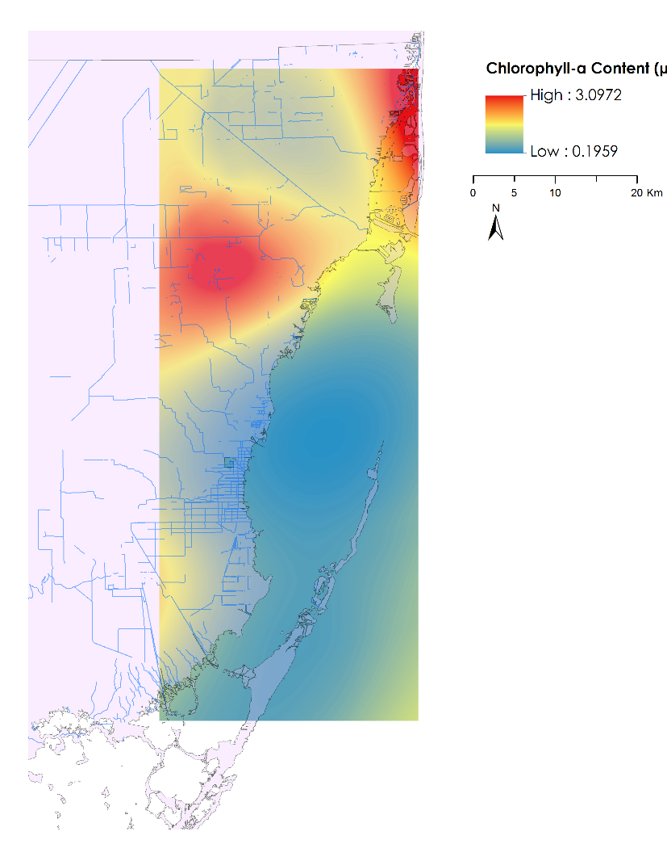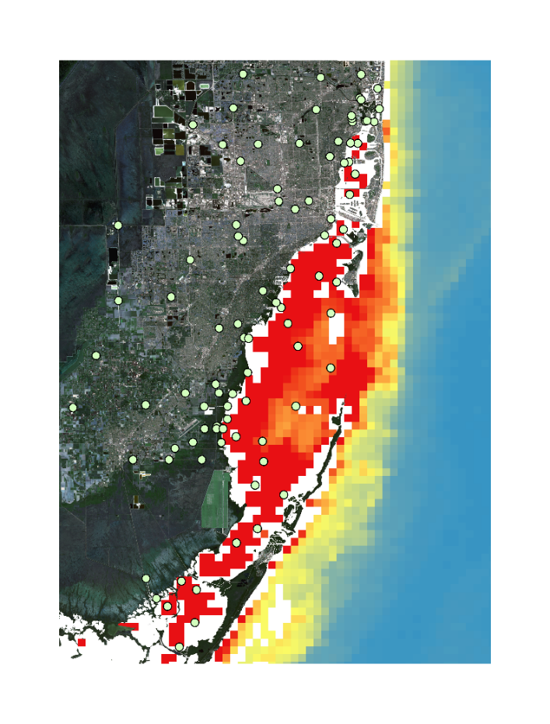
Chlorophyll-a Content (µg/L)
High: 3.0972
Low: 0.1959
Figure 12. Comparison of MODIS and predicted Chlorophyll-a using LSTM model January 2017
In order to validate the use of kriging as a spatial interpolation method for water quality parameters, including turbidity and chlorophyll-a, we overlaid in situ data values on our kriged surfaces. Although the Aqua MODIS water quality analysis did not produce data with a comparable spectral resolution to our study area, this comparison of kriged field measurements to remotely sensed imagery could apply to larger study areas that require smaller spatial resolutions. Likewise, using higher resolution data such as that produced by Sentinel-3, could present opportunities for our partner to better compare and visualize the in situ measurements.

In conclusion, our team has analyzed satellite imagery to assess the damage and recovery of coastal and urban vegetation in the City of Miami Beach in response to Hurricane Irma. In addition, we have shown that deep learning models can use historical in situ measurements to train a tool that predicts trends in future behavior of water quality parameters. In combination with Earth observations, this forms a powerful and intuitive tool which can be used to generate maps that better assess impacts of severe weather events and plan for new policies. Our work can be used to set the foundation for a methodology to develop more resilient, ecologically-aware cities.

6. Acknowledgments
We would like to thank our science advisors Dr. Rosanna Rivero of the University of Georgia College of Environment and Design, and Dr. Marguerite Madden of the University of Georgia Department of Geography. We would also like to thank our project partners at the City of Miami Beach Public Works Department, and especially Francisco D’Elia, for continued support and involvement throughout this project. Finally, we would like to acknowledge the team members who completed the first phase of this project during the Fall 2017 term: Maria Luisa Escobar Pardo, Christopher Cameron, Abhishek Kumar, Sonia Linton, David Rickless, Navid Hashemi Tonekaboni, and Sam Weber.
Any opinions, findings, and conclusions or recommendations expressed in this material are those of the authors and do not necessarily reflect the views of the National Aeronautics and Space Administration.

This material is based upon work supported by NASA through contract NNL16AA05C and cooperative agreement NNX14AB60A.

7. Glossary
Artificial Neural Network (ANN) – A machine learning model inspired by its biological counterpart and consists of many interconnected neuron units that pass information between layers to learn feature mappings when train on input data
Deep Learning (DL) – Another term for neural network based approaches that utilize many neural network layers to learn complex, hierarchical feature maps from very large datasets
Kriging – A method of interpolation that generates an estimated surface from a scattered set of points with z-values
Landsat 5 Thematic Mapper (TM) – Launched on March 1, 1984, the Landsat 5 satellite provided multispectral images of Earth until January 2013, it is also the current record holder as the longest operating Earth observation satellite.
Landsat 8 Operational Land Imager (OLI) – Launched on February 11, 2013, the Landsat 8 satellite images the entire Earth every 16 days in an 8-day offset from Landsat 7 and acquires moderate resolution multispectral images of the globe.
Long Short-Term Memory networks (LSTM) – A type of recurrent neural network that uses different gating mechanisms to control how input information is stored and forgotten in a neuron unit’s internal memory
Moderate Resolution Imaging Spectroradiometer – Terra (MODIS-Terra) – With its high temporal resolution and 36 discrete spectral bands, the moderate-resolution imaging spectroradiometer is ideal for tracking large scale changes.
Normalized Difference Vegetation Index (NDVI) – A numerical indicator that uses the visible and near-infrared bands of the electromagnetic spectrum, and is adopted to analyze remote sensing measurements and assess whether the target being observed contains live green vegetation or not
Recurrent Neural Networks (RNN) – A type of neural network architecture commonly used for sequential data and learning tasks such as language translation, time-series prediction, and speech recognition
Resiliency – The capacity of an ecosystem to respond to a perturbation or disturbance by resisting damage and recovering quickly

8. References
Costanza, R., Pérez-Maqueo, O., Martinez, M. L., Sutton, P., Anderson, S. J., & Mulder, K. (2008). The value of coastal wetlands for hurricane protection. Ambio, 37(4), 241-248.

Cui, H., Stein, A., & Myers, D. E. (1995). Extension of spatial information, bayesian kriging and updating of prior variogram parameters. Environmetrics, 6(4), 373–384. https://doi.org/10.1002/env.3170060406

Davis, J. L., Currin, C. A., O'Brien, C., Raffenburg, C., & Davis, A. (2015). Living shorelines: coastal
resilience with a blue carbon benefit. Plos One, 10(11), https://doi.org/10.1371/journal.pone.0142595

Hoa, N. H. (2017). Comparison of various spectral indices for estimating mangrove covers using PlanetScope data: a case study in Xuan Thuy national park, Nam Dinh province. Management of Forest Resources and Environment, 5, 74-83.

Hochreiter, S. & Schmidhuber, J. (1997). Long Short-Term Memory. Neural Computation, 9(8), 1735-1780.

LeCun, Y., Bengio, Y., & Hinton, G. (2015). Deep Learning. Nature, 521, 436-444, doi:10.1038/nature14539

Liu, Wen-Cheng, Yu, H., & Chung, C. (2017). Assessment of Water Quality in a Subtropical Alpine Lake Using Multivariate Statistical Techniques and Geostatistical Mapping: A Case Study. International Journal of Environmental Research and Public Health, 8(4), 1126-1140.

McCabe, M. F., Aragon, B., Houborg, R., & Mascaro, J. (2017). CubeSats in hydrology: ultrahigh-resolution insights into vegetation dynamics and terrestrial evaporation. Water Resources Research, 53, 10017-10024.

NASA Goddard Space Flight Center, Ocean Ecology Laboratory, Ocean Biology Processing Group. Moderate-resolution Imaging Spectroradiometer (MODIS) Aqua Ocean Color Data; 2018 Reprocessing. NASA OB.DAAC, Greenbelt, MD, USA. doi:10.5067/AQUA/MODIS/L2/OC/2018.

Planet Team (2017). Planet Application Program Interface: In Space for Life on Earth. San Francisco, CA. https://api.planet.com.

Rebuild by Design - in Partnership with 100 Resilient Cities (2017, November 10). Retrieved from: http://www.rebuildbydesign.org/.

Spanger-Siegfried, E., Fitzpatrick, M., & Dahl, K. (2014). Encroaching Tides. Greentips, 1-64.

U.S. Geological Survey Earth Resources Observation and Science Center. (2014). Provisional Landsat OLI Surface Reflectance. [Landsat 8].US Geological Survey. https://doi.org/10.5066/F78S4MZJ

Walker, N. D., Leben, R. R., & Balasubramanian, S. (2005). Hurricane‐forced upwelling and chlorophyll a enhancement within cold‐core cyclones in the Gulf of Mexico. Geophysical Research Letters, 32, L18610, doi:10.1029/2005GL023716

Wdowinski, S., Bray, R., Kirtman, B. P., & Wu, Z. (2016). Increasing flooding hazard in coastal communities due to rising sea level: Case study of Miami Beach, Florida. Ocean and Coastal Management, 126, 1-8. doi:10.1016/j.ocecoaman.2016.03.002

Yang, X. & Jin, W. (2010). GIS-based spatial regression and prediction of water quality in river networks: A case study in Iowa. Environmental Management, 1943-1951. doi:10.1016/j.jenvman.2010.04.011

Zhu, X. X., Tuia, D., Mou, L., Xia, G., Zhang., L., Xu, F., & Fraundorfer, F. (2017). Deep Learning in Remote Sensing: A Comprehensive Review and List of Resources. IEEE Geoscience and Remote Sensing, 5(4), 8-36. doi:10.1109/MGRS.2017.2762307

9. Appendices

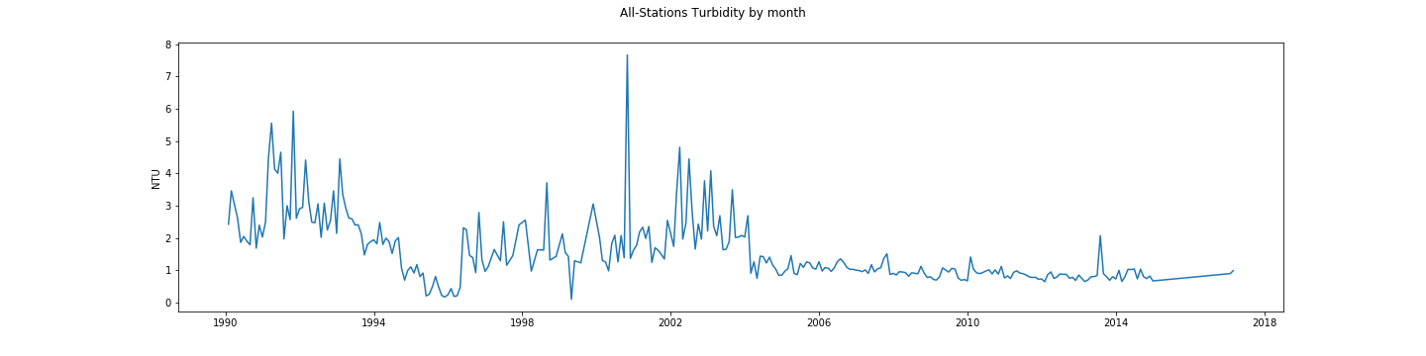
(a)
(b)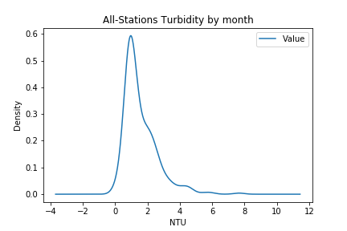 (c)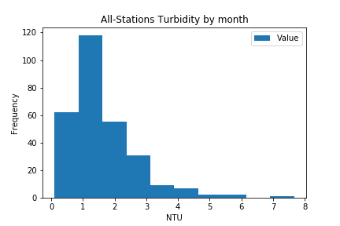

Figure A1. (a) Line plot of turbidity measurements for all 170 stations for every month. (b) Density plot of turbidity measurements. (c) Histogram chart of turbidity measurements.

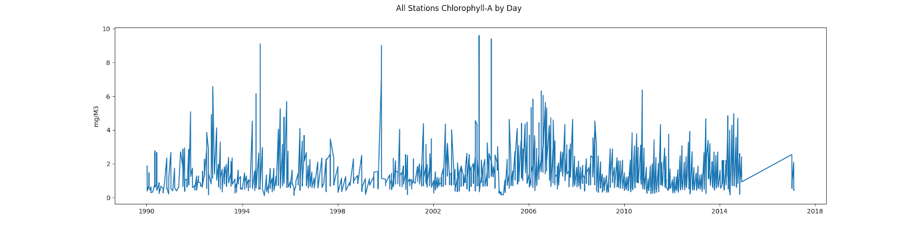
(a)
(b)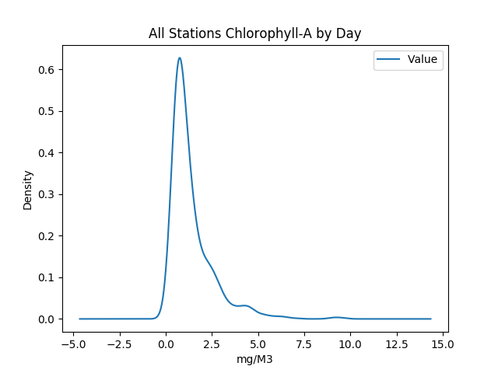 (c)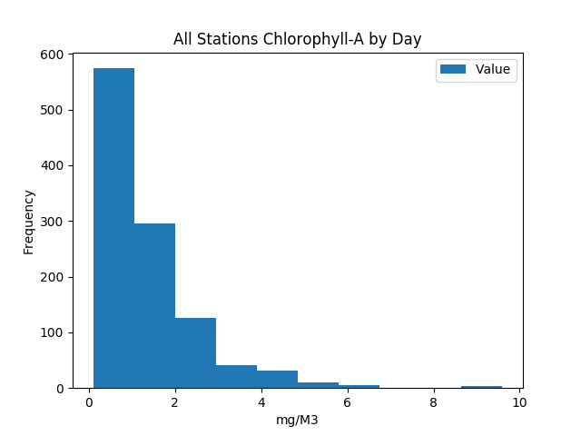

Figure A2. (a) Line plot of Chlorophyll-a measurements for all 170 stations for every day. (b) Density plot of Chlorophyll-a measurements. (c) Histogram chart of Chlorophyll-a measurements.

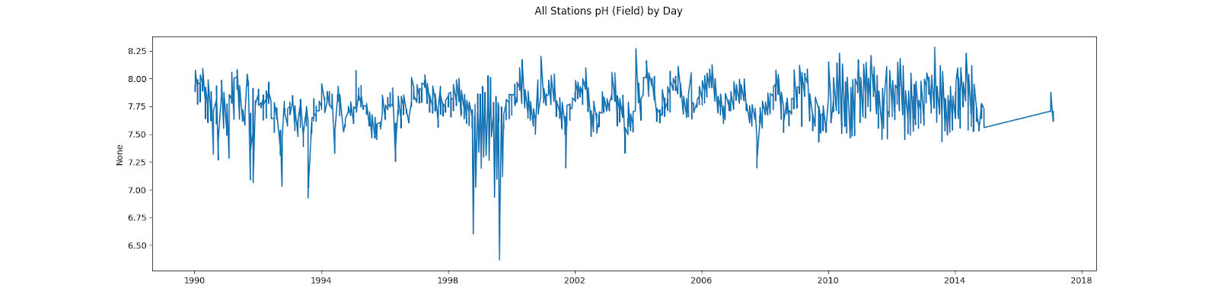
(a)
(b)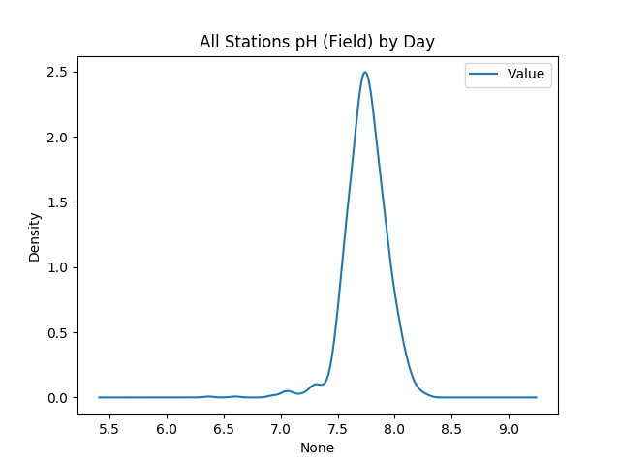 (c)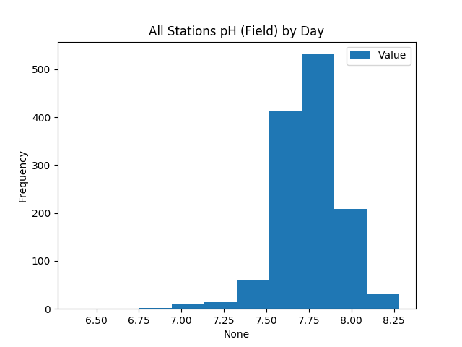

Figure A3. (a) Line plot of pH measurements for all 170 stations for every day. (b) Density plot of pH measurements. (c) Histogram chart of pH measurements.

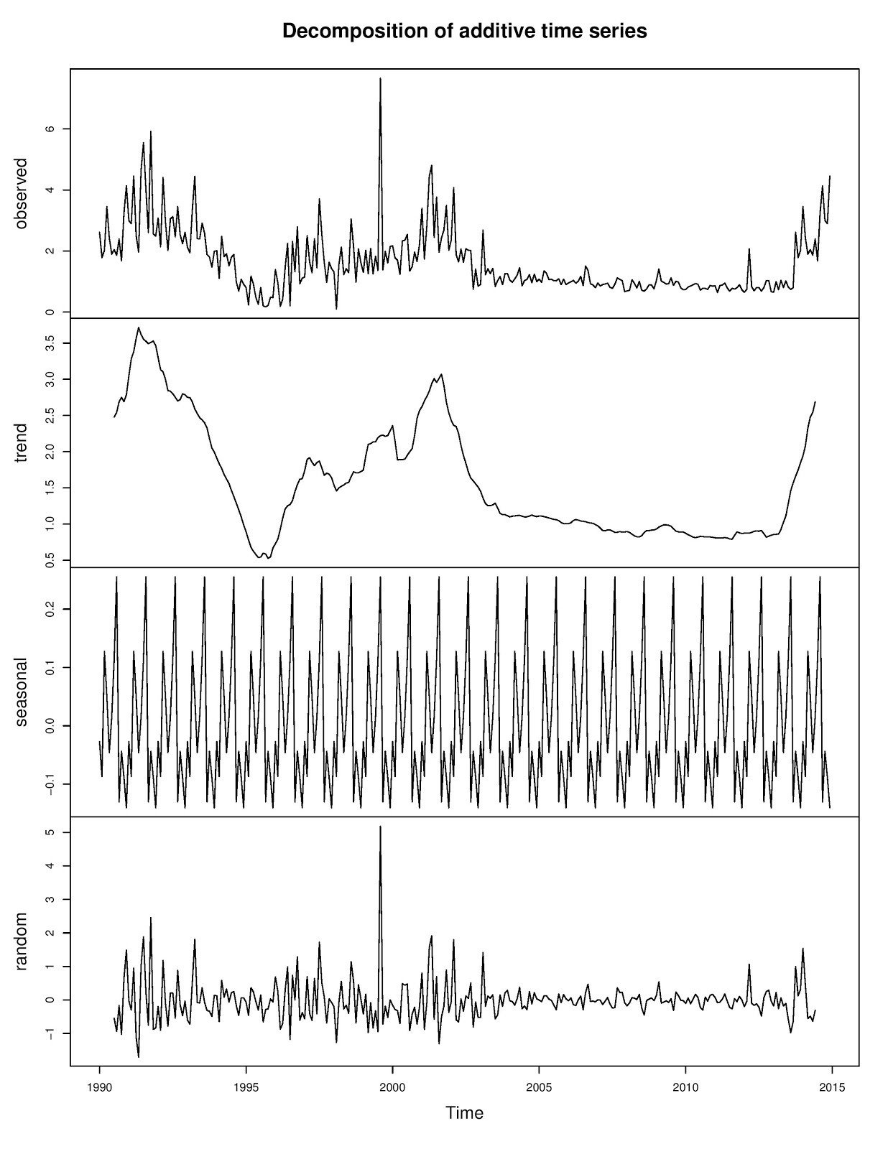
Figure A4. Decomposition of additive time series for turbidity data.
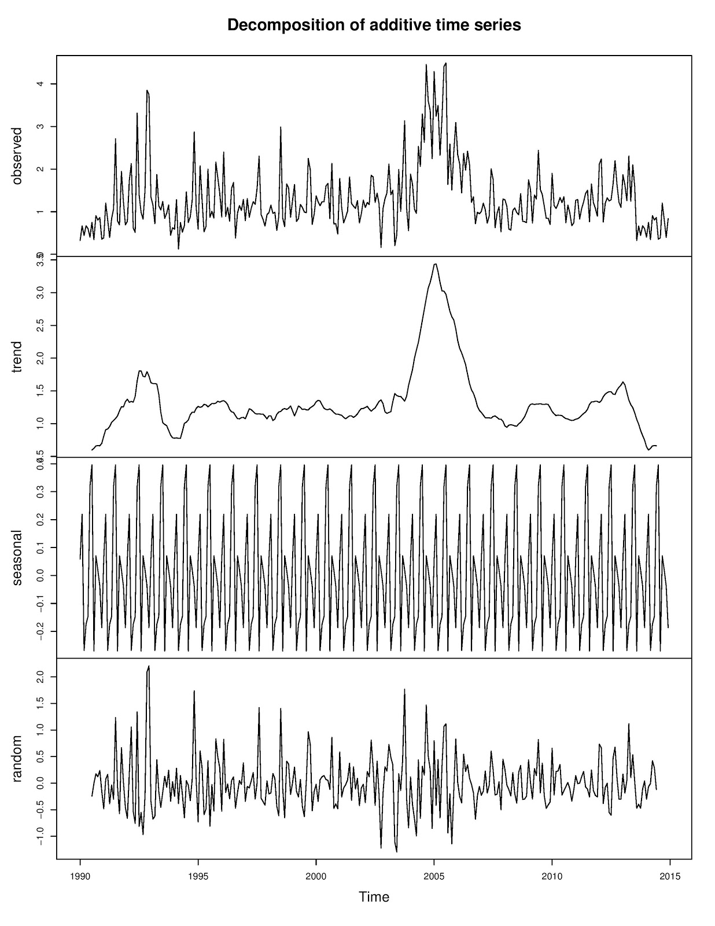
Figure A5. Decomposition of additive time series for chlorophyll-a data.

Table A1.
Summary statistics of in situ water quality data.
Statistics | Temperature (Celsius) | Turbidity (NTU) | Chlorophyll-a (mg/M³) | pH
count (#) | 302 | 287 | 1090 | 1268
mean | 25.750173 | 1.569733 | 1.395038 | 7.749568
std | 3.035108 | 1.034684 | 1.183538 | 0.183191
min | 17.367793 | 0.100000 | 0.100000 | 6.368000
25% | 23.481435 | 0.894017 | 0.673838 | 7.645922
50% | 25.956033 | 1.210377 | 0.986083 | 7.750452
75% | 28.499866 | 2.026107 | 1.738750 | 7.861371
max | 31.220664 | 7.662775 | 9.600000 | 8.283333

